Preparation of an Indian Grey Mongoose (Urva edwardsii) as a Museum Specimen using the Taxidermy Technique

Abstract
Taxidermy provides a means of preserving the external appearance of animal specimens for museum display, anatomical teaching and wildlife education. This descriptive report documents the preparation of a single Indian grey mongoose (Urva edwardsii) that died following a road accident on the campus of Assam Veterinary and Fishery University, Khanapara, Guwahati, Assam. The carcass was received by the Department of Veterinary Anatomy and Histology for preparation as an educational specimen. A mid-ventral incision was used to separate the skin, with particular care taken around the head and limbs. Body dimensions were recorded to guide the construction of an artificial form. The procedure included cleaning the skin, immersing it for three days in a solution containing two litres of water, 75 g of salt and 50 g of alum, and shade-drying it. The original preparation also recorded the application of arsenical soap. The treated skin was positioned over a supporting form made from foam and wood wool, stitched, and arranged using wire supports. Artificial eyes and a display base completed the mount. The finished specimen retained a recognisable external body outline and provided a three-dimensional teaching resource. However, neither long-term preservation performance nor educational outcomes were measured. The use of protected wildlife and hazardous preservatives requires appropriate legal authorisation and chemical-safety controls.
Keywords: Indian grey mongoose, taxidermy, museum specimen, wildlife education
Introduction:
The Indian grey mongoose, also known as the Asian grey mongoose, is an omnivorous mammal distributed across parts of the Indian subcontinent and western Asia. It occupies a range of habitats, including scrubland, open woodland and cultivated landscapes, and may occur near human settlements. Its diet is varied and can include rodents, reptiles, birds, insects and other small animals (Macdonald, 2009; Mudappa & Choudhury, 2024). Although the species is assessed as Least Concern globally and listed in Schedule II under the Wild Life (Protection) Act, 1972, this status does not mean that individual animals are free from local threats. Illegal exploitation for mongoose hair has been reported in India, particularly for the manufacture of brushes. The use of specimens in educational collections should therefore be based on lawful, documented sources and should never create demand for animals killed for display (Mudappa & Choudhury, 2024). Taxidermy is the preservation and reconstruction of an animal’s external form by preparing the skin and arranging it over a supporting body or mannequin. Properly prepared museum specimens can support the teaching of external morphology, comparative anatomy, species recognition and public understanding of biodiversity. Published documentation of taxidermied bird specimens illustrates the role of museum collections in retaining animal material for subsequent reference and study (Rahemo et al., 2021). Studies of mounted skeletal collections in veterinary anatomy also demonstrate how preserved animal material may serve as a teaching resource, although osteological preparation represents a different type of specimen from taxidermy (Dia et al., 2024). Byrne (2023) proposed the use of salvaged remains and existing collections within approaches intended to limit harm associated with acquiring research material.
Biological collections are important repositories of physical evidence that can be revisited when taxonomic interpretations, teaching priorities or research questions change. Their value rests not only in preserving visible characteristics but also in linking specimens to reliable contextual information such as identification, geographical origin, date and circumstances of acquisition. Suarez and Tsutsui (2004) described the diverse scientific and societal contributions of museum collections, while Bradley et al. (2014) emphasised that specimens and their associated records require sustained curatorial care. In this context, the preparation of an opportunistically recovered mongoose can contribute to a local teaching collection, provided that the material is appropriately documented and maintained. A recent faunal inventory drawing on specimens in a national zoological collection likewise demonstrates how preserved material can support taxonomic documentation (Priyadarsini, 2026).
Collection-management research describes the role of coordinated metadata and specimen records in facilitating future access to physical holdings (Cicero et al., 2024). In a separate Indian zoological survey, identified specimens were deposited in an institutional collection, illustrating one means of retaining material supporting published faunal records (Chowdhury & Mitra, 2026). Recent analyses of biodiversity records also underscore the continuing importance of documenting new specimens alongside maintaining existing natural history collections (Forbes et al., 2025).
The educational usefulness of physical specimens is distinct from, although complementary to, that of photographs and digital records. A three-dimensional mount permits learners to examine relative dimensions, body configuration, pelage distribution and the orientation of external structures from different viewpoints. Natural history collections can therefore support observation-based learning and the development of questions about biodiversity and morphology. Suarez and Tsutsui (2004), Bradley et al. (2014) and McLean et al. (2016) collectively establish the relevance of well-curated biological specimens to research and teaching. However, the extent of any teaching benefit depends on how the specimen is interpreted and used; no learning outcomes were measured in the present case. The use of specimens for public education requires appropriate curatorial planning to balance accessibility with the care of collection material (Arriaga Jiménez & Fearn, 2025).
A museum visitor study found that offering haptic exploration of suitable mounted specimens was associated with greater engagement with exhibits; this finding should not be extended to the present chemically treated mount without an appropriate safety assessment (Hampp et al., 2025). Work on the reinterpretation of a preserved-wildlife gallery has also highlighted the relevance of explanatory context when presenting taxidermied specimens to visitors (Rigby et al., 2025). Course-based undergraduate activities using digitized natural history collections have additionally been discussed as an approach to engaging learners with specimen-derived information (Krumm et al., 2024).
An important consideration in acquiring mammalian specimens is that a single opportunistically collected animal may provide a permanent teaching resource without requiring the deliberate killing of an additional animal. The broader literature nevertheless cautions that the scientific value of specimens depends on their provenance, appropriate deposition and continued accessibility (McLean et al., 2016; Salvador & Cunha, 2020). A prepared mount is not interchangeable with a complete anatomical voucher because skinning and reconstruction may limit access to internal structures. The present report consequently focuses on external morphology and the recorded steps of preparation, rather than claiming to establish a comprehensive anatomical reference or a validated preservation method. Research on taxidermied animal specimens also emphasises the relevance of provenance information and access when considering their potential research use (Spennemann & O’Connell, 2025). A review of scientific applications of road-killed wildlife identified museum deposition among the documented uses of recovered animals, while also considering limitations associated with their use (Beckmann et al., 2026). Research on the restoration of a mammalian taxidermy specimen has addressed changes in visible appearance, reinforcing the need to distinguish an immediately completed mount from evidence of its long-term condition (Artola-Pino et al., 2025).
Objective of the study
This article records the preparation of a single Indian grey mongoose that died in a road accident on the university campus. The purpose is to describe the principal stages and educational value of preparing this opportunistically obtained specimen.
Materials and Methods:
The completed specimen provided an observable three-dimensional representation of the characteristic general body outline, including an elongated trunk, comparatively short limbs, a tapering head region and an extended tail. These features are described qualitatively from the finished mount and should not be interpreted as standardised morphometric measurements. The photographs document the transition from the recovered carcass to the separated skin, the supporting form and the completed display specimen (Figs. 1–4). The figures therefore provide a visual sequence of preparation rather than independent evidence of treatment efficacy.
The principal outcome of this single-specimen preparation was the production of an educational mount, not a controlled comparison of taxidermy methods. The original record does not provide replicate specimens, measured preservation performance, a learner assessment or long-term condition monitoring. Accordingly, no conclusion can be drawn regarding the relative efficacy of the salt–alum treatment, the longevity of the mount or its superiority to other preparation approaches. Literature on the curation and research uses of natural history specimens indicates why consistent records and continuing care would be important if this mount is maintained as part of a permanent collection (Bradley et al., 2014; McLean et al., 2016; Salvador & Cunha, 2020).
From an educational perspective, the value of the mount lies primarily in the opportunity for guided, repeated observation of the external morphology of a relatively small carnivorous mammal. Learners may compare the displayed head, ears, trunk, limbs and tail with descriptions in zoological teaching materials and use the preserved form to discuss species identification and adaptive external features. Museum objects are particularly useful when students can examine physical relationships among structures that are less immediately apparent in two-dimensional images. Suarez and Tsutsui (2004) recognised the broader societal importance of biological collections, and Bradley et al. (2014) identified their continuing contribution to education and research. These general findings support the rationale for maintaining such a mount, but they do not demonstrate that this particular specimen has improved student performance.
An additional consideration is the difference between visual fidelity and anatomical fidelity. Taxidermy reconstructs the external appearance of an animal after removal of internal tissues, whereas an osteological preparation, fluid-preserved specimen or anatomical dissection may preserve different types of information. In the current case, the artificial body and wire supports were intended to reproduce overall proportions and the desired posture. The position of a reconstructed limb or contour is consequently influenced by the preparation process, and students should be informed that a finished mount is an interpreted representation rather than an untouched biological specimen. Research on mammalian museum collections highlights the importance of selecting specimen types according to the questions being investigated (McLean et al., 2016). Thus, the mongoose mount is most appropriately used as a supplementary resource for visible morphology, rather than for detailed investigation of internal anatomy.
Documentation is central to the lasting academic value of the preparation. A specimen accession record would ideally accompany the mount, retaining the species identification, locality, recovery circumstances, preparation date, treatment history, responsible personnel and the original images. Such information facilitates interpretation, future conservation decisions and comparisons with other mammalian holdings. Bradley et al. (2014) linked long-term collection value to curatorial investment, while Salvador and Cunha (2020) called attention to the continuing need for deposition and maintenance of specimen-based evidence. The present report establishes the reported recovery setting and principal preparation steps; however, it does not document a catalogue identifier or systematic condition-checking programme. These features would be relevant to future collection management but should not be assumed to have been implemented.
The use of an animal recovered after accidental mortality also warrants a carefully qualified conservation interpretation. Salvage avoids procuring a new animal specifically for mounting, but the circumstances of a single road casualty do not establish the frequency of traffic-related mortality for the species or the conservation status of the local population. A single specimen cannot support inferences about population size, habitat preference or overall risk. Biological collections can contribute to broader ecological and conservation questions when records are sufficiently detailed and systematically integrated (Suarez & Tsutsui, 2004; McLean et al., 2016). The present case is better viewed as an example of educational reuse of already deceased wildlife, subject to applicable authorisations and institutional procedures, than as evidence for a wider population-level trend.
The preparation method raises a distinct issue concerning chemical hazards and subsequent handling. The original procedure recorded the use of arsenical soap, and the study did not undertake analytical testing for residual arsenic or other preservative compounds in the completed mount. Therefore, the absence of visible surface contamination cannot be taken as evidence of the safety of unprotected handling. The specimen should be managed in accordance with institutional hazardous-collection guidance, including appropriate assessment before direct student contact. Preservation practices also require attention to potential mechanical damage, deterioration and environmental conditions during storage and display. Bradley et al. (2014) discussed long-term curatorial responsibilities, and Salvador and Cunha (2020) highlighted the vulnerability of collections when stewardship is inadequate. Neither of these studies validates the chemical treatment used in this individual preparation; the current account is descriptive and should not be interpreted as a safety or efficacy trial.
One Indian grey mongoose that had died following a road accident on the campus of Assam Veterinary and Fishery University, Khanapara, Guwahati, Assam, was brought to the Department of Veterinary Anatomy and Histology for preparation as a teaching specimen. No animal was killed for the purpose of this work. The materials recorded for the procedure included No. 11 BP blades and No. 3 BP handles, rat-toothed forceps, cotton, needles and thread, wire, black beads for the eyes, plywood for the display base, an artificial-body material (styra foam and wood wool), adhesive, plaster of Paris, abrasive paper, brushes and measuring equipment. The original notes also list salt, alum, turpentine oil, formalin and arsenical soap (arsenic oxide/trioxide/pentaoxide-100gm, soap jelly-800gm, camphor-25gm, Borax-50gmand turpentine oil-12cc). Arsenical soap and formalin present significant health and environmental hazards; their use should not be reproduced as a routine recommendation. A mid-ventral incision was made from the shoulder region towards the stifle region, and the skin was separated carefully from the underlying tissues. Particular care was taken around the ears, eyes and nose to avoid tearing the delicate skin. The skin was removed from the body, and muscle was cleared from the distal portions of the limbs. The brain and eyeball were removed during preparation of the head. The dimensions of the body were recorded before an artificial body was shaped to approximate the original proportions. The original procedure notes describe immersion of the skin in a solution containing two litres of water, 75 g of salt and 50 g of alum for three days, followed by rinsing and shade-drying. As the suitability of this treatment depends on the skin condition, local practice and conservation requirements, it should be regarded as the procedure recorded for this specimen rather than a validated universal protocol. After drying, the skin was painted with arsenic soap. An artificial body was shaped using styra foam and wood wool and adjusted according to the recorded measurements. Wire supports were placed to maintain the position of the limbs and tail, and the head was connected to the supporting body. The prepared skin was positioned over the form and stitched with thread. Cotton was used where needed to fill small spaces, and black beads were used to represent the eyes. The ears, limbs and tail were arranged to produce a natural-looking posture. The mount was secured to a plywood base, and the surface was finished to improve its appearance.
Results & Discussion
A mounted specimen of the Indian grey mongoose (Fig. 4) was prepared from an animal that had died following a road accident (Fig. 1). The principal stages recorded were skin removal, cleaning and treatment of the skin, measurement and preparation of an artificial body (Figs. 2 and 3), insertion of supporting wires, positioning of the head and limbs, stitching of the skin, and mounting on a display base. Attention to the skin around the ears, eyes and nose was important because these areas are delicate and contribute strongly to species recognition. The prepared mount retained the recognisable external form of the animal and was suitable for use as a teaching and display specimen. No quantitative assessment of durability, colour retention or long-term preservation was undertaken.
This case documents the preparation of a single Indian grey mongoose for a teaching collection using an animal that had died accidentally. Museum mounts can provide students with a stable three-dimensional reference for examining body proportions, pelage, limb arrangement, head shape and other external features that may be difficult to appreciate from photographs alone. Such specimens can complement, but do not replace, examination of living animals, skeletal material, anatomical models and current field-identification resources. The choice of a naturally deceased specimen is important from a conservation perspective. The Indian grey mongoose is assessed as Least Concern at the global level and listed in Schedule II under the Wild Life (Protection) Act, 1972, but it has been affected by illegal harvesting for its hair. Consequently, educational taxidermy should be based on incidental mortality or other lawful sources and supported by clear records of origin; it should not encourage collection or killing for commercial display (Mudappa & Choudhury, 2024). The reported use of the species in human settings and its varied diet are part of its natural history, but these facts alone do not justify keeping or trading wild individuals (Macdonald, 2009). The procedure also highlights the importance of accurate measurements and a well-proportioned artificial body. If the form is too large or too small, the skin may be stretched, wrinkled or poorly aligned, particularly around the limbs, face and tail. Careful handling during skinning and mounting is therefore essential to preserve external characters. These observations are consistent with the broader purpose of museum specimens as durable reference materials for teaching and documentation, although the present case did not compare alternative tanning or mounting techniques.
Conclusion
This case report describes the preparation of one Indian grey mongoose that died following a road accident and was subsequently used to produce a museum teaching specimen. The recorded procedure involved careful skin removal, measurement of the body, treatment and drying of the skin, construction of a supporting artificial form, and final stitching and mounting. The finished specimen retained a recognisable external appearance, including the general proportions of the trunk, limbs, head and tail. It may therefore serve as a supplementary resource for supervised teaching of mammalian external morphology and wildlife awareness. The mount should not, however, be regarded as a substitute for materials needed to study internal anatomy or as evidence of the comparative effectiveness of any preservation technique. The preparation was not supported by long-term condition monitoring, chemical-residue testing or a formal assessment of student learning. Appropriate documentation of specimen provenance, lawful authorisation and safe collection management remains important, particularly because the recorded procedure involved a hazardous preservative.
Limitations
The limitations of this report follow directly from its case-study design. It describes one road-killed animal and records a preparation sequence that culminated in a recognisable mounted specimen. There was no comparison group, no repeated treatment application across specimens, no quantitative assessment of shrinkage, pest resistance or colour stability, and no formal evaluation of teaching outcomes. Consequently, any claims about technical performance should remain restricted to the immediate visible result. The broader scholarship on museum collections demonstrates the potential of well-documented preserved specimens for scientific and educational activities (Bradley et al., 2014; McLean et al., 2016; Salvador & Cunha, 2020), but that potential does not constitute measured evidence of the long-term success of the present mount. Future observational documentation could record condition over time and clarify how the specimen is used in practical classes without changing the descriptive conclusions reported here.

Declaration of AI Use

This manuscript was prepared through the intellectual contributions of the author(s) to the study design, data analysis, interpretation of results, and scholarly content. Grammarly and ChatGPT were used solely to assist with grammatical refinement and reference formatting during manuscript revision. The author(s) accept full responsibility for the accuracy, integrity, and final content of the manuscript.

COMPETING INTERESTS DISCLAIMER:
Authors have declared that they have no known competing financial interests OR non-financial interests OR personal relationships that could have appeared to influence the work reported in this paper.

References
Arriaga Jiménez, A., & Fearn, S. (2025). Balancing discovery and education in natural history collections. Natural History Collections and Museomics, 2, 1–8. https://doi.org/10.3897/nhcm.2.147409
Artola-Pino, M., Vila-Casòliva, M., & Quesada, J. (2025). Chromatic restoration of a beech marten taxidermy specimen to resemble its original population: Analysing painting products and colour parameters. Studies in Conservation, 70(3), 220–232. https://doi.org/10.1080/00393630.2024.2358593
Beckmann, C., Crossland, M. R., Wright, K. T., & Biro, P. A. (2026). Roadkill reimagined: A review of innovative scientific use and value of animals killed by vehicular traffic. Biology Letters, 22(1), 20250471. https://doi.org/10.1098/rsbl.2025.0471
Bradley, R. D., Bradley, L. C., Garner, H. J., & Baker, R. J. (2014). Assessing the value of natural history collections and addressing issues regarding long-term growth and care. BioScience, 64(12), 1150–1158. https://doi.org/10.1093/biosci/biu166
Byrne, A. Q. (2023). Reimagining the future of natural history museums with compassionate collection. PLOS Biology, 21(5), e3002101. https://doi.org/10.1371/journal.pbio.3002101
Chowdhury, P., & Mitra, S. (2026). Expanding the known marine brachyuran crab fauna of West Bengal, India: Eight new distributional records. Journal of Biology and Nature, 18(2), 230–240. https://doi.org/10.56557/joban/2026/v18i210849
Cicero, C., Koo, M. S., Braker, E., Abbott, J., Bloom, D., Campbell, M., Cook, J. A., Demboski, J. R., Doll, A. C., Frederick, L. M., Linn, A. J., Mayfield-Meyer, T. J., McDonald, D. L., Nachman, M. W., Olson, L. E., Roberts, D., Sikes, D. S., Witt, C. C., & Wommack, E. A. (2024). Arctos: Community-driven innovations for managing natural and cultural history collections. PLOS ONE, 19(5), e0296478. https://doi.org/10.1371/journal.pone.0296478
Dia, A., Kabkia, B., & Ben Khalifa, A. (2024). Realization of an osteological montage of domestic animals at the Museum of Anatomy of the Inter-State School of Veterinary Sciences and Medicine of Dakar. Asian Journal of Medicine and Health, 22(8), 182–189. https://doi.org/10.9734/ajmah/2024/v22i81083
Forbes, O., Young, A. G., & Thrall, P. H. (2025). Global sampling decline erodes science potential of natural history collections. Nature Communications, 16, 9255. https://doi.org/10.1038/s41467-025-64303-3
Hampp, C., Novak, M., Lange, A., & Schwan, S. (2025). Please touch the hedgehog: Haptic exploration of mounted specimens increases inspection time and positive evaluation of an exhibit. Science Education, 109(6), 1701–1715. https://doi.org/10.1002/sce.21991
Krumm, J. L., Jordan, C. N., Bronson, C. D., Weglarz, K. M., Genet, K., Johnson, M. G., Phillips, M., Flemming, A., Shea, E. K., Hewlett, J., Soltis, P. S., McCarthy, J., Trillo, P. A., & Woods, J. (2024). Improving access to undergraduate research using digitized natural history collections course-based research experiences. Ecosphere, 15(11), e70038. https://doi.org/10.1002/ecs2.70038
Macdonald, D. W. (Ed.). (2009). The encyclopedia of mammals (2nd rev. ed.). Oxford University Press. https://ib.berkeley.edu/sites/default/files/undergrad/syllabus/IB%20173_Fa14.pdf
McLean, B. S., Bell, K. C., Dunnum, J. L., Abrahamson, B., Colella, J. P., Deardorff, E. R., Weber, J. A., Jones, A. K., Salazar-Miralles, F., & Cook, J. A. (2016). Natural history collections-based research: Progress, promise, and best practices. Journal of Mammalogy, 97(1), 287–297. https://doi.org/10.1093/jmammal/gyv178
Mudappa, D., & Choudhury, A. U. (2024). Urva edwardsii. The IUCN Red List of Threatened Species 2024, e.T41611A259345602. https://doi.org/10.2305/IUCN.UK.2024-2.RLTS.T41611A259345602.en
Priyadarsini, P. (2026). Freshwater malacofaunal diversity of Jabalpur Division, Madhya Pradesh, India. Journal of Biology and Nature, 18(2), 318–326. https://doi.org/10.56557/joban/2026/v18i210912
Rahemo, Z. I. F., Al-Hassani, O. M., & Abood, S. K. (2021). Specimens of aquatic bird deposited at Mosul Natural History Museum, Mosul, Iraq. Asian Journal of Research in Zoology, 4(1), 28–33. https://doi.org/10.9734/ajriz/2021/v4i130105
Rigby, J., Haslam, L., Colley, I., & Lincoln, P. (2025). Reimagining the World Wildlife Gallery, Kendal Museum: A community engagement and reinterpretation project. Collections, 21(4), 462–467. https://doi.org/10.1177/15501906251345391
Salvador, R. B., & Cunha, C. M. (2020). Natural history collections and the future legacy of ecological research. Oecologia, 192(3), 641–646. https://doi.org/10.1007/s00442-020-04620-0
Spennemann, D. H. R., & O’Connell, M. C. G. (2025). Red tape or open slaughter? Examining and sampling biological animal specimens held in public and private collections. Collection and Curation, 44(3), 90–98. https://doi.org/10.1108/CC-09-2024-0048
Suarez, A. V., & Tsutsui, N. D. (2004). The value of museum collections for research and society. BioScience, 54(1), 66–74. https://doi.org/10.1641/0006-3568(2004)054[0066:TVOMCF]2.0.CO;2

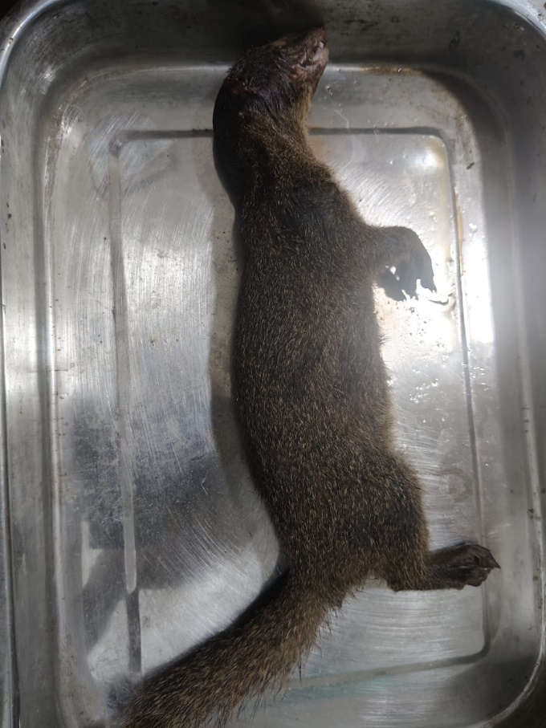
Fig.1. Photograph showing the Indian Grey Mongoose (Urva edwardsii) which was found in road Accident inside the campus of AVFU and presented in table for remove of skin.

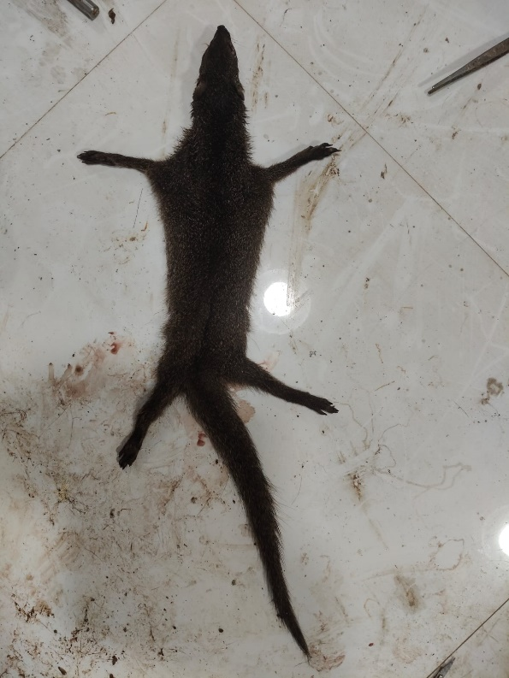
Fig.2. Photograph showing the skin of Indian Grey Mongoose (Urva edwardsii) .

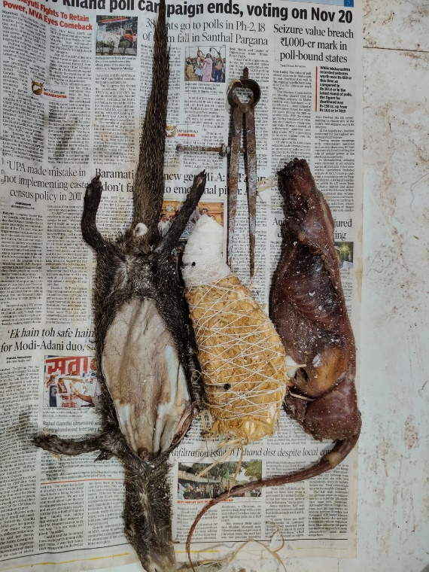
Fig.3. Photograph showing the skin, duplicate body and original body of Indian Grey Mongoose (Urva edwardsii) and campus for measurement of body of animal.

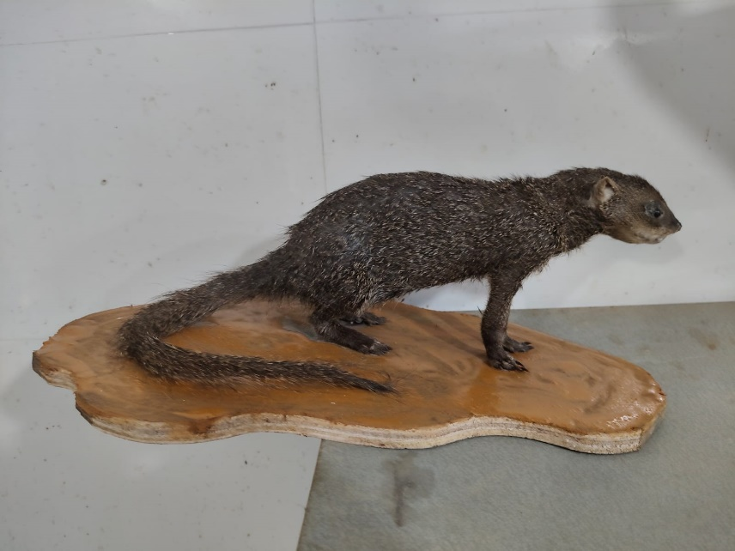
Fig.4. Photograph showing the Indian Grey Mongoose (Urva edwardsii) which can be displayed in museum for study of taxidermy.

