Legal Protection of Endangered Fauna in India: Linking Species Conservation, Habitat Ecology, and Wildlife Law

.
Abstract
Aims: To examine how wildlife laws in India can better reflect the ecological needs of endangered species, habitat quality, landscape connectivity, and evidence-based conservation practices.
Study Design: Qualitative, narrative legal and policy analysis.
Place and Duration of Study: India, focusing on wildlife protection laws, biodiversity policies, international commitments, and relevant conservation literature. The study period is not limited to a specific duration.
Methodology: The study examines the Wild Life (Protection) Act, 1972, the Biological Diversity Act, 2002, as amended, and constitutional principles relating to environmental protection. It also reviews conservation literature on habitat fragmentation, species vulnerability, ecological connectivity, and wildlife management. Based on this review, the study develops a five-part species–habitat–law integration framework covering species-risk assessment, habitat and connectivity mapping, threat-specific legal controls, community participation, and measurable monitoring with periodic legal review.
Results: The analysis identifies a gap between legal protection based on species schedules and designated protected areas and the wider ecological needs of endangered fauna. Habitat fragmentation, loss of connectivity, and cumulative environmental impacts require greater attention in wildlife conservation planning. The proposed framework provides five connected areas for improving the relationship between legal protection and ecological evidence. However, no numerical findings, statistical tests, or measured conservation outcomes are reported, as the study is based on qualitative legal and policy analysis.
Conclusion: Wildlife protection can become more effective when legal decisions consider current zoological evidence, habitat quality, ecological connectivity, and cumulative environmental impacts. Regular monitoring, community participation, and transparent reporting of conservation outcomes can further strengthen wildlife governance. The proposed framework offers a basis for policy development and future research, but its practical value must be tested through empirical studies of selected species and landscapes in India.
Keywords: endangered fauna; wildlife law; habitat ecology; species conservation; India;

1. INTRODUCTION

India has great diversity of fauna in the Himalaya, forests, grasslands, wetlands, deserts, coasts and marine ecosystems. This diversity is facing pressure, both from taxon- and landscape-specific factors (such as habitat modification, fragmentation, pollution, infrastructure development, introduction of invasive species, climate change, and illegal use) and from other factors. The International Union for Conservation of Nature (IUCN) Red List offers a worldwide system for assessing extinction risk and national legislation lays down legal obligations, limitations and instruments for wildlife protection (IUCN n.d.). Protection from direct killing alone is not enough: ecological assessment, or legal protection alone is not enough; a species can be protected from direct killing, but it can still decline if their breeding sites, prey or hydrological conditions or movement routes are degraded. The main wildlife protection law in India, which has been significantly amended since its enactment in 1972, is the Wild Life (Protection) Act, 2022. The legal framework also covers the Biological Diversity Act, 2002, as amended in 2023, the Environment (Protection) Act, 1986, forest related legislations and principles and international obligations arising out of Convention on Biological Diversity (CBD). The Wildlife Amendment 2022 streamlined schedules and incorporated provisions for implementation of the Convention on International Trade in Endangered Species of Wild Fauna and Flora (CITES) (Government of India, 2022; UNEP, n.d.). These instruments are an important legal framework but their conservation value relies on the coordination, enforcement and ecological implementation of it. The main point of this article is that endangered-fauna protection must be evaluated in the context of an integrated species–habitat–law perspective. Conservation outcomes are also dependent on the ecological processes that enable populations to persist - habitat extent and quality, connectivity, food availability, breeding success, seasonal movement and reduced exposure to cumulative threats - and species-level listing is required. The paper thus proposes a conceptual framework to be used in future empirical studies and to enhance the application of zoological evidence to conservation decisions.

2. Objectives and Research Questions
To analyse the key legal instruments of India that relate to the protection of endangered fauna and the conservation of habitat.
To illustrate the impact of habitat ecology, fragmentation and connectivity on the effectiveness of species protection, in practice.
To Identify gaps in governance due to disconnected legal designations and enforcement with ecological evidence.
To suggest an integrated framework and measurable indicators of connection between zoological evidence and implementation of wildlife law.
First, what are the laws on the books in India for the protection of species and habitats? (ii) What is their relevance to the field of wildlife biology? and (iii) what have they accomplished? (iii) How can the legal and administrative framework be improved to better incorporate ecological considerations? (iii) What are some metrics to assess the effectiveness of laws in achieving conservation goals?
3. MATERIALS AND METHODS

3.1 Research Design
This paper is written in a qualitative, narrative legal-policy approach, with an interdisciplinary ecological synthesis. It is not a systematic review, field survey or original biodiversity assessment. The legal element involves an overview of the key legislation and some key official sources, and the ecological element is based on existing conservation assessments and international biodiversity policy. The aim is analytical synthesis and developing a framework, not to estimate population trends or causal effects. The following were given priority: The Wild Life (Protection) Act, 1972 and its 2022 amendment, the Biological Diversity Act, 2002 and its 2023 amendment, the Ministry of Environment, Forest and Climate change's annual reporting, the IUCN Red List, the CBD and the Intergovernmental Science-Policy Platform on Biodiversity and Ecosystem Services (IPBES). The analysis then compared the ecological scale of major threats with the scale and operation of available legal mechanisms.
3.2 Results and Discussion
Legal architecture: from species protection to biodiversity governance The Wild Life (Protection) Act, 1972 is the basic law for the protection of wild animals and plants, the regulation of hunting and trade and the establishment and management of protected areas. The amendment 2022, among other changes, amended the schedules and added a chapter dedicated to international trade in listed specimens, which was aligned to CITES. The Ministry's annual report also reports that after amendment (MoEFCC, 2024) the Gangetic River Dolphin (Platanista gangetica) and Indus River Dolphin (Platanista minor) are now added as separate species in Schedule I. This is a prime example of the impact taxonomic clarity can have on priorities for legal protection and enforcement. The Biological Diversity Act, 2002 is complementary to the wildlife law and deals with the parameters of conservation, sustainable use and equitable and fair benefit sharing in relation to biological resources. The Biological Diversity (Amendment) Act, 2023 entered into force on 1st April 2024, while the Biological Diversity Rules, 2024 were in effect from 21st December 2024 (National Biodiversity Authority, n.d.). Where conservation engages with the scientific, genetic resources, local knowledge and community level of biodiversity governance these provisions are applicable. They are not, however, a substitute for the protection and habitat management of these species provided for under wildlife and environmental legislation and strategies.

3.3Why Habitat Ecology MustShape Legal Protection
Threatened populations are not isolated legal objects; they are components of ecological systems. Habitat loss can reduce carrying capacity, while fragmentation can isolate populations, restrict dispersal, increase edge effects and reduce opportunities for recolonization. A protected-area boundary may safeguard a core breeding site but fail to protect a seasonal corridor, a downstream river reach, a nesting beach or prey habitat outside the boundary. Conservation assessments therefore need to consider habitat quality, configuration and connectivity alongside the presence or absence of a species.
This issue is especially clear for wide-ranging mammals, riverine fauna, migratory species and animals dependent on specialized breeding or feeding habitats. The Ministry’s reporting on dolphin conservation, including a proposed conservation zone along a stretch of the Chambal River, illustrates the relevance of landscape-scale and river-system approaches (MoEFCC, 2024).

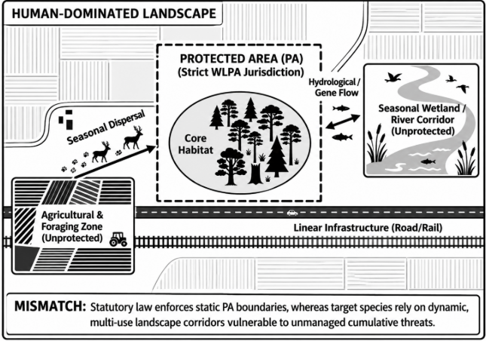
Fig.1 Spatial and functional mismatch concept diagram for wildlife protection. Inside the perimeters of designated Protected Areas (PA), statutory instruments (e.g., Wild Life Protection Act 1972) enforce strict protection, whereas critical ecological processes, such as seasonal dispersal, genetic exchange and hydrological flows, are dynamically related to unprotected multi-use landscapes.

3.4 Species schedules and ecological evidence: complementary tools
There are categories of restrictions and enforcement that can be administered through the use of legal schedules, whereas ecological risk is dynamic. Population status may change with the arrival of new surveys, changes in taxonomic knowledge or increased threats. On the other hand, a species, which is not at present evaluated as globally threatened, may still require protection at a local level if there is a stand out or a species-specific ecological value. A practical system should thus rely on the statutory classifications as the legal triggers whilst at the same time incorporating current distribution and population trend, habitat dependence, threat exposure and uncertainty into conservation planning. A defensible evidence chain should identify (a) a biological observation, (b) an ecological inference, (c) a legal finding and (d) a management response. For instance, a camera trap record may only demonstrate presence at a site, and does not prove population viability. A decrease in encounter rates can either be real or due to changes in detectability or in sampling. Likewise, a habitat map can also highlight areas of potential fragmentation, but cannot be used to define who is legally liable for them. The linkage of these steps is transparent and helps to avoid exaggerating scientific findings in administrative or judicial procedures.
3.5 Implementation challenges
A review of these four challenges arises. Firstly, ecological information can be geographically dispersed among forest departments, research organizations, local governments and independent studies. Second, project-level approvals may not be adequate to address cumulative impacts along a project corridor or a river system. Thirdly, the capacity of enforcement agencies may be limited in specialist identification, wildlife forensics, digital monitoring and prosecution. Fourth, interventions for conservation may not incorporate local and indigenous communities in which livelihoods and knowledge are intimately tied to landscapes. These are analytical themes for further verification based on state-level case studies, and do not necessarily reflect national-level findings from this review. There is also a need for proportional, socially legitimate measures if conservation is to be effective. Restrictions that ignore customary use, livelihood dependence and local knowledge can result in low-trust and low-compliance. Participatory monitoring, clear compensation mechanisms, and, where relevant and appropriate, consultations can enhance the legitimacy of conservation, without compromising legal conservation obligations. Community participation should be complementary, not supplanting, government responsibility, enforcement and independent scientific assessment.
3.6 Proposed Species–Habitat–Law Integration Framework
The paper outlines a five-step approach to operationalization of the connection between zoological evidence and legal protection. It is a conceptual framework and has yet to be validated in the real world. It is flexible for species, habitat or landscape and to enable future case study research.
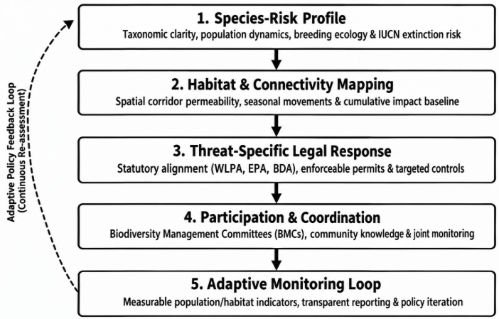

Fig 2. Schematic structure of proposed Species–Habitat–Law Integration Framework.

Table 1. Proposed Species–Habitat–Law Integration Framework. Indicators are illustrative and should be selected according to the target species, available data and relevant legal authority.
Component | Evidence / legal lever | Illustrative indicator
1. Species-risk profile | Taxonomic status, abundance or occupancy trend, breeding ecology, mortality and threat assessment | Trend in occupancy or abundance; breeding success where measurable
2. Habitat and connectivity | Habitat quality, corridor maps, seasonal movement, hydrology and cumulative-impact assessment | Habitat condition; corridor permeability; fragmentation metrics
3. Threat-specific legal response | Relevant wildlife, environmental, forest, pollution and trade controls; enforceable conditions | Compliance rate; verified offences; time to remedial action
4. Participation and coordination | Inter-agency protocols, community consultation, local biodiversity institutions and grievance channels | Joint monitoring events; response time; participation and benefit-sharing records
5. Adaptive monitoring | Baseline, periodic reassessment, transparent reporting and management revision | Change against baseline; review frequency; proportion of actions completed

3.7 Applying the Framework: illustrative Pathways
The initial step for river dolphins would be to integrate reliable occurrence and population data with river-flow, prey, fishing, pollution, and barrier data. Enforcement monitoring should not be the only measure used to monitor, but also ecological measures such as occupancy, observed mortality, and habitat condition. The example illustrates a way of organizing an assessment, rather than saying that a new field survey was performed for this paper.
The framework would identify terrestrial mammals which are affected by roads or railways, map their movement patterns and mortality hotspots, and create a plan to match infrastructure developments with ecological evidence and assess the effectiveness and implementation of mitigation measures such as crossing structures, speed management and seasonality restrictions. A count of protected hectares might be less important for threatened wetland birds or amphibians than the seasonal breeding site or condition of the water. Each of the legal responses should be applied to the ecology and not applied as a checklist.
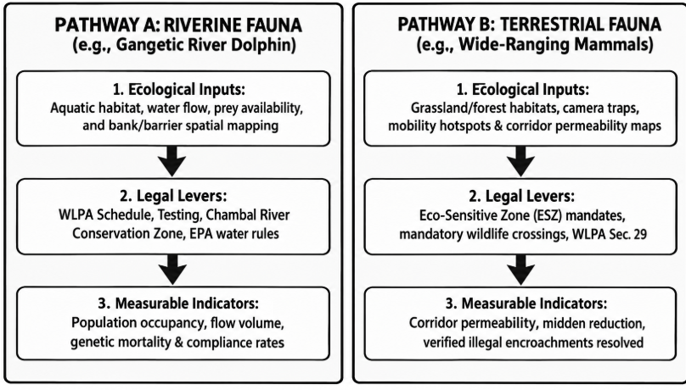
Fig 3. Illustrative operational pathways applying the Species–Habitat–Law Integration Framework to riverine ecosystems (Gangetic Dolphin) and terrestrial landscape corridors (wide-ranging mammals).
4. Recommendations
Where appropriate and at the species level, ecological baseline information, habitat maps, and explicit uncertainty statements should be incorporated into relevant plans and/or project assessments. Use of wildlife corridors, buffer zones, river sections and seasonal habitats outside formally protected zones should be used to measure landscape level and cumulative impacts. Consistent metadata and protocols should be followed to create standardised ecological monitoring systems to ensure the ability to compare data among locations and over time, while protecting sensitive species-location data. Specialized enforcement capability needs to be enhanced by making taxonomic identification easier, improving wildlife forensics, developing digital evidence management tools, and better coordination between forest departments, police, customs and other competent enforcement agencies. Conservation management should be adaptive and encouraged to do so with measurable indicators, periodic progress monitoring, and evidence-based modification of interventions that are not effective. Institutionalisation of meaningful community participation should be built on strategy of involving affected communities at the planning stage, incorporating of local ecological knowledge and ensuring compensation and grievance-redressal is accessible. In addition, practical training of administrative authorities, lawyers and judicial stakeholders on ecological uncertainty, species identification, habitat restrictions, and scientific evidence interpretation should be strengthened, as should legal and scientific integration. Finally, conservation performance should be measured in measurable ecological outcomes, as well as budgets, patrol activities, arrests and protected area designations, as these often do not equate to population recovery or long-term conservation effectiveness.

5. Research Limitations and Future Directions

This paper is a narrative legal-policy synthesis and does not make any causal claims about the link between a given statute and animal population changes. It does not present new field observations and does not present original statistical analysis, or systematic screening of all relevant literature. A second stage study can be conducted on one or two taxa and a specified landscape, should pre-register or document its search protocol, should employ validated species and habitat data, and should involve a time series comparison of legal interventions with ecological indicators. Examples of potential designs are before–after comparisons, matched-site analyses, spatial assessment of habitat connectivity, and structured interviews with relevant stakeholders, where ethical approval and informed consent are appropriate. This work may be used to measure the effectiveness of the proposed framework in decision quality or conservation outcomes.

Conclusion
It is best to enforce the protection for rare fauna when the statutory protection is coupled with the conditions under which the fauna can survive. However, the threats facing species are not only those of wildlife listings, or those of species being protected. While there is a fairly well established framework for wildlife and biodiversity governance in India, these issues cannot be addressed by listing species, and placing them under protection. The authors propose a Species – Habitat – Law Integration Framework that integrates evidence-based species risk information, habitat connectivity, threat-specific legal intervention, community involvement and adaptive monitoring. It's not about effectiveness; it's about a way to making and evaluating conservation decisions in a structured way. New taxon- and/or landscape-specific studies should be conducted based on open zoological data and existing laws to validate the framework. A coherent and effective governance framework that is more evidence responsive can enhance the potential to achieve concrete ecological results through law

Declaration of AI Use

This manuscript was prepared through the intellectual contributions of the author(s) to the study design, data analysis, interpretation of results, and scholarly content. Grammarly and ChatGPT were used solely to assist with grammatical refinement and reference formatting during manuscript revision. The author(s) accept full responsibility for the accuracy, integrity, and final content of the manuscript.

COMPETING INTERESTS DISCLAIMER:
Authors have declared that they have no known competing financial interests OR non-financial interests OR personal relationships that could have appeared to influence the work reported in this paper.

References
Convention on Biological Diversity. Kunming-Montreal Global Biodiversity Framework. Secretariat of the Convention on Biological Diversity; 2022 [cited 2026 Oct 24]. Available from: https://www.cbd.int/gbf
Government of India. The Wild Life (Protection) Act, 1972 (Act No. 53 of 1972), as amended. India Code; 1972 [cited 2026 Oct 24]. Available from: https://www.indiacode.nic.in/
Government of India. The Environment (Protection) Act, 1986 (Act No. 29 of 1986). India Code; 1986 [cited 2026 Oct 24]. Available from: https://www.indiacode.nic.in/
Government of India. The Biological Diversity Act, 2002 (Act No. 18 of 2003). India Code; 2002 [cited 2026 Oct 24]. Available from: https://www.indiacode.nic.in/
Government of India. The Wild Life (Protection) Amendment Act, 2022 (Act No. 18 of 2022). India Code; 2022 [cited 2026 Oct 24]. Available from: https://www.indiacode.nic.in/
Government of India. The Biological Diversity (Amendment) Act, 2023 (Act No. 10 of 2023). Gazette of India; 2023 [cited 2026 Oct 24]. Available from: https://egazette.gov.in/WritereadData/2023/247815.pdf
Intergovernmental Science-Policy Platform on Biodiversity and Ecosystem Services. Global assessment report on biodiversity and ecosystem services. IPBES Secretariat; 2019 [cited 2026 Oct 24]. Available from: https://doi.org/10.5281/zenodo.3831673
International Union for Conservation of Nature. The IUCN Red List of Threatened Species. IUCN; [cited 2026 Oct 24]. Available from: https://www.iucnredlist.org/
Ministry of Environment, Forest and Climate Change. Annual report 2023–2024. Government of India; 2024 [cited 2026 Oct 24]. Available from: https://moef.gov.in/uploads/2023/05/Annual-Report-English-2023-24.pdf
National Biodiversity Authority. Frequently asked questions. Government of India; [cited 2026 Oct 24]. Available from: https://nbaindia.nic.in/index.php/about-us/faqs
United Nations Environment Programme. Wildlife (Protection) Act, 1972 (No. 53 of 1972). Law and Environment Assistance Platform; [cited 2026 Oct 24]. Available from: https://leap.unep.org/en/countries/in/national-legislation/wildlife-protection-act-1972-no-53-1972

