Growth Performance of Tilapia (Oreochromisniloticus) Cultured in a Rainwater-Harvesting Aquaculture Pond

Abstract
The growth of tilapia (Oreochromisniloticus) was studied in a rainwater-harvesting aquaculture pond at H.H. The Rajah’s College, Pudukkottai, from September 2023 to February 2024. Fish were fed daily and sampled at weekly intervals for 24 weeks. Average body weight and body length were recorded throughout the culture period. Average weight increased from 3.0 g in the first week to 550.0 g in the twenty-fourth week, while average body length increased from 1.5 cm to 30.2 cm. Growth was gradual during the early weeks and became more pronounced as the fish increased in size. The continuous increase in both weight and length indicates that tilapia adapted well to the pond conditions maintained during the study. The findings support the use of rainwater-harvesting ponds for tilapia culture where adequate water, regular feeding and suitable environmental conditions can be maintained.
Keywords:Oreochromisniloticus, tilapia, growth performance, aquaculture, rainwater-harvesting pond, freshwater fish culture

1. Introduction
Freshwater aquaculture has become an important means of increasing fish production and making better use of available inland water resources. Ponds, reservoirs and other managed water bodies can support regular fish production when suitable species, feeding practices and water conditions are maintained. Tilapia is widely used in such systems because of its adaptability and relatively rapid growth. Oreochromisniloticus can be cultured in ponds and other freshwater environments and is capable of tolerating a range of culture conditions. It feeds on both naturally available food and supplementary feed and can grow successfully under managed pond conditions. Temperature, dissolved oxygen, pH, food availability and stocking conditions influence its growth and general performance. Rainwater-harvesting ponds are primarily constructed to collect and store seasonal rainfall, but they can also be used for fish culture when adequate water is available for a sufficient period. Such use can add productive value to an existing water-storage structure without requiring a separate culture pond.
The present study was carried out in a rainwater-harvesting aquaculture pond at H.H. The Rajah’s College, Pudukkottai. Tilapia growth was followed over a period of 24 weeks through weekly measurements of body weight and body length. The study examined the pattern of growth under the conditions maintained in the pond and assessed the suitability of the system for tilapia culture.
Growth performance in Nile tilapia is best interpreted as the outcome of interacting nutritional, biological and environmental factors rather than as a fixed species characteristic. Controlled investigations show that feeding level and stocking density can alter both growth and feed utilisation, so results obtained in one production system cannot automatically be transferred to another (El-Sayed, 2002). Dissolved oxygen is particularly relevant because it affects food intake and the allocation of energy between maintenance and growth. Tran-Duy et al. (2012) demonstrated that the oxygen concentration associated with maximal feeding responses may vary with fish body size. These observations provide a physiological basis for considering water quality alongside measurements of weight and length.
Biometric assessment offers a practical means of describing fish development over time. Body mass is sensitive to changes in feeding, tissue accumulation and physiological condition, whereas body length describes longitudinal growth. Published studies of Nile tilapia show that the relationship between these measurements can vary between cultured groups and rearing conditions (Barman et al., 2023; Kamble et al., 2024). It is therefore useful to examine their trajectories separately before drawing conclusions about condition, feed efficiency or production. An upward trajectory in mean mass does not, on its own, demonstrate superior feed conversion or higher survival because those outcomes require different measurements.
The use of a rainwater-harvesting pond is of practical interest where water storage infrastructure is available but the suitability of a particular pond for fish culture depends on local circumstances. Rainfall recharge, evaporation, seasonal changes in water depth, inflows and possible water-quality fluctuations can affect the volume and quality of the habitat. A site-specific growth record can establish whether fish increased in size during an observed culture cycle. It cannot, without a contemporaneous comparison pond, determine whether rainwater harvesting itself improves growth relative to other water sources. This distinction is important when moving from evidence of biological growth to broader recommendations for freshwater aquaculture.
The existing evidence also suggests the need for caution when comparing studies performed with fish at different life stages. El-Sayed (2002) examined the response of very small fry to stocking density and feeding rate, whereas Tran-Duy et al. (2012) investigated oxygen-related feeding responses in larger fish. Although both studies identify relevant mechanisms, neither provides an appropriate numerical benchmark for the present weekly series without accounting for initial size, culture duration, environmental conditions and management. The present investigation is consequently positioned as a descriptive evaluation of tilapia growth in one rainwater-harvesting pond, rather than a controlled test of competing culture techniques.

2. Materials and Methods

2.1 Study area
The study was conducted in the rainwater-harvesting aquaculture pond at H.H. The Rajah’s College, Pudukkottai. The pond was supplied with rainwater and was used for the culture of tilapia during the experimental period.

2.2 Experimental fish and culture period
Tilapia (Oreochromisniloticus) was used for the study. The culture period extended from September 2023 to February 2024. Fish were fed daily with commercial fish feed, and sampling was conducted once a week. A total of 24 weekly observations were recorded during the study

2.3 Growth measurements
Average body weight was recorded in grams and average body length in centimetres. The weekly measurements were used to follow changes in growth throughout the culture period. The first tabulated values were 3.0 g and 1.5 cm, while the final values were 550.0 g and 30.2 cm.

3. Results

3.1 Increase in body weight
Average body weight increased continuously over the 24-week culture period. The fish recorded an average weight of 3.0 g during Week 1. This increased to 7.0 g in Week 2, 11.0 g in Week 3 and 15.0 g in Week 4. By Week 8, average body weight had reached 35.2 g, followed by 70.5 g in Week 10 and 110.0 g in Week 12.
Growth became more pronounced during the later part of the culture period. Average weight increased to 159.0 g in Week 13, 218.0 g in Week 16 and 305.0 g in Week 19. The values recorded during the final four weeks were 398.0 g, 456.0 g, 503.0 g and 550.0 g respectively.
The fish showed a total increase of 547.0 g between the first and final tabulated observations. The pattern was continuous, with no reduction in average weight during any of the weekly measurements.
The recorded sequence is consistent with substantial absolute biomass accumulation per sampled fish over the observation period. Between Weeks 1 and 12, mean body weight increased by 107.0 g, whereas the difference between the recorded means for Weeks 13 and 24 was 391.0 g. These comparisons refer to distinct ranges of weekly observations and should not be treated as controlled growth-rate estimates. The corresponding weights and the direction of their changes are directly observable in Table 1 and Figure 1. Their interpretation as evidence of improving culture efficiency would require information about feed supplied, survival, initial stocking number and the consistency of the sampling procedure.
The magnitude of the mass increase should be read alongside the experimental context. El-Sayed (2002) identified both feeding level and stocking density as determinants of growth in Nile tilapia fry, while Tran-Duy et al. (2012) showed that dissolved oxygen availability can influence consumption and energy utilisation. Neither explanatory variable was quantified in the weekly growth table. Accordingly, the data support a descriptive statement that mean mass increased during the monitored cycle; they do not identify the causes of the increases or demonstrate that a particular management variable was optimal. Variability between individual fish and uncertainty around the weekly means also cannot be determined from the single average reported for each date.
A further distinction concerns absolute and proportional gains. An increase of several tens of grams late in a culture cycle can coexist with a reduction in percentage gain relative to the already larger starting mass for that interval. Consequently, larger week-to-week increments are not necessarily evidence of an increasing relative growth rate. The literature on tilapia growth and feed conversion provides a rationale for reporting specific growth rate and feed conversion ratio where the necessary individual or group-level measurements exist (El-Sayed, 2002). Such indices have not been added to the present results because the reported information does not establish feed intake, uncertainty or the complete methodological basis required for valid calculation.
Table 1. Weekly growth of Oreochromis niloticus during the 24-week culture period
Week | Average body weight (g) | Average body length (cm)
1 | 3.0 | 1.5
2 | 7.0 | 3.3
3 | 11.0 | 5.5
4 | 15.0 | 7.7
5 | 18.0 | 8.4
6 | 22.0 | 9.7
7 | 28.6 | 10.9
8 | 35.2 | 12.4
9 | 50.0 | 13.5
10 | 70.5 | 14.6
11 | 88.0 | 15.9
12 | 110.0 | 16.9
13 | 159.0 | 18.1
14 | 189.0 | 19.9
15 | 195.0 | 21.6
16 | 218.0 | 22.8
17 | 245.0 | 24.0
18 | 273.0 | 25.5
19 | 305.0 | 26.3
20 | 347.0 | 27.1
21 | 398.0 | 28.0
22 | 456.0 | 28.6
23 | 503.0 | 29.2
24 | 550.0 | 30.2
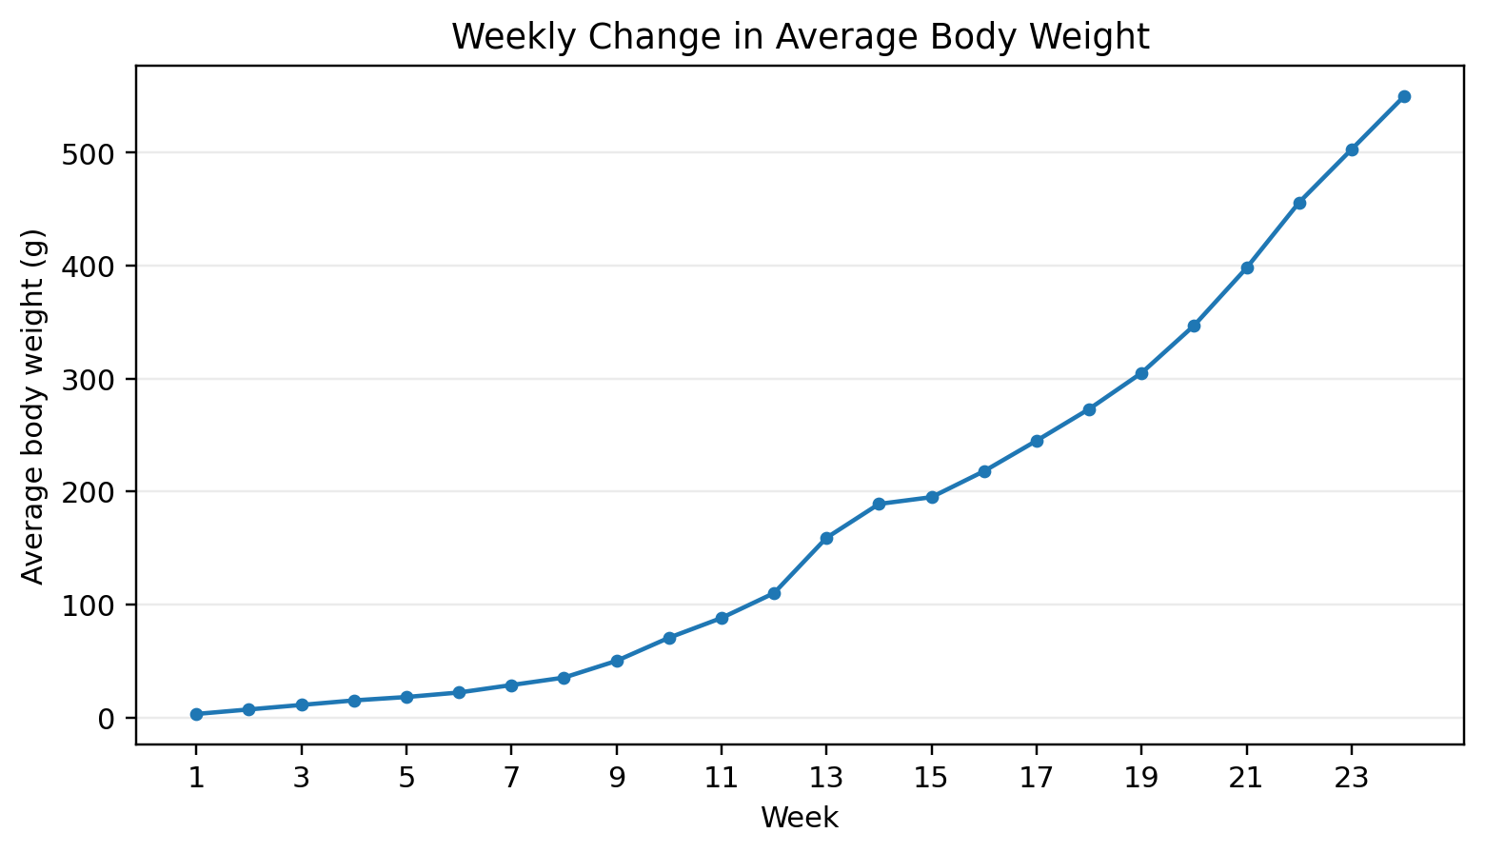
Figure 1. Weekly change in average body weight of Oreochromis niloticus

3.2 Increase in body length
Average body length also increased throughout the study. It was 1.5 cm during Week 1 and increased to 3.3 cm in Week 2, 5.5 cm in Week 3 and 7.7 cm in Week 4. The average length reached 12.4 cm in Week 8, 14.6 cm in Week 10 and 16.9 cm in Week 12. During the later weeks, the fish reached 18.1 cm in Week 13, 22.8 cm in Week 16 and 26.3 cm in Week 19. The final average length was 30.2 cm in Week 24. The overall increase in average length between the first and last observations was 28.7 cm. The weekly growth graphs show the same steady increase in weight and length over the culture period.
The length record provides a complementary description of fish development. The tabulated means show a positive change in every consecutive week, but the increments are not identical. For example, the recorded increase from Week 1 to Week 4 was 6.2 cm, while the increase from Week 21 to Week 24 was 2.2 cm. This pattern indicates that the temporal behaviour of length gain differs from that of absolute weight gain. Length and mass should therefore not be treated as interchangeable outcomes even when both increase. Figure 2 displays the continuous rise in average length across the 24 observations.
Studies of cultured Nile tilapia have used the relationship between length and body weight to investigate growth form and fish condition. Barman et al. (2023) found variation in condition-related measurements between the culture groups they examined, while Kamble et al. (2024) evaluated length–weight relationships under a dietary investigation. Those findings establish the interpretative value of paired biometric measurements, but the results are not directly comparable without considering sample composition, body-length definition and production conditions. The present means do not reveal whether every individual followed the same trajectory or whether differences in body size widened over time.
It would also be premature to classify the growth of the present fish as isometric or allometric solely from the two reported endpoint means. Such classifications ordinarily rely on fitting a weight–length relationship across appropriately paired observations and evaluating its exponent and uncertainty (Barman et al., 2023; Kamble et al., 2024). A sequence of weekly mean lengths paired with weekly mean weights does not substitute for individual fish measurements if a study seeks to infer individual-level allometry. For this reason, the current interpretation is restricted to the observed progression of average length.
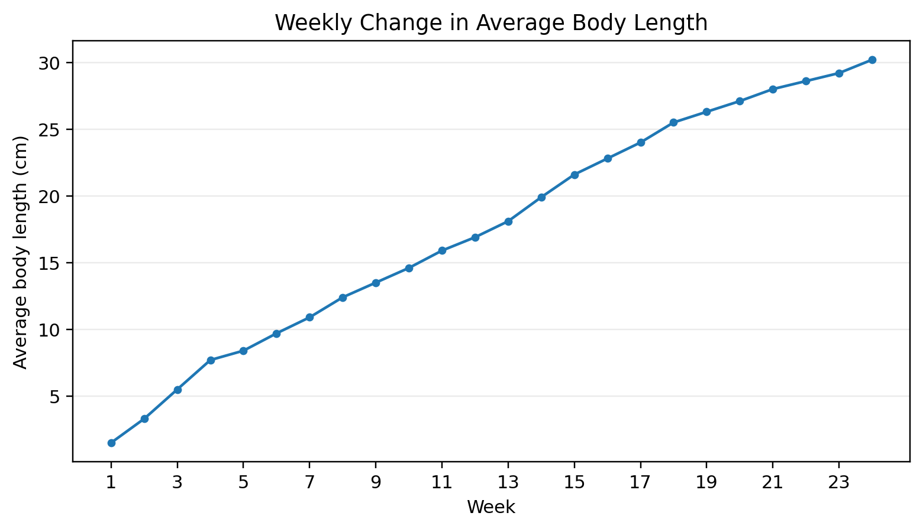
Figure 2. Weekly change in average body length of Oreochromis niloticus

3.3 Pattern of growth
The increase in body weight was relatively slow during the early stages of culture and became more rapid during the later weeks. Average weight rose from 3.0 g to 110.0 g during the first twelve weeks and from 159.0 g to 550.0 g between Weeks 13 and 24. Body length increased throughout the same period, although the weekly changes in length were more gradual than the changes in weight.
The later-week pattern can be understood as a difference between absolute changes in weight and absolute changes in length. The numerical weight gain between Weeks 20 and 24 was 203.0 g, compared with a length increase of 3.1 cm over the same observations. These values have different units and should not be compared as though they were equivalent rates. They do, however, show that a pronounced increase in mass can occur alongside smaller numerical increments in linear body dimensions. Similar attention to both characteristics is present in published tilapia biometric investigations (Barman et al., 2023; Kamble et al., 2024).
An important analytical limitation is that changes in the observed averages may be affected by the composition of fish sampled during successive weeks. The description of the study does not specify the number of fish measured at each interval, whether the same individuals were repeatedly measured or how fish were selected. If different fish were measured at different dates, some portion of the apparent trajectory could reflect sampling variation. No standard deviations, standard errors or confidence intervals accompany the means. Accordingly, the plotted lines document reported central values but do not establish the precision of those estimates or the statistical significance of consecutive differences.
The observed trend may also be influenced by characteristics that were not reported, including sex composition, size grading and the timing of maturation. Barman et al. (2023) investigated mono- and mixed-sex Nile tilapia groups and reported differences in weight-related responses under their particular cage conditions. Their findings emphasise that sex composition and culture context may matter when interpreting fish size. The present series does not provide the information needed to attribute its later-week trajectory to these mechanisms. The appropriate inference is that the measured average weight and length followed different numerical trajectories during the monitored period.

4. Discussion
The continuous increase in weight and length throughout the 24-week culture period shows that tilapia grew successfully under the pond conditions maintained during the study. Average body weight rose from 3.0 g to 550.0 g, while average length increased from 1.5 cm to 30.2 cm. No decline was recorded in either measurement during the observation period.
Tilapia is well suited to managed freshwater culture because it can adapt to different pond conditions and utilize both natural and supplementary food. Regular feeding during the present study provided an additional source of nutrition throughout the culture period. Growth depends on the availability and quality of food as well as on environmental conditions such as temperature and dissolved oxygen.
The weekly measurements also show a change in the rate at which body weight accumulated. Weight increased gradually during the first half of the study and more rapidly during the later stages. Length continued to increase during the same period, but the changes were steadier. The pattern suggests that larger fish accumulated body mass more rapidly during the later weeks of culture. Water conditions are important in maintaining fish growth. Temperature affects feeding and metabolism, while dissolved oxygen is required for respiration and normal physiological activity. The culture requirements discussed for tilapia indicate that temperatures around 25–30°C are generally favourable, while adequate dissolved oxygen and suitable pH are also necessary for sustained growth. The present observations also demonstrate the potential use of rainwater-harvesting ponds for fish culture. These ponds are normally intended for water storage, but they can support aquaculture where sufficient water remains available and basic pond management is maintained. The growth recorded over 24 weeks shows that tilapia can make productive use of such a system.
For small-scale freshwater culture, this is particularly useful because an existing rainwater-storage structure may be used for an additional productive purpose. Regular feeding, maintenance of pond water and appropriate stocking remain necessary if good growth is to be sustained.
The present outcome is compatible with the general capacity of Nile tilapia to grow under managed freshwater conditions, but successful growth should be distinguished from an experimentally demonstrated advantage of the rainwater-harvesting design. The investigation reports a single pond and does not include a separate conventional pond, reservoir or tank treatment. Consequently, it does not isolate the effect of the water-storage structure from feeding, stocking, weather or other environmental variables. Comparison with the broader aquaculture literature is useful for identifying factors that deserve monitoring, rather than for assigning a specific causal mechanism to the observed data (El-Sayed, 2002; Tran-Duy et al., 2012).
The increase in mean weight from 3.0 g to 550.0 g is a substantial descriptive result. Nevertheless, the percentage change between these two observations is sensitive to the extremely small baseline and should not be interpreted as an estimate of commercial productivity. Production per unit area or pond volume requires the number and biomass of fish harvested, as well as culture-area or water-volume information. Similarly, estimating survival requires a reliable record of initial and final fish counts. The study documents changes in fish size but does not establish yield per hectare, profitability, feed conversion or the efficiency of water use. These outcomes should remain separate in the interpretation of the findings.
The increase in length supports the conclusion that growth involved more than a change in body mass alone. However, weight–length relationships depend on biological and rearing conditions, and the relevant parameters should not be presumed identical across populations. Barman et al. (2023) reported condition-related measures for different sex compositions, and Kamble et al. (2024) examined biometric relationships in a dietary context. These studies illustrate why simultaneous measurement is informative and why condition factors require explicit assumptions and consistent biometric methods. Because the current investigation provides weekly mean values without individual-level distributions, a rigorous assessment of variation, length–weight exponent or condition factor has not been attempted.
The role of feeding warrants particular attention. Daily provision of supplementary feed is identified in the methods, but neither the feed formulation nor the amount offered, uneaten fraction or feeding adjustment is reported. El-Sayed (2002) demonstrated that the relationship between feed provision and growth is not necessarily linear across feeding levels. Thus, regular feeding may have contributed to the observed development without establishing whether the ration was nutritionally balanced or economically efficient. Future comparisons would benefit from recording feed composition, feeding frequency, daily ration, fish biomass and the manner in which feed was adjusted as the stock increased in size. Such measurements would permit stronger evaluation of husbandry than body mass alone.
Dissolved oxygen represents another plausible influence on growth that remains unmeasured in the report. Tran-Duy et al. (2012) showed that feeding responses to dissolved oxygen differ with body size, indicating that environmental constraints can change over a culture cycle. This is especially relevant to ponds subject to variable water volumes and changing weather, where conditions may differ by time of day or season. Regular recording of dissolved oxygen, water temperature and pH, ideally using consistent times and calibrated instruments, would help distinguish favourable growth under measured conditions from growth recorded in the absence of water-quality information. These recommendations concern study design and do not imply that oxygen limitation occurred in the pond.
Interpreting pond suitability also requires attention to the water balance. A rainwater-harvesting pond may experience episodic recharge and seasonal losses, and the magnitude of these changes will depend on the local catchment, pond geometry and management. The study period spans several months, but it provides no series of water depth, inflow, rainfall or evaporation observations. It is therefore not possible to determine how securely water availability was maintained throughout the cycle or whether particular periods presented management constraints. The reported completion of the culture observations is encouraging for feasibility at this site, yet replication across seasons would be needed before extending that conclusion to other rainwater-harvesting structures.
The absence of dispersion measures is a further limitation for inference. Each weekly entry is an average, without an accompanying fish count or measure of variability. A change in average size could reflect broadly similar individual trajectories or a more heterogeneous population with fast- and slow-growing fish. The two situations have different implications for grading, marketing and stock management. Repeated observations of identified fish, or appropriately randomised samples accompanied by sample size and variability, would make it possible to quantify uncertainty and evaluate whether growth differs among intervals. They would also support more robust comparison with published studies using different production systems.
The findings should be interpreted within the distinction between biological feasibility and economic feasibility. A pond may support increases in fish size while still requiring a substantial commitment to feed, labour, water monitoring and management. The manuscript does not provide the costs of inputs, pond construction or maintenance, the sale price of fish, or the quantity harvested. No claims about profitability or resource savings can therefore be derived directly from these observations. More comprehensive evaluation of such a production system would combine fish growth measurements with feed usage, survival, yield, operational costs and the reliability of seasonal water storage.
Taken together, the weekly observations provide a descriptive record of increasing mean fish size during one 24-week culture cycle. That conclusion is narrower than proof of optimal growth, causal effects of a rainwater-harvesting pond or general applicability across localities. The cited aquaculture literature identifies feeding and oxygen availability as important explanatory domains (El-Sayed, 2002; Tran-Duy et al., 2012), while biometric studies clarify the value and limitations of weight–length interpretation (Barman et al., 2023; Kamble et al., 2024). Combining these perspectives supports a cautious reading of the present data and highlights the additional measurements that would enable a controlled assessment of this culture approach.

5. Conclusion
Tilapia cultured in the rainwater-harvesting pond showed continuous growth during the 24-week study period. Average body weight increased from 3.0 g to 550.0 g, while average body length increased from 1.5 cm to 30.2 cm. Growth was slower during the early weeks and became more pronounced during the later stages of culture. The results show that tilapia can be successfully cultured in a rainwater-harvesting pond when sufficient water and regular feeding are maintained. Such ponds can be considered for small-scale freshwater fish production in places where suitable rainwater-storage structures are already available.

Declaration of AI Use

This manuscript was prepared through the intellectual contributions of the author(s) to the study design, data analysis, interpretation of results, and scholarly content. Grammarly and ChatGPT were used solely to assist with grammatical refinement and reference formatting during manuscript revision. The author(s) accept full responsibility for the accuracy, integrity, and final content of the manuscript.

COMPETING INTERESTS DISCLAIMER:
Authors have declared that they have no known competing financial interests OR non-financial interests OR personal relationships that could have appeared to influence the work reported in this paper.

References
Ballarin, J. D., and R. D. Haller. The Intensive Culture of Tilapia in Tanks, Raceways, and Cages. Westview Press, 1982.
Pullin, R. S. V. “Tilapias: Everyman’s Fish.” Biologist, vol. 32, no. 2, 1985, pp. 84–88.
Rahman, M. M. “An Economic Study of Pond Fish Culture in Some Selected Area of Mymensingh District.” MSc thesis, Bangladesh Agricultural University, Mymensingh, 1995.
Rahman, M. S. Water Quality Management in Aquaculture. BRAC Prokashana, 1992.
Sanches, L. E. F., and C. Hayashi. “Stocking Density Effect on Nile Tilapia (Oreochromis niloticus) Fry Performance during Sex Reversal.” Acta Scientiarum, vol. 21, 1999, pp. 619–625.
Wahab, M. A., Z. F. Ahmed, M. A. Islam, and S. M. Rahmatullah. “Effect of Introduction of Common Carp, Cyprinus carpio (L.), on the Pond Ecology and Growth of Fish in Polyculture.” Aquaculture Research, vol. 26, 1995, pp. 619–628.

Barman, S. K., Das, B. R., Kunda, M., Mazumder, S. K., Uddin, M. J., & Barman, P. P. (2023). Length-weight relationships and condition factors of mono- and mixed-sex Nile tilapia (Oreochromis niloticus) in open water cage culture system. Journal of Fisheries, 11(1), 111204. https://doi.org/10.17017/j.fish.431
El-Sayed, A.-F. M. (2002). Effects of stocking density and feeding levels on growth and feed efficiency of Nile tilapia (Oreochromis niloticus L.) fry. Aquaculture Research, 33(8), 621–626. https://doi.org/10.1046/j.1365-2109.2002.00700.x
Kamble, M. T., Salin, K. R., Chavan, B. R., Medhe, S. V., Thompson, K. D., & Pirarat, N. (2024). Length-weight relationship and condition factor of Nile tilapia (Oreochromis niloticus) fed diets supplemented with guava and star gooseberry leaf extract. F1000Research, 13, 540. https://doi.org/10.12688/f1000research.145369.2
Tran-Duy, A., van Dam, A. A., & Schrama, J. W. (2012). Feed intake, growth and metabolism of Nile tilapia (Oreochromis niloticus) in relation to dissolved oxygen concentration. Aquaculture Research, 43(5), 730–744. https://doi.org/10.1111/j.1365-2109.2011.02882.x

