Preparation of an Indian Grey Mongoose (Urva edwardsii) as a Museum Specimen by Taxidermy technique

Abstract
Taxidermy is a useful method for preserving animal specimens for museum display, anatomical teaching and wildlife education. This article describes the preparation of a museum mount from an Indian grey mongoose (Urva edwardsii) that died following a road accident on the campus of Assam Veterinary and Fishery University, Khanapara, Guwahati, Assam. The specimen was received by the Department of Veterinary Anatomy and Histology for educational use. The skin was carefully removed, the body dimensions were recorded, and a supporting artificial body was prepared to approximate the original form. The skin was cleaned and treated using a salt–alum solution, dried in shade, fitted over the artificial body, and secured with internal wire supports. The head, limbs, tail, ears and eyes were positioned as well as finished to obtain a recognizable external appearance. The case illustrates the practical stages involved in preparing a road-killed mammal for a teaching collection. Because the species is protected and because some traditional preservatives are hazardous, such work should be undertaken only with the required legal authorization and appropriate chemical-safety procedures. The resulting specimen can support instruction in mammalian external morphology and museum-based wildlife education.
Keywords: Indian grey mongoose, taxidermy, museum specimen, wildlife education
Introduction:
The Indian grey mongoose, also known as the Asian grey mongoose, is an omnivorous mammal distributed across parts of the Indian subcontinent and western Asia. It occupies a range of habitats, including scrubland, open woodland and cultivated landscapes, and may occur near human settlements. Its diet is varied and can include rodents, reptiles, birds, insects and other small animals (Macdonald, 2009; Mudappa & Choudhury, 2024). Although the species is assessed as Least Concern globally and Scheduled-II as per the wild life protection Act, 1972, this status does not mean that individual animals are free from local threats. Illegal exploitation for mongoose hair has been reported in India, particularly for the manufacture of brushes. The use of specimens in educational collections should therefore be based on lawful, documented sources and should never create demand for animals killed for display (Mudappa & Choudhury, 2024). Taxidermy is the preservation and reconstruction of an animal’s external form by preparing the skin and arranging it over a supporting body or mannequin. Properly prepared museum specimens can support the teaching of external morphology, comparative anatomy, species recognition and public understanding of biodiversity. This research article records the preparation of a single Indian grey mongoose that died in a road accident on the university campus. The purpose is to describe the principal stages and educational value of preparing this opportunistically obtained specimen.
Biological collections are important repositories of physical evidence that can be revisited when taxonomic interpretations, teaching priorities or research questions change. Their value rests not only in preserving visible characteristics but also in linking specimens to reliable contextual information such as identification, geographical origin, date and circumstances of acquisition. Suarez and Tsutsui (2004) described the diverse scientific and societal contributions of museum collections, while Bradley et al. (2014) emphasised that specimens and their associated records require sustained curatorial care. In this context, the preparation of an opportunistically recovered mongoose can contribute to a local teaching collection provided that the material is appropriately documented and maintained.
The educational usefulness of physical specimens is distinct from, although complementary to, that of photographs and digital records. A three-dimensional mount permits learners to examine relative dimensions, body configuration, pelage distribution and the orientation of external structures from different viewpoints. Natural history collections can therefore support observation-based learning and the development of questions about biodiversity and morphology. Suarez and Tsutsui (2004), Bradley et al. (2014) and McLean et al. (2016) collectively establish the relevance of well-curated biological specimens to research and teaching. However, the extent of any teaching benefit depends on how the specimen is interpreted and used; no learning outcomes were measured in the present case.
An important consideration in acquiring mammalian specimens is that a single opportunistically collected animal may provide a permanent teaching resource without requiring the deliberate killing of an additional animal. The broader literature nevertheless cautions that the scientific value of specimens depends on their provenance, appropriate deposition and continued accessibility (McLean et al., 2016; Salvador & Cunha, 2020). A prepared mount is not interchangeable with a complete anatomical voucher because skinning and reconstruction may limit access to internal structures. The present report consequently focuses on external morphology and the recorded steps of preparation, rather than claiming to establish a comprehensive anatomical reference or a validated preservation method.
Materials and Methods:
The completed specimen provided an observable three-dimensional representation of the characteristic general body outline, including the elongated trunk, comparatively short limbs, tapering head region and extended tail. These features are described qualitatively from the finished mount and should not be interpreted as standardised morphometric measurements. The photographs document the transition from the recovered carcass to the separated skin, the supporting form and the completed display specimen (Figs. 1–4). The figures therefore provide a visual sequence of preparation rather than independent evidence of treatment efficacy.
The principal outcome of this single-specimen preparation was the production of an educational mount, not a controlled comparison of taxidermy methods. The original record does not provide replicate specimens, measured preservation performance, a learner assessment or long-term condition monitoring. Accordingly, no conclusion can be drawn regarding the relative efficacy of the salt–alum treatment, the longevity of the mount or its superiority to other preparation approaches. Literature on the curation and research uses of natural history specimens indicates why consistent records and continuing care would be important if this mount is maintained as part of a permanent collection (Bradley et al., 2014; McLean et al., 2016; Salvador & Cunha, 2020).
From an educational perspective, the value of the mount lies primarily in the opportunity for guided, repeated observation of the external morphology of a relatively small carnivorous mammal. Learners may compare the displayed head, ears, trunk, limbs and tail with descriptions in zoological teaching materials and may use the preserved form to discuss species identification and adaptive external features. Museum objects are particularly useful when students can examine physical relationships among structures that are less immediately apparent in two-dimensional images. Suarez and Tsutsui (2004) recognised the broader societal importance of biological collections, and Bradley et al. (2014) identified their continuing contribution to education and research. These general findings support the rationale for maintaining such a mount, but they do not demonstrate that this particular specimen has improved student performance.
An additional consideration is the difference between visual fidelity and anatomical fidelity. Taxidermy reconstructs the external appearance of an animal after removal of internal tissues, whereas an osteological preparation, fluid-preserved specimen or anatomical dissection may preserve different types of information. In the current case, the artificial body and wire supports were intended to reproduce overall proportions and the desired posture. The position of a reconstructed limb or contour is consequently influenced by the preparation process, and students should be informed that a finished mount is an interpreted representation rather than an untouched biological specimen. Research on mammalian museum collections highlights the importance of selecting specimen types according to the questions being investigated (McLean et al., 2016). Thus, the mongoose mount is most appropriately used as a supplementary resource for visible morphology, rather than for detailed investigation of internal anatomy.
Documentation is central to the lasting academic value of the preparation. A specimen accession record would ideally accompany the mount, retaining the species identification, locality, recovery circumstances, preparation date, treatment history, responsible personnel and the original images. Such information facilitates interpretation, future conservation decisions and possible comparison with other mammalian holdings. Bradley et al. (2014) linked long-term collection value to curatorial investment, while Salvador and Cunha (2020) called attention to the continuing need for deposition and maintenance of specimen-based evidence. The present report establishes the reported recovery setting and principal preparation steps; however, it does not document a catalogue identifier or systematic condition-checking programme. These features would be relevant to future collection management but should not be assumed to have been implemented.
The use of an animal recovered after accidental mortality also warrants a carefully qualified conservation interpretation. Salvage avoids procuring a new animal specifically for mounting, but the circumstances of a single road casualty do not establish the frequency of traffic-related mortality for the species or the conservation status of the local population. A single specimen cannot support inferences about population size, habitat preference or overall risk. Biological collections can contribute to broader ecological and conservation questions when records are sufficiently detailed and systematically integrated (Suarez & Tsutsui, 2004; McLean et al., 2016). The present case is better viewed as an example of educational reuse of already deceased wildlife, subject to applicable authorisations and institutional procedures, than as evidence for a wider population-level trend.
The preparation method raises a distinct issue concerning chemical hazards and subsequent handling. The original procedure recorded the use of arsenical soap, and the study did not undertake analytical testing for residual arsenic or other preservative compounds in the completed mount. Therefore, the absence of visible surface contamination cannot be taken as evidence of safe unprotected handling. The specimen should be managed in accordance with institutional hazardous-collection guidance, including appropriate assessment before direct student contact. Preservation practices also require attention to potential mechanical damage, deterioration and environmental conditions during storage and display. Bradley et al. (2014) discussed long-term curatorial responsibilities, and Salvador and Cunha (2020) highlighted the vulnerability of collections when stewardship is inadequate. Neither of these studies validates the chemical treatment used in this individual preparation; the current account is descriptive and should not be interpreted as a safety or efficacy trial.
The limitations of this report follow directly from its case-study design. It describes one road-killed animal and records a preparation sequence that culminated in a recognisable mounted specimen. There was no comparison group, no repeated treatment application across specimens, no quantitative assessment of shrinkage, pest resistance or colour stability, and no formal evaluation of teaching outcomes. Consequently, any claims about technical performance should remain restricted to the immediate visible result. The broader scholarship on museum collections demonstrates the potential of well-documented preserved specimens for scientific and educational activities (Bradley et al., 2014; McLean et al., 2016; Salvador & Cunha, 2020), but that potential does not constitute measured evidence of the long-term success of the present mount. Future observational documentation could record condition over time and clarify how the specimen is used in practical classes without changing the descriptive conclusions reported here.
One Indian grey mongoose that had died following a road accident in the campus of Assam Veterinary and Fishery University, Khanapara, Guwahati, Assam, was brought to the Department of Veterinary Anatomy and Histology for preparation as a teaching specimen. No animal was killed for the purpose of this work. The materials recorded for the procedure included 11 Number size BP blades and 3 number size BP handles, rat-toothed forceps, cotton, needles and thread, wire, black beads for the eyes, plywood for the display base, an artificial-body material (styra foam and wood wool), adhesive, plaster of Paris, abrasive paper, brushes and measuring equipment. The original notes also list salt, alum, turpentine oil, formalin and arsenical soap (arsenic oxide/trioxide/pentaoxide-100gm, soap jelly-800gm, camphor-25gm, Borax-50gmand turpentine oil-12cc). Arsenical soap and formalin present significant health and environmental hazards; their use should not be reproduced as a routine recommendation. A mid-ventral incision was made from the shoulder region towards the stifle region, and the skin was separated carefully from the underlying tissues. Particular care was taken around the ears, eyes and nose to avoid the tearing of delicate skin. The skin was removed from the body, and muscle was cleared from the distal portions of the limbs. The brain as well as eye ball were removed during preparation of the head. The dimensions of the body were recorded before an artificial body was shaped to approximate the original proportions. The original procedure notes describe immersion of the skin in a solution containing two liters of water, 75 g of salt and 50 g of alum for three days, followed by rinsing and shade-drying. As the suitability of this treatment depends on the skin condition, local practice and conservation requirements, it should be regarded as the procedure recorded for this specimen rather than a validated universal protocol. After drying the skin was painted by Arsenic soap. An artificial body was shaped using styra foam and wood wool and adjusted according to the recorded measurements. Wire supports were placed to maintain the position of the limbs and tail, and the head was connected to the supporting body. The prepared skin was positioned over the form and stitched with thread. Cotton was used where needed to fill small spaces, and black beads were used to represent the eyes. The ears, limbs and tail were arranged to produce a natural-looking posture. The mount was secured to a plywood base, and the surface was finished to improve its appearance.
Results & Discussion
A mounted specimen of the Indian grey mongoose (Fig.4) was prepared from an animal that had died following a road accident (Fig.1). The principal stages recorded were skin removal, cleaning and treatment of the skin, measurement and preparation of an artificial body (Fig.2 &3), insertion of supporting wires, positioning of the head and limbs, stitching of the skin, and mounting on a display base. Attention to the skin around the ears, eyes and nose was important because these areas are delicate and contribute strongly to species recognition. The prepared mount retained the recognizable external form of the animal and was suitable for use as a teaching and display specimen. No quantitative assessment of durability, colour retention or long-term preservation was undertaken.
This case documents the preparation of a single Indian grey mongoose for a teaching collection using an animal that had died accidentally. Museum mounts can provide students with a stable three-dimensional reference for examining body proportions, pelage, limb arrangement, head shape and other external features that may be difficult to appreciate from photographs alone. Such specimens can complement, but do not replace, examination of living animals, skeletal material, anatomical models and current field-identification resources. The choice of a naturally deceased specimen is important from a conservation perspective. The Indian grey mongoose is assessed as Least Concern at the global level and schedule- II animal ae per the wildlife protection Act,1972, but it has been affected by illegal harvesting for its hair. Consequently, educational taxidermy should be based on incidental mortality or other lawful sources and supported by clear records of origin; it should not encourage collection or killing for commercial display (Mudappa & Choudhury, 2024). The reported use of the species in human settings and its varied diet are part of its natural history, but these facts alone do not justify keeping or trading wild individuals (Macdonald, 2009). The procedure also highlights the importance of accurate measurements and a well-proportioned artificial body. If the form is too large or too small, the skin may be stretched, wrinkled or poorly aligned, particularly around the limbs, face and tail. Careful handling during skinning and mounting is therefore essential to preserve external characters. These observations are consistent with the broader purpose of museum specimens as durable reference materials for teaching and documentation, although the present case did not compare alternative tanning or mounting techniques
Conclusion
An Indian grey mongoose that died following a road accident was prepared as a museum mount for educational use. The process involved careful skin removal, recording of body dimensions, preparation of an artificial form, positioning and stitching of the skin, and mounting on a base. The specimen can support teaching of mammalian external morphology and wildlife awareness.

Declaration of AI Use

This manuscript was prepared through the intellectual contributions of the author(s) to the study design, data analysis, interpretation of results, and scholarly content. Grammarly and ChatGPT were used solely to assist with grammatical refinement and reference formatting during manuscript revision. The author(s) accept full responsibility for the accuracy, integrity, and final content of the manuscript.

COMPETING INTERESTS DISCLAIMER:
Authors have declared that they have no known competing financial interests OR non-financial interests OR personal relationships that could have appeared to influence the work reported in this paper.

References
Macdonald, D. (Ed.). (2009). The encyclopedia of mammals (2nd ed.). Oxford University Press.
Mudappa, D., & Choudhury, A. U. (2024). Urva edwardsii. The IUCN Red List of Threatened Species, 2024, e.T41611A259345602. https://doi.org/10.2305/IUCN.UK.2024-2.RLTS.T41611A259345602.en
Bradley, R. D., Bradley, L. C., Garner, H. J., & Baker, R. J. (2014). Assessing the value of natural history collections and addressing issues regarding long-term growth and care. BioScience, 64(12), 1150–1158. https://doi.org/10.1093/biosci/biu166
McLean, B. S., Bell, K. C., Dunnum, J. L., Abrahamson, B., Colella, J. P., Deardorff, E. R., Weber, J. A., Jones, A. K., Salazar-Miralles, F., & Cook, J. A. (2016). Natural history collections-based research: Progress, promise, and best practices. Journal of Mammalogy, 97(1), 287–297. https://doi.org/10.1093/jmammal/gyv178
Salvador, R. B., & Cunha, C. M. (2020). Natural history collections and the future legacy of ecological research. Oecologia, 192(3), 641–646. https://doi.org/10.1007/s00442-020-04620-0
Suarez, A. V., & Tsutsui, N. D. (2004). The value of museum collections for research and society. BioScience, 54(1), 66–74. https://doi.org/10.1641/0006-3568(2004)054[0066:TVOMCF]2.0.CO;2

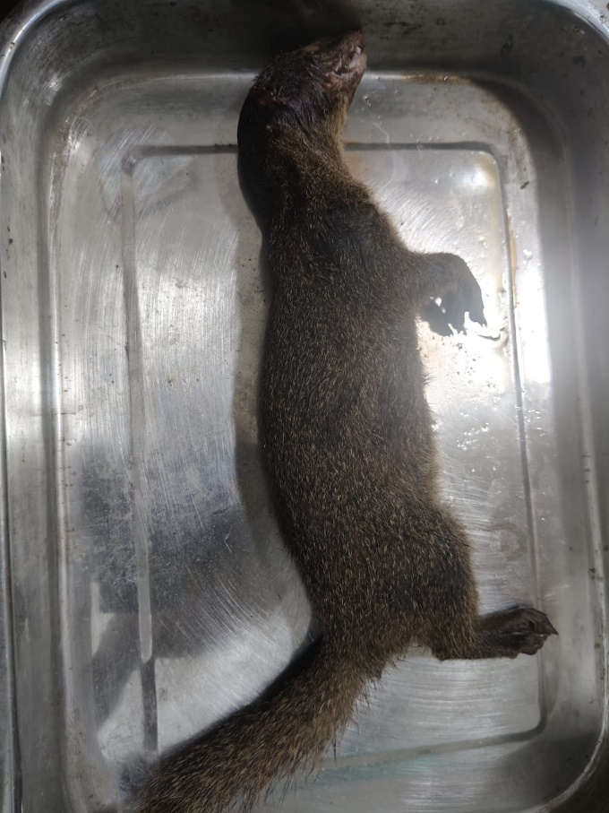
Fig.1. Photograph showing the Indian Grey Mongoose (Urva edwardsii) which was found in road Accident inside the campus of AVFU and presented in table for remove of skin.

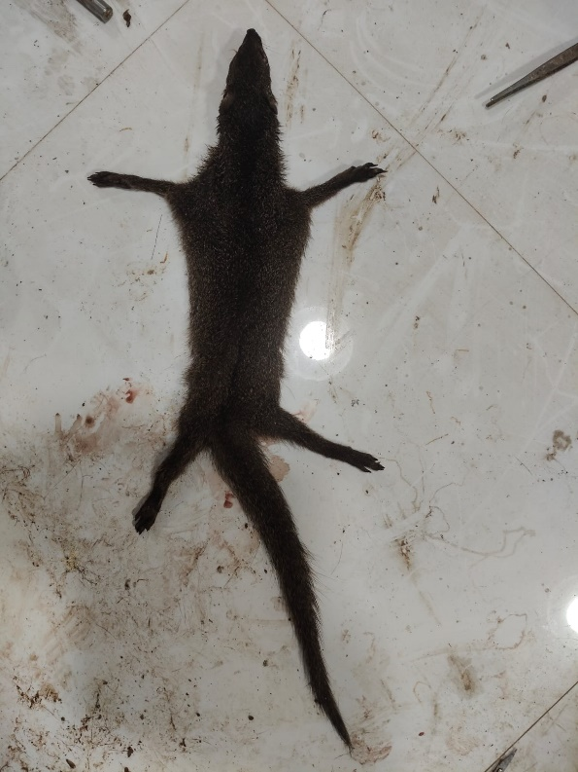
Fig.2. Photograph showing the skin of Indian Grey Mongoose (Urva edwardsii) .

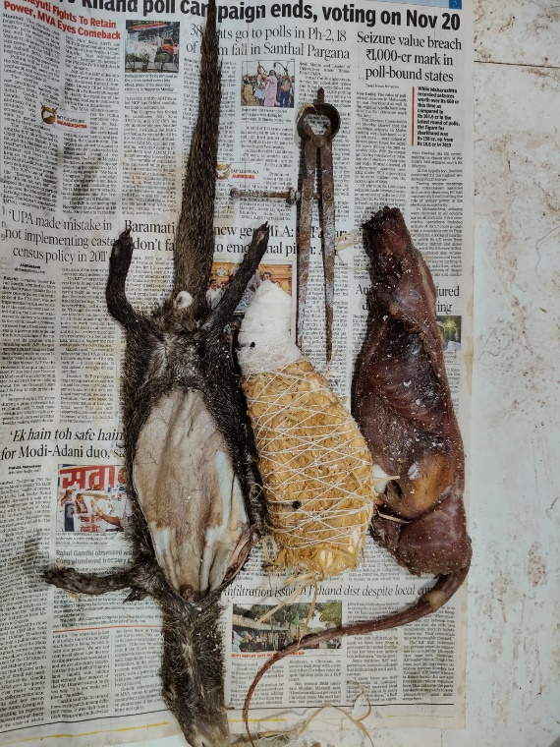
Fig.3. Photograph showing the skin, duplicate body and original body of Indian Grey Mongoose (Urva edwardsii) and campus for measurement of body of animal.

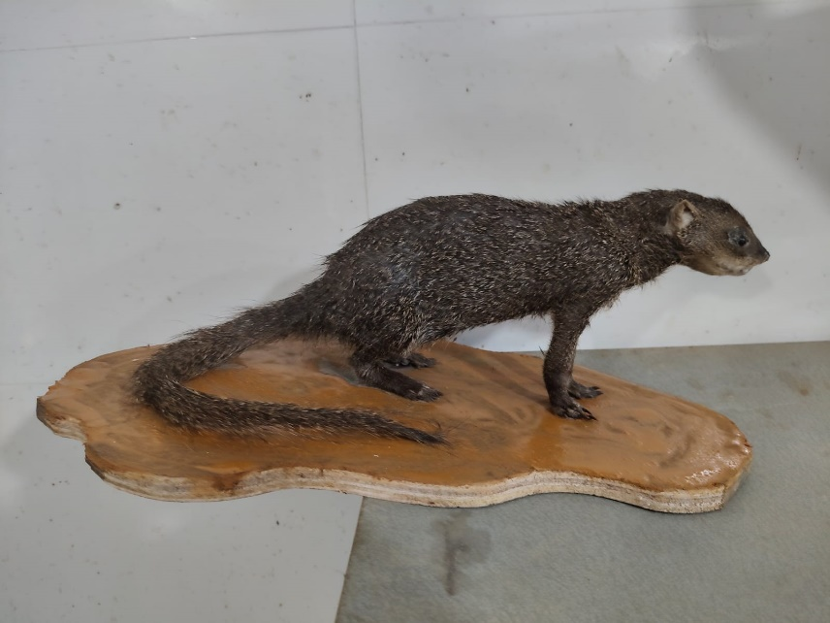
Fig.4. Photograph showing the Indian Grey Mongoose (Urva edwardsii) which can be displayed in museum for study of taxidermy.

