Investigating Hypoglycaemic and Hypolipidaemic Effects of Combined Rind Extracts of Cucumis Sativus and Citrullus Lanatus on Alloxan-induced Diabetic Wistar Rats

.
ABSTRACT
This study comparatively investigated the hypoglycaemic and hypolipidaemic effects of methanolic rind extracts of Cucumis sativus and Citrullus lanatus, administered individually and in combination, in alloxan-induced diabetic Wistar rats. Thirty male Wistar rats were used, and diabetes was induced with alloxan monohydrate (150 mg/kg). Diabetic rats were treated orally for 21 days with C. sativus (200 mg/kg), C. lanatus (200 mg/kg), their combination (100 mg/kg each), or metformin (500 mg/kg). Fasting blood glucose and serum lipid parameters were determined, while qualitative phytochemical screening was also performed. The extracts contained alkaloids, flavonoids, tannins, saponins, phenols and terpenoids. Treatment with both extracts progressively reduced fasting blood glucose, total cholesterol, LDL-cholesterol and triglycerides, while increasing HDL-cholesterol compared with the diabetic control. The combined extract produced greater improvements than the individual extracts, although metformin generally produced the greatest overall response. The findings indicate that C. sativus and C. lanatus rind extracts possess hypoglycaemic and hypolipidaemic activities and may have potential as complementary plant-based interventions for diabetes-associated metabolic disturbances. Further studies are recommended to identify and quantify the active phytochemicals, establish the mechanisms underlying the observed effects, and evaluate the long-term safety and efficacy of the combined extracts.

Keywords: Cucumis sativus; Citrullus lanatus; rind extracts; hypoglycaemic; hypolipidaemic ; diabetes mellitus; fasting blood glucose; lipid profile; Wistar rats; phytochemicals.

1. INTRODUCTION

Diabetes mellitus is a chronic metabolic disorder characterised by persistent hyperglycaemia resulting from impaired insulin secretion, insulin action, or both. Disturbances in lipid metabolism commonly accompany diabetes and may result in elevated serum cholesterol, triglycerides, and low-density lipoprotein cholesterol, thereby increasing the risk of cardiovascular complications (Dilworth et al., 2021; Jadon et al., 2024).

Plant materials contain diverse bioactive compounds capable of influencing glucose and lipid metabolism through antioxidant, enzyme-modulating, and insulin-related mechanisms (Atta et al., 2020; Ansari et al., 2024; Singh et al., 2026). Increasing attention is therefore being given to fruit by-products, particularly rinds, which are often discarded despite their potential therapeutic value. The rinds of Cucumis sativus and Citrullus lanatus have attracted interest because of their reported biological activities and their potential application in the management of metabolic disorders (Owo & Beresford, 2020; Javid et al., 2024; Idemudia & Enogieru, 2024).

Studies on C. sativus rind have reported potential antihyperglycaemic and lipid-modulating activities (Abbas et al., 2025; Dimeji et al., 2021). Extracts of the rind have been shown to contain phenolic and flavonoid compounds that may contribute to reductions in blood glucose through antioxidant activity and modulation of carbohydrate-metabolising pathways (Tasleem et al., 2026). Experimental evidence also suggests that cucumber rind preparations may improve lipid abnormalities by reducing circulating cholesterol and triglycerides while favourably influencing lipoprotein metabolism (Dimeji et al., 2021; Ilyas et al., 2025). These findings indicate that the rind, rather than being merely a waste material, may possess bioactive constituents with potential value in diabetes management (Kaur et al., 2026; Khalid et al., 2026).

Citrullus lanatus rind has likewise been investigated for its potential metabolic benefits. Experimental studies have reported reductions in blood glucose following administration of watermelon rind extracts in diabetic animal models (Adewumi et al., 2023; Mehreen et al., 2024). The hypoglycaemic activity has been associated with the presence of phenolic compounds, flavonoids, and other antioxidant constituents that may help attenuate oxidative stress and improve glucose utilisation (Rezq, 2017; Ajiboye et al., 2020). Watermelon rind extracts have also demonstrated potential hypolipidaemic effects, including reductions in serum total cholesterol and triglycerides and improvement of lipid-related parameters (Abu-Hiamed, 2018). However, the available evidence remains less extensive than that for conventional antidiabetic plant preparations.

Diabetes-associated hyperglycaemia and dyslipidaemia remain important therapeutic challenges (Zhao et al., 2026). Although preliminary studies indicate that C. sativus and C. lanatus rinds may possess hypoglycaemic and hypolipidaemic properties, comparative evidence regarding their effectiveness is limited. In addition, the potential advantage of combining the two rind extracts has not been adequately established. This creates a need for controlled experimental studies comparing their individual and combined effects in diabetic models. It is on this basis that this study aims to comparatively evaluate the hypoglycaemic and hypolipidaemic effects of methanolic rind extracts of C. sativus and C. lanatus, administered individually and in combination, in alloxan-induced diabetic Wistar rats.

2. Materials and methods

2.1 Sample Collection and Identification
Fresh Cucumis sativus and Citrullus lanatus fruits were purchased from Oil-Mill Market, Port Harcourt, Nigeria. The plants were authenticated by Professor Bio Louis Nyananyo, Department of Plant Science and Biotechnology, University of Port Harcourt. Voucher specimens were deposited in the departmental herbarium as UPH/V/1322 (C. sativus) and UPH/V/1323 (C. lanatus).
2.2 Preparation of Methanolic Extracts
The fruit rinds were separated, washed, air-dried for two weeks, and pulverised. Two hundred grams (200 g) of each powdered rind was macerated separately in 1.5 L of 80% methanol for 72 h with occasional stirring. The mixtures were filtered and concentrated at 40°C using a rotary evaporator. The resulting extracts weighed 2.0 g (C. sativus) and 1.8 g (C. lanatus) and were stored at 4°C.
2.3 Phytochemical Screening
Qualitative phytochemical screening was conducted using methods described by Harborne and Baxter (1983), Trease and Evans (1989), and Adekanmi et al. (2020). Alkaloids, flavonoids, tannins, saponins, phenols, and terpenoids were screened.
2.4 Experimental Animals
Thirty male Wistar rats weighing 150–200 g were used. The animals were acclimatised for one week under standard laboratory conditions with free access to feed and water. Ethical approval was obtained from the Research Ethics Committee, Faculty of Basic Medical Sciences, Rivers State University. Animal handling followed accepted guidelines for laboratory animal care and use.
2.5 Induction of Diabetes
Diabetes was induced by intraperitoneal administration of alloxan monohydrate (150 mg/kg body weight). After 72 h, fasting blood glucose was measured, and rats with glucose levels ≥200 mg/dL were considered diabetic and included in the study.
2.6 Acute Toxicity Study
Acute toxicity was evaluated using the method described by Lorke (1983). Twenty-four (24) rats were randomly assigned to six groups of four animals each. Groups I–V received the respective extracts at doses of 1000, 2000, 3000, 4000, and 5000 mg/kg body weight, respectively, while the control group received distilled water. The animals were observed for signs of toxicity and mortality over 14 days. The median lethal dose (LD₅₀) was estimated from the observed dose–mortality relationship.
2.7 Experimental Design
Diabetic rats were randomly assigned to six groups (n = 5):
Group 1: Normal control.
Group 2: Diabetic untreated control.
Group 3: Diabetic + C. sativus rind extract (200 mg/kg).
Group 4: Diabetic + C. lanatus rind extract (200 mg/kg).
Group 5: Diabetic + combined C. sativus and C. lanatus rind extracts (100 mg/kg each).
Group 6: Diabetic + metformin (500 mg/kg).
Treatments were administered orally once daily for 21 days using an orogastric tube.
2.8 Biochemical Analyses
2.8.1 Blood Collection
At the end of treatment, following an overnight fast, blood was collected under light anaesthesia by cardiac puncture. Blood for glucose measurement was obtained from the tail vein.
2.8.2 Blood Glucose Measurement
Fasting blood glucose was measured from tail-vein blood using a glucometer on days 0, 7, 14, and 21.
2.8.3 Determination of Serum Lipid Profile
Serum total cholesterol, triglycerides, HDL-cholesterol, and LDL-cholesterol were determined using Randox diagnostic kits (Randox Laboratories, UK) according to the manufacturer's instructions.
2.9 Statistical Analysis
Data were expressed as mean ± SEM. Differences among groups were analysed using one-way ANOVA, followed by Tukey's multiple comparison test. Statistical significance was set at p < 0.05. Analysis was performed using SPSS version 27.

3. Results

3.1. Phytochemical Composition of Extracts

Table 1 shows the qualitative phytochemical constituents present in the methanolic extracts of C. sativus and C. lanatus. The extracts tested positive for alkaloids, flavonoids, tannins, saponins, phenols, and terpenoids.

Table 1: Qualitative Phytochemical Constituents
Phytochemical | C. sativus | C. lanatus
Alkaloids | + | +
Flavonoids | +++ | ++
Tannins | ++ | ++
Saponins | +++ | ++
Phenols | ++ | +++
Terpenoids | + | +
(+ = low, ++ = moderate, +++ = high presence)

3.2 Effects of Extracts on Fasting Blood Glucose Levels

Table 2 and Figure 1 reveal the fasting blood glucose levels of the experimental groups during the 21-day treatment period. The normal control maintained stable glucose levels, while the diabetic control showed sustained hyperglycaemia throughout the study (p < 0.05). Treatment with C. sativus and C. lanatus rind extracts reduced fasting blood glucose levels, with greater reduction observed with the combined extract (5.44 ± 0.11 mmol/L) than the individual extracts (6.22 ± 0.07 and 6.61 ± 0.09 mmol/L, respectively) by day 21. Metformin produced the greatest reduction (5.00 ± 0.08 mmol/L).

Table 2: Fasting Blood Glucose Levels (mmol/L)
Group | Post-induction (Day 0) | Day 7 | Day 14 | Day 21
Normal Control | 4.72 ± 0.19ᵃ | 4.83 ± 0.19ᵃ | 4.67 ± 0.17ᵃ | 4.78 ± 0.17ᵃ
Diabetic Control | 14.56 ± 0.12ᵇ | 15.00 ± 0.10ᵇ | 15.33 ± 0.07ᵇ | 15.67 ± 0.09ᵇ
C. sativus (200 mg/kg) | 14.61 ± 0.08ᵇ | 11.00 ± 0.07ᶜ | 8.11 ± 0.06ᶜ | 6.22 ± 0.07ᶜ
C. lanatus (200 mg/kg) | 14.72 ± 0.09ᵇ | 11.28 ± 0.12ᶜ | 8.56 ± 0.08ᶜ | 6.61 ± 0.09ᶜ
Combined Extract (100 mg/kg each) | 14.50 ± 0.14ᵇ | 10.22 ± 0.11ᶜ | 7.33 ± 0.09ᵈ | 5.44 ± 0.11ᵈ
Metformin (200 mg/kg) | 14.67 ± 0.21ᵇ | 9.72 ± 0.18ᶜ | 6.67 ± 0.14ᵈ | 5.00 ± 0.08ᵉ
Values are expressed as mean ± SEM (n = 6). Means within the same column with different superscript letters (a–e) are significantly different at p < 0.05, as determined by one-way ANOVA followed by Tukey’s HSD post hoc test.
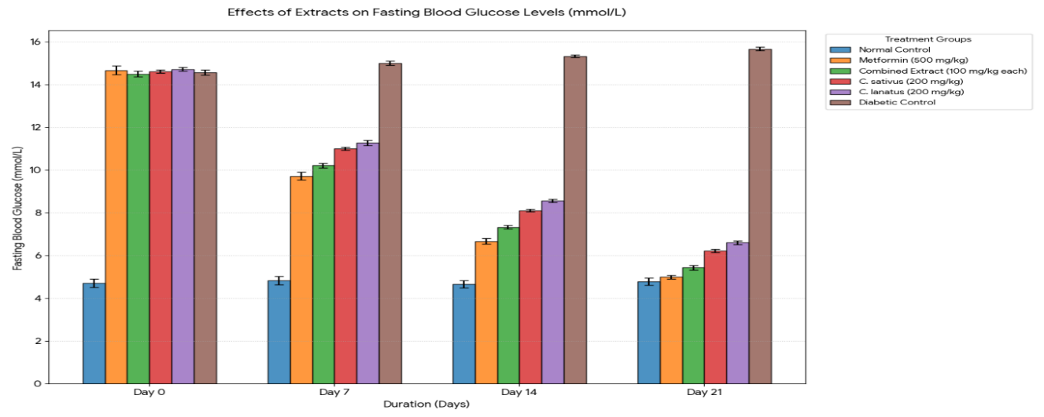
Figure 1: Fasting blood glucose levels
3.3 Effects of Extracts on Serum Lipid Profile
3.3.1 Effects of Extracts on Serum Total Cholesterol Levels
Table 3 and Figure 2 present the effects of C. sativus, C. lanatus, and their combined extract on total cholesterol levels across the experimental groups over 21 days. The results indicate that the normal control group maintained relatively stable total cholesterol levels throughout the study period, with only minor physiological fluctuations (2.85–2.93 mmol/L), confirming metabolic homeostasis. In contrast, the diabetic control group showed a progressive increase from Day 0 (4.66 mmol/L) to Day 21 (4.82 mmol/L), reflecting worsening hypercholesterolaemia. This group remained significantly higher (p < 0.05) than the normal control across all time points.
Treatment with C. sativus and C. lanatus extracts resulted in a time-dependent reduction in total cholesterol. By Day 21, values decreased to 3.60 mmol/L and 3.68 mmol/L, respectively, both significantly lower than the diabetic control (p < 0.05). The combined extract demonstrated enhanced efficacy, reducing cholesterol to 3.32 mmol/L by Day 21, indicating a stronger hypocholesterolemic effect than the individual extracts. The metformin-treated group exhibited the greatest reduction, reaching 3.13 mmol/L at Day 21, which was significantly different from all other groups (p < 0.05), highlighting its superior therapeutic performance.

Table.3: Effects of Extracts on Total Cholesterol (mmol/L)
Group | Post-induction (Day 0) | Day 7 | Day 14 | Day 21
Normal Control | 2.85 ± 0.08ᵃ | 2.87 ± 0.08ᵃ | 2.93 ± 0.08ᵃ | 2.90 ± 0.08ᵃ
Diabetic Control | 4.66 ± 0.11ᵇ | 4.74 ± 0.11ᵇ | 4.79 ± 0.11ᵇ | 4.82 ± 0.11ᵇ
C. sativus | 4.64 ± 0.10ᵇ | 4.14 ± 0.10ᶜ | 3.76 ± 0.09ᶜ | 3.60 ± 0.09ᶜ
C. lanatus | 4.66 ± 0.10ᵇ | 4.22 ± 0.09ᶜ | 3.81 ± 0.09ᶜ | 3.68 ± 0.09ᶜ
Combined Extract | 4.69 ± 0.10ᵇ | 4.01 ± 0.09ᶜ | 3.50 ± 0.08ᵈ | 3.32 ± 0.08ᵈ
Metformin | 4.66 ± 0.09ᵇ | 3.89 ± 0.08ᶜ | 3.37 ± 0.07ᵈ | 3.13 ± 0.06ᵉ
Values are expressed as mean ± SEM (n = 6). Means within the same column with different superscript letters (a–e) are significantly different at p < 0.05, as determined by one-way analysis of variance (ANOVA) followed by Tukey’s Honestly Significant Difference (HSD) post hoc test.

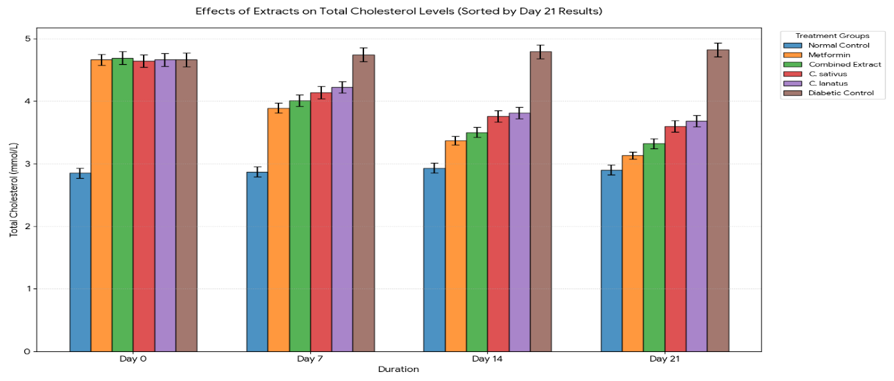
Figure 2. Mean total cholesterol
3.3.2 Effects of Extracts on Serum High-Density Lipoprotein (HDL)

Table 4 and Figure 3 indicate the changes in high-density lipoprotein (HDL) levels in normal, diabetic, and treated groups during the study duration. The normal control group maintained stable HDL levels (1.45–1.53 mmol/L), indicative of normal lipid metabolism. The diabetic control group showed a decline in HDL from 0.98 mmol/L at Day 0 to 0.91 mmol/L at Day 21, confirming impaired lipid regulation. These values were significantly lower than the normal control (p < 0.05).
Administration of rind extracts of C. sativus and C. lanatus resulted in progressive increases in HDL levels, reaching 1.24 mmol/L and 1.22 mmol/L, respectively, by Day 21. These increases were significant compared to the diabetic control (p < 0.05). The combined extract produced a more pronounced elevation (1.35 mmol/L), suggesting a synergistic enhancement of HDL restoration. The metformin group recorded the highest HDL level (1.40 mmol/L) at Day 21, significantly higher than all other groups (p < 0.05), reinforcing its efficacy in improving lipid profiles.

Table 4: High-Density Lipoprotein (HDL) (mmol/L)
Group | Post-induction (Day 0) | Day 7 | Day 14 | Day 21
Normal Control | 1.48 ± 0.05ᵃ | 1.50 ± 0.05ᵃ | 1.45 ± 0.05ᵃ | 1.53 ± 0.05ᵃ
Diabetic Control | 0.98 ± 0.06ᵇ | 0.93 ± 0.06ᵇ | 0.91 ± 0.06ᵇ | 0.91 ± 0.06ᵇ
C. sativus | 0.96 ± 0.06ᵇ | 1.09 ± 0.05ᶜ | 1.19 ± 0.05ᶜ | 1.24 ± 0.05ᶜ
C. lanatus | 0.96 ± 0.06ᵇ | 1.06 ± 0.06ᶜ | 1.17 ± 0.05ᶜ | 1.22 ± 0.05ᶜ
Combined Extract | 0.93 ± 0.06ᵇ | 1.14 ± 0.05ᶜ | 1.30 ± 0.05ᵈ | 1.35 ± 0.05ᵈ
Metformin | 0.96 ± 0.05ᵇ | 1.19 ± 0.05ᶜ | 1.35 ± 0.05ᵈ | 1.40 ± 0.04ᵉ
Values are expressed as mean ± SEM (n = 6). Means within the same column with different superscript letters (a–e) are significantly different at p < 0.05, as determined by one-way analysis of variance (ANOVA) followed by Tukey’s Honestly Significant Difference (HSD) post hoc test.
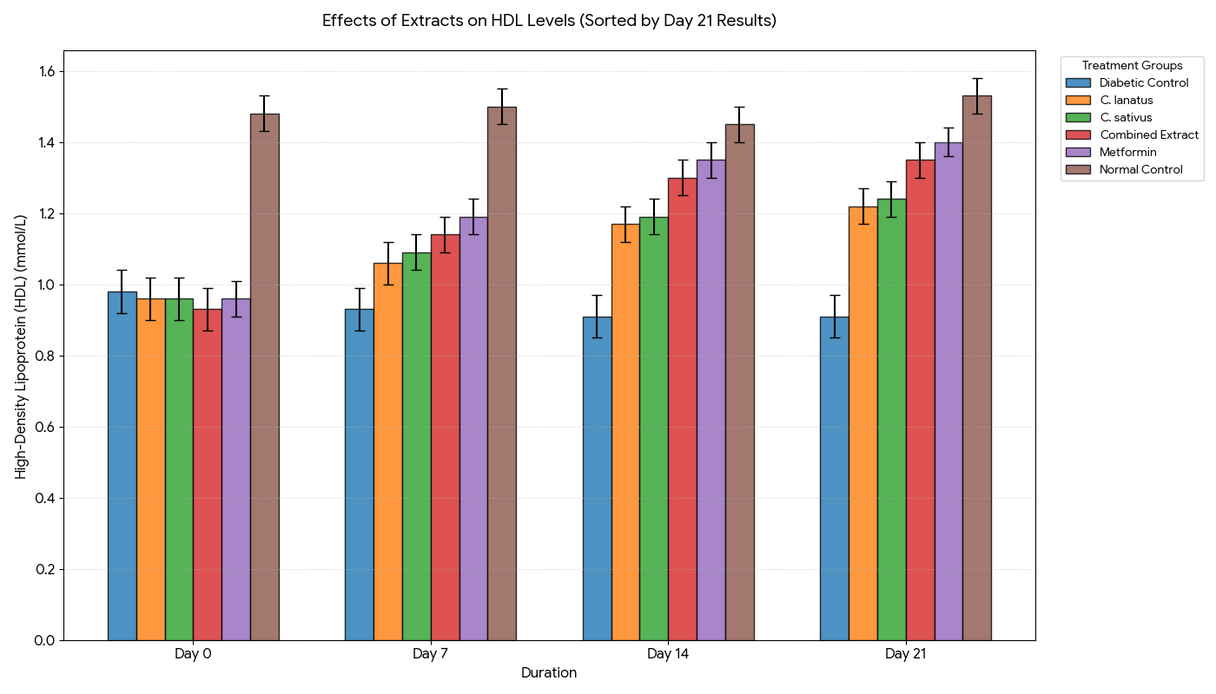
Figure 3. Mean HDL cholesterol
3.3.3 Effect of Extracts on Serum Low-Density Lipoprotein (LDL) Levels

Table 5 and Figure 4 highlight the variations in low-density lipoprotein (LDL) concentrations among the control and treatment groups from Day 0 to Day 21. The normal control group exhibited stable LDL levels (0.75–0.83 mmol/L), reflecting normal physiological balance, while the diabetic control group showed a gradual increase from 2.33 mmol/L to 2.43 mmol/L, indicating progressive deterioration in lipid metabolism. This group was significantly higher than all other groups (p < 0.05). Treatment with C. sativus and C. lanatus significantly reduced LDL levels over time, reaching 1.45 mmol/L and 1.50 mmol/L, respectively, by Day 21. The combined extract further improved LDL reduction to 1.22 mmol/L, demonstrating greater efficacy than individual treatments. The metformin group showed the most substantial reduction, achieving 1.09 mmol/L at Day 21, which was significantly lower than all other treatment groups (p < 0.05).

Table 5: Low-Density Lipoprotein (LDL) (mmol/L)
Group | Post-induction (Day 0) | Day 7 | Day 14 | Day 21
Normal Control | 0.80 ± 0.04ᵃ | 0.78 ± 0.04ᵃ | 0.83 ± 0.04ᵃ | 0.75 ± 0.04ᵃ
Diabetic Control | 2.33 ± 0.08ᵇ | 2.38 ± 0.08ᵇ | 2.41 ± 0.08ᵇ | 2.43 ± 0.08ᵇ
C. sativus | 2.31 ± 0.07ᵇ | 1.86 ± 0.07ᶜ | 1.55 ± 0.06ᶜ | 1.45 ± 0.06ᶜ
C. lanatus | 2.33 ± 0.08ᵇ | 1.92 ± 0.07ᶜ | 1.61 ± 0.07ᶜ | 1.50 ± 0.06ᶜ
Combined Extract | 2.36 ± 0.07ᵇ | 1.76 ± 0.06ᶜ | 1.30 ± 0.06ᵈ | 1.22 ± 0.05ᵈ
Metformin | 2.33 ± 0.07ᵇ | 1.68 ± 0.06ᶜ | 1.17 ± 0.05ᵈ | 1.09 ± 0.05ᵉ
Values are expressed as mean ± SEM (n = 6). Means within the same column with different superscript letters (a–e) are significantly different at p < 0.05, as determined by one-way analysis of variance (ANOVA) followed by Tukey’s Honestly Significant Difference (HSD) post hoc test.

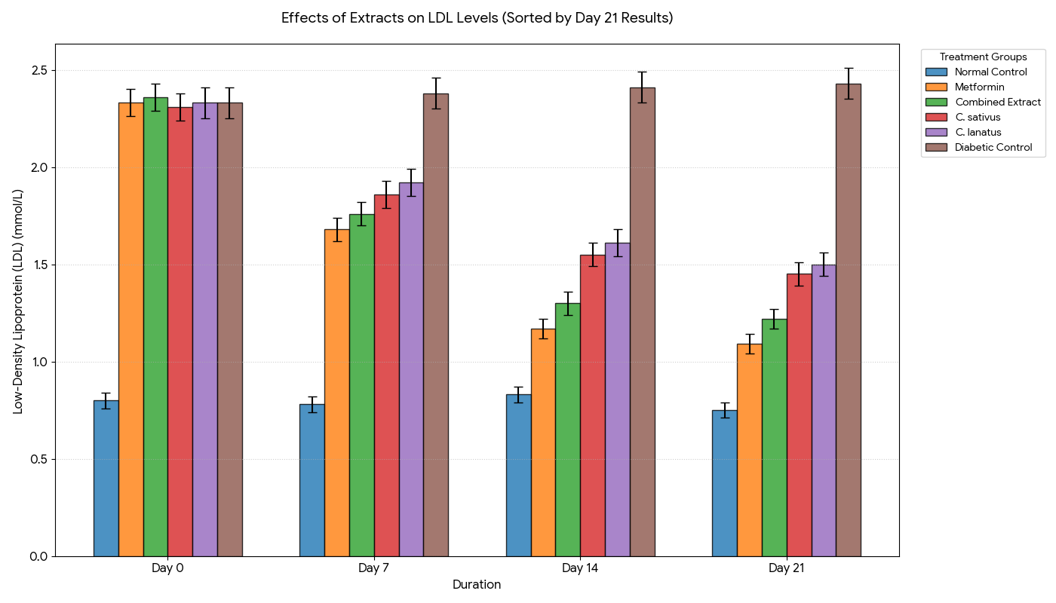
Figure 4. Mean LDL cholesterol

3.3.4 Effect of Extracts on Serum Triglyceride Levels

The effects of the extracts and metformin on triglyceride levels across all groups over the experimental period are presented in Table.6 and Figure 5. The normal control group maintained stable triglyceride levels (0.84–0.87 mmol/L), indicating metabolic stability. The diabetic control group exhibited a steady increase from 1.53 mmol/L to 1.59 mmol/L, reflecting worsening hypertriglyceridemia. These values were significantly higher than the normal control (p < 0.05).
Treatment with C. sativus and C. lanatus extracts resulted in significant reductions in triglyceride levels, reaching 1.14 mmol/L and 1.18 mmol/L, respectively, at Day 21. The combined extract showed improved efficacy, reducing triglycerides further to 1.04 mmol/L. The metformin-treated group demonstrated the greatest reduction (0.99 mmol/L), significantly lower than all other groups (p < 0.05), confirming its superior lipid-lowering effect.

Table 6: Triglycerides (mmol/L)
Group | Post-induction (Day 0) | Day 7 | Day 14 | Day 21
Normal Control | 0.85 ± 0.02ᵃ | 0.86 ± 0.02ᵃ | 0.84 ± 0.02ᵃ | 0.87 ± 0.02ᵃ
Diabetic Control | 1.53 ± 0.04ᵇ | 1.56 ± 0.04ᵇ | 1.58 ± 0.04ᵇ | 1.59 ± 0.04ᵇ
C. sativus | 1.51 ± 0.04ᵇ | 1.33 ± 0.04ᶜ | 1.19 ± 0.03ᶜ | 1.14 ± 0.03ᶜ
C. lanatus | 1.53 ± 0.04ᵇ | 1.36 ± 0.04ᶜ | 1.22 ± 0.04ᶜ | 1.18 ± 0.03ᶜ
Combined Extract | 1.54 ± 0.04ᵇ | 1.27 ± 0.03ᶜ | 1.08 ± 0.03ᵈ | 1.04 ± 0.03ᵈ
Metformin | 1.53 ± 0.04ᵇ | 1.24 ± 0.03ᶜ | 1.04 ± 0.03ᵈ | 0.99 ± 0.03ᵉ
Values are expressed as mean ± SEM (n = 6). Means within the same column with different superscript letters (a–e) are significantly different at p < 0.05, as determined by one-way analysis of variance (ANOVA) followed by Tukey’s Honestly Significant Difference (HSD) post hoc test.
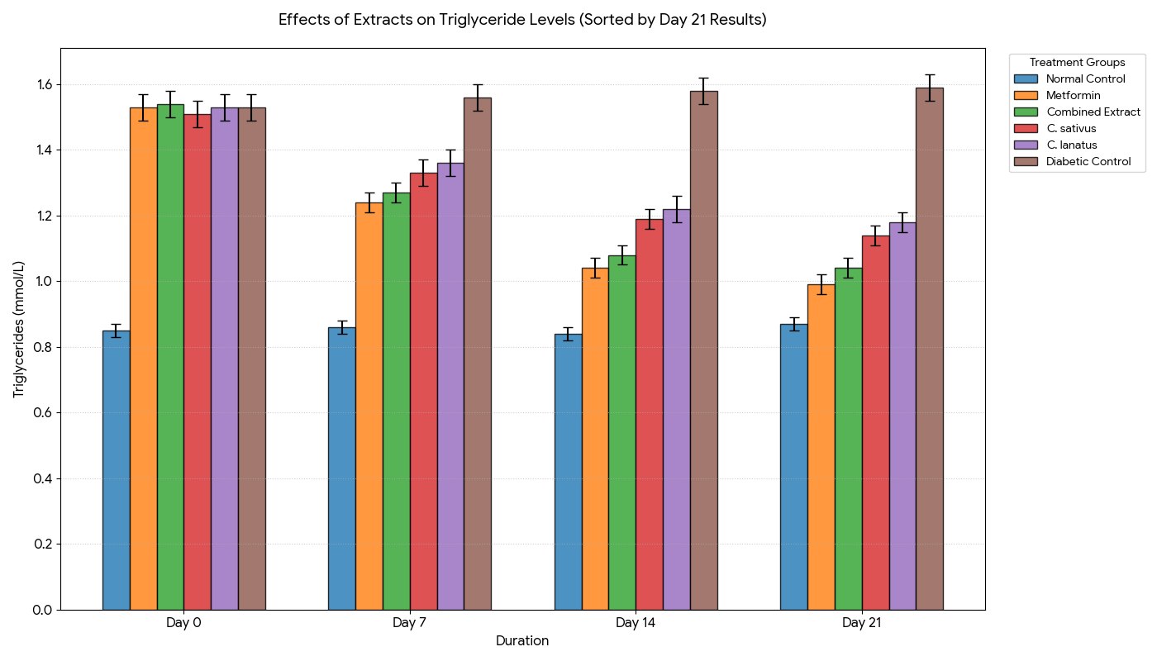
Figure 5. Mean Triglyceride
3.4. Acute toxicity results of the rind extract of C. sativus in rats
Table .7 presents the acute toxicity results of the rind extract of C. sativus in rats. No mortality was recorded in the control group or in any of the treatment groups administered doses ranging from 1000 to 5000 mg/kg body weight. The absence of mortality at all tested doses indicates that the extract exhibited no acute lethal effect within the tested dose range. Therefore, the median lethal dose (LD₅₀) of the rind extract of C. sativus was estimated to be greater than 5000 mg/kg body weight using the method described by Lorke (1983).
Table 7. Acute toxicity results of the rind extract of C. sativus in rats
Group | Dose (mg/kg body weight) | Number of rats | Number of deaths | Mortality (%)
Control | 0 (Distilled water) | 4 | 0 | 0
I | 1000 | 4 | 0 | 0
II | 2000 | 4 | 0 | 0
III | 3000 | 4 | 0 | 0
IV | 4000 | 4 | 0 | 0
V | 5000 | 4 | 0 | 0
LD₅₀ = >5000 mg/kg body weight.
3.4. Acute toxicity results of the rind extract of C. lanatus in rats
Table 8 presents the acute toxicity results of the rind extract of C. sativus in rats. No mortality was recorded in the control group or in any of the treatment groups administered doses ranging from 1000 to 5000 mg/kg body weight. The absence of mortality at all tested doses indicates that the extract exhibited no acute lethal effect within the tested dose range. Therefore, the median lethal dose (LD₅₀) of the rind extract of C. sativus was estimated to be greater than 5000 mg/kg body weight using the method described by Lorke (1983).
Table 8. Acute toxicity results of the rind extract of C. lanatus in rats
Group | Dose (mg/kg body weight) | Number of rats | Number of deaths | Mortality (%)
Control | 0 (Distilled water) | 4 | 0 | 0
I | 1000 | 4 | 0 | 0
II | 2000 | 4 | 0 | 0
III | 3000 | 4 | 0 | 0
IV | 4000 | 4 | 0 | 0
V | 5000 | 4 | 0 | 0
LD₅₀ = >5000 mg/kg body weight.

4. DISCUSSION

4.1. Phytochemical Composition of the Extracts
The methanolic rind extracts of C. sativus and C. lanatus contained flavonoids, saponins, phenols, alkaloids and terpenoids. The presence of these bioactive constituents may contribute to the antioxidant, hypoglycaemic and hypolipidaemic activities observed in the present study. Similar biological effects have been reported for C. lanatus rind extracts, which have demonstrated antihyperglycaemic and lipid-modulating activities in experimental diabetic models (Owo & Beresord, 2020), while the reported bioactive constituents of C. sativus have also been associated with glucose- and lipid-lowering effects (Uthpala et al., 2020; Obembe et al., 2023). These findings support the potential contribution of the identified phytochemicals to the metabolic effects of both rind extracts.
4.2. Effects of the Extracts on Fasting Blood Glucose Levels
The reduction in fasting blood glucose following treatment with the rind extracts indicates improved carbohydrate homeostasis. Alloxan-induced β-cell damage reduces insulin secretion, thereby limiting peripheral glucose uptake and glycolytic utilisation while promoting hepatic glycogenolysis and gluconeogenesis. This increases blood glucose and shifts energy metabolism towards greater reliance on fatty acid oxidation (Jaiyesimi et al., 2020; Palmer & Clegg, 2022; Liu et al., 2025). The glucose-lowering effects of C. lanatus and C. sativus may therefore reflect improved insulin action, enhanced peripheral glucose utilisation, increased glycogen synthesis and reduced hepatic glucose output (Uthpala et al., 2020; Ezekwe et al., 2020; Enyindah & Owo, 2026). The greater response to the combined extract suggests complementary actions of their bioactive constituents on carbohydrate utilisation and energy metabolism (Uro-Chukwu et al., 2024; Atta et al., 2020).

4.3. Effects of the Extracts on Serum Lipid Profile

The dyslipidaemia observed in the diabetic control group reflects disruption of normal energy metabolism associated with insulin deficiency. Reduced insulin action promotes adipose lipolysis and increases the release of fatty acids for hepatic uptake, where they are utilised for triglyceride synthesis and VLDL production. Treatment with the extracts improved the lipid profile, suggesting better regulation of fatty acid utilisation and storage and restoration of metabolic balance (Zhang et al., 2022). The effects of C. lanatus may be related to its flavonoids, lycopene and other bioactive compounds, while C. sativus may act through flavonoids, phytosterols and phenolic constituents that influence lipid synthesis, oxidation and cholesterol metabolism (Rejali et al., 2022; Obembe et al., 2023). The superior response to the combined extract may reflect complementary effects on carbohydrate utilisation, fatty acid metabolism and overall energy homeostasis. Metformin produced the greatest improvement, consistent with its effects on insulin sensitivity and hepatic energy metabolism through AMPK-related pathways (Szymczak-Pajor et al., 2022).

4.4. Acute Toxicity of Extracts

The acute toxicity results showed that no mortality occurred in rats administered C. sativus and C. lanatus rind extracts at doses ranging from 1,000 to 5,000 mg/kg body weight, suggesting low observed acute lethality under the experimental conditions. This finding is consistent with Ebhohon et al. (2022), who reported an oral median lethal dose (LD₅₀) greater than 5,000 mg/kg for methanol extract of C. lanatus rind, and a 2018 safety assessment of a standardised cucumber extract that reported no mortality at 2,000 mg/kg in rats. These findings are also consistent with the acute oral toxicity testing guidelines of the Organisation for Economic Co-operation and Development (OECD, 2002), which describe procedures for evaluating acute toxicity using limit-dose approaches. However, the absence of mortality does not establish complete safety, as biochemical alterations, haematological abnormalities or tissue damage may occur without death; therefore, further toxicological assessments are necessary to evaluate the effects of repeated exposure.

5. Conclusion

The study demonstrated that methanolic rind extracts of Cucumis sativus and Citrullus lanatus possess hypoglycaemic and hypolipidaemic activities in alloxan-induced diabetic Wistar rats. Both extracts improved fasting blood glucose and serum lipid abnormalities, while the combined extract produced greater improvements than the individual extracts. However, metformin generally produced the greatest overall response. The findings suggest that the rind extracts may influence carbohydrate, lipid and energy metabolism and could have potential as complementary agents in the management of diabetes-associated metabolic disturbances. Further studies are recommended to identify and quantify the active phytochemicals, establish the mechanisms underlying the observed effects, and evaluate the long-term safety and efficacy of the combined extracts.

Ethical approval

Ethical approval (Approval No. RSU/FBMS/REC/26/454) was obtained from the Research Ethics Committee, Faculty of Basic Medical Sciences, Rivers State University, Port Harcourt. All procedures complied with internationally accepted guidelines for the care and use of laboratory animals, with appropriate measures taken to minimise pain, distress, and unnecessary suffering.

Declaration of AI Use

This manuscript was prepared through the intellectual contributions of the author(s) to the study design, data analysis, interpretation of results, and scholarly content. Grammarly and ChatGPT were used solely to assist with grammatical refinement and reference formatting during manuscript revision. The author(s) accept full responsibility for the accuracy, integrity, and final content of the manuscript.

COMPETING INTERESTS DISCLAIMER:
Authors have declared that they have no known competing financial interests OR non-financial interests OR personal relationships that could have appeared to influence the work reported in this paper.

References

Abbas, F., Ch, A. R., Hamid, K., Khan, F., Iqbal, M. W., & Batul, M. (2025). Methanol Extract of Cucumis Sativus Peel Exhibits Anti-Diabesity and Anti-Cancer Activities in Mice: An In Vivo Study. The Research of Medical Science Review, 3(8), 1075-1087. https://doi.org/10.5281/zenodo.16991012

Abu-Hiamed, H. (2018). Hypocholesterolemic effects of watermelon fruit rind on rats. Nutrition & Food Science, 48(5), 836-845.

Adekanmi, A. A., Adekanmi, U. T., Adekanmi, A. S., & Oyekanmi, H. A. (2020). Assessment of proximate composition and phytochemical properties of bitter leaf (Vernonia amygdalina) and water leaf (Talinum triangular). United Int. J. Res. Technol, 1(9), 13-21.

Adewumi, A., Animashaun, R., Ajiboye, O. M., & Ogunwenmo, K. O. (2023). Antidiabetic Efficacy of Citrullus colocynthis and Citrullus lanatus: A Review. Bio-Science Research Bulletin-Biological Sciences, 39(1), 39.

Ajiboye, B. O., Shonibare, M. T., & Oyinloye, B. E. (2020). Antidiabetic activity of watermelon (Citrullus lanatus) juice in alloxan-induced diabetic rats. Journal of Diabetes & Metabolic Disorders, 19(1), 343-352.
Ansari, P., Khan, J. T., Chowdhury, S., Reberio, A. D., Kumar, S., Seidel, V., Abdel-Wahab, Y. H. A., & Flatt, P. R. (2024). Plant-Based Diets and Phytochemicals in the Management of Diabetes Mellitus and Prevention of Its Complications: A Review. Nutrients, 16(21), 3709.
Atta, A. H., Saad, S. A., Atta, S. A., Mouneir, S. M., Nasr, S. M., Desouky, H. M., & Shaker, H. M. (2020). Cucumis sativus and Cucurbita maxima extract attenuate diabetes-induced hepatic and pancreatic injury in a rat model. Journal of Physiology & Pharmacology, 71(4).
Dilworth, L., Facey, A., & Omoruyi, F. (2021). Diabetes mellitus and its metabolic complications: the role of adipose tissues. International journal of molecular sciences, 22(14), 7644.

Dimeji, I. Y., Samson, A. O., Muiz, M. A., Ayoola, A. M., & Olufemi, M. A. (2021). Hypolipidemic, Antioxidant, and Hepatoprotective Effects of Cucumber (Cucumis Sativus L.)-Supplemented Diet in Both Sexes of Sprague-Dawley Rats. Nigerian Journal of Experimental and Clinical Biosciences, 9(2), 82-88.
Enyindah, K. C., & Owo, G. J. (2026). Inhibition of Hepatic Gluconeogenic Enzymes by Selected Medicinal Plant Extracts in Alloxan-Induced Diabetic Rats. Asian Journal of Research in Biology, 9(1), 88-98.
Ezekwe, A.S., Ugwuezumba, P., Nwankpa, P., Egwurugwu, J., Ekweogu, C., Emengaha, F., & Akukwu, D. (2020). Qualitative phytochemical screening, GC-MS studies and in-vitro anti-oxidative properties of aqueous leaf extract of Gnetum africanum. Journal of Drug Delivery and Therapeutics, 10(1), 11-17.

Harborne, J., & Baxter, H. (1983). Phytochemical dictionary. A handbook of bioactive compounds from plants. Taylor and Frost, London, 791.
Idemudia, O. U., & Enogieru, A. B. (2024). Phytochemical and Pharmacological Activities of Cucumis sativus: An Updated Review. Tropical Journal of Natural Product Research, 8(7), 7612.

Ilyas, H., Baig, S. G., Sarfaraz, S., Sadaf, F., Siddiq, A., Asgher, A., ... & Wei, C. R. (2025). Cumulative Hepatoprotective, Antihyperlipidemic and Antioxidant Effects of Methanolic Seeds Extract of Citrullus lanatus, Cucumis melo, Cucumis sativus, and Cucurbita maxima With GC–MS Profile. Food Science & Nutrition, 13(9), e70358.
Jadon, A. S., Kaushik, M. P., Anitha, K., Bhatt, S., Bhadauriya, P., & Sharma, M. (2024). Types of diabetes mellitus, mechanism of insulin resistance and associated complications. In Biochemical immunology of diabetes and associated complications (pp. 1-18). Academic Press.
Jaiyesimi, K. F., Agunbiade, O. S., Ajiboye, B. O., & Afolabi, O. B. (2020). Polyphenolic-rich extracts of Andrographis paniculata mitigate hyperglycemia via attenuating β-cell dysfunction, pro-inflammatory cytokines and oxidative stress in alloxan-induced diabetic Wistar albino rat. Journal of Diabetes & Metabolic Disorders, 19(2), 1543-1556.

Javid, H., Fatima, U., Rukhsar, A., Hussain, S., Bibi, S., Bodlah, M. A., ... & Sharif, A. (2024). Phytochemical, nutritional and medicinal profile of Cucumis sativus L.(Cucumber). Food Science and Engineering, 358-377.

Kaur, S., Singh, V., & Singh, L. (2026). Fruit peel–derived bioactives for type 2 diabetes management. European Food Research and Technology, 252(5), 202.

Khalid, S., Zahid, M., Raana, S., Ramzan, K., Zehra, S. H., Ansar, S., ... & Onyeaka, H. (2026). Exploring the antidiabetic nutraceutical potential of fruits waste, a revolutionary approach for diabetes mellitus treatment. Phytochemistry Reviews, 25(2), 1751-1785.
Liu, D., Zhao, L., Wang, Y., Wang, L., Wu, D., & Liu, Y. (2025). Berberine: a rising star in the management of type 2 diabetes—novel insights into its anti-inflammatory, metabolic, and epigenetic mechanisms. Pharmaceuticals, 18(12), 1890.

Lorke, D. (1983). A new approach to practical acute toxicity testing. Archives of Toxicology, 54(4), 275–287. https://doi.org/10.1007/BF01234480
Mehreen, A., Iqbal, M. A., Ashfaq, Z., Anwar, R., Mahmood, M., Jameel, F., & Khan, M. A. (2024). Effects of Cucumis melo and Citrullus lanatus extracts on glucose level, lipid profile and hepato-renal performance of streptozotocin-induced diabetic albino rats. Pakistan Journal of Pharmaceutical Sciences, 37(1), 71.
Obembe, O. O., Abayomi, T. A., Tokunbo, O. S., Dare, J. B., & Usman, T. O. (2023). Sex Hormones, Antioxidants and Lipid Profile of Aqueous Cucumis sativus L.(cucumber) Treated Male Rats. International Journal of Medicine and Health Development, 28(2), 114-118.
Owo, G. J., & Beresford, S. J. (2020). Blood sugar lowering potentials of aqueous and ethanol extracts of the mixture of rinds of Citrullus vulgaris Schrad (watermelon) and Chrysophyllum albidum G.(Udara) fruits on alloxan-induced diabetic Wistar rats. Journal of Pharmaceutical Research International, 32, 86-90.
Palmer, B. F., & Clegg, D. J. (2022). Metabolic flexibility and its impact on health outcomes. In Mayo Clinic Proceedings (Vol. 97, No. 4, pp. 761-776). Elsevier.
Rejali, L., Ozumerzifon, S., Nayeri, H., & Asgary, S. (2022). Risk reduction and prevention of cardiovascular diseases: biological mechanisms of lycopene. Bioactive Compounds in Health and Disease-Online ISSN: 2574-0334; Print ISSN: 2769-2426, 5(10), 202-221.

Rezq, A. A. (2017). Antidiabetic activity and antioxidant role of watermelon (Citrullus lanatus) peels in streptozotocin-induced diabetic rats. Egyptian Journal of Nutrition, 32(2).
Singh, G., Sharma, V., & Udeh, B. N. (2026). Medicinal plants and lead phytomolecules as immunomodulators: An updated review. BioMed Research International, 2026(1), 6998034.
Szymczak-Pajor, I., Wenclewska, S., & Śliwińska, A. (2022). Metabolic action of metformin. Pharmaceuticals, 15(7), 810.

Tasleem, H., Abbas, A., Afzal, M. K., Saeed, J., Pandey, B., Alrohily, W., & Ahmad, A. (2026). Phytochemical Fingerprints by GC–MS, Antidiabetic and Multiorgan Protective Effects of Cucumis sativus Peel: An Integrated In Vitro, In Vivo, and In Silico Study. Chemistry & Biodiversity, 23(6), e71363.

Trease, G.E., Evans, W.C. (1989). Pharmacognosy, 11th ed., Bailliere Tindall, London pp. 45-50.
Uro-Chukwu, H. C., Ezekwe, A. S., Roberts, F., Okari, K. A., & Uro-Chukwu, F. C. U. (2024). Biochemical effects of high concentration of Colocasia esculenta flour fed on streptozotocin-induced diabetic rats. International Research Journal of Gastroenterology & Hepatology, 7, 44-60.
Uthpala, T. G., Marapana, R. A. U., Lakmini, K. P., & Wettimuny, D. C. (2020). Nutritional bioactive compounds and health benefits of fresh and processed cucumber (Cucumis sativus L.). Sumerianz Journal of Biotechnology, 3(9), 75-82.
Zhang, D., Wei, Y., Huang, Q., Chen, Y., Zeng, K., Yang, W., ... & Chen, J. (2022). Important hormones regulating lipid metabolism. Molecules, 27(20), 7052.

Zhao, L., Yuan, J., Yang, Q., Ma, J., Yang, F., Zou, Y., ... & Liu, F. (2026). Diabetes and its complications: molecular mechanisms, prevention and treatment. Signal Transduction and Targeted Therapy, 11(1), 22.

