Original Research article
BIOLOGICAL CONTROL POTENTIAL OF NESOLYNX THYMUS (GIRAULT) AGAINST UZI FLY INFESTING MUGA SILKWORM, Antheraea assamensis HELFER

ABSTRACT
Aims
The present study was undertaken to evaluate the biological control potential of Nesolynx thymus (Girault) against the uzi fly, an important parasitoid of the muga silkworm, Antheraea assamensis Helfer. Particular emphasis was placed on the effects of host age and host density on parasitisation by Nesolynx thymus.
Study Design
The study comprised a laboratory evaluation of the interaction between N. thymus and the uzi fly using uzi fly populations associated with the muga silkworm. Different host ages and host densities were evaluated to determine their influence on parasitisation and parasitoid performance.
Place and Duration of Study
The study was conducted at the Department of Sericulture, College of Agriculture, Assam Agricultural University, Jorhat, Assam, from 2022 to 2023.
Methodology
Uzi fly-infested muga silkworms were maintained under laboratory conditions, and the resulting uzi fly pupae were exposed to N. thymus under predetermined experimental conditions. Observations included host-age preference, percentage parasitisation, parasitoid emergence and other relevant parameters. The observations were summarised using mean values.
Results
The parasitisation response of N. thymus varied among the host ages evaluated. The highest mean parasitisation (86%) was recorded in 1-day-old pupae, whereas the lowest value (14%) was observed in 5-day-old uzi fly pupae. Variation in parasitisation was also observed in response to host density, with the highest value (71%) recorded at a parasitoid-to-host ratio of 3:15. Progeny production also increased with increasing host density.
Conclusion
The findings indicate that N. thymus has potential as a biological control agent against the uzi fly associated with the muga silkworm. Identifying suitable host stages and appropriate parasitoid–host combinations may assist in developing an effective biological control strategy for uzi fly management.
Keywords: Muga silkworm; Antheraea assamensis; Uzi fly; Nesolynx thymus; parasitoid; biological control; parasitization

- INTRODUCTION
Muga silk, which is produced by the semi-domesticated silkworm Antheraea assamensis Helfer, is a unique type of natural silk found mainly in northeastern India. Unlike fully indoor-reared silkworms, muga silkworms are reared outdoors and are therefore exposed to both biotic and abiotic stress factors. Pests and diseases are among the major biotic factors that have caused substantial commercial losses to silkworm rearers (Sarma et al., 2025; Neog et al., 2015; Borpuzari et al., 2022).
A review of insect pests of muga silkworms likewise identifies uzi fly infestation as a concern in outdoor rearing and highlights the need for suitable pest-management approaches (Singh et al., 2024).
The uzi fly is a tachinid dipteran insect and one of the major pests of the muga silkworm. The adult female deposits eggs on the silkworm body. Once the maggot hatches, it bores into the larva through the integument, leaving a dark scar at the penetration site, which is an effective indication that a silkworm has been attacked (Sut et al., 2024). Inside the host, the maggot develops as an endoparasite and causes serious damage. Muga rearers observe the effects in the field as weakened larvae, premature mortality and damaged cocoons (Brahma et al., 2023). Uzi fly infestation of muga silkworms varies throughout the year because weather conditions and the rearing season influence infestation. In a study covering six muga crop seasons, infestation occurred throughout the year but peaked at 89.3% in the Chotua crop (Feb–Mar) and 61.4% in the Jarua crop (Dec–Jan), beginning as early as the third instar. In the warmer Aherua and Bhodia crops, it declined to approximately 4–5% and was observed only in fifth-instar larvae. Low temperature and high humidity were both positively and significantly associated with infestation (Das & Das, 2016).
Management of the uzi fly in muga sericulture has involved various approaches, including cultural, mechanical and biological measures. Chemical methods are not ideal because silkworms are highly sensitive to chemicals. Biological control is of particular interest in sericulture because of its sustainable and environmentally friendly nature and the potential to avoid harm to silkworms. Parasitoids that naturally attack the uzi fly may therefore provide opportunities to develop more sustainable management approaches. Nesolynx thymus (Girault) is a parasitoid associated with the uzi fly and has attracted attention as a potential biological control agent. However, the effectiveness of a parasitoid depends on several biological characteristics, including host suitability, host age, host density, parasitoid density, parasitisation efficiency, successful progeny emergence and host-searching behaviour. Identifying suitable host stages and conditions that favour successful parasitisation is particularly important when considering this parasitoid for biological control programmes (Choudhury et al., 2014; Divya et al., 2009; Naan et al., 2024; Eswara Reddy, 2011; Senthoorraja et al., 2020).
A recent review of insect-pest management in sericulture also emphasises the importance of considering silkworm safety when selecting control measures (Sriram et al., 2026). Research on other parasitoid species has further shown that host age may influence parasitisation and reproductive performance, supporting the assessment of host-stage suitability under laboratory conditions (Mi et al., 2026). Similarly, host density has been evaluated as a factor affecting parasitoid mass-rearing performance in other host–parasitoid systems, although suitable rearing conditions remain species-dependent (Bai et al., 2026).
Although N. thymus has been investigated in relation to uzi fly management, its performance against uzi fly populations specifically associated with muga silkworms, and the relationships among host characteristics, parasitoid density and parasitisation behaviour, require further investigation. Understanding host preference and parasitoid behaviour can contribute to the selection of appropriate conditions for parasitoid multiplication and potential field deployment. Therefore, the present study was undertaken to evaluate the biological control potential of N. thymus against the uzi fly associated with the muga silkworm, with particular emphasis on host preference, parasitisation efficiency, parasitoid emergence and related parameters. The study also aimed to identify conditions associated with comparatively higher parasitisation that could provide a basis for the future development of N. thymus-based management of the uzi fly in muga sericulture.
- MATERIALS AND METHODS
  - Study site and experimental period
The study was conducted at the Department of Sericulture, Assam Agricultural University, Jorhat, Assam, India, from 2022 to 2023. The experiment was conducted under laboratory conditions while maintaining the room temperature in the laboratory. Newly emerged maggots were placed in containers containing soil to allow them to pupate.
  - Experimental insects
    - Muga silkworm
Muga silkworm (Antheraea assamensis Helfer) eggs were obtained from the Government Sericulture Farm, Titabar. After hatching, the silkworms were reared on som plants (Persea bombycina). Third-instar muga silkworms were used for the present study. They were artificially infested with uzi flies maintained in the laboratory of the Department of Sericulture, Assam Agricultural University, Jorhat, Assam.
    - Uzi fly & Nesolynx thymus
Uzi flies were obtained from previous rearing batches. Under natural rearing conditions, when silkworm-rearing trees are not covered with nylon nets, uzi flies generally attack the silkworms. The infested silkworms were collected and reared under laboratory conditions to obtain the uzi flies infesting them. After the uzi fly maggots matured, they emerged from the host silkworms and pupated in nearby cracks, crevices or soil. The uzi flies were collected when the maggots emerged from the silkworms to pupate. Adult Nesolynx thymus were obtained from the Central Muga Eri Research and Training Institute, Lahdoigarh, Central Silk Board, and maintained under laboratory conditions for subsequent experimental procedures.
  - Evaluation of host-age preference on parasitization by N. thymus
To determine the influence of host age on parasitisation, uzi fly pupae of different ages, collected from infested muga silkworms, were exposed separately to N. thymus. Six treatments were selected for the experiment, comprising uzi fly pupae aged 0 to 5 days. For each treatment, 10 pupae were used in each of five replications, and five mated adult female N. thymus were exposed to the host pupae for 3 days. After exposure, the hosts were maintained individually in separate boxes and observed for evidence of parasitisation and subsequent parasitoid emergence. The number of parasitised hosts was recorded for each treatment.
  - Evaluation of host density on parasitization by N. thymus
The effect of host density on parasitisation was evaluated by exposing different numbers of uzi fly pupae collected from infested muga silkworms to N. thymus according to the experimental treatments. Three mated adult female N. thymus were exposed to each treatment group. Parasitoid-to-host ratios of 3:5, 3:10 and 3:15 were evaluated. Each treatment, containing 1-day-old uzi fly pupae at different densities, was maintained for 3 days and replicated three times. After 3 days of exposure, the pupae were stored in separate glass vials to evaluate the percentage of parasitisation.
  - Determination of parasitization percentage
Parasitisation was determined using the following formula:
$$\text{Parasitization (\%)}=\frac{\text{Number of parasitized hosts}}{\text{Total number of hosts exposed}}×100$$
  - Data analysis
The observations obtained from the experimental treatments were summarised using arithmetic means to describe differences in the percentage of parasitisation.
- RESULTS AND DISCUSSION
  - Host-age preference on parasitization by Nesolynx thymus
The parasitisation response of N. thymus differed among the uzi fly host ages evaluated. The highest parasitisation (86%) was recorded when N. thymus was exposed to 1-day-old uzi fly pupae, followed by 0-day-old pupae, with a mean parasitisation of 74%. The lowest mean parasitisation (14%) was observed in 5-day-old pupae.
Table 1: Parasitization % of Muga silkworm uzi fly pupa by N. thymus based on host age.
Pupal age (days) | Mean* ± SEM | Parasitization (%)
0 | 7.40 ± 0.78 | 74
1 | 8.60 ± 0.48 | 86
2 | 5.80 ± 0.73 | 58
3 | 5.40 ± 0.99 | 54
4 | 2.80 ± 0.96 | 28
5 | 1.40 ± 0.78 | 14
*Mean of 5 replications with 10 numbers of pupa in each treatment
These observations indicate the host age preferred by the parasitoid. Host age influences the suitability of uzi fly pupae for parasitisation by N. thymus. Differences in host suitability and the reduced preference for older pupae may be associated with changes in the nutritional quality of uzi fly pupae as they age. Greater nutritional availability may support the production of more numerous and higher-quality progeny, and parasitoids may therefore avoid older hosts for oviposition (Belgumpe & Jadhav, 2017; Senthoorraja et al., 2020). The observed host-age preference is of practical relevance because synchronisation between parasitoid availability and susceptible host stages may influence the effectiveness of biological control.

Figure 1: % parasitization of different host age of uzi fly pupa by N. thymus
  - Effect of Host Density on Parasitization and Progeny Production of Nesolynx thymus
Parasitisation of uzi fly pupae increased with increasing host density (Table 2). When five pupae were provided, the mean number parasitised was 2.66 ± 0.65, corresponding to 53.20% parasitisation. The highest value occurred at a host density of 15 pupae, when 10.66 ± 1.73 pupae were parasitised (71.07%). The number of emerged progeny also increased with host density, from 53.67 ± 3.84 at a density of five pupae to 138.33 ± 6.96 at a density of 10 pupae and 194.00 ± 5.86 at a density of 15 pupae. Similarly, the mean progeny produced per female was lowest at five pupae (17.89) and highest at 15 pupae (64.67), with an intermediate value of 46.11 at 10 pupae.
Table 2: Effect of host density on parasitization, progeny emergence and progeny production per female of Nesolynx thymus.
Total number of uzi fly pupae (host density) | Mean ± SEM  (Number of pupae parasitized) | Parasitization (%) | Mean ± SEM (progeny emerged) | Mean progeny per female ± SEM
5 | 2.66 ± 0.65 | 53.20 | 53.67 ± 3.84 | 17.89
10 | 6.25 ± 1.31 | 62.50 | 138.33 ± 6.96 | 46.11
15 | 10.66 ± 1.73 | 71.07 | 194.00 ± 5.86 | 64.67
*Data includes mean for 3 replications in each treatment

Figure 2: Effect of host density on percentage parasitization, mean progeny emergence and mean progeny emergence per female of Nesolynx thymus.
The number of available hosts can strongly influence parasitoid oviposition. In N. thymus, host age, size and density are also important. Larger host pupae were parasitised more frequently than smaller ones, and 24–48-hour-old pupae were parasitised more frequently than older pupae (Senthoorraja et al., 2020). Similarly, parasitoid performance and the sex ratio of progeny declined when older host pupae were provided (Aruna & Manjunath, 2009). Larger pupae also produced more progeny per female and a more favourable sex ratio than smaller pupae (Aruna & Manjunath, 2010). Earlier work on uzi fly pupae showed that the progeny production of N. thymus increased with host availability, with the highest production recorded at parasitoid-to-host ratios of approximately 1:5 to 1:8 (Hasan et al., 2009).
In the present study, parasitisation also increased with host density. The mean numbers of parasitised pupae were 2.66, 6.25 and 10.66 at host densities of 5, 10 and 15, respectively, corresponding to parasitisation percentages of 53.20%, 62.50% and 71.07%. The number of emerged progeny also increased from 53.67 to 194.00, and progeny production per female was highest (64.67) at the greatest host density. Progeny production at a density of 15 was approximately 3.6 times that at a density of 5, although the number of hosts was only three times greater. Dividing progeny production by the number of parasitised pupae gave similar values across all three densities (approximately 18–22 per pupa). Thus, the increase in total progeny production was mainly associated with the greater number of parasitised pupae rather than larger broods per pupa. A possible explanation is that a greater availability of pupae allows females to locate unparasitised hosts more easily, reducing repeated oviposition in the same host. Hasan et al. (2009) also reported greater female progeny production at higher host densities in N. thymus, and the sex ratio of this parasitoid on uzi fly pupae is known to vary (Prakash et al., 2014). The parasitic potential of N. thymus on uzi fly pupae has also been found to vary with the season (Chakraborty et al., 2024). In the present study, a host density of 15 yielded the highest parasitisation and progeny production, indicating its suitability among the densities evaluated for laboratory rearing of N. thymus on uzi fly pupae.
- CONCLUSION
The uzi fly is a serious pest of the muga silkworm, Antheraea assamensis, and the pupal parasitoid Nesolynx thymus is one of the natural enemies used in its management. This study examined two factors affecting the performance of N. thymus on uzi fly pupae: host density and host age. In the host-density experiment, uzi fly pupae were provided at densities of 5, 10 and 15, and all recorded parameters increased with density. The mean number of parasitised pupae rose from 2.66 to 10.66, while the parasitisation percentage increased from 53.20% to 71.07%. Total progeny production followed the same trend (53.67, 138.33 and 194.00), and the mean progeny per female increased from 17.89 to 64.67. Progeny production at the highest density was approximately 3.6 times that at the lowest, although host availability was only three times greater. Progeny production per parasitised pupa remained approximately 18–22 across the densities, suggesting that the increase in total progeny resulted mainly from the greater number of parasitised pupae rather than larger broods per pupa. In the host-age experiment, N. thymus showed a clear preference for younger pupae. Parasitisation was highest in 1-day-old pupae (86%), followed by newly formed, 0-day-old pupae (74%), and then declined progressively to 14% in 5-day-old pupae. The mean number of parasitised pupae showed the same pattern, declining from 8.60 ± 0.48 at 1 day to 1.40 ± 0.78 at 5 days. Parasitisation of 5-day-old pupae was therefore approximately six times lower than that of 1-day-old pupae. Together, these results indicate that N. thymus responds positively to greater host availability and prefers younger pupae. Both factors are relevant to laboratory multiplication of the parasitoid. Among the conditions tested, a host density of 15 and pupae aged 0–1 day provided the highest parasitisation and progeny production, suggesting that these conditions could inform laboratory mass-rearing protocols for eventual field release in muga-rearing areas. However, the study was conducted under laboratory conditions with a limited number of females. The most suitable conditions should also be evaluated under field conditions, where temperature, humidity and season may influence parasitoid performance. Such evaluation could support the development of a more dependable biological control approach against the uzi fly in muga sericulture.
Limitations
The findings are derived from laboratory observations of uzi fly pupae exposed to N. thymus under the host-age and host-density treatments examined. The assessment was limited to pupae aged 0–5 days and parasitoid-to-host ratios of 3:5, 3:10 and 3:15. Accordingly, the conditions associated with greater parasitisation and progeny emergence in this study may not represent parasitoid performance under other rearing conditions. Their relevance to biological control in muga sericulture requires evaluation under field conditions, where temperature, humidity and seasonal conditions may influence parasitoid activity.
Declaration of AI Use

This manuscript was prepared through the intellectual contributions of the author(s) to the study design, data analysis, interpretation of results, and scholarly content. Grammarly and ChatGPT were used solely to assist with grammatical refinement and reference formatting during manuscript revision. The author(s) accept full responsibility for the accuracy, integrity, and final content of the manuscript.

COMPETING INTERESTS DISCLAIMER:
Authors have declared that they have no known competing financial interests OR non-financial interests OR personal relationships that could have appeared to influence the work reported in this paper.

References

1. Aruna, A. S., & Manjunath, D. (2009). Reproductive performance of Nesolynx thymus (Hymenoptera: Eulophidae), in relation to age of Musca domestica (Diptera: Muscidae). Biocontrol Science and Technology, 19(2), 139–149. https://doi.org/10.1080/09583150802624303
2. Aruna, A. S., & Manjunath, D. (2010). Reproductive performance of Nesolynx thymus (Hymenoptera: Eulophidae) as influenced by host (Musca domestica) size. BioControl, 55(2), 245–252. https://doi.org/10.1007/s10526-009-9256-3
3. Bai, X.-Q., Tian, S., Di, X.-Y., Wu, H.-Z., Yan, B., Ren, P., Ji, X.-Y., & Yang, M.-F. (2026). Effects of host density and instar stage on mass-rearing efficiency of Microplitis manilae (Hymenoptera: Braconidae). Journal of Asia-Pacific Entomology, 29(2), Article 102549. https://doi.org/10.1016/j.aspen.2026.102549
4. Belgumpe, S. J., & Jadhav, A. D. (2017). Mass production and utilization of Nesolynx thymus Girault for biological control of uzi fly Exorista bombycis in sericulture farming system of Maharashtra. Bulletin of the Indian Academy of Sericulture, 21(1–2), 33–36.
5. Borpuzari, P., Das, M. R., & Rahman, A. (2022). Comparative study on the rearing performance of muga silkworm (Antheraea assamensis Helfer) on two primary host plants som (Persea bombycina Kost) and soalu (Litsea monopetala Roxb) in different rearing seasons. Ecology, Environment and Conservation, 28(1), 568–573. https://doi.org/10.53550/EEC.2022.v28i01.085
6. Brahma, D., Chakraborty, R., Borah Dutta, R., Vasanth, V., & Bora, N. R. (2023). A study on the extent of uzi fly infestation on muga cocoons in the districts of Lakhimpur and Dhemaji of Assam. Biological Forum – An International Journal, 15(10), 1152–1157.
7. Chakraborty, R., Brahma, D., Bora, N. R., Borah Dutta, R., Sarma, J., & Rajkhowa, A. (2024). Evaluation of the parasitic potential of pupal parasitoid, Nesolynx thymus (Hymenoptera: Eulophidae), during different seasons for biological control of uzi fly. Journal of Scientific Research and Reports, 30(8), 729–734. https://doi.org/10.9734/jsrr/2024/v30i82293
8. Choudhury, B., Kumar, R., Chutia, P., & Rajkhowa, G. (2014). Host infestation potentiality of N. thymus to control the uzifly of muga silkworm, Antheraea assamensis (Helfer): A bio-control tool for controlling uzifly. Biological Forum – An International Journal, 6(1), 1–4.
9. Das, R., & Das, K. (2016). Effect of abiotic factors on infestation of uzifly (Exorista sorbillans Wiedemann) in different instar muga silkworm, Antheraea assamensis. Munis Entomology & Zoology, 11(1), 87–89. https://www.munisentzool.org/Issue/abstract/effect-of-abiotic-factors-on-infestation-of-uzifly-exorista-sorbillans-wiedemann-in-different-instar-muga-silkworm-antheraea-assamensis_967
10. Divya, S. H., Aruna, A. S., & Sathya Prasad, K. (2009). Effect of Nesolynx thymus (Hymenoptera: Eulophidae) density on its progeny production on Exorista bombycis (Diptera: Tachinidae) and Musca domestica (Diptera: Muscidae). Uttar Pradesh Journal of Zoology, 29(2), 149–154. https://mbimph.com/index.php/UPJOZ/article/view/790
11. Eswara Reddy, S. G. (2011). Integrated management of uzi fly, Exorista bombycis (Louis) (Dip.: Tachinidae), in muga silkworm, Antheraea assamensis Helfer (Lepi.: Saturniidae), under outdoor rearing conditions of Assam (India). Munis Entomology & Zoology, 6(2), 1012–1013. https://www.munisentzool.org/Issue/abstract/integrated-management-of-uzi-fly-exorista-bombycis-louis-dip-tachinidae-in-muga-silkworm-antheraea-assamensis-helfer-lep-saturniidae-under-out-door-rearing-conditions-of-assam-indi_482
12. Hasan, M. M., Uddin, M. R., Rahman Khan, M. A., & Saleh Reza, A. M. (2009). Effects of host density, host age, temperature and gamma irradiation on the mass production of Nesolynx thymus (Hymenoptera: Eulophidae), an endoparasitoid of uzi fly, Exorista sorbillans (Diptera: Tachinidae). Biocontrol Science and Technology, 19(sup1), 243–259. https://doi.org/10.1080/09583150902790319
13. Mi, Q., Zhang, F., & Hu, J. (2026). Effects of host age, parasitoid age, and superparasitism on reproductive fitness of Macrocentrus cingulum (Hymenoptera: Braconidae), a larval polyembryonic parasitoid. Pest Management Science, 82(1), 487–499. https://doi.org/10.1002/ps.70212
14. Naan, T., Sut, R., Kashyap, B., Dutta, R. B., Saikia, M., Gogoi, I., & Saikia, H. (2024). Effectiveness of plant oils for bio-intensive control of uzi fly infestation in mulberry silkworm (Bombyx mori): A comparative study. Journal of Advances in Biology & Biotechnology, 27(9), 1025–1037. https://doi.org/10.9734/jabb/2024/v27i91373
15. Neog, K., Dutta, P., Changmai, A., Goswami, D., & Choudhury, B. (2015). Comparative study on the rearing performance of muga silkworm under indoor and outdoor rearing conditions. International Journal of Agricultural Science and Food Technology, 1(1), 20–24. https://doi.org/10.17352/2455-815X.000006
16. Prakash, B. M., Prathima, A., Huchesh, H. C., Ravikumar, H., Sampathkumar, S., & Puttaraju, H. P. (2014). Sex ratio distortion in the Nesolynx thymus (Hymenoptera: Eulophidae), an ecto-pupal parasitoid of uzifly, Exorista sorbillans (Diptera: Tachinidae). European Journal of Entomology, 111(4), 453–456. https://doi.org/10.14411/eje.2014.059
17. Sarma, K., Chetry, V., Bawri, A., Borah, K. J., Khanikor, B., Kalita, T., Mech, B., Saikia, M. K., & Das, M. (2025). Ensemble distribution model of muga silkworm (Antheraea assamensis) and its primary host plant soalu (Litsea monopetala) in defined climate space. Scientific Reports, 15, Article 22080. https://doi.org/10.1038/s41598-025-05987-x
18. Senthoorraja, R., Subaharan, K., Gupta, A., Basavarajappa, S., Lalitha, Y., Bakthavatsalam, N., & Chandran, K. P. (2020). Host factors influencing the parasitism by Nesolynx thymus (Girault) (Hymenoptera: Eulophidae) on housefly, Musca domestica L. Journal of Biological Control, 34(3), 200–207. https://doi.org/10.18311/jbc/2020/26205
19. Singh, A., Kumar, V., Majumdar, M., Guha, L., & Neog, K. (2024). A comprehensive review of insect pest management in muga silkworm (Antheraea assamensis Helfer): Current scenario and future prospects. Journal of Experimental Agriculture International, 46(5), 47–55. https://doi.org/10.9734/jeai/2024/v46i52355
20. Sriram, K., Vairam, N., & Murugan, N. (2026). Sucking insect pests of mulberry and their integrated management for sustainable sericulture. Journal of Basic and Applied Research International, 32(6), 12–19. https://doi.org/10.56557/jobari/2026/v32i611243
21. Sut, R., Naan, T., Dutta, R. B., Kashyap, B., Saikia, M., Gogoi, I., & Saikia, H. (2024). The uzi fly challenge: Biological insights and threats to muga silkworms. Annual Research & Review in Biology, 39(9), 1–10. https://doi.org/10.9734/arrb/2024/v39i92113

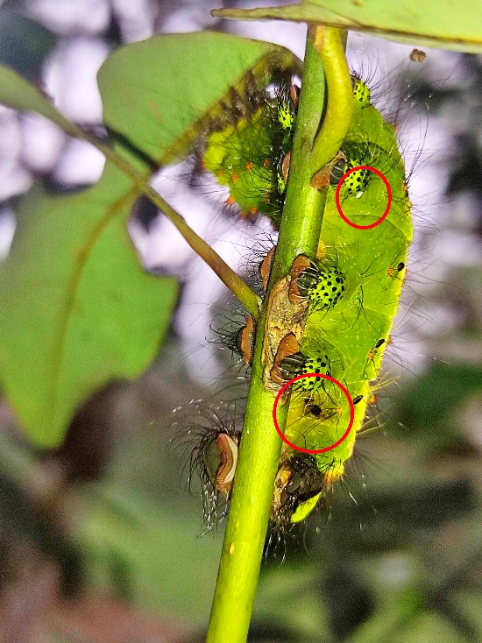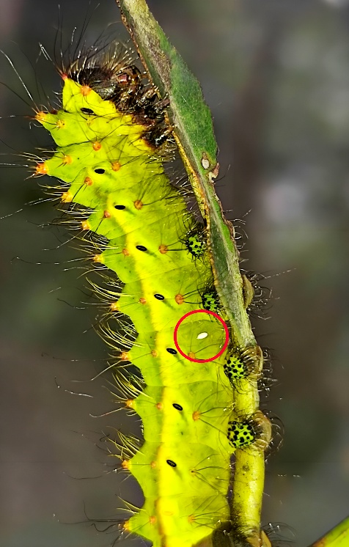
Fig. 3: Muga silkworm attacked by uzi fly
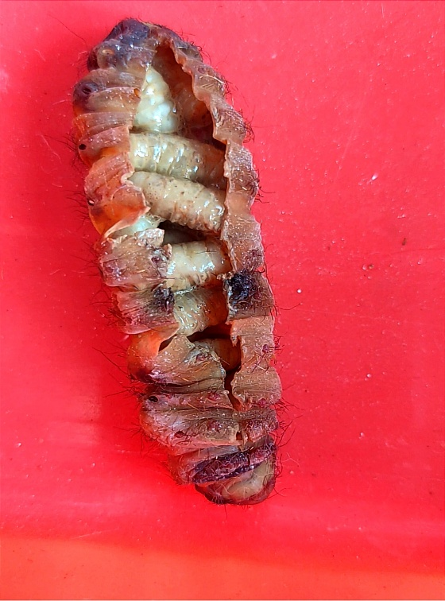
Fig. 4: Uzi fly maggot inside dead muga silkworm larva
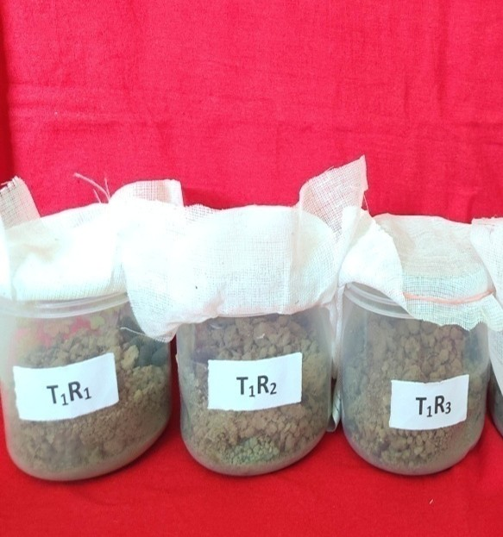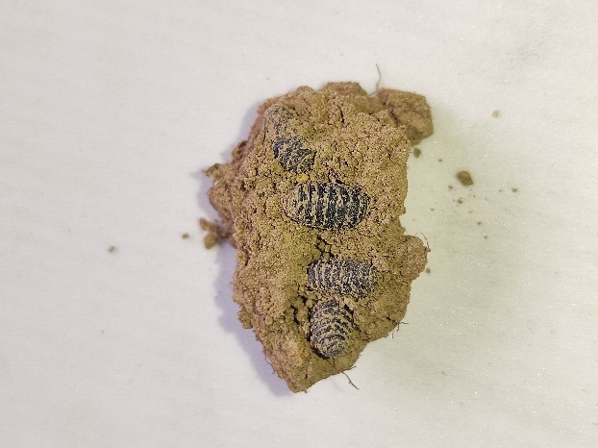
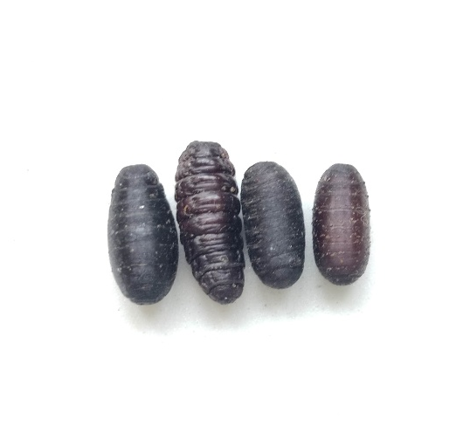
Fig. 5: Uzi fly pupa
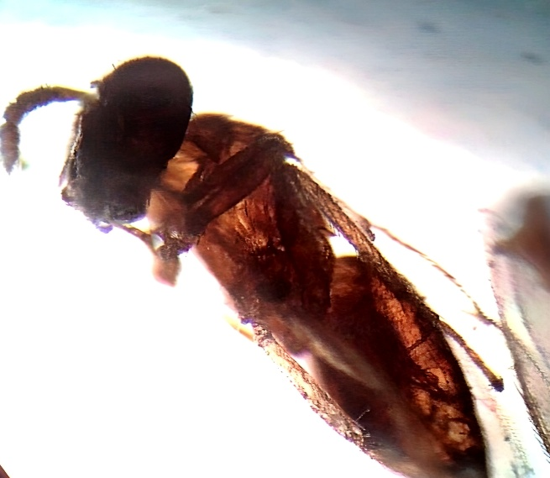
Fig. 6: Nesolynx thymus adult

