In Vitro Antidiabetic and Anti-inflammatory Activities of Pectin from the Seagrass Syringodium isoetifolium

ABSTRACT:
This study investigated the preliminary physicochemical characteristics and in vitro biological activities of pectin extracted from the seagrass Syringodium isoetifolium. Seagrass samples were collected from coastal waters near Karankadu in October 2025, and the isolated fraction was subsequently examined for several pectin-associated properties. Dried seagrass material was subjected to acid extraction, ammonium oxalate treatment and ethanol precipitation. The recovered material was evaluated using qualitative biochemical reactions and Fourier-transform infrared (FTIR) spectroscopy. Antioxidant activity was assessed by the DPPH radical-scavenging assay, while inhibition of heat-induced albumin denaturation and α-glucosidase activity was used to evaluate additional biological properties. The extract exhibited the precipitation, viscosity and solubility characteristics described for pectin. FTIR absorption bands at 1586.16 and 1422.24 cm⁻¹ were consistent with carboxylate-associated functional groups, suggesting an anionic polysaccharide profile; however, the degree of esterification was not quantified. Across the reported assay series, DPPH radical-scavenging activity increased from 17.5% to 66.25%, albumin-denaturation inhibition increased from 8.8% to 78.4%, and α-glucosidase inhibition increased from 8.5% to 76.0%. The manuscript reports corresponding IC₅₀ values of approximately 740, 629 and 652 µg/mL, respectively. These results indicate concentration-related responses in three in vitro screening assays. Further quantitative structural characterisation and biological evaluation are required before the extract's composition, mechanisms of action or potential practical applications can be established.
Keywords: Syringodium isoetifolium; seagrass; pectin; marine polysaccharide; FTIR spectroscopy;
INTRODUCTION:
Diabetes mellitus has emerged as one of the most pressing global health challenges of the twenty-first century, with the International Diabetes Federation estimating that 537 million adults were living with diabetes in 2021, a figure projected to reach 783 million by 2045 (Sun et al., 2022). Type 2 diabetes, which accounts for more than 90 % of cases, is characterised by chronic hyperglycaemia driven by insulin resistance and progressive β-cell dysfunction, and it is frequently accompanied by a state of low-grade systemic inflammation that accelerates vascular complications (Zheng et al., 2018). Current pharmacological management relies heavily on synthetic oral hypoglycaemic agents and non-steroidal anti-inflammatory drugs (NSAIDs); however, their long-term use is associated with undesirable side effects, including gastrointestinal ulceration, renal toxicity and hepatic dysfunction (Tundis et al., 2010). This therapeutic limitation has intensified the search for safer, plant-derived alternatives capable of simultaneously modulating hyperglycaemia and inflammation.
A key strategy in postprandial glycaemic control is the inhibition of intestinal α-glucosidase, the brush-border enzyme responsible for the terminal hydrolysis of dietary carbohydrates into absorbable glucose. Inhibition of this enzyme attenuates the post-meal glucose spike and has become a validated target for both conventional drugs (e.g., acarbose) and natural products (Lordan et al., 2013; Tundis et al., 2010). Likewise, inhibition of heat-induced protein denaturation is a widely accepted in vitro surrogate for anti-inflammatory screening, since denatured proteins act as endogenous antigens that trigger inflammatory cascades (Sakat et al., 2010). Marine organisms, which produce structurally unusual polysaccharides under extreme and highly saline environments, are increasingly recognized as privileged sources of such bioactive molecules (Ganesan et al., 2019; Jiao et al., 2011; Wijesekara et al., 2011). In a study of citrus pectin enzymatic hydrolysates, Zhang et al. (2025) reported α-glucosidase inhibition by pectin-derived oligosaccharides, supporting the relevance of enzyme-based screening of pectin-related materials.
Seagrasses, the only group of higher plants that have readapted to complete submergence in the marine environment, represent a conspicuously underexplored branch of this marine bioresource. Comprising some 60–70 species distributed across five families, seagrasses form extensive meadows in shallow coastal waters and are characterized by a carbohydrate-rich cell-wall matrix adapted to a saline, light-limited habitat (Short et al., 2007). Remarkably, marine angiosperms have been shown to biosynthesize sulphated and acidic polysaccharides, including sulphated galactans, as an adaptive response to seawater salinity (Aquino et al., 2005). Syringodium isoetifolium (family Cymodoceaceae), a widely distributed Indo-Pacific seagrass, accumulates substantial cell-wall polysaccharide reserves, yet its phytochemical and pharmacological potential remains largely untapped compared with its macroalgal counterparts. Recent research has also assessed antioxidant activity in solvent extracts of S. isoetifolium (Ramesh et al., 2025).
Among cell-wall polysaccharides, pectin occupies a singular position of industrial and biomedical importance. Pectin is a structurally heterogeneous family of galacturonic acid-rich polysaccharides comprising homogalacturonan, rhamnogalacturonan-I and rhamnogalacturonan-II domains in which α-(1→4)-linked D-galacturonic acid residues carry varying proportions of methyl-esterified and free carboxyl groups; this degree of esterification fundamentally determines gelling behaviour and biological activity (Ciriminna et al., 2016; Dranca & Oroian, 2018). Owing to its biocompatibility, biodegradability and generally recognised as safe (GRAS) status, pectin is extensively exploited as a gelling and stabilizing agent in food systems and as a drug-delivery excipient (Freitas et al., 2021; Noreen et al., 2017). Beyond its techno-functional roles, an expanding body of evidence attributes direct health-promoting properties to pectin, including cholesterol- and bile-acid lowering, immunomodulation, prebiotic effects, and, of direct relevance to the present study, viscosity-mediated attenuation of postprandial glycaemia through delayed gastric emptying and glucose absorption (Naqash et al., 2017; Weickert & Pfeiffer, 2008).
A recent review noted that the extraction, physicochemical characteristics and biological activities of pectin vary with its source and processing conditions (Xiang et al., 2024). Extraction and physicochemical characterisation of mango-peel pectin further exemplify the investigation of alternative terrestrial sources (Nyabuti, 2025).
Marine-derived polysaccharides in general, and acidic polyelectrolytes in particular, have demonstrated convincing antioxidant, anti-inflammatory and enzyme-inhibitory activities, which are largely underpinned by their anionic (carboxylate and sulphate) architecture and molecular weight (Cunha & Grenha, 2016; Fernando et al., 2016; Jiao et al., 2011; Wijesekara et al., 2011). Furthermore, "egg-box" cross-linking of low-methoxyl pectin carboxylates with divalent cations such as Ca²⁺, a property exploited in conventional pectin gelling (Grant et al., 1973), also confers metal-chelating and radical-stabilizing capacity relevant to antioxidant and anti-inflammatory action (Ciriminna et al., 2016; Naqash et al., 2017). While pectin from terrestrial sources (citrus, apple, sugar beet) has been studied extensively, pectin from marine angiosperms remains exceptionally rare in the literature, and, to date, the bioactivities of pectin isolated from S. isoetifolium have not been systematically evaluated.
The literature discussed above leaves a specific gap regarding the combined preliminary physicochemical characterisation and the in vitro assessment of the antioxidant, protein-denaturation inhibitory and α-glucosidase inhibitory activities of pectin isolated from S. isoetifolium.
Objective of the Study:
The objective of the present study was to extract pectin from S. isoetifolium, examine its physicochemical characteristics using qualitative tests and FTIR spectroscopy, and assess its in vitro DPPH radical-scavenging, albumin-denaturation inhibitory and α-glucosidase inhibitory activities.
MATERIALS AND METHODS:
  - COLLECTION OF SEAGRASS:
The seagrass Syringodium isoetifolium was collected during October 2025 in the coastal waters of Karankadu, near Ramanathapuram, Palk Strait, on the south-eastern coast of Tamil Nadu, India. The collected seagrass was washed twice with filtered seawater and then with freshwater to remove unwanted materials, including salts, sand particles and epiphytes. Excess water was removed from the seagrass samples using filter paper. The sample was shade-dried for five to ten days until thoroughly dry. Approximately 100 g of the dried seagrass sample was powdered using a mixer grinder, and the powdered sample was stored in a zip-lock bag for further use.
  - PECTIN EXTRACTION FROM S. isoetifolium:
The polysaccharide pectin was extracted from S. isoetifolium using an acid and chelation-based extraction method. A 10 g sample of S. isoetifolium was mixed with 200ml of 0.1M hydrochloric acid (HCL) in a conical flask and heated at 65°C for 2 hours at pH 2.0-2.5. The HCL mixture was filtered through Whatman filter paper and rinsed with water until the seagrass reached a neutral pH. A 0.5% ammonium oxalate solution was added to the mixture, which was then placed in a water bath at 80°C for 2 hours. The pH was maintained at 6.0-6.5 using a 15% sodium carbonate solution. The mixture was transferred to a centrifuge tube and centrifuged at 300rpm for 15mins. The supernatant was collected in a beaker. Pectin was precipitated by adding three times the supernatant volume of 95% ethanol. The precipitated pectin was filtered through Whatman filter paper, washed with 70% ethanol and dried in a hot-air oven at 80°C to obtain purified pectin.
  - FTIR ANALYSIS OF THE PECTIN FROM S. ISOETIFOLIUM:
Fourier Transform Infrared (FTIR) spectroscopy was performed to identify the functional groups present in the pectin from S. isoetifolium. A 1gm sample of dried pectin extract was subjected to FTIR analyser. FTIR spectra were recorded in the range of 4000 – 400cm^1. The characteristic peaks were analysed to determine the functional groups present in the samples. The analysis was used to examine the extracted material from S. isoetifolium.
  - BIOCHEMICAL TEST FOR PECTIN:
Biochemical tests were used to assess the presence and characteristics of pectin in the extracted sample. Specific functional groups and reactions characteristic of pectin polysaccharides were examined. In this study, biochemical tests, including alcohol precipitation, calcium chloride, viscosity, solubility and sodium hydroxide tests, were used to confirm the presence of pectin extracted from seagrass.
    - Pectin solution preparation:
A 1% pectin solution was prepared by dissolving 1g of pectin powder in 100ml of distilled water. The pectin mixture was heated gently at 60-70°C. The pectin solution was cooled to room temperature and used for biochemical and subsequent tests.
    - Alcohol precipitation test:
The pectin solution was mixed with three times its volume of 95% ethanol and kept at 4°C for 1 hour. The formation of a jelly-like precipitate was observed and was considered indicative of high-molecular-weight pectin.
    - Calcium chloride test:
To confirm the presence of pectin, 5ml of pectin solution was mixed with an equal volume of 1% calcium chloride solution. The formation of a white, gelatinous precipitate was observed, indicating the presence of pectin. (Calcium ions interact with galacturonic acid residues to form insoluble calcium pectate).
    - Viscosity test:
A 1% pectin solution in distilled water was stirred thoroughly, and the viscosity of the mixture was observed. The high viscosity suggests the presence of pectin.
    - Solubility test:
The pectin solution was tested for solubility in cold and hot water. Precipitation in cold water and complete dissolution in hot water were observed, indicating the presence of pectin.
    - Sodium hydroxide (NaOH) test:
A 2ml portion of pectin solution was mixed with a few drops of 0.1M sodium hydroxide (NaOH) solution and incubated for 15 – 20 minutes at room temperature. The formation of a gel or thickened solution indicated the presence of pectin.
  - Antioxidant activity:
The antioxidant activity of pectin extract was determined using the DPPH (2,2-diphenyl-1-picrylhydrazyl) radical scavenging assay. A 0.1mM DPPH solution was prepared by dissolving 1.95 mg in 25ml of methanol and stored in an amber bottle in the dark. Pectin samples were dissolved in distilled water at various concentrations (100, 200, 500,1000 mg/mL).A 1ml aliquot of each pectin concentration was mixed with 1mL of DPPH solution and incubated in the dark at room temperature for 30 minutes. The control contained 1mL of methanol and 1mL of DPPH, while the blank contained 1mL of pectin solution and 1mL of methanol (without DPPH). After incubation, the absorbance was measured at 520 nm using a colorimeter. The percentage inhibition in the DPPH assay was calculated using the following formula:
% inhibition= [(A control – A sample)/ A control)] X 100.
  - ANTI-INFLAMMATORY ASSAY:
Assessment of in vitro anti-inflammatory activity by inhibition of albumin denaturation:
The anti-inflammatory activity of the sample was assessed using the albumin-denaturation inhibition technique described by Mizushima and Kobayashi (1968) and Sakat et al. (2010), with minor modifications.
The reaction mixture consisted of 2ml of the sample ethanol extract at various concentrations, 0.2ml of a 1% aqueous solution of bovine albumin fraction and 2.8ml of PBS. The pH was adjusted using a small amount of 1N HCl. The samples were incubated at 37 ºC for 20 min and then heated to 51 º C for 20 min. After cooling, turbidity was measured at 660nm using a UV-visible spectrophotometer.
The percentage inhibition of protein denaturation was calculated as follows:
Percentage inhibition = (Abs Control –Abs Sample) X 100/ Abs control
  - ANTI DIABETIC ASSAY:
    - α-Glucosidase inhibition assay
Different concentrations of the sample extract were combined with 100 μl of 0.1 M phosphate buffer (pH 6.9) and 100 μl of α-glucosidase solution (1 Unit/ml/min) and pre-incubated at 25°C for 5 min (Worthington, 1993). Then, 100 μl of p-nitrophenyl-α-d-glucopyranoside (5 mM) was added and incubated at 25°C for 10 min. After incubation, absorbance was recorded at 405 nm and compared with a control containing 100 μl of buffer instead of the sample. The results were calculated and expressed as percentages.
RESULTS:
2.1. Pectin extraction from S. isoetifolium:
The identity of the polysaccharide extracted from Syringodium isoetifolium was established through qualitative physicochemical tests. Upon addition of ethanol, a white gelatinous precipitate formed immediately, consistent with the classical behaviour of pectin, which is insoluble in aqueous alcohols owing to dehydration of its hydration shell and consequent aggregation of high-molecular-weight galacturonan chains (Ciriminna et al., 2016; Freitas et al., 2021). Similarly, the addition of CaCl₂ produced a white precipitate of calcium pectate a hallmark reaction of polyuronides explained by the "egg-box" model, in which divalent calcium ions bridge the carboxylate groups of adjacent galacturonic acid residues (Grant et al., 1973). The ready formation of calcium pectate suggests a low degree of esterification, since abundant free –COOH/–COO⁻ groups are required for efficient ionic cross-linking (Dranca & Oroian, 2018). The extract dissolved completely in hot water, forming a viscous colloidal solution but remained insoluble in cold water, reflecting the characteristic dissolution behaviour of pectinaceous polysaccharides (Adetunji et al., 2017; Naqash et al., 2017). In the NaOH test, a gelatinous precipitate appeared, attributable to alkaline de-esterification and neutralisation of carboxylic groups to form pectates, confirming the presence of acidic functional groups the structural basis of pectin's gelling and metal-binding properties (Ciriminna et al., 2016). Together, these tests unambiguously establish the extract as a pectin-type polysaccharide.

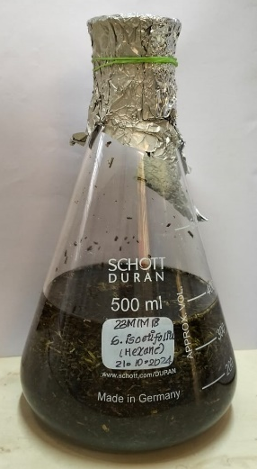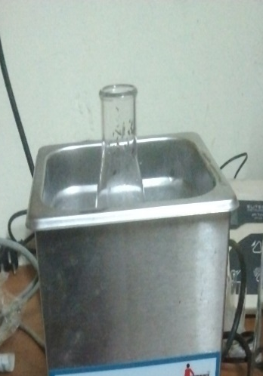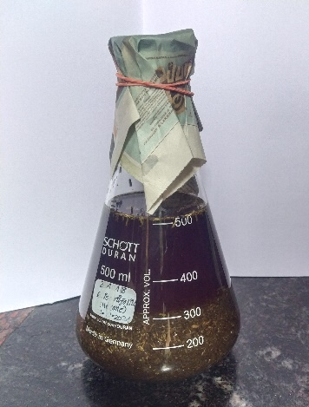

Seagrass with 0.1M HCL Water bath Seagrass with aluminium
Fig.1 Fig.2 oxalate
Fig.3

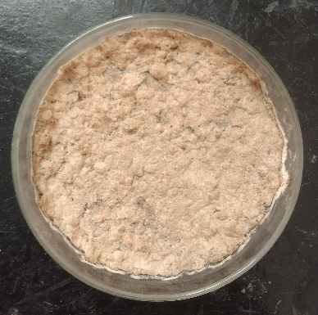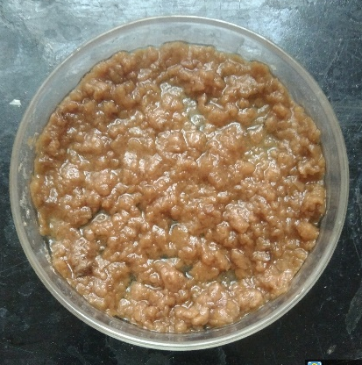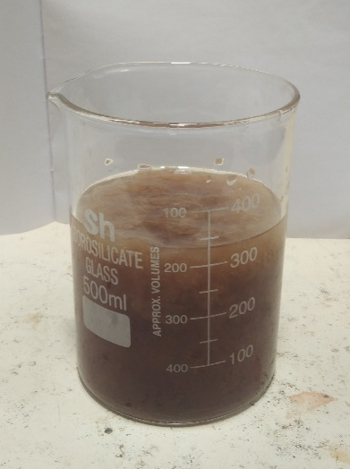
Dried at hot air oven Filter the ethanol Ammonium oxalate
precipitate supernatant
Fig.6 Fig.5 added 95% ethanol
Fig.4
Fig.1 – 6. Pectin extraction process from S. isoetifolium seagrass

2.2. FTIR ANALYSIS OF THE PECTIN FROM S. ISOETIFOLIUM:
The functional groups in the pectin extract were examined using FTIR analysis. The absorbance spectrum of the extracted sample was recorded.
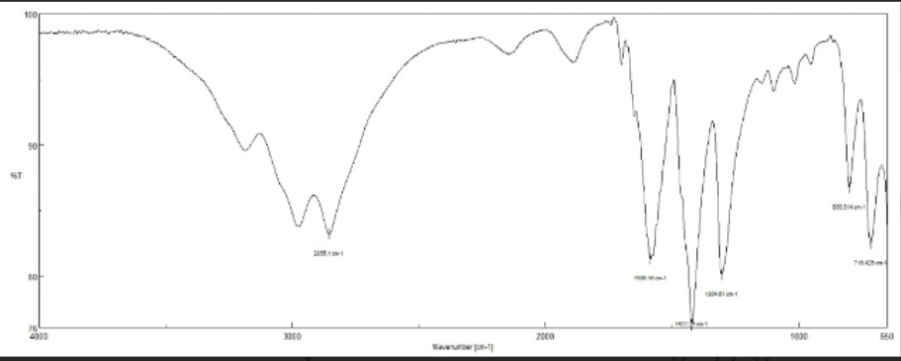
Fig.7
Graphical representation of FTIR analysis of pectin extract of S. isoetifolium

The absorption peaks and corresponding functional groups present in the extract are presented below.

Chart 1. Fourier-transform infrared (FTIR) absorption frequencies and corresponding functional group assignments of pectin extracted from the seagrass Syringodium isoetifolium.

Frequency range (standard)  (cm-1) | Absorption  (cm-1) | Functional group
730-780 | 716.42 | C-H out of plane bending (aromatic rings, alkenes or substituted benzene compounds)
800-890 | 800.34 | C-H out of plane bending (alkenes or aromatic compounds)
1200-1300 | 1304.61 | C-O stretching (Carboxyl, phenols or ethers)
1400-1450 | 1422.24 | C-H bending (methylene or methyl groups, alkanes or carbohydrates)
1550-1650 | 1586.16 | C=C stretching (aromatic rings)
2850-2925 | 2855.10 | C-H stretching (alkanes, methyl or carbohydrates)

The FTIR spectrum exhibited absorption bands characteristic of polyuronide polysaccharides. The band at 2855 cm⁻¹ arises from C–H stretching of methyl/methylene groups of uronic acid residues, while the bands at 800.34 and 716.42 cm⁻¹ correspond to C–H out-of-plane bending and pyranose-ring skeletal vibrations typical of glycosidic linkages. The band at 1304.61 cm⁻¹ reflects C–O stretching of carboxyl and ether groups of the galacturonan backbone. The band at 1586.16 cm⁻¹ lies in the region (1600–1630 cm⁻¹) attributed to the asymmetric stretching vibration of carboxylate anions (–COO⁻) in pectins, while 1422.24
cm⁻¹ coincides with the symmetric –COO⁻ stretch/C–H bending region (Jiao et al., 2011). The prominence of the carboxylate pair, together with the absence of a strong ester carbonyl band near 1730–1750 cm⁻¹, indicates a predominantly free-carboxyl (low-methoxyl) character. This is consistent with the calcium pectate precipitation observed, and with reports that marine angiosperms and green macrophytes contain anionic polysaccharides; seagrasses are known to biosynthesize sulfated galactans and acidic matrix polysaccharides (Aquino et al., 2005; Kidgell et al., 2019) which underpin many of their biological activities (Aquino et al., 2011; Cunha & Grenha, 2016).
  - BIOCHEMICAL TEST FOR PECTIN:
- Chart 2. Qualitative biochemical characterization of pectin extracted from Syringodium isoetifolium, showing the observations and corresponding inferences from alcohol precipitation, calcium chloride, viscosity, solubility, and sodium hydroxide tests.
Name of the test | Observation | Inference
Alcohol precipitation test | Formation of a white gelatinous precipitate upon addition of ethanol | Confirms the presence of pectin, which insoluble in alcohol and precipitate out.
Calcium chloride test | Formation of a white precipitate after adding Calcium chloride | Presence of pectin, which reacts with calcium ions to from calcium pectate.
Viscosity test | The pectin solution exhibits high viscosity or gel like consistency. | Conforming the colloidal and gel forming nature of pectin due to its polysaccharide structure.
Solubility test | Pectin dissolves fully in the hot water, forming viscous solution; insoluble in cold water. | Solubility characteristics confirms the identity of pectin as a water – soluble polysaccharide.
Sodium hydroxide (NaOH) test | Formation of a white gelatinous precipitate upon adding NaOH to the pectin solution. | Presence of acidic functional groups (carboxyl groups) in pectin the react with NaOH.

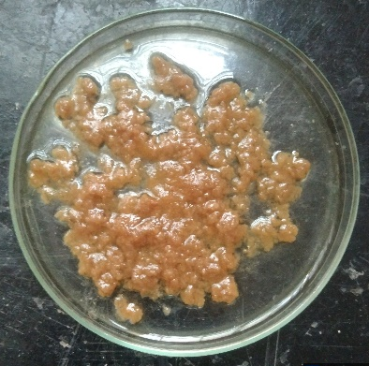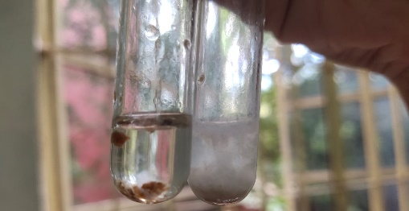
Fig 8: Alcohol precipitation test Fig 9: Calcium chloride test

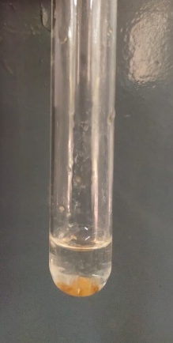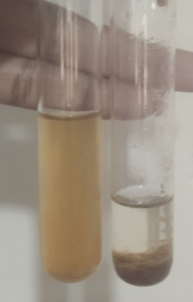
Fig 10: Viscosity test FIG 11: Solubility test

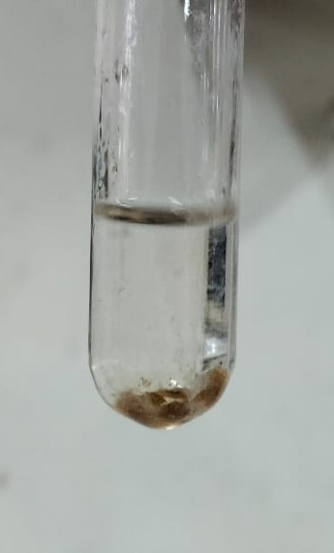
Fig 12: Sodium hydroxide (NaOH) test

2.4. ANTIOXIDANT ACTIVITY:
Different concentrations of pectin extract (100 μl,200 μl,500 μl and 1000 μl) were prepared and incubated with DPPH solution in the dark for 30 minutes. The antioxidant properties of the pectin extract were evaluated using the DPPH assay and absorbance was measured at 520nm using a colorimeter.

Concentration  (µl) | OD value | % Inhibition | Antioxidant activity range
Control | 0.80 | 0 % | Low
100 | 0.66 | 17.5% | Moderate
200 | 0.60 | 25.0% | Moderate
500 | 0.52 | 35.0% | Moderate
1000 | 0.27 | 66.25% | High

Table 1: Antioxidant activity of pectin using DPPH method
DPPH radical-scavenging capacity increased in a concentration-dependent manner, from 17.5 % at 100 µg/mL to 66.25 % at 1000 µg/mL, with an IC₅₀ of ≈740 µg/mL (Fig. 13). This moderate activity is typical of polyuronide-type polysaccharides, whose antioxidant action proceeds mainly through hydrogen donation from hydroxyl/carboxyl groups and chelation of pro-oxidant metal ions, rather than redox-active aromatic moieties (Wang et al., 2016). Polysaccharides are consequently weaker DPPH scavengers than phenolics (ascorbic acid: IC₅₀ ~10–20 µg/mL), yet they remain valuable biocompatible antioxidant macromolecules (Naqash et al., 2017; Zayed & Ulber, 2020). The observed IC₅₀ falls well within the range reported for marine algal polysaccharides (approximately 0.3–2 mg/mL), where potency is governed by uronic acid content, sulfate substitution, and molecular weight (Ganesan et al., 2019; Qi et al., 2005; Wijesekara et al., 2011). The anionic character inferred from FTIR therefore provides a plausible structural rationale for the scavenging behaviour of this seagrass pectin.
GRAPHICAL REPRESENTATION:

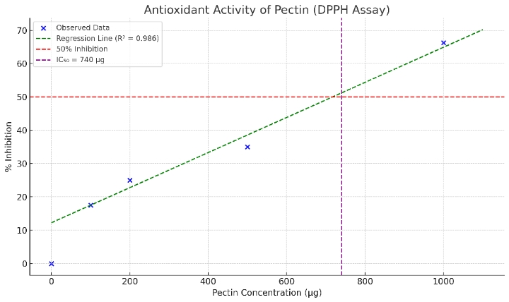

Fig 13: The graph shows antioxidant activity of pectin

2.5. ANTI-INFLAMMATORY ASSAY:
ANTI-INFLAMMATORY ASSAY
S.NO | NAME OF THE TEST | 100μg | 250μg | 500μg | 750μg | 1000μg | IC50
1. | Inhibition of Egg Albumin denaturation | 8.8% | 21.2% | 40.0% | 59.5% | 78.4% | 629μg
Table 2: Anti- inflammatory activity of pectin by egg albumin denaturation assay. Inhibition increased with the concentration, reaching 78.4% at 1000 μg with an IC50 of 620 μg.
The pectin inhibited heat-induced egg albumin denaturation in a concentration-dependent manner, achieving 78.4 % inhibition at 1000 µg/mL (IC₅₀ = 629 µg/mL) . Protein denaturation is implicated in the release of auto-antigens and inflammatory mediators; hence, its inhibition is an accepted in vitro surrogate for anti-inflammatory potential (Sakat et al., 2010). The activity approaches that of standard NSAIDs in comparable assay formats. This agrees with accumulating evidence that marine acidic/sulfated polysaccharides and fucoidans suppress inflammatory processes including protein denaturation, cyclooxygenase activity, and mediator release (Fernando et al., 2016; Wijesinghe & Jeon, 2012). For an anionic pectin, activity may further be linked to its polyelectrolyte nature, which can stabilize protein conformations and modulate immune-cell signalling (Cunha & Grenha, 2016; Noreen et al., 2017).
2.6. ANTI DIABETIC ASSAY:
ANTI DIABETIC ASSAY
S.NO | NAME OF THE TEST | 100μg | 250μg | 500μg | 750μg | 1000μg | IC50
1. | α-Glucosidase inhibition activity | 8.5% | 20.0% | 38.6% | 57.4% | 76.0% | 652μg

Table 3: Anti diabetic activity of pectin by α-Glucosidase inhibition assay. Inhibition increased with the concentration, reaching 76.0% at 1000 μg with an IC50 of 652 μg.
The pectin inhibited α-glucosidase in a concentration-dependent manner, reaching 76.0 % inhibition at 1000 µg/mL (IC₅₀ = 652 µg/mL) (Table 3). Inhibition of intestinal α-glucosidase delays enzymatic release of glucose from dietary carbohydrates and attenuates postprandial hyperglycaemia, the pharmacological basis of acarbose (Kim et al., 2005). Although less potent than acarbose, the activity is comparable to marine macroalgal extracts, whose α-glucosidase IC₅₀ values typically range from sub-mg/mL to low-mg/mL (Ganesan et al., 2019; Lordan et al., 2013). Beyond direct enzyme inhibition, dietary pectin blunts glycaemic responses through viscosity-mediated delay of gastric emptying and glucose absorption (Weickert & Pfeiffer, 2008), supporting a dual (enzymatic + physicochemical) antidiabetic mechanism. The moderate inhibition observed here, combined with the strong viscosity documented in the characterization tests, therefore suggests genuine functional-food potential (Freitas et al., 2021; Noreen et al., 2017).

DISCUSSION:
The pectin extracted from the seagrass Syringodium isoetifolium was successfully identified and characterized through a combination of qualitative physico-chemical tests, FTIR spectroscopy and three complementary in vitro bioassays, and the results collectively provide convincing evidence for its identity, structural features and pharmacological potential. In the preliminary characterization, the extract exhibited the entire classical repertoire of pectin behaviour — a white gelatinous precipitate in ethanol, a white calcium pectate precipitate following the addition of CaCl₂, high viscosity and gel-like consistency, hot-water solubility with cold-water insolubility, and a gelatinous precipitate with NaOH. The ethanol precipitation reaction arises from the dehydration and aggregation of high-molecular-weight galacturonan chains, which are inherently insoluble in aqueous alcohols, a behaviour documented for pectins from all conventional sources (Ciriminna et al., 2016; Dranca & Oroian, 2018). The vigorous calcium pectate formation observed here is particularly informative, because it is explained by the well-established "egg-box" model of Grant et al. (1973), in which divalent calcium ions cooperatively bridge contiguous blocks of de-esterified galacturonic acid residues on adjacent polymer chains; efficient cross-linking of this kind requires an abundance of free carboxyl groups and therefore indicates a low degree of esterification, analogous to the low-methoxyl pectins obtained from sugar beet and sunflower that gel by ionic rather than sugar–acid mechanisms (Dranca & Oroian, 2018; Naqash et al., 2017). The solubility and viscosity behaviour of the present extract likewise mirrors that reported for citrus and commercial low-methoxyl pectins, whose solution properties are governed by molecular weight, charge density and ionic strength (Adetunji et al., 2017; Freitas et al., 2021). Taken together, these reactions affirm that the S. isoetifolium extract is a genuine pectin-type polyuronide rather than a neutral gum or non-pectic polysaccharide.
The FTIR analysis corroborated and extended these findings at the molecular level. The absorption at 2855 cm⁻¹ corresponds to symmetric C–H stretching of the sugar-ring methylene and methyl groups, including the methoxyl groups of esterified uronic residues, while the band at 1304 cm⁻¹ reflects C–O stretching of carboxyl and ether functions of the galacturonan backbone, and the bands at 800.34 and 716.42 cm⁻¹ are consistent with pyranose-ring skeletal vibrations and glycosidic-linkage deformations characteristic of uronic-acid-rich polysaccharides (Synytsya et al., 2003). Although generic spectral libraries assign the band at 1586.16 cm⁻¹ to aromatic C=C stretching, such an assignment is chemically implausible for pectin, which contains no aromatic rings; in the established pectin literature this region (1600–1630 cm⁻¹) is instead attributed to the asymmetric stretching of carboxylate anions (–COO⁻), with the companion band at 1422.24 cm⁻¹ representing the symmetric –COO⁻ stretch combined with C–H deformation (Chatjigakis et al., 1998; Gnanasambandam & Proctor, 2000; Manrique & Lajolo, 2002). The dominance of this carboxylate pair, together with the absence of any prominent ester carbonyl band near 1730–1750 cm⁻¹, independently confirms the low-methoxyl, anionic character of the seagrass pectin inferred from the calcium chloride test — a coherent structure–chemistry agreement that strengthens the overall characterization. This anionic profile is also entirely consistent with the polysaccharide chemistry reported for marine angiosperms, which biosynthesize sulphated and acidic cell-wall polysaccharides, including sulphated galactans, as an adaptive response to seawater salinity (Aquino et al., 2005; Aquino et al., 2011).
The bioassay results demonstrate that this anionic architecture translates into meaningful and internally consistent biological activity. In the DPPH assay, radical scavenging increased dose-dependently from 17.5 % at 100 µg/mL to 66.25 % at 1000 µg/mL, with an IC₅₀ of approximately 740 µg/mL. It is well recognized that native polysaccharides are intrinsically weaker DPPH scavengers than low-molecular-weight phenolics such as ascorbic acid (IC₅₀ ≈ 10–20 µg/mL) because they lack redox-active aromatic moieties, and their antioxidant action proceeds mainly through hydrogen donation from hydroxyl and carboxyl groups and through chelation of pro-oxidant transition-metal ions (Wang et al., 2016). Judged against this context, the present IC₅₀ of ≈0.74 mg/mL sits comfortably within the 0.3–2.0 mg/mL range reported for marine algal polysaccharides: Qi et al. (2005) reported similarly concentration-dependent DPPH scavenging for Ulva pertusa polysaccharide and its sulfate derivatives, with potency rising with uronic-acid and sulfate content, while Yuan et al. (2005) observed comparable behaviour for κ-carrageenan oligosaccharide derivatives, again with activity enhanced by anionic substitution. The moderate but genuine scavenging capacity of the underivatized S. isoetifolium pectin is therefore entirely in line with the marine polysaccharide literature and plausibly attributable to its carboxylate-dense structure revealed by FTIR; indeed, controlled depolymerization or partial sulfation could reasonably be expected to enhance this activity further, as both modifications demonstrably do in the studies cited above (Qi et al., 2005; Yuan et al., 2005).
The anti-inflammatory evaluation by the inhibition of heat-induced egg albumin denaturation yielded a concentration-dependent response rising from 8.8 % to 78.4 % at 1000 µg/mL, with an IC₅₀ of 629 µg/mL. Protein denaturation generates endogenous auto-antigens that sustain inflammatory processes, and its inhibition is a validated in vitro surrogate for anti-inflammatory efficacy, with diclofenac sodium as the conventional reference standard (Sakat et al., 2010). The maximum inhibition of 78.4 % achieved here compares favourably with values reported for marine sulfated polysaccharides and fucoidans, which are documented to suppress protein denaturation, cyclooxygenase signalling and inflammatory mediator release (Fernando et al., 2016; Wijesinghe & Jeon, 2012). Mechanistically, the polyanionic –COO⁻ surface of the low-methoxyl pectin can interact electrostatically with cationic patches on albumin and thereby stabilise the protein's tertiary structure against thermal unfolding, while its capacity to chelate divalent cations the same "egg-box" chemistry exploited in gelling (Grant et al., 1973) may additionally dampen calcium-dependent inflammatory signalling (Cunha & Grenha, 2016; Naqash et al., 2017). Similarly, in the α-glucosidase inhibition assay the pectin produced a clear dose-response reaching 76.0 % at 1000 µg/mL with an IC₅₀ of 652 µg/mL. Intestinal α-glucosidase is a validated antidiabetic target whose inhibition delays terminal carbohydrate digestion and blunts postprandial hyperglycaemia, the pharmacological basis of acarbose (Tundis et al., 2010) and the potency observed here, although weaker than acarbose, falls within the sub-mg/mL range frequently reported for marine macroalgal extracts, which often display preferential α-glucosidase (over α-amylase) inhibition, a profile considered pharmacologically desirable because it minimizes the gastrointestinal side-effects associated with excessive pancreatic α-amylase suppression (Ganesan et al., 2019; Lordan et al., 2013). Moreover, the antidiabetic potential of this pectin is likely bimodal, combining direct enzyme inhibition with a physicochemical contribution from its documented high viscosity, which delays gastric emptying and glucose diffusion the mechanism underpinning the proven glycaemic benefits of viscous dietary fibres (Naqash et al., 2017; Weickert & Pfeiffer, 2008).
When the three bioactivities are considered together, a striking pattern emerges: the IC₅₀ values cluster tightly between 629 and 740 µg/mL, suggesting a common, moderately potent mechanism of action rather than the coincidental activity of trace secondary metabolites. This unified behaviour is best rationalized by the carboxylate-dense, low-methoxyl architecture independently evidenced by the CaCl₂/NaOH tests and the 1586/1422 cm⁻¹ FTIR carboxylate pair, a structural motif that underpins metal chelation (antioxidant activity), protein stabilisation (anti-inflammatory activity) and enzyme-surface interaction (α-glucosidase inhibition), consistent with the broad bioactivity of anionic marine polysaccharides generally reported in the literature (Jiao et al., 2011; Wijesekara et al., 2011). To the best of our knowledge, this represents one of the first systematic evaluations of the antidiabetic and anti-inflammatory potential of a pectin isolated from a marine angiosperm, a field overwhelmingly dominated by macroalgal fucoidans and ulvans (Kidgell et al., 2019; Zayed & Ulber, 2020), and thereby fills a genuine gap in the marine polysaccharide literature. Nevertheless, certain limitations warrant acknowledgement: the bioassays were conducted in vitro and at the level of crude extract without purification, and quantitative structural parameters, including galacturonic acid content, degree of esterification, sulphate content and molecular weight were not determined, although the degree of esterification can readily be quantified in future work from the FTIR band-area ratio of ester C=O to free carboxylate (Chatjigakis et al., 1998; Manrique & Lajolo, 2002). Future studies should therefore pursue comprehensive structural characterization, fractionation into discrete molecular-weight populations, and validation of the observed activities in vivo diabetic and inflammatory models (Dranca & Oroian, 2018; Ganesan et al., 2019). Within these limitations, the present findings position S. isoetifolium pectin as a promising, sustainable marine-derived nutraceutical candidate with concurrent antioxidant, anti-inflammatory and antidiabetic properties.
CONCLUSION:
Pectin was extracted from the seagrass Syringodium isoetifolium and examined using qualitative physicochemical tests, FTIR spectroscopy and three in vitro assays. The formation of precipitates following ethanol and calcium chloride treatment, together with the observed viscosity and solubility characteristics, was consistent with the expected behaviour of pectin-containing material. FTIR bands associated with carboxylate functional groups provided additional preliminary evidence of an anionic polysaccharide structure. The extract showed a concentration-related increase in DPPH radical-scavenging activity, reaching 66.25% inhibition at the highest reported test level. Albumin-denaturation and α-glucosidase inhibitory activities reached 78.4% and 76.0%, respectively, at their highest reported levels. These findings demonstrate measurable responses under the stated experimental conditions, but they do not establish efficacy against diabetes or inflammation in living organisms. The results provide an initial basis for further investigation of seagrass-derived pectin, particularly through quantitative structural analysis and more detailed biological studies. Determining the degree of esterification and other compositional characteristics would help clarify the relationship between the extracted material and the activities observed in this study.

Limitations
The findings are confined to preliminary characterisation and in vitro screening. Qualitative reactions and FTIR spectroscopy suggest pectin-related functional groups, but the galacturonic acid content, degree of esterification, molecular weight and sulphate content were not quantified. The assays provide evidence of radical scavenging, albumin-denaturation inhibition and α-glucosidase inhibition under experimental conditions but cannot establish physiological or therapeutic effects. Additional compositional analysis and subsequent biological evaluation would be necessary to clarify the extract's characteristics and potential applications.

Declaration of AI Use

This manuscript was prepared through the intellectual contributions of the author(s) to the study design, data analysis, interpretation of results, and scholarly content. Grammarly and ChatGPT were used solely to assist with grammatical refinement and reference formatting during manuscript revision. The author(s) accept full responsibility for the accuracy, integrity, and final content of the manuscript.

COMPETING INTERESTS DISCLAIMER:
Authors have declared that they have no known competing financial interests OR non-financial interests OR personal relationships that could have appeared to influence the work reported in this paper.

REFERENCE:

Adetunji, L. R., Adekunle, A., Orsat, V., & Raghavan, V. (2017). Advances in the pectin production process using novel extraction techniques: A review. Food Hydrocolloids, 62, 239–250. https://doi.org/10.1016/j.foodhyd.2016.08.015
Aquino, R. S., Grativol, C., & Mourão, P. A. S. (2011). Rising from the sea: Correlations between sulfated polysaccharides and salinity in plants. PLOS ONE, 6(4), Article e18862. https://doi.org/10.1371/journal.pone.0018862
Aquino, R. S., Landeira-Fernández, A. M., Valente, A. P., Andrade, L. R., & Mourão, P. A. S. (2005). Occurrence of sulfated galactans in marine angiosperms: Evolutionary implications. Glycobiology, 15(1), 11–20. https://doi.org/10.1093/glycob/cwh138
Chatjigakis, A. K., Pappas, C., Proxenia, N., Kalantzi, O., Rodis, P., & Polissiou, M. (1998). FT-IR spectroscopic determination of the degree of esterification of cell wall pectins from stored peaches and correlation to textural changes. Carbohydrate Polymers, 37(4), 395–408. https://doi.org/10.1016/S0144-8617(98)00057-5
Ciriminna, R., Fidalgo, A., Delisi, R., Ilharco, L. M., & Pagliaro, M. (2016). Pectin production and global market. Agro Food Industry Hi-Tech, 27(5), 17–20. https://researchportal.ulisboa.pt/en/publications/pectin-production-and-global-market/
Cunha, L., & Grenha, A. (2016). Sulfated seaweed polysaccharides as multifunctional materials in drug delivery applications. Marine Drugs, 14(3), Article 42. https://doi.org/10.3390/md14030042
Dranca, F., & Oroian, M. (2018). Extraction, purification and characterization of pectin from alternative sources with potential technological applications. Food Research International, 113, 327–350. https://doi.org/10.1016/j.foodres.2018.06.065
Fernando, I. P. S., Nah, J.-W., & Jeon, Y.-J. (2016). Potential anti-inflammatory natural products from marine algae. Environmental Toxicology and Pharmacology, 48, 22–30. https://doi.org/10.1016/j.etap.2016.09.023
Freitas, C. M. P., Coimbra, J. S. R., Souza, V. G. L., & Sousa, R. C. S. (2021). Structure and applications of pectin in food, biomedical, and pharmaceutical industry: A review. Coatings, 11(8), Article 922. https://doi.org/10.3390/coatings11080922
Ganesan, A. R., Tiwari, U., & Rajauria, G. (2019). Seaweed nutraceuticals and their therapeutic role in disease prevention: A review. Food Science and Human Wellness, 8(3), 252–263. https://doi.org/10.1016/j.fshw.2019.08.001
Gnanasambandam, R., & Proctor, A. (2000). Determination of pectin degree of esterification by diffuse reflectance Fourier transform infrared spectroscopy. Food Chemistry, 68(3), 327–332. https://doi.org/10.1016/S0308-8146(99)00191-0
Grant, G. T., Morris, E. R., Rees, D. A., Smith, P. J. C., & Thom, D. (1973). Biological interactions between polysaccharides and divalent cations: The egg-box model. FEBS Letters, 32(1), 195–198. https://doi.org/10.1016/0014-5793(73)80770-7
Jiao, G., Yu, G., Zhang, J., & Ewart, H. S. (2011). Chemical structures and bioactivities of sulfated polysaccharides from marine algae. Marine Drugs, 9(2), 196–223. https://doi.org/10.3390/md9020196
Kidgell, J. T., Magnusson, M., de Nys, R., & Glasson, C. R. K. (2019). Ulvan: A systematic review of extraction, composition and function. Algal Research, 39, Article 101422. https://doi.org/10.1016/j.algal.2019.101422
Kim, Y. M., Jeong, Y. K., Wang, M. H., Lee, W. Y., & Rhee, H. I. (2005). Inhibitory effect of pine extract on α-glucosidase activity and postprandial hyperglycemia. Nutrition, 21(6), 756–761. https://doi.org/10.1016/j.nut.2004.10.014
Lordan, S., Smyth, T. J., Soler-Vila, A., Stanton, C., & Ross, R. P. (2013). The α-amylase and α-glucosidase inhibitory effects of Irish seaweed extracts. Food Chemistry, 141(3), 2170–2176. https://doi.org/10.1016/j.foodchem.2013.04.123
Manrique, G. D., & Lajolo, F. M. (2002). FT-IR spectroscopy as a tool for measuring degree of methyl esterification in pectins isolated from ripening papaya fruit. Postharvest Biology and Technology, 25(1), 99–107. https://doi.org/10.1016/S0925-5214(01)00160-0
Mizushima, Y., & Kobayashi, M. (1968). Interaction of anti-inflammatory drugs with serum proteins, especially with some biologically active proteins. Journal of Pharmacy and Pharmacology, 20(3), 169–173. https://doi.org/10.1111/j.2042-7158.1968.tb09718.x
Naqash, S. Y., Masoodi, F. A., Rather, S. A., Wani, S. M., & Gani, A. (2017). Emerging concepts in the nutraceutical and functional properties of pectin—A review. Carbohydrate Polymers, 168, 227–239. https://doi.org/10.1016/j.carbpol.2017.03.058
Noreen, A., Nazli, Z.-I.-H., Akram, J., Rasul, I., Mansha, A., Yaqoob, N., Iqbal, R., Tabasum, S., Zuber, M., & Zia, K. M. (2017). Pectins functionalized biomaterials; a new viable approach for biomedical applications: A review. International Journal of Biological Macromolecules, 101, 254–272. https://doi.org/10.1016/j.ijbiomac.2017.03.029
Nyabuti, I. M. (2025). Extraction and characterization of pectin from ripe mango (Mangifera indica) peel. Asian Food Science Journal, 24(2), 18–27. https://doi.org/10.9734/afsj/2025/v24i2769
Qi, H., Zhang, Q., Zhao, T., Chen, R., Zhang, H., Niu, X., & Li, C. (2005). Antioxidant activity of different sulfate content derivatives of polysaccharide extracted from Ulva pertusa (Chlorophyta) in vitro. International Journal of Biological Macromolecules, 37(4), 195–199. https://doi.org/10.1016/j.ijbiomac.2005.10.008
Ramesh, A., Singh, P. K., Kanagaraja, A., Sakthivelu, M., Devadasan, V., Radhakrishnan, M., Gopinath, S. C. B., & Raman, P. (2025). Discovering the bioactive compounds in marine seagrasses from the Gulf of Mannar, India. Regional Studies in Marine Science, 88, Article 104260. https://doi.org/10.1016/j.rsma.2025.104260
Sakat, S. S., Juvekar, A. R., & Gambhire, M. N. (2010). In vitro antioxidant and anti-inflammatory activity of methanol extract of Oxalis corniculata Linn. International Journal of Pharmacy and Pharmaceutical Sciences, 2(1), 146–155. https://innovareacademics.in/journal/ijpps/Vol2Issue1/322.pdf
Short, F., Carruthers, T., Dennison, W., & Waycott, M. (2007). Global seagrass distribution and diversity: A bioregional model. Journal of Experimental Marine Biology and Ecology, 350(1–2), 3–20. https://doi.org/10.1016/j.jembe.2007.06.012
Sun, H., Saeedi, P., Karuranga, S., Pinkepank, M., Ogurtsova, K., Duncan, B. B., Stein, C., Basit, A., Chan, J. C. N., Mbanya, J. C., Pavkov, M. E., Ramachandaran, S., Wild, S. H., James, S., Herman, W. H., Zhang, P., Bommer, C., Kuo, S., Boyko, E. J., & Magliano, D. J. (2022). IDF Diabetes Atlas: Global, regional and country-level diabetes prevalence estimates for 2021 and projections for 2045. Diabetes Research and Clinical Practice, 183, Article 109119. https://doi.org/10.1016/j.diabres.2021.109119
Synytsya, A., Čopíková, J., Matějka, P., & Machovič, V. (2003). Fourier transform Raman and infrared spectroscopy of pectins. Carbohydrate Polymers, 54(1), 97–106. https://doi.org/10.1016/S0144-8617(03)00158-9
Tundis, R., Loizzo, M. R., & Menichini, F. (2010). Natural products as α-amylase and α-glucosidase inhibitors and their hypoglycaemic potential in the treatment of diabetes: An update. Mini-Reviews in Medicinal Chemistry, 10(4), 315–331. https://doi.org/10.2174/138955710791331007
Wang, J., Hu, S., Nie, S., Yu, Q., & Xie, M. (2016). Reviews on mechanisms of in vitro antioxidant activity of polysaccharides. Oxidative Medicine and Cellular Longevity, 2016, Article 5692852. https://doi.org/10.1155/2016/5692852
Weickert, M. O., & Pfeiffer, A. F. H. (2008). Metabolic effects of dietary fiber consumption and prevention of diabetes. The Journal of Nutrition, 138(3), 439–442. https://doi.org/10.1093/jn/138.3.439
Wijesekara, I., Pangestuti, R., & Kim, S.-K. (2011). Biological activities and potential health benefits of sulfated polysaccharides derived from marine algae. Carbohydrate Polymers, 84(1), 14–21. https://doi.org/10.1016/j.carbpol.2010.10.062
Wijesinghe, W. A. J. P., & Jeon, Y.-J. (2012). Biological activities and potential industrial applications of fucose-rich sulfated polysaccharides and fucoidans isolated from brown seaweeds: A review. Carbohydrate Polymers, 88(1), 13–20. https://doi.org/10.1016/j.carbpol.2011.12.029
Worthington, V. (Ed.). (1993). Worthington enzyme manual: Enzymes and related biochemicals. Worthington Biochemical Corporation. https://www.worthingtonweb.com/index/manual.html
Xiang, T., Yang, R., Li, L., Lin, H., & Kai, G. (2024). Research progress and application of pectin: A review. Journal of Food Science, 89(11), 6985–7007. https://doi.org/10.1111/1750-3841.17438
Yuan, H., Zhang, W., Li, X., Lü, X., Li, N., Gao, X., & Song, J. (2005). Preparation and in vitro antioxidant activity of κ-carrageenan oligosaccharides and their oversulfated, acetylated, and phosphorylated derivatives. Carbohydrate Research, 340(4), 685–692. https://doi.org/10.1016/j.carres.2004.12.026
Zayed, A., & Ulber, R. (2020). Fucoidans: Downstream processes and recent applications. Marine Drugs, 18(3), Article 170. https://doi.org/10.3390/md18030170
Zhang, K., Feng, N., Wang, Y., Li, N., Qi, X., Ouyang, X., Wang, Q., & Liu, M. (2025). Exploring the competitive inhibition of α-glucosidase by citrus pectin enzymatic hydrolysate and its mechanism: An integrated experimental and simulation approach. Food Chemistry, 464, Article 141819. https://doi.org/10.1016/j.foodchem.2024.141819
Zheng, Y., Ley, S. H., & Hu, F. B. (2018). Global aetiology and epidemiology of type 2 diabetes mellitus and its complications. Nature Reviews Endocrinology, 14(2), 88–98. https://doi.org/10.1038/nrendo.2017.151

