Macro Anatomy and Biometry of Pelvic girdle, Synsacrum, Pygostyle, sternum and Ribs of Himalayan Griffon Vulture (Gyps himalayensis)

Abstract
The Himalayan griffon vulture (Gyps himalayensis) is an Old World vulture. The present study examined the pelvic girdle, synsacrum, pygostyle, sternum and ribs of three Himalayan griffon vultures. The synsacrum was a complex and elongated structure formed by the fusion of the last thoracic vertebrae, lumbar vertebrae with the sacrum and the first coccygeal vertebrae. The synsacrum was firmly attached to the ilia of the pelvic girdle. The fusion was so extensive that it was very difficult to identify the individual vertebrae in the adult skeleton. The pelvic girdle of the Himalayan griffon vulture consisted of two hip bones. Each hip bone was composed of three bones, namely the ilium, ischium and pubis. The ilium was an elongated bone situated on the dorsal aspect of the synsacrum. The ilium was further divided into two parts, namely preacetabular and postacetabular parts. The preacetabular part was dorsally concave. It contained cranial and caudal iliac crests. The ischium was a plate-like bone and was located on the ventral aspect of the ilium. The ilium and ischium formed the acetabulum. The acetabulum had an articular area and a perforation. An elongated obturator foramen was also observed ventral to the acetabulum. In addition, an elongated, oval-shaped ilioischiatic foramen was also observed on the caudal aspect of the acetabulum. The pubis was a rod-like bone situated on the ventral aspect of the ischium. The pygostyle of the Himalayan griffon vulture was formed by the fusion of the last eight coccygeal vertebrae. The last segment of the pygostyle was hook-like. The sternum of the Himalayan griffon vulture was a broad, large, pneumatic, rectangular-shaped bone. It had two surfaces, namely dorsal and ventral. The dorsal surface was highly concave and contained pneumatic foramina, whereas the ventral surface was convex. The ventral surface contained a triangular sternal crest. It also had three borders, namely the cranial, caudal and lateral borders. The cranial border was straight and contained a deep groove and sternal spine. The sternal spine was thick and prismatic. It arose from the ventral edge of the cranial border. The caudal border contained a triangular projection and was completely undivided. The lateral border contained five articular cylinders and pneumatic foramina. The anterolateral process was short and thin whereas the posterolateral process joined with the narrow caudal part of the sternum and enclosed a large oval foramen. The ribs of the Himalayan griffon vulture were composed of vertebral and sternal extremities. The vertebral extremities contained a well-developed, long head, neck and tubercle. The lateral surface of the ribs was convex and the medial surface of the ribs was concave. The cranial border presented a groove, whereas the caudal border presented a well-developed uncinate process.
Key words: Macro, Anatomy, Pelvic girdle, Synsacrum, Pygostyle, sternum and Ribs of Himalayan Griffon Vulture
Introduction:
The Himalayan griffon vulture (Gyps himalayensis) is an Old World vulture. It plays a crucial role in maintaining ecosystems because it is a scavenging bird. The species is distributed in the Himalayas and foothills in northern and northeastern India as well as the adjacent Tibetan Plateau. It is the world’s largest true raptor among Old World vultures. As per the IUCN Red List, it is considered as Near Threatened (BirdLife International, 2017). The population of the Himalayan griffon vulture is declining due to diclofenac. Apart from this, the population is also declining due to the reduction of nesting trees and habitat loss. A recent assessment of avian conservation activities in central India also identified vultures among the focal taxa (Niharika & Edgaonkar, 2026). The study of the pelvic girdle, synsacrum, pygostyle, sternum and ribs of the Himalayan vulture has value for wildlife veterinarians and students of biological sciences in disease control and the conservation of the Himalayan griffon vulture.
Anatomical adaptations supporting avian flight include skeletal fusion and pneumaticity (Moitrayee et al., 2026). Computed tomographic comparisons have also documented differences in synsacral proportions among bird species (Abdo et al., 2024). Recent comparative studies have examined the relationship between sternal morphology and flight-related traits in birds (Deeming, 2026; Lowi-Merri et al., 2025). However, the anatomical studies considered here do not provide a species-specific account of the pelvic girdle, synsacrum, pygostyle, sternum and ribs of the Himalayan griffon vulture.
As literature on the pelvic girdle, synsacrum, pygostyle, sternum and ribs of the Himalayan vulture is scarce, the present study was designed to establish an anatomical baseline for this Near Threatened species.
Materials and Methods:
The present study examined the pelvic girdle, synsacrum, pygostyle, sternum and ribs of three Himalayan griffon vultures (Fig.1). Following the deaths of the three Himalayan griffon vultures, the birds were brought to the Department of Anatomy and Histology, College of Veterinary Science, Assam Agricultural University, Khanapara, Guwahati, Assam by the Bombay Natural History Society–Vulture Conservation Breeding Centre, Belguri, Rani, Kamrup, Assam. The skeletons of the Himalayan griffon vultures were processed for anatomical examination; published techniques for preparing skeletal specimens are described by Paramasivan et al. (2025). After processing, the pelvic girdle, synsacrum, pygostyle, sternum and ribs were removed and subjected to macroscopic anatomical examination.
Results:
The current study examined the pelvic girdle, synsacrum, pygostyle, sternum and ribs of three Himalayan griffon vultures. The synsacrum was a complex and elongated structure. It was formed by the fusion of the last thoracic vertebrae, lumbar vertebrae, sacrum and first coccygeal vertebrae. The synsacrum was firmly attached to the ilia of the pelvic girdle. The fusion of the synsacrum was so extensive that it was very difficult to identify the individual vertebrae in the adult skeleton. The pelvic girdle of the Himalayan griffon vulture consisted of two hip bones. Each hip bone was composed of three bones, namely the ilium, ischium and pubis. The ilium was an elongated bone situated on the dorsal aspect of the synsacrum. The ilium was further divided into two parts, namely preacetabular and postacetabular parts (Fig.2). The preacetabular part was dorsally concave. It contained cranial and caudal iliac crests. The ventral surface of the ilium presented the fossa renalis. The ischium was a plate-like bone and was located on the ventral aspect of the ilium (Fig.3). The ilium and ischium formed the acetabulum. The acetabulum had an articular area and a perforation. An antitrochanter was observed on the caudodorsal aspect of the acetabulum. An elongated obturator foramen was also observed ventral to the acetabulum. The size of the obturator foramen was smaller than the acetabulum. In addition, an elongated, oval-shaped ilioischiatic foramen was also observed on the caudal aspect of the acetabulum (Fig.4). Among these foramina, the ilioischiatic foramen was the largest in the Himalayan griffon vulture. The pubis was a rod-like bone situated on the ventral aspect of the ischium. The caudal part of the pubic bone was curved. The pygostyle of the Himalayan griffon vulture was formed by the fusion of the last eight coccygeal vertebrae. The supraspinous process of the coccygeal vertebrae was directed upwards, whereas the transverse process was directed downwards. The last vertebra of the pygostyle was hook-like. The sternum of the Himalayan griffon vulture was a broad, large, pneumatic, rectangular-shaped bone. It had two surfaces, namely dorsal and ventral. The dorsal surface was highly concave and contained pneumatic foramina, whereas the ventral surface was convex (Fig.5). The ventral surface contained a triangular sternal spine (Fig.6). The sternum also had three borders, namely the cranial, caudal and lateral borders. The cranial border was straight and it contained a deep groove and sternal spine. The sternal spine was thick and prismatic. It arose from the ventral edge of the cranial border. The caudal border contained a triangular projection and was completely undivided. The lateral border contained five articular cylinders and pneumatic foramina. The anterolateral process was short and thin whereas the posterolateral process joined with the narrow caudal part of the sternum and enclosed a large oval foramen. The ribs of the Himalayan griffon vulture were composed of vertebral and distal extremities. The vertebral extremities contained a well-developed, long head, neck and tubercle (Fig.7). The sternal extremities were blunt. The lateral surface of the ribs was convex and the medial surface of the ribs was concave. The cranial border presented a groove, whereas the caudal border presented a well-developed uncinate process.
The length and breadth of the ilium were 16.2 ± -0.23 cm and 8.23 ±4.25 cm, respectively, whereas the length and breadth of the ischium were 6.4 ±0.98 cm and 3.3±0.83 cm, respectively. The length and breadth of the pubis were 13.5±0.45 cm and 0.4±0.24 cm, respectively. The lengths of the pygostyle and synsacrum and the depth of the fossa renalis were 8.6± 0.32 cm, 21.5 ± 0.35 cm and 2.5 ±2.13 cm, respectively. The diameters of the ilioischiatic foramen, acetabulum and obturator foramen were 10.6±1.24 cm, 5.9 ±0.47 cm and 4.8±1.36 cm, respectively. The length and breadth of the sternum were 17.9 ±2.57 cm and 8.8 ±0.98 cm, respectively. The length and breadth of the sternal spine were 13.2 ±0.36 cm and 2.2 ±0.24 cm, respectively. The length and breadth of the ribs were 9.1 ±0.37 cm and 0.5±2.46 cm, respectively. The length of the uncinate process was 3.4±1.26 cm (Table.1).
Discussions:
The current study examined the pelvic girdle, synsacrum, pygostyle, sternum and ribs of three Himalayan griffon vultures. The synsacrum was a complex and elongated structure. It was formed by the fusion of the last thoracic vertebrae, lumbar vertebrae, sacrum and first coccygeal vertebrae. A similar finding was reported by Mehta et al. (2015) in Japanese quail. The synsacrum was firmly attached to the ilia of the pelvic girdle. These findings were in complete agreement with those of Raghavan and Kachroo (1964) in fowl. The fusion of the synsacrum was so extensive that it was very difficult to identify the individual vertebrae in the adult skeleton. The pelvic girdle of the Himalayan griffon vulture consisted of two hip bones. Each hip bone was composed of three bones, namely the ilium, ischium and pubis. The ilium was an elongated bone situated on the dorsal aspect of the synsacrum. The ilium was further divided into two parts, namely preacetabular and postacetabular parts. These findings were in accordance with the findings of Venkatesan et al. (2008) in emu. The preacetabular part was dorsally concave. It contained cranial and caudal iliac crests. The ventral surface of the ilium presented the fossa renalis. Similar findings were reported by Sathyamoorthy, Thirumurugan, Kumar, et al. (2013) in spot-billed pelicans. The ischium was a plate-like bone and was located on the ventral aspect of the ilium. The ilium and ischium formed the acetabulum. The acetabulum had an articular area and a perforation. An antitrochanter was observed on the caudodorsal aspect of the acetabulum. An elongated obturator foramen was also observed ventral to the acetabulum. The size of the obturator foramen was smaller than the acetabulum. In addition, an elongated, oval-shaped ilioischiatic foramen was also observed on the caudal aspect of the acetabulum. The size of the ilioischiatic foramen was much larger than the obturator foramen. A similar observation was reported by King and McLelland (1975) in fowl. Among these foramina, the ilioischiatic foramen was the largest in the Himalayan griffon vulture. The pubis was a rod-like bone situated on the ventral aspect of the ischium. These findings were corroborated by those of Nickel et al. (1977) in fowl. The caudal part of the pubic bone was curved. The pygostyle of the Himalayan griffon vulture was formed by the fusion of the last eight coccygeal vertebrae. The supraspinous process of the coccygeal vertebrae was directed upwards, whereas the transverse process was directed downwards. The last vertebra of the pygostyle was hook-like. The sternum of the Himalayan griffon vulture was a broad, large, pneumatic, rectangular-shaped bone. These findings were in accordance with the findings of Sathyamoorthy, Thirumurugan, and Rajan (2013) in white-rumped vultures. It had two surfaces, namely dorsal and ventral. The dorsal surface was highly concave and contained pneumatic foramina, whereas the ventral surface was convex. The ventral surface contained a triangular sternal crest. The sternum also had three borders, namely the cranial, caudal and lateral borders. The cranial border was straight and it contained a deep groove and sternal spine. The sternal spine was thick and prismatic. It arose from the ventral edge of the cranial border. The caudal border contained a triangular projection and was completely undivided as in the ostriches (Kassem et al., 2024). The lateral border contained five articular cylinders and pneumatic foramina. The anterolateral process was short and thin whereas the posterolateral process joined with the narrow caudal part of the sternum and enclosed a large oval foramen. The ribs of the Himalayan griffon vulture were composed of vertebral and distal extremities. The vertebral extremities contained a well-developed, long head, neck and tubercle. The sternal extremities were blunt. The lateral surface of the ribs was convex and the medial surface of the ribs was concave. The cranial border presented a groove, whereas the caudal border presented a well-developed uncinate process. Similar observations were reported by Sathyamoorthy, Thirumurugan, and Rajan (2013) in white-rumped vultures.
The length and breadth of the ilium were 16.2 ± -0.23 cm and 8.23 ±4.25 cm, respectively, whereas the length and breadth of the ischium were 6.4 ±0.98 cm and 3.3±0.83 cm, respectively. The length and breadth of the pubis were 13.5±0.45 cm and 0.4±0.24 cm, respectively. The lengths of the pygostyle and synsacrum and the depth of the fossa renalis were 8.6± 0.32 cm, 21.5 ± 0.35 cm and 2.5 ±2.13 cm, respectively. The diameters of the ilioischiatic foramen, acetabulum and obturator foramen were 10.6±1.24 cm, 5.9 ±0.47 cm and 4.8±1.36 cm, respectively. The length and breadth of the sternum were 17.9 ±2.57 cm and 8.8 ±0.98 cm, respectively. The length and breadth of the sternal spine were 13.2 ±0.36 cm and 2.2 ±0.24 cm, respectively. The length and breadth of the ribs were 9.1 ±0.37 cm and 0.5±2.46 cm, respectively. The length of the uncinate process was 3.4±1.26 cm. Deshmukh et al. (2016) reported that the maximum length of the preacetabular part of the ilium in peacocks was 7.5 ± 0.058 cm whereas in peahens it was 8 ± 0.058 cm. The maximum lengths of the postacetabular part in peacocks and peahens were 5.0 ± 0.058 cm and 5.4 ± 0.058 cm, respectively. This might be due to species differences.
Summary and Conclusions:
In the present investigation, it was observed that the synsacrum of the Himalayan griffon vulture was a complex and elongated structure. It was formed by the fusion of the last thoracic vertebrae, lumbar vertebrae with the sacrum and the first coccygeal vertebrae. The pelvic girdle of the Himalayan griffon vulture consisted of two hip bones. Each hip bone was composed of three bones, namely the ilium, ischium and pubis. The ilium was an elongated bone situated on the dorsal aspect of the synsacrum. The ischium was a plate-like bone and was located on the ventral aspect of the ilium. The pubis was a rod-like bone situated on the ventral aspect of the ischium. The pygostyle of the Himalayan griffon vulture was formed by the fusion of the last eight coccygeal vertebrae. The last segment of the pygostyle was hook-like. The sternum of the Himalayan griffon vulture was a broad, large, pneumatic, rectangular-shaped bone. It had two surfaces, namely dorsal and ventral. The dorsal surface was highly concave and contained pneumatic foramina, whereas the ventral surface was convex. The ventral surface contained a triangular sternal spine. It also had three borders, namely the cranial, caudal and lateral borders. The ribs of the Himalayan griffon vulture were composed of vertebral and distal extremities. The vertebral extremities contained a well-developed, long head, neck and tubercle. The lateral surface of the ribs was convex and the medial surface of the ribs was concave. The cranial border presented a groove, whereas the caudal border presented a well-developed uncinate process. The study of the pelvic girdle, synsacrum, pygostyle, sternum and ribs of the Himalayan vulture has value for wildlife veterinarians and students of biological sciences in disease control and the conservation of the Himalayan griffon vulture.
Limitations
The study was based on three Himalayan griffon vultures and focused on selected pelvic and axial skeletal structures. Accordingly, the measurements and anatomical descriptions should be interpreted as observations from the examined specimens rather than estimates of population-wide variation. The descriptive scope also limits conclusions beyond the structures assessed. Examination of additional specimens would be necessary to evaluate the consistency of these observations across the species.
Declaration of AI Use

This manuscript was prepared through the intellectual contributions of the author(s) to the study design, data analysis, interpretation of results, and scholarly content. Grammarly and ChatGPT were used solely to assist with grammatical refinement and reference formatting during manuscript revision. The author(s) accept full responsibility for the accuracy, integrity, and final content of the manuscript.

COMPETING INTERESTS DISCLAIMER:
Authors have declared that they have no known competing financial interests OR non-financial interests OR personal relationships that could have appeared to influence the work reported in this paper.

Reference:

Abdo, M., Rashed, R., Magdy, A., Banatean-Dunea, I., Fericean, L., Mahmoud, S. F., & Saleh, D. I. (2024). Comparative computed tomographic measurements of the synsacrum in some birds. International Journal of Morphology, 42(4), 1049–1052. https://doi.org/10.4067/S0717-95022024000401049
BirdLife International. (2017). Gyps himalayensis (amended version of 2017 assessment). The IUCN Red List of Threatened Species 2017, e.T22695215A118594518. https://doi.org/10.2305/IUCN.UK.2017-3.RLTS.T22695215A118594518.en
Deeming, D. C. (2026). Relationship between carina size and sternum morphology in birds reflects physical constraints of body size and flight style. Journal of Anatomy. Advance online publication. https://doi.org/10.1111/joa.70190
Deshmukh, S. K., Karmore, S. K., Gupta, S. K., Kodape, S., & Prakash, R. (2016). Comparative biometrical studies on the os-coxae and synsacrum of peacock and peahen. Veterinary Practitioner, 17(1), 41–42. https://www.researchgate.net/publication/324248770_Comparative_biometrical_studies_on_the_os-coxae_and_synsacrum_of_peacock_and_peahen
Kassem, M. A. M., Tahon, R. R., & El-Ayat, M. A. (2024). Anatomical and morphometric studies on the axial skeleton of ostrich (Struthio camelus). Zoomorphology, 143, 231–248. https://doi.org/10.1007/s00435-024-00642-x
King, A. S., & McLelland, J. (1975). Outlines of avian anatomy. Baillière Tindall. https://agris.fao.org/search/en/providers/122535/records/65ddfe1b0f3e94b9e5c91839
Lowi-Merri, T. M., Benson, R., Hu, H., O’Connor, J., Claramunt, S., & Evans, D. C. (2025). Enlargement of sternum traits facilitated the evolution of powered flight in birds. Nature Ecology & Evolution, 9, 1705–1718. https://doi.org/10.1038/s41559-025-02795-4
Mehta, S., Guha, K., Shalini, S., & Kumar, C. (2015). Gross anatomical studies on the os-coxae and synsacrum of Japanese quail (Coturnix coturnix japonica). Indian Journal of Veterinary Anatomy, 26(2), 126–127. https://epubs.icar.org.in/index.php/IJVA/article/view/45784
Moitrayee, M., Kalita, P. C., Kalita, A., Doley, P. J., Bora, T., & Keneisenuo, K. (2026). Unravelling the evolution and anatomical adaptations pertaining to avian flight. Journal of Advances in Biology & Biotechnology, 29(10), 329–343. https://doi.org/10.9734/jabb/2026/v29i104430
Nickel, R., Schummer, A., & Seiferle, E. (1977). Anatomy of the domestic birds. Verlag Paul Parey. https://agris.fao.org/search/en/providers/122535/records/65de0e53b766d82b18fbfe23
Niharika, M., & Edgaonkar, A. (2026). Conservation efforts for terrestrial bird species assemblages in the Central Indian Landscape. Journal of Global Ecology and Environment, 22(3), 348–362. https://doi.org/10.56557/jogee/2026/v22i311001
Paramasivan, S., Sathyamoorthy, O. R., Sivagnanam, S., Rajathi, S., & Sivakumar, S. A. (2025). Tools and techniques in preparation of coloured bones and skeletons for effective teaching, learning and museums. Indian Journal of Animal Research, 59(1), 17–21. https://doi.org/10.18805/IJAR.B-4717
Raghavan, D., & Kachroo, P. (1964). Anatomy of the ox: With comparative notes on the horse, dog and fowl. Indian Council of Agricultural Research. https://www.car.chula.ac.th/display7.php?bib=b1150269
Sathyamoorthy, O. R., Thirumurugan, R., Kumar, K. S., & Jayathangaraj, M. G. (2013). Gross morphological studies on the pelvic girdle of spot-billed pelicans (Pelecanus philippensis). Indian Journal of Veterinary Anatomy, 24(2), 109–110. https://epubs.icar.org.in/index.php/IJVA/article/view/27103
Sathyamoorthy, O. R., Thirumurugan, R., & Rajan, M. P. (2013). Gross anatomical studies on the sternum and ribs of white-rumped vultures (Gyps bengalensis). Indian Journal of Veterinary Anatomy, 24(2), 106–108. https://epubs.icar.org.in/index.php/IJVA/article/view/27102
Venkatesan, S., Muthukrishnan, S., Basha, S. H., Kannan, T. A., & Ramesh, G. (2008). Gross anatomy of the pelvic girdle of emu. Indian Veterinary Journal, 85(10), 1094–1096.

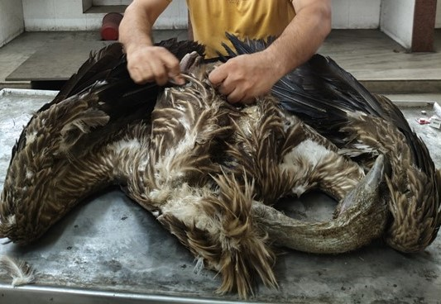
Fig.1: Photograph showing the Himalayan griffon vulture (Gyps himalayensis).

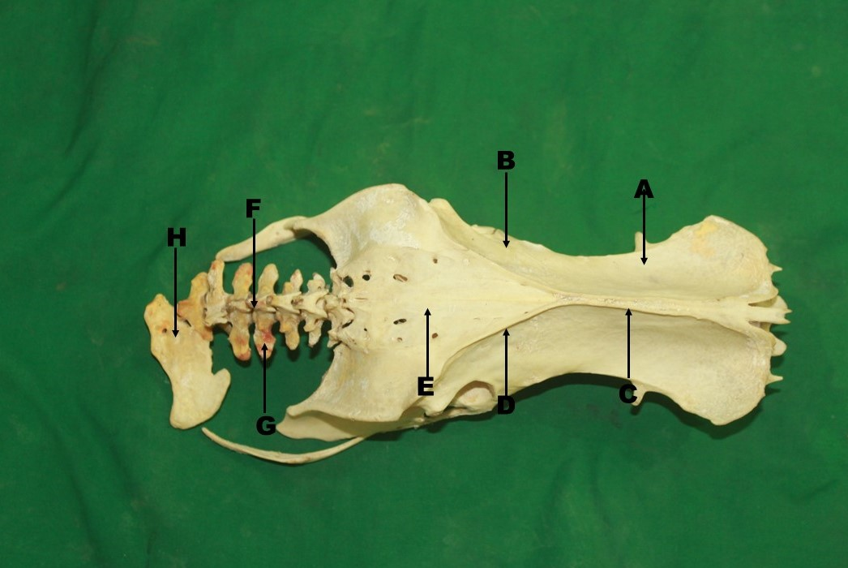
Fig.2: Photograph showing the preacetabular part (A), post acetabular part (B), cranial iliac crest (C) and caudal iliac crest (D) of ilium, Synsacrum (E), Supraspinous process (F), transverse process (G) and last vertebra (H) of Pygostyle of Himalayan griffon vulture (Gyps himalayensis).

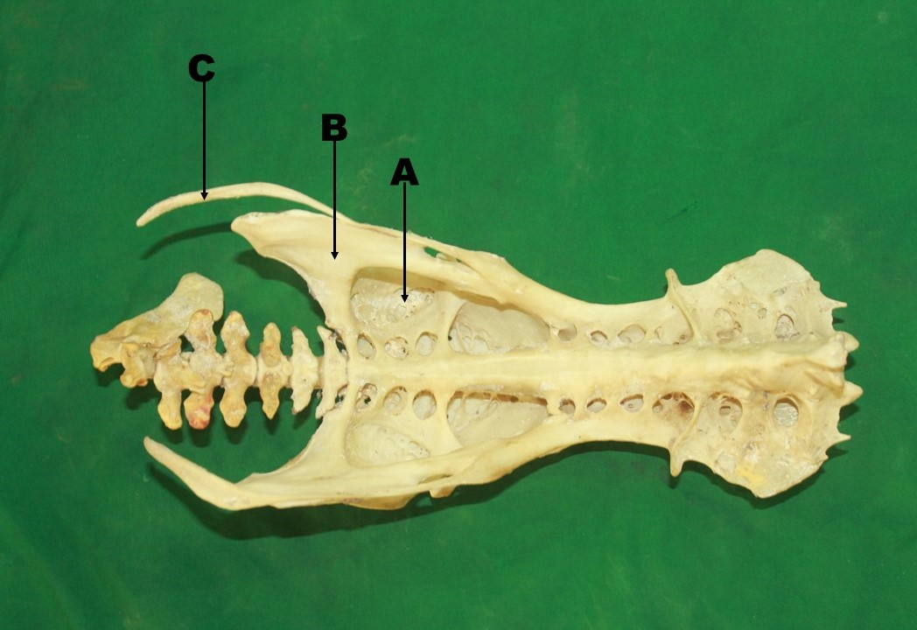
Fig.3: Photograph showing the fossa renalis (A) of ilium, ischium (B) and pubis (C) of Himalayan griffon vulture (Gyps himalayensis).

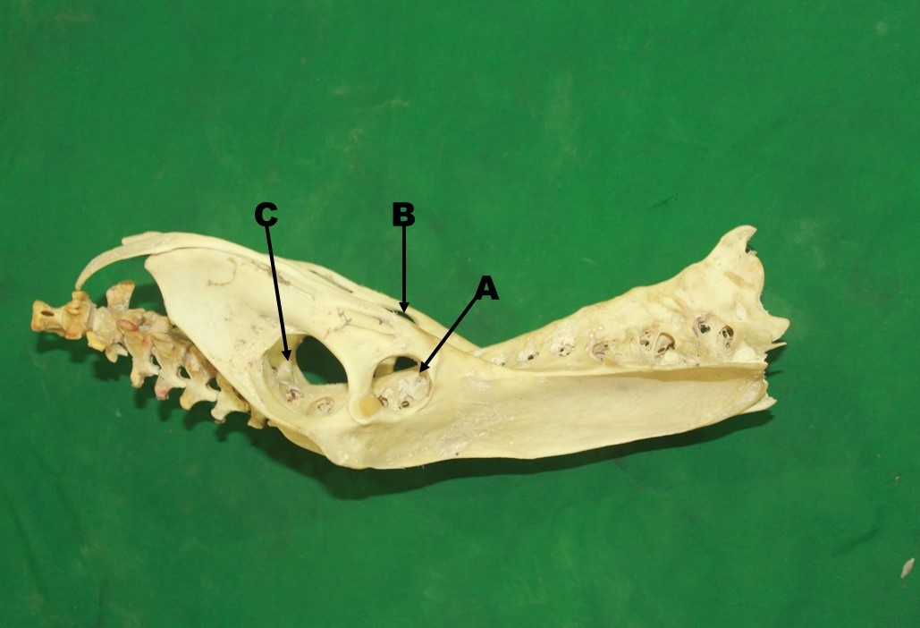
Fig.4: Photograph showing the acetabulum (A), obturator foramen (B) and ilioischiatic foramen (C) of pelvic girdle of Himalayan griffon vulture (Gyps himalayensis).

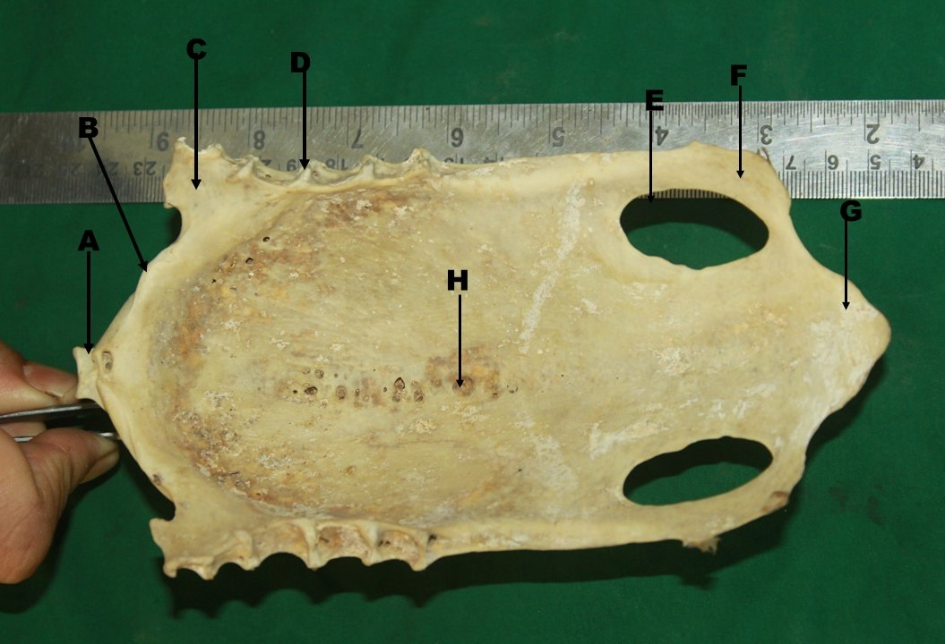
Fig.5: Photograph showing the sternal spine (A), Cranial border (B), Antero-lateral process (C), articular cylinder (D), large oval foramen (E), Postero-lateral process (F), triangular projection (G) and pneumatic foramen (H) of Himalayan griffon vulture (Gyps himalayensis).

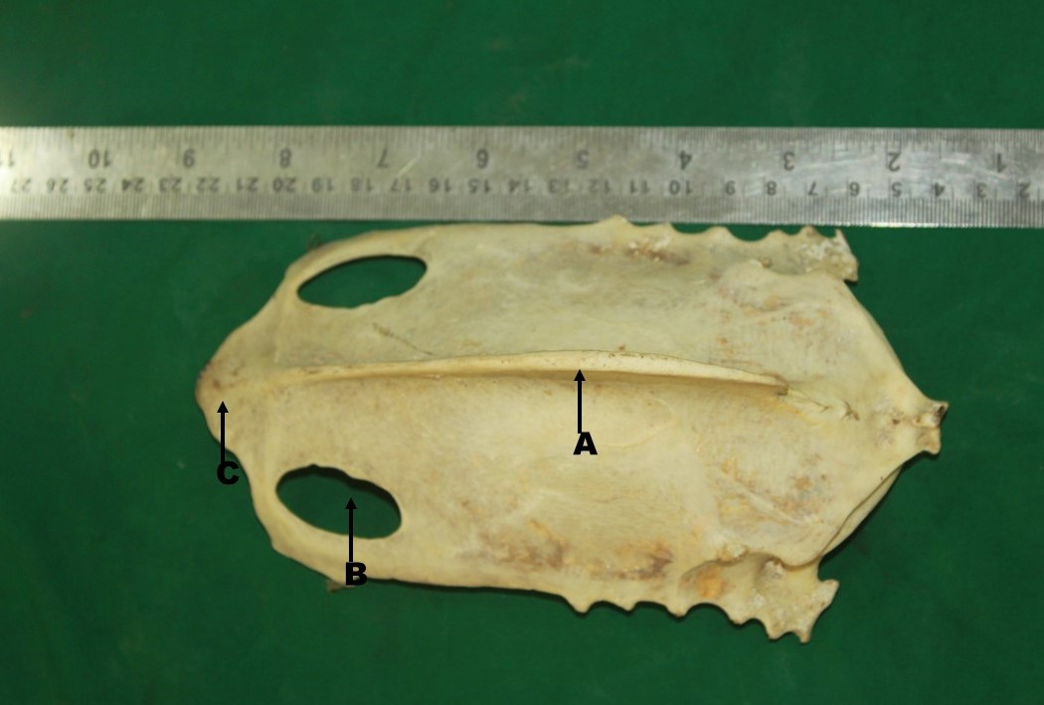
Fig.6: Photograph showing the sternal crest (A), large oval foramen (B) and triangular projection (C) of Himalayan griffon vulture (Gyps himalayensis).

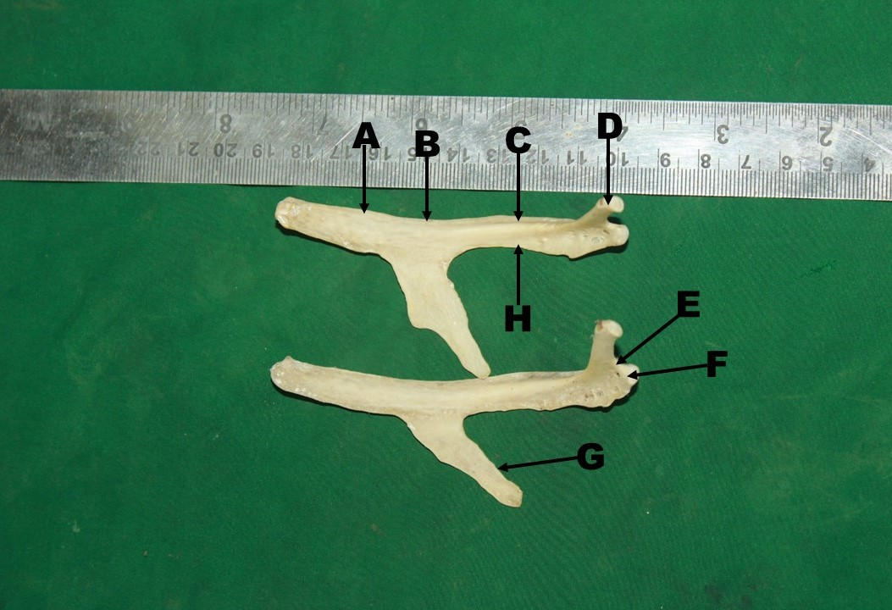
Fig.7: Photograph showing the medial surface (A), cranial border (B), groove (C), tubercle (D), neck (E), Head (F), Uncinate process (G) and caudal border (H) of Himalayan griffon vulture (Gyps himalayensis).

Table.1: Mean ±SE values of pelvic girdle, synsacrum, pygostyle, sternum and ribs of
Himalayan griffon vultures.
Parameters | Mean ± SE (Cm)
Length of ilium | 16.2 ± -0.23
Breadth of ilium | 8.23 ±4.25
Length of ischium | 6.4 ±0.98
Breadth of ischium | 3.3±0.83
Length of pubis | 13.5±0.45
Breadth of pubis | 0.4±0.24
Length of pygostyle | 8.6± 0.32
Length of synsacrum | 21.5 ± 0.35
Depth of fossa renalis | 2.5 ±2.13
Diameter of ilioischiatic foramen | 10.6±1.24
Diameter of acetabulum | 5.9 ±0.47
Diameter of obturator foramen | 4.8±1.36
Length of sternum | 17.9 ±2.57
Breadth of sternum | 8.8 ±0.98
Length of sternal spine | 13.2 ±0.36
Breadth of sternal spine | 2.2 ±0.24
Length of rib | 9.1 ±0.37
Breadth of rib | 0.5±2.46
Length of uncinate process | 3.4±1.26

