Original Research Article
Nesting habits of the Baya Weaver Ploceus philippinus (Linnaeus, 1766) in the agricultural landscape of Dharmabad, Nanded District, Maharashtra, India

.
ABSTRACT

The intricate nesting habits of the Baya Weaver Ploceus philippinus were studied in the agricultural landscape of Dharmabad, Nanded district, Maharashtra, between April and October 2026. This research focuses on Baya Weaver nesting habits such as nesting sites, nesting colonies, nesting materials, nest construction, nest repair, clay deposits on nest walls, various developmental stages of nests and certain threats to their nests. A total of 70 nests at different developmental stages (wad stage, ring stage, helmet stage, egg-chamber closed stage and complete nest stage) were studied. Of the 70 nests, 42 (60%) were active, 18 (26%) were abandoned and 10 (14%) had fallen to the ground. The Baya Weaver uses leaf fibres of palm fronds (Indian date palm), sugarcane leaves, paddy leaves and coarse grasses as nesting materials and takes an average of 18 days, ranging from 6–48 days, depending on the environmental conditions suitable for nest construction. Various anthropogenic activities, environmental factors (monsoon rain, wind, temperature and humidity), and natural predators such as crows, treepies, raptors, snakes and lizards pose threats to the Baya Weaver. Our research findings suggest that the Baya Weaver possesses specific adaptations for nesting in particular tree species, such as acacia and various tall palm trees. The present study enhances understanding of nesting habits of Baya Weaver and provides insights for the conservation of this species.

Keywords: Nesting site, nest colonies, nest development, nest material, nest repair, clay deposition, breeding habits, habitat, threats.

1. INTRODUCTION

Baya Weaver Ploceus philippinus (Linnaeus, 1766) belongs to the class Aves, order Passeriformes and family Ploceidae (Kalita et al., 2024). Baya Weavers are widely distributed across the Indian Subcontinent and Southeast Asia (Pandian, 2024). It is a non-migratory bird but shows local and seasonal movements in response to water and food availability (Quader, 2006). India is home to four species of weaver birds belonging to the genus Ploceus: Ploceus philippinus (Baya Weaver), Ploceus manyar (Streaked Weaver), Ploceus benghalensis (Black-breasted Weaver) and Ploceus megarhynchus (Yellow Weaver) (Craig, 2020; Ali, 2012). The Baya Weaver is a small, sparrow-sized weaver bird renowned for its elaborately woven nests constructed by males; thus, it represents an example of avian engineering (Quader, 2005). The Baya Weaver is a social, gregarious, polygynous and colonial breeder (Abdar, 2013). The breeding season of the Baya Weaver in India spans primarily from April to October, closely associated with the monsoon rains (Pandian, 2023). The Baya Weaver shows remarkable sexual dimorphism during the breeding season (Singh & Dhand, 2017). One behaviour of these birds is that females choose mates based on the quality of nests built by males (Pandian, 2018). During courtship, a male shows its nest to females by flapping its wings and inviting them to inspect and possibly occupy the nest (Pandian, 2022b). After inspecting the nest, the female accepts the male, after which the male proceeds to complete the nest by adding the entrance tunnel (Kalita et al., 2024).
The female lays about 2–4 white eggs and incubates them for about 15 to 18 days. Males occasionally assist females in feeding the chicks, and the chicks leave the nest after 18 days (Mahendra et al., 2024). In the non-breeding season, both males and females resemble female House Sparrows (Craig, 2020). Comparative avian research recognises nest structure, location, construction materials, and building duration as distinct traits that warrant systematic documentation (Sheard et al., 2024).

The Baya Weaver commonly selects habitats such as grasslands, agricultural landscapes, scrub, and secondary growth (Asokan et al., 2008). They mostly prefer tall, unbranched palm trees, such as date palm, coconut, and palmyra palm, as well as thorny trees like acacia species for constructing their pendulous nests (Thiruvenggadam et al., 2022; Yashmita-Ulman et al., 2017). The nests are woven with long strips of paddy leaves, rough grasses, and long strips torn from palm fronds (Borges et al., 2002; Quader, 2005). Nowadays Baya Weavers have adapted to modern life by building their nests in unconventional places such as under house eaves, electric wires and poles (Pandian, 2022a, 2022b). This adaptability shows the resilience of the species in different habitats. The Baya Weaver is an omnivorous bird that primarily eats seeds and grains (granivores) of rice, wheat, sorghum, millet, maize, sunflower and also eats small insects (insectivores), including grasshoppers, flies and beetles (Borges, 2002; Pandian, 2020). The nesting habits of the Baya Weaver were studied by Abdar (2013), Craig (2020), Quader (2005), Borges (2002) and Pathan (2023). Many researchers have studied breeding and nesting behaviour of the Baya Weaver (Kalita et al., 2024; Mahendra et al., 2024; Mallick et al., 2025; Pandian, 2021, 2023, 2024). Research on Dartford warblers has shown that variation in nest-material composition may reflect differences in the vegetation available in the surrounding habitat (Sugasawa et al., 2025). A survey of an agricultural university campus in Telangana recorded Baya Weavers among the birds found in a landscape containing crop fields and agroforestry trees (Reddy et al., 2024).

Baya Weavers are an essential part of the ecosystem, as they are involved in pollination of many flowers, seed dispersal and controlling pest populations (Mallick et al., 2025). However, they face threats such as human interference, habitat destruction, pollution, reduction of grass species used for nest-building material and foraging, climate change, shifts in weather patterns, rainfall timing and changing agricultural practices (Pathan & Goswami, 2023; Pathan et al., 2024; Skagen & Adams, 2012). As a result, their distribution becomes fragmented and sightings of these birds become rare in the wild. According to the IUCN Red List, the Baya Weaver is widely distributed across the Indian subcontinent and Southeast Asia. This species is classified in the Least Concern (LC) category and its population remains stable (BirdLife International, 2024). Various efforts have been undertaken to conserve this species. Organisations like the Bombay Natural History Society (BNHS) (https://www.bnhs.org) and Salim Ali Centre for Ornithology and Natural History (SACON) have launched initiatives to protect their nesting sites. A survey of avian conservation efforts in the Central Indian landscape identified habitat management among the priorities reported by respondents (Niharika & Edgaonkar, 2026).

No other detailed studies of Baya Weaver nesting habits have been documented in this locality. The present study was undertaken to address this research gap.
More specifically, locally documented observations of nest-site selection, nesting materials, construction stages, and threats are needed to characterise nesting habits in the agricultural landscape of Dharmabad.

Objectives:

- To study nesting habits, architectural behaviour, and ecological adaptation of the Baya Weaver.
- To examine nest-building and courtship.
- To understand nest-site selection and habitat preference.
- To identify different sources of nest material.
- To study the various developmental stages of nests.
- To formulate conservation strategies.

2. Materials and methods

2.1 Study area:
The present research was carried out in agricultural areas of Dharmabad, Nanded District, Maharashtra (Kadam, 2026). The people of this area depend primarily on agriculture. The major crops grown are paddy Oryza sativa, sugarcane Saccharum officinarum and jowar Sorghum bicolor.
Nest-supporting plant species, such as Acacia nilotica, palmyra palm, Indian date palm, and coconut palm are abundant in this region.

2.2 Methods:
The field survey was conducted from April 2026 to October 2026. Observations of Baya Weaver nesting sites were made during the active periods from 6:00 am to 10:00 am and from 4:00 pm to 6:00 pm. Using Nikon 8–24×25 Sportstar Zoom Binoculars, Baya Weaver nests, males plucking leaf fibres, various developmental stages of nests, clay deposition by females and the total number of colonies were observed. Nest construction, nest repair, eggs, chicks and various predators were observed and photographed using Nikon D7500 20.9 MP DSLR camera. The collected data were organised into tables, analysed and presented as graphs.

3. RESULTS AND DISCUSSION

The survey of the Baya Weaver colony revealed a total of 70 nests constructed on the acacia tree. Of these, 4 nests were at the wad stage, 7 at the ring stage, 15 at the helmet stage, 10 at the egg-chamber closed stage, and the remaining 34 were complete nests with entrance tubes.

Of the 70 nests, 42 (60%) were active, showing recent breeding activity, while 18 (26%) had been abandoned owing to predation or harsh weather conditions. Furthermore, 10 (14%) nests had fallen to the ground owing to strong winds or attacks by predatory birds. The present study shows the importance of trees such as Acacia and their habitats in supporting the breeding and nesting activities of Baya Weavers.

Initiation of Nest Construction
Nest construction by the male Baya Weaver in India begins primarily at the start of the monsoon season, generally from April to October.

Selection of Tree Species
Baya Weavers prefer trees based on predator safety, access to nest-building materials, and stability in various abiotic factors.
Baya Weavers use thorny Acacia species (Acacia nilotica) (Picture 1) and tall palm trees (Indian date palm, Palmyra palm, coconut palm) to suspend and anchor their elaborate, flask-shaped nests. This demonstrates their adaptability in nesting habits.

Sources of Nest Material
Baya Weavers primarily use long leaf fibres and strips from sugarcane (Saccharum officinarum), Indian date palm (Phoenix sylvestris), Palmyra palm (Borassus flabellifer), coconut palm (Cocos nucifera), long grass blades (such as Cynodon dactylon), rough grasses, and paddy leaves (Oryza sativa) to construct their hanging nests.

Stages of Nest Construction
There are five developmental stages of nest construction, namely wad stage, ring stage, helmet stage, egg-chamber closed stage, and complete nest stage.

- Wad stage
The wad stage is the first foundational phase of nest building by the male Baya Weaver.
This consists of a small initial clump or knot of woven plant fibres (such as grass, palm or date-palm strips) attached securely to a tree branch.
The male takes between 2 and 6 hours to form the basic wad. It forms an anchoring point.

- Ring Stage
Working downward from the wad, the male weaves a thick vertical strap that splits into a circular loop or ring.
This open loop outlines the future entrance and main frame of the egg-brooding chamber.
The male takes 5 days to complete the ring stage.

- Helmet stage
The helmet stage is a crucial intermediate phase in the nest-building process.
The nest shape is like an upside-down, half-woven dome resembling a riding helmet (Picture 3a).
It forms an upper portion and a partial outline of the egg-laying chamber.
The males took about 6–8 days to construct nests at the helmet stage.

- Egg-chamber closed stage
The open helmet-shaped nest is expanded and sealed off into a complete spherical or retort-shaped egg chamber (Picture 3b).
After completing nests at the helmet stage, males wait for females to select their nests, followed by mate pairing.
The male takes nearly 1 uninterrupted day to construct and complete the egg-chamber closed stage.

- Complete Nests
Once paired, the male resumes and finishes the structure by weaving the long, downward-pointing vertical entrance tube (Picture 3c).
A male Baya Weaver takes an average of 18 days to complete the entire nest construction.

Clay Reinforcement
Male Baya Weavers plaster small lumps of wet clay onto the inner walls of nests at the helmet stage to add structural stability, weight, and balance during heavy monsoon winds and storms.

Nest repairing
Male Baya Weaver birds actively inspect and repair damaged or weathered hanging nests by weaving in fresh, green strips of grass and plant fibres to tighten loose structures and reinforce weak attachment points (Picture 4).

Threats
The Baya Weaver nests face major threats from habitat destruction, human activities, avian and animal predators (crow species, Rufous treepie, Shikra), weather-related and environmental stresses (climate change, monsoon winds and heavy rains).

b
aaAadaaa
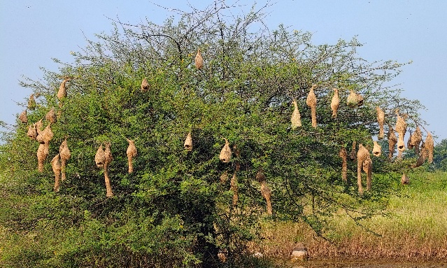 | 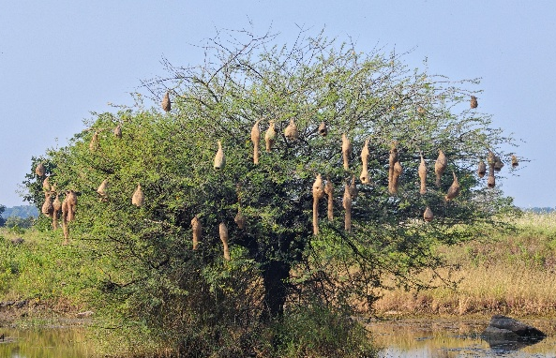

Picture 1. Nest colonies on Acacia nilotica tree in agricultural landscape of Dharmabad: a- Nesting colony- I, b- Nesting colony- II. © Sanket Kadam.

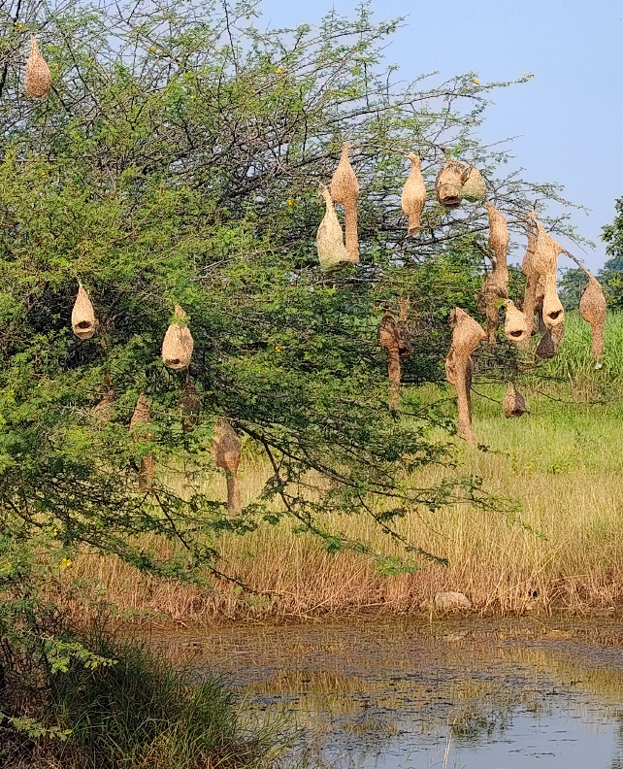

Picture 2. Nests attached to the tip of an Acacia nilotica tree branch. © Sanket Kadam.

b
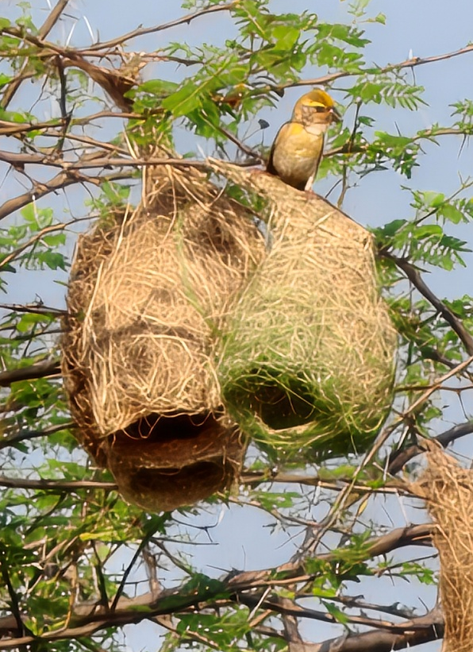  a | 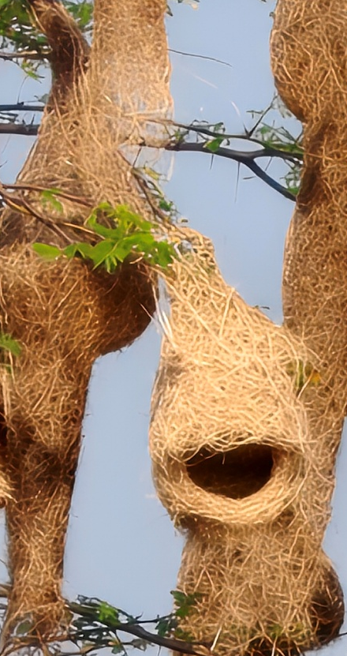
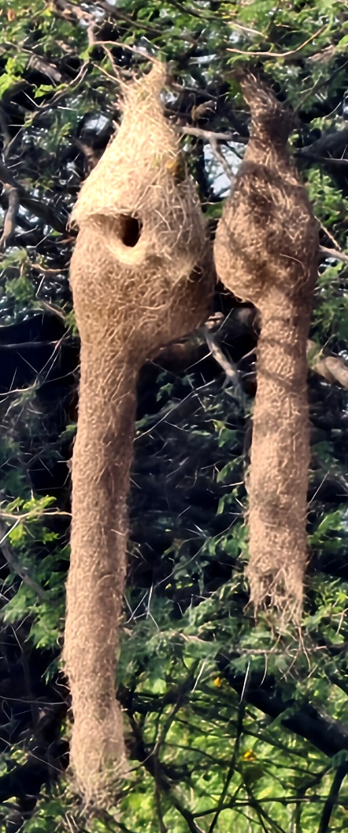  c | 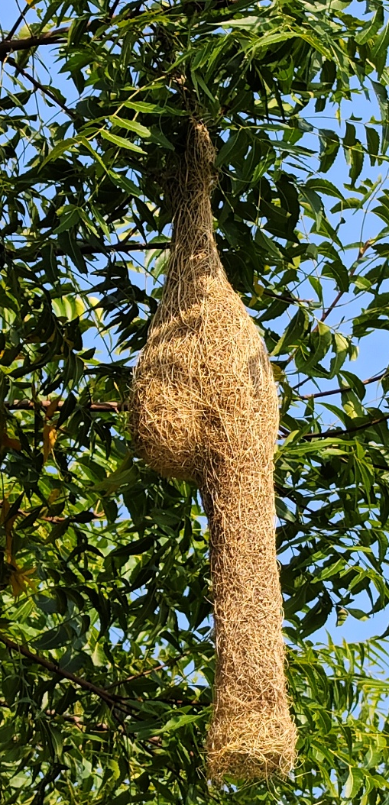  c

Picture 3. Various stages of nest development: a-Helmet stage nest 2, b-Egg-chamber closed stage nest, c- Complete nest with entrance tube: 1. Acacia nilotica, 2. Azadirachta indica.
© Sanket Kadam.

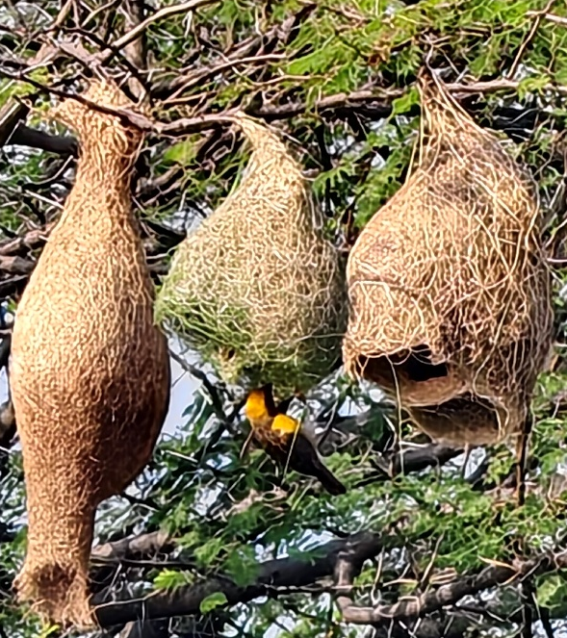 | 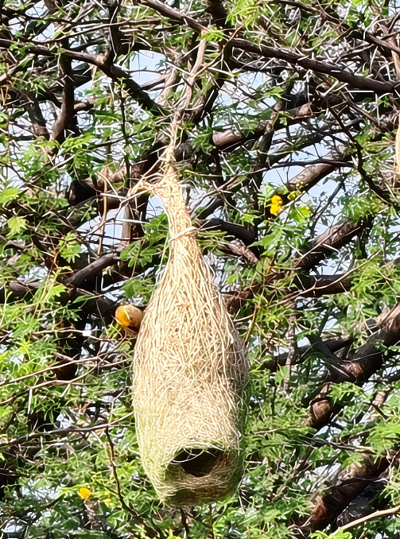

Picture 4. Nest repairing of helmet stage nest from old stalk by male Baya Weaver.
© Sanket Kadam.

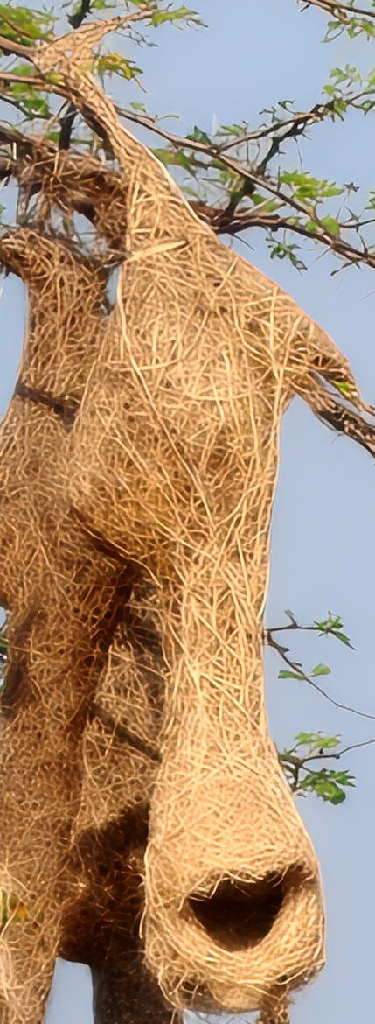

Picture 5. Buttressed nest (Two storeyed nest). © Sanket Kadam.

Fig. 1. Pie-chart representing Developmental stages of Nest construction of Baya weaver.

4. Conclusion

This is a systematic study of the nesting habits of the Baya Weaver in the specific geographical area of Dharmabad, Nanded, Maharashtra. The nesting behaviour of the Baya Weaver illustrates natural creativity, innovation and adaptability.
Habitat loss, urbanisation, shifts in agricultural practices, the rapid expansion of monoculture, climate change, anthropogenic activities and human–wildlife conflict contribute to a decline in the Baya Weaver population. As a result, conservation measures should be undertaken to support the survival of these birds in the landscape.

- The present systematic survey will help in drafting an action plan to conserve the populations of the Baya Weaver.
- Establish community-level or special management zones around known nesting colonies to monitor breeding seasons.
- Restrict pesticide and chemical usage in adjacent agricultural areas to safeguard the birds’ diet and breeding health.
- Protect the margins of wetlands, ponds, rivers, and irrigation canals.
- Maintain nearby grasslands, reedbeds, and cereal or millet agricultural fields that supply raw nesting fibres.
- The impact of environmental factors such as rain, wind, temperature and humidity needs to be studied.
- Enforce local wildlife protection laws to prevent the illegal trapping or trade of weaver birds, their eggs, or active nests.

No documentation of the nesting habits of the Baya Weaver is available from this locality. Therefore, the present study provides an initial account of Baya Weaver nesting habits in this locality.
These research findings will encourage ornithologists, researchers, educators, students, and wildlife enthusiasts to broaden their perspective on the ecological importance and conservation of the Baya Weaver.

Limitations
Observations were confined to the agricultural landscape of Dharmabad and one reported study period (April–October 2026), limiting broader geographical and seasonal interpretation. Although 70 nests were documented, the study does not provide systematic measurements of nest height, breeding success or quantified exposure to predators and environmental conditions. Consequently, the relative influence of individual threats cannot be determined from the reported observations. The locality-specific dataset also does not establish regional population trends or permit robust comparisons among nesting tree species.

Declaration of AI Use

This manuscript was prepared through the intellectual contributions of the author(s) to the study design, data analysis, interpretation of results, and scholarly content. Grammarly and ChatGPT were used solely to assist with grammatical refinement and reference formatting during manuscript revision. The author(s) accept full responsibility for the accuracy, integrity, and final content of the manuscript.

COMPETING INTERESTS DISCLAIMER:
Authors have declared that they have no known competing financial interests OR non-financial interests OR personal relationships that could have appeared to influence the work reported in this paper.

References
Abdar, M. R. (2013). Nesting ecology of Baya Weaver Ploceus philippinus (Linnaeus): Passeriformes. In B. Jadhav, U. Jadhav, & U. Bagde (Eds.), Current trends in life sciences (pp. 75–80). Lambert Academic Publishing.
Ali, S. (2012). The book of Indian birds (13th ed.). Oxford University Press. https://gsl.lbsnaa.gov.in/cgi-bin/koha/opac-detail.pl?biblionumber=174632
Asokan, S., Ali, A. M. S., & Nagarajan, R. (2008). Studies on nest construction and nest microclimate of the Baya Weaver, Ploceus philippinus (Linn.). Journal of Environmental Biology, 29(3), 393–396. https://www.jeb.co.in/journal_issues/200805_may08/paper_22.pdf
BirdLife International. (2024). Ploceus philippinus. The IUCN Red List of Threatened Species 2024, e.T22719005A263926922. https://doi.org/10.2305/IUCN.UK.2024-2.RLTS.T22719005A263926922.en
Borges, S. D., Desai, M., & Shanbhag, A. B. (2002). Selection of nest platforms and the differential use of nest building fibres by the Baya Weaver, Ploceus philippinus Linnaeus 1766. Tropical Zoology, 15(1), 17–25. https://doi.org/10.1080/03946975.2002.10531164
Craig, A. J. F. K. (2020). Baya Weaver (Ploceus philippinus) (Version 1.0). In J. del Hoyo, A. Elliott, J. Sargatal, D. A. Christie, & E. de Juana (Eds.), Birds of the world. Cornell Lab of Ornithology. https://doi.org/10.2173/bow.baywea1.01
Borges, S. D., Desai, M., & Shanbhag, A. B. (2002). Selection of nest platforms and the differential use of nest building fibres by the Baya Weaver, Ploceus philippinus Linnaeus 1766. Tropical Zoology, 15(1), 17–25. https://doi.org/10.1080/03946975.2002.10531164
Kadam, S. (2026). Avian diversity of Lal Bahadur Shastri Mahavidyalaya campus, Dharmabad, Maharashtra: A comprehensive checklist. Uttar Pradesh Journal of Zoology, 47(18), 1–7. https://doi.org/10.56557/upjoz/2026/v47i185852
Kalita, N., Bora, N., Choudhury, S., & Sahariah, D. (2024). Species distribution modelling of Baya Weaver Ploceus philippinus in Nagaon District of Assam, India: A zoogeographical analysis. Journal of Threatened Taxa, 16(3), 24949–24955. https://doi.org/10.11609/jott.8865.16.3.24949-24955
Mahendra, B. V., Kavitha, R. S., & Varija, S. H. (2024). Selection of nesting platform and architectural design significantly impact on mate choice in Baya Weaver bird, Ploceus philippinus Linnaeus 1766. Journal of Environment & Bio-Sciences, 38(1), 75–78. https://doi.org/10.59467/JEBS.2024.38.75
Mallick, M. A. I., Komal, K., Paik, S., Shree, D., Acharjee, S., Pankaj, S., & Ansari, S. A. (2025). Nesting ecology of Baya Weaver (Ploceus philippinus) in Ghatshila, Jharkhand, India. Journal of Fauna Biodiversity, 2(2), 45–51. https://doi.org/10.70206/jfb.v2i2.15689
Niharika, M., & Edgaonkar, A. (2026). Conservation efforts for terrestrial bird species assemblages in the Central Indian landscape. Journal of Global Ecology and Environment, 22(3), 348–362. https://doi.org/10.56557/jogee/2026/v22i311001
Pandian, M. (2018). Baya Weaver bird: Nest colonies and abnormal nests of Ploceus philippinus in Tindivanam Taluk, Villupuram District, Tamil Nadu, India. Zoo’s Print, 33(12), 15–27. https://doi.org/10.11609/zp.v33i12.3608
Pandian, M. (2020). Foraging behaviours of Baya Weaver Ploceus philippinus, during non-breeding seasons in northern Tamil Nadu, India. Zoo’s Print, 35(6), 29–32. https://doi.org/10.11609/zp.v35i6.5700
Pandian, M. (2021). Nesting habits of Baya Weaver Ploceus philippinus (Linnaeus, 1776) in rural Arakkonam Taluk, Vellore District, Tamil Nadu, India. Journal of the Bombay Natural History Society, 118, 3–17. https://doi.org/10.17087/jbnhs/2021/v118/144638
Pandian, M. (2022a). Nest colonies of Baya Weaver Ploceus philippinus (Linnaeus, 1766) on overhead power transmission cables in the agricultural landscape of Cuddalore and Villupuram districts (Tamil Nadu) and Puducherry, India. Journal of Threatened Taxa, 14(3), 20721–20732. https://doi.org/10.11609/jott.7748.14.3.20721-20732
Pandian, M. (2022b). Nesting habits of the Baya Weaver Ploceus philippinus (Linnaeus, 1766) in the agricultural landscape of Tindivanam, Tamil Nadu, India. Journal of Threatened Taxa, 14(5), 20970–20987. https://doi.org/10.11609/jott.7762.14.5.20970-20987
Pandian, M. (2023). Nest construction and repairing habits of Baya Weaver Ploceus philippinus (Aves: Passeriformes: Ploceidae) in the agricultural landscape of Villupuram District, Tamil Nadu, India. Journal of Threatened Taxa, 15(9), 23843–23856. https://doi.org/10.11609/jott.8149.15.9.23843-23856
Pandian, M. (2024). Nesting habits of Baya Weaver Ploceus philippinus (Linnaeus, 1766) on power and television cables in the agricultural landscape of Kallakurichi district, Tamil Nadu, India. Journal of Threatened Taxa, 16(6), 25345–25359. https://doi.org/10.11609/jott.8323.16.6.25345-25359
Pathan, Y., & Goswami, A. (2023). A review of Baya Weaver Ploceus philippinus (Linnaeus, 1766) (Aves: Passeriformes: Ploceidae): Ecological and conservation status. Journal of Threatened Taxa, 15(12), 24357–24367. https://doi.org/10.11609/jott.8260.15.12.24357-24367
Pathan, Y., Goswami, A., & Trivedi, V. M. (2024). Population status of Baya Weaver (Ploceus philippinus) in peninsular region Saurashtra of Gujarat, India. Uttar Pradesh Journal of Zoology, 45(16), 326–333. https://doi.org/10.56557/upjoz/2024/v45i164313
Quader, S. (2005). Elaborate nests in a weaverbird: A role for female choice? Ethology, 111(12), 1073–1088. https://doi.org/10.1111/j.1439-0310.2005.01134.x
Quader, S. (2006). Sequential settlement by nesting male and female Baya weaverbirds Ploceus philippinus: The role of monsoon winds. Journal of Avian Biology, 37(4), 396–404. https://doi.org/10.1111/j.0908-8857.2006.03607.x
Quader, S. (2005). Elaborate nests in a weaverbird: A role for female choice? Ethology, 111(12), 1073–1088. https://doi.org/10.1111/j.1439-0310.2005.01134.x
Reddy, V. R., Rajashekhar, M., Sunitha, V., Issai, A. S., Gurumurthy, P., Vaidyula, V. R., & Mounika, G. (2024). Avifaunal diversity in Telangana State: A case study in campus of Professor Jayashankar Telangana State Agricultural University, Rajendranagar, Hyderabad, India. Journal of Experimental Agriculture International, 46(5), 672–680. https://doi.org/10.9734/jeai/2024/v46i52421
Pathan, Y., & Goswami, A. (2023). A review of Baya Weaver Ploceus philippinus (Linnaeus, 1766) (Aves: Passeriformes: Ploceidae): Ecological and conservation status. Journal of Threatened Taxa, 15(12), 24357–24367. https://doi.org/10.11609/jott.8260.15.12.24357-24367
Sheard, C., Street, S. E., Healy, S. D., Troisi, C. A., Clark, A. D., Yovcheva, A., Trébaol, A., Vanadzina, K., & Lala, K. N. (2024). Nest traits for the world's birds. Global Ecology and Biogeography, 33(2), 206–214. https://doi.org/10.1111/geb.13783
Singh, P., & Dhand, S. (2017). Temperature effect on breeding biology and abnormal nest behaviour of Baya Weaver (Ploceous philippinus) in semi-arid area of Shekhawati region in Rajasthan. Kaav International Journal of Science, Engineering & Technology, 4(3), 1–7. https://www.kaavpublications.org/abstract/SAMPLE_1_PDF.pdf
Skagen, S. K., & Yackel Adams, A. A. (2012). Weather effects on avian breeding performance and implications of climate change. Ecological Applications, 22(4), 1131–1145. https://doi.org/10.1890/11-0291.1
Sugasawa, S., Hansell, M., Reilly, M., & Healy, S. D. (2025). Causes and consequences of material variation in avian nest building. Journal of Avian Biology, 2025(2), e03438. https://doi.org/10.1002/jav.03438
Thiruvenggadam, T., Mohd Top, M., Nulit, R., & Puan, C. L. (2022). Influence of climatic factors and nest tree characteristics on the nest structures of the Baya Weaver (Ploceus philippinus) in Peninsular Malaysia. Animals, 12(7), 815. https://doi.org/10.3390/ani12070815
Yashmita-Ulman, Kumar, A., & Sharma, M. (2017). Traditional home garden agroforestry systems: Habitat for conservation of Baya Weaver Ploceus philippinus (Passeriformes: Ploceidae) in Assam, India. Journal of Threatened Taxa, 9(4), 10076–10083. https://doi.org/10.11609/jott.3090.9.4.10076-10083

