Phenotypic Morphometry and Gross Anatomy of Certain Visceral organ with Scanning Electron Microscopy of Liver as well as Lung of Indian Gharial (Gavialis gangeticus)

Abstract
The Indian gharial (Gavialis gangeticus) is a critically endangered crocodilian species for which detailed anatomical information remains limited. In particular, studies on its phenotypic morphometry, gross anatomy of visceral organs, and scanning electron microscopic features of the liver and lungs are scarce. Such anatomical investigations may provide useful baseline information for comparative anatomical studies and wildlife veterinary assessment. This descriptive investigation examined the phenotypic morphometry, gross anatomy of selected visceral organs, and scanning electron microscopic features of the liver and lung of an Indian gharial. A female carcass recovered near the Nijlaguri River in Assam was subjected to post-mortem examination. External measurements were recorded, the visceral organs were examined, and liver and lung tissue samples were fixed in 2.5% glutaraldehyde for scanning electron microscopy. The reported body length, tail length, chest girth, neck girth and body weight were 6 ft 11 inches, 2 ft 8 inches, 11 ft 11 inches, 1 ft 7 inches and 27.45 kg, respectively. Gross examination showed that the liver comprised right and left lobes, with the right lobe larger than the left. The stomach formed a sac-like enlargement between the oesophagus and duodenum. The lungs had dorsal and ventral borders and lateral and medial surfaces, while the trachea divided into left and right bronchi. The heart was four-chambered, the kidneys showed distinct cortical and medullary regions, and the ovary was elongated and attached to the mesovarium. Scanning electron microscopy revealed pulmonary alveoli, bronchus-associated lymphoid tissue and a net-like structure. Liver images showed hepatic sinusoids, hepatocytes, vascular and biliary structures, and red blood cells within the sinusoids. These findings provide descriptive anatomical observations from a single specimen that may support further comparative investigations.

Key words: Phenotypic morphometry; Gross anatomy; Indian gharial; Visceral organs; Scanning electron microscopy; Liver; Lung

Introduction:
The Indian gharial is also known as the fish-eating crocodile and is one of the longest living crocodilians. The wild population of the Indian gharial is decreasing due to habitat loss and killing by people for indigenous medicine. Recent work on threatened freshwater fauna in India has identified habitat degradation and fragmentation as conservation concerns for freshwater species (Paul et al., 2025). The animal is classified as Critically Endangered by the International Union for Conservation of Nature and is listed under Schedule I of the Wildlife (Protection) Act, 1972. A field study in a regulated, unprotected Indian river identified associations between gharial distribution, river characteristics and human activities (Panda et al., 2023). The body of the Indian gharial is relatively slender and elongated, with a slender, parallel-sided snout. It has approximately 100 sharp, interlocking teeth. The dorsal surface is olive to tan, with dark blotches or bands, whereas the belly is pale. The animal is distributed in the Ganga, Indus, Brahmaputra and Mahanadi rivers of northern and eastern India, Pakistan, Nepal, Bhutan and Bangladesh. It inhabits large rivers with sandbanks and is a specialised fish-eater. It nests on sandbanks or alluvial deposits, laying 7–60 eggs, with an incubation period of 62 days. The diameter of the eggs and the length of the hatchlings are 59–64 mm and 172–176 mm, respectively (Das & Das, 2018). Knowledge of the phenotypic morphometry and gross anatomy of the visceral organs of the Indian gharial is important for wildlife veterinarians involved in disease control in this Schedule I, Critically Endangered species. The lung of the Indian gharial differs markedly from those of other reptiles, and variation in pulmonary structure within this reptilian group is noticeable (Porter, 1972). Comparative CT-based research on the lungs of Cuvier's dwarf caiman and the American alligator has described both shared and variable features of crocodilian bronchial architecture (Schachner et al., 2022). Scanning electron microscopy is a complementary approach in biomedical studies with a morphological basis and can be correlated with conventional electron microscopy. It enables the examination of different cell surfaces and provides information on the three-dimensional micro-organisation of tissues and organs. Refinements in scanning electron microscopy have made it possible to obtain readily interpretable and reproducible images of three-dimensional features and the spatial arrangement of individual cells within tissues. Even parenchymal organs, such as the liver, can be prepared and examined by correlated scanning electron microscopy. The present study examines the fine surface morphological characteristics of the liver and lung of the Indian gharial. Literature on the phenotypic morphometry, gross anatomy and scanning electron microscopy of the liver and lung of the Indian gharial is limited. Therefore, the present study was designed to establish anatomical descriptions of these organs and to examine the phenotypic morphometry and scanning electron microscopic features of the liver and lung as components of the digestive and respiratory systems.
Objective: This study aimed to document the phenotypic morphometry and gross anatomy of selected visceral organs of the Indian gharial (Gavialis gangeticus) and examine the liver and lung using scanning electron microscopy.
Materials and Methods:
The carcass of an Indian gharial was found on 7 October 2019 in the Nijlaguri River (N26°44’02.51’, E90°27’35.06’), according to a report from a forest official of Runikata Range, Chirang Division. On the following day, the carcass was transferred to the Field Director's office, Manas Tiger Reserve, Barpeta Road, Assam, for post-mortem examination. Before the post-mortem examination, the Indian gharial was identified as female by inserting a probe into the cloaca (Fig.4). Phenotypic morphometry was then studied, and the post-mortem examination was conducted. During the examination, the visceral organs were studied, and liver and lung tissue samples were collected and fixed in 2.5% glutaraldehyde for scanning electron microscopy. After fixation, the tissue samples were processed according to the standard method of SAIF, NEHU, Meghalaya. The processed tissue samples were examined at IASST, Pashim Boragaon, Guwahati, Assam.
Results:
In the present investigation, the body length (tip of the snout to tip of the tail), tail length, chest girth, neck girth and weight of the Indian gharial were 6 ft 11 inches, 2 ft 8 inches, 11 ft 11 inches, 1 ft 7 inches and 27.45 kg, respectively. The snout was blunt (Fig.1), and the teeth were sharp (Fig.2). The eyes were well developed, with upper and lower eyelids and a prominent nictitating membrane. The upper eyelid enclosed a bony support. The animal also had an external ear opening immediately behind the eye as a longitudinal slit, guarded above and below by folds of skin. Rounded horny thickenings of the skin (Fig.3) were observed. On the animal's back, these thickenings were underlain by bony plates of the same shape that adhered closely to them. Some bony plates were crested, and the horny thickenings followed the crests.
The liver of the Indian gharial consisted of two lobes, namely the right and left lobes. The right lobe was larger than the left lobe. The lobes were triangular and joined dorsomedially by a narrow isthmus (Fig.8). The liver was surrounded by Glisson’s capsule. The gall bladder was pouch-like and attached caudally to the right lobe of the liver in the dorsomedial region.
The stomach was a sac-like enlargement of the alimentary canal (Fig.9), situated between the oesophagus and duodenum, with a large, C-shaped sac on the left side and a smaller, spherical sac on the right side. The inner surface of the stomach contained foveolae gastricae and plica gastricae (Fig.11). The duodenum arose from the pyloric part of the stomach and was the first part of the intestine. The duodenum was followed by the jejunum and ileum. The jejunum had numerous small U-shaped loops with mesenteric attachments. The ileum was followed by the caecum, colon and rectum. The ascending colon consisted of three parts, namely the centripetal turn, central flexure and centrifugal turn (Fig.10).
The Indian gharial breathes through its lungs. Its respiratory system is adapted for both air and water. The lungs had multiple chambers (Fig.14). A net-like structure was also observed in the lung of the Indian gharial (Fig.15). The lung had two borders, dorsal and ventral; two surfaces, lateral and medial; a base; and an apex. The dorsal border was irregular and thick, whereas the ventral border was sharp and thin (Fig.5). The lateral surface was smooth and convex, whereas the medial surface was concave and contained the hilus.
The trachea (Fig.5) of the Indian gharial was located ventral to the oesophagus. The tracheal rings were complete. The trachea extended from the back of the oral cavity to the base of the heart, where it branched into two bronchi, namely the left and right bronchi.
The thymus (Fig.5) was a bilobed organ situated ventral to the base of the heart. The thymus was pale pink to greyish-red. It was almost triangular in shape and firmly attached to the trachea.
The heart of the Indian gharial had four chambers, namely the right atrium, right ventricle, left atrium and left ventricle. Of these four chambers, the right ventricle was the cranialmost compartment of the heart. The wall of the right ventricle was thinner than that of the left ventricle. The right atrioventricular opening contained three valves. Three papillary muscles were observed inside the right ventricle, and these were attached to the valves by the chordae tendineae. Trabeculae carneae were also observed within these structures. The right and left atria contained auricles, which were sac-like structures. The apex of the heart was formed by the left ventricle (Fig.6). The ascending and descending aortae arose from the base of the heart (Fig.7).
The kidney of the Indian gharial was located below the lumbar vertebrae. The kidney had two borders, namely the medial and lateral borders (Fig.12). Both borders were uneven. The cranial and caudal poles, or extremities, were blunt. The hilus was located on the medial border. The kidney had a distinct outer cortex and inner medulla (Fig.13).
The ovary of the Indian gharial was elongated and attached to the mesovarium. The infundibulum was funnel-shaped, and the ampulla was tortuous (Fig.16).
Scanning electron microscopy showed that the lung tissue contained numerous alveoli lined by simple squamous epithelium. In addition to the alveoli (Fig.20), bronchus-associated lymphoid tissue (BALT) (Fig.21) and a net-like structure (Fig.24) were observed. B and T lymphocytes were found in the BALT. The surfaces of the B lymphocytes appeared woollen-ball-like, whereas those of the T lymphocytes were smooth (Fig.22 & Fig.23). In the liver tissue, the parenchyma consisted of hepatic sinusoids and hepatocytes. At higher magnification, each hepatocyte was irregularly shaped and had a prominent central nucleus. The sinusoids were lined by simple endothelial cells resting on a basement membrane. The spaces between the hepatocytes consisted of intersinusoidal cords. In addition, the hepatic triad (hepatic portal vein, hepatic artery and bile duct) was identified among the liver lobes (Fig.18). Red blood cells (RBCs) occluded the hepatic sinuses (Fig.19). Intersinusoidal connective tissue was also observed (Fig.17).
Discussions:
In the present investigation, the body length (tip of the snout to tip of the tail), tail length, chest girth, neck girth and weight of the Indian gharial were 6 ft 11 inches, 2 ft 8 inches, 11 ft 11 inches, 1 ft 7 inches and 27.45 kg, respectively. The snout was blunt. The eyes were well developed, with upper and lower eyelids and a prominent nictitating membrane. The upper eyelid enclosed a bony support. The animal also had an external ear opening immediately behind the eye as a longitudinal slit, guarded above and below by folds of skin. Rounded horny thickenings of the skin were observed. On the animal's back, these thickenings were underlain by bony plates of the same shape that adhered closely to them. Some bony plates were crested, and the horny thickenings followed the crests. Similar findings were reported by Hyman (2004) in alligators.
The liver of the Indian gharial consisted of two lobes, namely the right and left lobes. The right lobe was larger than the left lobe. The lobes were triangular and joined dorsomedially by a narrow isthmus. The liver was surrounded by Glisson’s capsule. The gall bladder was pouch-like and attached caudally to the right lobe of the liver in the dorsomedial region. These findings were in agreement with those of Van Wilpe (2012) in the juvenile Nile crocodile.
The stomach was a sac-like enlargement of the alimentary canal situated between the oesophagus and duodenum, with a large, C-shaped sac on the left side and a smaller, spherical sac on the right side. The inner surface of the stomach contained foveolae gastricae and plica gastricae. A similar observation was reported by Nickel et al. (1979) in pigs. The duodenum arose from the pyloric part of the stomach and was the first part of the intestine. It was followed by the jejunum and ileum. The jejunum had numerous small U-shaped loops with mesenteric attachments. These findings were in agreement with those of King and McLelland (1975) in fowl. The ileum was followed by the caecum, colon and rectum. The ascending colon consisted of three parts, namely the centripetal turn, central flexure and centrifugal turn. Similar findings were reported by Nickel et al. (1979) in ruminants.
The Indian gharial breathes through its lungs. Its respiratory system is adapted for both air and water. The lungs had multiple chambers. The lung had two borders, dorsal and ventral; two surfaces, lateral and medial; a base; and an apex. The dorsal border was irregular and thick, whereas the ventral border was sharp and thin. The lateral surface was smooth and convex, whereas the medial surface was concave and contained the hilus. These findings were in agreement with those of Ghosh (2015) in cattle. The base and apex of the lung were blunt.
The trachea of the Indian gharial was located ventral to the oesophagus. The tracheal rings were complete. The trachea extended from the back of the oral cavity to the base of the heart, where it branched into two bronchi, namely the left and right bronchi. These findings were consistent with those of Banerjee and Ghosh (2020) in the Indian cobra (Naja naja).
The thymus was a bilobed organ situated ventral to the base of the heart. The thymus was pale pink to greyish-red. Similar findings were reported by Yugesh et al. (2014) in pigs. The thymus was almost triangular in shape and firmly attached to the trachea.
The heart of the Indian gharial had four chambers, namely the right atrium, right ventricle, left atrium and left ventricle. Of these four chambers, the right ventricle was the cranialmost compartment of the heart. The wall of the right ventricle was thinner than that of the left ventricle. The right atrioventricular opening contained three valves. Three papillary muscles were observed inside the right ventricle, and these were attached to the valves by the chordae tendineae. Trabeculae carneae were also observed within these structures. The right and left atria contained auricles, which were sac-like structures. The apex of the heart was formed by the left ventricle. The ascending and descending aortae arose from the base of the heart. These findings were consistent with those of Crick et al. (1998) in pigs.
The kidney of the Indian gharial was located below the lumbar vertebrae. The kidney had two borders, namely the medial and lateral borders. Both borders were uneven. The cranial and caudal poles, or extremities, were blunt. The hilus was located on the medial border. The kidney had a distinct outer cortex and inner medulla. Similar findings were reported by Nickel et al. (1979) in cattle.
The ovary of the Indian gharial was elongated and attached to the mesovarium. The infundibulum was funnel-shaped. Similar findings were reported by Ghosh (2015) in cattle and Deka et al. (2014) in Pati and Chara-Chemballi ducks. The ampulla was also observed to be tortuous.
Scanning electron microscopy showed that the lung tissue contained numerous alveoli lined by simple squamous epithelium. In addition to the alveoli, bronchus-associated lymphoid tissue (BALT) and a net-like structure were observed. These findings were in agreement with those of Barman et al. (1996) in goats. B and T lymphocytes were found in the BALT. The surfaces of the B lymphocytes appeared woollen-ball-like, whereas those of the T lymphocytes were smooth. A similar observation was reported by Nazerian et al. (1976) in chickens. In the liver tissue, the parenchyma consisted of hepatic sinusoids and hepatocytes. At higher magnification, each hepatocyte was irregularly shaped and had a prominent central nucleus. The sinusoids were lined by simple endothelial cells resting on a basement membrane. The spaces between the hepatocytes consisted of intersinusoidal cords. In addition, the hepatic triad (hepatic portal vein, hepatic artery and bile duct) was identified among the liver lobes. These findings were consistent with those of Boonyoung et al. (2017) in the dog-faced water snake. Red blood cells (RBCs) also occluded the hepatic sinuses. Intersinusoidal connective tissue was observed.
Summary and Conclusion:
Detailed knowledge of the phenotypic morphometry and gross anatomy of the liver, gall bladder, stomach, lung, trachea, thymus, heart, kidney, intestine and female reproductive system is essential for understanding their roles in physiology, pathology, endocrinology and surgical anatomy. The body length (tip of the snout to tip of the tail), tail length, chest girth, neck girth and weight of the Indian gharial were 6 ft 11 inches, 2 ft 8 inches, 11 ft 11 inches, 1 ft 7 inches and 27.45 kg, respectively. The snout was blunt. The liver consisted of two lobes, the right and left, with the right lobe larger than the left. The stomach was a sac-like enlargement of the alimentary canal situated between the oesophagus and duodenum. The duodenum arose from the pyloric part of the stomach and was the first part of the intestine. It was followed by the jejunum and ileum, and the ileum was followed by the caecum, colon and rectum. The lung had two borders, dorsal and ventral; two surfaces, lateral and medial; a base; and an apex. The trachea was located ventral to the oesophagus. The thymus was a bilobed organ situated ventral to the base of the heart. The kidney was located below the lumbar vertebrae and had two uneven borders, medial and lateral. Scanning electron microscopy showed spongy tissue, a bile duct, hepatic vein and hepatic artery, as well as red blood cells occluding the lumina of the hepatic sinuses. Numerous alveoli, BALT and a net-like structure were observed in the lung. B and T lymphocytes were also observed in the BALT of the lung. The ovary was elongated and attached to the mesovarium. This study may assist wildlife veterinarians in disease control programmes for a species classified as Critically Endangered by the IUCN and listed under Schedule I of the Wildlife (Protection) Act.

Limitations
The investigation was based on a single recovered female gharial, which limits the extent to which the observed morphometric and anatomical features can be generalised to other individuals, age groups or sexes. The study was descriptive and did not include comparisons with additional gharial specimens or quantitative measurements of the microscopic structures. Accordingly, the findings should be interpreted as observations from the examined carcass rather than as species-wide anatomical reference range.

Declaration of AI Use

This manuscript was prepared through the intellectual contributions of the author(s) to the study design, data analysis, interpretation of results, and scholarly content. Grammarly and ChatGPT were used solely to assist with grammatical refinement and reference formatting during manuscript revision. The author(s) accept full responsibility for the accuracy, integrity, and final content of the manuscript.

COMPETING INTERESTS DISCLAIMER:
Authors have declared that they have no known competing financial interests OR non-financial interests OR personal relationships that could have appeared to influence the work reported in this paper.
Reference:
Banerjee, A., & Ghosh, C. (2020). Gross anatomy of liver, lung and kidney of Indian cobra (Naja naja). Indian Journal of Animal Health, 59(1), 99–100. https://doi.org/10.36062/ijah.59.1.2020.99-100
Barman, N. N., Bhattacharyya, R., Upadhyaya, T. N., & Baishya, G. (1996). Development of bronchus-associated lymphoid tissue in goats. Lung, 174(2), 127–131. https://doi.org/10.1007/BF00177706
Boonyoung, P., Senarat, S., Kettratad, J., Jiraungkoorskul, W., Poolprasert, P., Wangkulangkul, S., Pengsakul, T., Yenchum, W., & Sulieman, Y. (2017). Esophagogastric region and liver tissue in dog-faced water snake Cerberus rynchops: Histology and histochemistry. Agriculture and Natural Resources, 51(6), 538–543. https://doi.org/10.1016/j.anres.2018.05.006
Crick, S. J., Sheppard, M. N., Ho, S. Y., Gebstein, L., & Anderson, R. H. (1998). Anatomy of the pig heart: Comparisons with normal human cardiac structure. Journal of Anatomy, 193(1), 105–119. https://doi.org/10.1046/j.1469-7580.1998.19310105.x
Das, I., & Das, A. (2018). A naturalist’s guide to the reptiles of India: Bangladesh, Bhutan, Nepal, Pakistan and Sri Lanka. Prakash Books. https://www.cbpbu.ac.in/userfiles/file/2023/Syllabus_NEP2023/SEC%20Syllabus/Wildlife%20Biology.pdf
Deka, A., Baishya, G., Sarma, K., & Bhuyan, M. (2014). Comparative anatomical study on infundibulum of Pati and Chara-Chemballi ducks (Anas platyrhynchos domesticus) during laying periods. Veterinary World, 7(4), 271–274. https://doi.org/10.14202/vetworld.2014.271-274
Ghosh, R. K. (2015). Primary veterinary anatomy (6th ed.). Current Books International. https://gadvasu.bestbookbuddies.com/cgi-bin/koha/opac-topissues.pl?branch=&do_it=1&itemtype=&limit=100&timeLimit=999
Hyman, L. H. (2004). Anatomy of comparative vertebrates (Reprint ed.). Satish Serial Publishing House. https://rnlkwc.ac.in/pdf/seminar-library/Seminar%20Library%20of%20Zoology.pdf
King, A. S., & McLelland, J. (1975). Outlines of avian anatomy. Baillière Tindall. https://agris.fao.org/search/en/providers/122535/records/65ddfe1b0f3e94b9e5c91839
Nazerian, K., Ackerson, A., & Hooper, G. (1976). Scanning electron microscopy in the study of chicken T and B cells and cells from Marek’s disease tumours. Avian Pathology, 5(2), 135–145. https://doi.org/10.1080/03079457608418178
Nickel, R., Schummer, A., Seiferle, E., & Sack, W. O. (1979). The viscera of the domestic mammals. Springer. https://doi.org/10.1007/978-1-4757-6814-5
Panda, A. K., Katdare, S., Gawan, S., Sharma, S. P., Badola, R., & Hussain, S. A. (2023). Population status and factors influencing the distribution of critically endangered gharial (Gavialis gangeticus) in a regulated unprotected river system in India. Global Ecology and Conservation, 46, Article e02547. https://doi.org/10.1016/j.gecco.2023.e02547
Paul, G. K., Kumar, P., Kumar, N., Shivakumar, P., Alam, S. S., Devi, R. S., & Kumar, S. (2025). Threatened freshwater faunal species of India and their conservation strategies. Asian Journal of Environment & Ecology, 24(6), 282–290. https://doi.org/10.9734/ajee/2025/v24i6742
Porter, K. R. (1972). Herpetology. W. B. Saunders. https://katalog.bibliothek.kit.edu/bib/994190
Schachner, E. R., Diaz, R. E., Coke, R., Echols, S., Osborn, M. L., & Hedrick, B. P. (2022). Architecture of the bronchial tree in Cuvier’s dwarf caiman (Paleosuchus palpebrosus). The Anatomical Record, 305(10), 3037–3054. https://doi.org/10.1002/ar.24919
Van Wilpe, E. (2012). Liver and gallbladder morphology of the juvenile Nile crocodile, Crocodylus niloticus (Laurenti, 1768) [Master’s thesis, University of Pretoria]. University of Pretoria Repository. http://hdl.handle.net/2263/29730
Yugesh, K., Jothi, S. S., Ranganathan, K., Jayaraman, P., Bharath, C. V., & Sujatha, N. (2014). Macroscopic and microscopic study of thymus of pig. IOSR Journal of Dental and Medical Sciences, 13(9), 52–55. https://doi.org/10.9790/0853-13985255

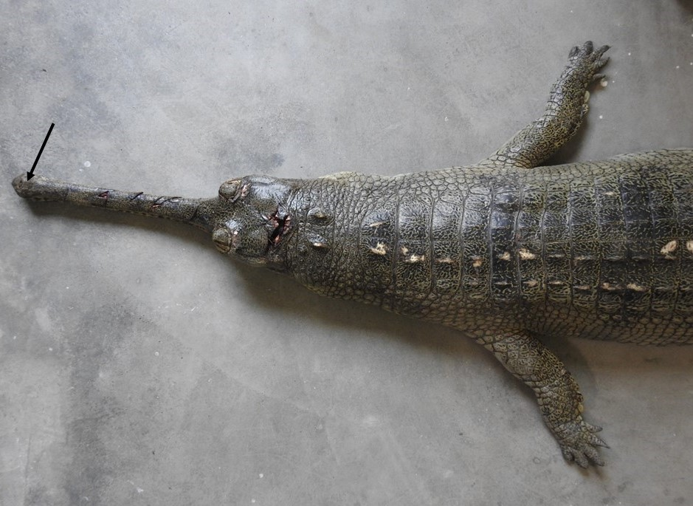
Fig.1: Photograph showing the snout (Black arrow) of the Indian Gharial (Gavialis gangeticus).
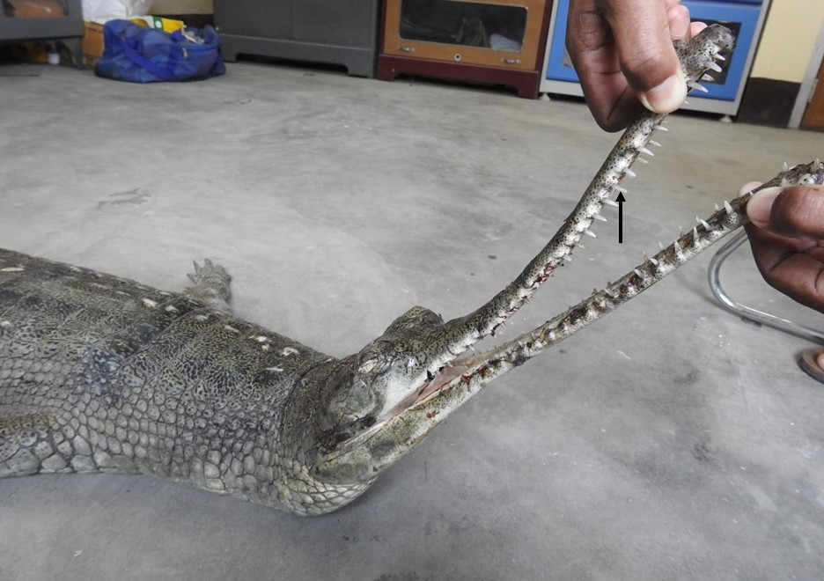
Fig.2: Photograph showing the sharp teeth (Black arrow) of the Indian Gharial (Gavialis gangeticus).

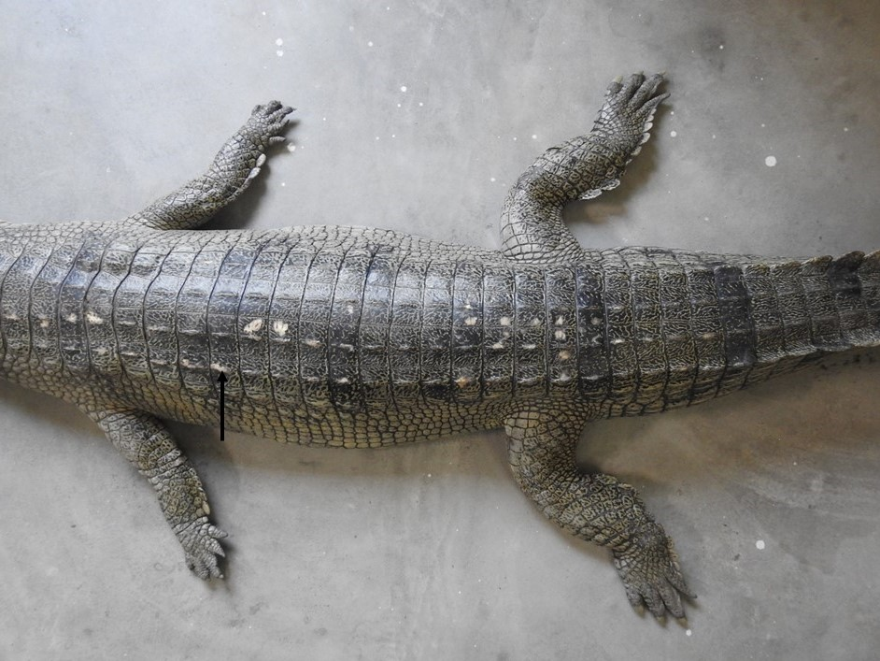
Fig.3: Photograph showing the rounded horny thickening of the skin (Black arrow) of the Indian Gharial (Gavialis gangeticus).
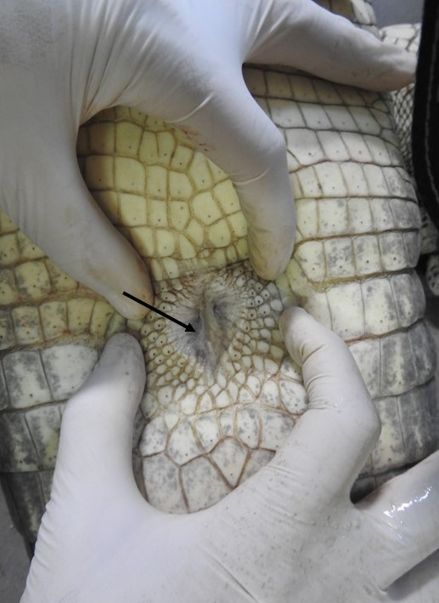
Fig.4: Photograph showing the cloaca of Indian Gharial (Gavialis gangeticus).

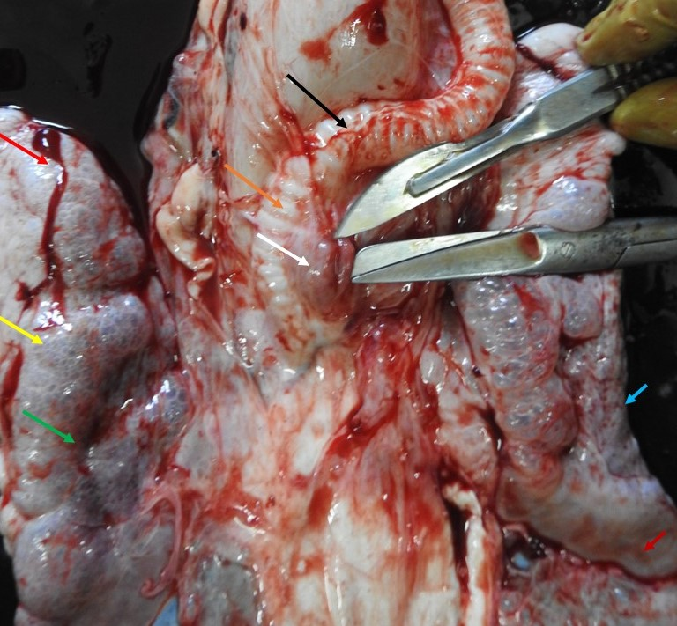
Fig.5: Photograph showing the trachea (black arrow), tracheal ring (brick colour arrow), thymus (white arrow), cranial end of right lobe of lung (red arrow), dorsal surface of lung (yellow arrow), lateral border of right lung (green arrow), lateral border of left lobe of lung (blue arrow), and caudal end of left lobe of lung (marron colour) and thymus (white arrow) of Indian Gharial (Gavialis gangeticus).
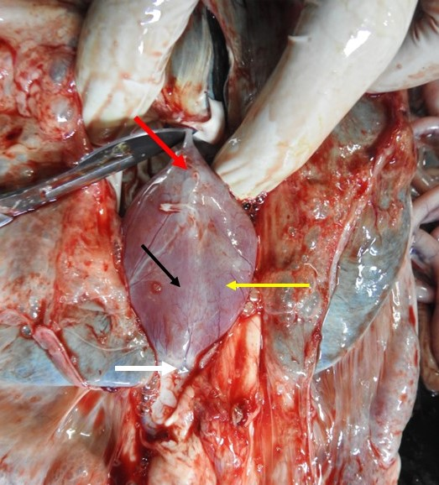
Fig.6: Photograph showing the pericardium of heart (black arrow), base of the heart (red arrow), body of the heart (yellow arrow) and apex of the heart (white arrow) of Indian Gharial (Gavialis gangeticus).

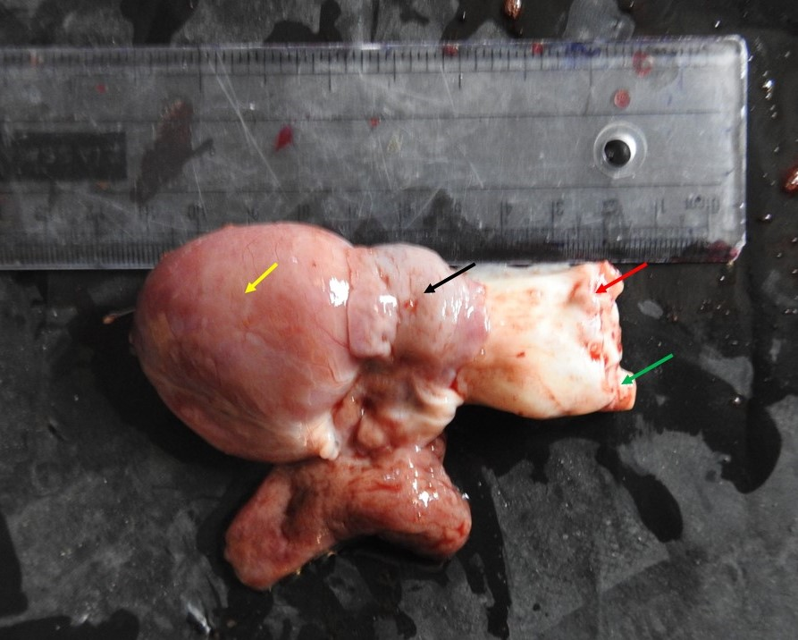
Fig.7: Photograph showing the auricle of heart (black arrow), base of ascending aorta (red arrow), ventricle of heart (yellow arrow) and base of descending aorta (green arrow) of Indian Gharial (Gavialis gangeticus).
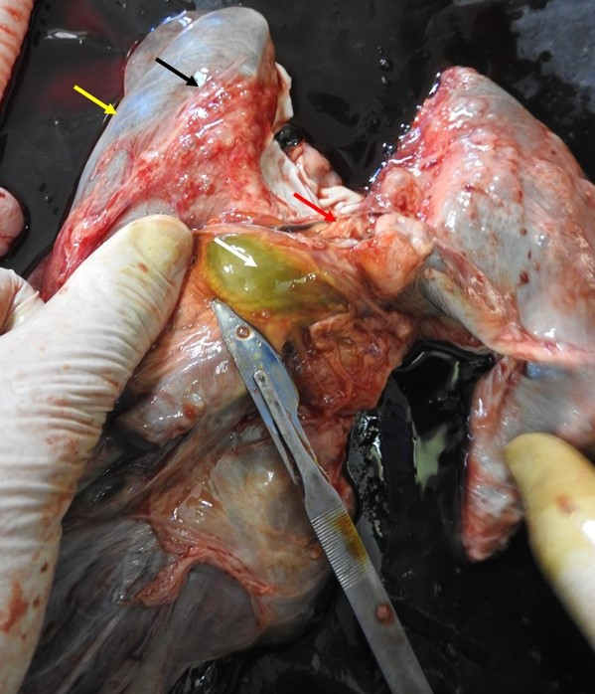
Fig.8: Photograph showing the Glisson’s capsule (black arrow), border of liver (yellow arrow), isthmus (red arrow) and gall bladder (white arrow) of liver of Indian Gharial (Gavialis gangeticus).

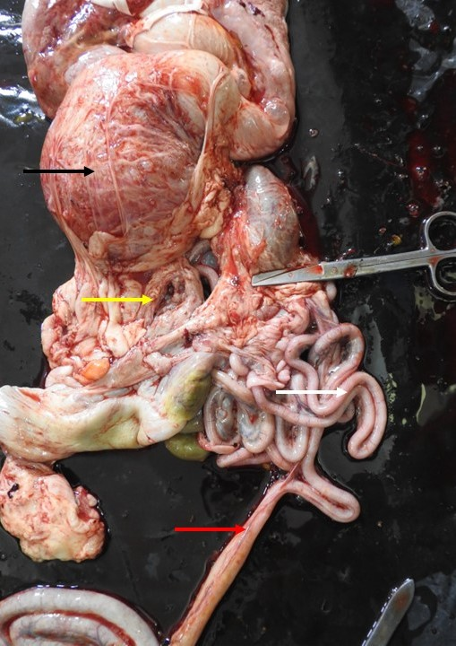
Fig.9: Photograph showing the stomach (black arrow),duodenum (yellow arrow), jejunum (white arrow) and ileum (red arrow) of Indian Gharial (Gavialis gangeticus).

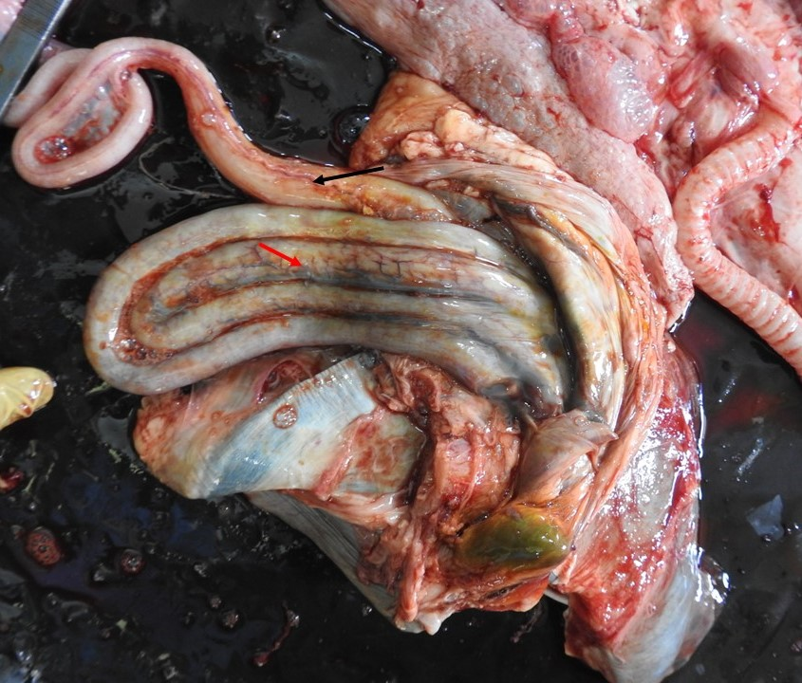
Fig.10: Photograph showing the caecum (black arrow) and colon (red arrow) of Indian Gharial (Gavialis gangeticus).

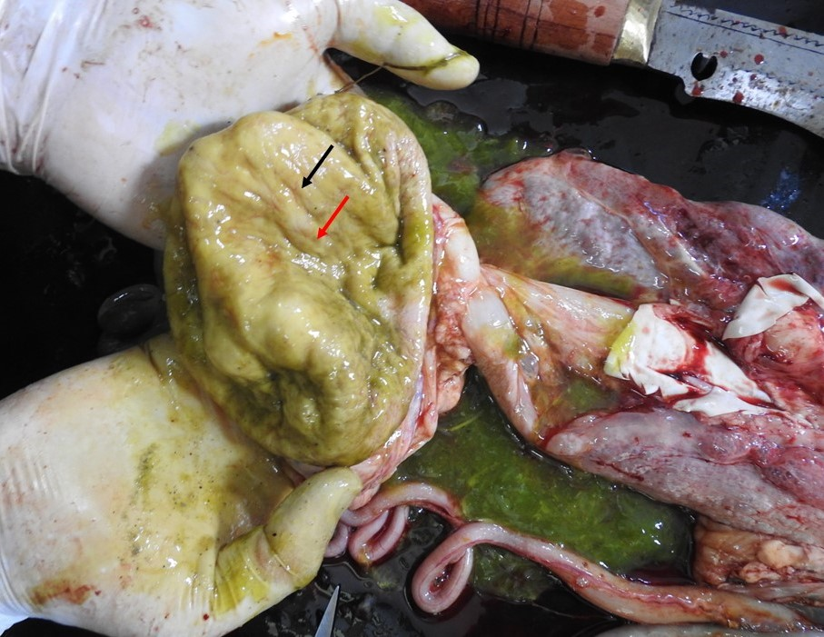
Fig.11: Photograph showing the plica gastricae (black arrow) and foveolae gastricae (red arrow) of stomach of Indian Gharial (Gavialis gangeticus).
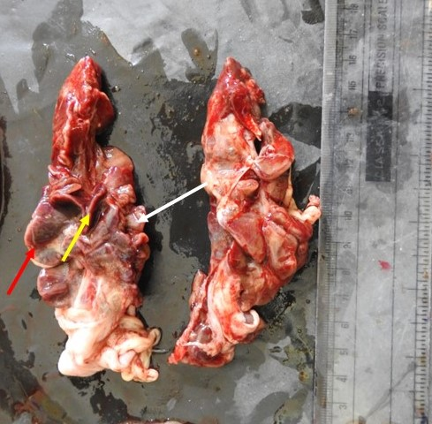
Fig.12: Photograph showing the lateral border (red arrow), medial border (white arrow) and hilus (yellow arrow) of kidney of Indian Gharial (Gavialis gangeticus).

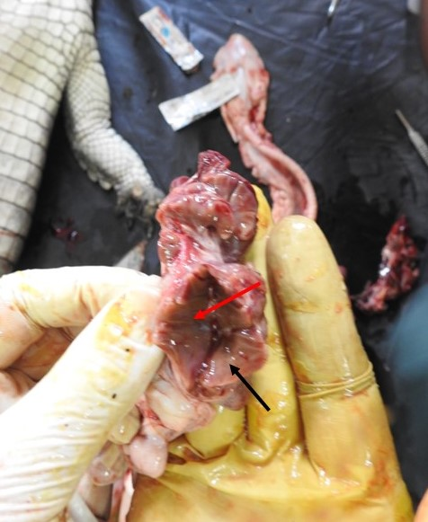
Fig.13: Photograph showing the cortex (black arrow) and medulla (red arrow) of kidney of Indian Gharial (Gavialis gangeticus).

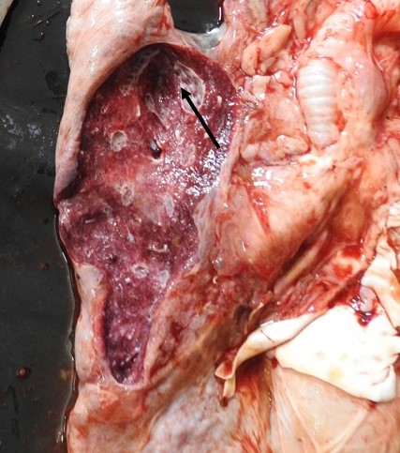
Fig.14: Photograph showing the multiple chambers (black arrow) of lung of Indian Gharial (Gavialis gangeticus).
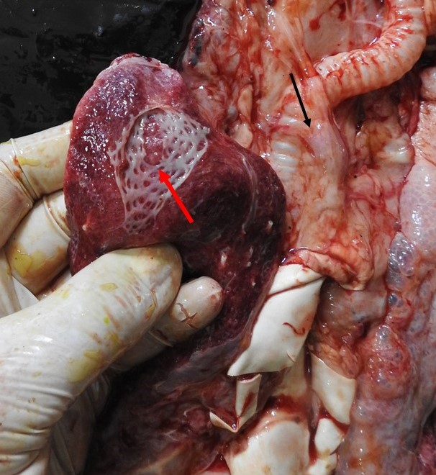
Fig.15: Photograph showing the honey comb like structure (red arrow) of lung and tracheal bifurcation (black arrow) of trachea of Indian Gharial (Gavialis gangeticus).
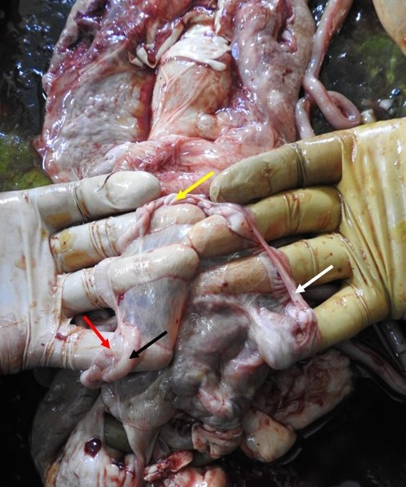
Fig.16: Photograph showing the ovary (black arrow), mesovarium (red arrow), infundibulum (white arrow) and ampulla (yellow arrow) of female reproductive system of Indian Gharial (Gavialis gangeticus).

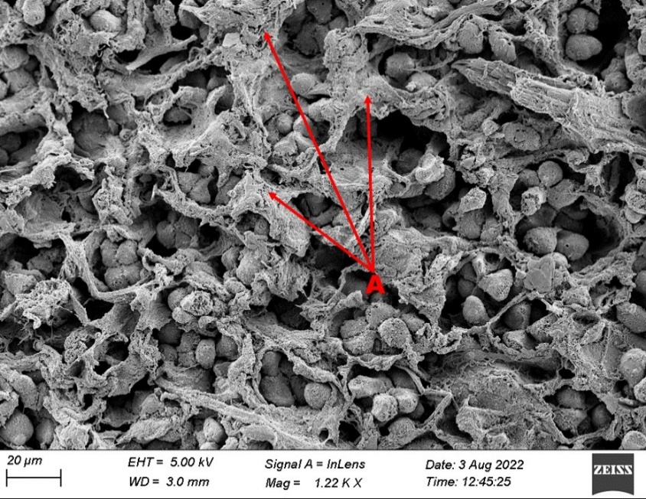
Fig. 17: Scanning Electron Photomicrograph showing the inter sinusoidal tissue (A) in liver of Indian Gharial (Gavialis gangeticus).

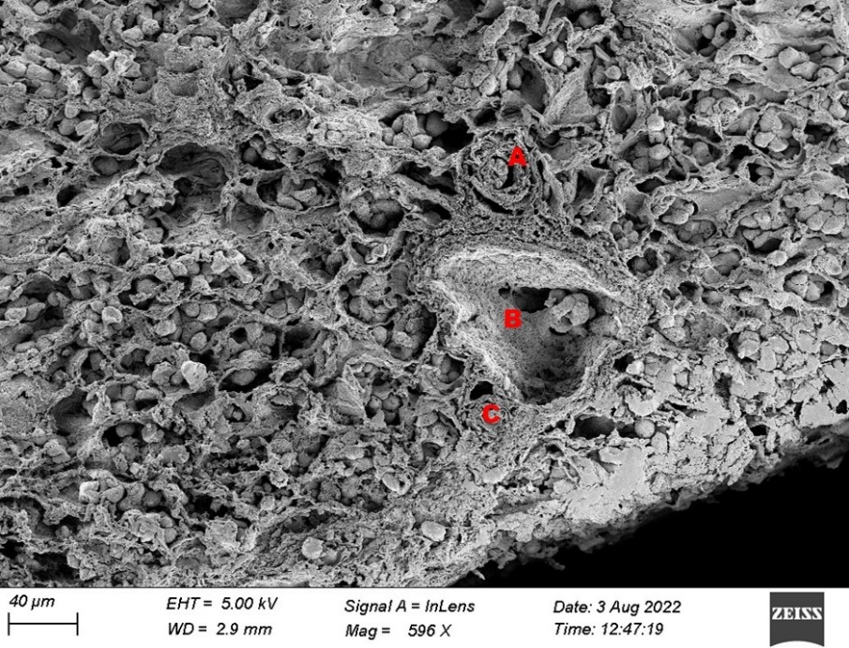
Fig. 18: Scanning Electron Photomicrograph showing the bile duct (A), hepatic vein (B) and hepatic artery (C) in liver of Indian Gharial (Gavialis gangeticus).

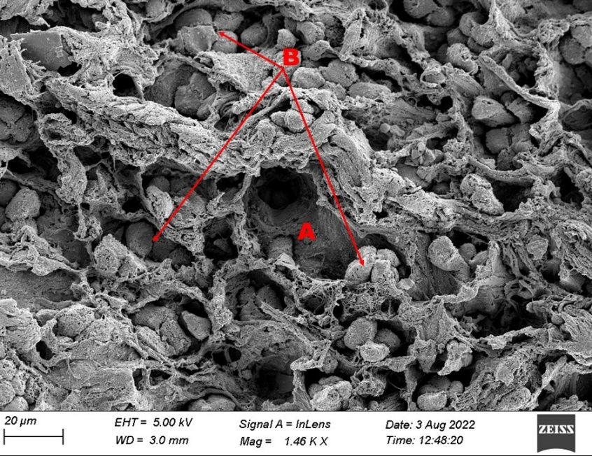

Fig.19: Scanning Electron Photomicrograph showing the RBC occlude the lumen of sinus of liver of Indian Gharial (Gavialis gangeticus).

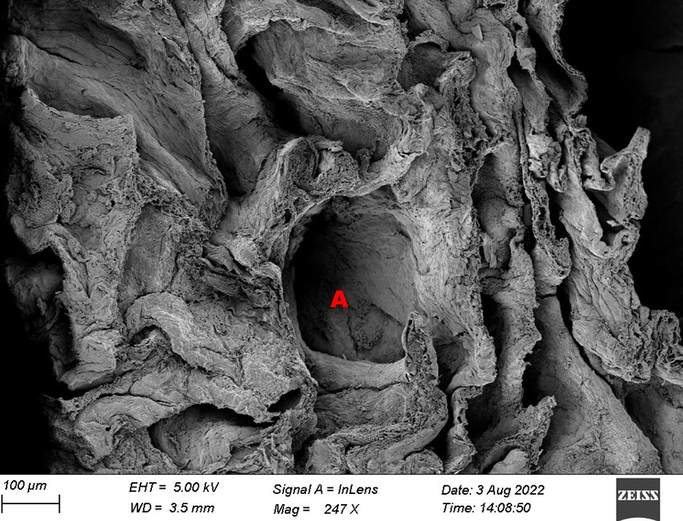
Fig.20: Scanning Electron Photomicrograph showing the alveoli of lung of Indian Gharial (Gavialis gangeticus).

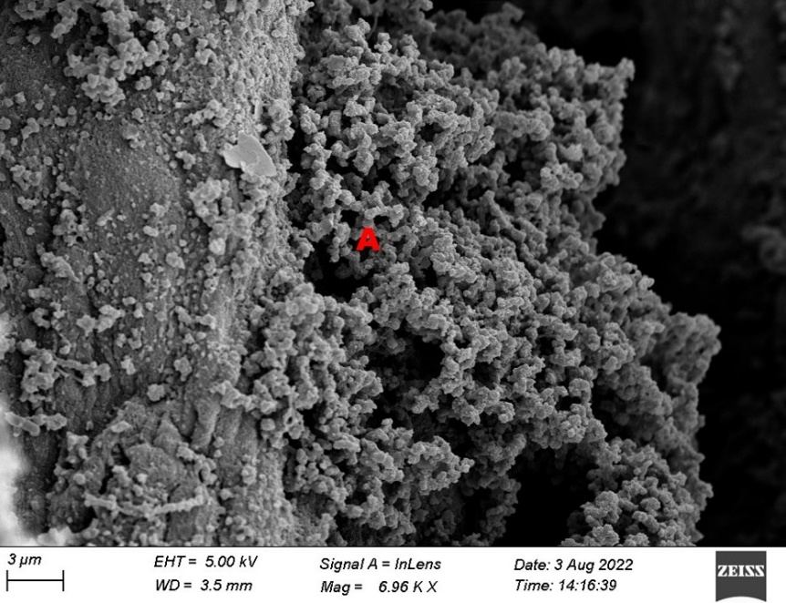
Fig.21: Scanning Electron Photomicrograph showing the Bronchus Associated Lymphoid Tissue (BALT)of lung of Indian Gharial (Gavialis gangeticus).

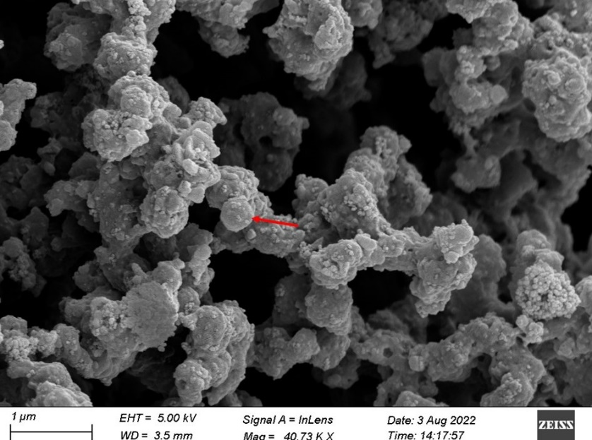
Fig.22: Scanning Electron Photomicrograph showing the Bronchus Associated Lymphoid Tissue (BALT)of lung of Indian Gharial (Gavialis gangeticus).

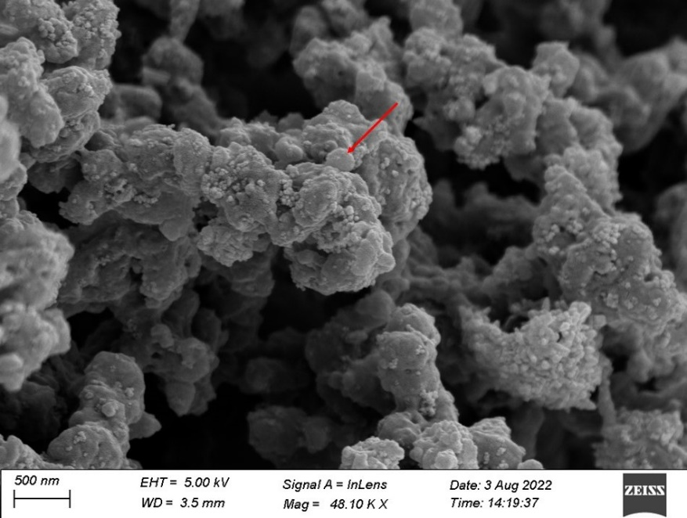
Fig.23: Scanning Electron Photomicrograph showing the T-lymphocytes of Bronchus Associated Lymphoid Tissue (BALT)of lung of Indian Gharial (Gavialis gangeticus).

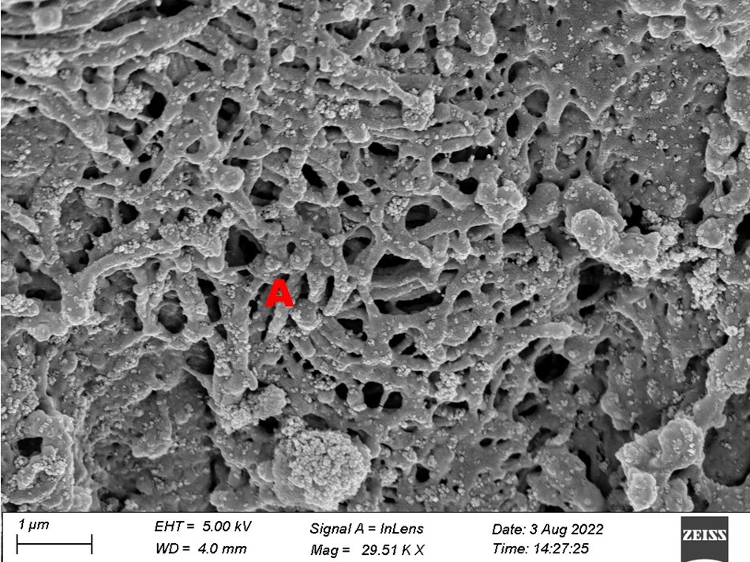
Fig.24: Scanning Electron Photomicrograph showing the network like structure of lung of Indian Gharial (Gavialis gangeticus).

