Bacterial shell disease syndrome in the mud crab Scylla serrata (Forskål, 1775) from the Pichavaram mangrove ecosystem, southeast coast of India

Abstract
Shell disease syndrome is characterised by progressive alterations of the crustacean cuticle and may involve interactions among the host, microorganisms, and environmental conditions. This study aimed to (i) characterize the morphological and histopathological changes associated with shell lesions in the wild mud crab Scylla serrata and (ii) characterize lesion-associated Aeromonas through 16S rRNA gene sequence analysis. A crab exhibiting conspicuous rust-brown to dark-brown lesions on the appendages and ventral body surface was collected from Mudasalodai Fishing Harbour adjacent to the Pichavaram mangrove ecosystem, southeast coast of India. Gross pathological observations were recorded, and tissue samples were fixed, processed by routine histological procedures, sectioned, and examined microscopically to assess tissue and cellular alterations. For molecular characterisation, DNA from lesion-associated material was subjected to PCR amplification and sequencing of the 16S rRNA gene, followed by sequence comparison and phylogenetic analysis with reference Aeromonas sequences. Histological examination revealed disruption of the gill cuticle and underlying epithelium, infiltration of eosinophilic granular haemocytes, and formation of haemocyte plugs or nodules. The hepatopancreas showed an increased abundance of B-cells around the basal lamina and the tubular lumen. Two 16S rRNA gene sequences obtained from lesion-associated material, designated AH01 and AH02, occupied different positions within the Aeromonas sequence dataset, with bootstrap support values of 64% and 79%, respectively, and were provisionally identified as Aeromonas hydrophila. The findings demonstrate an association between external shell lesions, internal tissue responses, and lesion-associated Aeromonas DNA in the examined crab. However, because the study was restricted to a single specimen and bacterial causality was not experimentally established, further sampling, bacterial isolation, and molecular confirmation are required to determine the potential role of Aeromonas in shell disease of wild S. serrata.
Keywords: Scylla serrata; mud crab; Pichavaram mangroves; shell disease syndrome; cuticular lesions; histopathology; gill epithelium; hepatopancreas; haemocyte nodules; Aeromonas hydrophila; 16S rRNA gene sequencing

1. Introduction
The exoskeleton of decapod crustaceans consists of the following acellular layers: a thin outer epicuticle of lipids and proteins and an underlying procuticle of chitin and Chito proteins toughened with calcite, secreted by the epidermis (Rowley & Coates, 2023). Chitin, a β-(1,4)-linked polymer of N-acetylglucosamine (GlcNAc), forms about 70% of the organic fraction of the crustacean exoskeleton and is the most abundant biopolymer after cellulose (Vogan et al., 2008). Moult casts of marine arthropods yield an estimated 1.3 × 10⁹ t of chitin each year, yet only traces accumulate in marine sediments, because chitinolytic bacteria recycle it efficiently (Keyhani & Roseman, 1999; Vogan et al., 2008). The intact carapace resists desiccation, predation and microbial attack, and few microbes can penetrate it (Rowley & Coates, 2023). When the cuticle of a living crustacean, rather than a discarded moult or carcass, is degraded, the condition is termed shell disease syndrome (Vogan et al., 2008).
Shell disease was first described in American lobsters Homarus americanus held in a tidal pound in Nova Scotia, where pitted lesions were attributed to chitinovorous bacteria (Hess, 1937). It has since been reported as black spot, brown spot, burnt spot, impoundment and epizootic shell disease, in more than 15 species of crabs, lobsters and shrimps from wild and captive populations worldwide (Getchell, 1989; Vogan et al., 2008; Rowley & Coates, 2023). The lesions are darkened by melanin, a defence response triggered by cuticular damage (Vogan et al., 2008). Rowley and Coates (2023) grouped these conditions into three types: Type 1, progressive erosion of the cuticle by microbial lipases, proteases and chitinases; Type 2, melanised responses to fungal or oomycete penetration; and Type 3, pigment change without erosion. The only well-documented shell disease of the mud crab Scylla serrata belongs to Type 3. At Port Curtis, Queensland, 21.7% of 673 mud crabs had shell lesions and 82.9% of these were ‘rust spots’; histopathology found no bacteria or fungi, and the cause was considered non-infectious (Andersen et al., 2000).
Type 1 shell disease begins when the non-chitinous epicuticle is removed by microbial lipolytic and proteolytic activity, predatory or cannibalistic injury, chemical attack, or abrasion by sediment and body parts (Vogan et al., 1999, 2008). Chitinolytic bacteria then colonise and degrade the exposed procuticle (Cook & Lofton, 1973; Getchell, 1989). Malloy (1978) reproduced lesions in lobsters with a chitinolytic Vibrio (Beneckea) isolate, but only after the epicuticle had been abraded; 17.7% of the inoculated animals developed carapace lesions. Bacteria isolated from lesions belong mainly to Vibrio, Pseudomonas, Aeromonas, Alteromonas, Pseudoalteromonas, Photobacterium and Flavobacterium (Getchell, 1989; Vogan et al., 2002). Culture-independent studies show that lesions carry a less diverse, dysbiotic community enriched in Flavobacteriaceae, especially Aquimarina spp., which supports a polymicrobial aetiology (Chistoserdov et al., 2012; Bergen et al., 2022; Rowley & Coates, 2023). Of direct relevance to mud crabs, Aquimarina hainanensis has been isolated from diseased S. serrata larvae in a hatchery (Midorikawa et al., 2020). In cultured Scylla serrata from southeast India, co-infection with mud crab reovirus and Staphylococcus saprophyticus has been reported (John et al., 2024). A separate investigation of a mud-crab aquaculture disease outbreak identified Vibrio alginolyticus as a bacterial pathogen of S. serrata (Kwok et al., 2024).
Shell disease is not confined to the cuticle. In the edible crab Cancer pagurus, culturable bacteria were present in the haemolymph of 78% of crabs examined, their numbers rose with lesion severity, and diseased crabs showed haemocytic nodules in the gills and graded necrosis of hepatopancreatic tubules (Vogan et al., 2001). Two chitinolytic isolates from C. pagurus lesions were lethal when injected into healthy crabs, and the extracellular products of one isolate killed crabs within 3 h (Vogan et al., 2002). Severely affected animals may also die when the old cuticle adheres to the new one at lesion sites and cannot be shed at moult (Smolowitz et al., 1992; Vogan et al., 1999). Even when not fatal, lesions lower market value, and severely affected crabs cannot be sold (Vogan et al., 1999).
Shell disease is strongly shaped by local habitat. In juvenile C. pagurus, the lesion pattern was linked to back-burrowing into abrasive sediments rich in chitinolytic bacteria (Vogan et al., 1999). Sediment chitinase activity was about twice as high (1.57 vs. 0.74 µmol GlcNAc mL⁻¹ h⁻¹) at the site where male crabs had significantly more severe disease (Vogan & Rowley, 2002). Higher prevalence has been associated with sewage sludge (Young & Pearce, 1975) and with reduced serum antibacterial activity in blue crabs from degraded estuaries (Noga et al., 1994), yet prevalence did not fall after a sewage outfall was closed (Powell & Rowley, 2005). Rising water temperature also favours disease by altering host immunity, moulting and microbial growth (Shields, 2019). The causes of shell disease are therefore likely to be site-specific and must be studied locally (Vogan & Rowley, 2002). A recent study of cultured Scylla paramamosain found that shell disease occurrence varied with water temperature, alongside changes in carapace-associated bacterial communities (Yu et al., 2025). A recent review also describes the occurrence of mud crabs in Indian mangrove and brackish-water habitats and discusses their importance to aquaculture (Raj et al., 2025).
The mud crab S. serrata is a commercially valuable portunid of Indo-Pacific mangrove estuaries; in Queensland alone, its fishery is worth about AUS$7 million yr⁻¹ (Andersen et al., 2000). Mud crabs burrow in soft, organically rich mangrove mud, which exposes the carapace to the abrasion and sediment bacteria implicated in shell disease of other crabs (Vogan et al., 1999; Vogan & Rowley, 2002). Yet, apart from the non-infectious rust spot condition (Andersen et al., 2000), bacterial (Type 1) shell disease has not been documented in wild S. serrata. The Pichavaram mangrove on the southeast coast of India supports an important mud crab fishery, but no information exists on shell disease in its crab populations. The present study therefore aimed to describe the external and internal pathology associated with the disease through histopathology and to investigate the lesion-associated bacterium through sequencing.

2. Material and methods
2.1. Sample collection
A mud crab, Scylla serrata, with conspicuous black, eroded lesions on its exoskeleton was obtained from Mudasalodai fishing harbour, Cuddalore District, Tamil Nadu, on the southeast coast of India [11.4853730, 79.7743795]. Mudasalodai is the main landing and marketing centre for crabs caught by artisanal fishers in the adjacent Pichavaram mangrove, an estuarine wetland between the Vellar and Coleroon estuaries. The crab was noticed among the crabs offered for sale because of its lesions and was purchased for examination. The position of the lesions on the carapace, chelipeds, walking legs and ventral surfaces was recorded and photographed (Vogan et al., 1999).
2.2 Histopathology
The crab was anaesthetised by chilling at 4–6°C for about 1 h before dissection (Andersen et al., 2000). Pieces of carapace and leg cuticle bearing lesions, together with gills, hepatopancreas and muscle, were removed. A piece of lesion-free cuticle from the same crab was taken for comparison. Calcified cuticle was fixed in Davidson's fixative and decalcified, while soft tissues were fixed in 10% neutral buffered formalin prepared in seawater for 24-48 h (Andersen et al., 2000).
Fixed tissues were dehydrated through a graded ethanol series (70–100%), cleared in xylene and embedded in paraffin wax. Sections 5 µm thick were cut on a rotary microtome and stained with haematoxylin and eosin (Andersen et al., 2000; Vogan et al., 2001). Sections were examined under a compound light microscope (10× eyepiece and 10× and 40× objectives; 100× and 400× magnification) and photographed. Internal organs were assessed for haemocytic infiltration and nodules, necrosis, and alterations in gill lamellae and hepatopancreatic tubules (Vogan et al., 2001).
2.3 Molecular confirmation by 16S rRNA gene sequencing
At dissection, before fixation, the lesion surface was swabbed with 70% ethanol and rinsed with sterile seawater, and the lesioned cuticle with the underlying soft tissue (about [25–50] mg) was excised aseptically using a sterile scalpel and placed in a sterile tube. A piece of lesion-free cuticle from the same crab was collected in the same way as a negative control. Total genomic DNA was extracted directly from the tissue, without culturing, using [Qiagen kit method] following the manufacturer's protocol. DNA quality and quantity were checked by 1% agarose gel electrophoresis and spectrophotometry (A260/A280).
The 16S rRNA gene was amplified by PCR in a 50 µl reaction containing PCR buffer and 16S rDNA-specific primers following the standard procedure of Weisburg et al. (1991), 200 pmol each of dATP, dGTP, dCTP and dTTP, and 1 µl (1 ng) of extracted DNA as the template. In the negative control, 1 µl of sterile distilled water replaced the template DNA. Amplification was carried out in a PCR thermal cycler with initial denaturation at 94°C for 5 min; 30 cycles of 94°C for 1 min, 54°C for 45 s and 72°C for 1 min; and final extension at 72°C for 10 min.
The obtained sequences were edited and aligned with reference Aeromonas sequences using MEGA software. Multiple-sequence alignment was performed using ClustalW, and phylogenetic relationships were reconstructed using the Neighbour-Joining method with 1,000 bootstrap replicates. The resulting phylogenetic tree was used to determine the evolutionary placement of the sequences obtained from the lesion material.
3. Results & Discussion
The present study documented the gross pathological features, histopathological alterations, and lesion-associated bacterial characteristics in Scylla serrata exhibiting shell lesions. Distinct external lesions were observed on the appendages and ventral body surface, accompanied by structural and cellular changes in the gill and hepatopancreatic tissues. Molecular analysis of lesion-associated material further revealed the presence of Aeromonas-related 16S rRNA sequences.
3.1 Gross observation
Gross examination revealed distinct rust-coloured lesions on the appendages and ventral body surface of affected Scylla serrata. As shown in Figure 1A, irregular rust-brown spots were visible on the chelate leg and swimming leg, with the lesions clearly distinguishable from the surrounding cuticular surface. Figure 1B showed the ventral surface of the carapace with localised superficial discolouration and focal lesions. The boxed regions in Figure 1B correspond to the areas shown at higher magnification in Figure 1C, where multiple superficial dark-brown lesions were clearly evident (black arrows).

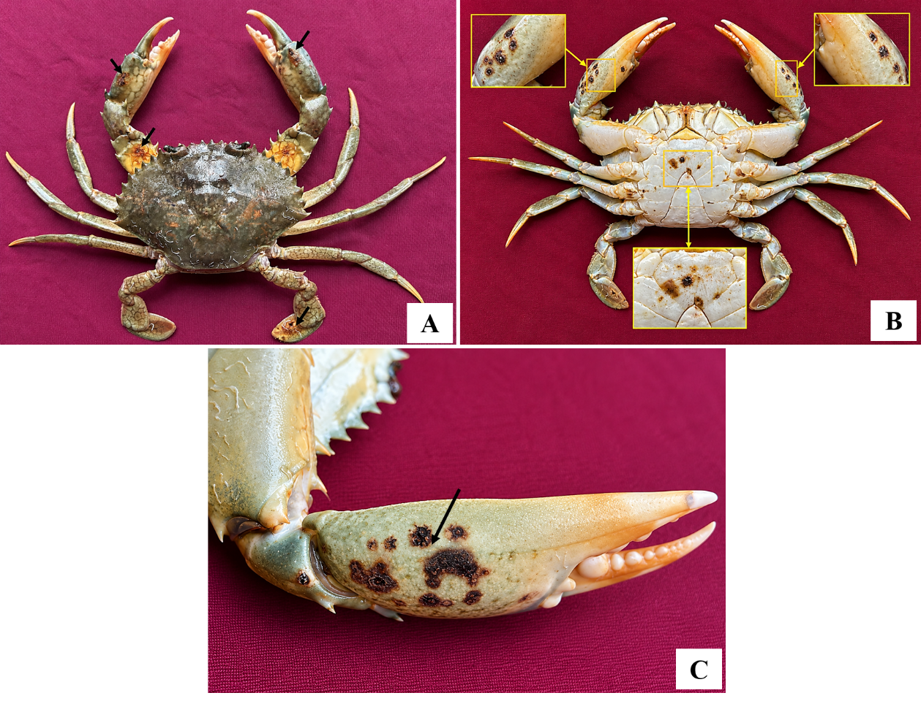
Figure 1. External manifestations of shell disease in mud crab Scylla serrata. A, rust-colored lesions on the chelate and swimming legs (arrows); B, ventral surface of the crab showing localized superficial lesions, with boxed areas indicating regions enlarged; C, magnified view of superficial shell lesions (black arrows)
3.2 Histopathology
Histological examination revealed distinct pathological alterations in the gill tissue of a crab exhibiting external shell disease lesions. In Figure 2A, lesions were evident on the outer surface of the gill cuticle, with disruption of the underlying epithelium and associated haemal space. Figure 2B showed pronounced haemocyte infiltration at the sites of epithelial damage, including numerous eosinophilic granular haemocytes, and haemocyte plug/nodule formation within or adjacent to the haemal spaces. Figure 2C demonstrated an increased abundance of B-cells associated with the basal lamina and surrounding the tubular lumen. Overall, these findings indicate marked cellular and structural responses in the gill tissues associated with shell disease lesions.
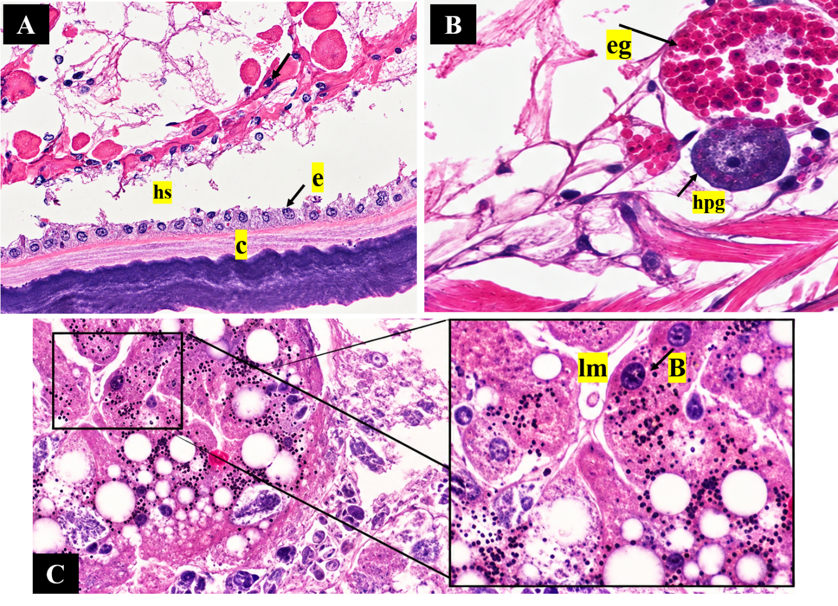
Figure 2. Histopathological alterations in the gill of a crab with shell disease lesions. A, outer gill cuticle (c), underlying epithelium (e) and haemal space (hs); B, epithelial lesion with haemocyte infiltration, haemocyte plug/nodule (hpg) and eosinophilic granular haemocytes (eg); C, increased abundance of B-cells (B), basal lamina and tubular lumen (lm).
3.3 Molecular characterization and phylogenetic analysis
The lesion-associated bacterial material was characterised using 16S rRNA gene sequences, and the resulting sequences were subjected to phylogenetic analysis using the neighbour-joining method. Two sequences obtained in the present study were designated AH01 (QB053383.1) and AH02 (QB053381.1). The phylogenetic tree revealed that the two sequences did not form a single cluster but occupied distinct positions within the analysed Aeromonas sequence dataset. AH01 (QB053383.1) clustered with MG428794.1, with a bootstrap support of 64%, whereas AH02 (QB053381.1) grouped with PZ959625.1, supported by a bootstrap value of 79%.

The cluster containing AH01 was subsequently associated with sequences PP759396.1, OR131038.1, PQ671497.1, PX884990.1 and PX884993.1, with strong support (100%) at the major internal node. Another well-supported lineage comprising OQ553752.1, OQ421482.1, OQ421472.1, OQ160719.1 and OQ160717.1 showed bootstrap values ranging from 83 to 97%.
Overall, the phylogenetic topology demonstrates that AH01 and AH02 represent distinct phylogenetic placements within the examined 16S rRNA sequence dataset and were provisionally identified as Aeromonas hydrophila, with AH01 showing its closest association with MG428794.1 and AH02 with PZ959625.1. The bootstrap values provide support for the inferred clustering relationships.

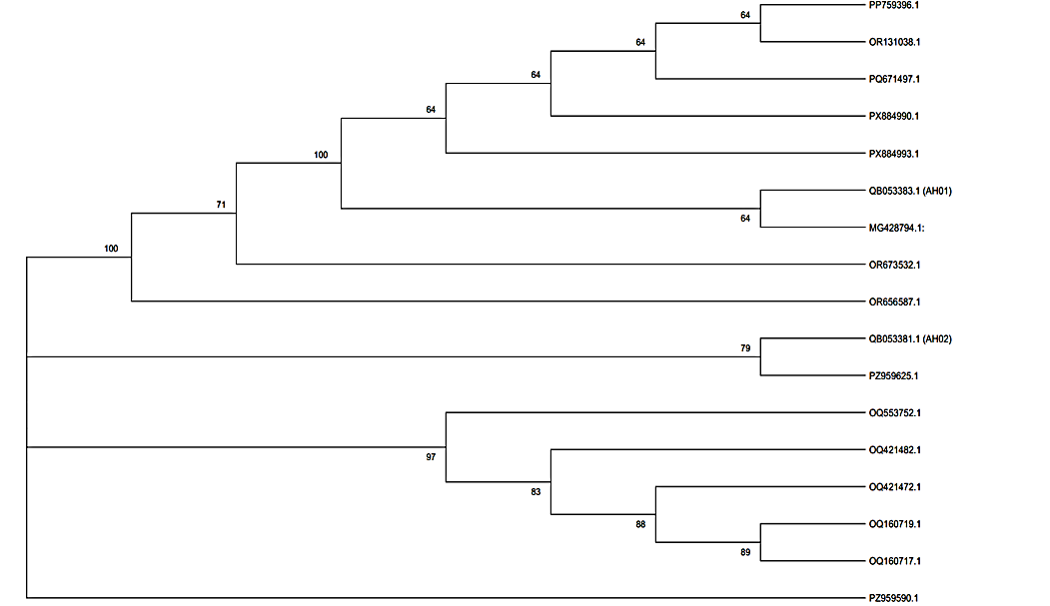
Figure 3. Neighbour-joining phylogenetic tree based on 16S rRNA gene sequences showing the relationships of the two sequences obtained in the present study (AH01 and AH02) with reference Aeromonas sequences. Numbers at the nodes represent bootstrap support values.

The present study documents shell disease in a wild mud crab Scylla serrata from the Pichavaram mangrove ecosystem. Superficial rust-brown to dark-brown cuticular lesions were accompanied by damage to the gill cuticle and epithelium, haemocytic nodules and changes in the hepatopancreas, and two 16S rRNA gene sequences recovered from lesion tissue were identified as Aeromonas hydrophila. Shell lesions of S. serrata have previously been described only from Port Curtis, Australia, where they were considered non-infectious (Andersen et al., 2000) and were later examined during a mortality event associated with harbour development (Dennis et al., 2016).
The gross appearance of the lesions resembled the rust spots of Port Curtis mud crabs, which were also rust-coloured and occurred mostly on the ventral surface. In those crabs, however, the lesions were confined to the endocuticle and the adjacent muscle attachment, bacteria were found, and the internal organs showed tissue alterations in the gill and hepatopancreas. The authors attributed them to a defect in the formation of the endocuticle, which is laid down after ecdysis (Travis, 1957) while calcium is rapidly taken up from the environment to calcify the new cuticle (Greenaway, 1985). In the present crab, by contrast, bacterial DNA was recovered from the lesion and internal organs showed pathological changes. The brown to black colour of shell lesions results from melanin deposited at sites of cuticular damage, part of the wound response of crustaceans (Nyhlén & Unestam, 1980) that is triggered early in the innate immune response (Lee & Söderhäll, 2002). Similarly, coloured lesions of differing aetiology have been reported as black necrotic disease in crabs from Scotland (Morado et al., 1988; Comely & Ansell, 1989).
The lesions were concentrated on the ventral surface and the appendages, which are the body regions in closest contact with the substratum. Damage to the epicuticle and invasion through cuticular pores and the bases of setae have been proposed as the main routes by which bacteria enter the cuticle (Prince et al., 1993). S. serrata lives in burrows in soft, fine-grained and organically rich mangrove mud. Bacterial abundance in sediments increases with particle surface area and organic content (Yamamoto & Lopez, 1985), and chitin is degraded rapidly in estuarine environments (Hood & Meyers, 1977). Mangrove sediments are therefore likely to expose the ventral cuticle of burrowing crabs to large numbers of chitinolytic bacteria, as in the estuarine blue crab Callinectes sapidus, in which shell disease was among the earliest described in crabs (Rosen, 1967).
The gill changes observed here closely match those described in shell-diseased edible crabs Cancer pagurus, in which lesions of the gill lamellae were associated with haemocyte nodules occluding the haemal sinuses, infiltration by eosinophilic granular cells and haemocytic plugs sealing breaches of the epithelium (Vogan et al., 2001). The decapod gill is covered by a thin cuticle continuous with the exoskeleton and has a delicate epithelium specialised for respiration and ion exchange (Lawson et al., 1994). Nodule formation is the characteristic response of crabs to bacteria in the haemocoel: bacteria injected into the shore crab Carcinus maenas are rapidly trapped by haemocytes in nodules, particularly in the gills (Smith & Ratcliffe, 1980), and similar nodules and tissue damage develop in the course of bacterial infections of the blue crab (Johnson, 1976). The nodules in the present crab therefore suggest that bacteria or their products had breached the gill cuticle and entered the haemolymph. Gill lesions and haemocyte responses are not specific to infection, however, and can also be induced by sublethal exposure to heavy metals such as cadmium (Victor, 1993).
The hepatopancreas also showed changes, with an increased abundance of B-cells along the basal lamina and around the tubular lumen. The tubules of the decapod hepatopancreas contain distinct R-, F- and B-cells with different roles in absorption, storage and secretion of digestive enzymes (Johnson, 1980; Ceccaldi, 1998). The proportions and appearance of these cells change through the moult cycle (Travis, 1957) and in response to toxicants (Bhavan & Geraldine, 2000), and bacteria can also damage the hepatopancreas directly, as in hepatopancreatic brush border lysis of shrimp (Vogt, 1997). The shift in B-cell abundance seen here may therefore reflect altered tubule activity during infection, but a single specimen cannot separate the effects of disease from those of the nutritional and moult state of the crab.
The bacterial sequences obtained from the lesion were provisionally identified as A. hydrophila. Chitinase production is widespread among aquatic bacteria, and Aeromonas is among the genera known to degrade chitin (Gooday, 1990; Bhattacharya et al., 2007). Most earlier studies of bacterial shell disease and related lesions isolated Vibrio, Pseudomonas and other marine genera (Baross et al., 1978; Cipriani et al., 1980; Stewart, 1993). Aeromonas species are most common in freshwater and brackish water. The Pichavaram mangrove lies between the Vellar and Coleroon estuaries and receives freshwater inflow, so salinity conditions there may favour Aeromonas over the strictly marine bacteria reported from shell disease in fully marine crustaceans.
The two sequences, AH01 and AH02, did not form a single cluster and grouped with different reference sequences, with moderate bootstrap support (64% and 79%). This may indicate that two closely related Aeromonas strains were present in the lesion, or it may reflect variation between the multiple copies of the 16S rRNA gene within one genome. Because the 16S rRNA gene often cannot reliably separate closely related Aeromonas species, the identification of A. hydrophila should be confirmed by sequencing housekeeping genes such as gyrB or rpoD.
The detection of A. hydrophila DNA in lesion tissue does not, by itself, show that this bacterium caused the disease. Rosen (1970) first proposed that shell lesions are microniches occupied by several interacting microbial groups. Culture-based 16S rRNA sequencing of lesion isolates from American lobsters Homarus americanus recovered a diverse community (Chistoserdov et al., 2005), and culture-independent analysis revealed a dysbiotic lesion microbiota rather than a single pathogen (Meres et al., 2012). Bacteria are also present in the haemolymph of apparently healthy crabs (Colwell et al., 1975; Sizemore et al., 1975), and members of the normal cuticular flora may become involved in shell disease once the cuticle is damaged (Porter et al., 2001). The universal 16S rDNA primers used here amplify most bacteria, so direct sequencing recovers the dominant taxa but may miss less abundant members of the lesion community. Establishing the role of A. hydrophila would require isolating it from lesions, testing the toxicity of its extracellular products (Costa-Ramos & Rowley, 2004), and reproducing lesions by experimental exposure of the cuticle, as has been done with lesion bacteria in lobsters (Quinn et al., 2012).
Shell disease is increasingly viewed as the outcome of interactions between host, environment and microbes rather than of a single pathogen (Castro et al., 2006). Environmental stressors can weaken invertebrate immune defences (Mydlarz et al., 2006); manganese, for example, suppresses immunity in the Norway lobster Nephrops norvegicus (Hernroth et al., 2004), and shell disease in estuarine blue crabs has been linked to tissue metal content (Weinstein et al., 1992). Prevalence can vary markedly between sites within a single estuarine system (Dyrynda, 1998) and rises with water temperature (Glenn & Pugh, 2006; Tlusty & Metzler, 2012). Diet also influences susceptibility, as shown in impounded and laboratory-held lobsters (Prince et al., 1995; Tlusty et al., 2008). Environmental conditions at the collection site were not measured in the present study, and these factors should be examined in future work in Pichavaram.
Shell disease has practical consequences for crustacean fisheries. Epizootic shell disease contributed to the decline of American lobster populations in southern New England (Castro et al., 2012), and disease can reduce the survival of commercially fished crustaceans (Hoenig et al., 2017). Disease levels may also rise where crustacean densities increase (Wootton et al., 2012). The mud crab is a major target of artisanal fisheries in Indo-Pacific mangroves (Heasman, 1980), and Pichavaram crabs are traded live and increasingly held for fattening and culture. Holding systems can favour disease outbreaks (Delves-Broughton & Poupard, 1976), and bacterial cuticular disease has caused losses in cultured larval lobsters (Ooi et al., 2020). The observation of shell lesions associated with Aeromonas DNA in a wild crab therefore warrants monitoring of both wild and cultured mud crab stocks in the region.
5. Summary and conclusion
This report describes shell disease in a wild mud crab, Scylla serrata, caught in the Pichavaram mangrove and landed at Mudasalodai fishing harbour on the southeast coast of India. The crab bore rust-brown to dark-brown superficial lesions on the chelipeds, swimming legs and ventral surface. Histopathology revealed lesions of the gill cuticle with epithelial disruption, infiltration of eosinophilic granular haemocytes and haemocyte nodules, together with an increased abundance of B-cells in the hepatopancreatic tubules. Two 16S rRNA gene sequences recovered directly from lesion tissue (AH01 and AH02) were provisionally identified as Aeromonas hydrophila by BLAST and neighbour-joining phylogenetic analysis.
Unlike the non-infectious rust spot disease previously described in S. serrata, the present case shows cuticular lesions and internal tissue responses, together with the detection of DNA provisionally assigned to a chitinolytic bacterial species. Aeromonas hydrophila may be considered a candidate organism associated with shell disease in mud crabs from brackish mangrove habitats. Because this is a single case, the causal role of A. hydrophila remains to be confirmed. Surveys of disease prevalence in wild and cultured mud crabs of the Pichavaram region, alongside environmental measurements, are also needed to assess the importance of this disease for the regional fishery.
Limitations
The investigation was restricted to one mud crab obtained from a fishing harbour, preventing estimation of disease prevalence or assessment of variation among animals and collection sites. The absence of a sampled healthy comparison group and measurements of local environmental conditions limits interpretation of the histopathological findings. Bacterial characterisation relied on 16S rRNA sequences obtained directly from lesion-associated material without culture-based isolation, additional discriminatory markers or experimental infection studies. Consequently, species-level assignment and causality remain uncertain. Future studies should incorporate representative sampling, appropriate comparisons, environmental measurements and confirmatory microbiological investigations.

Declaration of AI Use

This manuscript was prepared through the intellectual contributions of the author(s) to the study design, data analysis, interpretation of results, and scholarly content. Grammarly and ChatGPT were used solely to assist with grammatical refinement and reference formatting during manuscript revision. The author(s) accept full responsibility for the accuracy, integrity, and final content of the manuscript.

COMPETING INTERESTS DISCLAIMER:
Authors have declared that they have no known competing financial interests OR non-financial interests OR personal relationships that could have appeared to influence the work reported in this paper.

References
Andersen, L. E., Norton, J. H., & Levy, N. H. (2000). A new shell disease in the mud crab Scylla serrata from Port Curtis, Queensland (Australia). Diseases of Aquatic Organisms, 43, 233–239. https://doi.org/10.3354/dao043233
Baross, J. A., Tester, P. A., & Morita, R. Y. (1978). Incidence, microscopy and etiology of exoskeleton lesions in the tanner crab Chionoecetes tanneri. Journal of the Fisheries Research Board of Canada, 35, 1141–1149. https://doi.org/10.1139/f78-179
Bergen, N., Krämer, P., Romberg, J., Wichels, A., Gerlach, G., & Brinkhoff, T. (2022). Shell disease syndrome is associated with reduced and shifted epibacterial diversity on the carapace of the crustacean Cancer pagurus. Microbiology Spectrum, 10, e0341922. https://doi.org/10.1128/spectrum.03419-22
Bhattacharya, D., Nagpure, A., & Gupta, R. K. (2007). Bacterial chitinases: properties and potential. Critical Reviews in Biotechnology, 27, 21–28. https://doi.org/10.1080/07388550601168223
Bhavan, P. S., & Geraldine, P. (2000). Histopathology of the hepatopancreas and gills of the prawn Macrobrachium malcolmsonii exposed to endosulfan. Aquatic Toxicology, 50, 331–339. https://doi.org/10.1016/S0166-445X(00)00096-5
Castro, K. M., Cobb, J. S., Gomez-Chiarri, M., & Tlusty, M. (2012). Epizootic shell disease in American lobsters Homarus americanus in southern New England: past, present and future. Diseases of Aquatic Organisms, 100, 149–158. https://doi.org/10.3354/dao02507
Castro, K. M., Factor, J. R., Angell, T., & Landers, D. F., Jr. (2006). The conceptual approach to lobster shell disease revisited. Journal of Crustacean Biology, 26, 646–660. https://doi.org/10.1651/S-2761a.1
Ceccaldi, H. J. (1998). A synopsis of the morphology and physiology of the digestive system of some crustacean species studied in France. Reviews in Fisheries Science, 6, 13–39. https://doi.org/10.1080/10641269891314177
Chistoserdov, A. Y., Quinn, R. A., Gubbala, S. L., & Smolowitz, R. M. (2012). Bacterial communities associated with lesions of shell disease in the American lobster, Homarus americanus Milne-Edwards. Journal of Shellfish Research, 31, 449–462. https://doi.org/10.2983/035.031.0205
Chistoserdov, A. Y., Smolowitz, R., Mirasol, F., & Hsu, A. (2005). Culture-dependent characterization of the microbial community associated with epizootic shell disease lesions in American lobster, Homarus americanus. Journal of Shellfish Research, 24, 741–747. https://doi.org/10.2983/0730-8000(2005)24[741:CCOTMC]2.0.CO;2
Cipriani, G. R., Wheeler, R. S., & Sizemore, R. K. (1980). Characterization of brown spot disease of Gulf Coast shrimp. Journal of Invertebrate Pathology, 36, 255–263. https://doi.org/10.1016/0022-2011(80)90031-2
Colwell, R. R., Wicks, T. C., & Tubiash, H. S. (1975). A comparative study of the bacterial flora of the hemolymph of Callinectes sapidus. Marine Fisheries Review, 37, 29–33. https://spo.nmfs.noaa.gov/sites/default/files/pdf-content/MFR/mfr375-6/mfr375-66.pdf
Comely, C. A., & Ansell, A. D. (1989). The occurrence of black necrotic disease in crab species from the west of Scotland. Ophelia, 30, 95–112. https://doi.org/10.1080/00785326.1989.10430838
Cook, D. W., & Lofton, S. R. (1973). Chitinoclastic bacteria associated with shell disease in Penaeus shrimp and the blue crab Callinectes sapidus. Journal of Wildlife Diseases, 9, 154–159. https://doi.org/10.7589/0090-3558-9.2.154
Costa-Ramos, C., & Rowley, A. F. (2004). Effect of extracellular products of Pseudoalteromonas atlantica on the edible crab, Cancer pagurus. Applied and Environmental Microbiology, 70, 729–735. https://doi.org/10.1128/AEM.70.2.729-735.2004
Delves-Broughton, J., & Poupard, C. W. (1976). Disease problems of prawns in recirculation systems in the UK. Aquaculture, 7, 201–217. https://doi.org/10.1016/0044-8486(76)90139-3
Dennis, M. M., Diggles, B. K., Faulder, R., Olyott, L., Pyecroft, S. B., Gilbert, G. E., & Landos, M. (2016). Pathology of finfish and mud crabs Scylla serrata during a mortality event associated with a harbour development project in Port Curtis, Australia. Diseases of Aquatic Organisms, 121, 173–188. https://doi.org/10.3354/dao03011
Dyrynda, E. A. (1998). Shell disease in the common shrimp Crangon crangon: variations within an enclosed estuarine system. Marine Biology, 132, 445–452. https://doi.org/10.1007/s002270050410
Getchell, R. G. (1989). Bacterial shell disease in crustaceans: a review. Journal of Shellfish Research, 8, 1–6.
Glenn, R. P., & Pugh, T. L. (2006). Epizootic shell disease in American lobster (Homarus americanus) in Massachusetts coastal waters: interactions of temperature, maturity, and intermolt duration. Journal of Crustacean Biology, 26, 639–645. https://doi.org/10.1651/S-2754.1
Gooday, G. W. (1990). The ecology of chitin degradation. In K. C. Marshall (Ed.), Advances in microbial ecology (Vol. 11, pp. 387–430). Springer. https://doi.org/10.1007/978-1-4684-7612-5_10
Greenaway, P. (1985). Calcium balance and moulting in the crustacea. Biological Reviews, 60, 425–454. https://doi.org/10.1111/j.1469-185X.1985.tb00424.x
Heasman, M. P. (1980). Aspects of the general biology and fishery of the mud crab Scylla serrata (Forskal) in Moreton Bay, Queensland [Doctoral dissertation, University of Queensland]. https://fish.gov.au/Archived-Reports/2012/reports/Documents/Heasman_1980.pdf
Hernroth, B., Baden, S. P., Holm, K., Andre, T., & Söderhäll, I. (2004). Manganese induced immune suppression of the lobster, Nephrops norvegicus. Aquatic Toxicology, 70, 223–231. https://doi.org/10.1016/j.aquatox.2004.09.004
Hess, E. (1937). A shell disease in lobsters (Homarus americanus) caused by chitinovorous bacteria. Journal of the Biological Board of Canada, 3, 358–362. https://doi.org/10.1139/f37-021
Hoenig, J. M., Groner, M. L., Smith, M. W., Vogelbein, W. K., Taylor, D. M., Landers, D. F., Jr., Swenarton, J. T., Gauthier, D. T., Sadler, P., Matsche, M. A., Haines, A. N., Small, H. J., Pradel, R., Choquet, R., & Shields, J. D. (2017). Impact of disease on the survival of three commercially fished species. Ecological Applications, 27, 2116–2127. https://doi.org/10.1002/eap.1595
Hood, M. A., & Meyers, S. P. (1977). Rates of chitin degradation in an estuarine environment. Journal of the Oceanographical Society of Japan, 33, 328–334. https://doi.org/10.1007/BF02109578
John, A. S., Gopalakrishnan, A., Sravani, S., Dewangan, N. K., Seralathan, M. V., & Prabhu, N. M. (2024). Co-infection of mud crab Reovirus (MCRV) and Staphylococcus saprophyticus in giant mud crab, Scylla serrata (Forsskal, 1775). Aquaculture, 579, 740199. https://doi.org/10.1016/j.aquaculture.2023.740199
Johnson, P. T. (1976). Bacterial infection in the blue crab, Callinectes sapidus: course of infection and histopathology. Journal of Invertebrate Pathology, 28, 25–36. https://doi.org/10.1016/0022-2011(76)90067-7
Johnson, P. T. (1980). Histology of the blue crab, Callinectes sapidus: A model for the Decapoda. Praeger Scientific. https://www.si.edu/object/histology-blue-crab-callinectes-sapidus-model-decapoda-phyllis-t-johnson%3Asiris_sil_131025
Keyhani, N. O., & Roseman, S. (1999). Physiological aspects of chitin catabolism in marine bacteria. Biochimica et Biophysica Acta, 1473, 108–122. https://doi.org/10.1016/S0304-4165(99)00172-5
Kwok, C. T. K., Yu, R. C. W., Hau, P. T., Cheung, K. Y. C., Ng, I. C. F., Fung, J., Wong, I. T. F., Yau, M. C. Y., Liu, W. M., Kong, H. K., Siu, G. K. H., Chow, F. W. N., & Seto, S. W. (2024). Characteristics and pathogenicity of Vibrio alginolyticus SWS causing high mortality in mud crab (Scylla serrata) aquaculture in Hong Kong. Frontiers in Cellular and Infection Microbiology, 14, 1425104. https://doi.org/10.3389/fcimb.2024.1425104
Lawson, S. L., Jones, M. B., & Moate, R. M. (1994). Structural variability and distribution of cells in a posterior gill of Carcinus maenas (Decapoda: Brachyura). Journal of the Marine Biological Association of the United Kingdom, 74, 771–785. https://doi.org/10.1017/S0025315400090044
Lee, S. Y., & Söderhäll, K. (2002). Early events in crustacean innate immunity. Fish & Shellfish Immunology, 12, 421–437. https://doi.org/10.1006/fsim.2002.0420
Malloy, S. C. (1978). Bacteria induced shell disease of lobsters (Homarus americanus). Journal of Wildlife Diseases, 14, 2–10. https://doi.org/10.7589/0090-3558-14.1.2
Meres, N. J., Ajuzie, C. C., Sikaroodi, M., Vemulapalli, M., Shields, J. D., & Gillevet, P. M. (2012). Dysbiosis in epizootic shell disease of the American lobster (Homarus americanus). Journal of Shellfish Research, 31, 463–472. https://doi.org/10.2983/035.031.0206
Midorikawa, Y., Shimizu, T., Sanda, T., Hamasaki, K., Dan, S., Lal, M. T. B. M., Kato, G., & Sano, M. (2020). Characterization of Aquimarina hainanensis isolated from diseased mud crab Scylla serrata larvae in a hatchery. Journal of Fish Diseases, 43, 541–549. https://doi.org/10.1111/jfd.13151
Morado, J. F., Sparks, A. K., & O'Clair, C. E. (1988). A preliminary study of idiopathic lesions in the Dungeness crab, Cancer magister, from Rowan Bay, Alaska. Marine Environmental Research, 26, 311–318. https://doi.org/10.1016/0141-1136(88)90355-8
Mydlarz, L. D., Jones, L. E., & Harvell, C. D. (2006). Innate immunity, environmental drivers, and disease ecology of marine and freshwater invertebrates. Annual Review of Ecology, Evolution, and Systematics, 37, 251–288. https://doi.org/10.1146/annurev.ecolsys.37.091305.110103
Noga, E. J., Engel, D. P., Arroll, T. W., McKenna, S., & Davidian, M. (1994). Low serum antibacterial activity coincides with increased prevalence of shell disease in blue crabs Callinectes sapidus. Diseases of Aquatic Organisms, 19, 121–128. https://doi.org/10.3354/dao019121
Nyhlén, L., & Unestam, T. (1980). Wound reactions and Aphanomyces astaci growth in crayfish cuticle. Journal of Invertebrate Pathology, 36, 187–197. https://doi.org/10.1016/0022-2011(80)90023-3
Ooi, M. C., Goulden, E. F., Trotter, A. J., Smith, G. G., & Bridle, A. R. (2020). Aquimarina sp. associated with a cuticular disease of cultured larval palinurid and scyllarid lobsters. Frontiers in Microbiology, 11, 573588. https://doi.org/10.3389/fmicb.2020.573588
Porter, L., Butler, M., & Reeves, R. H. (2001). Normal bacterial flora of the spiny lobster Panulirus argus and its possible role in shell disease. Marine and Freshwater Research, 52, 1401–1405. https://doi.org/10.1071/MF01092
Powell, A., & Rowley, A. F. (2005). Unchanged prevalence of shell disease in the edible crab Cancer pagurus four years after decommissioning of a sewage outfall at Langland Bay, UK. Diseases of Aquatic Organisms, 68, 83–87. https://doi.org/10.3354/dao068083
Prince, D. L., Bayer, R. C., Gallagher, M. L., & Subramanyam, M. (1995). Reduction of shell disease with an experimental diet in a Nova-Scotian lobster pound. Journal of Shellfish Research, 14, 205–207.
Prince, D. L., Bayer, R. C., & Loughlin, M. (1993). Etiology and microscopy of shell disease in impounded American lobsters, Homarus americanus. Bulletin of the Aquaculture Association of Canada, 93(4), 87–89.
Quinn, R. A., Metzler, A., Smolowitz, R. M., Tlusty, M., & Chistoserdov, A. Y. (2012). Exposures of Homarus americanus shell to three bacteria isolated from naturally occurring epizootic shell disease lesions. Journal of Shellfish Research, 31, 485–493. https://doi.org/10.2983/035.031.0208
Raj, V. M., Sangeetha, R., & George, S. (2025). A comprehensive overview on the biology and culture practices of mud crab (Scylla sp.) in India. Asian Journal of Fisheries and Aquatic Research, 27, 103–108. https://doi.org/10.9734/ajfar/2025/v27i1868
Rosen, B. (1967). Shell disease of the blue crab, Callinectes sapidus. Journal of Invertebrate Pathology, 9, 348–353. https://doi.org/10.1016/0022-2011(67)90069-9
Rosen, B. (1970). Shell disease of aquatic crustaceans. In S. F. Snieszko (Ed.), A symposium on diseases of fishes and shellfishes (Special Publication No. 5, pp. 409–415). American Fisheries Society.
Rowley, A. F., & Coates, C. J. (2023). Shell disease syndromes of decapod crustaceans. Environmental Microbiology, 25, 931–947. https://doi.org/10.1111/1462-2920.16344
Shields, J. D. (2019). Climate change enhances disease processes in crustaceans: case studies in lobsters, crabs, and shrimps. Journal of Crustacean Biology, 39, 673–683. https://doi.org/10.1093/jcbiol/ruz072
Sizemore, R. K., Colwell, R. R., Tubiash, H. S., & Lovelace, T. E. (1975). Bacterial flora of the hemolymph of the blue crab, Callinectes sapidus: numerical taxonomy. Applied Microbiology, 29, 393–399. https://doi.org/10.1128/am.29.3.393-399.1975
Smith, V. J., & Ratcliffe, N. A. (1980). Cellular defence reactions of the shore crab, Carcinus maenas: in vivo hemocytic and histopathological responses to injected bacteria. Journal of Invertebrate Pathology, 35, 65–74. https://doi.org/10.1016/0022-2011(80)90085-3
Smolowitz, R. M., Bullis, R. A., & Abt, D. A. (1992). Pathologic cuticular changes of winter impoundment shell disease preceding and during intermolt in the American lobster, Homarus americanus. The Biological Bulletin, 183, 99–112. https://doi.org/10.2307/1542411
Stewart, J. E. (1993). Infectious diseases of marine crustaceans. In J. A. Couch & J. W. Fournie (Eds.), Pathobiology of marine and estuarine organisms (pp. 319–342). CRC Press. https://doi.org/10.1201/9781003069058-12
Tlusty, M. F., & Metzler, A. (2012). Relationship between temperature and shell disease in laboratory populations of juvenile American lobsters (Homarus americanus). Journal of Shellfish Research, 31, 533–541. https://doi.org/10.2983/035.031.0213
Tlusty, M. F., Myers, A., & Metzler, A. (2008). Short- and long-term dietary effects on disease and mortality in American lobster Homarus americanus. Diseases of Aquatic Organisms, 78, 249–253. https://doi.org/10.3354/dao01867
Travis, D. F. (1957). The moulting cycle of the spiny lobster, Panulirus argus Latreille. IV. Post-ecdysial histological and histochemical changes in the hepatopancreas and integumental tissues. The Biological Bulletin, 113, 451–479. https://doi.org/10.2307/1539076
Victor, B. (1993). Responses of hemocytes and gill tissues to sublethal cadmium chloride poisoning in the crab Paratelphusa hydrodromous (Herbst). Archives of Environmental Contamination and Toxicology, 24, 432–439. https://doi.org/10.1007/BF01146158
Vogan, C. L., Costa-Ramos, C., & Rowley, A. F. (2001). A histological study of shell disease syndrome in the edible crab Cancer pagurus. Diseases of Aquatic Organisms, 47, 209–217. https://doi.org/10.3354/dao047209
Vogan, C. L., Costa-Ramos, C., & Rowley, A. F. (2002). Shell disease syndrome in the edible crab, Cancer pagurus – isolation, characterization and pathogenicity of chitinolytic bacteria. Microbiology, 148, 743–754. https://doi.org/10.1099/00221287-148-3-743
Vogan, C. L., Llewellyn, P. J., & Rowley, A. F. (1999). Epidemiology and dynamics of shell disease in the edible crab Cancer pagurus: a preliminary study of Langland Bay, Swansea, UK. Diseases of Aquatic Organisms, 35, 81–87. https://doi.org/10.3354/dao035081
Vogan, C. L., Powell, A., & Rowley, A. F. (2008). Shell disease in crustaceans – just chitin recycling gone wrong? Environmental Microbiology, 10, 826–835. https://doi.org/10.1111/j.1462-2920.2007.01514.x
Vogan, C. L., & Rowley, A. F. (2002). Dynamics of shell disease in the edible crab Cancer pagurus: a comparative study between two sites on the Gower Peninsula, South Wales, UK. Diseases of Aquatic Organisms, 52, 151–157. https://doi.org/10.3354/dao052151
Vogt, G. (1997). Hepatopancreatic brush border lysis (HBL): a new bacterial disease of the shrimp Palaemon elegans. Diseases of Aquatic Organisms, 29, 151–155. https://doi.org/10.3354/dao029151
Weinstein, J. E., West, T. L., & Bray, J. T. (1992). Shell disease and metal content of blue crabs, Callinectes sapidus, from the Albemarle-Pamlico estuarine system, North Carolina. Archives of Environmental Contamination and Toxicology, 23, 355–362. https://doi.org/10.1007/BF00216245
Weisburg, W. G., Barns, S. M., Pelletier, D. A., & Lane, D. J. (1991). 16S ribosomal DNA amplification for phylogenetic study. Journal of Bacteriology, 173, 697–703. https://doi.org/10.1128/jb.173.2.697-703.1991
Wootton, E. C., Woolmer, A. P., Vogan, C. L., Pope, E. C., Hamilton, K. M., & Rowley, A. F. (2012). Increased disease calls for a cost-benefits review of marine reserves. PLOS ONE, 7, e51615. https://doi.org/10.1371/journal.pone.0051615
Yamamoto, N., & Lopez, G. (1985). Bacterial abundance in relation to surface area and organic content of marine sediments. Journal of Experimental Marine Biology and Ecology, 90, 209–220. https://doi.org/10.1016/0022-0981(85)90167-4
Young, J. S., & Pearce, J. B. (1975). Shell disease in crabs and lobsters from New York Bight. Marine Pollution Bulletin, 6, 101–105. https://doi.org/10.1016/0025-326X(75)90268-4
Yu, K., Wang, X., Wang, C., Mu, C., Ye, Y., Zhan, P., Li, R., & Shi, C. (2025). Temperature-dependent shell disease may relate to bacterial community changes of mud crab Scylla paramamosain in RAS. Aquaculture, 605, 742488. https://doi.org/10.1016/j.aquaculture.2025.742488

