Freshwater Molluscan Diversity, Abundance and Community Structure in Tank Ecosystems of Kadegaon, Maharashtra, India

.
ABSTRACT
Background: Freshwater molluscs are important components of inland aquatic ecosystems, yet local information on their assemblages in tank habitats of Kadegaon, Maharashtra, remains limited.
Aim:
To assess the diversity, abundance, distribution, and community structure of freshwater molluscs inhabiting selected tank ecosystems of Kadegaon, Sangli District, Maharashtra.
Study Design:
A field-based comparative study was conducted in two freshwater tank ecosystems.
Place and Duration of Study:
Nerli Tank (Site-I) and Surli Ghat Tank (Site-II), located in Kadegaon, Sangli District, Maharashtra, India. The study was carried out during January 2026, with repeated sampling conducted at both sites.
Methodology:
Freshwater molluscs were sampled using hand-picking, scoop-net collection, and random quadrat sampling (1 m × 1 m). Specimens were identified based on shell morphology and standard taxonomic keys. Species abundance and distribution were recorded for both sites, and community diversity was evaluated using the Shannon–Wiener diversity index and Simpson’s dominance index.
Results:
Five molluscan species belonging to the classes Gastropoda and Bivalvia were recorded: Pila sp., Bellamya sp., Lymnaea sp., Trochus sp., and Lamellidens sp. Gastropods were dominant at both sites. Site-I recorded 167 individuals, while Site-II recorded 115 individuals. Lymnaea sp. was the most abundant species, whereas Trochus sp. showed the lowest abundance. Lamellidens sp. was recorded exclusively at Site-I. The Shannon–Wiener diversity index was 1.41035 at Site-I and 1.27101 at Site-II, while Simpson’s dominance index was 0.276820 and 0.292906, respectively.
Conclusion:
Nerli Tank supported greater molluscan abundance and slightly higher species diversity than Surli Ghat Tank. The differences in species composition, abundance, and distribution between the two sites suggest variation in habitat characteristics and ecological conditions. The study highlights the ecological importance of tank ecosystems as habitats for freshwater molluscan communities and provides baseline information for future biodiversity monitoring and conservation.

Keywords: Molluscan diversity; freshwater molluscs; tank ecosystem; Gastropoda; Shannon–Wiener index; Simpson’s dominance index

1. INTRODUCTION
Biodiversity refers to the variation among living organisms and ecosystems (United Nations Environment Programme, 1992). It is a multifactorial concept that exhibits considerable heterogeneity across both time (Gaston, 2000; Rohde & Muller, 2005) and space (Diniz-Filho & Bini, 2005; Buckley & Jetz, 2008). Freshwater ecosystems, including ponds, lakes, rivers, and reservoirs, support a wide variety of biological communities and provide essential ecological services.
Freshwater molluscs represent an important and diverse component of freshwater biodiversity. They comprise approximately 4% of freshwater taxa and rank fifth in terms of species richness. These organisms are distributed across freshwater habitats worldwide, except Antarctica (Graf & Cummings, 2007; Strong et al., 2008). However, freshwater molluscs are among the most threatened groups of freshwater animals, primarily because of environmental changes and habitat degradation (Balian et al., 2008).
Global assessments show that freshwater gastropods comprise several thousand described species but face substantial pressures from habitat loss, degradation, and other freshwater stressors, reinforcing the value of local inventories and baseline monitoring (Reid et al., 2019; Strong et al., 2008). Recent regional inventories from India likewise document marked differences in freshwater molluscan composition and representation across localities, supporting the value of geographically focused baseline surveys (Prasad et al., 2025; Priyadarsini, 2026).
Freshwater molluscs belong to the phylum Mollusca and are mainly represented by two major classes, Gastropoda (snails) and Bivalvia (clams and mussels). They play important ecological roles in maintaining the balance of aquatic ecosystems through nutrient cycling, decomposition of organic matter, biofiltration, and grazing. They also serve as an important food source for fish, birds, and other aquatic organisms. Therefore, molluscs contribute significantly to aquatic food webs and overall ecosystem functioning (Subba Rao, 1989; Vaughn, 2018; Zieritz et al., 2022).
Beyond their contribution to species richness, freshwater bivalves influence nutrient recycling, substrate processes, habitat structure, and water filtration, demonstrating that molluscan diversity is linked to important ecosystem functions (Vaughn, 2018). Recent synthesis further supports the ecological importance of freshwater bivalves through their roles in filtration, biomonitoring, and other ecosystem services (Zieritz et al., 2022).
Recent Indian studies also demonstrate that freshwater molluscan richness and assemblage composition vary among habitat types and along environmental gradients, underscoring the value of site-level surveys for regional biodiversity assessment (Kulkarni et al., 2021; Sonowal et al., 2021). In central India, local freshwater gastropod distributions have been associated with environmental conditions such as dissolved oxygen and aquatic vegetation (Kolhe et al., 2025). Taxonomic work from Assam also demonstrates substantial regional diversity and endemism in freshwater mussels, underscoring the value of localized faunal documentation (Bolotov et al., 2024).
Gastropods, in particular, play an important ecological role in freshwater ecosystems by grazing on algae and detritus and serving as prey for various aquatic and terrestrial animals. Their abundance, distribution, and diversity can therefore provide useful information about the ecological condition of freshwater habitats (Agudo-Padrón, 2011). Consequently, the study of freshwater molluscan diversity is important for understanding aquatic biodiversity, community structure, and the ecological health of freshwater ecosystems. A local information gap therefore remains regarding the comparative diversity, abundance, distribution, and community structure of freshwater molluscs in tank ecosystems of Kadegaon, Sangli District. The aim of the present study was to assess and compare the diversity, abundance, distribution, and community structure of freshwater molluscs in selected tank ecosystems of Kadegaon, Sangli District, Maharashtra, India, and to evaluate their ecological significance.
2. material and methods

2.1 Study Sites (Plate I)
2.1.1 Site-I (Nerli Tank):
Nerli Tank is located at Nerli village in Kadegaon Taluka, approximately 7 km from Kadegaon town and about 70 km from Sangli city, at 17.32° N latitude and 74.39° E longitude. The tank is surrounded mainly by agricultural fields and is used for irrigation, domestic purposes, and livestock. It receives runoff from nearby agricultural areas and supports aquatic vegetation, benthic organisms, and freshwater molluscs such as Pila, Bellamya, and Lymnaea (Plate I).
2.1.2 Site-II (Surli Ghat Tank):
Surli Ghat Tank is located near Surli village in Kadegaon Taluka and is primarily used for irrigation and water storage. The tank is surrounded by agricultural land and small settlements and receives seasonal water through rainfall runoff and nearby drainage channels. It supports various aquatic organisms, including molluscs, plankton, and aquatic vegetation. Both sites were selected to facilitate a comparative assessment of molluscan diversity, abundance, distribution, and community structure in freshwater tank ecosystems of the Kadegaon region (Plate I).
2.1.3 Sampling Period and Method
Sampling was conducted during the morning hours in January 2026 to maintain relatively uniform environmental conditions. Molluscan specimens were collected using hand-picking, scoop-net, and quadrat methods. Quadrats measuring 1 m × 1 m were randomly placed at different locations within each tank, and the molluscan species present within each quadrat were collected and recorded. To improve the accuracy and reliability of the observations, the sampling procedure was repeated two to three times at each study site.
2.1.4 Identification of Species
The collected molluscan specimens were identified using standard zoological identification keys and relevant local fauna reference books. Identification was primarily based on shell morphological characteristics, including shell shape, colour, size, coiling pattern, and other distinguishing features.
2.1.5 Counting and Recording of Data
The number of individuals of each molluscan species was counted and recorded separately for each study site. The data were organised in the following format:
The number of individuals of each species is presented in the following table.

Calculation of Simpson’s Dominance Index (D) (Simpson, 1949)
D=(∑ni(ni-1))/(N(N-1))
Where:
nᵢ = number of individuals of species i
N = total number of individuals
pᵢ = proportion of individuals of species i (nᵢ / N)
D Value Interpretation
0 No dominance
0.01 – 0.30 High diversity (low dominance)
0.31 – 0.60 Moderate dominance
0.61 – 1.00 High dominance
Calculation of Shannon–Wiener Diversity Index (H′) (Shannon, 1948)
H′ = −∑(pᵢ ln pᵢ)
where:

pᵢ = proportion of individuals of species i (pᵢ = nᵢ / N)
nᵢ = number of individuals of species i
N = total number of individuals of all species
ln = natural logarithm

H′ Value Interpretation
<1.0 Very low diversity (disturbed/polluted habitat)
1.0-2.0 Low diversity
2.0 – 3.0 Moderate diversity
3.0 – 4.0 High Diversity
>4.0 Very high diversity (rare in freshwater ecosystems)

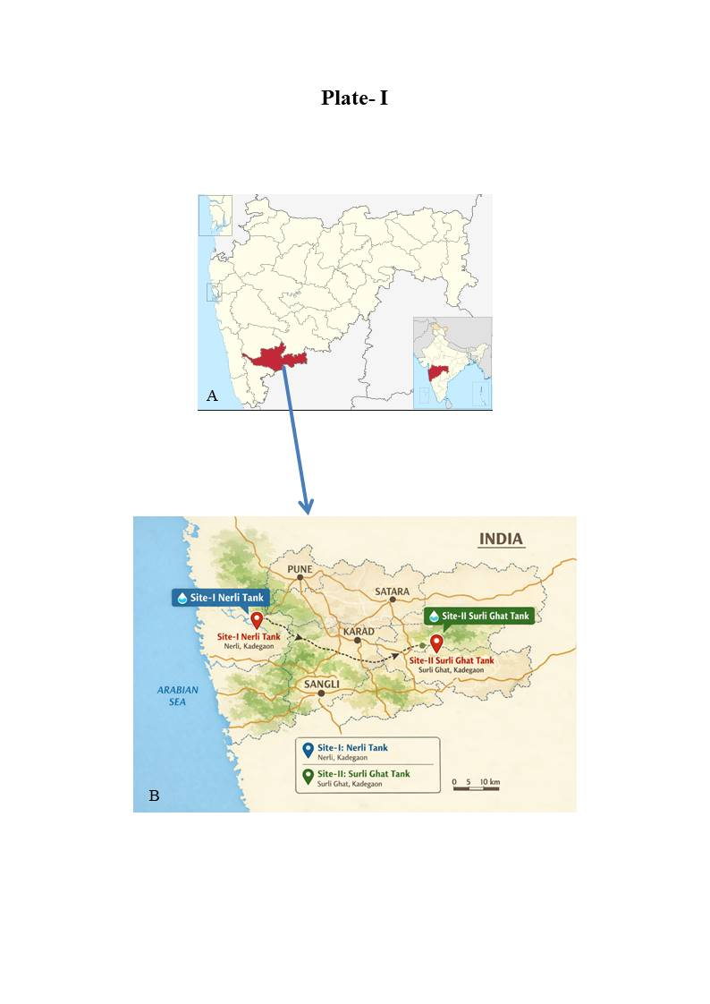
Plate I. Location map of the study area showing the sampling sites in Kadegaon Taluka, Sangli District, Maharashtra, India.

3. RESULTS AND DISCUSSION

The present investigation recorded five freshwater molluscan species belonging to two classes, Gastropoda and Bivalvia, from the selected tank ecosystems of the Kadegaon region. The recorded species were Pila sp., Bellamya sp., Lymnaea sp., Trochus sp., and Lamellidens sp. Four species belonged to Gastropoda, whereas one species belonged to Bivalvia. The distribution and abundance of the recorded species at Site-I (Nerli Tank) and Site-II (Surli Ghat Tank) are presented in Table 1 and Plate II.
A total of 167 individuals were recorded at Site-I, whereas 115 individuals were recorded at Site-II. Among the recorded species, Lymnaea sp. was the most abundant, with 70 individuals at Site-I and 43 individuals at Site-II. Pila sp. was the second most abundant species, with 40 and 36 individuals, respectively, followed by Bellamya sp., with 32 and 27 individuals. Trochus sp. occurred in relatively low numbers, with 11 individuals at Site-I and 9 individuals at Site-II. Lamellidens sp. was recorded exclusively at Site-I, with 14 individuals, and was absent from Site-II. The graphical representation of species abundance is presented in Figure 1.
The predominance of gastropods in the present study may be associated with their ecological adaptability and ability to utilise a variety of food resources, including algae, aquatic vegetation, detritus, and organic matter. Gastropods are also capable of occupying different microhabitats within freshwater ecosystems, which may contribute to their relatively high abundance. Similar dominance of gastropods has been reported in freshwater molluscan communities by Bijukumar et al. (2001), Subba (2003), and Raina et al. (2016).
Comparable Indian surveys have documented substantial spatial variation in freshwater gastropod richness and community composition, with habitat condition and anthropogenic gradients influencing local assemblages (Bagade et al., 2024; Kulkarni et al., 2021).
The greater total abundance observed at Nerli Tank compared with Surli Ghat Tank may be related to differences in habitat characteristics, aquatic vegetation, food availability, substrate composition, water quality, and other local environmental factors. The consistently high abundance of Lymnaea sp. at both sites suggests that this taxon is well adapted to the prevailing environmental conditions. Pila sp. and Bellamya sp. also showed relatively high abundance at both sites, indicating their successful establishment in the studied tank habitats. In contrast, the low abundance of Trochus sp. suggests a comparatively restricted distribution within the study area. The exclusive occurrence of Lamellidens sp. at Nerli Tank may be associated with site-specific substrate characteristics, availability of suitable habitat, water conditions, or food resources. However, these relationships should be interpreted cautiously because detailed physicochemical parameters were not assessed in the present diversity survey.
Field studies further indicate that freshwater mollusc communities can be structured by interacting environmental filters, including water chemistry, substrate, aquatic vegetation, hydrological stability, and connectivity; therefore, the site-level explanations proposed here remain ecologically plausible but untested without corresponding environmental measurements (Dubart et al., 2022; Sowa et al., 2019; Zawal et al., 2016).
The observed species composition is broadly comparable with previous studies of freshwater molluscan communities. Subba (2003) recorded ten freshwater molluscan species with a predominance of gastropods, while Raina et al. (2016) reported 17 molluscan species belonging to Gastropoda and Bivalvia from the Sip River in central India. Al-Saad et al. (2011) reported that molluscan species richness and distribution can vary according to environmental conditions and anthropogenic influences. Benthic macroinvertebrates, including molluscs, are also recognised as useful indicators of changes in aquatic environmental conditions because their distribution and community structure may respond to local habitat characteristics (Karr, 1987).
The Shannon–Wiener diversity index (H′) was 1.41035 at Site-I and 1.27101 at Site-II, indicating slightly higher molluscan diversity at Nerli Tank. The relatively higher diversity at Site-I may be associated with greater habitat heterogeneity and the availability of suitable ecological resources. In contrast, the comparatively lower diversity at Surli Ghat Tank may reflect differences in habitat structure, water chemistry, nutrient availability, aquatic vegetation, or other environmental factors. Freshwater molluscs constitute important components of aquatic communities and their distribution and diversity can provide useful information on ecological conditions (Ercan et al., 2013).
Accordingly, the modest difference in Shannon-Wiener diversity between the two tanks should be interpreted as a descriptive contrast in community structure rather than as evidence for a specific causal mechanism, because molluscan richness and turnover may respond jointly to habitat heterogeneity and multiple environmental gradients (Dubart et al., 2022; Sowa et al., 2019).
Simpson’s dominance index (D) was 0.276820 at Site-I and 0.292906 at Site-II. The slightly higher value at Surli Ghat Tank indicates marginally greater dominance within the community. The relatively high abundance of Lymnaea sp. and Pila sp. at Nerli Tank did not result in a higher overall dominance index. Thus, although Nerli Tank exhibited slightly higher Shannon–Wiener diversity and greater total abundance, Surli Ghat Tank showed slightly greater dominance. This demonstrates that species richness, abundance, diversity, and dominance represent different aspects of community structure and should therefore be interpreted together. Variations in molluscan community composition and dominance in relation to environmental conditions have also been reported in earlier studies (Sowa et al., 2019).
Regional studies from India likewise show that differences in habitat condition can alter gastropod richness, composition, and persistence, highlighting the importance of repeated seasonal sampling before assigning ecological status from a single survey period (Bagade et al., 2024; Kulkarni et al., 2021; Sonowal et al., 2021).
Overall, the present study demonstrates clear differences in molluscan abundance and community structure between the two selected tank ecosystems. Nerli Tank supported a higher total abundance (167 individuals) and slightly higher Shannon–Wiener diversity (H′ = 1.41035), with a Simpson’s dominance index of D = 0.276820, whereas Surli Ghat Tank supported 115 individuals with a Shannon–Wiener diversity of 1.27101 and a slightly higher Simpson’s dominance index of D = 0.292906. The occurrence of Lamellidens sp. exclusively at Nerli Tank further contributed to the difference in species composition between the two sites. The present findings provide baseline information on freshwater molluscan diversity and community structure in tank ecosystems of the Kadegaon region and highlight the potential usefulness of molluscan communities in future ecological monitoring and assessment of freshwater habitats.
Table 1: Distribution of Molluscan Species in Selected Sites of Kadegaon Region.

Sr. No | Name of the Species | Family | Site-I Nerli Tank | Site- II- Surli Tank | status
Sr. No | Name of the Species | Family | No of Species seen | No of Species seen | status
Class : Gastropoda ( Univalve Shell)
1 | Pila sp | Ampullariidae | 40 | 36 | Very common
2 | Bellymya sp | Viviparidae | 32 | 27 | Very common
3 | Lymnea sp | Lymnaeidae | 70 | 43 | common
4 | Trochus sp | Trochidae | 11 | 09 | Very Rare
Class : Gastropoda ( Two valved Shell)
1 | Lamellidens sp | Unionidae | 14 | 00 | Rare

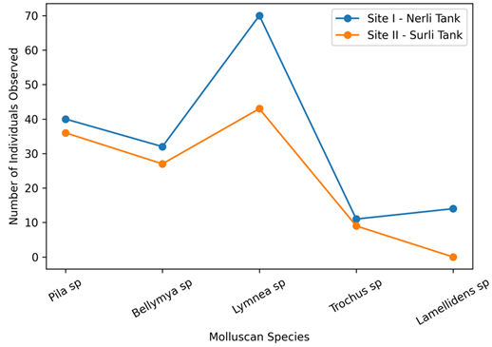
Figure 1. Comparison of molluscan species distribution at the two study sites.

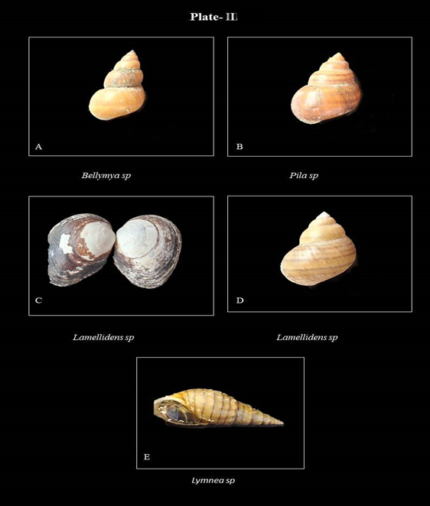
Plate II. Freshwater Molluscan Species Recorded from the Study Area
- A. Bellamya sp. (Family: Viviparidae); B. Pila sp. (Family: Ampullariidae); C. Lamellidens sp. (Family: Unionidae) – external view of shell valves; D. Pila sp. (Family: Ampullariidae) – shell morphology; E. Lymnaea sp. (Family: Lymnaeidae).
4. Conclusion

The present study provides baseline information on the diversity, abundance, distribution, and community structure of freshwater molluscs inhabiting two tank ecosystems of the Kadegaon region, Sangli District, Maharashtra. Five species belonging to Gastropoda and Bivalvia were recorded, with gastropods showing clear numerical dominance. Lymnaea sp. was the most abundant species at both study sites, whereas Trochus sp. showed the lowest abundance and Lamellidens sp. was restricted to Nerli Tank. Nerli Tank supported higher total abundance and slightly greater Shannon–Wiener diversity than Surli Ghat Tank, whereas Surli Ghat Tank showed slightly greater dominance according to Simpson’s dominance index. These differences indicate variation in the community structure of the two tank ecosystems, possibly reflecting differences in habitat characteristics and local environmental conditions. The findings establish a useful baseline for future monitoring of freshwater molluscan communities in the Kadegaon region and emphasise the ecological importance of conserving tank habitats. Further studies incorporating seasonal sampling and detailed physicochemical and water-quality parameters are recommended to better understand the environmental factors governing molluscan diversity and distribution.

Limitation
The study was limited to sampling conducted in January 2026 at two tank ecosystems, with sampling repeated only two to three times at each site. Detailed physicochemical, water-quality, substrate, and habitat variables were not measured. Consequently, observed differences in molluscan abundance, diversity, dominance, and species composition cannot be attributed to specific environmental drivers. Seasonal changes and longer-term temporal variation were also not assessed. The findings should therefore be interpreted as a baseline description of the sampled communities rather than a comprehensive ecological assessment of the two tanks.

Declaration of AI Use

This manuscript was prepared through the intellectual contributions of the author(s) to the study design, data analysis, interpretation of results, and scholarly content. Grammarly and ChatGPT were used solely to assist with grammatical refinement and reference formatting during manuscript revision. The author(s) accept full responsibility for the accuracy, integrity, and final content of the manuscript.

COMPETING INTERESTS DISCLAIMER:
Authors have declared that they have no known competing financial interests OR non-financial interests OR personal relationships that could have appeared to influence the work reported in this paper.

References

Agudo-Padrón, A. I. (2011). Current knowledge on population studies on five continental molluscs (Mollusca, Gastropoda et Bivalvia) of Santa Catarina State (SC, Central Southern Brazil region). Biodiversity Journal, 2(1), 9–12. https://www.biodiversityjournal.com/pdf/2_9-12.pdf
Al-Saad, H. T., Farid, W. A., & Al-Adhub, A. Y. (2011). Distribution and seasonal variations of n-alkanes in some species of molluscs from Shatt Al-Arab River. Mesopotamian Journal of Marine Sciences, 26(2), 182–196. https://doi.org/10.58629/mjms.v26i2.183
Bagade, A., Kulkarni, M. R., Khandare, S., Khandagle, A., Aravind, N. A., Shinde, Y., & Padhye, S. M. (2024). Rapid declines in freshwater gastropods in Pune city, India. Biodiversity, 25(4), 343–356. https://doi.org/10.1080/14888386.2024.2410013
Balian, E. V., Segers, H., Lévêque, C., & Martens, K. (2008). The freshwater animal diversity assessment: An overview of the results. Hydrobiologia, 595, 627–637. https://doi.org/10.1007/s10750-007-9246-3
Bijukumar, A., Sushama, S., & Biswas, T. (2001). Molluscs collected from the Bharathapuzha River, Kerala. Journal of the Inland Fisheries Society of India, 33(2), 68–69.
Bolotov, I. N., Sonowal, J., Kardong, D., Pasupuleti, R., Subba Rao, N. V., Unnikrishnan, S. K., Gofarov, M. Y., Kondakov, A. V., Konopleva, E. S., Lyubas, A. A., & Vikhrev, I. V. (2024). Discovery of an endemism hotspot of freshwater mussels (Bivalvia: Unionidae) in Assam, with a description of two new genera. Zoological Journal of the Linnean Society, 202(4), zlae052. https://doi.org/10.1093/zoolinnean/zlae052
Buckley, L. B., & Jetz, W. (2008). Linking global turnover of species and environments. Proceedings of the National Academy of Sciences of the United States of America, 105(46), 17836–17841. https://doi.org/10.1073/pnas.0803524105
Diniz-Filho, J. A. F., & Bini, L. M. (2005). Modelling geographical patterns in species richness using eigenvector-based spatial filters. Global Ecology and Biogeography, 14(2), 177–185. https://doi.org/10.1111/j.1466-822X.2005.00147.x
Dubart, M., Pointier, J.-P., Jarne, P., & David, P. (2022). Niche filtering, competition and species turnover in a metacommunity of freshwater molluscs. Oikos, 2022(9), e09157. https://doi.org/10.1111/oik.09157
Ercan, E., Gaygusuz, Ö., Tarkan, A. S., Reichard, M., & Smith, C. (2013). The ecology of freshwater bivalves in the Lake Sapanca basin, Turkey. Turkish Journal of Zoology, 37(6), 730–738. https://doi.org/10.3906/zoo-1212-23
Gaston, K. J. (2000). Global patterns in biodiversity. Nature, 405, 220–227. https://doi.org/10.1038/35012228
Graf, D. L., & Cummings, K. S. (2007). Review of the systematics and global diversity of freshwater mussel species (Bivalvia: Unionoida). Journal of Molluscan Studies, 73(4), 291–314. https://doi.org/10.1093/mollus/eym029
Karr, J. R. (1987). Biological monitoring and environmental assessment: A conceptual framework. Environmental Management, 11(2), 249–256. https://doi.org/10.1007/BF01867203
Kolhe, B. G., Naik, R. D., Anantharam, A. N., & Padhye, S. M. (2025). Beta diversity patterns and species-environment relationships of aquatic gastropods (Mollusca: Gastropoda) from an urban region in central India. Biologia, 80, 1425–1434. https://doi.org/10.1007/s11756-025-01907-6
Kulkarni, M. R., Bagade, A., & Padhye, S. M. (2021). Freshwater gastropod richness patterns along an urbanization gradient in tropical India. Journal of Urban Ecology, 7(1), juab035. https://doi.org/10.1093/jue/juab035
Prasad, S., Nath, P., & Bhushan, M. (2025). Systematic diversity, population abundance and ecological significance of shellfish fauna in Bihar, India. Journal of Scientific Research and Reports, 31(10), 182–192. https://doi.org/10.9734/jsrr/2025/v31i103561
Priyadarsini, P. (2026). Freshwater malacofaunal diversity of Jabalpur Division, Madhya Pradesh, India. Journal of Biology and Nature, 18(2), 318–326. https://doi.org/10.56557/joban/2026/v18i210912
Raina, R. K., Vyas, V., Swarup, A., & Gurjar, P. (2016). Molluscan diversity in River Sip—A tributary of River Narmada in central India. International Journal of Pure & Applied Bioscience, 4(5), 108–113. https://doi.org/10.18782/2320-7051.2381
Reid, A. J., Carlson, A. K., Creed, I. F., Eliason, E. J., Gell, P. A., Johnson, P. T. J., Kidd, K. A., MacCormack, T. J., Olden, J. D., Ormerod, S. J., Smol, J. P., Taylor, W. W., Tockner, K., Vermaire, J. C., Dudgeon, D., & Cooke, S. J. (2019). Emerging threats and persistent conservation challenges for freshwater biodiversity. Biological Reviews, 94(3), 849–873. https://doi.org/10.1111/brv.12480
Rohde, R. A., & Muller, R. A. (2005). Cycles in fossil diversity. Nature, 434, 208–210. https://doi.org/10.1038/nature03339
Shannon, C. E. (1948). A mathematical theory of communication. Bell System Technical Journal, 27(3), 379–423. https://doi.org/10.1002/j.1538-7305.1948.tb01338.x
Simpson, E. H. (1949). Measurement of diversity. Nature, 163, 688. https://doi.org/10.1038/163688a0
Sonowal, J., Puzari, M., & Kardong, D. (2021). Diversity of freshwater molluscs from the upper Brahmaputra Basin, Assam, India. Journal of Threatened Taxa, 13(5), 18237–18246. https://doi.org/10.11609/jott.7144.13.5.18237-18246
Sowa, A., Krodkiewska, M., Halabowski, D., & Lewin, I. (2019). Response of the mollusc communities to environmental factors along an anthropogenic salinity gradient. The Science of Nature, 106, Article 60. https://doi.org/10.1007/s00114-019-1655-4
Strong, E. E., Gargominy, O., Ponder, W. F., & Bouchet, P. (2008). Global diversity of gastropods (Gastropoda; Mollusca) in freshwater. Hydrobiologia, 595, 149–166. https://doi.org/10.1007/s10750-007-9012-6
Subba, B. R. (2003). Molluscan check list of Ghodaghodi Tal Area, Kailali District. Our Nature, 1(1), 1–2. https://doi.org/10.3126/on.v1i1.294
Subba Rao, N. V. (1989). Handbook freshwater molluscs of India. Zoological Survey of India. https://zsi.gov.in/handbook-and-pictorial-guides-book-toc?book_id=005&book_title=Handbook+Freshwater+Molluscs+of+India&type=hpg
United Nations Environment Programme. (1992). Convention on biological diversity. https://www.unep.org/resources/report/convention-biological-diversity-june-1992
Vaughn, C. C. (2018). Ecosystem services provided by freshwater mussels. Hydrobiologia, 810, 15–27. https://doi.org/10.1007/s10750-017-3139-x
Zawal, A., Lewin, I., Stępień, E., Szlauer-Łukaszewska, A., Buczyńska, E., Buczyński, P., & Stryjecki, R. (2016). The influence of the landscape structure within buffer zones, catchment land use and instream environmental variables on mollusc communities in a medium-sized lowland river. Ecological Research, 31(6), 853–867. https://doi.org/10.1007/s11284-016-1395-2
Zieritz, A., Sousa, R., Aldridge, D. C., Douda, K., Esteves, E., Ferreira-Rodríguez, N., Mageroy, J. H., Nizzoli, D., Osterling, M., Reis, J., Riccardi, N., Daill, D., Gumpinger, C., & Vaz, A. S. (2022). A global synthesis of ecosystem services provided and disrupted by freshwater bivalve molluscs. Biological Reviews, 97(5), 1967–1998. https://doi.org/10.1111/brv.12878

