Case Report

Rescue, Medical and Surgical Management of Severe Cervical Snare Trauma in an Indian Monitor Lizard (Varanus bengalensis)

Abstract
An adult Indian monitor lizard (Varanus bengalensis) weighing approximately 2.4 kg was rescued by Telangana Forest Department personnel from Veerpur village, Telangana, after entrapment in a nylon snare around the neck. On presentation to the Veterinary Clinical Complex, College of Veterinary Science, Korutla, the animal was depressed, dehydrated and minimally responsive, with clinical signs of circulatory shock. Examination revealed a contaminated circumferential cervical laceration involving the skin, subcutaneous tissue and superficial cervical musculature. Emergency management comprised thermal support, subcutaneous Ringer's lactate solution (20 mL/kg), antimicrobial and analgesic therapy, wound irrigation and protective bandaging. Following clinical stabilisation, surgical debridement and repair were undertaken under intramuscular ketamine anaesthesia (20 mg/kg) with local lignocaine administration. Devitalised tissue was removed, the muscle was sutured with absorbable polyglactin 910, and the skin was apposed with polyamide using a horizontal mattress pattern. Post-operative care included ceftriaxone (25 mg/kg intramuscularly) for 10 days, meloxicam (0.2 mg/kg intramuscularly) for 5 days, daily wound dressing and environmental support. By the tenth post-operative day, satisfactory tissue union permitted removal of the skin sutures. During rehabilitation, the lizard resumed voluntary feeding and demonstrated coordinated locomotion, neck mobility and normal responsiveness. After clinical examination, it was released into a suitable natural habitat near the rescue site. This case describes successful short-term clinical management and rehabilitation following severe cervical snare trauma.

Keywords: Varanus bengalensis, Indian monitor lizard, cervical laceration, nylon snare injury, surgical reconstruction, wildlife rehabilitation.

Introduction
The Indian monitor lizard (Varanus bengalensis) is among the largest terrestrial reptiles native to the Indian subcontinent, with a distribution extending across India, Nepal, Bangladesh, Sri Lanka, and parts of Southeast Asia. The species occupies a wide range of habitats, including deciduous forests, scrublands, rocky outcrops, agricultural fields, wetlands, and peri-urban environments. As an opportunistic carnivore and scavenger, it performs an important ecological function by regulating populations of rodents, insects, snakes, and other small vertebrates and contributing to ecosystem health through its scavenging activities (Bennett, 1995; Daniel, 2002). Observations of scavenging behaviour in Bengal monitors in Bangladesh provide species-specific evidence for this aspect of their ecology (Rahman et al., 2015).
Despite its ecological significance, V. bengalensis faces increasing anthropogenic pressures. Habitat fragmentation, expanding agriculture, road traffic accidents, electrocution, illegal hunting, domestic animal attacks, and entanglement in synthetic fishing nets or nylon snares have emerged as major causes of injury and mortality. Among these, nylon snare entrapment is particularly devastating because the non-biodegradable material may progressively tighten around body parts as the animal struggles to escape, causing vascular occlusion, ischaemia, pressure necrosis, extensive soft tissue damage, and, in severe cases, septicaemia or death (Mader & Divers, 2014). Research on monitor-lizard conservation perceptions in West Bengal has also examined human attitudes and local uses of these reptiles (Bhattacharya et al., 2024). The harmful effects of discarded fishing gear on reptiles have additionally been documented in marine turtle rehabilitation records, although the circumstances differ from terrestrial snare injuries (Himpson et al., 2023).
The Indian monitor lizard receives the highest level of legal protection under Schedule I of the Wildlife (Protection) Act, 1972, making its rescue, treatment, rehabilitation, and release essential components of wildlife conservation in India. Veterinary intervention not only improves the survival of injured animals but also contributes directly to the conservation of wild populations. Research incorporating snake-rescuer observations in Karnataka similarly highlights community awareness as a consideration in responses to human–reptile encounters (Ganavi et al., 2026). A recent veterinary review further emphasises the welfare value of treating individual injured wild animals while noting uncertainty regarding broader conservation effects (Beaulieu, 2025).
Reptile wound management differs considerably from that of mammals because reptiles have lower metabolic rates, temperature-dependent physiology, slower inflammatory responses, prolonged wound healing, and unique integumentary characteristics. Consequently, successful treatment requires careful stabilisation, meticulous surgical debridement, tension-free wound closure, appropriate antimicrobial therapy, and optimal environmental management (Divers & Mader, 2005; Jacobson, 2007; Divers & Stahl, 2019).
Although individual reports describing traumatic injuries in monitor lizards have been published, detailed documentation of severe circumferential cervical snare injuries followed by successful surgical repair and rehabilitation remains scarce. The present report describes the complete clinical management—from rescue and stabilisation to surgery, post-operative care, rehabilitation, and release—of an Indian monitor lizard with a life-threatening cervical snare laceration.

Case History
An adult Indian monitor lizard (Varanus bengalensis) weighing approximately 2.4 kg was rescued by personnel of the Telangana Forest Department from Veerpur village, Raikal mandal, Jagtial district, Telangana. According to the rescuers, the animal had become entrapped in a nylon snare and its repeated attempts to free itself caused progressive tightening of the nylon loop, producing a severe circumferential laceration around the neck (Figure 1A, 1B).
The rescued lizard was immediately transported to the Veterinary Clinical Complex (VCC), College of Veterinary Science, Korutla, for emergency veterinary care (Figure 2A and 2B).
On presentation, the lizard was markedly depressed and minimally responsive, was dehydrated, and showed clinical signs consistent with circulatory shock. Physical examination revealed a deep circumferential laceration encircling the cervical region with exposure of subcutaneous tissue and superficial cervical musculature. The wound margins were contaminated with dirt, and necrotic tissue was present, indicating prolonged entrapment. Mild haemorrhage and localised oedema were evident around the lesion. Despite the severity of the injury, no obvious tracheal rupture, oesophageal perforation, vertebral instability or neurological deficits were detected. The animal retained spontaneous respiration and protective reflexes but was unable to exhibit normal defensive behaviour because of pain and exhaustion.
Considering the compromised physiological status, surgical repair of the laceration was deferred until the patient had been medically stabilised.
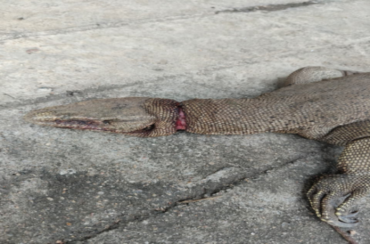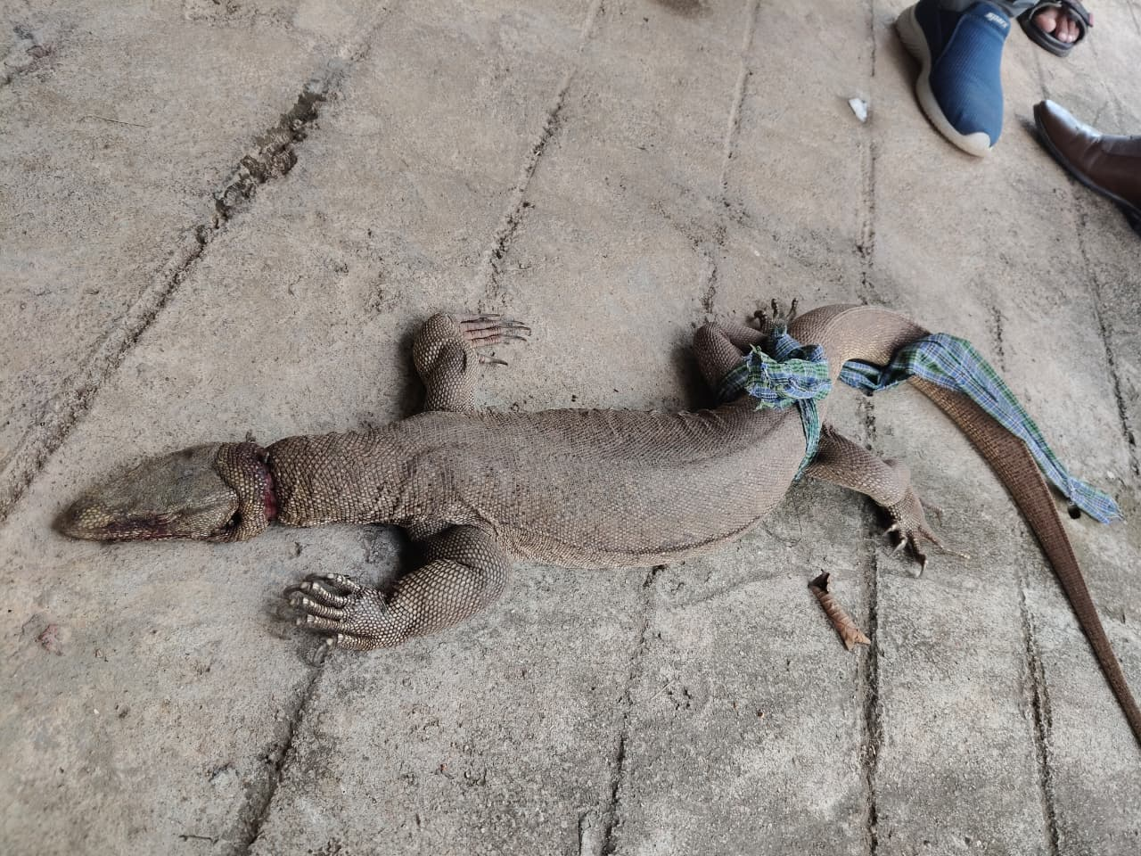
Figure 1A. Close-up view of the severe circumferential cervical laceration caused by nylon snare entrapment.
Figure 1B. Whole-body view of the rescued monitor lizard showing the cervical snare laceration on presentation.

Medical Stabilisation
On presentation, the immediate priority was stabilisation of the patient before surgical intervention (Figure 3). The Indian monitor lizard was housed in a cage to restrict its movement during recovery. As reptiles are ectothermic, the patient was maintained within its preferred optimal temperature zone (POTZ; 28–32°C) throughout hospitalisation to optimise cardiovascular function, immune competence, tissue perfusion and drug metabolism, thereby facilitating recovery and wound healing (Mader & Divers, 2014). Clinical examination revealed dehydration, circulatory shock and a contaminated circumferential cervical laceration. Supportive fluid therapy was initiated using Ringer's lactate solution (20 mL/kg body weight, SC) to restore hydration, improve circulating blood volume and enhance tissue perfusion. Considering the extensive soft-tissue injury and the high risk of secondary bacterial infection, ceftriaxone (Intacef ®) was administered intramuscularly at 25 mg/kg body weight as empirical broad-spectrum antimicrobial therapy. Meloxicam (Melonex ®) was also administered intramuscularly at 0.2 mg/kg body weight for pain and inflammation management. In addition, A Tribivet® (vitamin B-complex) injection was administered intramuscularly as supportive therapy to improve metabolic status and aid recovery from stress and trauma. The cervical wound was copiously irrigated with sterile normal saline to remove dirt, necrotic tissue, and foreign contaminants, followed by antiseptic lavage with dilute povidone–iodine solutions. A sterile gauze bandage was applied to protect the wound until surgical repair was initiated.
Following fluid resuscitation, antimicrobial therapy, thermal support and local wound management, there was a marked improvement in the patient's hydration status, alertness, and overall clinical condition. Adequate pre-operative stabilisation was considered essential, as correction of dehydration and maintenance of the animal within the preferred optimal temperature zone improve anaesthetic safety, support normal drug pharmacokinetics, and enhance post-operative wound healing in reptiles (Divers & Stahl, 2019; Carpenter & Harms, 2023). The patient was therefore considered fit for general anaesthesia on the following day.
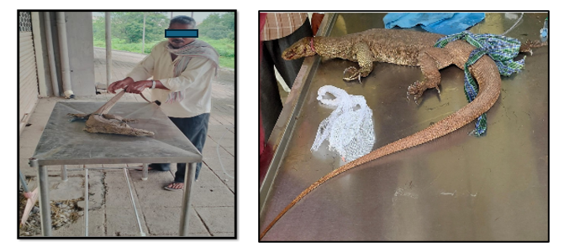
Figure 2A and 2B. Animal when presented to the clinic with the neck laceration.
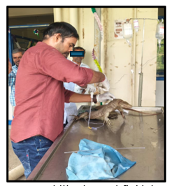
Figure 3. Initial emergency stabilisation and fluid therapy following rescue.

Surgical Management
Following successful medical stabilisation, suturing of the lacerated wound was undertaken under anaesthesia induced with intramuscular ketamine hydrochloride (20 mg/kg body weight), which provided satisfactory immobilisation for wound debridement and repair (Fig. 4A). Lignocaine hydrochloride was also administered as a linear infiltration to provide analgesia and was also sprayed over the entire wound surface (Fig. 4B and 4C). Throughout the procedure, the lizard was maintained on a padded surface to prevent hypothermia, as reptiles depend on external heat sources to maintain physiological functions and optimal tissue perfusion (Mader & Divers, 2014).
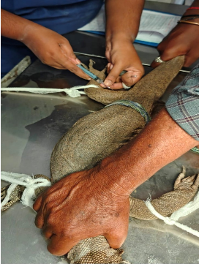
Figure 4A. Ketamine intramuscular administration.
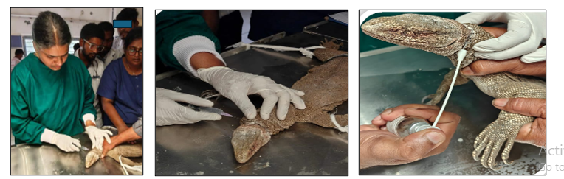
Figure 4B, 4C. Linear infiltration by lignocaine and also used in spray form.
The cervical wound was carefully examined and found to be a circumferential laceration extending through the skin, subcutaneous tissue, and superficial cervical musculature. The wound margins were irregular, contaminated, and showed localised necrosis caused by prolonged constriction from the nylon snare.
After aseptic preparation of the surgical field, a thorough surgical debridement was performed by excising devitalised tissue and refreshing the wound margins until healthy, viable tissue was exposed following evaluation of the circumferential wound (Fig. 5A and 5B). The wound was repeatedly irrigated with copious sterile normal saline followed by metronidazole and dilute povidone-iodine solutions to reduce bacterial contamination. Elimination of devitalised tissue is essential in reptiles because necrotic tissue delays granulation, predisposes to bacterial colonisation, and significantly prolongs wound healing (Divers & Mader, 2005).
Muscle suturing was performed in a simple continuous pattern using Polyglactin 910 (Vicryl® 2-0) to eliminate dead space and reduce wound tension. The subcutaneous tissue and skin were apposed using Polyamide (Ethilon ® 2-0) in a horizontal mattress suture pattern, a technique intended to distribute tension across the thick, keratinised reptilian skin and minimises the risk of wound dehiscence (Fig 6).
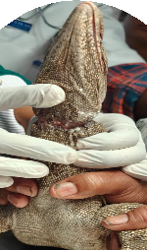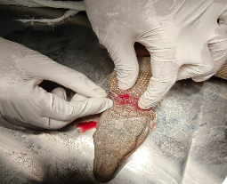
Figure 5A, 5B. After evaluating the circumferential laceration, surgical debridement was initiated.
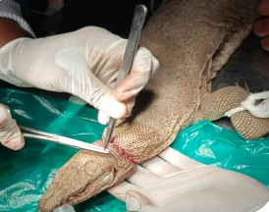
Figure 6. Intra-operative repair with layered wound closure of the cervical laceration.
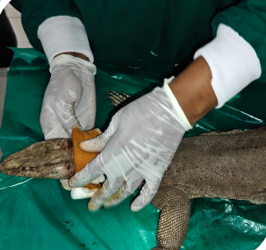
Figure 7A. Intra-operative subcutaneous bandage application after suturing and fluid administration.
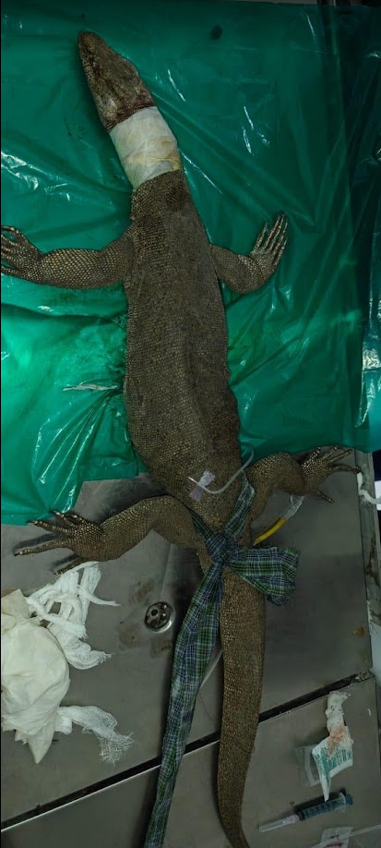
Figure 7B. Intra-operative subcutaneous bandage application after suturing and fluid administration.
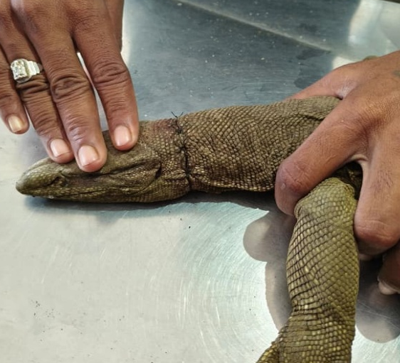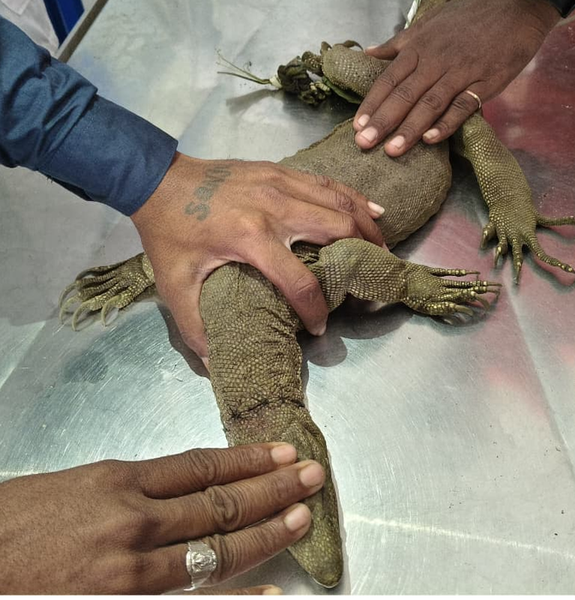
Figure 8A. post-operative appearance showing satisfactory skin apposition after surgical repair.
Figure 8B. Follow-up examination demonstrating progressive wound healing and restoration of cervical integrity prior to release.

Post-operative Management
Following suturing of the laceration, the lizard received ceftriaxone (25 mg/kg IM) for 10 days to prevent secondary bacterial infection. Meloxicam (0.2 mg/kg IM) was administered for 5 days to provide post-operative analgesia and control inflammation. The animal was reluctant to consume food while housed in the cage; therefore, 100 mL of DNS was administered subcutaneously each day (Fig 7B).
The sutured wound was dressed daily with metronidazole and povidone-iodine solutions (Fig. 9A and 9B) and covered with a padded sterile bandage to protect the site from contamination and mechanical trauma (Fig. 7A).
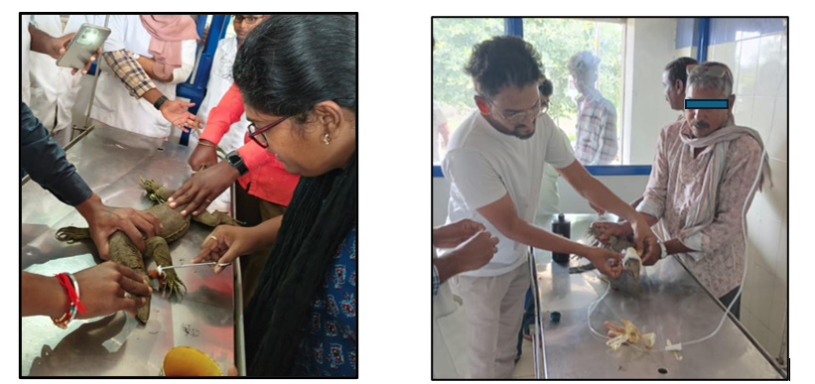
Figure 9A and 9B. post-operative wound management with daily dressing.
Routine monitoring of the suture site, continued thermoregulatory support, and maintenance of a clean, low-stress environment facilitated uneventful wound healing. Progressive granulation tissue formation and epithelialisation were observed during follow-up, and complete wound healing was observed by the tenth post-operative day. Skin sutures were removed after satisfactory tissue union.

Rehabilitation
Following satisfactory wound healing, the monitor lizard was transferred to a quiet rehabilitation enclosure for continued observation and recovery. To minimise stress, restraint and handling were minimised, and restricted to essential clinical examinations. The animal was maintained within its preferred optimal temperature zone with access to clean water and an appropriate environment. The recovering lizard was given small pieces of meat, which were readily accepted.
During the rehabilitation period, daily monitoring included assessment of general health, feeding behaviour, locomotion, neck mobility, and normal defensive responses. Progressive recovery was evident, with the restoration of normal alertness, tongue-flicking behaviour, voluntary food intake, coordinated walking and climbing activities. The sutured wound remained healthy, showing complete epithelialisation without evidence of infection.

Release
Before release, a final physical examination confirmed complete wound healing and restoration of normal physiological function. The lizard demonstrated coordinated locomotion, adequate neck movement, active prey-seeking behaviour, and normal responsiveness.
Considering the successful clinical recovery, the patient was declared fit for release. In coordination with the Telangana Forest Department, the monitor lizard was released into a suitable natural habitat close to the rescue location (Fig 10), with the intention of minimising ecological disruption.
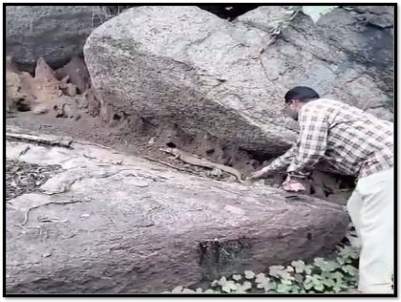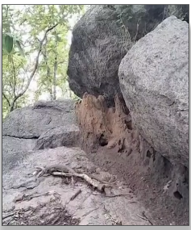
Figure 10. Release of the monitor lizard back into its natural habitat in Raikal forest under supervision of the Forest Beat Officer.

Discussion and Conclusion
Traumatic injuries caused by nylon snares and synthetic fishing nets are causes of morbidity in free-ranging reptiles. Owing to their non-biodegradable nature, these materials progressively tighten as animals struggle to escape, resulting in vascular compromise, tissue ischaemia, pressure necrosis, wound contamination, and, if untreated, septic complications (Jacobson, 2007; Mader & Divers, 2014). In the present case, entrapment in the snare caused a severe circumferential cervical laceration, and prolonged constriction resulted in extensive soft-tissue damage. No involvement of the trachea, oesophagus or major cervical vessels was observed, allowing successful wound healing with suturing.
Early medical stabilisation was critical to the favourable outcome. Correction of dehydration and circulatory compromise with crystalloid fluid therapy before anaesthesia improved tissue perfusion and patient stability. As reptiles are ectothermic, maintaining the lizard within its Preferred Optimal Temperature Zone (POTZ) was equally important for supporting immune function, drug metabolism, anaesthetic recovery, and tissue repair (Divers & Stahl, 2019; Doneley et al., 2018). Surgical debridement remains the cornerstone of contaminated wound management because removal of devitalised tissue reduces bacterial contamination, promotes granulation tissue formation, and facilitates epithelialisation (Bennett & Lock, 2000; Mader & Divers, 2014). In the present case, layered closure of the wound, post-operative broad-spectrum antimicrobial therapy, and analgesic and anti-inflammatory treatment were followed by uncomplicated wound healing without infection or dehiscence. Meloxicam is widely recommended in reptile medicine for the management of post-operative pain and inflammation when administered after adequate hydration and appropriate thermal support (Carpenter & Harms, 2023; Mader & Divers, 2014).
Successful wildlife treatment includes not only wound closure but also the restoration of normal physiological and behavioural function before release.
The restoration of normal feeding behaviour, coordinated locomotion, neck mobility and defensive responses indicated functional recovery and supported release into the native habitat, consistent with accepted wildlife rehabilitation principles (Miller & Fowler, 2015; Warwick et al., 2013). This case demonstrates that timely rescue, appropriate medical stabilisation and surgical management, and structured rehabilitation, together with close collaboration between veterinarians and the Forest Department, were associated with the successful treatment, rehabilitation and release of the severely injured monitor lizard to the wild while contributing to the conservation of this protected reptile species (Government of India, 1972; Mader & Divers, 2014).

The Indian monitor lizard (Varanus bengalensis) is protected under Schedule I of the Wildlife (Protection) Act, 1972, emphasising the conservation value of every rescued individual. Furthermore, this report emphasises the value of evidence-based clinical management in the conservation of Schedule I protected reptile species and underscores the need for greater awareness of injuries caused by nylon snares and other anthropogenic hazards that can entrap animals.

Limitations

This report documents one rescued Indian monitor lizard and therefore cannot establish the effectiveness of the treatment protocol across other animals, wound severities or reptile species. Recovery was assessed through the observed clinical and behavioural course up to release. Consequently, long-term wound integrity, survival and behaviour after release cannot be determined from the information presented. The findings should be interpreted as an individual clinical outcome rather than comparative evidence for a particular intervention.

Ethical Approval

Animal Ethic committee approval has been collected and preserved by the author(s)
Declaration of AI Use

This manuscript was prepared through the intellectual contributions of the author(s) to the study design, data analysis, interpretation of results, and scholarly content. Grammarly and ChatGPT were used solely to assist with grammatical refinement and reference formatting during manuscript revision. The author(s) accept full responsibility for the accuracy, integrity, and final content of the manuscript.

COMPETING INTERESTS DISCLAIMER:
Authors have declared that they have no known competing financial interests OR non-financial interests OR personal relationships that could have appeared to influence the work reported in this paper.

References
Beaulieu, M. (2025). Rehabilitating wild animal welfare: A focus on veterinary rescue and rehabilitation interventions. Research in Veterinary Science, 186, Article 105582. https://doi.org/10.1016/j.rvsc.2025.105582
Bennett, D. (1995). A little book of monitor lizards: A guide to the monitor lizards of the world and their care in captivity. Viper Press.
Bennett, R. A., & Lock, B. A. (2000). Nonreproductive surgery in reptiles. Veterinary Clinics of North America: Exotic Animal Practice, 3(3), 715–732. https://doi.org/10.1016/S1094-9194(17)30071-3
Bhattacharya, S., Zia, S. Z., Mahato, S., Gangwar, R. K., Singh, N., Auliya, M., & Koch, A. (2024). Conservation perceptions and attitudes regarding monitor lizards in West Bengal, India. Nature Conservation, 56, 201–222. https://doi.org/10.3897/natureconservation.56.133577
Carpenter, J. W., & Harms, C. A. (Eds.). (2023). Carpenter's exotic animal formulary (6th ed.). Saunders. https://doi.org/10.1016/C2019-0-00378-0
Daniel, J. C. (2002). The book of Indian reptiles and amphibians. Bombay Natural History Society & Oxford University Press. https://library.stcp.ac.in/cgi-bin/koha/opac-detail.pl?biblionumber=49251
Divers, S. J., & Mader, D. R. (Eds.). (2005). Reptile medicine and surgery (2nd ed.). Saunders Elsevier. https://library.rvc.ac.uk/Record/23514
Divers, S. J., & Stahl, S. J. (Eds.). (2019). Mader's reptile and amphibian medicine and surgery (3rd ed.). Elsevier. https://doi.org/10.1016/C2014-0-03734-3
Doneley, B., Monks, D., Johnson, R., & Carmel, B. (Eds.). (2018). Reptile medicine and surgery in clinical practice. Wiley-Blackwell. https://doi.org/10.1002/9781118977705
Ganavi, S., Pramod, A. F., Roopa, C., & Kumara, V. (2026). Assessment of ophidian diversity in and around Chitradurga Town, Karnataka. Journal of Global Ecology and Environment, 22(3), 228–240. https://doi.org/10.56557/jogee/2026/v22i310852
Government of India. (1972). The Wild Life (Protection) Act, 1972 (Act No. 53 of 1972, as amended). https://www.indiacode.nic.in/indiacode/bitstream/123456789/6198/1/the_wild_life_%28protection%29_act%2C_1972.pdf
Himpson, K., Dixon, S., & Le Berre, T. (2023). Evaluation of sea turtle morbidity and mortality within the Indian Ocean from 12 years of data shows high prevalence of ghost net entanglement. PLOS ONE, 18(8), Article e0289167. https://doi.org/10.1371/journal.pone.0289167
Jacobson, E. R. (Ed.). (2007). Infectious diseases and pathology of reptiles: Color atlas and text. CRC Press. https://doi.org/10.1201/9781420004038
Mader, D. R., & Divers, S. J. (Eds.). (2014). Current therapy in reptile medicine and surgery. Saunders Elsevier. https://doi.org/10.1016/C2010-0-67117-3
Miller, R. E., & Fowler, M. E. (Eds.). (2015). Fowler's zoo and wild animal medicine (Vol. 8). Elsevier. https://doi.org/10.1016/C2012-0-01362-2
Rahman, K. M. M., Khan, M. M. H., & Rakhimov, I. I. (2015). Scavenging behavior of the Bengal monitor (Varanus bengalensis) in Jahangirnagar University campus, Bangladesh. Journal of Scientific Research and Reports, 7(7), 539–550. https://doi.org/10.9734/JSRR/2015/18258
Warwick, C., Arena, P., Lindley, S., Jessop, M., & Steedman, C. (2013). Assessing reptile welfare using behavioural criteria. In Practice, 35(3), 123–131. https://doi.org/10.1136/inp.f1197

