Integrated Assessment of Mosquito-Borne Diseases in Ottapalam, Palakkad, Kerala

Abstract
The present multi-component observational and exploratory study assessed reported mosquito-borne disease patterns, community knowledge and preventive practices, household larval indices, and a pilot device-exposure experiment in Ottapalam, Palakkad, Kerala. Local annual case counts for 2021-2025 were abstracted from Primary Health Centre (PHC) Lakkidi records and interpreted alongside official state and national surveillance data. A community survey included 105 participants recruited through Google Forms and face-to-face interviews, and entomological surveillance covered 100 households in Wards 13, 14 and 15. The PHC summary recorded dengue cases of 11, 7, 21, 45 and 10 from 2021 through 2025, respectively. One malaria case was recorded in 2022 and two in 2024; values for 2021, 2023 and 2025 were not stated in the available local summary. No chikungunya cases were recorded in that summary. Survey responses indicated high general awareness but less consistent routine source-reduction behaviour. Six of 100 houses and six of 50 observed containers were positive for mosquito larvae, yielding a House Index of 6%, Container Index of 12% and Breteau Index of 6; no pupae were detected. In the pilot experiment, 20 Aedes albopictus eggs were assigned to each condition. Hatching began on day 5 under device-exposure conditions and on day 8 in the control condition, and the observed developmental stages were shorter under device exposure. No ovicidal or larvicidal effect was observed. Because acoustic dose was not calibrated, independent vessel replication was not documented, and a small device-associated temperature increase was observed, acoustic and thermal contributions cannot be separated. The findings support continued source reduction, community engagement, surveillance and integrated vector management, while acoustic approaches should remain experimental until tested under calibrated, independently replicated and temperature-controlled conditions.
Keywords: mosquito-borne diseases; dengue; malaria; chikungunya; Aedes albopictus; community awareness; larval indices; House Index; Container Index; Breteau Index; ultrasonic device; integrated vector management.

1. Introduction
Vector-borne diseases remain a major public health challenge; the World Health Organization (WHO) estimates that they account for more than 17% of infectious diseases and cause more than 700,000 deaths annually (WHO, 2024). Mosquitoes in the genera Aedes, Anopheles and Culex transmit important human pathogens, and their distribution and transmission dynamics are shaped by interacting climatic, environmental and social conditions. Dengue risk is influenced by vector distribution, urbanisation, water-storage practices, community behaviours and climate-related factors (WHO, 2025). These relationships make locally grounded surveillance and household-level vector assessment important for prevention and control.
Global dengue transmission reached a record level in 2024, with 14.6 million cases reported to WHO, including more than 13 million in the Region of the Americas (WHO, 2025). In India, National Center for Vector Borne Diseases Control (NCVBDC) surveillance recorded 289,235 dengue cases and 227,564 malaria-positive cases in 2023 (NCVBDC, n.d.-a, n.d.-b). Kerala has a recurrent vector-borne disease burden, with dengue contributing substantially to year-to-year fluctuations and seasonal patterns (Raj et al., 2022).
Kerala surveillance reported 16,766 confirmed dengue cases and 153 dengue deaths, 566 malaria cases and 7 malaria deaths, and 31 chikungunya cases in 2023 (Directorate of Health Services, Kerala [DHS Kerala], 2025a). For 2024, DHS Kerala reported 20,674 confirmed dengue cases with 128 deaths, 53,536 probable dengue cases with 13 deaths, 952 malaria cases with 6 deaths, and 29 chikungunya cases with 2 deaths (DHS Kerala, 2025b). These source-specific categories are retained because confirmed, probable and disease-specific surveillance counts should not be combined without labelling.
Entomological studies in Kerala have documented Aedes breeding in artificial containers and substantial temporal variation in House, Container and Breteau indices (Vaz et al., 2019; Wilson et al., 2022). Community knowledge alone may not ensure consistent source-reduction behaviour; work from Kerala and other Indian settings has identified gaps between awareness and routine preventive practice (Krishna et al., 2026; Setu et al., 2020). These findings support combining surveillance with practical household and community measures.
Localised information for Ottapalam remains limited because much of the available surveillance is aggregated above the municipal or facility-catchment level. The present study therefore combines PHC-based case summaries, a community awareness survey, household larval surveillance and an exploratory device-exposure experiment. The acoustic component is intentionally treated as a pilot. Prior evidence does not support electronic mosquito repellents for preventing bites, while laboratory ultrasound studies indicate that biological responses depend on device configuration and exposure conditions (Enayati et al., 2007; Kalimuthu et al., 2020).

2. Objectives
To describe reported case counts for 2021–2025 for dengue, malaria and chikungunya in the available PHC Lakkidi records and place these observations in state and national surveillance context.
To assess community knowledge, attitudes and practices regarding mosquito-borne disease prevention and vector-control measures in Ottapalam and surrounding areas.
To quantify household larval positivity in selected Ottapalam wards using the House Index, Container Index and Breteau Index.
To conduct a preliminary descriptive pilot experiment examining egg-to-adult developmental observations under control and ultrasonic device-exposure conditions.

3. Materials and Methods

3.1 Study design and setting
This multi-component observational and exploratory study was conducted between November 2025 and January 2026 in Ottapalam Municipality, Palakkad district, Kerala, India. It comprised four components: retrospective descriptive analysis of secondary case counts; a cross-sectional community awareness survey; household entomological surveillance; and a descriptive pilot experiment evaluating developmental observations under ultrasonic device-exposure conditions.

3.2 Epidemiological trend analysis
Aggregate annual case counts were obtained from PHC Lakkidi records available to the study for 2021-2025. Because the available materials did not establish that the PHC catchment captured all cases in Ottapalam Municipality, local findings are interpreted as PHC-based observations rather than municipality-wide incidence. State and national context was checked against NCVBDC and Kerala DHS surveillance sources. The analysis is descriptive and does not calculate incidence rates because population denominators were not available.

3.3 Community awareness survey
The study population comprised residents of Ottapalam and surrounding areas. A total of 105 participants were recruited through a dual-mode survey using Google Forms and face-to-face household interviews. Participants were recruited using convenience, non-probability sampling within selected wards, based on feasibility, accessibility, administrative approval and participant availability. Because participant-level random selection was not documented, the sample is not treated as probability-based or representative of the entire Ottapalam population.
A structured awareness questionnaire included demographic variables such as age, gender, education, area of residence, history of mosquito-borne disease and use of preventive resources. The questionnaire contained 23 questions. Questions 1, 2, 3, 4, 5, 6, 18, 19 and 20 were descriptive. Knowledge items were questions 7, 8, 9, 11, 16 and 17; attitude items were questions 10, 22 and 23; and practice items were questions 12, 13, 14, 15 and 21.
Responses were summarised at the item level using frequencies and percentages. Knowledge, attitude and practice items were grouped by domain according to the questionnaire structure described above, but composite Good/Moderate/Poor categories are not interpreted because validated cut-offs and reliability information were not documented. Item-level response denominators were not uniformly documented; accordingly, reported percentages are treated descriptively and are not assumed to use N = 105 for every item. Data collection occurred from 24 November to 1 December 2025.

3.4 Entomological field surveillance
An eight-member team, divided into four groups of two, conducted door-to-door larval surveillance of 100 households in Wards 13, 14 and 15 on two field days between December 2025 and January 2026. Outdoor water-holding containers, including tyres, coconut shells and discarded plastic materials, were inspected for mosquito larvae and pupae. Survey forms and GPS-capable smartphones were available for field data collection; photography was not used when residents expressed privacy concerns. Because no taxonomic confirmation method was documented in the field record, positive houses and containers are interpreted as positive for mosquito larvae rather than Aedes-confirmed.
The indices were calculated as follows:
House Index (HI) = (Number of houses positive for larvae / Number of houses inspected) × 100.
Container Index (CI) = (Number of containers positive for larvae / Number of containers inspected) × 100.
Breteau Index (BI) = (Number of positive containers / Number of houses inspected) × 100.

3.5 Ultrasonic pilot experiment
Twenty eggs assigned to each condition were maintained under shaded, well-ventilated conditions. The control condition was maintained without activated ultrasonic exposure, whereas the device-exposure condition used the prototype. Figures 1 and 2 show the schematic control and device-exposure setups, respectively. In Figure 1, the module shown in the schematic was not activated in the control condition.
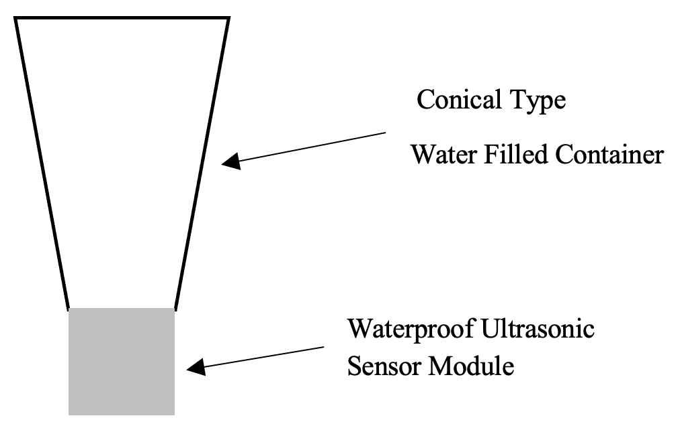

Figure 1. Schematic of the control setup. The ultrasonic module shown in the schematic was not activated in the control condition.
The activated ultrasonic device-exposure arrangement, including the microcontroller and display interface, is shown in Figure 2.
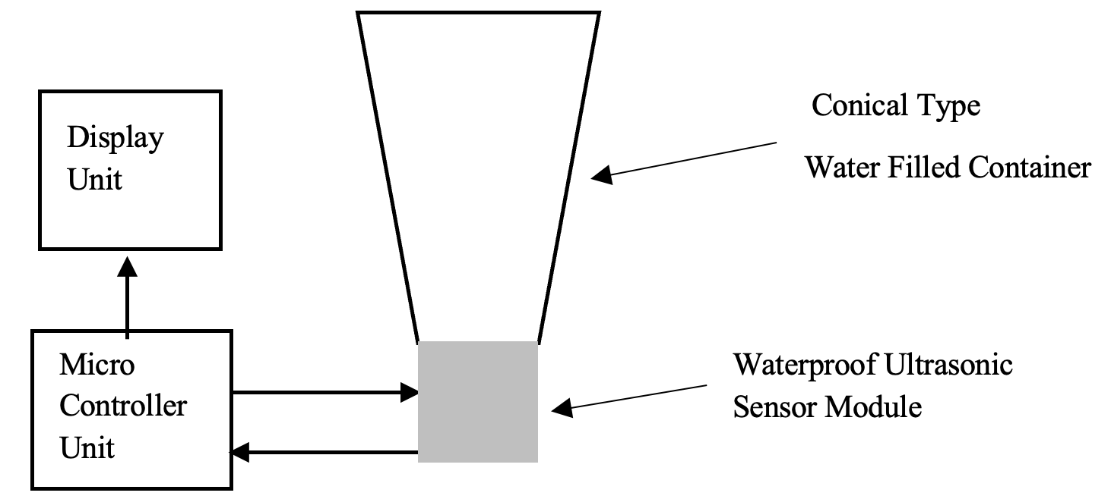
Figure 2. Schematic of the ultrasonic device-exposure setup.

The prototype ultrasonic system comprised a waterproof ultrasonic sensor module, a microcontroller unit (MCU), a water-filled container and a display interface. The transmitter operated at 40 kHz with an average output power of approximately 15 mW. A piezoelectric crystal converted electrical energy into mechanical vibrations, and the MCU controlled device operation. The available study record did not document acoustic pressure in water, transducer-to-sample distance, exposure duty cycle or an acoustic calibration procedure.
The experimental materials included 20 eggs per condition, clear 250-mL plastic beakers, a hand lens for observing developmental stages, a thermometer and pH paper. The source and method of taxonomic confirmation of Aedes albopictus eggs were not documented in the available record.
Two conditions were compared: a control maintained without activated ultrasonic exposure and a device-exposure condition at 40 kHz. The number of independent replicate vessels was not documented; therefore, individual eggs are not treated as independent experimental replicates and the experiment is interpreted descriptively.
Observation parameters included egg hatching, failure to hatch, timing of developmental transitions and an overall comparison of development between conditions. No inferential statistical analysis was applied.
High-precision climate control was not available. The two conditions were maintained in the same general microenvironment; water pH was measured using pH paper, and temperature was measured using a thermometer. A device-associated temperature increase of approximately 2°C was noted during the experiment. Because temperature can alter Aedes development, the design cannot separate acoustic from thermal effects. The experiment is therefore treated as an exploratory feasibility observation rather than an efficacy trial.

3.6 Ethical, administrative and privacy considerations
The study record notes administrative approval as part of field access and documents that the academic purpose of household visits and confidentiality were explained to residents. GPS-tagged photography was discontinued when privacy concerns were expressed, and inspections were completed without photography. The epidemiological component was reported as aggregate annual case counts, and only aggregate survey and household findings without personal identifiers were reported. No formal institutional ethics committee approval or waiver number, and no written-consent procedure, were documented in the study record; no such approval identifier or consent procedure is therefore asserted.

4. Results

4.1 Comparative epidemiological analysis
To provide external context, official surveillance data were rechecked against source-specific systems. NCVBDC recorded 227,564 malaria-positive cases and 289,235 dengue cases in India in 2023 (NCVBDC, n.d.-a, n.d.-b). In Kerala, DHS Kerala reported 16,766 confirmed dengue cases with 153 deaths, 566 malaria cases with 7 deaths and 31 chikungunya cases in 2023; for 2024, it reported 20,674 confirmed dengue cases with 128 deaths, 53,536 probable dengue cases with 13 deaths, 952 malaria cases with 6 deaths and 29 chikungunya cases with 2 deaths (DHS Kerala, 2025a, 2025b). These figures are presented according to the categories used by the respective surveillance sources.
Within the available PHC Lakkidi summary, dengue was the most consistently documented mosquito-borne disease. As summarised in Table 1, dengue counts rose from 11 in 2021 and 7 in 2022 to 21 in 2023 and 45 in 2024, then fell to 10 in 2025. The malaria field is available only for 2022 and 2024 in the summary, and missing years are not treated as zero.
Table 1. Reported mosquito-borne disease pattern in the PHC Lakkidi summary used in this study.
Year | Dengue cases | Malaria | Chikungunya
2021 | 11 | Not stated in local record summary | 0 reported
2022 | 7 | 1 case | 0 reported
2023 | 21 | Not stated in local record summary | 0 reported
2024 | 45 | 2 cases | 0 reported
2025 | 10 | Not stated in local record summary | 0 reported
One malaria case was recorded in 2022 and two in 2024. The available notes indicated possible travel- or mobility-related epidemiological context for some cases; however, the small numbers and incomplete documentation do not permit population-level inference. No chikungunya cases were recorded in the available PHC summary for 2021-2025. These are recorded facility-based case counts and should not be interpreted as proof of absence of community transmission.

4.2 Community knowledge, attitude and practices
The community survey included 105 participants from Ottapalam and nearby areas. More than 90% reported awareness of mosquito-borne diseases. Dengue was recognised by 90.4%, chikungunya by 83.7% and malaria by 79.8%, whereas recognition of Zika virus (18.3%) and Japanese encephalitis (13.5%) was lower. Approximately 39% of participants were residents of Ottapalam, most were aged 18-30 years, and females constituted nearly 70% of the sample. Because valid response denominators were not consistently documented at the item level, these percentages are presented descriptively rather than converted to assumed n/N values.
Regarding perceived local impact, 90.3% of respondents indicated that they were not aware of deaths from mosquito-borne diseases in their locality, whereas 9.7% reported that such deaths had occurred. Awareness of mosquito-control activities was moderate: 51% had noticed control measures, 25% had not and 24% were unsure. For public awareness programmes, 48.1% considered coverage adequate, 45.2% considered improvement necessary and 6.7% considered it inadequate. These item-level percentages may reflect differing valid-response denominators.
General awareness was high, but reported preventive practice was less consistent. More than 90% identified stagnant water as a breeding source, whereas only about 40% reported cleaning refrigerator drip trays or terrace gutters. The pattern suggests a knowledge-practice gap, while the convenience sample limits population-level inference.

4.3 Entomological surveillance and larval indices
Larval surveillance covered 100 households in Wards 13, 14 and 15 on two field days between December 2025 and January 2026. Household size ranged from one to nine residents. Six houses and six of 50 observed containers were larva-positive, and no pupae were detected. These counts yielded HI 6%, CI 12% and BI 6.
Table 2 summarises the field findings and larval indices. The results are interpreted as mosquito-larval rather than species-confirmed Aedes indices because taxonomic confirmation was not documented.
Table 2. Larval surveillance findings from 100 households in selected Ottapalam wards.
Entomological measure | Finding
Houses inspected | 100
Houses positive for larvae | 6
Containers observed | 50
Positive containers | 6
House Index (HI) | 6%
Container Index (CI) | 12%
Breteau Index (BI) | 6
Pupae detected | None
Most inspected houses were larva-negative, but localised breeding sites were observed around cattle-rearing areas and ornamental water features. These observations indicate that discrete water-holding habitats can persist even where no generalised sanitation problem is evident; no formal hygiene-scoring instrument was applied.
Larvae were found in plastic containers, discarded tyres, plastic buckets or pots, lotus ponds, leaf axils and stagnant water near cattle sheds. Because species-level identification was not documented, these are interpreted as mosquito-larval habitats. Kerala studies similarly identify artificial containers as important Aedes breeding sites (Vaz et al., 2019; Wilson et al., 2022).

4.4 Ultrasonic pilot experiment
Twenty eggs were observed in each condition. Hatching began on day 5 in the device-exposure condition and on day 8 in the control condition. In the control condition, 75% of eggs hatched on day 8 and the remainder on the following day. The reported pH was 7, and the water temperature at the time of measurement was 28°C. No ovicidal or larvicidal effect was observed.
Observed stage durations were shorter under device-exposure conditions. Table 3 summarises the descriptive developmental durations. The control-stage components sum to 14.6 days, whereas the device-exposure components sum to 10.4 days, corresponding to a 28.8% shorter total observed developmental duration. Because independent vessel replication, acoustic calibration and matched temperature control were not documented, this comparison is descriptive and cannot isolate an ultrasound-specific effect.
Table 3. Descriptive developmental durations observed under control and ultrasonic device-exposure conditions.
Developmental stage | Control group (days) | Ultrasound group (days) | % difference
Egg to larva | 8.2 | 5.2 | 36.6%
Larval stages | 4.2 | 3.4 | 19%
Pupal stage | 2.2 | 1.8 | 18%
Total days | 14.6 | 10.4 | 28.8%

5. Discussion
The PHC Lakkidi summary shows a recorded dengue peak in 2024 followed by a lower count in 2025. Kerala surveillance and published trend analyses confirm substantial interannual and seasonal variation in vector-borne disease occurrence, but the present study did not test causes of the local fluctuation (DHS Kerala, 2025a, 2025b; Raj et al., 2022). Climate, vector-control activity and awareness are therefore contextual considerations rather than demonstrated explanations for the local year-to-year pattern.
Few malaria cases were specified in the available PHC summary, and the available notes indicated possible travel- or mobility-related epidemiological context for some cases. Given the small numbers and missing yearly values, the data do not support population-level risk conclusions. Travel history and mobility may be considered during individual case investigation where epidemiologically relevant, but the present dataset does not permit classification of cases as imported or locally acquired.
No chikungunya cases were recorded in the PHC summary during 2021-2025. This should be interpreted as an absence of recorded cases in the available source rather than proof of zero community transmission, because no systematic virological or vector-infection surveillance was undertaken.
The community survey suggests substantial general awareness but inconsistent translation of knowledge into routine source reduction. Comparable awareness-practice gaps have been reported in Kerala and elsewhere in India (Krishna et al., 2026; Setu et al., 2020). Because the present survey used convenience sampling and item-level response denominators were not uniformly documented, its estimates should be interpreted descriptively rather than as population prevalence.
The entomological findings show that six houses and six observed containers were larva-positive, with no pupae detected. House Index and Container Index have different denominators and should not be compared directly as evidence of concentration. The observed habitats, particularly artificial containers and tyres, are consistent with previous Kerala entomological studies (Vaz et al., 2019; Wilson et al., 2022).
Household surveillance does not capture all potential vector habitats. Construction sites, public drains, building gutters and other non-residential settings were not systematically surveyed, and the two-day field snapshot cannot capture seasonal variation. These limitations also constrain any direct relationship between household larval indices and the PHC dengue case counts.
The device-exposure pilot did not demonstrate a mosquito-control effect: no ovicidal or larvicidal activity was observed, and development was earlier under device-exposure conditions than in the control. Kalimuthu et al. (2020) reported larval mortality with a differently configured ultrasonic system, illustrating that acoustic outcomes can depend on device configuration and exposure conditions. Electronic mosquito repellents have also failed to show evidence of preventing mosquito bites in field studies (Enayati et al., 2007). Although these technologies are not equivalent, both literatures underscore the need for controlled biological validation rather than assuming efficacy from device operation alone.
Temperature is an important confounder in the present pilot. A systematic review and meta-analysis found that temperature materially affects Aedes hatching, development and survival (Nik Abdull Halim et al., 2022). The approximately 2°C device-associated temperature increase observed here could therefore have contributed to the shorter developmental times. Without matched thermal control, the acoustic and thermal components cannot be separated, and the result should be described as earlier development under device-exposure conditions rather than as a confirmed ultrasound mechanism.
The pilot is therefore hypothesis-generating. Future studies should use calibrated acoustic pressure, defined exposure duration and duty cycle, standardised transducer distance, independently replicated vessels, matched temperature conditions, verified mosquito species, predefined developmental endpoints and an analysis plan appropriate to the experimental unit. The present observations do not justify field deployment of the prototype.

6. Limitations
The study has several limitations. PHC Lakkidi case counts may not represent all cases in Ottapalam Municipality, and missing malaria values for several years limit local trend interpretation. The community survey used convenience sampling, and item-level denominators, questionnaire validation and composite-score thresholds were not uniformly documented; consequently, only descriptive item-level findings are interpreted. Entomological surveillance covered 100 households in three wards on two field days, did not systematically include non-residential habitats and lacked documented species-level larval confirmation. The ultrasonic pilot included only 20 eggs per condition; independent vessel replication, calibrated acoustic dose, exposure distance/duty cycle and stringent environmental control were not documented. The approximately 2°C device-associated temperature difference is a major confounder. No causal inference can be made from the descriptive surveillance or cross-sectional components, and the pilot cannot establish acoustic efficacy or mechanism. No formal institutional ethics committee approval or waiver identifier was documented in the study record, and no such identifier is reported.

7. Conclusion
Within the PHC Lakkidi summary available to this study, dengue was the most consistently documented mosquito-borne disease and showed a peak of 45 recorded cases in 2024 followed by 10 in 2025. For malaria, one case was recorded in 2022 and two in 2024, while values for 2021, 2023 and 2025 were not stated in the available summary; no chikungunya cases were recorded. The community survey indicated high general awareness with less consistent routine source-reduction practice. Household surveillance identified six larva-positive houses, six positive containers, HI 6%, CI 12% and BI 6, with no pupae detected. These findings support focused source reduction and continued surveillance while remaining cautious about generalisation beyond the sampled households and PHC-based records.
The pilot did not demonstrate an ovicidal or larvicidal effect. Earlier development was observed under device-exposure conditions, but the absence of calibrated exposure, documented independent replication and matched thermal control prevents attribution specifically to ultrasound. Acoustic approaches should therefore remain experimental. Source reduction, community engagement, routine surveillance and integrated vector management remain the defensible foundations for local mosquito-borne disease control.

8. Recommendations
Prioritise source reduction by removing or managing stagnant water in domestic and peri-domestic settings, with particular attention to small artificial containers and discarded materials.
Repeat larval surveillance across seasons, expand coverage beyond the three sampled wards where feasible, include non-residential habitats, and document taxonomic identification of larvae.
Strengthen community engagement to translate knowledge into routine preventive behaviour, including consistent cleaning and covering of small water-holding containers.
Use integrated vector management to combine surveillance, environmental source reduction, community participation and context-appropriate vector-control measures.
Where malaria is identified, case investigation should consider travel history and population mobility at the individual epidemiological level without attributing risk to any population group.
Any future acoustic evaluation should use calibrated exposure, independent replication, matched temperatures and predefined biological endpoints before field application is considered.

Declaration of AI Use
This manuscript was prepared through the intellectual contributions of the author(s) to the study design, data analysis, interpretation of results and scholarly content. Grammarly and ChatGPT were used solely to assist with grammatical refinement and reference formatting during manuscript revision. The author(s) accept full responsibility for the accuracy, integrity and final content of the manuscript.

Competing Interests
The authors declare no known competing financial interests, non-financial interests or personal relationships that could have influenced the work reported in this paper.

9. References
Directorate of Health Services, Kerala. (2025a). Health at a glance: Kerala 2023–24. Government of Kerala. https://dhs.kerala.gov.in/wp-content/uploads/2025/05/H%40G-2023-24-1.pdf
Directorate of Health Services, Kerala. (2025b). Kerala—Communicable disease data for 2024. Government of Kerala. https://dhs.kerala.gov.in/wp-content/uploads/2025/06/IDSP-Annual-Data-2024.pdf
Enayati, A. A., Hemingway, J., & Garner, P. (2007). Electronic mosquito repellents for preventing mosquito bites and malaria infection. Cochrane Database of Systematic Reviews, 2007(2), Article CD005434. https://doi.org/10.1002/14651858.CD005434.pub2
Kalimuthu, K., Tseng, L.-C., Murugan, K., Panneerselvam, C., Aziz, A. T., Benelli, G., & Hwang, J.-S. (2020). Ultrasonic technology applied against mosquito larvae. Applied Sciences, 10(10), Article 3546. https://doi.org/10.3390/app10103546
Krishna, A., Sushan, A., Robinson, A., Kangusamy, B., Muthappan, S., & Abdulkader, R. S. (2026). Perceptions and practices of community and Ward Health, Sanitation and Nutrition Committee members on dengue fever and Aedes vector management in Kollam district, Kerala, India. Journal of Vector Borne Diseases, 63(1), 53–60. https://doi.org/10.4103/JVBD.JVBD_207_24
National Center for Vector Borne Diseases Control. (n.d.-a). Dengue situation in India. Ministry of Health and Family Welfare, Government of India. Retrieved October 7, 2026, from https://ncvbdc.mohfw.gov.in/index4.php?lang=1&level=0&lid=3715&linkid=431
National Center for Vector Borne Diseases Control. (n.d.-b). Magnitude of the problem. Ministry of Health and Family Welfare, Government of India. Retrieved October 7, 2026, from https://ncvbdc.mohfw.gov.in/index4.php?lang=1&level=0&lid=3699&linkid=420
Nik Abdull Halim, N. M. H., Che Dom, N., Dapari, R., Salim, H., & Precha, N. (2022). A systematic review and meta-analysis of the effects of temperature on the development and survival of the Aedes mosquito. Frontiers in Public Health, 10, Article 1074028. https://doi.org/10.3389/fpubh.2022.1074028
Raj, J., Soorya, V., & Anitha, K. R. (2022). Trends and seasonality of vector borne diseases in Kerala. International Journal of Community Medicine and Public Health, 9(10), 3701–3709. https://doi.org/10.18203/2394-6040.ijcmph20222559
Setu, Y., Sulania, A., & Singh, S. (2020). A study on knowledge and practices regarding mosquito borne diseases in Rithala village, New Delhi. International Journal of Scientific Reports, 7(1), 13–19. https://doi.org/10.18203/issn.2454-2156.IntJSciRep20205490
Vaz, C., Harikumar, A., Mundodan, J. M., Rafi, M., & Saju, C. R. (2019). Mosquito density in rural Kerala: A study on the trend of Aedes larval indices over monsoon in a rural area of Thrissur district, India. International Journal of Community Medicine and Public Health, 6(10), 4528–4532. https://doi.org/10.18203/2394-6040.ijcmph20194524
Wilson, A., Krishnadas, V. T., Saju, C. R., & Rafi, M. M. (2022). A study to assess the Aedes mosquto diversity and the different mosquito genera in a rural area in Thrissur, Kerala. International Journal of Community Medicine and Public Health, 9(4), 1736–1743. https://doi.org/10.18203/2394-6040.ijcmph20220847
World Health Organization. (2024, September 26). Vector-borne diseases. https://www.who.int/news-room/fact-sheets/detail/vector-borne-diseases
World Health Organization. (2025, August 21). Dengue. https://www.who.int/news-room/fact-sheets/detail/dengue-and-severe-dengue

