Annelid fauna of Purba Midnapur, West Bengal, India

Abstract
Purba Medinipur, West Bengal, has historically had limited locality-specific documentation of annelid diversity. A faunal survey conducted in 2026 assessed earthworms and leeches collected from moist microhabitats across the district. Field collection targeted leaf litter, decaying organic matter, and moist soil, with specimens recovered using pickaxes or spades. Specimens were narcotised, fixed, preserved, and examined using external morphological and internal anatomical characters for taxonomic identification. In total, 106 specimens were examined, comprising 85 earthworms and 21 leeches. Sixteen taxa were recorded: 14 earthworm taxa, of which 13 were identified to species level and one was retained as Perionyx sp., and two leech species. The earthworm material represented eight genera and three families, while the leech material represented one genus and one family. The systematic account reports district-level distributional records and identifies three named species—Perionyx shyamasreetus, Eutyphoeus sukhendui, and Haemadipsa rajbalaae—as first records from West Bengal. Perionyx sp. is retained as an unidentified taxon and is excluded from formal species-level and state-new-record counts. The material includes taxa collected from Nandigram, Mahishadal, Patashpur, Khejuri, Bhagawanpur, and other localities within Purba Medinipur. Recorded abundance varied among earthworm taxa, while the leech material comprised 18 specimens of Haemadipsa sylvestris and three of H. rajbalaae. These observations update the district-level annelid inventory and provide locality-specific baseline information on the occurrence and distribution of earthworms and leeches in the surveyed habitats. The findings also support continued systematic sampling to improve documentation of annelid diversity in Purba Medinipur.
Keywords: Annelida, Earthworms, Leeches, Purba Medinipur, West Bengal, New records.
Introduction: Annelids, predominantly represented by earthworms (Oligochaeta) and leeches (Hirudinea), play vital roles in ecological dynamics and biomedical science. Earthworms are critical ecosystem engineers and are often regarded as farmers' allies because of their ability to enhance soil aeration, increase porosity in agricultural terrains such as paddy fields, and facilitate nitrogen retention. Additionally, their casts provide nutrient-rich vermicompost essential for sustainable agriculture and horticulture. In India, foundational and recent taxonomic investigations by Julka (1988), Halder (1998), Halder et al. (2007), Mandal et al. (2017), Hasan et al. (2023, 2024), and Balakrishnan et al. (2025) have significantly expanded the understanding of oligochaete diversity. Globally, over 5,738 earthworm species have been described, with 498 recorded from India and 82 documented from West Bengal. Despite this regional richness, locality-specific records from Purba Medinipur district remain limited.
Recent studies have continued to examine earthworm-mediated processes in Indian agriculture, including vermicomposting systems in West Bengal and tank-irrigated paddy cultivation in Tamil Nadu (Mal & Chattopadhyay, 2024; Sugumaran et al., 2025).
Recent taxonomic and faunal studies have also refined knowledge of Indian earthworm diversity through an annotated checklist for the Indo-Gangetic Plains and community-level documentation from West Bengal (Tiwari et al., 2024; Ahmed et al., 2024).
Leeches, comprising predominantly sanguivorous and hermaphroditic organisms, have longstanding therapeutic relevance. Historically used in bloodletting to treat cutaneous ailments and infected wounds, modern hirudotherapy uses anticoagulant secretions such as hirudin to treat vascular and paralytic conditions. India's hirudinean taxonomy has been systematically documented through seminal works by Harding and Moore (1927), Chandra (1991), Ghosh (1998), and Mandal et al. (2026). Of approximately 917 species known worldwide, 91 occur in India, 33 in West Bengal, and only eight have previously been documented from the Medinipur region. The current study documents annelid fauna collected during recent field surveys in Purba Medinipur, presenting new distribution records for both the district and the state, including the terrestrial leech Haemadipsa rajbalaae.
Research gap: Although annelid diversity has been documented in broader regions of India and West Bengal, the available inventory for Purba Medinipur remains limited, indicating a need for updated locality-specific faunal documentation.
The current study documents annelid fauna collected during recent field surveys across Purba Medinipur and presents new distribution records for both the district and the state. A pickaxe was employed as an essential tool for excavating hard and moist microhabitats while minimising specimen damage (Fig. 1), with collection activities documented across representative sites in Haldia (Plate 1). Quantitative analyses detail specimen abundance across the recorded earthworm taxa (Fig. 2), together with the species composition and proportion of leeches under the genus Haemadipsa (Fig. 3). Morphological characteristics and external anatomy of key taxa are further illustrated, including the newly recorded terrestrial leech Haemadipsa rajbalaae (Plate 2), the dorsal aspect of Amynthas gracilis (Plate 3), and diagnostic characters of Perionyx sp. (Plate 4). Collectively, these findings update the regional faunal inventory and provide vital baseline data for local vermiculture and biodiversity conservation.
Objective: Therefore, the objective of this study was to document the annelid fauna collected during recent field surveys across Purba Medinipur and to report distributional records identified from the collected material.
Material and Methods: Sampling design and study coverage. The study was a targeted, locality-based faunistic survey of annelids in Purba Medinipur during 2026. The specimen records document collections from seven named localities across Nandigram, Mahishadal/Haldia, Patashpur, Khejuri, and Bhagawanpur on eight recorded collection dates between 11 July and 12 September 2026. Sampling targeted moist microhabitats, including leaf litter, decaying organic matter, and moist soil, using pickaxes or spades. Across the documented collections, 106 specimens were examined, comprising 85 earthworms and 21 leeches. The available field records do not specify geographic coordinates, a fixed plot or sampling area, time-standardised sampling effort, or a repeated site-by-site sampling schedule. Consequently, the specimen counts are treated as descriptive collection data rather than effort-standardised abundance estimates.
Collection, preservation and examination: Live specimens were placed in wide-mouth containers, washed in fresh water, and gradually narcotised in water with drops of 70% alcohol for about two hours to prevent body distortion or breakage. The narcotised specimens were fixed in 4% formalin for 24 hours to facilitate proper tissue rigidity for dissection, thoroughly washed, and permanently preserved in 70% alcohol. External morphology and internal anatomical structures, including the prostomium, clitellum, setal arrangement, dorsal and spermathecal pores, male and female pores, gizzard, hearts, caeca, prostate glands, and reproductive organs, as applicable, were examined under a binocular stereomicroscope. Identification was based on the diagnostic characters presented in the systematic accounts and the taxonomic literature already cited in the manuscript.
Distributional record assessment and voucher documentation: Formal new-record status was restricted to taxa identified to species level. Perionyx sp. was therefore retained as an unidentified taxon and excluded from formal species-level new-record counts. For each taxon, the systematic account reports the collection locality, date, collector, registration number, diagnostic description, and distribution. Record status was assessed using the distributional information and faunal/checklist literature already cited by the authors in this manuscript. The registration numbers are retained as voucher identifiers; the repository institution associated with these numbers was not recorded in the dataset used for this manuscript.
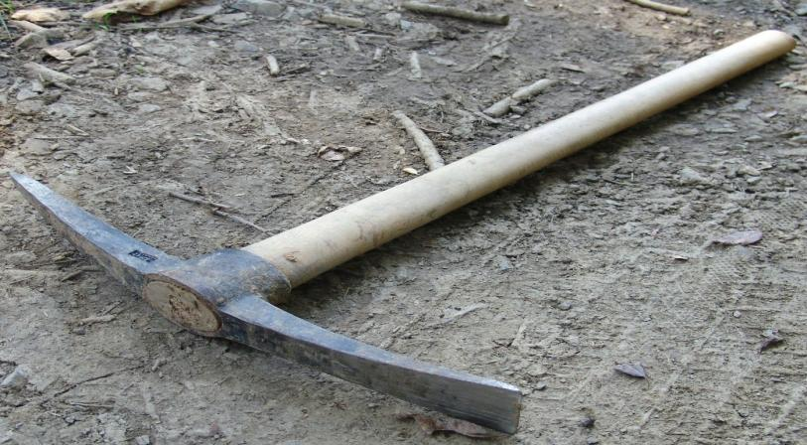

Figure. 1. Pickaxe. Essential tool for digging soil in hard and moist microhabitats for earthworm collection while preventing specimen damage caused by broad spades.

Results & Discussion

SYSTEMATIC ACCOUNT
Phylum: Annelida – Lamarck, 1802
Class: Clitellata – Michaelsen, 1919
Subclass: Oligochaeta – Grube, 1850
Supraorder: Megadrili – Benham, 1890
Order- Crassiclitellata Jamieson, Barrie G.M. (1988)
Family-Megascolecidae Daniele Rosa, 1891
Genus-Perionyx Perrier,1872
- Perionyx excavatus Perrier, 1872
- Perionyx sp.
- *Perionyx pokhrianus Stephenson, 1920
- *Perionyx macintoshi Beddard, 1883
- **Perionyx shyamasreetus Ghosh et al., 2018. (State new Record)
Genus- Amynthas Kinberg, 1867
- *Amynthas gracilis (Kinberg, 1867)
- *Amynthas corticis (Baird, 1869)
- *Amynthas morrisi (Beddard, 1892)

Genus- Lampito Kinberg, 1867

- Lampito mauritii Kinberg, 1867
Genus- Metaphire Sims & Easton, 1972
- Metaphire posthuma (Vaillant, 1868)
Genus-Polypheretima Michaelsen, 1934
- *Polypheretima elongata (Perrier, 1872)

Family-Acanthodrilidae Carl Claus 1880
Genus-Eutyphoeus Michaelsen, 1900
- **Eutyphoeus sukhendui Mandal et al., 2026
Genus-Octochaetona Gates, 1962
- *Octochaetona beatrix (Beddard, 1902)
Family: Rhinodrilidae William Blaxland Benham, 1890
Genus: Pontoscolex Schmarda, 1861
- *Pontoscolex corethrurus (Müller, 1857)
Order- Arhynchobdellida Blanchard, 1894
Family- Haemadipsidae Blanchard, 1893
Genus Haemadipsa Tennant, 1859
- Haemadipsa sylvestris Blanchard, 1894
- **Haemadipsa rajbalaae Mandal et al., 2026

* New records from Purba Medinipur
**New records from West Bengal
Note: Perionyx sp. is identified only to genus level and is not included in formal species-level or state-new-record counts.
Perionyx excavatus Perrier, 1872
1872. Perionyx excavatus Perrier, Nouv. Arch. Mus. Hist. Nat. Paris, 8: 126.
1998. Perionyx excavatus Halder, Fauna of West Bengal. State Fauna Series. 3(Part-l0): 17-93.
Material examined: 14 ex. Akandabari, Nandigram, Purba Medinipur, West Bengal. 16.VIII.2026. Coll. D. N. Das. Reg. No. An 8908/2.

Description: Length 35–125 mm, diameter 3–7 mm, comprising 79–121 segments. The annular clitellum spans segments 13–17. Its reproductive system is intricate, featuring distinct arrangements of pores and structures. Two pairs of spermathecal pores are situated near the mid-ventral line in segments 7/8 and 8/9. Male pores are located within small transverse protuberances in a single male field, with each protuberance having a slightly irregular transverse groove containing apertures of 4–9 perisetal follicles on segment 18. The single female pore is mid-ventral on segment 14. Genital markings are absent. Nephridiopores, although inconspicuous, are arranged in an irregular longitudinal row on each side near the median line. These anatomical details collectively underscore the complexity and diversity of the organism's morphology and reproductive system.
Distribution: India: West Bengal, Meghalaya, Andaman Island, Arunachal Pradesh, Assam,
Himachal Pradesh, Maharashtra, Manipur, Orissa, Sikkim, Tamil Nadu and Uttar Pradesh
Outside India: Madagascar and its adjacent islands, Sri Lanka, Myanmar, Thailand, Vietnam, the Malay Peninsula, Indonesia, the Philippines, Taiwan and the West Indies.
Perionyx sp.
Material examined: 4 ex. Gholpukur, Nandigram, Purba Medinipur, West Bengal. 16.VIII.2026. Coll. D. N. Das. Reg. No. An 8906/2.

Description: The male pore is on the 18th segment in a large groove. The female pore is on the 14th segment. Length 140 mm; diameter 6 mm; total segments 172. Dorsal pores occur at 3/4 and 4/5. Spermathecal pores occur at 7/8 and 8/9. The egg-shaped setae are perichaetine. No penial setae were observed. The last pair of hearts is on segment XIII. The prostate gland is recemosal from segments 18–20. The prostomium is epilobic.
Record status: The present material is identified only as Perionyx sp.; therefore, no formal species-level distributional or new-state-record claim is made for this taxon.

*Perionyx pokhrianus Stephenson, 1920
1920. Perionyx pokhrianus Stephenson. Mem. India Mus., 7: 208. (Type loc., Jorpokri,
Darjeeling Dist., W. Bengal, India; type in Zoological Survey of India, Calcutta).
Material examined: 1 ex. Gholpukur, Nandigram, Purba Medinipur, West Bengal. 15.VIII.2026. Coll. D. N. Das. Reg. No. An 8909/2.
Description: Length 64 mm; diameter 2.8 mm; 95 segments. The colour is pale violet dorsally, with no pigmentation ventrally. The prostomium is epilobic. Clitellum XIII–XVI. The first dorsal pore is at 4/5. Two pairs of spermathecal pores occur at 6/7 and 7/8. Male pores are near the midline. The gizzard is large and barrel-shaped in V; the last pair of hearts is in segment XIII.
Distribution: India: West Bengal—Darjeeling District and Purba Medinipur.

*Perionyx macintoshi Beddard, 1883

1883. Perionyx “mintoshi” Beddard, Ann. Mag. Nat. Hist., (ser. 5). 12: 217. (Type loc., “Akhyab” Burma; typus amissus.).
1975. Perionyx macintoshi: Julka & Halder, Proc. Zool. Soc.Calcutta.28: 15. Darjeeling Dist., W. Bengal, India; type in Zoological Survey of India, Calcutta).
Material examined: 1 ex., Dalimbachalk, Mahishadal, Haldia, Purba Medinipur, West Bengal. 9.IX.2026. Coll. D. N. Das. Reg. No. An 8911/2.
Description: Length 215 mm; diameter 9.1 mm; 189 segments. The colour is light blue dorsally and reddish ventrally. The prostomium is epilobic, with an open tongue. Clitellum XII–XIII. The first dorsal pore is at 5/6. Two pairs of spermathecal pores occur at 7/8 and 8/9. Male pores are minute and occur in a transverse groove. The gizzard is large and located in VI; the last pair of hearts is in segment XIII.
Distribution: India: West Bengal—Darjeeling District, Purba Medinipur, Howrah?; Arunachal Pradesh; and Meghalaya. Outside India: Nepal, Bhutan, and Myanmar.

**Perionyx shyamasreetus Ghosh et al., 2018.

2018. Perionyx shyamasreetus sp. nov. (Clitellata: Megascolecidae): Ghosh, S., Hasan N. and Mandal, C. K. A First report from India, Collected from Odisha J. Appl. Zool. Res. 29(2). 155-160.
Material examined: 5 ex., Bhagawanpur, Purba Medinipur, West Bengal. 10.IX.2026. Coll. D. N. Das. Reg. No. An 8912/2.
Description: The body is medium-sized and elongated, brownish dorsally and pinkish ventrally. The total body length is 3.2 cm, and the breadth is 3 mm. The middle part is almost half of the body. The anal pore measures 0.3 mm. The total number of body rings is 157. Male pores open at ring 18; the male pore is almost eye-shaped and small to medium in size. The female pore is obscure. The clitellar region is pinkish white. The earthworms live in the vermicompost garden, in shaded places and beneath the superficial layer of soil. During June–July, rainfall causes them to emerge from the soil in search of dry habitat, facilitating collection. The breeding season extends from June to July. During breeding, individuals remain embraced together from opposite ends. The male pore is below the female pore, which is unique to earthworms and opposite to the condition in leeches.
Distribution: India: Orissa; West Bengal (present record).
Record status: The present Purba Medinipur material is treated in this manuscript as a new record of Perionyx shyamasreetus for West Bengal.

*Amynthas gracilis (Kinberg, 1867)
1867. Amynthas gracilis Kinberg, J. G. H. "Annulata Nova. Öfversigt af Kongl. Vetenskaps-Akademiens Förhandlingar, Stockholm, 23 (4): 97–103.
Material examined: 24 ex. Chandankhali, Patashpur, Purba Medinipur, West Bengal. 29.VIII.2026. Coll. D. N. Das. Reg. No. An 8900/2.
Description: Dimensions 91–132 mm by 3.0–4.7 mm in x, 2.6–4.2 mm in xxx, and 2.6–4.0 mm in the clitellum; the body is cylindrical throughout, with 79–101 segments. The first dorsal pore is at 9/10 or 10/11. The clitellum is annular, xiv–xvi; setae are visible ventrally in xvi or are smooth. The female pore is single on xiv. Male pores are on xviii, with 11–16 setae between the male pores and 1–7 markings behind the setal line. Spermathecal pores are lateral at 5/6–7/8. The prostates are large in xviii, extending to xvi and xxii. The intestinal caeca are simple, originating in xxvii and extending anteriorly to xxv.
Distribution: India: West Bengal (Darjeeling, Purba Medinipur); Manipur; Meghalaya; Rajasthan; Sikkim; and Uttar Pradesh.
Outside India: Mauritius, Europe, Egypt, Pakistan, China, Myanmar, Sri Lanka, Bangladesh, Thailand, the Malay Peninsula, Hong Kong, Indonesia, the USA, some islands in the Pacific and Atlantic Oceans, the West Indies, and South America.
Amynthas corticis (Baird, 1869)
1869. Megascolex diffringens, Baird, Proc. zool. Soc. Lond., 1869:40.
1998. Amynthas diffringens, Halder, State Fauna Series 3: Fauna of West Bengal, Part 10: 43.
2013. Amynthas corticis, Blakemore, Journal of Species Research, 2(2):99-126.
Material examined: 1 ex. Kamarda, Khejuri, Purba Medinipur, West Bengal. 11.VII.2026. Coll. D. N. Das. Reg. No. An 8889/2.
Description: Length 45–170 mm and diameter 3–6 mm, comprising 79–121 segments. The prostomium is epilobic with an open tongue. The dorsal colouration varies from reddish, almost purple, reddish brown, yellowish brown, light brown, chocolate, and slate to greyish. The setae are perichaetine. The first dorsal pore typically appears at the 11/12 segment junction. The annular clitellum spans segments 14–16. Four pairs of minute, superficial spermathecal pores are located between segments 5/6 and 8/9. Paired male pores, also minute and superficial, are situated on segment 18 within small circular to transversely elliptical discs. The single female pore is mid-ventral on segment 14. Small, circular to shortly elliptical genital markings are paired and occur presetal, just median to the line of spermathecal pores, in some or all of segments 6–9, and postsetal, just in front of the spermathecal pores, in some or all of segments 5–8, occasionally near each male porophore on segment 18. The gizzard is single, large, somewhat conical, and located between septa 8/9 and 9/10, with the intestine usually originating in segment 16. The last pair of hearts is in segment 13. The worm is micronephridial, with astomate nephridia in at least some parts of the body. It is holandric, with unpaired ventral testis sacs and seminal vesicles in segments 11 and 12. The racemose prostates extend from segments 16 to 22 and have muscular, looped ducts. The octothecal earthworm has an inverted pear-shaped ampulla, with ducts shorter than the ampulla. The unidiverticulate spermathecae have a diverticulum arising from the anterior face of the duct, with a long stalk and a small spheroidal to ellipsoidal seminal chamber.
Distribution: India: Jammu & Kashmir; Himachal Pradesh; Uttar Pradesh; Arunachal Pradesh; Assam; Meghalaya; Manipur; Sikkim; West Bengal; Karnataka; Tamil Nadu; Haryana; Uttarakhand; and Bihar.
Amynthas morrisi (Beddard, 1892)
1892. Perichaeta morrisi Beddard, Proc. Zool. Soc. Lond., 1892: 166. (Type loc. Penang, Malay; type in Brit. Mus. (Nat. Hist.). London.).
1936. Pheritima morrisi; Gates, ibid., 38:437.
Material examined: 1 ex. Gholpukur, Nandigram, Purba Medinipur, West Bengal. 16.VIII.2026. Coll. D. N. Das. Reg. No. An 8896/2.
Description: The body is medium-sized and elongated, brownish dorsally and pinkish ventrally. The total body length is 3.2 cm, and the breadth is 3 mm. The middle part is almost half of the body. The anal pore measures 0.3 mm. The total number of body rings is 157. Male pores open at ring 18. The male pore is almost eye-shaped and small to medium in size. The female pore is obscure. The clitellar region is pinkish white. It is quadrithecal, with pores near mV at 8/9–9/10. The male pores are single and small. The clitellum is not demarcated. The first dorsal pore is between segments 3 and 4. The prostomium is epilobous, with an open tongue. The dorsum is purple, fading ventrally. There are 157 segments. The gizzard is on segment V. The oesophagus is widened and bead-shaped in xiii, with calciferous ridges extending into xiv and xi, and is valvular in xv. The last hearts are in xii (xiv). The nephridia are avesiculate. The species is holandric. Habit and habitat: The earthworms live in the vermicompost garden, in shaded places and beneath the superficial layer of soil. During June–July, rainfall causes them to emerge from the soil in search of dry habitat, facilitating collection. The breeding season extends from June to July. During breeding, individuals remain embraced together from opposite ends. The male pore is below the female pore, which is unique to earthworms and opposite to the condition in leeches.
Distribution: India: Odisha, West Bengal.

Lampito mauritii Kinberg, 1867
1867. Lampito mauritii Kinberg, Ofvers. K. Vetens. Akad. Forhandl. Stockholm. 23: 103.
(Type loc.- Mauritus; types in Naturhistorisca Riksmusset, Stockholm.).
1938. Lampito mauritii Gates, ibid., 40: 413.
1987. Lampito mauritii Julka & Senapati, Rec. zool. Surv. India. Occ. Paper No. 92: 9.
Material examined: 10 ex. Chaitannyapur, Mahishadal, Haldia, Purba Medinipur, West Bengal. 11.IX.2026. Coll. D. N. Das. Reg. No. An 8903/2.
Description: The earthworm under examination ranges from 95 to 155 mm in length and 3 to 6 mm in diameter, spanning 157 to 201 segments. It has an epilobic prostomium with a closed tongue, and its colouration varies from greyish to yellowish and brownish hues. Its perichaetine setae form circular arrangements, with interruptions mid-ventrally. The clitellum is present from segments XIV to XVII. Reproductive anatomy includes three pairs of large spermathecal pores in segments EG. The female and male apertures are on segments 14 and 18, respectively. Internally, the gizzard is located in segment V, and the intestine originates in segment XV. Micronephridial structures are observed on septa V to XIII and XIV, together with exonephric micromeronephridia in segment XV and posterior segments. The spermathecae have bidiverticulate ducts and digitiform diverticula.
Distribution: India: Almost every state of India. Elsewhere: Asia, Australia, and America.
Metaphire posthuma (Vaillant, 1868)
1868. Perichaeta posthuma Vaillant, Annl. Sci. Nat. (ser. 5), 10: 288.
1972. Metaphire posthuma Sims & Easton. Biol. J. Linn.Soc., 4(3): 239.
Material examined: 7 ex. Chaitannyapur, Mahishadal, Haldia, Purba Medinipur, West Bengal. 12.IX.2026. Coll. D. N. Das. Reg. No. An 8901/2.
Description: The clitellum is annular on XIV–XVI; setae are perichaetine; four pairs of minute spermathecal pores occur in 5/6–8/9; male pores are minute and occur in XVIII, each in a small disc on the median wall near the roof of a copulatory pouch; the female pore is single, mid-ventral, on XIV; genital markings are paired and circular in the setal circle, slightly median to the male-pore line; the pigment is brown; and the gizzard lies between septa 7/8 and 8/9.
Distribution: India: Almost every state. Elsewhere: A few countries in Asia, Europe, and America.
Polypheretima elongata (Perrier, 1872)

1872. Perichaeta elongata Perrier, Nouv. Arch. Mus. Hist. nat. Paris. 8: 124. (Type loc.- Peru; types in Museum National; d Histoire Naturelle, Paris.)
1979. Polypheretima elongata (Perrier): Easton, Bull. Br. Mus. nat. Hist. (Zool.), 35: 53.
Material examined: 13 ex. Kamarda, Khejuri, Purba Medinipur, West Bengal. 11.VII.2026. Coll. D. N. Das. Reg. No. An 8881/2.
Description: The body is 211 mm long and 4.5 mm wide, comprises 221 segments, and has a prolobous prostomium. The first dorsal pore is situated within the intersegmental furrow 12/13. The annular clitellum spans segments 14–16 and is devoid of setae and dorsal pores. Spermathecal pores are small and arranged in two pairs, lateroventrally placed within the intersegmental furrows 5/6/7. Male pores are housed within copulatory pouches in segment 18. The female pore is single and mid-ventrally located in segment 14, within a small circular depression, optimising mating opportunities. Genital markings, characterised by simple, large, smooth discs, are presetal and paired in segments 19–23. Septa are thickened from segments 3/4 to 7/8, with segment 8/9/10 absent and segment 10/11, /12/13. The gizzard is spherical and located after septa 8/9. The intestine begins in segment 15, with caeca. The last pair of hearts is positioned in segment 13, with a holandric pattern and seminal vesicles present in segments 11–12. Spermathecae are large and located in segment 5/6/7, with six per segment (three on the left-hand side and three on the right-hand side). The ampulla is large and ovoid, with a relatively short duct and a simple ectal diverticulum shorter than the ampulla, contributing to efficient sperm storage and transport. The racemose prostate is positioned in segments 16–19, with a muscular, C-shaped prostatic duct.
Distribution: India: Andaman and Nicobar Islands, Andhra Pradesh, Chhattisgarh, Gujarat, Karnataka, Kerala, Madhya Pradesh, Maharashtra, Meghalaya, Punjab, Rajasthan, Tamil Nadu, Telangana, Tripura, Uttar Pradesh and West Bengal.

Eutyphoeus sukhendui Mandal et al., 2026
Material examined: 1 ex., Gholpukur, Nandigram, Purba Medinipur, West Bengal. 16.VIII.2026. Coll. D. N. Das. Reg. No. An 8914/2.
Description: The oesophageal gizzard is single. Discrete calciferous glands are present. One pair of prostate glands is present. The intestinal typhlosole is not rudimentary. The species is 23 cm long and 0.9 cm broad. A single pair of spermathecal pores occurs between segments 7–8. The male pore is on the 17th segment, and the female pore is minute and on the 14th segment. The first genital marking is one pair between segments 11–12. The second genital markings are on segments 14 and 15, one on each segment on the right side of the ventral body. The third pair of genital markings occurs between segments 15–16. The fourth pair occurs between segments 16–17. The fifth pair occurs on segment 17 before the single pair of male pores. The seventh pair occurs between segments 18–19. The eighth pair occurs between segments 19–20. A tubular prostate gland occurs between segments 17–19. Five pairs of hearts occur between segments 9–11. Lumbricine setae occur on all segments except the first and last. The head is egg-shaped on the neck, with five tuber-like structures behind the spermathecae.
Distribution: India: Jharkhand; West Bengal (present record).
Record status: The present Purba Medinipur material is treated in this manuscript as a new record of Eutyphoeus sukhendui for West Bengal.
Octochaetona beatrix (Beddard, 1902)
1902. Octochaetus beatrix, Beddard, Ann. Mag. nat. Hist. (ser. 7), 9: 456.
Material examined: 1 ex., Chandankhali, Patashpur, Purba Medinipur, West Bengal. 29.VIII.2026. Coll. D. N. Das. Reg. No. An 8913/2.
Description: The specimen is 81 mm long and 3 mm wide, comprises 185 segments, and exhibits a range of distinctive morphological and reproductive traits. The prostomium is epilobous, and the first dorsal pore is situated at the intersegmental furrow between segments 12 and 13. The annular clitellum covers segments 13 to 16 and 18, with setae retained and furrows obscured. The male genital field is slightly depressed, with minute male pores located at or just median to the a setal line. Prostatic pores are also minute and median to the a setal line, with concave seminal grooves situated between the setal arcs of segments 16 and 19. Paired female pores are present, with the single female pore located at the middle of segment 14. Minute spermathecal pores occur on or slightly anterior to the setal arcs of segments 8 and 9. Combined male and prostatic pores are superficially positioned on segment 18. Although discrete genital markings are absent, paired oval to circular, slightly thickened areas are present lateral to the seminal grooves on segments 18 and 19. The septa between segments 4/5 and 8/9 to 11/12 are muscular, whereas the septa between segments 5/6, 6/7, and 7/8 are absent. The gizzard is located between septa 4/5 and 8/9, and the intestine begins in segment 16 or 17. The typhlosole is characterised by a large bifid lamelliform structure. The species is metandric, with penial setae ornamented with sparse triangular teeth. The spermathecae consist of two pairs, each with a spheroidal, shortly pyriform, oval, or flattened and shelf-like diverticulum that is shortly stalked and iridescent.
Distribution: India: Chhattisgarh, Andhra Pradesh, Arunachal Pradesh, Bihar, Chandigarh, Goa; Gujarat, Haryana, Himachal Pradesh, Jammu and Kashmir, Jharkhand, Karnataka, Kerala, Madhya Pradesh, Maharashtra, Odisha, Punjab, Rajasthan; Sikkim, Tamil Nadu; Tripura, Uttarakhand, Uttar Pradesh and West Bengal.
*Pontoscolex corethrurus (Müller, 1857)
1857. Lumbricus corethrurus, Muller, Abhandl. Naturgesch. Ges. Halle, 4:26. (Type loc.-Itajahy, Brazil; typus amissus).
1972. Pontoscolex corethrurus, Gates, Trans. Am. phil. Soc., 67: 54.
Material examined: 2 ex., Gholpukur, Nandigram, Purba Medinipur, West Bengal. 15.VIII.2026. Coll. D. N. Das. Reg. No. An 8915/2.
Description: The specimen is 48–120 mm long and 2 mm in diameter, with a segment count varying from 60 to 232, indicative of its anatomical complexity. The distinctive saddle-shaped clitellum is observed on segments 15–23, marking a specialised reproductive region associated with mating and egg deposition. Setal arrangement follows a lumbricine pattern, transitioning from closely paired to widely paired arrangements and finally to arrangements at the posterior end of the body, potentially aiding locomotion and environmental interaction. Three pairs of minute spermathecal pores occur at position C on segments 6/7 to 8/9, facilitating reproductive processes. Male pores, likely minute, are presumed to be located on segment 20/21, whereas female pores are minute and situated on the left side at position A B, slightly in front of segments 14–15. The intestine originates in segments 14 or 15, ensuring efficient digestion and nutrient absorption. The last pair of hearts is located in segment 11, ensuring efficient circulation throughout the organism. The spermathecae are club-shaped, with slender ducts, potentially serving as sites for sperm storage and maturation. Overall, this description provides insights into the morphological and reproductive characteristics of the organism and its biology and ecological significance.
Distribution: India: West Bengal; Andaman and Nicobar Islands; Andhra Pradesh; Gujarat; Karnataka; Kerala; Maharashtra; and Tamil Nadu. Elsewhere: Africa; Madagascar and its adjacent islands; Iran; Pakistan; Sri Lanka; Burma; Thailand; Kampuchia; the Malay Peninsula; Indonesia; the Philippines; Hong Kong; Australia; some islands in the Pacific Ocean; the USA; Mexico; the West Indies; and South America.
Haemadipsa sylvestris Blanchard, 1894
1894. Haemadipsa sylvestris Blanchard, Annali Mus. civ. Stor. nat. Giacomo Doria, 2 (4): 113 118 (Type- locality: Carin, Myanmar; Type-Deposited Not known).
2010. Haemadipsa sylvestris Mandal, J. Environ. & Sociobiol.: 7(2):209-211.
Material examined: 18 ex., Chandankhali, Patashpur, Purba Medinipur, West Bengal. 29.VIII.2026. Coll. D. N. Das. Reg. No. An 8916/2.
Description: The species of leech referred to as "the largest and robust land leech of India" has a striking appearance, with distinct colouration and notable features. It is plain yellow with three dark brown stripes along the body; the median line is narrower than the marginal stripes, which have a bright yellowish-orange hue. The number of sucker rays varies between 69 and 80, contributing to its strong attachment capabilities. Prehensile papillae are relatively underdeveloped, whereas furrow pits are arranged in five pairs on segments 8–12 and are described as enhancing sensory perception and navigation. With its robust build and distinctive colouration, this leech species reflects adaptation to the terrestrial environment and may play a significant role in the ecosystems of India's diverse landscapes.
Distribution: India: West Bengal; Sikkim; Assam; Arunachal Pradesh; Andaman and Nicobar Islands; Meghalaya; Uttar Pradesh; and Bihar.
Outside India: Burma, Java, and Sumatra.

Haemadipsa rajbalaae Mandal et al., 2026
Material examined: 3 ex., Dalimbachak, Mahishadal, Haldia, Purba Medinipur, West Bengal. 9.IX.2026. Coll. D. N. Das. Reg. No. An 8917/2.
Description: Length 35 mm; breadth 8 mm (nearer the posterior region); diameter of the anterior sucker 2.5 mm; posterior sucker 6 mm. The colour is yellowish, with two black stripes on the dorsal side. Ventrally, the colour is yellowish without stripes. The male pore is at 32/33, and the female pore is at 37/38. The anterior sucker has seven annuli. The first pair of eyes is on the third annulus, with a shadow of a thin medial dorsal stripe. There are five pairs of eyes. The total number of annuli is 104.
Distribution: India: Arunachal Pradesh; West Bengal (present record).
Record status: The present Purba Medinipur material is treated in this manuscript as a new record of Haemadipsa rajbalaae for West Bengal.

Figure. 2: Abundance / Specimen count of earthworm taxa recorded from Purba Medinipur, West Bengal

Figure. 3: Percentage composition of leech species (Haemadipsa spp.) recorded from Purba Medinipur, West Bengal
Conclusion
The 2026 survey documents 16 annelid taxa from Purba Medinipur based on 106 specimens: 14 earthworm taxa, comprising 13 species identified to species level and one unidentified Perionyx sp., and two leech species. The systematic account includes district-level distributional records and three named species treated in this manuscript as new records for West Bengal. The unidentified Perionyx sp. is not included in formal species-level or state-new-record counts. The collections from moist soil, leaf litter, decaying organic matter, agricultural settings, and associated microhabitats demonstrate the value of targeted field sampling for documenting regional annelid occurrence. Specimen-level examination of external morphology and internal anatomy enabled taxonomic identification across several genera and families. The abundance data represent descriptive specimen counts from the targeted collections, and Haemadipsa sylvestris constituted the majority of the leech material. Overall, the study provides an updated baseline inventory for the surveyed localities. Additional systematic sampling across other microhabitats and unsurveyed areas of the district would help clarify the distribution and local diversity of annelids in Purba Medinipur.
Limitations
The survey represents annelid material collected from selected localities and microhabitats in Purba Medinipur during 2026 and therefore provides a locality-based rather than exhaustive district-wide inventory. The available field records do not include geographic coordinates, fixed plot sizes, time-standardised sampling effort, or a repeated site-by-site sampling schedule; therefore, the specimen counts should not be interpreted as effort-standardised abundance estimates. The taxonomic assessment was based on morphological and internal anatomical examination of the collected specimens. Taxa represented by few specimens may not capture the full range of morphological variation. Further sampling across additional localities, seasons, and microhabitats, with standardised effort and complete georeferencing, would strengthen knowledge of distribution patterns and improve the completeness and reproducibility of the regional inventory.

Declaration of AI Use

This manuscript was prepared through the intellectual contributions of the author(s) to the study design, data analysis, interpretation of results, and scholarly content. Grammarly and ChatGPT were used solely to assist with grammatical refinement and reference formatting during manuscript revision. The author(s) accept full responsibility for the accuracy, integrity, and final content of the manuscript.

COMPETING INTERESTS DISCLAIMER:
Authors have declared that they have no known competing financial interests OR non-financial interests OR personal relationships that could have appeared to influence the work reported in this paper.

References
Ahmed, S., Julka, J. M., Banerjee, D., & Marimuthu, N. (2024). Spatial distribution of earthworm community structure along the wildlife sanctuaries of West Bengal, with a glimpse of parthenogenesis in Metaphire houlleti (Perrier, 1872). Frontiers in Ecology and Evolution, 12, 1372706. https://doi.org/10.3389/fevo.2024.1372706
Baird, W. (1869). Description of a new species of earthworm (Megascolex diffringens) found in North Wales. Proceedings of the Zoological Society of London, 1869, 40–43. https://doi.org/10.1111/j.1469-7998.1869.tb07288.x
Balakrishnan, S., Mondal, T., Mandal, C. K., Ahmed, S., Hasan, M. N., Yogesh Kumar, J. S., Sivaleela, G., & Raghunathan, C. (2025). Fauna of India checklist, Annelida: Polychaeta: Sipuncula: Clitellata (Rhynchobdellida, Arhynchobdellida, Crassiclitellata, Moniligastrida, Tubificida) (Online Version 2.0). Zoological Survey of India.
Beddard, F. E. (1883). Note on some earthworms from India. Annals and Magazine of Natural History, Series 5, 12(70), 213–224. https://doi.org/10.1080/00222938309459619
Beddard, F. E. (1892). On some species of the genus Perichoeta (s. str.). Proceedings of the Zoological Society of London, 1892, 153–172.
Beddard, F. E. (1902). On two new earthworms of the family Megascolecidae. Annals and Magazine of Natural History, Series 7, 9(54), 456–463. https://doi.org/10.1080/00222930208678621
Blakemore, R. J. (2013). Megascolex (Perichaeta) diffringens Baird, 1869 and Pheretima pingi Stephenson, 1925 types compared to the Amynthas corticis (Kinberg, 1867) and A. carnosus (Goto & Hatai, 1899) species-groups (Oligochaeta: Megadrilacea: Megascolecidae). Journal of Species Research, 2(2), 99–126. https://doi.org/10.12651/JSR.2013.2.2.099
Blanchard, R. (1894). Viaggio di Leonardo Fea in Birmania e regioni vicine. LVII. Hirudinées. Annali del Museo Civico di Storia Naturale di Genova, Series 2, 14, 113–118.
Chandra, M. (1991). The leeches of India: A handbook. Zoological Survey of India.
Easton, E. G. (1979). A revision of the “acaecate” earthworms of the Pheretima group (Megascolecidae: Oligochaeta): Archipheretima, Metapheretima, Planapheretima, Pleionogaster and Polypheretima. Bulletin of the British Museum (Natural History), Zoology, 35(1), 1–126. https://doi.org/10.5962/bhl.part.20451
Gates, G. E. (1936). The earthworms of Burma. V. Records of the Indian Museum, 38(4), 377–468. https://doi.org/10.26515/rzsi/v38/i4/1936/162306
Gates, G. E. (1938). Indian earthworms. IV. The genus Lampito Kinberg. V. Nellogaster, gen. nov., with a note on Indian species of Woodwardiella. Records of the Indian Museum, 40, 403–429.
Gates, G. E. (1972). Burmese earthworms: An introduction to the systematics and biology of megadrile oligochaetes with special reference to Southeast Asia. Transactions of the American Philosophical Society, 62(7), 1–326. https://doi.org/10.2307/1006214
Ghosh, G. C. (1998). Leech fauna of West Bengal. In State Fauna Series 3: Fauna of West Bengal, Part 10 (pp. 227–249). Zoological Survey of India. https://record.zsi.gov.in/handle/123456789/2531
Ghosh, S., Hasan, M. N., & Mandal, C. K. (2018). Perionyx shyamasreetus nov. (Clitellata: Megascolecidae): A first report from India, collected from Odisha. Journal of Applied Zoological Researches, 29(2), 155–160.
Halder, K. R. (1998). Annelida: Oligochaeta: Earthworms. In State Fauna Series 3: Fauna of West Bengal, Part 10 (pp. 17–93). Zoological Survey of India.
Halder, K. R., Dhani, S., & Mandal, C. K. (2007). On some earthworms present in unnamed collections of Zoological Survey of India. Records of the Zoological Survey of India, 107(3), 79–93. https://doi.org/10.26515/rzsi/v107/i3/2007/159128
Harding, W. A., & Moore, J. P. (1927). The fauna of British India, including Ceylon and Burma: Hirudinea. Taylor & Francis.
Hasan, M. N., Ahmed, S., Deuti, K., & Marimuthu, N. (2023). Earthworm (Annelida: Clitellata) fauna of Chhattisgarh, India. Journal of Threatened Taxa, 15(4), 23091–23100. https://doi.org/10.11609/jott.8135.15.4.23091-23100
Hasan, M. N., Reynolds, J. W., Ghosh, S., Mandal, C. K., & Ceylan, M. (2024). An update of species in the Metaphire genus along with Metaphire inclara (Gates, 1932) (Oligochaeta: Megascolecidae): A new record in India. Asian Journal of Biodiversity, 15(1), 1–29. https://doi.org/10.7828/ajob.v15i1.1644
Julka, J. M. (1988). The fauna of India and the adjacent countries: Megadrile Oligochaeta (earthworms); Haplotaxida: Lumbricina: Megascolecoidea: Octochaetidae. Zoological Survey of India.
Julka, J. M., & Halder, K. R. (1975). On the occurrence of the giant earthworm, Perionyx macintoshi Beddard, in Bhutan and Arunachal Pradesh (India). Proceedings of the Zoological Society of Calcutta, 28, 15–17.
Julka, J. M., & Senapati, B. K. (1987). Earthworms (Oligochaeta: Annelida) of Orissa, India. Records of the Zoological Survey of India, Miscellaneous Publication, Occasional Paper, 92, 1–49.
Kinberg, J. G. H. (1867). Annulata nova. Öfversigt af Kongliga Vetenskaps-Akademiens Förhandlingar, Stockholm, 23, 97–103.
Mal, S., & Chattopadhyay, G. N. (2024). Optimizing microbial activity during vermicomposting with different earthworm densities. Asian Journal of Soil Science and Plant Nutrition, 10(4), 54–61. https://doi.org/10.9734/ajsspn/2024/v10i4381
Mandal, C. K. (2010). Diversity and distribution of aquatic leeches in wetlands of West Bengal. Journal of Environment and Sociobiology, 7(2), 209–211.
Mandal, C. K., Mridha, R. S., & Hasan, M. N. (2017). Eutyphoeus naurangiyai sp. nov. (Clitellata: Octochaetidae): A new earthworm from Bihar, India. International Journal of Advanced Research in Basic Engineering Sciences and Technology, 3(6), 41–45.
Mandal, C. K., Gurumayum, S. D., Temjenmongla, Sharma, P., Bose, M., Hasan, M. N., & Ghosh, S. (2026). Description of Poecilobdella budhoi sp. nov. from Arunachal Pradesh, India. Uttar Pradesh Journal of Zoology, 47(18), 111–118. https://doi.org/10.56557/upjoz/2026/v47i185862
Müller, F. (1857). Description of a new species of earthworm (Lumbricus corethrurus). Annals and Magazine of Natural History, Series 2, 20(115), 13–15. https://doi.org/10.1080/00222935709487865
Perrier, E. (1872). Recherches pour servir à l’histoire des Lombriciens terrestres. Nouvelles Archives du Muséum d’Histoire Naturelle de Paris, 8, 5–198. https://doi.org/10.5962/bhl.title.12201
Sims, R. W., & Easton, E. G. (1972). A numerical revision of the earthworm genus Pheretima auct. (Megascolecidae: Oligochaeta), with the recognition of new genera and an appendix on the earthworms collected by the Royal Society North Borneo Expedition. Biological Journal of the Linnean Society, 4(3), 169–268. https://doi.org/10.1111/j.1095-8312.1972.tb00694.x
Stephenson, J. (1920). On a collection of Oligochaeta from the lesser-known parts of India and from eastern Persia. Memoirs of the Indian Museum, 7(3), 191–261. https://zsi.gov.in/fauna-of-india-auth?authid=10009&author=Stephenson%2C+J.&page=3
Sugumaran, M. P., Viswalingam, M., Gayathry, G., Bharathi Kumar, M., Natarajan, K., Jayakumar, J., & Kalaichelvi, K. (2025). Impact of earthworm infestation on tank-irrigated paddy cultivation. Journal of Global Agriculture and Ecology, 17(3), 48–52. https://doi.org/10.56557/jogae/2025/v17i39496
Tiwari, N., Tiwari, P., Gupta, N., & Yadav, S. (2024). An annotated checklist of earthworms (Annelida: Clitellata: Oligochaeta) of Indo-Gangetic Plains of India. Zootaxa, 5477(3), 251–294. https://doi.org/10.11646/zootaxa.5477.3.1
Vaillant, L. (1868). Note sur l’anatomie de deux espèces du genre Perichaeta et essai de classification des Annélides lombricines. Annales des Sciences Naturelles, Series 5, 10, 225–256.

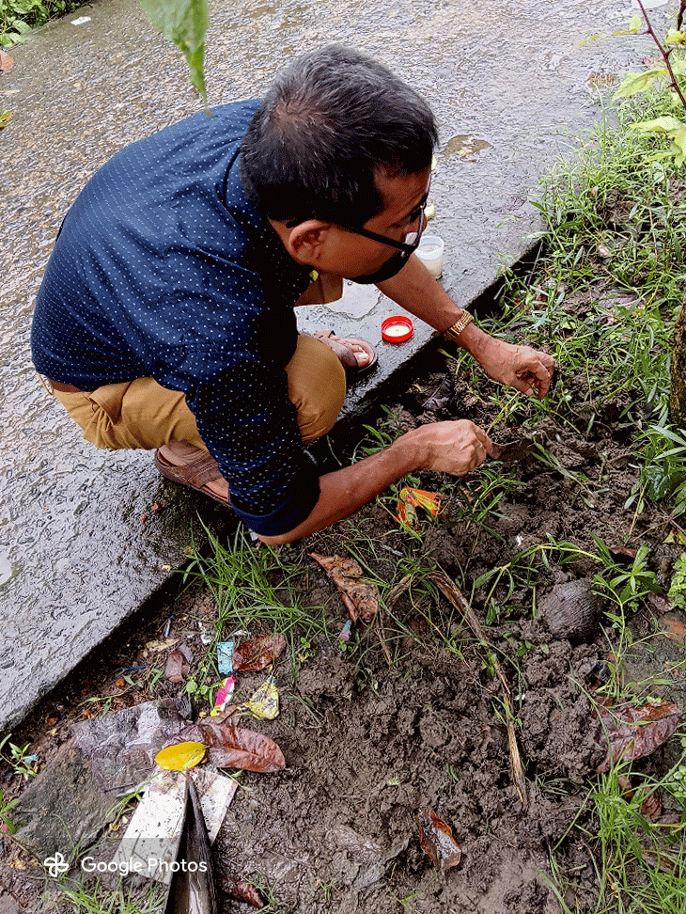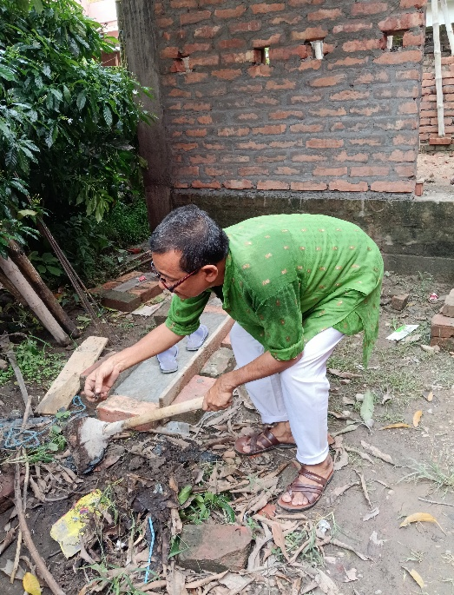
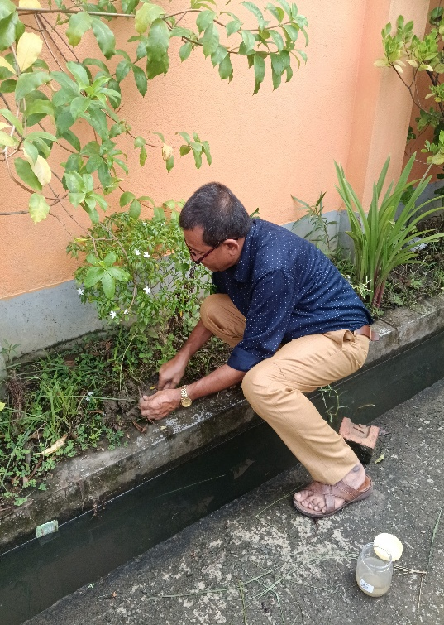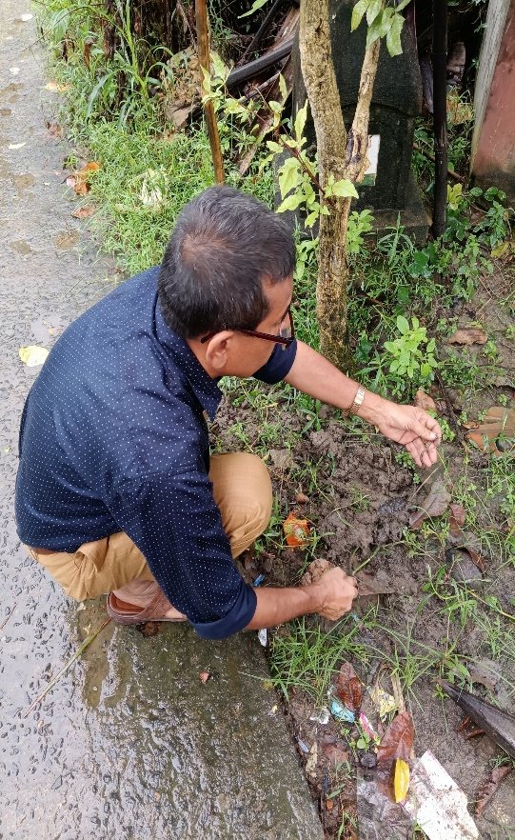

Plate 1: Collection spots at Haldia, Purba Medinipur

Plate 2
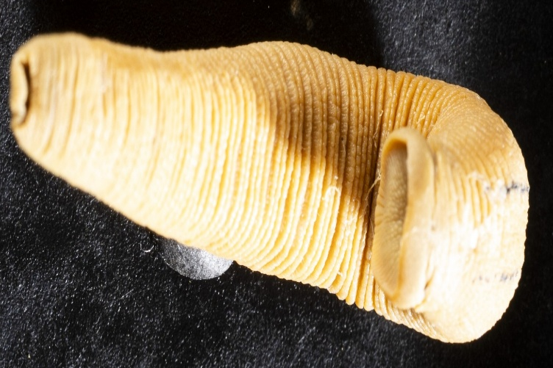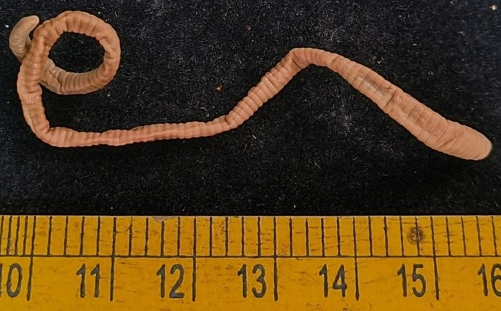
Haemadipsa rajbalaae (Ventral) Amynthas gracilis (Dorsal view)

Plate 3.
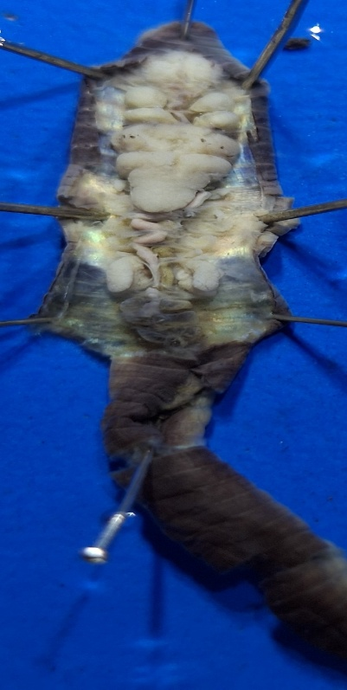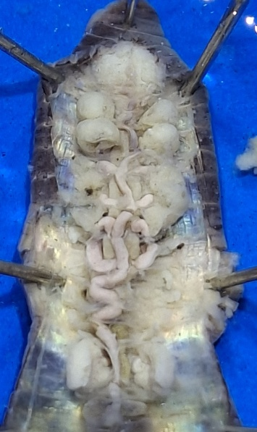
Perionyx sp. With Spermathecae, salivary gland, prostategland, last pair of heart
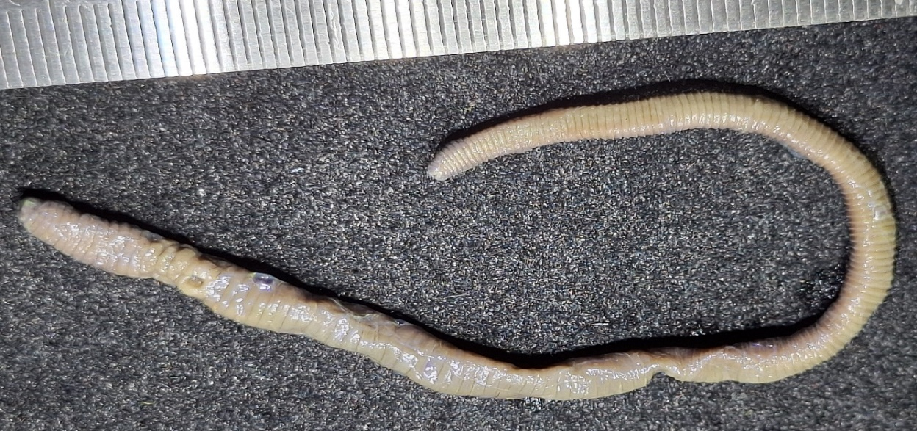

Plate 4. Showing Perionyx sp. Earthworm morphological characters.

