Original Research Article
Histological changes in the DuodenumacrossPostnatal DevelopmentalStages of Indian domestic Pig (Sus scrofa domesticus)

ABSTRACT
The present study characterised age-related histological changes in the duodenum of Indian domestic pigs across three postnatal developmental stages. Duodenal tissue from 18 Indian domestic pigs was categorised into three age groups: Group I (piglets, 0–4 weeks; n=6), Group II (weaners, >4–10 weeks; n=6), and Group III (>10 weeks; n=6). Tissues from the duodenum were collected and fixed in 10% neutral buffered formalin and Bouin’s fluid, processed for paraffin embedding, and sectioned at 5–6 µm. Histological evaluation employed Haematoxylin–Eosin for general architecture, Masson’s Trichrome for collagen–muscle differentiation, Wilder’s method for reticular fibres, and Weigert’s stain for elastic fibres. The duodenal wall consistently exhibited four tunics (mucosa, submucosa, muscularis, and serosa) across all age groups. Duodenal villi progressed from slender, tongue-shaped structures at birth to tall, ridge-like forms with broad bases and pointed apices. Enterocytes were columnar and displayed prominent brush borders, while connective tissue support (collagen, reticular, and elastic fibres) increased from Group I to Group III. Goblet cell density and intraepithelial lymphocyte counts in the mucosa increased with age, particularly in crypt regions. Paneth cells were absent at birth but appeared from day 21 onwards and became more abundant in older groups. The lamina muscularis mucosae thickened progressively, while plicae circulares became evident from day 7 and increased in prominence with age. Brunner’s glands, sparse and isolated at birth, formed compact lobules by day 13 and dominated the submucosa in weaners and adult pigs, especially in the cranial duodenum. Connective fibre intensity (collagen, reticular, and elastic) increased in all layers with advancing age. The tunica muscularis consisted of inner circular and outer longitudinal smooth muscle layers with intervening connective tissue containing myenteric plexuses, while the tunica serosa formed the outermost covering, with loose connective tissue, blood capillaries, nerves, variable adipose tissue, and external flat mesothelium. These age-related histological changes in the duodenum represent functional adaptation to postnatal digestive, absorptive, and immune demands, providing a baseline for porcine models and comparative monogastric studies.

Key words: Indian domestic pig, Duodenum, Small intestine, Paneth cells, Brunner’s glands; goblet cells; intraepithelial lymphocytes; plicae circulares

1. INTRODUCTION
The porcine digestive system is monogastric, and pigs are omnivorous; accordingly, they are used as a preferred large-animal model for preclinical translational research on intestinal diseases (Kararli, 1995; Schaaf & Gonzalez, 2022). During the postnatal period, the gastrointestinal tract of the neonatal pig encounters numerous challenges and severe stress, mainly at birth and weaning (Xu et al., 2000). The early growth stage is a crucial period for major intestinal growth and development in piglets (Hao et al., 2021). Changes in gut mucosal architecture are often used to evaluate digestive function, notably during development or interactions with food components (Skrzypek et al., 2005, 2010).
Recent gross-morphometrical evidence in Indian domestic pigs has likewise documented progressive age-related enlargement of the small-intestinal segments across postnatal groups (Gayathri et al., 2026).
Histologically, the villi are lined by enterocytes whose brush border membrane (striated border) forms the apical surface of the intestinal epithelial cells and is covered with microvilli. These microvilli further amplify the absorptive surface area and contain a variety of digestive enzymes crucial for the final stages of nutrient digestion. This structural specialisation enhances the intestine’s ability to hydrolyse and absorb nutrients effectively (Tsukahara et al., 2013).
The mucosa of the pig small intestine was lined by simple columnar epithelium with numerous goblet cells dispersed among the epithelial cells. Pyramidal-shaped Paneth cells with round or oval nuclei were observed at the base and neck regions of the crypts (Singh et al., 2021). In eutherian mammals, the duodenal or Brunner’s glands represent a distinctive feature, residing within the submucosa of the proximal duodenum. These glands originate immediately distal to the pyloric sphincter and extend with variable distribution along the length of the duodenum from the proximal to the distal end. Their ducts typically open directly into the intestinal lumen or merge with the overlying crypts of Lieberkuhn. The glands, which are chiefly populated by mucin-secreting cells, provide a viscoelastic mucous layer that coats and lubricates the surface (Krause, 2000). The first line of defence against pathogens is the mucous layer covering the intestine, which consists of mucins and glycoproteins secreted by goblet cells and acts as a mucosal surfactant or protective barrier (Barszcz & Skomiał, 2011).
Recent quantitative histopathology of piglets from multiple age groups has further demonstrated age-associated heterogeneity in intestinal wall morphology, particularly in younger animals with immature tissue architecture (Becker et al., 2025).
Recent work has also shown age-dependent variation in porcine Paneth-cell abundance, with these cells occurring predominantly in the duodenum and increasing during postnatal growth (Cui et al., 2026).
Despite these advances, detailed descriptive information on age-related histological maturation of the duodenum in Indian domestic pigs remains limited, particularly for coordinated changes in villous architecture, mucosal cell populations, Brunner’s glands, connective tissue fibres, and the muscular layers across distinct postnatal stages.
Objective: The present study aimed to characterize the histological changes in the duodenum of Indian domestic pigs across defined postnatal developmental stages, with emphasis on age-associated maturation of the mucosa, submucosa, muscularis, and serosa.

2. MATERIALS AND METHODS
2.1 Experimental animals and grouping
The study included 18 Indian domestic pigs of known postnatal age. Animals were included irrespective of sex, body weight, and nutritional status because the primary objective was to describe age-associated histological maturation of the duodenum rather than to evaluate the effects of these variables. Based on postnatal developmental stage, the animals were categorised into three groups, with six animals in each group: Group I (piglets; 0–4 weeks), Group II (weaners; 4–10 weeks), and Group III (above 10 weeks). The use of equal group sizes provided a consistent descriptive basis for comparing duodenal architecture across successive postnatal stages.
2.2 Collection and fixation of duodenal tissue
Duodenal samples were collected immediately after slaughter from local slaughterhouses in and around Hyderabad. Representative tissue from the duodenum was retained for histological assessment, including regional comparison of cranial, middle, and caudal portions where these regions were represented in the collected specimens. The lumen was gently washed with distilled water to remove ingesta and adherent material without mechanically damaging the mucosal surface. Tissue pieces were then trimmed to a size suitable for fixation while maintaining the orientation and continuity of the mucosa, submucosa, muscularis, and serosa. Specimens were fixed in 10% neutral buffered formalin (NBF) and Bouin’s fluid to preserve overall tissue architecture and cellular detail. Subsequent processing followed the routine histological procedures described by Singh & Sulochana (1996).
2.3 Tissue processing and section preparation
Following fixation, the tissue samples were processed by routine paraffin-embedding procedures. The specimens were dehydrated through graded alcohols, cleared using a routine histological clearing step, infiltrated with molten paraffin, and embedded to obtain sections that permitted evaluation of the full thickness of the duodenal wall. Paraffin blocks were sectioned at 5–6 µm using a rotary microtome. Sections were transferred to glass slides, dried, deparaffinised, and rehydrated before routine or special staining. These procedures were applied consistently to specimens from all three age groups to allow comparable qualitative assessment.
2.4 Histological and special staining procedures
The prepared sections were subjected to routine and special staining procedures. Each stain was selected for a specific histological parameter, as described below.
1. Haematoxylin and Eosin (H&E): Haematoxylin and Eosin staining was performed according to Singh & Sulochana (1996) and was used for evaluation of general histoarchitecture and cellular organisation. Haematoxylin provided nuclear contrast, whereas eosin differentiated cytoplasmic and extracellular tissue components. H&E-stained sections were used to assess the four tunics of the duodenal wall, villous configuration, epithelial lining and brush border, crypts of Lieberkuhn, goblet cells, intraepithelial lymphocytes, Paneth cells, lamina propria, lamina muscularis mucosae, Brunner’s glands, tunica muscularis, and tunica serosa.
2. Masson’s Trichrome: Masson’s Trichrome staining was performed according to Luna (1968) to differentiate collagen fibres from smooth muscle fibres. The stain was used to assess the distribution and relative prominence of collagen within the villous core, lamina propria, submucosa, connective tissue surrounding intestinal and Brunner’s glands, and the connective tissue associated with the muscular layers.
3. Wilder’s method: Wilder’s method was applied according to Singh & Sulochana (1996) for demonstration of reticular fibres. Reticular fibre distribution was assessed particularly in the supporting stromal framework of the mucosa and around intestinal glands and Brunner’s glands.
4. Weigert’s method: Weigert’s method was used according to Luna (1968) to demonstrate elastic fibres. The method permitted qualitative assessment of elastic fibres in the connective tissue supporting the duodenal wall, including regions around glands, blood vessels, and other stromal components.
After completion of the staining procedures, sections were dehydrated, cleared, and mounted using routine histological procedures before microscopic examination.
2.5 Microscopic examination and parameters assessed
All stained sections were examined by light microscopy. Evaluation was performed systematically from the mucosa outward to the serosa so that the same major structural parameters were considered in all age groups. The mucosal parameters included villous shape and relative prominence, epithelial cell morphology, brush-border appearance, the presence and distribution of goblet cells and intraepithelial lymphocytes, the occurrence and location of Paneth cells, crypt architecture, components of the lamina propria, and the continuity and relative development of the lamina muscularis mucosae. Submucosal assessment included the distribution, lobulation, and relative abundance of Brunner’s glands, associated connective tissue, blood vessels, and the presence of plicae circulares. The tunica muscularis was examined for the arrangement of the inner circular and outer longitudinal smooth-muscle layers and the intervening connective tissue containing myenteric plexuses. The tunica serosa was assessed for its connective tissue, vascular, neural, adipose, and mesothelial components.
Special-stain evaluation focused on the distribution and relative staining intensity of collagen, reticular, and elastic fibres in the different layers of the duodenal wall. Observations were compared descriptively among Group I, Group II, and Group III and, where applicable, among cranial, middle, and caudal regions of the duodenum. Terms such as increased, decreased, more prominent, or more abundant were therefore used to describe comparative qualitative patterns across the examined sections rather than formal histomorphometric measurements.
2.6 Photomicrography and data interpretation
Representative microscopic fields showing the characteristic findings were documented by photomicrography at magnifications appropriate to the structure being demonstrated. The photomicrographs were used to support descriptive comparison of villous architecture, mucosal cell populations, intestinal and Brunner’s glands, connective tissue fibres, and muscular layers among the postnatal groups. Because the investigation was designed as a descriptive histological study, no formal morphometric measurements or inferential statistical analyses were applied; interpretation was based on reproducible qualitative differences observed across the examined sections and developmental groups.

3. RESULTS AND DISCUSSION
In the present investigation, the duodenum of Indian domestic pigs in all postnatal age groups exhibited the typical four-layered organisation of the intestinal wall, comprising the tunica mucosa, tunica submucosa, tunica muscularis, and tunica serosa. Similar structural arrangements have been reported by Kadhim et al. (2012) in camels, Al-Mansour et al. (2020) in goats and gazelles, and Singh et al. (2021) in pigs, who described the presence of these four fundamental layers in the duodenal wall. Thus, the present findings indicate that the general histological organisation of the duodenum remains conserved during postnatal development.
The tunica mucosa of the duodenum consisted of the lamina epithelialis, lamina propria mucosae, and lamina muscularis mucosae. These observations are in accordance with the findings of Frappier (1998) in domestic animals and Siddiqi et al. (2011) in Black Bengal goats. The mucosal surface showed numerous villi lined by simple columnar epithelium with goblet cells in all postnatal groups (Fig 1). These findings are similar to the reports of Hassan and Moussa (2015) in goats, Kumar et al. (2013) in sheep, and Mohammad et al. (2020) in sheep and rabbits, who reported simple columnar epithelium interspersed with goblet cells over the villus surface. Singh et al. (2021) also observed abundant goblet cells in the surface epithelium of the pig duodenum. At birth, villi were slender, tongue-shaped, elongated, and ridge-like, with broad bases and pointed apices, whereas at later postnatal stages they became finger-like, elongated, and broader with advancing age (Fig 2 & 3). Such developmental alterations indicate progressive maturation of the absorptive surface area after birth. Similar age-dependent changes were observed by Skrzypek et al. (2018) in piglets and Raja et al. (2022) in guinea pigs. Simawy et al. (2024) similarly reported immature villi at one day of age and mature leaf-shaped villi at 60 days in cats, dogs, and goats. Suwaidan and Almaliki (2024) observed finger-like villi in neonatal dogs. The ridge-shaped villi observed in the present study are similar to the findings of Wiese et al. (2003) in pigs. The enterocytes observed in the present study appeared as tall columnar absorptive cells with basally placed oval nuclei and distinct apical brush borders (Fig 4). Similar findings were reported by Mohammad et al. (2020) in sheep and rabbits and Singh et al. (2021) in pigs, who identified absorptive enterocytes with prominent brush borders. Similarly, Clarke and Hardy (1971) identified non-vacuolated, low columnar epithelial cells in young pigs. The basement membrane of the surface epithelium was supported by connective tissue fibres comprising collagen, reticular, and a few elastic fibres. This is in agreement with the findings of Madara (1991), who described the basement membrane as a supporting element of the epithelium. Goblet cells were distributed among the surface epithelium and crypts, and their number increased from the cranial to the caudal part of the duodenum, as well as with advancing age (Fig 5). These observations corroborate the findings of Talukdar (1999) in adult crossbred pigs and Korkmaz and Kum (2016) in camels, who reported fewer goblet cells at villus tips and higher numbers towards crypt regions. Al-Saffar and Al-Zuhairy (2016) observed rounded goblet cells in domestic cats and noted alterations in the villus-crypt ratio with age. Singh et al. (2021) also reported numerous goblet cells embedded in the surface epithelium of pigs. The progressive increase in goblet cells observed in the present study may indicate increasing mucosal protection and lubrication requirements with postnatal growth.
Intraepithelial lymphocytes were frequently encountered among the enterocytes of villi and crypts in all age groups, and their number increased with age (Fig 5). Similar observations were made by Pabst et al. (1988) in pigs, Vega-López et al. (2001) in pigs, Kalita et al. (2021) in piglets, and Singh et al. (2021) in pigs, who identified intraepithelial immune cells located at the apical or basal portions of the lining mucosa. Raja et al. (2022) also observed intraepithelial cells and globular leukocytes throughout postnatal life in guinea pigs. The increased IEL population in the older groups of the present study may reflect progressive maturation of intestinal immune mechanisms.
The lamina propria in the present study consisted of intestinal glands lined by low columnar cells, connective tissue fibres, blood vessels, lymphatics, fibroblasts, and lymphocytes, while their numbers increased progressively with advancing age (Fig 6). Singh et al. (2021) also reported diffuse lymphocyte accumulation between villi and crypts in pigs. Increased lymphoid elements in the present study may indicate the development of intestinal immunity after birth. Hassan and Moussa (2015) described loose connective tissue rich in vascular and lymphatic elements within the lamina propria in goats, and similar findings were also reported in piglets by Kalita et al. (2017). Lymphocytic infiltration in the lamina propria increased with advancing age; these observations are in accordance with those of Rothkötter et al. (1991) in pigs. Crypts of Lieberkuhn (intestinal glands or mucosal glands) in the present investigation were simple tubulo-alveolar glands lined by simple columnar epithelium with goblet cells, which opened onto the surface epithelium at intervillous spaces near the base of the villi. The nuclei of these columnar cells were round to oval in shape and located at the base of the cell (Fig 7). These findings are similar to those of Kumar et al. (2013) in sheep, Gahlot et al. (2017) in goats, Gutte (2019) in sheep and goats, Al-Mansour et al. (2020) in goats and gazelles, and Deswal and Gahlot (2024) in pigs, who described simple tubular and alveolar glands extending from the muscularis mucosae to the villus bases. The predominance of goblet cells within crypts compared with villus tips observed in the present study agreed with the observations of Korkmaz and Kum (2016) in camels. The intestinal glands were encased by a layer of connective tissue fibres comprising collagen, reticular, and a few elastic fibres (Fig 8). The core of the villi was supported by the lamina propria along with a few fibres of the lamina muscularis. These findings are in accordance with those of Deswal and Gahlot (2024) in pigs. In all postnatal age groups, IELs were also observed among the simple columnar epithelial cells and within the crypts. The IELs were more abundant in the villi than in the crypts but showed a reduced cell count in the duodenum. These observations are in accordance with the findings of Dong et al. (2014) in pigs, Kalita et al. (2021) in piglets, and Raja et al. (2022) in guinea pigs, who observed lymphocytes in the epithelium with a large, round nucleus and a rim of cytoplasm. These cells were fewer in neonatal piglets and were age-dependent.
Paneth cells observed in the present study appeared as pyramidal cells with eosinophilic apical granules and were mainly located at the neck and basal portions of the crypts (Fig 9). These cells were absent immediately after birth and became evident from 21 days of postnatal life onwards, and their number increased progressively with age. This concurs with the findings of Verdile et al. (2019) in pigs, who reported the absence of Paneth cells at 0–6 days. Similar observations were reported by Obremski et al. (2005) in gilts, Hassan and Moussa (2015) in goats, and Cui et al. (2023) in pigs, who identified Paneth cells near the basal and neck regions of crypts and described them as part of the defence mechanisms. Singh (1971) reported in humans that Paneth cells were much denser in the duodenum.
At birth, the lamina muscularis mucosae in the present investigation was composed of a discrete layer of smooth muscle (Fig 10), which is similar to the findings of Simawy et al. (2024) in cats, dogs, and goats, who stated that the muscularis mucosae of smooth muscle fibres was not continuous at one day of age. At later ages, this muscular layer became thin and continuous but subsequently thickened with advancing age (Fig 7). This is similar to the findings of Barnwal and Yadava (1975) in Indian buffaloes and Singh et al. (2021) in pigs, who described only circularly arranged smooth muscle fibres. In contrast, Al-Mansour et al. (2020) observed two thick layers of smooth muscle, oriented into inner circular and outer longitudinal bundles, in goats and gazelles.
The tunica submucosa in all postnatal age groups was composed of Brunner’s glands and dense irregular connective tissue containing blood vessels and Meissner’s plexus. The present study demonstrated that Brunner’s glands were most abundant in the cranial duodenum and gradually decreased towards the middle and caudal regions. Similar findings were reported by Kadhim et al. (2012) in camels and Mohammadpour (2011) in guinea pigs, who observed a progressive reduction in glandular thickness from the cranial to the caudal part of the duodenum. Saleh et al. (2022) also noted the absence of these glands in the terminal part of the duodenum in bovines.
Brunner’s glands were tubulo-alveolar, mucus-secreting glands with wide lumina, surrounded by truncated pyramidal cells or low columnar cells that showed basal, flat nuclei and lightly stained eosinophilic cytoplasm. They extended from the submucosa to the mucosa at the base of the intestinal glands for their secretions (Fig 7, 11, 12 & 13), which is in accordance with Takehana et al. (1991) in ponies and Bansal et al. (1993) in buffaloes. In the present study, these were mucous-secreting glands, consistent with Simawy et al. (2024) in cats and dogs, who stated that Brunner’s glands were mucous in nature, while they were serous in goats. In contrast, serous types of submucosal glands were noted in pigs and rats by Eurell and Frappier (2006) and in wild brown rats by Al-Arubay (2025). Mohammad et al. (2020) observed a muco-serous type of Brunner’s glands in rabbits, while they were mucous in sheep. At birth, Brunner’s glands were few in number and isolated, whereas by day 13 of postnatal life, most of the submucosa was occupied by these glands in lobulated form, separated by thin interlobular connective tissue (Fig 7). However, this layer was heavily embedded with these glands, along with increased amounts of adipose tissue and connective tissue fibres, from Group II to Group III (Fig 12 & 13). Saleh et al. (2022) observed in adult cows that Brunner’s glands extended from the end of the pylorus to the first and middle thirds of the duodenal submucosa, while they were absent in the terminal third of the duodenum.
Plicae circulares (valves of Kerckring) became evident from the seventh day and increased in prominence with age (Fig 14 & 15). Their greater height in the caudal duodenum indicated an enhancement of the luminal surface area during maturation. The increased prominence of the plicae during postnatal development observed in the present study may reflect adaptation for efficient nutrient absorption. These findings are in accordance with the observations of Deswal and Gahlot (2024) in pigs, who stated that the mucosal folds were in the form of plicae circulares and that their height gradually increased towards the caudal part.
The tunica muscularis consisted of thick inner circular and thin outer longitudinal smooth muscle layers separated by connective tissue containing Auerbach’s plexus in all parts of the duodenum (Fig 16). A similar arrangement was reported by Talukdar (1999) in pigs, Hassan and Moussa (2015) in goats, Mohammad et al. (2020) in sheep, Gutte (2019) in sheep and goats, Al-Mansour et al. (2020) in goats and gazelles, and Singh et al. (2021) in pigs. The tunica serosa in all postnatal age groups formed the outermost layer, consisting of loose connective tissue, blood vessels, nerves, and adipose tissue covered by mesothelium. Similar findings were described by Hassan and Moussa (2015) in goats, Korkmaz and Kum (2016) in dromedary camels, Al-Mansour et al. (2020) in goats and gazelles, and Singh et al. (2021) in pigs, who reported a thin layer of loose connective tissue covered by mesothelial cells.

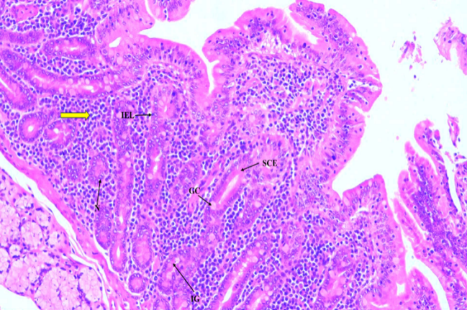
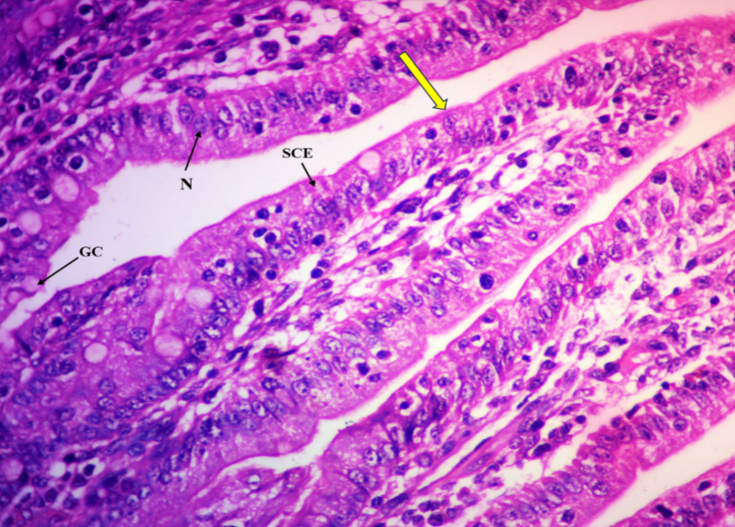
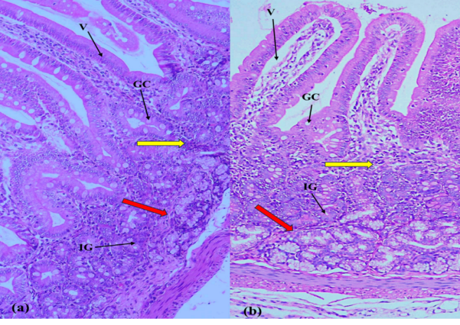
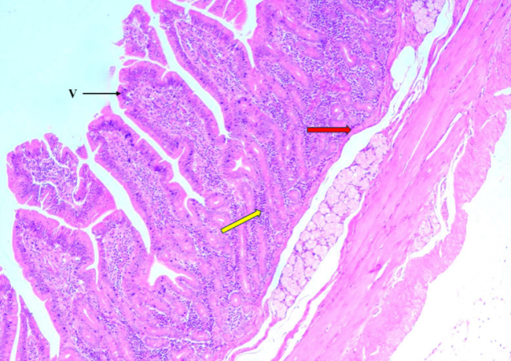
Fig 2.Photomicrograph of G-I piglets of (a) 7-day old and (b) 13-day old showing duodenum with goblet cells (GC), slender villi (V), lamina propria (yellow arrow), intestinal glands (IG) and lamina muscularis (red arrow).H&E 10x
Fig 4. Photomicrograph of Group I (13-day old) piglet showing duodenum with brush border membrane with microvilli (yellow arrow), goblet cells (GC), enterocytes/simple columnar epithelium (SCE) and nucleus (N). H&E 40x
Fig 1.Photomicrograph of G-II (55-day old) pig showing duodenum with ridge-like villi (arrow), lamina propria (yellow arrow) and lamina muscularis (red arrow). H&E 4x
Fig 5.Photomicrograph of G-III (152-day old) pig showing duodenum with intestinal glands (IG) in lamina propria (yellow arrow), intra-epithelial lymphocytes (IEL), goblet cells (GC), simple columnar epithelium (SCE) and its nucleus (N).H&E 10x

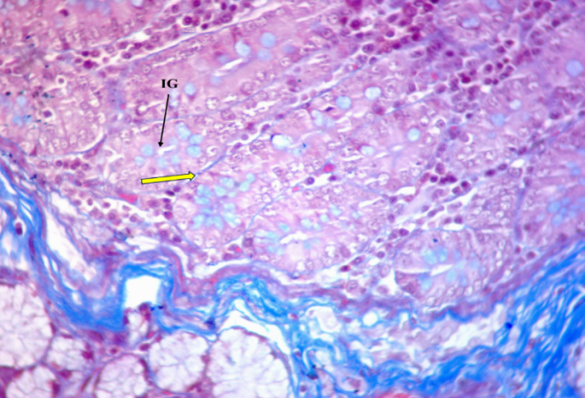
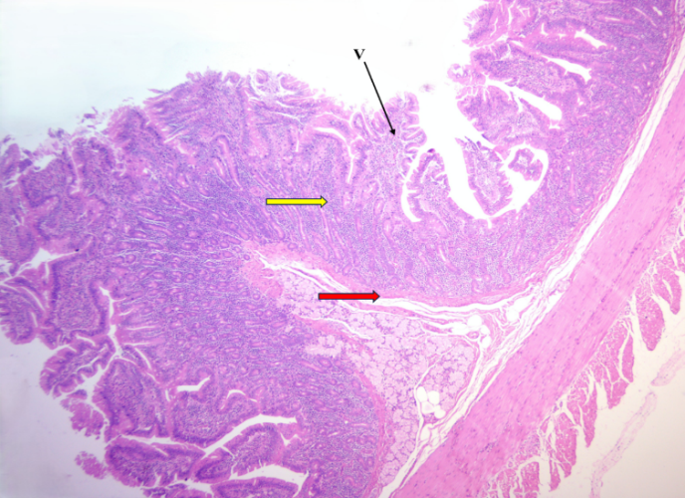
Fig 6. Photomicrograph of G-I (21-day old) piglet showing duodenum with collagen fibres (yellow arrow) around the intestinal glands (IG) in the lamina propria. Masson’s trichrome 40x
Fig 3. Photomicrograph of Group III (334-day old) pig showing duodenum with highly ridged villi (V), lamina propria (yellow arrow) and lamina muscularis (red arrow). H&E 4x
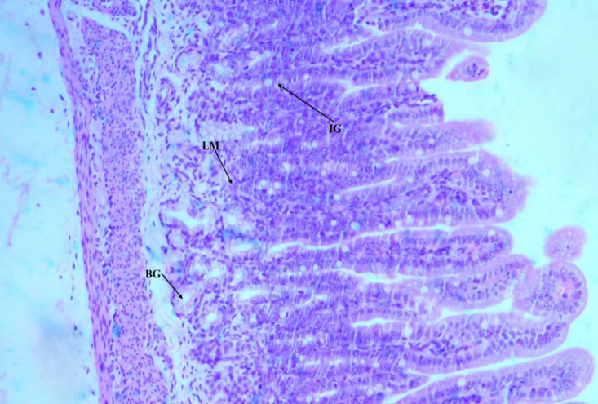
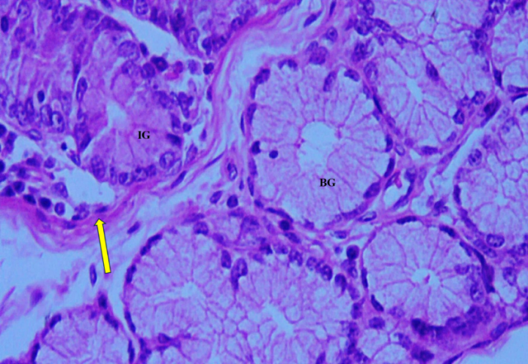
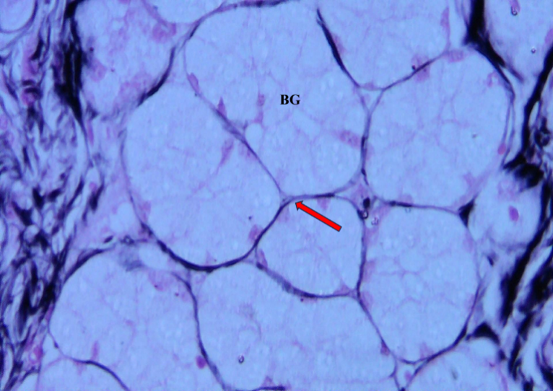
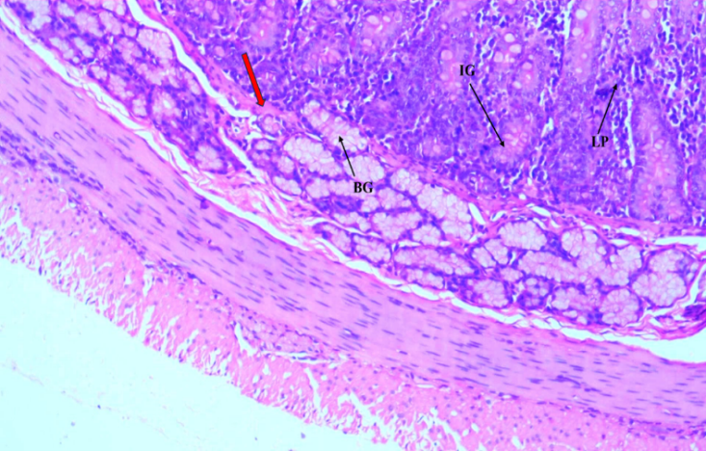
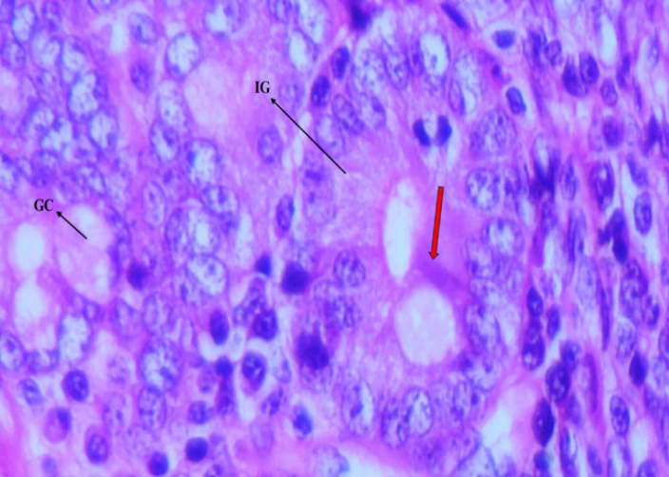
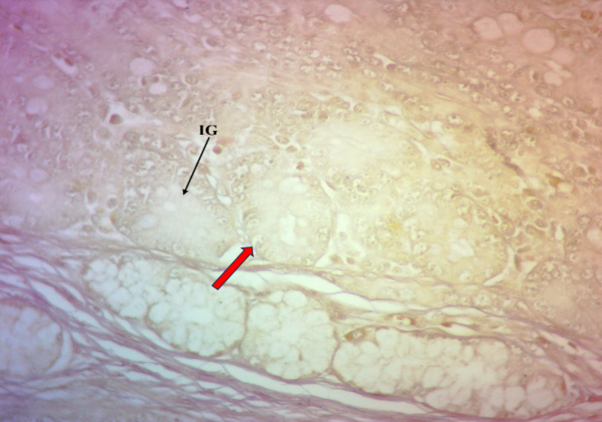
Fig 11. Photomicrograph of G-III (243-day old) pig small intestine showing duodenum segment with reticular fibres (arrows) around the Brunner’s glands (BG). Wilder’s 40x
Fig 12. Photomicrograph of Group II (43-day old) pig showing duodenum with intestinal glands (IG), lamina propria (LP), lamina muscularis (red arrow) and Brunner’s glands (BG). H&E 10x

Fig 10. Photomicrograph of G-I (0-day old) piglet showing duodenum with discrete lamina muscularis (LM), intestinal gland (IG) and Brunner’s glands (BG). H&E 10x
Fig 9. Photomicrograph of G-I (21-day old) piglet showing duodenum with Paneth cells (red arrow) in intestinal glands (IG) and goblet cells (GC). H&E 60x
Fig 8. Photomicrograph of G-I (21-day old) piglet showing duodenum with elastic fibres (red arrow) around intestinal glands (IG).
Weigert’s 10x
Fig 7. Photomicrograph of G-I (13-day old) piglet showing duodenum with intestinal glands (IG), continuous lamina muscularis (yellow arrow)
and Brunner’s glands (BG). H&E 40x
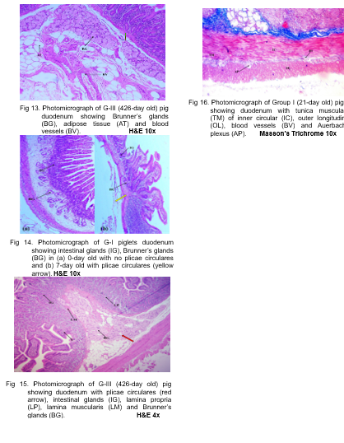
4. CONCLUSION
Postnatal development of the duodenum in Indian domestic pigs was characterised by progressive maturation of the mucosa, submucosa, and muscular components. Villi underwent distinct developmental alterations, while goblet cells, intraepithelial lymphocytes, and connective tissue fibres became increasingly prominent with age. Paneth cells appeared after birth, and Brunner's glands developed from sparse, isolated structures into prominent submucosal lobules. Plicae circulares also became evident during early postnatal life and increased in prominence with advancing age. Together, these observations indicate coordinated maturation of structural components associated with digestive, absorptive, protective, and intestinal immune functions. The findings provide descriptive baseline information on postnatal duodenal histology in Indian domestic pigs and may support future comparative and morphometric investigations of porcine intestinal development.

Limitation

The study was based on descriptive histological assessment of the duodenum across three defined postnatal age groups. Accordingly, the findings primarily establish qualitative age-associated patterns of tissue maturation rather than quantitative histomorphometric relationships. Interpretation is therefore confined to the examined duodenal tissues and developmental grouping used in the study. Further morphometric assessment would be required to quantify the magnitude of the structural changes described here.

Competing interests
No conflicts of interest

ETHICAL APPROVAL
The present investigation and its experimental design were approved by the Institutional Animal Ethics Committee, vide IAEC No. 11/26/IAEC-Pig/C.V.Sc./Hyd. Dt: 13.06.2025.

Declaration of AI Use

This manuscript was prepared through the intellectual contributions of the author(s) to the study design, data analysis, interpretation of results, and scholarly content. Grammarly and ChatGPT were used solely to assist with grammatical refinement and reference formatting during manuscript revision. The author(s) accept full responsibility for the accuracy, integrity, and final content of the manuscript.

REFERENCES

Al-Arubay, N. A. (2025). Histological and histochemical investigation of the Brunner glands in wild brown rats. Kerbala Journal of Veterinary Medical Sciences, 1(3), 70–73. https://doi.org/10.65639/kjvm.25.108
Al-Mansour, N. A., Jasim, Z. M., Al-Samawy, E. R., & Jasim, H. J. (2020). Histomorphometric and histochemical comparison of the duodenum between goat (Capra hircus) and gazelle (Gazella subgutturosa). Plant Archives, 20(Suppl. 1), 852–856.
Al-Saffar, F. J., & Al-Zuhairy, M. F. (2016). Postnatal developmental histomorphological and histochemical study of the duodenum in the domestic cat (Felis catus). International Journal of Current Research, 8(12), 43681–43690.
Bansal, N., Khatra, G. S., & Singh, J. (1993). Histomorphology and micrometry of tunica submucosa, Brunner’s glands and Peyer’s patches of buffalo small intestine. Indian Journal of Veterinary Anatomy, 5, 28–31.
Barnwal, A. K., & Yadava, R. C. P. (1975). Studies on the histological structures of the small intestine of Indian buffaloes (Bubalus bubalis). Indian Journal of Animal Health, 14(1), 19–23.
Barszcz, M., & Skomiał, J. (2011). The development of the small intestine of piglets: Chosen aspects. Journal of Animal and Feed Sciences, 20(1), 3–15. https://doi.org/10.22358/jafs/66152/2011
Becker, C. B., Hansen, M. S., Nielsen, S. S., & Jensen, H. E. (2025). Machine-learning for quantitative histopathology of piglet intestinal tissues: Challenges with limited training data. Frontiers in Veterinary Science, 12, 1620338. https://doi.org/10.3389/fvets.2025.1620338
Clarke, R. M., & Hardy, R. N. (1971). Histological changes in the small intestine of the young pig and their relation to macromolecular uptake. Journal of Anatomy, 108(Pt. 1), 63–77. PubMed record
Cui, C., Li, L., Wu, L., Wang, X., Zheng, Y., Wang, F., Wei, H., & Peng, J. (2023). Paneth cells in farm animals: Current status and future direction. Journal of Animal Science and Biotechnology, 14, 118. https://doi.org/10.1186/s40104-023-00905-5
Cui, X., Liu, R., Wu, Y., Chen, Y., Gao, Q., Zhou, J., Cao, Y., Yang, J., & Yang, Q. (2026). Dynamic distribution of Paneth cells in pig intestine under normal and infection conditions. BMC Veterinary Research, 22, 374. https://doi.org/10.1186/s12917-026-05470-3
Eurell, J. A., & Frappier, B. L. (Eds.). (2006). Dellmann’s textbook of veterinary histology (6th ed.). Blackwell Publishing.
Deswal, N., & Gahlot, P. K. (2024). Histmorphological and histochemical characterization of duodenum of pig. The Haryana Veterinarian, 63(Special Issue), 32–35.
Dong, L., Zhong, X., Ahmad, H., Li, W., Wang, Y., Zhang, L., & Wang, T. (2014). Intrauterine growth restriction impairs small intestinal mucosal immunity in neonatal piglets. Journal of Histochemistry & Cytochemistry, 62(7), 510–518. https://doi.org/10.1369/0022155414532655
Frappier, B. L. (1998). Digestive system. In H.-D. Dellmann & J. A. Eurell (Eds.), Textbook of veterinary histology (5th ed., pp. 164–202). Lippincott Williams & Wilkins.
Gahlot, P. K., Kumar, P., & Singh, G. (2017). Histoarchitecture and histochemistry of duodenum and jejunum of the goat (Capra hircus). The Haryana Veterinarian, 56(1), 37–40.
Gayathri, M., Ranjith Kumar, S., Vinaya Sheela, S., & Ashok Kumar, D. (2026). Gross-morphometrical studies on the small intestine in postnatal age groups of Indian domestic pigs (Sus scrofa domesticus). Archives of Current Research International, 26(8), 140–149. https://doi.org/10.9734/acri/2026/v26i82045
Gutte, M. M. (2019). Histological and histochemical studies on small intestine of sheep (Ovis aries) and goat (Capra hircus). Indian Journal of Veterinary Anatomy, 31(1).
Hao, Y., Xing, M., & Gu, X. (2021). Research progress on oxidative stress and its nutritional regulation strategies in pigs. Animals, 11(5), 1384. https://doi.org/10.3390/ani11051384
Hassan, S. A., & Moussa, E. A. (2015). Light and scanning electron microscopy of the small intestine of goat (Capra hircus). Journal of Cell and Animal Biology, 9(1), 1–8. https://doi.org/10.5897/JCAB2015.0425
Kadhim, K. H., Al-Mehanna, N. H., & Al-Baghdadi, E. F. (2012). The distribution of the goblet cells, Paneth cells and Brunner’s glands in duodenum of adult one-humped camels (Camelus dromedarius). Al-Qadisiyah Journal of Veterinary Medicine Sciences, 11(2), 46–49.
Kalita, A., Sarma, K., Talukdar, M., Deka, A., & Kalita, P. C. (2017). Gut integrity of neonatal piglets: A histomorphological analysis. Journal of Animal Research, 7(6), 1115–1121. https://doi.org/10.5958/2277-940X.2017.00167.X
Kalita, A., Talukdar, M., Sarma, K., Kalita, P. C., Gali, J. M., Tamuli, S., Choudhary, O. P., Doley, P. J., Debroy, S., & Keneisenuo. (2021). Impact of probiotic and zinc on brush-border enzyme and histo-enzymatic profile in the small intestine of pre- and postweaned piglets. Indian Journal of Animal Research, 55(10), 1192–1199. https://doi.org/10.18805/IJAR.B-4211
Kararli, T. T. (1995). Comparison of the gastrointestinal anatomy, physiology, and biochemistry of humans and commonly used laboratory animals. Biopharmaceutics & Drug Disposition, 16(5), 351–380. https://doi.org/10.1002/bdd.2510160502
Korkmaz, D., & Kum, S. (2016). A histological and histochemical study of the small intestine of the dromedary camel (Camelus dromedarius). Journal of Camel Practice and Research, 23(1), 111–116. https://doi.org/10.5958/2277-8934.2016.00018.7
Krause, W. J. (2000). Brunner’s glands: A structural, histochemical and pathological profile. Progress in Histochemistry and Cytochemistry, 35(4), 255–367. https://doi.org/10.1016/S0079-6336(00)80006-6
Kumar, P., Kumar, P., Singh, G., & Poonia, A. (2013). Histological architecture and histochemistry of duodenum of the sheep (Ovis aries). Indian Journal of Veterinary Anatomy, 25(1), 30–32.
Luna, L. G. (Ed.). (1968). Manual of histologic staining methods of the Armed Forces Institute of Pathology (3rd ed.). Blakiston Division, McGraw-Hill.
Madara, J. L. (1991). Functional morphology of epithelium of the small intestine. Comprehensive Physiology, 1991(12S19), 83–120. https://doi.org/10.1002/j.2040-4603.1991.tb01401.x
Mohammad, H. J., Ali, K. A., & Al-Ali, Z. A. J. R. (2020). Histomorphological and histochemical structure in the duodenum of sheep (Ovis aries) and rabbit (Oryctolagus cuniculus): A comparative study. Online Journal of Animal and Feed Research, 10(6), 251–258. https://doi.org/10.51227/ojafr.2020.34
Mohammadpour, A. A. (2011). Morphological and histochemical study of guinea pig duodenal submucosal glands. Bulgarian Journal of Veterinary Medicine, 14(4), 201–208.
Obremski, K., Gajecka, M., Zielonka, L., Jakimiuk, E., & Gajecki, M. (2005). Morphology and ultrastructure of small intestine mucosa in gilts with zearalenone mycotoxicosis. Polish Journal of Veterinary Sciences, 8(4), 301–307.
Pabst, R., Geist, M., Rothkötter, H. J., & Fritz, F. J. (1988). Postnatal development and lymphocyte production of jejunal and ileal Peyer’s patches in normal and gnotobiotic pigs. Immunology, 64(3), 539–544.
Raja, K., Ushakumary, S., Rajathi, S., & Ramesh, G. (2022). Histological studies on the duodenum of the guinea pig (Cavia porcellus) in postnatal age groups. Indian Journal of Veterinary Anatomy, 34(1), 58–63.
Rothkötter, H. J., Ulbrich, H., & Pabst, R. (1991). The postnatal development of gut lamina propria lymphocytes: Number, proliferation, and T and B cell subsets in conventional and germ-free pigs. Pediatric Research, 29(3), 237–242. https://doi.org/10.1203/00006450-199103000-00004
Saleh, T. F., Ahmed, N. S., & Abduljawaad, A. N. (2022). Histological and histochemical study of Brunner’s glands in local adult cows. Basrah Journal of Veterinary Research, 18(2), 248–257. https://doi.org/10.23975/bjvetr.2022.172825
Schaaf, C. R., & Gonzalez, L. M. (2022). Use of translational, genetically modified porcine models to ultimately improve intestinal disease treatment. Frontiers in Veterinary Science, 9, 878952. https://doi.org/10.3389/fvets.2022.878952
Siddiqi, M. N. H., Nasrin, M., Awal, M. A., & Kashem, M. A. (2011). Histology and histochemistry of the duodenum of Black Bengal goat in Bangladesh. International Journal of BioResearch, 1(1), 1–4.
Simawy, M. S. H., Fadhil, M., & Kadhim, K. H. (2024). Study of Brunner’s glands using histology and histochemistry in various age groups of cats, dogs and goats. South Asian Research Journal of Biology and Applied Biosciences, 6(5), 184–193. https://doi.org/10.36346/sarjbab.2024.v06i05.005
Singh, U. B., & Sulochana, S. (1996). Handbook of histological and histochemical techniques (2nd ed.). Premier Publishing House.
Singh, T. S., Sathyamoorthy, O. R., Basha, S. H., Ushakumary, S., & Raja, K. (2021). Histomorphological, histomorphometrical and histochemical studies on the small intestine of Large White Yorkshire pig (Sus scrofa domesticus). International Journal of Livestock Research, 11(2), 59–66. https://doi.org/10.5455/ijlr.20201210105527
Singh, I. (1971). The distribution of Paneth cells in the human small intestine. Anatomischer Anzeiger, 128(1), 60–65.
Skrzypek, T. H., Kazimierczak, W., Skrzypek, H., Valverde Piedra, J. L., Godlewski, M. M., & Zabielski, R. (2018). Mechanisms involved in the development of the small intestine mucosal layer in postnatal piglets. Journal of Physiology and Pharmacology, 69(1), 127–138. https://doi.org/10.26402/jpp.2018.1.14
Skrzypek, T., Valverde Piedra, J. L., Skrzypek, H., Kazimierczak, W., Szymańczyk, S. E., & Zabielski, R. (2010). Changes in pig small intestinal absorptive area during the first 14 days of life. Livestock Science, 133(1–3), 53–56. https://doi.org/10.1016/j.livsci.2010.06.023
Skrzypek, T., Valverde Piedra, J. L., Skrzypek, H., Woliński, J., Kazimierczak, W., Szymańczyk, S., Pawłowska, M., & Zabielski, R. (2005). Light and scanning electron microscopy evaluation of the postnatal small intestinal mucosa development in pigs. Journal of Physiology and Pharmacology, 56(Suppl. 3), 71–87.
Suwaidan, W. A., & Almaliki, S. H. (2024). Morphohistological and histochemical study of the duodenum in neonatal local breed dogs (Canis familiaris). African Journal of Biomedical Research, 27(3), 2600–2606. https://doi.org/10.53555/AJBR.v27i3.5970
Takehana, K., Masty, J., Abe, M., & Yamaguchi, M. (1991). Duodenal glands of the pony (Equus caballus). Anatomia, Histologia, Embryologia, 20(1), 1–9. https://doi.org/10.1111/j.1439-0264.1991.tb00285.x
Talukdar, M. (1999). Gross anatomical, histomorphological and histochemical studies on the stomach and intestine of crossbred adult pig [Doctoral dissertation, Assam Agricultural University].
Tsukahara, T., Kishino, E., Inoue, R., Nakanishi, N., Nakayama, K., Ito, T., & Ushida, K. (2013). Correlation between villous height and disaccharidase activity in the small intestine of piglets from nursing to growing. Animal Science Journal, 84(1), 54–59. https://doi.org/10.1111/j.1740-0929.2012.01039.x
Vega-López, M. A., Arenas-Contreras, G., Bailey, M., González-Pozos, S., Stokes, C. R., Ortega, M. G., & Mondragón-Flores, R. (2001). Development of intraepithelial cells in the porcine small intestine. Developmental Immunology, 8(2), 147–158. https://doi.org/10.1155/2001/25301
Verdile, N., Mirmahmoudi, R., Brevini, T. A. L., & Gandolfi, F. (2019). Evolution of pig intestinal stem cells from birth to weaning. Animal, 13(12), 2830–2839. https://doi.org/10.1017/S1751731119001319
Wiese, F., Simon, O., & Weyrauch, K. D. (2003). Morphology of the small intestine of weaned piglets and a novel method for morphometric evaluation. Anatomia, Histologia, Embryologia, 32(2), 102–109. https://doi.org/10.1046/j.1439-0264.2003.00430.x
Xu, R. J., Wang, F., & Zhang, S. H. (2000). Postnatal adaptation of the gastrointestinal tract in neonatal pigs: A possible role of milk-borne growth factors. Livestock Production Science, 66(2), 95–107. https://doi.org/10.1016/S0301-6226(00)00217-7

