Additional locality record of the mangrove crab Neosarmatium malabaricum (Henderson, 1893) (Decapoda: Brachyura: Sesarmidae) in the Kali Estuary, Karwar, Karnataka, India

Abstract: The mangrove crab Neosarmatium malabaricum (Henderson, 1893) is a sesarmid crab associated with mangrove and intertidal habitats along the western Indian Ocean and Indian west coast. The species was originally described from the Kerala coast and was subsequently redescribed and revised taxonomically. In the present study, six adult males of N. malabaricum were examined from the mangrove edges habitat of (Devbag, Kodibag, Siddar, Kinnar, Devalmakki) the Kali Estuary, Karwar, Uttara Kannada District, Karnataka, India. Carapace length (CL) ranged from 18.0–22.0 mm and carapace width (CW) from 22.0–25.0 mm, with CW/CL ratios of 1.14–1.22. Cheliped propodus length ranged from 15.0–23.0 mm, dactylus length from 9.5–14.0 mm and palm height from 10.0–14.0 mm. Identification was based on the characteristic subquadrate and transversely broad carapace, the morphology of the anterolateral margins and chelipeds, including the strong longitudinal rim on the upper surface of the palm and the position of the distal tooth on the dorsal surface of the dactylus. A male first gonopod (G1) was dissected from one specimen for morphological examination. The present observation extends the documented local distribution of N. malabaricum to the Kali Estuary at Karwar and contributes additional morphometric information for the species from the west coast of India. The record also emphasizes the importance of the mangrove habitats of the Kali Estuary for maintaining populations of semi-terrestrial sesarmid crabs.
Keywords: Brachyura; Sesarmidae; Neosarmatium malabaricum; mangrove crab; Kali estuary; Karwar; Karnataka; West coast of India; Additional locality

Introduction: Mangrove ecosystems along the Indian west coast support a diverse assemblage of brachyuran crabs, particularly members of the families Sesarmidae, Grapsidae, Ocypodidae and Portunidae. Mangrove-associated crabs contribute substantially to decomposition, nutrient cycling, sediment bioturbation and the transfer of mangrove-derived organic matter through estuarine food webs. Sesarmid crabs are especially important because several species consume, transport and process mangrove leaf litter. Neosarmatium malabaricum has been specifically demonstrated to play an important role in leaf-litter translocation and consumption in Indian mangrove ecosystems.
The species was originally described by Henderson (1893) in his contribution to Indian carcinology. The original material was associated with the Malabar region of south-western India. The taxon subsequently underwent nomenclatural changes, including treatment under Sarmatium and Neosarmatium. The currently accepted name is Neosarmatium malabaricum (Henderson, 1893). Serène (1975) rediscovered and redescribed N. malabaricum, providing important information on its morphology and distribution. Davie (1994), in his revision of Neosarmatium, subsequently clarified the diagnostic characters of the species and distinguished it from closely related taxa, particularly N. punctatum. The principal characters separating N. malabaricum from N. punctatum include the position of the distal tooth on the dorsal surface of the cheliped dactylus, the strong longitudinal rim on the upper surface of the palm, and the relative proportions of the carapace. In N. malabaricum, the distal tooth of the dactylus is situated close to the middle, while the upper surface of the palm possesses a strong longitudinal rim. The carapace is approximately 1.15–1.25 times broader than long. The species is known from mangrove habitats of the southwestern Indian region, including Kerala, and has also been reported from Goa and, more recently, Maharashtra. A study of the Aghanashini Estuary in Karnataka also recorded N. malabaricum at several sampling stations associated with mangrove and marsh habitats, demonstrating its occurrence elsewhere in coastal Karnataka. The Kali estuary at Karwar is another important mangrove-bearing estuarine system of Uttara Kannada District. Previous investigations have documented considerable brachyuran diversity in the Kali estuary and its mangrove habitats. However, a specifically documented occurrence of N. malabaricum from the Kali estuary, accompanied by detailed morphometric and photographic documentation, warrants reporting. The present study therefore documents six male specimens of N. malabaricum collected from the mangroves of the Kali estuary, Karwar.
The family Sesarmidae (Dana, 1851) constitutes one of the most ecologically dominant brachyuran groups in mangrove ecosystems of the Indo-West Pacific region (Davie 1994; Ng et al. 2008). Sesarmid crabs play a pivotal role in mangrove nutrient cycling, acting as primary processors of leaf litter and as bioturbators of mangrove sediments (Cannicci et al. 2008; Praveen & Oommen 2016). Among sesarmid genera, Neosarmatium (Serène & Soh, 1970) is particularly characteristic of the landward belt of Indo-West Pacific mangroves, with species typically occupying semi-terrestrial burrows in the upper intertidal zone. The genus Neosarmatium currently comprises 19 valid species distributed across the Indo-West Pacific (WoRMS 2024), of which only four species extend their range into the western Indian Ocean: N. laeve (A. MilneEdwards, 1869), N. meinerti (De Man, 1887), N. malabaricum (Henderson, 1893), and N. smithi (H. Milne-Edwards, 1853) (Ragionieri et al. 2012). Neosarmatium malabaricum (Henderson, 1893) was originally described as Sesarma malabaricum (Henderson, 1893) from the Kerala coast of India, making it one of the few Neosarmatium species with an Indian type locality. Despite this, the species has remained poorly documented from the Indian west coast in subsequent literature, with confirmed records largely confined to Kerala and, most recently, Maharashtra (Praveen & Oommen 2016; Trivedi et al. 2023) and Goa (ICMBAs). The Kali estuary at Karwar, Karnataka, supports one of the better preserved mangrove systems on the Karnataka coast, with Avicennia marina (Forsskal) Vierh.), Rhizophora mucronata (Lamarck) and Sonneratia sp. forming the dominant mangrove vegetation. Sesarmid crabs are abundant in this system, and ongoing surveys of the brachyuran fauna of the Kali estuary mangroves have yielded several noteworthy records. The present paper records additionally the occurrence of Neosarmatium malabaricum from the Kali estuary, Karwar, Karnataka, although it has already been listed from Aghanqshini estuary at Kumta, Karnataka (Shet G.N. et al. 2017) and describes the morphological characters of the specimens, compares them with the original description and Davie's (1994) revision, and discusses the distributional significance of this record for the west coast of India.

Materials and methods:
- Study area:
The Kali River Estuary is situated on the central-west coast of India in Uttara Kannada District, Karnataka. (Fig.1. a, b) The estuary opens into the Arabian Sea at Karwar and contains extensive intertidal mangrove habitats, creeks, mudflats and associated estuarine environments. The Kali estuary is located at 14°50′21″N, 74°09′05″E and documented a diverse mangrove flora and associated brachyuran crab fauna.
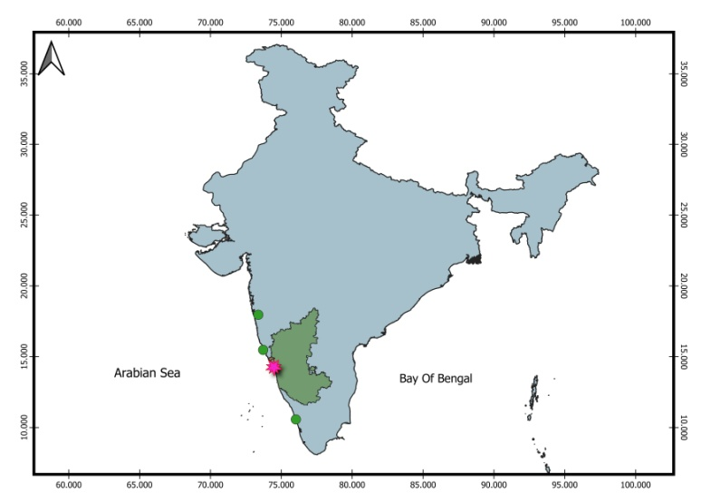
Fig.1. (a) Map showing the location of the study area in Karwar
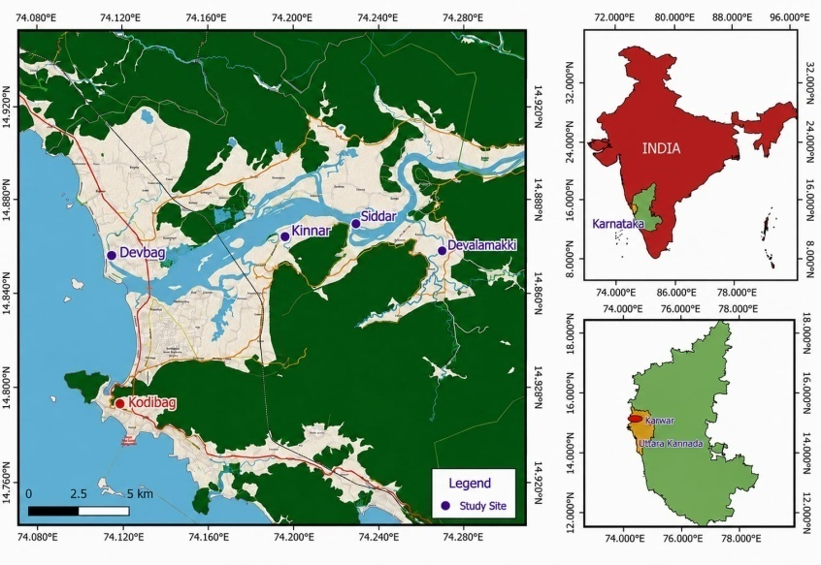
Fig.1. (b) Locations of the study sites in Kali estuary (Mangrove) Karwar, Karnataka
Table 1: Details of study sites along the Kali estuary (mangrove), Karwar
Sl.No. | Sampling sites | Co-ordinates | Area/substratum
1 | Devbag | 14.851⁰ N 74.112⁰ E | Intertidal hard soil
2 | Kodibag | 14.838⁰ N 74.133⁰ E | Estuarine border and embankment
3 | Kinnar | 14.864087⁰ N 74.193851⁰ E | Mangroves hard substratum grassy edges
4 | Siddar | 14.869376⁰ N 74.226107⁰ E | Mangroves hard substratum grassy edges
5 | Devalmakki | 14.857955⁰ N 74.265790⁰ E | Mangroves hard substratum grassy edges
- Collection and preservation:
The six adult male specimens identified as Neosarmatium malabaricum were examined. Specimens were collected from the mangrove habitats of the Kali estuary, Karwar, Karnataka, India, by hand collection during field sampling. Specimens of Neosarmatium malabaricum were collected from the mangrove creek habitat of the Kali estuarine mangrove edge areas like Devbag, Kodibag, Siddar, Kinnar, Devalmakki of Karwar, (Fig.1.(a,b)) Karnataka by a beat forester Gopal D. Naik forest Department Karwar, on May to August 2026, during rainy day and night time at regular intervals. Specimens were collected by hand from burrows and under mangrove root systems in the upper intertidal zone. Live specimens were photographed immediately after collection to document natural coloration. Specimens were subsequently preserved in 10% buffered formalin and transferred to 70% ethanol for long-term storage.
Morphological examination:
Carapace measurements (carapace length, CL; carapace width, CW) were taken using digital calipers to the nearest 0.1 mm. Carapace length was measured as the distance from the front margin to the posterior carapace margin along the mid-dorsal line. Carapace width was measured at the widest point of the carapace. Male first pleopods (G1) were dissected, treated with 10% KOH solution for 15–30 minutes to remove soft tissue, rinsed in distilled water, and mounted in glycerine on glass slides for examination. Morphological terminology follows Davie (1994) and Ng et al. (2008). Live coloration was documented from freshly collected specimens prior to preservation, following the principle that coloration characters are unreliable in formalin-preserved material and that hard sclerotised morphological characters take priority in taxonomic determination (Davie 1994). Photographs of live specimens were taken using a Sony Cybershot DSC-S2100 digital camera. G1 gonopod images were captured using a mobile phone camera through a dissecting microscope eyepiece.
Carapace length (CL) was measured along the median longitudinal axis from the anterior margin of the front to the posterior margin of the carapace. Carapace width (CW) was measured at the maximum width of the carapace. Cheliped propodus length was measured from the proximal articulation to the distal end of the propodus, while dactylus length was measured from its proximal articulation to the distal tip. Palm height was measured as the maximum vertical height of the propodus/palm. All measurements are expressed in millimetres. The specimens were examined under a stereomicroscope and photographed in dorsal, frontal and lateral views. Diagnostic structures of the carapace, chelipeds, walking legs, male pleon and first gonopod were examined. The left G1 of one male specimen was dissected and placed in NaOH solution for clearing and subsequent morphological examination. Taxonomic identification was based principally on Henderson (1893), Serène (1975) and Davie (1994), with nomenclature checked against current taxonomic databases and recent Indian brachyuran checklists. The crabs were identified morphologically by using standard taxonomic keys such as WoRMs and Marine Species Identification Portal and molecular confirmation by Dr. Santanu Mitra, Assistant Zoologist and taxonomist at the Crustacean Division of the ZSI, Kolkata, West Bengal confirmed as Neosarmatium malabaricum (Henderson, 1893) (Table2) (Fig.2) and (Fig.3) (Fig.4).
Results and Discussion:
Systematic accounts of Neosarmatium malabaricum (Henderson, 1893)

Kingdom: Animalia
Phylum: Arthropoda
Subphylum: Crustacea
Class: Malacostraca Latreille, 1802
Subclass: Eumalacostraca Grobben, 1892
Superorder: Eucarida Calman, 1904
Order: Decapoda Latreille, 1802
Suborder: Pleocyemata Burkenroad, 1963
Infraorder: Brachyura Linnaeus, 1758
Section: Eubrachyura de Saint Laurent, 1980
Subsection: Thoracotremata Guinot, 1977
Superfamily: Grapsoidea MacLeay, 1838
Family: Sesarmidae Dana, 1851
Genus: Neosarmatium Serène & Soh, 1970
Species: Neosarmatium malabaricum (Henderson, 1893)

Synonymy:

Neosarmatium malabaricum (Henderson, 1893)
Sarmatium malabaricum Henderson, (1893)
Sarmatium indicum var. malabaricum (Henderson, 1895)
Neosarmatium indicum malabaricum (Henderson, 1893)
The present combination, Neosarmatium malabaricum (Henderson, 1893), is currently accepted.
Materials examined and Morphological diagnosis:
Material: Six adult males. Locality: Mangrove habitat, Kali Estuary, Karwar, Uttara Kannada District, Karnataka, India. Voucher information: [Preserved in Dept. of Marine Biology Museum].
Carapace distinctly broader than long, subquadrate and moderately vaulted. Based on the specimens examined here, CW/CL ranged from 1.14 to 1.22, with a mean ratio of approximately 1.20. The dorsal surface is unevenly granular and bears distinct regional demarcations. The frontal margin is relatively broad and bears a median concavity. The anterolateral margins are armed with teeth 6 behind the external orbital angle, and the lateral margins are slightly concave or sub parallel posteriorly. The chelipeds are robust, particularly in the larger males. The propodus is relatively high, with the upper surface bearing a conspicuous longitudinal rim. The dactylus possesses teeth/tubercles on its dorsal surface; in N. malabaricum, the distal tooth is positioned close to the middle of the dactylus. These characters are particularly important in distinguishing the species from the closely related N. punctatum. Walking legs are moderately long and flattened. The merus, carpus and propodus bear setae, particularly along the margins and surfaces of the distal segments. The male pleon is relatively broad, with the distal segments forming the characteristic male abdominal outline. The G1 is relatively slender, with a curved distal portion and a strongly produced corneous apical process. The detailed morphology of the dissected G1 should be documented with a separate high magnification photograph or line drawing before submission, particularly because gonopod morphology is valuable in confirming species-level identification. Davie (1994) described the G1 of N. malabaricum as relatively slender, with the distal portion narrowing and a strongly produced straight corneous apical process.
Morphology of Neosarmatium malabaricum (Henderson, 1893)
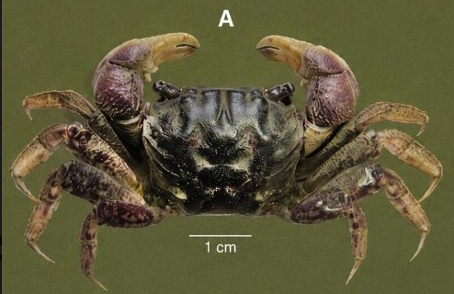
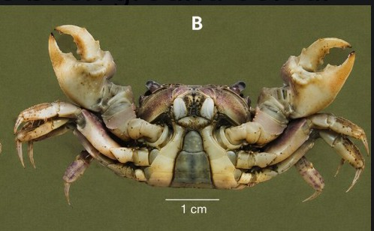
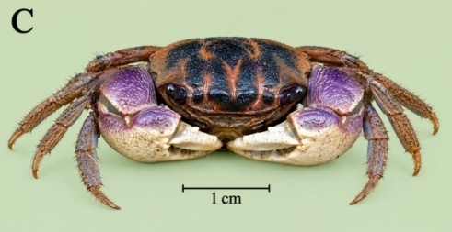
Fig.2. External structures of Neosarmatium malabaricum
A. N. malabaricum dorsal view, B. N. malabaricum ventral view
C. N. malabaricum front view,
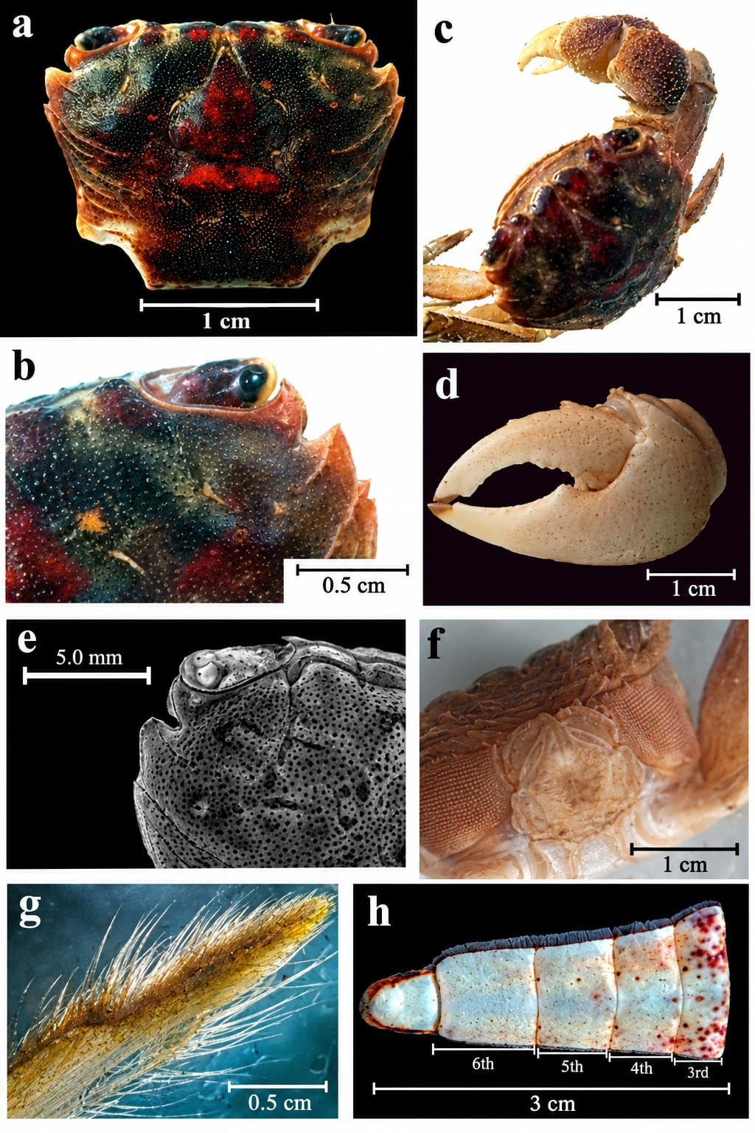
Fig. 3. External dissected structures of Neosarmatium malabaricum
(a) Dorsal view of adult male;
(b) Close-up of frontal and anterolateral carapace region;
(c) Lateral view showing general habitus and cheliped;
(d) Detached cheliped/propodus;
(e) Close-up of carapace frontal and orbital region, scale bar = 5.0 mm;
(f) Ventral/morphological view of diagnostic structures;
(g) Close-up of setose walking leg;
(h) Male pleon, showing abdominal segments.
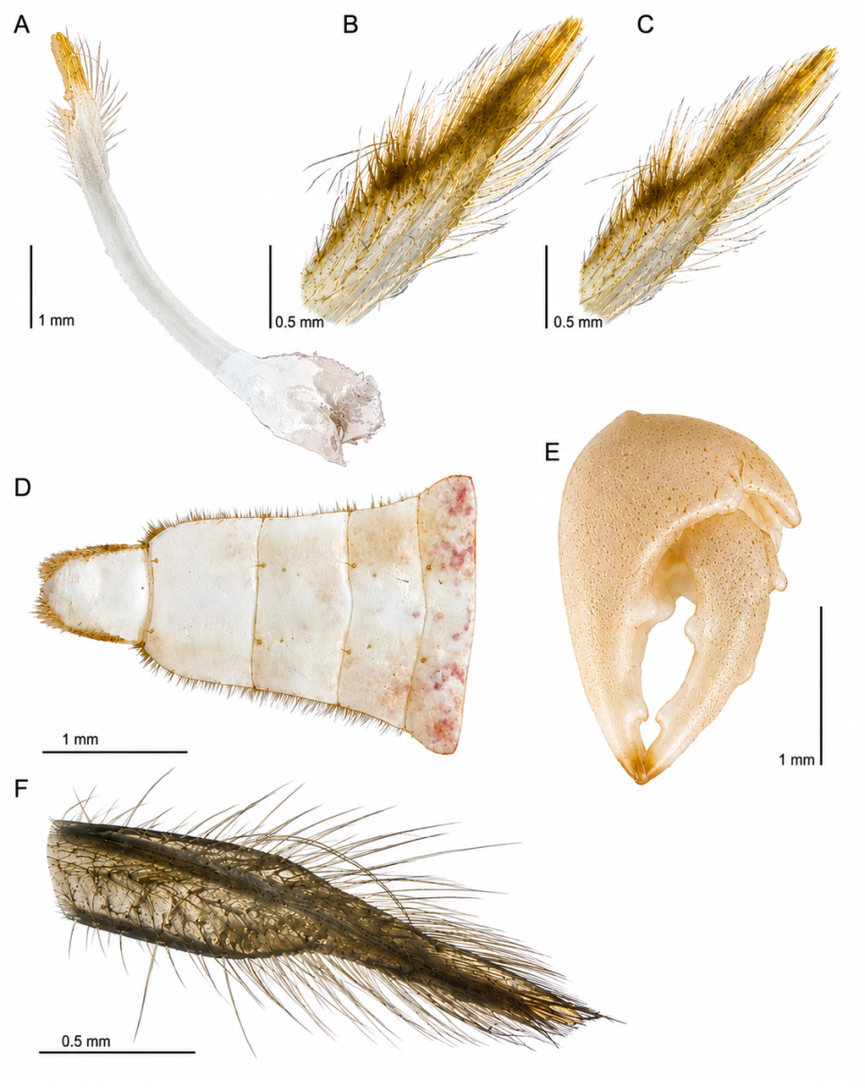
Fig.4. Gonopod associated structures from light microscope view of the dissected structures.
- Entire gonopod view (elongate, curved appendage with a setose distal region and expanded basal portion)
- Apical lobe, dorsal view (elongate,densly setose structure showing numerous fine marginal and surface setae)
- apical lobe, ventral view
- basal article (coxa), ventral view
- Sub-distal part (cheliped), ventral view
- distal part with long setae, dorsal view

Morphometric observations:

Table 2. Morphometric measurements of Neosarmatium malabaricum
Specimen Sex | CL  (mm) | CW  (mm) | CW/ CL | Right propodus L | Right dactylus L | Right palm H | Left propodus L | Left dactylus L | Left palm H
1 Male | 18.0 | 22.0 | 1.22 | 15.5 | 10.0 | 10.25 | 15.0 | 9.5 | 10.0
2 Male | 20.5 | 25.0 | 1.22 | 21.0 | 14.0 | 14.0 | 21.0 | 14.0 | 14.0
3Male | 22.0 | 25.0 | 1.14 | 23.0 | 15.0 | 14.0 | - | - | -
4Male | 21.0 | 25.0 | 1.19 | 18.0 | 13.0 | 12.0 | 18.0 | 12.0 | 12.0
5 Male | 21.0 | 25.0 | 1.19 | 18.0 | 13.0 | 12.0 | 18.0 | 12.0 | 12.0
6 Male | 20.5 | 25.0 | 1.22 | 21.0 | 14.0 | 14.0 | 21.0 | 14.0 | 14.0
Range | 18.0-22.0 | 22.0-25.0 | 1.14-1.22 | 15.5-23.0 | -10.0-15.0 | 10.25-14.0 | 15.0-21.0 | 9.5-14.0 | 10.0-14.0

The six males examined had a mean CL of 20.5 mm and mean CW of 24.5 mm. The mean CW/CL ratio is 1.20, indicating a distinctly transversely broad carapace. The right cheliped propodus ranged from 15.5 to 23.0 mm, while the right dactylus ranged from 10.0 to 15.0 mm. Palm height ranged from 10.25 to 14.0 mm. The available measurements demonstrate an increase in cheliped dimensions with increasing body size, although the small sample size prevents any formal allometric analysis. The observed CW/CL range agrees closely with the proportions reported for N. malabaricum in the taxonomic revision of Davie (1994), in which the carapace is approximately 1.15–1.25 times broader than long.
Remarks on identification
The present specimens agree with the diagnostic concept of Neosarmatium malabaricum established by Serène (1975) and Davie (1994). The combination of a transversely broad, vaulted carapace, the configuration of the frontal and anterolateral margins, the robust chelipeds, and particularly the strong longitudinal rim on the upper surface of the palm supports identification as N. malabaricum. A particularly important identification character is the position of the distal tooth on the upper surface of the cheliped dactylus. In N. malabaricum this tooth lies close to the middle of the dactylus, whereas in N. punctatum it is positioned distinctly proximal to the midpoint. The upper surface of the palm in N. malabaricum also bears a strongly developed longitudinal rim. These characters are preferably shown in a close-up figure in the manuscript. The present specimens are also consistent in general proportions with previously reported males. Davie (1994), for example, examined males from Sri Lanka with carapace dimensions including 21.5 × 18.1 mm, 22.7 × 18.8 mm, 23.8 × 19.3 mm, 26.2 × 21.5 mm, 29.7 × 24.3 mm and 30.9 × 24.3 mm, demonstrating comparable transversely broad carapaces.

Discussion: Records of Neosarmatium malabaricum (Henderson, 1893) were first reported by Henderson (1893) from Cochin, Malabar Coast, India, and subsequently from Sri Lanka and the Seychelles (Serène, 1975); Sulawesi was also included in its known distribution. In India, the species was later recorded from the mangroves of Kerala (Radhakrishnan et al., 2006), Goa, and Maharashtra. More recently, Satish C. et al. (2023) reported N. malabaricum from the Dharamtar estuary mangroves of Maharashtra, representing its first record from the state and extending its known distribution along the west coast of India. The species has also been documented from mangrove habitats of the Cochin backwaters, Kerala. In Karnataka, N. malabaricum has previously been reported from the Aghanashini (Shet G.N. et al. 2017) Estuary, where it occurred in mangrove associated habitats at several sampling stations.
The occurrence of Neosarmatium malabaricum in the Kali estuary is biogeographically significant because it adds another documented locality for a characteristic mangrove-associated sesarmid along the Karnataka coast. The species has been historically associated with the Kerala region, while subsequent studies have demonstrated a wider distribution along the south-western Indian coastline. Recent Indian compilations have listed N. malabaricum among the mangrove-associated brachyurans of India and have documented additional records from western coastal states. The record is particularly relevant in the context of the considerable mangrove-associated brachyuran diversity of Karnataka. Earlier work on the Kali estuary recorded a diverse assemblage of mangrove-associated crabs, while studies of the neighbouring Aghanashini estuary, Karnataka have also demonstrated the importance of mangrove habitats for sesarmid crabs. The present specimens fall within the general size and carapace proportions previously reported for N. malabaricum. The CW/CL ratio of the six males closely matching the diagnostic range given by Davie (1994). This morphometric agreement, together with the observed carapace and cheliped characters, supports the identification. The ecological importance of the species should also be considered. Sesarmid crabs contribute to the processing and redistribution of mangrove leaf litter, and N. malabaricum has been shown experimentally to translocate and consume mangrove leaves. Such activity can influence nutrient cycling and decomposition processes within mangrove ecosystems. Consequently, the presence of N. malabaricum in the Kali estuary adds not only to the taxonomic inventory of the estuary but also to the known functional diversity of its mangrove crab community. Because the present material consists only of six males, conclusions concerning population abundance, seasonal occurrence, sexual composition and habitat preference cannot yet be drawn. Further surveys should therefore document females, ovigerous individuals, juveniles, burrow density, microhabitat, substrate characteristics, salinity and association with individual mangrove species.
Conclusion: Six male specimens of Neosarmatium malabaricum (Henderson, 1893) were documented from mangrove habitat in the Kali estuary, Karwar, Karnataka. The specimens exhibited the characteristic transversely broad carapace and cheliped morphology of the species, with CW/CL ratios of 1.20. The morphological observations are consistent with the diagnostic features provided by Serène (1975) and Davie (1994).
The Neosarmatium malabaricum from the genus Neosarmatium is reported for the first time from Kali estuarine mangrove hard substratum edges along the Karwar coast of Karnataka, India and it has not been previously recorded from this region of Karwar.
The record constitutes an additional locality occurrence for N. malabaricum from the Karnataka coast and highlights the importance of the Kali estuary mangroves for maintaining sesarmid crab diversity.

Acknowledgements

Thanks to Dr. Santanu Mitra, Assistant Zoologist and taxonomist at the Crustacean Division of the ZSI, Kolkata, West Bengal for species confirmation. We thank Dr. Shivakumar B. Haragi, Chairman, P. G. Dept of Marine Biology for providing facilities for analysis of the specimens. The author acknowledges with gratitude the assistance of Claude (Anthropic, 2025), Google AI and Chat gpt (Open AI) in literature compilation, morphological analysis, and manuscript drafting.

Author contributions
Conceptualization and Design: PDB; VSk; Investigation, Methodology, Formal Analysis: Data collection: PDB; VSK; Field collections and survey: GDN: Original draft, Writing and Review PDB, VSK: Preparation of Map, Figure: PDB; VSK;
Conflict of interest
The authors declare that they have no conflict of financial or non-financial interests that could have influenced the outcome or interpretation of the results.
Ethical statement
No ethical approval is required as the study does not include activities that require ethical approval or involve protected organisms/human subjects/collection of samples/protected environments.
Publisher’s note
The views and claims presented in this article are solely those of the authors and do not necessarily reflect the positions of the publisher, editors, or reviewers. The publisher does not endorse or guarantee any claims made by the authors or those citing this article.
Declaration of AI Use
This manuscript was prepared through the intellectual contributions of the author(s) to the study design, data analysis, interpretation of results, and scholarly content. Grammarly and ChatGPT were used solely to assist with grammatical refinement and reference formatting during manuscript revision. The author(s) accept full responsibility for the accuracy, integrity, and final content of the manuscript.

References:
Cannicci,S.,Burrows,D.,Fratini,S.,Smith,T.J.,Offenberg,J.&Dahdouh-Guebas,F.(2008). Faunal impact on vegetation structure and ecosystem function in mangrove forests: a review. Aquatic Botany, 89: 186–200.

Dana, J. D. (1851). On the classification of the Crustacea Grapsoidea. The American Journal of Science and Arts, 12(35), 283–290.

Davie, P. J. F. (1994). Revision of Neosarmatium Serène & Soh (Crustacea: Brachyura: Sesarminae) with descriptions of two new species. Memoirs of the Queensland Museum, 35(1): 35–74.

de Man, J. G. (1887). Report on the Podophthalmous Crustacea of the Mergui Archipelago, collected for the Trustees of the Indian Museum, Calcutta, by Dr. John Anderson, FRS, Superintendent of the Museum.—Part II. Zoological Journal of the Linnean Society, 22(137), 65-128

Henderson, J. R. (1893). A contribution to Indian carcinology. Transactions of the Linnean Society of London, Zoology, 5: 325–458, pls 36–40.
Milne-Edwards, A. (1869). Note sur quelques nouvelles espèces de genre Sesarma Say. Nouvelles Archives du Muséum d’Histoire Naturelle de Paris, 5, 25–31.
Milne-Edwards, H. (1853). Mémoire sur la famille des Ocypodiens. Annales des Sciences Naturelles, Zoologie, 3(20), 163–226, plates 6–11.
Ng, P. K. L., Guinot, D.& Davie, P. J. F. (2008). Systema Brachyurorum: PartI. An annotated checklist of extant brachyuran crabs of the world. Raffles Bulletin of Zoology, Supplement 17: 1–286.

Praveen, V. P. & Oommen, M.M. (2016). Species preference in seedling predation by the sesarmid crab Neosarmatium malabaricum (Henderson, 1893) in a mangrove forest in India.Wetlands,37: 167–175.

Radhakrishnan, C., Palot, M. J., & Antony, C. (2006). Crustacea (Decapoda: Brachyura) associated with the mangrove ecosystems of Kerala, India. Records of the Zoological Survey of India, 106(4), 1-17.
Ragionieri, L., Fratini, S. & Schubart, C.D. (2012). Revision of the Neosarmatium meinerti species complex (Decapoda: Brachyura: Sesarmidae), with descriptions of three pseudocryptic Indo-West Pacific species. Raffles Bulletin of Zoology, 60(1): 71–87.

Sathish, C., Reddy, D. N., Bharti, V. S., Deshmukhe, G., & Jaiswar, A. K. (2023). Diversity and distribution of mangrove associated crabs (Infraorder: Brachyura) of India and the relationship between mangroves and crabs. Thalassas: An International Journal of Marine Sciences, 39(2), 847-866.
Serène, R. & Soh, C. L .(1970). New Indo-Pacific genera allied to Sesarma Say,1817 (Brachyura, Decapoda, Crustacea). Treubia, 27(4): 387–416.

Serène, R. (1975). Note addition nelle sur les espèces indo-pacifiques de Quadrella Dana 1851 (Crustacea, Decapoda, Brachyura). Bull. Soc. zool. Fr, 100(4), 509-521.

Shet, G. N., Chandran, M. S., & Ramachandra, T. V. (2016). Brachyuran Crabs of Aghanashini Estuary, South Indian West Coast, Karnataka. In Conference on Conservation and Sustainable Management of Ecologically Sensitive Regions in Western Ghats (Vol. 1, pp. 2-83).
Trivedi, J. N.,Trivedi,D.J.,Vachhrajani,K.D.&Ng,P.K.L.(2023).Diversity and distribution of mangrove associated crabs (Infraorder: Brachyura) of India and the relationship between mangroves and crabs. Thalassas: An International Journal of Marine Sciences.
WoRMS Editorial Board (2024). World Register of Marine Species. Available at https://www.marinespecies.org.

**********

