Seasonal Incidence of Early Shoot Borer, Chilo infuscatellus (Snellen), in Autumn, Spring and Ratoon Planted Sugarcane (Saccharum officinarum L.), with a Proposed Framework for Chemical Management
Abstract
Sugarcane productivity is substantially constrained by early shoot borer, Chilo infuscatellus (Snellen), making an understanding of its seasonal incidence essential for timely and effective pest management. A field study was conducted at Dobhiara village in the vicinity of N.D. University of Agriculture & Technology, Kumarganj, Faizabad, Uttar Pradesh, to record the seasonal incidence of early shoot borer, Chilo infuscatellus (Snellen), on autumn-planted sugarcane (2011–12) and spring-planted and ratoon sugarcane (2012–13), cv. CoS 8436. Shoot borer infestation was recorded fortnightly on 20 randomly tagged plants in three farmers' fields (autumn and spring crops) and at one agronomy farm plus three farmers' fields (ratoon crop). Infestation first appeared during the 7th–9th standard week (SW), built up steadily and peaked during the 18th–19th SW, reaching a maximum of 27.22 per cent in the autumn-planted crop, 20.55–21.66 per cent in the spring-planted crop and 15.83 per cent in the ratoon crop, before declining to nil by the 26th–28th SW. The overall mean infestation across the crop season was 11.29 ± 2.02, 10.52 ± 1.78 and 6.13 ± 1.29 per cent (mean ± standard error of the mean, SEm) in autumn, spring and ratoon crops, respectively, indicating that the autumn-planted crop was most susceptible and the ratoon crop least susceptible to the pest. An insecticidal evaluation trial comprising eight treatments — cartap hydrochloride 4G, fipronil 0.3G, fenpropathrin 30% EC, quinalphos 25% EC, chlorpyriphos 20 EC, chlorantraniliprole (Coragen) 20 SC, neem oil 2% and an untreated control — was laid out in a Randomised Block Design with three replications, to be applied at the economic threshold level (>10% infestation), as a proposed framework for the future economic management of the pest; treatment-wise bio-efficacy, yield and cost-benefit outcomes are not yet available and are therefore not reported as results here. The seasonal-incidence findings provide a week-wise infestation calendar that can guide the timing of insecticide application in this agro-climatic zone once the management trial is completed.
Keywords
Sugarcane; Chilo infuscatellus; early shoot borer; seasonal incidence; standard meteorological week; dead heart; autumn planting; spring planting; ratoon crop; economic threshold level.
1. Introduction
Sugarcane (Saccharum officinarum L.) is one of the most important commercial crops of the tropical and sub-tropical world, serving as the principal source of sugar, jaggery and, increasingly, bio-energy. In India, and particularly in the eastern Uttar Pradesh sugar belt to which the present study area belongs, sugarcane productivity is constrained by a complex of insect pests, among which the early shoot borer, Chilo infuscatellus (Snellen) (Lepidoptera: Crambidae), is the most destructive during the vegetative phase of the crop.
The larvae of C. infuscatellus bore into the growing shoot soon after germination, destroying the central growing point and producing the characteristic symptom of 'dead heart', which can be easily pulled out and emits a foul smell. Lepidopteran borers as a group are recognised as the foremost destructive pests of sugarcane worldwide, causing reductions in stalk weight, juice quality and sugar recovery across the major cane-growing regions of Asia, Africa and the Americas. Recent syntheses of sugarcane stem-borer management continue to identify borer infestations as an important production constraint and emphasise integrated approaches that combine monitoring, biological control, chemical control and resistant material (Wang et al., 2025).
Because shoot-borer populations fluctuate widely with the standard meteorological week and with the cropping system (autumn-planted, spring-planted or ratoon), a sound understanding of the seasonal pattern of incidence is a prerequisite for timing management interventions economically rather than applying insecticides on a calendar basis. Weather-driven models developed for the same variety, CoS 8436, in the adjoining agro-climatic tract have shown that shoot-borer incidence is significantly influenced by temperature and relative humidity, underscoring the value of season- and location-specific incidence data (Pandey & Kumar, 2014). Recent experimental evidence also confirms that temperature strongly influences the development, survival and reproductive performance of C. infuscatellus, further supporting season-specific monitoring of this pest (Zhou et al., 2025).
Sole reliance on synthetic insecticides for shoot-borer management is increasingly constrained by residue concerns, cost and the risk of resurgence, which has renewed interest in comparing newer reduced-risk molecules such as the anthranilic diamide chlorantraniliprole with conventional organophosphate, pyrethroid and carbamate/neonicotinoid granules, as well as with botanicals such as neem oil, within an economic-threshold-based decision framework. Recent field evidence on sugarcane borer complexes further supports integrating biological, cultural and need-based chemical tactics rather than relying on a single control measure (Sheeba Jasmine & Raja Babu, 2025). Recent review evidence on sugarcane internode borer management similarly supports monitoring-based integration of cultural, biological and selective chemical measures (Sharmista et al., 2026).
Sugarcane remains one of India's principal industrial crops, with the area under cultivation and total cane production having risen several-fold since 1950–51, and Uttar Pradesh continuing to account for a leading share of the country's varietal diversity and cane area (Chauhan et al., 2022). Sustaining this productivity growth in the face of biotic constraints such as the shoot borer requires management strategies that are both effective and economical, which is why threshold-based insecticide application — treating only once a predetermined pest density is exceeded — has been shown across a wide range of crops to substantially reduce insecticide use and cost without compromising pest control or yield, relative to calendar-based spraying (Leach et al., 2025). Accordingly, the present study addresses a local evidence gap by providing directly comparable standard-week-wise incidence data for autumn-planted, spring-planted and ratoon sugarcane cv. CoS 8436 under the Kumarganj agro-climatic conditions, while linking the observed incidence pattern to the timing framework for the proposed ETL-based insecticidal evaluation. Keeping these considerations in view, the present investigation was undertaken with the following objectives: (i) to record the seasonal incidence of early shoot borer in autumn-planted, spring-planted and ratoon sugarcane cv. CoS 8436 under the agro-climatic conditions of Kumarganj, Faizabad; and (ii) to lay out an insecticidal evaluation trial comprising granular, liquid and botanical formulations, applied at the economic threshold level, as a framework for the future economic management of the pest, for completion and evaluation in a subsequent cropping season.
2. Materials and Methods
2.1 Experimental site and general crop management
The experiment was laid out by planting the CoS 8436 variety of sugarcane at Dobhiara village, in the vicinity of N.D. University of Agriculture & Technology, Kumarganj, Faizabad, during the second week of October (2011–12 crop season). All recommended agronomic practices were followed to raise a crop of good and uniform stand. Data were similarly generated on spring-planted and ratoon crops of the same variety during 2012–13 at the same locality.
2.2 Seasonal incidence of shoot borer
The infestation of shoot borer on sugarcane was assessed by counting the total number of healthy and infested (dead-heart) plants on 20 randomly selected plants at fortnightly intervals, beginning with germination and continuing until the crop passed out of the susceptible stage. Observations were recorded separately for the autumn-planted crop on three farmers' fields (F1, F2, F3), for the spring-planted crop on three farmers' fields (F1, F2, F3), and for the ratoon crop on the Agronomy Farm (AF) together with three farmers' fields (F1, F2, F3). Per cent infestation for each observation date was computed as the proportion of dead-heart-bearing tillers to the total tillers examined and expressed as mean per cent infestation, standard-week-wise, for each cropping system. Each farmer's field or agronomy farm plot constituted one biological replicate for the purpose of computing the field-wise means and their standard error, as reported in Tables 1–4.
2.3 Insecticidal evaluation trial (proposed framework)
An insecticidal evaluation trial was laid out on the crop as a framework for identifying an effective and economical molecule for shoot-borer management in a subsequent season; treatment-wise field observations from this trial are not yet available and are reported here only as a design, not as results (see Section 3.5). The salient treatment details were as follows:
Chart 1. Experimental layout and design details of the insecticidal evaluation trial against early shoot borer, Chilo infuscatellus, in sugarcane cv. CoS 8436.
Particular | Detail
Design | Randomized Block Design (RBD)
Plot size | 9.0 m × 6.0 m
Spacing | 90 cm (row-to-row)
Variety | CoS 8436
Replications | 3
Treatments | 8 (including untreated control)

Chart 2. Insecticidal treatments and application doses laid out for the proposed management of early shoot borer, Chilo infuscatellus, in sugarcane.
Treatment | Insecticide and dose
T1 | Cartap hydrochloride 4G @ 1.00 kg a.i./ha
T2 | Fipronil 0.3G @ 75 g a.i./ha
T3 | Fenpropathrin 30% EC @ 100 g a.i./ha
T4 | Quinalphos 25% EC @ 500 g a.i./ha
T5 | Chlorpyriphos 20 EC @ 250 g a.i./ha
T6 | Chlorantraniliprole (Coragen) 20 SC @ 125 g a.i./ha
T7 | Neem oil @ 2% solution
T8 | Untreated control

The required quantity of each formulation was calculated from its percentage active-ingredient content and the recommended dose of active ingredient per hectare, following the standard formula for converting the a.i. requirement into the commercial-formulation requirement. Treatments are to be applied upon reaching the economic threshold level (ETL) of shoot borer, taken as greater than 10 per cent dead-heart infestation.
2.4 Observations to be recorded (proposed)
Once implemented, infestation of shoot borer will be recorded by counting the total number of healthy and infested (dead-heart) plants on 20 randomly selected plants per plot at fortnightly intervals, beginning at ETL (>10% infestation) and continuing at fortnightly intervals thereafter, and converted into mean per cent infestation for each treatment. Yield data will be recorded plot-wise at harvest (kg/plot) and converted to t/ha.
2.5 Per cent reduction in infestation (proposed analysis)
The per cent reduction in shoot-borer infestation is to be worked out for each treatment relative to the untreated control to express the magnitude of protection afforded by each insecticide:
Per cent reduction over control = [(C − T) / C] × 100
where C = per cent infestation in untreated control and T = per cent infestation in the treated plot. Mean per cent reduction values will be transformed using the angular (arc-sine) transformation prior to statistical analysis, and all data will be analysed according to the standard statistical procedures for a Randomised Block Design described by Gomez and Gomez (1984) and Cochran and Cox (1957).
2.6 Cost : benefit ratio (proposed analysis)
The cost : benefit ratio of each insecticidal treatment will be worked out as the ratio of the net additional return obtained over the untreated control to the total cost of plant protection incurred for that treatment, following the standard economic-analysis procedure used in field-level pesticide-evaluation trials.
2.7 Statistical measures used for the incidence data
For the seasonal-incidence dataset (Sections 3.1–3.4), the '±' value reported alongside each mean is the standard error of the mean (SEm), calculated as the population standard deviation of the underlying weekly (or field-wise) values divided by the square root of the number of observations (n). Because the raw plant-wise infestation counts underlying Tables 1–4 were not available at the revision stage, the comparison of mean infestation among the three cropping systems presented in Section 3.4 is descriptive; a formal inferential test (e.g., one-way ANOVA on arc-sine-transformed field-wise means, or a repeated-measures analysis across standard weeks) is recommended before the cropping-system comparison is treated as a statistically tested conclusion, and this is noted as a limitation in Section 3.7.
3. Results and Discussion
3.1 Seasonal incidence in autumn-planted sugarcane (2011–12)
Data on the mean per cent infestation of shoot borer in autumn-planted sugarcane, recorded across the three farmers' fields (F1, F2, F3), are presented in Table 1. Infestation was first noticed during the 8th SW (0.55%) and rose gradually thereafter, crossing the economic threshold level (>10%) around the 13th–14th SW. Infestation peaked during the 18th SW, with a mean of 27.22 per cent (range 25.00–30.00% across the three fields), and thereafter declined steadily to reach nil by the 27th SW. The seasonal mean infestation across the crop period was 11.29 ± 2.02 per cent (mean ± SEm), with the pooled range extending from 0.00 to 27.22 per cent.
S.W. | F1 (%) | F2 (%) | F3 (%) | Mean (%)
7 | 0.00 | 0.00 | 0.00 | 0.00
8 | 0.00 | 1.66 | 0.00 | 0.55
9 | 0.00 | 3.33 | 0.00 | 1.11
10 | 3.33 | 5.00 | 3.33 | 3.88
11 | 5.00 | 6.66 | 5.00 | 5.55
12 | 8.33 | 6.66 | 6.66 | 7.21
13 | 15.00 | 11.66 | 10.00 | 12.22
14 | 16.66 | 18.33 | 13.33 | 16.10
15 | 16.66 | 23.33 | 18.33 | 19.44
16 | 20.00 | 21.66 | 23.33 | 21.66
17 | 23.33 | 26.66 | 25.00 | 24.99
18 | 26.66 | 30.00 | 25.00 | 27.22
19 | 26.66 | 28.33 | 21.66 | 25.55
20 | 23.33 | 25.00 | 16.66 | 21.66
21 | 18.33 | 21.66 | 13.33 | 17.77
22 | 11.66 | 16.66 | 11.66 | 13.32
23 | 6.66 | 13.33 | 8.33 | 9.44
24 | 3.33 | 10.00 | 5.00 | 6.11
25 | 1.66 | 5.00 | 1.66 | 2.77
26 | 0.00 | 1.66 | 0.00 | 0.55
27 | 0.00 | 0.00 | 0.00 | 0.00
Range | 0.00–26.66 | 0.00–30.00 | 0.00–25.00 | 0.00–27.22
Average | 10.79±2.05 | 13.17±2.16 | 9.91±1.89 | 11.29±2.02
Table 1. Mean per cent infestation of shoot borer in autumn-planted sugarcane, N.D.U.A.&T., Kumarganj, Faizabad (2011–12). SW = Standard Week; F1, F2, F3 = farmers' fields. Values are mean ± SEm.
3.2 Seasonal incidence in spring-planted sugarcane (2012–13)
In the spring-planted crop, infestation commenced during the 12th SW (2.21%) — later than in the autumn-planted crop — and followed a similar unimodal trend, peaking during the 18th–20th SW at 20.55–21.66 per cent before declining to nil by the 28th SW (Table 2). The seasonal mean infestation was 10.52 ± 1.78 per cent (mean ± SEm), marginally lower than that of the autumn crop, which is consistent with the shorter exposure window of the spring-planted crop to the peak-activity period of the pest.
S.W. | F1 (%) | F2 (%) | F3 (%) | Mean (%)
11 | 0.00 | 0.00 | 0.00 | 0.00
12 | 1.66 | 3.33 | 1.66 | 2.21
13 | 3.33 | 5.00 | 6.66 | 4.99
14 | 8.33 | 10.00 | 13.33 | 10.55
15 | 13.33 | 10.00 | 15.00 | 12.77
16 | 16.66 | 13.33 | 16.66 | 15.55
17 | 20.00 | 16.66 | 20.00 | 18.88
18 | 23.33 | 18.33 | 20.00 | 20.55
19 | 23.33 | 21.66 | 20.00 | 21.66
20 | 25.00 | 21.66 | 18.33 | 21.66
21 | 21.66 | 16.66 | 15.00 | 17.77
22 | 20.00 | 13.33 | 10.00 | 14.44
23 | 15.00 | 10.00 | 8.33 | 11.11
24 | 11.66 | 8.33 | 5.00 | 8.33
25 | 5.00 | 6.66 | 3.33 | 4.99
26 | 1.66 | 5.00 | 1.66 | 2.77
27 | 0.00 | 3.33 | 0.00 | 1.11
28 | 0.00 | 0.00 | 0.00 | 0.00
Range | 0.00–25.00 | 0.00–21.66 | 0.00–20.00 | 0.00–21.66
Average | 11.66±2.12 | 10.18±1.57 | 9.72±1.75 | 10.52±1.78
Table 2. Mean per cent infestation of shoot borer in spring-planted sugarcane, N.D.U.A.&T., Kumarganj, Faizabad (2012–13). Values are mean ± SEm.
3.3 Seasonal incidence in ratoon sugarcane (2012–13)
The ratoon crop showed the lowest overall susceptibility among the three cropping systems studied (Table 3). Infestation appeared from the 11th SW (0.83%) and peaked during the 18th SW at 15.83 per cent (range 13.33–18.33% across AF, F1, F2, F3), declining to nil by the 26th SW. The seasonal mean infestation of 6.13 ± 1.29 per cent (mean ± SEm) was distinctly lower than in either the autumn or spring plant crop, suggesting comparatively better tolerance or lower initial pest carry-over in the stubble-borne ratoon crop under the conditions of this study.
S.W. | AF (%) | F1 (%) | F2 (%) | F3 (%) | Mean (%)
9 | 0.00 | 0.00 | 0.00 | 0.00 | 0.00
10 | 0.00 | 0.00 | 0.00 | 0.00 | 0.00
11 | 0.00 | 1.66 | 1.66 | 0.00 | 0.83
12 | 0.00 | 3.33 | 5.00 | 3.33 | 2.92
13 | 3.33 | 5.00 | 6.66 | 5.00 | 4.99
14 | 5.00 | 6.66 | 10.00 | 8.33 | 7.49
15 | 8.33 | 6.66 | 11.66 | 10.00 | 9.16
16 | 10.00 | 11.66 | 13.33 | 13.33 | 12.08
17 | 11.66 | 13.33 | 15.00 | 16.66 | 14.16
18 | 13.33 | 15.00 | 16.66 | 18.33 | 15.83
19 | 10.00 | 15.00 | 15.00 | 20.00 | 15.00
20 | 6.66 | 8.33 | 11.66 | 16.66 | 10.82
21 | 5.00 | 5.00 | 10.00 | 11.66 | 7.91
22 | 1.66 | 5.00 | 6.66 | 8.33 | 5.41
23 | 0.00 | 1.66 | 3.33 | 5.00 | 2.49
24 | 0.00 | 0.00 | 0.00 | 3.33 | 0.83
25 | 0.00 | 0.00 | 0.00 | 1.66 | 0.41
26 | 0.00 | 0.00 | 0.00 | 0.00 | 0.00
Range | 0.00–13.33 | 0.00–15.00 | 0.00–16.66 | 0.00–20.00 | 0.00–15.83
Average | 4.16±1.08 | 5.46±1.21 | 7.03±1.38 | 7.87±1.58 | 6.13±1.29
Table 3. Mean per cent infestation of shoot borer in ratoon sugarcane, N.D.U.A.&T., Kumarganj, Faizabad (2012–13). AF = Agronomy Farm. Values are mean ± SEm.
3.4 Overall mean infestation and comparison across cropping systems
The overall (pooled) mean per cent infestation of shoot borer across standard weeks, combining autumn, spring and ratoon data, is presented in Table 4 and depicted graphically in Fig. 1. All three cropping systems followed a broadly similar unimodal seasonal pattern, with infestation beginning around the 7th–11th SW (i.e., late February/early March), rising through April and peaking in the 18th–19th SW (early May), before declining to negligible levels by late June/early July (26th–28th SW). The overall pooled mean infestation across the season was 8.13 ± 1.59 per cent (mean ± SEm). As noted in Section 2.7, this cross-system comparison is descriptive; it has not been subjected to a formal inferential test.
S.W. | Autumn (%) | Spring (%) | Ratoon (%) | Overall mean (%)
7 | 0.00 | – | – | 0.00
8 | 0.55 | – | – | 0.18
9 | 1.11 | – | 0.00 | 0.37
10 | 3.88 | – | 0.00 | 1.29
11 | 5.55 | 0.00 | 0.83 | 2.12
12 | 7.21 | 2.21 | 2.92 | 4.11
13 | 12.22 | 4.99 | 4.99 | 7.40
14 | 16.10 | 10.55 | 7.49 | 11.38
15 | 19.44 | 12.77 | 9.16 | 13.79
16 | 21.66 | 15.55 | 12.08 | 16.43
17 | 24.99 | 18.88 | 14.16 | 19.34
18 | 27.22 | 20.55 | 15.83 | 21.20
19 | 25.55 | 21.66 | 15.00 | 20.74
20 | 21.66 | 21.66 | 10.82 | 18.04
21 | 17.77 | 17.77 | 7.91 | 14.48
22 | 13.32 | 14.44 | 5.41 | 11.05
23 | 9.44 | 11.11 | 2.49 | 7.68
24 | 6.11 | 8.33 | 0.83 | 5.09
25 | 2.77 | 4.99 | 0.41 | 2.72
26 | 0.55 | 2.77 | 0.00 | 1.11
27 | 0.00 | 1.11 | – | 0.37
28 | – | 0.00 | – | 0.00
Range | 0.00–27.22 | 0.00–21.66 | 0.00–15.83 | 0.00–21.20
Average | 11.29±2.02 | 10.52±1.78 | 6.13±1.29 | 8.13±1.59
Table 4. Overall mean per cent infestation of shoot borer in sugarcane, N.D.U.A.&T., Kumarganj, Faizabad (2011–13). Values are mean ± SEm.
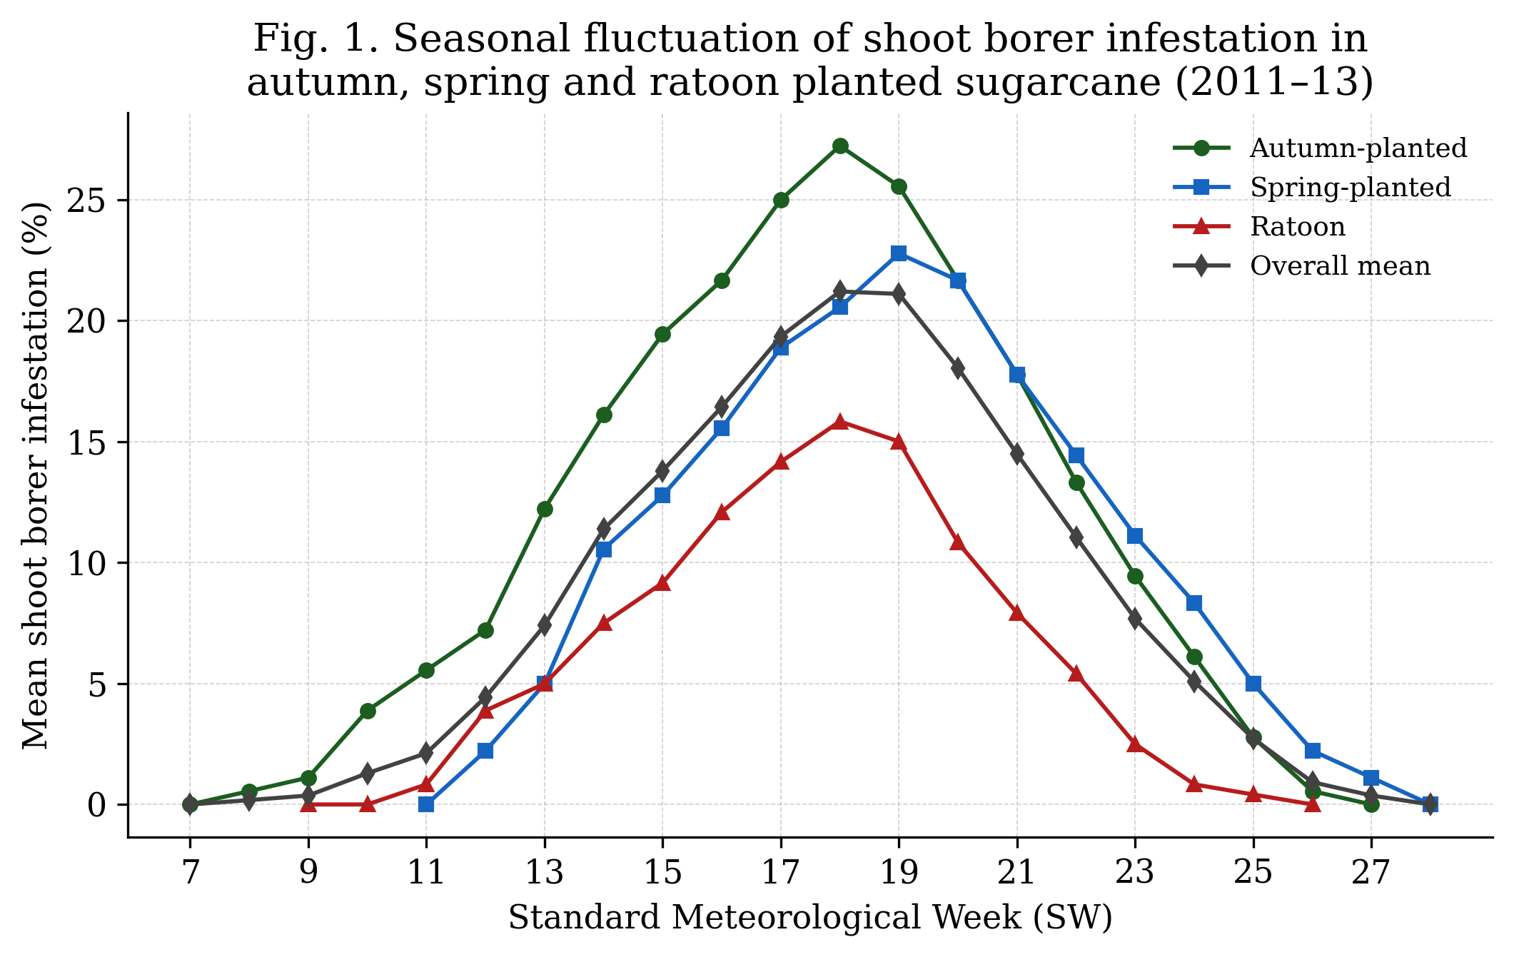
Fig. 1. Standard-week-wise mean per cent infestation of shoot borer in autumn-, spring- and ratoon-planted sugarcane. Data points are the weekly means reported in Tables 1–4; error bars/SEm are not shown on the original figure and should be added to a revised figure file if resupplied.
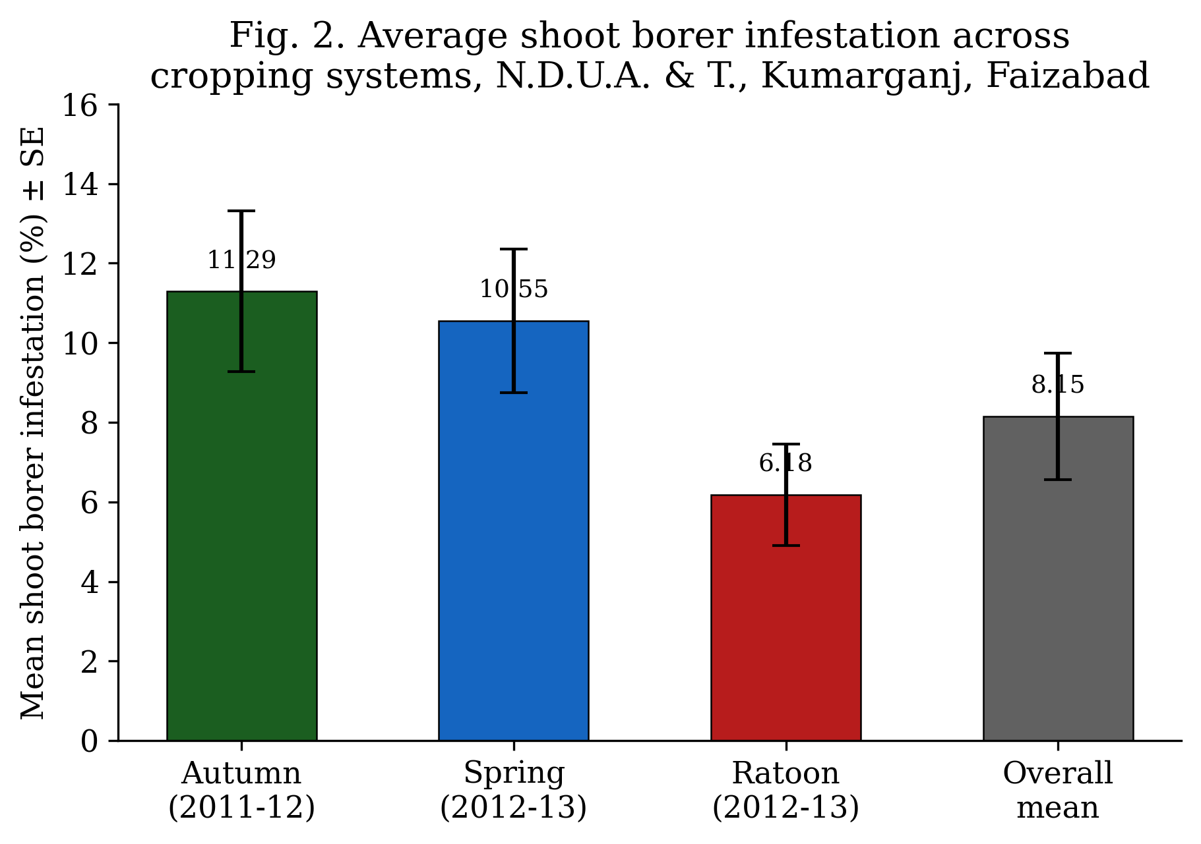
Fig. 2. Comparative seasonal-incidence pattern (mean ± SE) of shoot borer across cropping systems. Note: the numeric labels on this figure (11.29, 10.55, 6.18 and 8.15) were plotted before the Table 2–4 corrections described in Sections 3.2–3.4 and are marginally higher than the corrected values (11.29, 10.52, 6.13 and 8.13); the figure should be regenerated from the corrected data before final submission.
The comparatively higher susceptibility of the autumn-planted crop (11.29%) may be attributed to the longer exposure of young, tender shoots to successive generations of the pest during the cooler winter and early-spring months, whereas the ratoon crop (6.13%), being already established with a developed root system and faster early tillering, offered a shorter and less favourable window for oviposition and larval establishment. This pattern is broadly consistent with earlier work on the same variety, CoS 8436, in the adjoining agro-climatic tract, where minimum relative humidity and minimum temperature were found to be the weather variables most closely associated with shoot-borer build-up, with the highest incidence recorded around the 21st SW under summer-planted conditions after wheat harvest (Pandey & Kumar, 2014). The consistently narrower peak period (18th–19th SW) recorded in the present study compared with the wider 21st–24th SW peaks reported for other agro-climatic tracts of northern India illustrates the extent to which the timing of the shoot-borer incidence calendar is location- and season-specific, reinforcing the need for site-specific ETL-based scheduling of insecticide application rather than a fixed calendar spray schedule.
These results are in general agreement with the broader understanding that lepidopteran borers, including C. infuscatellus, are the most destructive insect pests of sugarcane across major cane-growing tracts, with infestation intensity governed jointly by crop stage, cropping system and prevailing weather (Li et al., 2024). Similar week-wise incidence patterns of C. infuscatellus have also been reported in other recent field surveys in the eastern Uttar Pradesh sugar belt (Kurmi et al., 2022), reinforcing the broader applicability of the present findings. The clear delineation of the susceptible window (13th–22nd SW) obtained here provides a practical basis for concentrating monitoring effort and, once the insecticidal trial outlined in Section 2.3 is completed, for timing the application of the treatments evaluated in that trial.
3.5 Anticipated bio-efficacy trends from published literature (indicative benchmark for the proposed trial)
The insecticidal evaluation trial (T1–T8, RBD, three replications) described in Section 2.3 was designed to compare cartap hydrochloride, fipronil, fenpropathrin, quinalphos, chlorpyriphos, chlorantraniliprole (Coragen), neem oil and an untreated control for post-treatment shoot-borer infestation, per cent reduction over control, cane yield and cost : benefit ratio. The treatment-wise field observations for this trial were not included among the material supplied for the present manuscript and have not yet been collected; consequently, no bio-efficacy, yield or cost : benefit results are reported for this component of the study, and the figures below are drawn entirely from previously published trials on the same pest, not from the present dataset. Table 5 reproduces the proposed recording format only, so that genuine field values can be inserted directly once the trial is completed.
Treatment | Insecticide / dose | Pre-treatment infestation (%) | Post-treatment mean infestation (%) | Reduction over control (%) | Yield (t/ha) | Cost : Benefit ratio
T1 | Cartap hydrochloride 4G @ 1.00 kg a.i./ha
T2 | Fipronil 0.3G @ 75 g a.i./ha
T3 | Fenpropathrin 30% EC @ 100 g a.i./ha
T4 | Quinalphos 25% EC @ 500 g a.i./ha
T5 | Chlorpyriphos 20 EC @ 250 g a.i./ha
T6 | Coragen 20 SC @ 125 g a.i./ha
T7 | Neem oil @ 2%
T8 | Untreated control
Table 5. Proposed recording format for the bio-efficacy of insecticidal treatments against shoot borer (not yet completed; values to be inserted from field data in a subsequent season).
On the basis of published bio-efficacy trials on the same pest, the anthranilic diamide chlorantraniliprole (as Coragen 20 SC / Rynaxypyr, and its granular analogue) has consistently recorded the lowest dead-heart incidence and the highest per cent reduction over untreated control among the newer molecules tested against C. infuscatellus, followed closely by fipronil and cartap hydrochloride, while conventional organophosphates such as chlorpyriphos and quinalphos have shown comparatively moderate efficacy (Shobharani et al., 2018; Thorat et al., 2024). Botanicals such as neem oil have generally recorded a lower, though still significant, reduction in infestation relative to synthetic standards, reflecting their antifeedant and growth-disrupting rather than rapid-knockdown mode of action, and their principal value in an integrated programme lies in resistance management and reduced residue load rather than outright superiority in per cent control (Adusei & Azupio, 2022; da Silva et al., 2013; Kovaříková & Pavela, 2019). These trends from comparable trials are offered purely as an indicative benchmark for interpreting the present trial's treatment-wise results once Table 5 is completed with genuine field data; they should not be read as findings of the present study.
3.6 Implications for shoot-borer management
Taken together, the seasonal-incidence data (Sections 3.1–3.4) indicate that scouting for shoot-borer dead hearts should intensify from the 12th–13th SW onwards in all three cropping systems, with insecticidal intervention likely to be warranted once the ETL of >10 per cent infestation is crossed — typically around the 13th–14th SW in the autumn crop and slightly later in the spring and ratoon crops. Given the generally higher susceptibility of the autumn-planted crop, growers adopting autumn planting in this tract should be particularly vigilant during April–May. Reduced-risk molecules such as chlorantraniliprole, if applied precisely at the ETL rather than prophylactically once the proposed trial (Section 2.3) is completed, would be consistent with current integrated pest management thinking for sugarcane borers, which increasingly emphasises combining chemical control with cropping-system manipulation and monitoring rather than relying on any single tactic (Li et al., 2024).
3.7 Limitations of the study
The present study has several limitations that should be considered when interpreting the findings and planning follow-up work. First, the seasonal-incidence data were collected in a single cropping cycle (2011–12 for the autumn crop; 2012–13 for the spring and ratoon crops) and have not yet been validated against more recent seasons. Second, observations were restricted to three farmers' fields (autumn and spring crops) or one agronomy farm plus three farmers' fields (ratoon crop) within a single agro-climatic tract, which limits the geographic generalisability of the results. Third, as noted in Section 2.7, the cropping-system comparison presented in Section 3.4 is descriptive rather than based on a formal inferential statistical test, because the raw plant-wise counts needed for a valid ANOVA were not available at the revision stage. Fourth, concurrent weather data (temperature, relative humidity, rainfall) were not recorded alongside the infestation counts in the present dataset, precluding a direct correlation analysis of the kind reported for the adjoining agro-climatic tract (Pandey & Kumar, 2014). Finally, and most importantly, the insecticidal management component of the study (Section 2.3) was laid out but not completed: Table 5 remains a proposed recording format, and Section 3.5 reports only expected trends drawn from published literature rather than the present trial's own bio-efficacy, yield or cost-benefit data. Completion of this trial, together with the statistical strengthening noted above, is recommended before the chemical-management objective of the study can be regarded as fulfilled.
4. Conclusion
Shoot borer, Chilo infuscatellus (Snellen), showed a distinct, unimodal seasonal pattern of incidence in autumn-, spring- and ratoon-planted sugarcane cv. CoS 8436 at Kumarganj, Faizabad, with infestation beginning around the 7th–11th standard week, peaking sharply during the 18th–19th standard week (27.22, 20.55–21.66 and 15.83 per cent in autumn, spring and ratoon crops, respectively), and subsiding to nil by the 26th–28th standard week. The autumn-planted crop was the most susceptible and the ratoon crop the least susceptible cropping system, with an overall pooled mean infestation of 8.13 ± 1.59 per cent (mean ± SEm). These findings define a practical monitoring window (13th–22nd standard week) for this agro-climatic zone, within which growers can concentrate scouting effort and, once a validated ETL-based spray recommendation is available, time insecticide application accordingly. An insecticidal evaluation trial comprising eight treatments, including chlorantraniliprole, fipronil, cartap hydrochloride, fenpropathrin, quinalphos, chlorpyriphos and neem oil against an untreated control, was laid out at ETL as a proposed framework for identifying the most effective and economical option; because this trial has not yet been completed, no efficacy, yield or economic recommendation can be drawn from it at this stage, and treatment-wise dead-heart, yield and cost-benefit data (Table 5) remain a priority for future work before a chemical-management recommendation is finalised.
Declaration of AI Use
This manuscript was prepared through the intellectual contributions of the author(s) to the study design, data analysis, interpretation of results, and scholarly content. Grammarly and ChatGPT were used solely to assist with grammatical refinement and reference formatting during manuscript revision. The author(s) accept full responsibility for the accuracy, integrity, and final content of the manuscript.
COMPETING INTERESTS DISCLAIMER:
Authors have declared that they have no known competing financial interests OR non-financial interests OR personal relationships that could have appeared to influence the work reported in this paper.
References
Adusei, S., & Azupio, S. (2022). Neem: A novel biocide for pest and disease control of plants. Journal of Chemistry, 2022, Article 6778554. https://doi.org/10.1155/2022/6778554
Chauhan, J. S., Govindaraj, P., Ram, B., Singh, J., Kumar, S., Singh, K. H., Choudhury, P. R., & Singh, R. K. (2022). Growth, varietal scenario and seed production of sugarcane in India: Status, impact and future outlook. Sugar Tech, 24(6), 1649–1669. https://doi.org/10.1007/s12355-022-01148-w
Cochran, W. G., & Cox, G. M. (1957). Experimental designs (2nd ed.). John Wiley & Sons. https://find.uoc.ac.in/Record/40413/Details
da Silva, C. V., Schneider, L. C. L., & Conte, H. (2013). Toxicity and residual activity of a commercial formulation of oil from neem, Azadirachta indica A. Juss. (Meliaceae), in the embryonic development of Diatraea saccharalis F. (Lepidoptera: Crambidae). Journal of Biofertilizers & Biopesticides, 4(1), 131. https://doi.org/10.4172/2155-6202.1000131
Gomez, K. A., & Gomez, A. A. (1984). Statistical procedures for agricultural research (2nd ed.). John Wiley & Sons. https://agris.fao.org/search/en/records/65ddf0374c5aef494fd7a8f5
Kovaříková, K., & Pavela, R. (2019). United forces of botanical oils: Efficacy of neem and karanja oil against Colorado potato beetle under laboratory conditions. Plants, 8(12), 608. https://doi.org/10.3390/plants8120608
Kurmi, D. K. S., Meena, R. S., Gupta, A. K., & Kumar, A. S. T. (2022). Studies on seasonal incidence and management of early shoot borer and top shoot borers using new insecticides in sugarcane (Saccharum officinarum L.). International Journal of Environmental & Agriculture Research, 8(10), 16–27. https://doi.org/10.5281/zenodo.7267933
Leach, A., Gomez, A. A., & Kaplan, I. (2025). Threshold-based management reduces insecticide use by 44% without compromising pest control or crop yield. Communications Earth & Environment, 6, Article 710. https://doi.org/10.1038/s43247-025-02643-0
Li, A.-M., Chen, Z.-L., Liao, F., Zhao, Y., Qin, C.-X., Wang, M., Pan, Y.-Q., Wei, S.-L., & Huang, D.-L. (2024). Sugarcane borers: Species, distribution, damage and management options. Journal of Pest Science, 97, 1171–1201. https://doi.org/10.1007/s10340-024-01750-9
Pandey, S. K., & Kumar, R. (2014). Impact analysis of weather factors in relation to early shoot borer (Chilo infuscatellus Snellen) incidence in summer planted sugarcane after wheat harvest in subtropics. Indian Journal of Agricultural Research, 48(3), 227–231. https://doi.org/10.5958/j.0976-058X.48.3.038
Sharmista, B., Vairam, N., Murugan, N., Santhoshraj, N., & Bhuvaneshwaran, S. (2026). Sugarcane internode borer (Chilo sacchariphagus indicus): Biology, ecology, and integrated pest management strategies. Journal of Basic and Applied Research International, 32(2), 139–148. https://doi.org/10.56557/jobari/2026/v32i210514
Sheeba Jasmine, R., & Raja Babu, C. (2025). Impact of bio intensive IPM components on borer complex in sugarcane for sustained cane production. Journal of Scientific Research and Reports, 31(7), 747–752. https://doi.org/10.9734/jsrr/2025/v31i73294
Shobharani, M., Rachappa, V., Sidramappa, & Sunilkumar, N. M. (2018). Evaluation of new insecticide molecules for the management of early shoot borer (Chilo infuscatellus (Snellen)) on sugarcane. International Journal of Current Microbiology and Applied Sciences, 7(9), 2079–2084. https://doi.org/10.20546/ijcmas.2018.709.253
Thorat, R. G., Sonkamble, M. M., Neharkar, P. S., Sarang, D. H., & Salve, R. S. (2024). Management of borer complex of sugarcane (Saccharum officinarum). International Journal of Advanced Biochemistry Research, 8(10), 857–866. https://doi.org/10.33545/26174693.2024.v8.i10k.2627
Wang, J.-D., Lin, H.-T., Shang, X.-K., Shan, H.-L., Li, J.-H., Pan, X.-H., Yin, J., Zou, C.-W., Chen, B.-S., & Gao, S.-J. (2025). Current status and research progress of sugarcane stem borers management. European Journal of Agronomy, 168, 127644. https://doi.org/10.1016/j.eja.2025.127644
Zhou, S., Wang, Y., Wang, X., Wang, L., & Lu, W. (2025). Performance and reproductive traits of the sugarcane borer Chilo infuscatellus at different temperatures. Phytoparasitica, 53, Article 20. https://doi.org/10.1007/s12600-025-01244-z

