Bacterial shell disease syndrome in the mud crab Scylla serrata (Forskål, 1775) from the Pichavaram mangrove ecosystem, southeast coast of India

Abstract
Shell disease syndrome is characterised by progressive alterations of the crustacean cuticle and may involve interactions among the host, microorganisms and environmental conditions. This study describes pathological changes associated with shell lesions in a wild mud crab, Scylla serrata, obtained from the Mudasalodai fishing harbour adjacent to the Pichavaram mangrove ecosystem on the southeast coast of India. A crab exhibiting conspicuous rust-brown to dark-brown lesions on the appendages and ventral body surface was examined by gross observation, histopathology and 16S rRNA gene sequence analysis. Histological examination showed disruption of the gill cuticle and underlying epithelium, infiltration of eosinophilic granular haemocytes and formation of haemocyte plugs or nodules. Changes in the hepatopancreas included an increased abundance of B-cells around the basal lamina and tubular lumen. Two 16S rRNA gene sequences obtained from lesion-associated material were designated AH01 and AH02. Phylogenetic analysis placed the sequences at different positions within an Aeromonas sequence dataset, with bootstrap support values of 64% and 79%, respectively, and both were provisionally identified as Aeromonas hydrophila. The observations demonstrate an association between external shell lesions, internal tissue responses and lesion-associated Aeromonas DNA in the examined crab. However, because the investigation was restricted to a single specimen and bacterial causality was not experimentally established, further sampling, bacterial isolation and molecular confirmation are required to determine the role of Aeromonas in shell disease of wild S. serrata.
Keywords:

1. Introduction
The exoskeleton of decapod crustaceans consists of acellular layers: a thin outer epicuticle of lipids and proteins, and an underlying procuticle of chitin and Chito proteins toughened with calcite, secreted by the epidermis (Rowley & Coates 2023). Chitin, a β-(1,4)-linked polymer of N-acetylglucosamine (GlcNAc), forms about 70% of the organic fraction of the crustacean exoskeleton and is the most abundant biopolymer after cellulose (Vogan et al. 2008). Moult casts of marine arthropods yield an estimated 1.3 × 10⁹ t of chitin each year, yet only traces accumulate in marine sediments, because chitinolytic bacteria recycle it efficiently (Keyhani & Roseman 1999; Vogan et al. 2008). The intact carapace resists desiccation, predation and microbial attack, and few microbes can penetrate it (Rowley & Coates 2023). When the cuticle of a living crustacean, rather than a discarded moult or carcass, is degraded, the condition is termed shell disease syndrome (Vogan et al. 2008).
Shell disease was first described in American lobsters Homarus americanus held in a tidal pound in Nova Scotia, where pitted lesions were attributed to chitinovorous bacteria (Hess 1937). It has since been reported, as black spot, brown spot, burnt spot, impoundment and epizootic shell disease, in more than 15 species of crabs, lobsters and shrimps from wild and captive populations worldwide (Getchell 1989, Vogan et al. 2008, Rowley & Coates 2023). The lesions are darkened by melanin, a defence response triggered by cuticular damage (Vogan et al. 2008). Rowley & Coates (2023) grouped these conditions into three types: Type 1, progressive erosion of the cuticle by microbial lipases, proteases and chitinases; Type 2, melanised responses to fungal or oomycete penetration; and Type 3, pigment change without erosion. The only well-documented shell disease of the mud crab Scylla serrata belongs to Type 3. At Port Curtis, Queensland, 21.7% of 673 mud crabs had shell lesions and 82.9% of these were ‘rust spots’; histopathology found no bacteria or fungi, and the cause was considered non-infectious (Andersen et al. 2000).
Type 1 shell disease begins when the non-chitinous epicuticle is removed by microbial lipolytic and proteolytic activity, predatory or cannibalistic injury, chemical attack, or abrasion by sediment and body parts (Vogan et al. 1999, 2008). Chitinolytic bacteria then colonize and degrade the exposed procuticle (Cook & Lofton 1973, Getchell 1989). Malloy (1978) reproduced lesions in lobsters with a chitinolytic Vibrio (Beneckea) isolate, but only after the epicuticle had been abraded; 17.7% of inoculated animals developed carapace lesions. Bacteria isolated from lesions belong mainly to Vibrio, Pseudomonas, Aeromonas, Alteromonas, Pseudoalteromonas, Photobacterium and Flavobacterium (Getchell 1989, Vogan et al. 2002). Culture-independent studies show that lesions carry a less diverse, dysbiotic community enriched in Flavobacteriaceae, especially Aquimarina spp., which supports a polymicrobial aetiology (Chistoserdov et al. 2012, Bergen et al. 2022, Rowley & Coates 2023). Of direct relevance to mud crabs, Aquimarina hainanensis has been isolated from diseased S. serrata larvae in a hatchery (Midorikawa et al. 2020).
Shell disease is not confined to the cuticle. In the edible crab Cancer pagurus, culturable bacteria were present in the haemolymph of 78% of crabs examined, their numbers rose with lesion severity, and diseased crabs showed haemocytic nodules in the gills and graded necrosis of hepatopancreatic tubules (Vogan et al. 2001). Two chitinolytic isolates from C. pagurus lesions were lethal when injected into healthy crabs, and the extracellular products of one isolate killed crabs within 3 h (Vogan et al. 2002). Severely affected animals may also die when the old cuticle adheres to the new one at lesion sites and cannot be shed at moult (Smolowitz et al. 1992, Vogan et al. 1999). Even when not fatal, lesions lower market value, and severely affected crabs cannot be sold (Vogan et al. 1999).
Shell disease is strongly shaped by local habitat. In juvenile C. pagurus, the lesion pattern was linked to back-burrowing into abrasive sediments rich in chitinolytic bacteria (Vogan et al. 1999). Sediment chitinase activity was about twice as high (1.57 vs 0.74 µmol GlcNAc ml^-1 h^-1) at the site where male crabs had significantly more severe disease (Vogan & Rowley 2002). Higher prevalence has been associated with sewage sludge (Young & Pearce 1975) and with reduced serum antibacterial activity in blue crabs from degraded estuaries (Noga et al. 1994), yet prevalence did not fall after a sewage outfall was closed (Powell & Rowley 2005). Rising water temperature also favours disease by altering host immunity, moulting and microbial growth (Shields 2019). The causes of shell disease are therefore likely to be site-specific and must be studied locally (Vogan & Rowley 2002).
The mud crab S. serrata is a commercially valuable portunid of Indo-Pacific mangrove estuaries; in Queensland alone, its fishery is worth about AUS$7 million yr^-1 (Andersen et al. 2000). Mud crabs burrow in soft, organically rich mangrove mud, which exposes the carapace to the abrasion and sediment bacteria implicated in shell disease of other crabs (Vogan et al. 1999, Vogan & Rowley 2002). Yet, apart from the non-infectious rust spot condition (Andersen et al. 2000), bacterial (Type 1) shell disease has not been documented in wild S. serrata. The Pichavaram mangrove on the southeast coast of India supports an important mud crab fishery, but no information exists on shell disease in its crab populations. The present study therefore aimed to describe the external and internal pathology associated with the disease through histopathology and confirmation of pathogen by sequencing.

2. Material and methods
2.1. Sample collection
Mud crab Scylla serrata with conspicuous black, eroded lesions on its exoskeleton was obtained from Mudasalodai fishing harbour, Cuddalore District, Tamil Nadu, on the southeast coast of India [11.4853730, 79.7743795]. Mudasalodai is the main landing and marketing centre for crabs caught by artisanal fishers in the adjacent Pichavaram mangrove, an estuarine wetland between the Vellar and Coleroon estuaries. It was noticed among the crabs offered for sale because of its lesions and was purchased for examination. The position of the lesions on the carapace, chelipeds, walking legs and ventral surfaces was recorded and photographed (Vogan et al. 1999).
2.2 Histopathology
The crab was anaesthetised by chilling at 4–6°C for about 1 h before dissection (Andersen et al. 2000). Pieces of carapace and leg cuticle bearing lesions, together with gills, hepatopancreas and muscle, were removed. A piece of lesion-free cuticle from the same crab was taken for comparison. Calcified cuticle was fixed in Davidson's fixative and decalcified, while soft tissues were fixed in 10% neutral buffered formalin prepared in seawater for 24–48 h (Andersen et al. 2000).
Fixed tissues were dehydrated through a graded ethanol series (70–100%), cleared in xylene and embedded in paraffin wax. Sections 5 µm thick were cut on a rotary microtome and stained with haematoxylin and eosin (Andersen et al. 2000, Vogan et al. 2001). Sections were examined under a light microscope and photographed. Internal organs were assessed for haemocytic infiltration and nodules, necrosis, and changes to gill lamellae and hepatopancreatic tubules (Vogan et al. 2001).
2.3 Molecular confirmation by 16S rRNA gene sequencing
At dissection, before fixation, the lesion surface was swabbed with 70% ethanol and rinsed with sterile seawater, and lesioned cuticle with the underlying soft tissue (about [25–50] mg) was excised aseptically with a sterile scalpel into a sterile tube. A piece of lesion-free cuticle from the same crab was collected in the same way as a negative control. Total genomic DNA was extracted directly from the tissue, without culturing, using [Qiagen kit method] following the manufacturer's protocol. DNA quality and quantity were checked by 1% agarose gel electrophoresis and spectrophotometry (A260/A280).
The 16S rRNA gene was amplified by PCR in a 50 µl reaction containing PCR buffer and 16S rDNA-specific primers following the standard procedure of Weisburg et al. (1991), 200 pmol each of dATP, dGTP, dCTP and dTTP, and 1 µl (1 ng) of extracted DNA as template. In the negative control, 1 µl of sterile distilled water replaced the template DNA. Amplification was carried out in a PCR thermal cycler with initial denaturation at 94°C for 5 min; 30 cycles of 94°C for 1 min, 54°C for 45 s and 72°C for 1 min; and final extension at 72°C for 10 min.
The purified 16S rDNA PCR product amplified from lesion DNA was sequenced directly, without prior culturing, on a commercial automated sequencer (Applied Biosystems). The sequence was compared with similar sequences in the GenBank database of the National Center for Biotechnology Information (NCBI) using the Basic Local Alignment Search Tool (BLAST), and the bacterium was identified on the basis of maximum identity. The sequence was submitted to GenBank through the BankIt program and assigned accession number.
3. Results & Discussion
3.1 Gross observation
Gross examination revealed distinct rust-colored lesions on the appendages and ventral body surface of affected Scylla serrata. As shown in Figure 1A, irregular rust-brown spots were visible on the chelate leg and swimming leg, with the lesions clearly distinguishable from the surrounding cuticular surface. Figure 2B showed the ventral surface of the carapace with localized superficial discoloration and focal lesions. The boxed regions in Figure 1B correspond to the areas shown at higher magnification in Figure 1C, where multiple superficial dark-brown lesions were clearly evident (black arrows).

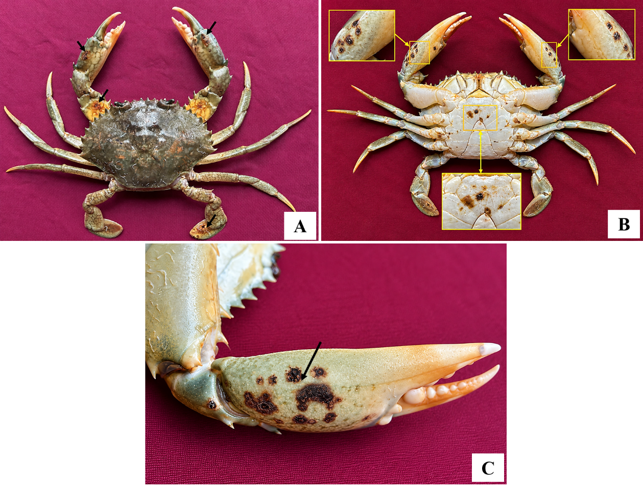
Figure 1. External manifestations of shell disease in mud crab Scylla serrata. A, rust-colored lesions on the chelate and swimming legs (arrows); B, ventral surface of the crab showing localized superficial lesions, with boxed areas indicating regions enlarged; C, magnified view of superficial shell lesions (black arrows)
3.2 Histopathology
Histological examination revealed distinct pathological alterations in the gill tissue of crabs exhibiting external shell disease lesions. In Figure 2A, lesions were evident on the outer surface of the gill cuticle, with disruption of the underlying epithelium and associated haemal space. Figure 2B showed pronounced haemocyte infiltration at the sites of epithelial damage, including numerous eosinophilic granular haemocytes, along with haemocyte plug/nodule formation within or adjacent to the haemal spaces. Figure 2C demonstrated an increased abundance of B-cells associated with the basal lamina and surrounding the tubular lumen. Overall, these findings indicate marked cellular and structural responses in the gill tissues associated with shell disease lesions.
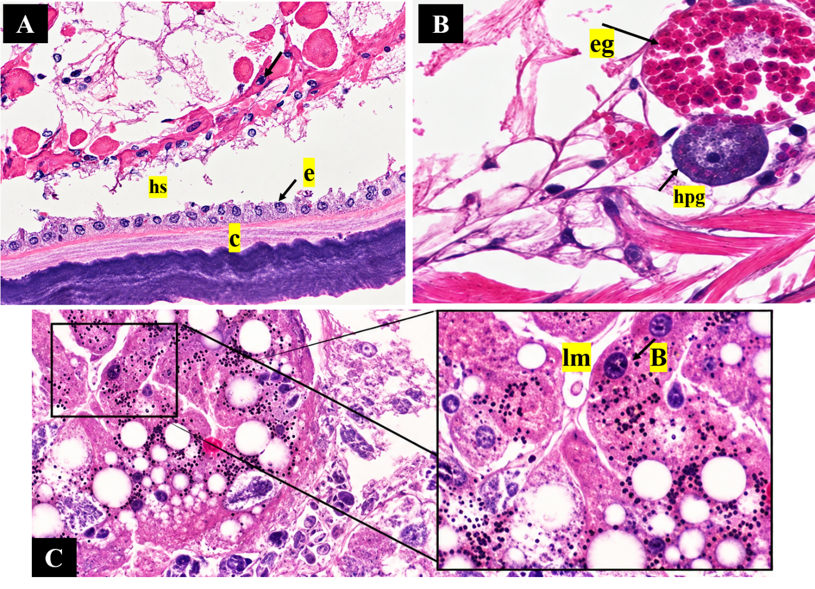
Figure 2. Histopathological alterations in the gill of a crab with shell disease lesions. A, outer gill cuticle (c), underlying epithelium (e) and haemal space (hs); B, epithelial lesion with haemocyte infiltration, haemocyte plug/nodule (hpg) and eosinophilic granular haemocytes (eg); C, increased abundance of B-cells (B), basal lamina and tubular lumen (lm).
3.3 Molecular characterization and phylogenetic analysis
The bacterial isolates were characterized based on 16S rRNA gene sequences, and the resulting sequences were subjected to phylogenetic analysis using the neighbour-joining method. Two sequences obtained in the present study were designated AH01 (QB053383.1) and AH02 (QB053381.1). The phylogenetic tree revealed that the two sequences did not form a single cluster but occupied distinct positions within the analyzed Aeromonas sequence dataset. AH01 (QB053383.1) clustered with MG428794.1, with a bootstrap support of 64%, whereas AH02 (QB053381.1) grouped with PZ959625.1, supported by a bootstrap value of 79%.

The cluster containing AH01 was subsequently associated with sequences PP759396.1, OR131038.1, PQ671497.1, PX884990.1 and PX884993.1, with strong support (100%) at the major internal node. Another well-supported lineage comprising OQ553752.1, OQ421482.1, OQ421472.1, OQ160719.1 and OQ160717.1 showed bootstrap values ranging from 83 to 97%.
Overall, the phylogenetic topology demonstrates that AH01 and AH02 represent distinct phylogenetic placements within the examined 16S rRNA sequence dataset and identified has Aeromonas hydrophila, with AH01 showing its closest association with MG428794.1 and AH02 with PZ959625.1. The bootstrap values provide support for the inferred clustering relationships.

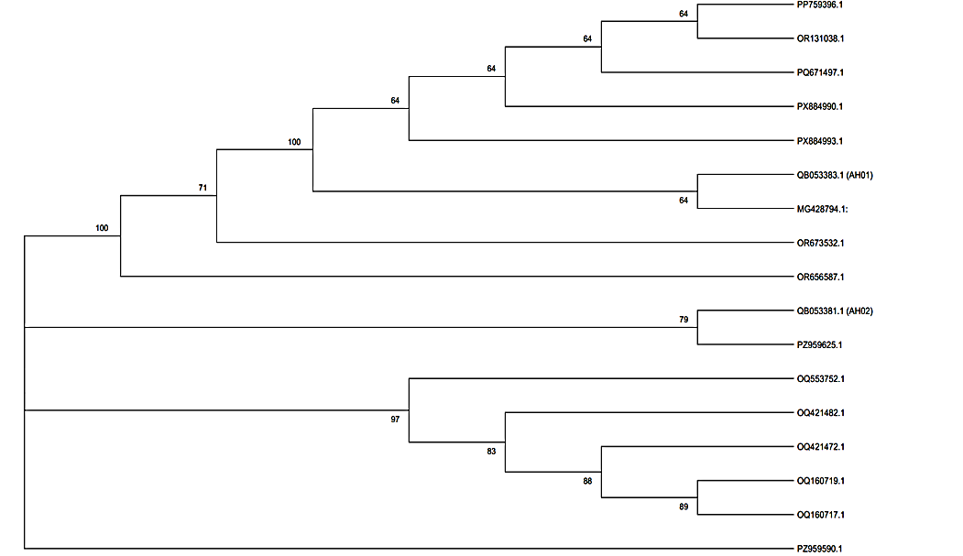
Figure 3. Neighbour-joining phylogenetic tree based on 16S rRNA gene sequences showing the relationships of the two sequences obtained in the present study (AH01 and AH02) with reference Aeromonas sequences. Numbers at the nodes represent bootstrap support values.

The present report documents shell disease in a wild mud crab Scylla serrata from the Pichavaram mangrove. Superficial rust-brown to dark-brown cuticular lesions were accompanied by damage to the gill cuticle and epithelium, haemocytic nodules and changes in the hepatopancreas, and two 16S rRNA gene sequences recovered from lesion tissue were identified as Aeromonas hydrophila. Shell lesions of S. serrata have previously been described only from Port Curtis, Australia, where they were considered non-infectious (Andersen et al. 2000) and were later examined during a mortality event associated with harbour development (Dennis et al. 2016).
The gross appearance of the lesions resembled the rust spots of Port Curtis mud crabs, which were also rust Coloured and occurred mostly on the ventral surface. In those crabs, however, the lesions were confined to the endocuticle and the adjacent muscle attachment, bacteria were found, and the internal organs shows tissue alteration in the gill and hepatopancreas. The authors attributed them to a defect in the formation of the endocuticle, which is laid down after ecdysis (Travis 1957) while calcium is rapidly taken up from the environment to calcify the new cuticle (Greenaway 1985). In the present crab, by contrast, bacterial DNA was recovered from the lesion and internal organs showed pathological changes. The brown to black colour of shell lesions results from melanin deposited at sites of cuticular damage, part of the wound response of crustaceans (Nyhlén & Unestam 1980) that is triggered early in the innate immune response (Lee & Söderhäll 2002). Similarly, Coloured lesions of differing aetiology have been reported as black necrotic disease in crabs from Scotland (Morado et al. 1988; Comely & Ansell 1989).
The lesions were concentrated on the ventral surface and the appendages, the body regions in closest contact with the substratum. Damage to the epicuticle and invasion through cuticular pores and the bases of setae have been proposed as the main routes by which bacteria enter the cuticle (Prince et al. 1993). S. serrata lives in burrows in soft, fine-grained and organically rich mangrove mud. Bacterial abundance in sediments increases with particle surface area and organic content (Yamamoto & Lopez 1985), and chitin is degraded rapidly in estuarine environments (Hood & Meyers 1977). Mangrove sediments are therefore likely to expose the ventral cuticle of burrowing crabs to large numbers of chitinolytic bacteria, as in the estuarine blue crab Callinectes sapidus, in which shell disease was among the earliest described in crabs (Rosen 1967).
The gill changes observed here closely match those described in shell-diseased edible crabs Cancer pagurus, in which lesions of the gill lamellae were associated with haemocyte nodules occluding the haemal sinuses, infiltration by eosinophilic granular cells and haemocytic plugs sealing breaches of the epithelium (Vogan et al. 2001). The decapod gill is covered by a thin cuticle continuous with the exoskeleton and has a delicate epithelium specialized for respiration and ion exchange (Lawson et al. 1994). Nodule formation is the characteristic response of crabs to bacteria in the haemocoel: bacteria injected into the shore crab Carcinus maenas are rapidly trapped by haemocytes in nodules, particularly in the gills (Smith & Ratcliffe 1980), and similar nodules and tissue damage develop in the course of bacterial infections of the blue crab (Johnson 1976). The nodules in the present crab therefore suggest that bacteria or their products had breached the gill cuticle and entered the haemolymph. Gill lesions and haemocyte responses are not specific to infection, however, and can also be induced by sublethal exposure to heavy metals such as cadmium (Victor 1993).
The hepatopancreas also showed changes, with an increased abundance of B-cells along the basal lamina and around the tubular lumen. The tubules of the decapod hepatopancreas contain distinct R-, F- and B-cells with different roles in absorption, storage and secretion of digestive enzymes (Johnson 1980; Ceccaldi 1998). The proportions and appearance of these cells change through the moult cycle (Travis 1957) and in response to toxicants (Bhavan & Geraldine 2000), and bacteria can also damage the hepatopancreas directly, as in hepatopancreatic brush border lysis of shrimp (Vogt 1997). The shift in B-cell abundance seen here may therefore reflect altered tubule activity during infection, but a single specimen cannot separate the effects of disease from those of the nutritional and moult state of the crab.
The bacterial sequences obtained from the lesion were identified as A. hydrophila. Chitinase production is widespread among aquatic bacteria, and Aeromonas is among the genera known to degrade chitin (Gooday 1990; Bhattacharya et al. 2007). Most earlier studies of bacterial shell disease and related lesions isolated Vibrio, Pseudomonas and other marine genera (Baross et al. 1978, Cipriani et al. 1980, Stewart 1993). Aeromonas species are most common in freshwater and brackish water. The Pichavaram mangrove lies between the Vellar and Coleroon estuaries and receives freshwater inflow, so salinity conditions there may favor Aeromonas over the strictly marine bacteria reported from shell disease in fully marine crustaceans.
The two sequences, AH01 and AH02, did not form a single cluster and grouped with different reference sequences, with moderate bootstrap support (64% and 79%). This may indicate that two closely related Aeromonas strains were present in the lesion, or it may reflect variation between the multiple copies of the 16S rRNA gene within one genome. Because the 16S rRNA gene often cannot reliably separate closely related Aeromonas species, the identification of A. hydrophila should be confirmed by sequencing housekeeping genes such as gyrB or rpoD.
The detection of A. hydrophila DNA in lesion tissue does not by itself show that this bacterium caused the disease. Rosen (1970) first proposed that shell lesions are microniches occupied by several interacting microbial groups. Culture-based 16S rRNA sequencing of lesion isolates from American lobsters Homarus americanus recovered a diverse community (Chistoserdov et al. 2005), and culture-independent analysis revealed a dysbiotic lesion microbiota rather than a single pathogen (Meres et al. 2012). Bacteria are also present in the haemolymph of apparently healthy crabs (Colwell et al. 1975, Sizemore et al. 1975), and members of the normal cuticular flora may become involved in shell disease once the cuticle is damaged (Porter et al. 2001). The universal 16S rDNA primers used here amplify most bacteria, so direct sequencing recovers the dominant taxa but may miss less abundant members of the lesion community. Establishing the role of A. hydrophila would require isolating it from lesions, testing the toxicity of its extracellular products (Costa-Ramos & Rowley 2004), and reproducing lesions by experimental exposure of the cuticle, as has been done with lesion bacteria in lobsters (Quinn et al. 2012).
Shell disease is increasingly viewed as the outcome of interactions between host, environment and microbes rather than of a single pathogen (Castro et al. 2006). Environmental stressors can weaken invertebrate immune defences (Mydlarz et al. 2006); manganese, for example, suppresses immunity in the Norway lobster Nephrops norvegicus (Hernroth et al. 2004), and shell disease in estuarine blue crabs has been linked to tissue metal content (Weinstein et al. 1992). Prevalence can vary markedly between sites within a single estuarine system (Dyrynda 1998) and rises with water temperature (Glenn & Pugh 2006, Tlusty & Metzler 2012). Diet also influences susceptibility, as shown in impounded and laboratory-held lobsters (Prince et al. 1995, Tlusty et al. 2008). Environmental conditions at the collection site were not measured in the present study, and these factors should be examined in future work in Pichavaram.
Shell disease has practical consequences for crustacean fisheries. Epizootic shell disease contributed to the decline of American lobster populations in southern New England (Castro et al. 2012), and disease can reduce the survival of commercially fished crustaceans (Hoenig et al. 2017). Disease levels may also rise where crustacean densities increase (Wootton et al. 2012). The mud crab is a major target of artisanal fisheries in Indo-Pacific mangroves (Heasman 1980), and Pichavaram crabs are traded live and increasingly held for fattening and culture. Holding systems can favour disease outbreaks (Delves-Broughton & Poupard 1976), and bacterial cuticular disease has caused losses in cultured larval lobsters (Ooi et al. 2020). The occurrence of Aeromonas-associated shell disease in a wild crab therefore warrants monitoring of both wild and cultured mud crab stocks in the region.
5. Summary and conclusion
This report describes shell disease in a wild mud crab Scylla serrata caught in the Pichavaram mangrove and landed at Mudasalodai fishing harbour, on the southeast coast of India. The crab bore rust-brown to dark-brown superficial lesions on the chelipeds, swimming legs and ventral surface. Histopathology revealed lesions of the gill cuticle with epithelial disruption, infiltration of eosinophilic granular haemocytes and haemocyte nodules, together with an increased abundance of B-cells in the hepatopancreatic tubules. Two 16S rRNA gene sequences recovered directly from lesion tissue (AH01 and AH02) were identified as Aeromonas hydrophila by BLAST and neighbour-joining phylogenetic analysis.
Unlike the non-infectious rust spot disease previously described in S. serrata, the present case shows the hallmarks of bacterial (Type 1) shell disease: a chitinolytic bacterium associated with the lesion and a host response that extends beyond the cuticle to internal organs. Aeromonas hydrophila should be considered a candidate agent of shell disease in mud crabs from brackish mangrove habitats. Because this is a single case, the causal role of A. hydrophila remains to be confirmed. Surveys of disease prevalence in wild and cultured mud crabs of the Pichavaram region, alongside environmental measurements, are also needed to assess the importance of this disease for the regional fishery.
Ethics Statement: Ethical approval was not required for the present study.
Declaration of AI Use

This manuscript was prepared through the intellectual contributions of the author(s) to the study design, data analysis, interpretation of results, and scholarly content. Grammarly and ChatGPT were used solely to assist with grammatical refinement and reference formatting during manuscript revision. The author(s) accept full responsibility for the accuracy, integrity, and final content of the manuscript.

COMPETING INTERESTS DISCLAIMER:
Authors have declared that they have no known competing financial interests OR non-financial interests OR personal relationships that could have appeared to influence the work reported in this paper.

References
- Andersen LE, Norton JH, Levy NH (2000) A new shell disease in the mud crab Scylla serrata from Port Curtis, Queensland (Australia). Dis Aquat Org 43:233–239. https://doi.org/10.3354/dao043233
- Baross JA, Tester PA, Morita RY (1978) Incidence, microscopy and etiology of exoskeleton lesions in the tanner crab Chionoecetes tanneri. J Fish Res Board Can 35:1141–1149
- Bergen N, Kramer P, Romberg J, Wichels A, Gerlach G, Brinkhoff T (2022) Shell disease syndrome is associated with reduced and shifted epibacterial diversity on the carapace of the crustacean Cancer pagurus. Microbiol Spectr 10:e0341922. https://doi.org/10.1128/spectrum.03419-22
- Bhattacharya D, Nagpure A, Gupta RK (2007) Bacterial chitinases: properties and potential. Crit Rev Biotech 27:21–28
- Bhavan PS, Geraldine P (2000) Histopathology of the hepatopancreas and gills of the prawn Macrobrachium malcolmsonii exposed to endosulfan. Aquat Toxicol 50:331–339
- Castro KM, Cobb JS, Gomez-Chiarri M, Tlusty M (2012) Epizootic shell disease in American lobsters Homarus americanus in southern New England: past, present and future. Dis Aquat Org 100:149–158. https://doi.org/10.3354/dao02507
- Castro KM, Factor JR, Angell T, Landers DF Jr (2006) The conceptual approach to lobster shell disease revisited. J Crustac Biol 26:646–660
- Ceccaldi HJ (1998) A synopsis of the morphology and physiology of the digestive system of some crustacean species studied in France. Rev Fish Sci 6:13–39
- Chistoserdov AY, Quinn RA, Gubbala SL, Smolowitz RM (2012) Bacterial communities associated with lesions of shell disease in the American lobster, Homarus americanus Milne-Edwards. J Shellfish Res 31:449–462. https://doi.org/10.2983/035.031.0205
- Chistoserdov AY, Smolowitz R, Mirasol F, Hsu A (2005) Culture-dependent characterization of the microbial community associated with epizootic shell disease lesions in American lobster, Homarus americanus. J Shellfish Res 24:741–747. https://doi.org/10.2983/0730-8000(2005)24[741:CCOTMC]2.0.CO;2
- Cipriani GR, Wheeler RS, Sizemore RK (1980) Characterization of brown spot disease of Gulf Coast shrimp. J Invertebr Pathol 36:255–263
- Colwell RR, Wicks TC, Tubiash HS (1975) A comparative study of the bacterial flora of the hemolymph of Callinectes sapidus. Mar Fish Rev 37:29–33
- Comely CA, Ansell AD (1989) The occurrence of black necrotic disease in crab species from the west of Scotland. Ophelia 30:95–112
- Cook DW, Lofton SR (1973) Chitinoclastic bacteria associated with shell disease in Penaeus shrimp and the blue crab Callinectes sapidus. J Wildl Dis 9:154–159. https://doi.org/10.7589/0090-3558-9.2.154
- Costa-Ramos C, Rowley AF (2004) Effects of extracellular products of Pseudoalteromonas atlantica on the edible crab, Cancer pagurus. Appl Environ Microbiol 70:729–735
- Delves-Broughton J, Poupard CW (1976) Disease problems of prawns in recirculation systems in the UK. Aquaculture 7:201–217
- Dennis MM, Diggles BK, Faulder R, Olyott L, Pyecroft SB, Gilbert GE and others (2016) Pathology of finfish and mud crabs Scylla serrata during a mortality event associated with a harbour development project in Port Curtis, Australia. Dis Aquat Org 121:173–188. https://doi.org/10.3354/dao03011
- Dyrynda EA (1998) Shell disease in the common shrimp Crangon crangon: variations within an enclosed estuarine system. Mar Biol 132:445–452
- Getchell RG (1989) Bacterial shell disease in crustaceans: a review. J Shellfish Res 8:1–6
- Glenn RP, Pugh TL (2006) Epizootic shell disease in American lobster (Homarus americanus) in Massachusetts coastal waters: interactions of temperature, maturity, and intermolt duration. J Crustac Biol 26:639–645. https://doi.org/10.1651/S-2754.1
- Gooday GW (1990) The ecology of chitin degradation. Adv Microb Ecol 11:387–430
- Greenaway P (1985) Calcium balance and moulting in the crustacea. Biol Rev 60:425–454
- Heasman MP (1980) Aspects of the general biology and fishery of the mud crab Scylla serrata (Forskal) in Moreton Bay, Queensland. PhD thesis, University of Queensland
- Hernroth B, Baden SP, Holm K, Andre T, Söderhäll I (2004) Manganese induced immune suppression of the lobster, Nephrops norvegicus. Aquat Toxicol 70:223–231
- Hess E (1937) A shell disease in lobsters (Homarus americanus) caused by chitinovorous bacteria. J Biol Board Can 3:358–362. https://doi.org/10.1139/f37-021
- Hoenig JM, Groner ML, Smith MW, Vogelbein WK, Taylor DM, Landers DF Jr and others (2017) Impact of disease on survival of three commercially fished species. Ecol Appl 27:2116–2127
- Hood MA, Meyers SP (1977) Rates of chitin degradation in an estuarine environment. J Oceanogr Soc Jpn 33:328–334
- Johnson PT (1976) Bacterial infection in the blue crab, Callinectes sapidus: course of infection and histopathology. J Invertebr Pathol 28:25–36
- Johnson PT (1980) Histology of the blue crab, Callinectes sapidus. Praeger Scientific, New York
- Keyhani NO, Roseman S (1999) Physiological aspects of chitin catabolism in marine bacteria. Biochim Biophys Acta 1473:108–122. https://doi.org/10.1016/S0304-4165(99)00172-5
- Lawson SL, Jones MB, Moate RM (1994) Structural variability and distribution of cells in a posterior gill of Carcinus maenas (Decapoda: Brachyura). J Mar Biol Assoc UK 74:771–785
- Lee SY, Söderhäll K (2002) Early events in crustacean innate immunity. Fish Shellfish Immunol 12:421–438
- Malloy SC (1978) Bacteria induced shell disease of lobsters (Homarus americanus). J Wildl Dis 14:2–10. https://doi.org/10.7589/0090-3558-14.1.2
- Meres NJ, Ajuzie CC, Sikaroodi M, Vemulapalli M, Shields JD, Gillevet PM (2012) Dysbiosis in epizootic shell disease of the American lobster (Homarus americanus). J Shellfish Res 31:463–472. https://doi.org/10.2983/035.031.0206
- Midorikawa Y, Shimizu T, Sanda T, Hamasaki K, Dan S, Lal MTBM and others (2020) Characterization of Aquimarina hainanensis isolated from diseased mud crab Scylla serrata larvae in a hatchery. J Fish Dis 43:541–549. https://doi.org/10.1111/jfd.13151
- Morado JF, Sparks AK, O'Clair CE (1988) A preliminary study of idiopathic lesions in the Dungeness crab, Cancer magister, from Rowan Bay, Alaska. Mar Environ Res 26:311–318
- Mydlarz LD, Jones LE, Harvell CD (2006) Innate immunity, environmental drivers, and disease ecology of marine and freshwater invertebrates. Annu Rev Ecol Evol Syst 37:251–288
- Noga EJ, Engel DP, Arroll TW, McKenna S, Davidian M (1994) Low serum antibacterial activity coincides with increased prevalence of shell disease in blue crabs Callinectes sapidus. Dis Aquat Org 19:121–128. https://doi.org/10.3354/dao019121
- Nyhlén L, Unestam T (1980) Wound reactions and Aphanomyces astaci growth in crayfish cuticle. J Invertebr Pathol 36:187–197
- Ooi MC, Goulden EF, Trotter AJ, Smith GG, Bridle AR (2020) Aquimarina sp. associated with a cuticular disease of cultured larval palinurid and scyllarid lobsters. Front Microbiol 11:573588. https://doi.org/10.3389/fmicb.2020.573588
- Porter L, Butler M, Reeves RH (2001) Normal bacterial flora of the spiny lobster Panulirus argus and its possible role in shell disease. Mar Freshw Res 52:1401–1405
- Powell A, Rowley AF (2005) Unchanged prevalence of shell disease in the edible crab Cancer pagurus four years after decommissioning of a sewage outfall at Langland Bay, UK. Dis Aquat Org 68:83–87. https://doi.org/10.3354/dao068083
- Prince DL, Bayer RC, Gallagher ML, Subramanyam M (1995) Reduction of shell disease with an experimental diet in a Nova-Scotian lobster pound. J Shellfish Res 14:205–207
- Prince DL, Bayer RC, Loughlin M (1993) Etiology and microscopy of shell disease in impounded American lobsters, Homarus americanus. Bull Aquacult Assoc Can 93-4:87–89
- Quinn RA, Metzler A, Smolowitz RM, Tlusty M, Chistoserdov AY (2012) Exposures of Homarus americanus shell to three bacteria isolated from naturally occurring epizootic shell disease lesions. J Shellfish Res 31:485–493. https://doi.org/10.2983/035.031.0208
- Rosen B (1967) Shell disease of the blue crab, Callinectes sapidus. J Invertebr Pathol 9:348–353
- Rosen B (1970) Shell disease in aquatic crustaceans. In: Snieszko SF (ed) A symposium on diseases of fishes and shellfishes. Spec Publ No. 5. American Fisheries Society, Washington, DC, p 409–415
- Rowley AF, Coates CJ (2023) Shell disease syndromes of decapod crustaceans. Environ Microbiol 25:931–947. https://doi.org/10.1111/1462-2920.16344
- Shields JD (2019) Climate change enhances disease processes in crustaceans: case studies in lobsters, crabs, and shrimps. J Crustac Biol 39:673–683. https://doi.org/10.1093/jcbiol/ruz072
- Sizemore RK, Colwell RR, Tubiash HS, Lovelace TE (1975) Bacterial flora of the hemolymph of the blue crab, Callinectes sapidus: numerical taxonomy. Appl Microbiol 29:393–399
- Smith VJ, Ratcliffe NA (1980) Cellular defence reactions of the shore crab, Carcinus maenas: in vivo hemocytic and histopathological responses to injected bacteria. J Invertebr Pathol 35:65–74
- Smolowitz RM, Bullis RA, Abt DA (1992) Pathologic cuticular changes of winter impoundment shell disease preceding and during intermolt in the American lobster, Homarus americanus. Biol Bull 183:99–112. https://doi.org/10.2307/1542411
- Stewart JE (1993) Infectious diseases of marine crustaceans. In: Couch JA, Fournie JW (eds) Pathobiology of marine and estuarine organisms. CRC Press, Boca Raton, FL, p 319–342
- Tlusty MF, Metzler A (2012) Relationship between temperature and shell disease in laboratory populations of juvenile American lobsters (Homarus americanus). J Shellfish Res 31:533–541. https://doi.org/10.2983/035.031.0213
- Tlusty MF, Myers A, Metzler A (2008) Short- and long-term dietary effects on disease and mortality in American lobster Homarus americanus. Dis Aquat Org 78:249–253. https://doi.org/10.3354/dao01867
- Travis DF (1957) The moulting cycle of the spiny lobster, Panulirus argus Latreille. IV. Post-ecdysial histological and histochemical changes in the hepatopancreas and integumental tissues. Biol Bull 113:451–479
- Victor B (1993) Responses of hemocytes and gill tissues to sublethal cadmium chloride poisoning in the crab Paratelphusa hydrodromous (Herbst). Arch Environ Contam Toxicol 24:432–439
- Vogan CL, Costa-Ramos C, Rowley AF (2001) A histological study of shell disease syndrome in the edible crab Cancer pagurus. Dis Aquat Org 47:209–217. https://doi.org/10.3354/dao047209
- Vogan CL, Costa-Ramos C, Rowley AF (2002) Shell disease syndrome in the edible crab, Cancer pagurus – isolation, characterization and pathogenicity of chitinolytic bacteria. Microbiology 148:743–754. https://doi.org/10.1099/00221287-148-3-743
- Vogan CL, Llewellyn PJ, Rowley AF (1999) Epidemiology and dynamics of shell disease in the edible crab Cancer pagurus: a preliminary study of Langland Bay, Swansea, UK. Dis Aquat Org 35:81–87. https://doi.org/10.3354/dao035081
- Vogan CL, Powell A, Rowley AF (2008) Shell disease in crustaceans – just chitin recycling gone wrong? Environ Microbiol 10:826–835. https://doi.org/10.1111/j.1462-2920.2007.01514.x
- Vogan CL, Rowley AF (2002) Dynamics of shell disease in the edible crab Cancer pagurus: a comparative study between two sites on the Gower Peninsula, South Wales, UK. Dis Aquat Org 52:151–157. https://doi.org/10.3354/dao052151
- Vogt G (1997) Hepatopancreatic brush border lysis (HBL): a new bacterial disease of the shrimp Palaemon elegans. Dis Aquat Org 29:151–155
- Weinstein JE, West TL, Bray JT (1992) Shell disease and metal content of blue crabs, Callinectes sapidus, from the Albemarle-Pamlico estuarine system, North Carolina. Arch Environ Contam Toxicol 23:355–362
- Weisburg WG, Barns SM, Pelletier DA, Lane DJ (1991) 16S ribosomal DNA amplification for phylogenetic study. J Bacteriol 173:697–703. https://doi.org/10.1128/jb.173.2.697-703.1991
- Wootton EC, Woolmer AP, Vogan CL, Pope EC, Hamilton KM, Rowley AF (2012) Increased disease calls for a cost-benefits review of marine reserves. PLoS One 7:e51615. https://doi.org/10.1371/journal.pone.0051615
- Yamamoto N, Lopez G (1985) Bacterial abundance in relation to surface area and organic content of marine sediments. J Exp Mar Biol Ecol 90:209–220
- Young JS, Pearce JB (1975) Shell disease in crabs and lobsters from New York Bight. Mar Pollut Bull 6:101–105. https://doi.org/10.1016/0025-326X(75)90268-4

