New Report of helminths infecting domestic chickens from Manipur
Abstract:
The study was conducted in three districts of Manipur with 308 chickens to identify helminth species and elucidate the effects of helminth infection in the gastrointestinal tracts of chickens kept under a local backyard production system. Postmortem findings identified two nematode species, seven cestode species, and one trematode species. The present investigation was undertaken in different localities of three districts of Manipur, namely Thoubal, Kakching, and Bisnupur, from May 2023 to April 2026, in the Department of Zoology, Parasitology Laboratory, Dhanamanjuri University, Imphal, Manipur, India. During these studies, we reported the following helminth parasites from our state, as no earlier investigations had reported them. The parasites include the cestodes Raillietina tetragona, Raillietina echinobothrida, Raillietina cisticillus, Chaontaenia infundibulum, and Amoebotania cuniata. In the case of nematodes, the most commonly encountered roundworm is Heterakis gallinarum. Among trematodes, only one species is reported as Echinostoma revolutum. In conclusion, large-scale research is recommended to determine whether other risk factors not considered in this study affect the epidemiology of helminthic disease and other complementary physiological parameters and indices of health, to further elucidate the interaction between helminths and the aforementioned health indices. It is also advisable to raise awareness among farmers about the importance of deworming to reduce economic losses caused by helminth parasites.
Keywords: New report, helminths, chicken, Manipur
Introduction:
Poultry is a promising sector in India, which is expanding day by day. It is also an appropriate income-generating sector for rural women, as well as landless and marginal farmers. But the indigenous chickens are affected by various parasites. Therefore, this study aimed to assess the prevalence and morphological identification of gastrointestinal helminths in backyard chickens in Manipur, India. Poultry, especially chicken, is one of the most intensively reared domesticated species, and is the most developed and profitable animal production business (FAO, 1987). Various scholars and rural development agencies have recognised its importance in developing countries and its role in improving the nutritional status and income of many small farmers over the last two decades (Nnadi, P. A. and George, S. O, 2010). Animal production in general and chickens in particular play important socioeconomic roles in developing countries (Alders, 2004). Backyard chicken production serves purposes such as income, egg hatching for replacement, consumption, cultural and/or religious ceremonies, and egg production (Moges et al., 2010). Poultry productivity improves when sound health protection and management principles are applied (Shane, 2005). The sector's economic contribution is not proportional to the large number of chickens because of many production, reproduction, and infrastructural constraints (Aberra, 2000). Poultry diseases are a major hindrance to poultry productivity, decreasing economic returns and potentially affecting industry development (Abebe et al., 1997). Among poultry diseases, helminthiasis is the most important problem for local chickens and a major cause of ill-health and productivity loss in different parts of the world (Eshetu et al., 2001). Parasitic diseases are a problem wherever poultry are raised, whether in large commercial operations or in small backyard flocks and economic losses caused by parasites on poultry can be significant (Fatihu et al., 1991). In fact, the indigenous chickens of Manipur, India, are parasitised by various parasites (Sarkar, 1976). Domestic chickens have a wide range of feeding habits, including grains, fruits, and insects, which may carry parasite stages and predispose them to parasitic infections (Adang et al., 2008; Oniye et al., 2000). Chickens pick up parasite eggs by ingesting contaminated feed, water, or litter, or by eating snails, earthworms, or other insects. Clinical signs of parasitism are unthriftiness, poor growth and feed conversion, decreased egg production and even death in severe infections. Furthermore, parasites can make the flock less resistant to other diseases and exacerbate existing disease conditions. Parasitic infections result in immunosuppression, especially in response to vaccines against some poultry diseases. Of all the intestinal worms, large roundworms (Ascaridia galli) probably inflict the most damage in young birds, being more severely affected. A mild infection is often unnoticed, but large numbers of worms, however, interfere with feed absorption, causing poor growth and production. In severe infections, worms can physically block the intestine, causing death (Yousuf et al., 2009). Gastrointestinal parasites that invade the host have morphological and physiological features such as a small, thread-like cylindrical body, hooks, and a hard body cuticle, which enhance their adaptation for long-term survival in their hosts. These parasites are a major factor limiting poultry industry productivity (Soulsby, 1982). Among poultry helminths, nematodes are the most important group, both in species number and in the extent of damage they cause; the main genera include Ascaridia, Heterakis, and Capillaria. A few cestode species occur in poultry. Like them, Choanotaenia infundibulum, Davainea proglottina, Raillietina cesticillus and Raillietina tetragona are also found in the intestine of poultry (Matur et al., 2010). The present report has undertaken to evaluate and to identify the three different forms of helminth parasites, viz., cestodes, trematodes and nematodes, which is a new report from our state, Manipur, which was conducted from May 2023 up to April 2026 in different localities of three different districts of Manipur, namely Thoubal, Kakching and Bisnupur Districts in the parasitology laboratory, Department of Zoology, Dhanamanjuri University, Manipur.
Materials and Methods:
Sampling Area:
Chicken Gastrointestinal samples were collected from slaughterhouses in rural areas of three districts of Manipur, India: Thoubal (163), Bisnupur (89), and Kakching (56). This experiment was performed in the Parasitology Laboratory, Department of Zoology, Dhanamanjuri University, Manipur, India.
Collection of samples:
Around noon on each sampling day, a batch of 6 intestines was randomly selected from chickens slaughtered between early morning and the time of collection. On sampling days, the gastrointestinal tracts (GIT) were placed in separate, labelled polythene bags and transported to the laboratory, maintaining a cool chain protocol.
The samples were used to isolate helminths. The gastrointestinal tracts were separated into the small intestine, caecum and large intestine. The entire length of each intestine was incised longitudinally, and the contents were emptied into sieves placed in large, clean, labelled plastic cups. Contents were washed in normal saline and examined under a light microscope. Larger helminths were collected directly by curved needle or forceps, and smaller ones were isolated under the microscope.

Processing of nematodes:
Nematodes were first washed in normal saline and then fixed in hot 70% ethanol or AFA fixative. For temporary microscopic examination, nematodes were cleared in glycerine so that the anterior end, oesophagus, spicules, vulva, tail and other diagnostic structures could be observed clearly. Male nematodes were examined carefully because spicules, caudal alae, papillae and tail morphology are important taxonomic characters (Soulsby, 1982; Anderson et al., 2009; Taylor et al., 2016).
Processing of cestodes and trematodes:
Cestodes and trematodes were washed in saline and gently flattened between two glass slides without excessive pressure. The specimens were fixed in AFA or 70% ethanol, stained with borax carmine, dehydrated through ascending grades of alcohol, cleared in xylene or clove oil and mounted in Canada balsam and identification of helminths was according to Yamaguti (1958, 1959), Khalil et al. (1994) and Soulsby (1982).
Collection of adult helminths was washed in normal saline and identified morphologically, and some parts were preserved in absolute ethanol and others in 70% ethanol. Genomic DNA sequencing was outsourced to Barcode BioScience Private Limited and compared with NCBI GenBank records using BLASTn (Altschul et al., 1990). Homologous sequences were aligned, and phylogenetic trees were constructed in MEGA7 with 1,000 bootstrap replicates (Tamura et al., 2021).
Results and discussion:
Results:
Examination of all 308 samples confirmed nine helminths by light microscopy and molecular identification. These included one species of nematode (Heterakis gallinarum), one species of trematode (Echinostoma revolutum), and seven species of cestode (Raillietina tetragona, Raillietina echinobothrida, Raillietina cisticillus, Chaontaenia infundibulum, Amoebotania cuniata, Davainea proglottina and Cotugnea digonopora)

Morphological observation:
Nematodes:
HETERAKIS GALLINARUM (Schrank, 1788).
General characters:
Adult worms are whitish, cylindrical and comparatively short, and they are usually recovered from the lumen of the caeca. The body is covered by a smooth cuticle, the anterior end bears three lips, and the oesophagus ends posteriorly in a distinct bulb. The sexes are separate and show sexual dimorphism, with females generally larger than males. The tail of the male has large alae, a circular pre-cloacal sucker and distinct twelve pairs of papillae, and the spicules are unequal. The eggs are ovoid to ellipsoidal, thick-shelled and smooth, and they are unsegmented when freshly laid.
Male (10 specimens):
Whole body measures 6 – 10 mm in length and 0.20 – 0.38 mm in width. The head diameter is 0.10–0.20 mm, with three buccal capsules. Oesophagus length 0.85 – 1.05 mm and width 0.17– 0.22 mm away from the anterior end, nerve ring at 0.17 – 0.22 mm away from the anterior end and excretory pore distance from the anterior end 0.07 – 0.82 mm. Spicules paired, unequal and measured as follows: the larger one is 1.3– 1.8 mm in length, while the smaller one is 0.6- 0.90 mm; precloacal sucker to cloaca length 0.06– 0.090 mm, and tail length 0.03- 0.51 mm (Fig. 1 and Plate.1).
Female (15 specimens):
Whole body measures 9- 15 mm in length and 0.17- 0.40 mm in width. The diameter of the head is 0.034-0.045 mm with three buccal capsules. Oesophagus length 0.90 – 1.05 mm and width 0.30– 0.4 mm away from the anterior end, nerve ring at 0.25- 40 mm away from the anterior end and tail length 0.80– 1.00 mm. Egg size 0.060- 0.080 × 0.035- 0.045 mm, and eggs are oval with a smooth shell (Fig. 1 and Plate 1).
Habitat and locality:
Recovered from the caeca of domestic chickens from Thoubal, Kakching and Bishnupur districts, Manipur, India.

Remarks:
The species Heterakis gallinarum was originally described by Schrank in 1788 as Ascaris gallinarum and is now accepted as Heterakis gallinarum (Schrank, 1788) Madsen, 1949. Several nominal names occurring in older literature have been treated as synonyms, viz., Ascaris vesicularis Frolich, 1791; Heterakis vesicularis (Frolich, 1791) Dujardin, 1845; and Heterakis gallinae (Gmelin, 1790). Madsen (1949) clarified that H. gallinarum (Schrank, 1788) should not be confused with H. gallinae (Gmelin, 1790), a point that is useful while comparing old reports of poultry heterakids.
The worms are small, whitish nematodes with a transversely striated cuticle, three well-defined lips at the anterior end and a characteristic oesophagus ending in a posterior bulb. In males, identification depends chiefly on the posterior region, particularly the pre-cloacal sucker, caudal alae, caudal papillae and two unequal spicules; females are longer and stouter, with the vulva situated near the middle of the body and a tapering posterior end (Soulsby, 1982; Yamaguti, 1961; Ara et al., 2024).
The morphological characters and dimensions of the present specimens agree with those of H. gallinarum. Such minor variation may be due to worm age, infection intensity, host condition, fixation procedure, and the degree of contraction during preservation.

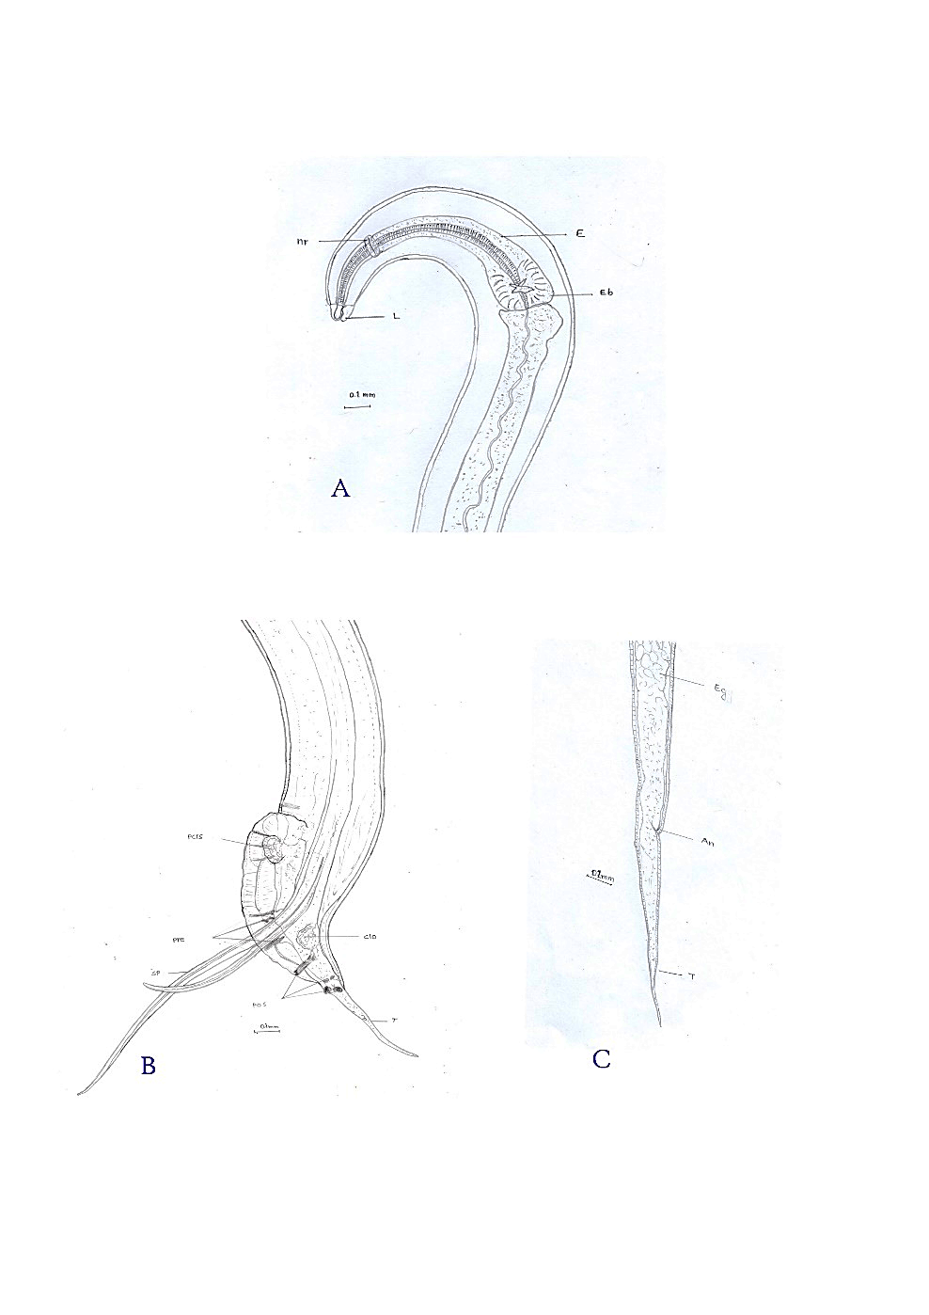
Figure 1: Heterakis gallinarum, A & C: anterior and posterior part of female, B: posterior part of male. E- oesophagus, L- lips, T- tail, An- anus, ep- oesophagus pore, sp- spicules, pcrs- precloacal chitinous-rimmed sucker, pos- postcloacal papillae, pre- precloacal papillae, eg- egg capsule, clo- cloca,
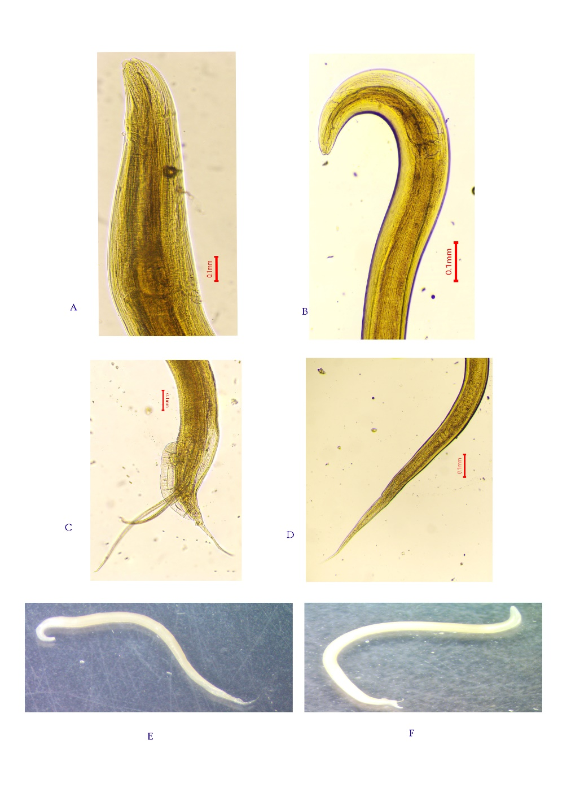
Plate.1: Heterakis gallinarum: A: Anterior part of the male, B: posterior part of male, C: anterior part of female, D: posterior part of female and E and F: whole body of the female and male.
Cestodes:
1. RAILLIETINA TETRAGONA (Molin, 1858).
Generic character:
Adults are whitish to yellowish-white, ribbon-like, dorsoventrally flattened and segmented. The body is divided into an anterior scolex, a narrow, unsegmented neck and a long strobila composed of immature, mature and gravid proglottids (Yamaguti, 1959; Soulsby, 1982). Scolex bears four suckers and an apical rostellum; rostellar hooks and sucker armature (Butboonchoo et al., 2016; Panich & Chontananarth, 2021). The neck is unsegmented and serves as the growth region from which new proglottids form (Soulsby, 1982). The strobila consists of many proglottids. Mature segments are hermaphroditic, while posterior gravid segments contain egg capsules instead of a single compact uterus and a unilateral genital pore situated in the anterior third of the segment, and gravid proglottids containing several eggs per capsule, usually 6-12 eggs (Yamaguti, 1959; Soulsby, 1982).
Description: (10 specimens):
Adult worm: The adult body is elongated, thin, yellowish-white and ribbon-like, and its length is about 20-28 cm. The surface is smooth, velvety, or silky (Fig..2 and plate 2).
Scolex: The scolex is ovoid and comparatively small, and the scolex diameter is 0.16-0.20 mm. It bears an apical rostellum and four suckers.
Suckers: Four suckers are present around the rostellum. They are ovoid-shaped and armed, and their size is 0.04 x 0.09 to 0.05 x 0.10 mm.
Rostellum and hooks: The rostellum is small, rounded to oval and armed with hooks. The rostellum size is 0.03 x 0.05 to 0.04 x 0.06 mm. The rostellar hooks are hammer-shaped and arranged in a single row.
Neck: The neck is unsegmented, thin and comparatively long. It lies immediately behind the scolex and gives rise to the developing proglottids of the strobila.
Strobila and proglottids: The strobila consists of many segments. Immature proglottids are present near the neck, mature proglottids occur in the middle region, and gravid proglottids are found posteriorly. Mature proglottids are hermaphroditic and contain one complete set of male and female reproductive organs.
Genital pore: The genital pore is unilateral. It is usually positioned in the anterior third of the segment's lateral margin.
Gravid proglottid and eggs: Gravid segments contain egg capsules. Each egg capsule usually contains 6-12 eggs.
Phylogenetic analysis:
The internal transcribed spacer 2 (ITS2) sequence in FASTA format was used for the region using the neighbour-joining method. The analysis contained 16 nucleotide sequences and 976 aligned positions. Evolutionary distances were calculated with the Maximum Composite Likelihood approach, ambiguous positions were removed for each sequence pair, and branch support was estimated from 1,000 bootstrap replicates. The optimal tree had a total branch length of 2.59582239, and its branch lengths are expressed as substitutions per site. These settings follow standard distance-based phylogenetic procedures implemented in MEGA 7 (Saitou & Nei, 1987; Tamura et al., 2004; Kumar et al., 2016).
The query sequence Raillietina-ITS2 was positioned within the principal assemblage of GenBank sequences identified as Raillietina tetragona. In the displayed topology (Figure 2), it occurs between reference sequences including MH421969.1 and MH421981.1 and is clearly separated from Raillietina echinobothrida (JN976628.1) and the basal Choanotaenia infundibulum sequence (ON112233.1) (Figure 3). This clustering results in molecular support for assigning the specimen to R. tetragona.
Habitat and locality:
Raillietina tetragona (Molin, 1858) has been obtained from the gastrointestinal tract of domestic chickens from Thoubal, Kakching and Bishnupur districts, Manipur, India.
Remarks:
This specimen may be referred to Raillietina tetragona because the observed diagnostic characters are consistent with the genus Raillietina and with published descriptions of R. tetragona. The segmented cestode body, armed scolex, four suckers, rostellum and egg-capsule formation support placement under Davaineidae. At the species level, the oval scolex, oval armed suckers, thin and long neck, single row of rostellar hooks and 6-12 eggs per egg capsule (Yamaguti, 1959; Soulsby, 1982; Butboonchoo et al., 2016).
The identification should not be based only on general body shape because several poultry cestodes are ribbon-like and occur in the small intestine. Raillietina tetragona closely resembles R. echinobothrida and R. cesticillus, but it differs from R. echinobothrida by its single row of rostellar hooks, anteriorly placed unilateral genital pore and 6-12 eggs per capsule. It differs from R. cesticillus by the presence of armed oval suckers and by having several eggs per capsule rather than a single egg per capsule (Butboonchoo et al., 2016; Panich & Chontananarth, 2021).
Therefore, the diagnostic conclusion should be written as: “The recovered cestode is identified as Raillietina tetragona (Molin, 1858) based on the presence of an oval scolex, armed oval suckers, armed rostellum with a single row of hooks, unilateral anterior genital pore and gravid proglottids with 6-12 eggs per egg capsule” and the ITS2 query clusters with multiple reference sequences of Raillietina tetragona and is phylogenetically distinct from the displayed R. echinobothrida and basal C. infundibulum sequences. The specimen is identified as Raillietina tetragona.
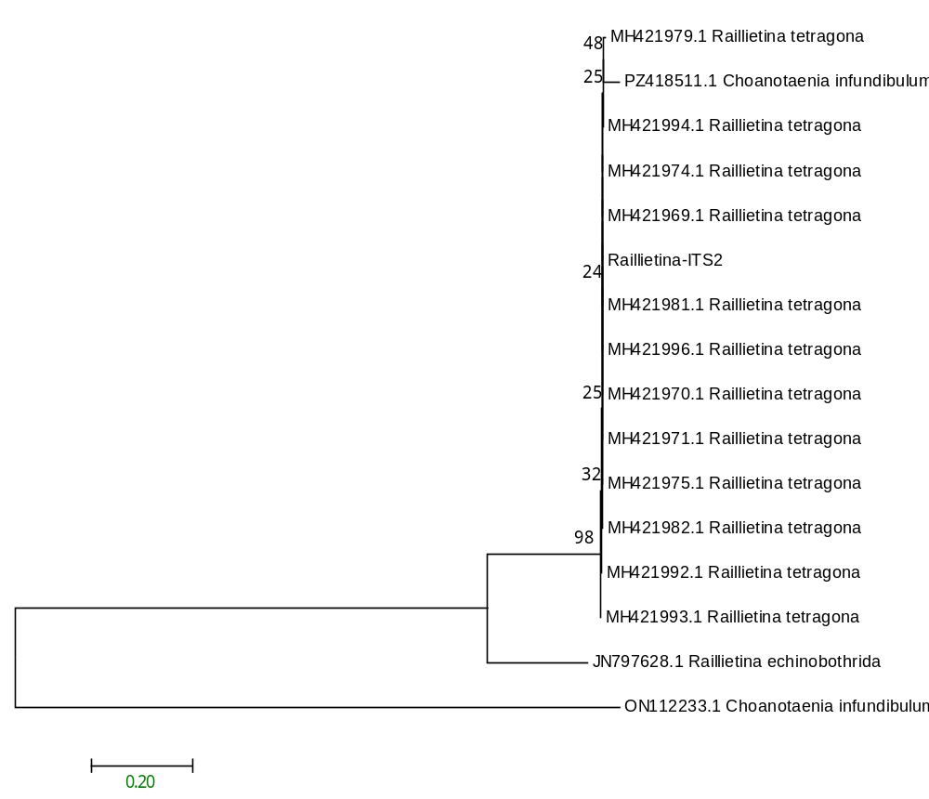
Figure 2: Phylogram of the analysis of Raillietina tetragona, showing relationships of Choanotaenia infundibulum using the neighbour-joining (NJ) tree method and Kimura 2-parameter distances ITS2 sequences. Numbers at nodes indicate bootstrap values by the NJ and ML methods (1000 replicates)
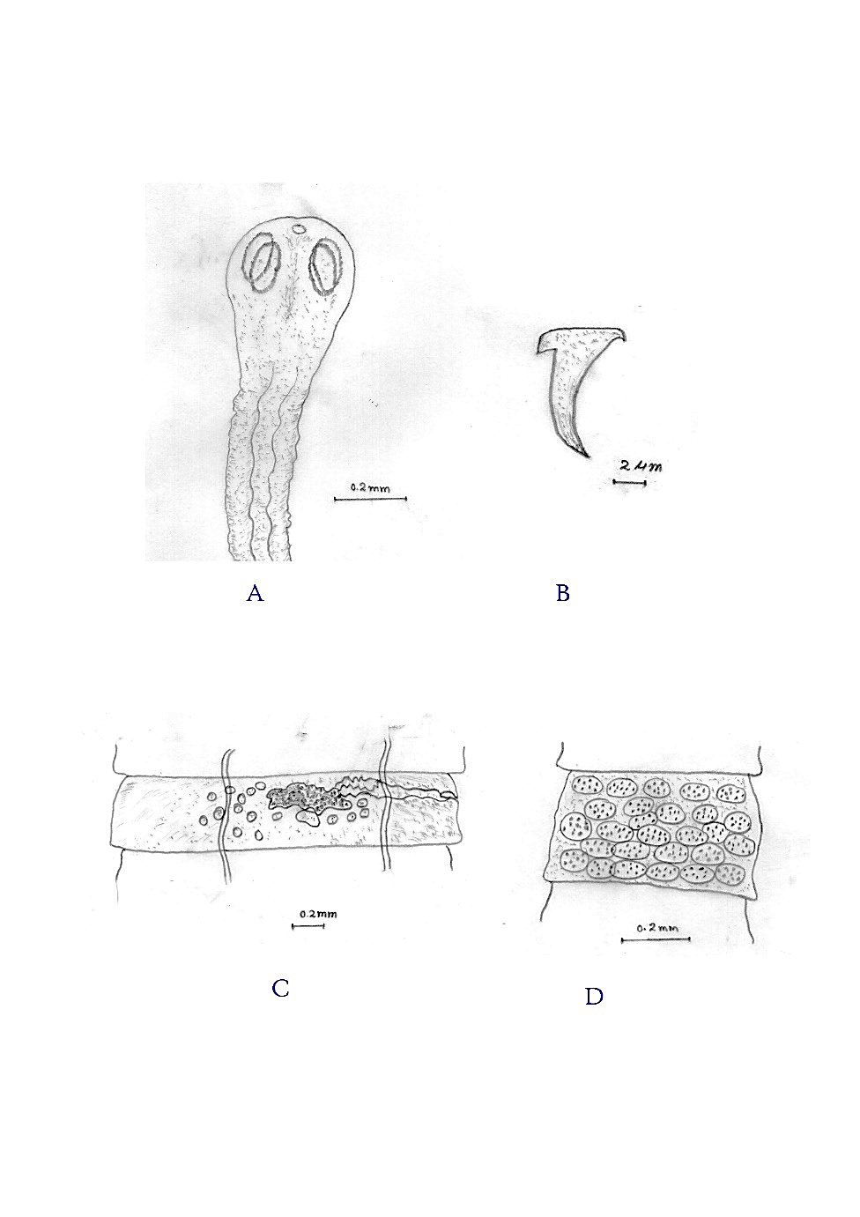
Figure 3: Raillietina tetragona. A: anterior part (scolex), B: hook, C: mature proglottid, D: gravid segment.
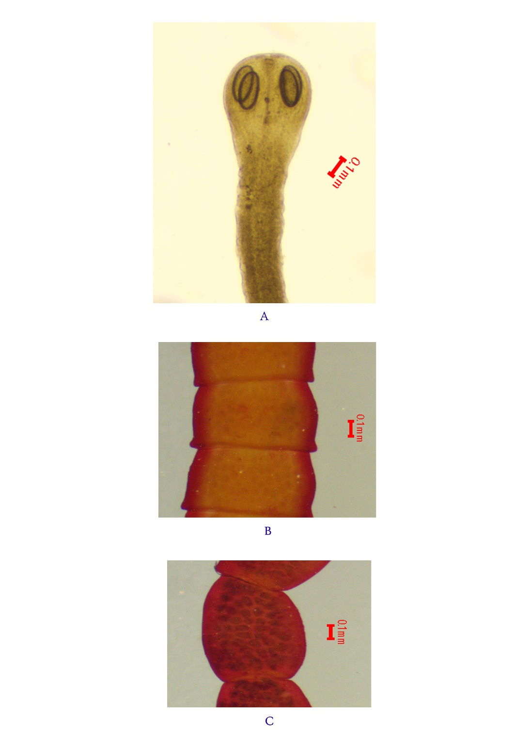
Plate 2: Raillietina tetragona. A: Scolex (anterior part), B: Mature proglottid, C: Gravid segment.
2. RAILLIENTINA ECHINOBOTHRIDA (Megnin, 1880)
Generic character:
The adult worm is elongated, ribbon-like, dorsoventrally flattened, and yellowish-white to pale whitish in colour, measuring 16-23 cm in length. The body is divided into scolex, neck and strobila. The strobila consists of numerous segments, beginning with immature segments near the neck, followed by mature and gravid segments posteriorly. The tegument is smooth to velvety and bears microtriches. Body width varies by region and state of contraction. The anterior region is narrow, while the middle and posterior segments become broader. Mature segments are generally broader than long, and gravid segments contain numerous egg capsules.
Description: (10 specimens)
The adult worm is long, ribbon-like, yellowish-white, and 16-23 cm. The scolex is round to spherical, 0.27-0.33 mm in diameter. Rostellum armed, retractile and rounded, 0.06 x 0.07 mm to 0.08 x 0.10 mm. Rostellar hooks are arranged in two rows and are hammer-shaped or pick-mattock-shaped. Four suckers present; suckers nearly round and armed, about 0.07 x 0.08 mm to 0.08 x0.09 mm. Neck short, broad, thick and unsegmented; mature proglottids are broader than long, and each has one set of reproductive organs. The genital pore is unilateral and located posterior to the middle portion of the segment margin. Testes are numerous, commonly about 30-40 in each mature segment, and the cirrus pouch is well-developed and placed outside the excretory duct. Ovary bilobed; vitelline gland compact and post-ovarian. Gravid proglottids contain numerous egg capsules and 8-12 eggs per capsule (Fig. 4 and plate 3).
Habitat and locality:
Raillietina echinobothrida (Megnin, 1880) has been obtained from the gastrointestinal tract of domestic chickens from Thoubal, Kakching, and Bishnupur districts, Manipur, India.
Remarks:
The cestode is identified as Raillietina echinobothrida (Megnin, 1880) based on its long ribbon-like body, round scolex measuring about 0.27-0.33 mm in diameter, armed rounded rostellum measuring about 0.06 x 0.07 mm to 0.08 x 0.10 mm, two rows of rostellar hooks, four armed nearly round suckers measuring about 0.07 x 0.08 mm to 0.08 x 0.09 mm, short thick neck, unilateral posterior genital pore, numerous testes and gravid proglottids containing egg capsules with several eggs. These characters distinguish it from R. tetragona and R. cesticillus and support its identification as the nodular tapeworm of poultry.
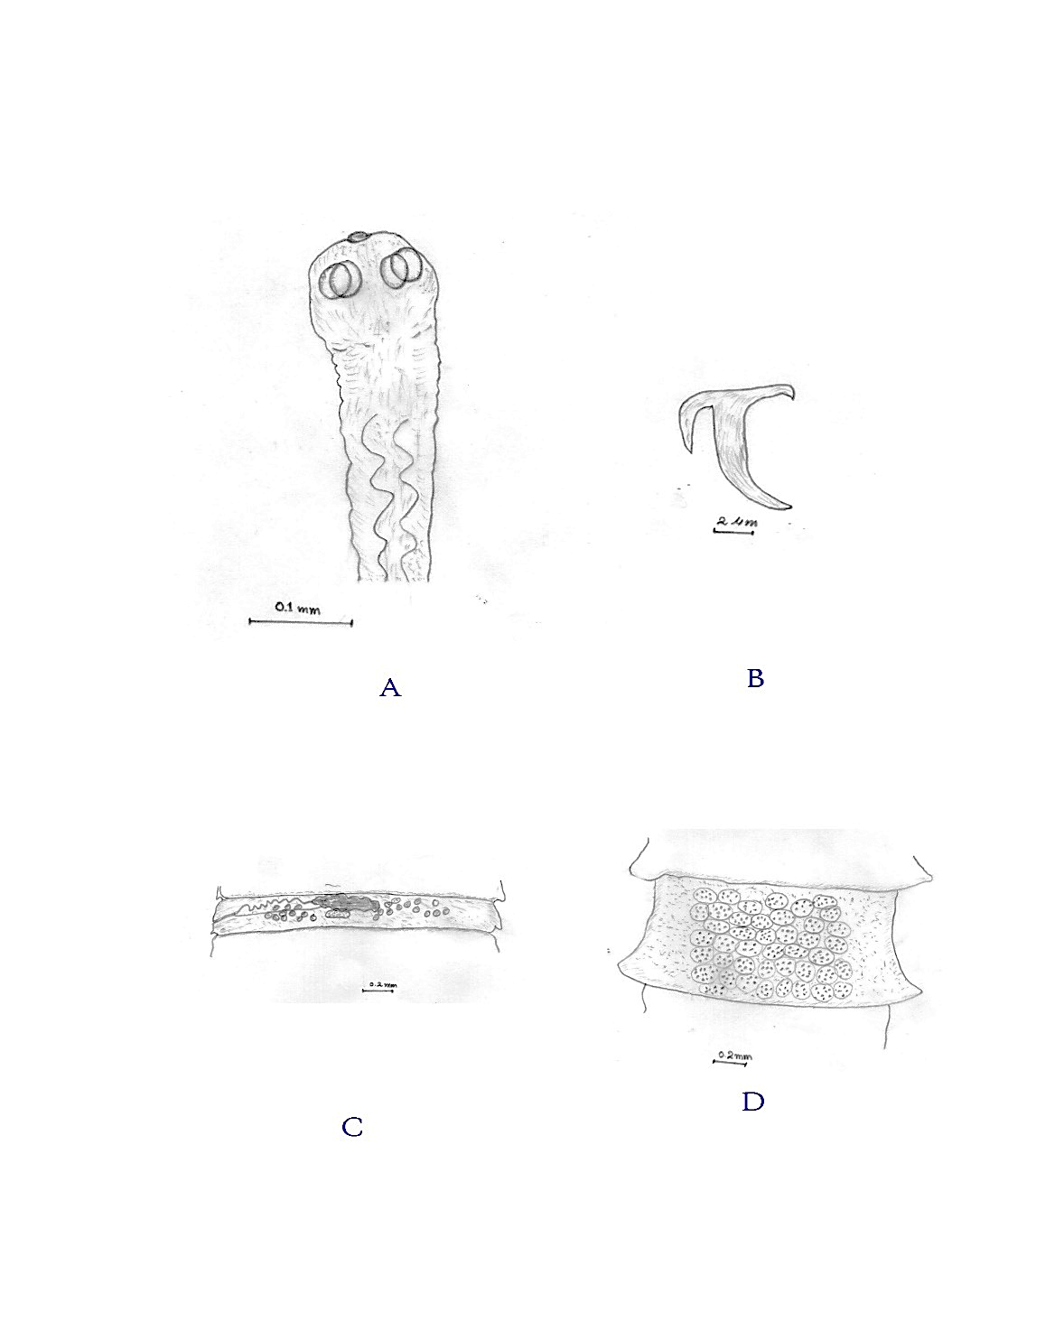
Figure 4: Raillietina echinobothrida. A: Anterior part (scolex), B: Hook, C: Mature proglottid, D: Gravid segment.

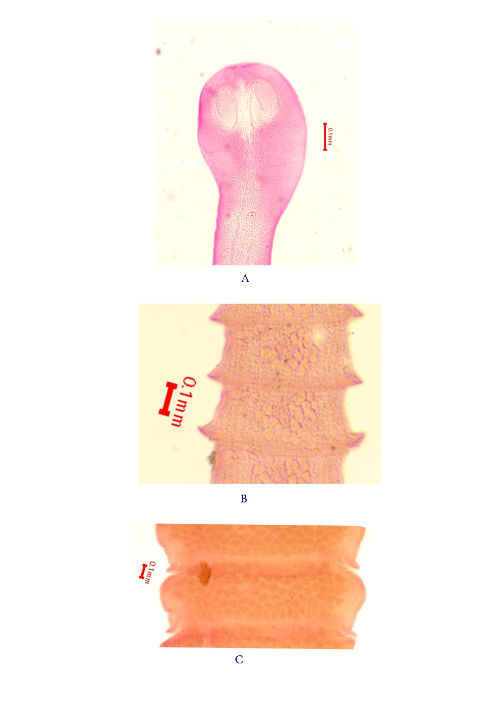
Plate 3: Raillietina echinobothrida. A: Anterior part (scolex), B: Mature proglottid, C: Gravid segment.

3. RAILLIETINA CESTICILLUS (Molin, 1858):
Generic character:
The adult worm is whitish, elongated, ribbon-like, and dorsoventrally flattened. The body is divided into a scolex, a very short or indistinct neck, and a strobila. Body length is 6-12 cm long and 1-2.5 mm wide. The strobila has immature, mature, and gravid proglottids. Mature segments are generally broader than long and contain a single set of reproductive organs. Terminal gravid segments contain numerous egg capsules, and each egg capsule contains a single egg.
Description: (10 specimens)
Adult worm whitish, ribbon-like, dorsoventrally flattened, and divided into scolex, neck, and strobila, with a body length of 6- 12 cm and a 1.5- 2.5 mm width. Scolex broad-headed and robust, with 134 μm diameters, and a wide, prominent rostellum. Rostellum armed with two rows of numerous hammer-shaped hooks, commonly about 400-500 hooks. Four suckers are present but are small, inconspicuous, and unarmed. Genital pores are irregularly alternating and anteriorly placed on the lateral margin. Gravid proglottids contain egg capsules with a single egg per capsule, and eggs are 75-88 μm in diameter (Figure 5 and plate 3).
Habitats and localities:
Raillietina cesticillus (Molin, 1858) has been obtained from the gastrointestinal tract of domestic chickens from Thoubal, Kakching, and Bishnupur districts, Manipur, India.
Remarks:
The species Raillietina cesticillus was erected by Molin (1858). This species has a broad scolex, a large rostellum, unarmed suckers, two rows of hammer-shaped rostellar hooks, irregularly alternating genital pores, and a single egg in each egg capsule (Butboonchoo et al., 2016; Kerroucha et al., 2022). It differs from R. tetragona by having unarmed suckers, two rows of hooks and irregularly alternating genital pores; R. tetragona has armed suckers, one row of hooks, unilateral genital pores and 6-12 eggs per capsule. It also differs from R. echinobothrida because R. echinobothrida has armed suckers, unilateral genital pores and several eggs per capsule (Butboonchoo et al., 2016). The morphology and dimensions of the present specimen are in close agreement with those provided by Molin (1858) for Raillietina cesticillus, except for having minor intraspecific variation. Therefore, the present nematodes are considered Raillietina cesticillus.
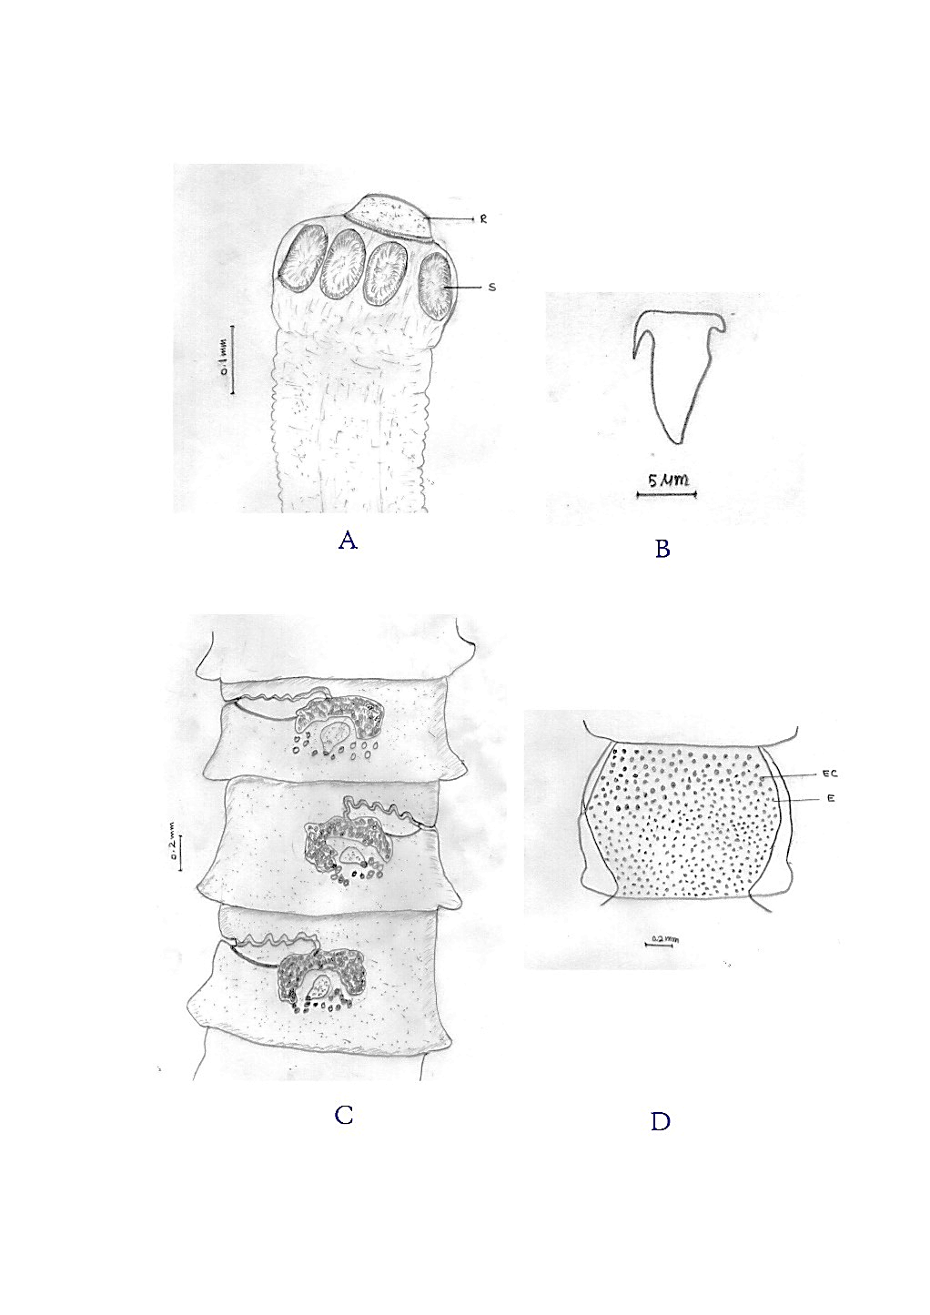
Figure 5: Raillietina cesticillus. A; Anterior part (scolex), B; Hook, C; Mature proglottid, D; Gravid segment.
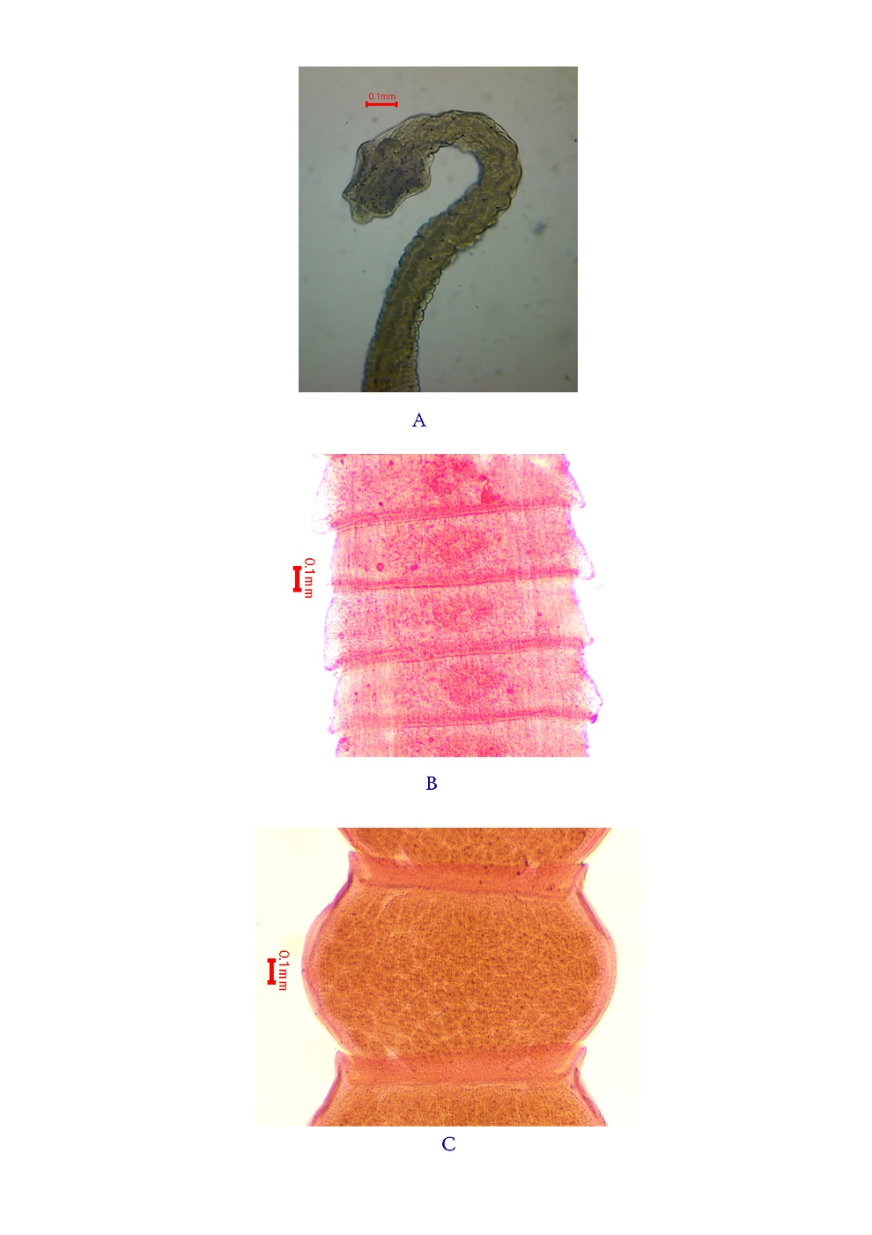
Plate 4: Raillietina cesticillus. A; Anterior part (scolex), B; Mature proglottid, C; Gravid segment.

4. CHOANOTAENIA INFUNDIBULUM (Bloch, 1779).
Generic character:
An adult cestode is found in the small intestine. The body is soft, whitish, dorsoventrally flattened and ribbon-like. The body is divided into three main regions: scolex, neck and strobila. The scolex bears four well-developed suckers and a prominent rostellum. The rostellum is armed with a single row of hooks, and the suckers are unarmed. The mature proglottids are broader than long and have a mature region that appears slightly wider than the posterior end. The genital pores are irregularly alternating. Each mature proglottid contains both male and female reproductive organs. The testes are numerous and situated in the posterior field of the mature segment. The ovary is bilobed; the vitelline gland is compact and located near the posterior region of the segment. Gravid proglottids are full of eggs and are passed with the faeces after detachment from the posterior end of the worm.
Description: (5 specimens)
The adult worm is white, flattened, ribbon-like and segmented. The strobila is composed of proglottids, and mature worms are 20 to 23 cm long and 1.5-3 mm wide. The body is not smooth-edged and the posterior margin of each segment is wider than the anterior margin. The scolex is small with four suckers and no arms. The scolex is 0.44-0.46 mm in diameter and 0.37-0.58 mm long. The suckers were 0.138-0.204 mm by 0.16-0.22 mm. The rostellum is armed with a single crown of small rostellar hooks. The neck is narrow, and the scolex measures 0.47-0.52 mm. Mature proglottids have irregularly alternating genital pores. Eggs are loose in the parenchyma, without uterine capsules, measuring 47 x 54 um (Figure 7 and plate 5).
Phylogenetic analysis:
We evaluated the evolutionary relationship of the study sequence using the internal transcribed spacer 2 (ITS2) region. The phylogenetic tree contains 16 nucleotide sequences and 1,304 aligned positions in the final dataset. Evolutionary distances were calculated by the Maximum Composite Likelihood method and expressed as base substitutions per site. A Neighbour-Joining tree was constructed in MEGA7, branch support was assessed with 1,000 bootstrap replicates, and the optimal tree had a total branch length of 4.36081104.
The study sequence “Choanotaenia-ITS2” is positioned directly with two reference sequences identified as Choanotaenia infundibulum, FZ418511.1 and JN073824.1. This specimen is consistent with C. infundibulum (Figure 6)
Habitat and locality:
Choanotaenia infundibulum (Bloch, 1779) has been obtained from the gastrointestinal tract of domestic chickens from Thoubal, Kakching, and Bishnupur districts, Manipur, India.
Remarks:
Bloch erected the species Choanotaenia infundibulum in 1779, describing a broad scolex with a prominent armed rostellum, four unarmed suckers, rostellar hooks in two rows, irregularly alternating genital pores in mature segments, and gravid egg capsules containing a single egg. These characters correspond with standard descriptions of R. cesticillus and separate it from the common poultry tapeworms R. tetragona and R. echinobothrida (Butboonchoo et al., 2016; Kerroucha et al., 2022; Souldby, 1982). The morphology and dimensions of the present specimen are in close agreement with those provided by Bloch (1779) for Raillietina cesticillus, except for having minor intraspecific variation. Therefore, the present nematodes are considered Choanotaenia infundibulum.
The ITS2 sequence “Choanotaenia-ITS2” is placed with reference sequences of Choanotaenia infundibulum and is separated from the Raillietina taxa included in the analysis. The topology therefore supports identification of the recovered poultry cestode as Choanotaenia infundibulum (Bloch, 1779).

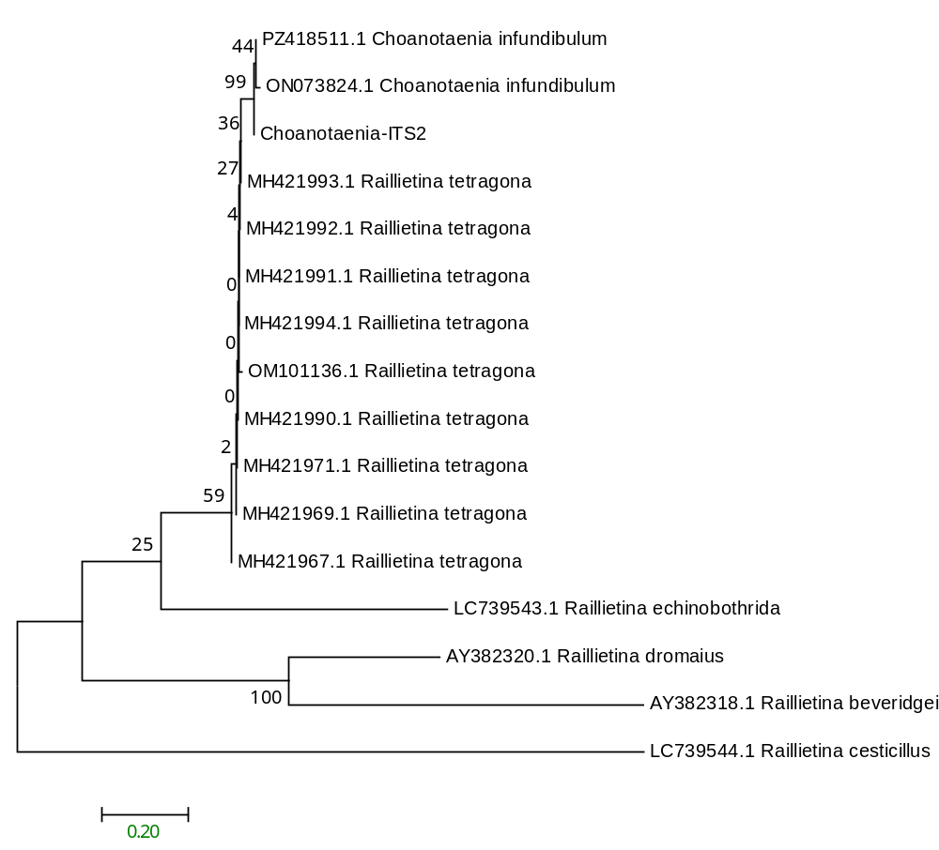

Figure.6: Phylogram of the analysis of Choanotaenia infundibulum, showing relationships of Raillietina cesticillus using the neighbour-joining (NJ) tree method and Kimura 2-parameter distances ITS2 sequences. Numbers at nodes indicate bootstrap values by the NJ and ML methods (1000 replicates).

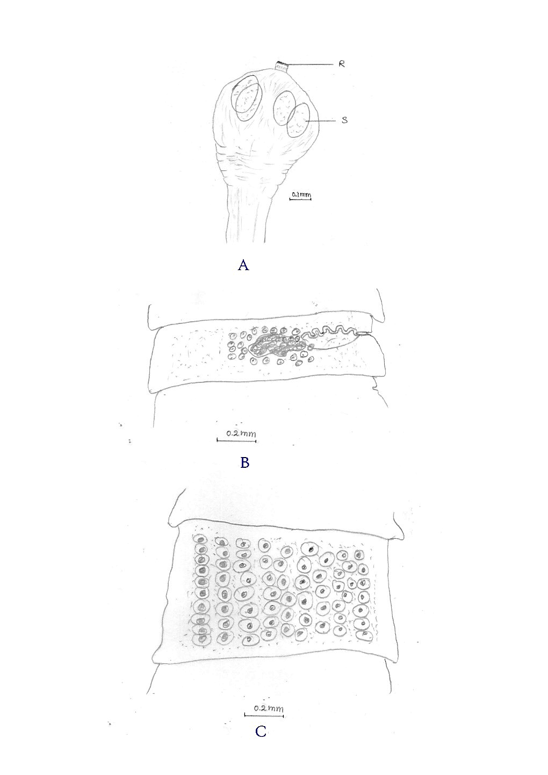
Figure 7: Choanotaenia infundibulum. A; Anterior part (scolex), B; Mature proglottid, C; Gravid segment.

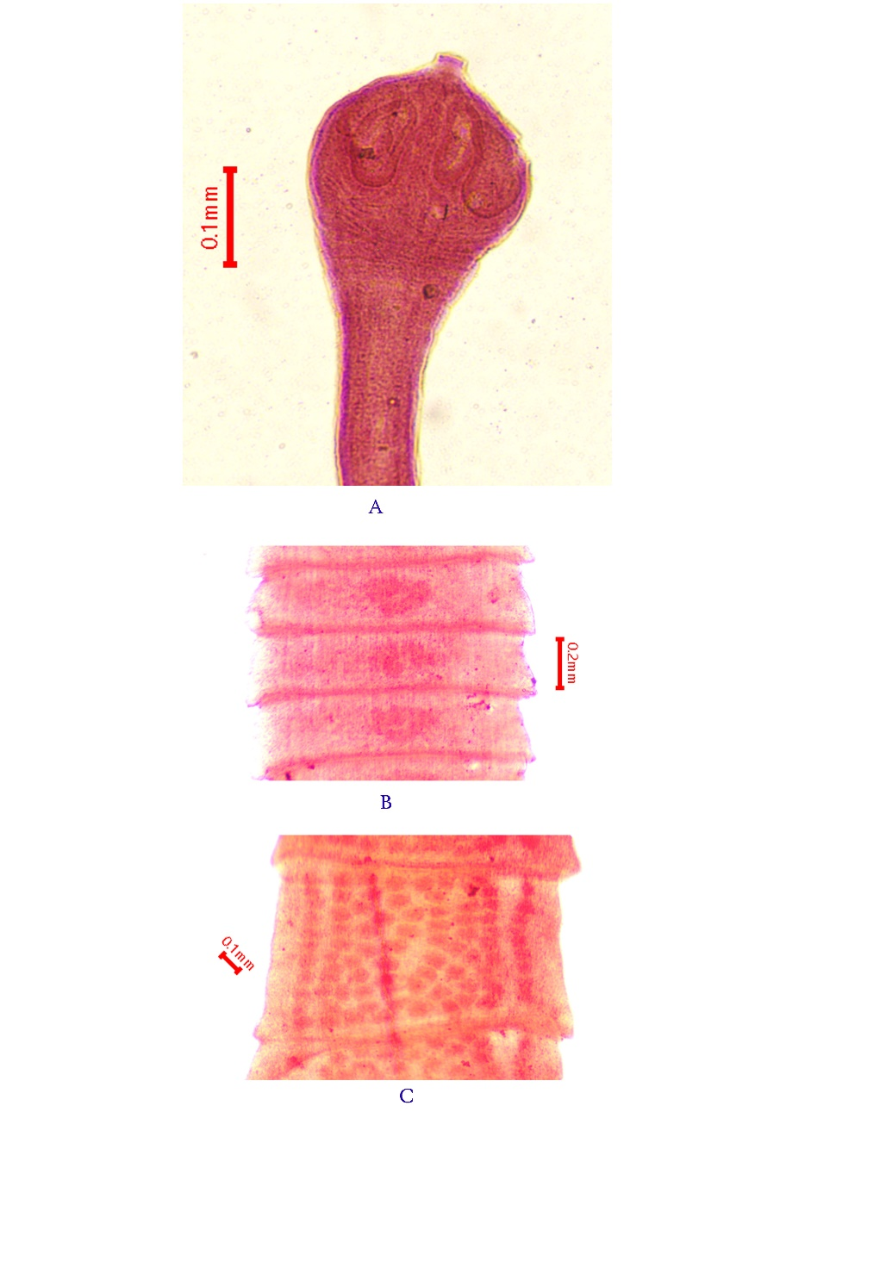
Plate.5: Choanotaenia infundibulum. A; Anterior part (scolex), B; Mature proglottid, C; Gravid segment.

5. AMOEBOTAENIA CUNEATA (Linstow, 1872):
Generic characters:
The adult worm is flattened, segmented, and ribbon-like, but much shorter than large poultry cestodes and measuring 3.5-4.5 mm. The strobila is composed of a few proglottids and the proglottids are usually wider than long. The scolex bears four suckers with armed. The rostellum carries a single row of hooks and the suckers are unarmed. The genital pores are usually irregularly alternating and are situated near the anterior margin of the proglottids. Mature proglottids contain a single set of genital organs, and the uterus is sac-like, slightly lobed. The eggs contain the hexacanth embryo. Development is indirect and involves an invertebrate intermediate host. Earthworms are the main intermediate hosts. (Meggitt, 1914; Monnig, 1926; Parasitipedia, 2021).
Description: (10 specimens)
The adult worm is a small, delicate, wedge-shaped tapeworm found attached to the mucosa of the small intestine of domestic chickens. The worm is usually white to translucent and flattened. The adult is about 3-4.5 mm long and about 1 mm wide, with up to about 20 proglottids. The anterior strobila becomes gradually broader, while the last few segments may become smaller again. The scolex is small and carries four unarmed suckers. The rostellum is armed with a single row of 12-14 hooks. Mature proglottids show genital pores that alternate irregularly and are positioned toward the extreme anterior margin. About 12-15 testes are arranged transversely in a single row near the posterior part of mature proglottids. The uterus is sac-like and slightly lobed; the eggs are nearly spherical, about 35 micrometres in diameter, and contain an oncosphere (Figure 8 and Plate 6).
Habitat and locality:
Amoebotaenia cuneata (von Linstow, 1872) has been obtained from the gastrointestinal tract of domestic chickens from Thoubal, Kakching, and Bishnupur districts, Manipur, India. Coll.
Remarks:
Cohn erected the genus Amoebotaenia in 1900, with the type species A. cuneata (von Linstow, 1872) Cohn, 1900. Several species of Amoebotaenia were described by many workers from avian hosts. The Indian checklist recorded nine species under this genus, viz., A. cuneata, A. megascolecis, A. maharashtri, A. indiana, A. cohni, A. kharati, A. domesticus, A. madrasiensis and A. agrawali (Banerjee, n.d.). The species A. cuneata was originally described as Taenia cuneata von Linstow, 1872, and later placed in Amoebotaenia by Cohn. Amoebotaenia sphenoides (Railliet, 1892) Meggitt, 1914 is treated as a synonym of A. cuneata in recent taxonomic catalogues (Dimitrova et al., 2023). The species occurs chiefly in the small intestine or duodenum of domestic fowl and other gallinaceous birds and earthworms act as the intermediate host in its life cycle (Meggitt, 1914; Monnig, 1926; Permin & Hansen, 1998). The morphological characters and dimensions of the present specimens are in agreement with those of A. cuneata (A. sphenoides) described by earlier workers, especially the very small, flattened and wedge-shaped strobila, measuring about 3-4 mm in length and about 1 mm in breadth; scolex with four suckers; armed rostellum bearing 12-14 hooks; short strobila with about 20-25 proglottids; genital pores irregularly alternate and situated near the anterior margin of the proglottid; testes usually 12-20 in number; and uterus sac-like and slightly lobed (Meggitt, 1914; Soulsby, 1982; Permin & Hansen, 1998). Minor variation in size, number of segments and contraction of the strobila may be due to the age of the worm, pressure during fixation, staining and mounting. Hence, based on these diagnostic characters, the present specimen is treated as Amoebotaenia cuneata (von Linstow, 1872) Cohn, 1900.
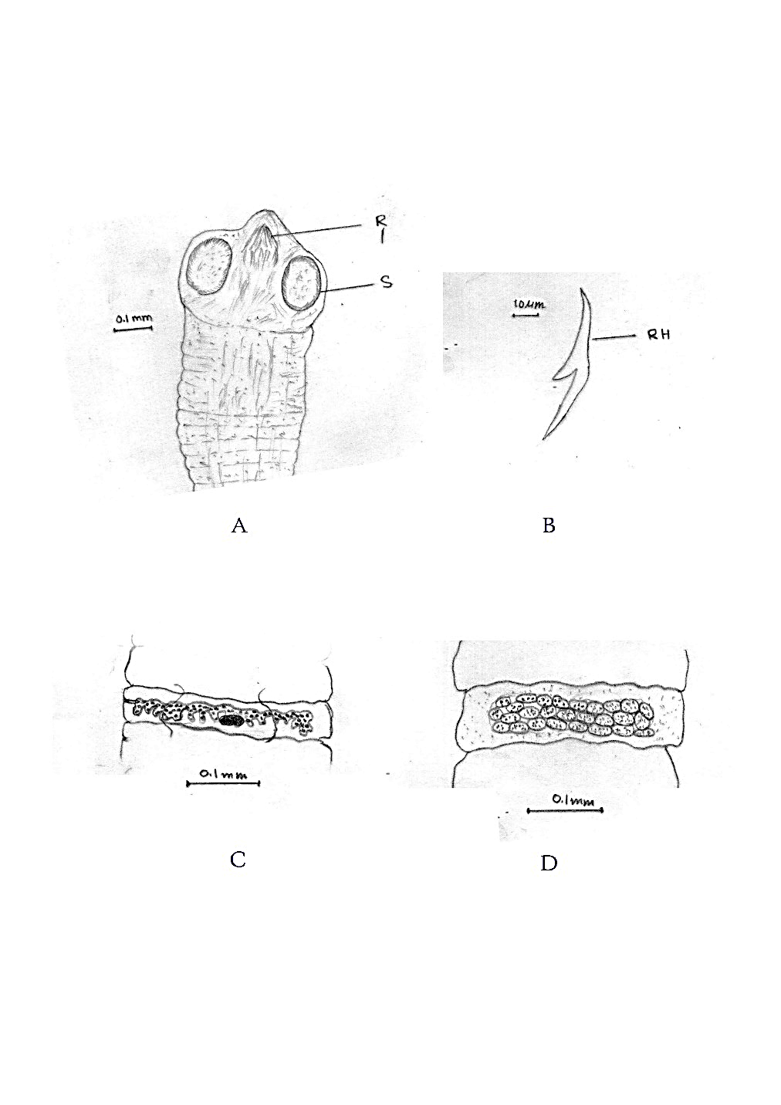
Figure 8: Amoebotaenia cuneata. A; Anterior part (scolex), B; Hook, C; Mature proglottid, D; Gravid segment.

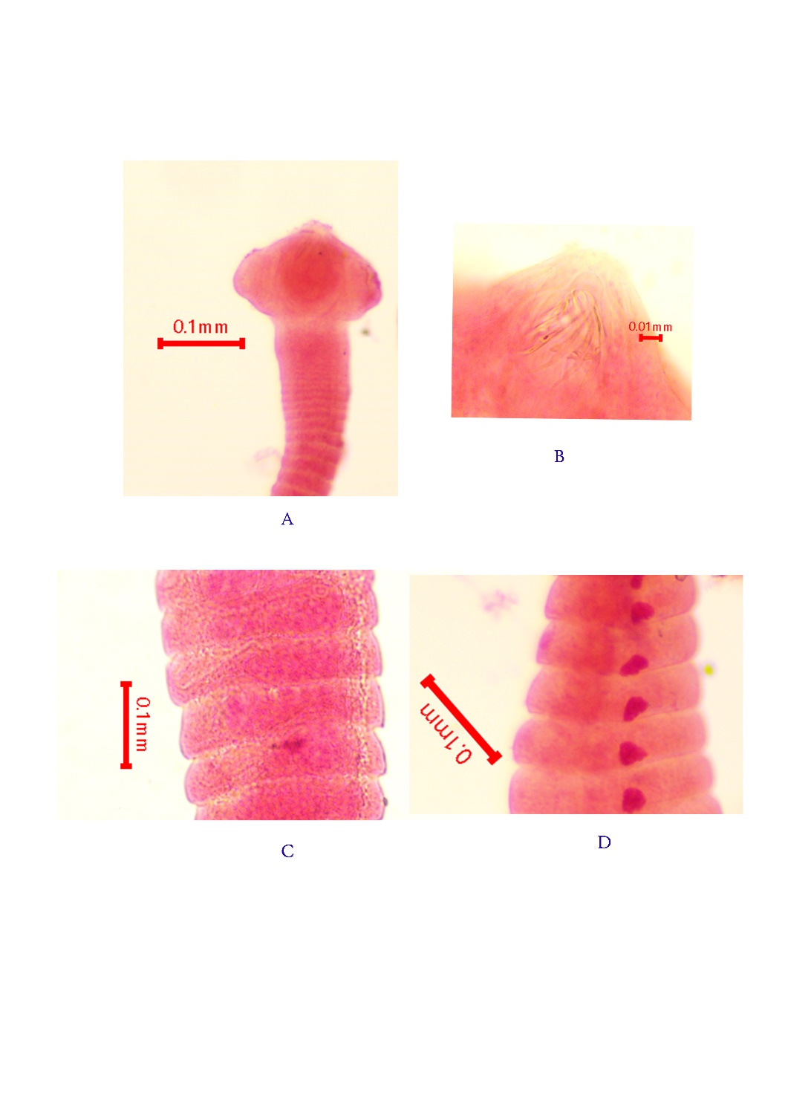
plate 6: Amoebotaenia cuneata. A; Anterior part (scolex), B; rostellum region, C; Mature proglottid, D; Gravid segment.

6. COTUGNIA DIGONOPORA (Pasquale, 1890):
Generic character:
The adult worm is a flattened, segmented strobila with a large scolex bearing four cup-shaped, muscular suckers; an apical rostellum armed with double rows of minute hooks and the highly diagnostic presence of two complete sets of reproductive organs with bilateral genital pores in each mature segment. The body measures 70-120 mm in length, the scolex 0.60 mm in diameter, the rostellum 0.30mm in diameter, rostellar hooks about 0.01 mm long, mature proglottids 2-2.50 x 0.40-0.50 mm and gravid proglottids 3.70 x 1.50 mm. The testes are rounded to oval and distributed in the mature segment. A cirrus pouch is present in each genital complex. The ovary is bilobed and located posterior to the middle region of the proglottid in each genital set. Gravid proglottids are larger than mature proglottids and measure 3.70 x 1.50 mm. In gravid segments, the uterus is replaced by egg capsules. Each egg capsule contains a single egg.
Habitat and locality:
Cotugnia digonopora (Pasquale, 1890) has been obtained from the gastrointestinal tract of domestic chickens from Thoubal, Kakching, and Bishnupur districts, Manipur, India. Coll.
Description: (6 specimens)
The adult strobila is elongated, whitish and tape-like. The total body length is 7–12cm. The body width is not uniform throughout the worm. The scolex is comparatively large and measures 0.55- 0.60 mm in diameter. It bears four well-developed, cup-shaped suckers, each measuring 0.10 × 0.15 mm. A distinct rostellum is present and measures 0.28-0.30 mm in diameter. The rostellum is armed with double rows of very minute hooks. The mature proglottids are rectangular and broader than the anterior neck, with pointed or slightly projecting posterior corners. A mature segment measures 2.50-3 × 0.50-0.55 mm. Each mature proglottid contains two complete sets of genital organs. The testes are small, rounded and measure 0.03-0.04 mm in diameter. The cirrus pouch is small and measures about 0.06 mm in length. Genital pores are positioned on the lateral margin and measure around 0.17 × 0.04 mm. The ovary is bilobed and situated posteriorly in the segment, measuring approximately 0.03 mm in width. The gravid proglottids are larger than the mature proglottids and measure approximately 3.70 × 1.50 mm. Each egg capsule generally contains a single egg measuring around 0.02–0.03 mm in diameter. The excretory canal is also visible in well-stained specimens (Figure 9 and plate7).
Phylogenetic analysis:
The nuclear internal transcribed spacer 2 (ITS2) sequence in FASTA format generated from the study specimen was analysed with reference cestode sequences using the Neighbour-Joining method. According to the information 135 shown in MEGA7 (Figure.8), the optimal tree had a total branch length of 1.73135893. Evolutionary distances were estimated by the Maximum Composite Likelihood method and expressed as the number of base substitutions per site. The analysis included 16 nucleotide sequences; ambiguous sites were removed for each sequence pair, and 2,155 positions were retained in the final dataset. We evaluated branch reliability with 1,000 bootstrap replicates, using the Hymenolepis diminuta sequence as an outgroup (Figure 8).
The study sequence “Cotugnia-ITS2” is recovered as the immediate sister sequence of LC748081.1 Cotugnia digonopora. The node connecting these two sequences has a bootstrap value of 94%, indicating strong and reproducible support for their association. This close placement is the principal molecular evidence for assigning the study specimen to C. digonopora. The short separation between the two terminal branches also indicates comparatively low ITS2 divergence between the study isolate.
Remarks:
The genus Cotugnia was erected by Diamare, 1893, with the type species C. digonopora (Pasquale, 1890) recorded from domestic fowl Gallus gallus domesticus. Several species of Cotugnia were described by many workers, viz. C. polyacantha Fuhrmann 1909, C. cuneata tenuis Meggitt, 1924, C. joyeuxi Baer, 1925, C. parva Baer, 1925, C. taiwanensis Yamaguti, 1935, C. rimandoi Tubangui and Masilungan, 1937, C. columbae Shinde, 1969, C. indiana Kasar et al., 2010 and other allied forms from domestic fowl, pigeons and related birds (Yamaguti, 1959, Kasar et al., 2010, Nanware & Bhure, 2013). The genus is distinguished from other davaineid cestodes by its strobilate body, distinct scolex with four muscular suckers, armed rostellum, numerous rostellar hooks and double sets of reproductive organs in mature proglottids (Yamaguti, 1959; Siddiqi, 1961).
The morphological characters and dimensions of the present specimens agree with those of C. digonopora (Pasquale, 1890; Diamare, 1893 as described by Siddiqi, 1960, 1961), except for minor variation. The rostellar hooks and rostellum are important diagnostic structures (Siddiqi, 1961). Minor variations in body size, scolex measurement, rostellar armature, number of testes and egg-capsule arrangement may occur due to host, maturity and fixation condition. Hence, the present specimen is treated as Cotugnia digonopora.
The ITS2 phylogenetic tree places the study sequence “Cotugnia-ITS2” directly with the reference accession LC748081.1 Cotugnia digonopora. Their relationship is supported by a high bootstrap value of 94%, providing strong evidence that the recovered cestode belongs to C. digonopora. The identification is therefore accepted as Cotugnia digonopora (Pasquale, 1890).
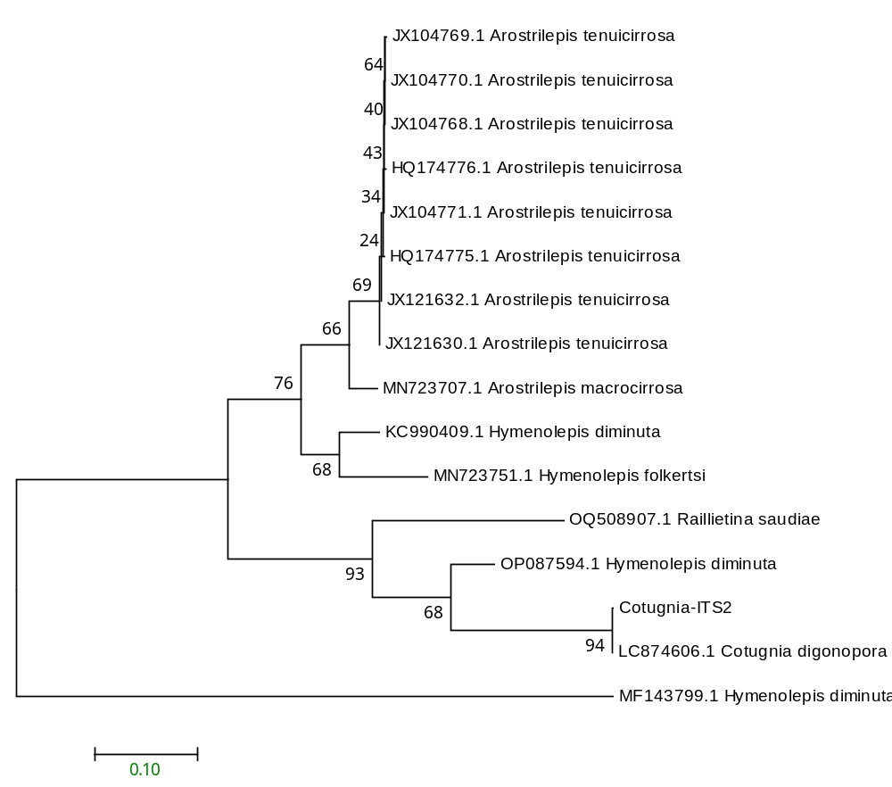
Figure 9: Phylogram of the analysis of Cotugnia digonopora, showing relationships of Hymenolepis diminuta using the neighbour-joining (NJ) tree method and Kimura 2-parameter distances ITS2 sequences. Numbers at nodes indicate bootstrap values by the NJ and ML methods (1000 replicates).
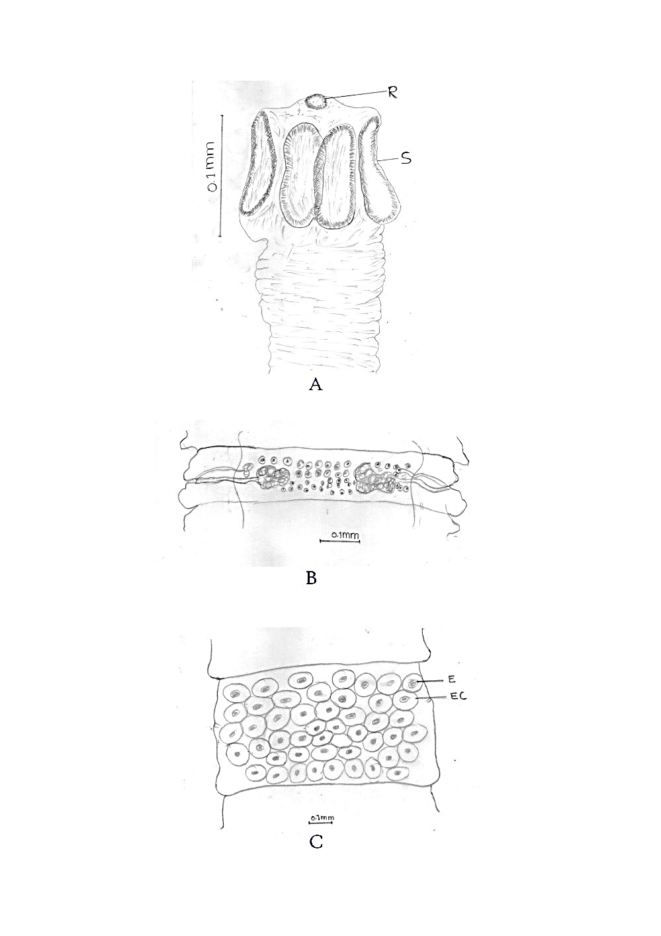
Figure 10: Cotugnia digonopora. A; Anterior part (scolex), B; Mature proglottid, C; Gravid segment.

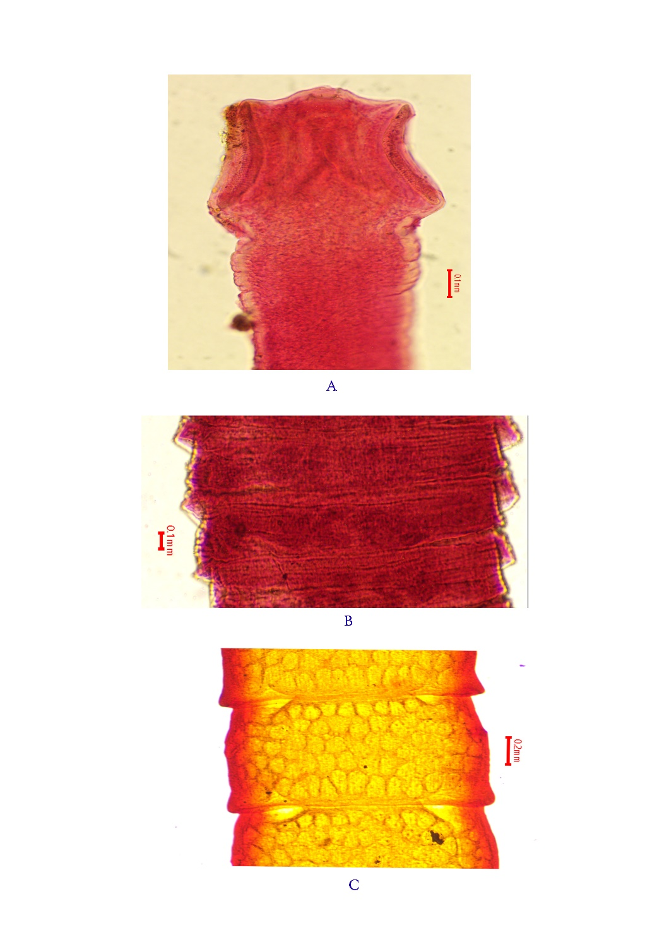
Plate 7: Cotugnia digonopora. A; Anterior part (scolex), B; Mature proglottid, C; Gravid segment.
7. DAVAINIA PROGLOTTINA (Davaine, 1860):
Generic character:
The body is delicate, short, ribbon-like and distinctly segmented into a small number of proglottids. The scolex is small and bears four rounded to oval suckers. A retractile rostellum is present at the anterior end and is armed with minute hooks; the suckers are also armed with small hooklets. The neck region is very short or indistinct, and segmentation begins soon behind the scolex. Proglottids are few in number, with immature, mature and gravid segments arranged in sequence. Each mature proglottid contains a single set of reproductive organs, and the genital pores are situated on the lateral margin. The uterus becomes filled with eggs in the gravid segment, and the eggs contain a typical hexacanth embryo.
Description: (8 specimens)
The adult worm is whitish, delicate and minute, measuring approximately 0.5-3.0 mm in length. The scolex is small and rounded, provided with four muscular suckers and a retractile rostellum. Both the rostellum and suckers are armed. The neck is short, and the strobila is composed of only a few proglottids. 4-6 segments are present, including immature, mature and gravid proglottids with hermaphroditic proglottids. Genital pores are marginal. The gravid segment contains egg capsules, commonly with a single egg in each capsule, and eggs are small, 28-40 micrometres, and contain a hexacanth embryo with hooks (Figure 11 and plate 8).
Habitat and locality:
Echinostoma revolutum (Frohlich, 1802) has been obtained from the gastrointestinal tract of domestic chickens from Thoubal, Kakching, and Bishnupur districts, Manipur, India.
Remarks:
Blanchard erected the genus Davainea in 1891, with D. proglottina (Davaine, 1860) as its type species; it was reported from domestic fowl, Gallus gallus domesticus. The dimensions and morphological characters of the present specimen agree with D. proglottina (Davaine, 1860) Blanchard, 1891, with slight differences in body measurement considered minor variations. Very small and delicate body; short strobila consisting of a few proglottids; globular scolex with four arm suckers; retractile rostellum armed with hooks; irregularly alternating genital pores; and the presence of a gravid segment containing numerous spherical eggs, the specimen is considered Davainea proglottina.
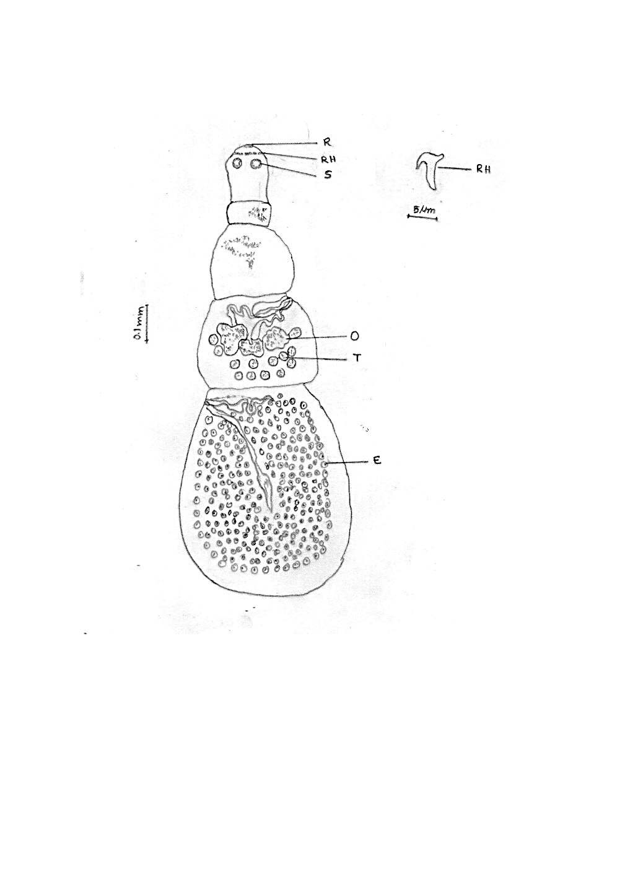
Figure 11: Davainea proglottina. Whole body and hooklet.
R- rostellum, RH- rostellum hook, S- sucker, O- ovary, T- testis, E- egg.

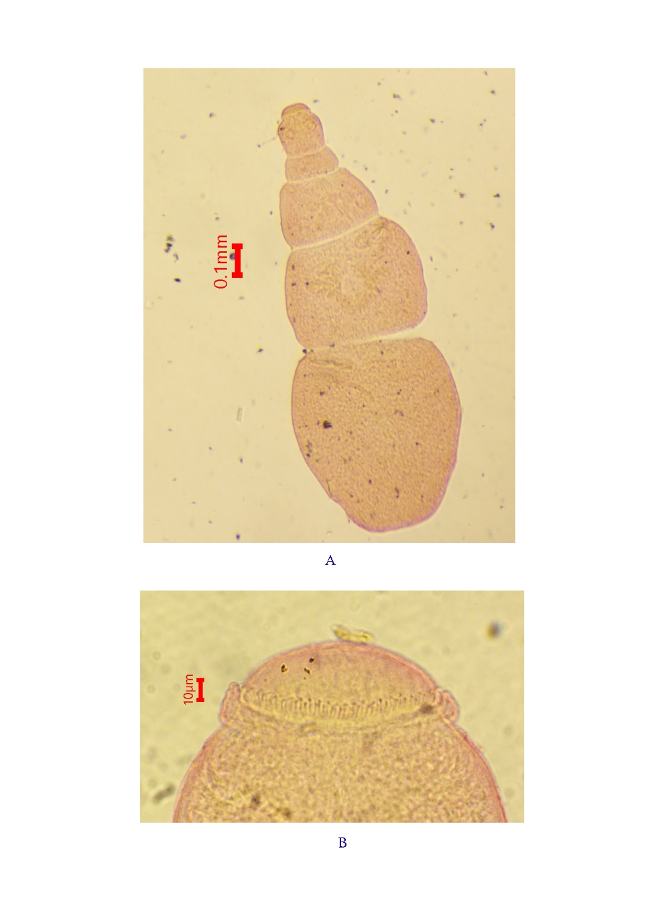
Plate 8: Davainea proglottina. A: whole body; B: anterior region.

Trematodes:
ECHINOSTOMA REVOLUTUM (Frolich, 1802):
Generic character:
The adult body is elongate, leaf-like and dorsoventrally flattened, with the posterior end usually broader than the anterior region. The subterminal oral sucker is surrounded by a conspicuous head collar bearing cuticular spines, while the ventral sucker is larger and situated in the anterior third of the body. A muscular pharynx and short oesophagus lead to two intestinal caeca extending posteriorly. The ovary lies anterior to two tandem testes in the posterior half. Vitelline follicles occupy the lateral fields, and the uterus is short and coiled between the ventral sucker and ovary. Eggs are large, oval and operculate.
Description: (10 specimens)
Echinostoma revolutum is an elongate, leaf-shaped and dorsoventrally flattened digenean trematode. 10 Adult specimens measure 4.0–5.5 mm in length and 1–1.3 mm in width. The anterior end bears a conspicuous muscular head collar surrounding the subterminal oral sucker. The collar has 37 arm spines arranged in two alternating rows. Fine tegumental spines cover the anterior body and gradually decrease posteriorly. The ventral sucker is large, muscular and situated in the anterior third of the body. A short prepharynx, muscular pharynx and oesophagus lead to two intestinal caeca that extend nearly to the posterior extremity. The reproductive organs are post-acetabular. A median, transversely oval ovary lies anterior to two tandem, smooth or weakly lobed testes. Vitelline follicles occupy the lateral fields from the level behind the ventral sucker to the posterior end. The uterus is moderately coiled and contains numerous large, oval, operculated eggs with an egg size of 55-70 × 93-125 μm (Figure 12 and plate 9).
Habitat and locality:
Echinostoma revolutum (Frohlich, 1802) has been obtained from the gastrointestinal tract of domestic chickens from Thoubal, Kakching, and Bishnupur districts, Manipur, India.
Remarks:
Fröhlich originally described the species as Fasciola revoluta in 1802, and Looss later placed it in Echinostoma in 1899. The accepted name is Echinostoma revolutum (Fröhlich, 1802) Looss, 1899. Its most important morphological feature is the head collar with 37 spines, including five angle spines on each side. The morphology and dimensions of the present specimen closely agree with those provided by Mohanta et al. 2019 and Chai et al. (2020), except for slight variation in body length, sucker size, and egg measurements. These differences are considered minor intraspecific variation caused by worm age, contraction during fixation, pressure during mounting, and host/locality effects. Therefore, the present specimen is regarded as Echinostoma revolutum.
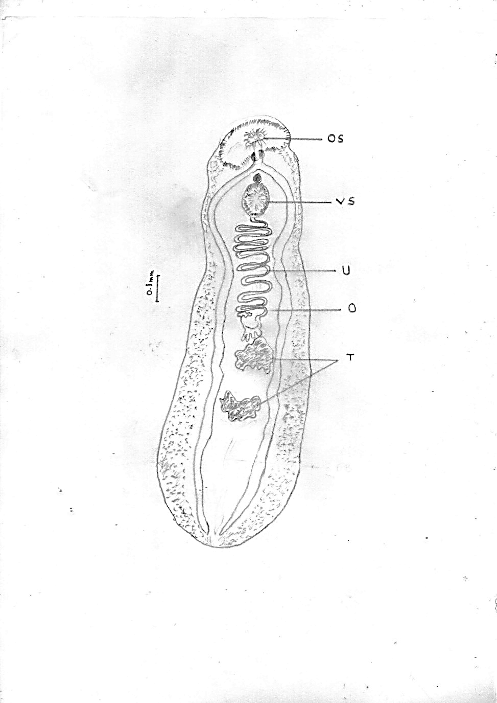
Figure 12: Echinostoma revolutum. OS- oral sucker, VS- ventral sucker, U- uterus, O- ovary, T- testis.

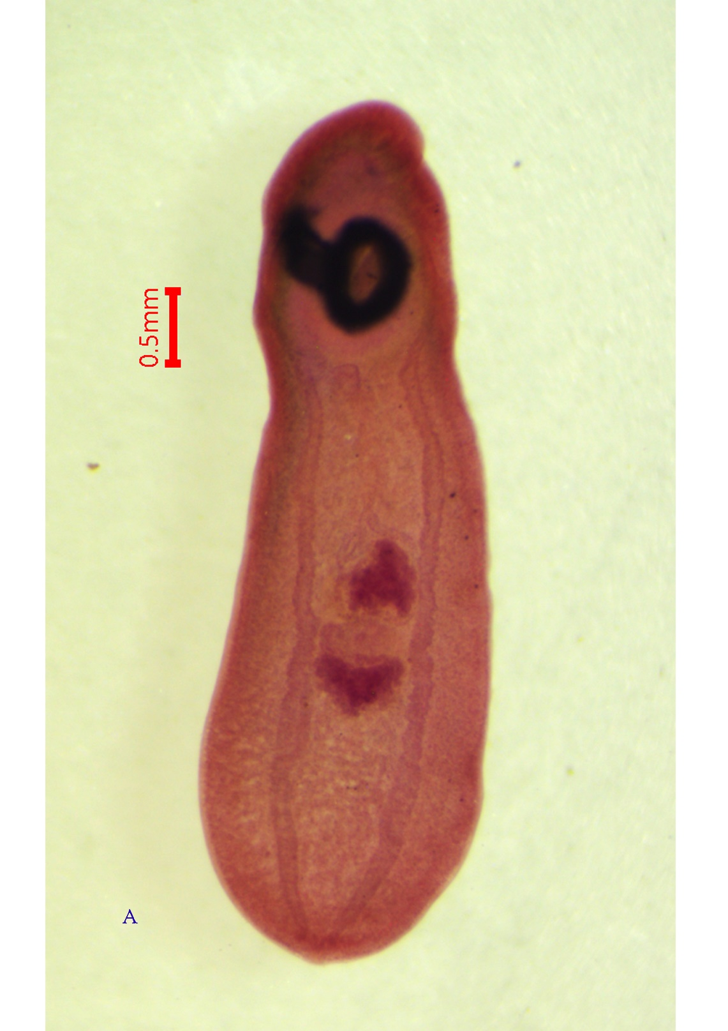
Plate.9: Whole body of Echinostoma revolutum.

Discussion:
In India, although several reports are available on gastrointestinal parasites of country chicken in general, little data is available on the occurrence of multiple or mixed parasitic infections that affect chicken health, cause death, and lead to economic loss. Previous studies have reported the common occurrence of GIH infections in most free-ranging country chickens across different geographical regions of India. In the present study, we noted high prevalence and intensity of GIH parasites in country chickens in our state, Manipur. Country chickens act as hosts to a wide variety of helminth parasites, especially cestode, nematode, and trematode parasites. In the present study, cestode infections were much more common than nematode infections. A similar situation was noted in other studies reported by Hussen et al. (2012), where a prevalence of 83.00% cestodes and 58.00% nematodes was recorded from country chicken, and Ashenafi and Eshetu (2004) recorded a prevalence of 86.32% cestodes and 75.79% nematodes. Trematodes were less in number and showed low prevalences, which might be due to less availability of wet habitats for chickens to ingest molluscs that act as the first-intermediate hosts for the hatched trematode larvae to reproduce asexually to generate free-swimming cercariae. No trematode infections were reported in studies carried out elsewhere by Magwisha et al. (2002) and Jaiswal et al. (2020). No acanthocephalan was observed in the present study, but a few studies previously reported it by Bhalerao (1937), Terregino et al. (1999), Amin et al. (2013), and Yousfi et al. (2013). Variations in infection prevalence across studies, including the present study, may reflect differences in geographical climate, which can limit parasite transmission or survival. However, parasites are more dominant in tropical countries, where climate and environmental conditions favour their survival. However, the high prevalence of GIH infections recorded in country chicken during the present study could be due to their free-ranging habit which allows them free access to infective stages of parasites through coincidental ingestion of arthropods like beetles, earthworms, ants etc. which act as intermediate hosts to most of the helminth parasites while in search of feed (Horsfall, 1938; Todd & Crowdus, 1952; Soulsby, 1982).
Molecular identification is an independent method for confirming poultry helminths when adult specimens are damaged, immature or difficult to distinguish morphologically. Genomic DNA can be extracted from a small portion of the worm while the remaining material is retained as a morphological voucher. Nuclear ribosomal markers, especially 18S rRNA, 28S rRNA and the internal transcribed spacer regions (ITS1 and ITS2) are useful for resolving relationships among nematodes, cestodes, and trematodes. The mitochondrial cytochrome c oxidase subunit I (cox1) gene is particularly valuable for discriminating closely related species and geographic isolates (Blouin, 2002; Nadler & Pérez-Ponce de León, 2011).
Thus, combining morphological and molecular identification is a stronger basis for determining helminth diversity, prevalence, and control priorities. Accurate taxonomy is important because nematodes, cestodes and trematodes differ in life cycle, pathogenicity, intermediate-host requirement and response to control measures. This integrated diagnostic approach is therefore suitable for producing reliable baseline data on gastrointestinal helminths of domestic chickens in Manipur, India.
Conclusion:
Examination of 308 gastrointestinal samples from domestic chickens collected in Thoubal, Bishnupur and Kakching districts identified nine helminth species comprising one nematode, seven cestodes and one trematode. The recovered taxa were Heterakis gallinarum, Raillietina tetragona, R. echinobothrida, R. cesticillus, Choanotaenia infundibulum, Amoebotaenia cuneata, Cotugnia digonopora, Davainea proglottina and Echinostoma revolutum. Morphological examination provided the principal basis for identification, while molecular analyses of selected specimens offered additional taxonomic support. The observed diversity indicates that backyard chickens in the studied districts harbour several gastrointestinal helminth taxa. Further systematic investigations incorporating quantitative epidemiological data and broader molecular characterization would improve understanding of their distribution and importance in poultry production.

Declaration of AI Use

This manuscript was prepared through the intellectual contributions of the author(s) to the study design, data analysis, interpretation of results, and scholarly content. Grammarly and ChatGPT were used solely to assist with grammatical refinement and reference formatting during manuscript revision. The author(s) accept full responsibility for the accuracy, integrity, and final content of the manuscript.

COMPETING INTERESTS DISCLAIMER:
Authors have declared that they have no known competing financial interests OR non-financial interests OR personal relationships that could have appeared to influence the work reported in this paper.

References

- FAO (Food and Agricultural Organization of the United Nations), Report on the expert consultation on rural poultry development in Asia, Dhaka, Bangladesh, March 1987, no. 274415, FAO, Rome, Italy.
- Nnadi, P. A., George, S. O., A Cross-Sectional Survey on Parasites of Chickens in Selected Villages in the Subhumid Zones of South-Eastern Nigeria, Journal of Parasitology Research, 2010, 141824, 6 pages, 2010. https://doi.org/10.1155/2010/141824
- Alders, R. G. (2004). Poultry for profit and pleasure (FAO Diversification Booklet No. 3). Food and Agriculture Organization of the United Nations. ISBN 978-92-5-105075-0.
- Moges, F., Mellesse, A., & Dessie, T. (2010). Assessment of village chicken production system and evaluation of the productive and reproductive performance of local chicken ecotype in Bure district, North West Ethiopia. African Journal of Agricultural Research, 5(13), 1739–1748. https://doi.org/10.5897/AJAR09.690
- Shane, S. M. (2005). Re-emergence of necrotic enteritis in the broiler industry. International Journal of Poultry Science, 4(9), 604–611. https://doi.org/10.3923/ijps.2005.604.611
- Aberra M (2000). Comparative studies on performance and physiological responses of Ethiopian local ('Angete-melata') chicken and their F1 crosses to long term heat stress. PhD thesis. Martin-Luther University, Halle-Wittenberg, Berlin, Germany. 182 pp.
- Abebe, W., Asfaw, T., Genete, B., Kassa, B., & Dorchies, P. H. (1997). Comparative studies of external parasites and gastro-intestinal helminths of chickens kept under different management systems in and around Addis Ababa (Ethiopia). Revue de Médecine Vétérinaire, 148(6), 497–500.
- Eshetu, Y., Mulualem, E., Ibrahim, H. M., Berhanu, A., & Aberra, K. (2001). Study of gastro-intestinal helminths of scavenging chickens in four rural districts of Amhara region, Ethiopia. Revue Scientifique et Technique, 20(3), 791–796. https://doi.org/10.20506/rst.20.3.1310
- Fatihu, M. Y., Ogbogu, V. C., Njoku, C. O., & Saror, D. I. (1991). Comparative studies of gastrointestinal helminths of poultry in Zaria, Nigeria. Revue d’Élevage et de Médecine Vétérinaire des Pays Tropicaux, 44(2), 175–177. https://doi.org/10.19182/remvt.9195
- Adang, K. L., Oniye, S. J., Ajanusi, O. J., Ezealor, A. U., & Abdu, P. A. (2008). Gastrointestinal helminths of the domestic pigeon (Columba livia domestica Gmelin, 1789; Aves: Columbidae) in Zaria, Northern Nigeria. Science World Journal, 3(1), 33–37
- Oniye, S. J., Audu, P. A., Adebote, D. A., Kwaghe, B. B., Ajanusi, O. J., & Nfor, M. B. (2000). Survey of helminth parasites of laughing dove (Streptopelia senegalensis) in Zaria, Nigeria. African Journal of Natural Sciences, 4, 65–66.
- Yousuf, M. A., Das, P. M., Anisuzzaman, M., & Banowary, B. (2009). Gastro-intestinal helminths of ducks: Some epidemiologic and pathologic aspects. Journal of the Bangladesh Agricultural University, 7(1), 91–97. https://doi.org/10.3329/jbau.v7i1.4969.
- Soulsby, E. J. L. (1982). Helminths, arthropods and protozoa of domesticated animals (7th ed.).
- Matur, B. M., Dawam, N. N., & Malann, Y. D. (2010). Gastrointestinal helminth parasites of local and exotic chickens slaughtered in Gwagwalada, Abuja (FCT), Nigeria. New York Science Journal, 3(5), 96–99. https://doi.org/10.7537/marsnys030510.15
- Anderson, R. C., Chabaud, A. G., & Willmott, S. (Eds.). (2009). Keys to the nematode parasites of vertebrates: Archival volume.
- Taylor, M. A., Coop, R. L., & Wall, R. L. (2016). Veterinary parasitology (4th ed.). Wiley-Blackwell. https://doi.org/10.1002/9781119073680
- Yamaguti, S. (1958). Systema helminthum: Vol. I. The digenetic trematodes of vertebrates (Parts I & II). Interscience Publishers.
- Yamaguti, S. (1959). Systema helminthum: Vol. II. The cestodes of vertebrates. Interscience Publishers.
- Khalil, L. F., Jones, A., & Bray, R. A. (Eds.). (1994). Keys to the cestode parasites of vertebrates. CAB International.
- Tamura, K., Stecher, G., & Kumar, S. (2021). MEGA11: Molecular Evolutionary Genetics Analysis version 11. Molecular Biology and Evolution, 38(7), 3022–3027. https://doi.org/10.1093/molbev/msab120
- Madsen, H. (1949). Heterakis gallinarum (Schrank, 1788) nec Heterakis gallinae (Gmelin, 1790). The Journal of Parasitology, 35(5), 543. https://doi.org/10.2307/3273660
- Ara, I., Khan, H. R., Tanveer, S., & Fatima, N. I. (2024). Morphological and molecular identification of Heterakis gallinarum in Gallus gallus and its phylogenetic analysis based on ITS1-5.8S-ITS2 rDNA fragment in Kashmir Valley, India. Journal of Parasitic Diseases, 48(4), 904–916. https://doi.org/10.1007/s12639-024-01724-9
- amaguti, S. (1961). Systema helminthum: Vol. III. The nematodes of vertebrates (Parts I & II). Interscience Publishers.
- Panich, W., & Chontananarth, T. (2021). Molecular detection of three intestinal cestode species (Raillietina echinobothrida, R. tetragona, and R. cesticillus) from poultry in Thailand. Avian Pathology, 50(4), 321–326. https://doi.org/10.1080/03079457.2021.1926920
- Butboonchoo, P., Wongsawad, C., Rojanapaibul, A., & Chai, J.-Y. (2016). Morphology and molecular phylogeny of Raillietina spp. (Cestoda: Cyclophyllidea: Davaineidae) from domestic chickens in Thailand. The Korean Journal of Parasitology, 54(6), 777–786. https://doi.org/10.3347/kjp.2016.54.6.777
- Saitou, N., & Nei, M. (1987). The neighbor-joining method: A new method for reconstructing phylogenetic trees. Molecular Biology and Evolution, 4(4), 406–425. https://doi.org/10.1093/oxfordjournals.molbev.a040454
- Tamura, K., Nei, M., & Kumar, S. (2004). Prospects for inferring very large phylogenies by using the neighbor-joining method. Proceedings of the National Academy of Sciences of the United States of America, 101(30), 11030–11035. https://doi.org/10.1073/pnas.0404206101
- Kumar, S., Stecher, G., & Tamura, K. (2016). MEGA7: Molecular Evolutionary Genetics Analysis version 7.0 for bigger datasets. Molecular Biology and Evolution, 33(7), 1870–1874. https://doi.org/10.1093/molbev/msw054
- Kerroucha, R., Medjoual, I., Bourguig, L., & Senouci, K. (2022). Identification of the main intestinal helminths of local breed chickens (Gallus gallus domesticus Linnaeus, 1758) reared in traditional mode in the Oran region. Helminthologia, 59(2), 170–178. https://doi.org/10.2478/helm-2022-0015
- Railliet, A. (1892). Notices parasitologiques. Bulletin de la Société zoologique de France, 17, 110–117.
- Dimitrova, Y. D., Vasileva, G. P., Mariaux, J., & Georgiev, B. B. (2023). Two and a half centuries after Houttuyn: A review of avian cestodes (Platyhelminthes: Cestoda) from Africa. Diversity, 15(5), 634. https://doi.org/10.3390/d15050634
- Meggitt, F. J. (1914). On the anatomy of a fowl tapeworm, Amoebotaenia sphenoides v. Lins. Parasitology, 7, 262–277.
- Monnig, H. O. (1926). The anatomy and life history of the fowl tapeworm (Amoebotaenia sphenoides). 11th and 12th Reports of the Director of Veterinary Education and Research, Part 1, 199–206. Pretoria: Government Printer and Stationery Office.
- Permin, A., & Hansen, J. W. (1998). Epidemiology, diagnosis and control of poultry parasites. FAO Animal Health Manual No. 4. Food and Agriculture Organization of the United Nations, Rome.
- Fuhrmann, O. (1909). Die Cestoden der Vögel. Zoologische Jahrbücher, Supplementheft, 10, 2–233. Gustav Fischer, Jena.
- Meggitt, F. J. (1924). On two species of Cestoda from a mongoose. Parasitology, 16(1), 48–54. https://doi.org/10.1017/S0031182000019867
- Baer, J. G. (1925). Quelques cestodes d’oiseaux nouveaux et peu connus. Bulletin de la Société Neuchâteloise des Sciences Naturelles, 49, 138–154.
- Tubangui, M. A., & Masilungan, V. A. (1937). Tapeworm parasites of Philippine birds. The Philippine Journal of Science, 62(4), 409–438.
- Shinde, G. B. (1969). A known and two new species of the genus Cotugnia Diamare, 1893 from the Columbiformes birds in Maharashtra, India. Rivista di Parassitologia, 30, 39–44.
- Kasar, C. R., Bhure, D. B., Nanware, S. S., & Sonune, M. B. (2010). Taxonomic observation of Cotugnia indiana sp. nov. (Cestoda: Davaineidae, Fuhrmann, 1907) from Columba livia. Asian Journal of Animal Science, 5(2), 193–198.
- Nanware, S. S., & Bhure, D. B. (2013). Studies on avian cestode genus Cotugnia Diamare, 1893 (Cestoda: Davaineidae, Fuhrmann, 1907) from Gallus gallus domesticus. Asian Journal of Bio Science, 8(1), 120–128.
- Siddiqi, A. H. (1961). Studies on the morphology of Cotugnia digonopora Pasquale, 1890 (Cestoda: Davaineidae). III. Hooks and rostellum. Zeitschrift für Parasitenkunde, 21(1), 88–92. https://doi.org/10.1007/BF00260179
- Davaine, C. J. (1860). Traité des entozoaires et des maladies vermineuses de l'homme et des animaux domestiques. Paris: J.-B. Baillière et fils. 838 pp.
- Fröhlich, J. A. (1802). Beyträge zur Naturgeschichte der Eingeweidewürmer. Der Naturforscher, 29, 5–96.
- Mohanta, U. K., Watanabe, T., Anisuzzaman, M., Ohari, Y., & Itagaki, T. (2019). Characterization of Echinostoma revolutum and Echinostoma robustum from ducks in Bangladesh based on morphology, nuclear ribosomal ITS2 and mitochondrial nad1 sequences. Parasitology International, 69, 1–7. https://doi.org/10.1016/j.parint.2018.11.002
- Chai, J.-Y., Cho, J., Chang, T., Jung, B.-K., & Sohn, W.-M. (2020). Taxonomy of Echinostoma revolutum and 37-collar-spined Echinostoma spp.: A historical review. The Korean Journal of Parasitology, 58(4), 343–371. https://doi.org/10.3347/kjp.2020.58.4.343
- Hussen, H., Chaka, H., Deneke, Y., & Bitew, M. (2012). Gastrointestinal helminths are highly prevalent in scavenging chickens of selected districts of Eastern Shewa Zone, Ethiopia. Pakistan Journal of Biological Sciences, 15(6), 284–289. https://doi.org/10.3923/pjbs.2012.284.289
- Ashenafi, H., & Eshetu, Y. (2004). Study on gastrointestinal helminths of local chickens in central Ethiopia. Revue de Médecine Vétérinaire, 155(10), 504–507.
- Magwisha, H. B., Kassuku, A. A., Kyvsgaard, N. C., & Permin, A. (2002). A comparison of the prevalence and burdens of helminth infections in growers and adult free-range chickens. Tropical Animal Health and Production, 34(3), 205–214. https://doi.org/10.1023/A:1015278524559
- Jaiswal, K., Mishra, S., & Bee, A. (2020). Prevalence of gastrointestinal helminth parasites in Gallus gallus domesticus in Lucknow, U.P., India. Advances in Zoology and Botany, 8(5), 422–430. https://doi.org/10.13189/azb.2020.080506
- Bhalerao, G. D. (1937). On a remarkable Acanthocephala from a fowl in India. Proceedings of the Zoological Society of London, Series B, 107(2), 199–203. https://doi.org/10.1111/j.1096-3642.1937.tb00002.x
- Terregino, C., Catelli, E., Poglayen, G., Tonelli, A., & Gadale, O. I. (1999). Etude préliminaire des helminthes du tube digestif du poulet en Somalie. Revue d’élevage et de médecine vétérinaire des pays tropicaux, 52(2), 107–112. https://doi.org/10.19182/remvt.9682
- Amin, O. M., Heckmann, R. A., Sahara, A., & Yudhanto, S. (2013). The finding of Mediorhynchus gallinarum (Acanthocephala: Gigantorhynchidae) in chickens from Indonesia, with expanded description using SEM. Comparative Parasitology, 80(1), 39–46. https://doi.org/10.1654/4562.1
- Yousfi, F., Senouci, K., Medjoual, I., Djellil, H., & Slimane, T. H. (2013). Gastrointestinal helminths in the local chicken Gallus gallus domesticus (Linnaeus, 1758) in traditional breeding of North-Western Algeria. Biodiversity Journal, 4(1), 229–234.
- Horsfall, M. W. (1938). Observations on the life history of Raillietina echinobothrida and of Raillietina tetragona (Cestoda). The Journal of Parasitology, 24(5), 409–421. https://doi.org/10.2307/3272117
- Todd, A. C., & Crowdus, D. H. (1952). On the life history of Ascaridia galli. Transactions of the American Microscopical Society, 71(3), 282–287. https://doi.org/10.2307/3223380
- Blouin, M. S. (2002). Molecular prospecting for cryptic species of nematodes: Mitochondrial DNA versus internal transcribed spacer. International Journal for Parasitology, 32(5), 527–531. https://doi.org/10.1016/S0020-7519(01)00357-5
- Nadler, S. A., & Pérez-Ponce de León, G. (2011). Integrating molecular and morphological approaches for characterizing parasite cryptic species: Implications for parasitology. Parasitology, 138(13), 1688–1709. https://doi.org/10.1017/S003118201000168X
- Adang KL, Oniye SL, Ajanusi OJ, Ezealor AU, Abdu PA (2008). Gastrointestinal helminths of the domestic pigeons (Columba livia domestica, Gmelin 1789 Aves: Columbidae) in Zaria, Northern Nigeria. Sci World J. https:// doi. org/ 10. 4314/ swj. v3i1. 51769
- Amin OM, Heckmann RA, Sahara A, Yudhanto S (2013). The finding of Mediorhynchus gallinarum (Acanthocephala: Gigantorhynchidae) in chickens from Indonesia, with expanded description using SEM. Comp Parasitol 80(1):39–46
- Ashenafi H, Eshetu Y (2004). Study on gastrointestinal helminths of local chicken in central Ethiopia. Revue De Médecine Vétérinaire 155(10):504–507.
- Bhalerao GD (1937). On a remarkable acanthocephala from a fowl in India. Proc Zool Soc Lond 107(2):199–203
- Horsfall MW (1938) Observations on the life history of Raillietina echinobothrida and of R tetragona (Cestoda). J Parasitol 24(5):409–421
- Hussen H, Chaka H, Deneke Y, Bitew M (2012). Gastrointestinal helminths are highly prevalent in scavenging chickens of selected districts of Eastern Shewa zone, Ethopia. Pak J Biol Sci 15(6):284–289
- Jaiswal K, Mishra S, Bee A (2020). Prevalence of gastrointestinal helminth parasites in Gallus gallus domesticus in Lucknow, UP, India. Adv Zool Botany. https:// doi. org/ 10. 13189/ azb. 2020. 080506
- Magwisha HB, Kassuku AA, Kyvsgaard NC, Permin A (2002) A comparison of the prevalence and burdens of helminth infections in growers and adult free-range chicken. Trop Anim Health Prod 34(3):205–214
- Permin A, Hansen JW (1998). Epidemiology diagnosis and control of poultry parasites. Food and Agricultural Organization of the United Nations Rome FAO Anim.
- Soulsby EJL (1982) Helminths, arthropods and protozoa of domesticated animals, 7th edn. Bailliere and Tindall, London
- Terregino C, Catelli E, Poglayen G, Tonelli A, Gadale OI (1999). Preliminary study of the helminths of the chicken digestive tract in Somalia. Revue Élev Méd Vét Pays Trop 52(2):107–112
- Todd AC, Crowdus DH (1952). On the life history of Ascaridia galli.Trans Am Microsc Soc 71(3):282–287
- Yousfi F, Senouci K, Medjoual I, Djellil H, Slimane TH (2013). Gastrointestinal helminths in the local chicken Gallus gallus domesticus (Linnaeus, 1758) in traditional breeding of North-Western Algeria.Biodivers J 4(1):229–234

