Original Research article
BIOLOGICAL CONTROL POTENTIAL OF NESOLYNX THYMUS (GIRAULT) AGAINST UZI FLY INFESTING MUGA SILKWORM, Antheraea assamensis HELFER

ABSTRACT
Aims
The present study was undertaken to evaluate the biological control potential of Nesolynx thymus (Girault) against Uzi fly, an important parasitoid-associated with of Muga silkworm, Antheraea assamensis Helfer. Particular emphasis was given to the effect of host age and host density on parasitization by Nesolynx thymus.
Study Design
The study comprised laboratory evaluation of the interaction between N. thymus and uzi fly using Muga silkworm-associated Uzi fly populations. Different host ages and host densities were evaluated to determine their influence on parasitisation and parasitoid performance.
Place and Duration of Study
The study was conducted at Department od Sericulture, College of Agriculture, Assam Agricultural University, Jorhat, Assam, during 2022 to 2023.
Methodology
Uzi fly-infested Muga silkworms were maintained under laboratory conditions, and they emerged pupae of uzi fly were exposed to N. thymus under predetermined experimental conditions. The observations included host-age preference, percentage parasitization, parasitoid emergence etc. The observations were summarized using mean values.
Results
The parasitization response of N. thymus varied among the host ages evaluated. The highest mean parasitization of 86% was recorded on 1-day old pupae, whereas the lowest value of 14% was observed on 5-days old pupae of uzi fly. Variation in parasitization was also observed in response to host density, with the highest value of 71% under 3:15 parasitoid: host ratio. Also increased in progeny production was seen with increase in host density.
Conclusion
The findings indicate that N. thymus has potential as a biological control agent against uzi fly associated with Muga silkworm. Identification of suitable host stages and appropriate parasitoid–host combinations may assist in developing an effective biological control strategy for Uzi fly management.
Keywords: Muga silkworm; Antheraea assamensis; Uzi fly; Nesolynx thymus; parasitoid; biological control; parasitization

- INTRODUCTION
The muga silk which comes from the semi-domesticated silkworm Antheraea assamensis Helfer is a unique type of natural silk found mainly in the northeastern part of India. Unlike fully indoor-based silkworms, muga silkworm production occurs outside and therefore the insects are exposed to both biotic and abiotic stress factors. Pests and diseases form some of the major biotic factors that have caused immense losses to silkworm rearers commercially (Sharma et al., 2025; Neog et al., 2015; Borpuzari et al., 2022).
The Uzi fly is a tachinid dipteran insect and one of the major pests of muga silkworm. The adult female deposits her eggs on the silkworm body. Once the maggot hatches, it bores straight into the larva through the integument, leaving a dark scar at the site of penetration which is the most efficient way to determine that a silkworm has been attacked (Sut et al., 2024). Inside the host, the maggot lives as an endoparasite and does serious harm. Muga farmers see the result in the field as weak larvae, early deaths and damaged cocoons (Brahma et al., 2023). The fly is not equally infest muga silkworm throughout the year, because weather and rearing season matter a great deal. In a study over six muga crop seasons, infestation occurred all year round, but it peaked at 89.3% in the Chotua crop (Feb–Mar) and 61.4% in the Jarua crop (Dec–Jan), starting as early as the third instar. In the warmer Aherua and Bhodia crops it dropped to only about 4–5% and was seen only in fifth-instar larvae. Low temperature and high humidity were both positively and significantly linked to infestation (Das & Das, 2016).
Management of Uzi fly in Muga sericulture has involved different approaches, including cultural, mechanical & biological measures. Chemical methods are not ideal since the silkworms are very sensitive towards chemical. However, biological control is of particular interest in sericulture due to it’s sustainable & environment friendly nature and they don’t cause any harm to silkworms. Parasitoids that naturally attack Uzi fly may therefore provide opportunities for developing more sustainable management approaches. Nesolynx thymus (Girault) is a parasitoid associated with Uzi fly and has attracted attention as a potential biological control agent. The effectiveness of a parasitoid, however, depends on several biological characteristics, including host suitability, host age, host density, parasitoid density, parasitization efficiency, successful emergence of progeny and host-searching behaviour. Identification of suitable host stages and conditions favouring successful parasitization is particularly important when considering the parasitoid for biological control programmes (Reddy, 2011; Choudhury et al., 2014; Senthoorraja et al., 2020; Naan et al., 2024).
Although N. thymus has been investigated in relation to Uzi fly management, information concerning its performance against Uzi fly associated specifically with Muga silkworm and the relationship between host characteristics, parasitoid density and parasitization behaviour requires further investigation. Understanding host preference and parasitoid behaviour can contribute to the selection of appropriate conditions for parasitoid multiplication and potential field deployment. Therefore, the present study was undertaken to evaluate the biological control potential of N. thymus against uzi fly associated with Muga silkworm, with particular emphasis on host preference, parasitization efficiency, parasitoid emergence etc. The study also aimed to identify conditions associated with comparatively higher parasitization that could provide a basis for future development of N. thymus-based management of Uzi fly in Muga sericulture.
- MATERIALS AND METHODS
  - Study site and experimental period
The study was conducted at Department of Sericulture, Assam Agricultural University, Jorhat, Assam, India, during 2022 to 2023. The experiment was conducted in laboratory condition while maintaining the room temperature in the laboratory. Newly emerged maggots were kept in containers with soil in it for the maggots to go pupation.
  - Experimental insects
    - Muga silkworm
Muga silkworm, Antheraea assamensis Helfer, eggs were obtained from Govt. Sericulture Farm, Titabar. After hatching the silkworms were reared on som plant (Persea bombycina). The larval stage used for the present study was third instar silkworms. The third instar muga silkworms were artificially infested with uzi fly that were maintained in the laboratory of Department of Sericulture, Assam Agricultural University, Jorhat, Assam.
    - Uzi fly & Nesolynx thymus
Uzi flies were obtained from previously done rearing batches. Under natural rearing conditions without the covering of the silkworm rearing trees with nylon net, uzi fly generally attacks the silkworms. These infested silkworms were then collected and reared under laboratory condition to collect the uzi fly that are infesting them. After maggots of uzi fly matures, they come out of their host silkworm bodies to pupate in nearby cracks and crevices or nearby soil. The uzi flies were collected exactly when the came out of the silkworms to pupate. The Nesolynx thymus adults were obtained from Central Muga Eri Research & Training Institute, Lahdoigarh, CSB, and they were maintained for further experimental procedure under laboratory condition.
  - Evaluation of host-age preference on parasitization by N. thymus
To determine the influence of host age on parasitization, uzi fly pupae of different age collected from infested muga silkworm were exposed separately to N. thymus. Six treatments were selected for the experiment viz. uzi fly pupae of 0-day old age to 5-day old age. For each treatment, 10 number of pupae were taken with 5 replications in each treatment, and 5 numbers of adult mated female N. thymus were exposed to host pupae for 3 days. After exposure, the hosts were maintained under the separate boxes individually and observed for evidence of parasitization and subsequent parasitoid emergence. The number of hosts parasitized was recorded for each treatment.
  - Evaluation of host density on parasitization by N. thymus
The effect of host density on parasitization was evaluated by exposing different numbers of uzi fly pupae collected from infested muga silkworm to N. thymus according to the experimental treatments. 3 numbers of mated adult female N. thymus were exposed to each treatment group. The parasitoid-to-host ratios of 3:5, 3:10 & 3:15 were evaluated. Each treatment containing 1-day old pupa of uzi fly at different density was maintained for 3 days and replicated 3 times. After 3 days of exposure, the pupae were then stored at different glass vials to evaluate the parasitization %.
  - Determination of parasitization percentage
Parasitization was determined based on the given formula:
$$\text{Parasitization (\%)}=\frac{\text{Number of parasitized hosts}}{\text{Total number of hosts exposed}}×100$$
  - Data analysis
The observations obtained from the experimental treatments were summarized using arithmetic means to describe differences in parasitization%.
- RESULTS AND DISCUSSION
  - Host-age preference on parasitization by Nesolynx thymus
The parasitization response of N. thymus differed among the Uzi fly host ages that were evaluated. The highest parasitization of 86 % was recorded when N. thymus was exposed to 1-day old pupae of uzi fly, followed by 0-day old pupa with a mean parasitization of 74%. The lowest mean parasitization (14%) was observed in 5 days old pupa.
Table 1: Parasitization % of Muga silkworm uzi fly pupa by N. thymus based on host age.
Pupal age (days) | Mean* ± SEM | Parasitization (%)
0 | 7.40 ± 0.78 | 74
1 | 8.60 ± 0.48 | 86
2 | 5.80 ± 0.73 | 58
3 | 5.40 ± 0.99 | 54
4 | 2.80 ± 0.96 | 28
5 | 1.40 ± 0.78 | 14
*Mean of 5 replications with 10 numbers of pupa in each treatment
These observations indicate the host age more preferred by the parasitoid. The different host age influences the suitability of the uzi fly pupa for parasitization by N. thymus. This differences in host suitability and decreased preference of parasitoid for aged pupae may be associated with changes in nutritional quality of the uzi fly pupae with increased age. As more nutrition means more and quality progeny production, hence the parasitoids instinctively avoid old host for oviposition (Senthoorraja et al., 2020; Belgumpe et al., 2017). The observed preference for host age is of practical relevance because synchronization between parasitoid availability and the susceptible host stage may influence the effectiveness of biological control.

Figure 1: % parasitization of different host age of uzi fly pupa by N. thymus
  - Effect of Host Density on Parasitization and Progeny Production of Nesolynx thymus
The parasitization of uzi fly pupae increased as the host density increased (Table 2). When 5 pupae were given, the mean number of pupae parasitized was 2.66 ± 0.65, which was 53.20% parasitization. The highest was at 15 pupae, where 10.66 ± 1.73 pupae were parasitized (71.07%). The number of progenies that emerged also became higher with more hosts. It was 53.67 ± 3.84 at host density 5, then 138.33 ± 6.96 at host density 10, and the maximum was 194.00 ± 5.86 at host density 15. In the same way, the mean progeny produced per female was lowest at 5 pupae (17.89) and highest at 15 pupae (64.67), with 46.11 in between at 10 pupae.
Table 2: Effect of host density on parasitization, progeny emergence and progeny production per female of Nesolynx thymus.
Total number of uzi fly pupae (host density) | Mean ± SEM  (Number of pupae parasitized) | Parasitization (%) | Mean ± SEM (progeny emerged) | Mean progeny per female ± SEM
5 | 2.66 ± 0.65 | 53.20 | 53.67 ± 3.84 | 17.89
10 | 6.25 ± 1.31 | 62.50 | 138.33 ± 6.96 | 46.11
15 | 10.66 ± 1.73 | 71.07 | 194.00 ± 5.86 | 64.67
*Data includes mean for 3 replications in each treatment

Figure 2: Effect of host density on percentage parasitization, mean progeny emergence and mean progeny emergence per female of Nesolynx thymus.
The number of hosts available has a big effect on how a parasitoid lays its eggs. In N. thymus, the age, size and density of the host also matter. Bigger host pupae were parasitised more than small ones, and 24–48 h old pupae were parasitised more than older ones (Senthoorraja et al., 2020). In the same way, the performance of the parasitoid and the sex ratio of its progeny went down when older host pupae were given (Aruna & Manjunath, 2009). Larger pupae also gave more progeny per female and better sex ratio than smaller pupae (Aruna & Manjunath, 2010). Earlier work on uzi fly pupae showed that the progeny of N. thymus increased when more hosts were given, and the best production was at a parasitoid to host ratio of about 1:5 to 1:8 (Hasan et al., 2009).
In the present study, we also found that parasitization went up as the host density went up. The mean number of pupae parasitized was 2.66 at host density 5, 6.25 at density 10 and 10.66 at density 15, and the parasitization was 53.20, 62.50 and 71.07% respectively. The number of progeny emerged also increased, from 53.67 to 194.00, and the progeny per female was highest (64.67) at the highest density. The progeny at density 15 was about 3.6 times more than at density 5, but the host pupae were only three times more. When we divided the progeny by the number of pupae parasitized, it was almost the same at all three densities (about 18–22 per pupa). This means the increase in progeny was mainly because more pupae were parasitized, and not because more progenies came out of each pupa. It may be that when more pupae are present, the females can find unparasitized hosts easily and do not have to lay on the same pupa repeatedly. Hasan et al. (2009) also reported that more female progeny were produced at higher host densities in N. thymus, and the sex ratio of this parasitoid on uzi fly is known to change (Prakash et al., 2014). The parasitic potential of N. thymus on uzi fly has also been found to vary with the season (Chakraborty et al., 2024). From the present results, host density 15 gave the highest parasitization and progeny, so it can be used for rearing N. thymus on uzi fly pupae.
- CONCLUSION
The Uzi fly is a serious pest of the muga silkworm, Antheraea assamensis, and the pupal parasitoid Nesolynx thymus is one of the natural enemies that has been in use as management measure against it. In this study, we looked at two factors that affect how well N. thymus performs on uzi fly pupae, namely host density and host age. In the host density experiment, uzi fly pupae were offered at densities of 5, 10 and 15, and all the parameters recorded increased with density. The mean number of pupae parasitized rose from 2.66 to 10.66, and the parasitization percentage rose from 53.20% to 71.07%. The total progeny followed the same trend (53.67, 138.33 and 194.00), and the mean progeny per female increased from 17.89 to 64.67. The progeny at the highest density was about 3.6 times that at the lowest, although the number of hosts was only three times higher. The progeny per parasitized pupa stayed at about 18 to 22 across the densities, so the gain in total progeny came mainly from more pupae being parasitized and not from larger broods in each pupa. In the host age experiment, N. thymus clearly preferred younger pupae. Parasitization was highest in 1-day-old pupae (86%), followed by freshly formed pupae of 0 days (74%), and it then fell steadily to only 14% at 5 days. The mean number of pupae parasitized showed the same pattern, going from 8.60 ± 0.48 at 1 day to 1.40 ± 0.78 at 5 days. Parasitization of 5-day-old pupae was therefore about six times lower than that of 1-day-old pupae. Taken together, these results show that N. thymus responds positively to a greater availability of hosts, and that it prefers young pupae over older ones. Both factors are important when the parasitoid is multiplied in the laboratory. For rearing N. thymus on uzi fly pupae, a host density of 15 and pupae of 0 to 1 day old gave the best parasitization and progeny production, and these conditions can be used for the mass production of the parasitoid for release in muga rearing fields. The work was also done under laboratory conditions with a limited number of females. The best conditions should also be tested under field conditions in muga rearing, where temperature, humidity and season can change how well the parasitoid performs. This would help in developing a dependable biological control method against the Uzi fly in muga sericulture.
Declaration of AI Use

This manuscript was prepared through the intellectual contributions of the author(s) to the study design, data analysis, interpretation of results, and scholarly content. Grammarly and ChatGPT were used solely to assist with grammatical refinement and reference formatting during manuscript revision. The author(s) accept full responsibility for the accuracy, integrity, and final content of the manuscript.

COMPETING INTERESTS DISCLAIMER:
Authors have declared that they have no known competing financial interests OR non-financial interests OR personal relationships that could have appeared to influence the work reported in this paper.

References
- Aruna, A.S. & Manjunath, D. (2009). Reproductive performance of Nesolynx thymus (Hymenoptera: Eulophidae) in relation to age of Musca domestica (Diptera: Muscidae). Biocontrol Science and Technology, 19(2), 139–149. https://doi.org/10.1080/09583150802624303
- Aruna, A.S. & Manjunath, D. (2010). Reproductive performance of Nesolynx thymus (Hymenoptera: Eulophidae) as influenced by host (Musca domestica) size. BioControl, 55, 245–252. https://doi.org/10.1007/s10526-009-9256-3
- Belgumpe, S. J., & Jadhav, A. D. (2017). Mass production and utilization of Nesolynx thymus Girault for biological control of uzi fly Exorista bombycis in Sericulture farming system of Maharashtra. Bull. Indian Acad. Seri, 21(1), 33-36.
- Borpuzari, S. P., Das, M. R., & Rahman, A. (2022). Comparative study on the Rearing performance of muga silkworm (Antheraea assamensis Helfer) on two primary host plants Som (Persea bombycina Kost) and Soalu (Litsea monopetala Roxb) in different rearing seasons. Eco Env Cons, 28(1), 568-573. http://doi.org/10.53550/EEC.2022.v28i01.085
- Brahma, D., Chakraborty, R., Dutta, R. B., Vasanth V. and Bora, N. R. (2023). A Study on the extent of Uzi Fly infestation on Muga Cocoons in the Districts of Lakhimpur and Dhemaji of Assam. Biological Forum – An International Journal, 15(10): 1152-1157
- Chakraborty, R., Brahma, D., Borah, N.R. & Borah Dutta, R. (2024). Evaluation of the parasitic potential of pupal parasitoid, Nesolynx thymus (Hymenoptera: Eulophidae) during different seasons for biological control of Uzi fly. Journal of Scientific Research and Reports, 30(8), 729–734. https://doi.org/10.9734/jsrr/2024/v30i82293
- Choudhury, B., Kumar, R., Chutia, P. and Rajkhowa G. (2014). Host infestation potentiality of N. thymus to control the uzifly of muga silkworm, Antheraea assamensis (Helfer)-A bio-control tool for controlling uzifly. Biological Forum, 6(1): 1-4.
- Das, R., & Das, K. (2016). Effect of Abiotic factors on infestation of Uzifly (Exorista sorbillans wiedemann) in different instar muga silkworm, Antheraea assamensis. Mun. Ent. Zool, 11(1), 87-89.
- DIVYA, S., ARUNA, A., & PRASAD, K. S. (2009). EFFECT OF NESOLYNX THYMUS (HYMENOPTERA: EULOPHIDAE) DENSITY ON ITS PROGENY PRODUCTION ON EXORISTA BOMBYCIS (DIPTERA : TACHINIDAE) AND MUSCA DOMESTICA (DIPTERA : MUSCIDAE). UTTAR PRADESH JOURNAL OF ZOOLOGY, 29(2), 149–154. Retrieved from https://mbimph.com/index.php/UPJOZ/article/view/790
- Hasan, M. M., Uddin, M. R., Rahman Khan, M. A., & Saleh Reza, A. M. (2009). Effects of host density, host age, temperature and gamma irradiation on the mass production of Nesolynx thymus (Hymenoptera: Eulophidae), an endoparasitoid of Uzi fly, Exorista sorbillans (Diptera: Tachinidae). Biocontrol Science and Technology, 19(sup1), 243–259. https://doi.org/10.1080/09583150902790319
- Naan, T., Sut, R., Kashyap, B., Dutta, R. B., Saikia, M., Gogoi, I., & Saikia, H. (2024). Effectiveness of Plant Oils for Bio-intensive Control of Uzi Fly Infestation in Mulberry Silkworm (Bombyx mori): A Comparative Study. Journal of Advances in Biology & Biotechnology, 27(9), 1025–1037. https://doi.org/10.9734/jabb/2024/v27i91373
- Neog, K., Dutta, P., Changmai, A., Goswami, D., Choudhury, B., & Neog, K. (2015). Comparative study on the rearing performance of muga silkworm under indoor and outdoor rearing conditions. International Journal of Agricultural Science and Food Technology, 1(2), 020-024. 10.17352/2455-815X.000006
- Prakash, B. M., Prathima, A., Huchesh, H. C., Ravikumar, H., Sampathkumar, S., & Puttaraju, H. P. (2014). Sex ratio distortion in the Nesolynx thymus (Hymenoptera: Eulophidae), an ecto-pupal parasitoid of uzifly, Exorista sorbillans (Diptera: Tachinidae). Eur. J. Entomol, 111(4), 453-456.
- Reddy, S. E. (2011). INTEGRATED MANAGEMENT OF UZI FLY, EXORISTA BOMBYCIS (LOUIS)(DIP.: TACHINIDAE) IN MUGA SILKWORM, ANTHERAEA ASSAMENSIS HELFER (LEPI.: SATURNIIDAE) UNDER OUT DOOR REARING CONDITIONS OF ASSAM (INDIA). Munis Entomology & zoology, 6(20), 1012-1013.
- Sarma, K., Chetry, V., Bawri, A., Borah, K. J., Khanikor, B., Kalita, T., ... & Das, M. (2025). Ensemble distribution model of Muga Silkworm (Antheraea assamensis) and its primary host plant Soalu (Litsea monopetala) in defined climate space. Scientific Reports, 15(1), 22080. https://doi.org/10.1038/s41598-025-05987-x
- Senthoorraja, R., Subaharan, K., Gupta, A., Basavarajappa, S., Lalitha, Y., Bakthavatsalam, N., & Chandran, K. P. (2020). Host factors influencing the parasitism by Nesolynx thymus (Girault)(Hymenoptera: Eulophidae) on housefly, Musca domestica L. Journal of Biological Control, 34(3): 200-207, 10.18311/jbc/2020/26205
- Sut, R., Naan, T., Dutta, R. B., Kashyap, B., Saikia, M., Gogoi, I., & Saikia, H. (2024). The Uzi Fly Challenge: Biological Insights and Threats to Muga Silkworms. Annual Research & Review in Biology, 39(9), 1–10. https://doi.org/10.9734/arrb/2024/v39i92113

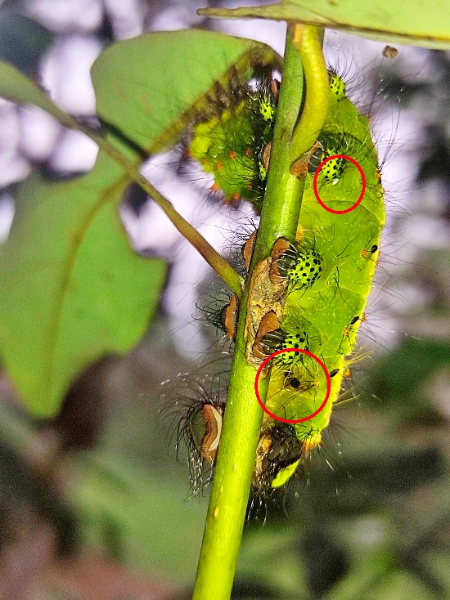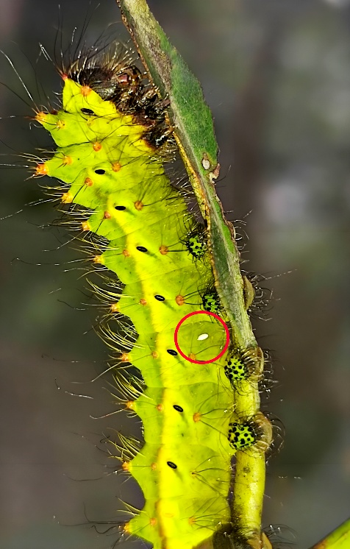
Fig. 3: Muga silkworm attacked by uzi fly
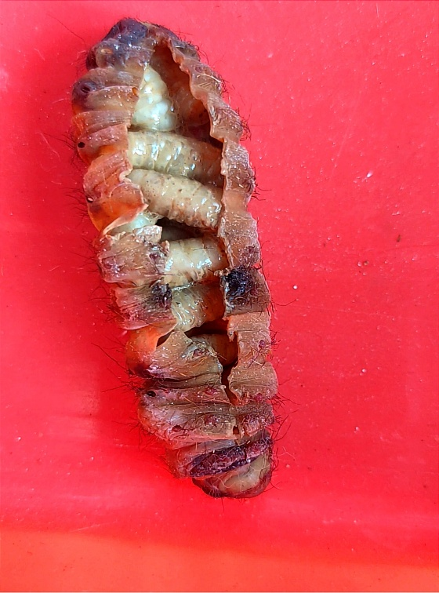
Fig. 4: Uzi fly maggot inside dead muga silkworm larva
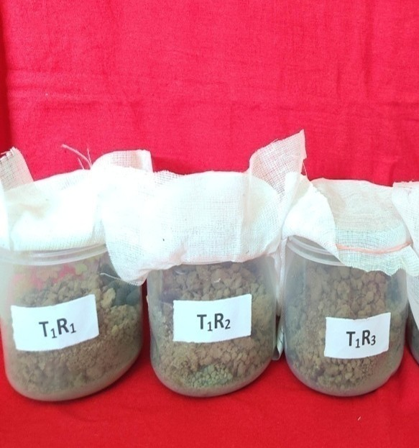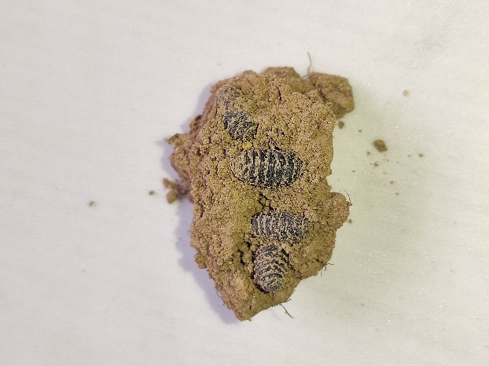
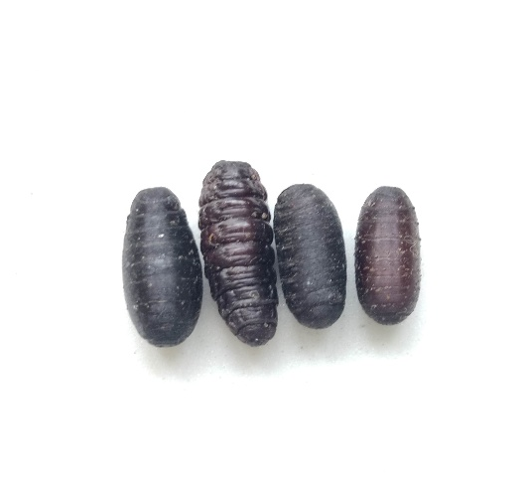
Fig. 5: Uzi fly pupa
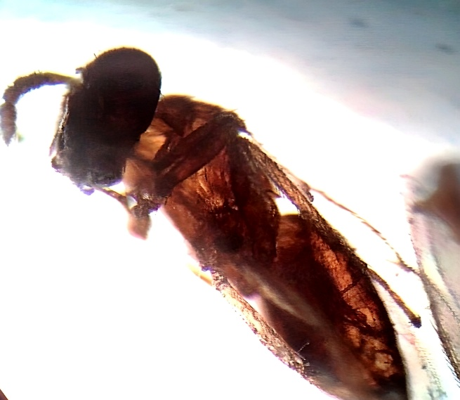
Fig. 6: Nesolynx thymus adult

