In Vitro Antidiabetic and Anti-inflammatory Activities of Pectin from the Seagrass Syringodium isoetifolium

ABSTRACT:
Pectin was extracted from the seagrass Syringodium isoetifolium and structurally characterized by qualitative physico-chemical profiling and Fourier-transform infrared (FTIR) spectroscopy. The spectroscopic signatures, notably the asymmetric and symmetric carboxylate stretching vibrations at 1586 and 1422 cm⁻¹, in conjunction with classical precipitation reactions (ethanol, CaCl₂ and NaOH), authenticated the isolate as an anionic, low-methoxyl (de-esterified) polyuronide. The macromolecule exhibited concentration-dependent DPPH free-radical scavenging capacity (66.25 % at 1000 µg/mL; IC₅₀ ≈ 740 µg/mL), substantial attenuation of heat-induced egg albumin denaturation (78.4 % at 1000 µg/mL; IC₅₀ = 629 µg/mL) and appreciable intestinal α-glucosidase inhibitory activity (76.0 % at 1000 µg/mL; IC₅₀ = 652 µg/mL). The concordant bioactivities, evidenced by the narrow IC₅₀ clustering (629–740 µg/mL), are rationalized on the basis of the carboxylate-dense, polyanionic architecture of the galacturonan backbone, which facilitates metal-ion chelation, hydrogen donation, protein conformational stabilization and enzyme-surface interaction through a common polyelectrolyte-mediated mechanism. Collectively, these findings substantiate the therapeutic multifunctionality of S. isoetifolium pectin and underscore its potential as a sustainable, marine-derived nutraceutical and functional-food ingredient for mitigating oxidative stress, inflammatory pathogenesis and postprandial hyperglycaemia, while providing a foundational framework for subsequent structural elucidation, degree-of-esterification quantification and in vivo pharmacological validation.
Keywords: Syringodium isoetifolium; seagrass; pectin; marine polysaccharide; FTIR spectroscopy;
INTRODUCTION:
Diabetes mellitus has emerged as one of the most pressing global health challenges of the twenty-first century, with the International Diabetes Federation estimating that 537 million adults were living with diabetes in 2021 a figure projected to reach 783 million by 2045 (Sun et al., 2022). Type 2 diabetes, which accounts for more than 90 % of cases, is characterized by chronic hyperglycaemia driven by insulin resistance and progressive β-cell dysfunction, and it is frequently accompanied by a state of low-grade systemic inflammation that accelerates vascular complications (Zheng et al., 2018). Current pharmacological management relies heavily on synthetic oral hypoglycaemic agents and non-steroidal anti-inflammatory drugs (NSAIDs); however, their long-term use is associated with undesirable side effects, including gastrointestinal ulceration, renal toxicity and hepatic dysfunction (Tundis et al., 2010). This therapeutic limitation has intensified the search for safer, plant-derived alternatives capable of simultaneously modulating hyperglycaemia and inflammation.
A key strategy in postprandial glycaemic control is the inhibition of intestinal α-glucosidase, the brush-border enzyme responsible for the terminal hydrolysis of dietary carbohydrates into absorbable glucose. Inhibition of this enzyme attenuates the post-meal glucose spike and has become a validated target for both conventional drugs (e.g., acarbose) and natural products (Tundis et al., 2010; Lordan et al., 2013). Likewise, inhibition of heat-induced protein denaturation is a widely accepted in vitro surrogate for anti-inflammatory screening, since denatured proteins act as endogenous antigens that trigger inflammatory cascades (Sakat et al., 2010). Marine organisms, which produce structurally unusual polysaccharides under extreme and highly saline environments, are increasingly recognized as privileged sources of such bioactive molecules (Jiao et al., 2011; Wijesekara et al., 2011; Ganesan et al., 2019).
Seagrasses the only group of higher plants that have re-adapted to complete submergence in the marine environment represent a conspicuously underexplored branch of this marine bioresource. Comprising some 60–70 species distributed across five families, seagrasses form extensive meadows in shallow coastal waters and are characterized by a carbohydrate-rich cell wall matrix adapted to a saline, light-limited habitat (Short et al., 2007). Remarkably, marine angiosperms have been shown to biosynthesize sulfated and acidic polysaccharides, including sulfated galactans, as an adaptive response to seawater salinity (Aquino et al., 2005). Syringodium isoetifolium (family Cymodoceaceae), a widely distributed Indo-Pacific seagrass, accumulates substantial cell-wall polysaccharide reserves, yet its phytochemical and pharmacological potential remains largely untapped compared with its macroalgal counterparts.
Among cell-wall polysaccharides, pectin occupies a singular position of industrial and biomedical importance. Pectin is a structurally heterogeneous family of galacturonic-acid-rich polysaccharides comprising homogalacturonan, rhamnogalacturonan-I and rhamnogalacturonan-II domains in which α-(1→4)-linked D-galacturonic acid residues carry varying proportions of methyl-esterified and free carboxyl groups; this degree of esterification fundamentally determines gelling behaviour and biological activity (Ciriminna et al., 2016; Dranca & Oroian, 2021). Owing to its biocompatibility, biodegradability and GRAS status, pectin is extensively exploited as a gelling and stabilizing agent in food systems and as a drug-delivery excipient (Freitas et al., 2021; Noreen et al., 2020). Beyond its techno-functional roles, an expanding body of evidence attributes direct health-promoting properties to pectin, including cholesterol- and bile-acid lowering, immunomodulation, prebiotic effects, and of direct relevance to the present study viscosity-mediated attenuation of postprandial glycaemia through delayed gastric emptying and glucose absorption (Naqash et al., 2017; Weickert & Pfeiffer, 2008).
Marine-derived polysaccharides in general, and acidic polyelectrolytes in particular, have demonstrated convincing antioxidant, anti-inflammatory and enzyme-inhibitory activities, which are largely underpinned by their anionic (carboxylate and sulfate) architecture and molecular weight (Jiao et al., 2011; Wijesekara et al., 2011; Fernando et al., 2016; Cunha & Grenha, 2016). Furthermore, "egg-box" cross-linking of low-methoxyl pectin carboxylates with divalent cations such as Ca²⁺ a property exploited in conventional pectin gelling (Grant et al., 1973) also confers metal-chelating and radical-stabilizing capacity relevant to antioxidant and anti-inflammatory action (Ciriminna et al., 2016; Naqash et al., 2017). While pectin from terrestrial sources (citrus, apple, sugar beet) has been studied exhaustively, pectin from marine angiosperms remains exceptionally rare in the literature, and to date the bioactivities of pectin isolated from S. isoetifolium have not been systematically evaluated.
MATERIALS AND METHODS:
  - COLLECTION OF SEAGRASS:
Seagrass Syringodium isoetifolium was collected during October 2025 in the coastal waters of karankadu near ramanathapuram, Palk strait, Southeast coast, Tamilnadu, India. The collected Seagrass was thoroughly washed with filtered seawater twice, and then using freshwater to remove any other unwanted materials such as salts, sand particles and epiphytes and then the water content in the Seagrass samples were removed using filter paper. The sample was shade dried for five to 10 days for through drying. About 100 g of dried seagrass sample was powdered using mixer grinder and the powdered sample was stored in a zip-lag bag for further use.
  - PECTIN EXTRACTION FROM S. isoetifolium:
Polysaccharide “Pectin” were extracted from S. isoetifolium using an acid and chelating extraction method. 10 g of S. isoetifolium seagrass was mixed with 200ml of 0.1M hydrochloric acid (HCL) in conical flask and then heated at 65°C for 2 hours at pH 2.0-2.5. The HCL mixture was filtered by Whatman filter paper and rinsed with water to reach neutral pH in the seagrass. 0.5% ammonium oxalate solution was added to the mixture and placed in the water bath at 80°C for 2 hours. (note the pH is 6.0-6.5 maintained by using 15% sodium carbonate solution). Transfer the mixture into the centrifuge tube and centrifuge at 300rpm for 15mins. Collect the supernatant into the beaker. The pectin is precipitated by adding 3 times its volume of supernatant in 95% ethanol. Filter the precipitate pectin by using Whatman filter paper then washed with 70% ethanol and dried at the hot air oven in 80°C to get purified pectin.
  - FTIR ANALYSIS OF THE PECTIN FROM S. ISOETIFOLIUM:
Fourier Transform Infrared (FTIR) spectroscopy was performed to identified the functional group present in the pectin from S. isoetifolium. 1gm of dried pectin extract was subjected to FTIR analyser. FTIR spectra were read in the range of 4000 – 400cm^1. The characteristic peaks were analysed to determine the functional group of the samples. It is used to analyze the bioactive compound present in the S. isoetifolium.
  - BIOCHEMICAL TEST FOR PECTIN:
Biochemical test was essential for confirming the pectin for presence and purity in the extracted sample. Specific functional group and reactions characteristic of the pectin polysaccharides was identified. In this study, biochemical tests such as alcohol precipitation test, calcium chloride test, viscosity test, solubility test, sodium hydroxide test were used to confirm the presence of pectin extracted from seagrass.
    - Pectin solution preparation:
1% of pectin solution prepared by dissolving 1g of pectin powder in 100ml of distilled water. The pectin mixture was heated gently at 60-70°C. Cool the pectin at room temperature and used for biochemical test and further test for research.
    - Alcohol precipitation test:
The pectin solution was mixed with 3 times its volumes of 95% ethanol and kept at 4°C for 1 hour. Observe the formation of a jelly like precipitate, confirmed the presence of high molecular pectin.
    - Calcium chloride test:
To confirm the presence of pectin, 5ml of pectin solution was mixed with equal volume 1% calcium chloride solution. Observe the formation of white, gelatinous precipitate that indicate presence of pectin. (calcium ions interact with galacturonic acid residues to form insoluble calcium pectate).
    - Viscosity test:
1% of pectin solution in distilled water was taken and stirred completely, viscosity of the mixture was observed. The high viscosity suggests the presence of pectin.
    - Solubility test:
The pectin solution was mixed with cold and hot water for testing solubility test. Precipitate in cold water and completely dissolved in hot water that indicates presence of pectin.
    - Sodium hydroxide (NaOH) test:
2ml of pectin solution was mixed with few drops of 0.1M sodium hydroxide (NaOH) solution and incubated for 15 – 20 minutes at room temperature. The formation of a gel or thickened solution that indicate presence of pectin.
  - Antioxidant activity:
The antioxidant activity of pectin extract was determined by using DPPH (2,2-diphenyl-1-picrylhydrazyl) radical scavenging assay. A 0.1mM DPPH solution was prepared by dissolving 1.95 mg in 25ml of methanol and stored in an amber bottle at dark places. Pectin sample were dissolved in distilled water in various concentration (100, 200, 500,1000 mg/mL).1ml of each pectin concentration was mixed with 1mL of DPPH solution and incubated in dark places at room temperature for 30 minutes. A control with 1mL methanol and 1mL DPPH, and blank contain 1mL of pectin solution with 1mL methanol (without DPPH). After incubation, the absorbance was measured at 520 nm using colorimeter. The percentage of DPPH assay was calculated using formula;
% inhibition= [(A control – A sample)/ A control)] X 100.
  - ANTI-INFLAMMATORY ASSAY:
Assessment of invitro anti-inflammatory activity Inhibition of albumin denaturation:
The anti-inflammatory activity of the given sample was studied by using inhibition of albumin denaturation technique which was studied according to Mizushima et.al., and Sakat et.al., followed with minor modifications.
The reaction mixture was consists of Ethanol extracts of the sample with various concentration, 2ml and 1% aqueous solution of 0.2ml of bovine albumin fraction and 2.8ml of PBS, pH of the reaction mixture was adjusted using small amount of 1N HCl. The sample extracts were incubated at 37 ºC for 20 min and then heated to 51 º C for 20 min, after cooling the samples the turbidity was measured at 660nm by UV-Visible Spectrophotometer.
The Percentage inhibition of protein denaturation was calculated as follows:
Percentage inhibition = (Abs Control –Abs Sample) X 100/ Abs control
  - ANTI DIABETIC ASSAY:
    - α-Glucosidase inhibition assay
Different concentration of the sample extract was taken with 100 μl of 0.1 M phosphate buffer (pH 6.9) and 100 μl of α-glucosidase solution (1 Unit/ml/min) and preincubated at 25°C for 5 min (Worthington, 1993). Then, 100 μl of p-nitrophenyl-α-d-glucopyranoside (5 mM) was added and incubated at 25°C for 10 min. After the incubation period, the absorbance readings were recorded at 405 nm and allegorized to a control that had 100 μl of buffer in place of the sample. The results were calculated and expressed on percentage basis.
RESULTS:
2.1. Pectin extraction from s. Isoetifolium:
The identity of the polysaccharide extracted from Syringodium isoetifolium was established through qualitative physico-chemical tests . Upon addition of ethanol, a white gelatinous precipitate formed immediately, consistent with the classical behaviour of pectin, which is insoluble in aqueous alcohols owing to dehydration of its hydration shell and consequent aggregation of high-molecular-weight galacturonan chains (Ciriminna et al., 2016; Freitas et al., 2021). Similarly, the addition of CaCl₂ produced a white precipitate of calcium pectate a hallmark reaction of polyuronides explained by the "egg-box" model, in which divalent calcium ions bridge the carboxylate groups of adjacent galacturonic acid residues (Grant et al., 1973). The ready formation of calcium pectate suggests a low degree of esterification, since abundant free –COOH/–COO⁻ groups are required for efficient ionic cross-linking (Dranca & Oroian, 2021). The extract dissolved completely in hot water, forming a viscous colloidal solution but remaining insoluble in cold water the characteristic dissolution behaviour of pectinaceous polysaccharides (Adetunji et al., 2017; Naqash et al., 2017). In the NaOH test, a gelatinous precipitate appeared, attributable to alkaline de-esterification and neutralization of carboxylic groups to form pectates, confirming the presence of acidic functional groups the structural basis of pectin's gelling and metal-binding properties (Ciriminna et al., 2016). Together, these tests unambiguously establish the extract as a pectin-type polysaccharide.

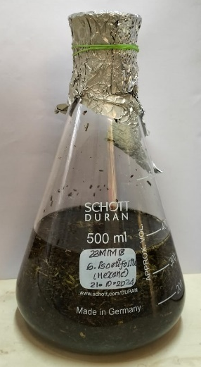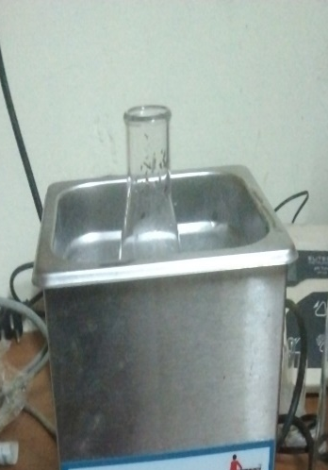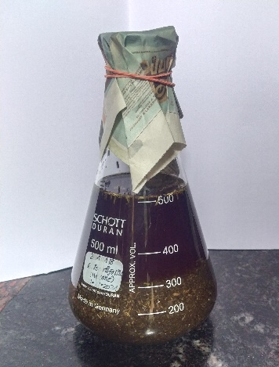

Seagrass with 0.1M HCL Water bath Seagrass with aluminium
Fig.1 Fig.2 oxalate
Fig.3

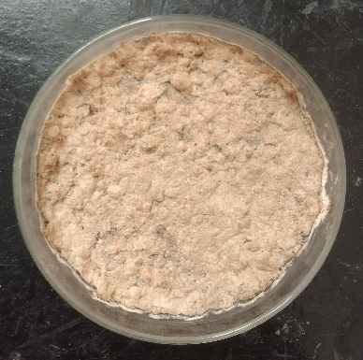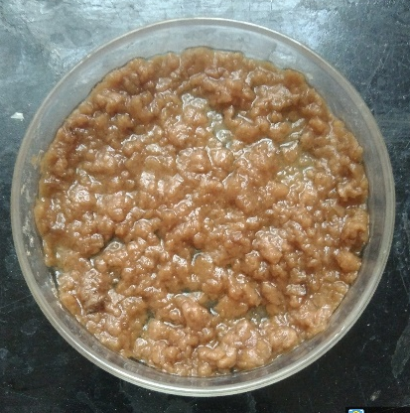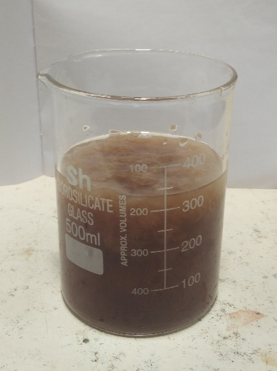
Dried at hot air oven Filter the ethanol Ammonium oxalate
precipitate supernatant
Fig.6 Fig.5 added 95% ethanol
Fig.4
Fig.1 – 6. Pectin extraction process from S. isoetifolium seagrass

2.2. FTIR ANALYSIS OF THE PECTIN FROM S. ISOETIFOLIUM:
The functional group on pectin extract were discovered through FTIR analysis. The absorbance of a sample from the extract was measured
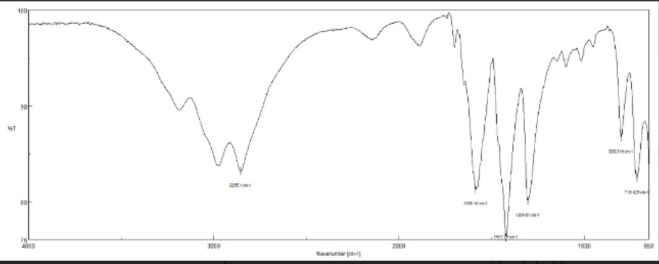
Fig.7
Graphical representation of FTIR analysis of pectin extract of S. isoetifolium

Absorbance peak and functional groups present in the extract were tabulated below,

Chart 1. Fourier-transform infrared (FTIR) absorption frequencies and corresponding functional group assignments of pectin extracted from the seagrass Syringodium isoetifolium.

Frequency range (standard)  (cm-1) | Absorption  (cm-1) | Functional group
730-780 | 716.42 | C-H out of plane bending (aromatic rings, alkenes or substituted benzene compounds)
800-890 | 800.34 | C-H out of plane bending (alkenes or aromatic compounds)
1200-1300 | 1304.61 | C-O stretching (Carboxyl, phenols or ethers)
1400-1450 | 1422.24 | C-H bending (methylene or methyl groups, alkanes or carbohydrates)
1550-1650 | 1586.16 | C=C stretching (aromatic rings)
2850-2925 | 2855.10 | C-H stretching (alkanes, methyl or carbohydrates)

The FTIR spectrum exhibited absorption bands characteristic of polyuronide polysaccharides.The band at 2855 cm⁻¹ arises from C–H stretching of methyl/methylene groups of uronic acid residues, while the bands at 800.34 and 716.42 cm⁻¹ correspond to C–H out-of-plane bending and pyranose-ring skeletal vibrations typical of glycosidic linkages. The band at 1304.61 cm⁻¹ reflects C–O stretching of carboxyl and ether groups of the galacturonan backbone.The band at 1586.16 cm⁻¹ lies squarely in the region (1600–1630 cm⁻¹) attributed to the asymmetric stretching vibration of carboxylate anions (–COO⁻) in pectins, while 1422.24
cm⁻¹ coincides with the symmetric –COO⁻ stretch/C–H bending region (Jiao et al., 2011). The prominence of the carboxylate pair, together with the absence of a strong ester carbonyl band near 1730–1750 cm⁻¹, indicates a predominantly free-carboxyl (low-methoxyl) character. This is consistent with the strong calcium pectate precipitation observed, and with reports that marine angiosperms and green macrophytes are rich in anionic polysaccharides seagrasses are known to biosynthesize sulfated galactans and acidic matrix polysaccharides (Aquino et al., 2005; Kidgell et al., 2019) which underpin many of their biological activities (Aquino et al., 2011; Cunha & Grenha, 2016).
  - BIOCHEMICAL TEST FOR PECTIN:
- Chart 2. Qualitative biochemical characterization of pectin extracted from Syringodium isoetifolium, showing the observations and corresponding inferences from alcohol precipitation, calcium chloride, viscosity, solubility, and sodium hydroxide tests.
Name of the test | Observation | Inference
Alcohol precipitation test | Formation of a white gelatinous precipitate upon addition of ethanol | Confirms the presence of pectin, which insoluble in alcohol and precipitate out.
Calcium chloride test | Formation of a white precipitate after adding Calcium chloride | Presence of pectin, which reacts with calcium ions to from calcium pectate.
Viscosity test | The pectin solution exhibits high viscosity or gel like consistency. | Conforming the colloidal and gel forming nature of pectin due to its polysaccharide structure.
Solubility test | Pectin dissolves fully in the hot water, forming viscous solution; insoluble in cold water. | Solubility characteristics confirms the identity of pectin as a water – soluble polysaccharide.
Sodium hydroxide (NaOH) test | Formation of a white gelatinous precipitate upon adding NaOH to the pectin solution. | Presence of acidic functional groups (carboxyl groups) in pectin the react with NaOH.

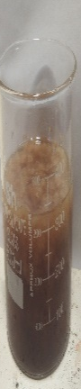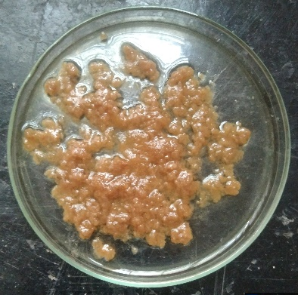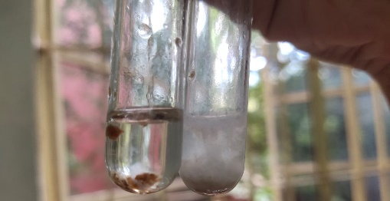
Fig 8: Alcohol precipitation test Fig 9: Calcium chloride test

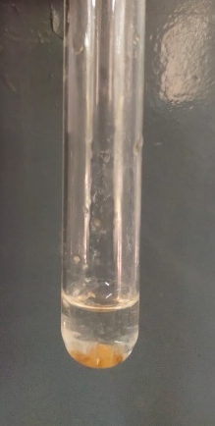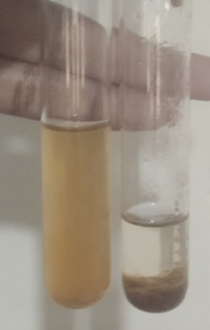
Fig 10: Viscosity test FIG 11: Solubility test

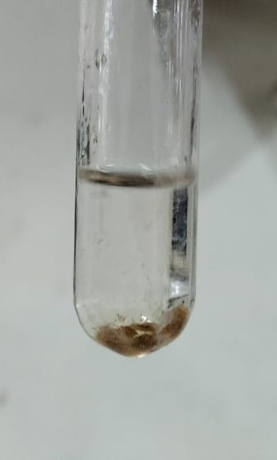
Fig 12: Sodium hydroxide (NaOH) test

2.4. ANTIOXIDENT ACTIVITY:
Different concentrations of pectin extract (100 μl,200 μl,500 μl and 1000 μl) were prepared and incubated in dark place for 30 minutes with DPPH solution. Antioxidant property of pectin extract was evaluated using the DPPH assay and absorbance was measured at 520nm using a colorimeter.

Concentration  (µl) | OD value | % Inhibition | Antioxidant activity range
Control | 0.80 | 0 % | Low
100 | 0.66 | 17.5% | Moderate
200 | 0.60 | 25.0% | Moderate
500 | 0.52 | 35.0% | Moderate
1000 | 0.27 | 66.25% | High

Table 1: Antioxidant activity of pectin using DPPH method
DPPH radical-scavenging capacity increased in a dose-dependent manner, from 17.5 % at 100 µg/mL to 66.25 % at 1000 µg/mL, with an IC₅₀ of ≈740 µg/mL (Fig. 13). This moderate activity is typical of polyuronide-type polysaccharides, whose antioxidant action proceeds mainly through hydrogen donation from hydroxyl/carboxyl groups and chelation of pro-oxidant metal ions, rather than redox-active aromatic moieties (Wang et al., 2016). Polysaccharides are consequently weaker DPPH scavengers than phenolics (ascorbic acid: IC₅₀ ~10–20 µg/mL), yet they remain valuable biocompatible antioxidant macromolecules (Naqash et al., 2017; Zayed & Ulber, 2020). The observed IC₅₀ falls well within the range reported for marine algal polysaccharides (approximately 0.3–2 mg/mL), where potency is governed by uronic acid content, sulfate substitution, and molecular weight (Wijesekara et al., 2011; Qi et al., 2005; Ganesan et al., 2019). The anionic character inferred from FTIR therefore provides a plausible structural rationale for the scavenging behaviour of this seagrass pectin.
GRAPHICAL REPRESENTATION:

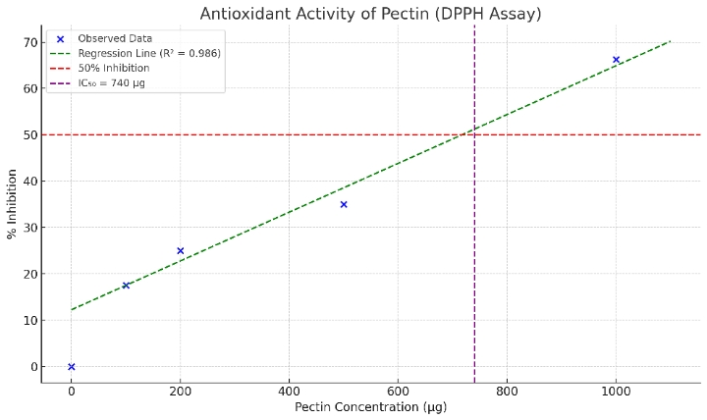

Fig 13: The graph shows antioxidant activity of pectin

2.5. ANTI-INFLAMMATORY ASSAY:
ANTI-INFLAMMATORY ASSAY
S.NO | NAME OF THE TEST | 100μg | 250μg | 500μg | 750μg | 1000μg | IC50
1. | Inhibition of Egg Albumin denaturation | 8.8% | 21.2% | 40.0% | 59.5% | 78.4% | 629μg
Table 2: Anti- inflammatory activity of pectin by egg albumin denaturation assay. Inhibition increased with the concentration, reaching 78.4% at 1000 μg with an IC50 of 620 μg.
The pectin inhibited heat-induced egg albumin denaturation in a concentration-dependent fashion, achieving 78.4 % inhibition at 1000 µg/mL (IC₅₀ = 629 µg/mL) . Protein denaturation is implicated in the release of auto-antigens and inflammatory mediators; hence, its inhibition is an accepted in vitro surrogate for anti-inflammatory potential (Sakat et al., 2010). The activity approaches that of standard NSAIDs in comparable assay formats. This agrees with accumulating evidence that marine acidic/sulfated polysaccharides and fucoidans suppress inflammatory processes including protein denaturation, cyclooxygenase activity, and mediator release (Wijesinghe & Jeon, 2012; Fernando et al., 2016). For an anionic pectin, activity may further be linked to its polyelectrolyte nature, which can stabilize protein conformations and modulate immune-cell signalling (Cunha & Grenha, 2016; Noreen et al., 2020).
2.6. ANTI DIABETIC ASSAY:
ANTI DIABETIC ASSAY
S.NO | NAME OF THE TEST | 100μg | 250μg | 500μg | 750μg | 1000μg | IC50
1. | α-Glucosidase inhibition activity | 8.5% | 20.0% | 38.6% | 57.4% | 76.0% | 652μg

Table 3: Anti diabetic activity of pectin by α-Glucosidase inhibition assay. Inhibition increased with the concentration, reaching 76.0% at 1000 μg with an IC50 of 652 μg.
The pectin inhibited α-glucosidase in a dose-dependent manner, reaching 76.0 % inhibition at 1000 µg/mL (IC₅₀ = 652 µg/mL) (Table 3). Inhibition of intestinal α-glucosidase delays enzymatic release of glucose from dietary carbohydrates and attenuates postprandial hyperglycaemia the pharmacological basis of acarbose (Kim et al., 2005). Although less potent than acarbose, the activity is comparable to marine macroalgal extracts, whose α-glucosidase IC₅₀ values typically range from sub-mg/mL to low-mg/mL (Lordan et al., 2013; Ganesan et al., 2019). Beyond direct enzyme inhibition, dietary pectin blunts glycaemic responses through viscosity-mediated delay of gastric emptying and glucose absorption (Weickert & Pfeiffer, 2008), supporting a dual (enzymatic + physicochemical) antidiabetic mechanism. The moderate inhibition observed here, combined with the strong viscosity documented in the characterization tests, therefore suggests genuine functional-food potential (Noreen et al., 2020; Freitas et al., 2021).

DISCUSSION:
The pectin extracted from the seagrass Syringodium isoetifolium was successfully identified and characterized through a combination of qualitative physico-chemical tests, FTIR spectroscopy and three complementary in vitro bioassays, and the results collectively provide convincing evidence for its identity, structural features and pharmacological potential. In the preliminary characterization, the extract exhibited the entire classical repertoire of pectin behaviour — a white gelatinous precipitate in ethanol, a white calcium pectate precipitate with CaCl₂, high viscosity and gel-like consistency, hot-water solubility with cold-water insolubility, and a gelatinous precipitate with NaOH. The ethanol precipitation reaction arises from the dehydration and aggregation of high-molecular-weight galacturonan chains, which are inherently insoluble in aqueous alcohols, a behaviour documented for pectins from all conventional sources (Ciriminna et al., 2016; Dranca & Oroian, 2021). The vigorous calcium pectate formation observed here is particularly informative, because it is explained by the well-established "egg-box" model of Grant et al. (1973), in which divalent calcium ions cooperatively bridge contiguous blocks of de-esterified galacturonic acid residues on adjacent polymer chains; efficient cross-linking of this kind requires an abundance of free carboxyl groups and therefore indicates a low degree of esterification, analogous to the low-methoxyl pectins obtained from sugar beet and sunflower that gel by ionic rather than sugar–acid mechanisms (Yapo, 2011; Naqash et al., 2017). The solubility and viscosity behaviour of the present extract likewise mirrors that reported for citrus and commercial low-methoxyl pectins, whose solution properties are governed by molecular weight, charge density and ionic strength (Adetunji et al., 2017; Freitas et al., 2021). Taken together, these reactions affirm that the S. isoetifolium extract is a genuine pectin-type polyuronide rather than a neutral gum or non-pectic polysaccharide.
The FTIR analysis corroborated and extended these findings at the molecular level. The absorption at 2855 cm⁻¹ corresponds to symmetric C–H stretching of the sugar-ring methylene and methyl groups, including the methoxyl groups of esterified uronic residues, while the band at 1304 cm⁻¹ reflects C–O stretching of carboxyl and ether functions of the galacturonan backbone, and the bands at 800.34 and 716.42 cm⁻¹ are consistent with pyranose-ring skeletal vibrations and glycosidic-linkage deformations characteristic of uronic-acid-rich polysaccharides (Synytsya & Novák, 2014). Although generic spectral libraries assign the band at 1586.16 cm⁻¹ to aromatic C=C stretching, such an assignment is chemically implausible for pectin, which contains no aromatic rings; in the established pectin literature this region (1600–1630 cm⁻¹) is instead attributed to the asymmetric stretching of carboxylate anions (–COO⁻), with the companion band at 1422.24 cm⁻¹ representing the symmetric –COO⁻ stretch combined with C–H deformation (Chatjigakis et al., 1998; Gnanasambandam & Proctor, 2000; Manrique & Lajolo, 2002). The dominance of this carboxylate pair, together with the absence of any prominent ester carbonyl band near 1730–1750 cm⁻¹, independently confirms the low-methoxyl, anionic character of the seagrass pectin inferred from the calcium chloride test — a coherent structure–chemistry agreement that strengthens the overall characterization. This anionic profile is also entirely consistent with the polysaccharide chemistry reported for marine angiosperms, which biosynthesize sulfated and acidic cell-wall polysaccharides, including sulfated galactans, as an adaptive response to seawater salinity (Aquino et al., 2005; Aquino et al., 2011).
The bioassay results demonstrate that this anionic architecture translates into meaningful and internally consistent biological activity. In the DPPH assay, radical scavenging increased dose-dependently from 17.5 % at 100 µg/mL to 66.25 % at 1000 µg/mL, with an IC₅₀ of approximately 740 µg/mL. It is well recognized that native polysaccharides are intrinsically weaker DPPH scavengers than low-molecular-weight phenolics such as ascorbic acid (IC₅₀ ≈ 10–20 µg/mL) because they lack redox-active aromatic moieties, and their antioxidant action proceeds mainly through hydrogen donation from hydroxyl and carboxyl groups and through chelation of pro-oxidant transition-metal ions (Wang et al., 2016). Judged against this context, the present IC₅₀ of ≈0.74 mg/mL sits comfortably within the 0.3–2.0 mg/mL range reported for marine algal polysaccharides: Qi et al. (2005) reported similarly concentration-dependent DPPH scavenging for Ulva pertusa polysaccharide and its sulfate derivatives, with potency rising with uronic-acid and sulfate content, while Yuan et al. (2005) observed comparable behaviour for κ-carrageenan oligosaccharide derivatives, again with activity enhanced by anionic substitution. The moderate but genuine scavenging capacity of the underivatized S. isoetifolium pectin is therefore entirely in line with the marine polysaccharide literature and plausibly attributable to its carboxylate-dense structure revealed by FTIR; indeed, controlled depolymerization or partial sulfation could reasonably be expected to enhance this activity further, as both modifications demonstrably do in the studies cited above (Qi et al., 2005; Yuan et al., 2005).
The anti-inflammatory evaluation by the inhibition of heat-induced egg albumin denaturation yielded a concentration-dependent response rising from 8.8 % to 78.4 % at 1000 µg/mL, with an IC₅₀ of 629 µg/mL. Protein denaturation generates endogenous auto-antigens that sustain inflammatory processes, and its inhibition is a validated in vitro surrogate for anti-inflammatory efficacy, with diclofenac sodium as the conventional reference standard (Sakat et al., 2010). The maximum inhibition of 78.4 % achieved here compares favourably with values reported for marine sulfated polysaccharides and fucoidans, which are documented to suppress protein denaturation, cyclooxygenase signalling and inflammatory mediator release (Wijesinghe & Jeon, 2012; Fernando et al., 2016). Mechanistically, the polyanionic –COO⁻ surface of the low-methoxyl pectin can interact electrostatically with cationic patches on albumin and thereby stabilize the protein's tertiary structure against thermal unfolding, while its capacity to chelate divalent cations the same "egg-box" chemistry exploited in gelling (Grant et al., 1973) may additionally dampen calcium-dependent inflammatory signalling (Cunha & Grenha, 2016; Naqash et al., 2017). Similarly, in the α-glucosidase inhibition assay the pectin produced a clear dose-response reaching 76.0 % at 1000 µg/mL with an IC₅₀ of 652 µg/mL. Intestinal α-glucosidase is a validated antidiabetic target whose inhibition delays terminal carbohydrate digestion and blunts postprandial hyperglycaemia the pharmacological basis of acarbose (Tundis et al., 2010) and the potency observed here, although weaker than acarbose, falls within the sub-mg/mL range frequently reported for marine macroalgal extracts, which often display preferential α-glucosidase (over α-amylase) inhibition, a profile considered pharmacologically desirable because it minimizes the gastrointestinal side-effects associated with excessive pancreatic α-amylase suppression (Lordan et al., 2013; Ganesan et al., 2019). Moreover, the antidiabetic potential of this pectin is likely bimodal, combining direct enzyme inhibition with a physicochemical contribution from its documented high viscosity, which delays gastric emptying and glucose diffusion the mechanism underpinning the proven glycaemic benefits of viscous dietary fibres (Weickert & Pfeiffer, 2008; Naqash et al., 2017).
When the three bioactivities are considered together, a striking pattern emerges: the IC₅₀ values cluster tightly between 629 and 740 µg/mL, suggesting a common, moderately potent mechanism of action rather than the coincidental activity of trace secondary metabolites. This unified behaviour is best rationalized by the carboxylate-dense, low-methoxyl architecture independently evidenced by the CaCl₂/NaOH tests and the 1586/1422 cm⁻¹ FTIR carboxylate pair a structural motif that underpins metal chelation (antioxidant activity), protein stabilization (anti-inflammatory activity) and enzyme-surface interaction (α-glucosidase inhibition), consistent with the broad bioactivity of anionic marine polysaccharides generally reported in the literature (Jiao et al., 2011; Wijesekara et al., 2011). To the best of our knowledge, this represents one of the first systematic evaluations of the antidiabetic and anti-inflammatory potential of a pectin isolated from a marine angiosperm, a field overwhelmingly dominated by macroalgal fucoidans and ulvans (Kidgell et al., 2019; Zayed & Ulber, 2020), and thereby fills a genuine gap in the marine polysaccharide literature. Nevertheless, certain limitations warrant acknowledgement: the bioassays were conducted in vitro and at the level of crude extract without purification, and quantitative structural parameters galacturonic acid content, degree of esterification, sulfate content and molecular weight were not determined, although the degree of esterification can readily be quantified in future work from the FTIR band-area ratio of ester C=O to free carboxylate (Chatjigakis et al., 1998; Manrique & Lajolo, 2002). Future studies should therefore pursue comprehensive structural characterization, fractionation into discrete molecular-weight populations, and validation of the observed activities in in vivo diabetic and inflammatory models (Dranca & Oroian, 2021; Ganesan et al., 2019). Within these limitations, the present findings position S. isoetifolium pectin as a promising, sustainable marine-derived nutraceutical candidate with concurrent antioxidant, anti-inflammatory and antidiabetic properties.
CONCLUSION:
Pectin was successfully extracted from the seagrass Syringodium isoetifolium and its identity was confirmed by qualitative physico-chemical tests and FTIR spectroscopy, which revealed characteristic carboxyl (–COO⁻) and polysaccharide functional groups indicative of a low-methoxyl pectin. The extract demonstrated dose-dependent antioxidant activity with 66.25 % DPPH scavenging at 1000 µg/mL (IC₅₀ ≈ 740 µg/mL), along with notable anti-inflammatory activity (78.4 % inhibition of egg albumin denaturation; IC₅₀ = 629 µg/mL) and promising antidiabetic potential (76.0 % α-glucosidase inhibition; IC₅₀ = 652 µg/mL). The concordant bioactivities suggest that the anionic, carboxyl-rich structure of seagrass pectin underpins its free-radical scavenging, protein-stabilizing and enzyme-inhibitory properties. Overall, the findings highlight S. isoetifolium pectin as a promising marine-derived nutraceutical candidate for the management of diabetes and inflammation. Further studies on its structural characterization and in vivo efficacy are recommended to validate its therapeutic application.
Declaration of AI Use

This manuscript was prepared through the intellectual contributions of the author(s) to the study design, data analysis, interpretation of results, and scholarly content. Grammarly and ChatGPT were used solely to assist with grammatical refinement and reference formatting during manuscript revision. The author(s) accept full responsibility for the accuracy, integrity, and final content of the manuscript.

COMPETING INTERESTS DISCLAIMER:
Authors have declared that they have no known competing financial interests OR non-financial interests OR personal relationships that could have appeared to influence the work reported in this paper.

REFERENCE:
- Adetunji, L. R., Adekunle, A., Orsat, V., & Raghavan, V. (2017). Advances in the pectin production process using novel extraction techniques: A review. Food Hydrocolloids, 62, 239–250. https://doi.org/10.1016/j.foodhyd.2016.08.015
- Aquino, R. S., Grativol, C., & Mourão, P. A. S. (2011). Rising from the sea: Correlations between sulfated polysaccharides and salinity in plants. PLoS ONE, 6(4), e18862. https://doi.org/10.1371/journal.pone.0018862
- Aquino, R. S., Landeira-Fernández, A. M., Valente, A. P., Andrade, L. R., & Mourão, P. A. S. (2005). Occurrence of sulfated galactans in marine angiosperms: Evolutionary implications. Glycobiology, 15(1), 11–21. https://doi.org/10.1093/glycob/cwi006
- Ciriminna, R., Fidalgo, A., Delisi, R., Ilharco, L. M., & Pagliaro, M. (2016). Pectin production and utilization. ChemistryOpen, 5(6), 692–699. https://doi.org/10.1002/open.201600025
- Cunha, L., & Grenha, A. (2016). Sulfated seaweed polysaccharides as multifunctional materials in drug delivery applications. Marine Drugs, 14(3), 42. https://doi.org/10.3390/md14030042
- Dranca, F., & Oroian, M. (2021). Extraction, purification and characterization of pectin from alternative sources with potential technological applications. Food Research International, 148, 110588. https://doi.org/10.1016/j.foodres.2021.110588
- Fernando, I. P. S., Nah, J.-W., & Jeon, Y.-J. (2016). Potential anti-inflammatory natural products from marine algae. Environmental Toxicology and Pharmacology, 48, 22–30. https://doi.org/10.1016/j.etap.2016.10.005
- Freitas, C. M. P., Coimbra, J. S. R., Souza, V. G. L., & Sousa, R. C. S. (2021). Structure and applications of pectin in food, biomedical, and pharmaceutical industry: A review. Coatings, 11(8), 922. https://doi.org/10.3390/coatings11080922
- Ganesan, A. R., Tiwari, U., & Rajauria, G. (2019). Seaweed nutraceuticals and their therapeutic role in disease prevention: A review. Food Science and Human Wellness, 8(3), 252–263. https://doi.org/10.1016/j.fshw.2019.08.001
- Grant, G. T., Morris, E. R., Rees, D. A., Smith, P. J. C., & Thom, D. (1973). Biological interactions between polysaccharides and divalent cations: The egg-box model. FEBS Letters, 32(1), 195–198. https://doi.org/10.1016/0014-5793(73)80770-7
- Jiao, G., Yu, G., Zhang, J., & Ewart, H. S. (2011). Chemical structures and bioactivities of sulfated polysaccharides from marine algae. Marine Drugs, 9(2), 196–223. https://doi.org/10.3390/md9020196
- Kidgell, J. T., Magnusson, M., de Nys, R., & Glasson, C. R. K. (2019). Ulvan: A systematic review of extraction, composition and function. Algal Research, 39, 101422. https://doi.org/10.1016/j.algal.2019.101422
- Kim, Y. M., Jeong, Y. K., Wang, M. H., Lee, W. Y., & Rhee, H. I. (2005). Inhibitory effect of pine extract on α-glucosidase activity and postprandial hyperglycemia. Nutrition, 21(6), 756–761. https://doi.org/10.1016/j.nut.2004.10.014
- Lordan, S., Smyth, T. J., Soler-Vila, A., Stanton, C., & Ross, R. P. (2013). The α-amylase and α-glucosidase inhibitory effects of Irish seaweed extracts. Food Chemistry, 141(3), 2170–2176. https://doi.org/10.1016/j.foodchem.2013.04.123
- Naqash, S. Y., Masoodi, F. A., Rather, S. A., & Wani, S. M. (2017). Emerging concepts in the nutraceutical and functional properties of pectin—A review. Carbohydrate Polymers, 168, 227–239. https://doi.org/10.1016/j.carbpol.2017.01.090
- Noreen, A., Nazli, Z.-I.-H., Akram, J., Rasul, I., Mansha, A., Yaqoob, N., Iqbal, R., Tabasum, S., Khan, M. U., & Zia, K. M. (2020). Pectins functionalized biomaterials; a new viable approach for biomedical applications: A review. International Journal of Biological Macromolecules, 147, 329–343. https://doi.org/10.1016/j.ijbiomac.2019.12.049
- Qi, H., Zhang, Q., Zhao, T., Chen, R., Zhang, H., Niu, X., & Li, C. (2005). Antioxidant activity of different sulfate content derivatives of polysaccharide extracted from Ulva pertusa (Chlorophyta) in vitro. International Journal of Biological Macromolecules, 37(4), 195–199. https://doi.org/10.1016/j.ijbiomac.2005.10.008
- Sakat, S., Juvekar, A. R., & Gambhire, M. N. (2010). In vitro antioxidant and anti-inflammatory activity of methanol extract of Oxalis corniculata Linn. International Journal of Pharmacy and Pharmaceutical Sciences, 2(1), 146–155.
- Short, F., Carruthers, T., Dennison, W., & Waycott, M. (2007). Global seagrass distribution and diversity: A bioregional model. Journal of Experimental Marine Biology and Ecology, 350(1–2), 3–20. https://doi.org/10.1016/j.jembe.2007.06.012
- Sun, H., Saeedi, P., Karuranga, S., Pinkepank, M., Ogurtsova, K., Duncan, B. B., Stein, C., Basit, A., Chan, J. C. N., Mbanya, J. C., Pavkov, M. E., Ramachandaran, S., Wild, S. H., James, S., Herman, W. H., Zhang, P., Bommer, C., Kuo, S., Boyko, E. J., & Magliano, D. J. (2022). IDF Diabetes Atlas: Global, regional and national diabetes prevalence estimates for 2021 and projections 2045. Diabetes Research and Clinical Practice, 183, 109119. https://doi.org/10.1016/j.diabres.2022.109119
- Tundis, R., Loizzo, M. R., & Menichini, F. (2010). Natural products as alpha-amylase and alpha-glucosidase inhibitors and their hypoglycemic potential in the treatment of diabetes: An update. Mini-Reviews in Medicinal Chemistry, 10(4), 315–331. https://doi.org/10.2174/138955710791331007
- Wang, J., Hu, S., Nie, S., Yu, Q., & Xie, M. (2016). Reviews on mechanisms of in vitro antioxidant activity of polysaccharides. Oxidative Medicine and Cellular Longevity, 2016, Article 5692852. https://doi.org/10.1155/2016/5692852
- Weickert, M. O., & Pfeiffer, A. F. H. (2008). Metabolic effects of dietary fiber consumption and prevention of diabetes. The Journal of Nutrition, 138(3), 439–442. https://doi.org/10.1093/jn/138.3.439
- Wijesekara, I., Pangestuti, R., & Kim, S.-K. (2011). Biological activities and potential health benefits of sulfated polysaccharides derived from marine algae. Carbohydrate Polymers, 84(1), 14–21. https://doi.org/10.1016/j.carbpol.2010.10.062
- Wijesinghe, W. A. J. P., & Jeon, Y.-J. (2012). Biological activities and potential industrial applications of fucose-rich sulfated polysaccharides and fucoidans isolated from brown seaweeds: A review. Carbohydrate Polymers, 88(1), 13–20. https://doi.org/10.1016/j.carbpol.2011.12.011
- Zayed, A., & Ulber, R. (2020). Fucoidans: Downstream processes and recent applications. Marine Drugs, 18(3), 170.
- Zheng, Y., Ley, S. H., & Hu, F. B. (2018). Global aetiology and epidemiology of type 2 diabetes mellitus and its complications. Nature Reviews Endocrinology, 14(2), 88–98. https://doi.org/10.1038/nrendo.2017.151

