Original Research Article

Qualitative Assessment and Group-wise Composition of Zooplankton in Pimpalgaon (Wakhaji) Dam, Nagpur, Maharashtra

.
ABSTRACT
Zooplankton are an important component of freshwater ecosystems and contribute significantly to aquatic food webs and biological productivity. The present study was undertaken to assess the qualitative composition of zooplankton in Pimpalgaon (Wakhaji) Dam, Nagpur, Maharashtra, during a one year study period of June,2023 to May,2024. Zooplankton samples were collected from the reservoir and examined for taxonomic identification using standard microscopic methods. The identified forms were documented and grouped into major taxonomic categories to describe the composition of the zooplankton assemblage. A total of 26 identified taxa were recorded during the study belonging to Rotifera, Cladocera and Copepoda. Rotifera represented the largest component with 11 taxa (42.31%), followed by Cladocera with 9 taxa (34.62%) and Copepoda with 6 taxa (23.08%). The rotifer assemblage included representatives of Brachionus, Keratella, Filinia, Asplanchna and Monostyla. Cladoceran assemblage included Diaphanosoma, Ceriodaphnia, Moina, Bosmina, Chydorus and Macrothrix. Copepoda was represented by genera including Mesocyclops, Eucyclops, Thermocyclops and Cyclops. The occurrence of several taxa commonly reported from freshwater ecosystems showed similarities with earlier observations from Indian reservoirs and lakes. However, differences in the representation of individual groups and taxa indicate variation in zooplankton composition among freshwater habitats. The present study gives a qualitative baseline of the zooplankton assemblage of Pimpalgaon (Wakhaji) Dam and contributes to the taxonomic documentation of its freshwater biological community.

Keywords: Zooplankton, qualitative assessment, taxonomic composition, Rotifera, Cladocera, Copepoda

1. INTRODUCTION
Freshwater ecosystems are foremost natural resources that support a broad range of biotic factors. It furnishes essential services such as fisheries, agriculture, irrigation, domestic water supply and maintenance of ecological processes. These ecosystems are closely associated with surrounding terrestrial environments and contribute significantly to ecosystem functioning and human well-being (Reddy et al., 2018). Among the various biological components of freshwater ecosystems, zooplankton are small aquatic organisms that play an major role in maintaining the ecological balance of lakes, reservoirs and other freshwater bodies.Freshwater zooplankton commonly include protozoans, rotifers, cladocerans and copepods. They are generally microscopic and remain suspended in the water column with limited capability to move against water currents (APHA, 1999). Zooplankton are therefore considered important components of aquatic food chains and secondary producers in freshwater ecosystems (Tugyan and Bozkurt, 2019). They also provide an important food source for fish larvae and other aquatic organisms (Bozkurt and Kara, 2020). The availability and composition of zooplankton can consequently impacts the growth, survival, reproduction and distribution of fishes, particularly during their larval and juvenile stages. Rotifers and cladocerans are important food organisms for early developmental stages of fishes, whereas copepods also forward energy towards higher trophic levels (Mohan and Priyadarshinee, 2022). In incorporation to their role in aquatic food webs, zooplankton communities are effective for understanding changes in environmental conditions. Because different zooplankton groups respond differently to changes in nutrient availability and water quality, their occurrence and community structure can provide useful information about the ecological condition of a water body. Rotifers and cladoceran have also been used as indicators of eutrophic conditions and deterioration of water quality in reservoirs (Singh et al., 2013). Rotifers are particularly involved in nutrient cycling and are considered sensitive to changes associated with pollution in freshwater environments (Shah et al., 2014). Similarly, eutrophication and seasonal environmental changes can influence zooplankton communities by affecting nutrient availability and the process of ecological succession within aquatic ecosystems (Ulgu and Bozkurt, 2015).Because zooplankton can respond relatively fast to such changes in environment, their communities are recognised as useful biological components for assessing ecological condition of lakes, reservoirs and wetlands (Turhan and Gokce, 2022).Qualitative analysis provides information about the taxonomic composition of the community. It includes the different groups, genera and species occurring in a particular water body. It helps in understanding occurrence, distribution and changes species in species community composition. Reservoirs are dynamic freshwater systems in which seasonal changes in rainfall, water level, nutrient input and other physico-chemical conditions can affect plankton communities. Pimpalgaon (Wakhaji) Dam is an important freshwater reservoir in the Nagpur region of Maharashtra and supports aquatic communities including zooplankton and fishes. A qualitative assessment of zooplankton in Pimpalgaon (Wakhaji) Dam can provide information on the diversity and distribution of its zooplankton community and their possible dependence on changing environmental conditions. Such information can enhance better understanding of the biological resources and functioning of reservoir ecology. Therefore, the present study was assigned to investigate the qualitative composition of zooplankton in Pimpalgaon (Wakhaji) Dam with emphasis on their diversity, occurrence and abundance during the study period. The study provides baseline information on the zooplankton community of the reservoir and may help in understanding seasonal changes in its aquatic ecosystem.
Zooplankton assemblages link primary producers and higher consumers, while their taxonomic and functional structure may vary with trophic state and fish-community characteristics (Pinel-Alloul et al., 2022; Qi et al., 2025). Assessments that integrate taxonomic composition with abundance and environmental measurements can provide stronger evidence about ecological condition than taxonomic inventories alone (Ochocka, 2021; Branco et al., 2002).
Reservoir studies have also documented spatial and seasonal turnover among rotifers, cladocerans and copepods, demonstrating that a pooled list of taxa should be interpreted as an inventory for the period surveyed rather than a direct measure of numerical dominance (Banerjee et al., 2022; Pinel-Alloul et al., 2022). Accordingly, the present record contributes a site-specific baseline against which future abundance-based and physicochemical investigations could be compared (Ochocka, 2021; Qi et al., 2025).
2. material and methods
2.1 Study Area
Pimpalgaon (Wakhaji) Dam is situated in Narkher Taluka of Nagpur District, Maharashtra. Nagpur District is located approximately between 21°08′46″ N latitude and 79°05′05″ E longitude. It is bounded by Bhandara District to the east, Amravati and Wardha districts to the west, Chandrapur District to the south and Madhya Pradesh to the north. Narkher Taluka lies in the north-western part of Nagpur District and is close to the Maharashtra–Madhya Pradesh state boundary. Following the administrative reorganization of Madhya Pradesh, the northern side of Narkher shares a boundary with Pandhurna District. Narkher town is located approximately 42.4 miles (about 68.2 km) north-west of Nagpur, whereas Pimpalgaon (Wakhaji) Dam is situated about 3.6 km east of Narkher. The reservoir is primarily associated with irrigation and supports agricultural activities in the surrounding area. The reservoir also provides financial support to local fishermen by having access of fishing practices. Therefore, it represents a suitable freshwater ecosystem for investigating its biological characteristics. In the present study, Pimpalgaon (Wakhaji) Dam was selected for the assessment zooplankton diversity, occurrence and abundance.
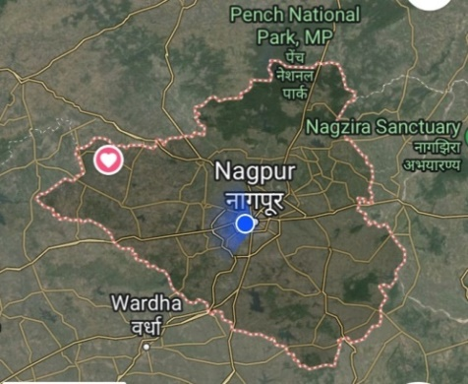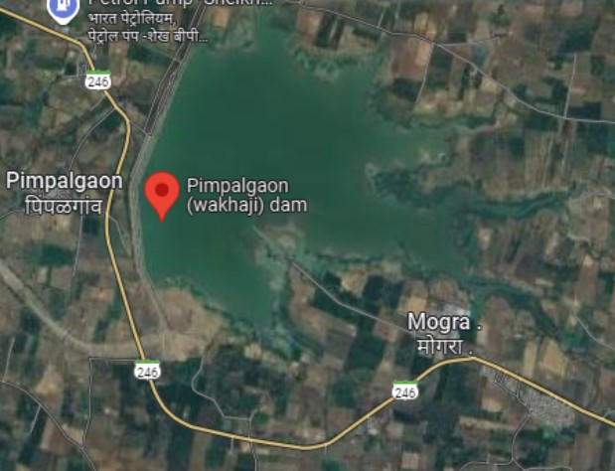
(A) (B)
Figure 1A. Geographical map showing the location (symbol of heart) of Pimpalgaon (Wakhaji) Dam in Nagpur District, Maharashtra, India. Figure 1B. Satellite view showing Pimpalgaon (Wakhaji) Dam.
2.2 Sampling Design
Zooplankton samples were collected once every month from five pre-selected sampling stations in Pimpalgaon (Wakhaji) Dam over a period of one year from June,2023 to May,2024.The sampling stations were selected to represent different parts of the reservoir and to account for spatial variation in the zooplankton community.Sampling was carried out during the early morning hours (7:00 A.M. to 9:00 A.M) throughout the study period to maintain consistency in sampling time and minimize variation associated with the time of sampling.
2.3 Sampling Methodology
For zooplankton sampling, 50 L of surface water was filtered through standard plankton net with a mesh size of 62 µm. The concentrated zooplankton collected in the collection bottle attached to the end of the net was carefully transferred into labelled sampling bottles. The samples were preserved immediately 4 % formalin for proper laboratory analysis. Qualitative analysis was performed for the identification and documentation of zooplankton taxa. The qualitative analysis of zooplankton carried out using standard procedures and keys described in the available literature of Michael and Sharma (1988), Battish (1992) and Manickam et al. (2019).
3. results and discussion
During the one year study period, the zooplankton assemblage recorded from Pimpalgaon (Wakhaji) Dam comprised 26 identified taxa, distributed among three major groups, namely Rotifera, Cladocera and Copepoda. Rotifera constituted the largest component of the recorded assemblage with 11 taxa (42.31%). The rotifer assemblage included Brachionus forficula, Brachionus caudatus, Brachionus diversicornis, Brachionus falcatus, Brachionus calyciflorus, Brachionus plicatilis, Asplanchna sp., Monostyla sp., Keratella tropica, Filinia opoliensis and Filinia longiseta. Cladocera represented the second major group, comprising 9 taxa (34.62%). The recorded cladocerans were Diaphanosoma sarsi, Ceriodaphnia cornuta, Ceriodaphnia reticulata, Moina brachiata, Moina micrura, Moina macrocopa, Bosmina longirostris, Chydorus sphaericus and Macrothrix goeldii. The presence of representatives belonging to several cladoceran genera indicates a comparatively diverse branchiopod component within the zooplankton assemblage.Copepoda accounted for 6 recorded forms (23.08%), including Mesocyclops leuckarti, Eucyclops agilis, Nauplius, Thermocyclops hyalinus, Cyclops scutifer and Cyclops vernalis. Thus, copepods formed the smallest proportion of the photographed and identified zooplankton assemblage during the study period.Overall, the group-wise composition showed a predominance of Rotifera (42.31%), followed by Cladocera (34.62%) and Copepoda (23.08%) (Fig.5). The photographic record therefore indicates that rotifers contributed the largest share of the observed taxonomic assemblage, while copepods constituted the comparatively smaller component.
3.1 Taxonomic composition and representation of major groups
The proportions reported here express the percentages of recorded taxonomic forms within the 26-item inventory; they are not estimates of relative individual abundance or biomass. Such distinctions matter because both species composition and quantitative structure are used in published zooplankton assessment frameworks, and taxon richness alone does not establish trophic status (Ochocka, 2021; Pinel-Alloul et al., 2022; Qi et al., 2025).
The occurrence of rotifers, cladocerans and copepods is consistent with the broad taxonomic organization reported in other freshwater investigations. However, their relative representation differs among water bodies, and these contrasts should not be interpreted as evidence of differences in water quality without comparable sampling effort and physicochemical measurements (Branco et al., 2002; Banerjee et al., 2022; Qi et al., 2025).
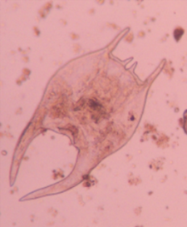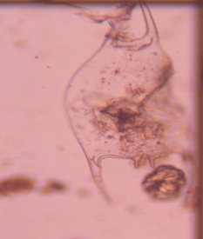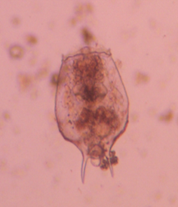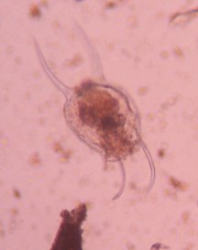
a) b) c) d)

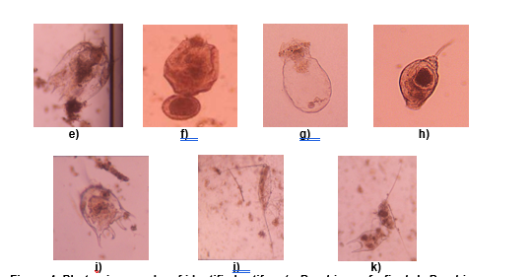
Figure 4. Photomicrographs of identified rotifers (a-Brachionus forficula,b-Brachionus diversicornis, c-Brachionus caudatus, d-Brachionus falcatus, e- Brachionus calyciflorus, f-Brachionus plicatilis, g- Asplanchna sp. h- Monostyla sp. i) Keratella tropica, j- Filinia opoliensis, k- Filinia longiseta recorded from Pimpalgaon (Wakhaji) dam.
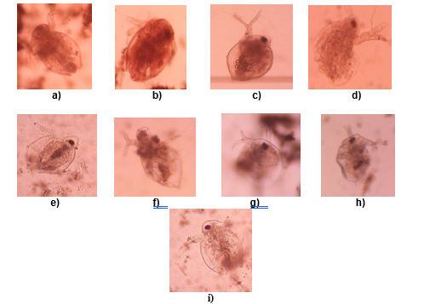
Figure 2. Photomicrographs of identified cladoceran (a-Diaphanosoma sarsi,b- Ceriodaphnia cornuta,c- Ceriodaphnia reticulata,d- Moina brachiata,e-Moina micrura,f- Moina macrocopa, g- Bosmina longirostris, h- Chydorus sphaericus,i-Macrothrix goeldii recorded from Pimpalgaon (Wakhaji) dam.
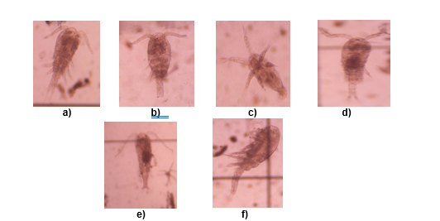 Figure 3. Photomicrographs of identified copepods (a- Mesocyclops leuckarti ,b- Eucyclops agilis,c-Nauplius,d-Thermocyclops hyalinus,e-Cyclops scutifer ,f- Cyclops vernalis recorded from Pimpalgaon (Wakhaji) dam.
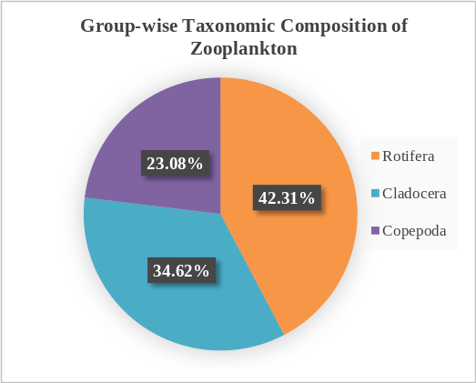
Figure 5. Group-wise taxonomic composition of Zooplankton

The present qualitative assessment recorded a diverse assemblage of zooplankton from Pimpalgaon (Wakhaji) Dam during the one year study period. The recorded assemblage included members of Rotifera, Cladocera and Copepoda. Rotifera formed the largest group with 11 recorded taxa followed by Cladocera with 9 taxa and Copepoda with 6 taxa. The higher representation of rotifers suggests that this group formed an important component of the zooplankton community during the study period. The occurrence of several genera such as Brachionus, Keratella and Filinia also shows that the reservoir supported a range of rotifer forms with different ecological characteristics.The present findings show some similarity with earlier studies from freshwater reservoirs and lakes. Goswami (2018), Anita et al. (2019) and Gadekar (2020) also reported the presence of rotifers such as Brachionus and Keratella together with cladocerans and copepods in freshwater ecosystems. Similar records were also reported by Sitre (2014) from Naik Lake. The repeated occurrence of these groups across different freshwater habitats indicates that Rotifera, Cladocera and Copepoda form an important part of zooplankton communities in tropical freshwater ecosystems. The occurrence of genera such as Brachionus, Keratella, Filinia, Daphnia, Moina, Ceriodaphnia, Mesocyclops and Eucyclops in the present study also shows that the reservoir provides suitable conditions for different zooplankton groups. Similar genera have been reported from Chankapur Dam, Nagaral Dam, Kalisarar Dam, Naik Lake and other freshwater habitats studied by earlier workers. However, the exact combination of taxa differs among these water bodies. This difference may be related to local environmental conditions and the seasonal nature of zooplankton occurrence. The occurrence of genera such as Brachionus, Keratella, Filinia, Daphnia, Moina, Ceriodaphnia, Mesocyclops and Eucyclops in the present study also shows that the reservoir provides suitable conditions for different zooplankton groups. Similar genera have been reported from Chankapur Dam, Nagaral Dam, Kalisarar Dam, Naik Lake and other freshwater habitats studied by earlier workers. However, the exact combination of taxa differs among these water bodies. This difference may be related to local environmental conditions and the seasonal nature of zooplankton occurrence.The present study also recorded members of different functional groups within the zooplankton community. Rotifers included several species of Brachionus, Keratella and Filinia. Cladocerans were represented by genera such as Moina, Ceriodaphnia, Bosmina, Chydorus and Diaphanosoma. Copepods included Mesocyclops, Eucyclops, Thermocyclops and Cyclops. The presence of these different taxa indicates that the zooplankton community was not restricted to a single taxonomic group. Overall, the present study indicates that Pimpalgaon (Wakhaji) Dam supports a varied zooplankton assemblage represented by Rotifera, Cladocera and Copepoda. The dominance of Rotifera in terms of recorded taxa followed by Cladocera and Copepoda was the main pattern observed during the study period. The similarity of several recorded genera with those reported from other freshwater ecosystems supports the general importance of these groups in freshwater zooplankton communities.Hence, the present study indicates that Pimpalgaon (Wakhaji) Dam supports a varied zooplankton assemblage represented by Rotifera, Cladocera and Copepoda. The dominance of Rotifera in terms of recorded taxa followed by Cladocera and Copepoda was the main pattern observed during the study period. The similarity of several recorded genera with those reported from other freshwater ecosystems supports the general importance of these groups in freshwater zooplankton communities.
3.2 Ecological interpretation and comparison with previous studies
A higher proportion of rotifer taxa in a qualitative inventory does not demonstrate that rotifers were numerically dominant or that the reservoir was eutrophic. Published indicator studies generally examine community abundance, species responses or multimetric indices alongside physicochemical data when interpreting trophic conditions (Branco et al., 2002; Ochocka, 2021; Qi et al., 2025). Therefore, the present findings should be understood primarily as documentation of the detected taxa rather than a stand-alone water-quality diagnosis.
Investigations of freshwater reservoirs also describe spatial and temporal changes in zooplankton composition. In Bakreswar Reservoir, for example, assemblage patterns differed among sampling periods and stations, while analyses across shallow Yangtze lakes identified associations with temperature, chlorophyll a, water transparency and nutrient-related variables (Banerjee et al., 2022; Qi et al., 2025). These studies provide possible ecological contexts for the variation discussed here but do not establish the specific environmental drivers operating in Pimpalgaon (Wakhaji) Dam.
3.3 Interpretation limits and implications for future monitoring
The reported material was obtained through surface-water filtration with a 62-µm mesh and qualitative identification. Consequently, some smaller organisms or developmental stages may be underrepresented, and the numbers of identified forms cannot be treated as estimates of density. A more comprehensive assessment would quantify organisms by sampling station and month, document sampling effort and identification resolution, and relate assemblage data to contemporaneous environmental measurements (Ochocka, 2021; Pinel-Alloul et al., 2022; Banerjee et al., 2022).
Combined taxonomic, functional and environmental information can improve comparative interpretation of lake assemblages, whereas the present inventory provides a useful but more limited reference point for subsequent surveys (Pinel-Alloul et al., 2022; Ochocka, 2021; Qi et al., 2025). Repeated monitoring could determine whether the observed richness distribution persists and whether composition changes are associated with seasonal hydrology or reservoir conditions.
6. CONCLUSION
The one year qualitative record demonstrates that the zooplankton community of Pimpalgaon (Wakhaji) Dam was composed of representatives of three major freshwater zooplankton groups. Rotifera showed the highest taxonomic representation, followed by Cladocera and Copepoda, indicating a community in which small-bodied rotifers formed the dominant component of the recorded assemblage. The occurrence of diverse cladoceran genera further suggests a well-represented branchiopod component, whereas the comparatively lower representation of copepods may reflect differences in their occurrence during the study period. Overall, the recorded assemblage reflects a taxonomically diverse freshwater zooplankton community comprising multiple rotifer,cladoceran and copepod forms.

10. CONSENT
Both authors have read and approved the final version of the manuscript and consent to its publication.

Declaration of AI Use

This manuscript was prepared through the intellectual contributions of the author(s) to the study design, data analysis, interpretation of results, and scholarly content. Grammarly and ChatGPT were used solely to assist with grammatical refinement and reference formatting during manuscript revision. The author(s) accept full responsibility for the accuracy, integrity, and final content of the manuscript.

COMPETING INTERESTS DISCLAIMER:
Authors have declared that they have no known competing financial interests OR non-financial interests OR personal relationships that could have appeared to influence the work reported in this paper.

References
Anita, S. M., Hatti, S. S., Majagi, S. & Chitra, J. (2019).Assessment of zooplankton diversity of Nagaral Dam, Chincholli, Kalaburagi.Research Journal of Life Sciences, Bioinformatics, Pharmaceutical and Chemical Sciences, 5(2), 269–281.
APHA.(1999).Standard Methods of water examination and waste water (20th edition). Washington D.C, American Public Health Association.
Battish S.K.(1992).Freshwater zooplankton of India New Delhi: Oxford & IBH Publishing Company.
Bozkurt, A. & Kara, B. (2020).Zooplankton fauna of Demrek Dam Lake (Kırıkhan, Hatay). LimnoFish: Journal of Limnology and Freshwater Fisheries Research, 6(3), 189–200.
Gadekar, G. P. (2020).Variation in zooplankton diversity of Kalisarar Dam of Gondia District, Maharashtra.International Journal for Environmental Rehabilitation and Conservation, 11(SP2), 48–53. https://doi.org/10.11208/essence.20.11.SP2.126
Goswami, D. B. (2018).Diversity of zooplankton from Chankapur Dam, Kalwan, Nashik (MS). International Journal of Creative Research Thoughts, 6(2), 588–590.
Manickam,N.S. & Bhavan,P.S.(2019).Techniques in the collection, preservation and morphological identification of freshwater zooplankton. Basic and Applied Zooplankton Biology,1(1),139-196.
Michael,R.G. & Sharma,B.K.(1998).Fauna of India and adjacent countries: Indian Cladocera (Crustacea:Branchiopoda:Cladocera). Zoological Survey of India.
Mohan, B. & Priyadarshinee, S. (2022). A study on the diversity and community structure of freshwater zooplankton and ichthyofaunal in Kumaraswamy Lake,Coimbatore district, Tamil Nadu, India. Journal of Materials and Environmental Science, 13(11), 1327–1338.
Reddy, M. T.,Sivaraj, N., Kamala, V., Pandravada, S. R., Sunil, N. & Dikshit, N. (2018). Classification, characterization and comparison of aquatic ecosystems in the landscape of Adilabad District, Telangana, Deccan Region, India. Open Access Library Journal, 5, e4459. https://doi.org/10.4236/oalib.1104459
Shah, J. A., Pandit, A. K. & Shah, G. M. (2014).A research on rotifers of aquatic ecosystems of Kashmir Himalaya for documentation and authentication. Proceedings of the National Academy of Sciences, India, Section B: Biological Sciences,85(1), 13–19. https://doi.org/10.1007/s40011-014-0334-7
Singh, U. B., Ahluwalia, A. S., Sharma, C.,Jindal, R. & Thakur, R. K. (2013). Planktonic indicators: A promising tool for monitoring water quality (early-warning signals).Eco. Env. & Cons.,19(3), 793–800.
Sitre, S. R. (2014). Zooplankton fauna assessment of Naik Lake of Nagpur City (M.S.) India. Online International Interdisciplinary Research Journal, 4(2), 118–123.
Tugyan, C. & Bozkurt, A. (2019). A study on zooplankton fauna and some water quality parameters of Kozan Dam Lake (Adana, Turkey). LimnoFish: Journal of Limnology and Freshwater Fisheries Research, 5(3), 147–158. https://doi.org/10.17216/LimnoFish.538344
Turhan, D. & Gokçe, D. (2022).Temporal and spatial variations of zooplankton community and biochemical response due to water quality in a deep dam lake (Turkey). International Journal of Pure and Applied Sciences, 8(1), 179–194.
Ulgu, M. & Bozkurt, A. (2015). Zooplankton fauna of Tahtakopru Dam Lake (Gaziantep). International Journal of Scientific and Technological Research, 1(1), 202–210.
Banerjee, A., Rakshit, N., Chakrabarty, M., Sinha, S., Ghosh, S., & Ray, S. (2022). Zooplankton community of Bakreswar reservoir: Assessment and visualization of distribution pattern using self-organizing maps. Ecological Informatics, 72, 101837. https://doi.org/10.1016/j.ecoinf.2022.101837
Branco, C. W. C., Rocha, M.-I. A., Pinto, G. F. S., Gômara, G. A., & De Filippo, R. (2002). Limnological features of Funil Reservoir (R.J., Brazil) and indicator properties of rotifers and cladocerans of the zooplankton community. Lakes & Reservoirs: Research & Management, 7(2), 87–92. https://doi.org/10.1046/j.1440-169X.2002.00177.x
Ochocka, A. (2021). ZIPLAₛ: Zooplankton Index for Polish Lakes’ Assessment: A new method to assess the ecological status of stratified lakes. Environmental Monitoring and Assessment, 193, Article 664. https://doi.org/10.1007/s10661-021-09390-7
Pinel-Alloul, B., Chemli, A., Taranu, Z. E., & Bertolo, A. (2022). Using the diversity, taxonomic and functional attributes of a zooplankton community to determine lake environmental typology in the natural southern boreal lakes (Québec, Canada). Water, 14(4), Article 578. https://doi.org/10.3390/w14040578
Qi, J., Wang, Y., Yuan, J., Liao, C., Liu, J., & Guo, C. (2025). Variations of zooplankton community as bioindicators of eutrophication and water quality in shallow Yangtze Lakes. Limnologica, 112, 126248. https://doi.org/10.1016/j.limno.2025.126248

