Macro Anatomy and Biometry of Pelvic girdle, Synsacrum, Pygostyle, sternum and Ribs of Himalayan Griffon Vulture (Gyps himalayensis)

Abstract
The Himalayan griffon vulture (Gyps himalayensis) is an Old World vulture. The present study was conducted on pelvic girdle, synsacrum, pygostyle, sternum and ribs of three numbers of Himalayan griffon vulture. The synsacrum was complex and elongated structure which one was formed by the fusion of last thoracic vertebrae, lumber vertebrae with the sacrum and first coccygeal vertebrae. The synsacrum was firmly attached to the ilia of pelvic girdle The fusion was so extensive that was very difficult to identify the individual vertebrae in an adult skeleton. Pelvic girdle of Himalayan griffon vulture consisted of two numbers of hip bone. Each hip bone composed of three numbers of bone viz., ilium, ischium and pubis. Ilium was elongated bone and it was situated on the dorsal aspect of the synsacrum. Ilium was further divided into two parts viz., pre acetabular part and post acetabular parts. The pre acetabular parts dorsally concave. It contained cranial and caudal iliac crest. Ischium was platelike bone and located ventral aspect of the ilium. Ilium and ischium form acetabulum. Acetabulum had articular area and perforation. An elongated obturator foramen was also observed ventral to the acetabulum. Apart from that structure an elongated oval shaped iloischiatic foramen also noticed caudal aspect of the acetabulum. The pubis was rodlike bone and situated ventral aspect ischium bone. The pygostyle of Himalayan griffon vulture was formed by the fusion of last eight numbers of coccygeal vertebrae. The last segment of the pygostyle was hook like. The sternum was Himalayan griffon vulture was broad, pneumatic, large and rectangular in shaped bone. It had two surface i.e. dorsal and ventral. The dorsal surface was highly concave and contained pneumatic foramen whereas the ventral surface was convex. The ventral surface contained triangular sternal crest. It had also three numbers of borders i.e. cranial, caudal and lateral borders. The cranial border was straight and contained a deep groove and sternal spine. The sternal spine was thick and prismatic. It arose from the ventral edge of the cranial border. The caudal border contained a triangular projection and completely undivided. The lateral border contained five numbers of articular cylinder along with pneumatic foramen. The antero-lateral process was short and thin whereas postero-lateral joined with the caudal narrow part of the sternum and enclosed a large oval foramen. The ribs of Himalayan griffon vulture composed of vertebral and sternal extremities. The vertebral extremities contained well developed long head, neck and tubercle. The lateral surface of the ribs was convex and the medial surface of the ribs was concave. The cranial border presented a groove whereas the caudal border presented a well-developed uncinate process.
Key words: Macro, Anatomy, Pelvic girdle, Synsacrum, Pygostyle, sternum and Ribs of Himalayan Griffon Vulture
Introduction:
The Himalayan griffon vulture (Gyps himalayensis) is an Old World vulture. It plays a crucial role maintain the ecosystem of the environment because it is considered as the scavenger birds of the ecosystem. They are distributed in the Himalayas, and foothills in North and Northeastern India as well as the adjacent Tibetan Plateau. It is world’s largest true raptors among the old world’s vulture. As per the IUCN Red list, it is considered as Near Threatened (Birdlife International ,2017). The population of Himalayan griffon vulture is decline due to diclofenac. Apart from this, the population is also decline due to reduction of nesting trees and habitat loss. The study of pelvic girdle, synsacrum, pygostyle, sternum and ribs of Himalayan vulture have great value to the wildlife veterinarian and students of biological science in diseases control regime as well as conservation of the Himalayan griffon vulture. Since there is very scanty literature on the pelvic girdle, synsacrum, pygostyle, sternum and ribs of Himalayan vulture, hence the present study was designed to established an anatomical norm being a near threatened species.
Materials and Methods:
The present study was conducted on pelvic girdle, synsacrum, pygostyle, sternum and ribs of three numbers of Himalayan griffon vulture (Fig.1). After death of three numbers of Himalayan griffon vulture, the vulture was brought to the Department of the Anatomy & Histology, College of Veterinary Science, Assam Agricultural University, Khanapara, Guwahati, Assam by Bombay Natural History Society, -Vulture Conservation Breeding Centre, Belguri, Rani, Kamrup, Assam. Then, the skeleton of Himalayan griffon vulture was processed as per the standard methods of Young (1980). After processing the pelvic girdle, synsacrum, pygostyle, sternum and ribs was removed and macro anatomical study were made on it.
Results:
The current study was conducted on pelvic girdle, synsacrum, pygostyle, sternum and ribs of three numbers of Himalayan griffon vulture. The synsacrum was complex as well as elongated structure. It was formed by the fusion of last thoracic vertebrae, lumber vertebrae, sacrum and first coccygeal vertebrae. The synsacrum was firmly attached to the ilia of the pelvic girdle. The fusion of synsacrum was so extensive that was very difficult to identify the individual vertebrae in an adult skeleton. Pelvic girdle of Himalayan griffon vulture consisted of two numbers of hip bone. Each hip bone composed of three numbers of bone viz., ilium, ischium and pubis. Ilium was elongated bone and it was situated on the dorsal aspect of the synsacrum. Ilium was further divided into two parts viz., pre acetabular part and post acetabular parts (Fig.2). The pre acetabular parts dorsally concave. It contained cranial and caudal iliac crest. The ventral surface of ilium presented fossa renalis. Ischium was platelike bone and located ventral aspect of the ilium (Fig.3). Ilium and ischium form acetabulum. Acetabulum had articular area and perforation. An anti-trochanter was noticed caudo-dorsal aspect of the acetabulum. An elongated obturator foramen was also observed ventral to the acetabulum. The size of the obturator foramen was smaller than the acetabulum. Apart from that structure an elongated oval shaped Ilo ischiatic foramen also noticed caudal aspect of the acetabulum (Fig.4). Among those foramen ilioischiatic foramen was largest in Himalayan griffon vulture. The pubis was rodlike bone and situated ventral aspect ischium bone. The caudal part of pubic bone was curve. The pygostyle of Himalayan griffon vulture was formed by the fusion of last eight numbers of coccygeal vertebrae. The supraspinous process of the coccygeal vertebrae was directed in upward direction whereas the transverse process was directed in downward direction. The last vertebra of the pygostyle was hook like. The sternum was Himalayan griffon vulture was broad, pneumatic, large and rectangular in shaped bone. It had two surface i.e. dorsal and ventral. The dorsal surface was highly concave and contained pneumatic foramen whereas the ventral surface was convex (Fig.5). The ventral surface contained triangular sternal spine (Fig.6). The sternum had also three numbers of borders i.e. cranial, caudal and lateral borders. The cranial border was straight and it contained a deep groove and sternal spine. The sternal spine was thick and prismatic. It arose from the ventral edge of the cranial border. The caudal border contained a triangular projection and completely undivided. The lateral border contained five numbers of articular cylinder along with pneumatic foramen. The antero-lateral process was short and thin whereas the postero-lateral process joined with the caudal narrow part of the sternum and enclosed a large oval foramen. The ribs of Himalayan griffon vulture composed of vertebral and distal extremities. The vertebral extremities contained well developed long head, neck and tubercle (Fig.7). The sternal extremities were blunt. The lateral surface of the ribs was convex and the medial surface of the ribs was concave. The cranial border presented a groove whereas the caudal border presented a well-developed uncinate process.
The length and breadth of ilium were 16.2 ± -0.23 cm and 8.23 ±4.25 cm, respectively whereas the length and breadth of ischium were 6.4 ±0.98 cm and 3.3±0.83 cm, respectively. The length and breadth of pubis bone were 13.5±0.45 cm and 0.4±0.24 cm, respectively. The length of pygostyle and synsacrum as well as depth of fossa renalis were 8.6± 0.32 cm and 21.5 ± 0.35 as well as 2.5 ±2.13 cm, respectively. The diameter of ilioischiatic foramen, acetabulum and obturator foramen were 10.6±1.24 cm, 5.9 ±0.47 cm and 4.8±1.36 cm, respectively. The length and breadth of sternum were 17.9 ±2.57 cm and 8.8 ±0.98 cm, respectively. The length and breadth of sternal spine were 13.2 ±0.36 cm and2.2 ±0.24 cm, respectively. The length and breadth of ribs were 9.1 ±0.37 cm and 0.5±2.46 cm, respectively. The length of uncinate process was 3.4±1.26 cm (Table.1).
Discussions:
The current study was conducted on pelvic girdle, synsacrum, pygostyle, sternum and ribs of three numbers of Himalayan griffon vulture. The synsacrum was complex as well as elongated structure. It was formed by the fusion of last thoracic vertebrae, lumber vertebrae, sacrum and first coccygeal vertebrae. Similar finding was reported by Mehata et al., (2014) in Japanese quail. The synsacrum was firmly attached to the ilia of the pelvic girdle. These findings were total agreement with the findings of Raghavan and Kachroo (1964) in fowl. The fusion of synsacrum was so extensive that was very difficult to identify the individual vertebrae in an adult skeleton. Pelvic girdle of Himalayan griffon vulture consisted of two numbers of hip bone. Each hip bone composed of three numbers of bone viz., ilium, ischium and pubis. Ilium was elongated bone and it was situated on the dorsal aspect of the synsacrum. Ilium was further divided into two parts viz., pre acetabular part and post acetabular parts. These findings were in accordance with the findings of Venkatesan et al., (2008) in Emu.The pre acetabular parts dorsally concave. It contained cranial and caudal iliac crest. The ventral surface of ilium presented fossa renalis. Similar findings were reported by Sathyamoorthy et al., (2012) in Spot-Billed Pelicans. Ischium was platelike bone and located ventral aspect of the ilium. Ilium and ischium form acetabulum. Acetabulum had articular area and perforation. An anti-trochanter was noticed caudo-dorsal aspect of the acetabulum. An elongated obturator foramen was also observed ventral to the acetabulum. The size of the obturator foramen was smaller than the acetabulum. Apart from that structure an elongated oval shaped Ilo ischiatic foramen also noticed caudal aspect of the acetabulum. The size of ilioischiatic foramen was much larger than the obturator foramen. Similar observation was reported by King and Mclelland (1975) in fowl. Among those foramen ilioischiatic foramen was largest in Himalayan griffon vulture. The pubis was rodlike bone and situated ventral aspect ischium bone. These findings were corroborated with the findings of Nickel et al., (1977) in fowl. The caudal part of pubic bone was curve. The pygostyle of Himalayan griffon vulture was formed by the fusion of last eight numbers of coccygeal vertebrae. The supraspinous process of the coccygeal vertebrae was directed in upward direction whereas the transverse process was directed in downward direction. The last vertebra of the pygostyle was hook like. The sternum was Himalayan griffon vulture was broad, pneumatic, large and rectangular in shaped bone. These findings were in accordance with the findings of Sathyamoorthy et al., (2012) in White-Rumped vultures. It had two surface i.e. dorsal and ventral. The dorsal surface was highly concave and contained pneumatic foramen whereas the ventral surface was convex. The ventral surface contained triangular sternal crest. The sternum had also three numbers of borders i.e. cranial, caudal and lateral borders. The cranial border was straight and it contained a deep groove and sternal spine. The sternal spine was thick and prismatic. It arose from the ventral edge of the cranial border. The caudal border contained a triangular projection and completely undivided as in the ostriches (Bezuidenhout,1986). The lateral border contained five numbers of articular cylinder along with pneumatic foramen. The antero-lateral process was short and thin whereas the postero-lateral process joined with the caudal narrow part of the sternum and enclosed a large oval foramen. The ribs of Himalayan griffon vulture composed of vertebral and distal extremities. The vertebral extremities contained well developed long head, neck and tubercle. The sternal extremities were blunt. The lateral surface of the ribs was convex and the medial surface of the ribs was concave. The cranial border presented a groove whereas the caudal border presented a well-developed uncinate process. Similar observations were reported by Sathyamoorthy et al., (2012) in White-Rumped vultures.
The length and breadth of ilium were 16.2 ± -0.23 cm and 8.23 ±4.25 cm, respectively whereas the length and breadth of ischium were 6.4 ±0.98 cm and 3.3±0.83 cm, respectively. The length and breadth of pubis bone were 13.5±0.45 cm and 0.4±0.24 cm, respectively. The length of pygostyle and synsacrum as well as depth of fossa renalis were 8.6± 0.32 cm and 21.5 ± 0.35 as well as 2.5 ±2.13 cm, respectively. The diameter of ilioischiatic foramen, acetabulum and obturator foramen were 10.6±1.24 cm, 5.9 ±0.47 cm and 4.8±1.36 cm, respectively. The length and breadth of sternum were 17.9 ±2.57 cm and 8.8 ±0.98 cm, respectively. The length and breadth of sternal spine were 13.2 ±0.36 cm and2.2 ±0.24 cm, respectively. The length and breadth of ribs were 9.1 ±0.37 cm and 0.5±2.46 cm, respectively. The length of uncinate process was 3.4±1.26 cm. Deshmukh (2016) reported that the pre acetabular part of ilium had maximum length in peacock was 7.5 ± 0.058 cm while in peahen it was 8 ± 0.058 cm. The post acetabular part had maximum length in peacock and peahen i.e. 5.0 ± 0.058 cm and 5.4 ± 0.058 cm, respectively. It might be due to species difference.
Summary and Conclusions:
In present investigation, it was observed that the synsacrum of Himalayan griffon vulture was complex and elongated structure. It was formed by the fusion of last thoracic vertebrae, lumber vertebrae with the sacrum and first coccygeal vertebrae. Pelvic girdle of Himalayan griffon vulture consisted of two numbers of hip bone. Each hip bone composed of three numbers of bone viz., ilium, ischium and pubis. Ilium was elongated bone and it was situated on the dorsal aspect of the synsacrum. Ischium was platelike bone and located ventral aspect of the ilium. The pubis was rodlike bone and situated ventral aspect ischium bone. The pygostyle of Himalayan griffon vulture was formed by the fusion of last eight numbers of coccygeal vertebrae. The last segment of the pygostyle was hook like. The sternum was Himalayan griffon vulture was broad, pneumatic, large and rectangular in shaped bone. It had two surface i.e. dorsal and ventral. The dorsal surface was highly concave and contained pneumatic foramen whereas the ventral surface was convex. The ventral surface contained triangular sternal spine. It had also three numbers of borders i.e. cranial, caudal and lateral borders. The ribs of Himalayan griffon vulture composed of vertebral and distal extremities. The vertebral extremities contained well developed long head, neck and tubercle. The lateral surface of the ribs was convex and the medial surface of the ribs was concave. The cranial border presented a groove whereas the caudal border presented a well-developed uncinate process. The study of pelvic girdle, synsacrum, pygostyle, sternum and ribs of Himalayan vulture have great value to the wildlife veterinarian and students of biological science in diseases control regime as well as conservation of the Himalayan griffon vulture.

Declaration of AI Use

This manuscript was prepared through the intellectual contributions of the author(s) to the study design, data analysis, interpretation of results, and scholarly content. Grammarly and ChatGPT were used solely to assist with grammatical refinement and reference formatting during manuscript revision. The author(s) accept full responsibility for the accuracy, integrity, and final content of the manuscript.

COMPETING INTERESTS DISCLAIMER:
Authors have declared that they have no known competing financial interests OR non-financial interests OR personal relationships that could have appeared to influence the work reported in this paper.

Reference:
King, A.S. and McLelland, J. (1975). Outline of Avian Anatomy.Bailler Tindall, London,6th Edn., p.18.
Nickel, R., Schummer, A. and Seiferle, E. (1977). Anatomy of the Domestic Birds. Verlag Paul Parey, Berlin, Hamburg, pp.16-17.
Raghavan, D.and Kachroo, P. (1964). Anatomy of Ox. Indian Council of Agricultural Research, New Delhi, pp.140.
Sathyamoorthy, O.R., Thirumurugan, R., Kumar, K.S.and Jayathangaraj, M.G. (2012). Gross morphological studies on the pelvic gridle of Spot-Biled Pelicans (Pelecanus philippensis). Indian Journal of Veterinary Anatomy,24(2):109-110.
Venkatesan, S., Muthukrishnan, S., Basha, S.H., Kannan, T.A. and Ramesh, G. 2008. Gross Anatomy of the pelvic girdle of Emu. Indian Veterinary Journal, 85: 1094-1096.
Mehta, S., Guha, K., Shalini, S. and Kumar, C. (2014). Gross Anatomical Studies on the Os coxae and Synsacrum of Japanese Quail (Coturnix coturnix japonica). Indian Journal of Veterinary Anatomy.26(2):126-127.
Sathyamoorthy, O.R., Thirumurugan, R. and Rajan, M.P. (2012). Gross Anatomical studies on the sternum and Ribs of White-Rumped vultures (Gyps begalensis). Indian Journal of Veterinary Anatomy.24(2):106-108.
Bezuidenhout. A.J. (1986). The topography of the thoracoabdominal viscera in the ostrich. Ondestepoort Journal of Veterinary Research,53:111-117.
Deshmukh, S.K., Karmore, S.K., Gupta, S.K., Kodape, S. and Prakash,R. (2016). Comparative biometrical studies on the os coxae and synsacrum of Peacock and Peahen. Veterinary Practitioner, 17(1): pp. 41-42.

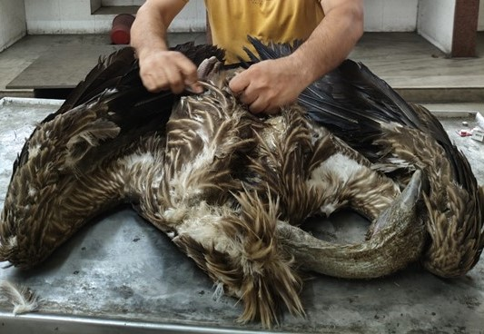
Fig.1: Photograph showing the Himalayan griffon vulture (Gyps himalayensis).

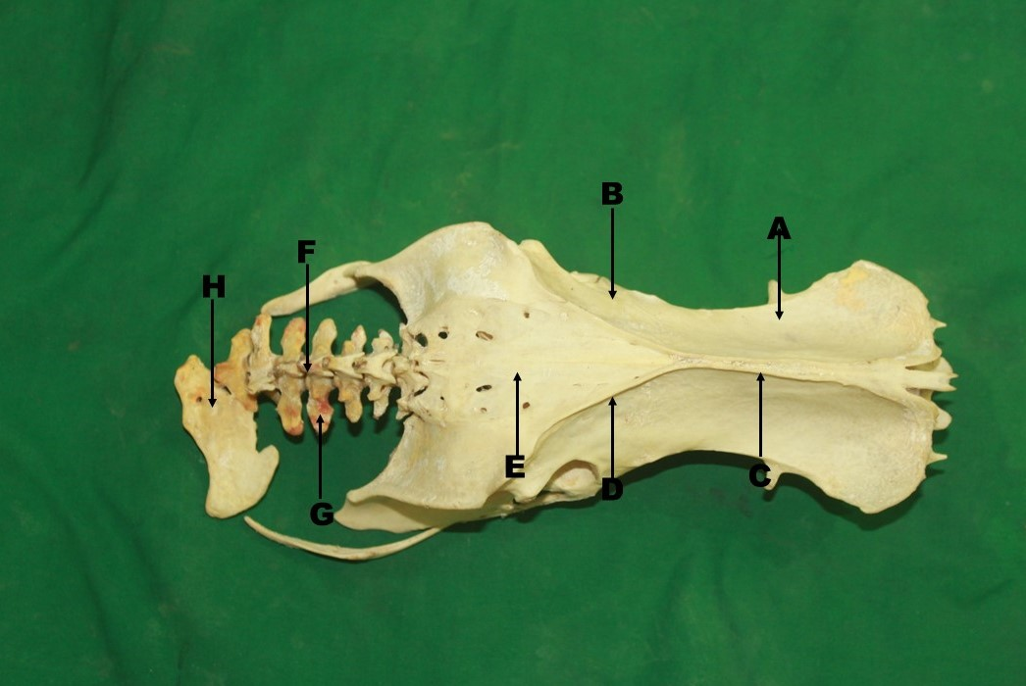
Fig.2: Photograph showing the preacetabular part (A), post acetabular part (B), cranial iliac crest (C) and caudal iliac crest (D) of ilium, Synsacrum (E), Supraspinous process (F), transverse process (G) and last vertebra (H) of Pygostyle of Himalayan griffon vulture (Gyps himalayensis).

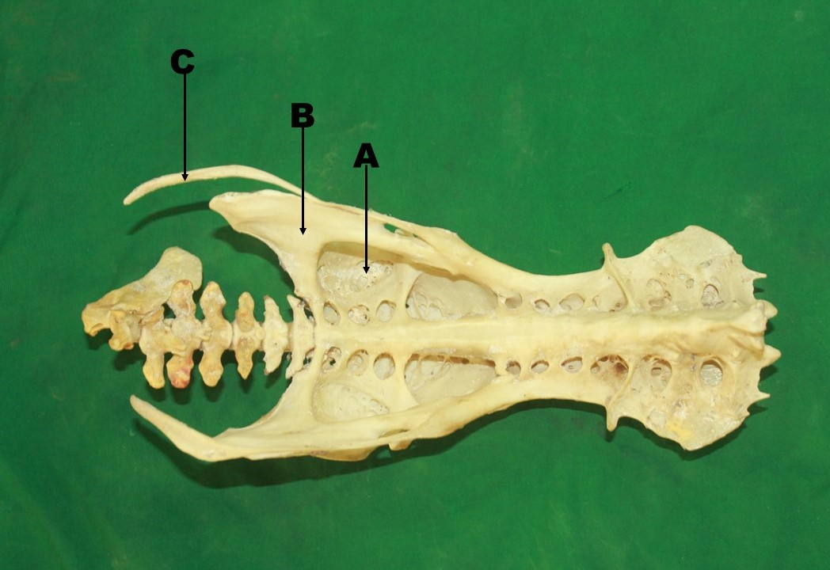
Fig.3: Photograph showing the fossa renalis (A) of ilium, ischium (B) and pubis (C) of Himalayan griffon vulture (Gyps himalayensis).

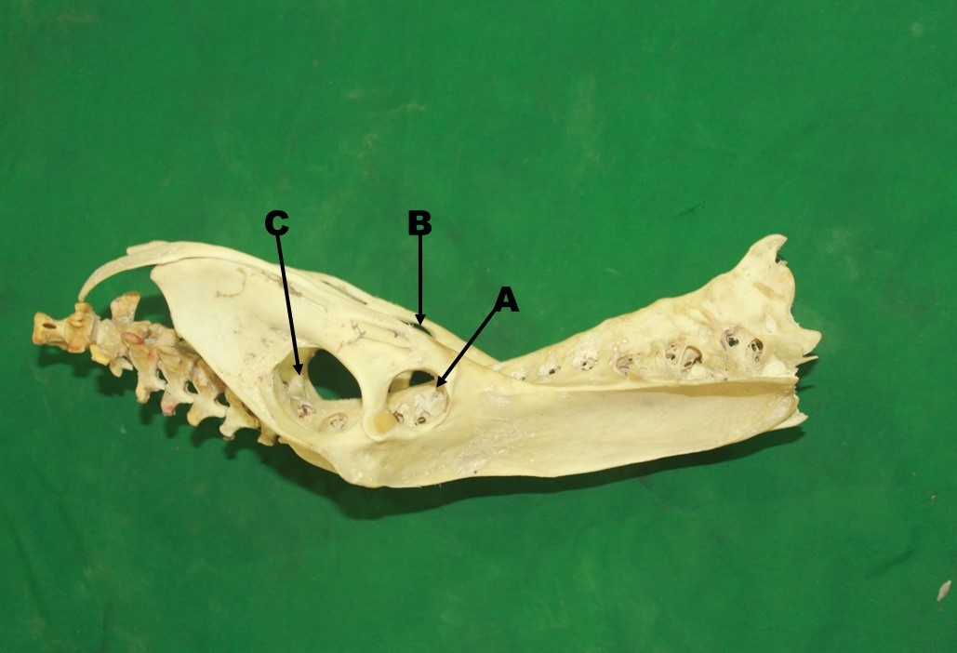
Fig.4: Photograph showing the acetabulum (A), obturator foramen (B) and ilioischiatic foramen (C) of pelvic girdle of Himalayan griffon vulture (Gyps himalayensis).

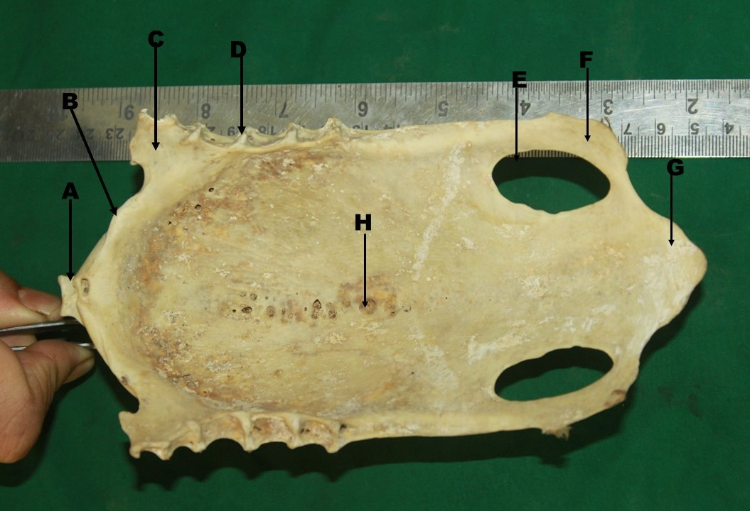
Fig.5: Photograph showing the sternal spine (A), Cranial border (B), Antero-lateral process (C), articular cylinder (D), large oval foramen (E), Postero-lateral process (F), triangular projection (G) and pneumatic foramen (H) of Himalayan griffon vulture (Gyps himalayensis).

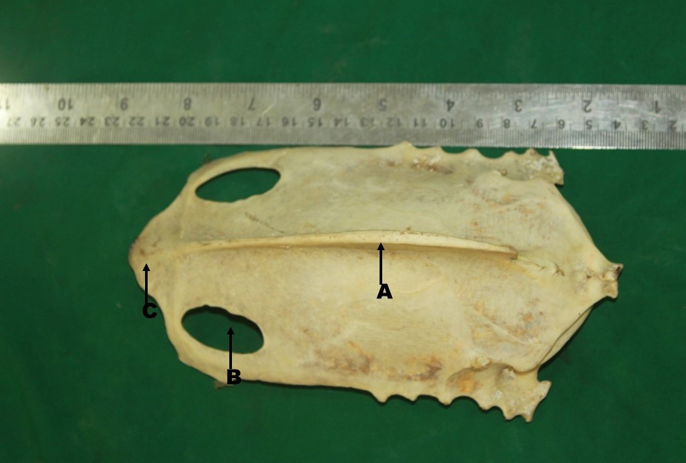
Fig.6: Photograph showing the sternal crest (A), large oval foramen (B) and triangular projection (C) of Himalayan griffon vulture (Gyps himalayensis).

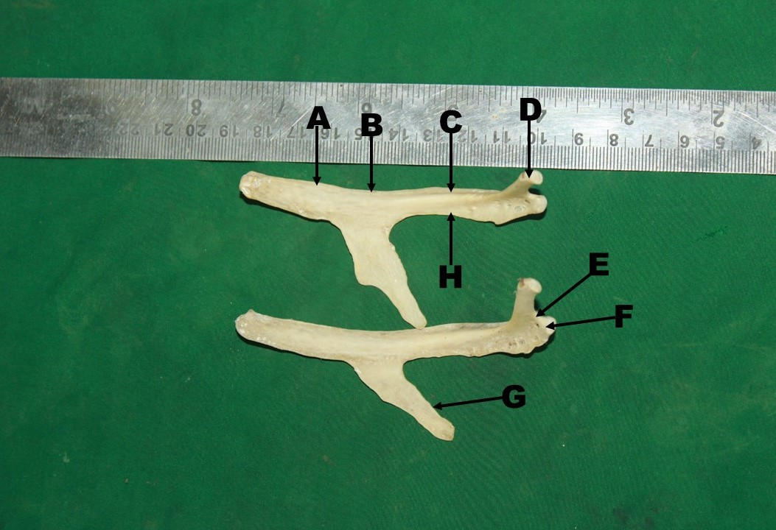
Fig.7: Photograph showing the medial surface (A), cranial border (B), groove (C), tubercle (D), neck (E), Head (F), Uncinate process (G) and caudal border (H) of Himalayan griffon vulture (Gyps himalayensis).

Table.1: Mean ±SE values of pelvic girdle, synsacrum, pygostyle, sternum and ribs of
Himalayan griffon vultures.
Parameters | Mean ± SE (Cm)
Length of ilium | 16.2 ± -0.23
Breadth of ilium | 8.23 ±4.25
Length of ischium | 6.4 ±0.98
Breadth of ischium | 3.3±0.83
Length of pubis | 13.5±0.45
Breadth of pubis | 0.4±0.24
Length of pygostyle | 8.6± 0.32
Length of synsacrum | 21.5 ± 0.35
Depth of fossa renalis | 2.5 ±2.13
Diameter of ilioischiatic foramen | 10.6±1.24
Diameter of acetabulum | 5.9 ±0.47
Diameter of obturator foramen | 4.8±1.36
Length of sternum | 17.9 ±2.57
Breadth of sternum | 8.8 ±0.98
Length of sternal spine | 13.2 ±0.36
Breadth of sternal spine | 2.2 ±0.24
Length of rib | 9.1 ±0.37
Breadth of rib | 0.5±2.46
Length of uncinate process | 3.4±1.26

