Original Research Article
Nesting habits of the Baya Weaver Ploceus philippinus (Linnaeus, 1766) in the agricultural landscape of Dharmabad, Nanded District, Maharashtra, India

.
ABSTRACT

The intricate nesting habits of Baya Weaver Ploceus philippinus were studied in the agricultural landscape of Dharmabad, Nanded district, Maharashtra between April and October 2026. This research is mainly on focuses on Baya Weaver nesting habits such as nesting sites, nesting colonies, nesting material, nest construction, nest repair, clay deposit on nest wall, various developmental stages of Nest and certain threats to their nest. A total of 70 nests of different developmental stages (wad stage, ring stage, helmet stage, egg-chamber closed stage and complete nest stage) were studied. Out of 70 nests, with 42 (60%) nests in active stage, 18 (25%) nests left abandoned and 10 (14%) nests fallen on the ground. The Baya Weaver uses leaf fibers of palm fronds (Indian date palm), sugarcane leaves, paddy leaves and coarse grasses as nest material and take average of 18 days ranging from 6-48 days depending on the environmental condition suitable for nest construction. Various Anthropogenic activities, environmental factors (monsoon rain, wind, temperature, humidity), natural predators such as crows, treepies raptors, snakes and lizards poses threats to Baya Weaver. Our research finding suggest that the Baya Weaver possess specific adaptations for nesting within these particular tree species like acacia, and various tall palm tree. The present study enhances the understanding of nesting habits of Baya Weaver and provides significant insight for the conservation of this species.

Keywords: Nesting site, nest colonies, nest development, nest material, nest repair, clay deposition, breeding habits, habitat, threats.

1. INTRODUCTION

Baya Weaver Ploceus philippinus (Linnaeus, 1766) is belongs to Class-Aves, Order-Passeriformes of family Ploceidae (Kalita et al., 2024). Baya Weavers are widely spread across the Indian Subcontinent and Southeast Asia (Pandian, 2024). It is non-migrant bird but shows local and seasonal movements in response to water and food availability (Quader, 2006). India is home for four species of Weaver birds belonging to the genus Ploceus – Ploceus philippinus (Baya Weaver), Ploceus manyar (Streaked Weaver), Ploceus benghalensis (Black-breasted Weaver) and Ploceus megarhynchus (Yellow Weaver) (Craig 2020). The Baya Weaver is a small, sparrow-sized weaver bird renowned for its elaborately woven nests constructed by the males thus, it is a true marvel of avian engineering (Quader, 2005). The Baya Weaver is a social, gregarious, polygynous and colonial breeder (Abdar, 2013). The breeding season of the Baya Weaver in India spans primarily from April to October, closely associate with the monsoon rains (Pandian, 2023).The Baya Weaver shows remarkable sexual dimorphism during breeding season (Singh & Dhand 2017). One of the most interesting behaviours of these birds is that the female chooses her mate based on the quality of nest build by male (Pandian, 2018). During courtship behaviour, male shows its nest to females by flapping its wings, invites females to inspects and probably occupy the nest (Pandian, 2022). After the inspection of nest, female give their acceptance towards male; after that, the male goes on to complete the nest by adding the entrance tunnel (Kalita et al., 2024).
The female lays about 2-4 white eggs and incubates them for about 15 to 18 days, males occasionally assist females in feeding the chicks and the chicks leave the nest after 18 days (Mahendra et al., 2024). In the non-breeding season, both males and females resemble as female House sparrows (Kumar, 2004).

The Baya Weaver commonly select habitats such as grasslands, agricultural landscape, scrub, and secondary growth (Asokan et al., 2008).They mostly prefer tall, unbranched palm trees, such as Date palm, coconut, and palmyra palm, as well as thorny trees like acacia tree species for constructing their pendulum nests (Thiruvenggadam et al., 2022). The nests are woven with long strips of paddy leaves, rough grasses, and long strips torn from palm fronds (Ramesh, 2019). Now a days Baya Weavers have adapted to modern life for building their nests in unconventional places such as on house caves, electric wires and poles (Pandian, 2022). This adaptability shows the resilience of the species in different habitats. The Baya Weaver is an omnivorous bird that primarily eats seeds and grains (granivores) of rice, wheat, sorgham, milket, maize, sunflower and also eats small insects (insectivores) grasshoppers, flies, beetles (Jha, 2021). The Nesting habits of Baya Weaver were studied by Abdar (2013), Craig (2020), Ramesh (2019), Jha (2021) and Shah (2023). Many researchers have studied breeding and nesting behavior of the Baya Weaver (Kumar 2004; Pandian 2023; Pandian 2024; Kalita et al., 2024; Mahendra 2024; Mallick 2025).

Baya Weaver are an essential part of the ecosystem, as they are involved in pollination of many flowers, seeds dispersal and controlling pest population (Mallick et al., 2025). However, they faces some threat such as human interference, habitat destruction, pollution, reduction of grass species use for nest-building material and foraging, climate change, shifting of weather patterns, rain timing and changing agricultural practices (Skagen & Adams, 2012). As a result, their distribution become fragmented and spotting of these birds become rare in the wild. According to IUCN Red List, the Baya Weaver is commonly widespread through Indian sub-continent and south-east Asia. This species is classified as Least Concern (LC) category and its population remains stable (BirdLife International. 2024). Many efforts are taken to conserve this species. Organizations like the Bombay Natural History Society (BNHS) (https://www.bnhs.org) and Salim Ali Centre for Ornithology and Natural History (SACON) have launched initiatives to protect their nesting sites.

No other detailed studies have been carried out on the Baya Weaver nesting habits in this region. To overcome this research gap, the present study was carried out.

Objectives:

- To study nesting habits, architectural behavior, and ecological adaptation of Baya Weaver.
- To know nest-building and courtship.
- To understand nest-site selection and habitat preference.
- To know different sources of nest material.
- To study various developmental stages of nest.
- To formulate conservational strategies.

2. Materials and methods

2.1 Study area:
The present research work was carried out in agricultural areas of Dharmabad, Nanded district, Maharashtra. The people of this primarily depends on agriculture. The major crops taken are Paddy Oryza satva, Sugarcane Saccharum ofcinarum and Jowar Sorghum bicolor.
The nest-supporting plant species such as Acacia nilotica, Palmyrah Palm, Indian Date Palm, and Coconut are abundantly present in this region.

2.2 Methods:
The field survey was conducted from April 2026 to October 2026. The observation of Baya Weaver nesting sites was done during its active time from early morning 6:00am to 10:00am and in the evening from 4:00pm to 6:00pm. Using Nikon 8-24x25 Sportstar Zoom Binoculars, the Baya Weaver nest, males plucking leaf fibers, various developmental stages of nests, clay deposition by females and total number of colonies were observed. Construction of nest, repairing of nest, eggs and chicks and various predators were observed and photographed using Nikon D7500 20.9MP DSLR Camera. The collected data was organized into tables, analyzed and shown as graphs.

3. results and discussion

The survey of Baya Weavers colony revealed a total of 70 nests constructed on the Acacia tree. Out of which 4 nests in wad stage, 7 nests in ring stage, 15 nests in helmet stage, 10 nests in egg-chamber closed stage, and remaining 34 nests in complete nests with entrance tubes.

Out of 70 nests, 42 (60%) nests were active, showing recent breeding activity, 18 (25%) nests were left abandoned, due to predation or harsh weather condition. Moreover, 10 (14%) nests has fallen on the ground, due to strong winds or attacks of predatory birds. The present study shows the importance of such trees like Acacia and it’s habitat to support and flourish the breeding and nesting activities of Baya Weavers.

Initiation of Nest Construction
Nest construction by the male Baya Weaver in India begins primarily at the start of the monsoon season, generally from April to October.

Selection of Tree Species
Baya Weavers prefer trees based on predator safety, access to nest building materials, and stability in various abiotic factors.
Baya weavers uses thorny Acacia species (Acacia nilotica) (Picture 1), tall palm trees (Indian date palm, Palmyra palm, coconut palm) to suspend and anchor their elaborate, flask-shaped nests. It shows their adaptability in nesting habits.

Sources of Nest Material
Baya Weavers primarily use long, Leaf fibers and strips from sugarcane (Saccharum officinarum), Indian date palm (Phoenix sylvestris), Palmyra palm (Borassus flabellifer), coconut palm (Cocos nucifera), Long grass blades (such as Cynodon dactylon), rough grasses, paddy leaves (Oryza sativa) to construct their hanging nest.

Stages of Nest Construction
There are five developmental stages in nest construction such as wad stage, ring stage, helmet stage, egg-chamber closed stage, and complete nest stage.

- Wad stage
The wad stage is the very first foundational phase of nest building by the male Baya Weaver.
A small, initial clump or knot of woven plant fibers (such as grass, palm or date-palm strips) attached securely to a tree branch.
Male takes a minimum of 2 hours to 6 hours for the basic wad formation. It forms an anchoring point.

- Ring Stage
Working downward from the wad, the male weaves a thick vertical strap that splits into a circular loop or ring.
This open loop outlines the future entrance and main frame of the egg-brooding chamber.
The male takes 5 days to complete the ring stage.

- Helmet stage
The helmet stage is a crucial intermediate phase in the nest-building process.
The nest shape is like an upside-down, half-woven dome resembling a riding helmet (Picture 3a).
It forms an upper portion and a partial outline of the egg-laying chamber.
The males took about 6 - 8 day to construct helmet stage nests.

- Egg-chamber closed stage
The open helmet-shaped nest is expanded and sealed off into a complete spherical or retort-shaped egg chamber (Picture 3b).
After completion of helmet stage nests, males wait for females for selection of their helmet stage nests followed by mate pairing.
The male takes nearly 1 continuous day to construct and complete the egg-chamber closed stage.

- Complete Nests
Once paired, the male resumes and finishes the structure by weaving the long, downward-pointing vertical entrance tube (Picture 3c).
A male Baya Weaver takes an average of 18 days to complete the entire nest construction.

Clay Reinforcement
Male Baya Weavers plaster small lumps of wet clay onto the inner walls of helmet stage nest to add structural stability, weight, and balance during heavy monsoon winds and storms.

Nest repairing
Male Baya Weaver birds actively review and repair damaged or weathered hanging nests by weaving in fresh, green strips of grass and plant fibers to tighten loose structures and reinforce weak attachment points (Picture 4).

Threats
The Baya Weaver nests face major threats from habitat destruction, human and anthropogenic activities, avian and animal predators (crow species, Rufous treepie, Shikra), weather and environmental stress (climate change, monsoon winds and heavy rains).

b
aaAadaaa
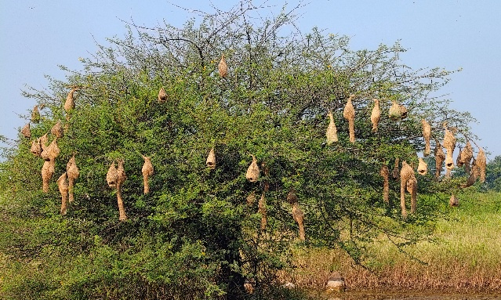 | 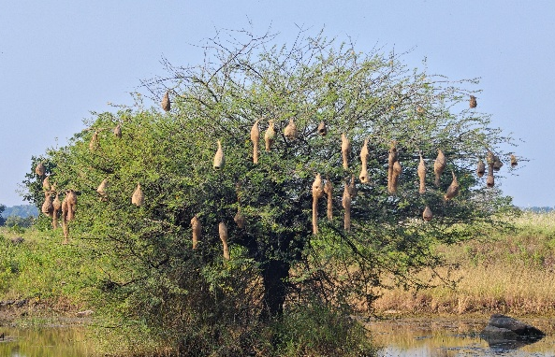

Picture 1. Nest colonies on Acacia nilotica tree in agricultural landscape of Dharmabad: a- Nesting colony- I, b- Nesting colony- II. © Sanket Kadam.

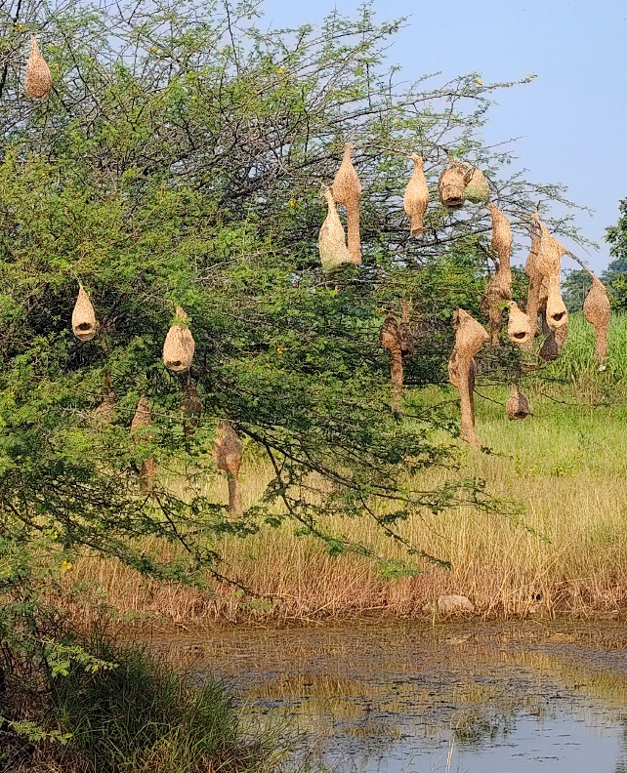

Picture 2. Nests attached to the tip of an Acacia nilotica tree branch. © Sanket Kadam.

b
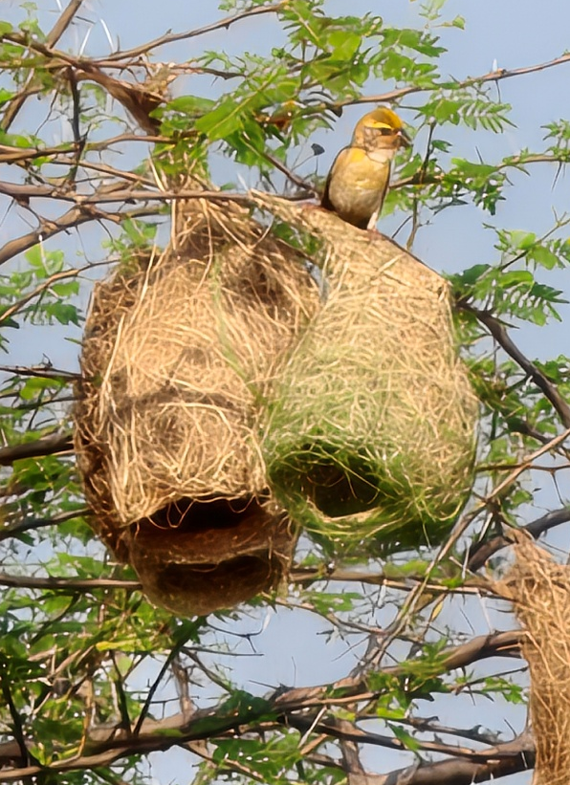  a | 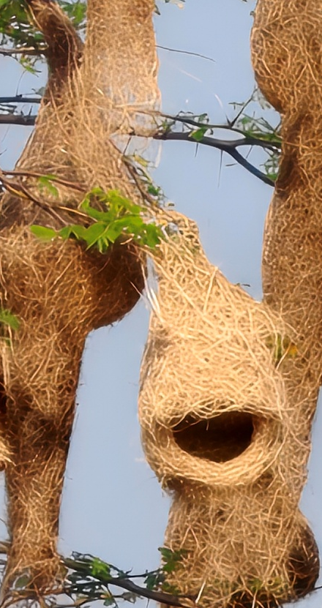
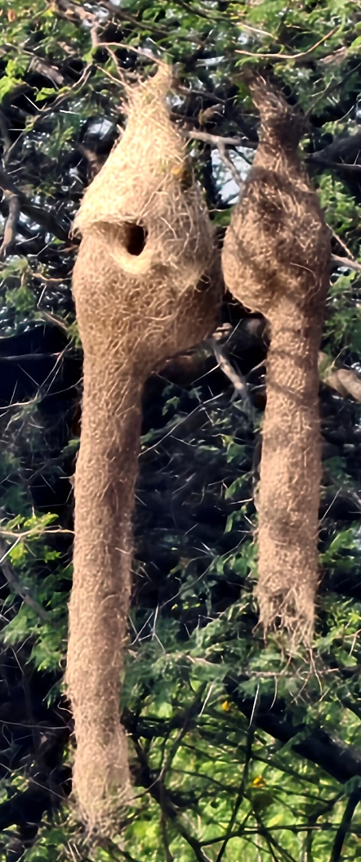  c | 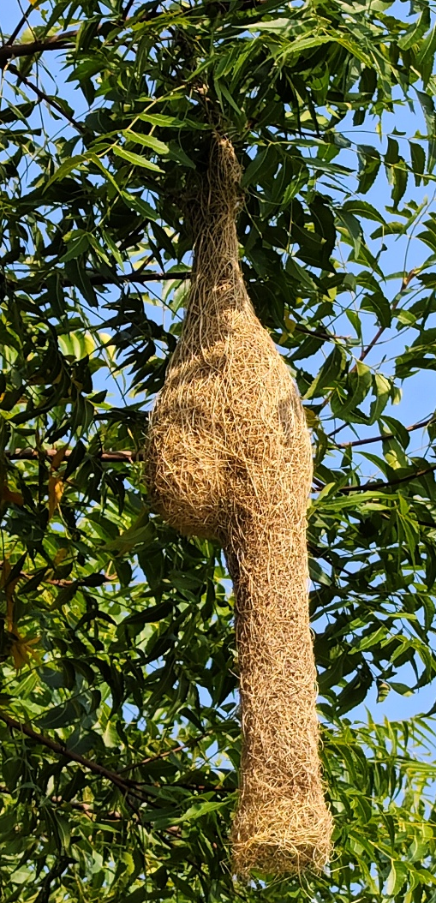  c

Picture 3. Various stages of nest development: a-Helmet stage nest 2, b-Egg-chamber closed stage nest, c- Complete nest with entrance tube: 1. Acacia nilotica, 2. Azadirachta indica.
© Sanket Kadam.

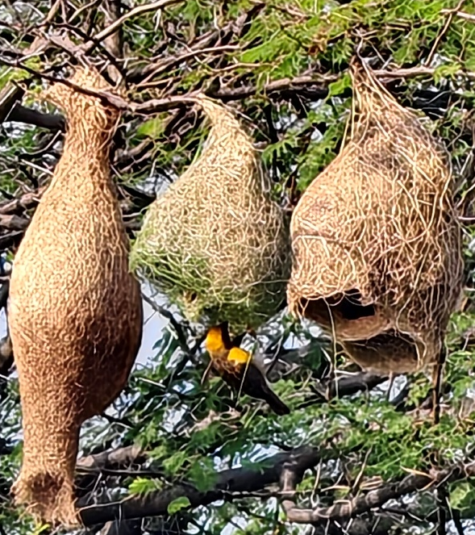 | 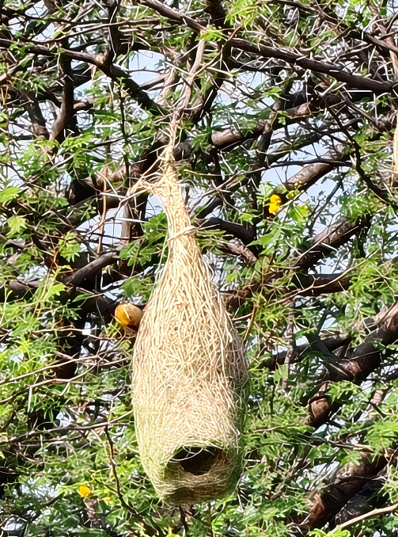

Picture 4. Nest repairing of helmet stage nest from old stalk by male Baya Weaver.
© Sanket Kadam.

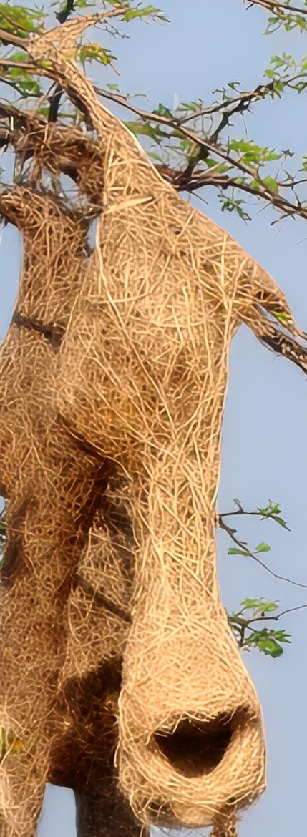

Picture 5. Buttressed nest (Two storeyed nest). © Sanket Kadam.

Fig. 1. Pie-chart representing Developmental stages of Nest construction of Baya weaver.

4. Conclusion

This is a systematic study on the nesting habits on Baya Weaver in a particular geographical area of Dharmabad, Nanded, Maharashtra. The Baya Weaver Bird’s story is one of the nature’s creativity, innovation and adaptability.
Due to habitat loss, urbanization, agricultural shifting, rapidly growing monoculture practices, climate change, anthropogenic activities and human-wildlife conflict there is a decline in population of baya weaver. As, a result many conservational efforts should taken to ensure that these beautiful creature survive and grace in our beautiful landscapes.

- The present systematic survey will help in drafting an action plan to conserve the populations of Baya Weaver.
- Establish community-level or special management zones around known nesting colonies to monitor breeding seasons.
- Restrict pesticide and chemical usage in adjacent agricultural areas to safeguard the birds’ diet and breeding health.
- Protect the margins of wetlands, ponds, rivers, and irrigation canals.
- Maintain nearby grasslands, reedbeds, and cereal or millet agricultural fields that supply raw nesting fibres.
- The impact of environmental factors such as rain, wind, temperature, humidity need to be study.
- Enforce local wildlife protection laws to prevent the illegal trapping or trade of weaver birds, their eggs, or active nests.

There is no any documentation of nesting habits of Baya weaver available from this region. So, the present study represents a first complete Nesting habits of Baya weaver from this region.
These research findings will encourage ornithologist, researchers, educators, students, and wildlife enthusiasts to broaden their perspective on the ecological importance and conservation of the Baya Weaver.
Declaration of AI Use

This manuscript was prepared through the intellectual contributions of the author(s) to the study design, data analysis, interpretation of results, and scholarly content. Grammarly and ChatGPT were used solely to assist with grammatical refinement and reference formatting during manuscript revision. The author(s) accept full responsibility for the accuracy, integrity, and final content of the manuscript.

COMPETING INTERESTS DISCLAIMER:
Authors have declared that they have no known competing financial interests OR non-financial interests OR personal relationships that could have appeared to influence the work reported in this paper.

References
Abdar, M. R. (2013). Nesting Ecology of Baya Weaver Ploceus Philippinus (Linnaeus): Passeriformes. Current Trends in Life Sciences; Jadhav, B., Jadhav, U., Bagde, U., Eds, 75-80.

Ali, S. (2012). The Book of Indian Birds (13th Ed). Oxford University Press.

Asokan, S., M.S. Ali & R. Nagarajan (2008). Studies on nest constructon and nest microclimate of the Baya Weaver, Ploceus Philippinus (Linn.). Journal of Environmental Biology 29: 393–396.

BirdLife International. 2024. Ploceus philippinus. The IUCN Red List of Threatened Species 2024: e.T22719005A263926922.
https://dx.doi.org/10.2305/IUCN.UK.2024-2.RLTS.T22719005A263926922.en

Borges, S. D., Desai, M., & Shanbhag, A. B. (2002). Selection of nest platforms and the differential use of nest building fibres by the Baya weaver, Ploceus philippinus Linnaeus 1766. Tropical Zoology, 15(1), 17-25.

Craig, A. J. F. K. (2020). Baya Weaver (Ploceus philippinus), version 1.0. In Birds of the World (J. del Hoyo, A. Elliott, J. Sargatal, D. A. Christie, and E. de Juana, Editors). Cornell Lab of Ornithology, Ithaca, NY, USA. https://doi.org/10.2173/bow.baywea1.01

Jha, N. (2021). Baya Weavers: The Architects of the Bird World. Nature inFocus. Natureinfocus.in

Jha, C. S., Goparaju, L., & Tripathi, N. (2016). Impact of Climate Change on Wetland Birds in India: A Case Study of Baya Weaver. Climate Research, 69(1), 109-119.

Kadam, S. (2026). Avian Diversity of Lal Bahadur Shastri Mahavidyalaya Campus, Dharmabad, Maharashtra: A Comprehensive Checklist. UTTAR PRADESH JOURNAL OF ZOOLOGY, 47(18), 1–7. https://doi.org/10.56557/upjoz/2026/v47i185852

Kalita, N., N. Bora, S. Choudhury & D. Sahariah (2024). Species distribution modelling of Baya Weaver Ploceus philippinus in Nagaon District of Assam, India: a zoogeographical analysis. Journal of Threatened Taxa 16(3): 24949–24955. https://doi.org/10.11609/jott.8865.16.3.24949-24955

Kumar, A. (2004). Breeding and Nesting Behavior of the Baya Weaver (Ploceus philippinus) in South Asia. Journal of Ornithology, 145(1), 45-57.

Mahendra, B., Kavitha, R., & Varija, S. (2024). Selection of Nesting Platform and Architectural Design Significantly Impact on Mate Choice in Baya Weaver Bird, Ploceus Philippinus Linnaeus 1766. Journal of Environment & Bio-sciences, 38(1). https://dx.doi.org/10.59467/JEBS.2024.38.75

Mallick, M. A. I., Komal, K., Paik, S., Shree, D., Acharjee, S., Pankaj, S., & Ansari, S. A. (2025). Nesting ecology of Baya Weaver (Ploceus philippinus) in Ghatshila, Jharkhand, India. Journal of Fauna Biodiversity, 2(2), 45-51.

Pandian, M. (2018). Baya Weaver Bird: Nest colonies and abnormal nests of Ploceus philippinus in Tindivanam Taluk, Villupuram District, Tamil Nadu, India. Bird-o-Soar 24. In: Zoo’s Print 33(12): 15—27.

Pandian, M. (2020). Foraging behaviours of Baya Weaver Ploceus philippinus, during non-breeding seasons in northern Tamil Nadu, India. ZOO’S PRINT, 35(6), 29-32.

Pandian, M. (2021a). Nesting habits of Baya Weaver Ploceus Philippinus (Linnaeus, 1776) in rural Arakkonam Taluk, Vellore District, Tamil Nadu, India. Journal of the Bombay Natural History Society 118: 03—17.

Pandian, M. (2022). Nest colonies of Baya Weaver Ploceus philippinus (Linnaeus, 1766) on overhead power transmission cables in the agricultural landscape of Cuddalore and Villupuram districts (Tamil Nadu) and Puducherry, India. Journal of Threatened Taxa 14(3): 20721–20732. https://doi.org/10.11609/jott.7748.14.3.20721-20732

Pandian, M. (2022). Nesting habits of the Baya Weaver Ploceus philippinus (Linnaeus, 1766) in the agricultural landscape of Tindivanam, Tamil Nadu, India. Journal of Threatened Taxa 14(5): 20970–20987. https://doi.org/10.11609/jot.7762.14.5.20970-20987

Pandian, M. (2023). Nest construction and repairing habits of Baya Weaver Ploceus philippinus (Aves: Passeriformes: Ploceidae) in the agricultural landscape of Villupuram District, Tamil Nadu, India. Journal of Threatened Taxa 15(9): 23843–23856. https://doi.org/10.11609/jot.8149.15.9.23843-23856

Pandian, M. (2024). Nesting habits of Baya Weaver Ploceus philippinus (Linnaeus, 1766) on power and television cables in the agricultural landscape of Kallakurichi district, Tamil Nadu, India. Journal of Threatened Taxa 16(6): 25345–25359. https://doi.org/10.11609/jot.8323.16.6.25345-25359

Pathan, Y. & A. Goswami (2023). A review of Baya Weaver Ploceus philippinus (Linnaeus, 1766) (Aves: Passeriformes: Ploceidae): ecological and conservation status. Journal of Threatened Taxa 15(12): 24357–24367. https://doi.org/10.11609/jott.8260.15.12.2435724367

Pathan, Y., Goswami, A., & Trivedi, D. V. (2024). Population Status of Baya Weaver (Ploceus Philippinus) in Peninsular Region Saurashtra of Gujarat, India. India (July 31, 2024).

Quader, S. (2005). Elaborate nests in a weaverbird: a role for female choice?. Ethology, 111(12), 1073-1088. https://doi.org/10.1111/j.1439- 0310.2005.01134.x

Quader, S. (2006). Sequential settlement by nesting male and female Baya weaverbirds Ploceus philippinus: the role of monsoon winds. Journal of Avian Biology, 37(4), 396-404.

Ramesh, A. (2019). The Incredible Weavers of the Wild: How Baya Weavers Craft Their Nests. Mongabay India. Mongabay.com

Shah, T. (2023). India’s Beautiful Weavers and Their Struggles to Survive in a Changing World. Scroll.in.

Singh, P., & Dhand, S. (2017). Temperature Effect on Breeding Biology and Abnormal Nest Behaviour of Baya Weaver (Ploceous Philippinus) in Semi-arid Area of Shekhawati Region in Rajasthan. Kaav Publ, 3, 1-7.

Skagen, S. K., & Adams, A. A. Y. (2012). Weather effects on avian breeding performance and implications of climate change. Ecological Applications, 22(4), 1131-1145. https://dx.doi.org/10.2307/23213949

Sundar, K. S. G., & Kittur, S. (2013). Population Decline of Grassland Birds in India: The Role of Agricultural Intensification. Biological Conservation, 167, 43-50.

Thiruvenggadam, T., Mohd. Top, M., Nulit, R., & Puan, C. L. (2022). Influence of climatic factors and nest tree characteristics on the nest structures of the baya weaver (Ploceus philippinus) in Peninsular Malaysia. Animals, 12(7), 815.

Yashmita-Ulman, A. K., & Sharma, M. (2017). Traditional home garden agroforestry systems: habitat for conservation of Baya Weaver Ploceus philippinus (Passeriformes: Ploceidae) in Assam, India. Journal of threatened taxa, 9(4), 10076-10083.

