Phenotypic Morphometry and Gross Anatomy of Certain Visceral organ with Scanning Electron Microscopy of Liver as well as Lung of Indian Gharial (Gavialis gangeticus)

Abstract
The gharial is also known as fish eating crocodile. This one is longest of all living crocodilians. The wild population Indian Gharial is decrease day by day due to habitat loss and killing by people for indigenous medicine. Phenotypic morphometry and Post mortem was did in Project Director office, Manas National Park. During Post mortem gross anatomy of certain visceral organs were studied and the tissue sample of liver, and lung was collected and fixed in 2.5% glutaraldehyde. After fixation, tissue sample were processed in Department of Anatomy & Histology, College of Veterinary Science, Assam Agricultural University, Khanapara, Guwahati and viewed in SAIF, Indian Institute of Advance Study of Science and Technology, Pachim Baragoan, Guwahati. In phenotypical morphometrical studied, it was noticed that the body length (tip of the snout to tip of the tail), tail length, chest grith, neck girth, weight of the Indian Gharial was 6ft 11 inch, 2ft 8inch, 11ft 11inch, 1ft 7inch and 27.45kg, respectively. In gross anatomical studied, it was observed that the liver of Indian Gharial was composed of two numbers lobes i.e., right and left lobes. The right lobes were larger than the left lobes. The shape of the stomach was sac like enlargement of the alimentary canal which was situated between the oesophagus and duodenum. The lung was composed of two borders i.e., dorsal and ventral, two surface i.e., lateral and medial, base and apex. The trachea was extended from back of the oral cavity to the base of the heart, where it branched into two bronchi i.e., left and right bronchi. The colour of the thymus was pale pink to greyish-red in colour. The shape of the thymus was almost triangular and firmly attached to the trachea. The heart of Indian gharial had four chambers i.e., right atrium, right ventricle, left atrium and left ventricle. The kidney had distinct outer cortex and inner medulla. The duodenum arose from the pyloric part of the stomach. It was first part of the intestine. The duodenum was followed by the jejunum and ileum. The ileum was followed by the caecum, colon and rectum. The ovary of Indian Gharial was elongated and attached to the mesovarium. In Scanning Electron Microscopy, it was observed that the tissue sample of lung contained numerous alveoli. Apart from the alveoli, Bronchus Associated Lymphoid Tissue (BALT) also noticed. B and T lymphocytes were found in BALT. In tissue sample of liver, it was found that the RBC occluded the sinuses of liver. Spongy type of connective tissue along with portal vein, bile duct and hepatic artery also observed in this liver. This study will be helpful to wild life veterinarian for disease control regime.
Key words: Phenotypic morphometry, Gross, Anatomy, Certain visceral, Organ, Scanning Electron Microscopy, Liver, Lung.
Introduction:
The Indian gharial is also known as fish eating crocodile. This is one of the longest of all living crocodilians. The wild population Indian Gharial is decrease day by day due to habitat loss and killing by people for indigenous medicine. The status of the animal as per the international union for conservation of nature is Critically endangered and as per the wildlife protection act, 1972 is schedule –I animal. The body of the Indian Gharial was relatively slender, elongated, slender snout and parallel sided. They have also about 100 sharp and interlocking teeth. The back side of the animal is olive to tan colour with dark blotches or bands on dorsum, belly pale. They are distributed in the river ganga, Indus, Brahmaputra Mahanadi of Northern and eastern India, Pakistan, Nepal, Bhutan and Bangladesh. They are inhabitant of large river with sand bank and is specialized fish eater. They nest on sand bank or alluvial deposits. They laying 7-60 eggs and incubation periods is 62 days. The diameter of egg and hatchlings are 59-64mm and 172-176mm, respectively (Das and Das,2018). The phenotypic morphometry and gross anatomy of visceral organs of Indian Gharial is important for wild life veterinarian in diseases control regime as schedule one species and critically endangered animal. The lung of Indian Gharial remarkable different from other reptiles and the variation in the nature of the pulmonary structure in this reptile group is quite noticeable (Porter. 1972). Scanning electron microscopy is necessary complementary approach for any biomedical study having a morphological basis. Correlated with the use of conventional electron microscopy. It not only enables examination of different cell surface but also provides clear information of the actual three-dimensional micro-organization of tissues as well as organs. Refinement in Scanning electron microscopy have progressed sufficiently to provide readily interpretable as well as reproducible image of three-dimensional features and spatial arrangements of single cells with tissues as well as even parenchymal organs, such as the liver can be easily prepared and studied by correlated by scanning electron microscopy. This topic reviews the fine surface morphological characteristics of liver and lung components of Indian Gharial.Since there is very scanty literature on the phenotypic morphometry and gross anatomy as well as on the scanning electron microscopy of liver and lung of Indian Gharial, being a critically endangered and schedule –I animal of wildlife, hence the present study was design to establish an an anatomical norm on these organs and phenotypic morphometry as well as scanning electron microscopic study of liver and lung is necessary as a part of digestive and respiratory system.
Materials and Methods:
The carcass of the Indian Gharial was found on 7th October, 2019 at Nijlaguri river (N26°44’02.51’, E90°27’35.06’) as per report of forest official, Runikata Range under Chirang Division. On the next day, the carcass was shifted to the Field Director office, Manas Tiger Reserve, Barpeta Road, Assam for postmortem. Before postmortem, the Indian Gharial was detected, female through the insertion of prob into the cloaca (Fig.4), and then phenotypic morphometry was studied and post mortem was conducted. During postmortem, the visceral organ of the animal was studied, and then collected from the tissue sample of liver and lung as well as fixed in 2.5% glutaraldehyde for scanning electron microscopy. After proper fixation, tissue samples were processed as per the standard method of SAIF, NEHU, Meghalaya. After processed, the tissue samples were viewed in IASST, Pashim Boragaon, Guwahati, Assam.
Results:
In present investigation, it was found that the body length (tip of the snout to tip of the tail), tail length, chest grith, neck girth, weight of the Indian Gharial was 6ft 11 inch, 2ft 8inch, 11ft 11inch, 1ft 7inch and 27.45kg, respectively. The snout of the Indian Gharial was blunt (Fig.1) and teeth were sharp (Fig.2). The eye was well developed with upper and lower eyelid along with prominent nictating membrane. The upper eyelid encloses a bony support. Apart from those structure, they had an external ear, opening immediately behind the eye by a longitudinal slit guarded above and below by skin folds. Rounded horny thickening of the skin (Fig.3) was observed. On the animal back those horny thickening was underlain by bony plates of the same shape and closely adherent to them. Some of the bony plates were crested and horny thickening follow the crests.
The liver of Indian Gharial was composed of two numbers lobes i.e., right and left lobes. The right lobes were larger than the left lobes. The shape of the lobes was triangular and joined dorso-medially by a narrow isthmus (Fig.8). The liver was surrounded by Glisson’s capsule. The shape of the gall bladder was pouch like which was attached caudally to the right lobe of the liver in the dorso-medial region.
The shape of the stomach was sac like enlargement of the alimentary canal (Fig.9) which was situated between the oesophagus and duodenum with a large, C-shaped sac on the left side and a smaller, spherical sac in right side. The inner side of the stomach contained foveolae gastricae and plica gastricae (Fig.11). The duodenum arose from the pyloric part of the stomach. It was first part of the intestine. The duodenum was followed by the jejunum and ileum. The jejunum had numbers of small U-shaped loops with mesenteric attachment. The ileum was followed by the caecum, colon and rectum. The ascending colon of colon composed of three parts i.e., centripetal turn, central flexure and centrifugal turn (Fig.10).
The Indian gharial breath through the lung. Their respiratory system adapted for both air and water. The lungs had multiple chambers (Fig.14) .Net like structure was also noticed in the lung of Indian Gharial (Fig.15). The lung was composed of two borders i.e., dorsal and ventral, two surface i.e., lateral and medial, base and apex. The dorsal border of the lung was irregular and thick whereas the ventral border of the lung was sharp and thin (Fig.5). The lateral surface of the lung was smooth and convex whereas the medial surface of the lung was concave and it contained hilus.
The trachea (Fig.5) of the Indian Gharial was located ventral surface of the oesophagus. The tracheal ring was complete. It was extended from back of the oral cavity to the base of the heart, where it branched into two bronchi i.e., left and right bronchi.
The thymus (Fig.5) was bilobed organ and situated ventral to base of the heart. The colour of the thymus was pale pink to greyish-red in colour. The shape of the thymus was almost triangular and firmly attached to the trachea.
The heart of Indian gharial had four chambers i.e., right atrium, right ventricle, left atrium and left ventricle. Among those four chambers, right ventricle was the cranial most compartment of the heart. The right ventricle was the cranial most compartment of the heart. The wall of the right ventricle was thin compared to the wall of the left ventricle. The right atrioventricular opening contained three numbers of valve. Three numbers of papillary muscles were observed inside the right ventricle and those were attached to the valve by the chorda tendinea. Apart from those structure trabeculae carneae muscles were found inside those structure. The right atrium and left atrium contained auricle which one was saclike structure. The apex of the heart was formed by the left ventricle (Fig,6). The ascending and descending aorta arose from the base of the heart (Fig.7).
The kidney of Indian Gharial was located below the lumbar vertebrae. The kidney consisted of two borders i.e., medial and lateral (Fig.12). Both the borders were uneven. It was also noticed that the cranial and caudal poles or extremities were blunt. The hilus was found in the medial border. The kidney had distinct outer cortex and inner medulla (Fig.13).
The ovary of Indian gharial was elongated and attached to the mesovarium. The infundibulum was funnel shaped and ampulla was tortious in manner (Fig.16).
In Scanning Electron Microscopy, it was observed that the tissue sample of lung contained numerous alveoli which one was lined by simple squamous epithelium. Apart from the alveoli (Fig.20), Bronchus Associated Lymphoid Tissue (BALT) (Fig.21) and netlike structure (Fig.24) was also noticed. B and T lymphocytes were found in BALT. The surface of the B Lymphocytes was looked like woollen ball like whereas the surface of the T lymphocytes was smooth (Fig.22& Fig.23). In tissue sample of liver, it was found that the the liver parenchyma was consisted of hepatic sinusoids and hepatocytes, It was also noticed that at higher magnification each hepatocyte cell was irregularly shaped with a prominent central nucleus. The sinusoid was lined with a simple endothelial cell resting on a basement membrane. The space between their hepatocytes was made up of intersinusoidal cords. In addition, among the liver lobes, the hepatic triad (hepatic portal vein, hepatic artery and bile duct) was detected (Fig.18). Apart from these RBC occluded the sinuses of liver (Fig.19). Inter sinusoidal type (Fig.17) of connective tissue also found.
Discussions:
In present investigation, it was found that the body length (tip of the snout to tip of the tail), tail length, chest grith, neck girth, weight of the Indian Gharial was 6ft 11 inch, 2ft 8inch, 11ft 11inch, 1ft 7inch and 27.45kg, respectively. The snout of the Indian Gharial was blunt. The eye was well developed with upper and lower eyelid along with prominent nictating membrane. The upper eyelid encloses a bony support. Apart from those structure, they had an external ear, opening immediately behind the eye by a longitudinal slit guarded above and below by skin folds. Rounded horny thickening of the skin was observed. On the animal back those horny thickening was underlain by bony plates of the same shape and closely adherent to them. Some of the bony plates were crested and horny thickening follow the crests. Similar finding was reported by Hyman (2004) in Alligators.
The liver of Indian Gharial was composed of two numbers lobes i.e., right and left lobes. The right lobes were larger than the left lobes. The shape of the lobes was triangular and joined dorso-medially by a narrow isthmus. The liver was surrounded by Glisson’s capsule. The shape of the gall bladder was pouch like which was attached caudally to the right lobe of the liver in the dorso-medial region. This finding was total agreement with the findings of Wilpe (2012) in Juvenile Nile Crocodile.
The shape of the stomach was sac like enlargement of the alimentary canal which was situated between the oesophagus and duodenum with a large, C-shaped sac on the left side and a smaller, spherical sac in right side. The inner side of the stomach contained foveolae gastricae and plica gastricae. Similar observation was reported by Nickel et al., (1979) in pig. The duodenum arose from the pyloric part of the stomach. It was first part of the intestine. The duodenum was followed by the jejunum and ileum. The jejunum had numbers of small U-shaped loops with mesenteric attachment. These findings were total agreement with the findings of Kings and Mcleland (1975) in fowl. The ileum was followed by the caecum, colon and rectum. The ascending colon of colon composed of three parts i.e., centripetal turn, central flexure and centrifugal turn. Similar findings were reported by Nickel et al., (1979) in ruminant.
The Indian gharial breath through the lung. Their respiratory system adapted for both air and water. The lungs had multiple chambers. The lung was composed of two borders i.e., dorsal and ventral, two surface i.e., lateral and medial, base and apex. The dorsal border of the lung was irregular and thick whereas the ventral border of the lung was sharp and thin. The lateral surface of the lung was smooth and convex whereas the medial surface of the lung was concave and it contained hilus. These findings were total agreement with the findings of Ghosh (2015) in cattle. The base and apex of the lung was blunt.
The trachea of the Indian Gharial was located ventral surface of the oesophagus. The tracheal ring was complete. It was extended from back of the oral cavity to the base of the heart, where it branched into two bronchi i.e., left and right bronchi. These findings were aligned with the findings of Banarjee and Ghosh (2020) in Indian Cobra (Naja naja)
The thymus was bilobed organ and situated ventral to base of the heart. The colour of the thymus was pale pink to greyish-red in colour. Similar findings were reported by Yugesh (2014) in pig. The shape of the thymus was almost triangular and firmly attached to the trachea.
The heart of Indian gharial had four chambers i.e., right atrium, right ventricle, left atrium and left ventricle. Among those four chambers, right ventricle was the cranial most compartment of the heart. The right ventricle was the cranial most compartment of the heart. The wall of the right ventricle was thin compared to the wall of the left ventricle. The right atrioventricular opening contained three numbers of valve. Three numbers of papillary muscles were observed inside the right ventricle and those were attached to the valve by the chorda tendinea. Apart from those structure trabeculae carneae muscles were found inside those structure. The right atrium and left atrium contained auricle which one was saclike structure. The apex of the heart was formed by the left ventricle. The ascending and descending aorta arose from the base of the heart. These findings were aligned with the findings of Crick et al., (1998) in Pig.
The kidney of Indian Gharial was located below the lumbar vertebrae. The kidney consisted of two borders i.e., medial and lateral. Both the borders were uneven. It was also noticed that the cranial and caudal poles or extremities were blunt. The hilus was found in the medial border. The kidney had distinct outer cortex and inner medulla. Similar findings were opined by Nickel et al., (1979) in cattle.
The ovary of Indian gharial was elongated and attached to the mesovarium. The infundibulum was funnel shaped. Similar findings were reported by Ghosh (2015) in cattle and Deka et al., (2014) in Pati and Chara-Chemballi duck. It was also noticed that the ampulla was tortuous in manner.
In Scanning Electron Microscopy, it was observed that the tissue sample of lung contained numerous alveoli which one was lined by simple squamous epithelium. Apart from the alveoli, Bronchus Associated Lymphoid Tissue (BALT) and netlike structure was noticed. These finding was total agreement with the findings of Barman et al., (1996) in goat. B and T lymphocytes were found in BALT. The surface of the B Lymphocytes was looked like woollen ball like whereas the surface of the T lymphocytes was smooth. Similar observation was reported by Nazerian et al. (1976) in chicken. In tissue sample of liver, it was found that the the liver parenchyma was consisted of hepatic sinusoids and hepatocytes, It was also noticed that at higher magnification each hepatocyte cell was irregularly shaped with a prominent central nucleus. The sinusoid was lined with a simple endothelial cell resting on a basement membrane. The space between their hepatocytes was made up of intersinusoidal cords. In addition, among the liver lobes, the hepatic triad (hepatic portal vein, hepatic artery and bile duct) was detected. These findings were aligned with the findings of Boonyong et al., (2017) in dog faced water snake. Apart from these RBC occluded the sinuses of liver. Inter sinusoidal type of connective tissue also found.
Summary and Conclusion:
Thorough knowledge of the phenotypic morphometry and gross anatomy of liver, gall bladder, stomach, lung, trachea, thymus, heart, kidney, intestine and female reproductive system are very essential in elucidating its role in physiology, pathology, endocrinology and surgical anatomy. The body length (tip of the snout to tip of the tail), tail length, chest grith, neck girth, weight of the Indian Gharial was 6ft 11 inch, 2ft 8inch, 11ft 11inch, 1ft 7inch and 27.45kg, respectively. The snout of the Indian Gharial was blunt. The liver of Indian Gharial was composed of two numbers lobes i.e., right and left lobes. The right lobes were larger than the left lobes. The shape of the stomach was sac like enlargement of the alimentary canal which was situated between the oesophagus and duodenum. The duodenum arose from the pyloric part of the stomach. It was first part of the intestine. The duodenum was followed by the jejunum and ileum. The ileum was followed by the caecum, colon and rectum. The lung was consisted of two borders i.e., dorsal and ventral, two surface i.e., lateral and medial, base and apex. The trachea of the Indian Gharial was located ventral surface of the oesophagus. The thymus was bilobed organ and situated ventral to base of the heart. The kidney of Indian Gharial was located below the lumbar vertebrae. The kidney consisted of two borders i.e., medial and lateral. Both the borders were uneven. In scanning electron microscopy, it was noticed that the spongy tissue, bile duct, hepatic vein and hepatic artery as well as RBC occlude the lumen of sinuses of liver of Indian Gharial. Numerous alveoli, BALT and Netlike structure were observed in lung of Indian Gharial. Apart from the structure B and T-lymphocytes were found in BALT of Lung of Indian Gharial. The ovary of Indian gharial was elongated and attached to the mesovarium. This study will be helpful to the wild life veterinarian in disease control regime, being a critically endangered animal as per IUCN and schedule –I animal as per wild life protection act.
Declaration of AI Use

This manuscript was prepared through the intellectual contributions of the author(s) to the study design, data analysis, interpretation of results, and scholarly content. Grammarly and ChatGPT were used solely to assist with grammatical refinement and reference formatting during manuscript revision. The author(s) accept full responsibility for the accuracy, integrity, and final content of the manuscript.

COMPETING INTERESTS DISCLAIMER:
Authors have declared that they have no known competing financial interests OR non-financial interests OR personal relationships that could have appeared to influence the work reported in this paper.
Reference:
Hyman, L.H. (2004). Anatomy of Comparative Vertebrates. Satish Serial Publishing House,403, Express Tower, Commercial complex, Azadpur, Delhi 10033(India), First Edition, Pp.50.
Das, I and Das, A. (2018). A Naturalist’s guide to the Reptiles of India, Bangladesh, Bhutan, Nepal, and Sri Lanka. Prakash Books. Pp. 156.
Banarjee, A. and Ghosh, C. (2020). Gross anatomy of liver, Lung and kidney of Indian Cobra (Naja naja). Indian Journal of Animal Health. 59{1):99-100.
Crick, S.J., Sheppard, M.N., Ho.S.Y., Gebstein, L. and Anderson, R.H. (1998). Anatomy of the Pig heart: comparison with normal human cardiac structure. Journal of Anatomy,193:105-119.
Yugesh, K., Jothi,D.S.S.,Ranganathan,D.K., Jayaraman,P.,Bharath, C.V.,Sujatha,N.(2014). Macroscopic and Microscopic study of thymus of Pig. Journal of Dental and Medical Science. 13(9):52-55.
Nazerian, K.; Ackerson, A. and Hooper, G. (1976). Scanning electron microscopy in the study of chicken t and b cells and cells from Marek’s disease tumors. Avian pathology, 5 (2): 135-145.
Boonyoung,P., Senarat,S., Kettratad, J., Jiraungkoorskul,W., Poolprasert,P., Wangkulangkul,S., Pengsakul,T., Yenchum,W. and Sulieman, Y. (2017). Esophagogastric region and liver tissue in dog faced water snake Cerberus rynchops: Histology and histochemistry. Agriculture and Natural Resources. 51: 538-543.
Barman, N.N., Bhattacharyya , R., Upadhyaya, T.N. and Baishya, G. (1996). Development of Brochus Associated Lymphoid tissue in goats. Agricultural and Food Science, Medicine.DOI:10.1007/BF00177706.
Deka, A., Baishya, G., Sarma, K. and Bhuyan. M. (2014). Comparative anatomical study on infundibulum of Pati and Chara-Chemballi ducks (Anas platrhynchos domesticus) during laying periods. Veterinary World.7(4):271-274.
Nickel, R., Schummer, A. and Seiferle, E. (1979). The viscera of the domestic mammals. Verlag Paul Parey, Berlin, Hamburg. Pp.68-302.
Ghosh, R.K. (2015).Primary Veterinary Anatomy.Current Book International 60, Lenin Sarani, Kolkata-13.Pp.195-294.
Wilpe, E.V.(2012).Liver and Gallbladder Morphology of the juvenile Nile crocodile, Crocodylus niloticus (Laurenti, 1768). A Thesis submitted to Department of anatomy and physiology, faculty of veterinary science, university of Pretoria.

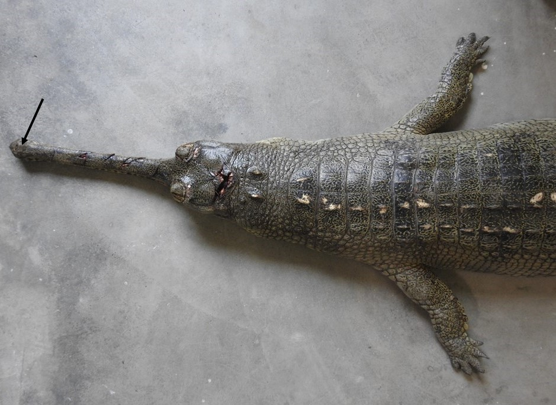
Fig.1: Photograph showing the snout (Black arrow) of the Indian Gharial (Gavialis gangeticus).
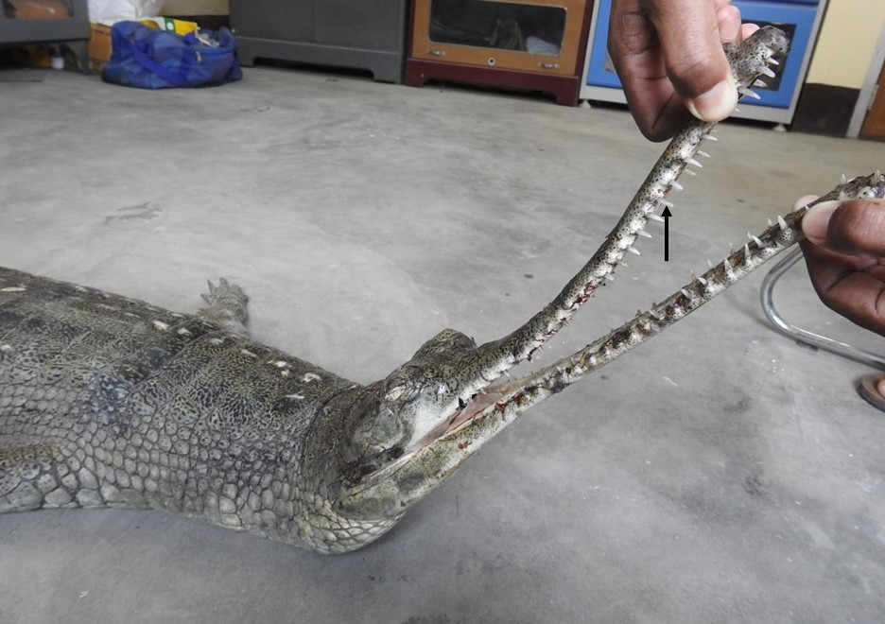
Fig.2: Photograph showing the sharp teeth (Black arrow) of the Indian Gharial (Gavialis gangeticus).

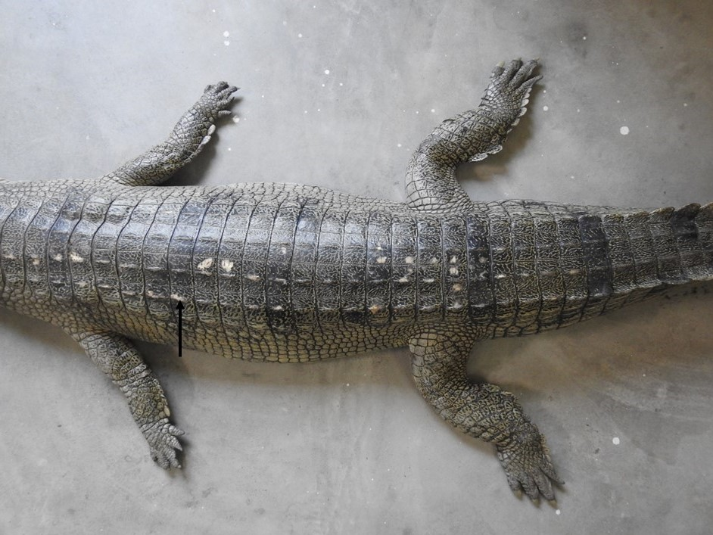
Fig.3: Photograph showing the rounded horny thickening of the skin (Black arrow) of the Indian Gharial (Gavialis gangeticus).
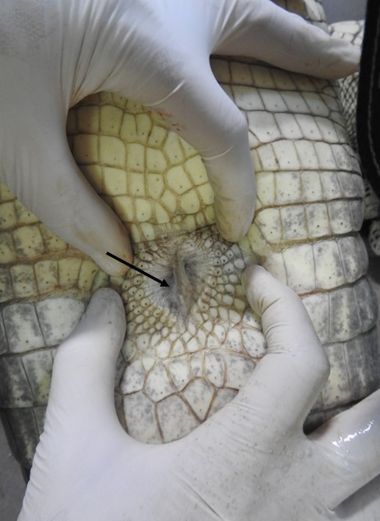
Fig.4: Photograph showing the cloaca of Indian Gharial (Gavialis gangeticus).

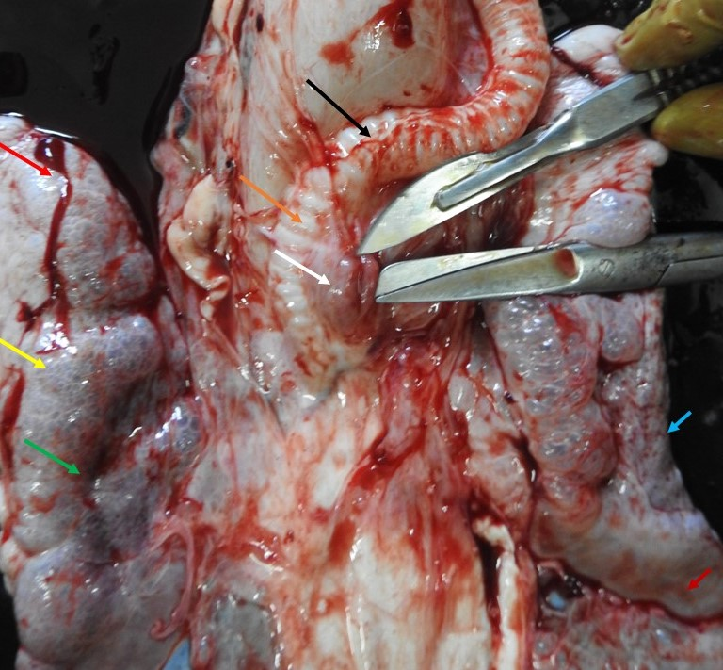
Fig.5: Photograph showing the trachea (black arrow), tracheal ring (brick colour arrow), thymus (white arrow), cranial end of right lobe of lung (red arrow), dorsal surface of lung (yellow arrow), lateral border of right lung (green arrow), lateral border of left lobe of lung (blue arrow), and caudal end of left lobe of lung (marron colour) and thymus (white arrow) of Indian Gharial (Gavialis gangeticus).
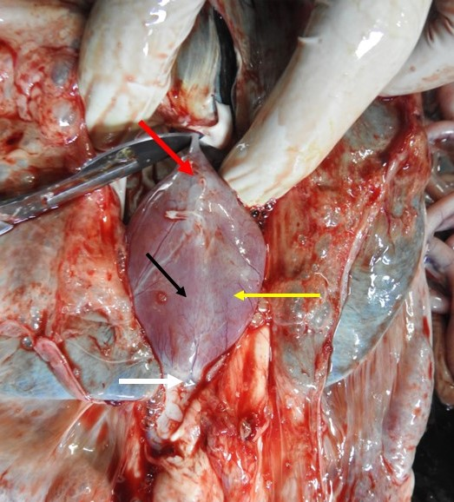
Fig.6: Photograph showing the pericardium of heart (black arrow), base of the heart (red arrow), body of the heart (yellow arrow) and apex of the heart (white arrow) of Indian Gharial (Gavialis gangeticus).

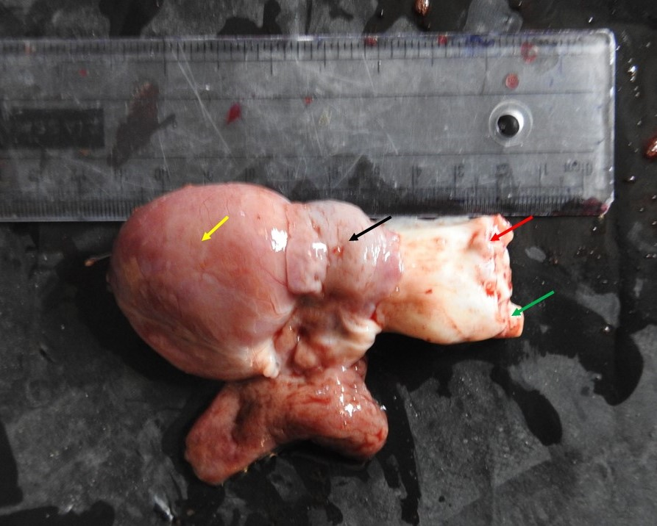
Fig.7: Photograph showing the auricle of heart (black arrow), base of ascending aorta (red arrow), ventricle of heart (yellow arrow) and base of descending aorta (green arrow) of Indian Gharial (Gavialis gangeticus).
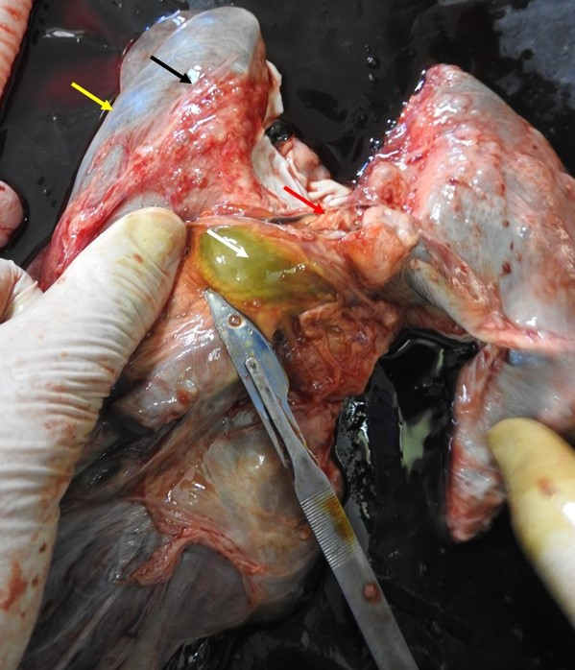
Fig.8: Photograph showing the Glisson’s capsule (black arrow), border of liver (yellow arrow), isthmus (red arrow) and gall bladder (white arrow) of liver of Indian Gharial (Gavialis gangeticus).

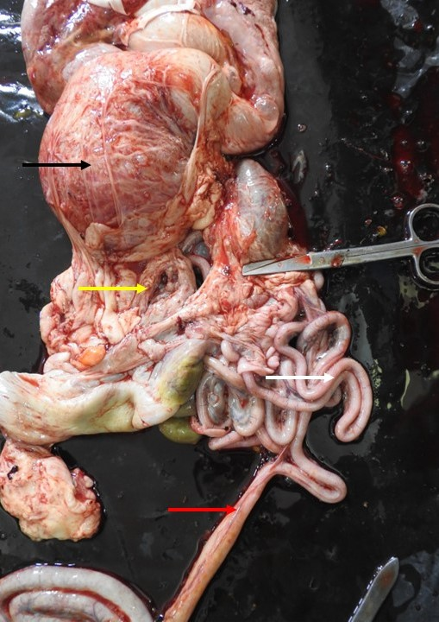
Fig.9: Photograph showing the stomach (black arrow),duodenum (yellow arrow), jejunum (white arrow) and ileum (red arrow) of Indian Gharial (Gavialis gangeticus).

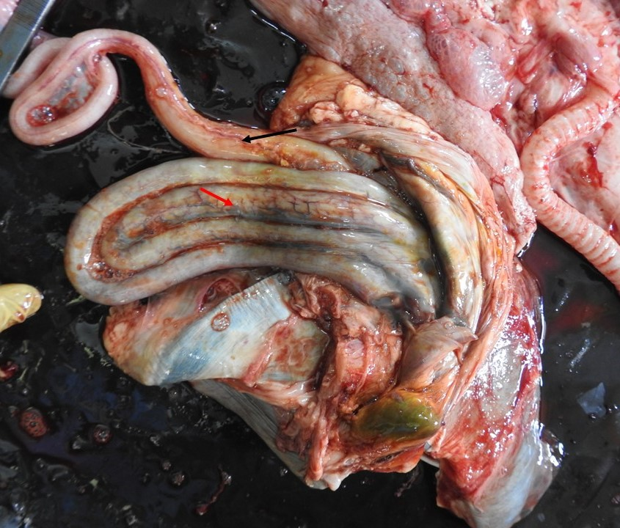
Fig.10: Photograph showing the caecum (black arrow) and colon (red arrow) of Indian Gharial (Gavialis gangeticus).

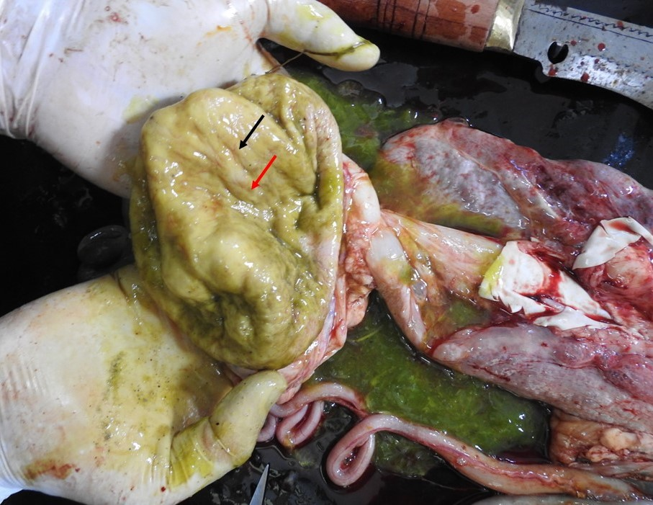
Fig.11: Photograph showing the plica gastricae (black arrow) and foveolae gastricae (red arrow) of stomach of Indian Gharial (Gavialis gangeticus).
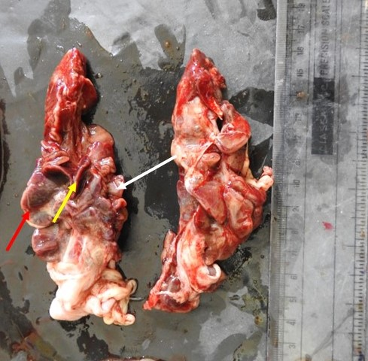
Fig.12: Photograph showing the lateral border (red arrow), medial border (white arrow) and hilus (yellow arrow) of kidney of Indian Gharial (Gavialis gangeticus).

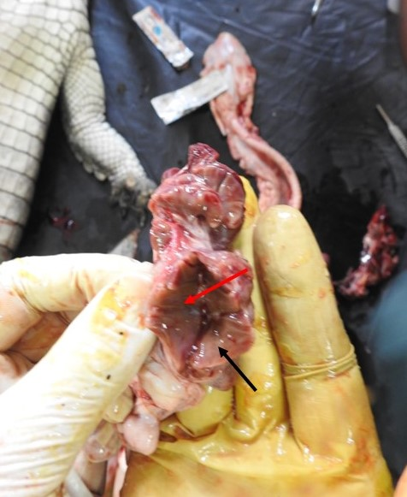
Fig.13: Photograph showing the cortex (black arrow) and medulla (red arrow) of kidney of Indian Gharial (Gavialis gangeticus).

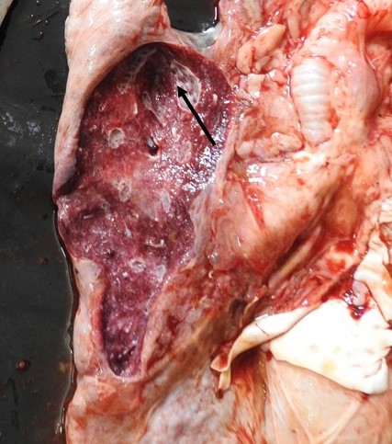
Fig.14: Photograph showing the multiple chambers (black arrow) of lung of Indian Gharial (Gavialis gangeticus).
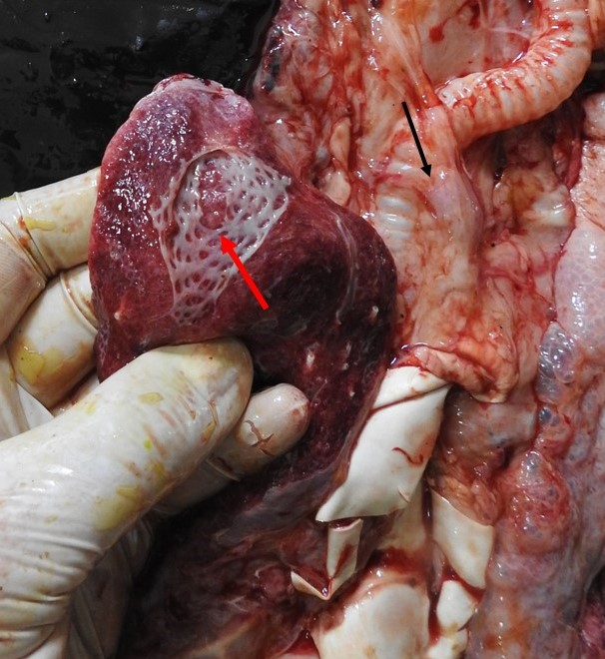
Fig.15: Photograph showing the honey comb like structure (red arrow) of lung and tracheal bifurcation (black arrow) of trachea of Indian Gharial (Gavialis gangeticus).
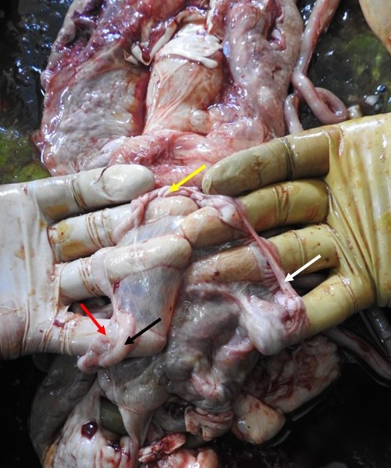
Fig.16: Photograph showing the ovary (black arrow), mesovarium (red arrow), infundibulum (white arrow) and ampulla (yellow arrow) of female reproductive system of Indian Gharial (Gavialis gangeticus).

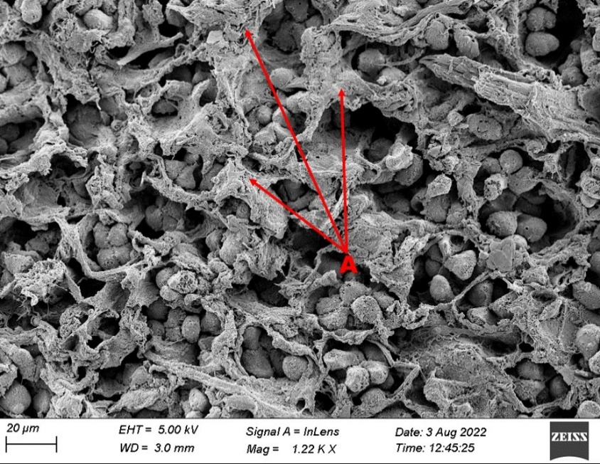
Fig. 17: Scanning Electron Photomicrograph showing the inter sinusoidal tissue (A) in liver of Indian Gharial (Gavialis gangeticus).

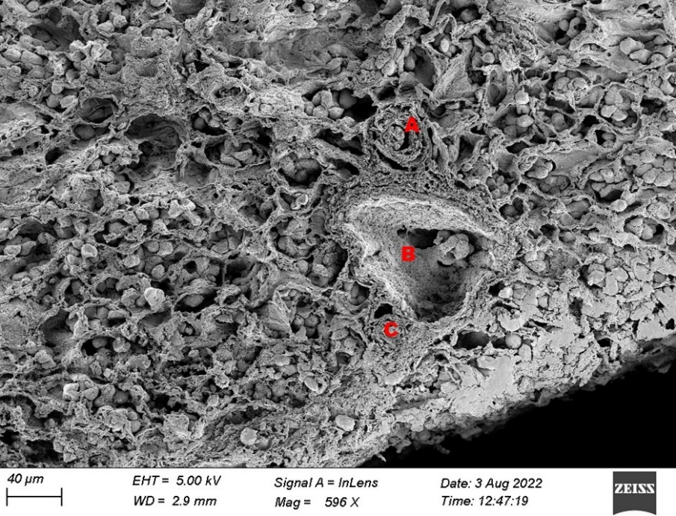
Fig. 18: Scanning Electron Photomicrograph showing the bile duct (A), hepatic vein (B) and hepatic artery (C) in liver of Indian Gharial (Gavialis gangeticus).

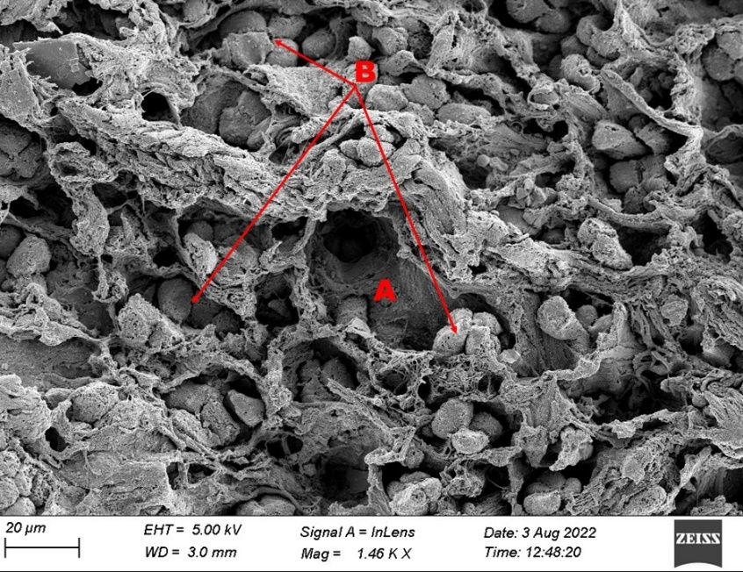

Fig.19: Scanning Electron Photomicrograph showing the RBC occlude the lumen of sinus of liver of Indian Gharial (Gavialis gangeticus).

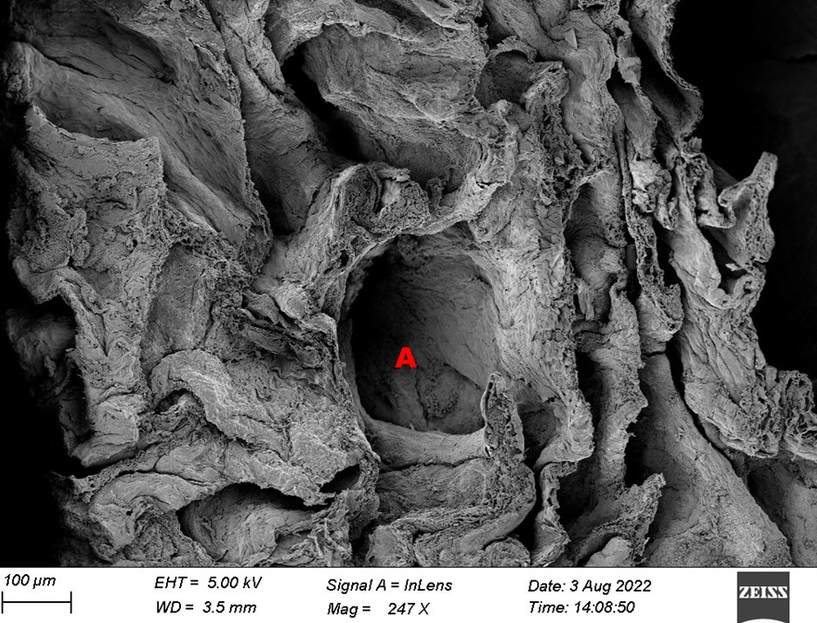
Fig.20: Scanning Electron Photomicrograph showing the alveoli of lung of Indian Gharial (Gavialis gangeticus).

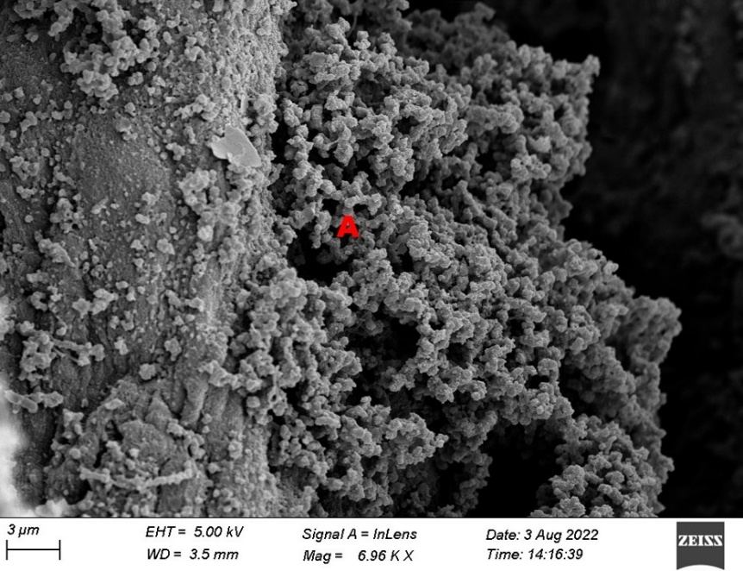
Fig.21: Scanning Electron Photomicrograph showing the Bronchus Associated Lymphoid Tissue (BALT)of lung of Indian Gharial (Gavialis gangeticus).

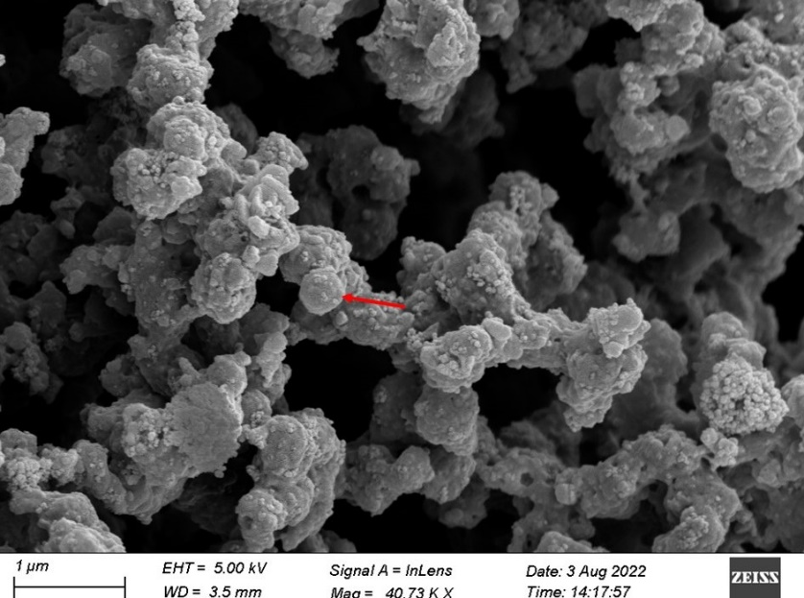
Fig.22: Scanning Electron Photomicrograph showing the Bronchus Associated Lymphoid Tissue (BALT)of lung of Indian Gharial (Gavialis gangeticus).

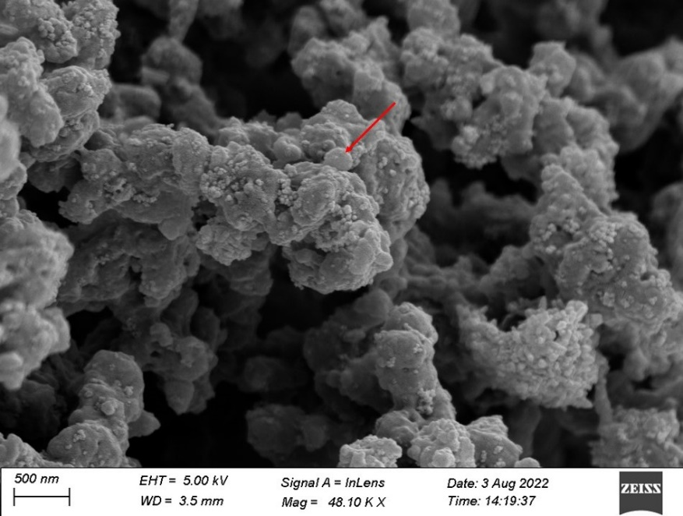
Fig.23: Scanning Electron Photomicrograph showing the T-lymphocytes of Bronchus Associated Lymphoid Tissue (BALT)of lung of Indian Gharial (Gavialis gangeticus).

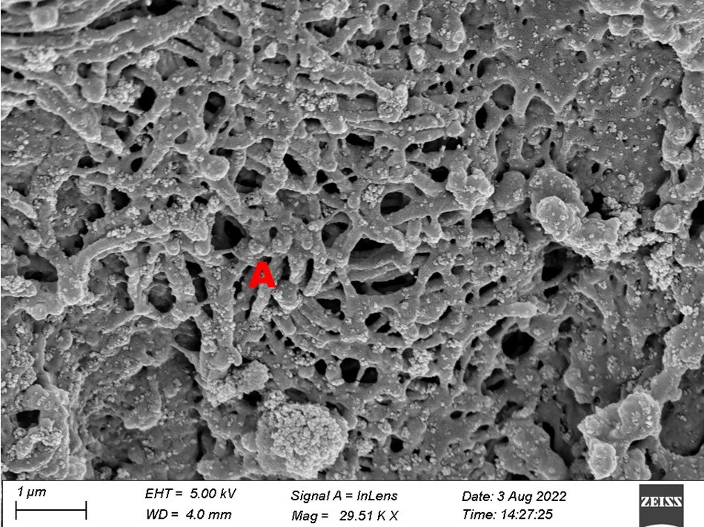
Fig.24: Scanning Electron Photomicrograph showing the network like structure of lung of Indian Gharial (Gavialis gangeticus).

