Original Research Article
Effects of plant essential oils fumigation on Acetylcholinesterase activity in Callosobruchus maculatus (F.)

Abstract
Essential oils (EOs) are well known for their diverse insecticidal properties, including fumigant activity against insect-pests infesting stored products. However, their effects on insect physiological processes may differ among oils. This study evaluated acetylcholinesterase (AChE) activity in adult C. maculatus following 24-h fumigation with seven essential oils, namely Ajwain, Cumin, Coriander, Dill, Celery, Caraway and Black Pepper, at their respective lethal concentrations. The LC₅₀ concentrations ranged from 18.8 to 154.8 µL L⁻¹, and observed mortality ranged from 45 to 55%, whereas mortality in the untreated control was 3.33%. A significant treatment effect was detected among the seven oils and the untreated control. Untreated insects showed the highest AChE activity (44.51 ± 0.96 U min⁻¹ mg⁻¹ protein), whereas Caraway-treated survivors exhibited the lowest activity (11.51 ± 1.18). Relative to the untreated control, AChE activity was reduced by 13.60–74.14% across the oil treatments, with the greatest reduction observed following Caraway exposure, followed by Celery (42%), Ajwain (38.2%), Black Pepper (36.9%) and Dill (30.9%). Cumin and Coriander produced comparatively lower reductions of 13.9 and 13.6%, respectively. These results demonstrate oil-specific alterations in AChE activity among surviving adults despite a similar mortality endpoint. The findings support the inclusion of biochemical endpoints alongside mortality for characterizing the physiological effects of acute essential-oil fumigation and provide a basis for further concentration-, time- and mechanism-oriented investigations of neurophysiological responses in C. maculatus. This study opens window to identify promising essential oils for sustainable, non-synthetic approaches to managing bruchids infesting stored pulses.
Key words: Pulses, Bruchids, Essential Oils (EOs), Fumigation, Acetylcholinesterase (AChE).
1. Introduction
Pulses are important components of food, agricultural, and livelihood systems, particularly in tropical and subtropical regions, because of their nutritional value, adaptability, and contribution to sustainable crop production. In India, where pulses constitute an important component of food security, protection of stored pulse commodities from insect infestation remains a major post-harvest concern. Several insect-pests attacks stored pulses and their losses, sometimes, exceeds the losses caused by field pests. Among these, bruchids (Bruchinae: Chrysomelidae: Coleoptera) are among the most important pests of stored legumes and their infestation enters storage through several routes including field infestations. Once they enter storage, they increase rapidly along storage period (Revanasidda et al. 2020). Larval feeding within seeds results in weight loss, deterioration of grain quality and marketability, and progressive damage when infestations are not adequately managed. Among the stored-pulse bruchids, Callosobruchus maculatus (F.) is a major cosmopolitan pest and has been reported as one of the principal Callosobruchus species associated with stored pulses in India (Aidbhavi et al., 2023a). The importance of C. maculatus is further reinforced by its rapid population increase under favourable storage conditions and its capacity to cause substantial cumulative seed damage.
Management of stored-pulse bruchids has traditionally relied heavily on synthetic insecticides and fumigants. Although phosphine remains an important fumigant because of its effectiveness against stored-product insects, increasing resistance in stored-pulse bruchids highlights the need for complementary and alternative management approaches. In India, resistance monitoring has demonstrated measurable variation in phosphine susceptibility among bruchid populations, further emphasizing the importance of developing additional tools for stored-pulse protection (Aidbhavi et al., 2023b; Nayak et al. 2021).
Plant essential oils (EOs) have received considerable attention as botanical alternatives for stored-product insect management because their compounds reported to demonstrate different mode of action against bruchid infesting pulses (Bandi et al. 2023). The volatile constituents of plant EOs can act through the vapour phase and can therefore be particularly relevant to enclosed storage and fumigation. Literatures indicate broad insecticidal activity of essential oils against C. maculatus, with fumigant, contact and repellent effects reported for oils from numerous plant species (Campolo et al., 2018; Mssillou et al., 2022). Their biological effects are not restricted to mortality, however, because essential oils contain multiple bioactive constituents capable of affecting physiological and biochemical processes in insects.
Among the potential biochemical targets of essential oils, the nervous system is particularly important. Acetylcholinesterase (AChE) is a key enzyme involved in termination of cholinergic signalling by hydrolysing acetylcholine at neuronal and neuromuscular junctions. Alteration of AChE activity can consequently interfere with normal cholinergic transmission and contribute to behavioural and physiological disturbance. Essential oils and their constituents have been extensively investigated for effects on AChE, and AChE inhibition is one of the most frequently discussed potential neurotoxic mechanisms of essential oils. At the same time, essential oils are chemically complex mixtures and may influence several targets simultaneously, including GABAergic and octopaminergic systems; therefore, changes in AChE activity should not automatically be interpreted as the sole mechanism responsible for toxicity (Jankowska et al., 2018; Campolo et al., 2018).
Experimental evidence in stored-product insects supports the importance of examining AChE responses together with mortality. Reports of rosemary (Rosmarinus officinalis) essential-oil fumigation affecting AChE and other biochemical enzymes in C. maculatus; notably, AChE activity increased rather than decreased under their exposure conditions (Krzyżowski et al. 2020). Conversely, a report of significant reductions in AChE activity in C. maculatus following exposure to Atalantia monophylla essential oil (Nattudurai et al. 2017). Likewise a significant AChE inhibition in C. maculatus following exposure to selected essential oils, showing that enzyme responses can vary according to the particular oil and exposure regime (Gupta et al. 2023).
Of particular relevance to the present study, several of the oils investigated here belong to Apiaceae. Studies of Apiaceae essential oils have documented insecticidal activity and effects on cholinesterasee-related pathways. For example, the AChE-related activity of the constituents of ajwain, caraway, celery, cumin and dill essential oils among a broader set of Apiaceae oils have been investigated against masquito species Aedes albopictus (Seo et al. 2015). Further, anticholinesterase activity was also demonstrated among essential oils including Dill and Fennel (Orhan et al. 2008). Such findings provide a biochemical basis for examining whether oils that differ substantially in fumigant potency also produce different AChE responses in the target insect.
Despite this growing research focus on effects of essential oils on biological activity of enzymes in insects, comparative information on AChE variation in bruchids infesting stored pulses following treatment with multiple essential oils remains limited. Exposure of target insects to particular concentration represents a common mortality endpoint but does not necessarily imply a common physiological state among surviving individulas. The present study therefore evaluated AChE activity in surviving adult C. maculatus after 24-h fumigation at the respective concentrations of seven essential oils: Ajwain, Cumin, Coriander, Dill, Celery, Caraway and Black Pepper. The study aimed to determine whether these oils produce distinct alterations in AChE activity and to quantify the relative regulation (increase or reduction) in enzyme activity compared with untreated insects. The study offers an important path for ascertaining the effects of essential oils on insect physiology thereby opening door for development of sustainable botanicals options for non-chemical management of bruchids infesting stored pulses.
2. Materials and Methods
2.1. Insect culture: The laboratory cultures of C. maculatus was initiated from the pure stock cultures maintained at the Storage Entomology Laboratory, Division of Crop Protection, ICAR-Indian Institute of Pulses Research (ICAR-IIPR), Kanpur, India. The insects were reared on infestation-free green gram, Vigna radiata (L.) R. Wilczek following standard protocols (Strong et al. 1968). Approximately 200 g grains were maintained in transparent 500 mL plastic jars with their caps fitted with mesh for ventilation and to prevent the entry of natural enemies. Cultures were maintained at 27 ± 2 °C and 65 ± 5% relative humidity (Aidbhavi et al. 2021; Mannava et al. 2022; Aidbhavi et al. 2026). Fifty pairs of 3–4-day-old adults were introduced into each grain unit and allowed to oviposit for five days, after which successive cultures were maintained to provide insects for experimentation.
2.2. Essential-oil fumigation and mortality assessment: The AChE study comprised seven essential oils namely Ajwain, Cumin, Coriander, Dill, Celery, Caraway and Black Pepper. Fumigation was conducted using already established LC₅₀ concentrations (Unpublished data) in airtight glass desiccators. The concentrations used were 25.7, 19.3, 18.8, 147.2, 154.8, 81.5 and 143.5 µL L⁻¹ for Ajwain, Cumin, Coriander, Dill, Celery, Caraway and Black Pepper, respectively. Filter-paper strips measuring 5 × 2 cm were impregnated with the required quantity of each essential oil using a micropipette and fixed to the inner surface of the desiccator lid. Adult insects, preferably 2 to 4 days old (sex unbiased), were placed in small glass vials within the desiccator, with muslin cloth covering the vial to prevent direct contact with the oil while allowing vapour exposure. The desiccators were hermetically sealed using silicone grease and parafilm (Revanasidda et al. 2022; Aidbhavi et al. 2023b). Respective untreated desiccators with same number of insects were served as the control. The mortality was recorded 24 h after fumigation and the moribund insects with no signs of movement when pressed with observation brush were considered as dead.
2.3. Preparation of enzyme extract: For AChE estimation, a separate group of 2 to 4 days old adult insects were exposed to each essential oil at its respective LC₅₀ concentration for 24 h. Surviving insects were collected immediately after required exposure period. Approximately 200 to 300 mg of surviving insects was homogenized in 2 mL of 100 mM phosphate buffer (pH 8.0). The homogenate was centrifuged at 15,000 rpm for 20 min at 4 °C, and the resulting supernatant was used as the enzyme extract. Untreated insects were processed similarly for the control.
2.4. Assay of acetylcholinesterase activity: AChE activity was determined using the colorimetric method of Ellman et al. (1961), using acetylthiocholine (ATCh-TI) as substrate. It was based on the hydrolysis of acetylthiocholine and reaction of the resulting thiocholine with 5,5′-dithiobis (2-nitrobenzoic acid) (DTNB), producing a coloured product measured spectrophotometrically.
The reaction mixture contained 2.2 mL phosphate buffer buffer (pH 7.4, 0.5 mM), 100 µL acetylthiocholine iodide (ATCh-TI, 0.5 mM), DTNB (0.33 mM) and 100 µL enzyme extract. The change in absorbance at 412 nm was monitored for 3 min at 15-s intervals using a UV–visible spectrophotometer. Three replicate determinations were made for each treatment. One unit of enzyme activity was defined as a change of 0.001 absorbance units per minute, and specific AChE activity was expressed as enzyme units min⁻¹ mg⁻¹ protein.
2.5. Protein estimation: Total soluble protein was estimated using the Lowry et al. (1951) method, with bovine serum albumin used to generate the standard curve. A 100-µL aliquot of enzyme extract was reacted with alkaline copper reagent followed by Folin–Ciocalteu reagent, and absorbance was measured at 660 nm. Protein concentration was calculated from the BSA standard curve.
2.6. Statistical analysis: AChE activities were expressed as mean ± standard error (SE) of three reported replicate determinations expressed in units min⁻¹ mg⁻¹ protein. Differences among the seven essential-oil treatments and the untreated control were evaluated by one-way analysis of variance (ANOVA), followed by Tukey's honestly significant difference (HSD) test at P < 0.05. Percentage reduction in AChE activity was calculated relative to the untreated control according to:
$$AChE inhibition (\%) = \frac{1-SAT}{SAC} ×100$$Where, SAT is specific activity of the enzyme in the treatment and SAC is specific activity of the enzyme in the control.
3. Results and Discussion
3.1 Mortality following fumigation at LC₅₀ concentrations: Mortality after 24 h remained close to the intended 50% endpoint across the seven essential oils (Table 1). Mortality ranged from 45% with Cumin to 55% with Black Pepper, while the untreated control showed only 3.33% mortality. Ajwain and Dill produced 53.33% mortality, Coriander and Celery 50%, and Caraway 51.67%. The corresponding numbers of survivors ranged from 27 to 33 insects per 60 exposed adults.
Table 1. Mortality of adult C. maculatus following 24-h fumigation at the respective LC₅₀ concentrations used for AChE estimation
Treatment | LC₅₀ (µL L⁻¹) | No. exposed | No. dead | Mortality (%) | Survivors
Ajwain | 25.7 | 60 | 32 | 53.33 | 28
Cumin | 19.3 | 60 | 27 | 45.00 | 33
Coriander | 18.8 | 60 | 30 | 50.00 | 30
Dill | 147.2 | 60 | 32 | 53.33 | 28
Celery | 154.8 | 60 | 30 | 50.00 | 30
Caraway | 81.5 | 60 | 31 | 51.67 | 29
Black Pepper | 143.5 | 60 | 33 | 55.00 | 27
Control | 0.0 | 60 | 2 | 3.33 | 58
The clustering of observed mortality around 50% provides a suitable common mortality endpoint for comparing physiological responses. At the same time, the marked difference among the LC₅₀ concentrations (from 18.8 µL L⁻¹ for Coriander to 154.8 µL L⁻¹ for Celery) indicates that the oils differed considerably in fumigant potency. Such variability is expected because essential oils are complex mixtures and their vapour-phase toxicity can depend on chemical composition, constituent volatility, exposure conditions and insect susceptibility (Rajendran & Sriranjini, 2008; Campolo et al., 2018). Studies with C. maculatus have likewise demonstrated considerable variation in fumigant toxicity among essential oils and individual volatile constituents.
3.2 AChE reaction kinetics during the assay: The underlying spectrophotometric records showed time-dependent changes in absorbance at 412 nm during the 180-s assay period, consistent with the kinetic principle of the Ellman reaction. The final specific AChE activities calculated from these reaction progress records varied markedly among treatments, with the greatest activity in the Cumin and Coriander extracts and the lowest activity in Caraway. The corrected Celery trace showed a gradual increase in absorbance from approximately 0.13–0.14 at the beginning of the reaction to 0.17 at 180 s, supporting the corresponding specific-activity estimate of 25.84 U min⁻¹ mg⁻¹ protein.
Because the readings at successive time points are repeated observations within the same assay, the kinetic traces are best used as descriptive evidence of reaction progress rather than as an additional independent statistical dataset. The principal statistical inference therefore remains based on the calculated specific activities.
Figure 1: Time-dependent changes in absorbance at 412 nm during the AChE assay of surviving adult C. maculatus following 24-h fumigation at the respective LC₅₀ concentrations. Absorbance was recorded at 15-s intervals for 180 s using the Ellman colorimetric assay.
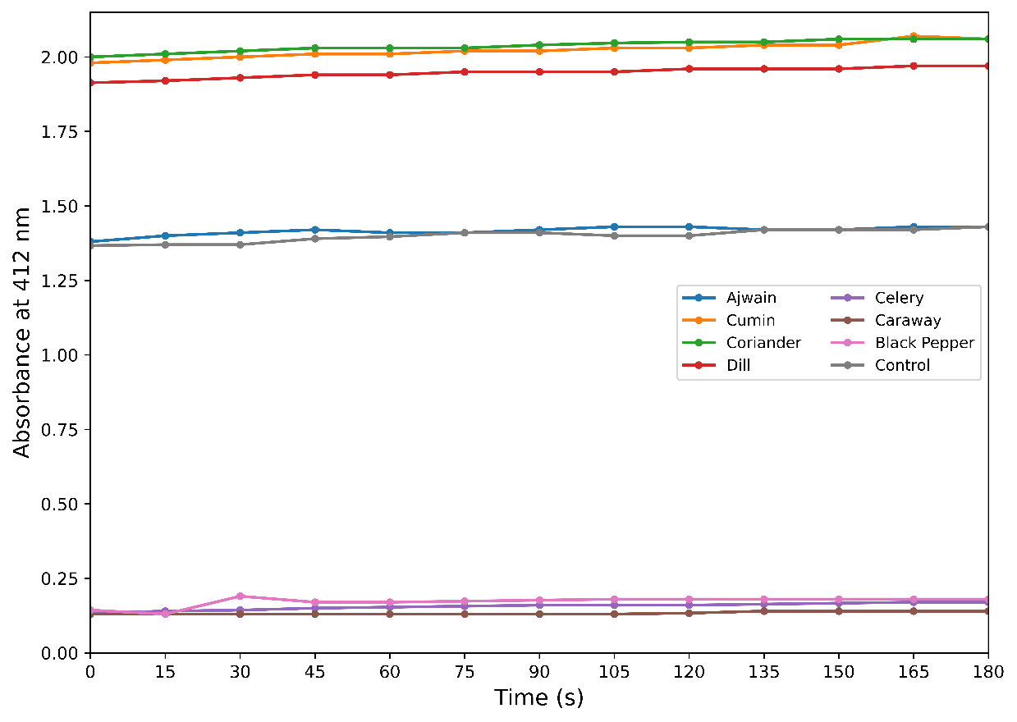
3.3 Essential-oil fumigation altered AChE activity in surviving adults: AChE activity differed very strongly among the seven essential-oil treatments and the untreated control (F₇,₁₆ = 234.04, P = 6.65 × 10⁻¹⁵) (Table 2, Figure 2). The untreated control showed the highest activity at 44.513 ± 0.961 U min⁻¹ mg⁻¹ protein. Coriander and Cumin retained relatively high activities of 38.459 ± 0.305 and 38.323 ± 0.162 U min⁻¹ mg⁻¹ protein, respectively. Dill showed intermediate activity (30.764 ± 0.054), whereas Ajwain, Black Pepper and Celery showed lower values of 27.499 ± 0.270, 28.067 ± 0.458 and 25.837 ± 0.892, respectively. Caraway produced the lowest AChE activity, at only 11.510 ± 1.176 U min⁻¹ mg⁻¹ protein.
Table 2. Acetylcholinesterase (AChE) activity in surviving adult C. maculatus following 24-h fumigation at the respective LC₅₀ concentrations
Treatment | LC₅₀ (µL L⁻¹) | AChE activity (U min⁻¹ mg⁻¹ protein) ± SE
Ajwain | 25.7 | 27.499 ± 0.270^{d}
Cumin | 19.3 | 38.323 ± 0.162^{b}
Coriander | 18.8 | 38.459 ± 0.305^{b}
Dill | 147.2 | 30.764 ± 0.054^{c}
Celery | 154.8 | 25.837 ± 0.892^{d}
Caraway | 81.5 | 11.510 ± 1.176e
Black Pepper | 143.5 | 28.067 ± 0.458^{cd}
Control | 0.0 | 44.513 ± 0.961ª
F value | — | 234.04
df | — | 7, 16
P value | — | 6.65 × 10⁻¹⁵
Note: Values are mean ± SE of three reported replicate determinations. Means sharing a common letter are not significantly different according to Tukey's HSD test at P < 0.05.
Relative to the untreated control, all seven essential oils were associated with reduced AChE activity, although the magnitude differed substantially among treatments. The strong overall ANOVA result and the separation of almost all treatment groups by Tukey HSD demonstrate that the observed differences were not simply a common downward shift. Rather, the oils produced distinct levels of AChE activity in surviving insects.
The pattern is particularly notable because previous studies have shown that essential-oil effects on AChE are not universally suppressive. Krzyżowski et al. (2020), for example, reported an increase in AChE activity following rosemary essential-oil fumigation of C. maculatus. In contrast, Nattudurai et al. (2017) observed substantial reductions in AChE activity following A. monophylla oil exposure, and Gupta et al. (2023) reported significant AChE inhibition for selected essential oils in C. maculatus. These contrasting responses reinforce the importance of considering the specific oil, exposure concentration, duration and physiological context when interpreting AChE activity.
Figure 2: AChE activity in surviving adult C. maculatus following 24-h fumigation at the respective LC₅₀ concentrations. Bars represent mean ± SE; different letters indicate significant differences according to Tukey's HSD test at P < 0.05.
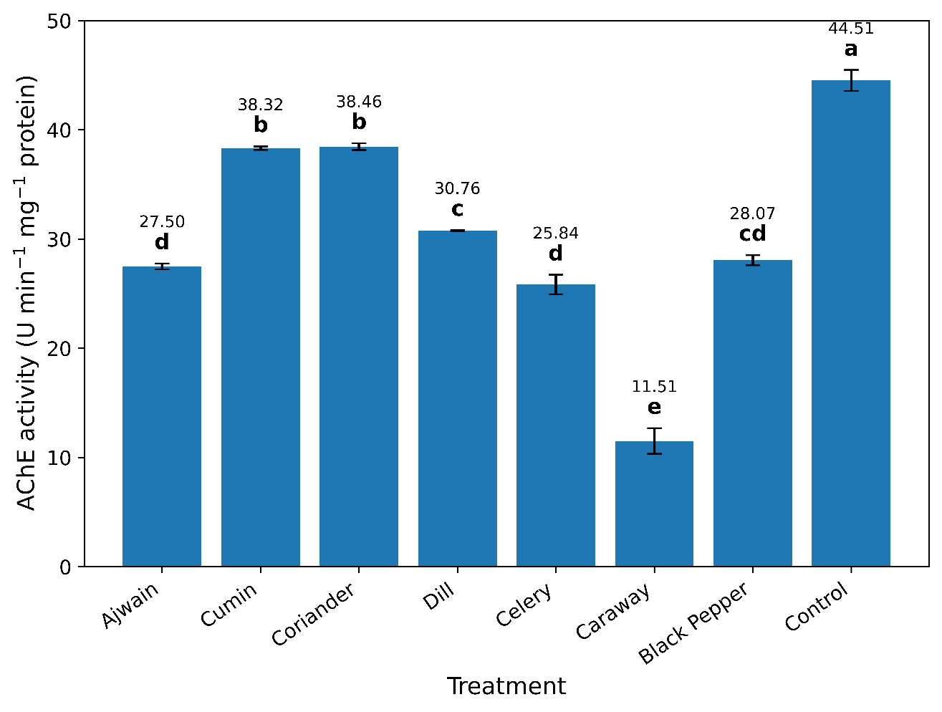
3.4 Relative reduction in AChE activity: The magnitude of the response becomes clearer when AChE activity is expressed relative to the untreated control (Table 3, Figure 3). Caraway produced the strongest reduction, with activity falling to 25.86% of the control value, equivalent to a 74.14% reduction. Celery showed a 41.96% reduction, followed by Ajwain (38.22%), Black Pepper (36.95%) and Dill (30.89%). Cumin and Coriander showed comparatively modest reductions of 13.91% and 13.60%, respectively.
Table 3. Relative AChE activity and reduction in AChE activity of surviving adult C. maculatus following 24-h fumigation at the respective LC₅₀ concentrations
Treatment | AChE activity ratio# | AChE reduction (%)
Ajwain | 0.618 | 38.22
Cumin | 0.861 | 13.91
Coriander | 0.864 | 13.60
Dill | 0.691 | 30.89
Celery | 0.580 | 41.96
Caraway | 0.259 | 74.14
Black Pepper | 0.631 | 36.95
Control | 1.000 | 0.00
#AChE activity ratio = treatment AChE activity / untreated-control AChE activity.
The large difference between Caraway and the other oils is physiologically interesting. Caraway produced approximately half the mortality range observed across the treatments but the greatest reduction in AChE activity, indicating that mortality magnitude and AChE response were not directly proportional. Similarly, Cumin and Coriander produced some of the lowest mortality values but retained comparatively high AChE activity. Thus, the biochemical response cannot simply be inferred from the mortality endpoint.
Figure 3: Relative reduction in AChE activity of surviving adult Callosobruchus maculatus following 24-h fumigation at the respective LC₅₀ concentrations. Values represent percentage reduction relative to the untreated control.
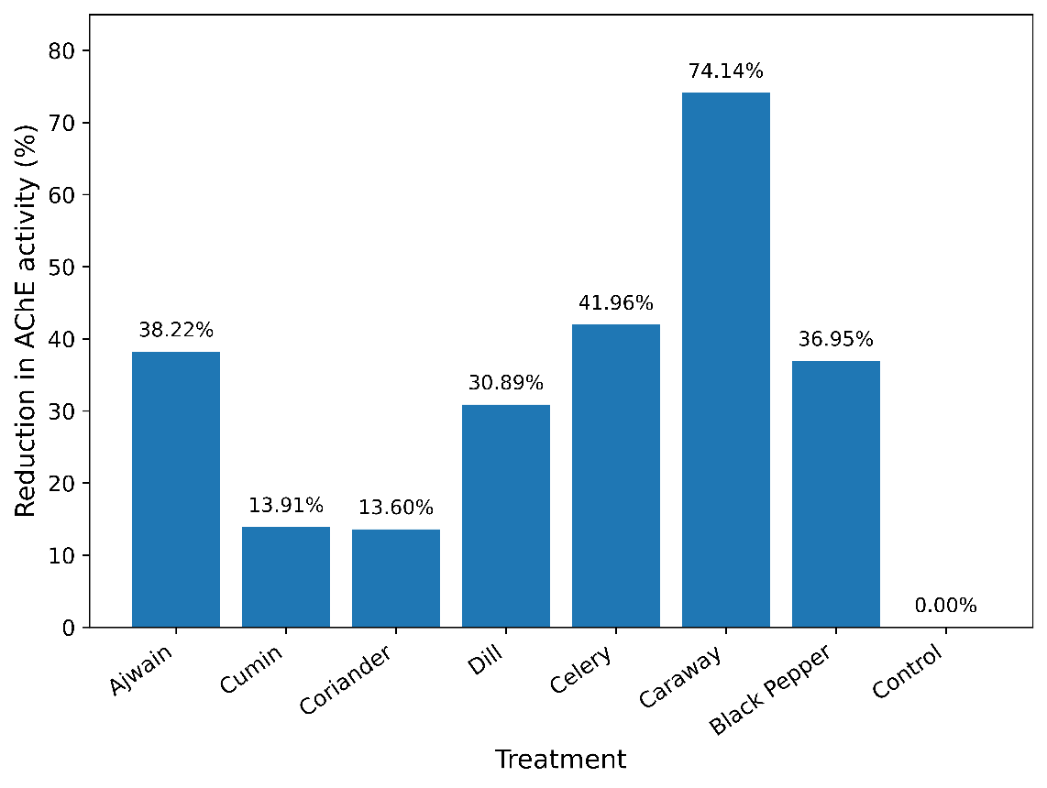
Such treatment-specific effects are consistent with the multimodal nature of essential-oil toxicity. Essential oils contain mixtures of monoterpenes, sesquiterpenes and other volatile compounds, and their biological effects may result from interactions among several molecular targets. Jankowska et al. (2018) emphasized that although AChE is one of the best-investigated targets of essential-oil components, other neuronal systems may also contribute to toxicity. Campolo et al. (2018) similarly emphasized that the biological action of essential oils against stored-product insects can involve multiple pathways rather than a single target.
The present pattern is also consistent with the documented biochemical activity of several Apiaceae oils and their constituents. Seo et al. (2015) reported insecticidal activity among ajowan, caraway, celery, cumin and dill oils and identified individual constituents with AChE-related activity in insect systems. These observations provide plausible biochemical context for the strong differences observed among the present oils, although the current experiment does not identify which constituents were responsible for the changes in C. maculatus which opens an interesting opportunity to ascertain the constituents responsible in the future studies.
3.4 Physiological significance and overall interpretation
The present findings demonstrate that essential-oil fumigation at the respective LC₅₀ concentrations was accompanied by substantial alterations in AChE activity among surviving adult C. maculatus. The response was clearly oil-specific, with reductions ranging from approximately 13.6% with Coriander to 74.1% with Caraway. This variation occurred despite the mortality endpoint being approximately 50% for all oils, indicating that similar acute mortality does not necessarily correspond to similar biochemical status in surviving insects.
The AChE response is therefore better interpreted as evidence of altered cholinergic-associated enzyme activity following fumigation, rather than as direct proof that the essential oils directly inhibited AChE. The distinction is important because the enzyme was measured from insect extracts after whole-insect exposure. Reduced activity could reflect direct or indirect physiological effects, changes in enzyme abundance or stability, altered metabolism, or other consequences of fumigation. Previous work in C. maculatus illustrates this context dependence, with rosemary essential oil associated with increased AChE activity in one study, while other essential oils have produced marked reductions.
The particularly strong response associated with Caraway provides an interesting basis for further investigation. Caraway contains bioactive volatile constituents, and Apiaceae essential oils can contain compounds with neuroactive or cholinesterase-modifying properties. However, attribution of the present response to a particular constituent would require chemical characterization of the oils together with constituent-specific assays. The detailed correlation of such data with mortalities owing to multiple concentrations and exposure periods, direct in vitro AChE inhibition assays, purified or recombinant insect AChE, and chemical profiling of the oils would help distinguish between direct enzymatic inhibition and post-exposure physiological modulation.
Overall, the study demonstrates that seven essential oils produced markedly different AChE activity profiles in surviving C. maculatus adults despite being evaluated at their respective LC₅₀ concentrations. Combining mortality with biochemical measurements therefore provides a more informative characterization of fumigant effects than mortality alone.
4. Conclusion
The study reports that the fumigation of adult C. maculatus with seven essential oils at their respective lethal concentrations resulted in substantial and treatment-dependent alterations in AChE activity in surviving insects. All oils reduced activity relative to the untreated control, with the largest reduction observed following Caraway exposure, whereas Cumin and Coriander showed comparatively modest reductions. The marked variation among oils indicates that a common mortality endpoint can be accompanied by distinctly different biochemical states. These findings support the use of AChE activity as a complementary physiological endpoint in the evaluation of botanical fumigants and provide a basis for more detailed dose-, time- and mechanism-oriented studies which paves way to identify the best essential oils for non-chemical management of bruchids infesting stored pulses.

Declaration of AI Use

This manuscript was prepared through the intellectual contributions of the author(s) to the study design, data analysis, interpretation of results, and scholarly content. Grammarly and ChatGPT were used solely to assist with grammatical refinement and reference formatting during manuscript revision. The author(s) accept full responsibility for the accuracy, integrity, and final content of the manuscript.

COMPETING INTERESTS DISCLAIMER:
Authors have declared that they have no known competing financial interests OR non-financial interests OR personal relationships that could have appeared to influence the work reported in this paper.

References
Aidbhavi R, Naik SSJ, Dutta D, Jaba J, Bandi SM, Gangashetty PI, Parihar AK, Bohra A, Akram M, Pratap A, and Dixit GP (2025). Identification of stable resistant wild pigeonpea donors to multiple predominant bruchid species in India. Scientific Reports https://doi.org/10.1038/s41598-025-33580-9
Aidbhavi, R., Murali Mohan, K., Soren, K. R., Bandi, S. M., Ranjitha, M. R., & Kodandaram, M. H. (2023a). Infestation, distribution and diversity indices of bruchid species on edible stored pulses in India. Journal of Stored Products Research, 101, 102085. https://doi.org/10.1016/j.jspr.2023.102085
Aidbhavi, R., Muralimohan, K., & Bandi, S. M. (2023b). The status of resistance to phosphine in common bruchid species infesting edible stored pulses in India. Journal of Stored Products Research, 103, 102164. https://doi.org/10.1016/j.jspr.2023.102164
Aidbhavi, R., Pratap, A., Verma, P., Lamichney, A., Bandi, S. M., Nitesh, S.D., Akram, M., Rathore, M., Singh, B. and Singh N.P. (2021) Screening of endemic wild Vigna accessions for resistance to three bruchid species. Journal of Stored Product Research 93: 101864. https://doi.org/10.1016/j.jspr.2021.101864
Campolo, O., Giunti, G., Russo, A., Palmeri, V., & Zappalà, L. (2018). Essential oils in stored product insect pest control. Journal of Food Quality, 2018, 6906105. https://doi.org/10.1155/2018/6906105
Ellman, G. L., Courtney, K. D., Andres, V., Jr., & Featherstone, R. M. (1961). A new and rapid colorimetric determination of acetylcholinesterase activity. Biochemical Pharmacology, 7(2), 88–95. https://doi.org/10.1016/0006-2952(61)90145-9
Gupta, H., Deeksha, Chaudhary, U., & Reddy, S. G. E. (2023). Insecticidal and detoxification enzyme inhibition activities of essential oils for the control of pulse beetle, Callosobruchus maculatus (F.) and Callosobruchus chinensis (L.) (Coleoptera: Bruchidae). Molecules, 28(2), 492. https://doi.org/10.3390/molecules28020492
Jankowska, M., Rogalska, J., Wyszkowska, J., & Stankiewicz, M. (2018). Molecular targets for components of essential oils in the insect nervous system—A review. Molecules, 23(1), 34. https://doi.org/10.3390/molecules23010034
Krzyżowski, M., Baran, B., Łozowski, B., & Francikowski, J. (2020). The effect of Rosmarinus officinalis essential oil fumigation on biochemical, behavioral, and physiological parameters of Callosobruchus maculatus. Insects, 11(6), 344. https://doi.org/10.3390/insects11060344
Lowry, O. H., Rosebrough, N. J., Farr, A. L., & Randall, R. J. (1951). Protein measurement with the Folin phenol reagent. Journal of Biological Chemistry, 193(1), 265–275.
Mannava, N., Bandi, S. M., Chandra, A., Kumar, V., Aidbhavi, R., Singh, B., & Jambhulkar, P. P. (2022). Bionomics of Callosobruchus analis (F.) in ten common food legumes. Journal of Stored Products Research, 98, 102010. https://doi.org/10.1016/j.jspr.2022.102010
Mssillou, I., Saghrouchni, H., Saber, M., Zannou, A. J., Balahbib, A., Bouyahya, A., Allali, A., Lyoussi, B., & Derwich, E. (2022). Efficacy and role of essential oils as bio-insecticide against the pulse beetle Callosobruchus maculatus (F.) in post-harvest crops. Industrial Crops and Products, 189, 115786. https://doi.org/10.1016/j.indcrop.2022.115786
Nattudurai, G., Baskar, K., Paulraj, M. G., Islam, V. I. H., Ignacimuthu, S., & Duraipandiyan, V. (2017). Toxic effect of Atalantia monophylla essential oil on Callosobruchus maculatus and Sitophilus oryzae. Environmental Science and Pollution Research, 24(2), 1619–1629. https://doi.org/10.1007/s11356-016-7857-9.
Nayak, M.K., Daglish, G.J., Phillips, T.W. and Ebert, P.R., 2020. Resistance to the fumigant phosphine and its management in insect pests of stored products: a global perspective. Annual Review of Entomology, 65(1), pp.333-350.
Orhan, I., Kartal, M., Kan, Y., & Sener, B. (2008). Activity of essential oils and individual components against acetyl- and butyrylcholinesterase. Zeitschrift für Naturforschung C, 63(7–8), 547–553.
Rajendran, S., & Sriranjini, V. (2008). Plant products as fumigants for stored-product insect control. Journal of Stored Products Research, 44(2), 126–135. https://doi.org/10.1016/j.jspr.2007.08.003.
Revanasidda, A., Subramanian, S., Ranjitha, M. R., Chandel, R. K., Srivastava, C., Bandi, S. M., Singh, B. and Singh, N. P. (2022) Comparative toxicity of phosphine to developmental stages of three Callosobruchus species infesting stored pulses. Journal of Asia-Pacific Entomology 25 (1): 101871. https://doi.org/10.1016/j.aspen.2022.101871
Revanasidda, Bandi, S.M., Verma, P., Bapatla, K.G. and Singh, B. (2020). A systematic methodology to assess bruchid field infestation and the impact of field-carry-over infestation in stored pulses. Journal of Food Legumes, 33(4), pp.262-264.
Seo, S.-M., Jung, C.-S., Kang, J., Lee, H.-R., Kim, S.-W., Hyun, J., & Park, I.-K. (2015). Larvicidal and acetylcholinesterase inhibitory activities of Apiaceae plant essential oils and their constituents against Aedes albopictus and formulation development. Journal of Agricultural and Food Chemistry, 63(45), 9977–9986. https://doi.org/10.1021/acs.jafc.5b03586.
Strong, R.G., Partida, G.J., Warner, D.N., 1968. Rearing stored product insects for laboratory studies, bean and cowpea weevil. J. Econ. Entomol. 61, 747–751. https://doi.org/10.1093/jee/61.3.747

