Weather-associated Seasonal Activity of Mustard Aphid, Lipaphis erysimi (Kaltenbach) Monitored Through Yellow Sticky Traps in Two Different Agro-ecological Conditions

Abstract
The mustard aphid, Lipaphis erysimi (Kaltenbach), is an important pest of rapeseed-mustard, and monitoring its alate population is useful for understanding its seasonal activity. The present investigation was conducted during Rabi 2024–25 and 2025–26 at Banda University of Agriculture and Technology (BUAT), Banda (India) and at a farmer-managed mustard field, to monitor the seasonal abundance of alate mustard aphids using yellow sticky traps and to assess their association with weather parameters. Two yellow sticky traps (21 × 15 cm) were installed at each location (300 m²), and aphid catches were recorded at weekly intervals. Maximum temperature, minimum temperature, average temperature, relative humidity and rainfall data were obtained from the Agro-meteorological Observatory, BUAT, and correlation coefficients were calculated separately for each location and season. During Rabi 2024–25, alate aphid activity commenced in the 1st standard meteorological week (SMW), with peak catches of 125.00 and 148.50 aphids trap⁻¹ at university farm, BUAT and the farmer-managed field, respectively, during the 6th SMW. During Rabi 2025–26, activity commenced earlier, in the 50th SMW, and again peaked during the 6th SMW, reaching 156.50 and 208.00 aphids trap⁻¹ at BUAT and the farmer-managed field, respectively. Thereafter, aphid catches declined towards crop maturity. Alate aphid catches showed negative correlations with maximum, minimum and average temperature, whereas relative humidity showed positive correlations and rainfall showed weak negative correlations. Significant negative correlations with minimum temperature (r = −0.555) and average temperature (r = −0.515) were observed only at the farmer-managed field during Rabi 2024–25; all other correlations were non-significant. The aphid catches were higher at the farmer-managed field than at university farm.
Keywords: Agro-ecology, Lipaphis erysimi; mustard aphid; seasonal monitoring; yellow sticky traps; weather parameters.
Introduction
Rapeseed-mustard (Brassica spp.) is one of the most important oilseed crops cultivated during the Rabi season in India and occupies a prominent position in the national edible oil economy (Khavse et al., 2014; Kumar et al., 2025). The crop is grown across diverse agro-climatic regions and serves as an important source of edible oil, protein-rich meal and livelihood security for small and marginal farmers (Patel et al., 2019; Rani et al., 2024). Mustard is valued not only as an oilseed crop but also for its nutritional and health-promoting properties. Mustard seeds are rich in glucosinolates, polyphenols, chlorophylls and several bioactive compounds that contribute to their antioxidant, antimicrobial and anti-inflammatory properties (Pedras & Yaya, 2015; Kaur et al., 2023; Mythili et al., 2026). Rapeseed-mustard is cultivated in more than 50 countries across the world and ranks among the leading sources of vegetable oil. During 2024–25, the global rapeseed-mustard crop occupied about 43.35 million hectares, with a production of 89.77 million tonnes and an average productivity of 2070 kg ha⁻¹. Canada remains the largest producer, followed by China and India. India contributes more than 13 per cent of global rapeseed-mustard production and occupies the third position among mustard-producing countries of the world (Kumar et al., 2025).
In India, rapeseed-mustard is cultivated in nearly all major agro-climatic regions and is grown across 24 states. Rajasthan is the leading producer, followed by Uttar Pradesh, Haryana, Madhya Pradesh and West Bengal, which together contribute the major share of national production (NIPHM, 2014; Kumar et al., 2025). Among the several constraints responsible for low productivity of rapeseed-mustard, insect pests are considered important biotic factors (Dhaliwal et al., 2004; Patel et al., 2019). More than 38 insect pest species infest Brassica crops at different growth stages; however, the mustard aphid, Lipaphis erysimi (Kaltenbach), is regarded as one of the major pests throughout the mustard-growing regions of India (Bakhetia, 1979; Bakhetia, 1987; Geethanjali et al., 2024). Both nymphs and adults suck plant sap from leaves, buds, flowers and siliquae, causing curling, yellowing, wilting and stunted growth of plants (Khan et al., 2015; Samal et al., 2021). Yield losses ranging from 35 to 96 per cent due to aphid infestation have been reported under favourable environmental conditions (Singh & Sharma, 2002; Shylesha et al., 2006; Geethanjali et al., 2024). In addition, aphid infestation can reduce seed quality and oil content, thereby causing significant economic losses to growers (Verma & Singh, 1987; Samal et al., 2021).
The incidence and population build-up of mustard aphid are strongly influenced by environmental factors, particularly temperature, relative humidity and crop phenology (Ali & Rizvi, 2012; Narjary et al., 2013). The winged form (alate) plays a crucial role in dispersal and establishment of new colonies in mustard fields and therefore serves as an important indicator of pest activity (Kumar et al., 2024). Early detection and monitoring of alate aphid populations are essential for developing timely and effective pest management strategies (Kumar et al., 2024). Although several studies have reported the seasonal incidence of mustard aphid and its association with weather parameters in different mustard-growing regions of India, information on alate aphid dynamics monitored through yellow sticky traps under Bundelkhand conditions remains limited. Previous investigations have largely focused on aphid population build-up at a single location, and comparatively little information is available regarding simultaneous monitoring of alate aphid populations under research-farm and farmer-managed field conditions. Since alate aphids play a key role in dispersal, colonization and initiation of infestation, generation of location-specific information on their population dynamics is essential for developing reliable forecasting systems and timely pest management strategies.
Yellow sticky traps have been widely used as an economical and efficient tool for monitoring flying aphid populations because of their strong attraction towards yellow colour (Kumar et al., 2024). These traps facilitate early detection of aphid migration and provide valuable information regarding seasonal abundance and population dynamics (Kumar et al., 2024). Such information can be effectively utilized in forecasting pest incidence and implementing integrated pest management strategies at the appropriate time (Mythili et al., 2026). Therefore, the present investigation was undertaken to monitor the alate population of mustard aphid through yellow sticky traps and to study its relationship with prevailing weather parameters.
Materials and methods
The present investigation was conducted during Rabi 2024–25 and 2025–26 at Banda University of Agriculture and Technology, Banda (India) and at a farmer-managed mustard field (300 m²) located at Atarra (Banda district). The study was conducted under two contrasting mustard-growing agro-ecological conditons of Bundelkhand, represented by the experimental field at BUAT, Banda, and a farmer-managed mustard field.
The BUAT campus (I Location) represented a research-farm agroecosystem where mustard was cultivated within an experimental agricultural setting under relatively defined field conditions mostly upland. In contrast, the farmer-managed field represented a production agroecosystem (particularly rice-based ecology) embedded within a larger mustard-growing landscape. The farmer-managed field (II Location) was surrounded by comparatively larger areas under mustard cultivation, where crops were sown at different times, resulting in early, medium and late-sown mustard fields occurring simultaneously in the surrounding area. This staggered sowing pattern provided relatively continuous availability of suitable mustard host plants during the crop season and may have favoured the movement, colonization and persistence of alate L. erysimi populations. Farmers of that region (canal irrigated, rice-based low land ecology) generally do not apply insecticides to the crop. Thus, the two agroecosystems differed in their surrounding crop landscape and crop-management practices, particularly in the continuity of mustard host availability and frequency of pesticide application, providing an opportunity to compare alate mustard aphid activity under research-farm (upland ecology and at few chemicals uasage regime) and farmer-managed conditions.
For monitoring the alate mustard aphid population, yellow sticky traps (Barrix Magic Sticker, Barrix Agro Sciences Pvt. Ltd.) measuring 21 × 15 cm were installed at both locations. Two traps were placed in the experimental field of the university farm and two traps were simultaneously installed at the farmer-managed field at Atarra. The traps were fixed on suitable supports and maintained just above the crop canopy throughout the crop-growing period. The height of the traps was adjusted periodically according to crop growth to ensure effective trapping of alate aphids.
Observations on alate mustard aphid population were recorded at weekly intervals by counting the number of aphids trapped on each yellow sticky trap. The aphid counts recorded from the two traps at each location were averaged for each observation date, and the resulting mean value was used as the alate aphid population for that observation. The yellow sticky traps were replaced after each weekly observation to maintain trapping efficiency throughout the crop season.
To assess the association of weather parameters with the population of alate mustard aphid, meteorological data comprising maximum temperature (°C), minimum temperature (°C), average temperature (°C), average relative humidity (%) and average rainfall (mm) were obtained from the Agro-meteorological Observatory, BUAT, Banda during the research period. The mean alate aphid population was correlated separately with the prevailing weather parameters for each location and cropping season using simple correlation analysis in Microsoft Excel. The simple correlation coefficient was calculated using the standard formula, and the significance of the correlation coefficients was tested at the 5% level of significance.
Results

Population of alate aphids on yellow sticky traps in relation to weather parameters at university farm during Rabi 2024–25
The data pertaining to the mean alate aphid population recorded on yellow sticky traps at weekly intervals during Rabi 2024–25 (Fig. 1 and Table 1) revealed that the population of alate aphids was first recorded during the 1st SMW, with a mean population of 9.50 aphids trap⁻¹. Thereafter, the population increased gradually to 21.00, 33.00 and 68.00 aphids trap⁻¹ during the 2nd, 3rd and 4th SMW, respectively. A further increase in population was observed during the 5th SMW (84.00 aphids trap⁻¹), and the population attained its peak of 125.00 aphids trap⁻¹ during the 6th SMW. Subsequently, the population declined to 92.50 aphids trap⁻¹ during the 7th SMW, followed by 84.50, 75.00 and 45.50 aphids trap⁻¹ during the 8th, 9th and 10th SMW, respectively.
The declining trend continued thereafter, and the population decreased to 23.50 and 22.50 aphids trap⁻¹ during the 11th and 12th SMW, respectively. Further reduction in aphid catches was observed during the 13th SMW (18.50 aphids trap⁻¹) and 14th SMW (7.50 aphids trap⁻¹). The population further declined to 5.50 aphids trap⁻¹ during the 15th SMW, while the lowest population of 2.50 aphids trap⁻¹ was recorded during the 16th SMW. Thus, the alate aphid population remained active from the 1st to 16th SMW, with maximum activity during the 6th SMW, after which the catches steadily declined towards crop maturity.
Further, the correlation coefficient between prevailing weather parameters and alate aphid population indicated that the population exhibited negative correlations with maximum temperature (r = −0.276), minimum temperature (r = −0.394), average temperature (r = −0.338) and rainfall (r = −0.291), whereas a positive correlation was observed with relative humidity (r = 0.074). However, none of the weather parameters showed a significant association with alate aphid population during the period of investigation. The peak activity of alate aphids during the 6th SMW followed the flowering stage of the mustard crop, which occurred during the last week of January. The availability of succulent plant parts coupled with congenial weather conditions during this period might have favoured increased aphid activity. Thereafter, the decline in aphid catches could be associated with increasing temperature and advancement of crop maturity during the later stages of the season.

Population of alate aphids on yellow sticky traps in relation to weather parameters at farmer-managed mustard field during Rabi 2024–25
It is evident from Fig. 1 and Fig. 2 that the population of alate aphids at the farmer-managed mustard field was first recorded during the 1st SMW, with a mean population of 12.50 aphids trap⁻¹. Thereafter, the population increased progressively to 38.50 aphids trap⁻¹ during the 2nd SMW and 86.50 aphids trap⁻¹ during the 3rd SMW. A sharp increase in aphid catches was recorded during the 4th SMW, when the population reached 124.00 aphids trap⁻¹. Although the population declined slightly to 105.50 aphids trap⁻¹ during the 5th SMW, it attained the highest level of 148.50 aphids trap⁻¹ during the 6th SMW. Thereafter, the aphid population gradually declined to 118.00 aphids trap⁻¹ during the 7th SMW and 88.50 aphids trap⁻¹ during the 8th SMW. The population further decreased to 55.00 and 28.50 aphids trap⁻¹ during the 9th and 10th SMW, respectively. A slight increase was observed during the 11th SMW, when the population reached 32.00 aphids trap⁻¹, after which the population again declined to 18.50 aphids trap⁻¹ during the 12th SMW and 12.00 aphids trap⁻¹ during the 13th SMW. The aphid catches further decreased to 4.50 and 3.00 aphids trap⁻¹ during the 14th and 15th SMW, respectively, and the lowest population of 2.50 aphids trap⁻¹ was recorded during the 16th SMW. Thus, the alate aphid population remained active throughout the observation period, with maximum activity during the 6th SMW, after which the catches showed a gradual declining trend.
The correlation analysis between alate aphid population and prevailing weather parameters revealed that the population was negatively correlated with maximum temperature (r = −0.462), minimum temperature (r = −0.555), average temperature (r = −0.515) and rainfall (r = −0.288), while a positive correlation was observed with relative humidity (r = 0.302). The correlation of alate aphid population with minimum temperature and average temperature was found to be significantly negative, whereas the remaining correlations were non-significant during the course of investigation. The higher alate aphid catches recorded at the farmer-managed mustard field as compared to the BUAT campus might be related to the larger area under mustard cultivation and the presence of crops at different growth stages owing to staggered sowing. The availability of early, medium and late-sown mustard fields in the surrounding area probably ensured continuous host availability for aphids, thereby favouring prolonged migration, colonization and population build-up throughout the crop season.

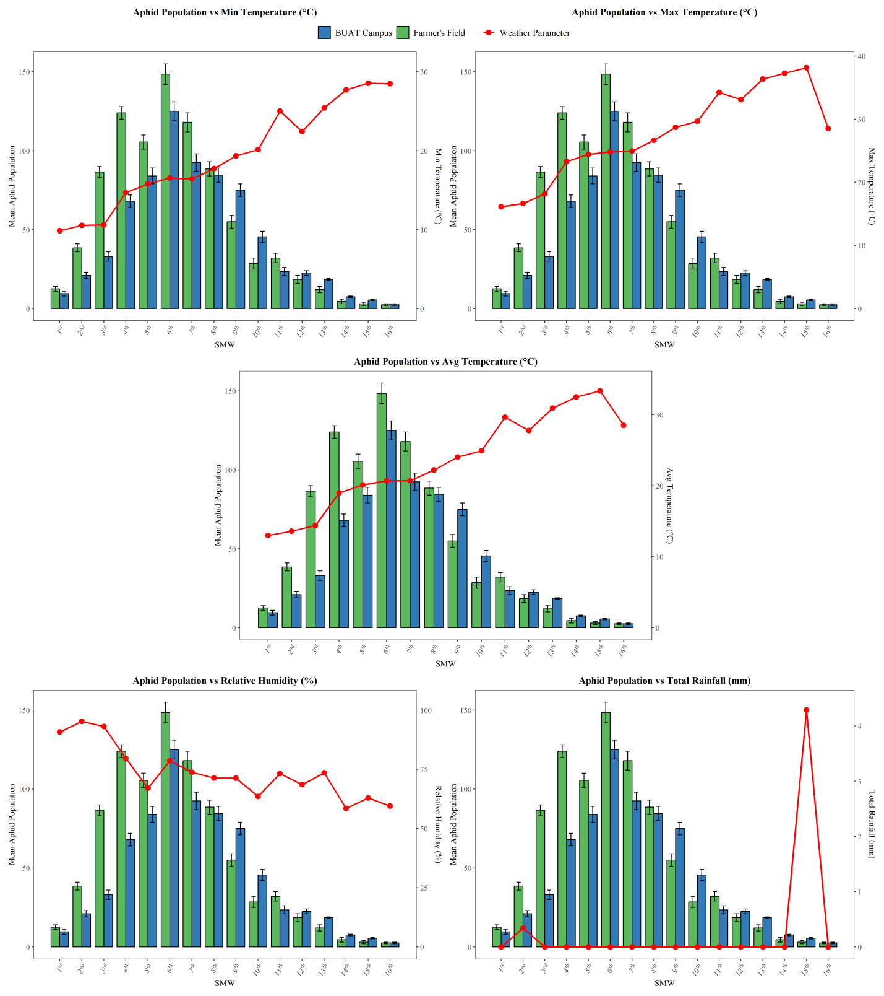
Fig 1. Weekly fluctuation of alate aphid population in relation to weather parameters at BUAT campus and farmer's field during Rabi, 2024–25.

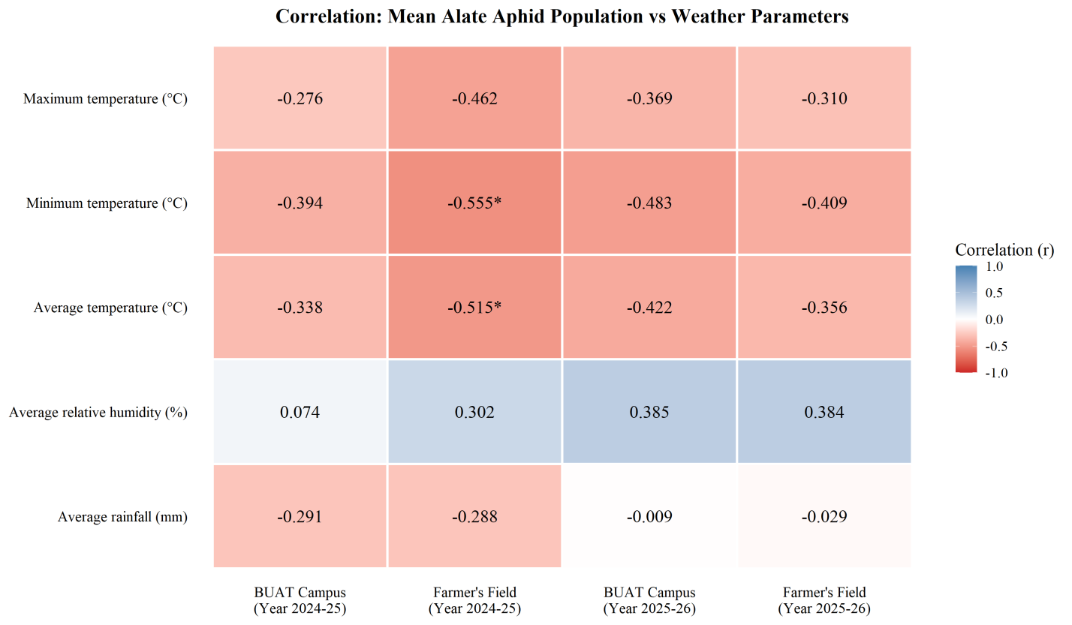
Fig. 2. Correlation coefficient (r) of alate aphid population with weather parameters at BUAT campus and farmer’s field during Rabi, 2024–25 and 2025-26

Population of alate aphids on yellow sticky traps in relation to weather parameters at BUAT campus during Rabi 2025–26
The data pertaining to the mean alate aphid population recorded on yellow sticky traps at weekly intervals during Rabi 2025–26 (Fig. 2 and Fig. 3) revealed that the population of alate aphids was first recorded during the 50th SMW, with a mean population of 4.50 aphids trap⁻¹. Thereafter, the population increased gradually to 7.50 and 12.50 aphids trap⁻¹ during the 51st and 1st SMW, respectively. A sharp increase in aphid catches was observed during the 2nd SMW, when the population reached 45.50 aphids trap⁻¹, followed by 99.50 aphids trap⁻¹ during the 3rd SMW. Although the population declined slightly to 78.00 aphids trap⁻¹ during the 4th SMW, it again increased and attained 128.00 aphids trap⁻¹ during the 5th SMW. The highest alate aphid population of 156.50 aphids trap⁻¹ was recorded during the 6th SMW, followed by 110.50, 67.50 and 63.00 aphids trap⁻¹ during the 7th, 8th and 9th SMW, respectively.
Thereafter, the population declined continuously to 28.50 aphids trap⁻¹ during the 10th SMW and 21.50 aphids trap⁻¹ during the 11th SMW. Further reduction in aphid catches was recorded during the 12th SMW (7.50 aphids trap⁻¹), while the lowest population of 2.50 aphids trap⁻¹ was observed during both the 13th and 14th SMW. Thus, the alate aphid population remained active from the 50th to 14th SMW, with maximum activity during the 6th SMW, after which the catches showed a gradual declining trend towards crop maturity.
Further, the correlation coefficient between prevailing weather parameters and alate aphid population indicated that the population exhibited negative correlations with maximum temperature (r = −0.369), minimum temperature (r = −0.483), average temperature (r = −0.422) and rainfall (r = −0.009), whereas a positive correlation was observed with relative humidity (r = 0.385). However, none of the weather parameters showed a significant association with alate aphid population during the period of investigation. The earlier appearance of alate aphids during the 50th SMW in Rabi 2025–26 as compared to Rabi 2024–25 may be attributed to the earlier sowing of the crop during the first fortnight of November, which resulted in the availability of suitable host plants for aphid colonization at an earlier stage of the season.

Population of alate aphids on yellow sticky traps in relation to weather parameters at farmer-managed mustard field during Rabi 2025–26
It is evident from Fig. 2 and Fig. 3 that the population of alate aphids at the farmer-managed mustard field was first recorded during the 50th SMW, with a mean population of 16.50 aphids trap⁻¹. Thereafter, the population increased steadily to 22.50 aphids trap⁻¹ during the 51st SMW and 27.50 aphids trap⁻¹ during the 1st SMW. A substantial rise in aphid catches was observed during the 2nd SMW, when the population reached 80.50 aphids trap⁻¹, followed by 98.50 aphids trap⁻¹ during the 3rd SMW. The population showed a slight decline during the 4th SMW (90.50 aphids trap⁻¹), but subsequently increased sharply to 166.50 aphids trap⁻¹ during the 5th SMW. The highest alate aphid population of 208.00 aphids trap⁻¹ was recorded during the 6th SMW, followed by 190.50, 146.50 and 122.50 aphids trap⁻¹ during the 7th, 8th and 9th SMW, respectively.
Thereafter, the aphid population declined markedly to 52.50 aphids trap⁻¹ during the 10th SMW and further decreased to 23.00 aphids trap⁻¹ during the 11th SMW. The declining trend continued, with populations of 17.00 and 13.50 aphids trap⁻¹ during the 12th and 13th SMW, respectively. The lowest population of 7.00 aphids trap⁻¹ was recorded during the 14th SMW. Thus, the alate aphid population remained active from the 50th to 14th SMW, with peak activity during the 6th SMW, after which the catches steadily declined towards the later stages of crop growth.
The correlation analysis between alate aphid population and prevailing weather parameters revealed that the population was negatively correlated with maximum temperature (r = −0.310), minimum temperature (r = −0.409), average temperature (r = −0.356) and rainfall (r = −0.029), while a positive correlation was observed with relative humidity (r = 0.384). However, all the correlations were non-significant during the course of investigation. Similar observations were recorded during Rabi 2024–25, wherein the farmer-managed mustard field supported higher alate aphid populations than the BUAT campus. The larger area under mustard cultivation and availability of crops at different growth stages in the surrounding area might have contributed to the sustained aphid activity throughout the season.

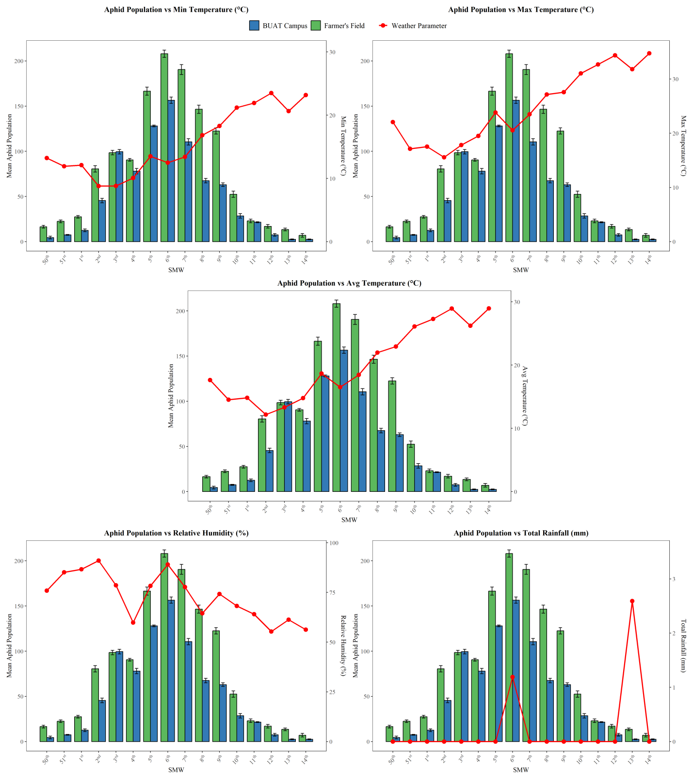
Fig. 3: Weekly population of alate aphids on yellow sticky traps at BUAT campus and farmer's field during Rabi, 2025–26.

Discussion
The present investigation revealed that the activity of alate aphids commenced during January in Rabi 2024–25 and during December–January in Rabi 2025–26. The catches increased progressively with crop development and attained peak abundance during the 6th SMW in both years, although the magnitude of catches was comparatively lower during Rabi 2024–25. Thereafter, alate aphid catches declined gradually towards crop maturity. The initial catches of alate aphids on yellow sticky traps coincided with the onset of flowering during January, whereas the peak catches during the 6th SMW coincided with the period when most of the mustard plants were in the full flowering stage. This temporal coincidence indicates an association between the flowering stage of the crop and increased catches of alate aphids under the prevailing field conditions. Following the peak, alate aphid catches declined gradually towards crop maturity.
The correlation analysis indicated that alate aphid catches generally exhibited negative associations with maximum temperature, minimum temperature and average temperature, whereas relative humidity showed positive associations with aphid catches during both years of investigation. During Rabi 2024–25, none of the weather parameters showed a significant correlation with alate aphid catches at the BUAT campus. However, at the farmer’s field, minimum temperature and average temperature exhibited significant negative correlations, whereas the remaining weather parameters showed non-significant associations. In contrast, during Rabi 2025–26, all the weather parameters showed non-significant associations with alate aphid catches at both locations, although the direction of association remained similar. The observed decline in alate aphid catches during the later crop stages coincided with increasing temperature and crop maturity. Relative humidity showed a weak positive association with alate aphid catches, whereas rainfall showed weak and non-significant associations throughout the study period.
The comparison between the two locations indicated that alate aphid catches were higher at the farmer’s field than at the BUAT campus during both years. The highest catch was recorded at the farmer’s field during Rabi 2025–26 (208.00 aphids trap⁻¹), followed by the BUAT campus during Rabi 2025–26 (156.50 aphids trap⁻¹), the farmer’s field during Rabi 2024–25 (148.50 aphids trap⁻¹) and the BUAT campus during Rabi 2024–25 (125.00 aphids trap⁻¹). The comparatively higher catches at the farmer’s field may be related to the larger surrounding area under mustard cultivation and the presence of mustard crops at different growth stages due to staggered sowing. The availability of early-, medium- and late-sown mustard fields in the surrounding area may have provided relatively continuous host availability during the crop season.
The present findings are in close agreement with the observations of Malik and Sachan (2013), who reported the occurrence of mustard aphid during December–January, with peak population during February. The findings are also in conformity with those of Bhati et al. (2015), who observed aphid activity from late December to March, with maximum population during February. Kalasariya and Parmar (2018) also reported that mustard aphid populations increased rapidly after initiation and attained peak abundance during February, followed by a gradual decline with increasing temperature and crop maturity.
The present findings are further supported by Raja et al. (2014), who reported that weather parameters play an important role in influencing mustard aphid population dynamics. The overall negative association of alate aphid catches with temperature observed in the present investigation indicates that comparatively cooler conditions were associated with greater aphid activity during the active crop-growth period, whereas increasing temperature during the later stages of crop development, together with crop maturity, coincided with a decline in aphid catches. Although significant negative correlations with minimum and average temperature were observed only at the farmer’s field during Rabi 2024–25, the direction of association with temperature was consistently negative across both years and locations. This suggests that temperature was associated with seasonal fluctuations in alate aphid abundance, although its association was not statistically significant in most location-season combinations. Relative humidity showed a weak positive association, whereas rainfall showed weak and non-significant associations with aphid abundance.
Wetland ecology, particularly in canal-irrigated, lowland, rice-based production systems, may create environmental conditions that favour the build-up and persistence of mustard aphid, L. erysimi (Kaltenbach), during the subsequent mustard-growing season. Compared with upland, non-canal-irrigated environments, lowland areas generally retain greater soil moisture and may experience higher relative humidity, moderated temperature fluctuations, and greater vegetation continuity. Such conditions can influence aphid development, survival, reproduction, and dispersal, while the surrounding rice-based vegetation and availability of alternate hosts may provide suitable habitats for aphid persistence between cropping periods. In addition, relatively humid and sheltered microclimatic conditions around field boundaries and crop canopies may facilitate colonization by alate aphids. Consequently, the interaction of irrigation regime, landscape moisture, cropping history, host-plant availability, and local weather conditions may contribute to greater seasonal abundance of L. erysimi in rice based agro-ecological conditions.
Conclusion
The present study revealed distinct seasonal fluctuations in the abundance of alate Lipaphis erysimi under the two mustard-growing agro-ecological conditions of Bundelkhand. The findings indicate that yellow sticky traps can provide useful information on the seasonal activity and abundance pattern of alate mustard aphids and may assist in timely monitoring. The development of a decision support system for mustard aphid management can be envisaged from the relationship between alate L. erysimi activity, weather parameters, and contrasting agro-ecosystems. Yellow sticky-trap catches, meteorological variables, crop stage, irrigation regime, and agro-ecological conditions of canal-irrigated lowland and non-canal-irrigated upland areas can be integrated to develop location-specific aphid risk indicators. Such a system may provide an early warning of impending aphid build-up and help farmers undertake timely field scouting and need-based management.
Declaration of AI Use

This manuscript was prepared through the intellectual contributions of the author(s) to the study design, data analysis, interpretation of results, and scholarly content. Grammarly and ChatGPT were used solely to assist with grammatical refinement and reference formatting during manuscript revision. The author(s) accept full responsibility for the accuracy, integrity, and final content of the manuscript.

COMPETING INTERESTS DISCLAIMER:
Authors have declared that they have no known competing financial interests OR non-financial interests OR personal relationships that could have appeared to influence the work reported in this paper.

References
Ali, A., & Rizvi, P. Q. (2012). Influence of abiotic and biotic factors on the population dynamics of mustard aphid, Lipaphis erysimi (Kalt.) on Indian mustard, Brassica juncea with respect to sowing dates. Academic Journal of Plant Sciences, 5(4), 123–127.
Bakhetia, D. R. (1979). Insect pest problems and their management in rape and mustard crops. Proceedings of the XV Annual Workshop-Cum-Seminar on Rapeseed and Mustard, 15, 47–53.
Bakhetia, D. R. C. (1987). Insect pests of rapeseed-mustard and their management. In Plant Protection in Field Crops, 27, 249–259.
Bhati, R., Sharma, A., & Joshi, N. (2015). Studies on occurrence and seasonal incidence of mustard aphid on Brassica crops. Journal of Eco-friendly Agriculture, 10(2), 143–146.
Dhaliwal, G. S., Arora, R., & Dhawan, A. K. (2004). Crop losses due to insect-pests in Indian agriculture. Indian Journal of Ecology, 31(1), 1–7.
Geethanjali, L., Singh, B., & Tiwari, A. (2024). A comprehensive review on holistic approaches for managing mustard aphid, Lipaphis erysimi (Kalt.). Plant Archives, 24(2), 1105–1112.
Kalasariya, R. L., & Parmar, K. D. (2018). Impact of weather parameters on population dynamics of mustard aphid, Lipaphis erysimi (Kaltenbach) under South Saurashtra zone. Journal of Insect Science, 31(1–2), 51–56.
Kaur, S., Tiwari, V., Kumari, A., Chaudhary, E., Sharma, A., Ali, U., & Garg, M. (2023). Protective and defensive role of anthocyanins under plant abiotic and biotic stresses: An emerging application in sustainable agriculture. Journal of Biotechnology, 361, 12–29.
Khan, I. A., Ahmad, M., Akbar, R., Hussain, S., Saeed, M., Farid, A., & Din, M. M. U. (2015). Study on aphid density and yield components of 12 Brassica genotypes under field conditions in Peshawar, Pakistan. Journal of Entomology and Zoology Studies, 3(6), 11–15.
Khavse, R., Singh, R., Manikandan, N., & Chaudhary, J. L. (2014). Influence of temperature on rapeseed-mustard yield at selected locations in Chhattisgarh state. Current World Environment, 9(3), 1034–1036.
Kumar, A., Mishra, M. K., Pandey, R., & Singh, B. K. (2024). Monitoring of alate mustard aphid, Lipaphis erysimi through yellow sticky trap. Ecology, Environment and Conservation, 30(Suppl.), S22–S25.
Kumar, A., Yadav, S., Ahlawat, N., & Yadav, J. (2020). Biochemical basis of resistance to mustard aphid, Lipaphis erysimi (Kaltenbach). Indian Journal of Entomology, 82(4), 875–879.
Kumar, D., Punia, R., Avtar, R., Kumar, A., & Malik, N. (2024). Monitoring and assessment of mustard aphid, Lipaphis erysimi in North-Western Haryana with yellow sticky trap. Journal of Applied Entomologist, 4(2), 12–14.
Kumar, V., Sharma, A. K., Yogi, R. K., & Singh, V. V. (2025). Rapeseed-mustard cultivation in India: National overview and regional insights with reference to Madhya Pradesh. Journal of Oilseed Brassica, 16(2), 149–157.
Malik, R., & Sachan, S. K. (2013). Population buildup of mustard aphid, Lipaphis erysimi (Kalt.) on Indian mustard in relation to abiotic factors. Progressive Agriculture, 13(1), 153–157.
Mythili, B., Pavan, T., Singha, A., Keerthika, N., & Ghosh, S. K. (2026). Sustainable management of pests infesting rapeseed and mustard crops. SATSA Mukhapatra—Annual Technical Issue, 30, 382–400.
National Institute of Plant Health Management. (2014). AESA based IPM package for mustard/rapeseed. Hyderabad, India: National Institute of Plant Health Management, 1–42.
Narjary, B., Adak, T., Meena, M. D., & Chakravarty, N. V. K. (2013). Population dynamics of mustard aphid in relation to humid thermal ratio and growing degree days. Journal of Agricultural Physics, 13(1), 39–47.
Patel, S., Singh, C. P., & Yadav, S. K. (2019). Monitoring of insect-pest complex on rapeseed mustard at Pantnagar. Journal of Entomological Research, 43(1), 73–76.
Pedras, M. S. C., & Yaya, E. E. (2015). Plant chemical defenses: Are all constitutive antimicrobial metabolites phytoanticipins? Natural Product Communications, 10(1), 209–218.
Raja, M., Kumar, S., David, P. M. M., & Natarajan, N. (2014). Influence of weather parameters on mustard aphid population and associated natural enemies in mustard ecosystem. Journal of Biological Control, 28(2), 77–82.
Rani, P., Rani, J., Mittal, A., & Sheoran, N. (2024). Assessment of drought tolerance of two cultivars of Indian mustard (Brassica juncea) using morphological and physiological parameters. Archives of Current Research International, 24(5), 437–450.
Samal, I., Dhillon, M. K., & Singh, N. (2021). Biological performance and biochemical interactions of mustard aphid (Lipaphis erysimi) in Brassica juncea. Indian Journal of Agricultural Sciences, 91(9), 1347–1352.
Shylesha, A. N., Thakur, N. S. A., Pathak, K. A., Rao, K. R., Saikia, K., Surose, S., Kodandaram, N. H., & Kalaishekar, A. (2006). Integrated management of insect pests of crops in North Eastern Hill Region (Technical Bulletin No. 19). Umiam, India: ICAR Research Complex for NEH Region, 45–58.
Singh, Y. P., & Sharma, K. C. (2002). Integrated approach to manage the mustard aphid, Lipaphis erysimi (Kalt.) (Homoptera: Aphididae) in oilseed Brassica crops—A review. Journal of Aphidology, 16(1–2), 77–88.
Verma, S. N., & Singh, O. P. (1987). Effect of mustard aphid infestation on oil content and seed quality of mustard. Pranikee, 8, 83–88.

