Case Report

Rescue, Medical and Surgical Management of Severe Cervical Snare Trauma in an Indian Monitor Lizard (Varanus bengalensis)

Abstract
An adult Indian monitor lizard (Varanus bengalensis) weighing 2.4 kg was rescued by the Telangana Forest Department from Veerpur village, Raikal mandal, Jagityal district, Telangana, after getting entrapped in a nylon snare around the neck. The animal was presented to the Veterinary Clinical Complex, College of Veterinary Science, Korutla, in a depressed, dehydrated and shock state with a severe circumferential cervical laceration exposing the superficial cervical muscle tissue. The animal was stabilised with fluid therapy, followed by wound irrigation with sterile normal saline, antiseptic cleansing using metronidazole, povidone-iodine solutions and protective bandaging. Following stabilisation, suturing was done under ketamine (20 mg/kg IM) and local anaesthesia. After debridement of devitalized tissue, the muscle and subcutaneous tissue was apposed using absorbable polyglactin 910 (Vicryl ® 2-0) with a continuous pattern and the skin was closed with non-absorbable polyamide (Ethilon ® 2-0) using a horizontal mattress suture pattern to achieve tension-free wound closure, following which a bandage was applied. Post-operative management included intramuscular ceftriaxone (25 mg/kg body weight) for 10 days, meloxicam (0.2 mg/kg body weight) for 5 days, daily wound dressing, supportive care, and rehabilitation under minimal-stress conditions. Skin sutures were removed on tenth post-operative day. The lizard regained normal feeding behaviour, locomotion, and responsiveness without any post-operative complications. Following complete clinical recovery, the animal was successfully rehabilitated and released into its native habitat. This case demonstrates that prompt stabilisation, surgical intervention and structured post-operative therapy have led to successful recovery, rehabilitation and release of this injured free-ranging Indian monitor lizard.

Keywords: Varanus bengalensis, Indian monitor lizard, cervical laceration, nylon snare injury, surgical reconstruction, wildlife rehabilitation.

Introduction
The Indian monitor lizard (Varanus bengalensis) is one of the largest terrestrial reptiles native to the Indian subcontinent, with a distribution extending across India, Nepal, Bangladesh, Sri Lanka, and parts of Southeast Asia. The species occupies a wide range of habitats, including deciduous forests, scrublands, rocky outcrops, agricultural fields, wetlands, and peri-urban environments. As an opportunistic carnivore and scavenger, it performs an important ecological function by regulating populations of rodents, insects, snakes, and other small vertebrates while contributing to the health of the ecosystem through its scavenging activities (Bennett, 1995; Daniel, 2002).
Despite its ecological significance, V. bengalensis faces increasing anthropogenic pressures. Habitat fragmentation, expanding agriculture, road traffic accidents, electrocution, illegal hunting, domestic animal attacks, and entanglement in synthetic fishing nets or nylon snares have emerged as major causes for injury and mortality. Among these, nylon snare entrapment is particularly devastating because the non-biodegradable material may progressively tighten around body parts as the animal struggles to escape, causing vascular occlusion, ischemia, pressure necrosis, extensive soft tissue damage, and, in severe cases, septicaemia or death (Mader & Divers, 2019).
The Indian monitor lizard is given the highest legal protection under Schedule I of the Wildlife (Protection) Act, 1972, making their rescue, treatment, rehabilitation, and release essential components of wildlife conservation in India. Veterinary intervention not only improves the survival of injured animals but also contributes directly to the conservation of genetically valuable wild populations.
Reptile wound management differs considerably from that of mammals because reptiles possess lower metabolic rates, temperature-dependent physiology, slower inflammatory responses, prolonged wound healing, and unique integumentary characteristics. Consequently, successful treatment requires careful stabilisation, meticulous surgical debridement, tension-free wound closure, appropriate antimicrobial therapy, and optimal environmental management (Divers & Mader, 2005; Jacobson, 2007; Divers & Stahl, 2019).
Although isolated reports describing traumatic injuries in monitor lizards have been published, detailed documentation of severe circumferential cervical snare injuries followed by successful surgical repair and rehabilitation remains scarce. The present report describes the complete clinical management—from rescue and stabilisation to surgery, post-operative care, rehabilitation, and release—of an Indian monitor lizard with a life-threatening cervical snare laceration.

Case History
An adult Indian monitor lizard (Varanus bengalensis) weighing approximately 2.4 kg was rescued by personnel of the Telangana Forest Department from Veerpur village, Raikal mandal, Jagtial district, Telangana. According to the rescuers, the animal had become entrapped in a nylon snare and repeated attempts to free itself caused progressive tightening of the nylon loop, producing a severe circumferential laceration around the neck (Figure 1A, 1B).
The rescued lizard was immediately transported to the Veterinary Clinical Complex (VCC), College of Veterinary Science, Korutla, for emergency veterinary care (Figure 2A and 2B).
On presentation, the lizard was markedly depressed, minimally responsive, dehydrated, and showed clinical signs consistent with circulatory shock. Physical examination revealed a deep circumferential laceration encircling the cervical region with exposure of subcutaneous tissue and superficial cervical musculature. The wound margins were contaminated with dirt, and there was necrotic tissue present, indicating prolonged entrapment. Mild haemorrhage and localised oedema were evident around the lesion. Despite the severity of the injury, no obvious tracheal rupture, oesophageal perforation, vertebral instability, or neurological deficits were detected. The animal retained spontaneous respiration and protective reflexes but was unable to exhibit normal defensive behaviour because of pain and exhaustion.
Considering the compromised physiological status, surgical repair of the laceration was deferred until the patient had been medically stabilised.
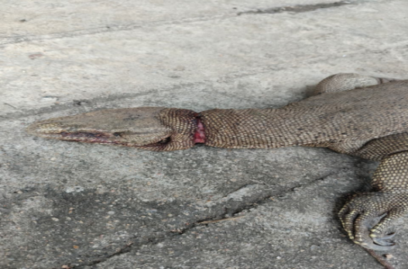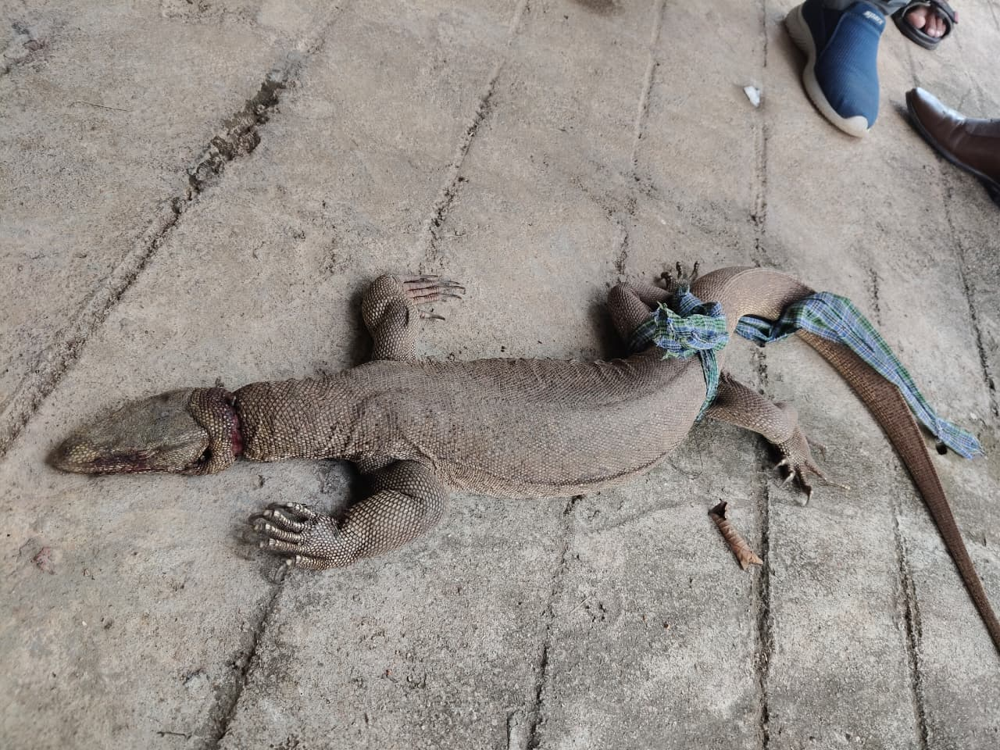
Figure 1A. Close-up view of the severe circumferential cervical laceration caused by nylon snare entrapment.
Figure 1B. Whole-body view of the rescued monitor lizard showing the cervical snare laceration on presentation.

Medical Stabilization
On presentation, the immediate priority was stabilisation of the patient before surgical intervention (Figure 3). The Indian monitor lizard was housed in cage to restrict its movement during recovery. As reptiles are ectothermic, the patient was maintained within its Preferred Optimal Temperature Zone (POTZ; 28–32°C) throughout hospitalisation to optimise cardiovascular function, immune competence, tissue perfusion and drug metabolism, thereby facilitating recovery and wound healing (Mader & Divers, 2019). Clinical examination revealed dehydration, circulatory shock and a contaminated circumferential cervical laceration. Supportive fluid therapy was initiated using Ringer's Lactate solution (20 mL/kg body weight, SC) to restore hydration, improve circulating blood volume and enhance tissue perfusion. Considering the extensive soft-tissue injury and the high risk of secondary bacterial infection, ceftriaxone (Intacef ®) was administered intramuscularly at 25 mg/kg body weight as empirical broad-spectrum antimicrobial therapy, meloxicam (Melonex ®) was also administered intramuscularly at 0.2 mg/kg body weight for pain and inflammation management. In addition, Tribivet® (Vitamin B-complex) injection was administered intramuscularly as supportive therapy to improve metabolic status and aid recovery from stress and trauma. The cervical wound was copiously irrigated with sterile normal saline to remove dirt, necrotic tissue, and foreign contaminants, followed by antiseptic lavage with dilute povidone–iodine solutions. A sterile gauze bandage was applied to protect the wound until surgical repair was initiated.
Following fluid resuscitation, antimicrobial therapy, thermal support and local wound management, there was marked improvement in the patient's hydration status, alertness, and overall clinical condition. Adequate pre-operative stabilisation was considered essential, as correction of dehydration and maintenance of the animal within the preferred optimal temperature zone improve anaesthetic safety, support normal drug pharmacokinetics, and enhance post-operative wound healing in reptiles (Divers & Stahl, 2019; Carpenter & Marion, 2024). The patient was therefore considered fit for general anaesthesia on the following day.
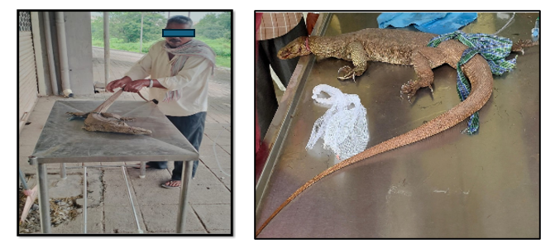
Figure 2A and 2B. Animal when presented to the clinic with the neck laceration.
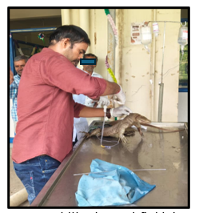
Figure 3. Initial emergency stabilisation and fluid therapy following rescue.

Surgical Management
Following successful medical stabilisation, suturing of the lacerated wound was undertaken with ketamine hydrochloride (20 mg/kg body weight, intramuscularly) anaesthesia, which provided satisfactory immobilisation for wound debridement and repair (Fig 4A). Lignocaine hydrochloride was also administered as a linear infiltration for adequate analgesia and it was also sprayed onto the whole wound surface (Fig 4B and 4C). Throughout the procedure, the lizard was maintained on a padded surface to prevent hypothermia, as reptiles depend on external heat sources for maintaining physiological functions and optimal tissue perfusion (Mader & Divers, 2019).
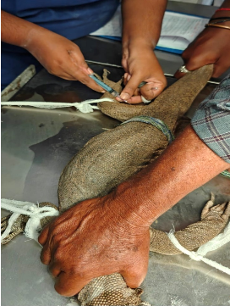
Figure 4A. Ketamine intramuscular administration.
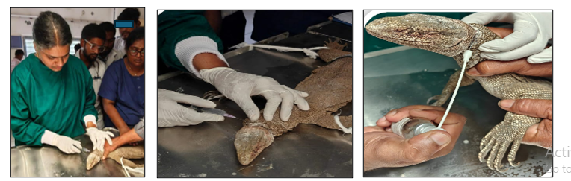
Figure 4B, 4C. Linear infiltration by lignocaine and also used in spray form.
The cervical wound was carefully examined and was found to be a circumferential laceration extending through the skin, subcutaneous tissue, and superficial cervical musculature. The wound margins were irregular, contaminated, and showed localised necrosis caused by prolonged constriction from the nylon snare.
After aseptic preparation of the surgical field, a thorough surgical debridement was performed by excising devitalized tissue and refreshing the wound margins until healthy, viable tissue was exposed after evaluating the circumferential wound (Fig 5A and 4B). The wound was repeatedly irrigated with copious sterile normal saline followed by metronidazole and dilute povidone-iodine solutions to reduce bacterial contamination. Elimination of devitalized tissue is essential in reptiles because necrotic tissue delays granulation, predisposes to bacterial colonisation, and significantly prolongs wound healing (Divers & Mader, 2005)
Muscle suturing was done in a simple continuous pattern using Polyglactin 910 (Vicryl® 2-0) to eliminate dead space and reduce wound tension. Subcutaneous and skin were apposed by using Polyamide (Ethilon ® 2-0) in a horizontal mattress suture pattern, which provides superior tension distribution across the thick, keratinised reptilian skin and minimises the risk of wound dehiscence (Fig 6).
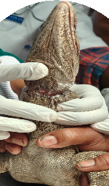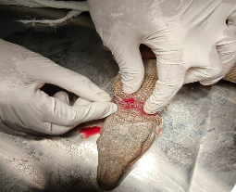
Figure 5A, 5B. After evaluating the circumferential laceration, surgical debridement was initiated.
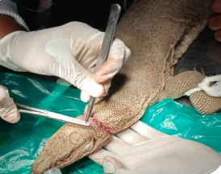
Figure 6. Intra-operative repair with layered wound closure of the cervical laceration.
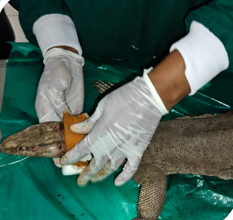
Figure 7A. Intra-operative subcutaneous bandage application after suturing and fluid administration.
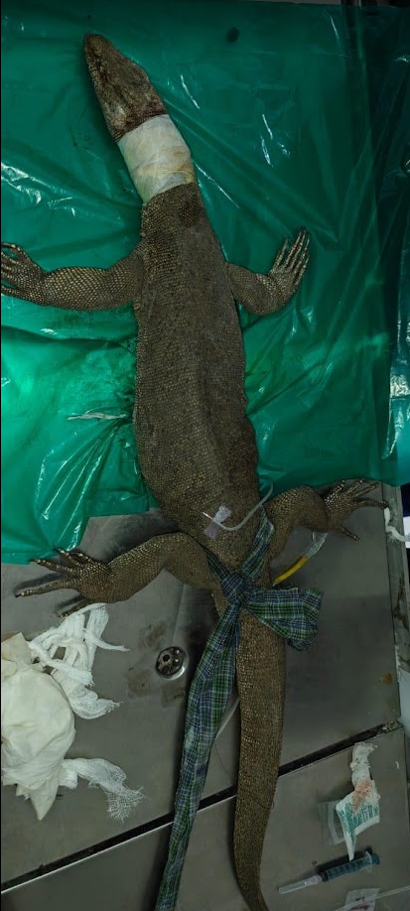
Figure 7B. Intra-operative subcutaneous bandage application after suturing and fluid administration.
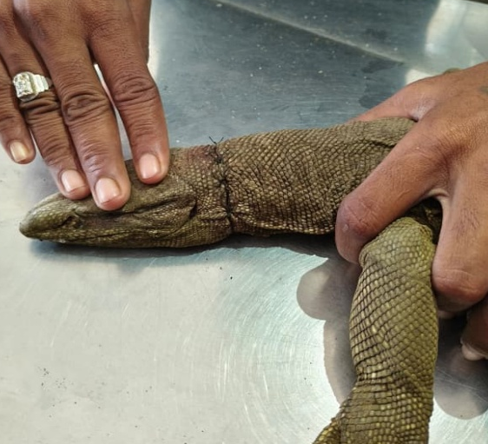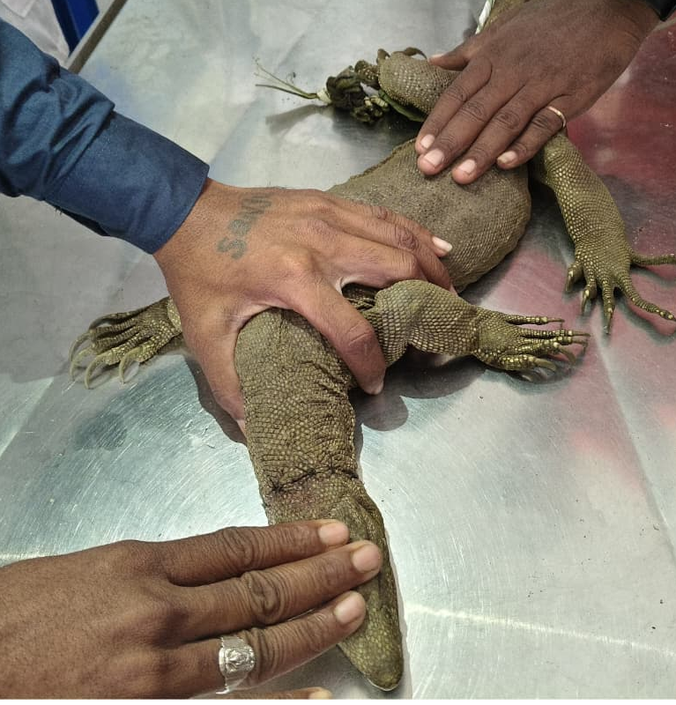
Figure 8A. post-operative appearance showing satisfactory skin apposition after surgical repair.
Figure 8B. Follow-up examination demonstrating progressive wound healing and restoration of cervical integrity prior to release.

Post-operative Management
Following suturing of the laceration, the lizard received ceftriaxone (25 mg/kg IM) for 10 days to prevent secondary bacterial infection. Meloxicam (0.2 mg/kg IM) was administered for 5 days to provide post-operative analgesia and control inflammation. The animal was reluctant to consume food during cage habitation, and hence daily fluids of 100 ml of DNS were administered subcutaneously (Fig 7B).
The sutured wound was dressed daily with metronidazole and povidone-iodine solutions (Fig 9A and 9B) and covered with a padded sterile bandage to protect the site from contamination and mechanical trauma (Fig 7A).
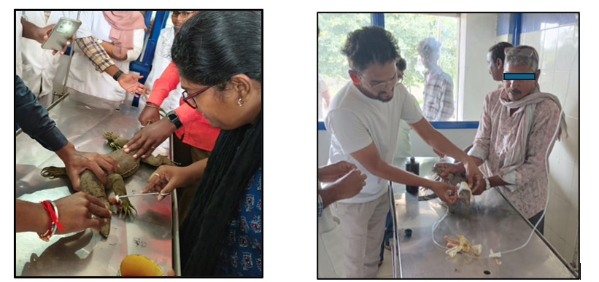
Figure 9A and 9B. post-operative wound management with daily dressing.
Routine monitoring of the suture site, continued thermoregulatory support, and maintenance of a clean, low-stress environment facilitated uneventful wound healing. Progressive granulation tissue formation and epithelialization were observed during follow-up, with complete wound healing by the tenth post-operative day. Skin sutures were removed after satisfactory tissue union.

Rehabilitation
Following satisfactory wound healing, the monitor lizard was transferred to a quiet rehabilitation enclosure for continued observation and recovery. To minimise stress, minimal restraint and handling was undertaken, which was restricted to essential clinical examination. The animal was maintained within its preferred optimal temperature zone with access to clean water and an appropriate environment. The recovering lizard was given small pieces of meat, which were readily accepted.
During the rehabilitation period, daily monitoring was done by checking general health, feeding behaviour, locomotion, neck mobility, and normal defensive responses. Progressive recovery was evident, with restoration of normal alertness, tongue-flicking behaviour, voluntary food intake, coordinated walking and climbing activities. The sutured wound remained healthy, showing complete epithelialization without evidence of infection.

Release
Before release, a final physical examination confirmed complete wound healing and restoration of normal physiological functions. The lizard demonstrated coordinated locomotion, adequate neck movement, active prey-seeking behaviour, and normal responsiveness.
Considering the successful clinical recovery, the patient was declared fit for release. In coordination with the Telangana Forest Department, the monitor lizard was released into a suitable natural habitat close to the rescue location (Fig 10), thereby minimising ecological disruption and maximising post-release survival.
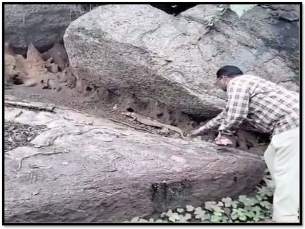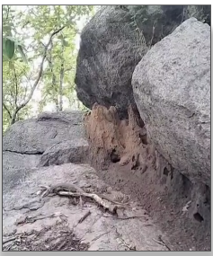
Figure 10. Release of the monitor lizard back into its natural habitat in Raikal forest under supervision of the Forest Beat Officer.

Discussion and Conclusion
Traumatic injuries caused by nylon snares and synthetic fishing nets are major causes of morbidity in free-ranging reptiles. Owing to their non-biodegradable nature, these materials progressively tighten as animals struggle to escape, resulting in vascular compromise, tissue ischemia, pressure necrosis, wound contamination, and, if untreated, septic complications (Jacobson, 2007; Mader & Divers, 2019). In the present case, entrapment in the snare caused a severe circumferential cervical laceration, and prolonged constriction resulted in extensive soft-tissue damage. Fortunately, there was no involvement of the trachea, oesophagus, and major cervical vessels, allowing successful wound healing with suturing.
Early medical stabilisation was critical to the favourable outcome. Correction of dehydration and circulatory compromise with crystalloid fluid therapy before anaesthesia improved tissue perfusion and patient stability. As reptiles are ectothermic, maintaining the lizard within its Preferred Optimal Temperature Zone (POTZ) was equally important for supporting immune function, drug metabolism, anaesthetic recovery, and tissue repair (Divers & Stahl, 2019; Doneley et al., 2020). Surgical debridement remains the cornerstone of contaminated wound management because removal of devitalized tissue reduces bacterial contamination, promotes granulation tissue formation, and facilitates epithelialization (Bennett, 1996; Mader & Divers, 2019). In the present case, layered closure of muscle, subcutaneous tissue and skin, post-operative broad-spectrum antimicrobial therapy and analgesic, anti-inflammatory therapy resulted in uncomplicated wound healing without infection or dehiscence. Meloxicam is widely recommended in reptile medicine for the management of post-operative pain and inflammation when administered after adequate hydration and appropriate thermal support (Carpenter & Marion, 2024; Mader & Divers, 2019).
Successful wildlife treatment includes not only wound closure but extends up to restoration of normal physiological and behavioural function before release.
The animal regained normal feeding behaviour, co-ordinated locomotion, neck mobility, and defensive responses indicated complete functional recovery and justified release into the native habitat, consistent with accepted wildlife rehabilitation principles (Miller & Fowler, 2015). This case demonstrates that timely rescue, appropriate medical stabilisation and surgical management, structured rehabilitation with close collaboration between veterinarians and the Forest Department resulted in the successful treatment, rehabilitation and release of the severely injured monitor lizard to the wild while contributing to the conservation of this protected reptile species (Government of India, 1972; Mader & Divers, 2019).

The Indian monitor lizard (Varanus bengalensis) is protected under Schedule I of the Wildlife (Protection) Act, 1972, emphasising the conservation value of every rescued individual. Furthermore, this report emphasises the value of evidence-based clinical management in the conservation of Schedule I protected reptile species and also underscores the need for greater awareness of injuries caused by nylon snares and other anthropogenic hazards placed in different regions for animal entrapment.

Declaration of AI Use

This manuscript was prepared through the intellectual contributions of the author(s) to the study design, data analysis, interpretation of results, and scholarly content. Grammarly and ChatGPT were used solely to assist with grammatical refinement and reference formatting during manuscript revision. The author(s) accept full responsibility for the accuracy, integrity, and final content of the manuscript.

COMPETING INTERESTS DISCLAIMER:
Authors have declared that they have no known competing financial interests OR non-financial interests OR personal relationships that could have appeared to influence the work reported in this paper.

References
Bennett, R. A. (1996). Soft tissue surgery in reptiles. Seminars in Avian and Exotic Pet Medicine, 5(4), 194–205.
Carpenter, J. W., & Marion, C. J. (Eds.). (2024). Exotic Animal Formulary (6th ed.). Elsevier.
Daniel, J. C. (2002). The Book of Indian Reptiles and Amphibians. Bombay Natural History Society & Oxford University Press.
Divers, S. J., & Mader, D. R. (2005). Reptile Medicine and Surgery (2nd ed.). Saunders Elsevier.
Divers, S. J., & Stahl, S. J. (2019). Reptile emergency and critical care. In D. R. Mader & S. J. Divers (Eds.), Current Therapy in Reptile Medicine and Surgery (pp. 515–534). Elsevier.
Doneley, B., Monks, D., Johnson, R., & Carmel, B. (2020). BSAVA Manual of Reptiles (3rd ed.). British Small Animal Veterinary Association.
Government of India. (1972). The Wild Life (Protection) Act, 1972 (Act No. 53 of 1972), as amended.
Jacobson, E. R. (2007). Infectious Diseases and Pathology of Reptiles: Color Atlas and Text. CRC Press.
Mader, D. R., & Divers, S. J. (Eds.). (2019). Current Therapy in Reptile Medicine and Surgery. Elsevier.
Miller, R. E., & Fowler, M. E. (Eds.). (2015). Fowler's Zoo and Wild Animal Medicine (Vol. 8). Elsevier.
Warwick, C., Arena, P., Lindley, S., Jessop, M., & Steedman, C. (2013). Assessing reptile welfare using behavioural and clinical indicators. Journal of Veterinary Behavior, 8(3), 123–131.

