Integrated Assessment of Mosquito-Borne Diseases in Ottapalam, Palakkad, Kerala

Abstract
The present mixed-method study assessed the epidemiological pattern of selected mosquito-borne diseases, community knowledge, attitudes and practices (KAP), household larval indices in Ottapalam Municipality, Palakkad, Kerala, and the preliminary effects of ultrasonic exposure on the developmental cycle of Aedes mosquitoes. Secondary epidemiological data for 2021–2025 were obtained from the Primary Health Centre (PHC), Lakkidi, Ottapalam, and the National Centre for Vector Borne Diseases Control (NCVBDC). A community awareness survey included 105 participants recruited through Google Forms and face-to-face household interviews. Entomological surveillance covered 100 households in Wards 13, 14 and 15, with assessment of House Index (HI), Container Index (CI) and Breteau Index (BI). Local surveillance showed that dengue was the principal mosquito-borne disease, with 11 cases in 2021, 7 in 2022, 21 in 2023, 45 in 2024 and 10 in 2025. Malaria was limited to one case in 2022 and two in 2024, with most cases documented among migrant populations, while no chikungunya cases were recorded during the study period. More than 90% of survey participants were aware of mosquito-borne diseases; dengue was recognized by 90.4%, chikungunya by 83.7% and malaria by 79.8%, whereas awareness of Zika virus and Japanese encephalitis was lower. Larval surveillance identified six larva-positive houses among 100 inspected houses and six positive containers among 50 observed containers, yielding HI 6%, CI 12% and BI 6; no pupae were detected. In a pilot laboratory experiment, 20 Aedes albopictus eggs were maintained in a control group and another 20 eggs were exposed to ultrasound under controlled experimental conditions. In the ultrasound-exposed group, 80% of the eggs hatched approximately three days earlier than those in the control group. The durations of egg-to-larva development, larval stages, pupal stage, and the overall developmental period were also shorter in the ultrasound-exposed group. These findings suggest that, under the experimental conditions used, uncalibrated acoustic exposure may have unintended stimulatory effects on mosquito development and should not be considered a vector-control intervention without systematic validation. The study supports continued emphasis on source reduction, community participation, surveillance and integrated vector management (IVM), while treating emerging acoustic technologies as experimental until their effects are adequately characterized.
Keywords: mosquito-borne diseases; dengue; malaria; chikungunya; Aedes albopictus; KAP; larval indices; House Index; Container Index; Breteau Index; ultrasonic device; integrated vector management.

1. Introduction
Mosquito-borne diseases (MBDs) remain a major public health challenge and contribute substantially to morbidity and mortality worldwide. Important mosquito vectors include Aedes, Anopheles and Culex species, which are particularly successful in tropical and subtropical environments where temperature and humidity support their development and transmission cycles [World Health Organization, 2023]. Rapid urbanization, climatic variability and inadequate waste management can create or maintain water-holding habitats that favour mosquito breeding and increase the risk of diseases such as dengue, malaria, chikungunya and Zika [CDC, 2024]. Local understanding of disease occurrence, community awareness and breeding-site distribution is therefore essential for designing context-specific vector-control strategies, particularly in peri-urban settings where routine control measures may be inconsistent [National Vector Borne Disease Control Programme, 2023].
The global burden of mosquito-borne disease has remained substantial. The World Health Organization reported particularly severe dengue transmission during 2023 and 2024, with more than 13 million cases reported in the Americas in 2024 [WHO, 2024]. More broadly, mosquito-borne infections account for a substantial proportion of infectious disease burden and are associated with more than 700,000 deaths annually [WHO, 2023]. India continues to experience a considerable burden because of its climatic and ecological suitability for vector proliferation. In 2023, more than 1.1 lakh mosquito-borne disease cases were reported nationally, with dengue and malaria accounting for a substantial proportion [NVBDCP, 2023]. Changing rainfall patterns and urban expansion have also contributed to shifts in the geographical distribution and intensity of dengue transmission [ICMR, 2024].
Kerala has experienced recurrent dengue transmission and has been described as a high-burden state for dengue. In 2023, approximately 17,426 confirmed dengue cases and 153 deaths were reported in the state [Directorate of Health Services Kerala, 2024]. More than 18,000 cases were reported by the middle of 2024, with intermittent rainfall providing repeated opportunities for vector breeding [The Hindu, 2024]. Palakkad presents a distinct epidemiological setting because agricultural landscapes, plantation areas and expanding urban environments occur in close proximity. In May 2024, the District Medical Officer issued an alert concerning dengue and leptospirosis following pre-monsoon showers [DMO Palakkad, 2024]. Climatic changes have also increased concern regarding emerging mosquito-borne threats, including West Nile fever [Mathrubhumi, 2024].
In Kerala, dengue is primarily transmitted by Aedes aegypti and Aedes albopictus. Ernakulam has consistently recorded high numbers of dengue cases, while districts such as Malappuram and Idukki have also emerged as important areas of concern [DHS Kerala, 2023]. Discarded plastic materials, coconut shells, containers, tyres and water-holding sites associated with plantations can provide productive breeding habitats. Intermittent rainfall can repeatedly generate new breeding sites. Current control efforts include weekly 'Dry Day' activities, source reduction and fogging; however, community participation is variable and insecticide resistance remains a concern [ICMR-VCRC, 2022].
Despite the state-level burden, localized information for Ottapalam is limited, as much of the available surveillance information is aggregated at district level. Such aggregation can obscure local epidemiological patterns and household-level breeding conditions. The present study therefore integrates secondary epidemiological surveillance, community KAP assessment, household larval surveillance and a preliminary experimental evaluation of an ultrasonic device.. By combining these components, the study aims to characterize the local situation and assess whether an emerging acoustic approach shows promise—or unintended effects—for mosquito control.

2. Objectives
To analyse five-year epidemiological trends (2021–2025) of dengue, malaria and chikungunya in comparison with state and national statistics.
To assess the Knowledge, Attitude and Practices (KAP) of the community in Ottapalam regarding mosquito-borne disease prevention and vector-control measures.
To determine larval density in Ottapalam through field surveillance of 100 households using standard entomological indices, namely House Index, Container Index and Breteau Index.
To conduct a preliminary pilot study to test the effect of an ultrasonic device on the life cycle of Aedes mosquito larvae.

3. Materials and Methods

3.1 Study design and setting
This community-based mixed-method implementation study was conducted during November 2025–January 2026 in Ottapalam Municipality, Palakkad district, Kerala, India. The study comprised three complementary components: retrospective epidemiological analysis using secondary surveillance data, a cross-sectional community survey assessing awareness and preventive practices, and an experimental pilot study evaluating ultrasonic exposure during mosquito development.

3.2 Epidemiological trend analysis
Records were collected from the registers of the Primary Health Centre, Lakkidi, Ottapalam, and from the National Centre for Vector Borne Diseases Control (NCVBDC) website (ncvbdc.mohfw.gov.in). Annual incidence and mortality information for dengue, malaria and chikungunya from 2021 to 2025 was reviewed to identify local temporal patterns and to place the Ottapalam observations within the broader state and national context.

3.3 Community awareness survey
The study population comprised residents of Ottapalam and surrounding areas. A total of 105 participants were recruited using a dual-mode survey consisting of Google Forms and face-to-face interviews during household visits. Convenience, non-probability sampling was used in randomly selected wards of Ottapalam, based on feasibility, accessibility, availability of participants, administrative approval and expected cooperation.
A structured awareness questionnaire included demographic variables such as age, gender, education, area of residence, previous history of mosquito-borne disease and use of available preventive resources. The questionnaire contained 23 questions. Questions 1, 2, 3, 4, 5, 6, 18, 19 and 20 were descriptive and were not scored. Knowledge was assessed using questions 7, 8, 9, 11, 16 and 17; Attitude using questions 10, 22 and 23; and Practices using questions 12, 13, 14, 15 and 21.
For scoring, correct identification or 'Yes' responses to knowledge items received 1 point, whereas incorrect, negative or uncertain responses received 0 points. For attitude, a positive response concerning prevention or seriousness received 1 point and 'No' received 0 points. For practices, 'Often' or 'Regularly' received 2 points, 'Sometimes' received 1 point and 'Never' received 0 points. The resulting responses were categorized as Good, Moderate or Poor Knowledge, Attitude, or Practice (KAP). Data were summarized using frequency distributions and percentages and presented using tables and pie charts. Data collection was conducted from 24 November 2025 to 1 December 2025. The questionnaire used in the study was circulated through Google Forms: https://forms.gle/kkspnfkAPt3saEfj7.

3.4 Entomological field surveillance
An eight-member team, divided into four groups of two, conducted door-to-door larval surveillance of 100 households on 22 December 2025 and 4 January 2026. Outdoor water-holding containers, including tyres, coconut shells and discarded plastic materials, were inspected for mosquito larvae and pupae. Survey forms and smartphones with Global Positioning System (GPS) capability were used for field data collection. The standard entomological indices House Index (HI), Container Index (CI) and Breteau Index (BI) were calculated.
The indices were calculated as follows:
House Index (HI) = (Number of houses positive for larvae / Number of houses inspected) × 100.
Container Index (CI) = (Number of containers positive for larvae / Number of containers inspected) × 100.
Breteau Index (BI) = (Number of positive containers / Number of houses inspected) × 100.

3.5 Ultrasonic pilot experiment
Aedes mosquito eggs were maintained and reared under shaded and well-ventilated conditions to minimize direct thermal stress and maintain a stable rearing environment. The objective was to determine whether ultrasonic sound waves affected the egg-hatching rate and developmental duration of Aedes albopictus across different life stages.
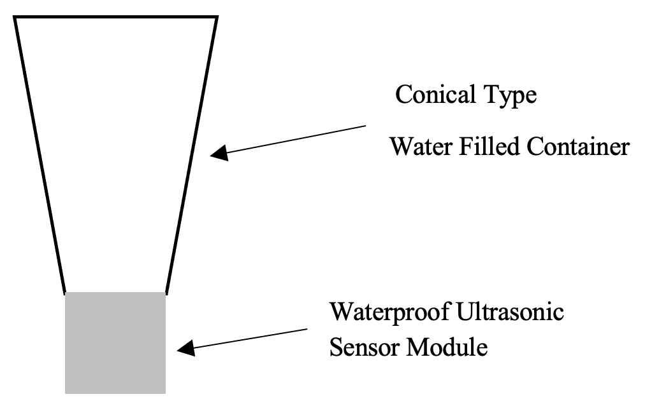

Figure 1. Experimental setup for control group.
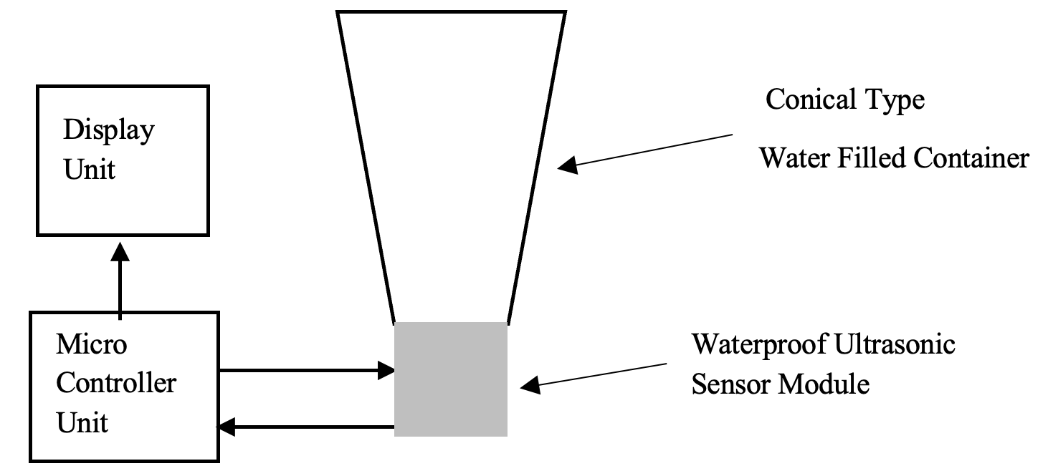
Figure 2. Experimental setup for test group.

The prototype ultrasonic system comprised a waterproof ultrasonic sensor module, a microcontroller unit (MCU), a water-filled container and a display interface. The transmitter operated at 40 kHz with an average output power of approximately 15 mW. A piezoelectric crystal converted electrical energy into mechanical vibrations, allowing acoustic waves to propagate through the water. The MCU monitored signal transmission and controlled system operation, while the display provided real-time status indication. The container was designed to promote relatively uniform acoustic distribution and minimize acoustic dead zones.
The experimental materials included 20 eggs for each group, clear 250-mL plastic beakers, a hand lens for observing larval instars, a thermometer and pH paper.
Two groups were established. The control group consisted of eggs maintained in standard water containers without ultrasonic exposure and the experimental setup for control group is shown in figure 1. The test group consisted of eggs exposed to high-frequency sound waves using the ultrasonic device and the experimental setup for test group is shown in figure 2.
Observation parameters included: (1) ovicidal activity, defined as the number of eggs failing to hatch; (2) morphogenetic effects, including any delay in transition from larva to pupa to adult; and (3) a general comparison of hatching and larval-to-adult development between the control and experimental groups.
High-precision climate control was not available. However, the control and experimental groups were maintained in the same microenvironment to keep environmental variables as similar as possible. The seasonal mean temperature for Ottapalam during the experimental period was approximately 27°C. Water pH was measured using pH paper and water temperature was recorded with a thermometer. This experiment was designed as a pilot feasibility study.

4. Results

4.1 Comparative epidemiological analysis
National and state surveillance data indicate that malaria, dengue and chikungunya continue to present important public health challenges in India, particularly in tropical states such as Kerala. In 2023, India reported approximately 240,000 malaria cases and more than 286,000 dengue cases, along with substantial numbers of suspected chikungunya infections. In Kerala, 9,770 dengue cases and 37 dengue-related deaths, 565 malaria cases and 7 malaria deaths, and 1,131 chikungunya cases were reported in 2023. In 2024, Kerala's Integrated Disease Surveillance Programme documented 952 malaria cases with 6 deaths, 20,674 confirmed dengue cases plus 53,536 probable cases with 141 dengue-related deaths, and 29 chikungunya cases with 2 deaths. These data indicate an increasing dengue burden and continued circulation or detection of all three diseases in the state.
Secondary data from PHC Lakkidi identified dengue as the principal mosquito-borne public health concern in Ottapalam Municipality.
Year | Dengue cases | Malaria | Chikungunya
2021 | 11 | Not stated in local record summary | 0 reported
2022 | 7 | 1 case | 0 reported
2023 | 21 | Not stated in local record summary | 0 reported
2024 | 45 | 2 cases | 0 reported
2025 | 10 | Not stated in local record summary | 0 reported

Table 1. Reported mosquito-borne disease pattern in Ottapalam based on the PHC Lakkidi data summarized in the study.
Dengue showed marked fluctuation across the five-year period. Cases were relatively low in 2021 (11 cases) and 2022 (7 cases), increased to 21 cases in 2023, reached a pronounced peak of 45 cases in 2024, and subsequently declined to 10 cases in 2025. Malaria incidence was minimal and consisted of one case in 2022 and two cases in 2024; most of these cases were documented among migrant populations, highlighting the potential role of population mobility in local disease dynamics. No chikungunya cases were reported during the study period, suggesting an absence of detected local transmission during the period covered by the available records.

4.2 Community knowledge, attitude and practices
The community survey included 105 participants from Ottapalam and nearby areas. More than 90% of respondents reported awareness of mosquito-borne diseases. Dengue was the most widely recognized disease (90.4%), followed by chikungunya (83.7%) and malaria (79.8%). Awareness was considerably lower for Zika virus (18.3%) and Japanese encephalitis (13.5%). Approximately 39% of participants were residents of Ottapalam. Most respondents were aged 18–30 years, and females constituted nearly 70% of the sample.
Regarding perceived local impact, 90.3% of respondents reported that no deaths due to mosquito-borne diseases had occurred in their locality, while 9.7% reported that such deaths had occurred. Awareness of mosquito-control activities was moderate: 51% had noticed control measures in their locality, 25% had not noticed such activities and 24% were unsure. Concerning public awareness programmes, 48.1% considered them adequate, 45.2% considered that improvement was required and 6.7% considered them inadequate.
Overall, the survey indicated a relatively high level of general awareness, but preventive practices were not uniformly implemented. More than 90% of respondents identified stagnant water as a mosquito-breeding source; however, only about 40% reported cleaning refrigerator drip trays or terrace gutters. This discrepancy indicates that knowledge does not necessarily translate into consistent source-reduction behaviour.

4.3 Entomological surveillance and larval indices
A house-to-house larval survey was conducted over two days, 23 December 2025 and 4 January 2026, between 9:30 AM and 11:45 AM, covering 100 households in Wards 13, 14 and 15. The structured survey recorded household size, stagnant water, container types and self-reported dengue and chikungunya cases. Household size ranged from one to nine residents.
An initial challenge was reluctance among some residents, who believed that the survey might be associated with municipal monitoring or sanitation enforcement. Some residents were specifically unwilling to permit GPS-tagged photography because of concerns that images might be used as evidence for penalties or legal action. After the study team explained the academic purpose of the survey and assured confidentiality, participation improved. Inspections were subsequently completed without photography.
Entomological measure | Finding
Houses inspected | 100
Houses positive for larvae | 6
Containers observed | 50
Positive containers | 6
House Index (HI) | 6%
Container Index (CI) | 12%
Breteau Index (BI) | 6
Pupae detected | None

Table 2. Larval surveillance findings from 100 households in Ottapalam.
Overall hygiene of the surveyed premises was rated as good, with effective water management in most households. Nevertheless, localized breeding sites were identified, particularly around households involved in cattle rearing and in premises with ornamental water features. Residents also reported an increase in mosquito-borne disease during the previous year and associated this increase with waste dumping in a nearby pond, which was subsequently closed.
Larvae were predominantly found in plastic containers, discarded tyres and plastic buckets or pots. Natural or ornamental breeding sites included lotus ponds and leaf axils, while stagnant water near cattle sheds represented another high-risk setting. The observed HI was 6%, CI was 12% and BI was 6, and no pupae were found.

4.4 Ultrasonic pilot experiment
Twenty eggs were used in each of the control and experimental groups. In the ultrasound-exposed group, 80% of eggs hatched three days earlier than those in the control group. Hatching began on day 5 in the experimental group, compared with day 8 in the control group. In the control group, 75% of eggs hatched on day 8 and the remainder hatched on the following day. The measured pH was 7 and the water temperature was 28°C. No ovicidal or larvicidal effect was observed.
Rather than delaying development, ultrasonic exposure was associated with faster hatching and a shorter observed developmental period. The experimental observations therefore suggest an unintended stimulatory effect under the conditions of this pilot study.
Developmental stage | Control group (days) | Ultrasound group (days) | % difference
Egg to larva | 8.2 | 5.2 | 36.6%
Larval stages | 4.2 | 3.4 | 19%
Pupal stage | 2.2 | 1.8 | 18%
Total days | 14.2 | 10.4 | 26%

Table 3. Developmental duration observed in control and ultrasound-exposed Aedes albopictus groups.

5. Discussion
The present study demonstrates the value of integrating epidemiological surveillance, community-level assessment and entomological field observations to understand mosquito-borne disease risk in a peri-urban setting. The PHC Lakkidi data indicate that dengue is the principal mosquito-borne disease concern in Ottapalam, with a pronounced increase in cases in 2024 followed by a substantial decline in 2025. The local pattern broadly follows the wider fluctuations reported in Kerala. The 2024 peak is plausibly associated with favourable climatic conditions, the creation of stagnant-water breeding habitats and rapid environmental changes. The subsequent decline in 2025 may reflect strengthened surveillance, targeted vector control and increased community awareness.
The malaria findings are also epidemiologically relevant. The recorded cases—one in 2022 and two in 2024—were largely associated with migrant populations. This observation emphasizes the importance of surveillance strategies that account for population mobility, particularly where people move between areas with different malaria transmission profiles. The small number of cases in Ottapalam does not establish absence of risk, but it indicates limited documented local transmission during the study period.
No chikungunya cases were recorded in the local surveillance data during 2021–2025. This contrasts with reports of chikungunya activity in some other Kerala districts and may reflect differences in land use, vector ecology, source reduction or other local factors. Because the present study did not include systematic virus testing or vector infection assessment, the absence of recorded cases should be interpreted as an absence of reported cases rather than definitive proof of zero transmission.
The community survey revealed substantial general awareness of mosquito-borne diseases. This is broadly consistent with the observation that adults in the study population had meaningful awareness and that many participants used preventive measures. Previous work in New Delhi reported moderate awareness with inadequate use of preventive measures [Setu et al. 2020], while a study of community perceptions in Karnataka found inadequate understanding of the causes and spread of mosquito-borne diseases [Kumar and Gururaj 2005]. In the present study, the high recognition of stagnant water as a breeding source contrasted with less consistent cleaning of refrigerator drip trays and terrace gutters. This gap between knowledge and routine practice is important because Aedes mosquitoes can exploit small domestic containers that may be overlooked during conventional sanitation activities.
The entomological findings further demonstrate that apparently satisfactory household sanitation does not eliminate breeding risk. Six of 100 inspected houses were positive for larvae, six of 50 inspected containers were positive, and no pupae were found. The CI of 12% was higher than the HI of 6%, indicating that breeding was concentrated in a subset of houses and containers. Breeding was detected in discarded tyres, plastic containers and pots, ornamental water features, leaf axils and areas near cattle sheds. These findings support the need for targeted source reduction rather than relying exclusively on generalized cleanliness campaigns.
The persistence of dengue despite high community awareness also suggests that important breeding sites may occur outside the residential spaces routinely accessible to household-level interventions. Construction sites, public drains, building gutters and other inaccessible or non-residential areas were not systematically surveyed in the present study. In addition, Ottapalam's role as a transit location may facilitate the importation of infections through travel. These factors should be considered when interpreting the relationship between household larval indices and reported dengue cases.
The ultrasonic pilot study produced the most unexpected finding of the investigation. The device was intended to evaluate whether acoustic exposure could disrupt the mosquito life cycle; however, the exposed eggs hatched earlier and the total developmental period was shorter than in the control group. The study therefore does not support the use of this prototype as a mosquito-control intervention. A previous study has reported larval mortality following exposure to ultrasonic waves in the 18–30 kHz range [Kalimuthu et al. 2020], illustrating that acoustic effects can vary with frequency, exposure conditions, distance and biological stage. Similarly, a systematic review of electronic mosquito repellents has emphasized the need for evidence-based evaluation of such technologies [Enayati et al. 2019].
Several mechanisms could potentially explain the observed acceleration. The investigators noted a small temperature increase of approximately 2°C associated with the device, although care was taken to minimize this effect. Even modest temperature changes can influence mosquito metabolism and developmental rate. Vibrational stress may also alter developmental responses, and relatively low-frequency acoustic exposure could potentially interact with natural vibrational cues. These mechanisms remain hypotheses and were not directly tested in the present experiment. Therefore, the observed acceleration should be regarded as a preliminary experimental observation rather than evidence of a confirmed biological mechanism.
The implications are important for vector-control technology development. An acoustic device that has not been calibrated and biologically validated could theoretically produce an effect opposite to that intended. The findings therefore support systematic testing under controlled conditions before any field deployment. With appropriate standardization, acoustic technologies may also have value in controlled biological systems, including research applications such as larval production for aquaculture; however, such applications would require independent validation.

6. Limitations
The ultrasonic device was a standardized prototype supplied by the Department of Electronics of a nearby college, and the present study represented an application and observational pilot rather than a fully controlled laboratory efficacy trial. Environmental factors including humidity and ambient noise were not controlled. The sample size of 20 eggs per group was small and limits statistical inference. The community survey used convenience, non-probability sampling and therefore may not represent the entire Ottapalam population. The entomological survey covered 100 households in three wards and was conducted on two field days, which may not capture temporal variation in breeding-site abundance. The available local epidemiological summary did not provide complete year-by-year values for every disease, and the present study did not undertake laboratory confirmation of mosquito infection or systematic surveillance of non-residential breeding sites.

7. Conclusion
This integrated assessment indicates that Ottapalam has a relatively high level of community awareness regarding mosquito-borne diseases, but household-level breeding remains detectable and dengue continues to represent the major documented local mosquito-borne disease concern. The five-year local record showed a marked dengue peak in 2024 followed by a decline in 2025, while malaria remained limited to a small number of cases associated largely with migrant populations and no chikungunya cases were recorded during the study period. The larval survey identified six positive houses, six positive containers, an HI of 6%, a CI of 12% and a BI of 6, with no pupae detected. These findings indicate that focused source reduction remains necessary even where overall household sanitation is good.
The ultrasonic pilot experiment did not demonstrate the hypothesized disruptive effect. Instead, exposure was associated with earlier egg hatching and a shorter developmental period. This unexpected result highlights the potential for uncalibrated acoustic technologies to produce unintended biological effects. Accordingly, source reduction, community education, regular surveillance and integrated vector management remain the most appropriate foundations for local mosquito-borne disease control, while new technological approaches should remain experimental until supported by controlled and reproducible evidence.

8. Recommendations
Immediate source reduction should be prioritized, particularly the removal or management of stagnant water in domestic and peri-domestic environments.
Systematic testing and controlled application of new mosquito-control technologies are necessary before field deployment.
Community engagement should be strengthened through regular 'Dry Day' activities and improved coverage of domestic water-storage containers.
Integrated Vector Management (IVM) should be adopted to combine surveillance, source reduction, community participation and appropriate vector-control measures.
Surveillance should include mobile and migrant populations because population movement may contribute to malaria re-introduction and disease spread.
Vector surveillance should extend, where feasible, to construction sites, public drains, building gutters and other non-residential breeding habitats that may be missed by household surveys.

Declaration of AI Use

This manuscript was prepared through the intellectual contributions of the author(s) to the study design, data analysis, interpretation of results, and scholarly content. Grammarly and ChatGPT were used solely to assist with grammatical refinement and reference formatting during manuscript revision. The author(s) accept full responsibility for the accuracy, integrity, and final content of the manuscript.

COMPETING INTERESTS DISCLAIMER:
Authors have declared that they have no known competing financial interests OR non-financial interests OR personal relationships that could have appeared to influence the work reported in this paper.

9. References
Anitha Wilson, V. T. Krishnadas C, R. Saju M, Mohammed Rafi (2022). A study to assess the Aedes mosquito diversity and the different mosquito genera in a rural area in Thrissur, Kerala. The International Journal of Community Medicine and Public Health (IJCMPH), 9(4), April 2022.
Centers for Disease Control and Prevention (CDC). (2024). About Dengue: What you need to know. U.S. Department of Health & Human Services. https://www.cdc.gov/dengue/about/index.html
Clint Vaz, Jenyz M Mundodan, Anjali Harikumar, Mohamed Rafi, C. R. Saju (2019). Mosquito density in rural Kerala: a study on the trend of Aedes larval indices over monsoon in a rural area of Thrissur district. IJCMPH, 6(10), October 2019.
Dmelloa, D. A., Gurub, B. R., & Acharyac, S. (2025). A comprehensive review of ultrasonic patent strategies for mosquito repellence: a landscape analysis. Journal of Sustainable Engineering, 2025 (July). https://doi.org/10.1080/19397038.2025.2543114
Directorate of Health Services (DHS), Kerala. (2023). Integrated Disease Surveillance Programme (IDSP) Annual Report. Government of Kerala.
Directorate of Health Services (DHS), Kerala. (2024). Communicable Disease Statistics: Monthly Report. Government of Kerala. http://dhs.kerala.gov.in/
District Medical Officer (Health), Palakkad. (2024, May 15). Press Release: Alert on Dengue and Leptospirosis during pre-monsoon showers. Palakkad District Medical Office.
Enayati, A., Hemingway, J., & Garner, P. (2019). Electronic mosquito repellents for preventing mosquito bites and malaria infection. Cochrane Database of Systematic Reviews, 2019(5). https://pmc.ncbi.nlm.nih.gov/articles/PMC6532582/
Indian Council of Medical Research (ICMR). (2024). Standard Treatment Guidelines for Management of Dengue Fever. Ministry of Health and Family Welfare, Government of India.
ICMR-Vector Control Research Centre (VCRC). (2022). Vector surveillance and control measures in Kerala: A status report. Pondicherry.
Indrajit Ghosh, Pankaj Kumar Tiwari, Joydev Chattopadhyay (2018). Effect of active case finding on dengue control: Implications from a mathematical model. arXiv:1808.08123 (q-bio).
Jishnu Raj, Anitha K. R, Soorya (2022). Trends and seasonality of vector borne diseases in Kerala. IJCMPH, 9(10).

