Annelid fauna of Purba Midnapur, West Bengal, India

Abstract: A faunal survey conducted across Purba Medinipur, West Bengal, in 2026 yielded 106 annelid specimens (85 earthworms and 21 leeches). Taxonomic analysis identified 16 species, comprising 14 oligochaetes across 8 genera and 3 families alongside 2 hirudinean species under one genus and single family. The 10 species represent new distribution records for Purba Medinipur district, significantly expanding its previously known diversity of 5 earthworms and 8 leeches. Furthermore, 3 species the earthworms Perionyx shyamasreetus and Eutyphoeus sukhendui, and the land leech Haemadipsa rajbalaae are recorded from the state of West Bengal for the first time. These findings update the regional annelid inventory and provide critical baseline data for local biodiversity conservation and vermiculture.
Keywords: Annelida, Earthworms, Leeches, Purba Medinipur, West Bengal, New records.
Introduction: Annelids, predominantly represented by earthworms (Oligochaeta) and leeches (Hirudinea), play vital roles in ecological dynamics and biomedical science. Earthworms are critical ecosystem engineers, often regarded as farmers' allies due to their ability to enhance soil aeration, boost porosity in agricultural terrains such as paddy fields, and facilitate nitrogen retention. Additionally, their casts provide nutrient-rich vermicompost essential for sustainable agriculture and horticulture. In India, foundational and recent taxonomic investigations by researchers such as Julka (1988), Halder (1998), Ghosh et al. (2024), and Balakrishna et al. (2025) have significantly expanded the understanding of oligochaete diversity. Globally, over 5,738 earthworm species have been described, with 498 recorded from India and 82 documented from West Bengal. Despite this regional richness, previous records from Purba Medinipur district account for only five species.
Leeches, comprising predominantly sanguivorous and hermaphroditic organisms, hold longstanding therapeutic relevance. Historically used in bloodletting to treat cutaneous ailments and infected wounds, modern hirudotherapy exploits anticoagulant secretions such as hirudin to treat vascular and paralytic conditions. India’s hirudinean taxonomy has been systematically documented through seminal works by Harding and Moore (1927), Chandra (1991), Ghosh (1998), and Mandal et al. (2026). Out of approximately 917 species known worldwide, 91 occur in India, 33 in West Bengal, and only 8 have previously been documented from the Medinipur region. The current study documents annelid fauna collected during recent field surveys in Purba Medinipur, presenting new distribution records for both the district and the state, including the terrestrial leech Haemadipsa rajbalaae.
The current study documents the annelid fauna collected during recent field surveys across Purba Medinipur, presenting new distribution records for both the district and the state. The pickaxe was employed as an essential tool for excavating hard and moist microhabitats while minimizing specimen damage (Fig. 1), with collection activities documented across representative spots in Haldia (Plate 1). Quantitative analyses detail the specimen abundance across the recorded earthworm taxa (Fig. 2) alongside the species composition and proportion of leeches under the genus Haemadipsa (Fig. 3). Morphological characteristics and external anatomy of key taxa are further illustrated, including the newly recorded terrestrial leech Haemadipsa rajbalaae (Plate 2), dorsal aspects of Amynthas gracilis (Plate 3), and diagnostic characters of Perionyx sp. (Plate 4). Collectively, these findings update the regional faunal inventory and provide vital baseline data for local vermiculture and biodiversity conservation.
Material and Methods: Earthworms and leeches were collected from moist microhabitats, including leaf litter, decaying organic matter, and soil excavated using pickaxes or spades. Live specimens were placed in wide-mouth containers, washed in fresh water, and gradually narcotized in water with drops of 70% alcohol for about two hours to prevent body distortion or breaking. The narcotized specimens were fixed in 4% formalin for 24 hours to facilitate proper tissue rigidity for dissection, thoroughly washed, and permanently preserved in 70% alcohol. Morphological and internal anatomical structures, particularly the caeca and reproductive organs, were examined under a binocular stereomicroscope for taxonomic identification.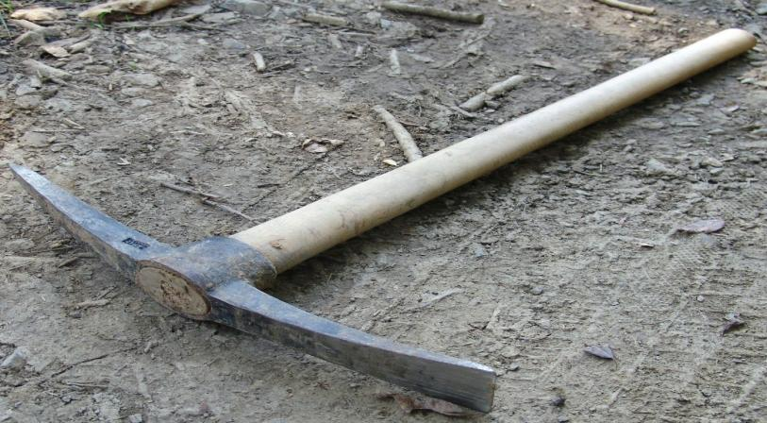
Figure. 1. Pickaxe. Essential tool for digging soil in hard and moist microhabitats for earthworm collection while preventing specimen damage caused by broad spades.
Distribution: India: Jharkhand.

Result & Discussion

SYSTEMATIC ACCOUNT
Phylum: Annelida – Lamarck, 1802
Class: Clitellata – Michaelsen, 1919
Subclass: Oligochaeta – Grube, 1850
Supraorder: Megadrili – Benham, 1890
Order- Crassiclitellata Jamieson, Barrie G.M. (1988)
Family-Megascolecidae Daniele Rosa, 1891
Genus-Perionyx Perrier,1872
- Perionyx excavatus Perrier, 1872
- **Perionyx sp.
- *Prionyx pokhrianus Stephenson, 1920
- *Perionyx macintoshi Beddard, 1883
- **Perionyx shyamasreetus Ghosh et. al., 2018. (State new Record)
Genus- Amynthas Kinberg, 1867
- *Amynthas gracilis (kinberg, 1866)
- *Amynthas corticis (Baird, 1869)
- *Amynthas morrisi (Beddard, 1892)

Genus- Lampito Kinberg, 1867

- Lampito mauritii Kinberg, 1867
Genus- Metaphire Sims &Easton, 1972
- Metaphire posthuma (Vaillant, 1868)
Genus-Polypheretima Michaelsen, 1934
- *Polypheretima elongata (Perrier, 1872)

Family-Acanthodrilidae Carl Claus 1880
Genus-Eutyphoeus Michaelsen, 1900
- **Eutyphoeus sukhendui Mandal et al., 2026
Genus-Octochaetona Gates, 1962
- *Octochaetona beatrix (Beddard, 1902)
Family: Rhinodrilidae William Blaxland Benham, 1890
Genus: Pontoscolex Schmarda, 1861
- *Pontoscolex corethrurus (Müller, 1857)
Order- Arhynchobdellida Blanchard, 1894
Family- Haemadipsidae Blanchard, 1893
Genus Haemadipsa Tennant, 1859
- Haemadipsa sylvestris Blanchard, 1894
- **Haemadipsa rajbalaae Mandal et al., 2026

* New records from Purba Medinipur
**New records from West Bengal
Perionyx excavatus Perrier, 1972
1872. Perionyx excavatus Perrier, Nouv. Arch. Mus. Hist. Nat. Paris, 8: 126.
1998. Perionyx excavatus Halder, Fauna of West Bengal. State Fauna Series. 3(Part-l0): 17-93.
Material examined: 14ex. Akandabari, Nandigram, Purba Medinipur, West Bengai. 16.VIII. 2026. Coll.D.N.Das. Reg. No. An 8908/2.

Description: Length of 35 to 125 mm, a diameter of 3 to 7 mm, and comprising 79 to 121 segments. The annular clitellum spans segment 13 to 17. Its reproductive system is intricate, featuring distinct arrangements of pores and structures. Two pairs of spermathecal pores are situated near the mid-ventral line in segments 7/8 and 8/9. Male pores are located within small transverse protuberances in a single male field, with each protuberance having a slightly irregular transverse groove containing apertures of 4 to 9 perisetal follicles, positioned on segment 18. The single female pore is mid-ventral on segment 14. Genital markings are absent. Nephridiopores, although inconspicuous, are arranged in an irregular longitudinal rank on each side near the median line. These anatomical details collectively underscore the complexity and diversity of the organism's morphology and reproductive system.
Distribution: India: West Bengal, Meghalaya, Andaman Island, Arunachal Pradesh, Assam,
Himachal Pradesh, Maharashtra, Manipur, Orissa, Sikkim, Tamil Nadu and Uttar Pradesh
Outside India: Madagascar and its adjacent islands, Sri Lanka, Myanmar, Thailand, Vietnam, Malay Peninsula, Indonesia, Philippines, Taiwan and West Indies.
**Perionyx sp.
Material examined: 4ex. Gholpukur, Nandigram, Purba Medinipur, West Bengal. 16.VIII. 2026. Coll.D.N.Das. Reg. No. An 8906/2.

Description: Male pore on 18th segment in a large groove. Female pore on 14th segment Length 140mm. Diameter 6mm. Total segment172. Dorsal pore on 3/4, 4/5. Spermathecal pore on 7/8 and 8/9. Egg shaped Setae perichaetine. No penial setae seen. Last pair of heart on XIII segment. Prostate gland recemosal from 18-20 segment. Prostomium epilobic.
Distribution: India. Arunachal, West Bengal.

*Prionyx pokhrianus Stephenson, 1920
1920. Prionyx pokhrianus Stephenson. Mem. India Mus., 7: 208. (Type loc., Jorpokri,
Darjeeling Dist., W. Bengal, India; type in Zoological Survey of India, Calcutta).
Material examined: 1ex. Gholpukur, Nandigram, Purba Medinipur, West Bengal. 15.VIII. 2026. Coll.D.N.Das. Reg. No. An 8909/2.
Description: Length 64mm, Diameter 2.8mm. Segments 95. Colour pale violet dorsally, no pigmentation ventrally. Prostomium epilobic. Clitellum XIII-XVI. First dorsal pore 4/5.Spermathecal pore 2 pairs 6/7 and 7/8. Male pores near the middle line. Gizzard large, barrel-shaped, in V; Last pair of hearts in XIII segment.
Distribution: India: West Bengal- Darjeeling District, Purba Medinipur.

*Perionyx macintoshi Beddard, 1883

1883. Perionyx “mintoshi” Beddard, Ann. Mag. Nat. Hist., (ser. 5). 12: 217. (Type loc., “Akhyab” Burma; typus amissus.).
1975. Perionyx macintoshi: Julka & Halder, Proc. Zool. Soc.Calcutta.28: 15. Darjeeling Dist., W. Bengal, India; type in Zoological Survey of India, Calcutta).
Material Examined: 1ex, Dalimbachalk, Mahishadal, Haldia, Purba Medinipur, West Bengal. 9.IX. 2026. Coll.D.N.Das. Reg. No. An 8911/2.
Description: Length 215mm, Diameter 9.1mm. Segments 189. Colour light blue dorsally, reddish ventrally. Prostomium epilobic. Tongue open. Clitellum XII-XIII. First dorsal pore 5/6.Spermathecal pore 2 pairs 7/8 and 8/9. Male pores minute in a transverse groove. Gizzard large, in VI; Last pair of hearts in XIII segment.
Distribution: India. West Bengal- Darjeeling District, Purba Medinipur, Howrah? Arunachal Pradesh, Meghalaya. Outside India: Nepal Bhutan, Myanmar.

**Perionyx shyamasreetus Ghosh et. al., 2018.

2018. Perionyx shyamasretus sp. nov. (Clitellata: Glossiphonidae): Ghosh, S., Hasan N. and Mandal, C. K. A First report from India, Collected from Odisha J. Appl. Zool. Res. 29(2). 155-160.
Material Examined: 5ex, Bhagawanpur, Purba Medinipur, West Bengal. 10.IX. 2026. Coll.D.N.Das. Reg. No. An 8912/2.
Description: Medium and elongated, brownish in colour. Ventral region pinkish in colour. The total length of the body is 3.2cm. Breadth 3 mm. Middle part almost half of the body. Anal pore: .3 mm. Total number of body rings is 157. Male pores open between the rings 18. Male pore is almost eye shaped. Small to medium sized. Female pore: obscure. Clitellar region: pinkish white. The species of earthworms live in the vermicompost garden. It lives in the shadow place and beneath the half superficial lair of the soil. In the month of June -July due to rain it comes out from the soil in search of dry habitat, and favours the process of collection. Breeding season ranges from June–July. It remains embraced together from opposite end at the time of breeding. Male pore is below the female pore which is unique to earthworm and opposite in leeches.
Distribution: India. Orissa.

*Amynthas gracilis (kinberg, 1866)
1866. Amynthas gracilis Kinberg, J. G. H. "Annulata Nova. Öfversigt af Kongl. Vetenskaps-Akademiens Förhandlingar, Stockholm, 23 (4): 97–103.
Material examined: 24ex. Chandankhali, Patashpur, Purba Medinipur, West Bengal. 29.VIII. 2026. Coll.D.N.Das. Reg. No. An 8900/2.
Description: Dimensions 91–132 mm by 3.0– 4.7 mm in x, 2.6–4.2 mm in xxx, 2.6–4.0 mm in clitellum; body cylindrical throughout, segments 79–101. First dorsal pore at 9/10 or 10/11. Clitellum annular, xiv–xvi; setae visible on ventral in xvi or smooth. Female pore single on xiv. Male pores on xviii, 11–16 setae between male pores, 1–7 markings behind setal line. Spermathecal pores lateral at 5/6–7/8. Prostates large in xviii extending to xvi and xxii. Intestinal caeca simple, originating in xxvii, extending anteriorly to xxv.
Distribution: India: West Bengal (Darjeeling,Purba Medinipur); Manipur, Meghalaya; Rajasthan; Sikkim; Uttar Pradesh.
Outside India: Maurritus, Europe, Egypt, Pakisthan, Chaina, Myanmar, Srilaka, Bangladesh, Thailand, Malay Peninsula, Hogkong, Indonesia, USA, Some Islands in the Pacific and Atlantic Ocean, West Indies, South America.
Amynthas corticis (Baird, 1869)
1869. Megascolex diffringens, Baird, Proc. zool. Soc. Lond., 1869:40.
1998. Amynthas diffringens, Halder, State Fauna Series 3: Fauna of West Bengal, Part 10: 43.
2013. Amynthas corticis, Blakemore, Journal of Species Research, 2(2):99-126.
Material examined: 1ex. Kamarda, Khejuri, Purba Medinipur, West Bengal. 11.VII. 2026. Coll.D.N.Das. Reg. No. An 8889/2.
Description: Length 45-170 mm in length and 3-6 mm in diameter, comprising 79-121 segments. Its prostomium is epilobic with an open tongue. The dorsal coloration varies from reddish, almost purple, reddish brown, yellowish brown, light brown, chocolate, slate, to greyish. The setae are perichaetine. The first dorsal pore typically appears at the 11/12 segment junction. The clitellum, which is annular, spans segments 14-16. It has four pairs of minute, superficial spermathecal pores located between segments 5/6 and 8/9. Paired male pores, also minute and superficial, are situated on segment 18 within small circular to transversely elliptical discs. The single female pore is mid-ventral on segment 14. Small, circular to shortly elliptical genital markings are paired and found presetal just median to the line of spermathecal pores in some or all of segments 6-9, and postsetal just in front of the spermathecal pores in some or all of segments 5-8, occasionally near each male porophore on segment 18. The gizzard is single, large, somewhat conical, and located between septa 8/9 and 9/10, with the intestine usually originating in segment 16. The last pair of hearts is found in segment 13. The worm is micronephridial, with astomate nephridia in at least some parts of the body. It is holandric, with unpaired, ventral testis sacs and seminal vesicles in segments 11 and 12. The racemose prostates extend from segments 16 to 22, featuring muscular and looped ducts. The octothecal earthworm has inverted pear-shaped ampulla, with ducts shorter than the ampulla. The unidiverticulate spermathecae have a diverticulum arising from the anterior face of the duct, featuring a long stalk and a small spheroidal to ellipsoidal seminal chamber.
Distribution: India. Jammu & Kashmir; Himachal Pradesh; Uttar Pradesh; Arunachal Pradesh; Assam; Meghalaya; Manipur; Sikkim; West Bengal; Karnataka; Tamil Nadu; Haryana; Uttrakhand and Bihar.
Amynthas morrisi (Beddard, 1892)
1892. Perichaeta morrisi Beddard, Proc. Zool. Soc. Lond., 1892: 166. (Type loc. Penang, Malay; type in Brit. Mus. (Nat. Hist.). Londan.).
1936. Pheritima morrisi; Gates, ibid., 38:437.
Material examined: 1ex. Gholpukur, Nandigram, Purba Medinipur, West Bengal. 16. VIII. 2026. Coll.D.N.Das. Reg. No. An 8896/2.
Description: Medium and elongated, brownish in colour. Ventral region: pinkish in colour. Size: The total length of the body is 3. 2cm. Breadth 3 mm. Middle part almost half of the body. Anal pore: .3 mm. Number of body rings: Total number of body rings is 157. Male pores open between the rings 18. Male pore is almost eye shaped. Small to medium sized. Female pore: obscure. Clitellar region: pinkish white. Quadrithecal, pores near mV, at (8/9-9/10). Male pores single small. Clitellum not demarcated. First dorsal pore, Between 3 and 4 segment. Prostomium, epilobous, tongue open. Color purple on dorsum, fade up in ventrally. Segments- 157 segments. Gizzard on V segment. Esophagus, widened, bead-shaped in xiii and there with calciferous ridges that extend into xiv and xi, valvular in xv. Last hearts, in xii (xiv) Nephridia avesiculate. Holandric. Habit and habitat: The species of earthworms live in the vermicompost garden. It lives in the shadow place and beneath the half superficial lair of the soil. In the month of June -July due to rain it comes out from the soil in search of dry habitat, and favours the process of collection. Breeding season ranges from June –July. It remains embraced together from opposite end at the time of breeding. Male pore is below the female pore which is unique to earthworm and opposite in leeches.
Distribution: India: Odisha, West Bengal.

Lampito mauritii Kinberg, 1867
1867. Lampito mauritii Kinberg, Ofvers. K. Vetens. Akad. Forhandl. Stockholm. 23: 103.
(Type loc.- Mauritus; types in Naturhistorisca Riksmusset, Stockholm.).
1938. Lampito mauritii Gates, ibid., 40: 413.
1987. Lampito mauritii Julka &amp; Senapati, Rec. zool. Surv. India. Occ. Paper No. 92: 9.
Material examined: 10ex. Chaitannyapur, Mahishadal, Haldia, Purba Medinipur, West Bengal. 11.IX. 2026. Coll.D.N.Das. Reg. No. An 8903/2.
Description: The earthworm under examination ranges from 95 to 155 mm in length and 3 to 6 mm in diameter, spanning segments 157 to 201. It features epilobic projections on its prostomium and a closed tongue, with coloration varying from grayish to yellowish and brownish hues. Notably, its perichaetine setae form circular arrangements, with interruptions mid-ventrally. The clitellum, present from segments XIV to XVII, plays a pivotal role in reproduction. Reproductive anatomy includes three pairs of large spermathecal pores in segments EG, Female and male aperture are on 14 and 18 th segment. Male Internally, the gizzard resides in segment V, with the intestinal origin in segment XV. Micronephridial structures are observed on septa V to XIII and XIV, along with exonephric micromeronephridia in segment XV and posterior segments. The sperm thecae feature bidiverticulate ducts and digitiform diverticula.
Distribution: India: Almost every state of India. Elsewhere: Asia, Australia and America.
Metaphire posthuma (Vaillant, 1868)
1868. Perichaeta posthuma Vaillant, Annl. Sci. Nat. (ser. 5), 10: 288.
1972. Metaphire posthuma Sims & Easton. Biol. J. Linn.Soc., 4(3): 239.
Material examined: 7ex. Chaitannyapur, Mahishadal, Haldia, Purba Medinipur, West Bengal. 12.IX. 2026. Coll.D.N.Das. Reg. No. An 8901/2.
Description: Clitellum annular on XIV -XVI; setae perichaetine; spermathecal pores 4 pairs, minute, in 5/6-8/9; male pores in XVIII, minute, each in a small disc on median wall near roof of a copulatory pouch; female pore single, mid-ventral, on XIV; genital markings paired, circular in setal circle slightly median to male pore line; pigment brown; gizzard between septa 7/8 and 8/9.
Distribution: India: Almost every state. Elsewhere: Few countries of Asia, Europe and America.
Polypheretima elongata (Perrier, 1872)

1872. Perichaeta elongata Perrier, Nouv. Arch. Mus. Hist. nat. Paris. 8: 124. (Type loc.- Peru; types in Museum National; d Histoire Naturelle, Paris.)
1979. Polypheretima elongata (Perrier): Easton, Bull. Br. Mus. nat. Hist. (Zool.), 35: 53.
Material examined: 13ex. Kamarda, Khejuri, Purba Medinipur, West Bengal. 11.VII. 2026. Coll.D.N.Das. Reg. No. An 8881/2.
Description: Body 211 mm in length and 4.5 mm in width, it comprises a remarkable 221segments, prostomium is prolobous. The first dorsal pore is situated within the intersegmental furrow 12/13. The annular clitellum spans segment 14–16, devoid of setae and dorsal pores, Spermathecal pores are small and arranged in two pairs, lateroventrally placed within the intersegmental furrows 5/6/7. Male pores are housed within copulatory pouches in segment 18. Female pores are singular and mid-ventrally located in segment 14, nestled within a small circular depression, optimizing mating opportunities. Genital markings, present and characterized by simple, large smooth discs, are pre setal and paired in segments 19–23. Septa are thickened from segments 3/4 to 7/8, with segment 8/9/10 absent and segment 10/11, /12/13. Gizzard, spherical in shape after septa 8/9. The intestine initiates in segment 15, with caeca. The last pair of hearts is positioned in segment 13, holandric pattern, with seminal vesicles present in segments 11–12. Spermathecae are large and located in segment 5/6/7, with six (three left-hand side, three right-hand side) per segment. The ampulla is large and ovoid, with a relatively short duct and a simple ectal diverticulum shorter than the ampulla, contributing to efficient sperm storage and transport. The prostate, racemose in structure, is positioned in segments 16–19, with a muscular, C-shaped prostatic duct.
Distribution: India: Andaman and Nicobar Islands, Andhra Pradesh, Chhattisgarh, Gujarat, Karnataka, Kerala, Madhya Pradesh, Maharashtra, Meghalaya, Punjab, Rajasthan, Tamil Nadu, Telangana, Tripura, Uttar Pradesh and West Bengal.

Eutyphoeus sukhendui Mandal e al., 2026
Material Examined: 1ex, Gholpukur, Nandigram, Purba Medinipur, West Bengal. 16.VIII. 2026. Coll.D.N.Das. Reg. No. An 8914/2.
Description: Oesophageal gizzard single. Discrete calciferous glands present. One pair of prostate glands. Intestinal typhlosole not rudimentary. Length of the species 23cm. Breadth .9cm. Spermathecal pore single pair between 7-8 segment. Male pore on 17th segment. Female pore minute on 14th segment. First genital marking 1 pair between 11-12 segment. Second genital markings on 14th and 15 th segment one on each segment at the right side of the ventral body. Third pair of genital markings on between 15-16 segment. Fourth pair of genital markings on between 16-17 th segment. Fifth pair of genital markings on 17th segment before the one pair male pore. Seventh pair of genital markings on between 18-19 segment. Eighth pair of genital markings on between 19-20 segment. Tubular Prostate gland in between 17- 19 th segment. Five pair of hearts between 9-11 segments. Lumbricine setae on all the segments except first and last segment. Egg shaped head on neck and 5 tubers like structure back of the spermathecae.
Distribution: India: Jharkhand.
Octochaetona beatrix (Beddard, 1902)
1902. Octochaetus beatrix, Beddard, Ann. Mag. nat. Hist. (ser. 7), 9: 456.
Material Examined: 1ex, Chandankhali, Patashpur, Purba Medinipur, West Bengal. 29.VIII. 2026. Coll.D.N.Das. Reg. No. An 8913/2.
Description: Length 81 mm in length and 3 mm in width, comprises 185 segments and exhibits a range of distinctive morphological and reproductive traits. The prostomium is epilobous, and the first dorsal pore is situated at the intersegmental furrow between segments 12 and 13. The annular clitellum covers segments 13 to 16 and 18, with setae retained and furrows obscured. The male genital field is slightly depressed, featuring minute male pores located at or just median to the a setal line. Prostatic pores are also minute and median to the a setal line, with concave seminal grooves situated between the setal arcs of segments 16 and 19. Paired female pores are present, with the single female pore located at the middle of segment 14. Minute spermathecal pores are found on or slightly anterior to the setal arcs of segments 8 and 9. Combined male and prostatic pores are superficially positioned on segment 18. While discrete genital markings are absent, paired oval to circular slightly thickened areas are present lateral to the seminal grooves on segments 18 and 19. The septa between segments 4/5 and 8/9 to 11/12 are muscular, while the septa between segments 5/6, 6/7, and 7/8 are absent. The gizzard is located between septa 4/5 and 8/9, and the intestine begins in segment 16 or 17. The typhlosole is characterized by a large bifid lamelliform structure. The species is metandric, with penial setae ornamented with sparse triangular teeth. The spermathecae consist of two pairs, each featuring a spheroidal, shortly pyriform, oval, or flattened and shelf-like diverticulum that is shortly stalked and iridescent.
Distribution: India: Chhattisgarh, Andhra Pradesh, Arunachal Pradesh, Bihar, Chandigarh, Goa; Gujarat, Haryana, Himachal Pradesh, Jammu and Kashmir, Jharkhand, Karnataka, Kerala, Madhya Pradesh, Maharashtra, Odisha, Punjab, Rajasthan; Sikkim, Tamil Nadu; Tripura, Uttarakhand, Uttar Pradesh and West Bengal.
*Pontoscolex corethrurus (Müller, 1857)
1856. Lumbricus corethrurus, Muller, Abhandl. Naturgesch. Ges. Halle, 4:26. (Type loc.-Itajahy, Brazil; typus amissus).
1972. Pontoscolex coreihrurus, Gates, Trans. Am. phil. Soc., 67: 54.
Material Examined: 2ex, Gholpukur, Nandigram, Purba Medinipur, West Bengal. 15. VIII. 2026. Coll.D.N.Das. Reg. No. An 8915/2.
Description: Length 48 to 120 mm and a diameter of 2 mm, it exhibits considerable variation in segment count, spanning from 60 to 232 segments, indicative of its anatomical complexity. The distinctive shaddle-shaped clitellum is observed on segments 15 to 23, marking a specialized reproductive region associated with mating and egg deposition. Setal arrangement follows a lumbricine pattern, transitioning from closely paired to widely paired, and finally culminating in; arrangements at the hinder end of the body, potentially aiding in locomotion and environmental interaction. Reproductively, three pairs of minute spermathecal pores are observed at position C on segments 6/7 to 8/9, facilitating reproductive processes. Male pores, likely minute in size, are presumed to be located on segment 20/21, while female pores are minute and situated on the left side at position A B, slightly in front of segments 14 to 15. The intestinal origin is noted in segments 14 or 15, ensuring efficient digestion and nutrient absorption. The last pair of hearts is located in segment 11, ensuring efficient circulation throughout the organism. Spermathecae are characterized by a club-shaped structure, with slender ducts, potentially serving as sites for sperm storage and maturation. Overall, this comprehensive depiction offers valuable insights into the intricate morphological and reproductive characteristics of the organism, providing a deeper understanding of its biology and ecological significance.
Remarks: The species first time record in state in Bihar.
Distribution: India: West Bengal; Andaman and Nicobar Islands; Andhra Pradesh; Gujarat; Karnataka; Kerala; Maharashtra; Tamil Nadu Elsewhere: Africa, Madagascar and its adjacent islands; Iran, Pakistan; Sri Lanka, Burma, Thailand, Kampuchia, Malay Peninsula, Indonesia, Philippines, Hong Kong; Australia, some islands in the Pacific Ocean; U.S.A. Mexico; West Indies, South America.
Haemadipsa sylvestris Blanchard, 1894
1894. Haemadipsa sylvestris Blanchard, Annali Mus. civ. Stor. nat. Giacomo Doria, 2 (4): 113 118 (Type- locality: Carin, Myanmar; Type-Deposited Not known).
2010. Haemadipsa sylvestris Mandal, J. Environ. & Sociobiol.: 7(2):209-211.
Material Examined: 18ex, Chandankhali, Patashpur, Purba Medinipur, West Bengal. 29.VIII. 2026. Coll.D.N.Das. Reg. No. An 8916/2.
Description: The species of leech referred to as "the largest and robust land leech of India" presents a striking appearance with its distinct coloration and notable features. Colored in a plain yellow hue, it boasts three dark brown stripes along its body, with the median line appearing narrower than the marginal stripes, which exhibit a bright yellowish-orange hue. The number of sucker rays varies between 69 and 80, contributing to its strong attachment capabilities. While prehensile papillae are relatively underdeveloped, the presence of furrow pits, arranged in five pairs on segments 8 to 12, enhances its sensory perception and navigation abilities. This leech species, with its robust build and unique coloration, embodies the adaptation of terrestrial leeches to their environment, likely playing a significant role in the ecosystems of India's diverse landscapes.
Distribution: India: West Bengal; Sikkim; Assam; Arunachal Pradesh; Andaman and Nicobour Island; Arunachal Pradesh; Meghalaya; Uttar Pradesh and Bihar.
Outside India: Burma, Java and Sumatra.

Haemadipsa rajbalaae Mandal et al, 2026
Material Examined: 3ex, Dalimbachak, Mahishadal, Haldia, Purba Medinipur, West Bengal. 9.IX. 2026. Coll.D.N.Das. Reg. No. An 8917/2.
Description: Length 35mm. breadth 8mm. (Nearer to posterior region), Diameter of anterior sucker 2.5 mm. Posterior sucker 6mm. Colour yellowish with two black stripe on dorsal side. Ventrally yellowish colour. Without any stripe. Male pore 32/33, Female pore 37/38. 7 annuli of anterior sucker. First pair of eyes on 3rd annuli, shadow of thin medial dorsal stripe. Eyes 5 pair. Total annuli 104.
Distribution: India: Arunachal Pradesh, West Bengal.

Figure. 2: Abundance / Specimen count of earthworm species recorded from Purba Medinipur, West Bengal

Figure. 3: Percentage composition of leech species (Haemadipsa spp.) recorded from Purba Medinipur, West Bengal
Conclusion: This investigation highlights those coastal and agricultural habitats in Purba Medinipur harbor substantially richer annelid diversity than historical surveys indicated. The recovery of species such as Perionyx shyamasreetus, Eutyphoeus sukhendui, and Haemadipsa rajbalaae extends their recognized geographic ranges from neighboring states into the lower Gangetic plains. Methodologically, utilizing pickaxes proved far more effective than standard spades for sampling hard or compact soils while minimizing physical specimen damage during field recovery. These taxonomic determinations not only refine the known bio-inventory of West Bengal's invertebrate fauna but also highlight candidates suitable for local vermicomposting practices and prospective pharmacological study. Continued systematic micro-habitat sampling across the district’s remaining unexplored wetlands and coastal belts remains crucial for uncovering further cryptic and unrecorded annelid taxa.

Declaration of AI Use

This manuscript was prepared through the intellectual contributions of the author(s) to the study design, data analysis, interpretation of results, and scholarly content. Grammarly and ChatGPT were used solely to assist with grammatical refinement and reference formatting during manuscript revision. The author(s) accept full responsibility for the accuracy, integrity, and final content of the manuscript.

COMPETING INTERESTS DISCLAIMER:
Authors have declared that they have no known competing financial interests OR non-financial interests OR personal relationships that could have appeared to influence the work reported in this paper.

References
Balakrishnan, S., Mondal, T., Mandal, C. K., Ahmed, S., Hasan, M. N., Yogesh Kumar, J. S., Sivaleela, G., & Raghunathan, C. (2025). Fauna of India checklist, Annelida: Polychaeta: Sipuncula: Clitellata (Rhynchobdellida, Arhynchobdellida, Crassiclitellata, Moniligastrida, Tubificida) (Online Version 2.0). Zoological Survey of India.
Chandra, M. (1991). The leeches of India: A handbook (Director, Zoological Survey of India, Ed.). Zoological Survey of India.
Ghosh, G. C. (1998). Leech fauna of West Bengal. Zool. Surv. India, State Fauna Series, 3(Part 10), 227-249.

Halder, K.R. 1998. Annelida:Oligochaeta:earthworms, State Fauna Series3:Fauna of West Bengal, part, Rec. Zool. Surv. India,10: 17-93.
Haldar, K.R. Dhani.S. & Mandal, C.K.2004. On some earthworm of present in unnamed
Collections of ZSI. Rec.Zool. Surv.india.107 (part-3):79-93.
Halder, K. R., Dhani, S., & Mandal, C. K. (2007). On Some Earthworms Present in Unnamed Collections of Zoological Survey of India. Records of the Zoological Survey of India, 107(3), 79–93.
Hasan, M.N., Ahmed, S., and Deuti, K., & Marimuthu, N. 2023. Earthworm (Annelida:
Clitellata) fauna of Chhattisgarh, India. Journal of Threatened Taxa, 15 (4):
23091–23100.
Harding, W. A., & Moore, J. P. (1927). The Fauna of British India, including Ceylon and Burma: Hirudinea. Taylor and Francis, London, 302 pp.
Julka, J.M. 1988. Fauna of India & the adjacent Countries: Megadrile Oligochaeta (Earthworms); Haplotaxida: Lumbricina: Megascolecoidea: Octochaetidae, Zoological Survey of India, Calcutta. 400 p.p.
Mandal, C.K., Mridha, R.S. and Hasan, M. N. 2017. Eutyphoeus naurangiyai sp. nov. (Clitellata: Octochaetidae) A New Earthworm from Bihar, India. International Journal of Advanced Research in Basic Engineering Sciences and Technology (IJARBEST). 3(6): 41-45.
Mandal, C. K., Gurumayum, S. D., Temjenmongla, Sharma, P., Bose, M., Hasan, M. N., &
Ghosh, S. (2026). Description of Poecilobdella budhoi sp. nov. from Arunachal
Pradesh, India. Uttar Pradesh Journal of Zoology, 47(18), 111–118.
https://doi.org/10.56557/upjoz/2026/v47i185862.
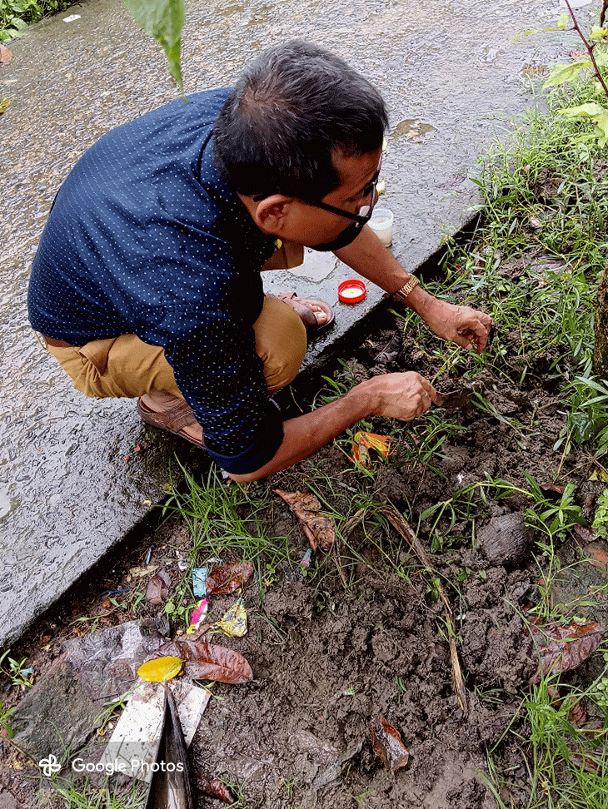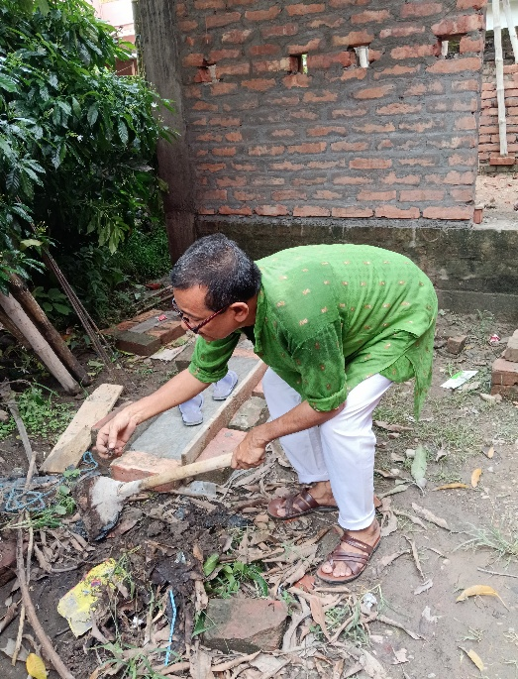
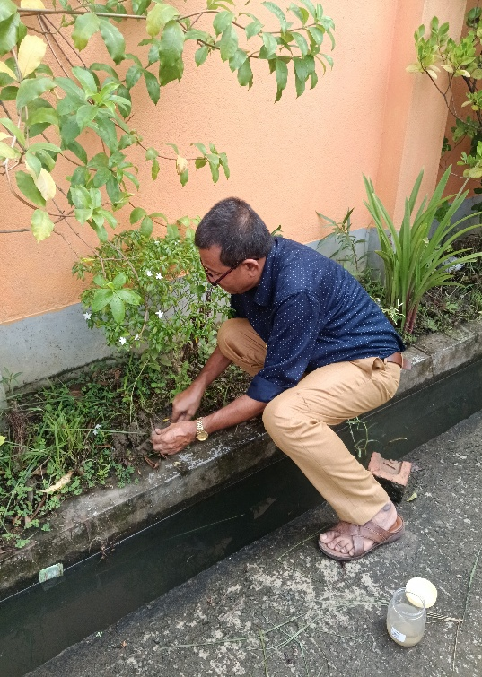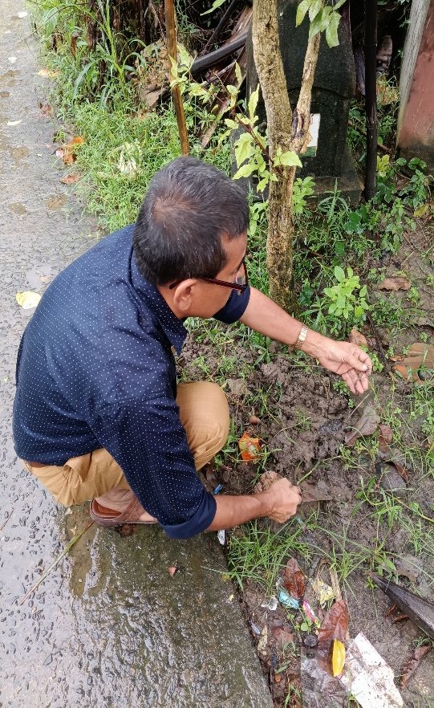

Plate 1: Collection spots at Haldia, Purba Medinipur

Plate 2
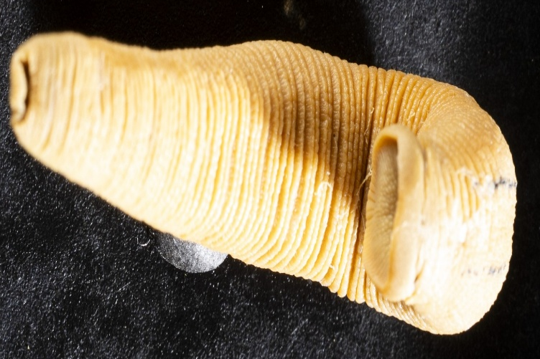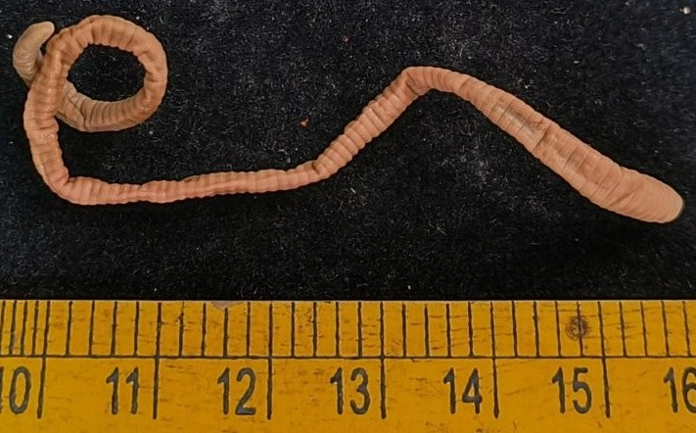
Haemadipsa rajbalaae (Ventral) Amynthas gracilis (Dorsal view)

Plate 3.
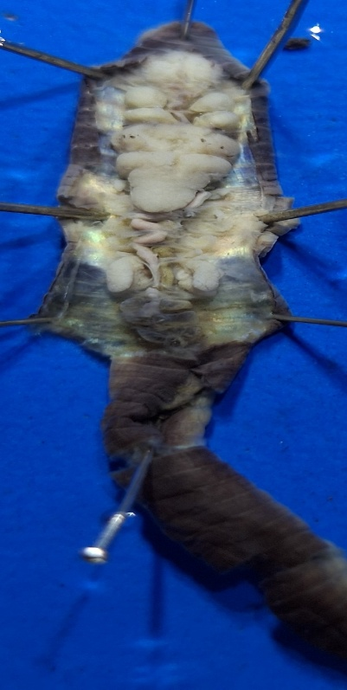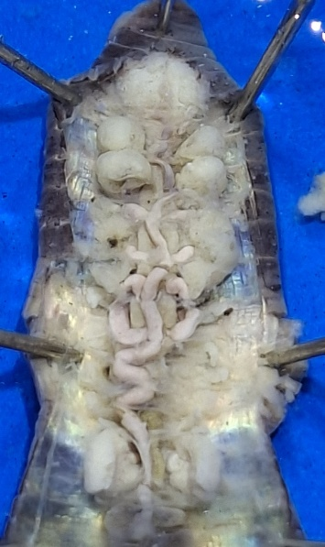
Perionyx sp. With Spermathecae, salivary gland, prostategland, last pair of heart
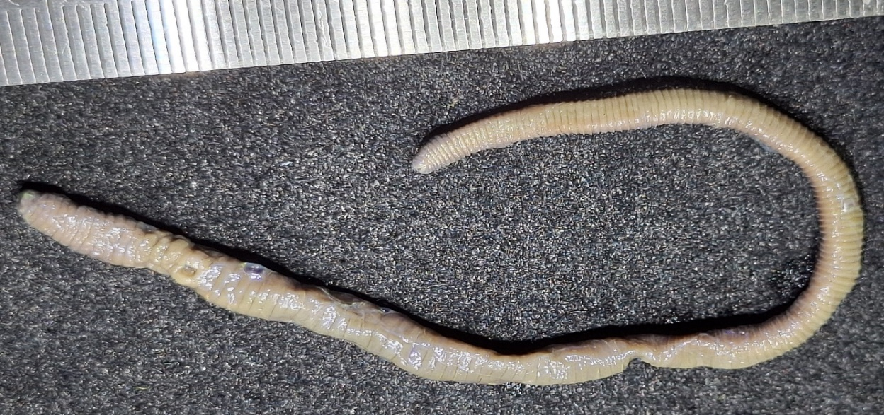

Plate 4. Showing Perionyx sp. Earthworm morphological characters.

