Original Research Article
Histological changes in the Duodenum across Postnatal Developmental Stages of Indian domestic Pig (Sus scrofa domesticus)

ABSTRACT
Present study characterized the age-related histological changes in the duodenum of Indian domestic pigs across three postnatal developmental stages. Duodenum of small intestine from 18 Indian domestic pigs was categorized into three age groups: Group I (piglets, 0–4 weeks; n=6), Group II (weaners, 4–10 weeks; n=6), and Group III (>20 weeks; n=6). Tissues from duodenum were collected and fixed in 10% neutral buffered formalin and Bouin’s fluid, processed for paraffin embedding, and sectioned at 5–6 µm. Histological evaluation employed Haematoxylin–Eosin for general architecture, Masson’s Trichrome for collagen–muscle differentiation, Wilder’s method for reticular fibres, and Weigert’s stain for elastic fibres. The duodenal wall consistently exhibited four tunics (mucosa, submucosa, muscularis, serosa) across all age groups. Villi of duodenum progressed from slender, tongue-shaped structures at birth to tall, ridge-like forms with broad bases and pointed apices. Enterocytes were columnar, displayed prominent brush borders with increasing connective tissue support (collagen, reticular, elastic fibres) from Group I to III. Goblet cell density and intraepithelial lymphocyte counts in the mucosa were increased with age, particularly in crypt regions. Paneth cells were absent at birth, but appeared from day 21 onwards and became more abundant in older groups. The lamina muscularis mucosae thickened progressively, while plicae circulares became evident from day 7 and increased prominence with age. Brunner’s glands, sparse and isolated at birth, formed compact lobules by day 13 and dominated the submucosa in weaners and adult pigs, especially in the cranial duodenum. Connective fibre intensity (collagen, reticular, elastic) increased in all layers with advancing age.The tunica muscularis consisted of inner circular and outer longitudinal smooth muscle layers with intervening connective tissue containing myenteric plexuses, while tunica serosa formed the outermost covering with loose connective tissue, blood capillaries, nerves, variable adipose tissue, and external flat mesothelium. These age related histological changes in the duodenum mark functional adaptation to postnatal digestive, absorptive and immune demands forming a baseline for porcine models and comparative monogastric studies.

1. INTRODUCTION
The porcine digestive system acts as monogastric and omnivorous type of diet, used as a preferred large animal model for pre-clinical intestinal disease translational research (Kararli, 1995; Schaaf and Gonzalez et al., 2022).During postnatal period, the gastrointestinal tract of the neonatal pig encounters numerous challenges and severe stress, mainly at the time of birth and weaning (Xu et al., 2000). The early growth stage is the crucial period of piglet for the major growth and development of intestine (Hao et al., 2021). Modifications to the gut mucosal architecture often evaluate digestive function, notably during the development or interactions with food components (Skrzypek et al., 2005).
Histologically, the villi are lined by enterocytes whose brush border membrane (striated border) is the apical surface of the intestinal epithelial cells, covered with microvilli. These microvilli further amplify the absorptive surface area and contain a variety of digestive enzymes crucial for the final stages of nutrient digestion. This structural specialization enhances the intestine’s ability to hydrolyze and absorb nutrients effectively (Tsukahara et al., 2013).
The mucosa of the pig small intestine was lined by simple columnar epithelium with numerous goblet cells dispersed among the epithelium. Pyramidal-shaped Paneth cells, with round or oval nuclei were observed at the base and neck regions of the crypts (Singh et al., 2021).In eutherian mammals, the duodenal or Brunner’s glands represent a distinctive feature, residing within the submucosa of proximal duodenum. These glands originate immediately distal to the pyloric sphincter, extending with variable distribution along the length of the duodenum from proximal to distal end. Their ducts typically open directly into the intestinal lumen or merge with the overlying crypts of Lieberkuhn. The glands which are chiefly populated by mucin-secreting cells provides viscoelastic mucous layer that coats and lubricates (Krause, 2000).The first line of defence against pathogens constitutes the mucous layer covering the intestine, consists of mucins and glycoproteins secreted by goblet cells as a surfactant of mucosa or protective barrier (Barszcz and Skomial, 2011).

2. MATERIALS AND METHODS
Animals of known age, irrespective of sex, body weight, and nutritional status, were classified according to developmental stage into three postnatal age groups: Group I (piglets; 0–4 weeks), Group II (weaners; 4–10 weeks), and Group III (above 10 weeks), with six animals in each group. Samples of duodenum were collected immediately after slaughter from local slaughter houses in and around Hyderabad. Freshly collected duodenal specimens were thoroughly washed with distilled water and tissue samples were collected, cut to the desired size and fixed in 10% neutral buffered formalin (NBF) and Bouin’s fluid. Post fixation these specimens were processed for routine histological staining techniques (Singh and Sulochana, 1996). Tissue samples were processed following standard protocols and paraffin sections of 5-6 µm thickness were prepared using a rotary microtome (Singh and Sulochana, 1996). The paraffin sections were stained using both routine and special staining techniques, as outlined below:
- Haematoxylin and Eosin method for detailed histo-architecture (Singh and Sulochana, 1996).
- Masson’s Trichrome method for differentiation of collagen and muscle fibres (Luna, 1968).
- Wilder’s method for reticular fibres (Singh and Sulochana, 1996).
- Weigert’s method for elastic fibres (Luna, 1968).
Detailed microscopic features of the components of duodenum were observed and photomicrographed accordingly.

3. RESULTS AND DISCUSSION
In the present investigation, the duodenum of Indian domestic pigs in all postnatal age groups exhibited the typical four-layered organization of the intestinal wall comprising tunica mucosa, tunica submucosa, tunica muscularis and tunica serosa. Similar structural arrangement has been reported in pigs by Kadhim et al. (2012) in camels, Al Mansour et al. (2020) in goat and gazelle and Singh et al. (2021) in pigs, who described the presence of these four fundamental layers in the duodenal wall. Thus, the present findings indicate that the general histological organization of the duodenum remains conserved during postnatal development.
Tunica mucosa of the duodenum consisted of lamina epithelialis, lamina propria mucosae and lamina muscularis mucosae. These observations are in accordance with findings of Frappier (1998) in domestic animals and Siddiqi et al. (2011) in Black Bengal goat. The mucosal surface showed numerous villi lined by simple columnar epithelium with goblet cells in all postnatal groups (Fig 1). These findings are similar with the reports of Hassan and Moussa (2015) in goats, Kumar et al. (2013) in sheep and Mohammad et al. (2020) in sheep and rabbits, who reported simple columnar epithelium interspersed with goblet cells over the villus surface. Singh et al. (2021) also observed abundant goblet cells in the surface epithelium of pig duodenum. At birth, villi were slender, tongue-shaped, elongated and ridge-like with broad bases and pointed apices, whereas at later postnatal stages they became finger-like, elongated and broader with the advancement of age (Fig 2 & 3). Such developmental alterations indicate progressive maturation of absorptive surface area after birth. Similar age-dependent changes were observed by Skrzypek et al. (2018) in piglets and Raja et al. (2022) in guinea pigs. Simawy et al. (2024), similarly reported immature villi at one day of age and mature leaf-shaped villi at 60-days in cats, dogs and goats. Suwaidan and Almaliki (2024) noticed finger-like villi in neonatal dogs. The ridge-shaped villi observed in the present study are similar with the findings of Wiese et al. (2003) in pigs. The enterocytes observed in the present study appeared as tall columnar absorptive cells with basally placed oval nuclei and distinct apical brush borders (Fig 4). Similar findings were reported by Mohammad et al. (2020) in sheep and rabbit and Singh et al. (2021) in pig, who identified absorptive enterocytes with prominent brush borders. Similarly, Clarke and Hardy (1971) in young pigs identified non-vacuolated, low columnar epithelial cells. The basement membrane of the surface epithelium was supported by connective tissue fibers of collagen, reticular and few elastic fibers. This is in agreement with the findings of Madara (1991), who reported the basement membrane as supporting elements of the epithelium. Goblet cells were distributed among surface epithelium and crypts, and their number increased from cranial to caudal part of the duodenum as well as with age advancement (Fig 5). These observations corroborate the findings of Talukdar (1999) in adult crossbred pigs and Korkmaz and Kum (2016) in camels, who reported fewer goblet cells at villus tips and higher numbers toward crypt regions. Al Saffar and Al Zuhairy (2016) observed rounded goblet cells in domestic cats and noted alterations in villi-crypt ration with age. Singh et al. (2021) also reported numerous goblet cells embedded in the surface epithelium of pigs. The progressive increase in goblet cells observed in the present study may indicate increasing mucosal protection and lubrication requirements with postnatal growth.
Intraepithelial lymphocytes were frequently encountered among enterocytes of villi and crypts in all age groups and their number increased with age (Fig 5). Similar observations were made by Pabst et al. (1988) in pigs, Vega Lopez et al. (2001) in porcines, Kalita et al. (2021) in piglets and Singh et al. (2021) in pigs, who identified intraepithelial immune cells located at the apical or basal portions of the lining mucosa. Raja et al. (2022) also observed intraepithelial cells and globular leukocytes throughout postnatal life in guinea pigs. Increased IEL population in older groups of present study may reflect progressive maturation of intestinal immune mechanisms.
The lamina propria in present study consisted of intestinal glands lined by low columnar cells, connective tissue fibres, blood vessels, lymphatics, fibroblasts and lymphocytes, while their number increased progressively as the age advanced (Fig 6). Singh et al. (2021) also reported diffuse lymphocytes accumulation between villus and crypts in pigs. Increased lymphoid elements in the present study may indicate development of intestinal immunity after birth. Hassan and Moussa (2015) in goats described loose connective tissue rich in vascular and lymphatic elements within lamina propria and also in piglets (Kalita et al., 2017). The lymphocytic infiltration in lamina propria increased as the age advanced, these reports are in accordance with the Rothkotter et al. (1991) in pigs. Crypts of Lieberkuhn (intestinal glands or mucosal glands) in the present investigation were simple tubulo-alveolar glands lined by simple columnar epithelium with goblet cells, which opened onto the surface epithelium at intervillous spaces near the base of the villi. The nuclei of these columnar cells were round to oval in shape and located at the base of the cell (Fig 7), these finding are similar to Kumar et al. (2013) in sheep, Gahlot et al. (2017) in goats, Gutte et al. (2019) in sheep and goats, Al Mansour et al. (2020) in goat and gazelle and Deswal and Gahlot (2024) in pigs, who described simple tubular and alveolar glands extending from muscularis mucosae to villus bases. The predominance of goblet cells within crypts compared with villus tips observed in the present study agreed with observations of Korkmaz and Kum (2016) in camels. The intestinal glands were encased by a layer of connective tissue fibres made of collagen, reticular and few elastic fibers (Fig 8). The core of the villi was supported by lamina propria along with few fibers of lamina muscularis. These findings are in accordance with the findings of Deswal and Gahlot (2024) in pigs. In all postnatal age groups, IEL were also observed among the simple columnar epithelial cells and the crypts. The IELs were abundant in the villi than in crypts but seen reduced cell count in duodenum. These observations are in accordance with the findings of Dong et al. (2014) in pigs, Kalita et al. (2021) in piglets and Raja et al. (2022) in guinea pigs, who observed the lymphocytes in the epithelium with large, round nucleus and rim of cytoplasm. These cells were fewer in neonatal piglets and were age-dependent.
Paneth cells observed in the present study appeared as pyramidal cells with eosinophilic apical granules and were mainly located at neck and basal portions of crypts (Fig 9). These cells were absent immediately after birth and became evident from 21 days of postnatal life onwards and their number increased progressively with the age. This is in concurrence with finding of Verdile et al. (2019) in pigs, who reported absence of Paneth cells in 0-6 days. Similar observations were reported by Obremski et al. (2005) in gilts, Hassan and Moussa (2015) in goat and Cui et al. (2023) in pigs, who identified Paneth cells near basal and neck regions of crypts and mentioned them as the defense mechanisms. Singh (1971) in humans reported Paneth cells to be much denser in the duodenum.
At birth, the lamina muscularis mucosae in the present investigation was composed of discrete layer of smooth muscle (Fig 10), which is similar to the findings of Simawy et al. (2024) in cat, dog and goat, who stated that muscularis mucosa of smooth muscle fibres was not continuous at one-day of age. At later ages, this muscular layer became thin and continuous, but subsequently thickened as the age advanced (Fig 7). This is similar to the findings of Barnwal and Yadava (1975) in Indian buffaloes and Singh et al. (2021) in pigs, who described only circularly arranged smooth muscle fibres. Whereas in goat and gazelle (Al Mansour et al., 2020), two thick layers of smooth muscle oriented into inner circular and outer longitudinal bundles were observed.
The tunica submucosa in all postnatal age groups composed of Brunner’s glands, dense irregular connective tissue containing blood vessel and Meissner’s plexus. The present study demonstrated that Brunner’s glands were most abundant in cranial duodenum and gradually decreased towards middle and caudal regions. Similar findings were reported by Kadhim et al. (2012) in ponies, Mohammadpour (2011) in guinea pigs, who observed progressive reduction in glandular thickness from cranial to caudal part of duodenum. Saleh et al. (2019) also noted the absence of these glands in terminal part of duodenum in bovines.
Brunner’s glands were tubulo-alveolar gland of mucus secreting type, with wide lumen surrounded by truncated pyramidal cells or low columnar cells which showed basal flat nuclei and lightly stained eosinophilic cytoplasm. They were extended from the submucosa to mucosa at base of intestinal glands for their secretions(Fig 7, 11, 12 & 13), which is in accordance with the Takehana et al. (1991b) in pony and Bansal et al. (1993) in buffalo. In present study, these were mucous secreting glands, which is akin with Simawy et al. (2024) in cats and dogs, who stated that Brunner’s glands were mucous in nature, while they were serous in goats. In contrast, the serous types of submucosal glands were noted in pigs and rats by Dellmann and Eurell (2006) and Al Arubay (2025) in wild brown rat. Mohammad et al. (2020) observed muco-serous type of Brunner’s glands in rabbits, while they were mucous in sheep. At birth, the Brunner’s glands were few in number and isolated while at 13th day of postnatal life, most of the submucosa was occupied by these glands in lobulated form, separated by thin interlobular connective tissue (Fig 7). However, this layer was heavily embedded by these glands along with increased amount of adipose tissue and connective tissue fibres from group II to III (Fig 12 & 13). Saleh et al. (2019) in adult cow noticed Brunner’s glands from the end of pylorus to the first and middle thirds of submucosa of the duodenum, while they were absent in terminal third part of duodenum.
Plicae circulares (Valves of Keckring) became evident from the seventh day and increased in prominence with age(Fig 14 & 15). Their greater height at caudal duodenum indicated enhancement of luminal surface area during maturation. Postnatal development of plicae, the increased prominence observed in the present study may reflect adaptation for efficient nutrient absorption. These are in accordance with the observations of Deswal and Gahlot (2024) in pigs, who stated that the mucosal folds were in the form of plicae circulares and their height gradually increased to caudal part.
Tunica muscularis consisted of thick inner circular and thin outer longitudinal smooth muscle layers separated by connective tissue containing Auerbach’s plexus in all parts of the duodenum (Fig 16). Similar arrangement was reported by Talukdar (1999) in pigs, Hassan and Moussa (2015) in goats, Mohammad et al. (2020) in sheep, Gutte et al. (2019) in sheep and goat, Al Mansour et al. (2020) in goat and gazelle and Singh et al. (2021) in pigs. The tunica serosa in all postnatal age groups formed the outermost layer consisting of loose connective tissue, blood vessels, nerves and adipose tissue covered by mesothelium. Similar findings were described by Hassan and Moussa (2015) in goats, Korkmaz and Kum (2016) in dromedary camels, Al Mansour et al. (2020) in goat and gazelle and Singh et al. (2021) in pigs, who reported that a thin layer constructed by loose connective tissue covered by a layer of mesothelial cells.

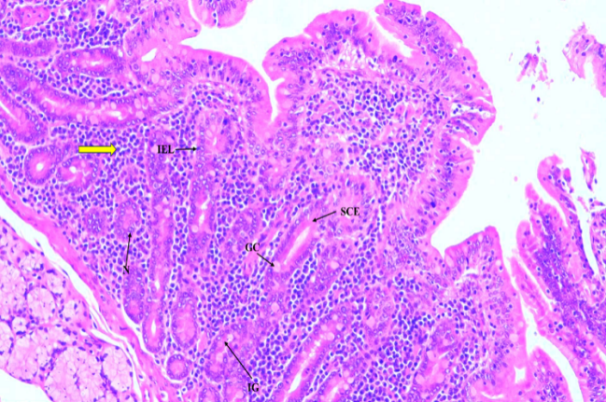
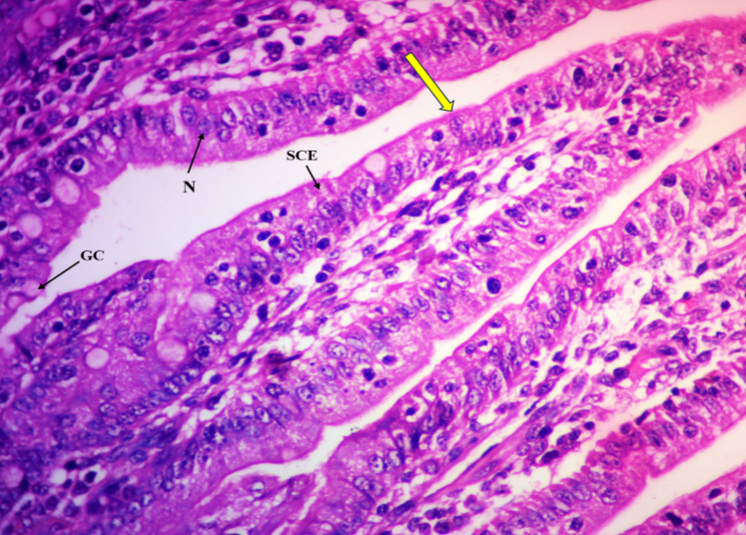
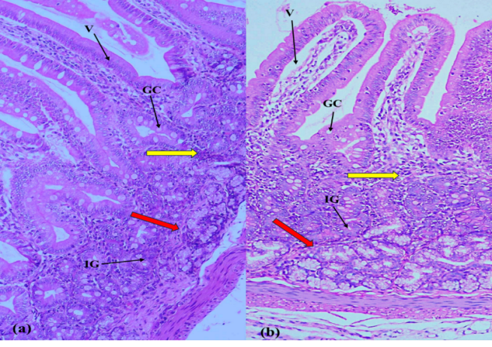
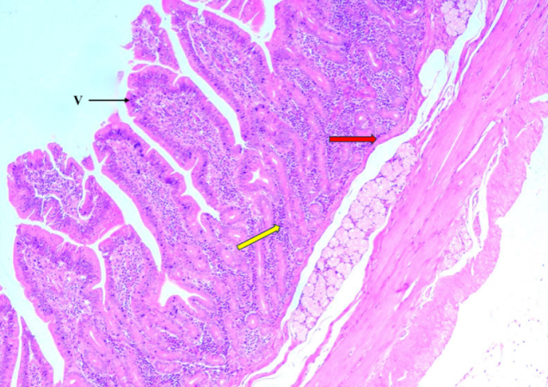
Fig 2. Photomicrograph of G-I piglets of (a) 7-day old and (b) 13-day old showing duodenum with goblet cells (GC), slender villi (V), lamina propria (yellow arrow), intestinal glands (IG) and lamina muscularis (red arrow).H&E 10x
Fig 4. Photomicrograph of Group I (13-day old) piglet showing duodenum with brush border membrane with microvilli (yellow arrow), goblet cells (GC), enterocytes/simple columnar epithelium (SCE) and nucleus (N). H&E 40x
Fig 1. Photomicrograph of G-II (55-day old) pig showing duodenum with ridge-like villi (arrow), lamina propria (yellow arrow) and lamina muscularis (red arrow). H&E 4x
Fig 5. Photomicrograph of G-III (152-day old) pig showing duodenum with intestinal glands (IG) in lamina propria (yellow arrow), intra-epithelial lymphocytes (IEL), goblet cells (GC), simple columnar epithelium (SCE) and its nucleus (N).H&E 10x

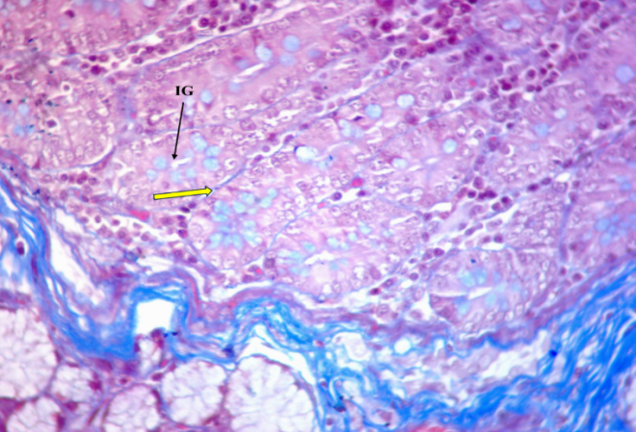
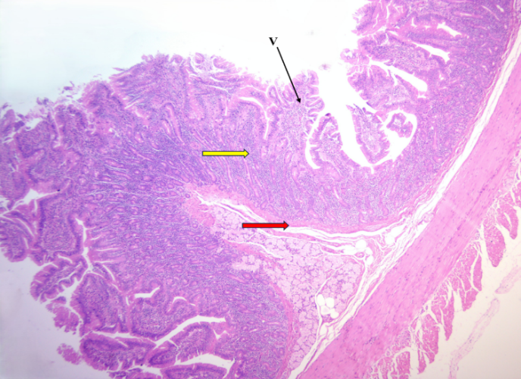
Fig 6. Photomicrograph of G-I (21-day old) piglet showing duodenum with collagen fibres (yellow arrow) around the intestinal glands (IG) in the lamina propria. Masson’s trichrome 40x
Fig 3. Photomicrograph of Group III (334-day old) pig showing duodenum with highly ridged villi (V), lamina propria (yellow arrow) and lamina muscularis (red arrow). H&E 4x
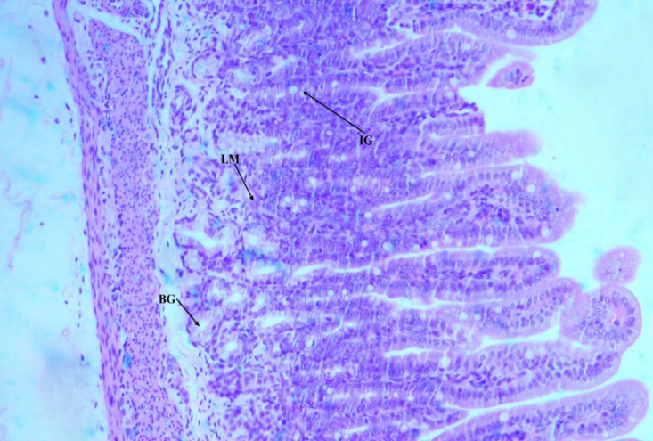
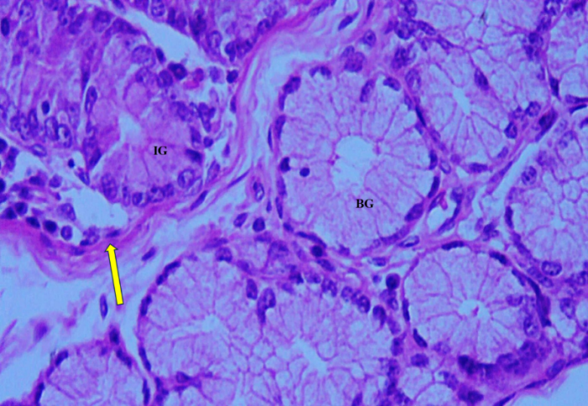
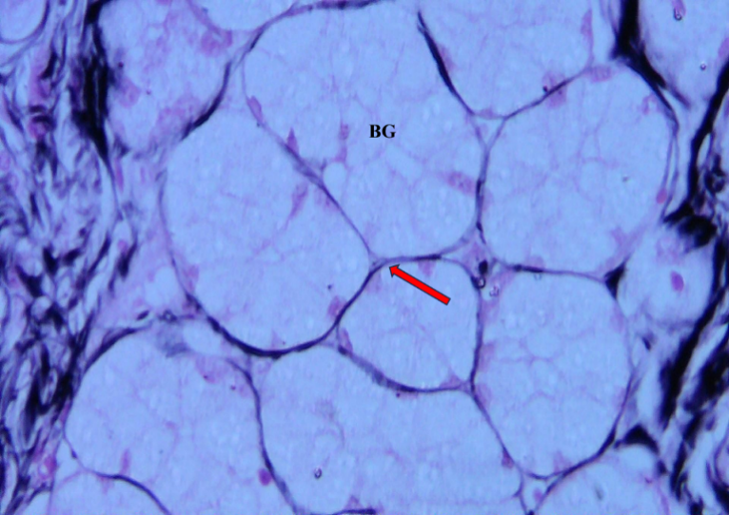
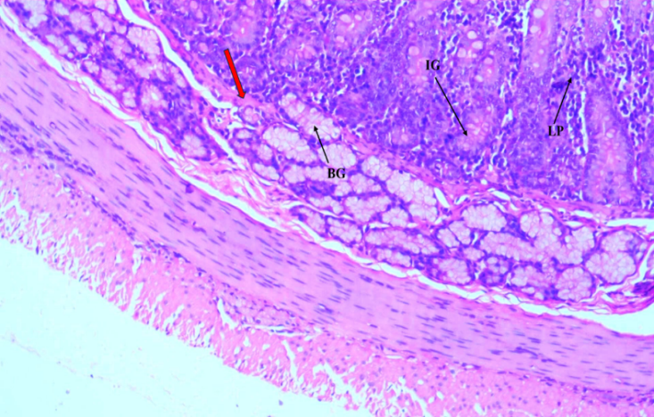
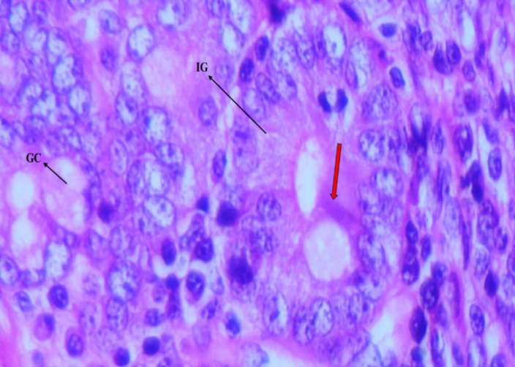
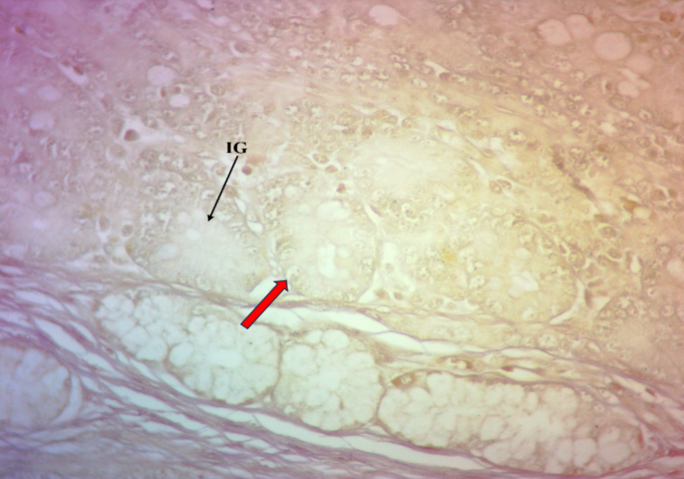
Fig 11. Photomicrograph of G-III (243-day old) pig small intestine showing duodenum segment with reticular fibres (arrows) around the Brunner’s glands (BG). Wilder’s 40x
Fig 12. Photomicrograph of Group II (43-day old) pig showing duodenum with intestinal glands (IG), lamina propria (LP), lamina muscularis (red arrow) and Brunner’s glands (BG). H&E 10x

Fig 10. Photomicrograph of G-I (0-day old) piglet showing duodenum with discrete lamina muscularis (LM), intestinal gland (IG) and Brunner’s glands (BG). H&E 10x
Fig 9. Photomicrograph of G-I (21-day old) piglet showing duodenum with Paneth cells (red arrow) in intestinal glands (IG) and goblet cells (GC). H&E 60x
Fig 8. Photomicrograph of G-II (21-day old) piglet showing duodenum with elastic fibres (red arrow) around intestinal glands (IG).
Weigert’s 10x
Fig 7. Photomicrograph of G-I (13-day old) piglet showing duodenum with intestinal glands (IG), continuous lamina muscularis (yellow arrow)
and Brunner’s glands (BG). H&E 40x
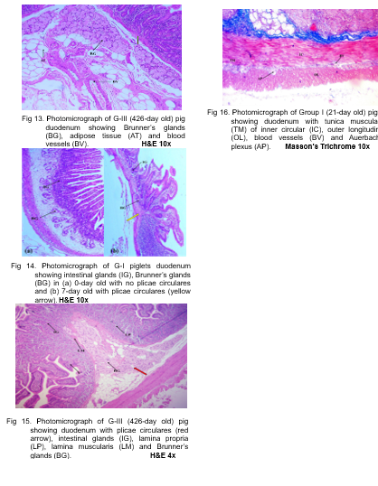
4. CONCLUSION
Postnatal development of the duodenum in Indian domestic pigs was characterized by progressive maturation of the mucosa, submucosa and muscular components. Villi underwent distinct developmental alterations, while goblet cells, intraepithelial lymphocytes and connective tissue fibres became increasingly prominent with age. Paneth cells appeared after birth, and Brunner's glands developed from sparse isolated structures into prominent submucosal lobules. Plicae circulares also became evident during early postnatal life and increased in prominence with advancing age. Together, these observations indicate coordinated maturation of the structural components associated with digestive, absorptive, protective and intestinal immune functions. The findings provide descriptive baseline information on postnatal duodenal histology in Indian domestic pigs and may support future comparative and morphometric investigations of porcine intestinal development.

Competing interests
No conflicts of interest

ETHICAL APPROVAL
The present investigation and its experimental design were approved by the Institutional Animal Ethics Committee, vide IAEC No. 11/26/IAEC-Pig/C.V.Sc./Hyd. Dt: 13.06.2025.

Declaration of AI Use

This manuscript was prepared through the intellectual contributions of the author(s) to the study design, data analysis, interpretation of results, and scholarly content. Grammarly and ChatGPT were used solely to assist with grammatical refinement and reference formatting during manuscript revision. The author(s) accept full responsibility for the accuracy, integrity, and final content of the manuscript.

REFERENCES

Al Arubay, N. A. (2025). Histological and histochemical investigation of the Brunner glands in wild brown rats. Kerbala Journal of Veterinary Medical Sciences, 1(3), 70–73.
Al Mansour, N. A., Jasim, Z. M., Al Samawy, E. R., & Jasim, H. J. (2020). Histomorphometric and histochemical comparison of the duodenum between goat (Capra hircus) and gazelle (Gazella subgutturosa). Plant Archives, 20(1), 852–856.
Al Saffar, F. J., & Al Zuhairy, M. F. (2016). Postnatal developmental histomorphological and histochemical study of the duodenum in the domestic cat (Felis catus). International Journal of Current Research, 8(12), 43681–4390.
Bansal, N., Khatra, G. S., & Singh, J. (1993). Histomorphology and micrometry of tunica submucosa, Brunner’s glands and Peyer’s patches of buffalo small intestine. Indian Journal of Veterinary Anatomy, 5, 23–28.
Barnwal, A. K., & Yadava, R. C. P. (1975). Studies on the histological structures of small intestine of Indian buffaloes (Bubalus bubalis). Indian Journal of Animal Health, 14, 19–23.
Barszcz, M., & Skomiał, J. (2011). The development of the small intestine of piglets: chosen aspects. Journal of Animal and Feed Sciences, 20(1), 3–15.
Clarke, R. M., & Hardy, R. N. (1971). Histological changes in the small intestine of the young pig and their relation to macromolecular uptake. Journal of Anatomy, 108, 63.
Cui, C., Li, L., Wu, L., Wang, X., Zheng, Y., Wang, F., Wei, H., & Peng, J. (2023). Paneth cells in farm animals: current status and future direction. Journal of Animal Science and Biotechnology, 14(1), 118.
Dellmann, D. H., & Eurell, J. (2006). Dellmann’s textbook of veterinary histology (6th ed., pp. 194–199). Blackwell.
Deswal, N., & Gahlot, P. K. (2024). Histomorphological and histochemical characterization of duodenum of pig. The Pharma Innovation Journal, 13(8), 95–99.
Dong, L., Zhong, X., Ahmad, H., Li, W., Wang, Y., Zhang, L., & Wang, T. (2014). Intrauterine growth restriction impairs small intestinal mucosal immunity in neonatal piglets. Journal of Histochemistry & Cytochemistry, 62(7), 510–518.
Frappier, B. L. (1998). Digestive system. In Textbook of veterinary histology (5th ed., pp. 187–191). Williams & Wilkins.
Gahlot, P. K., Kumar, P., & Singh, G. (2017). Histoarchitecture and histochemistry of duodenum and jejunum of the goat (Capra hircus). Haryana Veterinarian, 56(1), 37–40.
Gutte, M. M., Lambate, S. B., & Yadav, G. B. (2019). Histological and histochemical studies on small intestine of sheep (Ovis aries) and goat (Capra hircus). International Journal of Chemical Studies, 7(3), 1801–1805.
Hao, Y., Xing, M., & Gu, X. (2021). Research progress on oxidative stress and its nutritional regulation strategies in pigs. Animals, 11(5), 1384.
Hassan, S. A., & Moussa, E. A. (2015). Light and scanning electron microscopy of the small intestine of goat (Capra hircus). Journal of Cell Animal Biology, 9, 1–8.
Kadhim, K. H., Al Mehanna, N. H., & Al-Baghdadi, E. F. (2012). The distribution of goblet cells, Paneth cells and Brunner’s glands in duodenum of adult one-humped camels (Camelus dromedarius).
Kalita, A., Sarma, K., Talukdar, M., Deka, A., & Kalita, P. C. (2017). Gut integrity of neonatal piglets: A histomorphological analysis. Journal of Animal Research, 7(6), 1115–1121.
Kalita, A., Talukdar, M., Sarma, K., Kalita, P. C., Gali, J. M., Tamuli, S., Choudhary, O. P., Doley, P. J., & Debroy, S. (2021). Impact of probiotic and zinc on brush-border enzyme and histo-enzymatic profile in the small intestine of pre- and postweaned piglets. Indian Journal of Animal Research, 1, 8.
Kararli, T. T. (1995). Comparison of the gastrointestinal anatomy, physiology, and biochemistry of humans and commonly used laboratory animals. Biopharmaceutics & Drug Disposition, 16(5), 351–380.
Korkmaz, D., & Kum, S. (2016). A histological and histochemical study of the small intestine of the dromedary camel (Camelus dromedarius). Journal of Camel Practice and Research, 23(1), 111–116.
Krause, W. J. (2000). Brunner’s glands: A structural, histochemical and pathological profile. Progress in Histochemistry and Cytochemistry, 35(4), 255–367.
Kumar, P., Kumar, P., Singh, G., & Poonia, A. (2013). Histological architecture and histochemistry of duodenum of the sheep (Ovis aries). Indian Journal of Veterinary Anatomy, 25, 30–32.
Luna, L. G. 1968. Manual of histologic staining methods of the Armed Forces Instituteof Pathology. pp. xii-258.
Madara, J. L. (1991). Functional morphology of epithelium of the small intestine. Handbook of Physiology, 6, 83–120.
Mohammad, H. J., Ali, K. A., & Al-Ali, Z. A. J. R. (2020). Histomorphological and histochemical structure in the duodenum of sheep (Ovis aries) and rabbit (Oryctolagus cuniculus): A comparative study. Journal of Animal and Feed Research, 10(6), 251–258.
Mohammadpour, A. A. (2011). Morphological and histochemical study of guinea pig duodenal submucosal glands. Bulgarian Journal of Veterinary Medicine, 14(4), 201–208.
Obremski, K., Gajecka, M., Zielonka, L., Jakimiuk, E., & Gajecki, M. (2005). Morphology and ultrastructure of small intestine mucosa in gilts with zearalenone mycotoxicosis. Polish Journal of Veterinary Sciences, 8, 301–307.
Pabst, R., Geist, M., Rothkotter, H. J., & Fritz, F. J. (1988). Postnatal development and lymphocyte production of jejunal and ileal Peyer’s patches in normal and gnotobiotic pigs. Immunology, 64(3), 539.
Raja, K., Ushakumary, S., Rajathi, S., & Ramesh, G. (2022). Histological studies on the duodenum of the guinea pig (Cavia porcellus) in postnatal age groups. The Pharma Innovation Journal, 11(10), 1770–1774.
Rothkotter, H. J., Ulbrich, H., & Pabst, R. (1991). The postnatal development of gut lamina propria lymphocytes: Number, proliferation, and T and B cell subsets in conventional and germ-free pigs. Pediatric Research, 29(3), 237–242.
Saleh, T. F., Ahmed, N. S., & Abduljawaad, A. N. (2019). Histological and histochemical study of Brunner’s glands in local adult cows. Biochemical and Cellular Archives, 19(2), 4051–4056.
Schaaf, C. R., & Gonzalez, L. M. (2022). Use of translational, genetically modified porcine models to ultimately improve intestinal disease treatment. Frontiers in Veterinary Science, 9, 878952.
Siddiqi, M. N. H., Nasrin, M., Awal, M. A., & Kashem, M. A. (2011). Histology and histochemistry of the duodenum of Black Bengal goat in Bangladesh. International Journal of BioResearch, 11(1), 10–14.
Simawy, M. S. H., Fadhil, M., & Kadhim, K. H. (2024). Study of Brunner’s glands using histology and histochemistry in various age groups of cats, dogs and goats. South Asian Research Journal of Biology and Applied Biosciences, 6(5), 184–193.
Singh. U. B. and Sulochana , S. 1996. Handbook of Histological and Histochemical Techniques. 97: 110-111.
Singh, T. S., Sathyamoorthy, O. R., Basha, S. H., Ushakumary, S., & Raja, K. (2021). Histomorphological, histomorphometrical and histochemical studies on the small intestine of large white Yorkshire pig (Sus scrofa domesticus). Journal of Livestock Research, 11(2), 59–66.
Singh, I. (1971). The distribution of Paneth cells in the human small intestine. Anatomischer Anzeiger, 128(1), 60–65.
Skrzypek, T. H., Kazimierczak, W., Skrzypek, H., Valverde Piedra, J. L., Godlewski, M. M., & Zabielski, R. (2018). Mechanisms involved in the development of the small intestine mucosal layer in postnatal piglets. Journal of Physiology and Pharmacology, 69(1), 127–138.
Skrzypek, T., Piedra, J. V., Skrzypek, H., Kazimierczak, W., Szymanczyk, S. E., & Zabielski, R. (2010). Changes in pig small intestinal absorptive area during the first 14 days of life. Livestock Science, 133(1–3), 53–56.
Skrzypek, T., Piedra, J. V., Skrzypek, H., Wolinski, J., Kazimierczak, W., Szymanczyk, S., & Zabielski, R. (2005). Light and scanning electron microscopy evaluation of the postnatal small intestinal mucosa development in pigs. Journal of Physiology and Pharmacology, 56, 71.
Suwaidan, W. A., & Almaliki, S. H. (2024). Morphohistological and histochemical study of the duodenum in neonatal local breed dogs (Canis familiaris). African Journal of Biomedical Research, 27(3), 2600–2606.
Takehana, K., Masty, J., Abe, M., & Yamaguchi, M. (1991). Duodenal glands of the pony (Equus caballus). Anatomia Histologia Embryologia, 20(1), 1–9.
Talukdar, M. (1999). Gross anatomical, histomorphological and histochemical studies on the stomach and intestine of crossbred adult pig (Doctoral dissertation). Assam Agricultural University, Khanapara, Guwahati, India.
Tsukahara, T., Kishino, E., Inoue, R., Nakanishi, N., Nakayama, K., Ito, T., & Ushida, K. (2013). Correlation between villous height and disaccharidase activity in the small intestine of piglets from nursing to growing. Animal Science Journal, 84(1), 54–59.
Vega Lopez, M. A., Arenas-Contreras, G., Bailey, M., Gonzalez-Pozos, S., Stokes, C. R., Ortega, M. G., & Mondragon Flores, R. (2001). Development of intraepithelial cells in the porcine small intestine. Journal of Immunology Research, 8(2), 147–158.
Verdile, N., Mirmahmoudi, R., Brevini, T. A. L., & Gandolfi, F. (2019). Evolution of pig intestinal stem cells from birth to weaning. Animal, 13(12), 2830–2839.
Wiese, F., Simon, O., & Weyrauch, K. D. (2003). Morphology of the small intestine of weaned piglets and a novel method for morphometric evaluation. Anatomia Histologia Embryologia, 32(2), 102–109.
Xu, R. J., Wang, F., & Zhang, S. H. (2000). Postnatal adaptation of the gastrointestinal tract in neonatal pigs: A possible role of milk-borne growth factors. Livestock Production Science, 66(2), 95–107.

