New distribution record of the mangrove crab Neosarmatium malabaricum (Henderson,1893)(Decapoda:Brachyura:Sesarmidae) in the Kali estuary, Karwar, Karnataka, India

Abstract: The present study highlights the new distribution record of the mangrove sesarmid crab, Neosarmatium malabaricum (Henderson, 1893), from the Karwar, Karnataka west coast of India. Six live specimens of Neosarmatium malabaricum collected from hard substratum mangrove edges Of Devbag, Kodibag, Siddar, Kinnar, Devalmakki along the Kali estuary, Karwar, Karnataka west coast of India. This finding contributes to the understanding of Neosarmatium malabaricum distribution along the Indian coast. Morphological characters of the specimens have been studied, photographed.
Key words: Brachyura, Sesarmidae, Neosarmatium malabaricum, Mangrove crab, Kali estuary, Karwar, Karnataka, West coast of India
Introduction: The family Sesarmidae (Dana, 1851) constitutes one of the most ecologically dominant brachyuran groups in mangrove ecosystems of the Indo-West Pacific region (Davie 1994; Ng et al. 2008). Sesarmid crabs play a pivotal role in mangrove nutrient cycling, acting as primary processors of leaf litter and as bioturbators of mangrove sediments (Cannicci et al. 2008; Praveen & Oommen 2016). Among sesarmid genera, Neosarmatium (Serène & Soh,1970) is particularly characteristic of the landward belt of Indo-West Pacific mangroves, with species typically occupying semi-terrestrial burrows in the upper intertidal zone. The genus Neosarmatium currently comprises 19 valid species distributed across the Indo-West Pacific (WoRMS 2024), of which only four species extend their range into the western Indian Ocean: N. laeve (A. Milne-Edwards, 1869), N. meinerti (de Man, 1887), N. malabaricum (Henderson, 1893), and N. smithi (H. Milne-Edwards, 1853) (Ragionieri et al. 2012). Neosarmatium malabaricum (Henderson, 1893) was originally described as Sesarma malabaricum (Henderson, 1893) from the Malabar coast of India, making it one of the few Neosarmatium species with an Indian type locality. Despite this, the species has remained poorly documented from the Indian west coast in subsequent literature, with confirmed records largely confined to Kerala and, most recently, Maharashtra (Praveen & Oommen 2016; Trivedi et al. 2023) and Goa (ICMBAs, (2023)).
The present paper records new distribution of Neosarmatium malabaricum from the Kali estuarine hard substratum mangrove edges of Karwar, Karnataka, although it has already been listed from Aghanashini estuary at Kumta (Shet G.N. et al. 2017) Karnataka. A specifically documented occurrence of N. malabaricum from the Kali Estuary, accompanied by detailed morphometric and photographic documentation, warrants reporting. The present study therefore documents Six male specimens of N. malabaricum collected from the mangroves hard substratum edges of the Kali estuary, Karwar. For the first time, Neosarmatium malabaricum specimen was reported along the Kali estuarine hard substratum mangrove areas of Karwar west coast of India, which is situated along India’s South Konkan coast. The specimen was encountered by beat forester Gopal D. Naik forest Department Karwar, during rainy night survey of mangrove edges of Devbag, Kodibag, Siddar, Kinnar, Devalmakki which is situated along Kali estuary, is located at Karwar (14°48'N, 74°07'E), Uttar Kannada district, Karnataka, on the west coast of India. The estuary receives fresh water inflow from the Kali River and opens into the Arabian Sea at Karwar Bay. A total of six live specimens were investigated in the present study. A vernier calliper was used to measure it to the closest 0.1 mm. Identification keys were used to confirm the species of the specimen, which was then identified, recorded, and preserved in a 90% ethanol.

Materials and methods: The six male specimens of Neosarmatium malabaricum were collected. The sampling were carried out during rainy night at low tide by beat forester Gopal D. Naik from May to August 2026, on Kali estuarine hard substratum area of mangroves Devbag, Kodibag, Kinner, Siddar, Devalmakki (Fig.1). It was handpicked and measured using calipers, preserved in 90% ethanol, identified using taxonomic keys. Further measurements were made in the laboratory.
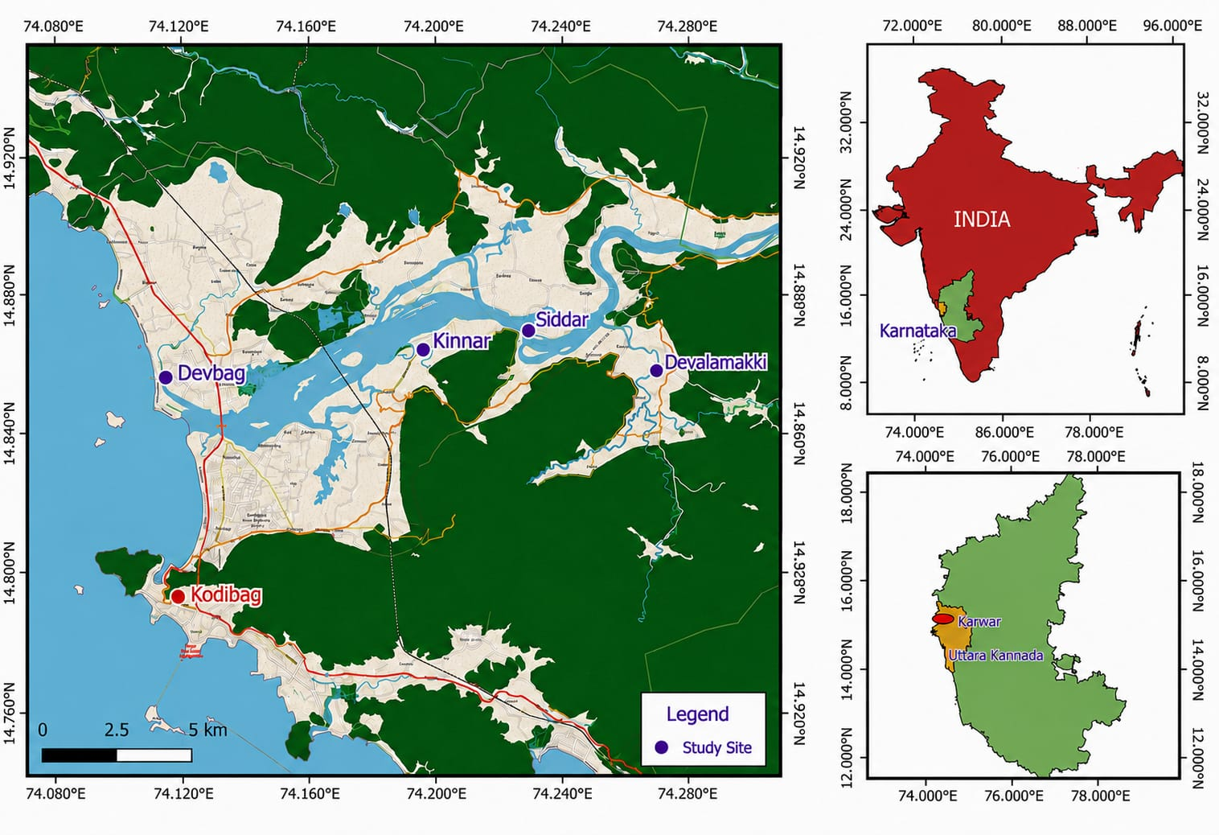
Fig.1. Locations of the study sites in Kali estuary (Mangrove) Karwar Karnataka

Table 1: Details of study sites
Sl.No. | Sampling sites | Coordinates | Area/substratum
1 | Devbag | 14.851⁰ N 74.112⁰ E | Intertidal hard soil
2 | Kodibag | 14.838⁰ N 74.133⁰ E | Estuarine border and embankment
3 | Kinnar | 14.864087⁰ N 74.193851⁰ E | Mangroves hard substratum grassy edges
4 | Siddar | 14.869376⁰ N 74.226107⁰ E | Mangroves hard substratum grassy edges
5 | Devalmakki | 14.857955⁰ N 74.265790⁰ E | Mangroves hard substratum grassy edges

Results and Discussion:
Systematic accounts:
Phylum: Arthropoda
Class: Malcostraca
Order: Decapoda (Latreille, 1802)
Infraorder: Brachyura (Latreille, 1802)
Superfamily: Grapsoidea (MacLeay , 1838)
Family: Sesarmidae (Dana, 1851)
Genus: Neosarmatium (Serène&Soh, 1970)
Species: Neosarmatium malabaricum (Henderson, 1893)

Synonymy:

Sarmatium malabaricum (Henderson, 1893)

Neosarmatium indicum malabaricum (Henderson,1893)

Neosarmatium malabaricum (Henderson, 1893)

Materials examined: Six specimens, May to August 2026, along the Kali estuarine hard substratum mangrove edges of Karwar coast (14°48'N, 74°07'E), Uttar Kannada district, Karnataka, collected by Gopal D. Naik beat forester Karwar, rainy night at mangroves hard substratum edge area grassy land sampling.
Description: Carapace distinctly broader than long, subquadrate and moderately vaulted. Based on the specimens examined here, CW/CL ranged from 1.14 to 1.22, with a mean ratio of approximately 1.19. The dorsal surface is unevenly granular and bears distinct regional demarcations. The frontal margin is relatively broad and bears a median concavity. The anterolateral margins are armed with teeth behind the external orbital angle, and the lateral margins are slightly concave or sub parallel posteriorly. The chelipeds are robust, particularly in the larger males. The propodus is relatively high, with the upper surface bearing a conspicuous longitudinal rim. The dactylus possesses teeth/tubercleson its dorsal surface; in N.malabaricum, the distal tooth is positioned close to the middle of the dactylus. These characters are particularly important in distinguishing the species from the closely related N. punctatum. Walking legs are moderately long and flattened. The merus, carpus and propodus bear setae, particularly along the margins and surfaces of the distal segments. The male pleon is relatively broad, with the distal segments forming the characteristic male abdominal outline. The G1 is relatively slender, with a curved distal portion and a strongly produced corneous apical process. The detailed morphology of the dissected G1 documented with a separate high-magnification photograph, gonopod morphology is for confirming species-level identification. Davie (1994) described the G1 of N.malabaricum as relatively slender, with the distal portion narrowing and a strongly produced straight corneous apical process. The Six individuals of mangrove sesarmid crabs (Neosarmatium malabaricum) were collected from mangrove edges survey along the Kali estuarine areas of Devbag, Kodibag, Siddar, Kinnar, Devalmakki, Karwar, Uttar Kannada, Karnataka on May to August 2026. The crabs were identified morphologically and confirmed as Neosarmatium malabaricum (Henderson, 1893) (Table2) (Fig.2) and (Fig.3).
A.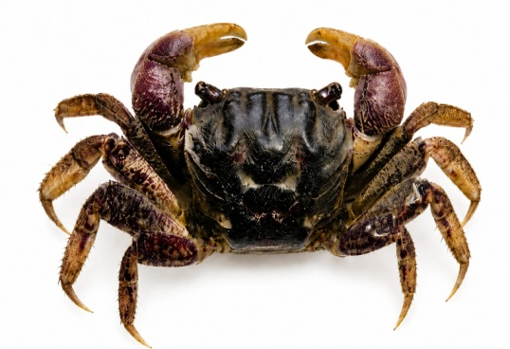 B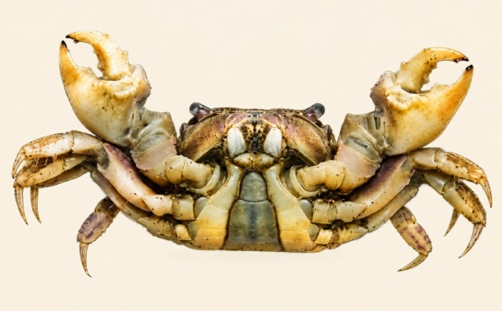
C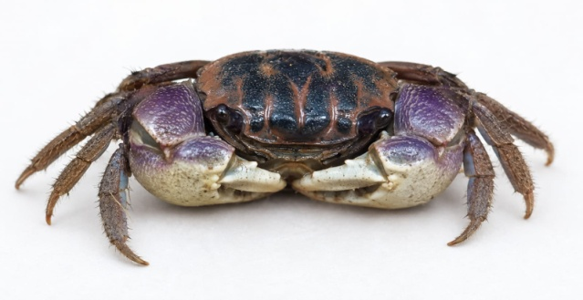 D. 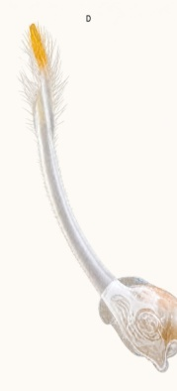

Fig.2. A. Neosarmatium malabaricum dorsal view, B. N. malabaricum ventral view
C. N. malabaricum front view, D. G1 of N. malabaricum

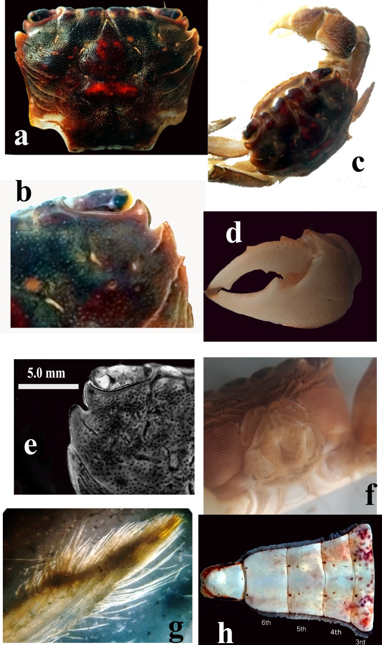

Figure 3. Morphological diagnosis of Neosarmatium malabaricum (Henderson, 1893)
(a) Dorsal view of adult male; (b) Close-up of frontal and anterolateral carapace region;
(c) Lateral view showing general habitus and cheliped; (d) Detached cheliped/propodus;
(e) Close-up of carapace frontal and orbital region, scale bar=5.0mm;
(f) Ventral/morphological view of diagnostic structures; (g) Close-up of setose walking leg; (h) Male pleon, showing abdominal segments.

Morphometric observations:

Table 2. Morphometric measurements of Neosarmatium malabaricum
Specimen Sex | CL  (mm) | CW  (mm) | CW/ CL | Right propodus L | Right dactylus L | Right palm H | Left propodus L | Left dactylus L | Left palm H
1 Male | 18.0 | 22.0 | 1.22 | 15.5 | 10.0 | 10.25 | 15.0 | 9.5 | 10.0
2 Male | 20.5 | 25.0 | 1.22 | 21.0 | 14.0 | 14.0 | 21.0 | 14.0 | 14.0
3Male | 22.0 | 25.0 | 1.14 | 23.0 | 15.0 | 14.0 | - | - | -
4Male | 21.0 | 25.0 | 1.19 | 18.0 | 13.0 | 12.0 | 18.0 | 12.0 | 12.0
5 Male | 21.0 | 25.0 | 1.19 | 18.0 | 13.0 | 12.0 | 18.0 | 12.0 | 12.0
6 Male | 20.5 | 25.0 | 1.22 | 21.0 | 14.0 | 14.0 | 21.0 | 14.0 | 14.0
Range | 18.0-22.0 | 22.0-25.0 | 1.14-1.22 | 15.5-23.0 | -10.0-15.0 | 10.25-14.0 | 15.0-21.0 | 9.5-14.0 | 10.0-14.0

Discussion: Records of Neosarmatium malabaricum (Henderson, 1893) were first reported by Henderson (1893) from Cochin, Malabar Coast, India, and subsequently from Sri Lanka and the Seychelles (Serène, 1975); Sulawesi was also included in its known distribution. In India, the species was later recorded from the mangroves of Kerala (Radhakrishnan et al., 2006), Goa, and Maharashtra. More recently, Satish C. et al. (2023) reported N. malabaricum from the Dharamtar estuary mangroves of Maharashtra, representing its first record from the state and extending its known distribution along the west coast of India. The species has also been documented from mangrove habitats of the Cochin backwaters, Kerala. In Karnataka, N. malabaricum has previously been reported from the Aghanashini (Shet G.N. et al. 2017) Estuary, where it occurred in mangrove associated habitats at several sampling stations.
Conclusion: The Neosarmatium malabaricum from the genus Neosarmatium is reported for the first time from Devbag, Kodibag, Siddar, Kinnar, Devalmakki of Kali estuarine mangrove hard substratum edges along the Karwar coast of Karnataka, India and it has not been previously recorded from this region of Karwar. This report of Neosarmatium malabaricum shows its extended distribution along the west coast of India. The present study provides important documentation of Neosarmatium malabaricum from the Karwar west coast of India based on morphological characteristics. A new species record from new broadens the species occurrence and offers valuable information for biodiversity conservation management.

Ethical statement
No ethical approval is required as the study does not include activities that require ethical approval or involve protected organisms/human subjects/collection of samples/protected environments.
Declaration of AI Use

This manuscript was prepared through the intellectual contributions of the author(s) to the study design, data analysis, interpretation of results, and scholarly content. Grammarly and ChatGPT were used solely to assist with grammatical refinement and reference formatting during manuscript revision. The author(s) accept full responsibility for the accuracy, integrity, and final content of the manuscript.

COMPETING INTERESTS DISCLAIMER:
Authors have declared that they have no known competing financial interests OR non-financial interests OR personal relationships that could have appeared to influence the work reported in this paper.

References:
Cannicci,S.,Burrows,D.,Fratini,S.,Smith,T.J.,Offenberg,J.&Dahdouh-Guebas,F.(2008). Faunal impact on vegetation structure and ecosystem function in mangrove forests: a review. Aquatic Botany, 89: 186–200.

Davie, P. J. F. (1994). Revision of Neosarmatium Serène & Soh (Crustacea: Brachyura: Sesarminae) with descriptions of two new species. Memoirs of the Queensland Museum, 35(1): 35–74.

de Man, J. G. (1887). Report on the Podophthalmous Crustacea of the Mergui Archipelago, collected for the Trustees of the Indian Museum, Calcutta, by Dr. John Anderson, FRS, Superintendent of the Museum.—Part II. Zoological Journal of the Linnean Society, 22(137), 65-128

Henderson, J. R. (1893).A contribution to Indian carcinology. Transactions of the Linnean Society of London, Zoology, 5: 325–458, pls 36–40.
Milne-Edwards, A. (1869). Note sur quelques nouvelles espèces de genre Sesarma Say. Nouvelles Archives du Muséum d’Histoire Naturelle de Paris, 5, 25–31.
Milne-Edwards, H. (1853). Mémoire sur la famille des Ocypodiens. Annales des Sciences Naturelles, Zoologie, 3(20), 163–226, plates 6–11.
Ng, P. K. L., Guinot, D.& Davie, P. J. F. (2008). Systema Brachyurorum: PartI. An annotated checklist of extant brachyuran crabs of the world. Raffles Bulletin of Zoology, Supplement 17: 1–286.

Praveen, V. P. & Oommen, M.M. (2016). Species preference in seedling predation by the sesarmid crab Neosarmatium malabaricum (Henderson, 1893) in a mangrove forest in India.Wetlands,37: 167–175.

Radhakrishnan, C., Palot, M. J., & Antony, C. (2006). Crustacea (Decapoda: Brachyura) associated with the mangrove ecosystems of Kerala, India. Records of the Zoological Survey of India, 106(4), 1-17.
Ragionieri, L., Fratini, S. & Schubart, C.D. (2012). Revision of the Neosarmatium meinerti species complex (Decapoda: Brachyura: Sesarmidae), with descriptions of three pseudocryptic Indo-West Pacific species. Raffles Bulletin of Zoology, 60(1): 71–87.

Sathish, C., Reddy, D. N., Bharti, V. S., Deshmukhe, G., & Jaiswar, A. K. (2023). Diversity and distribution of mangrove associated crabs (Infraorder: Brachyura) of India and the relationship between mangroves and crabs. Thalassas: An International Journal of Marine Sciences, 39(2), 847-866.
Serène, R. & Soh, C. L .(1970). New Indo-Pacific genera allied to Sesarma Say,1817 (Brachyura, Decapoda, Crustacea). Treubia, 27(4): 387–416.

Serène, R. (1975). Note addition nelle sur les espèces indo-pacifiques de Quadrella Dana 1851 (Crustacea, Decapoda, Brachyura). Bull. Soc. zool. Fr, 100(4), 509-521.

Shet, G. N., Chandran, M. S., & Ramachandra, T. V. (2016). Brachyuran Crabs of Aghanashini Estuary, South Indian West Coast, Karnataka. In Conference on Conservation and Sustainable Management of Ecologically Sensitive Regions in Western Ghats (Vol. 1, pp. 2-83).
Trivedi, J. N.,Trivedi,D.J.,Vachhrajani,K.D.&Ng,P.K.L.(2023).Diversity and distribution of mangrove associated crabs (Infraorder: Brachyura) of India and the relationship between mangroves and crabs. Thalassas: An International Journal of Marine Sciences.
WoRMS Editorial Board (2024).World Register of Marine Species. Available at https://www.marinespecies.org.

