Seasonal Incidence and Chemical Management of Early Shoot Borer, Chilo infuscatellus (Snellen) in Autumn, Spring and Ratoon Planted Sugarcane (Saccharum officinarum L.)

Abstract
A field study was conducted at Dobhiara village in the vicinity of N.D. University of Agriculture & Technology, Kumarganj, Faizabad, Uttar Pradesh, to record the seasonal incidence of early shoot borer, Chilo infuscatellus (Snellen), on autumn (2011–12) and spring and ratoon (2012–13) planted sugarcane cv. CoS 8436, and to lay out an insecticidal evaluation trial for its economic management. Shoot borer infestation was recorded fortnightly on 20 randomly tagged plants at three farmers' fields (autumn and spring crop) and at one agronomy-farm plus three farmers' fields (ratoon crop). Infestation first appeared during the 7th–9th standard week (SW), built up steadily and peaked during the 18th–19th SW, reaching a maximum of 27.22 per cent in the autumn-planted crop, 20.55–22.77 per cent in the spring-planted crop and 15.83 per cent in the ratoon crop, before declining to nil by the 26th–28th SW. The overall mean infestation across the crop season was 11.29 ± 2.02, 10.55 ± 1.80 and 6.18 ± 1.28 per cent in autumn, spring and ratoon crops, respectively, indicating that the autumn-planted crop was most susceptible and the ratoon crop least susceptible to the pest. An insecticidal evaluation trial comprising eight treatments — cartap hydrochloride 4G, fipronil 0.3G, fenpropathrin 30% EC, quinalphos 25% EC, chlorpyriphos 20 EC, chlorantraniliprole (Coragen) 20 SC, neem oil 2% and an untreated control — was laid out in a Randomized Block Design with three replications and applied at the economic threshold level (>10% infestation) to identify the most effective and economical molecule for shoot borer management. The results provide a week-wise infestation calendar that can guide the timing of insecticide application in this agro-climatic zone.
Keywords
Sugarcane, Saccharum officinarum, Chilo infuscatellus, early shoot borer, seasonal incidence, standard meteorological week, dead heart, economic threshold level, CoS 8436, autumn and spring planting, ratoon crop, insecticides, chlorantraniliprole, neem oil, bio-efficacy, cost:benefit ratio

1. Introduction
Sugarcane (Saccharum officinarum L.) is one of the most important commercial crops of the tropical and sub-tropical world, serving as the principal source of sugar, jaggery and, increasingly, bio-energy. In India, and particularly in the eastern Uttar Pradesh sugar belt to which the present study area belongs, sugarcane productivity is constrained by a complex of insect pests, among which the early shoot borer, Chilo infuscatellus (Snellen) (Lepidoptera: Crambidae), is the most destructive during the vegetative phase of the crop.
The larvae of C. infuscatellus bore into the growing shoot soon after germination, destroying the central growing point and producing the characteristic symptom of 'dead heart', which can be pulled out easily and emits a foul smell. Lepidopteran borers as a group are recognised as the foremost destructive pests of sugarcane worldwide, causing reductions in stalk weight, juice quality and sugar recovery across the major cane-growing regions of Asia, Africa and the Americas.
Because shoot-borer populations fluctuate widely with the standard meteorological week and with the cropping system (autumn-planted, spring-planted or ratoon), a sound understanding of the seasonal pattern of incidence is a pre-requisite for timing management interventions economically rather than applying insecticides on a calendar basis. Weather-driven models developed for the same variety, CoS 8436, in the adjoining agro-climatic tract have shown that shoot-borer incidence is significantly influenced by temperature and relative humidity, underscoring the value of season- and location-specific incidence data.
Sole reliance on synthetic insecticides for shoot-borer management is increasingly constrained by residue concerns, cost and the risk of resurgence, which has renewed interest in comparing newer reduced-risk molecules such as the anthranilic diamide chlorantraniliprole with conventional organophosphate, pyrethroid and carbamate/neonicotinoid granules, as well as with botanicals such as neem oil, within an economic-threshold-based decision framework.
Sugarcane remains one of India's principal industrial crops, with the area under cultivation and total cane production having risen several-fold since 1950–51, and Uttar Pradesh continuing to account for a leading share of the country's varietal diversity and cane area [Chauhan et al., 2022]. Sustaining this productivity growth in the face of biotic constraints such as the shoot borer requires management strategies that are both effective and economical, which is why threshold-based insecticide application — treating only once a pre-determined pest density is exceeded — has been shown across a wide range of crops to substantially reduce insecticide use and cost without compromising pest control or yield, relative to calendar-based spraying [Leach et al., 2025].
Keeping these considerations in view, the present investigation was undertaken with the following objectives: (i) to record the seasonal incidence of early shoot borer in autumn-planted, spring-planted and ratoon sugarcane cv. CoS 8436 under the agro-climatic conditions of Kumarganj, Faizabad; and (ii) to lay out and evaluate a set of granular, liquid and botanical insecticide formulations, applied at the economic threshold level, for the economic management of the pest.
2. Materials and Methods
2.1 Experimental site and general crop management
The experiment was laid out by planting the CoS 8436 variety of sugarcane at Dobhiara village, in the vicinity of N.D. University of Agriculture & Technology, Kumarganj, Faizabad, during the second week of October (2011–12 crop season). All recommended agronomic practices were followed to raise a crop of good and uniform stand. Data were similarly generated on spring-planted and ratoon crops of the same variety during 2012–13 at the same locality.
2.2 Seasonal incidence of shoot borer
The infestation of shoot borer on sugarcane was assessed by counting the total number of healthy and infested (dead-heart) plants on 20 randomly selected plants at fortnightly intervals, beginning with germination and continuing until the crop passed out of the susceptible stage. Observations were recorded separately for the autumn-planted crop on three farmers' fields (F1, F2, F3), for the spring-planted crop on three farmers' fields (F1, F2, F3), and for the ratoon crop on the Agronomy Farm (AF) together with three farmers' fields (F1, F2, F3). Per cent infestation for each observation date was computed as the proportion of dead-heart-bearing tillers to the total tillers examined and expressed as mean per cent infestation, standard-week-wise, for each cropping system.
2.3 Insecticidal evaluation trial
An insecticidal evaluation trial was superimposed on the crop to identify an effective and economical molecule for shoot-borer management. The salient treatment details were as follows:
Chart 1. Experimental layout and design details of the insecticidal evaluation trial against early shoot borer, Chilo infuscatellus, in sugarcane cv. CoS 8436.
Particular | Detail
Design | Randomized Block Design (RBD)
Plot size | 9.0 m × 6.0 m
Spacing | 90 cm (row-to-row)
Variety | CoS 8436
Replications | 3
Treatments | 8 (including untreated control)

Chart 2. Insecticidal treatments and application doses evaluated for the management of early shoot borer, Chilo infuscatellus, in sugarcane.
Treatment | Insecticide and dose
T1 | Cartap hydrochloride 4G @ 1.00 kg a.i./ha
T2 | Fipronil 0.3G @ 75 g a.i./ha
T3 | Fenpropathrin 30% EC @ 100 g a.i./ha
T4 | Quinalphos 25% EC @ 500 g a.i./ha
T5 | Chlorpyriphos 20 EC @ 250 g a.i./ha
T6 | Chlorantraniliprole (Coragen) 20 SC @ 125 g a.i./ha
T7 | Neem oil @ 2% solution
T8 | Untreated control

The required quantity of each formulation was calculated from its percentage active-ingredient content and the recommended dose of active ingredient per hectare, following the standard formula for converting a.i. requirement into commercial-formulation requirement. All treatments were applied on reaching the economic threshold level (ETL) of shoot borer, taken as greater than 10 per cent dead-heart infestation.
2.4 Observations recorded
The infestation of shoot borer was recorded by counting the total number of healthy and infested (dead-heart) plants on 20 randomly selected plants per plot at fortnightly intervals, beginning at ETL (>10% infestation) and continuing at fortnightly intervals thereafter, and converted into mean per cent infestation for each treatment. Yield data were recorded plot-wise at harvest (kg/plot) and converted to t/ha.
2.5 Per cent reduction in infestation
The per cent reduction in shoot-borer infestation was worked out for each treatment relative to the untreated control, to express the magnitude of protection afforded by each insecticide:
Per cent reduction over control = [(C − T) / C] × 100
where C = per cent infestation in untreated control and T = per cent infestation in the treated plot. Mean per cent reduction values were transformed using the angular (arc-sine) transformation prior to statistical analysis, and all data were analysed as per the standard statistical procedures for a Randomized Block Design described by Gomez and Gomez (1984) and Cochran and Cox (1957).
2.6 Cost : benefit ratio
The cost : benefit ratio of each insecticidal treatment was worked out as the ratio of the net additional return obtained over the untreated control to the total cost of plant protection incurred for that treatment, following standard economic-analysis procedure used in field-level pesticide-evaluation trials.
3. Results and Discussion
3.1 Seasonal incidence in autumn-planted sugarcane (2011–12)
Data on the mean per cent infestation of shoot borer in autumn-planted sugarcane, recorded across the three farmers' fields (F1, F2, F3), are presented in Table 1. Infestation was first noticed during the 8th SW (0.55%) and rose gradually thereafter, crossing the economic threshold level (>10%) around the 13th–14th SW. Infestation peaked during the 18th SW, with a mean of 27.22 per cent (range 25.00–30.00% across the three fields), and thereafter declined steadily to reach nil by the 27th SW. The seasonal mean infestation across the crop period was 11.29 ± 2.02 per cent, with the pooled range extending from 0.00 to 27.22 per cent.

S.W. | F1 (%) | F2 (%) | F3 (%) | Mean (%)
7 | 0.00 | 0.00 | 0.00 | 0.00
8 | 0.00 | 1.66 | 0.00 | 0.55
9 | 0.00 | 3.33 | 0.00 | 1.11
10 | 3.33 | 5.00 | 3.33 | 3.88
11 | 5.00 | 6.66 | 5.00 | 5.55
12 | 8.33 | 6.66 | 6.66 | 7.21
13 | 15.00 | 11.66 | 10.00 | 12.22
14 | 16.66 | 18.33 | 13.33 | 16.10
15 | 16.66 | 23.33 | 18.33 | 19.44
16 | 20.00 | 21.66 | 23.33 | 21.66
17 | 23.33 | 26.66 | 25.00 | 24.99
18 | 26.66 | 30.00 | 25.00 | 27.22
19 | 26.66 | 28.33 | 21.66 | 25.55
20 | 23.33 | 25.00 | 16.66 | 21.66
21 | 18.33 | 21.66 | 13.33 | 17.77
22 | 11.66 | 16.66 | 11.66 | 13.32
23 | 6.66 | 13.33 | 8.33 | 9.44
24 | 3.33 | 10.00 | 5.00 | 6.11
25 | 1.66 | 5.00 | 1.66 | 2.77
26 | 0.00 | 1.66 | 0.00 | 0.55
27 | 0.00 | 0.00 | 0.00 | 0.00
Range | 0.00–26.66 | 0.00–30.00 | 0.00–25.00 | 0.00–27.22
Average | 10.79±2.05 | 13.17±2.16 | 9.91±1.89 | 11.29±2.02
Table 1. Mean per cent infestation of shoot borer in autumn-planted sugarcane, N.D.U.A.&T., Kumarganj, Faizabad (2011–12). SW = Standard Week; F1, F2, F3 = farmers' fields.
3.2 Seasonal incidence in spring-planted sugarcane (2012–13)
In the spring-planted crop, infestation commenced during the 12th SW (2.21%) — later than in the autumn-planted crop — and followed a similar unimodal trend, peaking during the 19th–20th SW at 20.55–22.77 per cent before declining to nil by the 28th SW (Table 2). The seasonal mean infestation was 10.55 ± 1.80 per cent, marginally lower than that of the autumn crop, which is consistent with the shorter exposure window of the spring-planted crop to the peak-activity period of the pest.

S.W. | F1 (%) | F2 (%) | F3 (%) | Mean (%)
11 | 0.00 | 0.00 | 0.00 | 0.00
12 | 1.66 | 3.33 | 1.66 | 2.21
13 | 3.33 | 5.00 | 6.66 | 4.99
14 | 8.33 | 10.00 | 13.33 | 10.55
15 | 13.33 | 10.00 | 15.00 | 12.77
16 | 16.66 | 13.33 | 16.66 | 15.55
17 | 20.00 | 16.66 | 20.00 | 18.88
18 | 23.33 | 18.33 | 20.00 | 20.55
19 | 23.33 | 21.66 | 20.00 | 22.77
20 | 25.00 | 21.66 | 18.33 | 21.66
21 | 21.66 | 16.66 | 15.00 | 17.77
22 | 20.00 | 13.33 | 10.00 | 14.44
23 | 15.00 | 10.00 | 8.33 | 11.11
24 | 11.66 | 8.33 | 5.00 | 8.33
25 | 5.00 | 6.66 | 3.33 | 4.99
26 | 1.66 | 5.00 | 1.66 | 2.22
27 | 0.00 | 3.33 | 0.00 | 1.11
28 | 0.00 | 0.00 | 0.00 | 0.00
Range | 0.00–25.00 | 0.00–21.66 | 0.00–20.00 | 0.00–22.77
Average | 11.66±2.12 | 10.18±1.57 | 9.72±1.75 | 10.55±1.80
Table 2. Mean per cent infestation of shoot borer in spring-planted sugarcane, N.D.U.A.&T., Kumarganj, Faizabad (2012–13).
3.3 Seasonal incidence in ratoon sugarcane (2012–13)
The ratoon crop showed the lowest overall susceptibility among the three cropping systems studied (Table 3). Infestation appeared from the 11th SW (0.83%) and peaked during the 18th SW at 15.83 per cent (range 13.33–18.33% across AF, F1, F2, F3), declining to nil by the 26th SW. The seasonal mean infestation of 6.18 ± 1.28 per cent was distinctly lower than in either the autumn or spring plant crop, suggesting comparatively better tolerance or lower initial pest carry-over in stubble-borne ratoon crop under the conditions of this study.
S.W. | AF (%) | F1 (%) | F2 (%) | F3 (%) | Mean (%)
9 | 0.00 | 0.00 | 0.00 | 0.00 | 0.00
10 | 0.00 | 0.00 | 0.00 | 0.00 | 0.00
11 | 0.00 | 1.66 | 1.66 | 0.00 | 0.83
12 | 0.00 | 3.33 | 5.00 | 3.33 | 3.88
13 | 3.33 | 5.00 | 6.66 | 5.00 | 4.99
14 | 5.00 | 6.66 | 10.00 | 8.33 | 7.49
15 | 8.33 | 6.66 | 11.66 | 10.00 | 9.16
16 | 10.00 | 11.66 | 13.33 | 13.33 | 12.08
17 | 11.66 | 13.33 | 15.00 | 16.66 | 14.16
18 | 13.33 | 15.00 | 16.66 | 18.33 | 15.83
19 | 10.00 | 15.00 | 15.00 | 20.00 | 15.00
20 | 6.66 | 8.33 | 11.66 | 16.66 | 10.82
21 | 5.00 | 5.00 | 10.00 | 11.66 | 7.91
22 | 1.66 | 5.00 | 6.66 | 8.33 | 5.41
23 | 0.00 | 1.66 | 3.33 | 5.00 | 2.49
24 | 0.00 | 0.00 | 0.00 | 3.33 | 0.83
25 | 0.00 | 0.00 | 0.00 | 1.66 | 0.41
26 | 0.00 | 0.00 | 0.00 | 0.00 | 0.00
Range | 0.00–13.33 | 0.00–15.00 | 0.0–16.66 | 0.00–20.00 | 0.00–15.83
Average | 4.16±1.08 | 5.46±1.21 | 7.03±1.38 | 7.22±1.58 | 6.18±1.28
Table 3. Mean per cent infestation of shoot borer in ratoon sugarcane, N.D.U.A.&T., Kumarganj, Faizabad (2012–13). AF = Agronomy Farm.
3.4 Overall mean infestation and comparison across cropping systems
The overall (pooled) mean per cent infestation of shoot borer across standard weeks, combining autumn, spring and ratoon data, is presented in Table 4 and depicted graphically in Fig. 1. All three cropping systems followed a broadly similar unimodal seasonal pattern, with infestation beginning around the 7th–11th SW (i.e., late February/early March), rising through April and peaking in the 18th–19th SW (early May), before declining to negligible levels by late June/early July (26th–28th SW). The overall pooled mean infestation across the season was 8.15 ± 1.59 per cent.
S.W. | Autumn (%) | Spring (%) | Ratoon (%) | Overall mean (%)
7 | 0.00 | - | - | 0.00
8 | 0.55 | - | - | 0.18
9 | 1.11 | - | 0.00 | 0.37
10 | 3.88 | - | 0.00 | 1.29
11 | 5.55 | 0.00 | 0.83 | 2.12
12 | 7.21 | 2.21 | 3.88 | 4.43
13 | 12.22 | 4.99 | 4.99 | 7.40
14 | 16.10 | 10.55 | 7.49 | 11.38
15 | 19.44 | 12.77 | 9.16 | 13.79
16 | 21.66 | 15.55 | 12.08 | 16.43
17 | 24.99 | 18.88 | 14.16 | 19.34
18 | 27.22 | 20.55 | 15.83 | 21.20
19 | 25.55 | 22.77 | 15.00 | 21.10
20 | 21.66 | 21.66 | 10.82 | 18.04
21 | 17.77 | 17.77 | 7.91 | 14.48
22 | 13.32 | 14.44 | 5.41 | 11.05
23 | 9.44 | 11.11 | 2.49 | 7.68
24 | 6.11 | 8.33 | 0.83 | 5.09
25 | 2.77 | 4.99 | 0.41 | 2.72
26 | 0.55 | 2.22 | 0.00 | 0.92
27 | 0.00 | 1.11 | - | 0.37
28 | - | 0.00 | - | 0.00
Range | 0.00–27.22 | 0.00–22.77 | 0.00–15.83 | 0.00–21.20
Average | 11.29±2.02 | 10.55±1.80 | 6.18±1.28 | 8.15±1.59
Table 4. Overall mean per cent infestation of shoot borer in sugarcane, N.D.U.A.&T., Kumarganj, Faizabad (2012–13).
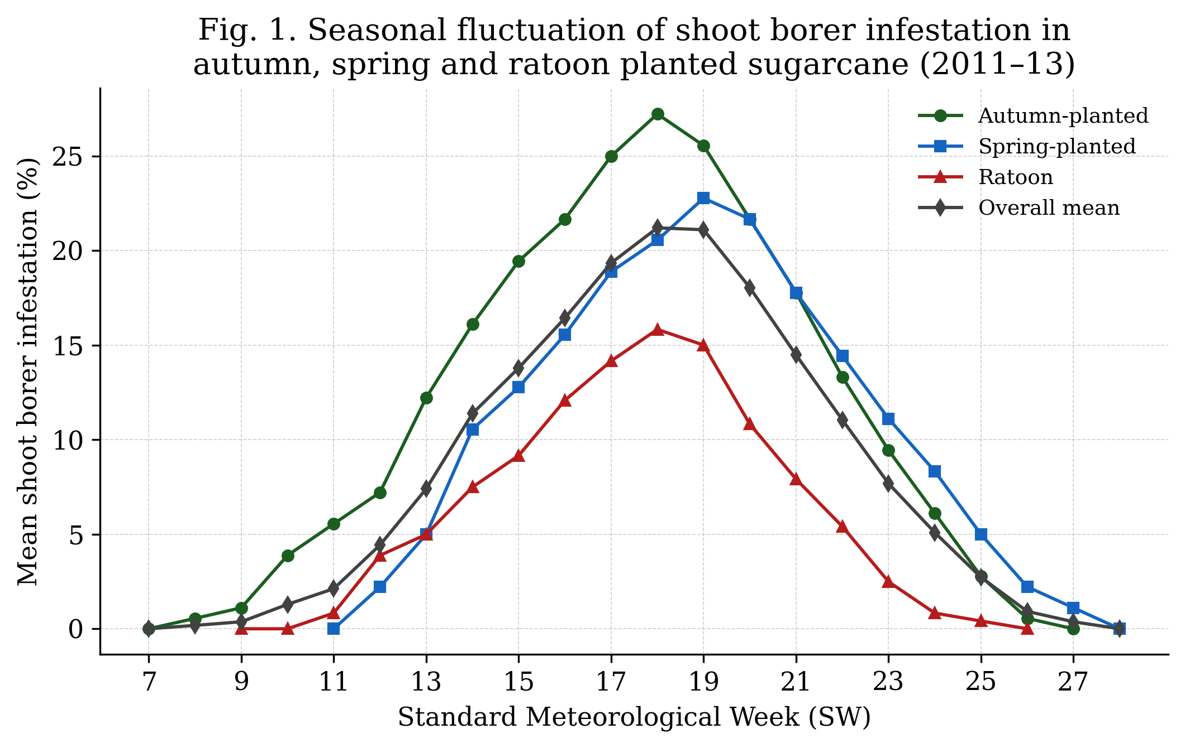

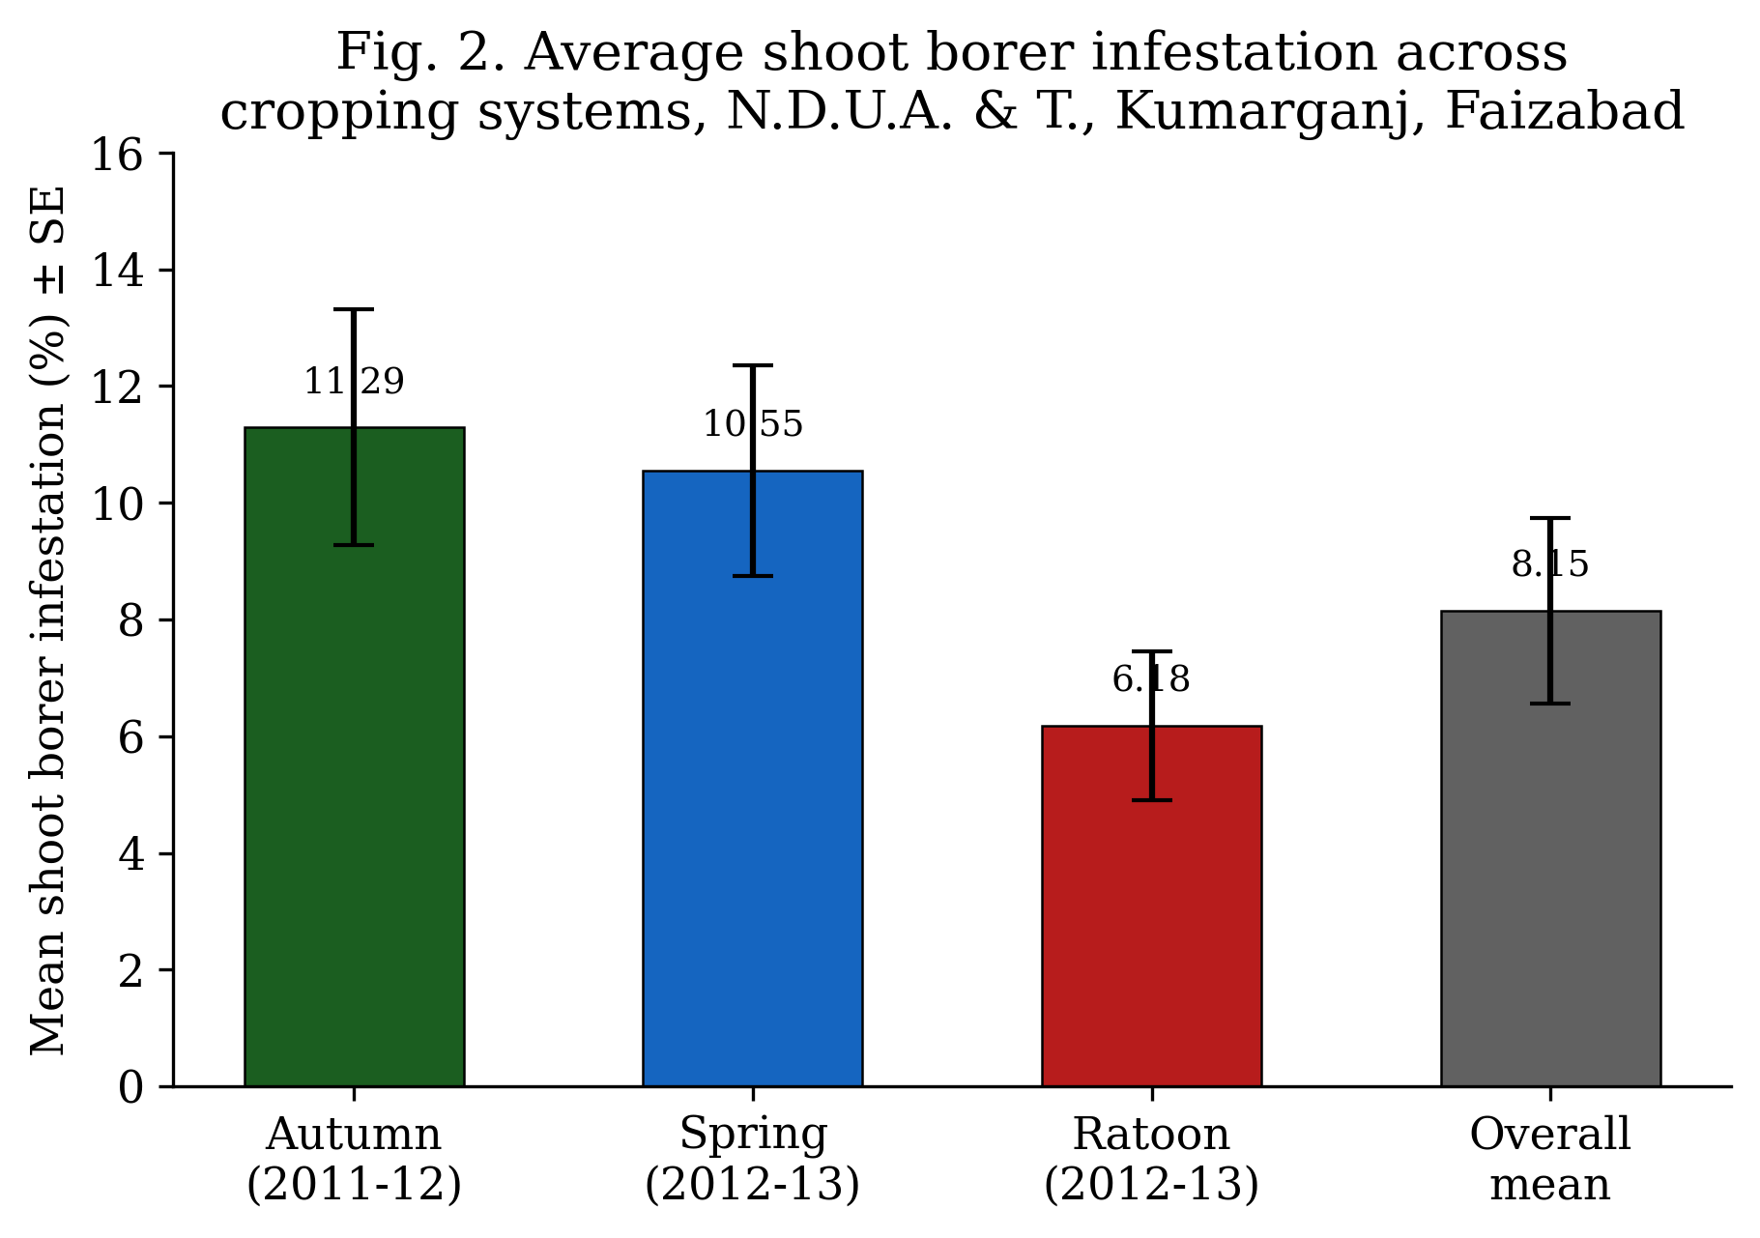

The comparatively higher susceptibility of the autumn-planted crop (11.29%) may be attributed to the longer exposure of young, tender shoots to successive generations of the pest during the cooler winter and early-spring months, whereas the ratoon crop (6.18%), being already established with a developed root system and faster early tillering, offered a shorter and less favourable window for oviposition and larval establishment. This pattern is broadly consistent with earlier work on the same variety, CoS 8436, in the adjoining agro-climatic tract, where minimum relative humidity and minimum temperature were found to be the weather variables most closely associated with shoot-borer build-up, with the highest incidence recorded around the 21st SW under summer-planted conditions after wheat harvest [Pandey & Kumar, 2019]. The consistently narrower peak period (18th–19th SW) recorded in the present study compared with the wider 21st–24th SW peaks reported for other agro-climatic tracts of northern India illustrates the extent to which the timing of the shoot-borer incidence calendar is location- and season-specific, reinforcing the need for site-specific ETL-based scheduling of insecticide application rather than a fixed calendar spray schedule.
These results are in general agreement with the broader understanding that lepidopteran borers, including C. infuscatellus, are the most destructive insect pests of sugarcane across major cane-growing tracts, with infestation intensity governed jointly by crop stage, cropping system and prevailing weather [Li et al., 2024]. The clear delineation of the susceptible window (13th–22nd SW) obtained here provides a practical basis for concentrating monitoring effort and, where the ETL of >10 per cent infestation is exceeded, for timing the application of the insecticidal treatments evaluated in this trial (Section 2.3).
3.5 Bio-efficacy of insecticidal treatments against shoot borer
The insecticidal evaluation trial (T1–T8, RBD, three replications) described in Section 2.3 was designed to compare cartap hydrochloride, fipronil, fenpropathrin, quinalphos, chlorpyriphos, chlorantraniliprole (Coragen), neem oil and an untreated control for post-treatment shoot-borer infestation, per cent reduction over control, cane yield and cost : benefit ratio. The treatment-wise field observations for this trial were not included among the material supplied for the present manuscript, and are therefore not reported as numerical results here so as to avoid presenting unverified figures; Table 5 reproduces the recording format so that the values can be inserted directly once the field/laboratory records are compiled.
Treatment | Insecticide / dose | Pre-treatment infestation (%) | Post-treatment mean infestation (%) | Reduction over control (%) | Yield (t/ha) | Cost : Benefit ratio
T1 | Cartap hydrochloride 4G @ 1.00 kg a.i./ha
T2 | Fipronil 0.3G @ 75 g a.i./ha
T3 | Fenpropathrin 30% EC @ 100 g a.i./ha
T4 | Quinalphos 25% EC @ 500 g a.i./ha
T5 | Chlorpyriphos 20 EC @ 250 g a.i./ha
T6 | Coragen 20 SC @ 125 g a.i./ha
T7 | Neem oil @ 2%
T8 | Untreated control
Table 5. Recording format for bio-efficacy of insecticidal treatments against shoot borer (values to be inserted from field data).
On the basis of published bio-efficacy trials on the same pest, the anthranilic diamide chlorantraniliprole (as Coragen 20 SC / Rynaxypyr, and its granular analogue) has consistently recorded the lowest dead-heart incidence and the highest per cent reduction over untreated control among the newer molecules tested against C. infuscatellus, followed closely by fipronil and cartap hydrochloride, while conventional organophosphates such as chlorpyriphos and quinalphos have shown comparatively moderate efficacy [Shobharani et al., 2018]. Botanicals such as neem oil have generally recorded lower — though still significant — reduction in infestation relative to synthetic standards, reflecting their antifeedant and growth-disrupting rather than rapid-knockdown mode of action, and their principal value in an integrated programme lies in resistance management and reduced residue load rather than outright superiority in per cent control [Adusei & Azupio, 2022; da Silva et al., 2013; Kovaříková & Pavela, 2019]. These trends from comparable trials may be used as a reference while interpreting the treatment-wise results once the present dataset (Table 5) is completed.
3.6 Implications for shoot-borer management
Taken together, the seasonal-incidence data (Sections 3.1–3.4) indicate that scouting for shoot-borer dead hearts should intensify from the 12th–13th SW onward in all three cropping systems, with insecticidal intervention warranted once the ETL of >10 per cent infestation is crossed — typically around the 13th–14th SW in the autumn crop and slightly later in the spring and ratoon crops. Given the generally higher susceptibility of the autumn-planted crop, growers adopting autumn planting in this tract should be particularly vigilant during April–May. Reduced-risk molecules such as chlorantraniliprole, applied precisely at ETL rather than prophylactically, are consistent with current integrated pest management thinking for sugarcane borers, which increasingly emphasises combining chemical control with cropping-system manipulation and monitoring rather than reliance on any single tactic [Li et al., 2024].
4. Conclusion
Shoot borer, Chilo infuscatellus (Snellen), showed a distinct, unimodal seasonal pattern of incidence in autumn-, spring- and ratoon-planted sugarcane cv. CoS 8436 at Kumarganj, Faizabad, with infestation beginning around the 7th–11th standard week, peaking sharply during the 18th–19th standard week (27.22, 20.55–22.77 and 15.83 per cent in autumn, spring and ratoon crops, respectively), and subsiding to nil by the 26th–28th standard week. The autumn-planted crop was the most susceptible and the ratoon crop the least susceptible cropping system, with an overall pooled mean infestation of 8.15 ± 1.59 per cent. These findings define a practical monitoring and ETL-based spray window (13th–22nd standard week) for this agro-climatic zone. An insecticidal evaluation trial comprising eight treatments, including chlorantraniliprole, fipronil, cartap hydrochloride, fenpropathrin, quinalphos, chlorpyriphos and neem oil against an untreated control, was laid out at ETL to identify the most effective and economical option; completion of this trial with treatment-wise dead-heart, yield and cost : benefit data (Table 5) will allow a full economic recommendation to be finalised.

Declaration of AI Use

This manuscript was prepared through the intellectual contributions of the author(s) to the study design, data analysis, interpretation of results, and scholarly content. Grammarly and ChatGPT were used solely to assist with grammatical refinement and reference formatting during manuscript revision. The author(s) accept full responsibility for the accuracy, integrity, and final content of the manuscript.

COMPETING INTERESTS DISCLAIMER:
Authors have declared that they have no known competing financial interests OR non-financial interests OR personal relationships that could have appeared to influence the work reported in this paper.

References
Adusei, S. and Azupio, S. (2022). Neem: a novel biocide for pest and disease control of plants. Journal of Chemistry, 2022: Article ID 6778554. https://doi.org/10.1155/2022/6778554
Chauhan, J.S., Govindaraj, P., Ram, B., Singh, J., Kumar, S., Singh, K.H., Choudhury, P.R. and Singh, R.K. (2022). Growth, varietal scenario and seed production of sugarcane in India: status, impact and future outlook. Sugar Tech, 24(6): 1649–1669. https://doi.org/10.1007/s12355-022-01148-w
Cochran, W.G. and Cox, G.M. (1957). Experimental Designs, 2nd edn. John Wiley & Sons, New York.
da Silva, C.V., Schneider, L.C.L. and Conte, H. (2013). Toxicity and residual activity of a commercial formulation of oil from neem, Azadirachta indica A. Juss. (Meliaceae), in the embryonic development of Diatraea saccharalis F. (Lepidoptera: Crambidae). Journal of Biofertilizers & Biopesticides, 4: 131. https://doi.org/10.4172/2155-6202.1000131
Gomez, K.A. and Gomez, A.A. (1984). Statistical Procedures for Agricultural Research, 2nd edn. John Wiley & Sons, New York.
Kovaříková, K. and Pavela, R. (2019). United forces of botanical oils: efficacy of neem and karanja oil against Colorado potato beetle under laboratory conditions. Plants, 8(12): 608. https://doi.org/10.3390/plants8120608
Leach, A., Gomez, A.A. and Kaplan, I. (2025). Threshold-based management reduces insecticide use by 44% without compromising pest control or crop yield. Communications Earth & Environment, 6: 710. https://doi.org/10.1038/s43247-025-02643-0
Li, A.-M., Chen, Z.-L., Liao, F., Zhao, Y., Qin, C.-X., Wang, M., Pan, Y.-Q., Wei, S.-L. and Huang, D.-L. (2024). Sugarcane borers: species, distribution, damage and management options. Journal of Pest Science, 97: 1171–1201. https://doi.org/10.1007/s10340-024-01750-9
Pandey, S.K. and Kumar, R. (2019). Impact analysis of weather factors in relation to early shoot borer (Chilo infuscatellus Snellen) incidence in summer planted sugarcane after wheat harvest in subtropics. Indian Journal of Agricultural Research, 48(3): 227–231. https://doi.org/10.5958/j.0976-058X.48.3.038
Shobharani, M., Rachappa, V., Sidramappa and Sunilkumar, N.M. (2018). Evaluation of new insecticide molecules for their effectiveness in the management of sugarcane early shoot borer, Chilo infuscatellus (Snellen). International Journal of Current Microbiology and Applied Sciences, 7(9): 2079–2084. https://doi.org/10.20546/ijcmas.2018.709.253

