Gene expression analysis of major antioxidant genes in PBMC during various stages of lactation in Pandharpuri buffalo

Abstract
Lactation in the indigenous Pandharpuri buffalo (Bubalus bubalis) is a physiologically demanding period characterised by drastic metabolic shifts that generate excess reactive oxygen species (ROS), leading to oxidative stress. This study aimed to evaluate the relative gene expression of major antioxidant genes within peripheral blood mononuclear cells (PBMCs) across non-lactating (dry), early-, mid-, and late-lactation stages. PBMCs serve as effective, minimally invasive sensors for observing systemic physiological status and cellular stress responses. Blood samples were collected from four groups of eight female buffaloes to measure the transcript abundance of Catalase (CAT), Superoxide Dismutases (SOD1, SOD2, SOD3), and Glutathione Peroxidases (GPX1, GPX2, GPX3). Using non-lactating buffaloes as a baseline, the data revealed a highly coordinated, stage-specific antioxidant response. The early-lactation phase emerged as the most oxidatively challenging window, characterised by a massive upregulation of frontline defence genes CAT, SOD1, and GPX1. As lactation progressed, expression patterns shifted; cytoplasmic SOD1 accumulated linearly, peaking during late lactation, while extracellular SOD3 peaked in mid-lactation. In contrast, GPX3 showed an initial early peak but was subsequently downregulated in later stages. These findings indicate that, while acute mitochondrial stress is managed early postpartum, systemic oxidative stress persists heavily into late lactation. Characterising this transcriptomic profile provides critical insights into the metabolic resilience of the Pandharpuri breed and highlights the potential for stage-specific nutritional interventions to mitigate oxidative stress and preserve animal health. This study will help to understand the antioxidant pathway governing the lactational response. Further correlation with oxidative stress markers can be crucial in formulating nutritional strategies to combat oxidative stress during different lactational phases in Pandharpuri buffaloes.

Keywords- Pandharpuri buffalo; Bubalus bubalis; peripheral blood mononuclear cells; PBMCs; oxidative stress; antioxidant genes; lactation stages; catalase; superoxide dismutase; glutathione peroxidase; real-time qPCR

___________________________________________________________________________
Introduction-
The Pandharpuri buffalo represents an invaluable indigenous genetic resource belonging to the riverine category of Bubalus bubalis. Predominantly reared in the semi-arid regions of southern Maharashtra, this breed exhibits a distinct phenotype, notable for its long, sword-shaped horns and a remarkable capacity to tolerate long, irregular milking intervals without a sudden cessation of milk yield (Patil et al., 2026). Recent comparative analysis of indigenous cattle and buffalo milk has documented breed-associated variation in antioxidant characteristics, including Pandharpuri buffalo milk, supporting the relevance of breed-specific assessment of antioxidant status (Gangu Naidu et al., 2025).
Lactation is a physiologically demanding period in dairy livestock, characterised by drastic metabolic shifts and cellular adaptations to sustain milk synthesis. Lactation is divided into three core physiological stages, each requiring distinct homeorhetic adjustments. The early-lactation stage spans from parturition to 60–90 days postpartum; this stage demands the sudden mobilisation of energy and fat reserves to support peak milk yield, frequently causing a state of negative energy balance (NEB), high energy demand, peak ROS production, and oxidative stress. The mid-lactation stage extends from day 91 to 200 postpartum; this period represents a homeostatic plateau during which nutrient intake balances milk production requirements. The late-lactation stage in buffaloes spans from day 200 to the end of the lactation cycle (approximately 305–350 days in Pandharpuri buffaloes); this phase transitions the animal towards mammary gland involution and preparation for the subsequent gestation/lactation cycle, with shifts in mammary involution and immune activity. These metabolic challenges are highly pronounced. The transition from the non-lactating state through early, mid-, and late-lactation stages is accompanied by a massive increase in oxygen consumption by the mammary gland, generating an excess of reactive oxygen species (ROS). When ROS production exceeds the systemic neutralising capacity, oxidative stress ensues, causing cellular injury, lipid peroxidation, and diminished immune capability. A recent synthesis of transition-dairy-cow evidence likewise identifies the periparturient period as a major window of redox imbalance and emphasises careful interpretation of circulating oxidative-stress markers (Jemima et al., 2026). Oxidative stress has also been implicated in periparturient immune dysfunction, reinforcing the value of evaluating antioxidant defences together with systemic physiological status (Abuelo, 2025).
Lactation research in livestock faces difficulties because of the limitations associated with directly obtaining tissue through mammary gland biopsies (Cánovas et al., 2014). Although evaluating transcripts shed into milk fat globules (MFGs) offers a non-invasive view of mammary-specific expression, it fails to capture the broader systemic stress profile and cellular immunity of the animal. Evangelista et al. (2022) demonstrated that dietary antioxidant supplementation in lactating Mediterranean buffaloes improved milk yield without affecting milk antioxidant activity. Song et al. (2026) conducted a multi-tissue transcriptomic study of river buffalo (Bubalus bubalis) that revealed insights into lactation performance and tissue-specific gene networks.
In transition buffaloes, antioxidant supplementation studies have demonstrated measurable changes in plasma antioxidant activity and milk-leucocyte defence during early lactation, further supporting the sensitivity of antioxidant systems to this physiological period (Deepak et al., 2024).
Peripheral blood mononuclear cells (PBMCs) serve as a reliable, minimally invasive biological window for observing systemic physiological status, immune fitness, and cellular stress responses. PBMCs comprise lymphocytes (T cells, B cells, and NK cells) and monocytes that circulate continuously throughout peripheral organ systems. PBMCs function as early-warning biological sensors. Changes in the transcript abundance of antioxidant enzymes within PBMCs directly reflect the animal's systemic homeostatic adjustments, offering a clear view of the influence of subclinical oxidative stress. Consequently, their transcriptomic configuration is highly responsive to alterations in blood chemistry, endocrine fluxes, circulating non-esterified fatty acids (NEFAs), and pro-inflammatory cytokines. Keller et al. (2021) investigated antioxidant and inflammatory gene expression profiles specifically within bovine PBMCs, demonstrating the reliability of these cells in reflecting systemic physiological and nutritional interventions. In transcriptomic profiling, the defensive network against oxidative injury is governed by major antioxidant enzymes, including Superoxide Dismutase (SOD), Catalase (CAT), and Glutathione Peroxidase (GPx).
Superoxide dismutase catalyses the dismutation of highly reactive superoxide anions and molecular oxygen. The family consists of three distinct isoforms characterised by their sub-cellular localisation and metal cofactors. SOD1 (Cu/Zn-SOD), located primarily in the cytoplasm, acts as the primary defence against radicals generated in the cytosol. SOD2 (Mn-SOD), localised within the mitochondrial matrix, has transcription that is tightly linked to mitochondrial electron transport chain efficiency, making it highly sensitive to changes in metabolic activity. SOD3 (Extracellular SOD) is an extracellular enzyme that scavenges radicals in the extracellular matrix and vascular environment. Catalase is a tetrameric, haem-containing enzyme located primarily within peroxisomes. It directly reduces hydrogen peroxide. CAT has an exceptionally high turnover rate but a relatively low affinity for superoxide, meaning that it is primarily mobilised during surges of heavy peroxide generation. Glutathione peroxidases reduce both free hydrogen peroxide and organic hydroperoxides into water or corresponding alcohols using reduced glutathione (GSH) as an electron donor. The GPX1 isoform is the most abundant intracellular selenoprotein, acting as a crucial sensor for steady-state peroxide clearance in erythrocytes and PBMCs. Schogor et al. (2013) investigated mammary gene expression and antioxidant activity, noting that cellular glutathione peroxidases, such as GPX1, serve as a primary frontline defence in mammary tissues. They found that these enzymes rapidly clear peroxides to preserve cellular membrane integrity during peak metabolic throughput. Arora et al. (2019) and Sikka et al. (2023) conducted comparative transcriptomic analyses of Murrah buffaloes. Arora et al. (2019) compared early-, mid-, and late-lactation stages using the milk transcriptome, while Sikka et al. (2023) utilised whole-blood transcriptome analysis to identify key genes regulating milk production traits. Recent proteomic profiling of buffalo milk somatic cells also demonstrated stage-related metabolic and immune shifts during early lactation, indicating that cellular molecular responses change dynamically across the lactational transition (Kittur et al., 2025).
Research gap: Although previous studies have characterised oxidative markers, antioxidant activity, or lactation-associated molecular changes in buffaloes and cattle, stage-wise expression of major antioxidant genes specifically in PBMCs of Pandharpuri buffaloes across non-lactating, early-, mid-, and late-lactation stages remains insufficiently characterised. This limits breed-specific understanding of systemic antioxidant transcriptional responses across the lactation cycle.
Objective
The present work was conducted to study the levels of antioxidant gene expression at various stages of lactation in Pandharpuri buffaloes and to assess the antioxidant status of the animals during these stages.
Materials and Methods-
A total of 32 blood samples were collected from Pandharpuri buffaloes. Four groups, each consisting of eight female Pandharpuri buffaloes, were formed according to lactation stage: early (60–90 days postpartum), mid (90–200 days postpartum), and late lactation (200–305 days postpartum), with the 4th group consisting of non-lactating female Pandharpuri buffaloes. Peripheral blood mononuclear cells (PBMCs) were isolated from whole blood using density-gradient centrifugation with Histopaque-1077 medium (density 1.077 g/mL). Cells at the interface were collected in separate tubes and used for the gene expression study. Total RNA from PBMCs was isolated using the TRIzol method. Total RNA was quantified using a NanoDrop spectrophotometer (Thermo). cDNA was synthesised using a Takara PrimeScript first-strand cDNA synthesis kit. Sequences for the target antioxidant genes and the endogenous control GAPDH were extracted from the NCBI Nucleotide database. De novo primers were designed using GeneScript primer design software and procured using a custom oligosynthesis service. The sequences of the designed primers are provided in table 1
Sr. No | Gene | Accession No | Primer sequence | Product Size
1 | Catalase | JF901935.1 | F TCGTGGCTTTGCAGTGAAAT | 172
1 | Catalase | JF901935.1 | R CCAGAAGTCCCAGACCATGT | 172
2 | SOD1 | NM_001290973.1 | F GAGAGGCATGTTGGAGACCT | 153
2 | SOD1 | NM_001290973.1 | R TCTGCCCAAGTCATCTGGTT | 153
3 | SOD2 | XM_025294324.2 | F GCCATCCAAAGTGGCTTTCA | 117
3 | SOD2 | XM_025294324.2 | R ACAAGTGGTCACACAACTGC | 117
4 | SOD3 | XM_006041480.4 | F TTCTTCCACCTTGAGGGCTT | 191
4 | SOD3 | XM_006041480.4 | R TACTTCCAGACCTGGCCATC | 191
5 | GPx1 | MF817512.1 | F CAACGACGTCTCCTGGAACT | 122
5 | GPx1 | MF817512.1 | R GGGACAGCAGGGTTTCAATG | 122
6 | GPx2 | JF901938.1 | F TCCTTCTACGACCTCAGTGC | 136
6 | GPx2 | JF901938.1 | R CGTTGAGTTGGGTGAAGTCC | 136
7 | GPx3 | XM_025292396.2 | F AACAGCTGTGTGCTGTGAAG | 194
7 | GPx3 | XM_025292396.2 | R CACTTCTGGGTGGTGTTTGG | 194
8 | GADPH | BC102589 | F TGGAAAGGCCATCACCATCT | 66
8 | GADPH | BC102589 | R CCCACTTGATGTTGGCAG | 66
Table 1: Sequence of the designed primers

Real-time PCR Study- Each sample was run in duplicate for the target and reference control genes. The 20 µL reaction was carried out in duplicate using 50 ng of the template and 0.5 mM primer concentrations.
Table 2: Composition and volume of components used for the real-time PCR reaction.

Component | Volume per reaction
cDNA template | 1µl
Forward Primer | 1µl
Reverse Primer | 1µl
Real time PCR Master Mix(2X) | 10µl
Nuclease free water | 7µl
Total | 20 µl
A no-template control (NTC) was included for gene quantification to check for contamination in reaction components other than the cDNA. To ensure that the cDNA samples were not contaminated with genomic DNA, reactions were set up using 10 ng of non-reverse-transcribed RNA in place of cDNA. Failure to generate a detectable signal indicated that the samples were DNA-free. In the negative control, only the real-time master mix and primers were added. Melt-curve analysis was performed to check for non-specific amplification. The real-time qPCR reaction conditions were:
Table 2: Composition and volume of components used for the real-time PCR reaction.

Segment | Remark | Thermal Profile | Time | No of cycles
1 | Hot start PCR | 95⁰C | 15 min | 1
2 | Denaturation | 95⁰C | 10 sec | 35
2 | Annealing | 58⁰C | 30 Sec | 35
2 | Extension | 72⁰C | 30 sec | 35
3 | Dissociation curve analysis | 95⁰C | 1 min | 1
3 | Dissociation curve analysis | 65⁰C | 30 sec | 1
3 | Dissociation curve analysis | 65⁰C -95⁰C | 2 degree per min | 1
3 | Dissociation curve analysis | 95⁰C | 30 sec | 1
After the run ended, cycle threshold (Ct) values and amplification plots were determined for all samples. Agarose gel electrophoresis of the amplified PCR products was performed using a 100 bp DNA ladder, and melt-curve analysis was used to confirm specific PCR amplification.
Relative gene expression was calculated using the 2^{-ΔΔct} method (Livak & Schmittgen, 2001), which compares the threshold cycle (Ct) values of a target antioxidant gene with those of the reference gene GAPDH (housekeeping gene) across the three lactational stages relative to the non-lactating group of Pandharpuri buffaloes. Gene expression changes were expressed as mean linear fold change and mean log fold change for the respective groups. Relative gene-expression fold changes were compared using one-way ANOVA to calculate the overall P value for significant differences in fold change among groups. Between-group comparisons were performed using Tukey’s honestly significant difference test for multiple comparisons.
Results and discussion-
All eight genes tested using real-time PCR showed PCR products of the expected size. Melt-curve analysis conducted after the real-time PCR amplification run revealed a single melt peak for all tested target genes. The NTC control in all tested batches did not show any amplification. Agarose gel electrophoresis of the amplified PCR products revealed a single sharp band corresponding to the specific amplification product.
Fig 1: Agarose gel electrophoresis of amplified PCR products of antioxidant genes in Pandharpuri buffaloes, showing the expected amplicon sizes for GPX3, Catalase, SOD1, GPX1, GPX2 and SOD3.

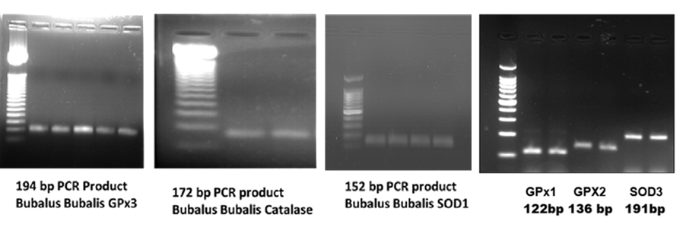
Table 3: Gene expression Mean fold (2^-ΔΔct) change and Log2 fold change of target antioxidant genes in various groups relative to non-lactating pandharpuri buffalo
Gene | Group | Mean dCt | Mean FC | SEM (FC) | Mean Log2FC | SEM (Log) | P value
Catalase | 1) Non Lactating Pandharpuri buffalo | -2.055 | 1.0000ª | 0.3050 | -0.0000 | 0.3893 | 0.0494
Catalase | 2) Early lactation | -3.568 | 2.8547 ^{c} | 0.7503 | 1.5133 | 0.2740 | 0.0494
Catalase | 3) Mid Lactation | -2.837 | 1.719 ^{b} | 0.4114 | 0.7817 | 0.3226 | 0.0494
Catalase | 4) Late Lactation | -2.208 | 1.1121ª | 0.3380 | 0.1533 | 0.4614 | 0.0494
SOD1 | 1) Non Lactating Pandharpuri buffalo | -3.753 | 1.0000 ª | 0.4258 | -0.0000 | 0.4680 | 0.001
SOD1 | 2) Early lactation | -3.987 | 1.1755 ª | 0.1927 | 0.2333 | 0.2318 | 0.001
SOD1 | 3) Mid Lactation | -4.928 | 2.2579 ^{b} | 0.4222 | 1.1750 | 0.2551 | 0.001
SOD1 | 4) Late Lactation | -5.952 | 4.5895 ^{c} | 1.0367 | 2.1983 | 0.2750 | 0.001
SOD2 | 1) Non Lactating Pandharpuri buffalo | -3.810 | 1.0000 ª | 0.2159 | -0.0000 | 0.4412 | 0.0043
SOD2 | 2) Early lactation | -5.725 | 3.7711 ^{d} | 0.6929 | 1.9150 | 0.2416 | 0.0043
SOD2 | 3) Mid Lactation | -5.105 | 2.4538 ^{c} | 0.5968 | 1.2950 | 0.3097 | 0.0043
SOD2 | 4) Late Lactation | -4.442 | 1.5494 ^{b} | 0.2004 | 0.6317 | 0.1710 | 0.0043
SOD3 | 1) Non Lactating Pandharpuri buffalo | -4.485 | 1.0000 ª | 0.2196 | -0.0000 | 0.2589 | 0.314
SOD3 | 2) Early lactation | -5.722 | 2.3565 ª | 2.1206 | 1.2367 | 0.8531 | 0.314
SOD3 | 3) Mid Lactation | -6.170 | 3.2154 ª | 1.0568 | 1.6850 | 0.5496 | 0.314
SOD3 | 4) Late Lactation | -5.653 | 2.2475 ª | 1.7833 | 1.1683 | 0.5178 | 0.314
GPX1 | 1) Non Lactating Pandharpuri buffalo | -3.448 | 1.0000 ª | 0.4486 | -0.0000 | 0.4148 | 0.0048
GPX1 | 2) Early lactation | -6.392 | 7.6919 ^{d} | 2.5468 | 2.9433 | 0.3701 | 0.0048
GPX1 | 3) Mid Lactation | -6.017 | 5.9312 ^{c} | 0.8115 | 2.5683 | 0.2222 | 0.0048
GPX1 | 4) Late Lactation | -4.302 | 1.8067 ^{b} | 0.6327 | 0.8533 | 0.4523 | 0.0048
GPX2 | 1) Non Lactating Pandharpuri buffalo | -1.965 | 1.0000 ª | 0.5340 | -0.0000 | 0.4828 | 0.5497
GPX2 | 2) Early lactation | -2.122 | 1.1147 ª | 1.2945 | 0.1567 | 0.8288 | 0.5497
GPX2 | 3) Mid Lactation | -2.517 | 1.4658 ª | 0.7230 | 0.5517 | 0.5114 | 0.5497
GPX2 | 4) Late Lactation | -1.232 | 0.6015 ª | 0.2248 | -0.7333 | 0.3860 | 0.5497
GPX3 | 1) Non Lactating Pandharpuri buffalo | -2.915 | 1.0000 ª | 0.5760 | -0.0000 | 0.8841 | 0.5859
GPX3 | 2) Early lactation | -3.793 | 1.8383 ª | 1.5337 | 0.8783 | 0.8308 | 0.5859
GPX3 | 3) Mid Lactation | -2.493 | 0.7466 ª | 0.4550 | -0.4217 | 0.6086 | 0.5859
GPX3 | 4) Late Lactation | -2.398 | 0.6990 ª | 0.2037 | -0.5167 | 0.4483 | 0.5859

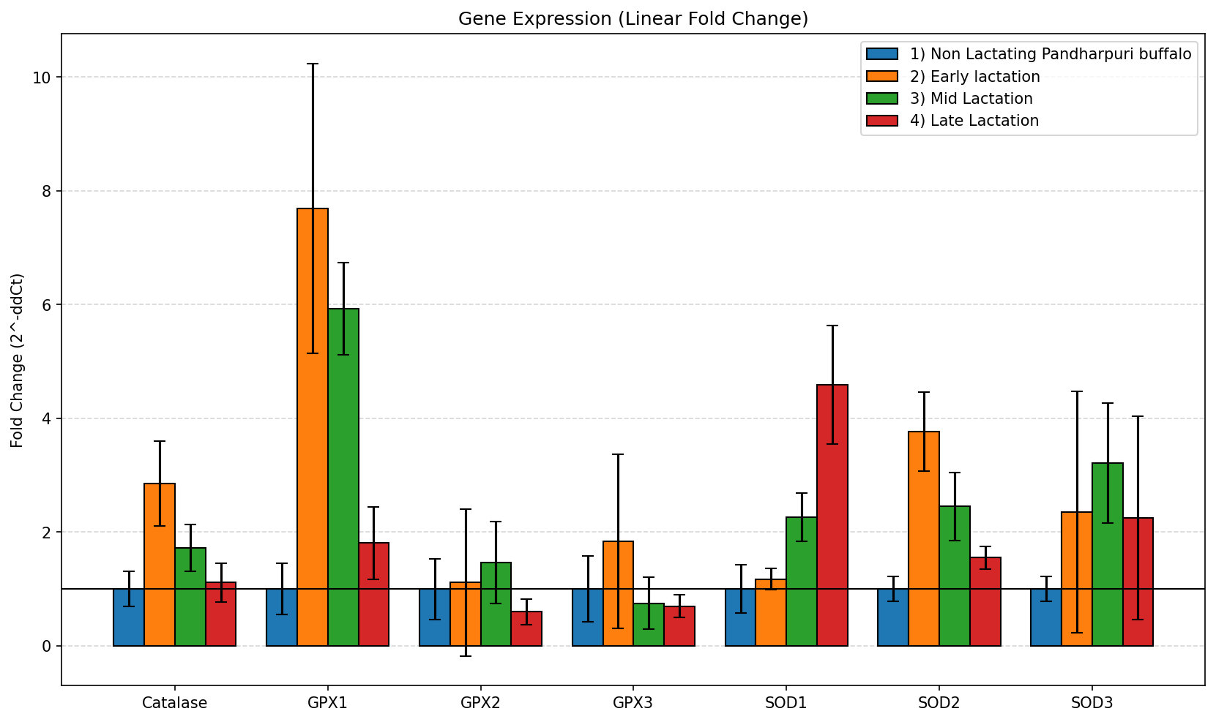
Fig 2: Relative expression of antioxidant genes expressed as linear fold change (2⁻ΔΔCt) during non-lactating, early, mid and late lactation stages in Pandharpuri buffaloes.

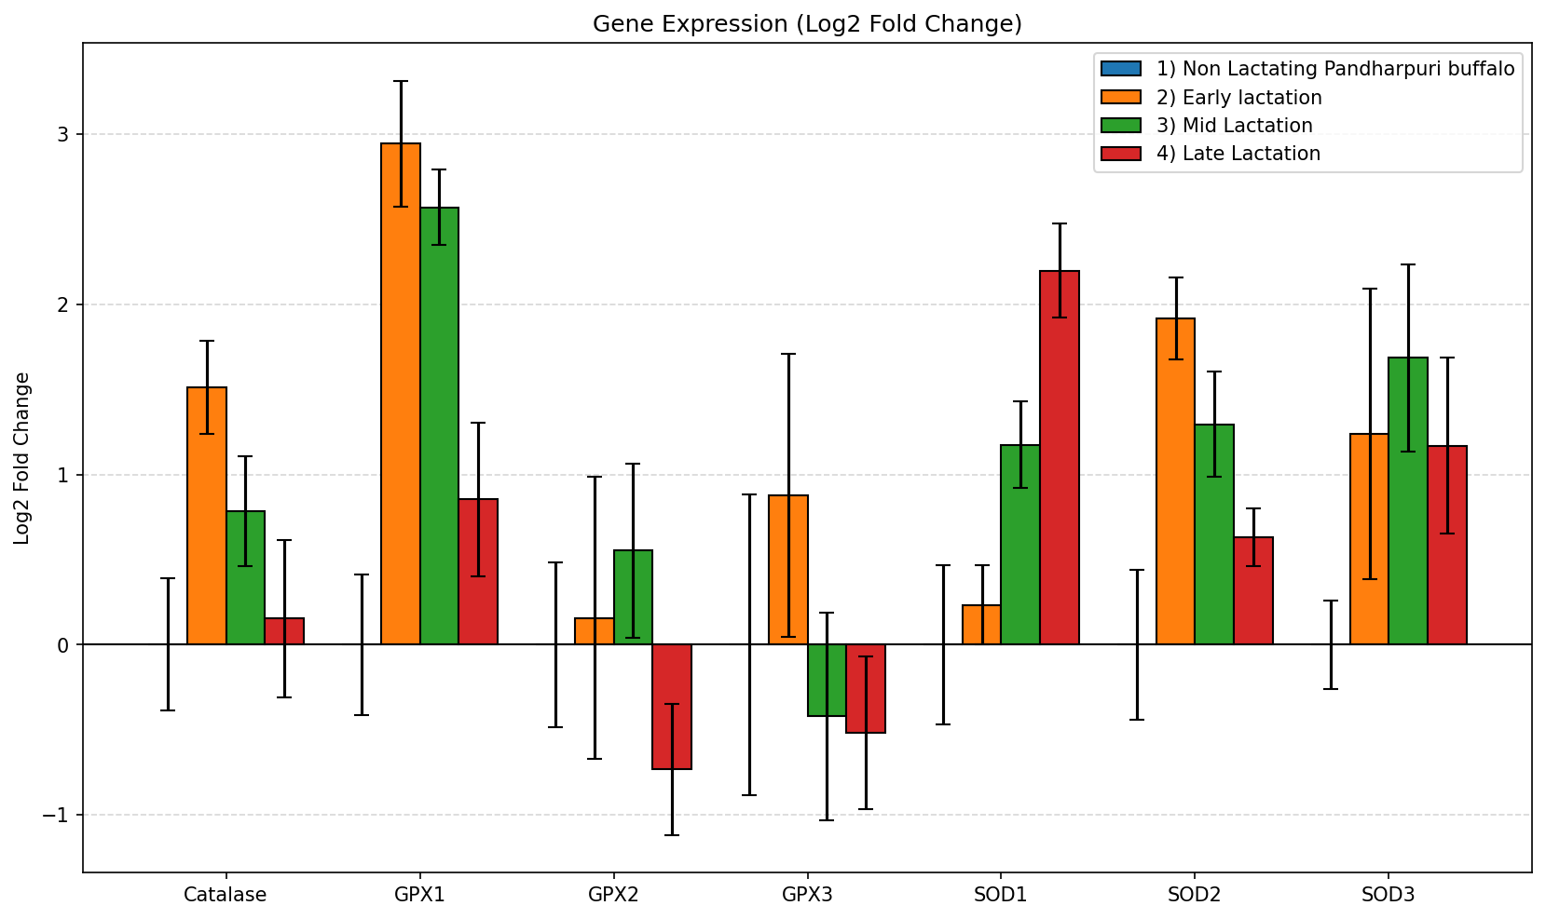
Fig 3: Relative expression of antioxidant genes expressed as log₂ fold change during non-lactating, early, mid and late lactation stages in Pandharpuri buffaloes.

This study evaluates the expression patterns of major antioxidant enzyme genes, viz. Catalase, Superoxide Dismutases (SOD1, SOD2, SOD3), and Glutathione Peroxidases (GPX1, GPX2, GPX3), in Pandharpuri buffaloes across different physiological stages. Using Non-Lactating buffaloes as the control baseline (Fold Change = 1.00), gene expression was quantified during Early, Mid, and Late lactation phases to understand cellular oxidative stress responses during milk production. Several key antioxidant genes show a sharp, dramatic upregulation immediately at the onset of lactation: GPX1 exhibits the highest overall induction in the study, increasing to a 7.69-fold level in early lactation before gradually declining. GPX1 (Cytoplasmic Glutathione Peroxidase) exhibits the most robust induction in the entire study, increasing to a 7.69-fold level during early lactation. This massive surge aligns with findings by Kour et al. (2024), who monitored transition-period buffaloes and established that dairy animals experience peak systemic oxidative stress immediately postpartum due to negative energy balance. The dry (non-lactating) phase involves pregnancy-related changes, while the initiation of lactation and tissue repair triggers a substantial surge in metabolic demand. After calving, a buffalo's milk production increases rapidly while her feed intake is limited. This deficit forces her body to break down body fat (lipolysis), a highly metabolic process that releases massive amounts of free radicals. Clinical studies show that crucial oxidative stress indicators, such as malondialdehyde (MDA), are significantly higher during the early postpartum lactation stage compared with the stable dry period.
Schogor et al. (2013) similarly noted that cellular glutathione peroxidases serve as a primary frontline defence in mammary tissues, rapidly clearing peroxides to preserve cellular membrane integrity during peak metabolic throughput. SOD2 (Mitochondrial) reaches its peak expression early on (3.77-fold). Because early lactation demands a massive metabolic surge in mammary tissue mitochondria, this upregulation is likely a defence mechanism against a spike in superoxide radicals. Catalase gene expression was found to follow a similar pattern, peaking early at 2.85-fold to neutralise hydrogen peroxide before tapering back towards baseline levels by late lactation. It parallels this early protective response, peaking at 2.85-fold. This directly complements the SOD2 elevation; as SOD2 converts superoxides into H2O2, Catalase acts downstream to rapidly cleave H2O2 into water and oxygen. This synchronised upregulation of CAT and SOD during early lactation validates the findings of Tufarelli et al. (2023), who documented that high-yielding dairy animals experience a significant elevation in core antioxidant enzyme activities immediately following parturition to mitigate tissue damage from elevated respiratory rates.
Interestingly, Cytoplasmic SOD1 expression increases progressively as lactation advances, reaching its maximum in late lactation (4.59-fold). Extracellular SOD3 peaks during mid-lactation (3.22-fold) and remains elevated. This suggests a transition from acute, organelle-specific stress management to long-term, systemic cytoplasmic and extracellular defence. Unlike mitochondrial SOD2 (which steadily declines after early lactation), SOD1 (Cytoplasmic) increases progressively over time, reaching its maximum during late lactation at 4.59-fold. Concurrently, SOD3 peaks during mid-lactation at 3.22-fold and remains highly elevated into late lactation (2.25-fold). While acute mitochondrial stress stabilises, systemic cytoplasmic and extracellular fluid oxidative stress continues to accumulate across the entire lactation cycle. This linear accumulation of SOD1 and SOD3 tracks with observations by Tufarelli et al. (2023), who reported that chronic, lactation-driven oxidative stress accumulates in tissues over time, requiring sustained, long-term systemic enzymatic upregulation even as daily milk volumes begin to taper. GPX2 displays a modest, delayed upregulation, peaking in mid-lactation (1.47-fold) before dropping below baseline in late lactation. Unlike its counterparts, GPX3 shows minimal changes. It peaks lightly in early lactation (1.84-fold) but undergoes distinct downregulation during mid-lactation (0.75-fold) and late lactation (0.70-fold), as evidenced by the negative Log2 Fold Change values. This suggests that plasma/extracellular glutathione peroxidase may play a less critical role or may be actively suppressed in later stages of lactation. These findings are strongly supported by transition-period ruminant health studies (Kour et al., 2024; Tufarelli et al., 2023).
The onset of lactation marks the most volatile stage for antioxidant gene regulation. At parturition and during early lactation, the dramatic escalation in milk production drives a steep increase in metabolic rate, leading to elevated concentrations of Malondialdehyde (MDA), a key biomarker of lipid peroxidation. Concurrently, serum values and PBMC mRNA expression levels of SOD2, CAT, and GPX1 typically experience a noticeable decline after early lactation. This downregulation points to an overarching systemic exhaustion of the antioxidant defence system, as the high rate of free radical generation outpaces the cell's transcriptional machinery. In Pandharpuri buffaloes, this stress is compounded by the animal’s unique physiological adaptation for intermittent milking, which demands rapid structural remodelling of mammary tissue and puts additional stress on circulating leucocytes.
As the buffalo transitions into mid-lactation, where the lactational load is higher, dry matter intake rises to match the energy demands of milk production, resolving the negative energy balance. During this stage, early-phase antioxidant mRNA expression of CAT, GPX1, and SOD2 begins to decline, while the mRNA expression of SOD1, SOD3, and GPx2 in PBMCs exhibits a significant, compensatory upregulation. This transcriptional rebound reflects the stabilisation of the animal's metabolic state, allowing its cellular machinery to restore homeostatic balance and build up defences against ongoing oxidative stress.
In the final stages of lactation, the expression patterns of antioxidant genes diverge from those seen in earlier phases. The expression of SOD2 and GPX1 often remains elevated or stabilises to protect PBMCs from the inflammatory signalling cascades that accompany mammary gland involution and the initial stages of the next pregnancy cycle. A similar pattern of antioxidant-marker variation across physiological stages was observed by El-Sayed et al. (2024) in ewes.
This study was conducted exclusively to understand the antioxidant pathway governing the lactational response. Further large-scale study is required using cross-sectional grouping and longitudinal sampling. Additional gene expression data can be correlated with oxidative stress markers to understand the actual effect of variability in gene expression.
Conclusion
The data highlight a highly coordinated, stage-specific antioxidant response in Pandharpuri buffaloes. The massive initial surge in GPX1, SOD2, and Catalase indicates that early lactation is the most oxidatively challenging phase for the animal. Conversely, the steady rise of SOD1 suggests that the physiological burden shifts but persists heavily into late lactation. The qPCR data map a highly coordinated, stage-specific antioxidant response in Pandharpuri buffaloes. The sharp early spikes in GPX1, SOD2, and Catalase validate the early-lactation antioxidant response. Meanwhile, the linear accumulation of SOD1 reveals a lingering metabolic toll that persists into late lactation. This metabolic profile can be utilised to optimise nutritional and management strategies to alleviate oxidative stress in lactating dairy buffaloes. This collaborative profile suggests that antioxidant interventions (such as dietary supplementation with Vitamin E, Selenium, or plant-derived polyphenols) are most critical during the transition to early lactation to cushion the acute GPX1/SOD2 spike, but should be sustained structurally to support the animal's ongoing cytoplasmic defence (SOD1) in later stages. Developing stage-specific nutritional strategies (such as strategic antioxidant and trace mineral supplementation) can support the animal's native antioxidant expression during peak lactation.

Limitations

This cross-sectional study included 32 Pandharpuri buffaloes, with eight animals representing each lactation-stage group. Because separate groups were assessed at the different stages, the design did not follow within-animal changes across the lactation cycle. The analysis was limited to PBMC transcript abundance and did not include concurrent biochemical oxidative-stress markers; therefore, gene-expression changes should not be interpreted as direct measurements of oxidative damage or antioxidant enzyme activity. Larger longitudinal studies integrating transcriptomic and biochemical measurements would strengthen stage-specific interpretation.

Ethical approval
Necessary approval from institutional animal ethics committee was obtained (IAEC/17/23/KNPCVS/2024).

Declaration of AI Use
This manuscript was prepared through the intellectual contributions of the author(s) to the study design, data analysis, interpretation of results, and scholarly content. Grammarly and ChatGPT were used solely to assist with grammatical refinement and reference formatting during manuscript revision. The author(s) accept full responsibility for the accuracy, integrity, and final content of the manuscript.

10. References
Abuelo, A. (2025). ADSA Foundation Scholar Award: Shakin' off the rust—Oxidative stress and redox status as underlying factors of immune dysfunction in periparturient cows and preweaning calves. Journal of Dairy Science, 108(8), 7861–7875. https://doi.org/10.3168/jds.2025-26707
Arora, R., Sharma, A., Sharma, U., Girdhar, Y., Kaur, M., Kapoor, P., Ahlawat, S., & Vijh, R. K. (2019). Buffalo milk transcriptome: A comparative analysis of early, mid and late lactation. Scientific Reports, 9(1), 5993. https://doi.org/10.1038/s41598-019-42513-2
Cánovas, A., Rincón, G., Bevilacqua, C., Islas-Trejo, A., Brenaut, P., Hovey, R. C., Boutinaud, M., Morgenthaler, C., VanKlompenberg, M. K., Martin, P., & Medrano, J. F. (2014). Comparison of five different RNA sources to examine the lactating bovine mammary gland transcriptome using RNA-sequencing. Scientific Reports, 4, 5297. https://doi.org/10.1038/srep05297
Deepak, D., De, U. K., Sarkar, T. K., Katoch, S., John, J. K., & Sarkar, V. K. (2024). Strategic administration of antioxidant multiminerals and vitamins to transitional buffaloes augments antioxidant and udder defense mechanisms in early lactation. Research in Veterinary Science, 172, 105253. https://doi.org/10.1016/j.rvsc.2024.105253
El-Sayed, A. A., Sallam, A. M., & Abou-Soliman, I. (2024). Metabolic profile and gene expression pattern of cytokines and antioxidants markers during different physiological stages in Barki ewes. BMC Veterinary Research, 20(1), 206. https://doi.org/10.1186/s12917-024-04018-7
Evangelista, C., Bernabucci, U., & Basiricò, L. (2022). Effect of antioxidant supplementation on milk yield and quality in Italian Mediterranean lactating buffaloes. Animals, 12(15), 1903. https://doi.org/10.3390/ani12151903
Gangu Naidu, S., Padmaja, K., Jayasri, K., Prasad Rao, T., & Pooja, C. (2025). Comparative nutritional and antioxidant quality of milk from indigenous cattle and buffalo breeds in India. Journal of Advances in Biology & Biotechnology, 28(12), 665–671. https://doi.org/10.9734/jabb/2025/v28i123414
Jemima, G., Susmitha, Ch., Vamsi, Y., Charumathi, K., Srikanth, N. R., Mutha Rao, M., & Sunny Praveen, K. (2026). Oxidative stress and antioxidant defense mechanisms in transition dairy cows: An updated review. Asian Journal of Current Research, 11(3), 427–453. https://doi.org/10.56557/ajocr/2026/v11i310990
Keller, M., Manzocchi, E., Rentsch, D., Lugarà, R., & Giller, K. (2021). Antioxidant and inflammatory gene expression profiles of bovine peripheral blood mononuclear cells in response to Arthrospira platensis before and after LPS challenge. Antioxidants, 10(5), 814. https://doi.org/10.3390/antiox10050814
Kittur, P. M., Satheesan, L., Gunturu, N. T., Somagond, Y. M., Madhusoodan, A. P., Gandham, R. K., Alex, R., & Dang, A. K. (2025). Proteomic analysis of buffalo milk somatic cells reveals metabolomic and immunological transitions during early lactation. Scientific Reports, 15, 22704. https://doi.org/10.1038/s41598-025-08433-0
Kour, S., Sharma, N., Guttula, P. K., Gupta, M. K., dos Santos, M. V., Bacic, G., Macesic, N., Pathak, A. K., & Son, Y.-O. (2024). Identification and validation of putative biomarkers by in silico analysis, mRNA expression and oxidative stress indicators for negative energy balance in buffaloes during transition period. Animal Bioscience, 37(3), 522–535. https://doi.org/10.5713/ab.23.0284
Livak, K. J., & Schmittgen, T. D. (2001). Analysis of relative gene expression data using real-time quantitative PCR and the 2−ΔΔCT method. Methods, 25(4), 402–408. https://doi.org/10.1006/meth.2001.1262
Patil, A., Gaur, P., Pal, P., Alex, R., Chhotaray, S., Gandham, R. K., & Vohra, V. (2026). Genome-wide insights into intermittent milking behavior of Pandharpuri buffalo. Current Issues in Molecular Biology, 48(1), 101. https://doi.org/10.3390/cimb48010101
Schogor, A. L. B., Palin, M.-F., dos Santos, G. T., Benchaar, C., Lacasse, P., & Petit, H. V. (2013). Mammary gene expression and activity of antioxidant enzymes and oxidative indicators in the blood, milk, mammary tissue and ruminal fluid of dairy cows fed flax meal. British Journal of Nutrition, 110(10), 1743–1750. https://doi.org/10.1017/S0007114513001220
Sikka, P., Singh, K. P., Singh, I., Mishra, D. C., Paul, S. S., Balhara, A. K., Andonissamy, J., Chaturvedi, K. K., Rao, A. R., & Rai, A. (2023). Whole blood transcriptome analysis of lactating Murrah buffaloes divergent to contrasting genetic merits for milk yield. Frontiers in Animal Science, 4, 1135429. https://doi.org/10.3389/fanim.2023.1135429
Song, X., Wang, D., Luo, X., Qin, C., Li, L., Yang, Y., Pi, Y., Deng, Y., Cui, K., Li, Z., Xu, W., & Liu, Q. (2026). A multi-tissue transcriptomic atlas of river buffalo with a focus on the genetic underpinnings of lactation performance across four lactation stages in the mammary gland. International Journal of Molecular Sciences, 27(9), 4032. https://doi.org/10.3390/ijms27094032
Tufarelli, V., Colonna, M. A., Losacco, C., & Puvača, N. (2023). Biological health markers associated with oxidative stress in dairy cows during lactation period. Metabolites, 13(3), 405. https://doi.org/10.3390/metabo13030405

