First Record of Lepas (Lepas) indica Annandale, 1909 (Cirripedia: Lepadidae) from the West Coast of India, with a Taxonomic Key to the Indian Species of the Genus Lepas

Abstract
This study documents Lepas (Lepas) indica Annandale, 1909 (Cirripedia: Lepadidae), a pelagic stalked barnacle species, collected from a single piece of driftwood washed ashore at Karwar, Uttara Kannada District, Karnataka, India (14.8311° N, 74.1250° E) on 1st September 2025. Sixty-eight specimens, deposited in the Crustacea Division of the Zoological Survey of India (registration no. CR878), were examined morphologically. Identification is supported by the laterally compressed subtriangular capitulum, strongly arched carinal margin bearing two or more prominent sinuous projections, quadrilateral scutum with an internal tooth on the left scutum and external basal ridges, lateral appendages, and mouthpart morphology. Published material-based records from India, cited in the taxonomic literature, are from Odisha and Tamil Nadu on the east coast. The present study material therefore represents the first documented occurrence of the species on the Indian west coast. A concise diagnosis, distributional account, and key to the four Indian species of Lepas are provided in the present study.
Keywords: barnacle; Lepadidae; distribution record; stranded driftwood; Karnataka; West Coast; taxonomic key.

Introduction
The genus Lepas Linnaeus, 1758 (Cirripedia: Lepadidae) comprises a group of pelagic stalked barnacles commonly known as goose barnacles. These are widely distributed in tropical and temperate marine waters. They attach to natural and anthropogenic floating substrates, including driftwood, marine debris, and even other marine fauna, and rafting can facilitate dispersal over substantial distances (Gil & Pfaller, 2016; Schiffer & Herbig, 2016). This association with mobile substrates contributes to broad geographic distributions, but it cannot by itself be interpreted as evidence of local establishment or attachment origin.
In the modern higher-level classification of barnacles, Lepas is placed within Lepadidae, Lepadoidea, and Scalpellomorpha (Chan et al., 2021), with 15 valid species recognised in the genus by WoRMS (2026). Four species are documented from Indian waters: Lepas (Lepas) anatifera Linnaeus, 1758, Lepas (Lepas) anserifera Linnaeus, 1767, Lepas (Lepas) pectinata Spengler, 1793, and Lepas (Lepas) indica Annandale, 1909 (Trivedi, Patel, et al., 2021; Valarmathi, 2025). Lepas indica was originally described as Lepas anatifera indica by Annandale (1909) from off the Ganjam coast, Odisha, and was subsequently recorded from the Madras (present-day Chennai) coast by Daniel (1956). Apart from these records, there is no other record of this species from India.
Outside India, Lepas (Lepas) indica Annandale, 1909 has been reported from the Mozambique Channel adjacent to Madagascar and from the South China and East China seas (Jones & Hosie, 2016; Liu & Ren, 2007; Ren, 1989). The taxonomically validated Indian barnacle records compiled by Trivedi, Patel, et al. (2021) also retain the record of Lepas (Lepas) indica Annandale, 1909 and identify its Indian type locality on the east coast. There is no published source identifying a material-based west-coast record of this species prior to the Karwar collection.
The objectives of the present study are to document the species from the west coast of India, provide an updated morphological diagnosis and differential diagnosis, summarise the documented Indian and global distribution of Lepas indica, and present a practical key to the four Lepas species reported from Indian waters.

Materials and Methods
During a coastal field survey at Karwar, Karnataka, a piece of driftwood bearing stalked barnacles was found washed ashore. The attached barnacles were examined and carefully detached using forceps and a scalpel to minimise damage to the capitular plates and soft body parts. The fresh material was photographed using a Nikon P900 camera and subsequently preserved in 70% ethanol. In the laboratory, the specimens were examined under a Leica EZ4 stereo-zoom binocular microscope for qualitative morphological identification.
Taxonomic assessment was based on capitular shape and plates, the carinal margin, scutum, tergum and carina, peduncle, cirri, lateral appendages, and mouthparts, and was conducted by comparison with the original description and relevant modern accounts (Annandale, 1909; Trivedi, Doshi, et al., 2021; Trivedi, Patel, et al., 2021). The examined material is deposited in the Crustacea Division, Zoological Survey of India, Kolkata, under registration no. CR878.
For the distributional statement, the Indian record was cross-checked against the primary historical records cited herein and the taxonomically validated Indian records of Trivedi, Patel, et al. (2021), together with relevant modern taxonomic literature. No earlier material-based west-coast Indian record of Lepas (Lepas) indica Annandale, 1909 was identified in these published sources.

Results

Taxonomy
Classification follows Chan et al. (2021).
Order: Scalpellomorpha Buckeridge & Newman, 2006
Superfamily: Lepadoidea Chan, Dreyer, Gale, Glenner, Ewers-Saucedo, Pérez-Losada, Kolbasov, Crandall & Høeg, 2021
Family: Lepadidae Darwin, 1852
Genus: Lepas Linnaeus, 1758
Lepas (Lepas) indica Annandale, 1909
Type locality: Off the Ganjam coast, Odisha (then Orissa), India (Annandale, 1909; Trivedi, Patel, et al., 2021).
Material examined: 68 specimens from one piece of stranded driftwood, Karwar, Uttara Kannada District, Karnataka, India, 14.8311° N, 74.1250° E; collected by S. Mitra and Md. Shahbaz on 1st September 2025; deposited in Crustacea Division, Zoological Survey of India, registration no. CR878.
Diagnosis: Capitulum laterally compressed and subtriangular, with a truncate apex (Fig. 3A, B). Carinal margin strongly arched, bearing two or more prominent sinuous projections (Fig. 3D). Valves thick and white, covered by a thin membrane and separated by reddish to dark purplish membranous tissue. The tergal occludent margin is straight, terminating in a tooth-like projection at the junction with the scutal margin; radiating ridges are prominent. The scutum is quadrilateral, with a slightly convex base and a nearly smooth surface; an internal tooth is present on the left scutum, and an external basal ridge is present on both scuta (Fig. 3C). The carina is narrow, with parallel tooth-like or pectinate projections (Fig. 3D). The peduncle is shorter than the capitulum. Six pairs of elongate cirri are present; the articles bear clusters of short, soft setae, and colour in life ranges from dark purple to brown and yellow (Fig. 3E). Cirri I and II are not distinctly spaced (Fig. 3F). Two lateral appendages are present on each side, one on the prosoma and one at the base of cirrus I; the appendage at the base of cirrus I is longer. The penis is shorter than cirrus VI, slender, and densely setose. The labrum is distinct. The maxilla has a notch near the upper margin (Fig. 3G). The mandible is slender, with six teeth including the inner angle, stout setae along the lower margin, and finer setae along the upper margin (Fig. 3H). The combination of the strongly arched, conspicuously sinuous carinal margin and the scutal and appendage characters is consistent with the original diagnosis of the taxon (Annandale, 1909).
Differential diagnosis: Among the four Lepas species recorded from India, Lepas (Lepas) indica Annandale, 1909 is most readily separated by the strongly arched carinal margin bearing conspicuous sinuous or pectinate projections. Lepas (Lepas) anatifera Linnaeus, 1758 has five comparatively smooth, thin capitular plates and a generally smooth carina, whereas Lepas (Lepas) anserifera Linnaeus, 1767 has distinctly striated plates and a strongly convex or protuberant scutal occludent margin (Sundara Raj, 1927; Trivedi, Doshi, et al., 2021). Lepas (Lepas) pectinata Spengler, 1793 also has conspicuous radial sculpture, but differs from Lepas (Lepas) indica Annandale, 1909 in lacking the characteristic series of prominent sinuous carinal-margin projections; the tergum is characteristically notched near the scutal margin in the diagnostic scheme used below. These features provide a practical external separation of Lepas (Lepas) indica Annandale, 1909 from the other Indian congeners.
Colour in life: Shells predominantly off-white to cream, with bright red to yellow semicircular bands extending from the carinal side towards the opposite margin (Fig. 2). Some individuals show dark brown to black areas. The peduncle is dark brown.
Distribution in India: Karnataka, west coast (present study; Fig. 1); Odisha and Tamil Nadu, east coast (Annandale, 1909; Daniel, 1956; Trivedi, Patel, et al., 2021).
Global distribution: India; Mozambique Channel adjacent to Madagascar (Ren, 1989); South China Sea and East China Sea/China (Jones & Hosie, 2016; Liu & Ren, 2007; Trivedi, Patel, et al., 2021).

Discussion
Four species of Lepas are documented from Indian waters: Lepas (Lepas) anatifera Linnaeus, 1758, Lepas (Lepas) anserifera Linnaeus, 1767, Lepas (Lepas) pectinata Spengler, 1793, and Lepas (Lepas) indica Annandale, 1909. Lepas (Lepas) anatifera Linnaeus, 1758 has been reported from both the western and eastern sectors of India, including Gujarat, Tamil Nadu, Odisha, West Bengal, and the Andaman and Nicobar Islands (Annandale, 1909; Daniel, 1956; Krishnamoorthy, 2007; Nilsson-Cantell, 1938; Ramakrishna et al., 2003; Trivedi, Doshi, et al., 2021). Lepas (Lepas) anserifera Linnaeus, 1767 has likewise been reported from Gujarat on the west coast and from Tamil Nadu, Odisha, the Godavari Delta, and the Andaman and Nicobar Islands on the eastern side of the country (Krishnamoorthy, 2007; Nilsson-Cantell, 1938; Parmar et al., 2018; Sundara Raj, 1927; Trivedi, Doshi, et al., 2021). Lepas (Lepas) pectinata Spengler, 1793 has a more restricted published Indian record, including Tamil Nadu and the Andaman Islands (Daniel, 1956; Nilsson-Cantell, 1938).
The present collection adds a documented west-coast Indian occurrence of Lepas (Lepas) indica Annandale, 1909 to the previously published Indian records from Odisha and Tamil Nadu. The 68 specimens provide substantial material for morphological assessment, but they all originated from one piece of stranded driftwood and therefore constitute a single faunistic occurrence. Accordingly, the present record should not be interpreted as evidence of a resident breeding population at Karwar, as proof of the location at which the barnacles initially settled, or as multiple independent geographic observations.
Rafting nevertheless provides a biologically plausible explanation for the arrival of Lepas on stranded floating material. Oceanic Lepas commonly colonise mobile natural and artificial substrates, and studies of barnacle assemblages on floating debris demonstrate that such substrata can mediate long-distance transport (Bérgamo et al., 2023; Gil & Pfaller, 2016). The present driftwood-associated occurrence is compatible with this broader dispersal mechanism. However, because the origin and trajectory of the driftwood were not determined, no specific transport pathway between the Bay of Bengal and the Arabian Sea can be inferred from the present material. However, because the previously recorded and present occurrence regions are separated by a considerable coastal distance, the present occurrence could also represent part of a population occurring in the nearby vicinity.
Lepas (Lepas) indica Annandale, 1909 remains infrequently represented in the published Indian literature. Morphological similarity and intraspecific variability within Lepas can complicate identification, while molecular work has demonstrated previously unrecognised diversity within the widespread genus Lepas (Schiffer & Herbig, 2016). In the present specimens, the conspicuously sinuous carinal margin, together with the scutal, appendage, and mouthpart characters, provides the principal morphological basis for identification. Future targeted coastal surveys, explicit documentation of raft substrates, and integration of morphology with molecular sequence data would help determine whether Lepas (Lepas) indica Annandale, 1909 is regularly present along the west coast and clarify its dispersal history.

Key to the Indian Species of Lepas
The following key synthesises diagnostic characters used in Annandale (1909), Sundara Raj (1927), Chan et al. (2021), Trivedi, Doshi, et al. (2021), and the present material.
1a. Carinal margin strongly arched, bearing two or more prominent sinuous or pectinate projections - Lepas (Lepas) indica Annandale, 1909.
1b. Carinal margin without prominent sinuous projections - go to 2.
2a. Capitular plates smooth or with only weak radial striation; carina generally smooth or only weakly barbed - Lepas (Lepas) anatifera Linnaeus, 1758.
2b. Capitular plates with clear radial striation or furrowing - go to 3.
3a. Tergum with a notch on the scutal margin near the occludent angle; scutal occludent margin slightly to evenly convex - Lepas (Lepas) pectinata Spengler, 1793.
3b. Tergum without a corresponding scutal-margin notch; scutal occludent margin strongly convex and protuberant - Lepas (Lepas) anserifera Linnaeus, 1767.

Conclusion
Specimens of Lepas (Lepas) indica Annandale, 1909 recovered from stranded driftwood at Karwar, Karnataka, represent the first documented occurrence on the west coast of India among the published material-based records verified for this study. The finding expands the documented Indian occurrence of the species from previously published east-coast records to Karnataka. The material does not establish local population persistence, the origin of attachment, or a specific east-to-west transport pathway, but the possibility of a local breeding population cannot be excluded because the previously recorded and present occurrence regions are separated by a considerable coastal distance. The revised diagnosis, differential diagnosis, and identification key provide practical morphological criteria for recognising Lepas (Lepas) indica Annandale, 1909 among Indian congeners. Continued coastal sampling, careful documentation of floating substrates, and molecular analyses are needed to assess the frequency, connectivity, and dispersal history of this rarely reported pelagic barnacle in Indian waters.

Acknowledgement
The authors express their sincere gratitude to Dr. Dhriti Banerjee, Director, Zoological Survey of India, Kolkata, for providing the essential research facilities necessary for carrying out the present study. The authors also extend their heartfelt thanks to Dr. K. Valarmathi, Scientist-E and Officer-in-Charge, Crustacea Section, ZSIK, for her support throughout the course of this work. The authors sincerely express their gratitude to Dr. Parangama Chowdhury, Assistant Professor, Salesian College, Siliguri, for preparing the map depicting the collection localities.

Declaration of AI Use
This manuscript was prepared through the intellectual contributions of the author(s) to the study design, data analysis, interpretation of results, and scholarly content. AI tools were used solely to assist with grammatical refinement and reference formatting during manuscript revision. The author(s) accept full responsibility for the accuracy, integrity, and final content of the manuscript.

Competing Interests
Authors have declared that no competing interests exist.

References
Annandale, N. (1909). An account of the Indian Cirripedia Pedunculata. Part I—Family Lepadidae (sensu stricto). Memoirs of the Indian Museum, 2(2), 61–137. https://zsi.gov.in/fauna-of-india-memories-articles?letter=A
Bérgamo, D. B., Craveiro, N., Magalhães, K. M., Yogui, G. T., Soares, M. O., Zanardi-Lamardo, E., Rojas, L. A. V., de Lima, M. C. S., & Rosa Filho, J. S. (2023). Tar balls as a floating substrate for long-distance species dispersal. Marine Pollution Bulletin, 196, 115654. https://doi.org/10.1016/j.marpolbul.2023.115654
Chan, B. K. K., Dreyer, N., Gale, A. S., Glenner, H., Ewers-Saucedo, C., Pérez-Losada, M., Kolbasov, G. A., Crandall, K. A., & Høeg, J. T. (2021). The evolutionary diversity of barnacles, with an updated classification of fossil and living forms. Zoological Journal of the Linnean Society, 193(3), 789–846. https://doi.org/10.1093/zoolinnean/zlaa160
Daniel, A. (1956). The Cirripedia of the Madras Coast. Bulletin of the Madras Government Museum, New Series, Natural History Section, 6(2), 1–40. https://tamildigitallibrary.in/Articles/நூல்-60890-The%20cirripedia%20of%20the%20Madras%20Coast-New%20series%20-%20Natural%20history%20section%2C%20Vol.6%2C%20No.%202
Gil, M. A., & Pfaller, J. B. (2016). Oceanic barnacles act as foundation species on plastic debris: Implications for marine dispersal. Scientific Reports, 6, 19987. https://doi.org/10.1038/srep19987
Jones, D. S., & Hosie, A. M. (2016). A checklist of the barnacles (Cirripedia: Thoracica) of Singapore and neighbouring waters. Raffles Bulletin of Zoology, Supplement 34, 241–311. https://lkcnhm.nus.edu.sg/app/uploads/2017/06/S34rbz241-311.pdf
Krishnamoorthy, P. (2007). Cirripedes. In K. Venkataraman, J. T. Jothinayagam, & P. Krishnamoorthy (Eds.), Fauna of Chennai Coast (Marine Ecosystem Series No. 1, pp. 57–60). Zoological Survey of India. https://www.zsi.gov.in/ecosystem-series-books
Liu, R. Y., & Ren, X. Q. (2007). Crustacea: Cirripedia: Thoracica (Fauna Sinica: Invertebrata, Vol. 42). Science Press.
Nilsson-Cantell, C. A. (1938). Cirripedes from the Indian Ocean in the collection of the Indian Museum, Calcutta. Memoirs of the Indian Museum, 13(1), 1–81.
Parmar, H. H., Joshi, D. M., Salvi, H., & Kamboj, R. D. (2018). Diversity and distribution of Cirripedia from Gujarat Coast, India. International Journal of Scientific Research in Biological Sciences, 5(5), 25–29. https://doi.org/10.26438/ijsrbs/v5i5.2529
Ramakrishna, Sarkar, J., & Talukdar, S. (2003). Marine invertebrates of Digha coast and some recommendations on their conservation. Records of the Zoological Survey of India, 101(3–4), 1–23. https://doi.org/10.26515/rzsi/v101/i3-4/2003/159540
Ren, X. (1989). On a collection of Cirripedia Thoracica from Madagascar and adjacent waters. Bulletin du Muséum National d’Histoire Naturelle, Section A, 11(2), 431–468. https://doi.org/10.5962/p.288299
Schiffer, P. H., & Herbig, H.-G. (2016). Endorsing Darwin: Global biogeography of the epipelagic goose barnacles Lepas spp. (Cirripedia, Lepadomorpha) proves cryptic speciation. Zoological Journal of the Linnean Society, 177(3), 507–525. https://doi.org/10.1111/zoj.12373
Sundara Raj, B. (1927). Cirripedia. In The littoral fauna of Krusadai Island in the Gulf of Mannar (pp. 111–116). Bulletin of the Madras Government Museum, New Series, Natural History Section, 1(1). https://govtmuseumchennai.org/uploads/topics/16528788856179.pdf
Trivedi, J. N., Doshi, M., Patel, K. J., & Chan, B. K. K. (2021). Diversity of intertidal, epibiotic, and fouling barnacles (Cirripedia, Thoracica) from Gujarat, northwest India. ZooKeys, 1026, 143–178. https://doi.org/10.3897/zookeys.1026.60733
Trivedi, J., Patel, K., Chan, B. K. K., Doshi, M., & Padate, V. (2021). Diversity of Indian barnacles in marine provinces and ecoregions of the Indian Ocean. Frontiers in Marine Science, 8, 657651. https://doi.org/10.3389/fmars.2021.657651
Valarmathi, K. (2025). Fauna of India checklist: Arthropoda: Crustacea: Thecostraca: Cirripedia (barnacles) (Version 2.0). Zoological Survey of India. https://doi.org/10.26515/Fauna/2/2025/Arthropoda:Crustacea:Crustacea:Thecostraca%20%28Barnacles%29
WoRMS. (2026). Lepas Linnaeus, 1758. World Register of Marine Species. Retrieved May 27, 2026, from https://www.marinespecies.org/aphia.php?p=taxdetails&id=106087

Figures
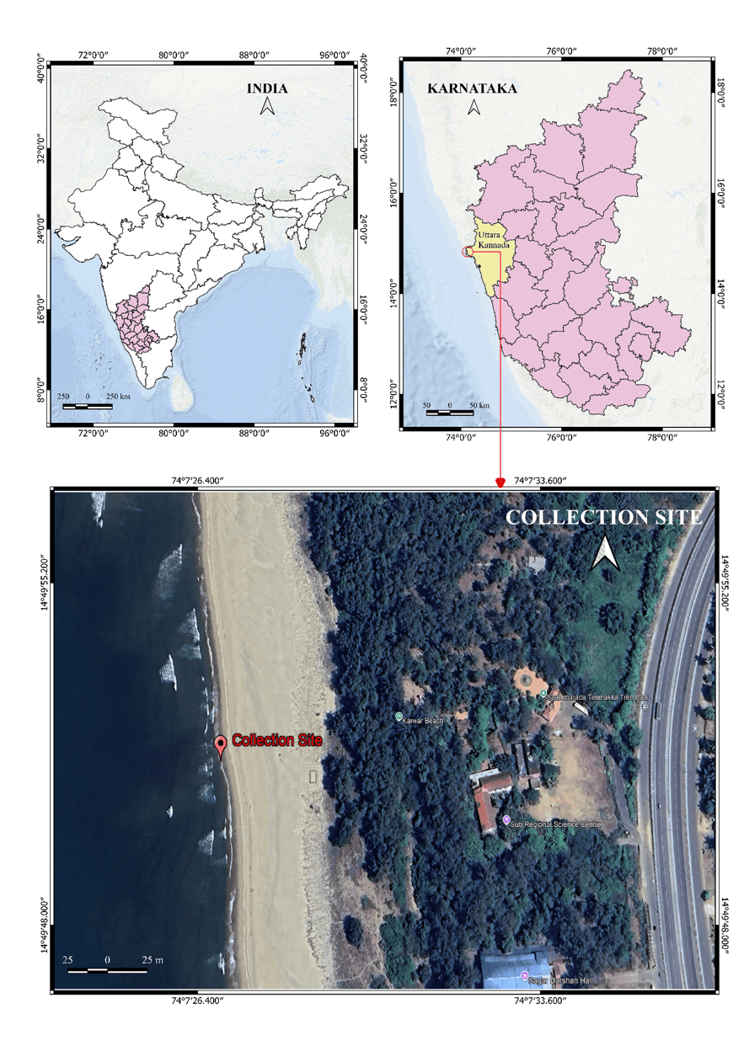
Figure 1. Collection locality of Lepas (Lepas) indica Annandale, 1909 at Karwar, Uttara Kannada District, Karnataka, India (14.8311° N, 74.1250° E).

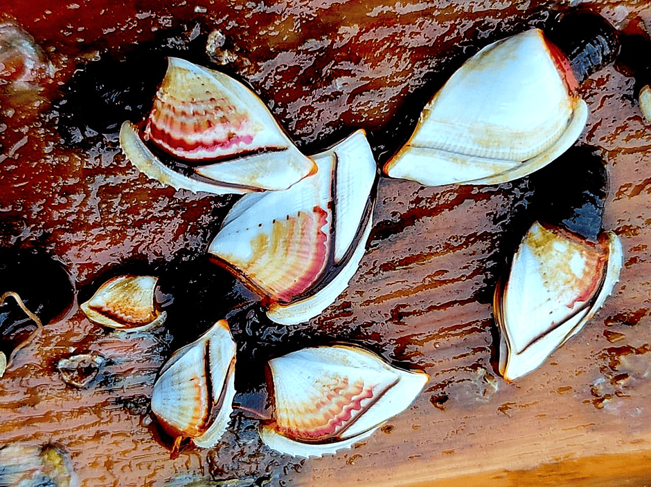
Figure 2. Freshly collected Lepas specimens illustrating the external contrast between Lepas (Lepas) indica Annandale, 1909, with a conspicuously spinous/sinuous carinal margin, and Lepas (Lepas) anatifera Linnaeus, 1758, with a comparatively smooth carinal margin.

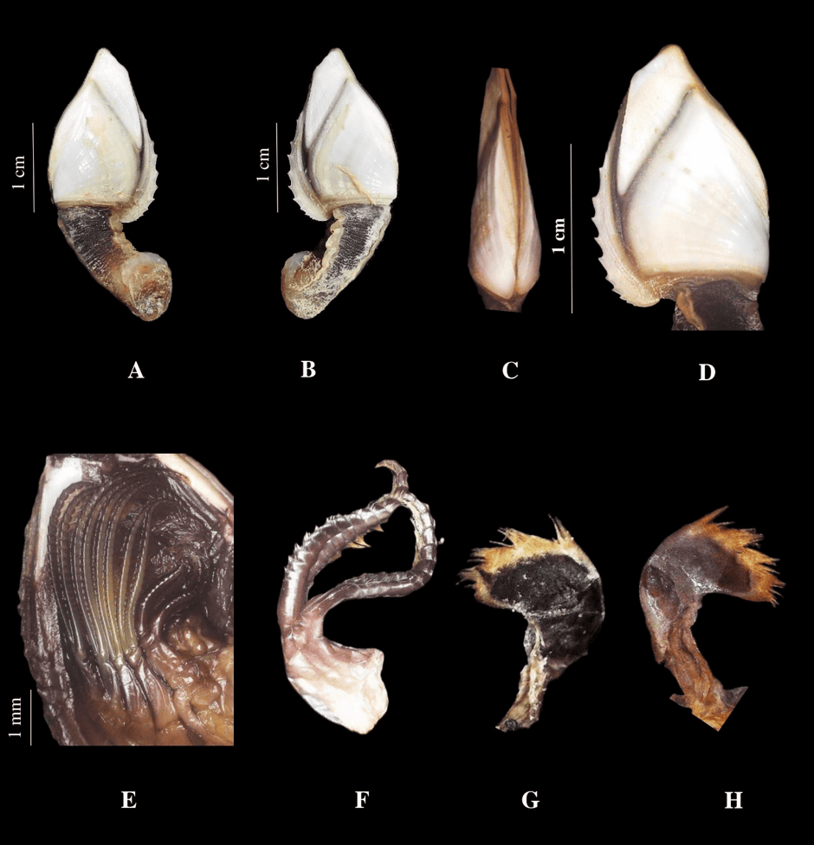
Figure 3. Lepas (Lepas) indica Annandale, 1909. A, overall left view; B, overall right view; C, ventral view after removal of the carina; D, enlarged carina showing the spinous/sinuous edge; E, cirri; F, enlarged first and second cirri; G, maxilla; H, mandible. Scale bars are as shown in the figure.

