Comparative Effects of Chronic Stevia, Saccharin, and Sucralose Consumption on Body Weight, Blood Glucose, Serum Cholesterol, and Histopathological Alterations in the Liver and Kidneys of Male Wistar Rats

Abstract
The increasing use of natural and artificial sweeteners has raised concerns about their metabolic and tissue-level effects during prolonged exposure. This study compared the effects of chronic Stevia, saccharin, and sucralose administration on body weight, blood glucose, serum cholesterol, and liver and kidney histopathology in male Wistar rats. Twenty adult male Wistar rats were randomly allocated to four groups (n = 5 per group): control, Stevia, saccharin, and sucralose. Treatments were administered orally once daily for eight weeks. Body weight was recorded during the experimental period, while blood glucose and serum cholesterol were measured at the specified assessment points. Liver and kidney tissues were examined histopathologically. Stevia- and saccharin-treated rats showed greater body weight gain than the sucralose-treated group (P < 0.05). Saccharin was associated with lower blood glucose and serum cholesterol concentrations by the end of the experiment, whereas the sucralose-treated group exhibited the highest final blood glucose level. Histopathological examination identified hepatic and renal alterations in the treated groups, including hepatocellular degeneration, fatty change, vascular congestion, tubular epithelial degeneration, haemorrhagic lesions, and inflammatory cell infiltration. Chronic exposure to the tested sweeteners was therefore associated with distinct metabolic responses and reported tissue alterations. These findings indicate that changes in biochemical parameters alone may not fully reflect tissue-level effects and should be interpreted cautiously when considering prolonged sweetener exposure.
Keywords: Stevia; Saccharin; Sucralose; Histopathology; Liver; Kidney; Wistar rats.
Introduction
The global prevalence of obesity, diabetes mellitus, and cardiovascular diseases has increased substantially over recent decades, prompting a growing demand for sugar substitutes as healthier alternatives to sucralose. Excessive dietary sugar intake has been strongly associated with metabolic disorders, leading both consumers and the food industry to adopt natural and artificial sweeteners in an effort to reduce caloric intake while maintaining palatability. Recent reviews have emphasised that artificial and non-nutritive sweeteners differ in their applications and reported health implications, supporting compound-specific evaluation of their long-term effects (Pooja & Ekta, 2026; Thakur & Vatika, 2025).
Saccharin is one of the most widely used non-nutritive artificial sweeteners because of its high sweetening potency and negligible caloric value. Although it has long been considered safe within the recommended acceptable daily intake, accumulating evidence suggests that prolonged consumption may induce oxidative stress, inflammation, metabolic disturbances, and structural alterations in several organs, particularly the liver and kidneys. In a controlled human study, saccharin and sucralose produced distinct glycaemic responses, reinforcing the need to assess individual non-nutritive sweeteners separately (Suez et al., 2022).
Stevia (Stevia rebaudiana Bertoni) is a natural, non-caloric sweetener that has gained considerable attention as a potential healthier alternative to both sucralose and synthetic sweeteners. Its major bioactive constituents, stevioside and rebaudioside A, have been reported to possess antihyperglycaemic, antioxidant, anti-inflammatory, and lipid-lowering properties. Nevertheless, the long-term safety of Stevia remains controversial, as some experimental studies have reported adverse histopathological changes following prolonged exposure. Recent reviews of sucralose have also described metabolic, oxidative, and tissue-related concerns and have called for continued evaluation of its long-term biological effects (Aguayo-Guerrero et al., 2024; Tkach et al., 2025).
Because the liver and kidneys play central roles in the metabolism, detoxification, and excretion of dietary compounds, they are particularly susceptible to injury induced by chronic exposure to sweetening agents. Histopathological evaluation provides a sensitive approach for detecting tissue alterations that may occur before biochemical abnormalities become evident. Although numerous studies have independently investigated the biological effects of sucralose, saccharin, and Stevia, direct comparisons of their metabolic and histopathological effects under identical experimental conditions remain limited. Therefore, the present study aimed to compare the effects of chronic administration of Stevia, saccharin, and sucralose on body weight, blood glucose, serum cholesterol, and histopathological changes in the pancreas, liver, and kidneys of male Wistar rats.
Materials and methods
Experimental design
Twenty healthy adult male Wistar rats (Rattus norvegicus), weighing 230–250 g, were obtained from the Animal House, Faculty of Science, University of Kufa, Iraq. Animals were housed under standard laboratory conditions (22 ± 2°C, relative humidity 50–60%, and a 12 h light/12 h dark cycle) with free access to a standard laboratory diet and drinking water. All rats were acclimatised for one week before the experiment commenced. The animals were divided into four groups, with five rats in each group:
- Group I: The control group received 1.5 mL sterile distilled water.
- Group II: Rats received 15 mg of Stevia orally, dissolved in 1.5 mL sterile distilled water.
- Group III: Rats received 15 mg/kg of saccharin orally, dissolved in 1.5 mL sterile distilled water.
- Group IV: Rats received 15 mg/kg of sucralose dissolved in 1.5 mL sterile distilled water.
All treatments were administered once daily by oral gavage for eight consecutive weeks. The selected dose was based on the protocol described by Toor et al. (2018).
The liver and kidneys were collected after the animals were euthanised, fixed in 10%, routinely processed, embedded in paraffin wax, sectioned at approximately 4 µm thickness using a rotary microtome, and stained with haematoxylin and eosin (H&E).
Measurement of Body Weight
Body weight was recorded at baseline (Week 0) and subsequently at Weeks 4 and 8 using a calibrated electronic balance. Body weight gain was calculated by comparing the measurements obtained during the experimental period.
Blood Sampling and Biochemical Analysis
Blood samples were collected aseptically from the tail vein at Weeks 0, 4, and 8. Serum was separated by centrifugation and used for the determination of blood glucose and total cholesterol concentrations using commercially available diagnostic kits according to the manufacturers' instructions.
Statistical Analysis Data were analysed using IBM SPSS Statistics version 26.0 (IBM Corp., Armonk, NY, USA). Results were evaluated using the one-way ANOVA test; all results were expressed as mean ± SD, and values were considered significant at P ≤ 0.05. Comparisons among experimental groups were performed using one-way analysis of variance (one-way ANOVA), followed by Tukey's post hoc multiple comparison test.
Results & Discussion
The results shown in Table (1) indicate that significant differences in body weight gain were observed among the experimental groups throughout the study (P < 0.05). Rats receiving Stevia and saccharin exhibited greater body weight gain than those in the sucralose-treated group, whereas the control group maintained a normal pattern of weight gain.
Table 1: Body weight measurement
Time /mean ±stander deviation |  |  | Groups
weight8week | weight4week | weight1week
183±1.5bd | 154±10.5bd | 117±21.9b |  | Water(G1)
193±10.3acd | 185±7.9ad | 155.6±10.2ad |  | Stevia(G2)
184.6±1.1bd | 176±3.8d | 151.2±14.6acd |  | Saccharine (G3)
152.2±3.1abc | 118.2±29.9abc | 127.4±16.8bc |  | Sucrose(G4)
178.2±16.6 | 158.4±30.4 | 137.8±22.3 |  | Total
.000* | .000* | .005* |  | ANOVA Test.

Sample size (n) is 5 for each group. * -Indicates significant difference among all groups at p < 0.05 as tested by ANOVA Test. Superscript letters (a, b, c and d) indicate significant differences compared to group 1, 2,3 and 4 respectively at p < 0.05 as tested by Tukey post hoc multiple comparisons.
Time /mean +_stander deviation |  |  | Groups
sugar level 8 week | sugar level 4 week | sugar level 1 week | Groups
119.6±1.1 ^{bc} | 107.8±1.6bc | 97±1.2 | Water (G1)
±4.5 ^{ac d} 106.8 | 117.6±6 ª d | 97±1.2 | Stevia (G2)
±4.6 ^{a bd} 99.4 | 120±2.9 ^{a d} | 96.4±0.5 | Saccharine (G3)
± 0.5 bc 122.6 | 103.2±1.3 ^{bc} | 97±1.2 | Sucrose (G4)
±10.1 112.1 | 112.1±7.7 | 96.8±1 | Total
.000* | .000* | .772 | ANOVA Test.

Table 2: Sugar level Measurement

Table (2) showed no significant differences among the groups at baseline. After four weeks of treatment, blood glucose levels increased significantly in the Stevia- and saccharin-treated groups compared with the control and sucralose groups (P < 0.05). However, by the end of the eighth week, glucose concentrations had significantly decreased in both the Stevia and saccharin groups, whereas the sucralose-treated group exhibited the highest blood glucose level (P < 0.05).
On the other hand, the results in Table (3) showed that no statistically significant differences were observed among the groups during the first week of the experiment. After four weeks, the saccharin-treated group showed a significant increase in serum cholesterol compared with the Stevia and sucralose groups (P = 0.005). At the end of the experimental period, serum cholesterol levels were significantly lower in the saccharin-treated group than in the control and Stevia-treated groups (P < 0.05).
Table 3: cholesterol level measurement
Time /mean +_stander diviation |  |  | Groups
cholesterol level 8 week | cholesterol level 4 week | cholesterol level 1 week | Groups
±1.1c 117.4 | ± 1.1bd 124.6 | 120.2 ± 2.2 | Water (G1)
± 1.3c 116.8 | ±2.7ac 118.2 | 121.4 ± 2.4 | Stevia (G2)
114.4 ± 1.1abd | ± 2.3bd 124.4 | 122.4± 2.1 | Saccharine (G3)
± 1.1c 116.4 | ±1.3ac 118.2 | 121.4 ± 2.4 | Sucrose (G4)
±1.5 116.2 | ±3.7 121.3 | 121.3 ± 2.2 | Total
.006 | .000 | .538 | ANOVA

Histopathology
Histopathological examination of the liver showed normal hepatic lobular architecture in the control group (Fig. 1). However, hepatocellular degeneration with disruption of the hepatic cords was observed in the Stevia-treated group (Fig. 2). In the saccharin-treated group, pyknotic nuclei were observed in hepatocytes, indicating cellular injury (Fig. 3). The sucralose-treated group showed fatty degeneration characterised by cytoplasmic vacuolation of hepatocytes (Fig. 4).
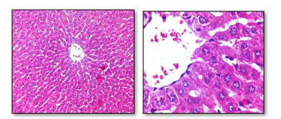
Figure 1:Photomicrograph of liver of control negative group rats.
A&B/ Normal architecture of hepatic tissue. Note the arrangement of hexagonal lobule arrow) and acini. hexagonal lobules are centered on the central vein. Hematoxylin and Eosin. A:100X and B:400x.
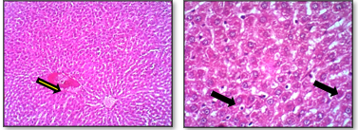
Figure 2 : Photomicrograph of Liver of stevia treated group rats.
A&B/ Severe fatty change of hepatic cells appear as vacuoles(black arow) and congestion (yellow arrow) was observed in affected area of hepatic tissue. Hematoxylin and Eosin. A:100X and B:400x.
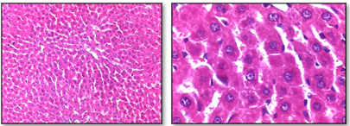
Figure 3 :Photomicrograph of Liver Saccharin-treated group rats.
A&B/ Normal histology of hepatic tissue was observed. Hematoxylin and Eosin. A:100X and B:400X.

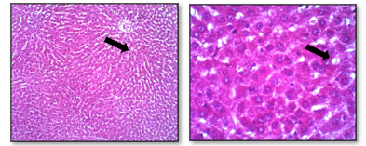
Figure 4: Photomicrograph of liver of sucralose treated group rats.
A&B/ Mild Fatty change formed vacuoles (black arrow) in hepatic tissue was observed. Hematoxylin and Eosin. A:100X and B:400X.
Finally, kidney sections of the control negative group showed normal renal cortical and medullary architecture (Figs. 5 and 6). In the Stevia-treated group, renal tissue exhibited degeneration and necrosis of tubular epithelial cells accompanied by inflammatory cell infiltration within the cortex, together with degenerative changes in the loops of Henle (Figs. 7 and 8). The saccharin-treated group demonstrated degeneration of proximal and distal renal tubules with haemorrhagic lesions in the renal medulla (Figs. 9 and 10). Similar pathological alterations were observed in the sucralose-treated group, including tubular epithelial degeneration and haemorrhage within the renal medulla (Figs. 10 and 11).
; 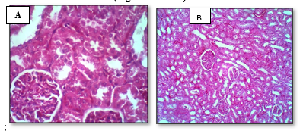
Figure 9: Photomicrograph of kidney of control negative group rats.
A&B/ Normal architecture of renal cortex was observed. Note the renal glomeruls (black arrow) and renal tubules . Hematoxylin and Eosin. A:100X and B:400X.
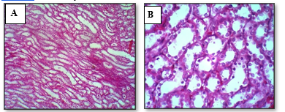
Figure 10:Photomicrograph of kidney of control negative group rats.
A&B/ Normal architecture of renal medulla was observed. Hematoxylin and Eosin. A:100X and B:400x.
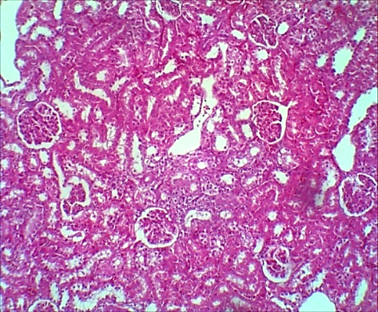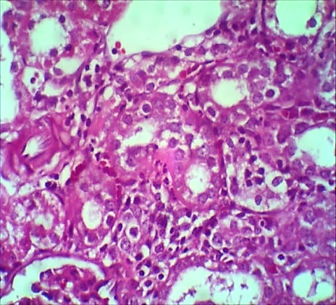
B
A
Figure 11: Photomicrograph of Kidney post stevia treatment group rats .
A&B/
Necrosis of epithelial cells of renal tubules (black arow) filled with inflammatory cell infiltration (yellow arrow) was observed in renal cortex. Hematoxylin and Eosin. A:100X and B:400X.

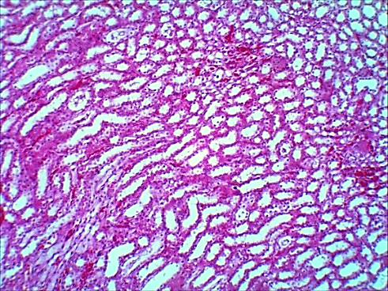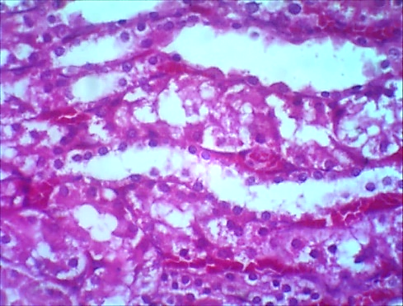
A
B
Figure 12: Photomicrograph of Kidney post stevia treatment group rats .
A&B/ Destruction of epithelial cells of loop henle tubules was observed in renal medulla. Hematoxylin and Eosin. A:100X and B:400X.
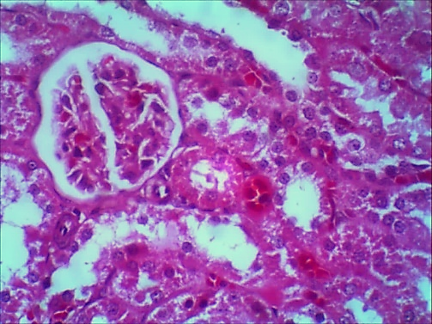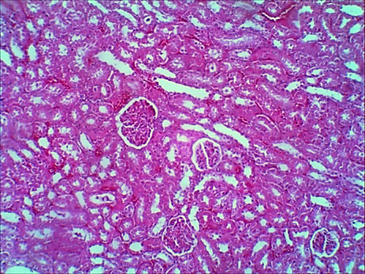
B
A
Figure 13: Photomicrograph of of Kidney post Saccharine treatment group rats .
A&B/ Destruction of epithelial cells (black arrow) of individual renal tubules was observed in renal cortex. Hematoxylin and Eosin. A:100X and B:400X.
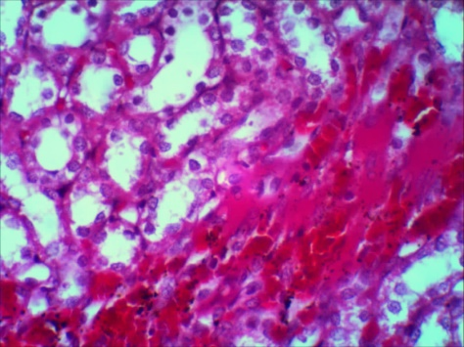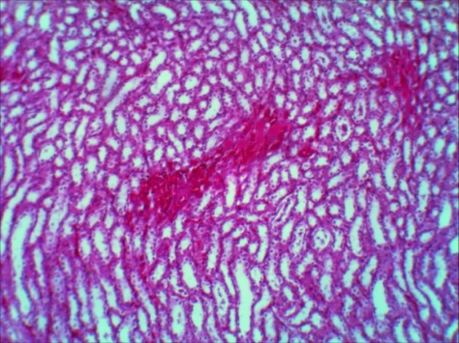
A
B
Figure 14: Photomicrograph of of Kidney post Saccharine treated group rats .
A&B/ Hemorrhage formed numerous as clusters was observed in renal medulla. Hematoxylin and Eosin. A:100X and B:400X.
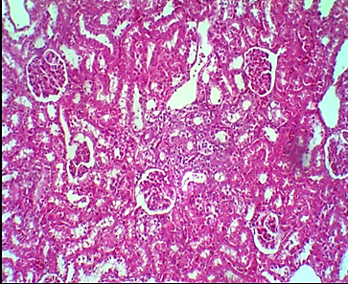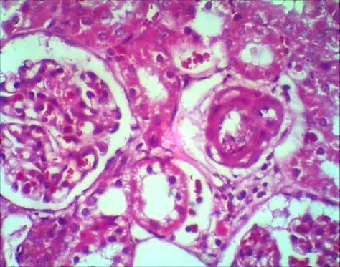
Figure 15: Photomicrograph of kidney post sucrose treatment group rats.
A&B/ Destruction of epithelial cells (black arrow)of individual renal tubules was observed in renal cortex. Hematoxylin and Eosin. A:100X and B:400X.
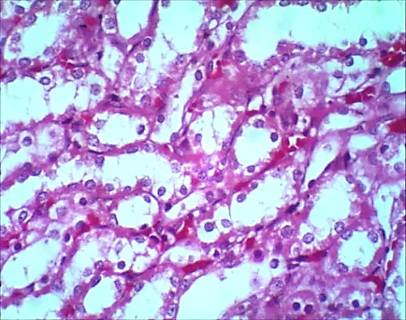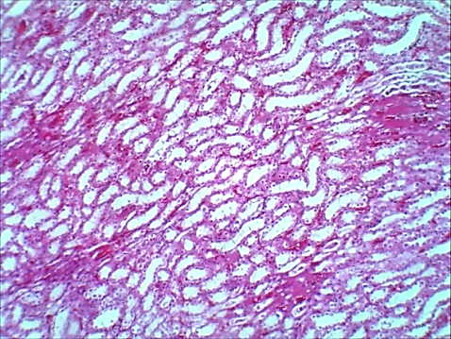
Figure 16: Photomicrograph of Kidney of sucrose treated group rats.
A&B/ Destruction of epithelial cells (black arrow) of loop henle renal tubules with hemorrhage (yellow arrow) present between tubules was observed in renal medulla. Hematoxylin and Eosin. A:100X and B:400X.
The present study compared the effects of chronic administration of Stevia, saccharin, and sucralose on body weight, blood glucose, serum cholesterol, and histopathological alterations in the liver and kidneys of male Wistar rats. Although Stevia and saccharin produced favourable effects on selected metabolic parameters, histopathological examination demonstrated that all tested sweeteners induced varying degrees of hepatic and renal injury.
The significant increase in body weight observed in the Stevia- and saccharin-treated groups compared with the sucralose-treated group suggests that non-nutritive sweeteners may influence energy balance and metabolic regulation independently of their caloric content. Similar findings have been reported by Swithers et al. (2013), who proposed that artificial sweeteners may alter physiological mechanisms involved in appetite regulation and energy homeostasis.

Biochemical analysis revealed that saccharin significantly reduced blood glucose and serum cholesterol concentrations by the end of the experimental period. These findings agree with previous studies suggesting that non-nutritive sweeteners may improve glycaemic control by reducing dietary sugar intake and modulating glucose metabolism (Amin et al., 2016; Ionescu et al., 1988). In contrast, the sucralose-treated group exhibited the highest blood glucose concentration, consistent with the well-established metabolic effects of excessive sucralose consumption.
Despite these metabolic improvements, histopathological examination demonstrated that chronic exposure to all tested sweeteners resulted in structural alterations in hepatic tissue. Stevia administration induced hepatocellular degeneration, whereas saccharin caused nuclear pyknosis, indicating irreversible cellular injury. Sucralose treatment resulted in fatty degeneration and cytoplasmic vacuolation, suggesting impaired lipid metabolism and hepatocellular damage. These observations are consistent with previous reports describing oxidative stress, inflammatory responses, and lipid peroxidation as major mechanisms underlying sweetener-induced liver injury (Farid et al., 2020; Finamor et al., 2021).
Renal histopathological findings further confirmed the adverse effects of prolonged sweetener consumption. Degeneration of renal tubular epithelial cells, inflammatory cell infiltration, and haemorrhagic lesions were observed in the treated groups, particularly following saccharin and sucralose administration. These pathological alterations may reflect direct nephrotoxic effects associated with chronic exposure to sweetening agents and their metabolites. Similar renal lesions have been reported by Toskulkao et al. (1994) and Amin et al. (2016), who demonstrated that prolonged sweetener administration may impair renal function through oxidative damage and tubular degeneration. Overall, the present findings indicate that improvements in biochemical parameters should not be interpreted as evidence of complete biological safety. Histopathological assessment revealed significant tissue alterations that may precede clinically detectable organ dysfunction. Therefore, long-term consumption of both natural and artificial sweeteners should be approached with caution, and further studies using larger sample sizes, longer exposure periods, and additional molecular and biochemical markers are recommended to clarify their safety profile.

Conclusion
Chronic administration of Stevia, saccharin, and sucralose for eight weeks produced distinct changes in body weight, blood glucose, and serum cholesterol in male Wistar rats, together with reported histopathological alterations in the liver and kidneys. Stevia- and saccharin-treated animals showed greater weight gain than the sucralose-treated group, while saccharin was associated with lower final blood glucose and serum cholesterol concentrations. In contrast, the sucralose-treated group exhibited the highest final blood glucose level. Histopathological examination described hepatic and renal abnormalities across treated groups, indicating that apparently favourable changes in selected biochemical variables did not necessarily correspond to an absence of tissue-level alterations. The findings therefore support cautious interpretation of metabolic outcomes when assessing prolonged exposure to these sweeteners. Because the experiment involved small groups and predominantly qualitative histopathological assessment, the biological significance of the observed changes requires further confirmation. Additional controlled studies with larger samples, standardised exposure conditions, quantitative tissue evaluation, and complementary biochemical measures are needed to clarify the long-term safety profile of the tested sweeteners.

Limitations

The study was limited by the small group size (n = 5), the eight-week exposure period, and the inclusion of male rats only. Histopathological assessment was predominantly qualitative, which limits the precision of comparisons among treatment groups. The biochemical evaluation focused on body weight, blood glucose, and serum cholesterol, restricting the breadth of metabolic interpretation.

Declaration of AI Use

This manuscript was prepared through the intellectual contributions of the author(s) to the study design, data analysis, interpretation of results, and scholarly content. Grammarly and ChatGPT were used solely to assist with grammatical refinement and reference formatting during manuscript revision. The author(s) accept full responsibility for the accuracy, integrity, and final content of the manuscript.

Ethical Approval
All animal handling and experimental procedures were carried out in accordance with the guidelines for the care and use of laboratory animals of the Faculty of Veterinary Medicine, University of Kufa, Iraq. Every effort was made to minimize animal suffering and to use the minimum number of animals required to achieve the objectives of the study.

COMPETING INTERESTS:
Authors have declared that they have no known competing financial interests OR non-financial interests OR personal relationships that could have appeared to influence the work reported in this paper.

References
Aguayo-Guerrero, J. A., Méndez-García, L. A., Solleiro-Villavicencio, H., Viurcos-Sanabria, R., & Escobedo, G. (2024). Sucralose: From sweet success to metabolic controversies—Unraveling the global health implications of a pervasive non-caloric artificial sweetener. Life, 14(3), 323. https://doi.org/10.3390/life14030323
Amin, K. A., Al-Muzafar, H. M., & Abd Elsttar, A. H. (2016). Effect of sweetener and flavoring agent on oxidative indices, liver and kidney function levels in rats. Indian Journal of Experimental Biology, 54(1), 56–63. Official journal archive
Farid, A., Hesham, M., El-Dewak, M., & Amin, A. (2020). The hidden hazardous effects of stevia and sucralose consumption in male and female albino mice in comparison to sucrose. Saudi Pharmaceutical Journal, 28(10), 1290–1300. https://doi.org/10.1016/j.jsps.2020.08.019
Finamor, I. A., Bressan, C. A., Torres-Cuevas, I., Rius-Pérez, S., da Veiga, M., Rocha, M. I., Pavanato, M. A., & Pérez, S. (2021). Long-term aspartame administration leads to fibrosis, inflammasome activation, and gluconeogenesis impairment in the liver of mice. Biology, 10(2), Article 82. https://doi.org/10.3390/biology10020082
Ionescu, E., Rohner-Jeanrenaud, F., Proietto, J., Rivest, R. W., & Jeanrenaud, B. (1988). Taste-induced changes in plasma insulin and glucose turnover in lean and genetically obese rats. Diabetes, 37(6), 773–779. https://doi.org/10.2337/diab.37.6.773
Pooja, & Ekta. (2026). Artificial sweeteners in the food industry: Classification, applications, health implications, and future perspectives. Journal of Advances in Food Science & Technology, 13(3), 62–74. https://doi.org/10.56557/jafsat/2026/v13i310671
Toora, B. D., Saraswathy, S., Pillai, M. M., & Mishra, S. (2018). Effect of artificial sweeteners on the blood glucose concentration. Journal of Medical Academics, 1(2), 81–85. https://doi.org/10.5005/jp-journals-10070-0017
Suez, J., Cohen, Y., Valdés-Mas, R., Mor, U., Dori-Bachash, M., Federici, S., Zmora, N., Leshem, A., Heinemann, M., Linevsky, R., Zur, M., Ben-Zeev Brik, R., Bukimer, A., Eliyahu-Miller, S., Metz, A., Fischbein, R., Sharov, O., Malitsky, S., Itkin, M., … Elinav, E. (2022). Personalized microbiome-driven effects of non-nutritive sweeteners on human glucose tolerance. Cell, 185(18), 3307–3328.e19. https://doi.org/10.1016/j.cell.2022.07.016
Swithers, S. E., Sample, C. H., & Davidson, T. L. (2013). Adverse effects of high-intensity sweeteners on energy intake and weight control in male and obesity-prone female rats. Behavioral Neuroscience, 127(2), 262–274. https://doi.org/10.1037/a0031717
Thakur, M., & Vatika, K. (2025). Gerontological implications of artificial sweeteners marketed in India: A comprehesnsive review. Archives of Current Research International, 25(8), 400–411. https://doi.org/10.9734/acri/2025/v25i81426
Tkach, V. V., Morozova, T. V., Gaivão, I. O. d. M., Miranda, N. G. d., Ivanushko, Y. G., Martins, J. I. F. d. P., & Barros, A. N. (2025). Sucralose: A review of environmental, oxidative and genomic stress. Nutrients, 17(13), 2199. https://doi.org/10.3390/nu17132199
Toskulkao, C., Deechakawan, W., Leardkamolkarn, V., Glinsukon, T., & Buddhasukh, D. (1994). The low calorie natural sweetener stevioside: Nephrotoxicity and its relationship to urinary enzyme excretion in the rat. Phytotherapy Research, 8(5), 281–286. https://doi.org/10.1002/ptr.2650080506

