Ichthyofaunal diversity of Tammileru reservoir of Andhra Pradesh during 2016-2018
Abstract:
This study aimed to assess fish faunal diversity and conservation status in Tammileru Reservoir. The Tammileru River is a significant freshwater source for the Ramsar wetland Kolleru Lake and is connected to the Kolleru Lake ecosystem, which is crucial for diverse migratory and resident fish species. It primarily acts as a breeding and feeding ground for various fish species. A dam was constructed on the Tammileru River at Nagireddygudem village in Chintalapudi Mandal, and this reservoir was the principal study site, where fish species were collected. There are no fishermen regularly operating in this reservoir; fishing is carried out by part-time fishermen who employ gill nets, cast nets, and rod and line to supplement their income. Generally, local fishermen catch fish daily, but catches are higher on Saturdays for sale on Sundays. Field visits to the local fish market were conducted twice a month during the sample-collection period to document fish species diversity and record the morphometric measurements required for species identification. Fish diversity was characterised by orders such as Cypriniformes, Siluriformes, Perciformes, and Channiformes, comprising a mix of indigenous and commercial species. The dominant fish fauna in this river comprised Wallago attu, Channa marulius, Mystus spp., Chela sp., Ompok sp., Heteropneustes fossilis, Puntius spp., Etroplus spp., and Labeo spp. The transplanted carps, Labeo rohita, Cirrhinus mrigala, and Cyprinus carpio, appeared abundantly in catches. In the absence of regular stocking, wild populations are being exploited by fishermen.
Keywords: Eastern Ghats, Eutrophication, Kolleru Lake, Ramsar wetland, Tammileru reservoir.
Introduction: India has extensive riverine water resources, which are characterised by rich fish diversity and production potential. India has 29,000 km of riverine resources, including 14 major rivers (catchment area >20,000 km²), 44 medium rivers (catchment area between 2,000 and 20,000 km²), and innumerable minor rivers (catchment area <2,000 km²) (Das et al., 2021).
The Tammileru River is a non-perennial, medium-sized river originating from Bethupalli Cheruvu (Betupalli tank) in Khammam district, Telangana, flowing roughly 130 km before finally discharging into Kolleru Lake, Andhra Pradesh. A dam is located on the Tammileru River at Nagireddigudem village in Chintalpudi Mandal, West Godavari district, A.P., 60 km from the river's origin. From the reservoir site, the river travels 40 km and enters Eluru town; from there, it travels 15 km and enters Kolleru Lake, the largest freshwater lake of India and a Ramsar Convention site (Rao et al., 2018).
Tammileru flows through Eluru district and is notorious for frequently breaching its banks and causing severe flooding in the city of Eluru during periods of heavy rainfall before draining into Kolleru Lake. Hence, this river is widely considered the Dukkadayini (river of sorrow or bringer of distress) of Eluru. To protect surrounding communities from these floods, as well as to meet their agricultural needs, this dam was constructed in 1980 by the Government of Andhra Pradesh. The reservoir covers a total area of 900 hectares, has a catchment area of 236 square miles and a storage capacity of 3 TMC (thousand million cubic feet), and provides irrigation facilities to surrounding villages with an ayacut of 9,169 acres. The earth dam is 6.4 kilometres long, with a full reservoir level of 355 feet. The reservoir acts as an important irrigation source for over 3,720 hectares (9,192.32 acres) of upland areas across Chintalpudi, Lingapalem, and Chatrai mandals in Eluru and Krishna districts. In total, nine villages, Thalarlapalli, Errampalli, Edavalli, Kalynampadu, Mankollu, Polavaram, Chatrai, Thummagudem, and Somavaram, benefit from this irrigation and flood-control project (Andhra Pradesh Space Applications Centre [APSAC], 2023; Sarkar et al., 2021).
Regular estimation of fish species diversity in aquatic ecosystems is a prerequisite for the proper management and conservation of these resources. The study site, Tammileru Reservoir, was visited at 15-day intervals from March 2016 to February 2018. A total of 48 visits were made during the study period. Fish diversity in the region shows high species richness, with studies identifying more than 30 recorded species, dominated by orders such as Cypriniformes, Siluriformes, Perciformes, and Channiformes, and including a mix of indigenous and commercially important species such as Channa striata, Labeo rohita, and Mastacembelus armatus. The dominant fish fauna in this river comprise Wallago attu, Channa marulius, Mystus spp., Chela sp., Ompok sp., Heteropneustes fossilis, Puntius spp., Etroplus spp., and Labeo spp. The transplanted carps, Labeo rohita, Cirrhinus mrigala, and Cyprinus carpio, appear abundantly in catches. A comprehensive study of the fish and fisheries of Lake Kolleru recorded 52 fish species, of which 40 were primarily freshwater species belonging to 11 genera, as reported by Dutt and Murthy (1976). Another study on the capture fishery of Lake Kolleru reported 11 additional species, provided a status assessment, and proposed an approach document for the eco-development of the lake (Dutt, 1983). Rao et al. (1987) reported 61 fish species together with 12 prawn species. After restoration of the lake, 92 fish species were reported (Rao et al., 2013b; Raju et al., 2014).
Recent studies of Indian freshwater and reservoir systems have likewise used ichthyofaunal inventories and environmental assessments to establish baseline information for monitoring, conservation, and fisheries management (Andrabi et al., 2024; Patel, 2025; Rathod et al., 2026).
At the national level, current conservation literature further emphasises the value of addressing knowledge gaps through systematic documentation and monitoring of freshwater fish resources (Sarkar et al., 2024).
The fish fauna of the lake may reflect changes in the habitat due to anthropogenic activities. Understanding the fish diversity of a particular region is crucial for the effective management of its ichthyofaunal resources and the formulation of appropriate conservation measures. Moreover, detailed knowledge of the existing fish fauna is fundamental for the sustainable utilisation of fishery resources and serves as a basis for the scientific development and expansion of aquaculture (Hiddink et al., 2008). Although many researchers have studied the ichthyofauna of lotic and lentic waters in various riverine systems, relatively few studies have focused on specific regions, leaving significant gaps in our understanding of their fish biodiversity (Jan et al., 2023; Rao et al., 2013a). The present work provides an inventory of the ichthyofauna of Tammileru Reservoir, Eluru District. This inventory will serve as a baseline for the ichthyofaunal diversity of the river and facilitate future fish-faunal surveys, monitoring, and biodiversity studies.
Research gap: Despite studies on the connected Kolleru Lake and other freshwater systems, a reservoir-specific baseline inventory of the ichthyofauna of Tammileru Reservoir remains limited, restricting site-specific information for subsequent monitoring and conservation assessment.
Objective: The objective of the present study was to document the ichthyofaunal diversity of Tammileru Reservoir, Eluru District, and to establish a baseline for future fish-faunal surveys, monitoring, and biodiversity studies.
Material and methods: Fishing is usually conducted using locally made, flat-bottomed dugout boats. Their sizes vary in length, width, and depth, and they are usually intended for one to three people. Locally available wood is used to construct the boats, usually ‘Sal’ (Shorea robusta). The fishing boats used in the study area are locally referred to as Donga or Dinghi. Fishers in Tammileru Reservoir employ a wide range of fishing nets to capture fish from their natural habitats. The selection and use of fishing gear vary depending on the type of aquatic ecosystem, such as reservoirs, rivers, ponds, and other water bodies, reflecting differences in habitat characteristics and fishing practices. The major types of fishing gear used in the study area are described below:
Gill nets: Gill nets are locally called ‘Fasla Jaal’. Two types of gill nets are used: floating gill nets and stationary gill nets. The latter have floats attached to the head twine and sinkers attached to the foot twine. The nets are made of nylon and vary in mesh size. They are tied across the river from one end to the other at the surface, kept overnight, and removed early in the morning. This is the main gear used in reservoirs.
Cast nets: These are locally known as ‘Saukhi’ or ‘Jholi’ and are used in shallow areas. The sinkers are made of cast iron, and the thread is usually nylon. Most fishermen personally own one cast net. Two types of cast nets are used in the area: (a) the stringed type, as prevalent in northern India, and (b) the non-stringed type, as prevalent in West Bengal and locally known as ‘Bangali Saukhi’.
Drag nets: These are locally called ‘Mahajaal’ and are generally made of nylon. Various mesh sizes are used in rivers, ponds, tanks, etc. Drag nets are used only in shallow-water areas. In reservoirs, they are used along the periphery near the banks.
Fish sampling: Fish were collected from March 2016 to February 2018. Direct sampling of fish specimens was conducted in three steps at pre-fixed sites. Sampling was performed in two ways: by direct capture using nets or by collection from fishermen at the local fish market.
Preservation, labelling and identification of samples: Preservation of fish specimens was necessary to confirm species identification. The collected fish specimens were preserved in a 10% formaldehyde solution at the sampling site. Each sample was labelled and entered in a field diary under a number. The recorded details included the locality, date and time of collection, and other related information about the specimen. A durable plastic label bearing a serial number was used. Before preservation, the colour of each specimen was also recorded in the field diary.
Fish specimens were identified based on a combination of external morphological features such as body shape, colouration, body size, and the shape and position of fins. Meristic characters, including the number of fin rays, scale counts in specific series, the presence or absence of scales in particular regions, and distinctive features such as barbels were also considered for accurate identification. Morphometric measurements, particularly body proportions such as the ratio of head length to total body length, were used to support species identification. Both fresh and preserved specimens were examined during the identification process. Fresh specimens were primarily used to observe colour patterns, whereas preserved specimens were used for detailed morphometric and meristic analyses.
Results: This study recorded 30 fish species belonging to 8 orders, 10 families, and 20 genera (shown in Table 3 and Figure 4) during the study period. Monthly, seasonal, percentage-wise, and order-wise observations of the recorded fish species from Tammileru River are shown in Tables 1, 2, 3 and Figures 1, 2a, 2b, and 3, respectively. The order Cypriniformes, which includes Labeo rohita, Catla catla, Cirrhinus mrigala, and Cyprinus carpio, was dominant, representing 11 species and contributing 65.75% of the total fish species, followed by Perciformes, which included three species, namely Channa punctatus, C. striatus, and Glossogobius giuris, representing 9.17%; Siluriformes, with two species, Wallago attu and Mystus vittatus, representing approximately 17.50%; and Synbranchiformes, represented by a single species, Mastacembelus armatus, at approximately 2.75%. Other fish species accounted for 5%.
Seasonal observations showed that Cypriniformes were recorded at a higher percentage in the monsoon season (66.50%), followed by the pre-monsoon (65.50%) and post-monsoon (65.25%) seasons, whereas Perciformes were recorded at a higher percentage in the post-monsoon season (9.75%), followed by the monsoon (9.00%) and pre-monsoon (8.75%) seasons. Further, Siluriformes were recorded at a higher percentage in the post-monsoon season (17.75%), followed by the pre-monsoon (17.50%) and monsoon (17.25%) seasons. Synbranchiformes were recorded at a higher percentage in the post-monsoon (3.00%) and pre-monsoon (3.00%) seasons than in the monsoon season (2.25%). The remaining freshwater fish species were recorded at a higher percentage in the pre-monsoon season (5.75%), followed by the monsoon (5.25%) and post-monsoon (4.00%) seasons.
Month-wise observations of fish species from Tammileru Reservoir were also recorded. Cirrhinus mrigala was more abundant in July, followed by May and September, and was least abundant in October. Labeo rohita was more abundant in December, followed by April and November, and was least abundant in October, whereas Catla catla was more abundant in October and less abundant in December. Wallago attu was more abundant in June, followed by February and March, and was least abundant in December. Cyprinus carpio was more abundant in October and less abundant in June and December. Mystus spp. were more abundant in August, followed by July and September, whereas Channa spp. had the highest percentage in October, followed by May, July, and August. Glossogobius giuris had a higher percentage in February, followed by January, April, and November. Mastacembelus spp. were more abundant in October, followed by January, June, and December, and were sometimes not recorded in February and September. Other freshwater fish species were more abundant in October and had lower percentages in January, July, and December, as shown in Table 2.

Species | Pre-monsoon (%) | Monsoon (%) | Post-monsoon (%)
Cirrihinus mrigala | 5.00 | 4.50 | 4.25
Labeo rohita | 43.00 | 37.75 | 44.25
Catla catla | 9.50 | 14.00 | 8.00
Wallago attu | 10.00 | 6.50 | 10.00
Cyprinus carpio | 8.00 | 10.25 | 8.75
Mystus sps. | 7.50 | 10.75 | 7.75
Channa sps. | 4.50 | 5.75 | 3.75
Glossobius | 3.75 | 3.00 | 5.75
Mastacembulus sps. | 3.00 | 2.25 | 3.00
Others | 5.75 | 5.25 | 4.00
Table 1. Percentage of fish species in a seasonal wise catch composition.
Order | Pre-monsoon (%) | Monsoon (%) | Post-monsoon (%)
Cypriniformes | 65.50 % | 66.50 % | 65.25 %
Perciformes | 8.75 % | 9.00 % | 9.75 %
Siluriformes | 17.50 % | 17.25 % | 17.75 %
Synbranchiformes | 3.00 % | 2.25 % | 3.00 %
Others | 5.75 % | 5.25 % | 4.00 %
Table 2. Order wise fish species in a seasonal wise catch composition
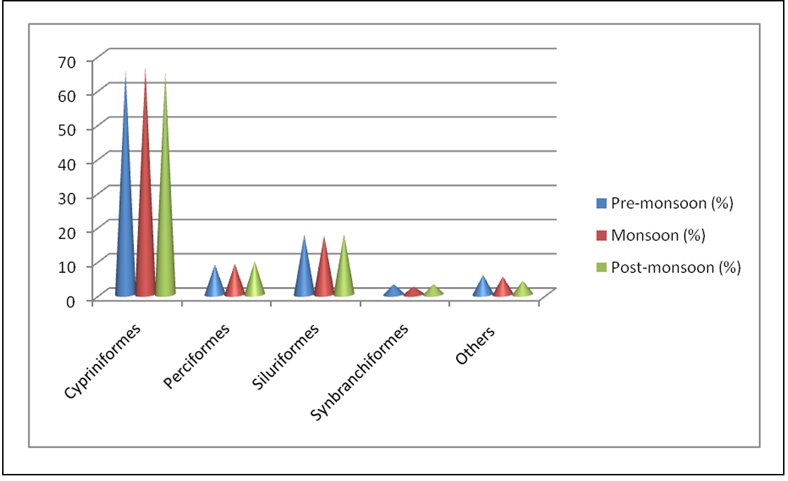
Figure 1. Order wise fish species in a seasonal wise catch composition
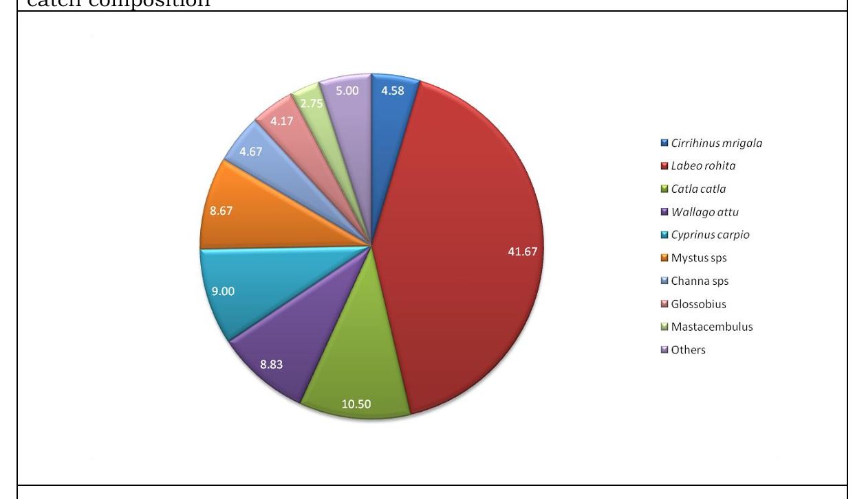
2a
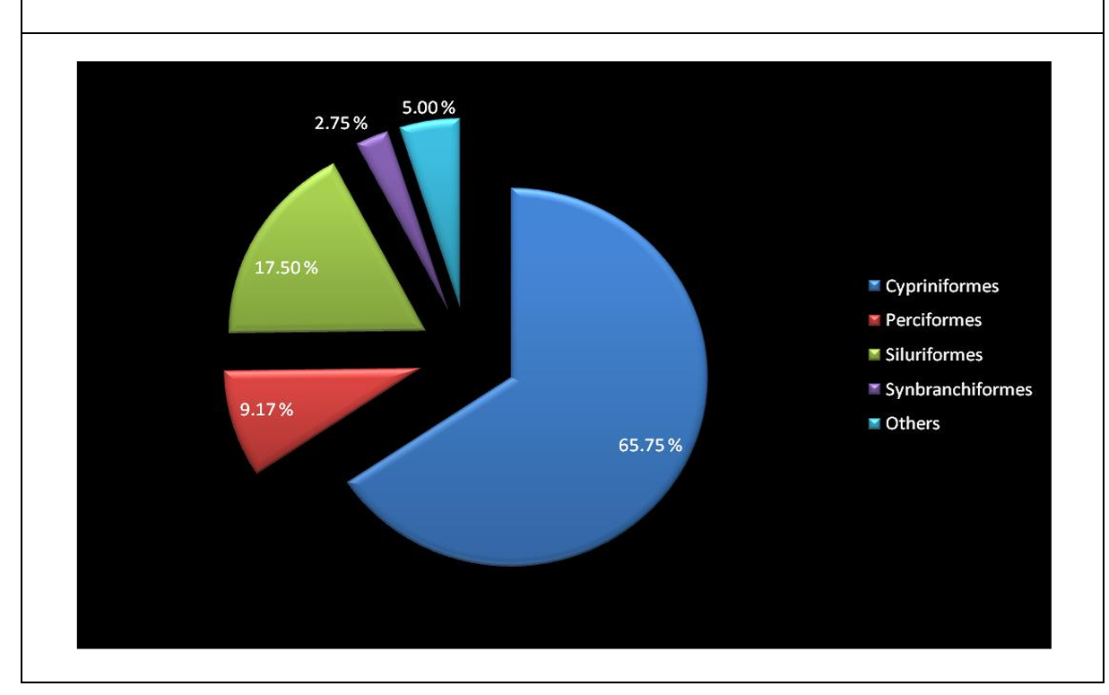
2b
Figure 2a & 2b. Species wise and order wise fish species in a seasonal wise catch composition.
S. No | Order | Family | Genus | Species | Common Name
1 | Cypriniformes | Cyprinidae | Labeo | rohita | Rohu
 |  |  |  | calbasu | Kaki botche
 |  |  |  | bata | Bata chepa
 |  |  |  | fimbriatus | fringed-lipped peninsula carp/yerra-gandumenu
1 | Cypriniformes | Cyprinidae | Catla | catla | Botcha
1 | Cypriniformes | Cyprinidae | Cirrhinus | mrigala | Gaddi chepa
 |  |  |  | reba | Reba carp
1 | Cypriniformes | Cyprinidae | Cyprinus | carpio | Common carp
1 | Cypriniformes | Cyprinidae | Osteobrama | cotio | Dhela / cotio
1 | Cypriniformes | Cyprinidae | Systomus | sarana | Olive barb / sarana barb
1 | Cypriniformes | Cyprinidae | Ctenopharyngodon | idella | Grass carp
2 | Siluriformes | Siluridae | Wallago | attu | Valuga
2 | Siluriformes | Siluridae | Ompok | bimaculatus | Two spotted butter catfish
 |  |  |  | pabda | Pabdah catfish
2 | Siluriformes | Bagridae | Mystus | vittatus | Erra jella
 |  |  |  | cavasius | Guddi jella
2 | Siluriformes | Bagridae | Clarius | batrachus | Walking catfish/Marpu
3 | Perciformes | Channidae | Channa | punctatus | Spotted snakehead
 |  |  |  | striatus | Striped snakehead
 |  |  |  | marulius | Great snake head/ Bullseye snake head/ Cobra snake head
3 | Perciformes | Cichlidae | Etroplus | maculatus | Orange chromide
3 | Perciformes | Cichlidae | Oreochromis | mossambicus | Mozambique tilapia
4 | Synbranchiformes | Mastacembelidae | Mastacembelus | armatus | Spiny eel
4 | Synbranchiformes | Mastacembelidae | Macrognathus | pancalus | Spiny eel
 |  |  |  | aral | One -stripe spiny eel
5 | Anguilliformes | Anguillidae | Anguilla | bengalensis | Mottled eel
 |  |  |  | bicolor | Shortfin eel
6 | Osteoglossiformes | Notopteridae | Notopterus | notopterus | Featherbacks / knife fishes
7 | Gobiiformes | Gobiidae | Glossogobius | giuris | tank goby/ bar-eyed goby
8 | Beloniformes | Belonidae | Xenentodon | cancila | Needle fish
Table 3. Fresh water fish species reported from Tammileru River, West Godavari District.
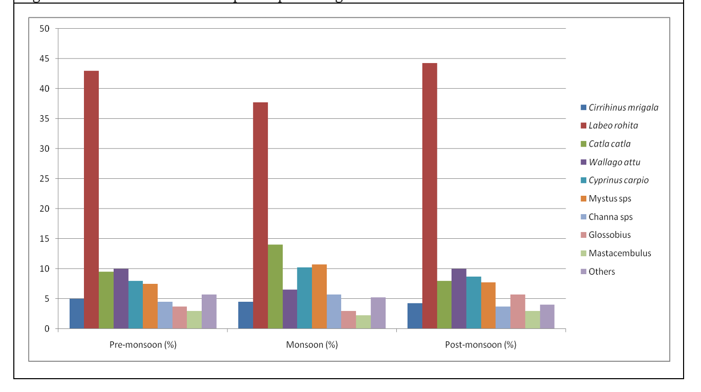
Figure 3. Seasonal variation of species percentage of fresh water fishes in Tammileru river
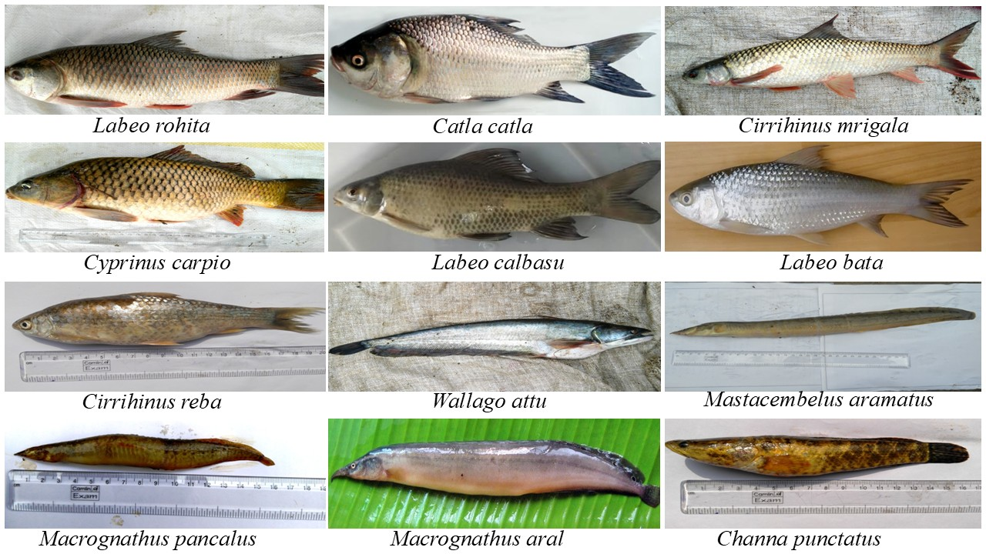
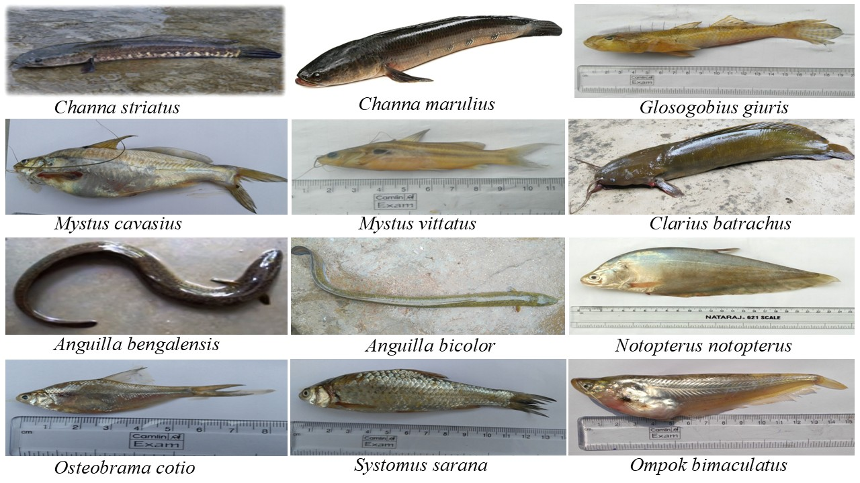
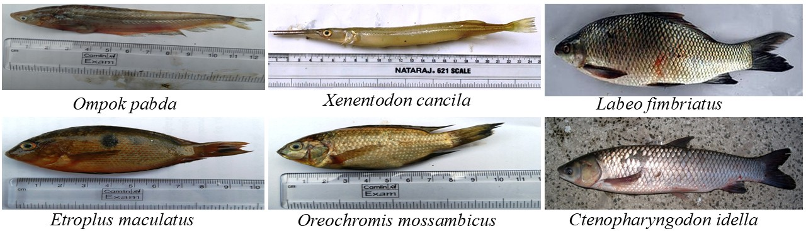
Fig. 4 A diverse freshwater ichthyofaunal community of Tammileru river of Andhra Pradesh.
Discussion: Fish diversity in a wetland is crucial for maintaining ecological balance, supporting food security, and driving nutrient cycling. Ichthyofaunal diversity helps regulate populations of algae and aquatic insects, provides critical income and nutrition for surrounding communities, and enhances the overall resilience of the habitat (Dudgeon et al., 2006). Fish also provide vital nutrition and income for millions, while enhancing habitat resilience to environmental changes and supporting high biodiversity. Wetlands such as Tammileru Reservoir support commercially important fish species (Food and Agriculture Organization of the United Nations [FAO], 2024).
The monthly, seasonal, and percentage-wise composition of families, genera, and species recorded from Tammileru Reservoir during the present study is summarised in Tables 1-3 and Figures 1-3. Cypriniformes emerged as the most dominant order, a pattern consistent with earlier studies from the connected Kolleru Lake ecosystem (Barman, 2004; Krishna et al., 2013; Rao et al., 2013b). This recurring dominance across independent surveys of the same catchment suggests that Cypriniformes, particularly the major and minor carps, form the ecological and economic backbone of this river system, likely reinforced by decades of carp stocking in reservoirs across the region (Krishna et al., 2016; Lakshmi et al., 2015). Krishna et al. (2013) similarly reported 14 species of Siluriformes from Kolleru Lake, and catfish diversity in the same lake has also been documented by Rao et al. (2013b) and Lakshmi et al. (2015), broadly corroborating the present findings.
In the present investigation, 30 species belonging to 8 orders were recorded, among which Cypriniformes was dominant, contributing 11 species. The 11 Cypriniformes species were Labeo rohita, L. calbasu, L. bata, L. fimbriatus, Catla catla, Cirrhinus mrigala, C. reba, Cyprinus carpio, Osteobrama cotio, Systomus sarana, and Ctenopharyngodon idella. All 11 species in this order belong to the family Cyprinidae. Siluriformes consisted of six species belonging to two families, namely Siluridae and Bagridae. Wallago attu, Ompok bimaculatus, and O. pabda belong to the family Siluridae, whereas Clarias batrachus, Mystus vittatus, and M. cavasius belong to the family Bagridae. The group traditionally classified under Perciformes (modern classification: Channiformes) consists of three species, Channa punctatus, C. striatus, and C. marulius, belonging to the family Channidae. Etroplus maculatus and Oreochromis mossambicus belong to the family Cichlidae of the order Perciformes. Mastacembelus armatus, Macrognathus pancalus, and M. aral belong to the family Mastacembelidae and the order Synbranchiformes or Mastacembeliformes. Anguilla bengalensis and A. bicolor belong to the family Anguillidae and the order Anguilliformes. Osteoglossiformes consists of one species, Notopterus notopterus, belonging to the family Notopteridae; Gobiiformes consists of one species, Glossogobius giuris, belonging to the family Gobiidae; and Beloniformes consists of one species, Xenentodon cancila, belonging to the family Belonidae (Table 3 and Figure 4).
The seasonal shift observed in the present study, with Cypriniformes peaking during the monsoon and Siluriformes and air-breathing fishes increasing during the post-monsoon period, likely reflects breeding-related upstream migration of carps triggered by monsoon inflow, followed by a corresponding rise in catfish and air-breathing species as water levels recede in the post-monsoon reservoir. Similar results were reported by Zhao et al. (2020). Taken together, these findings suggest that the present species composition may itself be an early indicator of gradually changing water quality in the reservoir rather than a stable baseline (Jayasankar, 2018; Sugunan, 2000).
The presence of C. carpio and C. idella among the dominant catch is notable, as both are exotic species rather than native to this river system. Their persistence in the catch in the absence of regular restocking suggests that these populations are now self-sustaining or repeatedly replenished through escape from upstream aquaculture activity, and their continued dominance may be exerting competitive pressure on native cyprinids such as Labeo and Cirrhinus species (Vilizzi & Tarkan, 2015). Monitoring the relative abundance of exotic versus native carp populations in subsequent years would help clarify whether this represents stable coexistence or gradual displacement of native fish fauna.
It is also important to note that the present sampling strategy combined direct net-based collection with periodic visits to the local fish market, as no fishermen operate in the reservoir on a full-time basis. Although this approach was necessary given the part-time nature of local fishing activity, it may have introduced bias towards larger, commercially preferred species while under-representing smaller or non-commercial fish less likely to reach the market (Ghosh et al., 2024). Future studies using standardised, gear-independent sampling across all size classes, together with quantitative diversity indices such as the Shannon-Wiener and Margalef's richness indices, would allow more precise year-on-year comparisons and strengthen conservation assessments for this river system (Morris et al., 2014).
CONCLUSION
In the case of Tammileru Reservoir, an important freshwater source contributing to the Ramsar-designated Kolleru Lake, the ichthyofaunal composition documented in this study has significant implications for the management and conservation of the wider aquatic ecosystem. The dominance of hardy, tolerant taxa, including catfishes, air-breathing fishes, and exotic carps, alongside the comparatively limited representation of sensitive native cyprinids, reinforces the need for controlled stocking practices, water-quality monitoring, and regulation of fishing gear, particularly fine-mesh gill nets that can indiscriminately capture juveniles, to conserve the native ichthyofaunal diversity of this river. The present study provides a baseline assessment of the ichthyofaunal diversity of Tammileru Reservoir, serving as a reference for future faunal surveys, monitoring initiatives, and biodiversity-conservation strategies within the broader Kolleru Lake ecosystem. Further studies are required on the conservation and sustainable management of fish species in Tammileru Reservoir.
Limitation

The findings represent the fish assemblage recorded in Tammileru Reservoir during March 2016 to February 2018. Sampling combined direct net-based collection with periodic observations of catches from local fishermen and the fish market; therefore, the inventory reflects species encountered through these collection routes. The study provides a site- and period-specific baseline, and subsequent surveys with comparable temporal coverage and broader standardised sampling would be useful for assessing longer-term changes in ichthyofaunal composition.
Declaration of AI Use:
This manuscript was prepared through the intellectual contributions of the author(s) to the study design, data analysis, interpretation of results, and scholarly content. Grammarly and ChatGPT were used solely to assist with grammatical refinement and reference formatting during manuscript revision. The author(s) accept full responsibility for the accuracy, integrity, and final content of the manuscript
Competing Interests:
Authors have declared that they have no known competing interests.

Reference:
Andhra Pradesh Space Applications Centre. (2023). District survey report – Eluru District 2023. Government of Andhra Pradesh. https://eluru.ap.gov.in/notice/district-survey-report-2023/
Andrabi, S., Bakhtiyar, Y., Yousuf, T., Akhtar, M., & Nissar, S. (2024). Water quality assessment in relation to fish assemblage using multivariate analysis in Manasbal Lake, Kashmir. Water Science, 38, 92–108. https://doi.org/10.1080/23570008.2023.2300850
Barman, R. P. (2004). The fishes of the Kolleru Lake, Andhra Pradesh, India with comments on their conservation. Records of the Zoological Survey of India, 103(1–2), 83–89. https://faunaofindia.nic.in/PDFVolumes/records/103/01-02/0083-0089.pdf
Das, B. K., Bhakta, D., Kumar, L., Nair, S. M., Koushlesh, S. K., Sajina, A. M., Roshith, C. M., & Samanta, S. (2021). Ichthyofaunal diversity of the major Indian rivers: A review. Journal of the Inland Fisheries Society of India, 53(1–2), 22–35. https://doi.org/10.47780/jifsi.53.1-2.2021.115769
Dudgeon, D., Arthington, A. H., Gessner, M. O., Kawabata, Z.-I., Knowler, D. J., Lévêque, C., Naiman, R. J., Prieur-Richard, A.-H., Soto, D., Stiassny, M. L. J., & Sullivan, C. A. (2006). Freshwater biodiversity: Importance, threats, status and conservation challenges. Biological Reviews, 81(2), 163–182. https://doi.org/10.1017/S1464793105006950
Dutt, S. (1983). Fishes of Lake Kolleru. In Ecodevelopment of Kolleru Lake: Status and approach document of INCOR. INCOR. https://moef.gov.in/uploads/2018/03/agenda-22.pdf
Dutt, S., & Murthy, V. S. (1976). On the fish and fisheries of Lake Kolleru, Andhra Pradesh. Memoirs of the Society of Zoology, Guntur, 1, 17–27. https://moef.gov.in/uploads/2018/03/agenda-22.pdf
Food and Agriculture Organization of the United Nations. (2024). A review of the inland fisheries of India (FAO Fisheries and Aquaculture Circular No. 1265). FAO. https://doi.org/10.4060/cd0674en
Ghosh, S., Anju, P., Pattanayak, R., & Sahu, N. C. (2024). Fisheries and aquaculture in wetland ecosystems: A review of benefits, risks, and future prospects in India. Journal of Coastal Research, 40(3), 598–612. https://doi.org/10.2112/JCOASTRES-D-23-00045.1
Hiddink, J. G., MacKenzie, B. R., Rijnsdorp, A. D., Dulvy, N. K., Nielsen, E. E., Bekkevold, D., Heino, M., Lorance, P., & Ojaveer, H. (2008). Importance of fish biodiversity for the management of fisheries and ecosystems. Fisheries Research, 90(1–3), 6–8. https://doi.org/10.1016/j.fishres.2007.11.025
Jan, S., Gul, S., Iqbal, G., & Bhat, F. A. (2023). Risk factors in the natural habitat of fish: A review. Asian Journal of Agricultural Extension, Economics & Sociology, 41(9), 691–698. https://doi.org/10.9734/AJAEES/2023/v41i92093
Jayasankar, P. (2018). Present status of freshwater aquaculture in India – A review. Indian Journal of Fisheries, 65(4), 157–165. https://doi.org/10.21077/ijf.2018.65.4.81300-20
Krishna, P. V., Madhusudhana, R. K., Sunitha, K., & Prabhavathi, K. (2013). Impact of the habitat destruction and pollution effect on fish faunal diversity of the Lake Kolleru, Andhra Pradesh, India. BIOINFO Environment and Pollution, 3(1), 29–31. https://bioinfopublication.org/pages/article.php?id=BIA0002067
Krishna, P. V., Panchakshari, V., Suresh, P., Prabhavathi, K., & Anil Kumar, K. (2016). Ichthyofaunal diversity of siluriformis from Kolleru Lake, Andhra Pradesh, India. International Journal of Fisheries and Aquatic Studies, 4(6), 420–424. https://www.fisheriesjournal.com/archives/?ArticleId=1020&issue=6&part=F&vol=4&year=2016
Lakshmi, B. B., Naidu, Y. P., & Rao, K. R. (2015). Ichthyo faunal diversity and conservation of Kolleru Lake—A Ramsar site in Andhra Pradesh. IOSR Journal of Pharmacy and Biological Sciences, 10(2), 13–21. https://doi.org/10.9790/3008-10221321
Morris, E. K., Caruso, T., Buscot, F., Fischer, M., Hancock, C., Maier, T. S., Meiners, T., Müller, C., Obermaier, E., Prati, D., Socher, S. A., Sonnemann, I., Wäschke, N., Wubet, T., Wurst, S., & Rillig, M. C. (2014). Choosing and using diversity indices: Insights for ecological applications from the German Biodiversity Exploratories. Ecology and Evolution, 4(18), 3514–3524. https://doi.org/10.1002/ece3.1155
Patel, P. (2025). A study on relationship between water quality parameters and fish diversity in freshwater bodies in Chhattisgarh, Central India. Asian Journal of Research in Biosciences, 7(1), 86–98. https://doi.org/10.56557/ajorib/2025/v7i1113
Raju, C. S., Rao, J. C. S., & Simhachalam, G. (2014). Biodiversity and conservation status of ichthyofauna of Lake Kolleru, Andhra Pradesh, India. International Journal of Scientific Research, 3(5), 555–562. https://doi.org/10.15373/22778179/MAY2014/183
Rao, J. C. S., Simhachalam, G., & Raju, C. S. (2013a). A study on ichthyofaunal diversity, conservation status and anthropogenic stress of River Champavathi, Vizianagaram District (AP), India. Asian Journal of Experimental Biological Sciences, 4(3), 418–425.
Rao, J. C. S., Simhachalam, G., & Raju, C. S. (2013b). Ornamental fish diversity of Lake Kolleru, the only Ramsar site in Andhra Pradesh, India. Bulletin of Environment, Pharmacology and Life Sciences, 2(7), 48–55. https://bepls.com/beplsjune2013/10.pdf
Rao, K. B., Chandana, I., Dhanamjayarao, E. N., & Murty, P. B. (2018). Textural characteristics of the sediments from Kolleru Lake and Tammileru River, Andhra Pradesh, India. International Journal of Basic and Applied Research, 8(12), 928–943.
Rao, K. J., Rao, K. V., Rama Raju, T. S., & Rao, K. S. (1987). Studies on the position and prospectus of fisheries of Kolleru Lake with special reference to the management of resources. Journal of the Indian Society of Coastal Agricultural Research, 5(1), 215–221. https://moef.gov.in/uploads/2018/03/agenda-22.pdf
Rathod, R., Ghatge, S., Belsare, S., Patil, K., Rathod, A., & Dhawad, B. (2026). Ichthyofaunal diversity of Wadgaon Dam in the Wunna River Basin, Maharashtra, India. Journal of Advances in Biology & Biotechnology, 29(8), 1447–1456. https://doi.org/10.9734/jabb/2026/v29i84270
Sarkar, U. K., Kathirvelpandian, A., Kantharajan, G., Tyagi, L. K., & Lakra, W. S. (2024). The concept of “state fishes of India”: Current status, knowledge gaps, and strategic plans for conservation and sustainable utilization. Journal of Fish Biology, 104(6), 1675–1697. https://doi.org/10.1111/jfb.15729
Sarkar, U. K., Mishal, P., Borah, S., Karnatak, G., Chandra, G., Kumari, S., Meena, D. K., Debnath, D., Yengkokpam, S., Das, P., DebRoy, P., Yadav, A. K., Aftabuddin, M., Gogoi, P., Pandit, A., Bhattacharjya, B. K., Tayung, T., Lianthuamluaia, L., & Das, B. K. (2021). Status, potential, prospects, and issues of floodplain wetland fisheries in India: Synthesis and review for sustainable management. Reviews in Fisheries Science & Aquaculture, 29(1), 1–32. https://doi.org/10.1080/23308249.2020.1779650
Sugunan, V. V. (2000). Ecology and fishery management of reservoirs in India. Hydrobiologia, 430, 121–147. https://doi.org/10.1023/A:1004081316185
Vilizzi, L., & Tarkan, A. S. (2015). Experimental evidence for the effects of common carp (Cyprinus carpio L., 1758) on freshwater ecosystems: A narrative review with management directions for Turkish inland waters. Journal of Limnology and Freshwater Fisheries Research, 1(3), 123–149. https://doi.org/10.17216/LimnoFish-5000130907
Zhao, Y., Zhang, L., Wang, C., & Xie, C. (2020). Biology and ecology of grass carp in China: A review and synthesis. North American Journal of Fisheries Management, 40, 1379–1399. https://doi.org/10.1002/nafm.10512

