Management Strategies and Control Activities for Nematode Infestation in Soybean Production

Abstract

Soybean production in Washim District, Maharashtra, is affected by plant-parasitic nematodes, yet field-level information on farmer awareness, infestation patterns, management practices, and perceived effectiveness remains limited. This study examined management strategies and control activities used by soybean farmers for nematode infestation. Data were collected from 210 farmers using a structured questionnaire and field observations, supplemented by secondary sources, and were analysed using descriptive statistical methods. Forty-three per cent of respondents reported being very aware of nematode-related diseases, while 52% identified Meloidogyne incognita as the most commonly recognised nematode. Nematode infestation was reported every season by 42% of farmers, and sandy soil was identified as the most vulnerable soil type by 52%. Yield loss exceeding 40% was reported by 61% of respondents. Crop rotation (53%) and deep ploughing (29%) were the most commonly reported cultural practices. Among biological options, Paecilomyces lilacinus was reported by 58% of farmers, whereas fluopyram was the most commonly reported chemical nematicide (46%). Farmers' assessment of existing control practices remained cautious: 64% were neutral and 29% were dissatisfied. The findings indicate that farmers use multiple cultural, biological, and chemical approaches, but perceived effectiveness is inconsistent. Greater emphasis on integrated nematode management, farmer training, accessible biological inputs, and institutional support may improve the sustainability of soybean nematode management in the study area.

Keywords: Soybean; plant-parasitic nematodes; nematode infestation; Meloidogyne incognita; integrated nematode management; crop rotation; biological control; chemical control; farmer awareness.

1. Introduction

Soybean is one of the most significant legume crops grown worldwide, and it is especially important in India. Soybean is one of the most commercially important crops cultivated worldwide for food, feed, and industrial use. This crop is a valuable agricultural product and source of revenue because it is one of the world's major sources of protein for animal feed and the second largest source of vegetable oil. To fulfil the demands of the rapidly growing population, enhancing soybean yield (SY) is one of the key goals of breeding programmes worldwide (Yates et al., 2024). Understanding soybean in-season growth and production is critical for government, corporate, and farmer decision-making, as it has a direct impact on crop health and harvest management, crop insurance, food security, supply regulation, the financial market, and strategic planning regarding social, environmental, and economic policies. Various stressors, particularly the soybean cyst nematode, can drastically limit soybean productivity, causing yield losses of up to 90% (Gorny, 2025).

Nematodes are microscopic roundworms that do not have segments. They are a complex group of creatures with a variety of eating patterns, including both "free-living" helpful nematodes and plant-parasitic nematodes. Soilborne plant-parasitic nematodes survive and breed by feeding on plant tissues. Their feeding can cause root injury, compromise root function, resulting in yield loss (Arjoune et al., 2022). Plant-parasitic nematodes, which are minute and often only 0.01 to 0.04 in. (300 to 1000 μm) long, can cause noticeable damage to soybean crops through disease symptoms. Their impact can also be quantified when yields do not meet expectations. In addition to direct harm, feeding wounds on soybean roots provide a pathway for secondary illnesses caused by fungi or bacteria. Most plant-parasitic nematodes have a life cycle of three to four weeks; therefore, multiple generations of nematodes can occur in a growing season (Yadav, 2017).

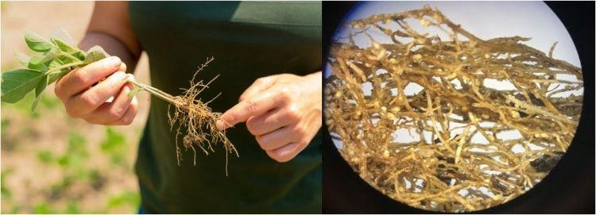

Figure 1 Nematode at Soybean roots

Plant-parasitic nematodes are typically more problematic and have a greater influence on yield in coarse, sandy soils, but they can occur in any soil type and growing region. Sandy, coarse soils have larger soil pores, which facilitates nematode migration (Jjagwe et al., 2024). Nematodes that harm soybeans live on or inside root tissues, then travel through water films between soil particles to find a host plant. Because they are so small, nematodes move very slowly through the soil, often only 5 feet per year. However, they may be disseminated over greater distances through phenomena that move the soil they inhabit, such as flooding and wind, or movement of planting or tillage equipment from field to field (Shinde et al., 2018).

Evidence from soybean production systems likewise identifies root-knot nematodes (Meloidogyne spp.) and soybean cyst nematode as important constraints and supports the combined use of chemical, biological, and cultural measures for management (Júnior et al., 2022).

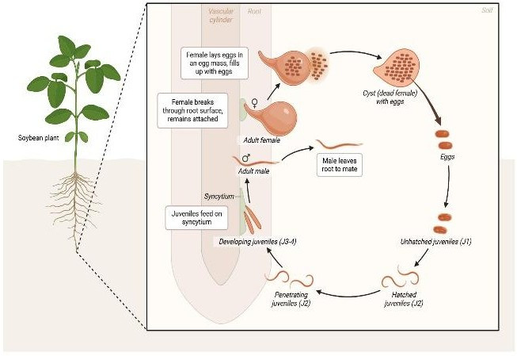

Figure 2 Soybean Nematode Life Cycle

Effects of Nematode Infection on Soybean Plant Health

Nematodes have a characteristic impact on the roots of soybean plants. Some nematode infection symptoms are obvious, while others take a long time to resolve. In some circumstances, the severity of apparent symptoms is proportionate to the drop in yield. Root-infesting nematodes reduce harvest quality in crops containing edible tubers, rhizomes, and taproots. Nematode-infected soybean plants respond similarly to those with distorted or damaged root systems (Lima et al., 2017). Symptoms vary depending on the genera that infest different regions of the soybean plant. In addition to the creation of root galls and cysts in the roots, the above-ground symptoms of nematode infection include: Stunted shoot growth and subsequent decrease in the shoot-to-root ratio, chlorosis in foliage due to nutritional inadequacies, temporary wilting due to water stress induced by root inefficiency in transporting water, and a decrease in plant fresh weight (Nisha, 2024).

Management Practices and Control Activities for Nematode Infestation in Soybean

1. Cultural Management

Practices Crop Rotation

Crop rotation is one of the most effective cultural techniques used in India's soybean-growing regions, particularly Maharashtra and Madhya Pradesh. Farmers alternate soybeans with non-host crops such as maize, sorghum, wheat, or cotton to disrupt the life cycle of plant-parasitic nematodes (Nisha, 2024). Continuous soybean cultivation increases nematode buildup in the soil, resulting in significant yield losses. Rotation reduces nematode populations naturally, without the need for chemicals. It also increases soil fertility and microbiological activity (Kranti et al., 2021). Crop rotation is a viable and cost-effective strategy in Indian rainfed agriculture. It reduces infestation by species such as Meloidogyne incognita and soybean cyst nematode. Farmers who use rotation strategies frequently report enhanced root health and crop vitality (Lima et al., 2017). Agricultural extension programmes heavily support this strategy. However, adoption is occasionally hampered due to market preference for soybeans. Overall, it remains a viable and environmentally friendly control technique (Senthil Kumar et al., 2025). Evidence from nematode-infested field crops also indicates that decomposed animal manures can reduce plant-parasitic nematode populations, supporting organic amendments as a complementary component of integrated management (Olaifa & Adekunle, 2021).

Deep Summer Ploughing

Deep summer ploughing is frequently used in India's soybean belts, particularly in the Vidarbha and Marathwada areas. During the summer, fields are ploughed thoroughly, exposing soil layers to high temperatures. This exposure helps to kill nematode eggs, larvae, and other soil pests (Abd-Elgawad, 2025). The hot Indian summer, which frequently exceeds 40°C, increases the efficacy of this approach. It lowers nematode survivability before the sowing season starts. Farmers benefit from better soil aeration and weed control. This approach is inexpensive and does not require chemical inputs (Sharma et al., 2014). Indian agricultural universities promote it as part of an integrated nematode management approach. However, its performance is contingent on appropriate timing and soil moisture conditions. Many farmers use it with organic additives to achieve better results. It is a precautionary and environmentally safe technique (Swain, 2025).

Use of Healthy Seeds

In India, using certified and healthy soybean seeds is crucial to avoiding nematode infection. Nematodes might enter new fields through contaminated or untreated seeds. Agricultural organisations such as seed certification boards help ensure farmers have access to high-quality seed (Abhishek & Shiwangi, 2024). Strong root development and consistent germination are encouraged by healthy seeds. In the early phases of growth, strong roots are less susceptible to nematode assault. It is advised in many Indian states to treat seeds with nematicides or bioagents prior to sowing. This aids in preventing early infection in seedlings. In general, farmers who use certified seeds report higher output stability. Contaminated farm-saved seeds are discouraged via awareness campaigns. It is a straightforward but successful preventive measure. It is an important component of sustainable soybean production (Kranti et al., 2021).

Field Sanitation

Crop debris, weeds, and contaminated plant leftovers must be removed and destroyed as part of field sanitation. Nematodes live in soil particles and residual roots in Indian soybean fields. These leftovers serve as a source of reinfestation in the next season if they are not eliminated (Abd-Elgawad, 2025). In certain places, farmers burn or bury contaminated waste deeply. Because weeds serve as nematodes' alternate hosts, weed control is also crucial. Over time, nematode populations accumulate less in clean areas (Senthil Kumar et al., 2025). Crop health and general soil hygiene are enhanced by this approach. Crop rotation and organic amendments are frequently used in conjunction with it. During training programmes, agricultural extension services place a strong emphasis on sanitation. Despite being straightforward, it dramatically lowers nematode carryover. It encourages sustainable soil management over the long run (Gorny, 2025).

Soil Solarisation

In parts of India's irrigated soybean regions, soil solarisation is an environmentally benign technique. During hot months, it entails covering wet soil with clear polyethylene sheets (Abd-Elgawad, 2025). The temperature of the soil is raised by solar radiation to a point where nematodes cannot survive. This method efficiently eliminates eggs, larvae, and other soil pathogens. It functions well in India's climate during the hottest summer months (Senthil Kumar et al., 2025). Additionally, it lessens fungal infections and weed seeds. Better soil conditions for soybean seeding are advantageous to farmers. It is particularly helpful in high-value crop areas and nurseries. However, because of the expense and labour required, it might not be employed extensively. It is a successful non-chemical control strategy despite several drawbacks (Swain, 2025).

Proper Irrigation and Drainage

Controlling the spread of nematodes in soybean fields requires effective irrigation and drainage management. Nematode migration and infection are facilitated by excessive soil moisture (Jjagwe et al., 2024). In India, farms with inadequate drainage frequently exhibit greater levels of nematode infection. Root stress and water stagnation are avoided with controlled watering. Effective drainage lowers the frequency of illness and increases the amount of oxygen available to roots (Yadav, 2017). When feasible, farmers are encouraged to adopt drip or scheduled irrigation systems. Plant resistance to nematodes is improved by balanced water management. Additionally, it enhances crop growth and nutrient uptake. Bund management and field leveling are advised by agricultural experts. It is a helpful technique that increases the efficacy of other control strategies (Lavhe et al., 2019).

2. Resistant Soybean Varieties

Resistant Varieties

One key tactic used in India to control production losses brought on by plant-parasitic nematodes is the use of soybean cultivars resistant to nematodes. Soybean cultivars resistant to soybean cyst nematodes (SCN) and root-knot nematodes (Meloidogyne spp.) have been created by research organisations such as ICAR. These cultivars reduce nematode multiplication and penetration in plant roots (Abhishek & Shiwangi, 2024). Crop damage and production loss are thereby greatly reduced. These improved varieties are encouraged to be used by farmers in areas such as Maharashtra, Madhya Pradesh, and Rajasthan that cultivate soybeans. Additionally, resistant cultivars lessen reliance on chemical nematicides. However, persistent monocropping and nematode adaptability may occasionally lead to a breakdown in resistance (Shinde et al., 2018). As a result, it is advised to rotate varieties regularly. These cultivars perform well under moderate infestation levels. They play a crucial role in integrated nematode management. Their use increases soybean farming's sustainability and production (Nisha, 2024).

Improved Seed Selection

In India's soybean production systems, better seed selection is crucial to reducing nematode infestation. It is recommended that farmers choose certified, superior, and regionally specific soybean seeds. These seeds are bred for greater adaptability, increased yield potential, and resistance to soil-borne pests. Poor-quality or farm-saved seeds raise the risk of disease and nematode proliferation in several Indian farming locations (Sharma et al., 2014). Strong early root development and consistent germination are guaranteed by improved seeds. Plants with robust root systems are better able to withstand nematode attack. Agricultural experts advise replacing seeds every season or two. Protection is further improved by treating seeds with bioagents or authorised chemicals. Access to improved cultivars is facilitated by government seed distribution programmes. This method lowers the risk of early-stage infection while increasing crop stand. It is an easy and cost-effective preventive strategy (Abhishek & Shiwangi, 2024).

3. Biological Control Methods

Fungal Bioagents

In India, fungal bioagents such as Paecilomyces lilacinus and Trichoderma spp. are frequently employed to manage plant-parasitic nematodes in soybean fields. By attacking nematode eggs and juveniles, these fungi lower the number of nematodes in the soil. By boosting plant growth and nutrient uptake, they also improve root health. These bioagents are frequently used in Indian agriculture as soil or seed treatments. They do not damage beneficial soil organisms and are environmentally benign. Combining them with organic amendments like compost or neem cake boosts their efficacy (Abd-Elgawad, 2025). Farmers who use fungal bioagents report improved crop vigour and reduced root-gall formation. However, temperature and soil conditions might affect how well they work. For optimal effectiveness, they need to be handled and stored properly (Kranti et al., 2021). Their application under Integrated Pest Management (IPM) is encouraged by agricultural extension services. These bioagents are an environmentally friendly substitute for chemical nematicides (Abhishek & Shiwangi, 2024). Recent soybean-focused literature further supports biological and other bio-based agents as components of sustainable nematode management, while emphasising the need to translate promising approaches into effective field-scale applications (Silva et al., 2025).

Beneficial Bacteria

In India, beneficial bacteria such as Bacillus subtilis and Pseudomonas fluorescens are frequently employed as biological control agents to manage nematodes in soybeans. By creating harmful compounds and strengthening plant resilience, these bacteria reduce nematode activity. They establish a defence against nematode invasion by colonising the root zone (Abd-Elgawad, 2025). Typically, application is carried out using biofertilisers, soil soaking, or seed treatment. Their use in organic and sustainable farming systems is encouraged by Indian agricultural research agencies (Lima et al., 2017). Additionally, they enhance microbial diversity and soil fertility. Following application, farmers report better root growth and fewer signs of disease. Combining them with organic manure increases their efficacy. However, their efficacy may be impacted by shelf life and storage conditions. They are economical, safe, and good for the environment. Their application in integrated nematode management is growing (Shinde et al., 2018).

Natural Predators

In Indian soybean fields, nematode numbers are largely suppressed by natural predators and beneficial soil organisms. These include beneficial microfauna found in healthy soils, nematode-trapping fungi, and predatory fungi. By consuming eggs, juveniles, or adult nematodes, they naturally control nematode populations (Senthil Kumar et al., 2025). In India, organic farming methods promote the development of these advantageous organisms. Their activity is increased by using compost, green manure, and fewer chemical inputs. Long-term insect control and increased soil biodiversity are advantageous to farmers (Senthil Kumar et al., 2025). In undisturbed soils with a high organic content, natural predator activity is frequently higher. However, these beneficial organisms may be harmed by overuse of pesticides. They play an indirect but crucial function in preserving ecological equilibrium. They encourage long-term, sustainable nematode control (Yadav, 2017).

4. Chemical Control Measures

Seed Treatment

In Indian soybean farming, treating seeds with nematicides or bio-based compounds is a standard procedure. It guards against early nematode infection in seeds and young plants. Stronger root development and improved germination are observed in treated seeds. This approach is particularly helpful in areas where nematode issues are known to exist (Abd-Elgawad, 2025). In India, authorised chemicals or biological agents are frequently used for seed treatment. It offers defence while the soybean is at its most vulnerable growing stage. Because it is inexpensive and simple to implement, farmers favour it. It increases plant stand uniformity and decreases early crop losses (Lima et al., 2017). Careful dosing is advised by agricultural guidelines to prevent toxicity. For better outcomes, it is frequently combined with other management techniques. In extension programmes, this approach is heavily emphasised (Kigeso et al., 2024). Multi-environment soybean trials have shown that nematode-protectant seed treatments can contribute to management of soybean cyst nematode and associated disease pressure, although their performance can vary across environments (Bissonnette et al., 2024).

Soil Application of Nematicides

In extensively infested soybean fields in India, nematicides are applied to the soil to rapidly reduce nematode populations. Fluopyram and other chemicals are used in accordance with established norms (Yadav, 2017). Nematodes in the soil are immediately affected by these nematicides, which lower their activity and reproduction. Depending on the degree of infestation, farmers apply them either before or during sowing. Nematodes can be rapidly but temporarily controlled with this technique. It is typically employed when cultural and biological approaches are inadequate (Sharma et al., 2014). On the other hand, excessive use can deteriorate soil health and pollute the ecosystem. The use of some substances is regulated by the government. It is advised to wear protective gear when applying. In cases of severe infestation, it works well as a short-term measure (Lavhe et al., 2019).

Controlled Chemical Use

Sustainable soybean production practices in India depend on the controlled application of chemical nematicides. It is recommended that farmers use chemicals at recommended dosages and only when absolutely necessary. Overuse can result in environmental risks, soil toxicity, and the emergence of resistance (Sharma et al., 2014). Extension services encourage the use of chemicals in conjunction with biological and cultural techniques.

Current reviews therefore favour integrated programmes that combine judicious chemical use with biological control and soil amendments rather than relying on a single control measure (Tian et al., 2025).

Farmers are urged to adhere closely to label guidelines. Efficiency is increased and costs are decreased with controlled application. Additionally, it shields beneficial soil organisms from harm. In India, awareness campaigns emphasise the dangers of using pesticides carelessly. Success depends largely on timing and dosage. This strategy supports safer and longer-lasting nematode control (Abhishek & Shiwangi, 2024).

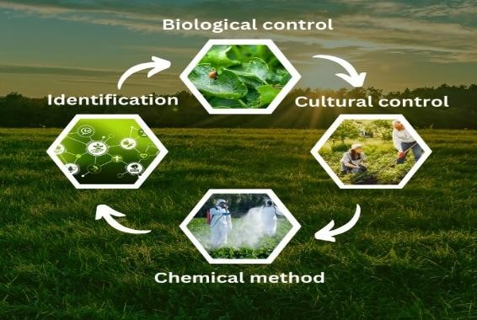

Figure 3 Management Strategies for Nematode Infestation in Soybean

Despite the development of numerous management techniques, including chemical nematicides, biological control agents, resistant cultivars, and cultural practices, their uptake and efficacy under regional field conditions are still uneven. Without adequate understanding of integrated nematode control, many farmers continue to use traditional methods (Kigeso et al., 2024). Furthermore, there are limited region-specific data on farmers' actual degree of awareness, the intensity of infestations currently occurring, and the efficacy of management techniques implemented in soybean fields (Senthil Kumar et al., 2025). Consequently, this study is required to identify gaps in current methods, evaluate their efficacy under local agroclimatic conditions, and thoroughly examine the management strategies and control activities employed by soybean producers. The results of this study may help improve soybean productivity and farmer livelihoods in the study area by suggesting realistic, affordable, and sustainable nematode management strategies.

Although the manuscript identifies several available management options, evidence remains limited on how soybean farmers in the study area understand nematode problems, which control measures they actually use, and how effective they perceive these measures under local farming conditions.

Objective

The objective of this study was to examine farmers’ management strategies and control activities for nematode infestation in soybean production, with emphasis on awareness, commonly recognised nematodes, practices used, and perceived effectiveness in the study area.

2. Literature Review

One of the least visible risks to soybean production globally is plant-parasitic nematodes, which significantly reduce output and degrade crop quality. Species such as Meloidogyne incognita and soybean cyst nematode (SCN) damage the root system, leading to poor nutrient uptake, stunted development, chlorosis, and decreased production (Lavhe et al., 2019). Nematode infestation in soybean fields is further increased by ongoing monocropping, inappropriate soil conditions, and limited awareness, according to research. To reduce nematode populations and crop loss, a number of management techniques have been developed, such as cultural practices, resistant varieties, biological control agents, organic amendments, and chemical nematicides (Swain, 2025). Owing to environmental concerns about excessive chemical use, integrated nematode management approaches that combine sustainable and eco-friendly methods have become increasingly important. Therefore, increasing soybean yield and creating sustainable nematode management techniques require an understanding of the efficacy of various control measures (Abd-Elgawad, 2025).

Swain (2025) investigated crop protection and integrated nematode management. Global agriculture faces a significant threat from plant-parasitic nematodes. Although chemical treatment is still effective, integrated pest management (IPM) is required due to its negative environmental effects. A sustainable method of managing nematodes can be achieved by combining cultural methods, biological control, and resistant crop cultivars. Future studies on plant-derived nematicides and gene-editing technologies will improve our capacity to manage these covert agricultural risks.

Gorny (2025) investigated the control of soybean nematodes. Nematodes are tiny roundworms without segments. They are a diverse group of organisms with a wide range of feeding habits, including nematodes that parasitize plants and "free-living" helpful nematodes. To survive and reproduce, soilborne plant-parasitic nematodes consume plant tissues. Their feeding may cause harm to the roots, which could impair root function and reduce yield. Soybean-affecting nematodes live on or within root tissues and travel through water films between soil particles in search of a host plant. Nematodes are so small that they can only migrate up to five feet a year through the soil on their own. However, they could be spread across greater distances by planting or tillage machinery moving from field to field or by natural events such as wind and flooding that shift the soil they live in.

Yates et al. (2024) evaluated a phytochemical seed-coating approach for soybean cyst nematode (SCN) management using the phenolic acid derivatives 4-hydroxybenzaldehyde (4HBD) and 2,3-dihydroxybenzoic acid (2,3DHBA) at variable concentrations. The treatments were assessed against two SCN types and for potential effects on soybean growth. The authors found that 2,3DHBA significantly reduced SCN abundance in Race 2-infected plants in a dose-dependent manner, while neither compound significantly reduced soybean germination or early plant growth. The study indicates that phenolic-acid-based seed coatings may complement sustainable SCN management and support the development of environmentally safer biopesticides.
Abd-Elgawad (2025) noted that examining the real dangers associated with biopesticides is still necessary to facilitate economical formulation, registration, farmer awareness, and use globally. However, tank mixing that guarantees legality and prevents incompatibilities based on chemical and physical agro-inputs can also offer better benefits. The goal is to design pesticides that are safe, effective, and well-formulated by deciphering the intricate interactions involved in applying many inputs. To overcome such constraints and difficulties, sophisticated strategies should be used. These methods would use bioinformatics, RNA-Seq in pesticide synthesis, microencapsulation, nanopesticides, and volatile organic chemicals as signals for soil dwellers.
Senthil Kumar et al. (2025) explain the main nematode species that influence crops grown under protection, their effects on agricultural productivity and health, their ecological relationships, and different integrated management techniques. To lessen the threat posed by plant-parasitic nematodes, integrated management techniques using biological, chemical, and cultural methods are crucial. A comprehensive strategy to effectively manage nematode populations and maintain the productivity of protected cultivation systems includes cultural practices such as crop rotation and soil solarisation, chemical treatments with nematicides, and biological control using biocontrol agents and natural predators.
Nisha (2024) investigated the control of nematodes in spices and plantation crops. Perennial crops including coconut, arecanut, coffee, betelvine, cardamom, black pepper, ginger, and turmeric are grown on the same plot of land in Kerala's mixed cropping systems. In agricultural systems based on coconuts, plant-parasitic nematodes seriously harm crops, resulting in lower yields and financial losses. An environmentally benign substitute for chemical nematicides is the selection of nematode-tolerant domesticated or wild animals and the adoption of resistance through breeding. In Kerala's mixed cropping systems, fungal and bacterial antagonists have been shown to be effective against root-knot nematodes. In mixed cropping systems with plantation crops, using organic manures, mulching, and cultivating antagonistic crops can help lower nematode populations and enhance soil health. Since the degree of control varies with environmental conditions, crop, and targeted nematode, integrated management programmes should be developed in multi-crop production systems based on the effect of the control strategy on nematode population and benefit-cost ratio.
Kigeso et al. (2024) evaluated seven treatments using a CRD design. The treatments were inoculated with 1000 J2 of M. incognita and replicated six times in a study carried out in Mwanza, Tanzania. The number of galls decreased from 104 in 0.0 kg BSFF/inoculated to 3 in 1.0 kg BSFF/inoculated, with 6.33, 23.67, 51.51, and 52.50 galls in 0.75 kg BSFF/inoculated, 0.5 kg BSFF/inoculated, 50mL chitosan/inoculated, and 0.25 kg BSFF/inoculated, respectively. Additionally, symptoms such as chlorosis decreased from nine leaves in 0.0 kg BSFF/inoculation to zero in 1.0 kg BSFF.
Jjagwe et al. (2024) investigated the effects of soybean cyst nematode (SCN) infestation on the yield of susceptible and resistant seed variants as well as soybean production. In comparison to resistant varieties (SCN populations: 0 to 340), susceptible varieties had higher SCN populations (20 to 1080), lower yields, and poorer crop vigour recovery. The Green Normalized Difference Vegetation Index (GNDVI, r = −0.6) and blue band reflectance (r = 0.58) showed the strongest association with SCN populations, according to high-resolution (1.3 cm/pixel) aerial multispectral imaging. However, the best indicators of plant vigour and those with the strongest association with SY were GDNVI, Green Chlorophyll Index (GCI), and Normalized Difference Red Edge Index (NDRE) (r = 0.59–0.75). Then, using two statistical and four machine learning (ML) models at ten distinct train–test data split ratios (50:50–95:5), reflectance (REF) and VIs were used to estimate SY. The accuracy of SY estimation was significantly impacted by the ML models and the train-test data split ratio. The best and most reliable model was Random Forest (RF) (r: 0.84–0.97, rRMSE: 8.72–20%); however, the ML models performed less well as the train–test split ratio increased. Out of all the models, the 95:5 train–test ratio performed the best; this ratio would be appropriate for modelling across smaller or medium-sized datasets.

Arjoune et al. (2022) described the stages of soybean vegetation and reproduction, the life cycles of SCN, and the factors that affect this disease. The impact of SCN on soybean yield loss and the difficulties in detecting it are highlighted by the authors. The authors outline direct sampling techniques for obtaining and analysing soil samples to assess SCN egg numbers. After outlining the benefits and drawbacks of these direct approaches, the authors review computer vision and remote sensing-based detection techniques, including data collection via satellite, aerial, and ground methods, and machine learning techniques for image analysis-based soybean cyst nematode detection. In high-performance and large-data settings, the authors emphasise the evaluation techniques and benefits of the overall detection workflow. The authors discuss a number of management techniques, including fertilisation, crop rotation, SCN-resistant cultivars such as PI 88788, and SCN's growing resistance to these tactics. The authors examine machine learning methods for predicting soybean crop yields and the impact of fertilisers, insecticides, and herbicides on reducing SCN infection.

Kranti et al. (2021) noted that although the harm caused by plant-parasitic nematodes is rarely apparent to the unaided eye, research on their significance should not be understated. Nematodes quickly accumulate large population densities in vegetables, potatoes, sugar beets, tobacco, and other perennial fruit crops such as citrus, grapes, bananas, pineapples, etc. due to their short life cycle and rapid rates of reproduction. Because crop rotation is not possible, the population stays constant. Because plant-parasitic nematodes are microscopic (length 0.5–1.5 mm; diameter 30–50 µm), they live in soil and harm the root system. As a result, their damage is frequently underestimated because a cursory examination of the crop from the outside does not immediately reveal the detrimental effects on the plant's growth.
Lavhe et al. (2019) assessed the presence of plant-parasitic nematodes in 737 soil samples taken from 16 agricultural systems over 119 talukas. The regions where the population of the reniform nematode R. reniformis exceeded the damage threshold (200/100cc soil) were located and charted. Yavatmal district had the most samples from cotton crops with high reniform nematode population densities, followed by Buldhana, while Nagpur and Gadchiroli had lower populations. Yavatmal had the most high-density sites for the pigeon pea crop, followed by Buldhana and Amravati, while Gadchiroli had the lowest. Variation in population density may be associated with the gradual expansion of irrigation through drip systems.
Shinde et al. (2018) examined plant-parasitic nematodes associated with soybean fields in the Godavari Basin of Jalna District, Maharashtra, India, during August–October 2010 and August–October 2011. Two species from two genera associated with soybean fields were observed. Meloidogyne incognita and Rotylenchulus reniformis were the nematode species identified.
Yadav (2017) covered recent approaches to controlling nematode populations, including the use of biological control techniques, integrated pest management, cropping system design, host plant genetic alteration, and the creation of naturally occurring nematicides. Research and development priorities in applied nematology should be established because these alternatives are more target-specific and have biological origins, which may better preserve the environment and biodiversity.

Table 1 Comparative Table for Previous Work done

Author & Year | Methodology | Key Results | Research Gap
Swadhin Kumar Swain (2025) | Review of integrated nematode management and crop protection approaches including cultural, biological, and resistant variety strategies. | Highlighted that plant-parasitic nematodes are major agricultural threats. Integrated Pest Management (IPM) combining cultural practices, biological control, and resistant varieties offers sustainable control. Future prospects include gene-editing and plant-derived nematicides. | Limited field-level validation of advanced technologies such as gene editing and botanical nematicides under diverse agro-climatic conditions.
Adrienne Gorny (2025) | Descriptive study on soybean nematodes, their biology, movement, and spread mechanisms. | Explained nematode feeding behavior, root damage, yield loss, and dispersal through water, flooding, wind, and machinery. Emphasized the importance of understanding nematode ecology in soybean production. | Lack of practical large-scale management strategies and region-specific control recommendations for soybean farmers.
Ping Yates (2024) | Phytochemical soybean seed-coating experiment using 4HBD and 2,3DHBA at different concentrations under SCN-infected and non-infected conditions. | 2,3DHBA reduced SCN abundance in Race 2-infected plants in a dose-dependent manner; the tested compounds did not significantly reduce germination or early plant growth. | Further field-scale validation, testing across broader SCN populations, and evaluation of formulation performance under production conditions are needed.
Mahfouz M.  M. Abd-Elgawad (2025) | Review of biopesticide applications, pesticide interactions, and advanced formulation technologies. | Emphasized benefits of biopesticides and tank mixing. Suggested use of microencapsulation, nanopesticides, volatile organic compounds, RNA-Seq, and bioinformatics for safer and more effective pest management. | Limited awareness, high formulation costs, and inadequate registration frameworks hinder widespread adoption of biopesticides.
P Senthil Kumar (2025) | Review of nematode species affecting protected cultivation and integrated management strategies. | Integrated approaches involving crop rotation, soil solarization, nematicides, and biological agents effectively reduced nematode populations and maintained productivity. | Need for location-specific integrated management protocols under protected cultivation systems.
Nisha (2024) | Review of nematode management in mixed cropping systems involving plantation crops and spices in Kerala. | Resistant varieties, fungal and bacterial antagonists, organic manures, mulching, and antagonistic crops improved soil health and reduced nematode populations. | Lack of economically optimized integrated management programmes suitable for multi-crop systems and varying environments.
Andrea Malima Kigeso (2024) | Experimental CRD study in Tanzania using different levels of Black Soldier Fly Frass (BSFF) against Meloidogyne incognita. | BSFF significantly reduced gall formation and chlorosis symptoms in soybean plants. Higher BSFF doses showed better nematode suppression. | Further field-scale validation and economic feasibility studies are required before commercial recommendation.
Pius Jjagwe (2024) | Combined field trials, multispectral aerial imaging, vegetation indices, and machine learning models for soybean cyst nematode (SCN) assessment. | Resistant soybean varieties performed better than susceptible ones. Random Forest model showed highest prediction accuracy for soybean yield estimation. | Need for scalable and cost-effective remote sensing systems for real-time SCN detection in large agricultural fields.
Youness Arjoune (2022) | Review of SCN detection methods including soil sampling, computer vision, remote sensing, and machine learning. | Discussed advantages and limitations of direct sampling and AI-based SCN detection methods. Reviewed management strategies including resistant varieties and crop rotation. | Limited integration of AI technologies into practical field-level SCN monitoring systems.
K. K. V. V. S. Kranti (2021) | General review on significance and impact of plant-parasitic nematodes on crops. | Highlighted rapid nematode multiplication, hidden root damage, and severe crop losses in annual and perennial crops. | Need for better diagnostic and monitoring techniques due to invisible nature of nematode damage.
N. V. Lavhe (2019) | Large-scale soil survey of 737 samples across  16 crop systems in Maharashtra. | Identified high population density of Rotylenchulus reniformis in cotton and pigeon pea fields, especially in Yavatmal district. | Need for continuous monitoring and correlation studies between irrigation practices and nematode spread.
Laxmikant V. Shinde (2018) | Field investigation of soybean nematodes in Jalna District, Maharashtra during 2010–2011. | Recorded two major nematode species: Meloidogyne incognita and Rotylenchulus reniformis associated with soybean. | Limited information on seasonal population dynamics and effective control measures in soybean ecosystems.
Usha Yadav (2017) | Review of modern nematode control approaches including genetic manipulation, IPM, biological control, and natural  nematicides. | Suggested eco-friendly and target-specific alternatives to chemical nematicides for sustainable nematode management. | More applied research is needed to commercialize biological and genetic control methods for field conditions.

3. Research Gap
Several questions remain unresolved about nematode management in soybean production, especially in areas such as Washim District where soybeans are an important crop. The majority of earlier research has concentrated on broad nematode management techniques, but limited research has addressed infestation patterns unique to a given area, farmer knowledge, or the efficacy of integrated control strategies in the agroclimatic conditions of Washim District. The frequency of significant nematode species such as Meloidogyne incognita and Rotylenchulus reniformis in Washim's soybean-growing regions and their direct effect on yield losses are not well understood. Furthermore, information is limited regarding local farmers' acceptance and financial viability of environmentally friendly strategies such as biological control agents, organic amendments, resistant cultivars, and integrated pest management (IPM) techniques. Moreover, sophisticated methods such as bio-based nematicides, machine learning-based detection, and remote sensing have not been sufficiently assessed for practical application in soybean farming in this area. Thus, in order to prevent nematode infestation in soybean production in the Washim district of Maharashtra, India, a comprehensive study of sustainable, economical, and location-specific management measures is required.
4. Methodology

To gather information about nematode infestation, its effects on soybean yield, and farmers' management strategies, the study used both primary and secondary data sources. A systematic questionnaire was created and distributed to soybean farmers in the chosen study area to gather primary data. Using appropriate sampling approaches, a total sample of 210 farmers was selected. Awareness of nematode infestation, symptoms seen in soybean crops, yield losses, management techniques used, application of chemical and biological controls, crop rotation techniques, and difficulties farmers encounter in managing nematodes were all included in the questionnaire. In order to comprehend the actual infestation conditions and control techniques used in the fields, field observations and visits were also carried out.

A variety of published and unpublished sources, including journal articles, research papers, government reports, internet databases, agricultural websites, books, and earlier studies on nematode infestation and soybean yield, were used to gather secondary data. To derive significant findings about efficient management techniques and control measures for nematode infestation in soybean agriculture, the gathered data were examined using suitable statistical and descriptive techniques.

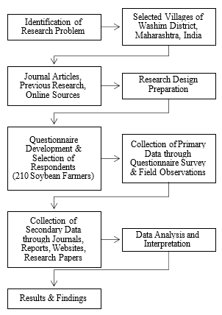

Figure 4 Methodology Flowchart

5. Results and discussion

The study's analysis focuses on understanding the control measures and management approaches used by soybean farmers in Washim District to deal with nematode infestation. To assess farmer awareness, infestation levels, crop losses, and the efficacy of various management strategies, the data gathered from 210 farmers through questionnaires and field observations were systematically categorised, tabulated, graphically displayed, and evaluated. The main obstacles faced by farmers were determined using both primary and secondary data, and the contribution of cultural, biological, and chemical management techniques to lowering nematode infestation and raising soybean productivity was evaluated.

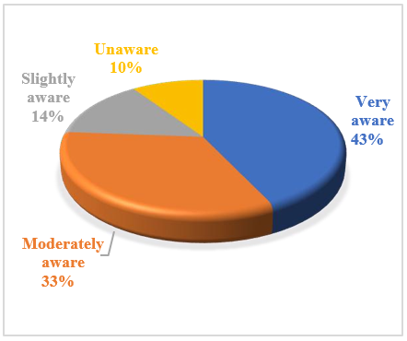

Graph 1 familiar are you with nematode-related diseases in soybean crops

Ninety farmers (43%) are very aware of nematode-related diseases in soybeans, according to the data on farmers' awareness, suggesting good knowledge among a substantial proportion of respondents. Approximately 70 farmers (33%) have a moderate level of awareness, indicating a partial comprehension of the issue. Meanwhile, 30 farmers (14%) have little awareness about nematode problems. There is a knowledge gap, as evidenced by the fact that only 20 farmers (10%) are unaware of nematode-related illnesses. Overall, the results show that although awareness is generally high, extension and training programmes still need to be strengthened in order to increase farmers' comprehension and early detection of nematode infestation.

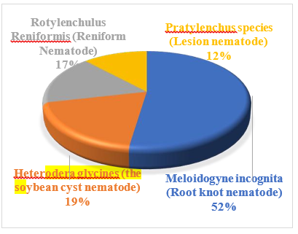

Graph 2 plant-parasitic nematode is typically linked to soybean damage in India

According to the analysis, Meloidogyne incognita, also known as the root-knot nematode, was cited by 110 respondents (52%) as the primary pest causing damage to soybeans. This suggests that the most frequently seen and identified issue in soybean fields is the root-knot nematode. Forty farmers (19%) identified the soybean cyst nematode, Heterodera glycines, indicating a moderate level of awareness of this species. Thirty-five farmers (17%) reported Rotylenchulus reniformis (reniform nematode), but only 25 farmers (12%) reported Pratylenchus species (lesion nematode). Overall, the results show that the most common and dominant species harming soybeans in the research area is the root-knot nematode, whereas knowledge of other nematode species is still relatively limited.

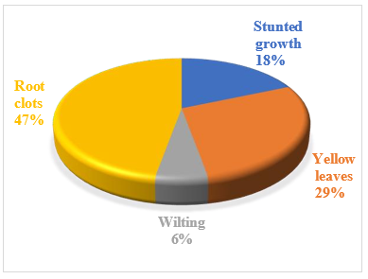

Graph 3 most prevalent symptoms of nematode-affected soybean plant

According to 99 farmers (47%), root galls or knots are the most frequently reported symptom of nematode-infected soybean plants, indicating significant root-knot nematode activity in the field. This was followed by 60 farmers (29%) reported yellowing of the leaves, which is indicative of a nutrient deficiency brought on by damaged root systems. 39 farmers (18%) reported stunted growth, indicating decreased plant development as a result of inadequate nutrient and water intake. Wilting symptoms were recorded by a smaller percentage of 12 farmers (6%), suggesting serious infestation in a small number of cases. Overall, the results show that the most common signs of nematode infestation in soybean crops are root damage symptoms, particularly root galls and yellowing.

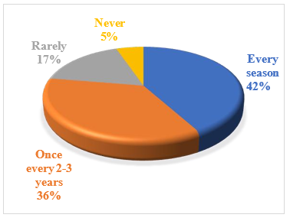

Graph 4 experience nematode infections on the soybean crop

Nematode infestation of soybeans is a common issue in the study area, according to the data. The largest group of farmers, 88 respondents (42%), stated that they were infected with nematodes each season, showing ongoing pressure from soil-borne pests. According to 75 farmers (36%), infestation occurs once every two to three years, with a moderate recurrence based on agricultural techniques and field conditions. A smaller subset of 36 farmers (17%) reported infrequent nematode issues, which may indicate improved field management or reduced infection levels. Only 11 farmers (5%) said they had never been infected by nematodes. Overall, the results indicate that nematode infestation is a persistent problem in soybean farming, necessitating consistent and efficient management techniques.

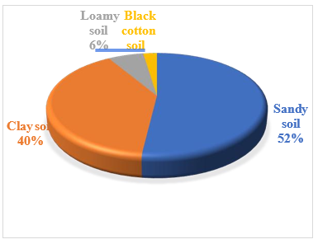

Graph 5 soil type in the region is the most easily affected by nematode infestation

The analysis indicates that sandy soil is most vulnerable to nematode infestation, with 109 respondents (52%) reporting it as highly affected.

This is followed by clay soil, reported by 83 farmers (40%), suggesting moderate susceptibility due to moisture retention conditions. Loamy soil was identified by 13 farmers (6%), indicating comparatively lower risk of nematode attack, while black cotton soil was least affected, reported by only 5 farmers (2%). Overall, the findings show that light-textured soils, especially sandy soils, are more prone to nematode infestation due to better aeration and easier movement of nematodes, highlighting the need for targeted soil management practices in such regions.

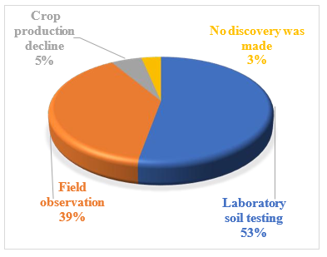

Graph 6 strategy for identifying nematode infestation

According to 111 respondents (53%), laboratory soil testing is the most commonly reported method used by farmers to detect nematode infestation, indicating an increasing dependence on scientific diagnosis. This was followed by 81 farmers (39%) who employed field observation to identify signs such as root damage and stunted development. A smaller subset of 11 farmers (5%) relied on a drop in crop production as a sign, which means that infestation was detected only after yield loss. Only 7 farmers (3%) stated that they had not found nematode infestation, indicating either a lack of awareness or the absence of obvious signs in their farms. Overall, the results show that field-based and reactive identification techniques are still commonly used, despite the growing adoption of scientific methodologies.

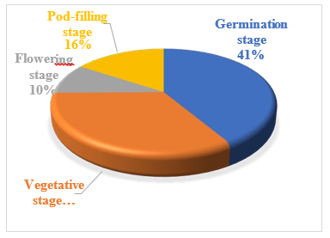

Graph 7 phase of soybean development do nematodes have the greatest impact

Because young seedlings are particularly susceptible to early root damage, the study shows that nematodes have the greatest impact during the germination stage, as indicated by 87 farmers (42%). The vegetative stage, where nematode feeding impacts plant growth and development, was reported next by 70 farmers (34%). Twenty farmers (10%) reported that the flowering stage had the least impact on yield formation, while 33 farmers (16%) classified the pod-filling stage as having a moderate impact. Overall, the results show that early growth stages especially germination and vegetative phases are most vulnerable to nematode infection, which, if left unchecked, can result in large output losses.

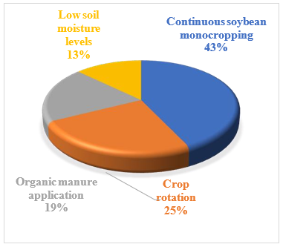

Graph 8 element raises nematode growth in soybean crops

The analysis shows that continuous soybean monocropping is the most significant factor increasing nematode growth, reported by 90 farmers (43%), as repeated cultivation allows nematode populations to build up in soil. This is followed by crop rotation, identified by 52 farmers (25%), which is generally a control practice but may be ineffective when not properly implemented. Organic manure application was reported by 41 farmers (20%), indicating that in some cases it may not be sufficient alone to suppress nematodes if not well decomposed or properly applied. Low soil moisture levels were mentioned by 27 farmers (12%), showing comparatively lesser influence. Overall, the findings suggest that poor cropping practices, especially continuous monocropping, play the major role in increasing nematode infestation in soybean fields.

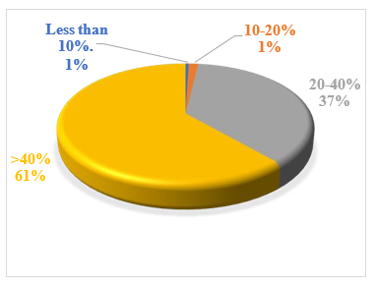

Graph 9 estimated yield loss owing to nematode attacks

The analysis indicates that nematode infestation causes significant yield losses in soybean production. A majority of farmers, 129 respondents (61%), reported more than 40% yield loss, showing severe impact on crop productivity. This is followed by 77 farmers (37%) who experienced 20–40% yield loss, indicating moderate damage levels in many fields. A very small proportion of 3 farmers (1%) reported 10–20% loss, while only 1 farmer (0.5%) observed less than 10% loss, suggesting minimal impact in rare cases. Overall, the findings clearly reveal that nematode infestation is a major constraint in soybean cultivation, leading to substantial economic losses and highlighting the urgent need for effective management strategies.

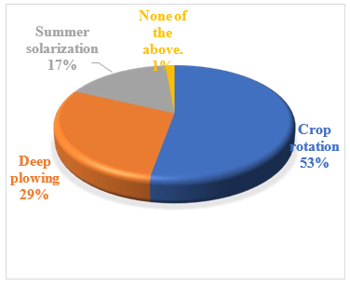

Graph 10 cultural practices do you use to control nematodes

According to the analysis, crop rotation is the most commonly reported cultural method for controlling nematodes, as stated by 111 farmers (53%), demonstrating its widespread use in soybean farming. Deep ploughing, which is used by 61 farmers (29%), was reported next and helps lower nematode survivability by exposing them to heat and predators. Because of financial and weather-related limitations, 35 farmers (17%) employed summer solarisation, indicating a limited but noteworthy uptake. Nearly all farmers reported using at least one cultural method, as only 3 farmers (1%) reported not using any of the aforementioned techniques. Overall, the results show that cultural methods are widely used, with crop rotation being the most favoured nematode management tactic.

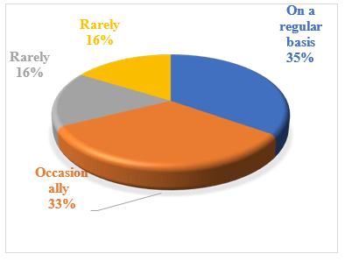

Graph 11 used nematicides on your soybean crops

The analysis indicates that the use of nematicides among soybean farmers is common but varies in frequency. A total of 73 farmers (35%) reported using nematicides on a regular basis, showing a consistent dependence on chemical control methods. 69 farmers (33%) use them occasionally, indicating moderate reliance depending on infestation severity. 34 farmers (16%) reported using them rarely, while another 34 farmers (16%) also fall under the same rare-use category (as per repeated response grouping). Overall, the findings suggest that while chemical control is widely practiced in the study area, many farmers use nematicides only when necessary, reflecting a gradual shift toward more cautious and need-based application.
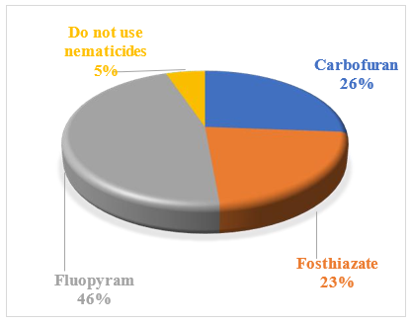
Graph 12 nematicide recommend for soybean nematode management
According to the analysis, Fluopyram is the most frequently recommended nematicide for managing soybean nematodes, as indicated by 97 farmers (46%), indicating its greater acceptance among respondents. Following this, 55 farmers (26%) reported carbofuran, and 47 farmers (22%) reported fosthiazate, indicating a moderate preference for conventional chemical choices. Eleven farmers, or 5% of the total, stated that they do not use nematicides, indicating a preference for integrated or non-chemical methods. Overall, the results indicate that farmers continue to rely heavily on chemical nematicides, with fluopyram being the most commonly reported choice in the study region.

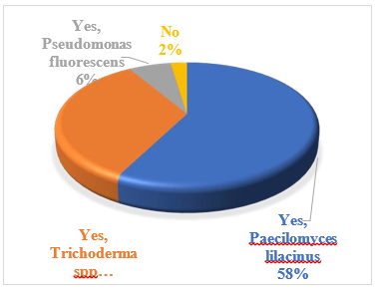
Graph 13 biological control strategies for nematode management

According to the analysis, biological control methods are frequently used in soybean farming to manage nematodes. For control of nematode eggs, Paecilomyces lilacinus is the most favoured bioagent, as evidenced by the fact that 121 farmers (58%) reported using it. Next, 71 farmers (34%) use Trichoderma spp., which is also also frequently used in soil-health and soil-borne disease management. Pseudomonas fluorescens was used by a smaller proportion of 13 farmers (6%), indicating a limited but growing use of bacterial bioagents. In the research area, biological approaches are widely accepted, as evidenced by the 5 farmers (2%) who reported not applying any biological control strategies. Overall, the results show that soybean producers are increasingly adopting environmentally benign nematode management techniques.
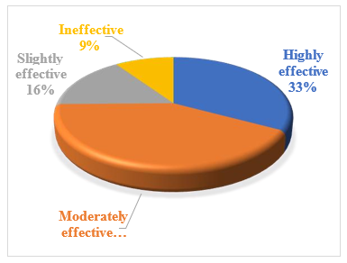
Graph 14 existing nematode management strategies

According to the analysis, farmers believe that their current methods for managing nematodes in soybean production are moderately effective overall. 88 farmers, or 42% of the total, stated that their methods are moderately effective, indicating some control over nematode infestation. This was followed by 69 farmers (33%) reported that their tactics were highly effective, suggesting that integrated approaches are performing well in certain areas. Twenty farmers (10%) considered their approaches as ineffective, indicating significant management issues in some places, while 33 farmers (16%) considered them slightly effective, indicating limited control in certain settings. Overall, the results indicate that although current nematode management techniques offer a moderate level of control, their efficacy still needs to be improved for more reliable and long-lasting outcomes.
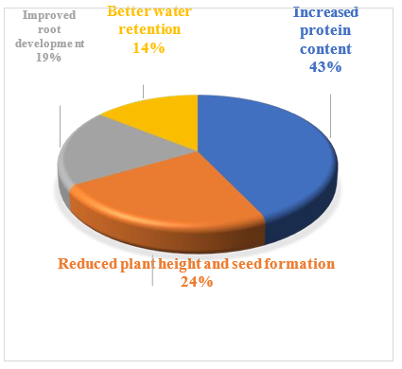
Graph 15 prevalent impact caused by nematode infestations on soybean yield
According to the analysis, 90 farmers (43%) indicated increased protein content as the most frequent effect of nematode infection. This may reflect an indirect or misinterpreted perception associated with plant stress. 50 farmers (24%) reported decreased plant height and poor seed development as another effect, suggesting a direct detrimental impact on soybean production and output. 40 farmers (19%) reported improved root development, and 30 farmers (14%) reported better water retention. These responses were less frequent and may reflect differences in farmer perception or field conditions. Overall, the results indicate that nematode infestation primarily results in decreased soybean growth and production performance, while farmers' perceptions of these effects differ greatly.
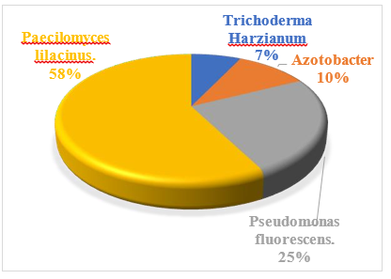
Graph 16 bio-agent is frequently used to deal with plant-parasitic nematodes

According to 121 farmers (58%), Paecilomyces lilacinus is the most commonly employed bioagent for controlling plant-parasitic nematodes, indicating its widespread reported use in soybean farming. Pseudomonas fluorescens, which is used by 52 farmers (25%), was reported next, indicating its increasing use because of its ability to control nematodes and promote plant growth. Twenty-two farmers (11%) reported using Azotobacter, indicating moderate use mainly for improving soil fertility and indirectly suppressing nematodes. Despite being acknowledged for its role in soil health and pathogen management, Trichoderma harzianum was the least-used bioagent, as stated by 15 farmers (7%). Overall, the results indicate that fungal bio-agents specifically, Paecilomyces lilacinus—are strongly preferred in biological nematode management techniques.

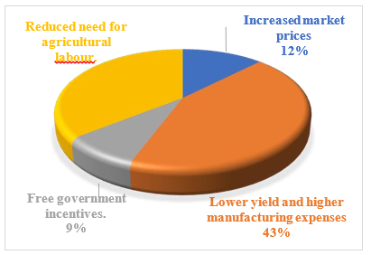
Graph 17 financial effect of a severe nematode infection on soybean farmers

According to 91 farmers (43%), the most frequently reported financial impact of a severe nematode infestation is lower yield and higher production costs. This indicates a substantial economic loss as a result of decreased productivity and higher input costs. Following this, 75 farmers (36%) reported a reduced demand for agricultural labour, which reflects a decline in farming activity and job prospects during severely impacted seasons. Twenty-six farmers (12%) reported higher market prices, which may reflect reduced supply but may not compensate for yield losses. Government incentives were reported by a lesser percentage of 18 farmers (9%), suggesting limited access to or knowledge of support programmes. Overall, the results indicate that nematode infection has a significant detrimental financial impact on soybean farmers, primarily due to decreased output and higher production costs.
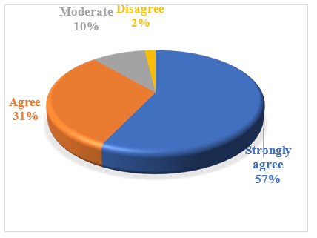
Graph 18 nematodes provide a significant danger to soybean output in India
According to the analysis, most respondents considered that nematodes pose a significant risk to India's soybean crop. 120 farmers (57%) strongly agree that nematodes constitute a serious threat, demonstrating a high level of understanding of their detrimental effects on crop health and output. This is followed by 66 farmers (31%) who agree, indicating that nematode infestation is a common concern. Twenty farmers, or 10% of the total, had a neutral opinion, indicating some doubt about how serious the issue is. Only a small proportion rejected the view that nematodes pose a substantial risk, with only 4 farmers (2%) disagreeing. Overall, the results indicate that the majority of surveyed farmers viewed nematodes as a significant barrier to soybean yield.
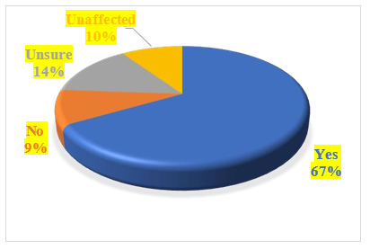
Graph 19 climate change may be increasing nematode infection in soybean crops

According to the analysis, most farmers perceived climate change as contributing to increased nematode infestation in soybean crops. A total of 140 farmers (67%) answered “yes”, indicating a strong perception that shifting rainfall and temperature patterns increase nematode activity. Thirty farmers (14%) expressed uncertainty, showing a lack of clarity regarding the relationship between nematode infestation and climate change. Twenty farmers (10%) who said "no" and another twenty farmers (10%) who said "unaffected" indicate that a smaller proportion does not link nematode issues to climate change. Overall, the results show that farmers believe that climate variability has a significant impact on nematode infection in soybean production.
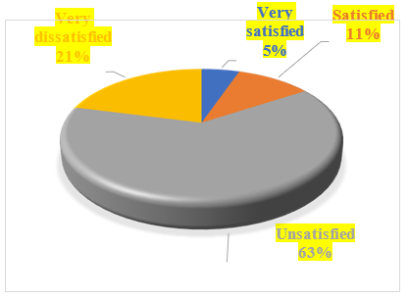
Graph 20 satisfied are farmers with the present yields from nematode-affected soybean crops
According to the data, farmers were generally dissatisfied with soybean yields when nematodes are present. Nematode infection was perceived to have considerably reduced crop productivity, as indicated by the majority of 133 farmers (63%) who expressed dissatisfaction.
Following this, 44 farmers (21%) reported being very dissatisfied, which is indicative of significant crop losses and financial strain. Only 22 farmers (10%) reported being satisfied with their yields, and only 11 farmers (5%) reported being very satisfied. Overall, the results indicate that the majority of farmers are dissatisfied with the current yields from nematode-affected soybean crops, underscoring the need for better and more efficient management techniques.
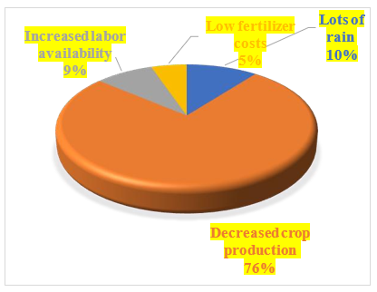
Graph 21 cause for farmer unhappy with nematode infestations

According to the analysis, 159 farmers (76%) cited reduced agricultural production as the primary reason for their dissatisfaction with nematode infestation, suggesting that yield loss is the main concern. This was followed by heavy rainfall, reported by 22 farmers (10%), indicating that in certain situations, too much rainfall may exacerbate nematode-related field conditions. Only 11 farmers (5%) mentioned low fertiliser costs as a consideration, which is less directly tied to nematode impact, while a lesser percentage of 18 farmers (9%) mentioned greater labour availability. Overall, the results indicate that farmer discontent in nematode-affected areas is primarily caused by decreased soybean productivity.
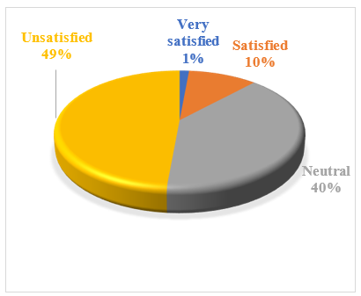
Graph 22 farmers satisfied with chemical nematicides as a solution

According to the data, farmers are generally dissatisfied with chemical nematicides as a nematode management option. Concerns regarding limited effectiveness, cost, or long-term soil consequences were expressed by the majority of 102 farmers (49%) who expressed dissatisfaction. Following this, 83 farmers (40%) were neutral, indicating a lack of confidence in their overall performance. Three farmers (1%) were very satisfied with chemical nematicides, while only 22 farmers (10%) reported being satisfied. Overall, the results indicate that farmer satisfaction is limited, underscoring the need for more integrated and sustainable nematode management strategies.
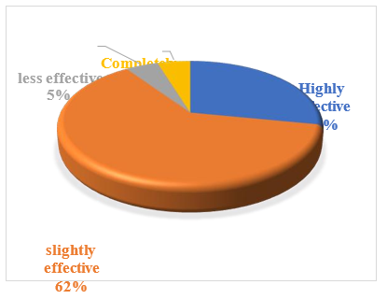
Graph 23 farmers evaluate the effectiveness of biological pesticides

According to the data, farmers believe biological pesticides are only moderately effective at controlling nematode infection in soybean crops.
A total of 131 farmers (62%) considered them only slightly effective, indicating that although they offer some control, the outcomes are not entirely satisfactory. This was followed by 59 farmers (28%) who considered them highly effective, indicating that a sizable portion of respondents rated them favourably. A smaller proportion of 10 farmers (5%) considered them less effective, while another 10 farmers (5%) considered them completely ineffective. Overall, the results indicate that biological pesticides were perceived as only partially effective, with room for improvement in field-level consistency and performance.
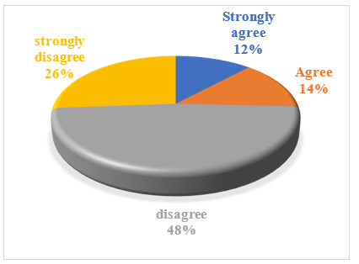
Graph 24 farmers believe that government or agricultural improvement support are sufficient

According to the analysis, the majority of farmers believe that agricultural or governmental support is insufficient for nematode management. The largest group, comprising 101 farmers (48%), disagreed, suggesting that they do not think the support programmes in place are sufficient. Fifty-five farmers (26%) strongly disagreed, indicating a higher level of dissatisfaction with institutional support. Only 25 farmers (12%) strongly agreed that support is adequate, while 29 farmers (14%) agreed. Overall, the results indicate that the majority of farmers believe that government and agricultural support programmes are insufficient to effectively combat nematode infestation in soybean farming.
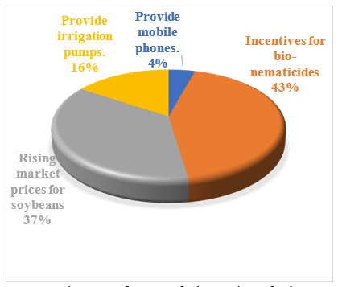
Graph 25 farmers feel requires further government support
According to 91 farmers (43%), incentives for bio-nematicides are the most favoured area requiring government support, demonstrating a high need for affordable and environmentally compatible nematode management solutions. Following this, 77 farmers (36%) recommended higher market prices for soybeans, indicating farmers' desire for greater income and profitability. 33 farmers (16%) mentioned the availability of irrigation pumps, underscoring the necessity of better irrigation infrastructure to lessen crop stress and nematode severity. Digital assistance tools were less frequently requested, with 9 farmers (4%) suggesting the provision of mobile phones. Overall, the results show that improving soybean output and nematode management mostly requires financial and input-based government support.
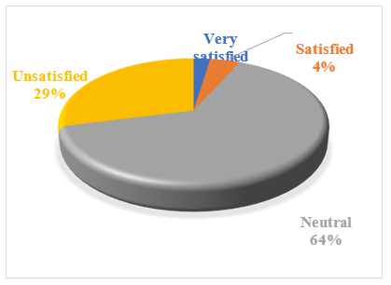
Graph 26 farmers with existing nematode control practices for soyabean crops
According to the analysis, farmers are generally neutral or dissatisfied with the nematode management methods currently used in soybean farming. A majority of 135 farmers (64%) were neutral regarding the efficacy of the control measures in place. This was followed by 61 farmers (29%) who were dissatisfied, which reflects worries about ongoing output losses and insufficient nematode control. Five farmers (2%) were very satisfied with current techniques, while 9 farmers (4%) were satisfied. Overall, the results show that most farmers are not fully convinced of the effectiveness of the nematode control techniques currently in use, underscoring the need for more effective and long-lasting solutions.
The results demonstrate that farmers have a moderate to high degree of awareness about nematode infestation, with the majority of respondents able to recognise typical symptoms such as yellowing, stunted growth, and root galls. However, there is still a lack of knowledge among farmers about nematode species other than Meloidogyne incognita. Nematode infestation is also common, according to the study, with many farmers reporting yearly or seasonal occurrences, especially in sandy soils and areas under continuous soybean cultivation. This is consistent with earlier research indicating that inadequate soil management techniques and monocropping greatly increase the accumulation of nematode populations. Nematodes are a major financial barrier in soybean farming, as evidenced by the greatest yield losses (>40%) recorded by the majority of farmers.
In terms of management practices, farmers predominantly rely on cultural methods such as crop rotation and deep ploughing, along with increasing use of biological agents such as Paecilomyces lilacinus and Trichoderma spp. Chemical nematicides, especially fluopyram, are still widely used, although farmer satisfaction with chemical control is generally low. This indicates a gradual but incomplete shift towards integrated nematode management (INM), where biological and cultural methods are gaining importance but have not fully replaced chemical dependence.

The results further show that biological pesticides are perceived as moderately effective, suggesting potential for expansion but also highlighting inconsistency in field performance. Farmers’ dissatisfaction with current management practices and government support indicates the need for stronger extension services, training programmes, and institutional interventions. Additionally, concerns about climate change influencing nematode outbreaks reflect growing farmer awareness of environmental impacts on pest dynamics. Overall, the study confirms that while multiple management strategies are being used, none was perceived to provide complete control under current conditions. This indicates the need for a more integrated, location-specific, and sustainable nematode management approach combining resistant varieties, biological control, improved cultural practices, and supportive government policies to enhance soybean productivity and farmer income.
6. Conclusion
Plant-parasitic nematodes are a serious and ongoing issue in Washim District's soybean-growing regions, as the study on management techniques and control measures for nematode infestation in soybean production clearly indicates. High infestation levels, recurrent production losses, and obvious crop damage, especially from root-knot nematodes, were observed by farmers. The results show that early crop stages such as germination and vegetative phases, sandy soils, and continuous monocropping are the most susceptible to nematode infestation.
Plant-parasitic nematodes, of which Meloidogyne incognita is the most common species (52%), constitute a significant barrier to soybean production, according to a study conducted in Washim District. A significant percentage of farmers reported seasonal infection with output losses surpassing 40% (61%), and the majority reported obvious symptoms such as root galls (47%) and leaf yellowing (29%). Monocropping techniques and sandy soils (52%) were found to be important factors associated with the occurrence of nematodes. Crop rotation (53%), deep ploughing (29%), and biological control agents such as Paecilomyces lilacinus (58%) were the most commonly used methods reported by farmers; the most commonly reported chemical nematicide was fluopyram (46%). Overall, the findings show that while a variety of control methods are employed, their efficacy is only moderate, underscoring the necessity of more robust integrated nematode management techniques.

Additionally, the study shows that farmers are increasingly using a mix of chemical, biological, and cultural management techniques. The most commonly used cultural techniques are deep ploughing and crop rotation, while biological agents such as Trichoderma spp. and Paecilomyces lilacinus are frequently employed. Despite the continued preference for chemical nematicides such as fluopyram, farmer satisfaction with chemical management is comparatively poor, suggesting limitations in sustainability and effectiveness. The survey also shows that farmers have a modest level of awareness and a strong belief that nematodes substantially reduce soybean output and income. The majority of farmers voiced discontent with present yields, control methods, and insufficient government assistance. Thus, the study concludes that sustainable soybean production and efficient nematode control in the area depend on integrated nematode management strategies, greater farmer training, improved access to biological inputs, and stronger institutional support.

7. Future Scope
To determine the most successful and financially feasible combinations under various agroclimatic conditions, future research can focus on large-scale field validation of integrated nematode management (INM) techniques combining cultural, biological, and chemical strategies. Additionally, future studies could develop and assess nematode-resistant soybean cultivars that are tailored to the soil and climate of the area. For the early detection and prediction of nematode infestation, technologies including machine learning, drone-based crop monitoring, and remote sensing could be further investigated. Furthermore, molecular and biotechnological methods, including gene editing and the creation of bio-nematicides, offer potential for long-term pest management.
To close the gap between field-level behaviours and scientific recommendations, future research could also focus on enhancing farmer knowledge, adoption behaviour, and training initiatives. To find affordable solutions for small and marginal farmers, economic evaluation of various management techniques is also important. Furthermore, long-term research¬ on biodiversity, soil health, and the effects of climate change on nematode dynamics may support the development of more robust soybean production systems.
Limitation
This study was based on a descriptive survey of 210 soybean farmers in Washim District, which may limit the generalisability of the findings beyond the study area. The specific sampling procedure and study duration were not clearly detailed. Data were derived mainly from questionnaires and field observations, making the results dependent on farmers’ awareness, recall, and perceptions. Nematode infestation, yield loss, and management effectiveness were not independently validated through controlled field experiments or systematic laboratory measurements. Potential influences of soil, climate, farm management, and other production factors were not separately controlled. Future multi-location studies using longitudinal field and laboratory assessments are recommended.

Declaration of AI Use
This manuscript was prepared through the intellectual contributions of the author(s) to the study design, data analysis, interpretation of results, and scholarly content. Grammarly and ChatGPT were used solely to assist with grammatical refinement and reference formatting during manuscript revision. The author(s) accept full responsibility for the accuracy, integrity, and final content of the manuscript.

COMPETING INTERESTS DISCLAIMER:
Authors have declared that they have no known competing financial interests OR non-financial interests OR personal relationships that could have appeared to influence the work reported in this paper.

References
Abd-Elgawad, M. M. M. (2025). Integrated nematode management strategies: Optimization of combined nematicidal and multi-functional inputs. Plants, 14(7), 1004. https://doi.org/10.3390/plants14071004
Abhishek, & Shiwangi. (2024). Integrated nematode management (INM). In S. Menon, A. K. Maurya, D. Patra, & P. Jayswal (Eds.), Futuristic trends in agriculture engineering & food sciences (Vol. 3, Book 6, pp. 72–82). Iterative International Publishers. https://doi.org/10.58532/V3BCAG6P1CH8
Arjoune, Y., Sugunaraj, N., Peri, S., Nair, S. V., Skurdal, A., Ranganathan, P., & Johnson, B. (2022). Soybean cyst nematode detection and management: A review. Plant Methods, 18, 110. https://doi.org/10.1186/s13007-022-00933-8
Bissonnette, K. M., Barizon, J., Adee, E., Ames, K. A., Becker, T., Biggs, M., Bradley, C. A., Brown, M., Byamukama, E., Chilvers, M. I., Faske, T. R., Harbach, C. J., Jackson-Ziems, T. A., Kandel, Y. R., Kleczewski, N. M., Koehler, A. M., Markell, S. G., Mueller, D. S., Sjarpe, D. A., ... Tenuta, A. U. (2024). Management of soybean cyst nematode and sudden death syndrome with nematode-protectant seed treatments across multiple environments in soybean. Plant Disease, 108(6), 1729–1739. https://doi.org/10.1094/PDIS-02-23-0292-RE
Gorny, A. (2025). Soybean nematode management. In North Carolina soybean production guide (Chapter 8). NC State Extension. https://content.ces.ncsu.edu/north-carolina-soybean-production-guide/8-soybean-nematode-management
Jjagwe, P., Chandel, A. K., & Langston, D. B. (2024). Impact assessment of nematode infestation on soybean crop production using aerial multispectral imagery and machine learning. Applied Sciences, 14(13), 5482. https://doi.org/10.3390/app14135482
Júnior, M. T. A., Dos Santos, A. F., Barros, D. I., Quirino, M. S., Nunes, H. V., Sales, P. V. G., de Oliveira, L. B., da Costa Leite, O., Gonçalves, F. B., da Silva Reis, A., Lima Vale, K. C., Ribeiro Pinto, J., Coelho de Aguiar, E., & di Napoli Nunes, B. H. (2022). Nematodes, a problem for soybean crops in the Brazilian Cerrado. Journal of Scientific Research and Reports, 28(6), 1–6. https://doi.org/10.9734/jsrr/2022/v28i630522
Kigeso, A. M., Andika, D. O., & Nzogela, Y. B. (2024). Management of root knot nematode Meloidogyne incognita using black soldier fly frass in soybean [Glycine max (L.)]. Journal of Current Opinion in Crop Science, 5(2), 103–112. https://doi.org/10.62773/jcocs.v5i2.247
Kranti, K. K. V. V. S., Supriya, P., Keshari, N., Salalia, R., Gunda, N. K., Sehgal, M., & Malik, M. (2021). Good agricultural practices for nematode management in horticultural crops. International Journal of Agriculture, Environment and Sustainability, 3(1), 17–25. https://medicaljournalshouse.com/index.php/Int-J-Agriculture-Environment/article/download/755/564/3474
Lavhe, N. V., Undirwade, D. B., Gokte-Narkhedkar, N., & Borkar, S. L. (2019). Locating areas of high density of plant parasitic nematode, Rotylenchulus spp. in Vidarbha region of Maharashtra State, India. International Journal of Current Microbiology and Applied Sciences, 8(12), 142–151. https://doi.org/10.20546/ijcmas.2019.812.022
Lima, F. S. O., Correa, V. R., Nogueira, S. R., & Santos, P. R. R. (2017). Nematodes affecting soybean and sustainable practices for their management. In Soybean – The basis of yield, biomass and productivity. IntechOpen. https://doi.org/10.5772/67030
Nisha, M. S. (2024). Nematode management in plantation crops and spices. Indian Journal of Nematology, 53(Special Issue), 61–73. https://doi.org/10.5958/0974-4444.2024.00006.7
Olaifa, G. O., & Adekunle, O. K. (2021). Effects of selected animal manures on plant-parasitic nematodes infecting yam species. Asian Journal of Plant and Soil Sciences, 6(1), 202–210. https://doi.org/10.56557/ajopss/2021/v6i130
Senthil Kumar, P., Pragadeesh, A. R. U., Sandhya, N., Abishagu, A., & Senthil Kumar, M. (2025). Management of nematode menace in protected cultivation of vegetables in India. Plant Science Today, 12(2). https://doi.org/10.14719/pst.6862
Sharma, A. N., Gupta, G. K., Verma, R. K., Sharma, O. P., Bhagat, S., Amaresan, N., Saini, M. R., Chattopadhyay, C., Sushil, S. N., Asre, R., Kapoor, K. S., Satyagopal, K., & Jeyakumar, P. (2014). Integrated pest management for soyabean. National Centre for Integrated Pest Management. https://www.niphm.gov.in/IPMPackages/Soyabean.pdf
Shinde, L. V., Phalke, G. B., & Harde, S. N. (2018). Plant parasitic nematodes associated with soybean (Glycine max L.) fields from Godavari Basin (M.S.) in Jalna District, India. International Journal of Agriculture & Environmental Science, 5(6), 66–69. https://doi.org/10.14445/23942568/IJAES-V5I6P111
Silva, G. M., Campos, E. V. R., de Oliveira, F. F., Rodrigues, J. de S., Proença, P. L. de F., Melo, A. A., & Fraceto, L. F. (2025). Harnessing nanotechnology and bio-based agents: Advanced strategies for sustainable soybean nematode management. Plant Nano Biology, 13, 100195. https://doi.org/10.1016/j.plana.2025.100195
Swain, S. K. (2025). Integrated nematode management: A holistic approach to crop protection. Agri Articles, 5(2), 8–10. https://agriarticles.com/wp-content/uploads/2025/03/E-05-02-02-08-10.pdf
Tian, Z., Zhou, N., Yang, H., Gao, X., Liu, L., Peng, D., & Han, S. (2025). Chemical and biological controls and soil amendments for plant-parasitic nematode management. New Plant Protection, 2(4), e70020. https://doi.org/10.1002/npp2.70020
Yadav, U. (2017). Recent trends in nematode management practices: The Indian context. International Research Journal of Engineering and Technology, 4(12), 482–487. https://www.irjet.net/archives/V4/i12/IRJET-V4I1290.pdf
Yates, P., Janiol, J., Li, C., & Song, B.-H. (2024). Nematocidal potential of phenolic acids: A phytochemical seed-coating approach to soybean cyst nematode management. Plants, 13(2), 319. https://doi.org/10.3390/plants13020319

