Original Research Article
Morphological, Histological and Histochemical Studies on the Gizzard of Post-natal Haringhata Black Chickens

.
ABSTRACT

Background: Breed- and age-specific information on the postnatal gizzard of Haringhata Black chickens is limited.
Aims: The present research was carried out to explore the morphological, morphometric, histological and histochemical aspects and localisation of mast cells in the gizzard of Haringhata Black chickens.
Study design: The investigation was carried out on 60 Haringhata Black chickens divided into five groups, viz. day-old, 15-day-old, 30-day-old, 45-day-old and 60-day-old birds, with six birds of each sex in each age group.
Place and Duration of Study: Department of Veterinary Anatomy and Histology, Faculty of Veterinary and Animal Sciences, West Bengal University of Animal and Fishery Sciences, Kolkata-700037, India, between June 2022 and January 2023.
Methodology: A total of 60 Haringhata Black chickens aged 0, 15, 30, 45 and 60 days, comprising 6 birds of each sex in each age group, were sacrificed and the gizzards were examined for gross morphological and morphometric studies. Portions of the gizzard were fixed in normal buffered formalin and later processed and prepared for histological and histochemical studies.
Results: The gizzard of the Haringhata Black chicken was a highly muscular, dark-brown, biconvex, lens-like organ covered by a considerable amount of fat. It was made up of four tunics: mucosa, submucosa, muscularis and serosa. The mucosal epithelium reacted positively to PAS-AB staining, indicating the presence of acidic and neutral mucins. A thick cornified layer, the koilin, lined the lumen of the gizzard, covered the mucous layer externally and showed moderate reactivity to PAS-AB stain. A distinct lamina muscularis was absent in the tunica mucosa of the gizzard of Haringhata Black chickens. The submucosa was composed of loose connective tissue, mainly collagen fibres. Mast cells were noticed within the connective tissue fibres in this layer. The tunica muscularis was very thick and organised in three layers: the inner oblique layer, the thick intermediate circular layer and an outer longitudinal layer. The outer serosa was typical and rich in blood vessels and nerves.
Conclusion: The study provides information on the gross morphology, morphometry, histology and histochemical characteristics of the gizzard of the Haringhata Black chicken at different developmental stages. The observations of the present study may serve as useful baseline data for future studies on the developmental anatomy, comparative morphology, physiology and pathological alterations of the gizzard in Haringhata Black chickens and other indigenous chicken breeds.

Keywords: Haringhata Black chicken; gizzard; ventriculus; gross morphology; morphometry; histology; koilin; mast cells
1. INTRODUCTION
Human dependence on agriculture dates back thousands of years. Animal husbandry is an integral part of agriculture because humans benefit substantially from rearing animals and birds. Rearing poultry birds, especially chickens, contributes substantially to the economy of farmers and the nation. The rapid rise in the human population results in an increased demand for protein and other nutrients. Poultry farming plays a key role in meeting this increasing demand for protein in the form of protein-rich meat and eggs.
Recent characterisation of indigenous chickens reared under backyard systems has further demonstrated the usefulness of breed-specific baseline information for documenting local chicken populations (Kumar et al., 2025).
The Haringhata Black chicken
The Haringhata Black (HB) chicken is an indigenous poultry breed native to West Bengal, India. Its primary breeding tract is located in Haringhata and Chakdah blocks of Nadia district, with the breed also occurring in adjoining areas, including Amdanga and Bongaon blocks of North 24 Parganas district, West Bengal. Haringhata Black chicken is the only registered indigenous chicken breed of West Bengal reported to date with accession number 12008 (Pal et al., 2020). This medium-sized chicken with a compact body is reared for both meat and eggs. Black feathers with a red-coloured single comb, ear lobe, wattle and white shanks are the characteristic features of this breed. They are well tolerated, and their survival ability against predators is commendable, which makes them different from other chicken breeds. These birds are genetically superior to most other chickens and have very good resistance to diseases (Mandal, 2020). The Haringhata Black chicken can be reared in the backyard poultry farming system with minimum investment and on commercial farms under the deep-litter system. The by-products obtained from these birds can be used for making pillows, brooms, brushes and many other fancy things.
Age-related comparative anatomical and histochemical studies have recently been reported for the bursa of Fabricius of Haringhata Black chickens, providing a precedent for age-specific structural characterisation in this breed (Chaudhury et al., 2026).
The anatomy of the chicken gastrointestinal tract influences the utilisation of feed processed by it. The anterior portion of the tract is adapted for ingestion, storage, and partial digestion of starch and proteins (Turk, 1982). Chickens cannot bite their food as they lack teeth. The ingested feed is moistened by the saliva secreted by the salivary glands present in the mouth. The feed is then pushed down the throat by the tongue.
Comparative assessment of gastrointestinal tract dimensions across chicken breeds has been used to characterise breed-related anatomical variation in the digestive system (Neuhaus et al., 2024).
Stomach: The stomach consists of two major compartments: the proventriculus and the gizzard. The proventriculus is a cylindrical structure located between the oesophagus and gizzard and is often referred to as the true stomach of birds as enzymatic digestion takes place in this compartment. The next compartment of the chicken stomach after the proventriculus is the gizzard or the ventriculus. It is a hard, muscular, almost round (biconvex) structure in which the feed materials are broken down into minute particles through muscular contraction.
Recent work in chickens has also combined digestive tract histology with segment-specific gastrointestinal characterisation, illustrating the value of anatomical assessment for describing the organisation of the avian digestive system (Guo et al., 2023).
However, an explicit gap remains in the breed- and age-specific integrated description of the gross morphology, morphometry, histology and histochemistry of the gizzard in postnatal Haringhata Black chickens.
Considering the typical role of the gizzard and the paucity of relevant literature, the present study was undertaken to understand the morphology, histology and histochemistry of the gizzard of Haringhata Black chickens at different ages.

2. Materials and Methods

2.1 Procurement and Distribution of Experimental Birds:
A total of 60 Haringhata Black chickens were slaughtered for the present investigation. The birds were procured from State Poultry Farm-1, Mohanpur, Nadia, West Bengal. The birds were divided into five groups according to age, viz. day 0, 15, 30, 45 and 60 days. Each group consisted of 12 birds. The male-to-female ratio was 1:1 in each group. No housing or feeding was required by the investigators because birds from each age group were brought from the farm on the specified slaughter days.
2.2 Collection of Specimens and Preservation:
For the present study, birds of the desired ages were procured from the farm and the live weights of the birds were recorded using a digital weighing balance. The birds were then sacrificed by cervical dislocation after anaesthetising them with chloroform vapour. The thoracic and abdominal cavities were opened to observe the in situ positioning of the different segments of the digestive tract and the associated organs. The gizzard was then dissected out, cleaned and measured before being preserved in 10% NBF.
2.3 Gross Morphometry:
After sacrificing the birds, the abdominal and thoracic cavities were opened along the mid-ventral border of the bird’s body. The intact digestive tract from oesophagus to cloaca was then separated. The gizzards were then weighed separately. The length and diameter of the gizzard were measured using a Vernier scale and recorded. After gross morphometry, the samples were preserved in 10% neutral buffered formalin (NBF) for histological and histochemical studies.
2.4 Gross Photography:
Immediately after opening the body cavities of the birds along the mid-ventral border, gross photographs were taken to document the anatomical positions of the digestive tract and its relationships with adjacent organs before gross morphometry. Photographs of the gizzard were taken after it was dissected from the digestive tract.
2.5 Chemicals:
All chemicals and glassware were purchased from Sigma Chemicals (USA), Allied Scientific products (India), Merck (India), HiMedia (India) and Rankem (India).
2.6 Equipment:
- Leica DM 2000 microscope
- Leica QWIN software for image analysis
- Leica rotary microtome
2.7 Processing of Tissues, Block Preparation and Sectioning:
All the fixed tissues were washed overnight, dehydrated in ascending concentrations of alcohol, cleared with acetone and benzene, impregnated with molten wax, and paraffin blocks were prepared before sectioning (Luna, 1968). All sections were cut at 5 µm thickness using a Leica 2125 DM rotary microtome. The sections were taken on clean, grease-free, albuminised glass slides for histological and histochemical staining.
2.8 Staining Methods:
The sections were then stained using the following methods to demonstrate the histological organisation and histochemical characteristics:
A) Mayer’s Haematoxylin and Eosin (H&E) staining method for general histological observations (Luna, 1968).
B) Masson’s Trichrome (MT) staining method for visualisation of collagen fibres (Luna, 1968).
C) PAS-Alcian Blue (PAS-AB) staining method for demonstration of mucopolysaccharides (Luna, 1968).
D) Weigert’s Resorcin Fuchsin (Weigert’s) staining method for demonstration of elastic fibres (Sheehan & Hrapchak, 1973).
E) Metachromasia by Toluidine Blue (TB) for mast cells (Luna, 1968).

2.9 Photomicrography:
The stained slides were examined under a light microscope (Leica DM2000) to study histological organisation and histochemical characteristics, and photomicrographs were obtained using a Leica DM2000 microscope equipped with a Leica camera at different magnifications.
2.10 Micrometry:
Leica Qwin Image Analyser software on a Leica DM2000 microscope was used to obtain micrometric data from the stained sections.
2.11 Statistical Analysis:
The recorded data were analysed statistically according to the standard method described by Snedecor and Cochran (1989), using SPSS version 17.0 software.

3. Results and Discussion
3.1 Gross Morphology of the Gizzard:
The gizzard of the Haringhata Black chicken was a highly muscular, dark-brown organ and was covered by a considerable amount of fat. It was biconvex lens-like in appearance and was almost round to oval in shape. The surfaces of the gizzard presented a shiny layer of tendinous tissue that was thicker at the centre and thinner at the edges. Thick, cream-coloured corneous tissue covered the inner surface of the gizzard and was raised into ridges (Fig. 1). This surface functioned as the bird’s teeth and was made up of strong keratinised material called koilin. This layer protected the gizzard from the damaging effects of the HCl and pepsin originating from the proventriculus and the muscular action on the food. The gizzard consisted of a body, a craniodorsal and a caudoventral blind sac. Two pairs of opposing thick and thin muscles were observed in the gizzard. The thick muscle masses were inserted into the tendinous centres, one on each surface, while the thinner muscles covered the blind sacs. The caudoventral and craniodorsal thin muscles lined the caudoventral and craniodorsal portions of the gizzard, respectively. The cranioventral and caudodorsal thick muscles aided in the powerful grinding contractions for breaking up the feed materials into smaller pieces. The four muscles were arranged in an asymmetrical manner, which helped in mixing and grinding actions during contraction. The proventriculus communicated with the cranial aspect of the craniodorsal blind sac through the isthmus, whereas the small intestine originated from the cranial portion of the right surface of the gizzard via the pyloric opening. The gizzard was situated within the thoraco-abdominal cavity, immediately caudal to the proventriculus and in close association with the hepatic lobes (Fig. 2). Cranially, the gizzard was in contact with the caudal extremity of the left hepatic lobe, producing a pronounced impression, whereas caudally it was related to the duodenum and pancreas. Its dorsal surface was associated with the testis in males and the ovary in females, while its ventral surface rested against the floor of the abdominal cavity. The left surface was related to the left abdominal wall and the visceral surface of the left hepatic lobe. Cranially, the right surface was associated with the spleen and the visceral surface of the left hepatic lobe, upon which it produced a deep impression. The ventral portion of the right surface was related to the duodenum and jejunum.

The average weight, length and diameter of the gizzard were lowest in day-old birds and highest in 60-day-old birds of both sexes (Graphs 1-3). There were no significant differences in gizzard weight, length or diameter between males and females within the same age groups. However, the weight, length and diameter of the gizzard in each sex differed significantly (p < 0.05) among age groups (Graphs 1-3).
The present morphological observations of the gizzard were consistent with those of Nasrin et al. (2012) in broilers, as well as with the earlier statements on domestic fowls by Getty (1975). In the present study, the gizzard was larger than the proventriculus. Sinha and Mrigesh (2018) also reported that the gizzard of Uttara fowl was larger than the proventriculus. Klasing (1999), Al-Saffar and Al-Samawy (2016) and AbdElnaeem et al. (2019) in birds, domestic pigeons and kingfishers, respectively, reported that the inner surface of the gizzard was covered by a thick keratinised koilin layer, which was consistent with the present findings. When the koilin layer wore out, the glands in the gizzard produced more koilin that passed to the surface and hardened to replace the worn-out tissue. It served as a protective covering against the acidic action of the proventricular secretions which passed to the gizzard. The arrangement of muscular layers, position and relationships of the organ with adjacent organs agreed with earlier observations by Abumandour (2013) in the falcon.

3.2 Histology and Histochemical Properties of the Gizzard (Muscular Stomach):
The ventriculus, or gizzard, of the Haringhata Black chicks was composed of four tunics: mucosa, submucosa, muscularis and serosa (Fig. 3). The mucosa was thrown into folds that were separated by intervening depressions called sulci (Fig. 4). The folds were lined by cuboidal epithelial cells with goblet cells and lymphocytes interspersed among them. The nuclei of the epithelial cells were round and located towards the base of the cells. The epithelium reacted positively to PAS-AB staining, indicating the presence of acidic and neutral mucins (Fig. 5). A thick cornified layer lined the lumen of the gizzard and covered the mucous layer externally. This layer was composed of koilin, a secretion of the simple, straight tubular gizzard glands. The koilin layer showed moderate reactivity to PAS-AB stain (Figs. 6 and 7).
The lamina propria consisted of loose connective tissue fibres, mainly collagen and reticular fibres, with a few elastic fibres (Fig. 8). The lamina epithelialis invaginated into the lamina propria to form elongated pits ending in the glands of the gizzard. The glands appeared as simple, straight tubular glands and were separated by collagen and reticular fibres. The glandular lining epithelium was cuboidal and comprised chief cells, basal cells and goblet cells. The chief cells were round, with round-to-oval nuclei. The basal cells were fewer and were located at the fundic portion of the glands. The basal cells had pale cytoplasm and round nuclei. The gizzard glands reacted moderately to PAS-AB staining.
A distinct lamina muscularis was absent in the tunica submucosa of the gizzard of Haringhata Black chickens.
The submucosa was composed of loose connective tissue, mainly collagen fibres (Fig. 8). Mast cells were observed within the connective tissue fibres in this layer (Fig. 9). The submucosa was negative for PAS-AB staining, indicating the absence of mucins in this layer. Blood vessels and nerves were observed in this layer. The walls of the blood vessels were composed of elastic fibres.
The tunica muscularis was very thick compared with the other sections of the digestive tract. This layer constituted the major part of the gizzard wall. The striking feature of this layer of the gizzard wall was that, unlike the tunica muscularis of most other tubular organs, the muscle fibres of the muscularis layer of the gizzard were organised in three layers: the inner oblique layer, the thick intermediate circular layer and an outer longitudinal layer. The muscle bundles were separated by bands of dense connective tissue. Blood vessels and nerves were present in this layer. The walls of the blood vessels were composed of elastic fibres.
The outer serosa was typical and rich in blood vessels and nerves.
The gizzard also showed changes in the thickness of various tunics in both males and females of different age groups. The mucosal folds were very distinct in the males and females of day-old birds, but as age progressed, the folds were not well demarcated. The number of glands and the goblet cell population within the glands and villous lining also increased with age in male and female birds. The lymphocyte population in both the intraepithelial compartments and the lamina propria increased in all age groups of male and female birds. The average height (mean ± SE) of the mucosal folds and the average thickness of the tunica muscularis increased with age in both sexes. The values of all the above parameters were found to be lowest in day-old birds and highest in 60-day-old birds of both sexes (Tables 1 and 2). There was no significant difference in the average height of the mucosal folds or the average thickness of the tunica muscularis between male and female birds within the same age group, except at 0 and 15 days of age, when the height of the mucosal folds differed significantly between sexes (Table 1). However, these parameters differed significantly (p < 0.01) among age groups in both males and females (Tables 1 and 2).

The gizzard wall of the Haringhata Black chicken was composed of four layers, as also reported by AbdElnaeem et al. (2019), Al-Saffar and Al-Samawy (2016), Batah et al. (2012) and Beheiry (2018) in the kingfisher, domestic pigeon, coot bird and turkey, respectively. The mucosa was thrown into folds that were separated by intervening depressions called sulci. The folds were lined by cuboidal cells with goblet cells and lymphocytes interspersed among them. Similar features were observed in laughing dove and kingfisher by Madkour and Mohamed (2019) and AbdElnaeem et al. (2019), respectively. The lining epithelium of the folds showed strong reactivity to PAS-AB stain, while the cuticle layer showed moderate positivity to this stain. AbdElnaeem et al. (2019) in hoopoe, Al-Saffar and Al-Samawy (2016) in domestic pigeon, Demirbağ et al. (2015) in chickens, Zhu (2015) in black-tailed crake, Selvan et al. (2008) in guinea fowl and Taher et al. (2020) in moorhen also reported that the lining epithelium was PAS positive. The gizzard glands were moderately PAS-AB positive and a similar reaction was observed in broiler chickens by Udoumoh et al. (2020). Beheiry (2018) reported that the cuticle was PAS-AB positive in turkey. Madkour and Mohamed (2019) reported that the lamina propria consisted of loose connective tissue fibres, mainly collagen and reticular fibres, with a few elastic fibres. Blood vessels and nerves were observed in this layer, consistent with the present findings. A distinct lamina muscularis was absent, as also reported by Batah et al. (2012) in coot bird. The tunica muscularis of the gizzard wall was organised in three layers: the inner oblique layer, the thick intermediate circular layer and an outer longitudinal layer as also observed in Kadaknath fowls by Das et al. (2018). The three-layered arrangement observed in the present study was also reported by Al-Saffar and Al-Samawy (2015) in the mallard. The tunica serosa of the gizzard of the coot bird was rich in blood vessels and nerves (Batah et al., 2012), which concurred with the present findings.

4. Conclusion
The gizzard of the Haringhata Black chicken was biconvex lens-like in appearance and almost round to oval in shape. The two surfaces of the gizzard were covered by a shiny layer of tendinous tissue that was thicker at the centre and thinner at the edges. The inner surface was lined by thick, cream-coloured corneous tissue called koilin, which was raised into ridges. It consisted of a body, a craniodorsal and a caudoventral blind sac. The cranioventral and caudodorsal thick muscles were responsible for the powerful grinding contractions that broke down the feed materials. The glandular stomach opened into the cranial aspect of the craniodorsal blind sac through the isthmus, while the small intestine began at the cranial part of the right surface of the gizzard through the pyloric opening. It was placed in the thoraco-abdominal cavity immediately behind the proventriculus in close relation to the liver lobes. The mean weight, length and diameter of the gizzard increased with age. The ventriculus, or gizzard, of the Haringhata Black chicks was composed of four tunics: mucosa, submucosa, muscularis and serosa. The mucosa was thrown into folds that were separated by the sulci. The folds were lined by cuboidal epithelial cells with goblet cells and lymphocytes interspersed among them. The mucous layer was covered by a thick cornified koilin layer. The koilin layer showed moderate reactivity to PAS-AB stain, while the fold epithelium showed a positive PAS-AB reaction. The lamina propria consisted of loose connective tissue fibres, mainly collagen and reticular fibres, with a small amount of elastic fibres. The simple, straight gizzard glands and mast cells were evident in this layer. A distinct lamina muscularis was not observed in the tunica submucosa of the gizzard of Haringhata Black chickens. The submucosa was composed of loose connective tissue, mainly collagen fibres. The tunica muscularis was very thick and organised in three layers: the inner oblique layer, the thick intermediate circular layer and an outer longitudinal layer. The outer serosa was typical and rich in blood vessels and nerves. The mean height of the mucosal folds and the thickness of the tunica muscularis increased with age in both male and female birds.

Limitation
This study was limited to 60 Haringhata Black chickens examined at five postnatal ages from day 0 to day 60. The design did not include a contemporaneous comparison breed, and observations were based on the gross morphometric, histological and histochemical methods described in the manuscript. Accordingly, the findings should be interpreted as age-specific baseline observations for the sampled Haringhata Black chickens rather than as evidence of broader functional, pathological or breed-wide effects.

.

Ethical approval
The proposed research work was duly approved by the Institutional Animal Ethics Committee, Faculty of Veterinary and Animal Sciences, Kolkata-37. The project proposal number was 763/GO/SL/03/CPCSEA/10/2021-22.

Declaration of AI Use

This manuscript was prepared through the intellectual contributions of the author(s) to the study design, data analysis, interpretation of results, and scholarly content. Grammarly and ChatGPT were used solely to assist with grammatical refinement and reference formatting during manuscript revision. The author(s) accept full responsibility for the accuracy, integrity, and final content of the manuscript.

COMPETING INTERESTS DISCLAIMER:
Authors have declared that they have no known competing financial interests OR non-financial interests OR personal relationships that could have appeared to influence the work reported in this paper.

References
Pal, A., Pal, A., Mallick, A. I., Biswas, P., & Chatterjee, P. N. (2020). Molecular characterization of Bu-1 and TLR2 gene in Haringhata Black chicken. Genomics, 112(1), 472–483. https://doi.org/10.1016/j.ygeno.2019.03.010
Mandal, S. (2020, July 30). Haringhata Black: An indigenous poultry breed for rural people. ePashupalan. https://epashupalan.com/6097/animal-breeds/haringhata-black-an-indigenous-poultry-breed-for-rural-people/
Turk, D. E. (1982). The anatomy of the avian digestive tract as related to feed utilization. Poultry Science, 61(7), 1225–1244. https://doi.org/10.3382/ps.0611225
Luna, L. G. (Ed.). (1968). Manual of histologic staining methods of the Armed Forces Institute of Pathology (3rd ed.). Blakiston Division, McGraw-Hill. https://www.ncbi.nlm.nih.gov/nlmcatalog/173265
Sheehan, D. C., & Hrapchak, B. B. (1973). Theory and practice of histotechnology. C. V. Mosby Company.
Snedecor, G. W., & Cochran, W. G. (1989). Statistical methods (8th ed.). Iowa State University Press. https://lib.ui.ac.id/detail.jsp?id=138813
Nasrin, M., Siddiqi, M. N. H., Masum, M. A., & Wares, M. A. (2012). Gross and histological studies of digestive tract of broilers during postnatal growth and development. Journal of the Bangladesh Agricultural University, 10(1), 69–77. https://doi.org/10.3329/jbau.v10i1.12096
Getty, R. (Ed.). (1975). Sisson and Grossman's the anatomy of the domestic animals (5th ed., Vol. 2). W. B. Saunders. https://iucat.iu.edu/iupuc/1910745
Sinha, R., & Mrigesh, M. (2018). Gross morphometrical studies on the gizzard of post hatch Uttara fowl. Journal of Experimental Zoology, India, 21(1), 495–497. https://connectjournals.com/file_html_pdf/2804801H_495A.pdf
Klasing, K. C. (1999). Avian gastrointestinal anatomy and physiology. Seminars in Avian and Exotic Pet Medicine, 8(2), 42–50. https://doi.org/10.1016/S1055-937X(99)80036-X
Al-Saffar, F. J., & Al-Samawy, E. R. M. (2016). Histomorphological and histochemical study of stomach of domestic pigeon (Columba livia domestica). The Iraqi Journal of Veterinary Medicine, 40(1), 89–96. https://doi.org/10.30539/iraqijvm.v40i1.144
AbdElnaeem, A. H., Elshaer, F. M., & Rady, M. I. (2019). Histological and histochemical studies of the esophagus and stomach in two types of birds with different feeding behaviors. International Journal of Development, 8(1), 23–42. https://doi.org/10.21608/idj.2019.64030
Abumandour, M. M. (2013). Morphological studies of the stomach of falcon. Scientific Journal of Veterinary Advances, 2(3), 30–40.
Al-Saffar, F. J., & Al-Samawy, E. R. M. (2015). Histomorphological and histochemical studies of the stomach of the mallard (Anas platyrhynchos). Asian Journal of Animal Sciences, 9(6), 280–292. https://doi.org/10.3923/ajas.2015.280.292
Batah, A. L., Selman, H. A., & Saddam, M. (2012). Histological study for stomach (proventriculus and gizzard) of coot bird Fulica atra. Diyala Agricultural Sciences Journal, 4(1), 9–16.
Beheiry, R. R. (2018). Some histological and scanning electron microscopic studies on the gizzard of Turkey. Alexandria Journal of Veterinary Sciences, 59(1), 37–43. https://doi.org/10.5455/ajvs.1377
Madkour, F. A., & Mohamed, A. A. (2019). Macro-microscopical anatomy of the gizzard of Egyptian laughing dove and rock pigeon. Assiut Veterinary Medical Journal, 65(161), 278–285. https://doi.org/10.21608/avmj.2019.168916
Demirbağ, E., Çınar, K., Tabur, M., & Aştı, R. (2015). Histochemical structure of stomach (proventriculus and gizzard) in some bird species. Süleyman Demirel University Journal of Natural and Applied Sciences, 19(2), 115–122. https://doi.org/10.19113/sdufbed.48385
Zhu, L. (2015). Histological and histochemical study on the stomach (proventriculus and gizzard) of Black-tailed Crake (Porzana bicolor). Pakistan Journal of Zoology, 47(3), 607–616.
Selvan, P. S., Ushakumary, S., & Ramesh, G. (2008). Studies on the histochemistry of the proventriculus and gizzard of post-hatch Guinea fowl (Numida meleagris). International Journal of Poultry Science, 7(11), 1112–1116. https://doi.org/10.3923/ijps.2008.1112.1116
Taher, I. A., Ali, A. A., Ahmed, S. G., Al-Samawy, E. R., & Al-Saffar, F. J. (2020). Histology and histochemical structure of the stomach (proventriculus and ventriculus) in moorhen (Gallinula chloropus) in South Iraq. Plant Archives, 20(Suppl. 1), 189–194. https://www.plantarchives.org/SPECIAL%20ISSUE%2020-1/37__189-194_.pdf
Udoumoh, A. F., Nwaogu, I. C., Igwebuike, U. M., & Obidike, I. R. (2020). Histogenesis and histochemical features of gastric glands of pre-hatch and post-hatch broiler chicken. The Thai Journal of Veterinary Medicine, 50(1), 17–25. https://doi.org/10.56808/2985-1130.3071
Das, S., Dhote, B. S., & Singh, G. K. (2018). Histomorphological studies on the gizzard of Kadaknath fowl. International Journal of Chemical Studies, 6(4), 1823–1826. https://www.chemijournal.com/archives/?ArticleId=3257&issue=4&si=false&vol=6&year=2018
Chaudhury, N., Ray, S., Das, S., & Das, S. (2026). Age-related comparative gross morphological, biometrical, histological and histochemical studies on the bursa of Fabricius of Haringhata Black chicken and commercial broiler chicken. Archives of Current Research International, 26(9), 8–18. https://doi.org/10.9734/acri/2026/v26i92107
Kumar, P. G., Praveena, P. E., & Churchil, R. R. (2025). Reproductive traits and haematological profiles of indigenous chickens of Kerala, India. Journal of Biology and Nature, 17(2), 301–311. https://doi.org/10.56557/joban/2025/v17i29626
Neuhaus, N., Lierz, M., & Möller Palau-Ribes, F. (2024). Comparative study of gastrointestinal tract size in three parent breeds for the production of dual-purpose organic chickens. Anatomia, Histologia, Embryologia, 53(5), e13098. https://doi.org/10.1111/ahe.13098
Guo, P., Lin, S., Lin, Q., Wei, S., Ye, D., & Liu, J. (2023). The digestive tract histology and geographical distribution of gastrointestinal microbiota in yellow-feather broilers. Poultry Science, 102(10), 102844. https://doi.org/10.1016/j.psj.2023.102844
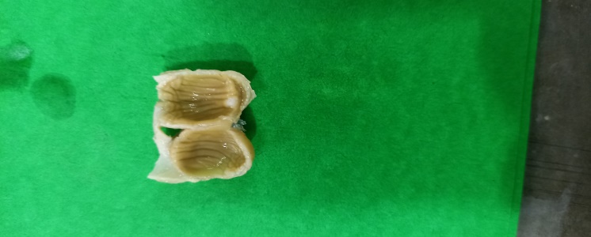 | 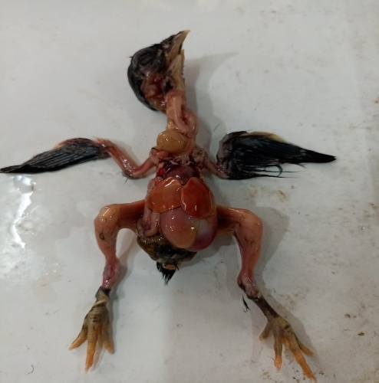
Fig. 1. Photograph of gizzard of Haringhata Black chicken showing the coilin layer arranged in the form of ridges( shown by arrow) on the mucosal surface. | Fig. 2. Photograph showing in-situ positioning of liver (Blue arrow) and gizzard (Black arrow) of day old Haringhata Black chicken.
  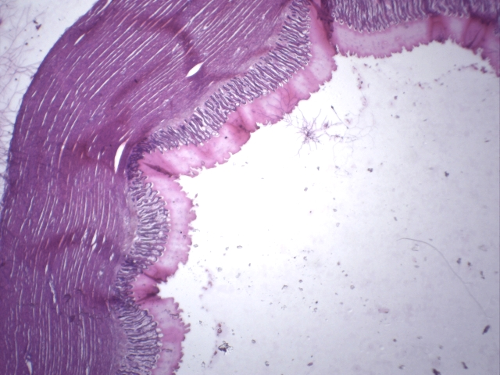
  K
  A
  B
  C
  D
  Fig. 3. Photomicrograph of gizzard of day old Haringhata Black chicken showing tunica mucosa (A), tunica submucosa(B), tunica muscularis(C) and tunica serosa(D) and Koilin (K) layer. H&E X4.
  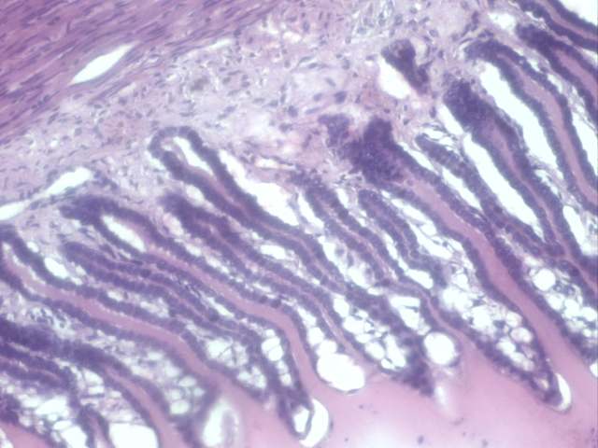
  Fig. 4. Photomicrograph of gizzard of 0 day old Haringhata Black chicken showing the sulci between the mucosal folds. H&E X40.

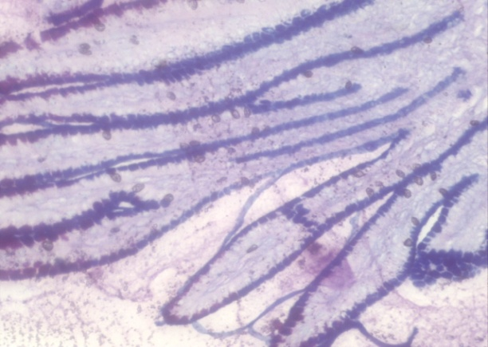 | 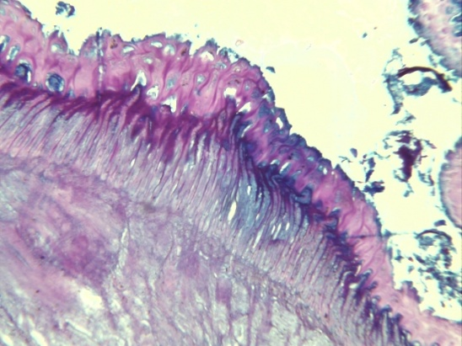
Fig. 5. Photomicrograph of gizzard of day old Haringhata Black chicken showing PAS-AB positive mucosal lining (deep blue colour). PAS-AB X10. | Fig. 6. Photomicrograph of gizzard of day old Haringhata Black chicken showing alcinophilic cells (blue colour) in the mucosal folds. PAS-AB X10 & 40.
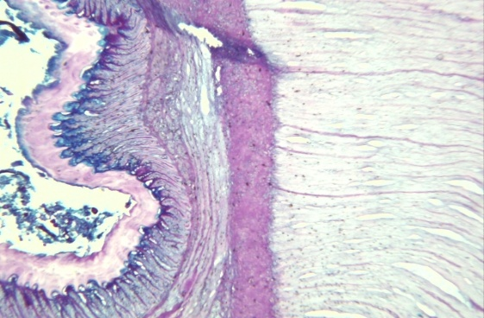 | 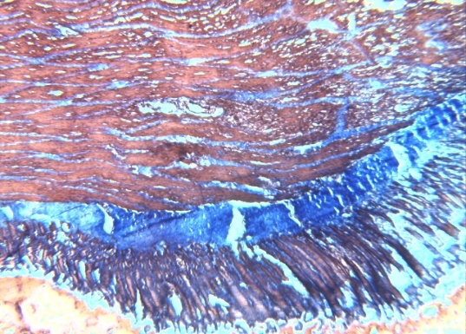
Fig. 7. Photomicrograph of gizzard of day old Haringhata Black chicken showing mucus secretion on the surface of koilin layer. PAS-AB X10. | Fig. 8. Photomicrograph of gizzard of day old Haringhata Black chicken showing collagen fibres (blue colour) between the muscle fibres of tunica muscularis, tunica submucosa and lamina propria. MT X10.

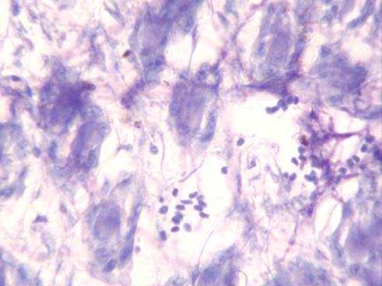
Fig. 9. Photomicrograph of gizzard of day old Haringhata Black chicken showing mast cells (blue arrow) in the tunica submucosa. TB X10.

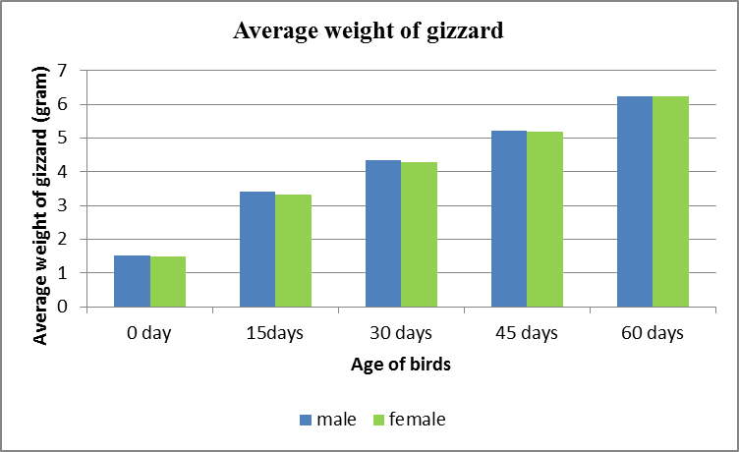 |  |  |  | 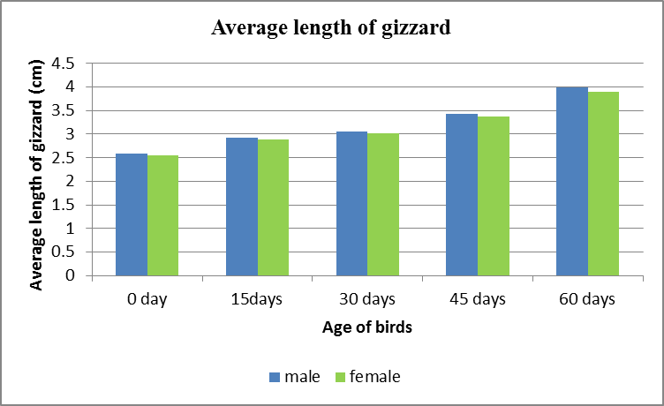
Graph 1. Graphical presentation of age-wise comparison of the average weight of gizzard of all the groups of Haringhata Black chicks. |  |  |  | Graph 2. Graphical presentation of age-wise comparison of the average length of gizzard of all the groups of Haringhata Black chicks.
Graph 3. Graphical presentation of age-wise comparison of the average diameter of gizzard of all the groups of Haringhata Black chicks. |  |  |  | Graph 4. Graphical presentation of age-wise comparison of the average thickness of tunica muscularis of gizzard of all the groups of Haringhata Black chicks
Table 1.. Measurement of height (Mean+SE) of mucosal folds of gizzard in µm in male and female birds of different ages.
Age (in days) | Male | Female | p-value
0 | 145.480^{ap}±1.258 | 139.640^{bp}±0.763 | 0.002
15 | 235.090^{aq}±1.077 | 230.110^{bq}±0.428 | 0.002
30 | 305.140^{ar}±10.932 | 301.430^{ar}±9.221 | 0.064
45 | 405.760as±5.121 | 402.720as±5.212 | 0.075
60 | 462.080^{at}±6.767 | 459.080^{at}±8.622 | 0.084
p-value | 0.000 | 0.000
N.B. Means bearing different superscript {(a,b,c,d…) and (p,q,r,s….)} in the same row and column respectively differ significantly (p<0.01)

Table 2. Measurement of thickness (Mean+SE) tunica muscularis of gizzard in µm in male and female birds of different ages.
Age (in days) | Male | Female | p-value
0 | 88.543^{ap}±3.234 | 86.234^{ap}±3.251 | 0.565
15 | 130.179^{aq}±5.232 | 130.068^{aq}±3.477 | 0.643
30 | 190.906^{ar}±6.231 | 183.876^{ar}±4.287 | 0.423
45 | 234.112as±8.763 | 230.543as±6.253 | 0.132
60 | 271.045^{at}±7.354 | 267.432^{at}±7.654 | 0.384
p-value | 0.000 | 0.000
N.B. Means bearing different superscript {(a,b,c,d…) and (p,q,r,s….)} in the same row and column respectively differ significantly (p<0.01)

