The Efficacy of Ginkgo Biloba and Fenugreek as Hepatoprotective Agents Against Carbon Tetrachloride-Induced Liver Injury in Male Rats

ABSTRACT

BACKGROUND
Liver diseases represent a major global health burden and are associated with considerable morbidity and mortality worldwide. Carbon tetrachloride (CCl₄)-induced hepatotoxicity is a well-established experimental model commonly used to evaluate the hepatoprotective potential of natural products and therapeutic agents.

OBJECTIVES
This study aimed to evaluate the hepatoprotective effects of Ginkgo biloba and Trigonella foenum-graecum (fenugreek) extracts, administered individually or in combination, against CCl₄-induced liver injury in male rats.

METHODS
Fifty adult male rats were randomly allocated into five experimental groups. Hepatic injury was induced using carbon tetrachloride (CCl₄). Treatment groups received Ginkgo biloba extract, fenugreek extract, or a combination of both. Serum biochemical markers including aspartate aminotransferase (AST), lactate dehydrogenase (LDH), malondialdehyde (MDA), and superoxide dismutase (SOD) were evaluated. Histopathological examination of liver tissues was performed using Masson's Trichrome staining.

RESULTS
Administration of CCl₄ resulted in significant elevation of AST, LDH, and MDA levels, accompanied by a significant reduction in SOD activity compared with the control group (P ≤ 0.05). Treatment with Ginkgo biloba and fenugreek extracts improved liver function biomarkers and oxidative stress parameters. Histopathological findings revealed marked restoration of hepatic architecture in treated groups, particularly in rats receiving the combined treatment.

CONCLUSIONS
Ginkgo biloba and fenugreek extracts exhibited significant hepatoprotective and antioxidant effects against CCl₄-induced liver injury. Combined administration of both extracts provided greater protection than either treatment alone and may represent a promising natural therapeutic strategy for preventing hepatic damage.
Keywords: Carbon tetrachloride (CCl₄), Fenugreek, Ginkgo biloba, Hepatitis, Hepatoprotective effect
INTRODUCTION
Hepatitis B virus (HBV) is one of the main etiological agents of chronic liver problems, and hepatitis is regarded as one of the major viral diseases affecting the liver (Seeger & Mason, 2015). Long-term HBV infection can result in serious liver problems such as cirrhosis and hepatocellular cancer (Ganem & Prince, 2004; Lok & McMahon, 2007).
Because of their physiological and pathological resemblance to humans, experimental rats are frequently used in biomedical research, especially in toxicological and metabolic studies. The therapeutic potential of medicinal plants in preventing oxidative stress and tissue damage has garnered significant scientific attention in recent years. According to Fabricant and Farnsworth (2001), herbal remedies are considered potential sources for the development of hepatoprotective drugs.
Antioxidant, anti-inflammatory, anti-allergic, anticancer, and cytoprotective properties are among the many pharmacological activities of Ginkgo biloba. Furthermore, prior research has shown its positive effects on respiratory and cardiovascular processes (Smith & Luo, 2004; Diamond & Bailey, 2013).
Traditional medicine has long used fenugreek (Trigonella foenum-graecum L.), an annual medicinal herb in the Fabaceae family (Basch et al., 2003). The therapeutic benefits of fenugreek seeds are attributed to a variety of biologically active components, including flavonoids, alkaloids, steroidal saponins, amino acids, and volatile oils (Srinivasan, 2006).
Numerous plant-derived substances have been shown to have hepatoprotective and antioxidant properties against liver damage. According to earlier studies, fenugreek and Ginkgo biloba both have protective properties against oxidative liver damage (Chávez-Morales et al., 2011; Mbarki et al., 2017).
Recent experimental studies using carbon tetrachloride models have also reported that plant-derived treatments can attenuate biochemical and histopathological features of hepatic injury, including alterations linked to oxidative stress and inflammation (Awonegan et al., 2025; Olaniran et al., 2025; Munakarmi et al., 2024). Contemporary evidence further supports the hepatoprotective relevance of Ginkgo biloba and Trigonella foenum-graecum in experimental liver injury, with reported improvements in antioxidant status, inflammatory responses, and hepatic pathology (Shaaban et al., 2025; Chi et al., 2025). A remaining experimental question is whether administration of Ginkgo biloba and fenugreek together produces a greater protective response than either extract alone under the same CCl₄-induced liver injury conditions. Addressing this question requires concurrent evaluation of biochemical markers of hepatocellular injury and oxidative stress together with histopathological changes.
Therefore, the present study was conducted to evaluate the hepatoprotective efficacy of these two medicinal plants, individually and in combination, against CCl₄-induced liver injury in male rats.

MATERIALS AND METHODS

Plant Materials and Extract Preparation
The Ginkgo biloba extract dose of 120 mg/kg body weight/day was selected on the basis of previously published research (Al Kury et al., 2020). A total of 240 mg of Ginkgo biloba extract was dissolved in 10 mL of distilled water and gently heated in a water bath to prepare the hydroalcoholic extract. The prepared solution was administered orally once daily at a dose of 1 mL/100 g body weight. Fenugreek seeds were obtained from local markets in Najaf Province, Iraq. Using a Soxhlet extraction device, the seeds were ground into a fine powder and extracted with 70% ethanol. The solvent was evaporated under reduced pressure using a rotary evaporator to produce the dry extract, which was then stored at 4°C until use. A daily dose of 15 mg/kg body weight of fenugreek extract was administered orally for 28 days.
Experimental Animals and Design
Fifty healthy adult male rats were used in this experiment. The animals were randomly divided into five groups of ten rats each. The institutional ethical rules for laboratory animal experiments were followed in all animal-related procedures.
Experimental groups
- For four weeks, Group 1, the control group, received intraperitoneal injections of olive oil twice weekly.
- For four weeks, Group 2 received intraperitoneal injections of carbon tetrachloride (CCl₄) diluted in olive oil at a concentration of 0.5 mg/kg body weight to induce liver damage.
- For 28 consecutive days, Group 3 received Ginkgo biloba extract orally at a dose of 120 mg/kg body weight one hour before CCl₄ administration (Al Kury et al., 2020).
- For 28 days, Group 4 received fenugreek extract orally at a dose of 15 mg/kg body weight each day before CCl₄ injection.
- Ginkgo biloba and fenugreek extracts were administered in combination to Group 5 before CCl₄ administration throughout the trial.
Biochemical and histopathological analysis
Blood samples were collected to measure oxidative stress indicators such as MDA and SOD, as well as serum biochemical markers such as AST and LDH. ELISA kits from Elascience Company were used for all biochemical measurements.
To assess fibrosis and structural hepatic changes, liver specimens were collected and processed for histological analysis using Masson's Trichrome staining procedure.

Statistical Analysis
Data were expressed as mean ± standard error (SE). Statistical analysis was performed using one-way analysis of variance (ANOVA) followed by an appropriate post hoc multiple-comparison test. Differences among groups were considered statistically significant when P ≤ 0.05.

RESULTS

Biochemical parameters
Statistical analysis revealed significant differences among the experimental groups (P ≤ 0.05) in serum aspartate aminotransferase (AST), lactate dehydrogenase (LDH), malondialdehyde (MDA), and superoxide dismutase (SOD) levels. Overall, administration of carbon tetrachloride (CCl₄) produced a pronounced biochemical pattern of hepatic injury characterised by increased markers of hepatocellular damage and oxidative stress, together with impairment of the endogenous antioxidant defence system. Treatment with Ginkgo biloba extract, Trigonella foenum-graecum (fenugreek) extract, or their combination significantly attenuated most of these CCl₄-induced alterations.
Serum MDA levels were significantly higher in the CCl₄-treated group than in the normal control group (P < 0.05), indicating increased lipid peroxidation and oxidative stress. In contrast, administration of G. biloba, fenugreek, or the combined extracts significantly reduced MDA concentrations compared with the untreated CCl₄ group (P < 0.05). The reduction in MDA was particularly pronounced in the combined-treatment group, indicating a greater attenuation of lipid peroxidation when both extracts were administered together (Graph 1).
A similar pattern was observed for serum LDH activity. CCl₄ administration resulted in a significant elevation of LDH activity compared with the normal control group. This increase is consistent with hepatocellular membrane damage and leakage of intracellular enzymes into the circulation. Treatment with either G. biloba or fenugreek extract significantly reduced LDH activity compared with the untreated CCl₄ group. The combined treatment resulted in a greater normalisation of LDH activity, suggesting more effective preservation of hepatocellular integrity (Graph 2).
Serum AST activity was also significantly increased following CCl₄ exposure compared with the control group (P < 0.05). The elevation of AST is consistent with hepatocellular injury and disruption of hepatocyte membrane integrity. Administration of G. biloba and fenugreek extracts significantly reduced AST activity compared with the untreated CCl₄ group. The greatest improvement was observed in the combined-treatment group, in which AST activity showed a stronger tendency towards the control condition (Graph 3).
In contrast to AST, LDH, and MDA, SOD activity was significantly decreased in CCl₄-exposed rats compared with the normal control group. This reduction indicates impairment of the endogenous antioxidant defence system following CCl₄ exposure. Treatment with G. biloba or fenugreek significantly restored SOD activity compared with the untreated CCl₄ group. The combined treatment produced the greatest apparent restoration of SOD activity, suggesting enhanced antioxidant defence following simultaneous administration of both extracts (Graph 4).
Taken together, the biochemical findings demonstrated a consistent pattern of CCl₄-induced hepatic injury associated with increased lipid peroxidation and reduced antioxidant capacity. Treatment with the tested plant extracts reversed these changes to different degrees, with the combined treatment producing the most pronounced overall biochemical improvement.

Histopathological findings
Histopathological examination further supported the biochemical findings. Masson's trichrome staining demonstrated clear differences in hepatic morphology among the experimental groups.
Liver sections from the normal control group showed preserved hepatic architecture, regularly arranged hepatocyte cords, intact sinusoidal spaces, and an absence of obvious degenerative, necrotic, inflammatory, or fibrotic changes (Figure 1A and B).
In contrast, the CCl₄-treated group showed marked pathological alterations characterised by architectural distortion, hepatocellular degeneration, centrilobular necrosis, sinusoidal congestion, inflammatory cell infiltration, and increased collagen deposition (Figure 1C and D; Figure 4). These changes indicate substantial hepatic structural injury following CCl₄ exposure. The increased collagen deposition observed in this group was consistent with the development of fibrotic changes associated with chemically induced hepatic injury.
Treatment with G. biloba extract resulted in a clear attenuation of the pathological alterations induced by CCl₄. Liver sections showed partial restoration of the normal hepatic architecture, reduced hepatocellular degeneration, and decreased collagen fibre deposition compared with the untreated CCl₄ group (Figure 2).
Similarly, administration of T. foenum-graecum extract markedly improved the hepatic morphology. The treated sections showed restoration of hepatic architecture, reduced hepatocellular degeneration, minimal fatty changes, and attenuated inflammatory infiltration compared with the CCl₄ group (Figure 5).
The most pronounced morphological improvement was observed in the combined-treatment group receiving G. biloba and T. foenum-graecum. Liver sections from this group demonstrated near-normal hepatic architecture, markedly reduced degenerative changes, and minimal collagen deposition (Figure 3). These findings indicate substantial structural recovery compared with the severe hepatic lesions observed in the CCl₄ group.
The histopathological observations were therefore consistent with the biochemical findings. The reduction in degenerative and inflammatory lesions, together with decreased collagen deposition, was most apparent in the combined-treatment group. These results provide morphological evidence supporting the hepatoprotective effects of both plant extracts against CCl₄-induced hepatic injury.

DISCUSSION
The present study demonstrated that CCl₄ administration produced substantial hepatic injury in male rats, as evidenced by significant alterations in serum AST, LDH, MDA, and SOD, together with pronounced histopathological abnormalities. In contrast, administration of Ginkgo biloba and Trigonella foenum-graecum extracts significantly attenuated these biochemical and morphological changes. The combined treatment produced the greatest overall improvement, suggesting that the two extracts may exert complementary hepatoprotective effects.
Carbon tetrachloride is a well-established experimental hepatotoxicant because its metabolic activation generates highly reactive free-radical intermediates. CCl₄ is primarily metabolised by cytochrome P450 enzymes, particularly CYP2E1, producing the trichloromethyl radical (CCl₃•). In the presence of oxygen, this radical can form the trichloromethyl peroxyl radical (CCl₃OO•), which initiates lipid peroxidation and damages cellular membranes. These events contribute to hepatocellular degeneration, necrosis, inflammation, and, with repeated exposure, fibrotic remodelling (Recknagel et al., 1989; Weber et al., 2003; Fareed et al., 2024).
The marked increase in AST observed in the CCl₄ group in the present study is consistent with hepatocellular membrane injury. AST is predominantly intracellular, and disruption of hepatocyte membranes facilitates the release of intracellular enzymes into the circulation. Therefore, the elevation of AST provides biochemical evidence of CCl₄-induced hepatocellular damage. The subsequent reduction in AST following treatment with G. biloba and fenugreek suggests that both extracts contributed to the preservation of hepatocyte integrity.
The increase in LDH further supports the occurrence of cellular injury. LDH is a cytoplasmic enzyme released into the circulation following cellular membrane disruption and tissue damage. The simultaneous elevation of AST and LDH in the CCl₄ group therefore indicates substantial hepatocellular injury rather than an isolated alteration in one biochemical marker. The reduction of both enzymes following administration of the plant extracts suggests attenuation of CCl₄-induced cellular damage.
The significant increase in MDA in CCl₄-treated rats represents an important indicator of oxidative injury. MDA is a commonly used marker of lipid peroxidation and reflects oxidative damage to cellular membrane lipids. The elevation of MDA in the present study is consistent with the established mechanism of CCl₄ toxicity, whereby reactive metabolites attack polyunsaturated fatty acids and initiate lipid peroxidation. The resulting membrane damage can further increase cellular permeability, impair organelle function, and contribute to hepatocyte death.
The significant reduction in MDA following treatment with G. biloba provides evidence that the extract attenuated lipid peroxidation. This finding agrees with previous experimental research demonstrating the protective effect of Ginkgo preparations against CCl₄-induced hepatic injury. Earlier studies reported reductions in AST and MDA together with improvement in hepatic histology following Ginkgo treatment (Chávez-Morales et al., 2011).
More importantly, recent evidence provides further support for the antioxidant activity of G. biloba. Pu et al. (2024) demonstrated that Ginkgo biloba extract reduced CCl₄-associated AST and MDA alterations while increasing SOD and catalase activities. The same study reported attenuation of inflammatory mediators and suggested involvement of the PI3K/AKT signalling pathway in the protective response. These observations are highly consistent with the present findings, particularly the simultaneous reduction in MDA and restoration of SOD activity.
The antioxidant effect of G. biloba may be related to its complex phytochemical composition, particularly flavonoid and terpene constituents. These compounds may act as free-radical scavengers and contribute to the maintenance of cellular antioxidant capacity. The recent LC-MS and pathway analysis reported by Pu et al. (2024) identified multiple bioactive constituents of Ginkgo and suggested a multi-component, multi-target mechanism involving PI3K/AKT and other signalling pathways. Although these molecular mechanisms were not directly examined in the present study, they provide a plausible explanation for the biochemical and histological protection observed.
The reduction in MDA following fenugreek treatment is also consistent with previous experimental evidence. Fenugreek seeds contain polyphenols, flavonoids, polysaccharides, and other bioactive constituents with antioxidant properties. Mbarki et al. (2017) demonstrated that fenugreek supplementation significantly reduced the biochemical disturbances produced by CCl₄ and improved antioxidant-related parameters in male rats. Similarly, an experimental study using aqueous fenugreek extract reported that CCl₄ increased serum transaminases and lipid peroxidation, whereas fenugreek administration ameliorated these changes and improved antioxidant enzyme activity.
The current findings therefore support the concept that fenugreek protects hepatic tissue, at least in part, through attenuation of oxidative stress. The antioxidant constituents of fenugreek may reduce reactive oxygen species and lipid peroxidation, thereby limiting membrane damage and subsequent leakage of intracellular enzymes. The improvement in AST and LDH observed in the fenugreek-treated group is compatible with this mechanism.
The reduction of SOD activity in the CCl₄ group represents another important feature of the oxidative imbalance induced by CCl₄. SOD is a major endogenous antioxidant enzyme that catalyses the conversion of superoxide radicals into hydrogen peroxide and molecular oxygen. Excessive production of reactive oxygen species may overwhelm antioxidant defences and contribute to depletion or impairment of endogenous antioxidant enzymes. The decreased SOD activity observed in the present study therefore indicates compromised antioxidant protection.
Treatment with G. biloba and fenugreek restored SOD activity, suggesting improvement of the endogenous antioxidant defence system. The finding is particularly relevant because it occurred together with a reduction in MDA. Thus, treatment did not simply reduce an isolated marker of oxidative damage but was associated with simultaneous improvement in both oxidative injury and antioxidant defence. Similar changes in SOD and MDA have been reported in experimental studies of Ginkgo and fenugreek against chemically induced liver injury.
The histopathological findings provide important morphological confirmation of these biochemical effects. The CCl₄-treated group exhibited severe architectural distortion, hepatocellular degeneration, centrilobular necrosis, sinusoidal congestion, inflammatory infiltration, and increased collagen deposition. These findings are consistent with the recognised pathological consequences of CCl₄-induced oxidative and inflammatory hepatic injury. CCl₄ toxicity is known to involve not only lipid peroxidation but also inflammatory signalling, apoptosis, necrosis, and fibrogenic responses (Fareed et al., 2024).
The presence of increased collagen deposition in the CCl₄ group is particularly relevant because persistent hepatic injury can activate fibrogenic pathways and promote extracellular matrix accumulation. Previous studies have shown that Ginkgo extract can attenuate CCl₄-induced hepatic fibrosis and reduce fibrosis-associated markers, including TGF-β1, α-SMA, and collagen-related parameters (Ding et al., 2005). The reduction in collagen deposition observed following Ginkgo treatment in the present study is therefore consistent with the previously described anti-fibrotic potential of this plant.
The Ginkgo-treated group showed partial restoration of hepatic architecture and reduced collagen deposition. This morphological improvement corresponds well with the observed reductions in AST, LDH, and MDA and the restoration of SOD. The agreement among biochemical and histological endpoints strengthens the interpretation that Ginkgo exerted a genuine hepatoprotective effect.
Fenugreek treatment similarly improved the histological appearance of the liver. Reduced hepatocellular degeneration, minimal fatty changes, and attenuated inflammatory infiltration were observed compared with the untreated CCl₄ group. These findings are consistent with previous studies showing hepatoprotective and antioxidant effects of fenugreek against CCl₄ and other chemical hepatotoxicants.
The most notable finding of the present study was the greater overall improvement observed after combined administration of G. biloba and fenugreek. The combination resulted in the most pronounced improvement in AST, LDH, MDA, and SOD and was accompanied by near-normal hepatic architecture and minimal collagen deposition. This suggests that the two extracts may act through complementary mechanisms involving oxidative stress reduction, preservation of hepatocellular membranes, enhancement of antioxidant defence, and attenuation of tissue injury.
The superior response to combined treatment may be related to the different but potentially overlapping phytochemical profiles of the two plants. Ginkgo contains flavonoid glycosides and terpene-related compounds, whereas fenugreek contains polyphenols, flavonoids, polysaccharides, and other bioactive constituents. The simultaneous presence of these compounds could provide broader antioxidant and cytoprotective activity than either extract alone.
However, the present findings should not be interpreted as definitive evidence of pharmacological synergy. Although the combination produced greater apparent protection than either extract alone, demonstration of true synergy requires a specific interaction analysis or experimental design. Therefore, the current findings are more appropriately interpreted as indicating a greater protective effect and potentially complementary actions of the two extracts. This terminology provides a scientifically conservative interpretation of the observed results.
The biochemical and histological findings together suggest that oxidative stress is an important target of the hepatoprotective activity of both extracts. CCl₄ exposure increased MDA and reduced SOD, indicating an imbalance between oxidative damage and antioxidant defence. Treatment reversed both changes. Because oxidative stress contributes to membrane injury, inflammation, mitochondrial dysfunction, and fibrogenic responses, attenuation of oxidative stress may represent a central mechanism underlying the observed hepatic recovery.
Recent mechanistic evidence also supports the possibility that Ginkgo acts through multiple cellular pathways. Pu et al. (2024) reported that Ginkgo extract modulated PI3K/AKT-related signalling and reduced inflammatory mediators in a CCl₄-induced liver injury model. The PI3K/AKT pathway is involved in cell survival, metabolism, growth, and apoptosis; modulation of this pathway may therefore contribute to the ability of Ginkgo to protect hepatocytes from toxic injury. Nevertheless, because PI3K/AKT signalling was not directly measured in the present experiment, this mechanism should be considered a plausible interpretation rather than a demonstrated mechanism of the current study.
The present findings are also compatible with the established relationship between oxidative stress and inflammation in CCl₄-induced liver injury. Reactive oxygen species can activate inflammatory pathways, while inflammatory cells may generate additional reactive species, creating a self-amplifying cycle of tissue injury. The reduction in inflammatory infiltration observed histologically following treatment may therefore be partly related to the antioxidant effects of the extracts. However, direct measurement of cytokines such as TNF-α, IL-1β, and IL-6 would be required to confirm this mechanism in the present experimental model.
An additional important observation was the reduction in collagen deposition in the treated groups, particularly following combined administration. Although Masson's trichrome staining provides morphological evidence of collagen deposition, quantitative determination of collagen content or fibrosis scoring would provide stronger evidence for an anti-fibrotic effect. Therefore, the current findings support attenuation of histological fibrotic changes but should not be interpreted as definitive proof of an anti-fibrotic molecular mechanism.
Overall, the consistency between biochemical and histopathological findings represents an important strength of the present study. AST and LDH provided evidence of hepatocellular injury, MDA reflected lipid peroxidation, and SOD provided information regarding endogenous antioxidant defence. Histopathological examination demonstrated the corresponding structural consequences of CCl₄ exposure and the subsequent recovery following treatment. The simultaneous improvement across these different endpoints strengthens the evidence for the hepatoprotective activity of G. biloba and fenugreek.
The current findings also contribute to the existing experimental evidence regarding plant-derived hepatoprotective agents. Previous studies have demonstrated the protective effects of Ginkgo and fenugreek separately against CCl₄-induced injury. The present investigation extends these observations by examining both extracts separately and in combination and by evaluating biochemical oxidative-stress markers together with histopathological changes.
Nevertheless, further studies are required to determine the precise mechanisms responsible for the superior response to combined treatment. Future investigations should include quantitative fibrosis assessment, additional antioxidant markers such as catalase, glutathione, and glutathione peroxidase, and inflammatory mediators such as TNF-α, IL-1β, and IL-6. Molecular evaluation of pathways including PI3K/AKT, MAPK, TGF-β/Smad, and apoptosis-related signalling would also provide a more comprehensive understanding of the protective mechanisms.
In conclusion, the present study demonstrated that Ginkgo biloba and Trigonella foenum-graecum extracts significantly attenuated CCl₄-induced hepatic injury in male rats. Their protective effects were characterised by reductions in serum AST, LDH, and MDA, restoration of SOD activity, and improvement of hepatic histological architecture. The reduction in collagen deposition and degenerative lesions further supported the tissue-protective effects of the extracts. Combined administration produced the greatest overall biochemical and histopathological improvement, suggesting potentially complementary hepatoprotective actions. These findings support further investigation of the combined botanical approach using quantitative fibrosis assessment and molecular analyses to establish the mechanisms underlying the observed protection.

CONCLUSION
Carbon tetrachloride exposure produced marked hepatic injury in male rats, as indicated by increased serum AST, LDH, and MDA levels, reduced SOD activity, and substantial histopathological alterations. Treatment with Ginkgo biloba or Trigonella foenum-graecum (fenugreek) extract attenuated these biochemical and morphological changes, supporting protective effects against hepatocellular injury and oxidative stress. The combined administration of both extracts produced the greatest apparent overall improvement, including stronger restoration of the measured biochemical parameters, near-normal hepatic architecture, and minimal collagen deposition relative to the untreated CCl₄ group. These findings are consistent with potentially complementary hepatoprotective actions of the two botanical extracts. However, the greater response observed with the combined treatment should not be interpreted as definitive pharmacological synergy because a formal interaction analysis was not performed. Overall, the study supports further experimental investigation of the combined botanical approach, particularly using quantitative fibrosis assessment, additional antioxidant and inflammatory markers, and molecular analyses to clarify the mechanisms underlying the observed protective response.
Limitations
The study evaluated a single preclinical CCl₄ model in male rats and used a limited biochemical panel comprising AST, LDH, MDA, and SOD together with predominantly morphological assessment by Masson’s trichrome staining. Collagen deposition was not quantitatively assessed, and inflammatory cytokines, additional antioxidant enzymes, and molecular pathways discussed in relation to the findings were not directly measured. The design also did not include a formal interaction analysis capable of establishing pharmacological synergy between the extracts. Accordingly, the greater response to combined treatment should be interpreted as an apparent complementary effect rather than definitive synergy.
ETHICS APPROVAL

All experimental procedures involving animals were reviewed and approved by the Ethical Committee of the Faculty of Veterinary Medicine, University of Kufa, Iraq. Animal handling and experimental protocols were conducted in accordance with the institutional guidelines for the care and use of laboratory animals and complied with internationally accepted standards for animal welfare.

COMPETING INTERESTS DISCLAIM
Authors have declared that they have no known competing financial interests OR non-financial interests OR personal relationships that could have appeared to influence the work reported in this paper.

Declaration of AI Use

This manuscript was prepared through the intellectual contributions of the author(s) to the study design, data analysis, interpretation of results, and scholarly content. Grammarly and ChatGPT were used solely to assist with grammatical refinement and reference formatting during manuscript revision. The author(s) accept full responsibility for the accuracy, integrity, and final content of the manuscript.

REFERENCES
Al Kury, L. T., Dayyan, F., Shah, F. A., Malik, Z., Khalil, A. A. K., Alattar, A., Alshaman, R., Ali, A., & Khan, Z. (2020). Ginkgo biloba extract protects against methotrexate-induced hepatotoxicity: A computational and pharmacological approach. Molecules, 25(11), 2540. https://doi.org/10.3390/molecules25112540
Awonegan, P. A., Oyelade, W. A., & Onifade, I. L. (2025). Hepatoprotective effects and ameliorative potential of Solanum nigrum leaf extract on biochemical and histological alterations in CCl₄-induced liver injury in rats. International Journal of Biochemistry Research & Review, 34(4), 350–361. https://doi.org/10.9734/ijbcrr/2025/v34i41026
Basch, E., Ulbricht, C., Kuo, G., Szapary, P., & Smith, M. (2003). Therapeutic applications of fenugreek. Alternative Medicine Review, 8(1), 20–27.
Chávez-Morales, R. M., Jaramillo-Juárez, F., Posadas del Río, F. A., Reyes-Romero, M. A., Rodríguez-Vázquez, M. L., & Martínez-Saldaña, M. C. (2011). Protective effect of Ginkgo biloba extract on liver damage by a single dose of CCl₄ in male rats. Human & Experimental Toxicology, 30(3), 209–216. https://doi.org/10.1177/0960327110371698
Chi, L., Niu, H., Niu, Y., Yao, R., Shi, D., Lu, B., & Pang, Z. (2025). Trigonella foenum-graecum L. ameliorates metabolism-associated fatty liver disease in type 2 diabetic mice: A multi-omics mechanism analysis. Journal of Ethnopharmacology, 348, 119862. https://doi.org/10.1016/j.jep.2025.119862
Diamond, B. J., & Bailey, M. R. (2013). Ginkgo biloba: Indications, mechanisms, and safety. Psychiatric Clinics of North America, 36(1), 73–83. https://doi.org/10.1016/j.psc.2012.12.006
Ding, J., Yu, J., Wang, C., Hu, W., Li, D., Luo, Y., Luo, H., & Yu, H. (2005). Ginkgo biloba extract alleviates liver fibrosis induced by CCl₄ in rats. Liver International, 25(6), 1224–1232. https://doi.org/10.1111/j.1478-3231.2005.01169.x
Fabricant, D. S., & Farnsworth, N. R. (2001). The value of plants used in traditional medicine for drug discovery. Environmental Health Perspectives, 109(Suppl. 1), 69–75. https://doi.org/10.1289/ehp.01109s169
Fareed, M. M., Khalid, H., Khalid, S., & Shityakov, S. (2024). Deciphering molecular mechanisms of carbon tetrachloride-induced hepatotoxicity: A brief systematic review. Current Molecular Medicine, 24(9), 1124–1134. https://doi.org/10.2174/0115665240257603230919103539
Ganem, D., & Prince, A. M. (2004). Hepatitis B virus infection—Natural history and clinical consequences. The New England Journal of Medicine, 350(11), 1118–1129. https://doi.org/10.1056/NEJMra031087
Lok, A. S. F., & McMahon, B. J. (2007). Chronic hepatitis B. Hepatology, 45(2), 507–539. https://doi.org/10.1002/hep.21513
Mbarki, S., Alimi, H., Bouzenna, H., Elfeki, A., & Hfaiedh, N. (2017). Phytochemical study and protective effect of Trigonella foenum graecum (fenugreek seeds) against carbon tetrachloride-induced toxicity in liver and kidney of male rat. Biomedicine & Pharmacotherapy, 88, 19–26. https://doi.org/10.1016/j.biopha.2016.12.078
Munakarmi, S., Gurau, Y., Shrestha, J., Chand, L., Park, H. S., Lee, G.-H., & Jeong, Y. J. (2024). trans-Chalcone ameliorates CCl₄-induced acute liver injury by suppressing endoplasmic reticulum stress, oxidative stress and inflammation. Pathology - Research and Practice, 263, 155663. https://doi.org/10.1016/j.prp.2024.155663
Olaniran, J. S., Olaniyi, T. D., Adeleke, G. E., Aborisade, A. B., & Adetutu, A. (2025). Hepatoprotective effect of Anogeissus leiocarpus against carbon tetrachloride-induced toxicity in rat liver damage. Asian Journal of Research in Biosciences, 7(1), 62–74. https://doi.org/10.56557/ajorib/2025/v7i1111
Pu, X., Fu, Y., Yang, Y., & Xu, G. (2024). Ginkgo biloba extract alleviates CCl₄-induced acute liver injury by regulating PI3K/AKT signaling pathway. Heliyon, 10(4), e26093. https://doi.org/10.1016/j.heliyon.2024.e26093
Recknagel, R. O., Glende, E. A., Jr., Dolak, J. A., & Waller, R. L. (1989). Mechanisms of carbon tetrachloride toxicity. Pharmacology & Therapeutics, 43(1), 139–154. https://doi.org/10.1016/0163-7258(89)90050-8
Seeger, C., & Mason, W. S. (2015). Molecular biology of hepatitis B virus infection. Virology, 479–480, 672–686. https://doi.org/10.1016/j.virol.2015.02.031
Shaaban, H. M., Mehana, E.-S. E., Oda, S. S., Tohamy, H. G., Gad El-Karim, D. R., & Shukry, M. (2025). Hepatoprotective mechanisms of Ginkgo-biloba and dandelion extracts: Antioxidant activity and modulation of TNF-α and P53 pathways in thioacetamide-induced liver injury. Toxicology Research, 14(3), tfaf075. https://doi.org/10.1093/toxres/tfaf075
Smith, J. V., & Luo, Y. (2004). Studies on molecular mechanisms of Ginkgo biloba extract. Applied Microbiology and Biotechnology, 64(4), 465–472. https://doi.org/10.1007/s00253-003-1527-9
Srinivasan, K. (2006). Fenugreek (Trigonella foenum-graecum): A review of health beneficial physiological effects. Food Reviews International, 22(2), 203–224. https://doi.org/10.1080/87559120600586315
Weber, L. W. D., Boll, M., & Stampfl, A. (2003). Hepatotoxicity and mechanism of action of haloalkanes: Carbon tetrachloride as a toxicological model. Critical Reviews in Toxicology, 33(2), 105–136. https://doi.org/10.1080/713611034

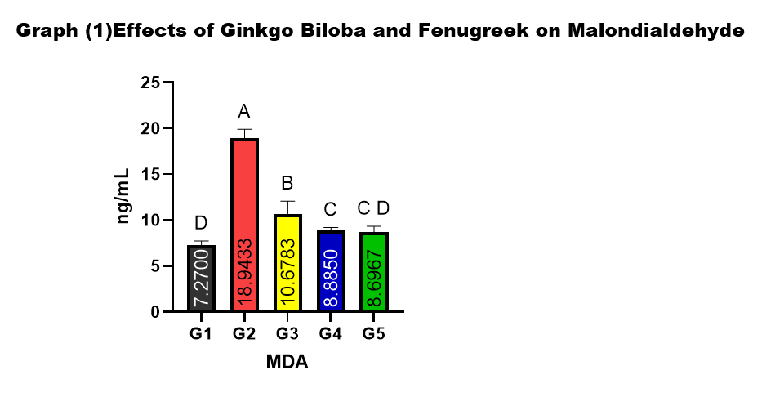

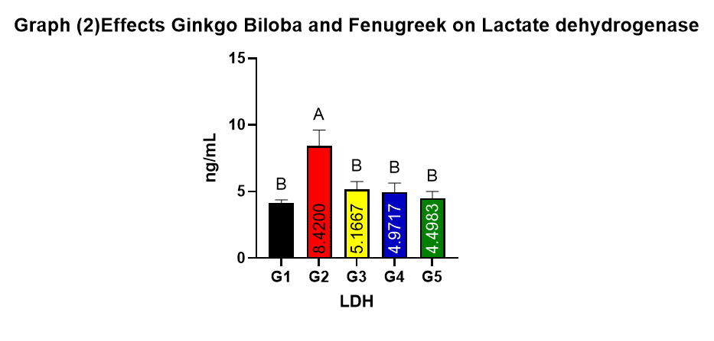
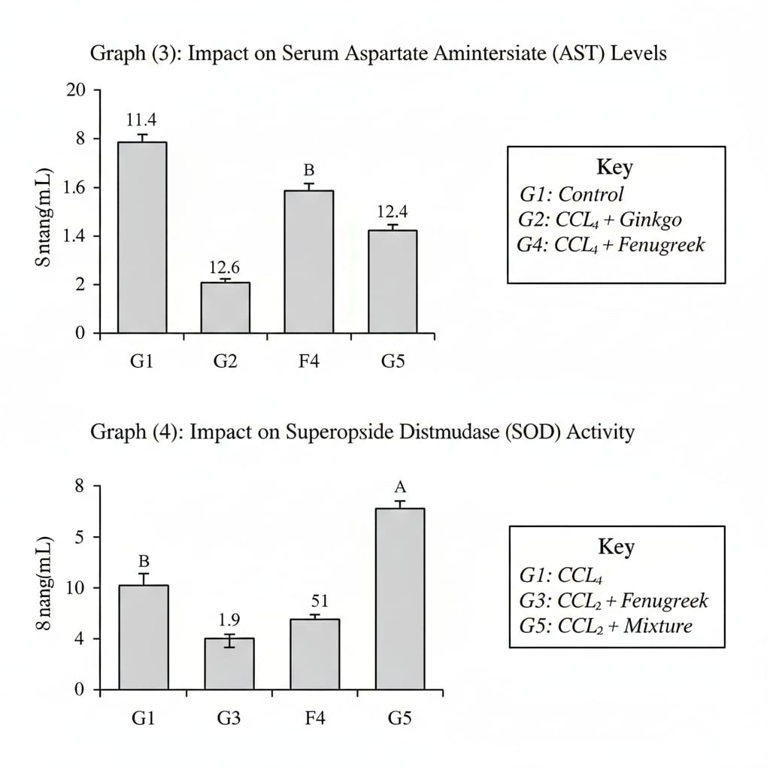

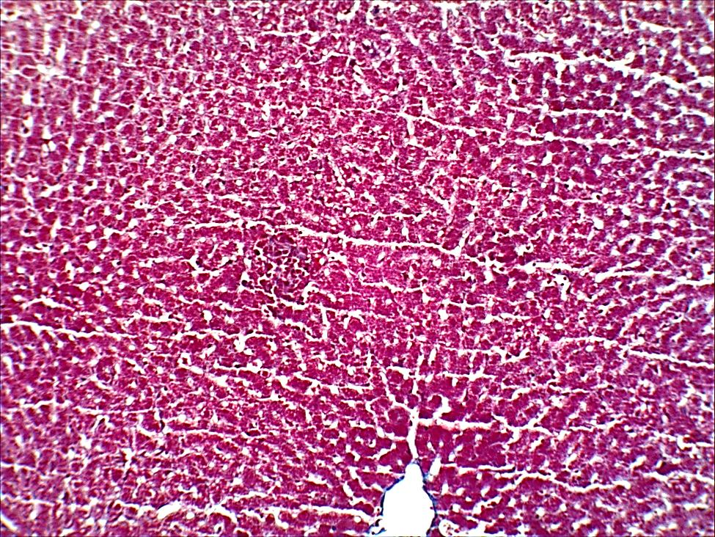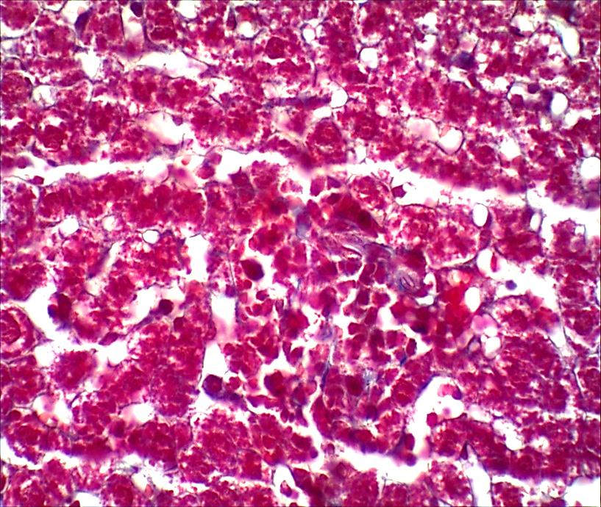
Figure 1. Histopathological features of liver tissue in control and CCl₄-treated rats.
Masson’s trichrome–stained liver sections show normal hepatic architecture in control rats with intact hepatocyte cords and sinusoids (A, B), whereas CCl₄-treated rats exhibit marked architectural disruption, hepatocellular degeneration and necrosis, inflammatory infiltration, and increased collagen deposition indicative of fibrosis (C, D).
Magnification: A, C = 100×; B, D = 400×.

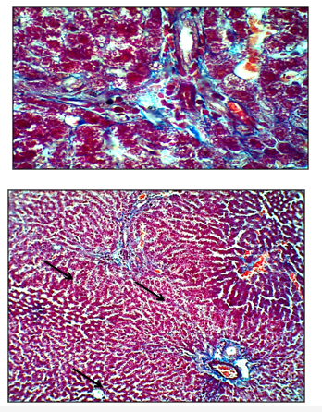
Figure 2. Liver histology of CCl₄ + Ginkgo biloba–treated rats.
Masson’s trichrome staining demonstrates attenuation of CCl₄-induced hepatic injury, with partial restoration of liver architecture and reduced collagen fiber deposition compared with the CCl₄ group.
Magnification: A = 100×; B = 400×.

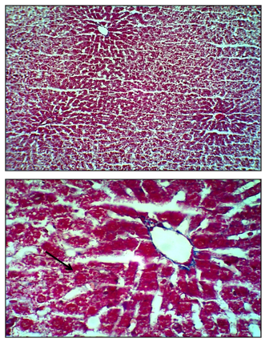

Figure 3. Liver histology of CCl₄ + Ginkgo biloba + Trigonella foenum-graecum–treated rats.
Masson’s trichrome staining shows near-normal hepatic architecture with minimal collagen deposition, indicating marked reversal of CCl₄-induced liver injury.
Magnification: A = 100×; B = 400×.
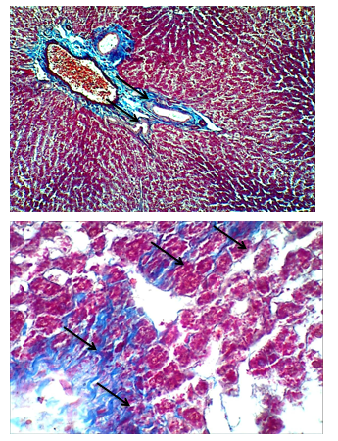

Figure 4.Liver sections of CCl₄-treated rats exhibit marked hepatic injury, evidenced by architectural distortion, hepatocellular fatty degeneration, centrilobular necrosis, sinusoidal congestion, and inflammatory infiltration.
Magnification: A = 100×; B = 400×
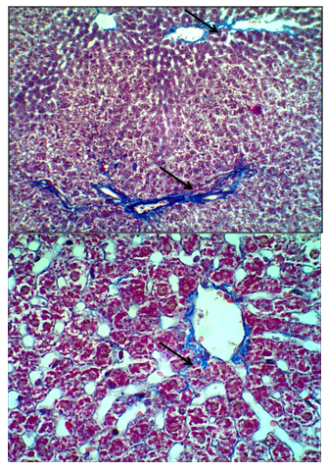
Figure 5.
Liver sections from rats treated with CCl₄ plus Trigonella foenum-graecum show marked histological improvement, with restoration of hepatic architecture, reduced hepatocellular degeneration, minimal fatty changes, and attenuated inflammatory infiltration compared with the CCl₄ group.
Magnification: A = 100×; B = 400×./

