Length–Weight Relationship and Condition Factors of the Freshwater Prawn Macrobrachium lamarrei from the Sone River, Bihar, India: A Sex-Wise Comparative Study

Abstract: Sex-wise length–weight relationships and condition factors of Macrobrachium lamarrei were investigated in wild populations. The aim of the present study was to evaluate sex-wise length–weight relationships and condition factors of M. lamarrei from the Sone River, Bihar, across different length classes. The length–weight relationship showed negative allometric growth in males (b = 2.6154), females (b = 2.7443), and the pooled population (b = 2.6700), indicating that body weight increased at a slower rate than total length. The coefficient of correlation (r) was highest in males (0.9131), followed by the pooled population (0.9011) and females (0.8757), while the coefficient of determination (R²) ranged from 0.7668 to 0.8338, demonstrating a strong relationship between length and body weight. Relative condition factor (Kn) values were generally greater than 1 across all length classes, indicating that individuals generally attained body weights comparable to or slightly higher than those predicted by the length–weight relationship. Variation in Fulton's condition factor (K) among different size classes indicated differences in somatic condition. Overall, the condition-factor indices indicated that the population of M. lamarrei in the Sone River maintained a favourable physiological status, while the negative allometric growth pattern provided useful information on size-dependent body development. Together, the length–weight relationship and condition factors of M. lamarrei provide basic information on the population structure and physiological condition of prawns and can serve as useful indicators for long-term ecological monitoring and assessment of habitat suitability for freshwater prawns.

Keywords: Macrobrachium lamarrei; length–weight relationship; Fulton’s condition factor; relative condition factor; negative allometric growth; freshwater prawn; sex-wise variation; Sone River; Bihar; population condition.
Introduction
Length–weight relationships are important and commonly used biometric measurements in fisheries and aquatic biology for assessing the overall health status of prawn populations. They provide useful information about growth patterns within a population and allow comparisons among individuals of different sizes, sexes, seasons, or geographical locations. In freshwater prawns, the length–weight relationship provides baseline information on population characteristics and growth patterns in relation to body size and, when combined with condition-factor indices, offers a broad picture of the population's biological status.
Recent studies continue to apply length–weight relationships together with condition-factor indices to describe growth patterns and relative body condition in aquatic populations (de Carvalho-Souza et al., 2023; Maji et al., 2026).
Freshwater prawns belong to the genus Macrobrachium and are an important component of riverine and other water bodies, contributing to aquatic food webs and supporting fisheries and aquaculture. The growth and development of these freshwater prawns mainly depend on favourable ecological parameters, food availability, reproductive activities, habitat characteristics, and water quality. Hence, information on the growth and condition of a population is useful for understanding the biological performance of the natural population and for helping that population flourish.

Macrobrachium lamarrei is a minor freshwater prawn distributed across different parts of the country, primarily in freshwater habitats, and contributes to aquatic biodiversity. Studies of length–weight relationships and condition factors describe the growth characteristics of individuals under natural conditions and help identify problems affecting the development of individual body parameters. Generally, the growth and body condition of any population vary across locations, habitats, food resources, environmental conditions, and population structure, and information gathered from one location may be useful for studying populations in other locations.
Within freshwater prawns, recent work on Macrobrachium vollenhovenii has likewise demonstrated the utility of length, weight, and condition-factor measurements for comparing size-related variation among morphotypes and habitats (Oyebola et al., 2024).
The Sone River, part of the Ganges basin, supports rich aquatic biodiversity and ecosystem functioning. Freshwater prawns and other benthic fauna can serve as indicators of nutrient cycling and food chains. Thus, there is a need to investigate the current health status and well-being of Sone River prawns and identify individuals that may exhibit distinct morphometric and meristic characteristics. Such information is important because males and females may differ in growth, physiological condition, and reproductive success, which can subsequently influence population structure and the overall well-being of individuals.
Freshwater prawn surveys in the Koshi River of eastern Bihar have documented M. lamarrei among the recorded Macrobrachium assemblage, supporting its regional occurrence within Bihar river systems (Prasad et al., 2023).
The condition factor is an indicator of well-being and of the effects of ecological conditions on growth. The relative condition factor (Kn) is a vital biological indicator widely used in biological and crustacean studies to assess the health, nutritional status, and body condition of aquatic organisms. Fulton's condition factor (K), which assumes a fixed proportional relationship between body length and body weight, is regarded as an effective measure of the ecological health and physiological condition of aquatic animals. The current study aims to determine the length–weight relationships and condition factors of male and female individuals caught in the Sone River, Bihar, and to assess their body condition and fitness across different length categories.
Several research reports have evaluated the length–weight relationships and condition factors of freshwater prawns in India, especially within the genus Macrobrachium, to assess growth, health, and population status in natural ecosystems such as rivers, reservoirs, and estuaries in different regions of the country (Abohweyere & Williams, 2008; Kumar et al., 2014, 2016; Kurup et al., 2000; Lodhi et al., 2024; Rana & Kumar, 2013; Ranjeet & Kurup, 2002; Sahu et al., 2024; Sarkar et al., 2013; Sethi et al., 2012, 2013; Soomro et al., 2012; Yang et al., 2016). However, reports on the length–weight relationship and condition factor of Macrobrachium lamarrei from the Sone River are lacking; hence, the present study was conducted using different prawn length groups. By providing population-specific information on M. lamarrei, the study establishes baseline data for future ecological pollution investigations. Detailed knowledge of morphological and metric criteria can be used to predict weight at a given length and vice versa.
The findings of this study may also be useful for monitoring changes in prawn populations, supporting the sustainable use of these prawns, and providing biological information for fisheries management and aquaculture research. The study may also support future efforts to improve the culture production of this species under intensive conditions. Prawns are an important subject in fisheries science and aquaculture because they constitute a multi-million-dollar industry.
Accordingly, the objective of the present study was to evaluate sex-wise length–weight relationships and condition factors of M. lamarrei from the Sone River, Bihar, across different length classes.
Material and Methods
The present study was conducted in the village of Makrain, Rohtas district, along the Sone River in the southwestern region of Bihar, India, from November 2025 to January 2026. Geographically, Rohtas district lies between approximately 24°34′12″–25°15′00″ N latitude and 83°40′12″–84°30′00″ E longitude and is located at an average elevation of about 107–110 metres above sea level, as shown in Figure 1. A total of 164 Macrobrachium lamarrei specimens were examined for biomimetic analyses, comprising 100 females and 64 males. The specimens were collected from the Sone River and subsequently used for total length and body weight analyses to study the length–weight relationship and condition factor.
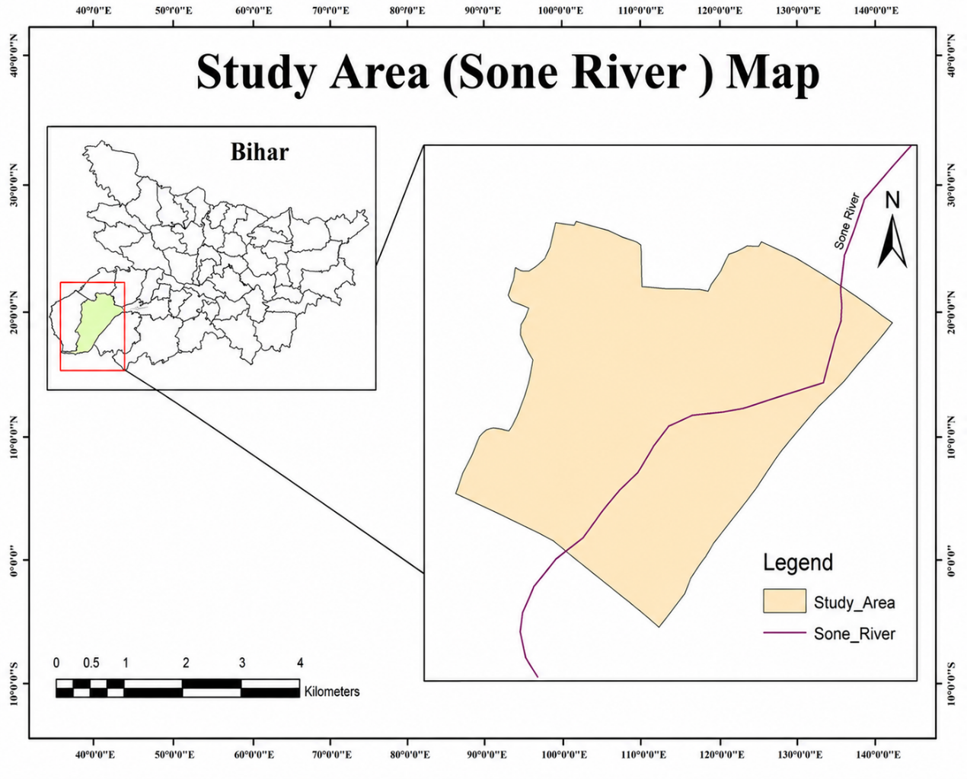
Figure 1: Location Map of the study area
Length-weight relationship (LWR)
The length–weight relationship was analysed separately by grouping the data into sex- and season-wise categories. After water was wiped from the body, freshly collected specimens were weighed accurately using a digital weighing balance (0.001 g), and total body length (mm) was measured using a digital Vernier calliper with an accuracy of 0.01 mm.
The length–weight relationship (LWR) of Macrobrachium lamarrei was estimated following the method proposed by Le Cren (1951) using the equation:
W = aLᵇ
where W represents the body weight of the prawn, L is the body length, a is the intercept (constant), and b is the regression coefficient, which describes the growth pattern.
Relative Condition Factor (Kn)
The relative condition factor (Kn) was estimated using the formula proposed by Le Cren (1951). This parameter was used to assess and compare prawn condition across various size categories and populations, as outlined by Omogoriola et al. (2011).
Relative condition factor
Here, Kn is the relative condition factor, and W is the actual weight of the prawn in grams.
The estimated weight (w̅) was calculated as w̅ = aLb
Here, w̅ is the estimated weight of the prawn, L is the prawn length, while a and b are the intercept and slope of the length–weight regression equation, respectively.
Fulton's Condition Factor (K)
Fulton's condition factor (K) differs from the relative condition factor (Kn) because the former measures the difference between an individual prawn and an imaginary standard, while the latter measures the difference between the weight of an individual prawn and the mean expected weight for a particular length.
The condition factor (K) of Macrobrachium lamarrei was computed using Fulton's condition factor formula, first defined by Fulton (1904). This formula assumes that body weight is proportional to the cube of body length. Using the calculation methods suggested by Pauly (1984) and Wootton (1992), the condition factor was computed from the mean values of total length and body weight of the prawns using the following formula.
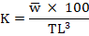
Where: stands for the total body weight of the prawn (g), while TL denotes the total length (cm).
Note: A multiplication factor of 100 is used to standardise the condition factor and bring it closer to 1.
Data Analysis
All calculations, including the length–weight relationship, Fulton's condition factor (K), and relative condition factor (Kn), were performed using a scientific calculator. Statistical analyses, including descriptive statistics, regression analysis, and graphical presentations, were conducted using Microsoft Excel 2021 and R.

Result and Discussion
Length-weight relationship
The values corresponding to the length–weight relationships of male and female Macrobrachium lamarrei are plotted in Figures 2 and 3, respectively, while the pooled relationship data are shown in Figure 4. The regression coefficient (b) was 2.6154 for males, 2.7443 for females, and 2.6700 for the pooled population (Table 1), and all estimated b values were below 3, confirming negative allometric growth. Statistical testing at the 95% confidence level against the theoretical value of 3 showed significant negative allometric growth in the male, female, and pooled data. The coefficient of correlation (r) was highest in males (0.9131), followed by the pooled population (0.9011) and females (0.8757), suggesting a strong relationship between length and weight. Similarly, the coefficient of determination (R²) ranged from 0.7668 to 0.8338, with the highest value observed in males, indicating that individual body length explained more than 76% of the variation in body weight.
Table 1: Parameters of the length-weight relationship of M. lamarrei .
Sex | N | a | b | r | R²
Male | 64 | 2.910 | 2.6154 | 0.9131 | 0.8338
Female | 100 | 2.867 | 2.7443 | 0.8757 | 0.7668
Pooled | 164 | 2.886 | 2.6700 | 0.9011 | 0.8120
n=number of specimens, a=regression co-efficient, b=regression co-efficient, r=correlation co-efficient, r²=Coefficient of determination

Table 2: Length–Weight Relationship, Condition Factors of Female Macrobrachium lamarrei Based on Grouped Classes
Class Interval (cm) | Mid L (cm) | f | Avg W (g) | log L | log W | logL × logW | (logL)² | Calculated W′ (g) | K | Kn
2.5–2.9 | 2.7 | 2 | 0.17 | 0.431 | −0.770 | −0.332 | 0.186 | 0.091 | 0.864 | 1.87
3.0–3.4 | 3.2 | 3 | 0.333 | 0.505 | −0.478 | −0.241 | 0.255 | 0.145 | 1.016 | 2.29
3.5–3.9 | 3.7 | 24 | 0.336 | 0.568 | −0.474 | −0.269 | 0.323 | 0.216 | 0.598 | 1.56
4.0–4.4 | 4.2 | 46 | 0.485 | 0.623 | −0.314 | −0.196 | 0.389 | 0.306 | 0.655 | 1.59
4.5–4.9 | 4.7 | 22 | 0.609 | 0.672 | −0.215 | −0.145 | 0.452 | 0.419 | 0.587 | 1.45
5.0–5.4 | 5.2 | 3 | 0.817 | 0.716 | −0.088 | −0.063 | 0.513 | 0.558 | 0.581 | 1.46
The female M. lamarrei specimens shown in Table 2 were distributed across six size classes ranging from 2.5–2.9 cm to 5.0–5.4 cm. The 4.0–4.4 cm length class had the highest frequency, comprising 46 individuals, whereas the lowest frequencies occurred in the 2.5–2.9 cm and 5.0–5.4 cm size classes, represented by 2 and 3 individuals, respectively. Mean body weight increased progressively with increasing individual length, indicating a positive relationship between body length and weight. The calculated (predicted) weight (W′) also increased steadily from 0.091 g to 0.558 g across the respective length classes.
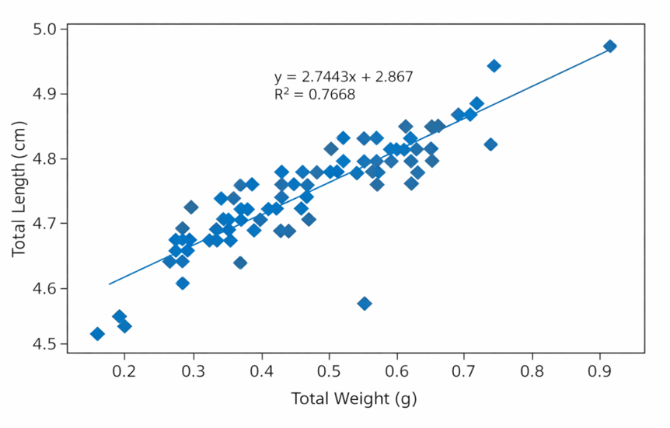
Figure 2: Regression analysis of Total Length vs Total weight of female M. lamarrei

Figure 2 shows the relationship between total weight (TW) and total length (TL) of females, and the scatter plot exhibits a positive linear relationship, with total weight ranging from 0.16 to 0.92 g and total length ranging from 4.51 to 4.97 cm. Most observations are concentrated within the weight interval of 0.30–0.65 g, corresponding to total lengths of 4.66–4.85 cm, indicating that most specimens belonged to the intermediate size class. The positive regression coefficient (2.7443) indicates that total length increases with increasing body weight. The regression model yielded R² = 0.7668, indicating that 76.68% of the variation in total length is explained by total body weight, with the remaining 23.32% unexplained.

Table 3: Length–Weight Relationship, Condition Factors of male Macrobrachium lamarrei Based on Grouped Classes

Class Interval (cm) | Mid L (cm) | f | Avg W (g) | log L | log W | logL × logW | (logL)² | Calculated W′ (g) | K | Kn
2.5–2.9 | 2.7 | 3 | 0.120 | 0.431 | −0.921 | −0.397 | 0.186 | 0.070 | 0.610 | 1.714
3.0–3.4 | 3.2 | 9 | 0.198 | 0.505 | −0.703 | −0.355 | 0.255 | 0.116 | 0.605 | 1.707
3.5–3.9 | 3.7 | 10 | 0.326 | 0.568 | −0.487 | −0.277 | 0.323 | 0.179 | 0.644 | 1.821
4.0–4.4 | 4.2 | 31 | 0.480 | 0.623 | −0.319 | −0.199 | 0.389 | 0.258 | 0.648 | 1.860
4.5–4.9 | 4.7 | 9 | 0.676 | 0.672 | −0.170 | −0.114 | 0.452 | 0.361 | 0.651 | 1.873
5.0–5.4 | 5.2 | 2 | 0.905 | 0.716 | −0.043 | −0.031 | 0.513 | 0.489 | 0.644 | 1.851

The length-class distribution of male Macrobrachium lamarrei showed a similar trend, with the highest frequency recorded in the 4.0–4.4 cm class (31 individuals). Mean body weight increased steadily from 0.120 g to 0.905 g, indicating a positive length–weight relationship consistent with the calculated weight data (Table 3).

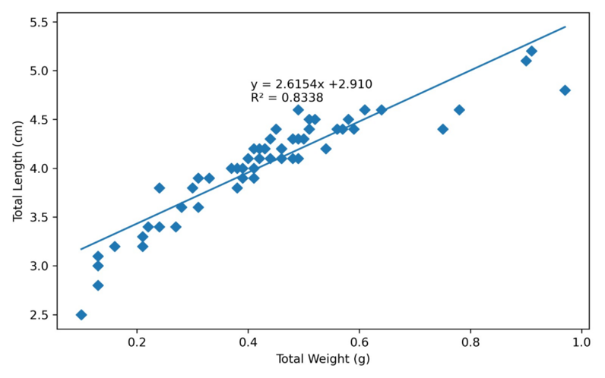
Figure 3: Regression analysis of Total Length vs Total weight of male M. lamarrei
Figure 3 shows the relationship between total weight (TW) and total length (TL) for males, demonstrating a positive linear association between the two variables. The total weight of male individuals ranged from 0.10 to 0.98 g, while total length varied between 2.50 and 5.20 cm. The regression coefficient was positive, indicating a proportional increase in total length with increasing body weight. The regression model yielded a coefficient of determination (R² = 0.8338), indicating that 83.38% of the total variation in body length was explained by body weight. The model did not explain the remaining 16.62% of the variation, and the observed data points were closely clustered around the fitted regression line, indicating minimal dispersion and a high degree of linearity between the measured variables. The regression model provides a statistical description of the morphometric relationship between these two variables within the male population.

Table 4. Length–Weight Relationship, Condition Factors of Pooled data of Macrobrachium lamarrei Based on Grouped Classes
Class Interval (cm) | Mid L (cm) | f | Average Weight (W) (g) | log L | log W | log L × log W | (log L)² | Calculated W′ (g) | K | Kn
2.5–2.9 | 2.7 | 5 | 0.150 | 0.431 | −0.824 | −0.355 | 0.186 | 0.082 | 0.762 | 1.83
3.0–3.4 | 3.2 | 12 | 0.267 | 0.505 | −0.574 | −0.290 | 0.255 | 0.131 | 0.815 | 2.04
3.5–3.9 | 3.7 | 34 | 0.333 | 0.568 | −0.478 | −0.271 | 0.323 | 0.197 | 0.621 | 1.69
4.0–4.4 | 4.2 | 77 | 0.483 | 0.623 | −0.316 | −0.197 | 0.389 | 0.282 | 0.651 | 1.71
4.5–4.9 | 4.7 | 31 | 0.629 | 0.672 | −0.201 | −0.135 | 0.452 | 0.391 | 0.605 | 1.61
5.0–5.4 | 5.2 | 5 | 0.852 | 0.716 | −0.070 | −0.050 | 0.513 | 0.523 | 0.606 | 1.63
In the pooled data for both sexes, the length-class distribution of Macrobrachium lamarrei showed similar trends in frequency and proportional increases in length and weight, demonstrating a positive length–weight relationship (Table 4).

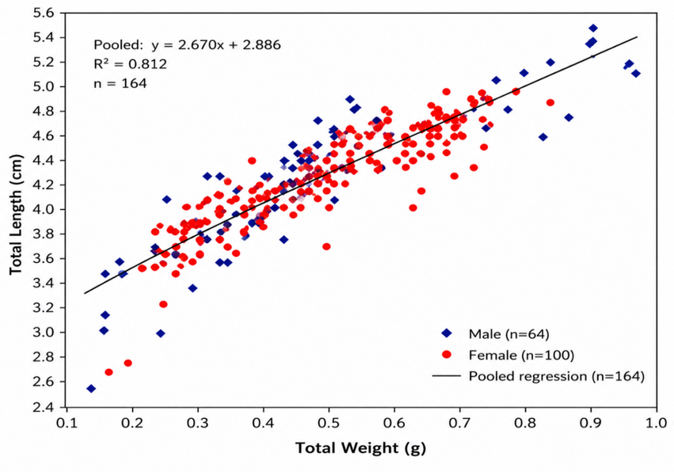
Figure 4: Regression analysis between Total length vs body weight in the pooled data of M. lamarrei
Figure 4 shows the pooled data for both sexes, and the scatter plot illustrates the relationship between total weight (g) and total length (cm) of Macrobrachium lamarrei. A total of 164 specimens were examined, including 64 males (blue diamonds) and 100 females (red circles). The regression equation (y = 2.670x + 2.886) indicates a strong positive linear relationship between weight and length. Overall, the graph shows that total length increases in proportion to body weight in both sexes, and the positive regression coefficient (2.670) indicates that total length increases linearly with body weight. The regression model yielded R² = 0.812, indicating that 81.2% of the variation in total length is explained by total body weight, with the remaining 18.8% unexplained.
Condition Factors
As shown in Figure 5, the condition factors of female Macrobrachium lamarrei were evaluated across six length classes (2.5–2.9 to 5.0–5.4 cm). The number of individuals in each class was 2, 3, 26, 45, 22, and 2, respectively. The relative condition factor (Kn) generally remained close to 1.0, reaching a maximum of 1.11 in the 5.0–5.4 cm class, indicating that the observed body weight was nearly equal to, or slightly greater than, the expected weight. Fulton's condition factor (K) varied among length classes, increasing gradually from 0.57 (2.5–2.9 cm) to 0.65 (3.0–3.4 cm), fluctuating slightly in the two middle classes (0.62–0.64), and then decreasing to 0.56 in the largest length class (5.0–5.4 cm). These variations indicate differences in body condition among size groups.
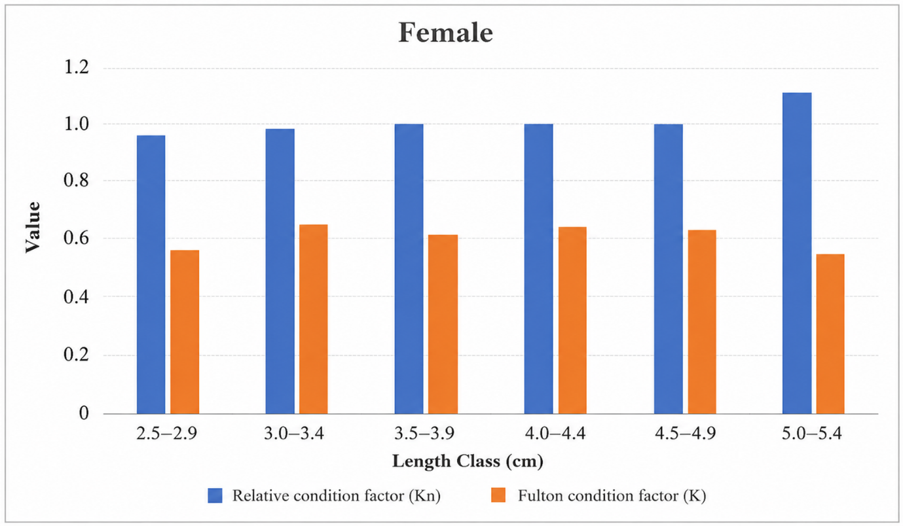
Figure 5: Relative Condition Factor (Kn) and Fulton Condition Factor (K) in Female
Macrobrachium lamarrei

Similarly, as shown in Figure 6, the condition factors of male Macrobrachium lamarrei were analysed across six length classes (2.5–2.9 to 5.0–5.4 cm). The number of individuals in the respective classes was 2, 8, 10, 34, 8, and 2. The relative condition factor (Kn) remained close to unity across all length classes and attained its highest value (1.04) in the 2.5–2.9 cm length class, indicating that the observed body weight was nearly equal to the expected weight. Fulton's condition factor (K) varied among length classes, reaching a maximum of 0.69 in the 4.5–4.9 cm class and a minimum of 0.57 in the 2.5–2.9 cm class, suggesting generally good physiological condition in male individuals throughout the study period.
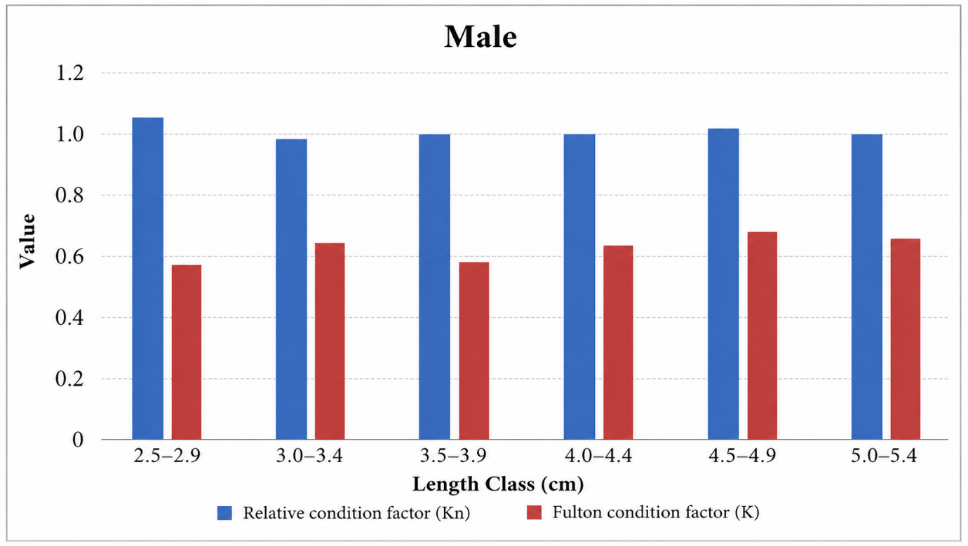
Figure 6: Relative Condition Factor (Kn) and Fulton's Condition Factor (K) in male Macrobrachium lamarrei
The present study showed that body weight increased with increasing length in Macrobrachium lamarrei, indicating a significant positive length–weight relationship (LWR), meaning that an individual's body weight increased consistently with total length. This growth relationship confirms the expected length–weight relationship commonly observed in freshwater prawns. The relatively high coefficients of determination (R² = 0.8338 for males, 0.7668 for females, and 0.812 for both sexes pooled) indicate a strong relationship between total length and body weight, suggesting that body length is a reliable predictor of body weight in the studied population. The comparatively higher R² value observed in males indicates a stronger length–weight relationship than in females. In contrast, the relatively lower R² value in females may be associated with greater variability arising from reproductive development and gonadal maturation.
Overall, the regression analysis confirms a strong positive association between total weight and total length in female Macrobrachium lamarrei. The relatively high coefficient of determination and the close clustering of observations around the fitted regression line indicate that body weight is a reliable predictor of total length in the studied population. Thus, for both sexes, the consistency in Kn values and fluctuations in K values indicated normal physiological conditions and growth under the prevailing environmental conditions of the Sone River.
Discussion
The present study revealed a negative allometric growth pattern in Macrobrachium lamarrei, particularly in females, indicating that body weight increased at a slower rate than total length. This pattern is comparable with the findings of Ara et al. (2014), who documented negative allometric growth in Macrobrachium lamarrei from Bangladesh, and Lodhi et al. (2024), who reported negative allometric growth in prawn populations from northern India. However, the similarity in growth patterns should not be interpreted as evidence of identical ecological conditions, and the observed growth pattern in the Sone River prawn population may reflect the combined effects of local food availability, variability, habitat characteristics, and seasonal conditions. Ara et al. (2014) and Lodhi et al. (2024) suggested that seasonal variation, food availability, reproductive status, and habitat characteristics are among the major factors influencing the growth pattern of freshwater prawns.
Differences in length–weight relationships among populations are expected because several biological and environmental factors influence individual growth. Froese (2006) emphasised that length–weight relationship parameters are population-specific and may vary with sex, maturity stage, season, habitat quality, food availability, and geographical location. Therefore, slight variations in regression parameters among different studies are considered normal and reflect differences in ecological conditions and population characteristics rather than inconsistencies in growth.
Negative allometric growth was observed in the present study, and during juvenile stages, a considerable proportion of assimilated energy is allocated to rapid linear growth. In contrast, mature individuals divert more energy towards gonadal development, reproduction, and maintenance metabolism, resulting in comparatively slower weight gain. Hartnoll (1982) reported that moulting and reproductive cycles are the principal biological processes regulating growth in decapod crustaceans. Similarly, Mariappan and Balasundaram (2004) observed that moulting frequency and reproductive maturity significantly influence growth patterns in freshwater prawns. Chang (1995) further explained that immediately after ecdysis, the exoskeleton expands rapidly, increasing body length, while tissue growth and biomass accumulation occur more gradually, contributing to negative allometric growth.
In the pooled regression analysis of 164 M. lamarrei specimens (64 males and 100 females), there was a strong positive linear correlation between body weight and body length. The high coefficient of determination (R² = 0.812) implies that 81.2% of the variation in body length can be explained by body weight; therefore, body weight is a dependable predictor of body length in the pooled population. The remaining 18.8% of the variation may be attributable to biological parameters such as sex, age, maturity, and nutritional status, as well as environmental factors.
Overall, the present study demonstrates that Macrobrachium lamarrei from the Sone River exhibits a significant length–weight relationship with negative allometric growth. The findings provide important baseline information on the biology of M. lamarrei and may be valuable for future studies on population dynamics, ecological monitoring, fisheries management, and conservation of freshwater prawn resources in the Sone River ecosystem.
Fulton's condition factor (K) is widely used as an index of body condition and reflects the balance between body weight and body length in aquatic organisms. In the present study, the observed K values indicated that the population of Macrobrachium lamarrei maintained a stable body condition throughout the study period. Variations in K among different length groups and between sexes were within the expected range for natural populations and are likely associated with differences in growth, moulting, and reproductive status.
The comparatively lower K values observed in smaller individuals may be associated with rapid somatic growth and frequent moulting during the juvenile stage. As body size increased, K values also increased, suggesting improved tissue development and energy storage with growth. Similar observations have been reported by Mariappan and Balasundaram (2004), who showed that moulting frequency and growth significantly influence the body condition of freshwater prawns.
A slight decline in K in the larger size groups may be associated with sexual maturation and reproductive activity. Hartnoll (1982) reported that seasonal reproductive cycles and energy allocation are major factors influencing condition in decapod crustaceans. Comparable trends have also been reported by Lodhi et al. (2024), who observed variation in the condition factor of Macrobrachium lamarrei with reproductive development.
The observed variation in K is also consistent with the negative allometric growth pattern recorded in the present study. Because M. lamarrei exhibited b < 3, body length increased faster than body weight, which may contribute to lower condition values in some size groups. Froese (2006) emphasised that Fulton's condition factor assumes isometric growth and should therefore be interpreted alongside the length–weight relationship, particularly when growth deviates from isometry.
Overall, the present findings indicate that the population of Macrobrachium lamarrei maintained satisfactory body condition during the study period despite exhibiting negative allometric growth. The observed pattern is consistent with previous studies on freshwater prawns and suggests that normal biological processes such as growth, moulting, and reproduction were the principal factors influencing body condition.
The relative condition factor (Kn) is a widely accepted indicator of the physiological condition of aquatic organisms because it compares observed body weight with expected body weight derived from the length–weight relationship (Le Cren, 1951). In the present study, the Kn values of Macrobrachium lamarrei remained close to unity in both males and females, indicating that the sampled population maintained body weights appropriate for their respective lengths and was in satisfactory physiological condition throughout the study period.
Kn in freshwater prawns is affected by age, sex, reproductive stage, moulting, nutritional status, and environmental conditions. In general, young prawns have low Kn values because a considerable amount of energy is used for somatic growth and exoskeleton production; intermediate-sized prawns have high Kn values, indicating good feeding and physiological condition, while adult prawns have relatively low Kn values because more energy is utilised for gonadal development, reproduction, and metabolism. Females generally have higher Kn values than males, primarily because of greater energy demands during ovarian development. The variation in Kn observed between males and females may be associated with differences in energy allocation for growth and reproduction. Similar sex-related variation in condition has been reported in freshwater prawns, where reproductive activity influences body weight relative to body length (Lodhi et al., 2024). However, the magnitude of this variation depends on the reproductive stage and sampling season.
The relative condition factor is directly related to the length–weight relationship because the expected body weight used in its calculation is estimated from the length–weight regression. Le Cren (1951) proposed Kn as a more reliable measure of body condition than Fulton's condition factor (K), particularly when growth deviates from isometric conditions. Since the present study demonstrated negative allometric growth (b < 3), using Kn provides a more appropriate assessment of body condition, as it accounts for the species' actual growth pattern rather than assuming isometric growth. Froese (2006) reported that condition indices should be interpreted alongside the length–weight relationship to obtain a reliable assessment of the biological condition of aquatic organisms.
Although minor variations in Kn have been reported among different populations, such differences are expected because body condition is influenced by several biological and ecological factors, including reproductive status, food availability, season, size composition, and habitat characteristics (Froese, 2006; Le Cren, 1951). Therefore, slight differences in Kn among studies reflect natural population variability rather than differences in overall population health.
Overall, the relative condition factor recorded in the present study indicates that the population of Macrobrachium lamarrei maintained satisfactory physiological condition and body weights consistent with those expected from the length–weight relationship. These results provide valuable baseline information on the health and growth status of M. lamarrei and contribute to future studies on population dynamics, ecological monitoring, and sustainable management of freshwater prawn resources.
Conclusion
The present study provided baseline information on the growth pattern and body characteristics of M. lamarrei in the Sone River, showing that the length–weight relationship was strongly associated with body weight and total length and that growth patterns differed by sex.
The condition indices generally indicated a favourable body condition in the sampled populations across the examined size range. These findings provide useful biometric information for further population monitoring of M. lamarrei in the Sone River and contribute to the conservation of these freshwater resources. Further studies will be needed on freshwater prawn populations across sections of the Sone River during different seasons, using environmental and reproductive variables as indicators to assess growth and condition.
Limitation
The study represents specimens collected from a single locality at Makrain during November 2025–January 2026; therefore, interpretation should remain specific to the sampled population and period. The analysis focused on total length, body weight, and derived condition indices across the recorded size classes. Broader spatial and seasonal generalisation will require sampling from additional sections of the Sone River and during other seasons, together with the environmental and reproductive variables proposed for future investigation. These limitations define the scope within which the reported biometric relationships should be interpreted.
Author Contribution
Aditi S. conducted data collection and manuscript writing. Nikita assisted with data analysis and manuscript preparation; Koshal K provided scientific supervision, critically reviewed and revised the manuscript, and oversaw the overall study. All authors reviewed and approved the final manuscript.

COMPETING INTERESTS DISCLAIMER:
Authors have declared that they have no known competing financial interests OR non-financial interests OR personal relationships that could have appeared to influence the work reported in this paper.
Funding Declaration:
The authors declare that no specific financial grant from any funding agency in the public, commercial, or not-for-profit sectors was received for the research, authorship, and/or publication of this article.

Declaration of AI Use

This manuscript was prepared through the intellectual contributions of the author(s) to the study design, data analysis, interpretation of results, and scholarly content. Grammarly and ChatGPT were used solely to assist with grammatical refinement and reference formatting during manuscript revision. The author(s) accept full responsibility for the accuracy, integrity, and final content of the manuscript.

References
Abohweyere, P. O., & Williams, A. B. (2008). Length-weight relationship and condition factor of Macrobrachium macrobrachion in the Lagos-Lekki Lagoon system, Nigeria. Research Journal of Biological Sciences, 3(11), 1333–1336. https://doi.org/10.36478/rjbsci.2008.1333.1336
Ara, M. G., Nabi, M. N., Ahmed, Z. F., & Fatema, M. K. (2014). Length-weight relationship and growth pattern inference of a small indigenous freshwater prawn, Macrobrachium lamarrei (H. Milne-Edwards, 1837) in Bangladesh. Research in Agriculture, Livestock and Fisheries, 1(1), 137–145. https://doi.org/10.3329/ralf.v1i1.22377
Chang, E. S. (1995). Physiological and biochemical changes during the molt cycle in decapod crustaceans: An overview. Journal of Experimental Marine Biology and Ecology, 193(1–2), 1–14. https://doi.org/10.1016/0022-0981(95)00106-9
de Carvalho-Souza, G. F., Medeiros, D. V., Silva, R. de A., & González-Ortegón, E. (2023). Width/length–weight relationships and condition factor of seven decapod crustaceans in a Brazilian tropical estuary. Regional Studies in Marine Science, 60, 102880. https://doi.org/10.1016/j.rsma.2023.102880
Froese, R. (2006). Cube law, condition factor and weight–length relationships: History, meta-analysis and recommendations. Journal of Applied Ichthyology, 22(4), 241–253. https://doi.org/10.1111/j.1439-0426.2006.00805.x
Fulton, T. W. (1904). The rate of growth of fishes. In Twenty-second annual report of the Fishery Board for Scotland (Part III, pp. 141–241). Fishery Board for Scotland. https://www.fishbase.se/references/FBRefSummary.php?ID=1282
Hartnoll, R. G. (1982). Growth. In L. G. Abele (Ed.), The biology of Crustacea: Vol. 2. Embryology, morphology, and genetics (pp. 111–196). Academic Press. https://www.vliz.be/en/imis?module=ref&refid=198680
Kurup, B. M., Harikrishnan, M., & Sureshkumar, S. (2000). Length-weight relationship of male morphotypes of Macrobrachium rosenbergii (de Man) as a valid index for differentiating their developmental pathway and growth phases. Indian Journal of Fisheries, 47(4), 283–290. https://epubs.icar.org.in/index.php/IJF/article/view/8503
Kumar, K., Rana, A. R., & Kotnala, C. B. (2014). Length–weight relationship of Macrobrachium assamense peninsulare (Tiwari, 1958), a minor freshwater prawn in Rawasan Stream of Uttarakhand, India. Journal of Mountain Research, 9, 13–19. https://jmr.sharadpauri.org/archive.php
Kumar, K., Rana, A. R., & Kotnala, C. B. (2016). Preliminary study of Fulton’s condition factor (CF) and relative condition factor (Kn) of Macrobrachium assamense peninsulare from Rawasan Stream, Uttarakhand, India. International Journal of Current Research, 8(9), 37736–37739. https://www.journalcra.com/article/preliminary-study-fulton%E2%80%99s-condition-factor-cf-and-relative-condition-factor-kn
Le Cren, E. D. (1951). The length-weight relationship and seasonal cycle in gonad weight and condition in the perch (Perca fluviatilis). Journal of Animal Ecology, 20(2), 201–219. https://doi.org/10.2307/1540
Lodhi, S., Ahmed, A., Swami, V. P., & Shukla, S. (2024). Morphometric analysis and condition factor of freshwater prawn, Macrobrachium lamarrei (Crustacea-Decapoda) from the Gomti River, Lucknow, Uttar Pradesh, India. Uttar Pradesh Journal of Zoology, 45(11), 69–77. https://doi.org/10.56557/upjoz/2024/v45i114071
Maji, D., Tudu, A. K., Rath, S., Roy Chowdhury, B., Ali, M. R., & Mukherjee, S. (2026). Length-weight relationships and Fulton’s condition factor of ocellated pufferfish (Leiodon cutcutia) from the Indo-Bangladesh transboundary River (Icchamati), West Bengal, India, with emphasis on seasonal variations. Asian Journal of Current Research, 11(1), 32–44. https://doi.org/10.56557/ajocr/2026/v11i110170
Mariappan, P., & Balasundaram, C. (2004). Studies on the morphometry of Macrobrachium nobilii (Decapoda, Palaemonidae). Brazilian Archives of Biology and Technology, 47(3), 441–449. https://doi.org/10.1590/S1516-89132004000300015
Omogoriola, H. O., Williams, A. B., Adegbile, O. M., Olakolu, F. C., Ukaonu, S. U., & Myade, E. F. (2011). Length-weight relationships, condition factor (K) and relative condition factor (Kn) of sparids, Dentex congoensis (Maul, 1954) and Dentex angolensis (Maul & Poll, 1953), in Nigerian coastal water. International Journal of Biological and Chemical Sciences, 5(2), 739–747. https://doi.org/10.4314/ijbcs.v5i2.72147
Oyebola, O. O., Coker, O. M., Oche, C., Akanmu, O. A., Alamu, O., Azuh, V. O., & Idowu, C. F. (2024). Morphologic and phylogenetic investigations revealed size-divergent clades in chelae morphotypes of freshwater prawn Macrobrachium vollenhovenii Herklots (Decapoda: Palaemonidae) in a lake and river system of Southwest Nigeria. The Journal of Basic and Applied Zoology, 85, 22. https://doi.org/10.1186/s41936-024-00376-8
Pauly, D. (1984). Fish population dynamics in tropical waters: A manual for use with programmable calculators (ICLARM Studies and Reviews No. 8). International Center for Living Aquatic Resources Management. https://hdl.handle.net/20.500.12348/3445
Prasad, S., Nath, P., & Chaudhary, D. N. (2023). Freshwater prawns diversity (Crustacea: Decapoda) in the River Koshi, Eastern Bihar. Asian Journal of Research in Zoology, 6(2), 11–18. https://doi.org/10.9734/ajriz/2023/v6i2107
Rana, A. R., & Kumar, K. (2013). Length weight relationship and Fulton’s condition factor of Macrobrachium assamense peninsularie in Khoh tributary of Ram Ganga from Garhwal Himalaya, Uttarakhand, India. Environment Conservation Journal, 14(3), 17–22. https://doi.org/10.36953/ECJ.2013.14303
Ranjeet, K., & Kurup, B. M. (2002). Management strategies associating batch-graded and size-graded postlarvae can reduce heterogeneous individual growth in Macrobrachium rosenbergii. Aquaculture Research, 33(15), 1221–1231. https://doi.org/10.1046/j.1365-2109.2002.00775.x
Sahu, O., Mogalekar, H. S., Sahil, Sanjay, Kumar, P., Ram, R. K., Nayak, S. K., Srivastava, P. P., & Brahmchari, R. K. (2024). Length-weight relationship and exploitation of Macrobrachium species in the Burhi Gandak River, North Bihar, India. Indian Journal of Fisheries, 71(3), 60–68. https://doi.org/10.21077/ijf.2024.71.3.133789-07
Sarkar, U. K., Khan, G. E., Dabas, A., Pathak, A. K., Mir, J. I., Rebello, S. C., Pal, A., & Singh, S. P. (2013). Length weight relationship and condition factor of selected freshwater fish species found in River Ganga, Gomti and Rapti, India. Journal of Environmental Biology, 34(5), 951–956.
Sethi, S. N., Ram, N., & Venkatesan, V. (2012). Length-weight relationship of Macrobrachium lar (Fabricius, 1798), an endemic freshwater prawn in streams and ponds of Andaman and Nicobar Islands. Indian Journal of Fisheries, 59(4), 157–161. https://epubs.icar.org.in/index.php/IJF/article/view/14978
Sethi, S. N., Ram, N., & Venkatesan, V. (2013). Morphometric relationships of the monkey river prawn Macrobrachium lar (Fabricius, 1798) (Decapoda, Palaemonidae) from the Andaman Islands. Indian Journal of Fisheries, 60(2), 157–161. https://epubs.icar.org.in/index.php/IJF/article/view/21309
Soomro, A. N., Baloch, W. A., Chandio, T. J., Achakzai, W. M., & Saddozai, S. (2012). Condition factor and length-weight relationship of monsoon river prawn Macrobrachium malcolmsonii malcolmsonii (H. Milne-Edwards, 1844) (Palaemonidae) in lower Indus River. Pakistan Journal of Zoology, 44(5), 1279–1283. https://www.zsp.com.pk/vol-44%5B5%5D.html
Wootton, R. J. (1992). Fish ecology. Blackie; Chapman & Hall. https://doi.org/10.1007/978-94-011-3832-1
Yang, M., Ding, F., & Dai, X. (2016). Length-length, length-weight relationships and condition factor of the giant freshwater prawn Macrobrachium rosenbergii (de Man, 1879) cultured in earthen pond at high density. Asian Fisheries Science, 29(4), 164–177. https://doi.org/10.33997/j.afs.2016.29.4.001

