Amelioration of Metabolic and Hepatic Alterations by Caralluma fimbriata in High-Fat Diet-Fed Obese Rats

ABSTRACT
Background: Obesity induced by prolonged high-fat-diet consumption is associated with insulin resistance, dyslipidaemia, oxidative imbalance, and hepatic injury.
Aim: The present study evaluated the effects of Caralluma fimbriata extract (CFE) on fat deposition, oxidative stress, inflammation, and fibrosis in the liver of high-fat diet (HFD)-induced obese rats.
Method : Thirty male Wistar rats were divided into five groups (n = 6): control (C), control+CFE, HFD, HFD+CFE (200 mg/kg/day for 150 days; preventive model), and obese+CFE (OBS+CFE; 200 mg/kg/day after 90 days of HFD feeding for the subsequent 60 days; therapeutic model).
Results: HFD-fed rats showed significant increases in body weight, plasma glucose, insulin resistance (HOMA-IR), leptin, lipid-profile parameters, and hepatic markers. Elevated lipid peroxidation and protein oxidation, together with reduced antioxidant enzyme activities (GPx, GR, GST, SOD, and CAT) and HDL cholesterol levels, were also observed. CFE supplementation significantly improved body weight, hyperglycaemia, insulin resistance, hyperleptinaemia, and dyslipidaemia. It increased HDL-C levels and restored antioxidant enzyme activities in both the preventive and therapeutic groups. Additionally, CFE significantly (p < 0.05) reduced plasma and hepatic lipids, including triglycerides, total cholesterol, and free fatty acids, while improving phospholipid levels.
Conclusion: Histopathological findings supported these results. Overall, CFE ameliorated liver dysfunction in HFD-fed rats by reducing oxidative stress and inflammation, suggesting potential protective and therapeutic effects.
Keywords: Caralluma fimbriata, oxidative stress, insulin resistance, high-fat diet, hepatic transaminases
Background
Obesity is increasingly recognised as a chronic, relapsing, and multifactorial disease with complex genetic and environmental determinants. It has emerged as a major global health challenge affecting both developed and developing countries (Młynarska et al., 2025). A long-term high-fat diet (HFD) is a key contributor to obesity and is associated with several metabolic complications, including dyslipidaemia, hypertension, non-alcoholic fatty liver disease, cardiovascular disorders, and reduced life expectancy (Kyrou et al., 2018). Previous studies have demonstrated that prolonged consumption of an HFD rapidly induces obesity and insulin resistance, highlighting unhealthy dietary habits as a major risk factor (Gujjala et al., 2023; Sudhakara et al., 2014, 2018).
Recent experimental studies in high-fat-diet-fed rats have reported improvements in hepatic oxidative-stress indices, dyslipidaemia, and histological liver injury following the administration of selected plant-derived bioactives (Noreen et al., 2025; Sarkar et al., 2025; Yasmin et al., 2025).
Chronic obesity is also linked to an increased risk of various cancers, particularly colorectal and prostate cancers (Olatona et al., 2018). Prolonged HFD intake promotes inflammation by upregulating Toll-like receptor 4 (TLR4), leading to increased production of pro-inflammatory cytokines and alterations in metabolic hormones such as insulin and leptin (Pati et al., 2023; Xu et al., 2018). These changes disrupt glucose homeostasis and contribute to insulin resistance (Galicia-Garcia et al., 2020; Tramullas et al., 2016). Experimental studies have further shown that HFD induces hyperglycaemia, hyperinsulinaemia, and hyperleptinaemia in animal models (Gujjala et al., 2016, 2017, 2022).
In an obese Wistar-rat model, a hydroalcoholic medicinal-plant extract was similarly evaluated using body-weight indices and hepatic markers of lipid peroxidation and antioxidant defence (Akotegnon et al., 2025).
Given the growing burden of obesity-related complications, there is an urgent need to develop effective strategies for prevention and management. In this context, Caralluma fimbriata, an edible succulent plant with known appetite-suppressing and antioxidant properties, has gained attention. It contains bioactive compounds that may reduce energy intake, enhance thermogenesis, and regulate lipid metabolism (Gujjala et al., 2016, 2017, 2022). Recent Wistar-rat research has also assessed plant-derived preparations through the combined evaluation of body weight, lipid profiles, and oxidative-stress biomarkers (Odia & Akpevwe-Erhieyovwe, 2025). However, the available evidence does not clearly establish whether CFE can provide both preventive and therapeutic benefits against HFD-induced hepatic lipid accumulation, oxidative imbalance, and associated tissue injury within a single long-term experimental design. Therefore, the present study investigates the protective and therapeutic effects of Caralluma fimbriata extract on oxidative stress, inflammation, and tissue damage in HFD-induced obese rats.
METHODS
Chemicals
Reduced and oxidised glutathione, thiobarbituric acid (TBA), 1-chloro-2,4-dinitrobenzene (CDNB), and pyrogallol were purchased from SISCO Research Laboratories (P) Ltd, Mumbai, India. All other chemicals and solvents were of analytical grade and were purchased from Sisco Research Laboratories (P) Ltd., Mumbai, India.
Preparation of plant extract
The extract of Caralluma fimbriata was prepared from the aerial parts of the plant using 40% aqueous alcohol (40 parts alcohol and 60 parts water). Approximately 12 kg of dried plant material was obtained from 100 kg of fresh plant, yielding 1 kg of final extract.
The hydroalcoholic extract of C. fimbriata (CFE; light brown, dry powder; batch number: CFE/10011) was supplied by Green Chem Herbal Extracts and Formulations, Bangalore, India. The plant material used for extraction was originally collected from the Kolli Hills and subsequently cultivated at the company’s farm in Hosur, Tamil Nadu, India. Prior to administration, the extract was dissolved in distilled water.
Experimental Animals and Diet
A total of thirty male Wistar rats (8 weeks old), weighing 160–170 g, were procured from the Biogen Laboratory Animal Facility, Bangalore, India, and housed in the Animal House, Department of Zoology. The animals were maintained under standard laboratory conditions at a temperature of 23 ± 2°C with a 12 h light/12 h dark cycle. They were provided ad libitum access to a standard pellet diet or high-fat diet (HFD) and drinking water. Before the commencement of the experiment, all animals were acclimatised for one week. Throughout the experimental period, the rats were maintained under sedentary conditions without any enforced physical activity. The dose of Caralluma fimbriata extract (CFE) used in this study was based on previously reported studies (Gujjala et al., 2016, 2017, 2022).
The HFD was formulated as a lard-based diet containing 60 kJ% energy from fat, 20 kJ% from protein, and 20 kJ% from carbohydrates, in accordance with Diet-Induced Obesity (DIO) diet standards (New Brunswick, NJ, USA).
Obesity Induction and Treatment in Rats
Male Wistar rats were randomly divided into five groups (n = 6 per group) as follows:
- Group C (Control): Rats were fed a standard pellet diet containing 65% carbohydrates, 8% fat, 13% protein, 12.75% fibre, and 1.25% vitamins and minerals, along with distilled water, for 150 days.
- Group C+CFE: Rats received a standard pellet diet along with Caralluma fimbriata extract (CFE; 200 mg/kg body weight) administered concurrently for 150 days.
- Group HFD: Rats were fed a high-fat diet (HFD) for 150 days to induce obesity.
- Group HFD+CFE (Protective model): Rats received HFD along with CFE (200 mg/kg body weight) simultaneously for 150 days.
- Group OBS+CFE (Therapeutic model): Rats were fed HFD for 90 days to induce obesity, followed by co-administration of HFD and CFE (200 mg/kg body weight) for the subsequent 60 days.

Body Weight and Organ Weights

Body weight was recorded for all animals throughout the experimental period. At the end of the study, the absolute and relative weights of the liver, abdominal fat, and epididymal fat pads were measured in all experimental groups. Relative organ weights were calculated with respect to the final body weight of each animal.
Biochemical Analysis
During the experimental period, blood samples were collected at 30-day intervals from 12-hour-fasted rats via the retro-orbital plexus using capillary tubes. Samples were collected into fresh vials containing EDTA (10 mg/mL) as an anticoagulant. The blood samples were centrifuged at 3,000 rpm for 5 minutes using an Eppendorf Centrifuge 5805R (Germany). The separated plasma was aliquoted and stored under appropriate frozen conditions for the estimation of glucose, insulin, leptin, adiponectin, and lipid-profile parameters. At the end of the experimental period, the animals were fasted overnight and euthanised by cervical decapitation. The abdominal cavity was opened, and the liver was carefully excised, rinsed in ice-cold saline, and processed for further biochemical analyses.
Biochemistry of Serum/Plasma
Plasma glucose concentration was measured using the glucose oxidase method with a commercial kit from Excel Diagnostics, India. Plasma insulin levels were determined by radioimmunoassay (RIAK-1) obtained from the Bhabha Atomic Research Centre, Mumbai, following the method of Yalow and Berson (1961). Insulin resistance (IR) was assessed using the homeostasis model assessment (HOMA) and glucose–insulin (GI) index (Pickavance et al., 1999). The HOMA index was calculated using the formula: HOMA = [insulin (μU/mL) × glucose (mmol/L)] / 22.5. Plasma leptin levels were measured using a sandwich ELISA kit (Mouse and Rat Leptin ELISA) from BioVendor Laboratory Medicine, Czech Republic.
Lipid Profile Analysis
Plasma triglyceride (TG) levels were determined using the glycerol-3-phosphate oxidase–phenol aminophenazone (GPO–PAP) enzymatic method with a commercial kit from Excel Diagnostics, India. Total cholesterol (TC) and high-density lipoprotein cholesterol (HDL-C) were measured using standard enzymatic methods with kits from the same manufacturer. Very low-density lipoprotein cholesterol (VLDL-C) and low-density lipoprotein cholesterol (LDL-C) levels were calculated using the Friedewald equation (Friedewald et al., 1972) as follows: VLDL-C = TG / 5 and LDL-C = TC − (HDL-C + VLDL-C). The atherogenic index (AI) was calculated according to Liu et al. (1999) using the formula: AI = TC / HDL-C.
Liver Functional Tests
Serum activities of alkaline phosphatase (ALP), alanine transaminase (ALT), and aspartate transaminase (AST) were measured using kinetic methods recommended by the International Federation of Clinical Chemistry (IFCC). The assays were performed using commercial diagnostic kits from Erba Diagnostics Mannheim GmbH, Mumbai, India.
Hepatic Transaminases
A 10% (w/v) liver homogenate was prepared in 0.1 M Tris-HCl buffer (pH 7.4) and centrifuged at 18,514 × g for 45 minutes using an Eppendorf Centrifuge 5804R equipped with rotor No. 14030. The resulting clear supernatant was collected and used for the estimation of hepatic transaminases. The activities of glutamate oxaloacetate transaminase (GOT) and glutamate pyruvate transaminase (GPT) were determined according to the method described by Reitman and Frankel (1957).
Hepatic Lipids
Liver lipids were extracted according to the method of Folch et al. (1957). The levels of total cholesterol (TC) and triglycerides (TAG) were determined using enzymatic kits from Excel Diagnostics, India. Free fatty acids (FFA) were estimated using the method of Duncombe (1963). Phospholipids (PL) were determined according to Connerty et al. (1961), while total lipids (TL) were quantified using the method described by Folch et al. (1957).
Hepatic Oxidative Stress Markers
Lipid peroxidation (LPO) in liver tissue was assessed by measuring thiobarbituric acid-reactive substances (TBARS) according to the method of Utley et al. (1967), using a 10% liver homogenate prepared in 0.15 M KCl. The results were expressed as nanomoles of malondialdehyde (MDA) formed per minute per milligram of protein. Protein oxidation was evaluated by estimating protein carbonyl (PC) content using the method of Levine et al. (1990). Reduced glutathione (GSH) levels were determined according to the method of Ellman (1959). Total protein content in the liver homogenate was measured using the method of Lowry et al. (1951) for normalisation of biochemical parameters.
Hepatic Antioxidant Enzyme Assay
A 10% (w/v) liver tissue homogenate was prepared in ice-cold 0.15 M KCl and centrifuged at 12,000 rpm for 45 minutes using a Sigma 3K18 Laboratory Centrifuge (rotor No. 12150). The resulting clear supernatant was collected and used for the estimation of antioxidant enzyme activities. The activities of glutathione peroxidase (GPx; EC 1.11.1.9), glutathione-S-transferase (GST; EC 2.5.1.18), and glutathione reductase (GR; EC 1.8.1.7) were determined using the methods of Rotruck et al. (1973), Habig et al. (1974), and Pinto and Bartley (1969), respectively. Superoxide dismutase (SOD; EC 1.15.1.1) activity was measured according to Soon and Tan (2002), while catalase (CAT; EC 1.11.1.6) activity was estimated using the method of Beers and Sizer (1952).
Histological Assessment of the Liver
Liver tissues were collected from all experimental groups and fixed in 10% neutral buffered formalin. The samples were processed, paraffin-embedded, and sectioned at a thickness of 5 µm. The sections were stained with haematoxylin and eosin (H&E) and examined under a light microscope for histopathological evaluation.
Statistical Analysis
Data are expressed as the mean ± standard error (SE) for six animals in each group. Statistical analysis was performed using Duncan’s multiple range test (DMRT), as described by Duncan (1955), with the aid of SPSS (version 13.0 for Windows; SPSS Inc., USA). A value of p < 0.05 was considered statistically significant.
RESULTS
Effects of CFE on Liver and Epididymal Fat Pad Weight
The absolute and relative weights of the liver and epididymal fat pads are presented in Table 1. The HFD group showed significant increases in both absolute and relative liver weights (25.5% and 28.8%) and epididymal fat-pad weights (66.3% and 88.3%) compared with the control group. Co-administration of CFE in the HFD+CFE and OBS+CFE groups significantly prevented these increases. No notable differences were observed between the C and C+CFE groups.

Table 1
Protective and therapeutic effects of CFE on absolute and relative organ weights in five experimental groups

Tissues | Groups
 | Group-C | Group-C+CFE | Group-HFD+CFE | Group-HFD | Group-OBS+CFE
Liver tissue weight (g)
Absolute | 8.38 ± 0.32ª | 8.30 ± 0.42ª | 8.45 ± 0.31ª | 10.52 ± 0.56^{b} | 9.10 ± 0.48ª
Relative | 2.29 ± 0.08ª | 2.52 ± 0.09ª | 2.66 ± 0.11^{b} | 2.95 ± 0.13^{b} | 2.64 ± 0.08ª
Epidymal fat pads (g)
Absolute | 5.35 ± 0.41ª | 5.58 ± 0.25ª | 6.77 ± 0.32^{bc} | 8.90 ± 0.64^{d} | 7.88 ± 0.47^{c}
Relative | 1.28 ± 0.06ª | 1.78 ± 0.03ª | 2.02 ± 0.11^{b} | 2.41 ± 0.09^{b} | 2.28 ± 0.12^{b}

Data are mean ± S.E.M. values of six rats per each group. Means in the same column with different superscripts are significantly different (P < 0.05). ^{a,b,c,d,e:} significant differences between groups. control rats; C+CFE, control rats treated with Caralluma fimbriata; HFD, high-fat diet fed rats; HFD+CFE, high-fat diet rats treated with Caralluma fimbriata (protective model); OBS+CFE, high-fat diet fed animals treated with Caralluma fimbriata (therapeutic model).

Effects of CFE on Body Weight
HFD-fed rats exhibited a significant increase in body weight (29%) compared with controls. CFE treatment significantly reduced weight gain in the HFD+CFE (24.4%) and OBS+CFE (14.3%) groups. Additionally, the CFE-treated groups showed reduced body-weight gain compared with controls, indicating its protective and therapeutic efficacy (Fig. 1).
Effects of CFE on Plasma Glucose, Insulin, Leptin and HOMA
HFD significantly increased plasma glucose (108.1%), insulin (241.9%), and the HOMA index (612.2%) compared with controls. CFE supplementation significantly reduced these parameters in both the HFD+CFE and OBS+CFE groups, although the values remained higher than those of controls. The C+CFE group maintained near-normal levels (Fig. 1). Plasma leptin levels were significantly elevated in HFD-fed rats. CFE treatment reduced leptin levels in both the HFD+CFE and OBS+CFE groups (Fig. 2A). The C+CFE group showed a slight reduction compared with controls, indicating protective effects of CFE against high-fat-diet-induced abnormalities in Wistar rats.
Fig. 1. Changes in body weight (A) plasma glucose (B), plasma insulin (C) and HOMA (D) in HFD fed rats

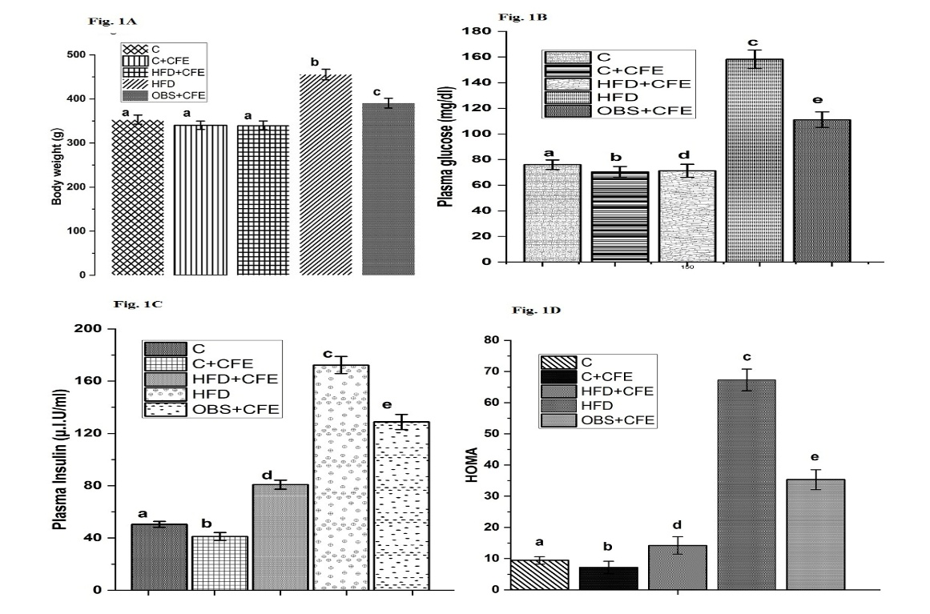
Group- C, C+CFE, control rats treated with Caralluma fimbriata; HFD, high-fat diet fed rats; HFD+CFE, high-fat diet rats treated with Caralluma fimbriata (protective model); OBS+CFE, high-fat diet fed animals treated with Caralluma fimbriata (therapeutic model). (Values are mean ± SEM (n=6 animals in each group). a-e Significant differences between groups-C, C+CFE, HFD, HFD+CFE and OBS+CFE.
Effects of CFE on Lipid Profile
HFD significantly increased TG, TC, LDL-C, VLDL-C, and the atherogenic index, while decreasing HDL-C. CFE supplementation effectively reversed these alterations in both treatment groups. The C+CFE group also showed an improved lipid profile, suggesting anti-atherogenic effects (Figs. 2A and 3D).
Fig. 2. Changes in fasting plasma leptin (A), fasting plasma triglycerides (B), and fasting plasma cholesterol (C) in HFD fed rats

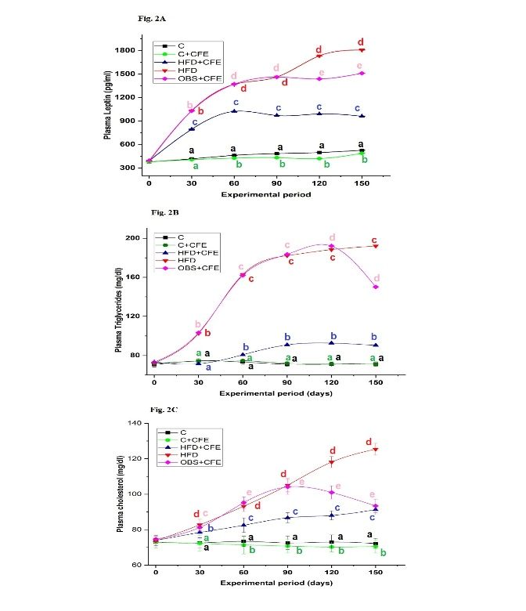
Group-C, C+CFE, control rats treated with Caralluma fimbriata; HFD, high-fat diet fed rats; HFD+CFE, high-fat diet rats treated with Caralluma fimbriata (protective model); OBS+CFE, high-fat diet fed animals treated with Caralluma fimbriata (therapeutic model). (Values are mean ± SEM (n=6 animals in each group).
Fig. 3. Changes in VLDL-C (A), LDL-C (B), HDL-C (C) and Atherogenic Index (AI) in HFD fed rats
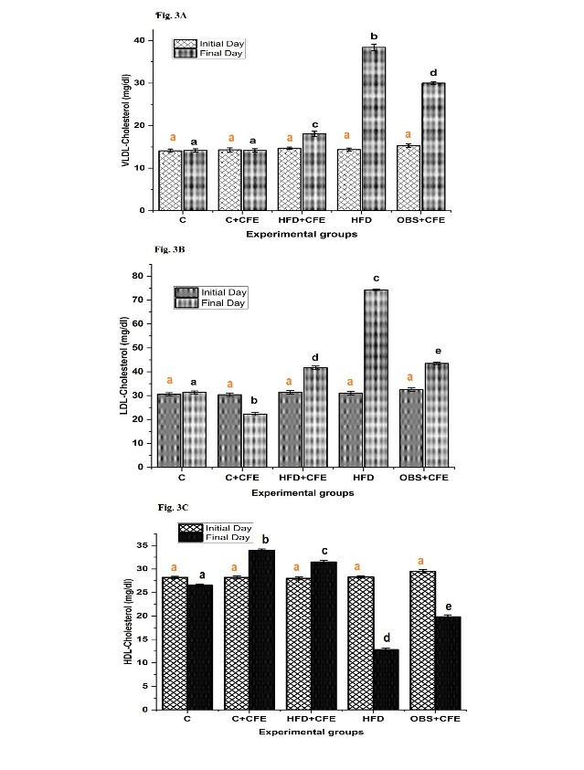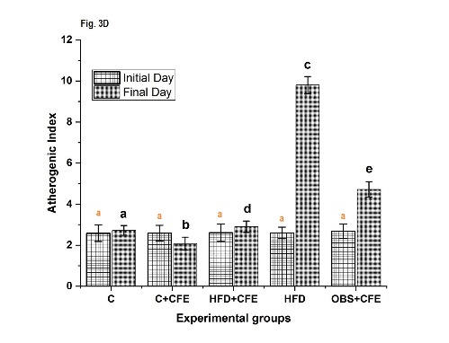
Group-C, C+CFE, control rats treated with Caralluma fimbriata; HFD, high-fat diet fed rats; HFD+CFE, high-fat diet rats treated with Caralluma fimbriata (protective model); OBS+CFE, high-fat diet fed animals treated with Caralluma fimbriata (therapeutic model). (Values are mean ± SEM (n=6 animals in each group). a-e Significant differences between groups-C, C+CFE, HFD, HFD+CFE and OBS+CFE.
Effects of CFE on Hepatic Lipid Content
As shown in Table 2, rats fed a high-fat diet (HFD) exhibited significant increases in hepatic total cholesterol (38.7%), triglycerides (75%), total lipids (45.7%), and free fatty acids (100%), along with a significant decrease in phospholipids (24.4%) compared with the control group. Co-administration of CFE in both the protective (HFD+CFE) and therapeutic (OBS+CFE) groups significantly attenuated these alterations. In contrast, the C+CFE group showed no significant changes in hepatic total lipids, total cholesterol, triglycerides, or free fatty acids, with only a slight variation in phospholipid levels compared with the control group.
Table 2: Protective and therapeutic effects of CFE on hepatic lipids in five experimental groups
Experimental Groups | Total lipids (mg/g tissue) | Triglyceride (mg/g tissue) | Total Cholesterol (mg/g tissue) | Phospholipids (mg/g tissue) | Free fatty acids (mg/g tissue)
C | 48.6±0.02ª | 5.6±0.03ª | 3.1±0.03ª | 26.6±0.03ª | 0.90±0.04ª
C+CFE | 47.3±0.02ª | 5.5±0.03ª | 2.9±0.04ª | 28.1±0.02^{d} | 0.89±0.04ª
HFD+CFE | 49.0±0.06ª | 6.0±0.02^{b} | 3.2±0.03ª | 28.0±0.03^{d} | 1.00±0.02^{b}
HFD | 70.8±0.03^{c} | 9.8±0.03^{d} | 4.3±0.01^{c} | 20.1±0.02^{c} | 1.80±0.04^{d}
OBS+CFE | 54.1±0.03^{b} | 8.7±0.05^{c} | 3.9±0.03^{b} | 25.2±0.03^{b} | 1.30±0.02^{c}
Data are mean ± S.E.M. values of six rats per each group. Means in the same column with different superscripts are significantly different (P < 0.05). ^{a,b,c,d,e:} significant differences between groups. control rats; C+CFE, control rats treated with Caralluma fimbriata; HFD, high-fat diet fed rats; HFD+CFE, high-fat diet rats treated with Caralluma fimbriata (protective model); OBS+CFE, high-fat diet fed animals treated with Caralluma fimbriata (therapeutic model).
Effects of CFE on Serum and Hepatic Transaminases
HFD significantly elevated serum SGOT, SGPT, and SALP activities, indicating liver damage. CFE supplementation markedly reduced these enzyme levels in the treated groups. As shown in Figs. 4 and 5, rats in the high-fat diet (HFD) group exhibited significant increases in hepatic transaminase activities, with glutamate oxaloacetate transaminase (GOT) and glutamate pyruvate transaminase (GPT) elevated by 25.6% and 22.4%, respectively, compared with the control group. Co-administration of CFE in both the protective (HFD+CFE) and therapeutic (OBS+CFE) groups significantly attenuated these increases. GOT activity was reduced by 17.9% and 15.4%, while GPT activity decreased by 10.7% and 8.3% in the HFD+CFE and OBS+CFE groups, respectively, compared with the HFD group. No significant differences in hepatic transaminase activities were observed between the control (C) and C+CFE groups.

Fig. 4. Effect of CFE on serum transaminases in HFD fed rats
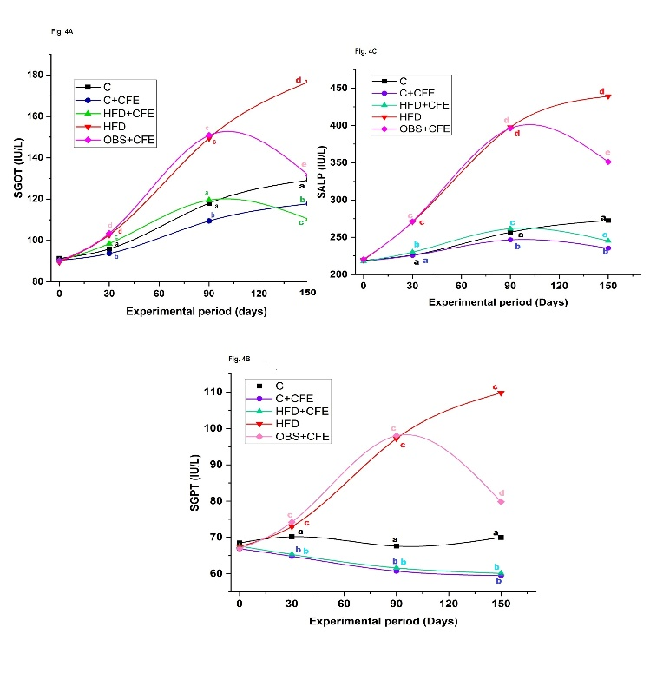
Fig. 5. Effect of CFE on hepatic transaminases in HFD fed rats
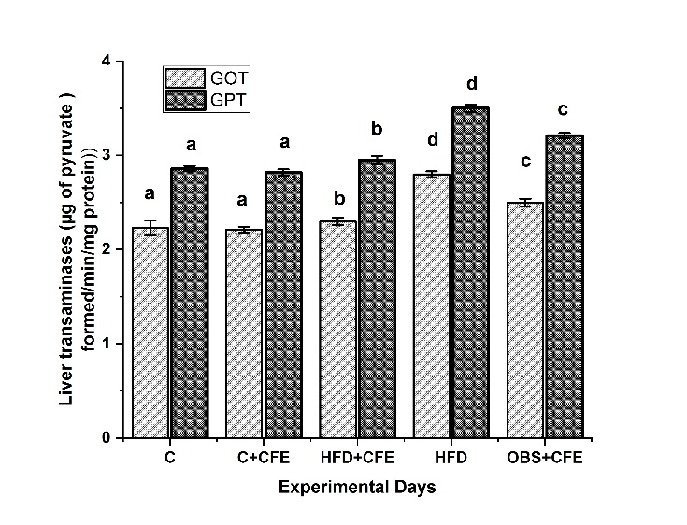
Group-C, C+CFE, control rats treated with Caralluma fimbriata; HFD, high-fat diet fed rats; HFD+CFE, high-fat diet rats treated with Caralluma fimbriata (protective model); OBS+CFE, high-fat diet fed animals treated with Caralluma fimbriata (therapeutic model). (Values are mean ± SEM (n=6 animals in each group). a-e Significant differences between groups-C, C+CFE, HFD, HFD+CFE and OBS+CFE.
Effects of CFE on Hepatic Oxidative Stress Markers
Oxidative stress was evaluated by measuring lipid peroxidation (LPO), protein oxidation (PO), and reduced glutathione (GSH) levels in liver tissue (Table 3). Rats fed a high-fat diet (HFD) showed significant increases in LPO (214.0%) and PO (72.4%) levels, along with a marked decrease in GSH (47.2%) compared with the control group. Co-administration of CFE in both the protective (HFD+CFE) and therapeutic (OBS+CFE) groups significantly reduced LPO (63.7% and 46.0%) and PO (41.7% and 29.3%) levels, while increasing GSH levels (81% and 18.4%), respectively, compared with the HFD group.
Experimental animals | Lipid peroxidation (nmol MDA formed/min/mg protein) | Protein oxidation (µmol of protein carbonyls/mg protein) | Reduced Glutathione (µg of GSH/mg protein)
C | 24.95±0.04ª | 1.74±0.03ª | 7.20±0.02ª
C+CFE | 23.00±0.04^{b} | 1.65±0.03^{b} | 7.84±0.04^{b}
HFD+CFE | 28.40±0.03^{d} | 1.75±0.03ª | 6.88±0.04^{d}
HFD | 78.35±0.01^{c} | 3.00±0.02^{c} | 3.80±0.02^{c}
OBS+CFE | 42.30±0.03e | 2.12±0.02^{d} | 4.50±0.04e
Table 3
Protective and therapeutic effects of CFE on oxidative stress markers in five experimental animals
Data are mean ± S.E.M. values of six rats per each group. Means in the same column with different superscripts are significantly different (P < 0.05). ^{a,b,c,d,e:} significant differences between groups. control rats; C+CFE, control rats treated with Caralluma fimbriata; HFD, high-fat diet fed rats; HFD+CFE, high-fat diet rats treated with Caralluma fimbriata (protective model); OBS+CFE, high-fat diet fed animals treated with Caralluma fimbriata (therapeutic model).
Effects of CFE on Hepatic Antioxidant Enzymes
The activities of antioxidant enzymes, including glutathione peroxidase (GPx), glutathione-S-transferase (GST), glutathione reductase (GR), superoxide dismutase (SOD), and catalase (CAT), were significantly reduced in HFD-fed rats by 54.8%, 19.2%, 45.6%, 32.2%, and 18.6%, respectively, compared with controls (Figs. 6A and B). CFE supplementation in both the HFD+CFE and OBS+CFE groups significantly restored these enzyme activities. Increases were observed in GPx (46.4% and 15.7%), GST (21.2% and 12.0%), GR (67.0% and 20.5%), SOD (46.5% and 26.8%), and CAT (20.0% and 9.8%) compared with the HFD group, indicating improved antioxidant defence.
Fig. 6. Effect of CFE on antioxidant enzymes in HFD fed rats
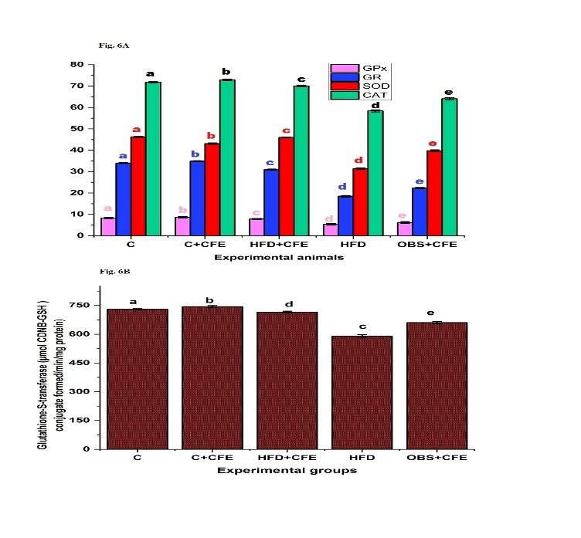
Group-C, C+CFE, control rats treated with Caralluma fimbriata; HFD, high-fat diet fed rats; HFD+CFE, high-fat diet rats treated with Caralluma fimbriata (protective model); OBS+CFE, high-fat diet fed animals treated with Caralluma fimbriata (therapeutic model). (Values are mean ± SEM (n=6 animals in each group). a-e Significant differences between groups-C, C+CFE, HFD, HFD+CFE and OBS+CFE. GPx (µg of GSH consumed/min/mg protein), GR (µmol NADPH oxidized/min/mg protein), SOD (U/mg protein), and CAT (mmol H₂O₂ consumed/min/mg protein).
Effects of CFE on Hepatic Steatosis
Fig. 7 presents representative photomicrographs of liver sections from all experimental groups. The control group (C) exhibited normal hepatic architecture, characterized by well-arranged hepatocytes, intact portal triads, and clearly defined sinusoids, with no evidence of lipid accumulation (Fig. 7A).
Fig. 7. Effect of CFE treatment on high fat diet induced hepatic damage in rats (H & E stain) at 10X.

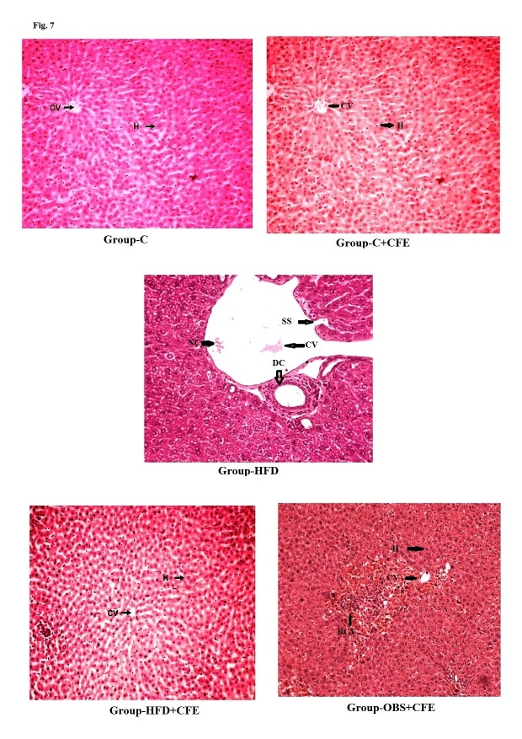
(A) Group-C: control group; (B) Group-C+CFE: treated with Caralluma fimbriata (200 mg/kg body weight) in distilled water orally for 150 days (C+CFE); (C) Group-HFD: High fat diet fed rats; (D) Group-HFD+CFE: HFD fed rats treated with Caralluma fimbriata (200 mg/kg body weight) in distilled water orally by gastric intubation for 150 days (HFD+CFE) (protective model); (E) Group-OBS+CFE: High Fat diet fed rats treated with Caralluma fimbriata (200 mg/kg body weight) in distilled water orally for 60 days (OBS+CFE) (therapeutic model). SS- sinusoids space; CV, central vein; V, vacuolization; NC, necrotic changes; DC, degenerative changes; RCV; Regeneration Central Vein

DISCUSSION
The present study demonstrates that Caralluma fimbriata extract (CFE) exerts both protective and therapeutic effects against high-fat diet (HFD)-induced metabolic syndrome and hepatic injury. These findings are consistent with earlier reports indicating the antioxidative and metabolic regulatory potential of CFE in multiple tissues (Gujjala et al., 2016, 2017, 2022; Sudhakara et al., 2014, 2018). The results suggest that CFE effectively attenuates key features of metabolic syndrome, including hyperglycaemia, hyperinsulinaemia, insulin resistance, dyslipidaemia, and liver dysfunction.
Insulin resistance (IR) is widely recognised as a central mechanism underlying metabolic syndrome. In the present study, HFD feeding significantly increased body weight, plasma glucose, insulin levels, the HOMA index, and leptin levels, confirming the development of obesity and IR (Moller, 2001). These changes were exacerbated with prolonged HFD exposure (Labib, 2003). However, CFE administration significantly reduced body-weight gain and improved glycaemic control and insulin sensitivity in both the preventive and therapeutic models. The ability of CFE to maintain normoglycaemia and lower insulin levels suggests enhanced insulin sensitivity, which may be attributed to its bioactive constituents (Gujjala et al., 2016, 2017, 2022).
The liver plays a central role in lipid metabolism, and its dysfunction is a hallmark of obesity-related disorders (Kraegen et al., 1991). HFD-fed rats showed elevated plasma and hepatic lipid levels, including TC, TG, LDL-C, and free fatty acids, along with reduced HDL-C levels. These alterations were accompanied by histological evidence of hepatic steatosis and inflammation (Bray, 2004). CFE treatment significantly improved lipid profiles and reduced hepatic lipid accumulation, indicating its antihyperlipidaemic effect (Gujjala et al., 2022). This may be partly due to reduced intestinal lipid absorption and modulation of lipid-metabolism pathways. Elevated serum transaminase activities observed in HFD-fed rats indicate hepatocellular damage (Cohen & Kaplan, 1979; Giannini et al., 2005; Khoursheed et al., 1995; Wilkes et al., 1998), which was further supported by histopathological findings (Batista et al., 2014; Manna & Jain, 2015; Rockey, 2001). CFE administration effectively normalised these enzyme levels, suggesting hepatoprotective activity. The reduction in hepatic GOT and GPT activities further confirms the protective role of CFE against liver injury.
Oxidative stress is a critical factor linking obesity to metabolic and hepatic disorders (Alves-Bezerra & Cohen, 2018; Bechmann et al., 2012). In the present study, HFD significantly increased lipid peroxidation and protein oxidation while reducing antioxidant defences such as GSH and enzymatic antioxidants (SOD, CAT, GPx, GST, and GR). These findings indicate impaired redox balance due to excessive reactive oxygen species (ROS) production (Batista et al., 2014; Manna & Jain, 2015). CFE supplementation markedly reduced oxidative-stress markers and restored antioxidant enzyme activities, highlighting its strong antioxidant potential. This effect may be attributed to the presence of bioactive compounds such as flavonoids, saponins, and phenolic compounds (Gujjala et al., 2017, 2022).
Histopathological analysis further supported the biochemical findings. Severe hepatic steatosis, inflammation, and cellular degeneration observed in HFD-fed rats were markedly attenuated by CFE treatment, although they were not completely reversed. This indicates that, while CFE has significant protective effects, prolonged damage may require extended intervention. Overall, the findings suggest that CFE mitigates HFD-induced metabolic and hepatic alterations through multiple mechanisms, including improved insulin sensitivity, regulation of lipid metabolism, reduction of oxidative stress, and enhancement of antioxidant defence systems. Therefore, CFE may serve as a promising natural therapeutic agent for the management of obesity-related metabolic disorders and the prevention of fatty liver disease progression.
Conclusion
The present study demonstrates that an HFD induces obesity-associated metabolic disturbances, leading to oxidative stress, inflammation, and hepatic injury. Supplementation with CFE effectively ameliorated these alterations in both the preventive and therapeutic models. CFE significantly improved body-weight regulation, reduced oxidative stress and inflammatory responses, and protected against liver dysfunction. These findings highlight the potential of CFE as a natural therapeutic agent for managing obesity-related metabolic and hepatic disorders. However, further studies, particularly well-designed clinical trials in humans, are required to validate its efficacy and safety.

Limitation
This study used a small sample of male Wistar rats (n = 6 per group) and evaluated a single CFE dose. The findings are therefore limited to the experimental conditions and cannot be directly generalised to females, other animal models, or humans. The study did not include dose–response comparisons, long-term post-treatment follow-up, or direct molecular assessment of the pathways underlying the observed metabolic and hepatic effects.

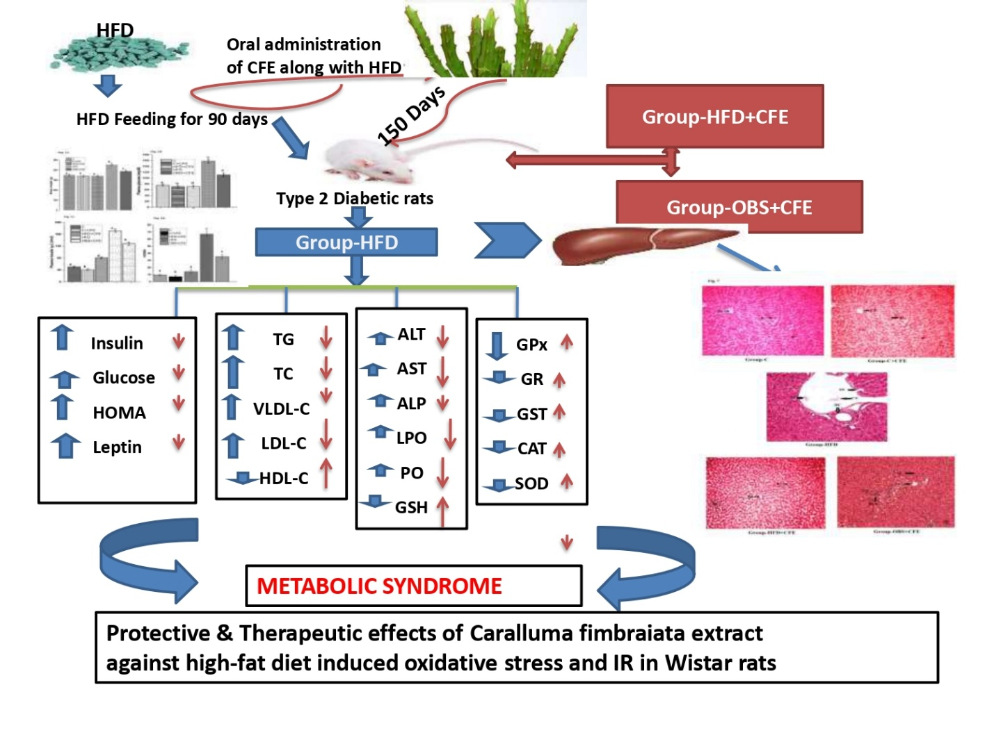
Fig. 8. Proposed mechanism of the protective effects of Caralluma fimbriata extract in high-fat diet–induced metabolic syndrome in Wistar rats

Ethical Approval
All experimental protocols involving laboratory animals were conducted in accordance with the guidelines of the Committee for the Purpose of Control and Supervision of Experiments on Animals (CPCSEA), Government of India (Regd. No: 1889/GO/Re/S/16/CPCSEA, dated 23 October 2021). The study was approved by the Institutional Animal Ethics Committee (IAEC), S.K. University (Regd. No: SKU/IAEC/01/2022).

Declaration of AI Use

This manuscript was prepared through the combined contributions of all author(s), including contributions to the study design, data, content development, results, interpretation, and related scholarly work. The author(s) acknowledge the use of Grammarly and ChatGPT to assist with grammar checking, language refinement, reference formatting. These AI-assisted tools were not used as authors and did not replace the intellectual contributions or scholarly judgment of the author(s). All AI-assisted outputs, including content, references, and interpretations, were carefully reviewed, revised, verified, and approved by the author(s). The author(s) accept full responsibility for the accuracy, integrity, and final content of the manuscript.

COMPETING INTERESTS:
Authors have declared that they have no known competing financial interests OR non-financial interests OR personal relationships that could have appeared to influence the work reported in this paper.

REFERENCES
Akotegnon, A. R., Faton, E. O. M., Chokki, S., Bah, F., Michodjehoun, C., Sezan, A., & Baba-Moussa, L. (2025). Effect of Ficus umbellata (Vahl.) leaves on oxidative stress in obese Wistar rats. Journal of Pharmaceutical Research International, 37(6), 1–10. https://doi.org/10.9734/jpri/2025/v37i67699
Alves-Bezerra, M., & Cohen, D. E. (2018). Triglyceride metabolism in the liver. Comprehensive Physiology, 8(1), 1–22. https://doi.org/10.1002/cphy.c170012
Batista, Â. G., Lenquiste, S. A., Cazarin, C. B. B., da Silva, J. K., Luiz-Ferreira, A., Bogusz, S., Jr., Hantao, L. W., de Souza, R. N., Augusto, F., Prado, M. A., & Maróstica, M. R., Jr. (2014). Intake of jaboticaba peel attenuates oxidative stress in tissues and reduces circulating saturated lipids of rats with high-fat diet-induced obesity. Journal of Functional Foods, 6, 450–461. https://doi.org/10.1016/j.jff.2013.11.011
Bechmann, L. P., Hannivoort, R. A., Gerken, G., Hotamisligil, G. S., Trauner, M., & Canbay, A. (2012). The interaction of hepatic lipid and glucose metabolism in liver diseases. Journal of Hepatology, 56(4), 952–964. https://doi.org/10.1016/j.jhep.2011.08.025
Beers, R. F., Jr., & Sizer, I. W. (1952). A spectrophotometric method for measuring the breakdown of hydrogen peroxide by catalase. Journal of Biological Chemistry, 195(1), 133–140. https://doi.org/10.1016/S0021-9258(19)50881-X
Bray, G. A. (2004). Medical consequences of obesity. The Journal of Clinical Endocrinology & Metabolism, 89(6), 2583–2589. https://doi.org/10.1210/jc.2004-0535
Cohen, J. A., & Kaplan, M. M. (1979). The SGOT/SGPT ratio—An indicator of alcoholic liver disease. Digestive Diseases and Sciences, 24(11), 835–838. https://doi.org/10.1007/BF01324898
Connerty, H. V., Briggs, A. R., & Eaton, E. H., Jr. (1961). Simplified determination of the lipid components of blood serum. Clinical Chemistry, 7(1), 37–53. https://doi.org/10.1093/clinchem/7.1.37
Duncan, D. B. (1955). Multiple range and multiple F tests. Biometrics, 11(1), 1–42. https://doi.org/10.2307/3001478
Duncombe, W. G. (1963). The colorimetric micro-determination of long-chain fatty acids. Biochemical Journal, 88(1), 7–10. https://doi.org/10.1042/bj0880007
Ellman, G. L. (1959). Tissue sulfhydryl groups. Archives of Biochemistry and Biophysics, 82(1), 70–77. https://doi.org/10.1016/0003-9861(59)90090-6
Folch, J., Lees, M., & Sloane Stanley, G. H. (1957). A simple method for the isolation and purification of total lipides from animal tissues. Journal of Biological Chemistry, 226(1), 497–509. https://doi.org/10.1016/S0021-9258(18)64849-5
Friedewald, W. T., Levy, R. I., & Fredrickson, D. S. (1972). Estimation of the concentration of low-density lipoprotein cholesterol in plasma, without use of the preparative ultracentrifuge. Clinical Chemistry, 18(6), 499–502. https://doi.org/10.1093/clinchem/18.6.499
Galicia-Garcia, U., Benito-Vicente, A., Jebari, S., Larrea-Sebal, A., Siddiqi, H., Uribe, K. B., Ostolaza, H., & Martín, C. (2020). Pathophysiology of type 2 diabetes mellitus. International Journal of Molecular Sciences, 21(17), 6275. https://doi.org/10.3390/ijms21176275
Giannini, E. G., Testa, R., & Savarino, V. (2005). Liver enzyme alteration: A guide for clinicians. CMAJ, 172(3), 367–379. https://doi.org/10.1503/cmaj.1040752
Gujjala, S., Putakala, M., Nukala, S., Bangeppagari, M., Ramaswamy, R., & Desireddy, S. (2016). Renoprotective effect of Caralluma fimbriata against high-fat diet-induced oxidative stress in Wistar rats. Journal of Food and Drug Analysis, 24(3), 586–593. https://doi.org/10.1016/j.jfda.2016.01.013
Gujjala, S., Putakala, M., Nukala, S., Bangeppagari, M., Rajendran, R., & Desireddy, S. (2017). Modulatory effects of Caralluma fimbriata extract against high-fat diet-induced abnormalities in carbohydrate metabolism in Wistar rats. Biomedicine & Pharmacotherapy, 92, 1062–1072. https://doi.org/10.1016/j.biopha.2017.06.016
Gujjala, S., Putakala, M., Bongu, S. B. R., Ramaswamy, R., & Desireddy, S. (2022). Preventive effect of Caralluma fimbriata against high-fat diet-induced injury to the heart by modulation of tissue lipids, oxidative stress, and histological changes in Wistar rats. Archives of Physiology and Biochemistry, 128(2), 474–482. https://doi.org/10.1080/13813455.2019.1693601
Gujjala, S., Bangeppagari, M., Devarakonda, V. L. N. P., Bellamkonda, R., Bhadramraju, R., Kameswaran, S., Ramaswamy, R., & Desireddy, S. (2023). Pleiotropic effects of Salacia reticulata and simvastatin on oxidative stress and insulin resistance in a rat model. Biomedicine & Pharmacotherapy, 164, 114960. https://doi.org/10.1016/j.biopha.2023.114960
Habig, W. H., Pabst, M. J., & Jakoby, W. B. (1974). Glutathione S-transferases: The first enzymatic step in mercapturic acid formation. Journal of Biological Chemistry, 249(22), 7130–7139. https://doi.org/10.1016/S0021-9258(19)42083-8
Khoursheed, M., Miles, P. D., Gao, K. M., Lee, M. K., Moossa, A. R., & Olefsky, J. M. (1995). Metabolic effects of troglitazone on fat-induced insulin resistance in the rat. Metabolism, 44(11), 1489–1494. https://doi.org/10.1016/0026-0495(95)90151-5
Kraegen, E. W., Clark, P. W., Jenkins, A. B., Daley, E. A., Chisholm, D. J., & Storlien, L. H. (1991). Development of muscle insulin resistance after liver insulin resistance in high-fat-fed rats. Diabetes, 40(11), 1397–1403. https://doi.org/10.2337/diab.40.11.1397
Kyrou, I., Randeva, H. S., Tsigos, C., Kaltsas, G., & Weickert, M. O. (2018). Clinical problems caused by obesity. In Endotext. MDText.com, Inc. https://www.ncbi.nlm.nih.gov/books/NBK278973/
Labib, M. (2003). ACP best practice No. 168: The investigation and management of obesity. Journal of Clinical Pathology, 56(1), 17–25. https://doi.org/10.1136/jcp.56.1.17
Levine, R. L., Garland, D., Oliver, C. N., Amici, A., Climent, I., Lenz, A. G., Ahn, B. W., Shaltiel, S., & Stadtman, E. R. (1990). Determination of carbonyl content in oxidatively modified proteins. Methods in Enzymology, 186, 464–478. https://doi.org/10.1016/0076-6879(90)86141-H
Liu, C. S., Lin, C. C., & Li, T. C. (1999). The relation of white blood cell count and atherogenic index ratio of LDL-cholesterol to HDL-cholesterol in Taiwan school children. Acta Paediatrica Taiwanica, 40(5), 319–324. https://pubmed.ncbi.nlm.nih.gov/10910541/
Lowry, O. H., Rosebrough, N. J., Farr, A. L., & Randall, R. J. (1951). Protein measurement with the Folin phenol reagent. Journal of Biological Chemistry, 193(1), 265–275. https://doi.org/10.1016/S0021-9258(19)52451-6
Manna, P., & Jain, S. K. (2015). Obesity, oxidative stress, adipose tissue dysfunction, and the associated health risks: Causes and therapeutic strategies. Metabolic Syndrome and Related Disorders, 13(10), 423–444. https://doi.org/10.1089/met.2015.0095
Młynarska, E., Bojdo, K., Bulicz, A., Frankenstein, H., Gąsior, M., Kustosik, N., Rysz, J., & Franczyk, B. (2025). Obesity as a multifactorial chronic disease: Molecular mechanisms, systemic impact, and emerging digital interventions. Current Issues in Molecular Biology, 47(10), 787. https://doi.org/10.3390/cimb47100787
Moller, D. E. (2001). New drug targets for type 2 diabetes and the metabolic syndrome. Nature, 414(6865), 821–827. https://doi.org/10.1038/414821a
Noreen, S., Shehzadi, S., Egbuna, C., & Aja, P. M. (2025). Lycopene alleviates lipid dysregulation, oxidative stress, and hypercholesterolemia in obese rats subjected to a high-fat diet. Food Science & Nutrition, 13(7), e70549. https://doi.org/10.1002/fsn3.70549
Odia, K. M., & Akpevwe-Erhieyovwe, C. O. (2025). Beetroot (Beta vulgaris) as a nutritional strategy for metabolic disorders: Effects on lipid metabolism and body weight. Journal of Medicine and Health Research, 10(2), 361–368. https://doi.org/10.56557/jomahr/2025/v10i29825
Olatona, F. A., Onabanjo, O. O., Ugbaja, R. N., Nnoaham, K. E., & Adelekan, D. A. (2018). Dietary habits and metabolic risk factors for non-communicable diseases in a university undergraduate population. Journal of Health, Population and Nutrition, 37(1), 21. https://doi.org/10.1186/s41043-018-0152-2
Pati, S., Irfan, W., Jameel, A., Ahmed, S., & Shahid, R. K. (2023). Obesity and cancer: A current overview of epidemiology, pathogenesis, outcomes, and management. Cancers, 15(2), 485. https://doi.org/10.3390/cancers15020485
Pickavance, L. C., Tadayyon, M., Widdowson, P. S., Buckingham, R. E., & Wilding, J. P. H. (1999). Therapeutic index for rosiglitazone in dietary obese rats: Separation of efficacy and haemodilution. British Journal of Pharmacology, 128(7), 1570–1576. https://doi.org/10.1038/sj.bjp.0702932
Pinto, R. E., & Bartley, W. (1969). The effect of age and sex on glutathione reductase and glutathione peroxidase activities and on aerobic glutathione oxidation in rat liver homogenates. Biochemical Journal, 112(1), 109–115. https://doi.org/10.1042/bj1120109
Reitman, S., & Frankel, S. (1957). A colorimetric method for the determination of serum glutamic oxalacetic and glutamic pyruvic transaminases. American Journal of Clinical Pathology, 28(1), 56–63. https://doi.org/10.1093/ajcp/28.1.56
Rockey, D. C. (2001). Hepatic blood flow regulation by stellate cells in normal and injured liver. Seminars in Liver Disease, 21(3), 337–350. https://doi.org/10.1055/s-2001-17551
Rotruck, J. T., Pope, A. L., Ganther, H. E., Swanson, A. B., Hafeman, D. G., & Hoekstra, W. G. (1973). Selenium: Biochemical role as a component of glutathione peroxidase. Science, 179(4073), 588–590. https://doi.org/10.1126/science.179.4073.588
Sarkar, S., Ghosh, S., & Biswas, M. (2025). Naringin ameliorates high-fat diet-induced hepatotoxicity and dyslipidemia in an experimental rat model via modulation of antioxidant enzymes, AMPK, and SERBP-1c signalling pathways. Toxicology Reports, 14, 102062. https://doi.org/10.1016/j.toxrep.2025.102062
Soon, Y. Y., & Tan, B. K. H. (2002). Evaluation of the hypoglycemic and anti-oxidant activities of Morinda officinalis in streptozotocin-induced diabetic rats. Singapore Medical Journal, 43(2), 77–85. https://www.smj.org.sg/article/evaluation-hypoglycemic-and-anti-oxidant-activities-morinda-officinalis-streptozotocin
Sudhakara, G., Mallaiah, P., Sreenivasulu, N., Sasi Bhusana Rao, B., Rajendran, R., & Saralakumari, D. (2014). Beneficial effects of hydro-alcoholic extract of Caralluma fimbriata against high-fat diet-induced insulin resistance and oxidative stress in Wistar male rats. Journal of Physiology and Biochemistry, 70(2), 311–320. https://doi.org/10.1007/s13105-013-0304-1
Sudhakara, G., Mallaiah, P., Rajendran, R., & Saralakumari, D. (2018). Caralluma fimbriata and metformin protection of rat pancreas from high-fat diet-induced oxidative stress. Biotechnic & Histochemistry, 93(3), 177–187. https://doi.org/10.1080/10520295.2017.1406615
Tramullas, M., Finger, B. C., Dinan, T. G., & Cryan, J. F. (2016). Obesity takes its toll on visceral pain: High-fat diet induces Toll-like receptor 4-dependent visceral hypersensitivity. PLOS ONE, 11(5), e0155367. https://doi.org/10.1371/journal.pone.0155367
Utley, H. G., Bernheim, F., & Hochstein, P. (1967). Effect of sulfhydryl reagents on peroxidation in microsomes. Archives of Biochemistry and Biophysics, 118(1), 29–32. https://doi.org/10.1016/0003-9861(67)90273-1
Wilkes, J. J., Bonen, A., & Bell, R. C. (1998). A modified high-fat diet induces insulin resistance in rat skeletal muscle but not adipocytes. American Journal of Physiology-Endocrinology and Metabolism, 275(4), E679–E686. https://doi.org/10.1152/ajpendo.1998.275.4.E679
Xu, M., Jung, X., Hines, O. J., Eibl, G., & Chen, Y. (2018). Obesity and pancreatic cancer: Overview of epidemiology and potential prevention by weight loss. Pancreas, 47(2), 158–162. https://doi.org/10.1097/MPA.0000000000000974
Yalow, R. S., & Berson, S. A. (1961). Immunoassay of plasma insulin in man. Diabetes, 10(5), 339–344. https://doi.org/10.2337/diab.10.5.339
Yasmin, T., Menon, S. N., Pandey, A., Siddiqua, S., Kuddus, S. A., Rahman, M. M., Khan, F., Hoque, N., Rana, M. S., Subhan, N., Habibi, E., Ramezani, F., Sarker, S. D., Nahar, L., Alam, M. A., & Hasan, R. (2025). Resveratrol attenuates hepatic oxidative stress and preserves gut mucosal integrity in high-fat diet-fed rats by modulating antioxidant and anti-inflammatory pathways. Scientific Reports, 15, 25162. https://doi.org/10.1038/s41598-025-08450-z

