Case Report
Combination Therapy Versus Monotherapy for the Management of Feline Dermatophytosis Caused by Microsporum canis and Its Zoonotic Significance: A Report of Four Cases
Abstract
Feline dermatophytosis caused by Microsporum canis is clinically important because of its contagious and zoonotic nature. This case series describes the diagnosis and treatment outcomes of four male Persian cats treated with either pulse itraconazole combined with continuous terbinafine or continuous terbinafine monotherapy. The cats were aged 5 months to 2 years and weighed 1.5–3.3 kg. They presented with pruritus, alopecia, scaling, and lesions affecting the nose, neck, ears, shoulder region, and periocular area. A 10-year-old boy who owned one of the cats also presented with tinea corporis in the groin. Diagnosis in the cats was based on clinical history and signs, direct microscopic examination of hair and scales, fungal culture on Sabouraud’s dextrose agar, and PCR confirmation of M. canis. Two cats received itraconazole at 5 mg/kg orally once daily using an alternating-week pulse regimen, together with terbinafine at 30 mg/kg. Two cats received terbinafine at 30 mg/kg orally once daily as monotherapy. Mycological cure was determined using consecutive negative fungal cultures. The combination-treatment cats reached the documented cure endpoint after 56 and 70 days, whereas the monotherapy cats reached it after 112 and 126 days. All four cats ultimately achieved mycological cure. This study indicated that combination therapy of itraconazole and terbinafine was more effective than terbinafine monotherapy to treat feline dermatophytosis caused by Microsporum canis.
Keywords: Feline dermatophytosis; Microsporum canis; combination therapy; monotherapy; mycological cure; Persian cats; zoonosis; tinea corporis
1. Introduction
Feline dermatophytosis is a superficial fungal infection of keratinised tissues in cats. This condition is clinically significant because it is contagious, infectious, and transmissible between individuals (Moriello et al., 2017). Owing to its pathogenicity and considerable zoonotic potential, Microsporum canis is the most prevalent and important cause of dermatophytosis in cats (Miller et al., 2012; Scott et al., 2001). Arthrospores are the infectious forms of dermatophytes and are produced when fungal hyphae fragment into small infectious spores. The infection can spread through direct contact with hair or scales from affected animals, environmental exposure, or contaminated fomites (Miller et al., 2012; Moriello et al., 2017). In ectothrix hair invasion, the hair cuticle is damaged. Dermatophytes that cause ectothrix invasion include M. canis and M. audouinii (Patel et al., 2017). Studies of the normal fungal flora of healthy companion cats indicate that M. canis is not a typical component of the feline skin microbiome (Meason-Smith et al., 2017; Scott et al., 2013). The condition is usually self-limiting by the fourth month after the onset of clinical signs. Nevertheless, treatment of infected cats is advised to shorten the clinical course and reduce the risk of disease transmission (Moriello et al., 2017; Scott et al., 2001). Current treatment recommendations include systemic antifungal medication to eliminate infection from the intrafollicular portion of the hair, topical therapy to disinfect the haircoat, and environmental cleaning to remove mycotic debris.
In cats, Microsporum canis infection is clinically important because infected hairs and environmental arthroconidia facilitate direct and indirect transmission, and feline cases can expose human contacts. Fungal culture remains central to confirmation and monitoring, whereas PCR can provide rapid species-level detection but should be interpreted together with clinical and culture findings (Aneke et al., 2018; Jacobson et al., 2018; Moriello et al., 2017).
Current evidence-based recommendations generally favour one effective systemic agent, such as itraconazole or terbinafine, combined with whole-body topical therapy and environmental decontamination; evidence supporting the routine concurrent use of two systemic agents in cats remains limited (DeTar et al., 2025; Moriello et al., 2017; Puls et al., 2018).
Young age, a long haircoat, group housing, and environmental exposure can influence the epidemiology of feline dermatophytosis, but these variables should be treated as contextual risk factors rather than deterministic causes (DeTar et al., 2019; Meason-Smith et al., 2017; Scott et al., 2013).
A recent six-month clinical survey from Central India identified age and breed as relevant epidemiological factors in feline dermatological disorders and documented fungal infections among affected cats, supporting structured consideration of host factors during clinical evaluation (Patil et al., 2026). Studies of companion-animal dermal disease have also shown that lesion-margin hair and scale specimens can yield dermatophytes on selective fungal media, underscoring the importance of appropriate sampling for laboratory confirmation (Sharma, 2022). An Indian investigation of domestic cats combined molecular identification with systemic and topical management, reinforcing the value of species-level diagnosis when planning treatment for feline dermatophytosis (Sheetal et al., 2024). Characterisation of canine- and feline-origin M. canis isolates has demonstrated variability in virulence-associated traits, antifungal susceptibility and genotypes, indicating that treatment response should not be inferred from clinical appearance alone (Bagra et al., 2024).
Despite established diagnostic and treatment guidance, evidence directly comparing concurrent itraconazole-terbinafine therapy with terbinafine monotherapy in naturally affected cats remains limited. The present four-case series addresses this gap descriptively, but its small, non-randomised design does not permit definitive comparative efficacy conclusions.
Objective
This case report aimed to describe the clinical presentation, laboratory confirmation, treatment response, and time to documented mycological cure in four cats with M. canis dermatophytosis treated with either pulse itraconazole plus continuous terbinafine or terbinafine monotherapy, and to document the concurrent cutaneous lesion reported in one human contact.
2. Case presentation
Four male Persian cats, aged 20 months, 18 months, 5 months, and 2 years and weighing 3.10 kg, 2.5 kg, 1.5 kg, and 3.3 kg, respectively, were presented to the R.V.P., IVRI, Izatnagar, with pruritus, alopecia, and scaling. The first cat had lesions on the nose, dorsal neck, and both ears (Figure 1). The second cat had scaling confined to the nose (Figure 2). The third cat had a small focal area of alopecia on the neck (Figure 3). The fourth cat had lesions on the neck, both ears, below the right ear, and above the left eye (Figure 4).
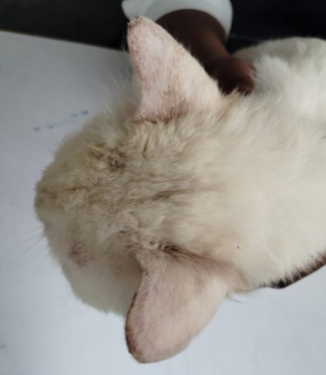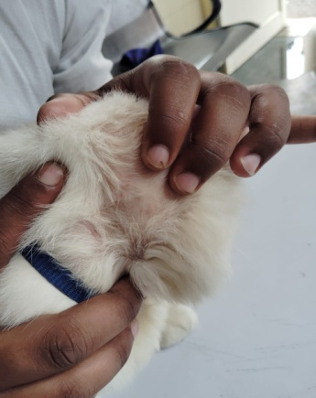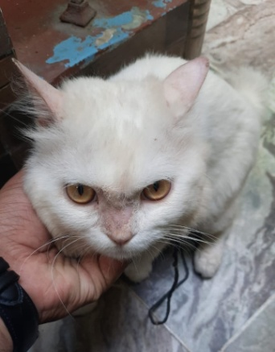
C
B
A
Figure 1 Alopecia on both the ears, neck and nose
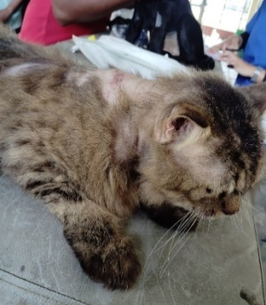
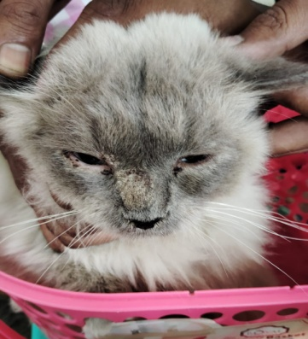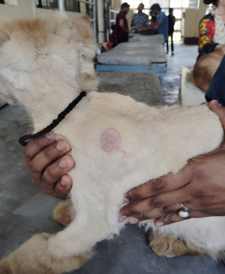
Figure 2 Scaling of nose Figure 3 Alopecia on left shoulder region Figure 4 Lesions on neck and below ear
The skin became red and inflamed where the affected areas had been scratched.
3. Investigation
For laboratory examination, skin scrapings were collected from different lesions using a BP blade (Fig. 5).
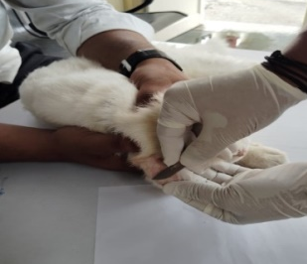
Figure. 5. Sample collection from Microsporum canis infected cat
Direct microscopic examination of scraped hairs and scales stained with lactophenol cotton blue revealed ectothrix arthroconidia (Figure 6).
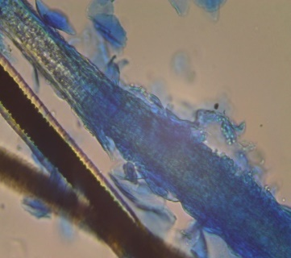
Fig 6 Photomicrograph of skin scraping stained with Lactophenol cotton blue examined microscopically (40X) showing distorted hair shaft with ectothrix hair invasion with arthroconidia.

Fungal culture was used for definitive diagnosis and species identification. Culture and isolation were performed on Sabouraud's dextrose agar. The colony was white and cottony to woolly (Figure 7), with a brown or golden-yellow reverse on Sabouraud's dextrose agar (Carter & Cole, 1990). Molecular confirmation of Microsporum canis was performed by PCR, and the result was positive for M. canis (176 bp) (Figure 8).

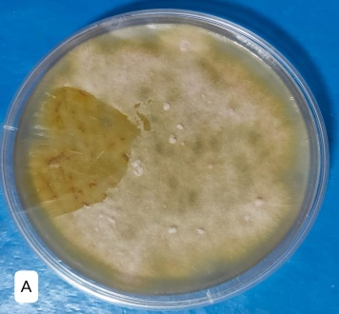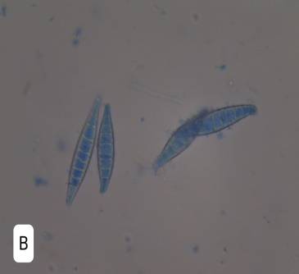

Figure 7 Culture morphology and macroscopic colony (A) and characteristic microscopic morphology in lactophenol cotton blue mount (B) of Microsporum canis
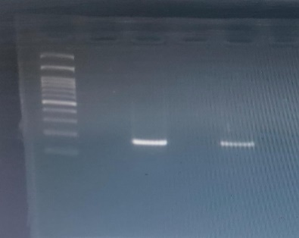
3
2
M
Figure 8 PCR result of Microsporum canis. Lane M- represent ladder, Lane 2- denotes positive control for M. canis. Lane 3- denotes postive for M. canis
The 10-year-old owner of one cat also had dermatophytosis (tinea corporis) and itching in the groin area (Figure 9).
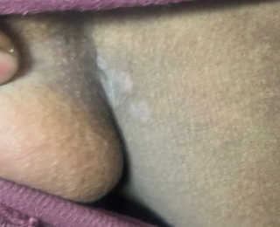
Figure 9 Dermtophytosis (tinea corporis) in owner on groin region
3. Treatment
After investigation, all four cats were treated for Microsporum canis infection.
3.1 Combination Therapy: Two cats were treated with systemic itraconazole at 5 mg/kg body weight orally once daily, using a pulse regimen of one week on treatment followed by one week off treatment for 5 weeks (Puls et al., 2018), together with continuous terbinafine at 30 mg/kg body weight (Moriello et al., 2017).
3.2 Monotherapy: The other two cats were treated with oral terbinafine at 30 mg/kg body weight once daily (Kotnik et al., 2001) for 4 months.
A shampoo containing miconazole combined with chlorhexidine was used (Aneke et al., 2018). Supportive treatment consisted of omega-3 and omega-6 fatty acids.
4. Outcome and follow up
4.1 Outcome of combination therapy: One cat treated with combination therapy achieved two consecutive negative cultures on days 42 and 56 and was considered cured after 70 days (Figure 10), because the sample collected on day 56 required several weeks of incubation before a negative result was reported. The other cat treated with combination therapy achieved negative cultures on days 28 and 42 and was considered cured after 56 days (Figure 11).
The 56-70-day cure intervals observed in the two cats receiving itraconazole plus terbinafine fall within the broad time frame reported for protocols incorporating pulse itraconazole and repeated mycological monitoring. However, published feline evidence principally supports itraconazole as a systemic agent used with topical treatment, and the contribution of adding terbinafine cannot be isolated in this uncontrolled two-cat subgroup (DeTar et al., 2025; Moriello et al., 2017; Puls et al., 2018).
Two consecutive negative cultures provide a conservative endpoint, although culture turnaround time may delay the date on which cure is formally documented (Jacobson et al., 2018; Moriello et al., 2017).
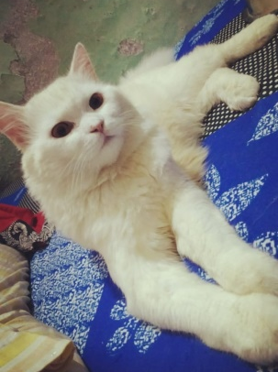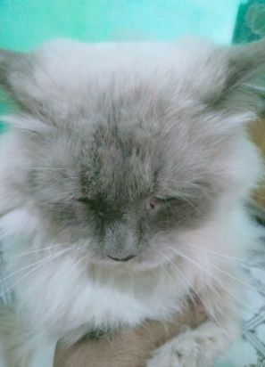
Figure 10 Cat after 70 days post-treatment Figure 11 Cat after 56 days post-treatment
4.2 Monotherapy: The third cat, treated with terbinafine alone, had negative cultures on days 98 and 112 and was considered cured after 126 days (Figure 12). The fourth cat, also treated with terbinafine alone, was considered cured after 112 days of treatment (Figure 13).
Terbinafine has documented activity against feline Microsporum canis infection, but treatment duration is variable and mycological cure may lag behind clinical improvement. The longer intervals in these two cats are therefore compatible with reported variability, but they do not establish inferiority because lesion burden, adherence, topical treatment, and isolate susceptibility were not controlled (Aneke et al., 2018; Kotnik et al., 2001; Moriello et al., 2017).
A reported terbinafine-resistant feline Microsporum canis isolate indicates that reduced susceptibility is possible, although a single report does not imply that resistance caused the prolonged treatment courses in the present cats (Hsiao et al., 2018; Khurana et al., 2019).
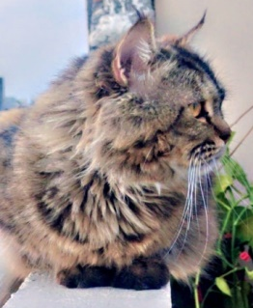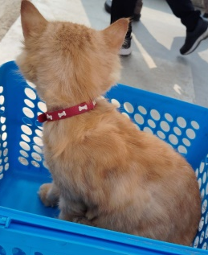
Figure 12 Cat after 126 days post-treatment Figure 13 Cat after 112 days post-treatment
5. Discussion
This four-case series sought to compare itraconazole-terbinafine combination therapy with terbinafine monotherapy for the management of feline dermatophytosis. The cats receiving combination therapy reached documented mycological cure sooner than those receiving monotherapy. This case series provides an in vivo descriptive comparison of terbinafine monotherapy and the combination of itraconazole and terbinafine for feline dermatophytosis. Terbinafine and itraconazole inhibit ergosterol synthesis at different stages, which may provide a biological rationale for their combined use. Their combination has also shown potential synergism in a pharmacokinetic model. The development of resistance to these medications in pathogenic fungi may reduce the relative effectiveness of monotherapy (Khurana et al., 2019); however, other factors, such as host-fungal interactions and fungal virulence, may also contribute to treatment failure (Sardana et al., 2018). This study had several limitations, including the small number of cases and the use of different drug brands.
Because all four cats ultimately achieved mycological cure, the principal observed difference was the time to documented cure rather than the final cure proportion. With only two cats per regimen and no randomisation, blinding, standardised lesion scoring, or susceptibility testing, the findings should be interpreted as a descriptive signal that warrants controlled evaluation rather than proof of superior efficacy.
The biological rationale for combining terbinafine and itraconazole is plausible because the drugs inhibit different steps in ergosterol synthesis; however, dermatophyte combination studies are heterogeneous, and most clinical data derive from human disease or in vitro systems. Consequently, those findings cannot be directly extrapolated to feline Microsporum canis infection (Brescini et al., 2021; Ramzi et al., 2023).
The present observations are compatible with established evidence that pulse itraconazole is effective in cats and that terbinafine can be effective as monotherapy, while response times vary across studies and settings (Kotnik et al., 2001; Moriello et al., 2017; Puls et al., 2018).
Human pharmacokinetic and onychomycosis studies demonstrate the persistence of itraconazole and terbinafine in keratinised tissues, but they do not establish feline dose equivalence or comparative efficacy (Cauwenbergh et al., 1988; Goodfield, 1992).
Foundational veterinary texts and diagnostic references describe ectothrix invasion, culture characteristics, and treatment principles, while contemporary feline microbiome and clinical studies provide more specific evidence for cats (Carter & Cole, 1990; Meason-Smith et al., 2017; Miller et al., 2012; Patel et al., 2017; Scott et al., 2001; Scott et al., 2013).
Resistance should be considered only one possible contributor to delayed response; host factors, infection burden, environmental contamination, drug exposure, and adherence may also influence outcome (Aneke et al., 2018; Hsiao et al., 2018; Khurana et al., 2019; Sardana et al., 2018).
Because the literature search was not designed to establish publication priority, the study is best framed as a preliminary case-series comparison rather than a definitive first in vivo demonstration.
In conclusion, compared with terbinafine monotherapy, the combination of itraconazole and terbinafine was associated with a shorter observed time to clinical and mycological cure.
In this four-cat case series, combination therapy was associated with a shorter observed time to documented mycological cure; controlled studies are required before dual systemic therapy can be recommended over established systemic-plus-topical protocols (DeTar et al., 2025; Moriello et al., 2017).

Conclusions
All four cats in this case series achieved documented mycological cure following systemic antifungal treatment. The two cats treated with pulse itraconazole combined with continuous terbinafine reached the reported cure endpoint after 56 and 70 days, while the cats receiving terbinafine alone reached it after 112 and 126 days. The observations therefore indicate a shorter time to documented cure in the combination-treatment cases. However, the study included only two cats per regimen and lacked random allocation, blinding, standardised lesion scoring, baseline matching, and statistical comparison. Differences in age, initial lesion burden, treatment adherence, topical management, environmental contamination, and isolate susceptibility may have influenced the outcomes. Because all animals ultimately recovered, the results do not demonstrate a higher final cure rate for combination therapy. They should instead be interpreted as preliminary clinical observations supporting further investigation. Larger controlled studies with standardised systemic and topical protocols, environmental decontamination, adverse-effect monitoring, and uniform culture schedules are necessary before dual systemic treatment can be recommended over established treatment approaches for feline dermatophytosis.

Limitations
This report included only four cats, with two animals assigned to each treatment regimen, and lacked randomisation, blinding, baseline matching, or statistical analysis. Lesion severity, adherence, environmental decontamination, and topical treatment were not standardised. The duration of terbinafine administration in the combination group was unclear, and adverse effects or liver-function monitoring were not reported. The human contact's lesion was not independently confirmed or linked molecularly to the feline isolate.
Declaration of AI Use

This manuscript was prepared through the combined contributions of all author(s), including contributions to the study design, data, content development, results, interpretation, and related scholarly work. The author(s) acknowledge the use of Grammarly and ChatGPT to assist with grammar checking, language refinement, reference formatting. These AI-assisted tools were not used as authors and did not replace the intellectual contributions or scholarly judgment of the author(s). All AI-assisted outputs, including content, references, and interpretations, were carefully reviewed, revised, verified, and approved by the author(s). The author(s) accept full responsibility for the accuracy, integrity, and final content of the manuscript.

COMPETING INTERESTS DISCLAIMER:
Authors have declared that they have no known competing financial interests OR non-financial interests OR personal relationships that could have appeared to influence the work reported in this paper.

References
Aneke, C. I., Otranto, D., & Cafarchia, C. (2018). Therapy and antifungal susceptibility profile of Microsporum canis. Journal of Fungi, 4(3), 107. https://doi.org/10.3390/jof4030107
Bagra, J. K., Nair, S. S., Athira, V., Kumar, M. S., Kumar, M., Thomas, P., Kumar, B., Chaturvedi, V. K., Dandapat, P., & Abhishek. (2024). In vitro virulotyping, antifungal susceptibility testing and DNA fingerprinting of Microsporum canis strains of canine and feline origin. Comparative Immunology, Microbiology and Infectious Diseases, 104, 102100. https://doi.org/10.1016/j.cimid.2023.102100
Brescini, L., Fioriti, S., Morroni, G., & Barchiesi, F. (2021). Antifungal combinations in dermatophytes. Journal of Fungi, 7(9), 727. https://doi.org/10.3390/jof7090727
Carter, G. R., & Cole, J. R., Jr. (Eds.). (1990). Diagnostic procedure in veterinary bacteriology and mycology (5th ed.). Academic Press. https://doi.org/10.1016/C2009-0-02725-1
Cauwenbergh, G., Degreef, H., Heykants, J., Woestenborghs, R., Van Rooy, P., & Haeverans, K. (1988). Pharmacokinetic profile of orally administered itraconazole in human skin. Journal of the American Academy of Dermatology, 18(2), 263-268. https://doi.org/10.1016/S0190-9622(88)70037-7
DeTar, L. G., Dubrovsky, V., & Scarlett, J. M. (2019). Descriptive epidemiology and test characteristics of cats diagnosed with Microsporum canis dermatophytosis in a Northwestern US animal shelter. Journal of Feline Medicine and Surgery, 21(12), 1198-1205. https://doi.org/10.1177/1098612X19825519
DeTar, L., Janke, K. J., & Jacobson, L. (2025). Randomized, non-inferiority clinical trial of three topical dermatophytosis treatments in shelter cats. Journal of Feline Medicine and Surgery, 27(9), 1098612X251360611. https://doi.org/10.1177/1098612X251360611
Goodfield, M. J. D. (1992). Short-duration therapy with terbinafine for dermatophyte onychomycosis: A multicentre trial. British Journal of Dermatology, 126(Suppl. 39), 33-35. https://doi.org/10.1111/j.1365-2133.1992.tb00007.x
Jacobson, L. S., McIntyre, L., & Mykusz, J. (2018). Comparison of real-time PCR with fungal culture for the diagnosis of Microsporum canis dermatophytosis in shelter cats: A field study. Journal of Feline Medicine and Surgery, 20(2), 103-107. https://doi.org/10.1177/1098612X17695899
Hsiao, Y.-H., Chen, C., Han, H. S., & Kano, R. (2018). The first report of terbinafine resistance Microsporum canis from a cat. Journal of Veterinary Medical Science, 80(6), 898-900. https://doi.org/10.1292/jvms.17-0680
Khurana, A., Sardana, K., & Chowdhary, A. (2019). Antifungal resistance in dermatophytes: Recent trends and therapeutic implications. Fungal Genetics and Biology, 132, 103255. https://doi.org/10.1016/j.fgb.2019.103255
Kotnik, T., Kožuh Eržen, N., Kužner, J., & Drobnič-Košorok, M. (2001). Terbinafine hydrochloride treatment of Microsporum canis experimentally induced ringworm in cats. Veterinary Microbiology, 83(2), 161-168. https://doi.org/10.1016/S0378-1135(01)00412-6
Meason-Smith, C., Diesel, A., Patterson, A. P., Older, C. E., Johnson, T. J., Mansell, J. M., Suchodolski, J. S., & Rodrigues Hoffmann, A. (2017). Characterization of the cutaneous mycobiota in healthy and allergic cats using next generation sequencing. Veterinary Dermatology, 28(1), 71-e17. https://doi.org/10.1111/vde.12373
Miller, W. H., Griffin, C. E., & Campbell, K. L. (2012). Muller and Kirk's small animal dermatology (7th ed.). Elsevier Saunders. https://shop.elsevier.com/books/muller-and-kirks-small-animal-dermatology/miller/978-1-4160-0028-0
Moriello, K. A., Coyner, K., Paterson, S., & Mignon, B. (2017). Diagnosis and treatment of dermatophytosis in dogs and cats: Clinical consensus guidelines of the World Association for Veterinary Dermatology. Veterinary Dermatology, 28(3), 266-e68. https://doi.org/10.1111/vde.12440
Patel, S., Meixner, J. A., Smith, M. B., & McGinnis, M. R. (2017). Superficial mycoses and dermatophytes. In S. K. Tyring, O. Lupi, & U. R. Hengge (Eds.), Tropical dermatology (2nd ed., pp. 189-201). Elsevier. https://doi.org/10.1016/B978-0-323-29634-2.00017-1
Patil, V. D., Singh, B., Pradhan, S., Shrman, K., Jadav, K., Jain, S., Singh, A., & Gupta, V. (2026). Occurrence of dermatological disorders in cats: A six-month study from Central India. Journal of Advances in Biology & Biotechnology, 29(2), 288-297. https://doi.org/10.9734/jabb/2026/v29i23638
Puls, C., Johnson, A., Young, K., Hare, J., Rosenkrans, K., Young, L., & Moriello, K. A. (2018). Efficacy of itraconazole oral solution using an alternating-week pulse therapy regimen for treatment of cats with experimental Microsporum canis infection. Journal of Feline Medicine and Surgery, 20(10), 869-874. https://doi.org/10.1177/1098612X17735967
Ramzi, S. H. T., Arif, S. A., Majid, A., Kumar, S., Shumail, H., Qudsia, F., Zainab, Y., Varrassi, G., & Khatri, M. (2023). Efficacy of terbinafine and itraconazole combination therapy versus terbinafine or itraconazole monotherapy in the management of fungal diseases: A systematic review and meta-analysis. Cureus, 15(11), e48819. https://doi.org/10.7759/cureus.48819
Sardana, K., Kaur, R., Arora, P., Goyal, R., & Ghunawat, S. (2018). Is antifungal resistance a cause for treatment failure in dermatophytosis? A study focused on tinea corporis and cruris from a tertiary centre. Indian Dermatology Online Journal, 9(2), 90-95. https://doi.org/10.4103/idoj.IDOJ_137_17
Scott, D. W., Miller, W. H., & Erb, H. N. (2013). Feline dermatology at Cornell University: 1407 cases (1988-2003). Journal of Feline Medicine and Surgery, 15(4), 307-316. https://doi.org/10.1177/1098612X12468922
Scott, D. W., Miller, W. H., & Griffin, C. E. (2001). Muller & Kirk's small animal dermatology (6th ed.). W. B. Saunders. https://doi.org/10.1016/B978-0-7216-7618-0.X5001-9
Sharma, P. (2022). Health status of stray dogs in human society, their potential to harbor various fungal pathogens and call for humane method of management. Journal of Biology and Nature, 14(1), 1-15. https://doi.org/10.56557/joban/2022/v14i17507
Sheetal, M. S., Chandran, A., Janus, A., Sindhu, O. K., Melepat, D. P., Kaithathara, V., & Rathish, R. L. (2024). Dermatophytosis in domestic cats: Identification and treatment in an Indian context. Acta Tropica, 255, 107237. https://doi.org/10.1016/j.actatropica.2024.107237

