Description of Poecilobdella budhoi sp. nov. from Arunachal Pradesh, India
Abstract
A mature hirudinid leech collected from the Kurung River, Kurung Kumey District, Arunachal Pradesh, India (27°47′ N, 92°51′ E; 1015 m a.s.l.) on 7 August 2025 is described as Poecilobdella budhoi sp. nov. The holotype (ZSI-GNC-An 8611/2) is deposited in the General Non-Chordata collection of the Zoological Survey of India. External and internal morphology was examined using binocular microscopy, dissection, and slide-calliper measurements. The holotype is 13 cm long and is characterised by brownish-blue colouration in life that fades after preservation, absence of longitudinal dorsal and ventral stripes, a smooth tegument, 112 externally counted annuli, an anterior sucker 9 mm wide, and a posterior sucker 2.3 cm wide with 64 visible rays. The male gonopore occurs on annulus 31 and the female gonopore between annuli 35 and 36, giving a four-annulus separation. Internally, the specimen has six pairs of crop caeca, a large to medium-sized prostate, a short-to-moderate vaginal stalk, and a small-to-moderate vaginal caecum. This character combination differs from the 11 selected comparator taxa summarised in Table 1. Because the description is based on a single holotype and no molecular sequence data are available, additional specimens and integrative molecular analyses are desirable to evaluate intraspecific variation and phylogenetic placement.
Keywords: Annelida; Hirudinea; Hirudinidae; Poecilobdella budhoi; new species; taxonomy; morphology
INTRODUCTION
The genus Poecilobdella Blanchard, 1893 has long been used in morphology-based treatments of large Asian hirudinid leeches. Characters employed in species-level comparisons include pigmentation, annulation, ocular arrangement, sucker morphology, gonopore position and separation, crop caeca, and female reproductive anatomy (Harding & Moore, 1927; Mandal et al., 2021; Mandal et al., 2025). In recent Indian literature, several freshwater taxa have continued to be described under Poecilobdella, making explicit comparative diagnosis important when proposing additional species.
Generic limits and species boundaries among Asian buffalo leeches nevertheless require careful interpretation. Historically, Hirudinaria and Poecilobdella have been distinguished principally using features of the female reproductive system, particularly the development of the vaginal stalk, although the taxonomic treatment of these genera has not been entirely stable (Phillips, 2012; Jeratthitikul et al., 2020). Molecular and integrative studies of Hirudinaria and related hirudinids have shown that external colour forms may conceal distinct evolutionary lineages and that mitochondrial and nuclear markers can materially strengthen species delimitation (Tubtimon et al., 2014; Jeratthitikul et al., 2020; Jiranuntskul et al., 2022). Phylogenetic investigations of Asian buffalo leeches further indicate that reproductive morphology is most informative when interpreted together with molecular evidence, particularly where externally similar specimens may represent genetically differentiated lineages (Phillips, 2012; Tubtimon et al., 2014; Jeratthitikul et al., 2020; Jiranuntskul et al., 2022). Nakano and Lai (2016) likewise combined morphology and molecular phylogenetics in their treatment of Poecilobdella nanjingensis, whereas Shannan et al. (2024) demonstrated the utility of mitochondrial cytochrome c oxidase subunit I (COI) data for identifying Indian Hirudinaria manillensis. The case of P. nanjingensis illustrates the continuing difficulty of defining these generic boundaries, because its female reproductive anatomy departs from the conventional diagnosis of Poecilobdella, and molecular phylogenetic evidence led Nakano and Lai (2016) to emphasise the need for further evaluation of its generic position. Accordingly, the generic assignment in the present study follows the recent Indian morphology-based usage of Poecilobdella, while recognising that broader integrative revision of this taxonomic complex remains desirable. In the absence of molecular sequence data from the present holotype, this placement is therefore best interpreted as a morphology-based generic assignment within the comparative framework adopted here, rather than as a phylogenetically tested resolution of its generic position.
Recent Indian additions relevant to the present comparison include P. aligarhensis (Mandal et al., 2021), P. sukhendui as documented in the Zoological Survey of India compilation of 2024 discoveries (Banerjee et al., 2025), P. kananbalaae (Mandal et al., 2025), P. tarubalaae (Mandal, Sharma, et al., 2026), P. lakshmikantai (Mandal, Bose, et al., 2026a), and P. manashiae (Mandal, Bose, et al., 2026b). The comparative framework in Table 1 additionally includes historically treated congeners P. manillensis, P. granulosa, P. viridis, P. javanica, and P. hubeiensis.
The classical regional account of Harding and Moore (1927) remains an important morphological reference for South Asian Hirudinea, while recent descriptions provide updated character comparisons for newly named Indian taxa. In leeches, externally visible annuli are not equivalent to true somites; accordingly, the present description uses “annuli” for the externally counted rings rather than treating them as body segments (Bhatia, 1970). Because diagnostic characters in hirudinids can also be affected by preservation, maturity, and intraspecific variation, a morphology-based new-species proposal should emphasise a reproducible combination of characters rather than a single trait.
During surveys in Arunachal Pradesh, a mature specimen from the Kurung River was found to possess a combination of external and internal characters not represented among the 11 selected comparator taxa summarised in Table 1. The present study describes this specimen as Poecilobdella budhoi sp. nov. and documents its diagnostic morphology. The comparison is explicitly limited to the taxa and character states for which the authors assembled usable morphological information and is not intended as a global revision of Poecilobdella, whose generic limits remain incompletely resolved in molecular studies.
MATERIALS AND METHODS
Sampling and collection
The collection apparatus consisted of a 3-foot (0.91 m) iron handle, a circular iron frame 1.5 feet (0.46 m) in diameter, and a 2-foot (0.61 m) suspended bag of fine mosquito netting (Fig. 1).
A leech was collected from the Kurung River, Kurung Kumey District, Arunachal Pradesh, using the dip net. Field collection involved wading to approximately 2 feet (0.61 m) depth and agitating the water column with the net; when the leech approached the disturbed area, it was captured by sweeping the net beneath it.
Specimen preparation, fixation, and preservation
The specimen was rinsed in fresh water to remove surface debris.
For relaxation, the leech was placed in a 1-L container filled approximately one-third with fresh water. Seventy per cent ethanol was added stepwise: 10 mL initially, a second 10 mL after 30 min, and a final 10 mL after 1 h, until complete relaxation was achieved.
Mucus and regurgitated blood released during relaxation were removed by rinsing with fresh water. The relaxed specimen was fixed in 4% formalin for 24 h to provide tissue rigidity for anatomical dissection.
After fixation, the specimen was transferred to 70% ethanol for long-term preservation.
Morphological examination and type deposition. The single mature specimen was examined under a binocular microscope, measured with a slide calliper, and dissected to document external morphology, external annulation, crop caeca, and reproductive anatomy. Measurements reported below refer only to the examined holotype. Annular counts refer to externally observed annuli rather than true somites (Bhatia, 1970). No molecular sequence data were generated for this specimen. The holotype was deposited in the National Zoological Collections, General Non-Chordata (GNC) Section, Zoological Survey of India, Kolkata.
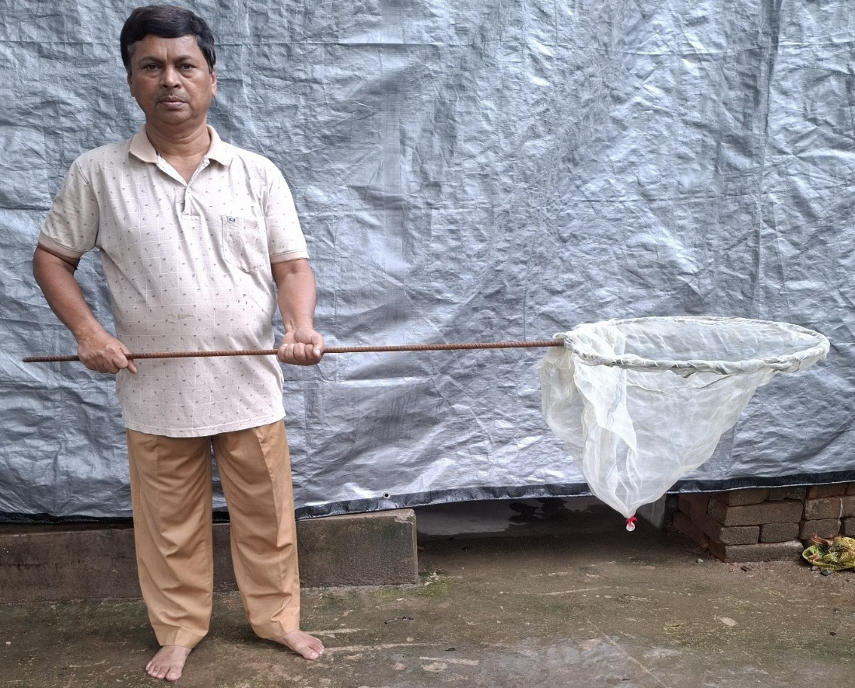
Fig. 1. Dip net (leech net) used for field collection.
Material examined. INDIA: Arunachal Pradesh, Kurung Kumey District, Kurung River, 27°47′ N, 92°51′ E, 1015 m a.s.l.; holotype, 1 specimen, ZSI-GNC-An 8611/2; collected 7 August 2025 by Temjenmongla and party. The specimen was submitted for identification and deposition through S. D. Gurumayum and Temjenmongla.
RESULTS AND DISCUSSION
Phylum: Annelida Lamarck, 1809
Class: Clitellata
Subclass: Hirudinea
Order: Arhynchobdellida
Family: Hirudinidae
Genus: Poecilobdella Blanchard, 1893
For diagnosis, the new specimen was compared with 11 selected taxa assembled in Table 1. The comparison uses classical morphology for the historically treated species (Harding & Moore, 1927), the modern Indian descriptions of P. aligarhensis, P. kananbalaae, P. tarubalaae, P. manashiae, and P. lakshmikantai (Mandal et al., 2021; Mandal et al., 2025; Mandal, Sharma, et al., 2026; Mandal, Bose, et al., 2026a, 2026b), and the comparative character states reported for P. sukhendui and P. hubeiensis in a recent Indian treatment (Mandal, Bose, et al., 2026b). The Zoological Survey of India compilation independently documents publication of P. sukhendui in 2024 (Banerjee et al., 2025). This matrix is a focused morphological comparison rather than an exhaustive revision of the genus.
Taxonomic account. The mature Kurung River specimen is designated as the holotype of Poecilobdella budhoi sp. nov. The taxonomic proposal is based on the combined external and internal morphology documented below and on comparison with the selected taxa summarised in Table 1.
Diagnosis: Poecilobdella budhoi sp. nov. (Plates 1–3)
Holotype 13 cm in total length; living colouration brownish blue, fading after preservation; dorsal and ventral surfaces nearly uniform and without longitudinal stripes; tegument smooth. Head breadth approximately 3 cm and midbody breadth 2.3 cm. Anterior sucker 9 mm wide; posterior sucker 2.3 cm wide, with 64 visible rays arranged in two zones, including 13 central rays. Body with 112 annuli. Male gonopore on annulus 31; female gonopore between annuli 35 and 36; gonopores separated by four annuli (Plates 1 and 2).
The eyes are indistinct in the preserved holotype and are therefore not used as a primary diagnostic character. The buccal cavity contains three jaws with acute teeth and numerous salivary papillae. Six pairs of crop caeca are present; the second pair is nearly equal in size. The reproductive system includes a large to medium-sized prostate gland, a short-to-moderate vaginal stalk, and a small-to-moderate vaginal caecum (Plates 2 and 3). The external body was observed to form five visually distinguishable regions, with the cephalic portion comprising 43 annuli.

Table 1. Morphological comparison of Poecilobdella budhoi sp. nov. with 11 selected comparator taxa.
Character | P. manillensis | P. granulosa | P. viridis | P. javanica | P. aligarhensis | P. kananbalaae | P. hubeiensis | P. tarubalaae | P. sukhendui | P. manashiae | P. lakshmikantai | P. budhoi sp. nov.
Dorsal/ventral stripe pattern | Three pairs yellow dorsolateral stripes; one black median broken stripe | Two pairs yellow longitudinal stripes; one black median line; submarginal stripes | Marginal orange stripes; metameric spots | Dark dorsal stripes; metameric spots | Seven dorsal stripes; median stripe paler than six dorsolateral stripes | Three pairs black dorsal stripes; lateral pair broken | Two black square-like stripes | One median black stripe; two black spotted lines | No dorsal or ventral stripes | Five broken black dorsal stripes | Seven black dorsal stripes with dot-like patterning | No longitudinal dorsal or ventral stripes
Colour | Dorsal brown; ventral green | Dorsal olive green; ventral reddish | Dorsal olive green; ventral grey-green | Dorsal olive green; yellow/orange margins | Brown | Dorsal brown; ventral yellowish | Dark brown dorsally; dark green ventrally | Dark brown dorsally; dark green ventrally | Dorsal brown; ventral greyish | Brownish-green dorsally; brownish ventrally with black dots | Reddish brown | Brownish blue in life
Body length | 12.2 cm | 9.4 cm | 11.1 cm | 10.6 cm | 42 mm | 9.9 cm | NR | 4 cm | 14.5 cm | 89 mm | 35 mm | 13 cm
Maximum breadth | 2.7 cm | 2.2 cm | 2.3 cm | 2.1 cm | 8 mm | 1.4 cm | NR | 5 mm | 3.5 cm | 10 mm | 8 mm | 3 cm
Anterior sucker breadth | 1.8 mm | 1.9 mm | 1.7 mm | 1.3 mm | 2 mm | 6 mm | NR | 3.5 mm | Not reported as an absolute width | 5 mm | 1 mm | 9 mm
Posterior sucker breadth | Large | Approximately equal to anterior sucker | Smaller than anterior sucker | Large; approximately body width | Reported as ~3× anterior sucker | 1.1 cm | Large | 3 mm | 2.3 cm; 110 rays reported | 8 mm | 3 mm; 42 rays reported | 2.3 cm; 64 visible rays
Gonopore separation | 5 annuli | 5 annuli | 5 annuli | 7 annuli | 5 annuli | 5 annuli | 5 annuli | 5 annuli | Male 29–30; female 34–35 | Male 33–34; female 38–39; 5 annuli | 6 annuli | Male on 31; female 35–36; 4 annuli
Vaginal stalk / caecum | Stalk absent | Stalk approximately equal to caecum length | Stalk reported longer than caecum | Stalk absent | Stalk reported larger | Very short stalk | Short stalk | Stalk absent | Stalk shorter than vaginal caecum | Short stalk; large rounded caecum | Short-stalked vaginal canal | Short-to-moderate stalk; small-to-moderate caecum
Eyes | 5 pairs | 5 pairs | 5 pairs | 5 pairs; positions reported on annuli 2, 3, 4, 6, 9 | Reported as 9 pairs | 5 pairs; positions reported on annuli 3, 5, 6, 8, 11 | 5 pairs; positions reported on annuli 2, 3, 4, 5, 6 | 5 pairs; positions reported on annuli 2, 4, 5, 7, 10 | 5 pairs; positions reported on annuli 2, 3, 5, 6, 8 | 5 pairs on annuli 4, 5, 6, 8, 11 | 5 pairs | Indistinct in preserved holotype; not used diagnostically
Total annuli | 112 | 101 | 107 | 105 | 108 (including posterior-sucker annuli in source) | 110 | NR | 113 | 111 | 109 | 110 | 112
Source | Harding & Moore (1927) | Harding & Moore (1927) | Harding & Moore (1927) | Harding & Moore (1927) | Mandal et al. (2021) | Mandal et al. (2025) | Mandal, Bose, et al. (2026b) | Mandal, Sharma, et al. (2026) | Mandal, Bose, et al. (2026b) | Mandal, Bose, et al. (2026b) | Mandal, Bose, et al. (2026a) | Present study
Note. Values were retained and typographically normalised from the cited comparative sources; NR indicates that a corresponding value was not reported in the source used for the table. For P. kananbalaae, the anterior-sucker value follows the published comparative table (6 mm); the narrative text of that source contains an internally inconsistent 6-cm statement. The present species is represented by the holotype (n = 1).

Distribution. Known only from the type locality in the Kurung River, Kurung Kumey District, Arunachal Pradesh, India.
Etymology. The specific epithet budhoi honours the late Budha Mandal in recognition of his interest in zoological specimen collection.
Habitat. Riverine freshwater habitat.
Differential diagnosis. Within the selected comparison in Table 1, the holotype is differentiated by the combined occurrence of an unstriped dorsal and ventral surface, 112 externally counted annuli, a four-annulus separation between the male and female gonopores, a posterior sucker 2.3 cm wide with 64 visible rays, and the observed female reproductive anatomy. Absence of longitudinal body stripes is also reported for P. sukhendui, so stripe absence alone is not treated as diagnostic. The four-annulus gonopore separation differs from the five-annulus condition reported for several compared taxa, the six-annulus condition reported for P. lakshmikantai (Mandal, Bose, et al., 2026a), and the seven-annulus condition listed for P. javanica in the classical comparison (Harding & Moore, 1927). Because the eyes are not distinctly visible in the preserved holotype, ocular position is not treated as a decisive diagnostic feature. The proposed diagnosis therefore rests on the combined character set rather than any single observation.
Remarks. The description is based on a single mature holotype. The specimen provides observable external and internal characters for formal morphological documentation, but a sample of one does not permit assessment of intraspecific, ontogenetic, or preservation-related variation. No DNA sequence is available from the holotype. This limitation is particularly relevant in Asian buffalo leeches because integrative studies have identified cryptic diversity and demonstrated the value of COI and nuclear sequence data for distinguishing morphologically similar lineages and testing species boundaries (Tubtimon et al., 2014; Jeratthitikul et al., 2020; Jiranuntskul et al., 2022; Shannan et al., 2024). Additional freshly collected material from the type locality and surrounding drainages should therefore be compared morphologically and, where feasible, analysed using mitochondrial COI together with a nuclear marker to test the phylogenetic placement of Poecilobdella budhoi.
COMPETING INTERESTS
The authors declare no known competing financial interests, non-financial interests, or personal relationships that could have influenced the work reported in this manuscript.
CONCLUSION
The Kurung River holotype is proposed as Poecilobdella budhoi sp. nov. on the basis of a character combination that includes absence of longitudinal stripes, 112 externally counted annuli, a male gonopore on annulus 31, a female gonopore between annuli 35 and 36, four-annulus gonopore separation, a 2.3-cm posterior sucker with 64 visible rays, and the observed reproductive anatomy. Within the selected morphological comparison presented here, this combination is not shared by the comparator taxa. The holotype is deposited in the Zoological Survey of India under accession ZSI-GNC-An 8611/2. Because only one specimen is presently available and molecular data were not generated, additional material should be evaluated through integrative morphological and molecular comparison before the range of intraspecific variation and broader phylogenetic placement are considered resolved.
DECLARATION OF AI USE
During manuscript revision, Grammarly and ChatGPT were used for language-editing and reference-formatting assistance only. All taxonomic observations, measurements, interpretations, and final scientific decisions were made and verified by the authors, who take responsibility for the accuracy and integrity of the manuscript.
REFERENCES
Banerjee, D., Raghunathan, C., Rizvi, A. N., & Sengupta, J. (Eds.). (2025). Animal discoveries 2024: New species and new records. Zoological Survey of India. https://zsi.gov.in/uploads/documents/importantLinks/english/Animal_Discoveries_2024_1.pdf
Bhatia, M. L. (1970). The segmentation of the gnathobdellid leeches with special reference to the Indian leech Hirudinaria and medicinal leech Hirudo. Journal of Morphology, 132(3), 361–375. https://doi.org/10.1002/jmor.1051320309
Blanchard, R. (1893). Révision de Hirudinées du Musée de Turin. Bollettino dei Musei di Zoologia ed Anatomia Comparata della R. Università di Torino, 8(145), 1–32. https://doi.org/10.5962/bhl.part.27223
Harding, W. A., & Moore, J. P. (1927). The fauna of British India, including Ceylon and Burma: Hirudinea. Taylor & Francis. https://faunaofindia.nic.in/php/fbi_books_list.php
Jeratthitikul, E., Jiranuntskul, P., Nakano, T., Sutcharit, C., & Panha, S. (2020). A new species of buffalo leech in the genus Hirudinaria Whitman, 1886 (Arhynchobdellida, Hirudinidae) from Thailand. ZooKeys, 933, 1–14. https://doi.org/10.3897/zookeys.933.49314
Jiranuntskul, P., Boonporn, A., Kongrit, C., Panha, S., & Jeratthitikul, E. (2022). Biodiversity of the buffalo leeches genus Hirudinaria (Arhynchobdellida, Hirudinidae) in southern Thailand revealed from DNA barcoding. Zoological Studies, 61, e84. https://doi.org/10.6620/ZS.2022.61-84
Mandal, C. K., Bose, M., Sharma, P., Mridha, S., Sikdar, R., Hasan, M. N., & Ghosh, S. (2026a). Poecilobdella lakshmikantai: A new leech from Arunachal Pradesh, India. Uttar Pradesh Journal of Zoology, 47(14), 73–82. https://doi.org/10.56557/upjoz/2026/v47i145753
Mandal, C. K., Bose, M., Sharma, P., Mridha, S., Sikdar, R., Hasan, M. N., & Ghosh, S. (2026b). Poecilobdella manashiae: A new species of leech from Tripura, India. Uttar Pradesh Journal of Zoology, 47(13), 87–96. https://doi.org/10.56557/upjoz/2026/v47i135730
Mandal, C. K., Mridha, S., Sharma, P., Bose, M., Hassan, N., Sachi, A., & Ghosh, S. (2025). Poecilobdella kananbalaae: A new species of leech from Karnataka, India. Uttar Pradesh Journal of Zoology, 46(23), 201–210. https://doi.org/10.56557/upjoz/2025/v46i235394
Mandal, C. K., Mridha, S., Yasir, M., Kalam, A., Jameel, M., Anwar, M., & Ghosh, S. (2021). Poecilobdella aligarhensis: A new leech (Clitellata: Hirudinida) from Aligarh, India. Journal of Applied Zoological Researches, 32(2), 180–186.
Mandal, C. K., Sharma, P., Bose, M., Mridha, S., Hasan, N., Sikdar, R., Sachi, A., & Ghosh, S. (2026). Morphological description and taxonomic notes on Poecilobdella tarubalaae sp. nov. from Karnataka, India. Uttar Pradesh Journal of Zoology, 47(3), 63–72. https://doi.org/10.56557/upjoz/2026/v47i35486
Nakano, T., & Lai, Y.-T. (2016). First record of Poecilobdella nanjingensis (Hirudinida: Arhynchobdellida: Hirudinidae) from Taiwan and its molecular phylogenetic position within the family. Species Diversity, 21(2), 127–134. https://doi.org/10.12782/sd.21.2.127
Phillips, A. J. (2012). Phylogenetic placement of a new species of Asian buffalo leech (Arhynchobdellida: Hirudinidae), and confirmation of human-mediated dispersal of a congener to the Caribbean. Invertebrate Systematics, 26(3), 293–302. https://doi.org/10.1071/IS12004
Shannan, P. Z. T., Suganya, S. G., Ramesh, M., & Jemima, E. A. (2024). Molecular based identification and phylogenetic relationship of the leech Hirudinaria manillensis from India by using mitochondrial cytochrome c oxidase subunit I gene. Molecular Biology Reports, 51(1), 787. https://doi.org/10.1007/s11033-024-09720-1
Tubtimon, J., Jeratthitikul, E., Sutcharit, C., Kongim, B., & Panha, S. (2014). Systematics of the freshwater leech genus Hirudinaria Whitman, 1886 (Arhynchobdellida, Hirudinidae) from northeastern Thailand. ZooKeys, 452, 15–33. https://doi.org/10.3897/zookeys.452.7528

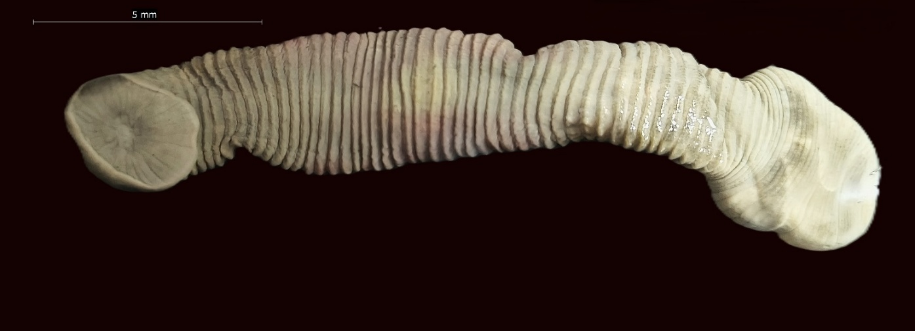
AS
PS
PS
Plate 1A. Dorsal view of Poecilobdella budhoi, showing the anterior sucker (AS) and posterior sucker (PS).
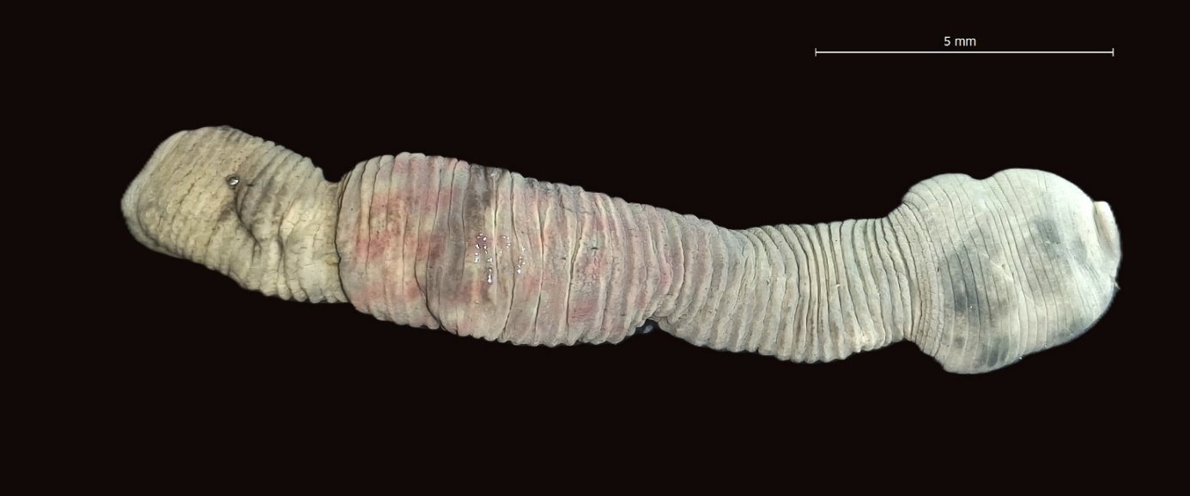
AS
PS
Plate 1B. Ventral view of Poecilobdella budhoi, showing the anterior sucker (AS) and posterior sucker (PS).
Plate 2. External and dissected diagnostic structures of Poecilobdella budhoi, including the posterior sucker, male and female gonopores, anterior region, epididymis, and prostate.
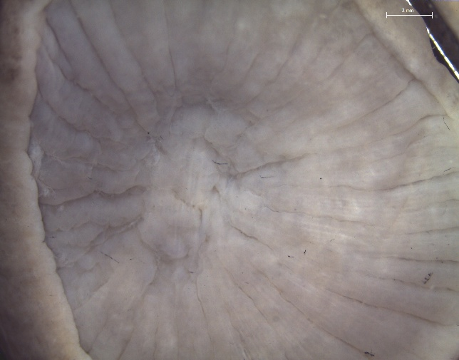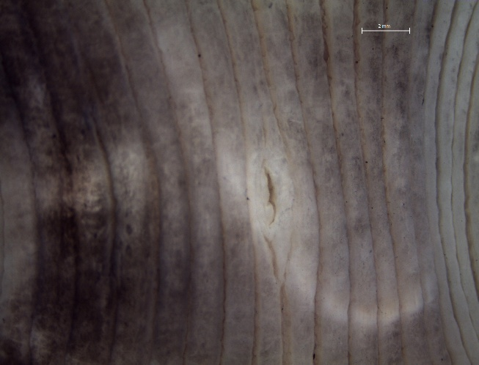
Poecilobdella budhoi: posterior sucker rays (left) and male/female gonopore region (right).
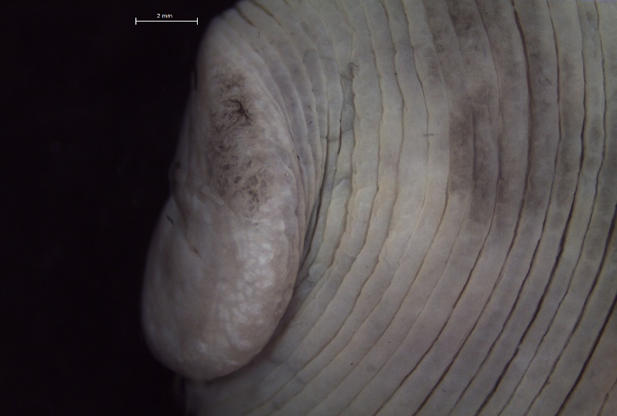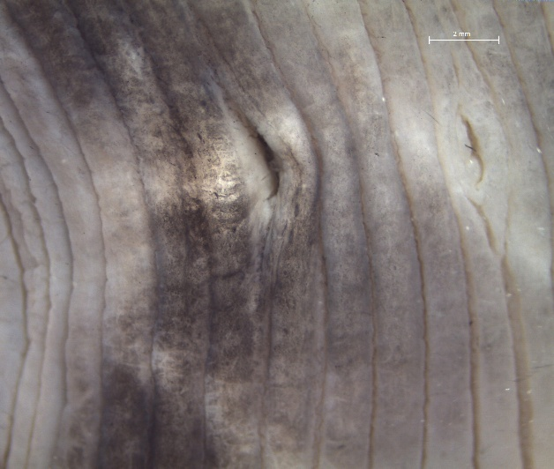
MP
FP
Poecilobdella budhoi: posterior sucker (left) and male/female gonopores (right; FP, female pore; MP, male pore).
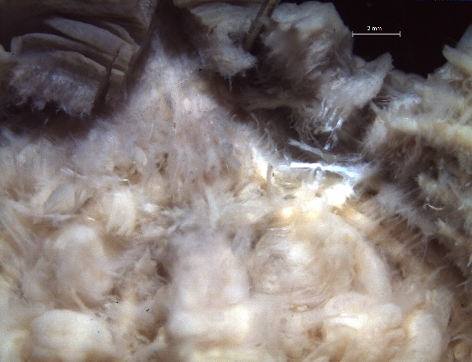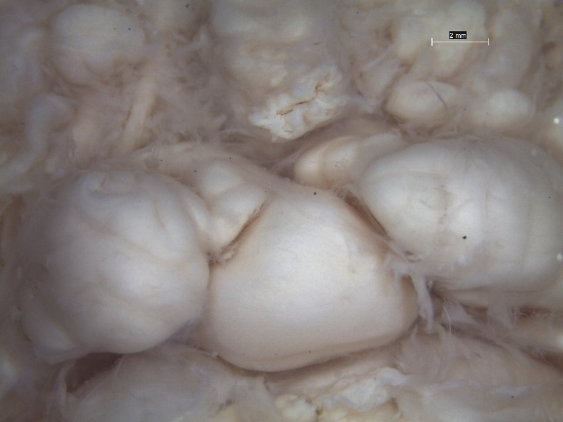
B
A
Poecilobdella budhoi: dissected anterior region (left) and epididymis (A) with prostate (B) (right).
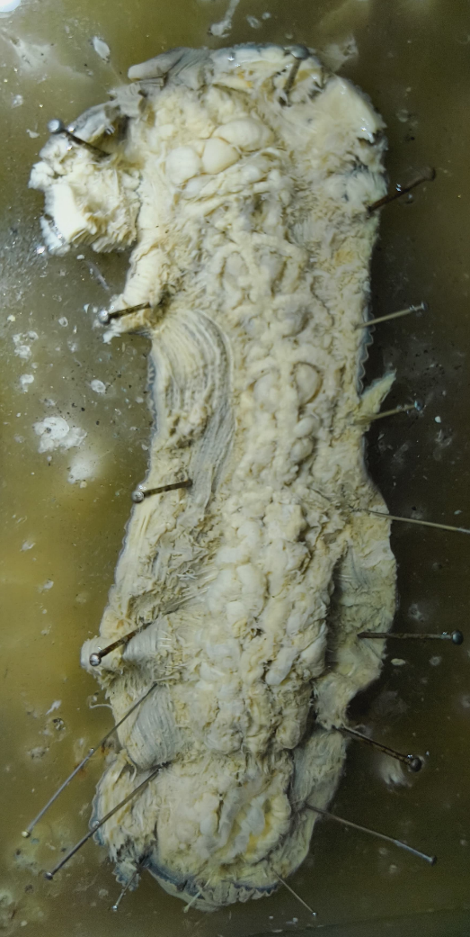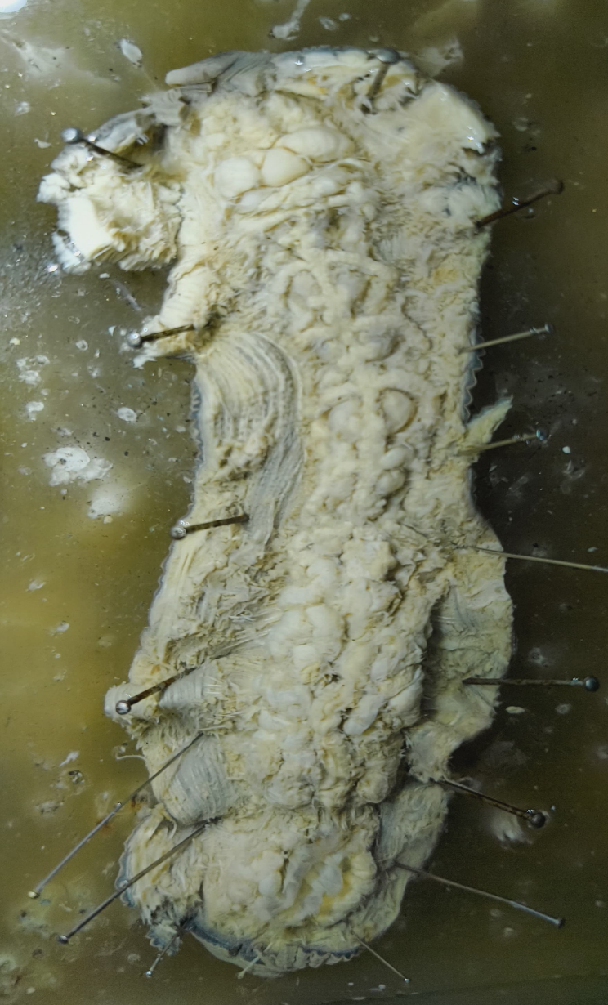
H
G
F
E
D
C
B
A
Plate 3. Internal anatomy of Poecilobdella budhoi, showing six pairs of crop caeca (C–H), testicular structures, epididymis (A), prostate (B), and vaginal caecum.

