Efficacy of GS-441524 in the Management of Feline Infectious Peritonitis: A Clinical Study

ABSTRACT
Aim
The present study was undertaken to determine the occurrence of Feline Infectious Peritonitis (FIP) in cats presented to the Veterinary Clinical Complex (VCC), Rajendranagar, Hyderabad, and to evaluate the associated clinical signs and therapeutic management strategies.
Study Design
The study included cats presented to the VCC, College of Veterinary Science, Rajendranagar, Hyderabad, showing clinical signs suggestive of FIP. Data were analyzed with respect to breed, age, and gender, and therapeutic efficacy was assessed between two treatment groups.
Place and Duration of Study: The study was conducted at the VCC, College of Veterinary Science, Rajendra Nagar, Hyderabad, from September 2024 to September 2025.
Methodology: All presented cats underwent detailed physical and clinical examinations, and findings were systematically recorded. Suspected cases were subjected to diagnostic evaluations including hematology, serum biochemistry, effusion analysis, radiography, and ultrasonography to support clinical diagnosis. For therapeutic assessment, FIP-suspected cats were randomly allocated into two treatment groups—Group I and Group II with each group comprising 12 animals and therapeutic efficacy was evaluated. The data obtained was subjected to statistical analysis.
Results : Out of 2,569 cats screened, 108 cats tested positive for FIP, indicating an overall occurrence rate of 4.2%. Male cats (58.33%) were more frequently affected than females (41.67%). Breed-wise distribution showed that Persian cats had the highest occurrence (49/108).In effusive FIP, the predominant clinical signs were respiratory distress (74.36%), ascites (53.85%), pleural effusion (37.18%), and dyspnea (50%). In non-effusive FIP, common signs included seizures (33.33%), ataxia (22.22%), icterus (14.81%), nystagmus (11.11%), and anisocoria (11.11%).Effusion samples were typically clear, viscous, and straw-colored, and all tested positive for the Rivalta test. The albumin-to-globulin (A/G) ratio in effusion was <0.45 in 65 cases (86.67%). Major hematobiochemical abnormalities included lymphopenia (68.52%) and hyperglobulinemia (71.30%). Radiographic findings revealed pleural effusion in 22 cats (30.55%) and abdominal effusion with ground-glass appearance in 43 cats (59.72%). Ultrasonography showed anechoic effusion (59.26%) and hepatomegaly with rounded liver margins (41.97%).
Treatment and outcome: Group I animals treated with Prednisolone and Group II animals treated with Inj Remdesivir followed by oral GS441524. Group II animals showed marked clinical recovery, with significant resolution of clinical signs and normalization of hematobiochemical parameters.
Conclusion: GS-441524 has emerged as a highly promising therapeutic agent for FIP, demonstrating a remarkably high success rate in affected cats and offering new hope in the management of this once-fatal disease.

INTRODUCTION
Feline Infectious Peritonitis (FIP) is a fatal, immune-mediated disease of domestic and wild felids occurring worldwide. It accounts for approximately 0.3%–1.4% of feline deaths presented to veterinary institutions (Olsen, 1993; Tekes & Thiel, 2016; Xia et al., 2020). The disease is caused by the Feline Coronavirus (FCoV), a member of the Coronaviridae family—an enveloped, positive-sense, single-stranded RNA virus found globally in cats. Feline coronavirus (FCoV) infection is very common in cats, usually causing only mild intestinal signs such as diarrhoea. Up to 10% of FCoV infections, however, result in the fatal disease feline infectious peritonitis (FIP) (Tasker, 2018).
Transmission of FECV primarily occurs through the fecal–oral route, targeting enterocytes in the intestinal tract. Feline Infectious Peritonitis Virus (FIPV) arises from mutations in the Feline Enteric Coronavirus (FECV) within an infected host. FIP can develop at any age and occur in cats from multi-cat environments like shelters or catteries, where FCoV exposure is high (Pedersen, 2014). The mutated virus replicates within monocytes, macrophages, and lymph nodes, disseminating systemically via the bloodstream. The resultant antigen–antibody complex formation and release of vasoactive substances contribute to vascular injury, protein-rich effusions, and the characteristic clinical manifestations of FIP. Stress could inhibit immune function and make viruses more susceptible to mutation and proliferation (Addie et.al.,2009). Housing density was considered one of the major risk factors for FIP as well, and overcrowding could lead to virus mutation and disease development (Riemer et.al.,2016).
FIP manifests in three clinical forms—effusive (wet), non-effusive (dry), and mixed types.The effusive form is characterized by immune-mediated accumulation of inflammatory exudates and fibrinous serositis, leading to proteinaceous effusions, most commonly in the abdominal cavity, though effusions may also occur in the thoracic, pericardial, or scrotal cavities (Worthing et al., 2012).The non-effusive (dry) form features granulomatous or pyogranulomatous lesions in organs such as the mesenteric lymph nodes, liver, kidneys, bowel wall, central nervous system, and eyes. In some cases, terminal progression of the dry form may result in effusion, producing a mixed type (Hartmann, 2005).The wet form is generally more prevalent than the dry or mixed forms under natural conditions (Pedersen, 2009).
Diagnosis of non-effusive FIP remains particularly difficult because of its non-specific clinical and laboratory findings. Detection of Feline Coronavirus (FCoV) RNA in effusion samples is among the most reliable diagnostic indicators of FIP (Soma et al., 2013), and effusion analysis generally provides greater diagnostic value than blood testing (Sharif et al., 2010). Although immunofluorescence staining for FCoV antigen in macrophages offers high specificity, its sensitivity is limited by the low macrophage count in effusions. Currently, the gold standard for FIP diagnosis remains immunohistochemistry (IHC) detection of FCoV antigen in affected tissues. However, IHC is invasive, requires specialized facilities and expertise, and a negative result does not definitively exclude FIP, making the diagnostic process complex and often presumptive (Sykes, 2014). Historically, FIP was regarded as an almost invariably fatal condition, with treatment limited to supportive care. Advances in antiviral therapy, particularly nucleoside analogues, have markedly improved the prognosis of affected cats. In this context, the present study was conducted to assess the therapeutic efficacy and clinical outcomes of GS-441524 in cats with Feline Infectious Peritonitis (FIP), encompassing its various clinical forms.
MATERIALS AND METHODS

Selection of cases
The present case study was carried out on cats presented to the Veterinary Clinical Complex (VCC), College of Veterinary Science, Rajendranagar, Hyderabad, during the period from September 2024 to September 2025. A total of 2,569 cats presented to the VCC were screened for Feline Infectious Peritonitis (FIP). Data regarding breed, age, and sex were systematically recorded. Each cat underwent a comprehensive physical and clinical examination, and all observations were carefully documented. Selected cases were further evaluated using diagnostic imaging techniques, including radiography and ultrasonography, to aid in clinical assessment and diagnosis.
Inclusion criteria
Due to the limited availability of advanced diagnostic facilities in veterinary hospitals and the reluctance of cat owners to consent to invasive diagnostic procedures such as biopsies, establishing a definitive diagnosis of feline infectious peritonitis (FIP) through non-invasive approaches remains challenging. In the absence of confirmatory tests, a presumptive diagnosis of FIP can be made based on a combination of history, clinical signs and routine clinicopathological findings. Accordingly, the following inclusion criteria for diagnosing FIP cases were established based on previously published literature (Hartmann, 2005; Sykes, 2014; Greene, 2012; Pedersen, 2014; Tasker, 2018; Riemer et al., 2016; Felten & Hartmann, 2019; Yin et al., 2021).
Cases fulfilling five or more of the following diagnostic criteria were regarded as consistent with FIP.
- Typical clinical signs consistent with effusive FIP (pleural effusion and/or ascites) or non-effusive FIP (ocular and/or neurological manifestations such as ataxia and seizures).
- Hyperglobulinemia with a decreased albumin-to-globulin (A/G) ratio below the cut-off value of 0.6.
- Positive Rivalta’s test result in effusion samples.
- Characteristic effusion findings—high protein content (>3.5 g/dL) with low cellularity, predominantly composed of macrophages and neutrophils.
- Positive FIP virus detection, either by a RAPID antigen test (Lateral Flow Assay) or confirmed by Reverse Transcription–Polymerase chain reaction (RT-PCR).
- Lymphopenia with a neutrophilic left shift, a typical hematological change observed in both effusive and non-effusive forms of FIP.
- Hyperbilirubinemia in the absence of significantly elevated hepatic enzyme activities or hemolytic anemia.
Sample collection
Wet blood film examination was performed using blood samples collected from the superficial ear vein. Additional blood samples were obtained from the cephalic vein and transferred into sterile vials, both with and without EDTA, for subsequent analyses. Hematological parameters were measured using an EDAN hematology analyzer, while biochemical parameters were estimated with an EXIGO veterinary biochemistry analyzer. Blood smear examination was carried out to rule out hemoprotozoan infections, and coprological examination was conducted to exclude endoparasitic infestations.Blood samples collected from six apparently healthy cats were used as healthy controls. In FIP-suspected cases, abdominal or pleural effusion samples were collected for further analysis and subjected to the Rivalta test to aid in diagnostic confirmation.
Rivalta test: It is a simple, rapid inexpensive point-of-care test for FIP. One drop of 8% acetic acid is added to 5 mL of distilled water and mixed thoroughly, and a drop of effusion is carefully layered on top. If the drop disappears and the solution remains clear, the test result is negative. If the drop retains its shape, stays attached to the surface, or floats slowly down the tube, then the test result is positive (Greene ,2012).
Therapeutic protocol: For therapeutic evaluation, the FIP affected cats were randomly divided into two treatment groups—Group I and Group II—with each group comprising 12 animals.
Group I animals were treated with Prednisolone administered orally at a dose rate of 4 mg/kg/day for 10–14 days, followed by gradual tapering at two-week intervals to 0.25 mg/kg/day upto 84 days.
Group II animals were treated with Remdesivir (JUBI-R) administered subcutaneously at 10 mg/kg once daily for two weeks. This induction phase was followed by a maintenance regimen using GS-441524 capsules (BASMIFIP, India), administered orally at 15 mg/kg/day for the wet form and dry form without neurological signs, and 20 mg/kg/day for the dry form with neurological involvement, for an additional 10 weeks (Taylor et.al 2022)
Supportive therapy: Both groups received supportive therapy in addition to their respective specific treatment protocols. The supportive management included Inj. Furosemide (2 mg/kg, IM or IV) for controlling effusions, and Inj. Amoxicillin + Sulbactam to manage secondary bacterial infections, Haematinics and Gastroprotectants like Sucralfate @ 0.5 g per cat orally q 8hr. For cats exhibiting seizures (particularly in the dry form), Inj. Diazepam (0.5-1 mg/kg, IM) was administered.Interventional procedures such as thoracocentesis and abdominocentesis were performed when necessary to alleviate respiratory distress caused by fluid accumulation (Figure 2). Additionally, immunomodulators like Syrup Immunol and neuroprotectants such as Syrup Neurokind were administered as adjunct therapies to boost the immune response and support neurological function.
Therapuetic monitoring: Therapeutic monitoring was performed by assessing the normalization of clinical signs and hemato-biochemical parameters throughout the treatment period.
Statistical Analysis: The data obtained was subjected to statistical analysis as per the method described by Snedecor and Cochran (1994) by using SPSS 20.00 version.
RESULTS
In the present study, a total of 2,569 cats were screened for Feline Infectious Peritonitis (FIP), out of which 108 cats tested positive, indicating an overall occurrence rate of 4.2%. Among the affected cats, 78 cases (72.22%) exhibited the effusive (wet) form, 27 cases (25%) showed the non-effusive (dry) form, and 3 cats (2.78%) presented with a mixed form of FIP. A few cats initially presented with non-effusive FIP, which later progressed to ascites and the effusive form.In terms of sex distribution, male cats (63/108) were more frequently affected than females (45/108). Breed-wise analysis revealed that Persian cats had the highest occurrence (49/108), followed by Domestic Shorthair (DSH) cats (32/108), non-descript cats (20/108), and crossbred cats (7/108).
In the present study, cats affected with Feline Infectious Peritonitis (FIP) exhibited a wide range of clinical manifestations depending on the form of the disease. In the effusive (wet) form, the predominant clinical signs included ascites (42/78; 53.85%), pleural effusion (29/78; 37.18%), ascites with pleural effusion (6/78; 7.69%), respiratory distress (58/78; 74.36%), dyspnea (39/78; 50%), and scrotal edema (1/78; 1.28%) (Figure 1). Cats with the non-effusive (dry) form commonly exhibited neurological signs, such as seizures (9/27; 33.33%), ataxia (6/27; 22.22%), altered mental status (3/27; 11.11%), nystagmus (3/27; 11.11%), head tilt (2/27; 7.4%), tremors (1/27; 3.70%), and icterus (4/27; 14.81%). The ocular abnormalities recorded included anisocoria (3/27; 11.11%), uveitis (2/27; 7.4%), and iris colour change (1/27; 3.70%). Additionally, several non-specific clinical signs were observed in both forms of the disease, including fever (72/108; 66.67%), anorexia (56/108; 51.85%), pale mucous membranes (48/108; 44.44%), inappetence (44/108; 40.74%), lymphadenopathy (43/108; 39.81%), weight loss (35/108; 32.40%), lethargy (23/108; 21.30%) and diarrhoea (6/108; 5.55%).
Table:1 Haemato-biochemical findings in FIP affected cats (n=108)
Parameter |  | No of cats affected (n=108) | Percentage (%)
Lymphopenia |  | 74 | 68.52
Leukocytosis |  | 16 | 14.81
Neutrophilia |  | 52 | 48.15
Anaemia |  | 41 | 37.96
Thrombocytopenia |  | 39 | 36.11
Hyperglobulinemia |  | 77 | 71.30
Hypoalbuminemia |  | 31 | 28.70
A/G Ratio | < 0.6 | 72 | 66.67
A/G Ratio | > 0.6 | 28 | 25.92
Hyperproteinemia |  | 77 | 71.30
Hyperbilirubinemia |  | 69 | 63.89
Elevation of ALP |  | 23 | 21.30
Elevation of AST & ALT |  | 19 | 17.59
Elevation of BUN & Creatinine |  | 14 | 12.96

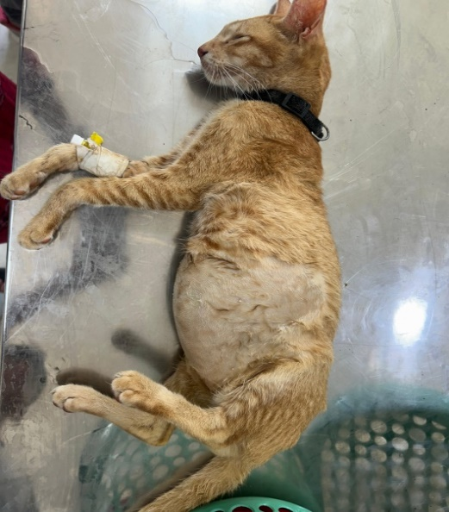 | 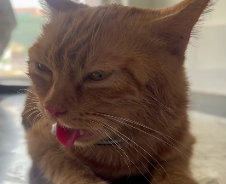
- Abdominal distension | - Respiratory distress
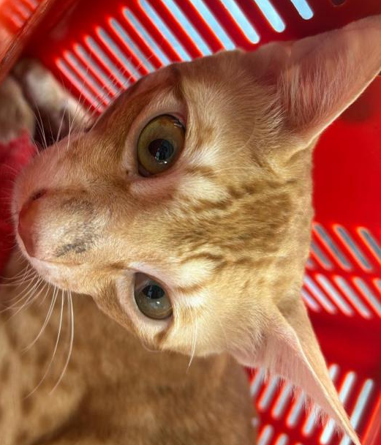 | 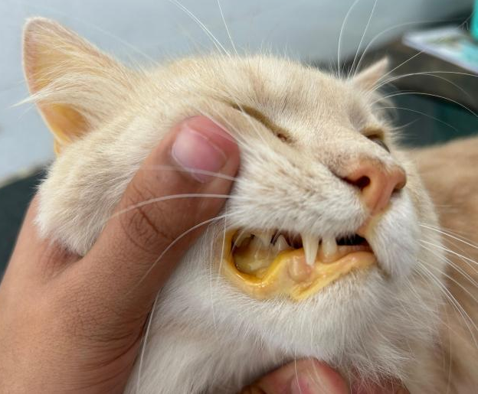
- Anisocoria | - Icterus
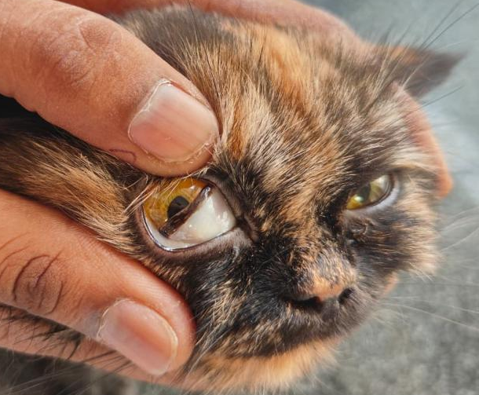 | 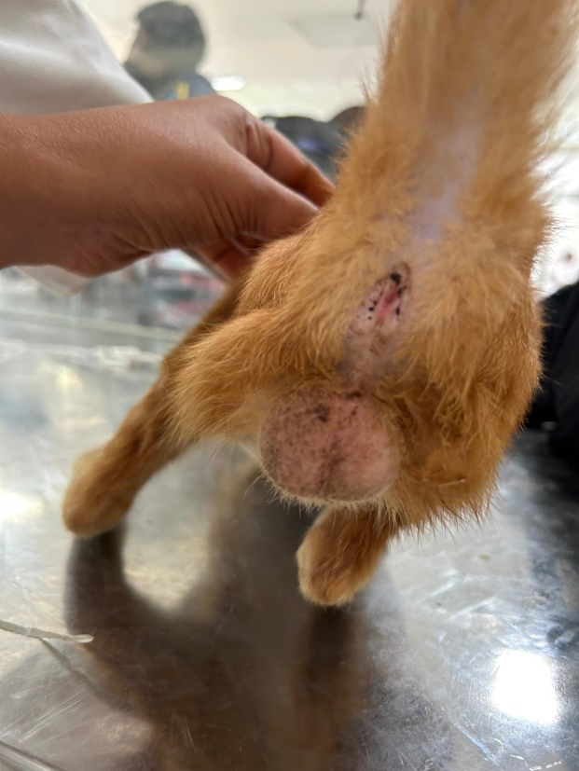
- Pale mucosa | - Scrotal edema
Figure:1 Clinical signs exhibited by FIP affected cats

Haemato-biochemical findings are presented in Table 1. Effusion analysis was carried out in 75 cats, which revealed fluid that was clear, viscous, and straw-yellow in color. Analysis of ascitic fluid showed a mean (± S.E.) total protein concentration of 3.68 ± 0.28 g/dL, albumin concentration of 1.20 ± 0.08 g/dL, and globulin concentration of 2.48 ± 0.89 g/dL. Microscopic examination of the ascitic fluid revealed a mean total nucleated cell count of 4.78 ± 1.12 ×10³/µL. The albumin-to-globulin (A/G) ratio in the effusion was <0.45 in 65 cases (86.67%) and between 0.45 and 0.6 in 10 cases (13.33%). Based on these findings, the effusion was classified as a modified transudate. Cytological examination showed that the predominant cells were non-degenerative neutrophils and macrophages. The Rivalta test, performed in all affected cases, demonstrated the characteristic “upside-down jellyfish” appearance of the effusion drop, indicative of a positive reaction consistent with FIP-associated effusion (Figure 2).
A total of 72 cats were subjected to radiographic examination, which revealed pleural effusion in 22 cats (30.55%), abdominal effusion with a ground-glass appearance in 43 cats (59.72%), abdominal effusion with gas-filled intestines in 7 cats (9.72%), hepatomegaly in 12 cats (16.67%), and renomegaly in 9 cats (12.5%) (Figure 3). Additionally, 81 cases underwent abdominal ultrasonography. The major findings noticed were anechoic effusion with floating of viscera (48/81), hepatomegaly with rounded liver margins (34/81), hyperechoic liver with portal vein engorgement (27/81), hypoechoic hepatic parenchyma (19/81), cholecystitis (6/81), medullary rim sign (16/81) and hyperechoic renal cortex with pyogranulomatous lesions (12/81) (Figure 4). Thoracic radiography revealed pleural effusion in 26 out of 81 cats examined. Of the 108 confirmed FIP cases, 33 cats tested positive in the lateral flow assay, while 42 cats were positive by RT-PCR (Figure 5). The remaining cases were diagnosed based on the clinical, laboratory, and imaging findings in accordance with the diagnostic criteria for FIP as described in the materials and methods.
Table 2: Haematological findings in FIP affected cats before and after therapy

Parameter | Healthy cats (Control) | Before Therapy | After Therapy
Parameter | Healthy cats (Control) | Before Therapy | Group I (n=12) |  | Group II (n=12)
Hb (g/dl) | 11.26 ±0.80ª | 7.26 ±0.12^{b} | 9.16 ±0.62^{bc} | 12.26 ±0.91^{c}
TEC (10⁶/μL) | 6.36±0.55ª | 4.36±0.78^{b} | 5.68±0.75^{ab} | 6.36±0.25ª
PCV (%) | 28.33± 1.20ª | 27.33±1.07ª | 29.12±1.45ª | 30.33±2.20ª
TLC (10³/μL)) | 13.88±0.18^{b} | 19.88±0.16ª | 15.88±0.46^{ab} | 13.88±0.41^{b}
PLT (x10⁵/uL) | 2.13±0.60^{b} | 1.09±0.20^{c} | 2.18±0.67^{b} | 3.11±0.34ª
Neutrophils (%) | 75.12±2.26^{b} | 81.18±2.34ª | 79.12±1.22^{b} | 76.12±2.16^{c}
Lymphocytes (%) | 13.12±1.83ª | 8.02±0.62^{c} | 10.12±1.56^{b} | 13.12±1.33ª
Monocytes (%) | 2.12±0.69ª | 1.12±0.54ª | 1.02±0.81ª | 1.02±0.89ª
Values bearing different superscripts in a row differ significantly (P< 0.05)
Values bearing similar superscripts in a row did not differ significantly (P >0.05)

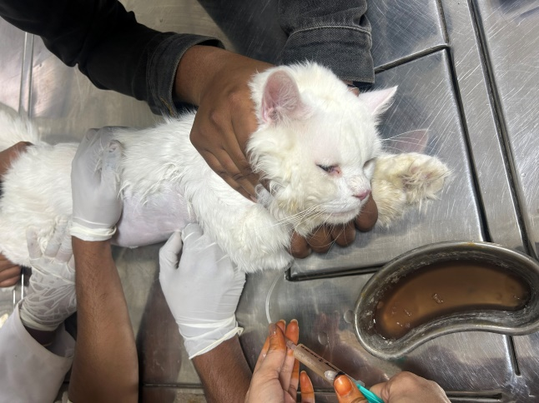 | 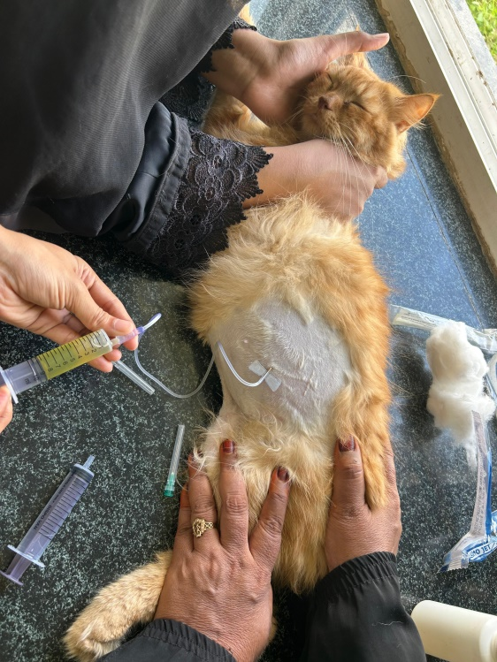
a) Thoracocentesis | b) Abdominocentesis
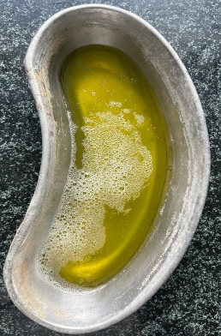 | 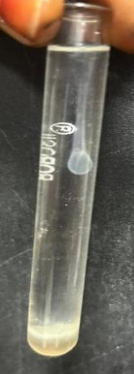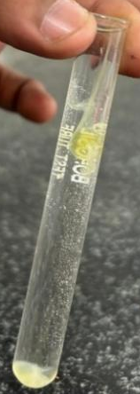
c) Effusion from FIP affected cat showing clear,  viscous, and straw-yellow colored fluid | d)The Rivalta test showing upside-down jellyfish”  appearance of the effusion drop
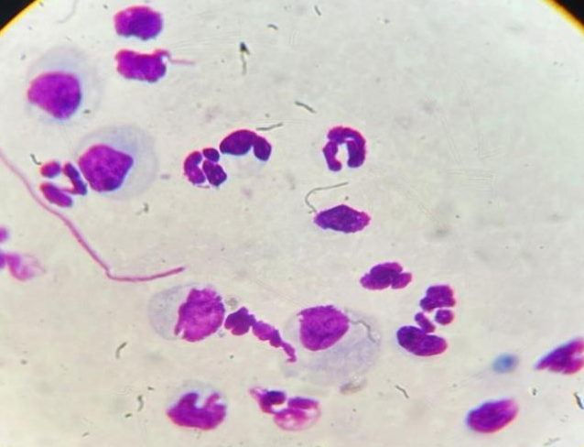 | 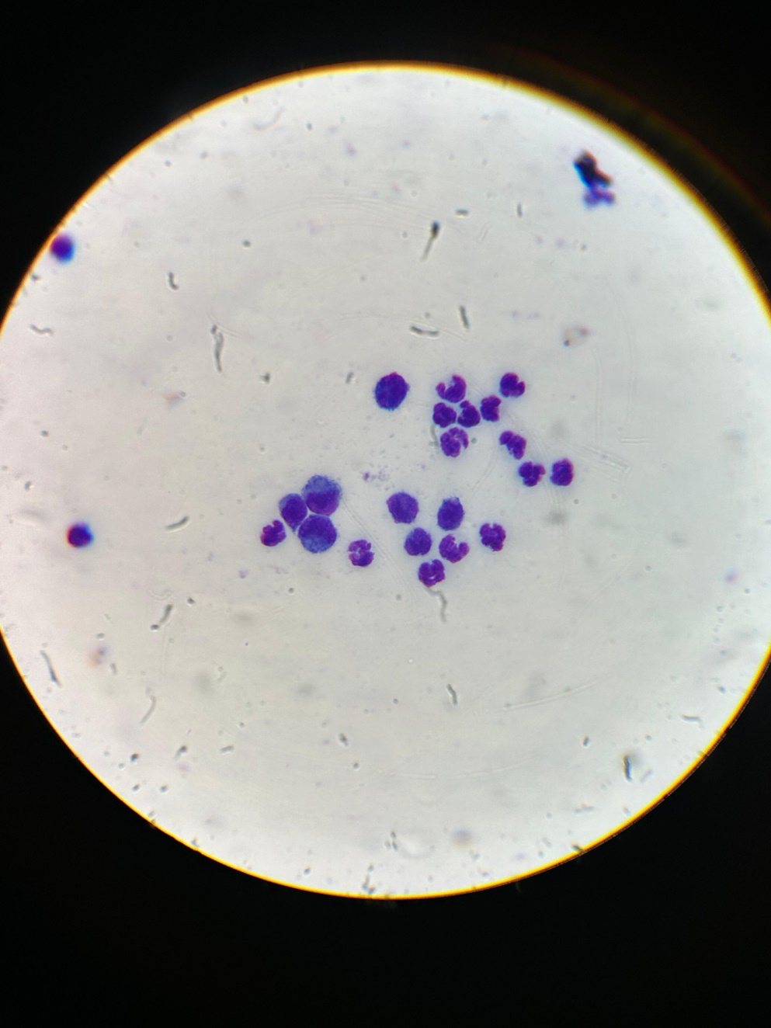
e) Ascitic fluid cytology from FIP affected cat showing macrophages and few neutrophils . | f) Pleural fluid cytology from FIP affected cat showing macrophages and non degenrative neutrophils
Figure 2: Effusion collection and Analysis from FIP affected dogs

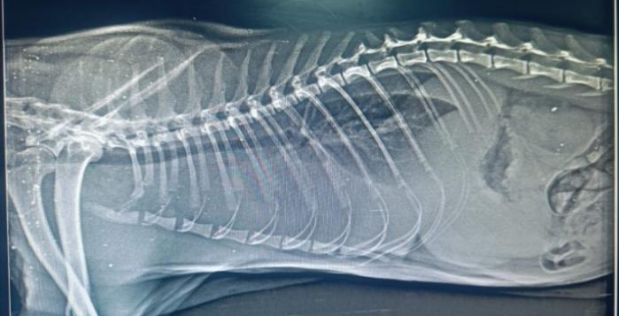 | 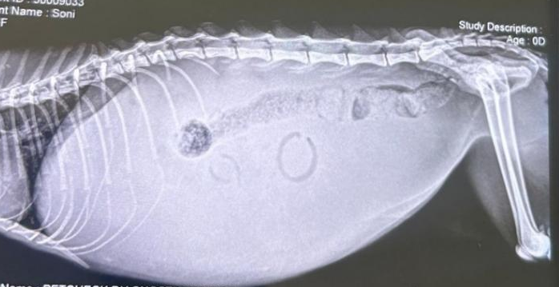
- Skiagram of FIP affected cat showing increased radio-opacity in pleural cavity suggestive of pleural effusion | - Skiagram of FIP affected cat showing increased radio-opacity in peritoneal cavity suggestive of peritoneal effusion with Ground glass appearance.
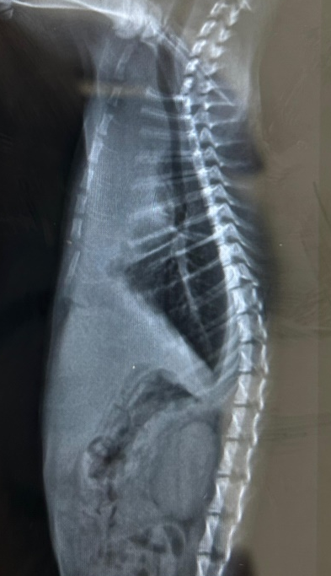 | 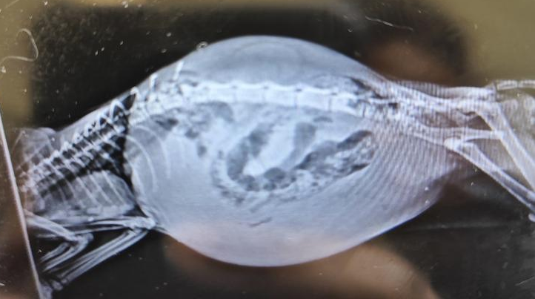
- Skiagram FIP affected cat showing pleural effusion, hepatomeagaly and renomegaly. | - Skiagram FIP affected cat showing abdominal effusion with gas filled intestines.
Figure 3: Radiographic findings in FIP affected cats

Table 3: Biochemical findings in FIP affected cats before and after therapy
Parameter | Healthy cats (Control) | Before Therapy | After Therapy
Parameter | Healthy cats (Control) | Before Therapy | Group I (n=12) | Group II (n=12)
ALT | 72.26 ±0.90^{b} | 87.04 ± 1.33ª | 70.16 ±0.62^{b} | 71.26 ±0.91^{b}
ALP | 100.09±1.89^{b} | 114.36±2.89ª | 105.68±1.85^{b} | 104.36±1.35^{b}
AST | 70.33± 0.72^{bc} | 107.33±1.97ª | 79.12±1.70^{b} | 68.33±1.24^{c}
Total protein | 7.88±0.79^{ab} | 9.88±0.13ª | 7.18±0.56^{b} | 6.68±0.91^{c}
Albumin | 3.23±0.30ª | 1.89±0.90^{c} | 2.18±0.67^{b} | 3.31±0.34ª
Globulin | 4.57±0.68^{bc} | 7.90±0.92ª | 5.09±0.87^{b} | 3.37±0.31^{c}
Total bilirubin | 0.22±0.36^{bc} | 1.2±0.14ª | 0.31±0.19^{b} | 0.12±0.11^{c}
BUN | 25.12±1.23^{b} | 38.02±0.82ª | 24.12±1.61^{b} | 23.12±1.03^{b}
Creatinine | 1.18±0.21^{c} | 2.72±0.45ª | 1.52±0.19^{b} | 1.43±0.12^{b}
Values bearing different superscripts in a row differ significantly (P< 0.05)
Values bearing similar superscripts in a row did not differ significantly (P >0.05)

Figure 4: Ultrasonographic findings in FIP affected cats
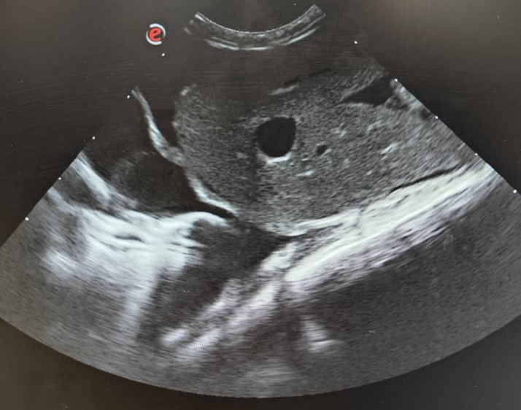 | 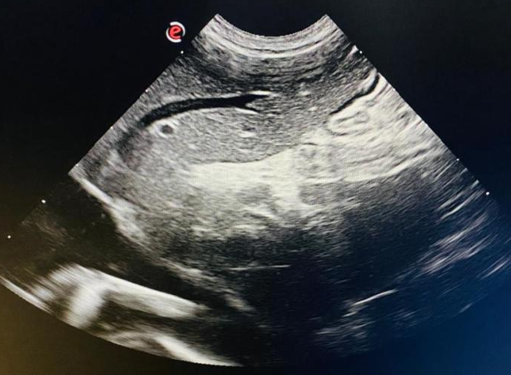
- Sonogram of FIP affected cat showing pleural  Effusion. | - Sonogram of FIP affected cat showing  hyperehogenic liver with engorged portal vein .
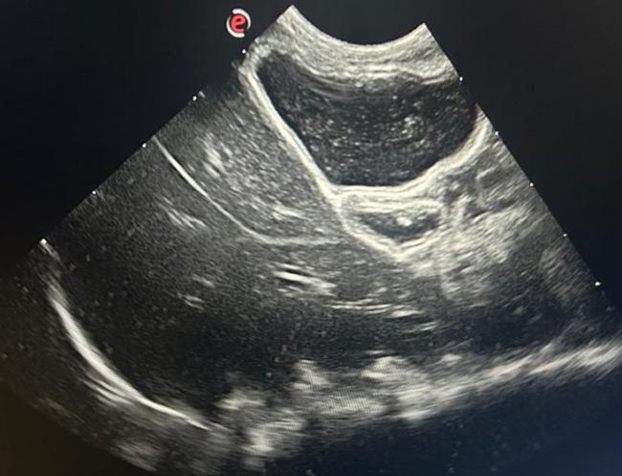 | 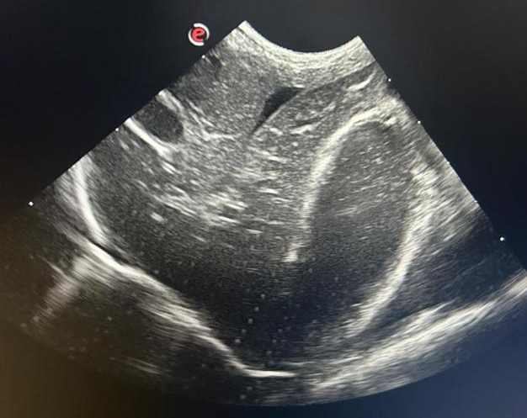
- Sonogram of FIP affected cat showing hypoehoic hepatic parenchyma. | - Sonogram of FIP affected cat showing multiple hypoechoic nodules within hepatic parenchyma with Periportal hyperechogenicity suggestive of pyogranulomatous inflammation.
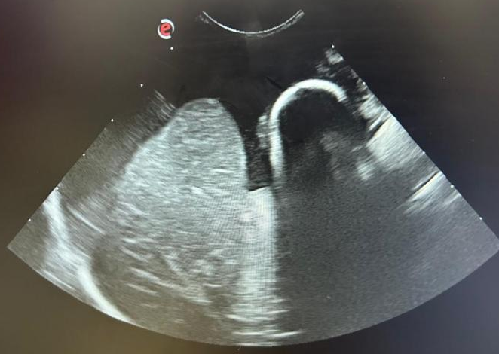 | 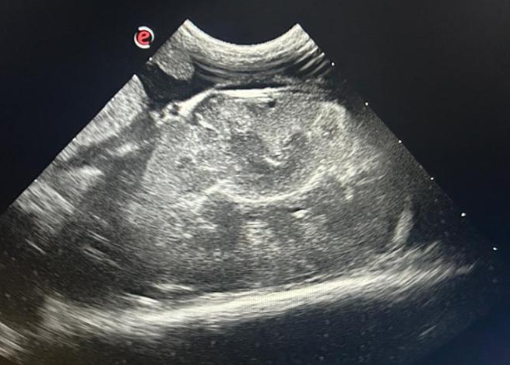
- Sonogram of FIP affected cat showing peritoneal effusion and hepatomegaly with rounding of liver lobe margins. | - Sonogram of FIP affected cat showing multifocal, ill-defined hypoechoic lesions within renal cortex with perirenal hyperechogenicity and poor corticomedullary distinction suggestive of pyogranulomatous inflammation.

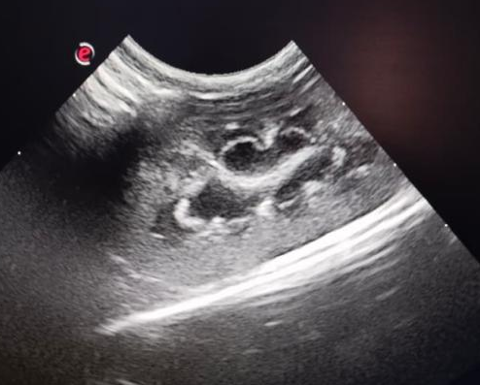 | 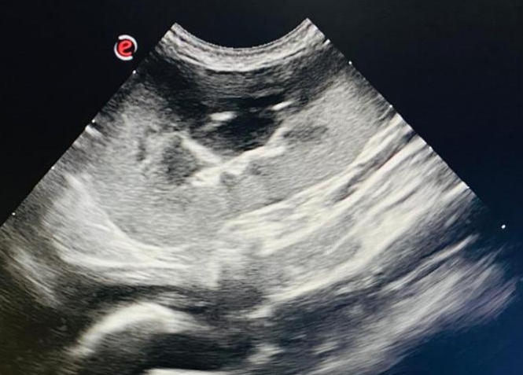
Sonogram of an FIP-affected cat showing a distinct medullary rim sign at the corticomedullary junction, indicative of renal inflammatory changes due to FIPV-associated immune-mediated vasculitis. | Sonogram of an FIP-affected cat showing a hyperechoic renal cortex with increased cortical thickness and mild pyelectasia.

Figure:5 Diagnostic techniques used for detection of FIP Virus .
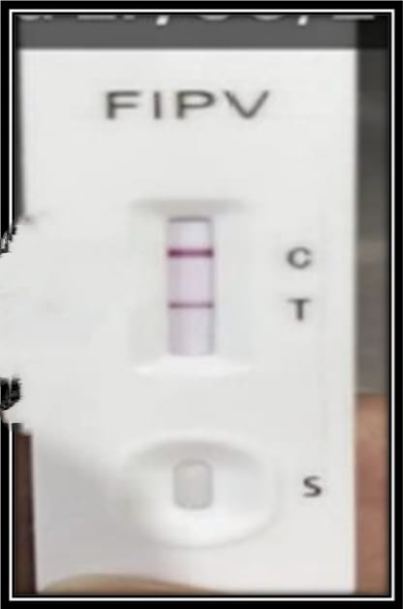 | 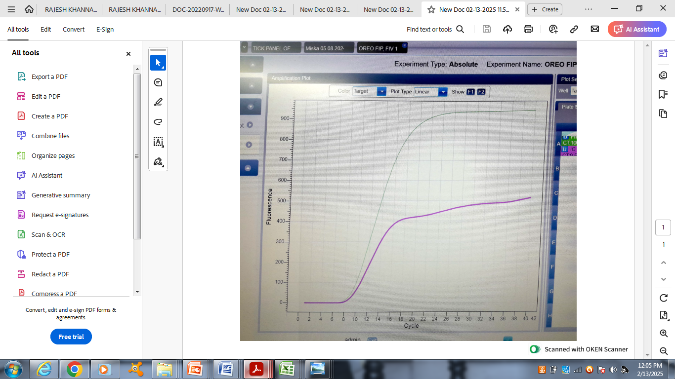
- Lateral flow assay showing a positive band for FIP | b) RT-q PCR amplification curve showing detection of feline coronavirus (FCoV) RNA from effusion sample.

The haematological and biochemical findings of FIP affected cats before and after therapy are presented in Tables 2 and 3, respectively. Following treatment, a significant improvement was observed in Group II cats compared to Group I, both in terms of resolution of clinical signs and normalization of haematological and biochemical parameters, indicating a more favorable therapeutic response in Group II.
DISCUSSION
In the present study, the overall occurrence of Feline Infectious Peritonitis (FIP) was found to be 4.2%. In contrast, Yin et al. (2021) reported a prevalence of 0.61%, while Riemer et al. (2016) documented a 1.42% prevalence in Germany. The majority of affected cats in the current study presented with the effusive form (72.22%), compared to 25% with the non-effusive form, which aligns with the observations of Riemer et al. (2016) and Kipar & Meli (2014), who also reported that most FIP cases manifest with effusions—commonly pleural, abdominal, or a combination of both. In terms of sex distribution, male cats (58.33%) were more frequently affected than females (41.67%), consistent with the findings of Worthing et al. (2012), Pesteanu-Somogyi et al. (2006), and Rohrbach et al. (2001). However, Yin et al. (2021) reported no significant correlation between sex and FIP occurrence. Persian cats (45.37%) showed the highest susceptibility in this study, likely reflecting breed preference among owners, which increases their representation and risk within the study population.
In the present study, the major clinical signs observed in cats affected with Feline Infectious Peritonitis (FIP) varied according to the disease form. In the effusive form, the predominant signs included respiratory distress (74.36%), ascites (53.85%), pleural effusion (37.18%), and dyspnea (50%), whereas in the non-effusive form, the most common signs were seizures (33.33%), ataxia (22.22%), icterus (14.81%), nystagmus (11.11%), and anisocoria (11.11%). These findings are consistent with earlier reports by Singh et al. (2005), Kipar et al. (2014), and Riemer et al. (2016). A retrospective study involving 286 cats with neurological disorders identified FIP as one of the major causes of neurological disease in cats (Dean et al., 2003).
It is important to note that the clinical presentation of FIP evolves over time, with gradual changes such as the development of effusion and fundic alterations; therefore, repeated clinical examinations are crucial to prevent diagnostic delays and initiate timely treatment. Generally, tests conducted on effusion samples provide higher diagnostic accuracy and predictive value than those performed on blood (Hartmann et al., 2003; Strasnieri et al., 2018). The effusion samples obtained in the current study were typically clear, viscous, and straw-colored, often forming string-like threads due to their high protein content (Pedersen, 2014).
In the present study, the Rivalta’s test was performed on all effusion samples and yielded a 100% positivity rate. The Rivalta’s test is a simple, rapid, and cost-effective diagnostic tool that can be easily performed in routine clinical settings, making it a valuable component of the diagnostic protocol for all cats presenting with effusion. According to Fischer et al. (2012), the test demonstrates a sensitivity of 91.3%, specificity of 65.5%, positive predictive value of 58.4%, and negative predictive value of 93.4%, supporting its usefulness as a reliable screening method in the clinical diagnosis of FIP.
The major haematological abnormalities observed in FIP-affected cats in the present study included lymphopenia (68.52%), neutrophilia (48.15%), and anaemia (37.96%). Several studies have reported lymphocytopenia as the most consistent haematological finding in both naturally occurring and experimentally induced FIP (Dean et al., 2003; de Groot-Mijnes et al., 2005), which is attributed to virus-induced apoptosis of T lymphocytes. The predominant biochemical alterations observed were hyperglobulinemia and hyperproteinemia (71.30% each), along with a decreased albumin-to-globulin (A/G) ratio (66.67%) and hyperbilirubinemia (63.89%). A reduction in the A/G ratio was evident in nearly all FIP cases, and when the ratio fell below 0.5, the disease was highly suspected (Yin et al., 2021). An A/G ratio of less than 0.45 in effusions containing >3.5 g/dL total protein and low cellularity, predominantly composed of neutrophils and macrophages, is considered highly predictive of effusive FIP (Greene, 2012). The hyperproteinemia observed in this study may be attributed to an inflammatory response leading to elevated acute phase protein synthesis (Hazuchova et al., 2017), while hyperbilirubinemia likely resulted from hepatic necrosis associated with the disease process.
As presented in Tables 2 and 3, a significant increase (P < 0.05) in haemoglobin, platelet count, and lymphocyte count, along with a significant decrease (P < 0.05) in total leukocyte count (TLC) and neutrophil count, was observed in Group II when compared to Group I. Similarly, a significant (P < 0.05) reduction in total protein, globulin, and bilirubin levels was recorded in Group II, indicating marked clinical and biochemical improvement following therapy.
GS-441524, a 1′-cyano-substituted adenine C-nucleoside ribose analog, effectively suppresses viral RNA synthesis. It is the active metabolite of remdesivir (RDV) and functions as an RNA chain terminator for viral RNA-dependent RNA polymerase, exhibiting strong inhibitory effects against FIPV in both tissue culture and experimentally infected cats (Solikhah et al., 2024). Moreover, GS-441524 and 3C-like protease inhibitors have demonstrated efficacy in treating both experimental and naturally occurring FIP cases. Two recent studies combining oral GS-441524 with injectable remdesivir (Coggins et al., 2023; Green et al., 2023) reported 94.6% survival (35/37 cats), which aligns with the findings of the current study. Gokalsing et al. (2025) also highlighted GS-441524 as a highly promising therapeutic agent for FIP adjusted according to the form, severity, and presence of neurological or ocular involvement. In the neurological form of FIP, a comparatively higher dose of GS-441524 is required, as increased plasma concentrations improve the likelihood of the drug crossing both the blood–brain and blood–eye barriers, thereby enhancing therapeutic efficacy in cats exhibiting neurological signs (Taylor et al., 2025).

In the present study, no relapse was observed in cats treated with GS-441524, whereas relapse occurred in cases managed with prednisolone therapy, further supporting the superior efficacy of GS-441524 in the management of FIP.
Conclusion
In the present study, the overall occurrence of FIP was 4.2%. Feline infectious peritonitis (FIP) remains a devastating and complex disease, and its diagnosis continues to pose significant challenges.A presumptive diagnosis of FIP is typically established based on the cat’s history, clinical signs, and supportive laboratory findings, including cytology of effusions, hematology,biochemical profiles and RT PCR. GS-441524 has emerged as a highly promising therapeutic agent for FIP, demonstrating a remarkably high success rate in affected cats and offering new hope in the management of this once-fatal disease.

Disclaimer (Artificial intelligence)
Option 1:
Author(s) hereby declare that NO generative AI technologies such as Large Language Models (ChatGPT, COPILOT, etc.) and text-to-image generators have been used during the writing or editing of this manuscript.

References
Addie, D. D., & Jarrett, O. (1992). A study of naturally occurring feline coronavirus infections in kittens. Veterinary Record, 130(6), 133–137.
Addie, D. D., Boucraut-Baralon, C., Egberink, H., Frymus, T., Gruffydd-Jones, T., Hartmann, K., Hosie, M. J., Lloret, A., Lutz, H., Pennisi, M. G., Radford, A. D., Thiry, E., Truyen, U., & Horzinek, M. C. (2009). Feline infectious peritonitis: ABCD guidelines on prevention and management. Journal of Feline Medicine and Surgery, 11(7), 594–604.
Coggins, S. J., Norris, J. M., Malik, R., Govendir, M., Hall, E. J., Kimble, B., & Thompson, M. F. (2023). Outcomes of treatment of cats with feline infectious peritonitis using parenterally administered remdesivir, with or without transition to orally administered GS-441524. Journal of Veterinary Internal Medicine, 37(4), 1772–1783.
Dean, G. A., Olivry, T., Stanton, C., & Pedersen, N. C. (2003). In vivo cytokine response to experimental feline infectious peritonitis virus infection. Veterinary Microbiology, 97(1–2), 1–12.
De Groot-Mijnes, J. D. F., van Dun, J. M., van der Most, R. G., & de Groot, R. J. (2005). Natural history of a recurrent feline coronavirus infection and the role of cellular immunity in survival and disease. Journal of Virology, 79(2), 1036–1044.
Felten, S., & Hartmann, K. (2019). Diagnosis of feline infectious peritonitis: A review of the current literature. Viruses, 11(11), 1068.
Fischer, Y., Sauter-Louis, C., & Hartmann, K. (2012). Diagnostic accuracy of the Rivalta test for feline infectious peritonitis. Veterinary Clinical Pathology, 41(4), 558–567.
Gokalsing, E., Ferrolho, J., Gibson, M. S., Vilhena, H., & Anastácio, S. (2025). Efficacy of GS-441524 for feline infectious peritonitis: A systematic review (2018–2024). Pathogens, 14(7), 717. https://doi.org/10.3390/pathogens14070717
Greene, C. E. (2012). Infectious diseases of the dog and cat (4th ed., pp. 92–108). W. B. Saunders.
Green, J., Syme, H., & Tayler, S. (2023). Thirty-two cats with effusive or non-effusive feline infectious peritonitis treated with a combination of remdesivir and GS-441524. Journal of Veterinary Internal Medicine, 37(4), 1784–1793.
Hartmann, K. (2005). Feline infectious peritonitis. Veterinary Clinics of North America: Small Animal Practice, 35(1), 39–79.
Hartmann, K., Binder, C., Hirschberger, J., Cole, D., Reinacher, M., Schroo, S., Frost, J., Egberink, H., Lutz, H., & Hermanns, W. (2003). Comparison of different tests to diagnose feline infectious peritonitis. Journal of Veterinary Internal Medicine, 17(6), 781–790.
Hazuchova, K., Held, S., & Neiger, R. (2017). Usefulness of acute phase proteins in differentiating between feline infectious peritonitis and other diseases in cats with body cavity effusions. Journal of Feline Medicine and Surgery, 19(8), 809–816.
Kipar, A., & Meli, M. L. (2014). Feline infectious peritonitis: Still an enigma? Veterinary Pathology, 51(2), 505–526.
Olsen, C. W. (1993). A review of feline infectious peritonitis virus: Molecular biology, immunopathogenesis, clinical aspects, and vaccination. Veterinary Microbiology, 36(1–2), 1–37.
Pedersen, N. C. (1976). Serologic studies of naturally occurring feline infectious peritonitis. American Journal of Veterinary Research, 37(12), 1449–1453.
Pedersen, N. C. (2009). A review of feline infectious peritonitis virus infection: 1963–2008. Journal of Feline Medicine and Surgery, 11(4), 225–258.
Pedersen, N. C. (2014). An update on feline infectious peritonitis: Diagnostics and therapeutics. Veterinary Journal, 201(2), 133–141.
Pesteanu-Somogyi, L. D., Radzai, C., & Pressler, B. M. (2006). Prevalence of feline infectious peritonitis in specific cat breeds. Journal of Feline Medicine and Surgery, 8(1), 1–5.
Riemer, F., Kuehner, K. A., Ritz, S., Sauter-Louis, C., & Hartmann, K. (2016). Clinical and laboratory features of cats with feline infectious peritonitis: A retrospective study of 231 confirmed cases (2000–2010). Journal of Feline Medicine and Surgery, 18(4), 348–356.
Rohrbach, B. W., Legendre, A. M., Baldwin, C. A., Lein, D. H., Reed, W. M., & Wilson, R. B. (2001). Epidemiology of feline infectious peritonitis among cats examined at veterinary medical teaching hospitals. Journal of the American Veterinary Medical Association, 218(7), 1111–1115.

Sharif, S., Arshad, S. S., Hair-Bejo, M., Omar, A. R., Zeenathul, N. A., & Alazawy, A. (2010). Diagnostic methods for feline coronavirus: A review. Veterinary Medicine International, 2010, Article ID 809480.
Singh, M., Foster, D. J., Child, G., & Lamb, W. A. (2005). Inflammatory cerebrospinal fluid analysis in cats: Clinical diagnosis and outcome. Journal of Feline Medicine and Surgery, 7(2), 77–93.
Snedecor G W and Cochran W G (1994). Statistical methods, 8th Edition, Iowa State University Press, USA.

Soma, T., Wada, M., Taharaguchi, S., & Tajima, T. (2013). Detection of ascitic feline coronavirus RNA from clinically suspected cats of feline infectious peritonitis. Journal of Veterinary Medical Science, 75(1), 13–94.
Solikhah, T. I., Agustin, Q. A. D., Damaratri, R. A., Siwi, D. A. F., Rafi’uttaqi, G. N., Hartadi, V. A., & Solikhah, G. P. (2024). A review of feline infectious peritonitis virus infection. Veterinary World, 17(11), 2417–2432.
Stranieri, A., Giordano, A., Paltrinieri, S., Giudice, C., Cannito, V., & Lauzi, S. (2018). Comparison of the performance of laboratory tests in the diagnosis of feline infectious peritonitis. Journal of Veterinary Diagnostic Investigation, 30(4), 459–463.
Sykes, J. E. (2014). Canine and feline infectious diseases (pp. 195–208). W. B. Saunders.

Taylor SS, Coggins S, Barker EN, Gunn-Moore D, Jeevaratnam K, Norris JM, Hughes D, Stacey E, MacFarlane L, O’Brien C, Korman R, McLauchlan G, Salord Torres X, Taylor A, Bongers J, Espada Castro L, Foreman M, McMurrough J, Thomas B, Royaux E, Calvo Saiz I, Bertoldi G, Harlos C, Work M, Prior C, Sorrell S, Malik R, Tasker S (2023): Retrospective study and outcome of 307 cats with feline infectious peritonitis treated with legally sourced veterinary compounded preparations of remdesivir and GS-441524 (2020-2022). Journal of Feline Medicine and Surgery 25 (9) 1098612X231194460.
Taylor SS, Tasker S, Barker E, Moore DG, Sorrell S,Cerna P, Coggins S. A.(2025).An update on the treatment of feline infectious peritonitis .International Cat Care.

Tekes, G., & Thiel, H. J. (2016). Feline coronaviruses: Pathogenesis of feline infectious peritonitis. Advances in Virus Research, 96, 193–218.
Worthing, K. A., Wigney, D. J., Dhand, N. K., Fawcett, A., McDonagh, P., Malik, R., & Norris, J. M. (2012). Risk factors for feline infectious peritonitis in Australian cats. Journal of Feline Medicine and Surgery, 14(6), 405–412.
Xia, H., Li, X., Zhao, W., Jia, S., Zhang, X., Irwin, D. M., & Zhang, S. (2020). Adaptive evolution of feline coronavirus genes based on selection analysis. BioMed Research International, 2020, Article ID 9089768.

