Original Research Article
Morphological, Histological and Histochemical Studies on the Gizzard of Post-natal Haringhata Black Chickens

.
ABSTRACT

Aims: The present research was carried out to explore the morphological, morphometrical, histological, histochemical aspect and localization of mast cells in the gizzard of the Haringhata Black chickens.
Study design: The investigation was carried out on 60 Haringhata Black chickens divided into five group viz. day old, 15 days, 30 days, 45 days and 60 days old with six birds of each sex in each age group.
Place and Duration of Study: Department of Veterinary Anatomy and Histology, Faculty of Veterinary and Animal Sciences, West Bengal University of Animal and Fishery Sciences, Kolkata-700037, India between June 2022 and January 2023.
Methodology: A total of 60 Haringhata Black chickens of 0, 15, 30, 45 and 60 days age comprising of 6 birds of each sex in each age group were sacrificed and the gizzard was observed for gross morphological and morphometrical studies. Portions from gizzard were fixed in normal buffered formalin and later processed and prepared for histological and histochemical studies.
Results: The gizzard of Haringhata Black chicken was a highly muscular, dark brown coloured biconvex lens-like organ and was covered by considerable amount of fat. It was made up of four tunics, the mucosa, submucosa, muscularis and serosa. The epithelium of mucosa reacted positively to the PAS-AB staining indicating the presence of acidic and neutral mucins. A thick cornified layer, the koilin lined the lumen of the gizzard and covered the mucous layer externally and showed moderate reactivity to PAS-AB stain. A distinct lamina muscularis was absent in the tunica submucosa of the gizzard of Haringhata Black chickens.The submucosa was composed of loose connective tissues mainly the collagen fibres. Mast cells were noticed within the connective tissue fibres in this layer.The tunica muscularis was very thick and organized in three layers: the inner oblique layer, the thick intermediate circular layer and an outer longitudinal layer.The outer serosa was typical and rich in blood and nerve vessels.
Conclusion: The study provides a novel information on the gross morphology, morphometry, histology and histochemical characteristics of the gizzard of Haringhata Black chicken at different developmental stages. The observations of the present study may serve as a useful baseline reference data for further future studies on the developmental anatomy, comparative morphology, physiology and pathological alterations of the gizzard in Haringhata Black chickens and other indigenous chicken breeds.

Keywords: gizzard, mast cells, koilin, collagen, serosa

1. INTRODUCTION
Human dependance on agriculture dates back to thousands and thousands of years. Animal husbandry is an integral part of agriculture as human beings are extremely benefitted from animal and bird rearing. Rearing of poultry birds, specialy chicken immensely boosts the economy of the farmers as well as the nation. Rapid rise in human population results in an increased demand for protein and other nutrients. The poultry farming plays a key role in meeting this increasing demand of protein in the form of protein-rich meat and eggs.
The Haringhata Black chicken
The Haringhata Black (HB) chicken is a native breed of West Bengal state of India. It has originated from the Haringhata and Chakdah blocks of Nadia district and nearby areas like Amdanga and Bongaon blocks in North 24 Parganas district of West Bengal. Haringhata Black chicken is the only registered indigenous chicken breed of West Bengal reported till date with accession number 12008 (Pal et al. 2020). This medium sized chicken with compact body is reared for both meat and eggs. Black feathers with red coloured single comb, ear lobe, wattle and white shank are the characteristic features of this breed. They are well tolerated and their surviving power against the predators is commendable which make them different from other breeds of chicken. These birds are genetically superior to most other chickens and have a very good resistance to diseases (Mandal, 2020). The Haringhata Black chicken can be reared in the backyard poultry farming system with minimum investment and also in commercial farms in the deep litter system. The by-products obtained from these birds can be used for making pillows, brooms, brushes and many other fancy things.
The anatomy of the chicken gastrointestinal tract influences the utilization of feed processed by it. The anterior portion of the tract is adapted for ingestion, storage, and partial digestion of starch and proteins (Turk, 1982). Chickens can't bite their food as they lack teeth. The ingested feed is moistened by the saliva secreted by the salivary glands present in the mouth. The feed is then further pushed down through the throat using the tongue.
Stomach: The stomach consists of two major compartments- the proventriculus and the gizzard. The proventriculus is a cylindrical structure located between the esophagus and gizzard and is often referred as the true stomach of birds as enzymatic digestion takes place in this compartment. The next compartment of the stomach of chicken after the proventriculus is the gizzard or the ventriculus. It is a hard muscular structure almost round (bi-convex) in shape where the feed materials are broken down into minute particles through muscular contraction.
Keeping in view, the typical role of the gizzard and due to the paucity of relavant literatures, the present study was undertaken to understand the morphology, histology and histochemistry of the gizzard of Haringhata Black chicken of different ages.

2. material and methods

2.1 Procurement And Distribution Of Experimental Birds:
A total of 60 Haringhata Black chickens were slaughtered for conducting the present investigation. The birds were procured from State Poultry Farm-1, Mohanpur, Nadia, West Bengal. The birds were divided into 5 groups according to their age, viz. 0 day, 15 days, 30 days, 45 days and 60 days. Each group consisted of 12 birds. The ratio of male to female was 1:1 in each group. No housing and feeding was needed from our side since the birds of respective age group were brought from the farms on the specific days of slaughters.
2.2 Collection Of Specimen And Preservation:
For the present study birds of desired age were procured from the farm and live weight of the birds were recorded with the help of digital weighing balance. The birds were then sacrificed by cervical dislocation after anaesthetising them with chloroform vapour. The thoracic and abdominal cavities were opened to observe the in-situ positioning of the different segments of the digestive tract and the associated organs. The gizzard was then dissected out and preserved in 10% NBF after necessary cleaning and measurements were done.
2.3 Gross Morphometry:
After sacrificing the birds, the abdominal and thoracic cavities were opened along the mid-ventral border of the bird’s body. The intact digestive tract from esophagus to cloaca was then separated out. The gizzards were then weighed separately. The length and diameter of gizzard were measured by using Vernier’s scale and recorded. After gross morphometry was done the samples were preserved for histological and histochemical techniques in 10% Neutral Buffered Formalin (NBF).
2.4 Gross Photography:
Immediately after opening the body cavities of the birds along the mid-ventral border of the body, gross photography of the anatomical positioning of the parts of the digestive tract and their relation with the adjacent organs was done and before gross morphometry. The photography of gizzard was taken after dissecting it out from the digestive tract.
2.5 Chemicals:
All chemicals and glassware were purchased from Sigma chemicals (USA), Allied Scientific products (India), Merck (India), HiMedia (India) and Rankem (India).
2.6 Equipments:
- Leica DM 2000 Microscope
- Leica QWIN software for image analysis
- Leica rotatory microtome
2.7 Processing Of Tissues, Block Preparation and Sectioning:
All the fixed tissues were washed over night, dehydrated in ascending order of alcohol, cleared with acetone and benzene, impregnated in melted wax and paraffin blocks were prepared before proceeding for sectioning (Luna, 1968). All sections were cut at 5µm thickness with the help of Leica 2125 DM rotary microtome. The sections were taken on clean grease free albumenized glass slides for histological and histochemical staining.
2.8 Staining Methods:
The sections were then stained by following staining methods for demonstration of the histological organisation and histochemical characteristics:
A) Mayer’s Haematoxyline and Eosin (H&E) staining method for general histological observations (Luna,1968).
B) Masson’s Trichome (MT) staining method for visualisation of collagen fibres (Luna,1968).
C) PAS-Alcian Blue(PAS-AB) staining method for demonstration of mucopolysaccharides (Luna,1968).
D) Weigert’s Resorcin Fuschin (Weigert’s) staining method for demonstration of elastic fibre. (Sheehan and Hrapchak, 1973).
E) Metachromasia By Toluidine Blue (TB) for Mast Cells (Luna, 1968).

2.9 Photomicrography:
The stained slides were visualised under light microscope (Leica DM2000) to study histological organisation and histochemical characteristics and photomicrographs were taken with the help of Leica DM2000 microscope with camera (Leica) under different magnifications.
2.10 Micrometry:
Leica Qwin Images Analyser software in Leica DM 2000 Microscope was used for taking micrometrical data from the stained sections.
2.11 Statistical Analysis:
The recorded data were analysed statistically as per the standard method given by Snedecor and Cochran (1994) with the help of SPSS 17.0 software.

3. results and discussion
3.1 Gross Morphology of the Gizzard:
The gizzard of Haringhata Black chicken was a highly muscular, dark brown coloured organ and was covered by considerable amount of fat. It was biconvex lens-like in appearance and was almost round to oval in shape. The surfaces of the gizzard presented a shiny layer of tendinous tissue which was thicker at the centre and became thin at the edges. Creamy coloured thick corny tissues covered the inner surface of gizzard and they were raised into ridges (Fig.1). This surface acted as the bird’s teeth and was made up of strong keratinized material called the koilin. This layer protected the gizzard from the damaging effects of the HCL and pepsin coming from the proventriculus and the muscular action on the food. The gizzard consisted of a body, a craniodorsal and a caudoventral blind sac. Two pairs of opposing thick and thin muscles were observed in the gizzard. The thick muscle masses got inserted into the tendinous centres, one on each surface, while the thinner muscles covered the blind sacs. The caudoventral and craniodorsal thin muscles lined the caudoventral and craniodorsal portion of the gizzard respectively. The cranio-ventral and caudo-dorsal thick muscles aided in the powerful grinding contractions for breaking up the feed materials into smaller pieces. The four muscles were arranged in an asymmetrical manner which helped in mixing and grinding actions during contraction. The proventriculus opened into the cranial aspect of the craniodorsal blind sac through the isthmus while the small intestine began from the cranial part of the right surface of the gizzard through the pyloric opening. It was placed in the thoraco-abdominal cavity just behind the proventriculus in close relation to liver lobes (Fig.2). The cranial end of gizzard was in contact with the caudal end of the left lobe of the liver forming deep impression while the caudal end contacted with the duodenum and pancreas. The dorsal surface was related to the testis in males and ovary in females while the ventral surface was resting on the abdominal floor. The left surface was related to the left abdominal wall and the visceral surface of the left lobe of the liver while the right surface was related cranially to the spleen and the visceral surface of the left lobe of the liver leaving a deep impression on it. The ventral portion of the right surface of the organ was related to the duodenum and jejunum.
The average weight, length and diameter of the gizzard were least in day old birds while maximum in birds of day 60 of age in both the sexes (Graph 1-3). There was no significant difference of the weight, length and diameter of gizzard between the male and female in the same age groups. However, the weight, length and diameter of the gizzard in birds of each sexes differed significantly (p<0.05) among the different age groups (Graph 1-3).
The present morphological observations of the gizzard agreed with that of Nasrin et al. (2012) in broilers, as well as with the earlier statements on domestic fowls by Getty (1975). In the present study, gizzard was larger than the proventriculus. Sinha et al. (2018) also reported that the gizzard of Uttara fowl was larger than proventriculus. Klasing (1999), Al-saffar et al. (2016) and AbdElnaeem et al. (2019) in most aves, pigeons and kingfisher respectively found that the inner surface of gizzard was covered by thick keratinised koilin layer which was in accordance with the present findings. When the koilin layer wore out, the glands in the gizzard produced more koilin that passed to the surface and hardened to replace the worn-out tissue. It served as a protective covering from the acidic action of the proventricular secretions which passed to the gizzard. The arrangement of muscular layers, position and relation of the organ with adjacent organs agreed with observations revealed earlier by Abumandour (2013) in falcon.

3.2 Histology And Histochemical Properties of the Gizzard (Muscular Stomach):
Ventriculus or gizzard of the Haringhata Black chicks was made up of four tunics: mucosa, submucosa, muscularis and serosa (Fig.3). The mucosa was thrown into folds that were separated by intervening depression called the sulci (Fig.4). The folds were lined by cuboidal epithelial cells with goblet cells and lymphocytes interspersed among them. The nuclei of the epithelial cells were round and placed towards the base of the cells. The epithelium reacted positively to the PAS-AB staining indicating the presence of acidic and neutral mucins (Fig 5). A thick cornified layer lined the lumen of the gizzard and covered the mucous layer externally. This layer was composed of koilin, the secretions from the simple straight tubular gizzard glands. The koilin layer showed moderate reactivity to PAS-AB stain (Fig.6 & 7).
The lamina propria consisted of loose connective tissue fibres mainly the collagen fibres, reticular fibres and few elastic fibres (Fig.8). The lamina epithelialis invaginated into the lamina propria to form elongated pits ending into the glands of the gizzard. The glands appeared simple straight tubular type and were separated by collagen and reticular fibres. The glandular lining epithelium was cuboidal type and it presented chief cells, basal cells and goblet cells. The chief cells were round in shape with round to oval nucleus. The basal cells were less in number and were located at the fundus portion of the glands. The basal cells had pale cytoplasm and round nucleus. The gizzard glands reacted moderately to the PAS-AB staining.
A distinct lamina muscularis was absent in the tunica submucosa of the gizzard of Haringhata Black chickens.
The submucosa was composed of loose connective tissues mainly the collagen fibres (Fig. 8). Mast cells were noticed within the connective tissue fibres in this layer (Fig. 9). The submucosa was negative to PAS-AB staining indicating the absence of mucins in this layer. Blood vessels and nerve vessels were observed in this layer. The wall of the blood vessels was composed of elastic fibres.
The tunica muscularis was very thick compared to the other sections of the digestive tract. This layer constituted the major portion of the gizzard wall. The striking feature of this layer of the gizzard wall is that unlike the tunica muscularis of most other tubular organs, the muscle fibres of the musclaris layer of gizzard were organized in three layers: the inner oblique layer, the thick intermediate circular layer and an outer longitudinal layer. The muscle bundles were separated by bands of dense connective tissue. Blood vessels and nerve vessels were present in this layer. The wall of the blood vessels was composed of elastic fibres.
The outer serosa was typical and rich in blood and nerve vessels.
The gizzard also showed changes in the thickness of various tunics in both males and females of different age groups. The mucosal folds were very distinct in the males and females of day old birds but as the age progressed the folds were not well demarcated. The number of glands and goblet cell population within the glands and villous lining also increased abruptly with age in male and female birds. The lymphocyte population, both in the intra-epithelial compartments as well as the lamina propria, increased in all age groups of male and female birds. The average height (Mean±SE) of the mucosal folds and the average thickness of the tunica muscularis increased with age in both sexes. The values of all the above parameters were found to be least in day old birds and maximum in birds of day 60 of age in both the sexes (Table 1 & 2). There was no significant difference of the average height of mucosal folds, average thickness of the tunica muscularis between the male and female birds in the same age group except in chicks of 0 day and 60 days old where the mucosal folds differed significantly in height between the male and female chicks (Table 1). However, these parameters in both males and females differed significantly (p<0.05) among the different age groups (Graph 2 and 4).

The gizzard wall of Haringhata Black chicken was made up of four layers like AbdElnaeem et al. (2019), Al-saffar et al. (2015), Batah et al. (2012), Beheiry (2018) reported in kingfisher, domestic pigeon, coot bird and turkey respectively. The mucosa was thrown into folds that were separated by intervening depression called the sulci. The folds were lined by cuboidal cells with goblet cells and lymphocytes interspersed among them. Similar features were observed in laughing dove and kingfisher by Madkour and Mohamed (2019) and AbdElnaeem et al. (2019) respectively. The lining epithelium of the folds showed strong reactivity to PAS-AB stain while the cuticle layer showed moderate positivity to this stain. AbdElnaeem et al. (2019) in hoopoe, Al-saffar et al. (2015) in domestic pigeon, Demirbag et al. (2015) in chickens, Zhu et al. (2015) in black tailed crake, Selvan et al. (2008) in guinea fowl and Taher et al. (2020) in moorhen also found that the lining epithelium was PAS positive. The gizzard glands were moderately PAS-AB positive and similar reaction was observed in broiler chickens by Udoumoh et al. (2020). Beheiry (2018) found the cuticle was PAS-AB positive in turkey. Madkour and Mohamed (2019) reported earlier that the lamina propria consisted of loose connective tissue fibres mainly the collagen fibres, reticular fibres and few elastic fibres. Blood vessels and nerve vessels were observed in this layer which was in accordance with our findings. A distinct lamina muscularis was absent which was also reported by Batah et al. (2008) in coot bird. The tunica muscularis of gizzard wall was organized in three layers: the inner oblique layer, the thick intermediate circular layer and an outer longitudinal layer which was also seen in Kadaknath fowls by Das et al. (2018). But the findings of Al-saffar et al. (2015) in domestic pigeon contradicted with the present findings where only two sub-layers of tunica muscularis was observed. The tunica serosa of gizzard of coot bird was rich in blood and nerve vessels (Batah et al., 2008) which concurred with the present findings.

4.Conclusion
The gizzard of Haringhata Black chicken was biconvex lens-like in appearance and almost round to oval in shape. The two surfaces of the gizzard were covered by a shiny layer of tendinous tissue which was thicker at the centre and became thin at the edges. The inner surface was lined by creamy coloured thick corny tissues called the koilin which was raised into ridges. It consisted of a body, a craniodorsal and a caudoventral blind sac. The cranioventral and caudodorsal thick muscles were responsible for the powerful grinding contractions for breaking up the feed materials. The glandular stomach opened into the cranial aspect of the craniodorsal blind sac through the isthmus while the small intestine began from the cranial part of the right surface of the gizzard through the pyloric opening. It was placed in the thoraco-abdominal cavity just behind the proventriculus in close relation to liver lobes. The mean weight, length and diameter of the gizzard increased with progression of age. Ventriculus or gizzard of the Haringhata Black chicks was made up of four tunics: mucosa, submucosa, muscularis and serosa. The mucosa was thrown into folds that were separated by the sulci. The epithelium of the folds was lined by cuboidal cells with goblet cells and lymphocytes interspersed between them. The mucous layer was covered by a thick cornified layer called the koilin. Koilin layer showed moderate reactivity to PAS-AB stain while epithelium of the folds showed PAS-AB positive reaction. The lamina propria consisted of loose connective tissue fibres mainly the collagen fibres, reticular fibres and small amount of elastic fibres. The simple straight gizzard glands and mast cells were evident in this layer. A distinct lamina muscularis was not observed in the tunica submucosa of the gizzard of Haringhata Black chickens. The submucosa was made up of loose connective tissues mainly the collagen fibres. The tunica muscularis was very thick and organized in three layers: the inner oblique layer, the thick intermediate circular layer and an outer longitudinal layer. The outer serosa was typical and rich in blood vessel, nerves. The mean height of the mucosal folds and the thickness of tunica muscularis increased with increase in age in both the male and female birds.

.

Ethical approval
The proposed research work was duly approved by the Institutional Animal Ethics Committee, Faculty of Veterinary and Animal Sciences, Kolkata-37. The project proposal number was 763/GO/SL/03/CPCSEA/10/2021-22.

Declaration of AI Use

This manuscript was prepared through the intellectual contributions of the author(s) to the study design, data analysis, interpretation of results, and scholarly content. Grammarly and ChatGPT were used solely to assist with grammatical refinement and reference formatting during manuscript revision. The author(s) accept full responsibility for the accuracy, integrity, and final content of the manuscript.

COMPETING INTERESTS DISCLAIMER:
Authors have declared that they have no known competing financial interests OR non-financial interests OR personal relationships that could have appeared to influence the work reported in this paper.

References
Pal, A., Pal, A., Mallick, A.I., Biswas, P. & Chatterjee, N. (2020). Molecular characterization of Bu-1 and TLR2 gene in Haringhata Black chicken. Genomics, 112, 472-483.
Mandal, S. (2020). Haringhata Black: An Indigenous Poultry Breed for Rural People. Epashupalan
Turk D.E. (1982). The Anatomy of the Avian Digestive Tract as Related to Feed Utilization. Poultry Science, 61, 1225-1244.
Luna, L.G. (1968). In: Manual of Histologic Staining Method of the Armed Forces Institute of Pathology,3rd edn., McGraw Hill Book Company, New York, pp.36- 37, 168-169.
Sheehan, D. C. and Hrapchak, B. B. (1973). Theory and practice of histotechnology. 1st Edn. The CV Mosby Company, Saint Louis, pp. 80-172.
Snedecor, G. W. and Cochran, W. G. (1989).In: Statistical methods. 8th edition, Lowa State University Press, Ames, 450-467.
Nasrin, M., Siddiqi, M.N.H., Masum, M.A. and Wares, M.A. (2012). Gross and histological studies of digestive tract of broilers during postnatal growth and development. Journal of Bangladesh Agriculture. University., 10(1): 69–77.
Getty, R. (1975). In: Sisson and Grossman’s the Anatomy of the Domestic Animals. Vol II, 5th Edn. W. B. Saunders Company, Philadelphia, Ch. 2, 1857-1882.
Sinha, R. and Mrigesh, M. (2018). Gross morphometrical studies on the gizzard of post hatch Uttara fowl. Journal of Exploratory Zoolology. 21(1): 495-49.
Klasing, K.C. (1999). Avian Gastrointestinal Anatomy and Physiology. Seminars in Avian and Exotic Pet Medicine, 8(2): 42-50.
Al-Saffar, F.J. and Al-Sawamy, E.R.M (2016). Histomorphological and histochemical study of stomach of domestic pigeon (Columba livia domestica). The Iraqi Journal of Veterinary Medicine, 40(1): 89-96.
AbdElnaeem, A.H, Elshaer, F.M. and Rady, M.I. (2019). Histological and histochemical studies of the esophagus and stomach in two types of birds with different feeding behaviors. International Journal of Development, 8(1): 23-42.
Abumandour, M.M. (2013). Morphological studies of the stomach of falcon. Scientific Journal of Veterinary Advances, 2(3): 30-40.
Al-Saffar, F.J. and Al-Sawamy, E.R.M (2015). Histomorphological and histochemical studies of the stomach of the Mallard (Anas platyrhynchos). Asian Journal of Animal Sciences, 9 (6): 280-29.
Batah, A.L., Selman, H.A. and Saddam, M. (2008). Histological study for stomach (proventriculus and gizzard) of coot bird Fulica atra. Diyala Agricultural Sciences Journal, 4(1): 9-16.
Beheiry, R.A. (2018). Some histological and scanning electron microscopic studies on the gizzard of Turkey. Alexandria Journal of Veterinary Sciences, 59(1): 37-43.
Madkour, F. A. and Mohamed, A. A. (2019). Macro-microscopical anatomy of the gizzard of egyptian laughing dove and rock pigeon. Assiut Veterinary Medical Journal, 65(161): 278-285.
Demirbag, E., Çinar, K., Tabur, M.A. and Asti, R.N. (2015). Histochemical structure of stomach (proventriculus and gizzard) in some bird species. Journal of Natural and Applied Science,19(2): 115-122.
Zhu, L. (2015). Histological and histochemical study on the stomach (proventriculus and gizzard) of Black-tailed Crake (Porzana bicolor). Pakistan Journal of Zoology, 47(3): 607-616.
Selvan, P.S., Ushakumary, S. and Ramesh, G. (2008). Studies on the histochemistry of the proventriculus and gizzard of post-hatch Guinea fowl (Numida meleagris). International Journal of Poultry Science, 7(11): 1112-1116.
Taher. I.B., Ali, A.A., Ahmed, S.G., Al-Samawy, E.R. and Al-Saffar, F.J. (2020). Histology and histochemical structure of the stomach (proventriculus and ventriculus) in moorhen (Gallinula chloropus) in south Iraq. Plant Archives, 20(1): 189-194.
Udoumoh, A.F., Igwebuike, U.M. and Ugwuoke, W.I. (2016). Morphological features of the distal ileum and ceca of the common pigeon (Columba livia). Journal of Experimental and Clinical Anatomy, 15(1): 27-30.
Das, S., Dhote, B.S. and Singh, G.K. (2018). Histomorphological studies on the gizzard of Kadaknath fowl. International Journal of Chemical Studies, 6(4): 1823-1826.
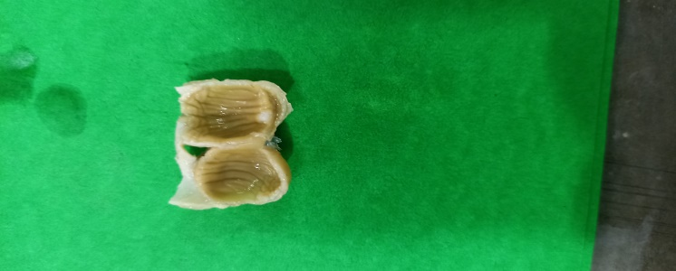 | 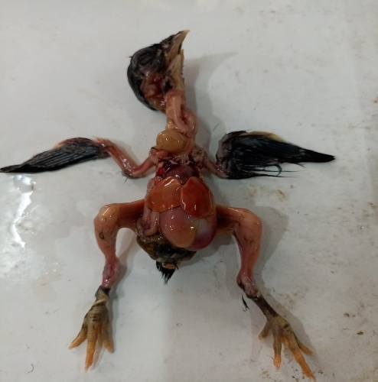
Fig. 1. Photograph of gizzard of Haringhata Black chicken showing the coilin layer arranged in the form of ridges( shown by arrow) on the mucosal surface. | Fig. 2. Photograph showing in-situ positioning of liver (Blue arrow) and gizzard (Black arrow) of day old Haringhata Black chicken.
  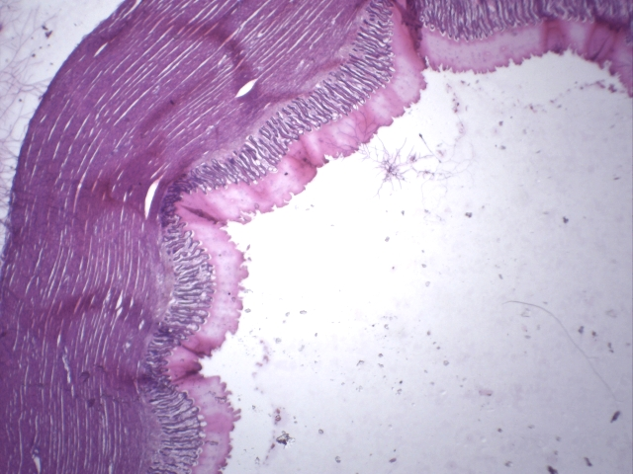
  K
  A
  B
  C
  D
  Fig. 3. Photomicrograph of gizzard of day old Haringhata Black chicken showing tunica mucosa (A), tunica submucosa(B), tunica muscularis(C) and tunica serosa(D) and Koilin (K) layer. H&E X4.
  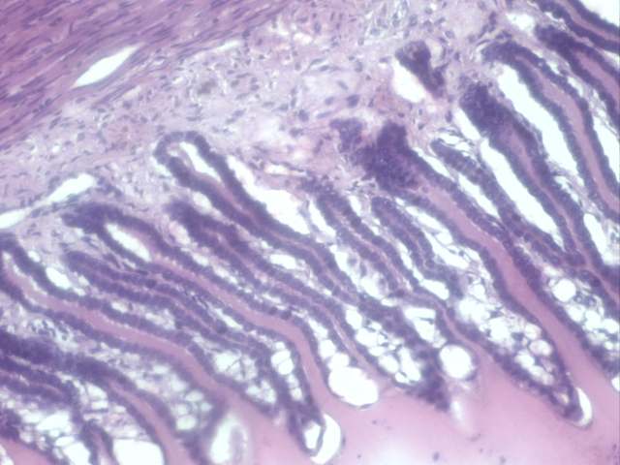
  Fig. 4. Photomicrograph of gizzard of 0 day old Haringhata Black chicken showing the sulci between the mucosal folds. H&E X40.

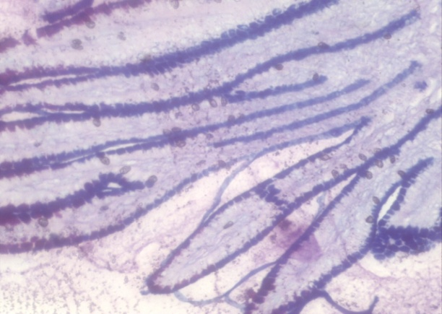 | 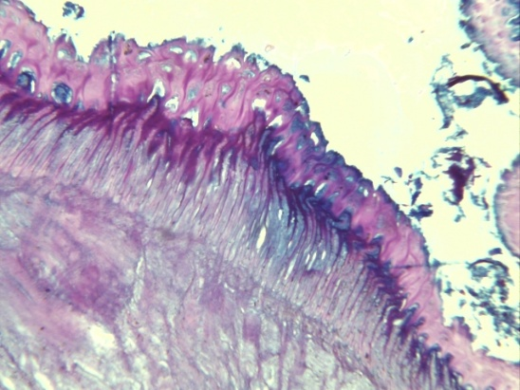
Fig. 5. Photomicrograph of gizzard of day old Haringhata Black chicken showing PAS-AB positive mucosal lining (deep blue colour). PAS-AB X10. | Fig. 6. Photomicrograph of gizzard of day old Haringhata Black chicken showing alcinophilic cells (blue colour) in the mucosal folds. PAS-AB X10 & 40.
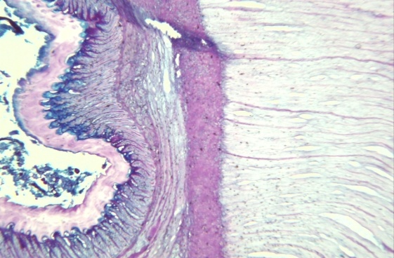 | 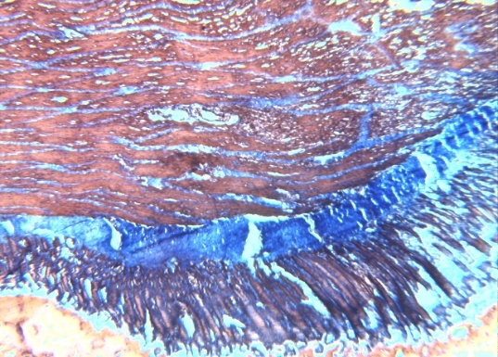
Fig. 7. Photomicrograph of gizzard of day old Haringhata Black chicken showing mucus secretion on the surface of koilin layer. PAS-AB X10. | Fig. 8. Photomicrograph of gizzard of day old Haringhata Black chicken showing collagen fibres (blue colour) between the muscle fibres of tunica muscularis, tunica submucosa and lamina propria. MT X10.

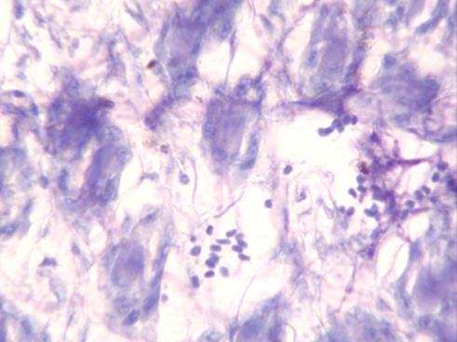
Fig. 9. Photomicrograph of gizzard of day old Haringhata Black chicken showing mast cells (blue arrow) in the tunica submucosa. TB X10.

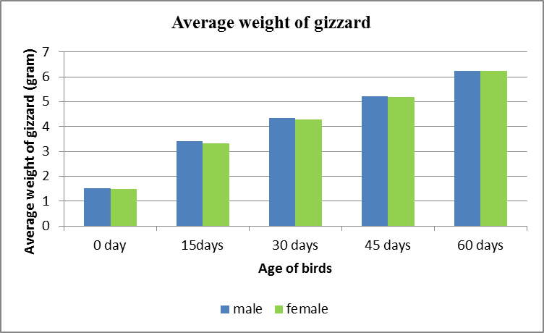 | 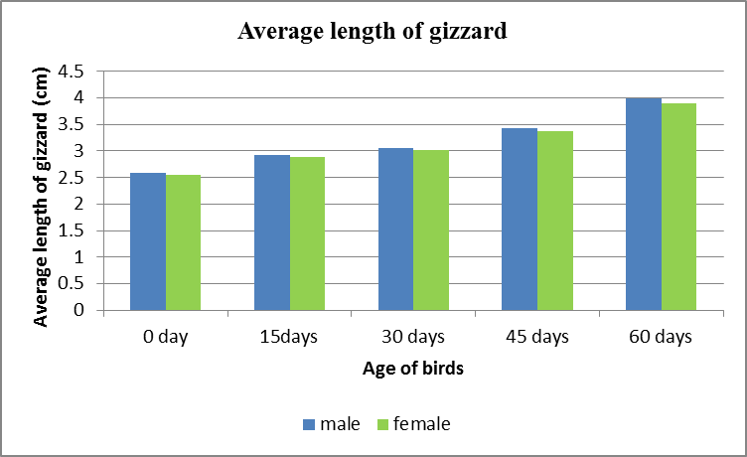
Graph 1. Graphical presentation of age-wise comparison of the average weight of gizzard of all the groups of Haringhata Black chicks. | Graph 2. Graphical presentation of age-wise comparison of the average length of gizzard of all the groups of Haringhata Black chicks.
Graph 3. Graphical presentation of age-wise comparison of the average diameter of gizzard of all the groups of Haringhata Black chicks. | Graph 4. Graphical presentation of age-wise comparison of the average thickness of tunica muscularis of gizzard of all the groups of Haringhata Black chicks
Table 1.. Measurement of height (Mean+SE) of mucosal folds of gizzard in µm in male and female birds of different ages.
Age (in days) | Male | Female | p-value
0 | 145.480^{ap}±1.258 | 139.640^{bp}±0.763 | 0.002
15 | 235.090^{aq}±1.077 | 230.110^{bq}±0.428 | 0.002
30 | 305.140^{ar}±10.932 | 301.430^{ar}±9.221 | 0.064
45 | 405.760as±5.121 | 402.720as±5.212 | 0.075
60 | 462.080^{at}±6.767 | 459.080^{at}±8.622 | 0.084
p-value | 0.000 | 0.000
N.B. Means bearing different superscript {(a,b,c,d…) and (p,q,r,s….)} in the same row and column respectively differ significantly (p<0.01)

Table 2. Measurement of thickness (Mean+SE) tunica muscularis of gizzard in µm in male and female birds of different ages.
Age (in days) | Male | Female | p-value
0 | 88.543^{ap}±3.234 | 86.234^{ap}±3.251 | 0.565
15 | 130.179^{aq}±5.232 | 130.068^{aq}±3.477 | 0.643
30 | 190.906^{ar}±6.231 | 183.876^{ar}±4.287 | 0.423
45 | 234.112as±8.763 | 230.543as±6.253 | 0.132
60 | 271.045^{at}±7.354 | 267.432^{at}±7.654 | 0.384
p-value | 0.000 | 0.000
N.B. Means bearing different superscript {(a,b,c,d…) and (p,q,r,s….)} in the same row and column respectively differ significantly (p<0.01)

