Length–Weight Relationship and Condition Factors of the Freshwater Prawn Macrobrachium lamarrei from the Sone River, Bihar, India: A Sex-Wise Comparative Study

Abstract: Sex-wise length-weight relationship and condition factor of M. lamarrei were investigated in wild populations in this study. The value of b < 3 in both sexes indicates negative allometric growth, and the R² value indicates an excellent relationship between total length and body weight. The regression coefficient (b) was 2.6154 for males, 2.7443 for females, and 2.6700 for the pooled population, indicating negative allometric growth (b < 3) in all length groups. The coefficient of correlation (r) was highest in males (0.9131), followed by the pooled population (0.9011) and females (0.8757). Similarly, the value of R² ranged from 0.7668 to 0.8338, suggesting a strong relationship between length and weight parameters. The relative condition factor values are generally greater than 1 for both sexes across all length classes, indicating that the observed body weight was almost equal to, or even slightly greater than, the expected weight predicted by the fitted regression equation. The fulton condition factor varied among length classes, suggesting generally good physiological condition in both sexes’ individuals throughout the study period. Overall, both indices indicate that Macrobrachium lamarrei in the Sone River maintained good physiological condition throughout the observed size range.

Keywords: Length-Weight Relationship, Condition Factors, Macrobrachium Lamarrei, Sone River, sex-wise comparison

Introduction
Length-weight relationships are an important calculation for assessing the overall health status of the prawn population. The condition factor is an indicator of well-being and of the effect of ecological conditions on growth. In fisheries, such analysis is essential to determine optimal feeding and the well-being of aquatic programmes. For wild populations, such analysis is needed to establish a baseline and ensure sustainable fisheries and aquaculture in the future. Therefore, the length-weight relationship is not only a formula but also a biometrical approach that integrates morphological and ecological approaches. The relative condition factor (Kn) is a vital biological indicator widely used in fisheries biology and studies of crustaceans to assess the health, nutrition, and body condition of aquatic organisms and fulton condition factor of (K), which assumes a fixed proportion between body length and body weight, regarded as an effective measure of the ecological health and physiological well-being of aquatic life because it does not depend on body size and reflects the effects of environmental and biological factors on growth. This method is widely used to estimate the health status of natural populations, compare populations across ecosystems, study seasonal fluctuations, assess habitat quality, and evaluate environmental suitability for growth. Relative Condition Factor is a good indicator of health status of a population, which depends on nutrition status, environmental conditions, and physiological state. The current study aims to determine Kn in male and female Macrobrachium lamarrei caught in the Sone River, Bihar, and to assess their body condition and fitness across different length categories.
The fulton condition factor (K) is perhaps one of the most widely used biometric indices in fisheries biology. Introduced by Fulton (1904), this factor is defined as the ratio of body weight to body length of an organism and is considered a reliable measure of the physiological well-being of the individual's. The basis of this condition factor is that, under ideal growth conditions, an organism's body weight varies with the cube of its body length. This condition factor in freshwater decapods (Crustacea), particularly in the genus Macrobrachium, is an informative parameter indicating growth status and population health. Variations in K depend on biological and ecological factors such as age, gender, moulting stage, gonad development, and food availability. Therefore, the condition factor reflects the population's overall ecological state. At present there are several research reports evaluated the length-weight relationship and condition factor of freshwater prawns in India, especially in the genus Macrobarchium, to asses growth, heath and population status in natural ecosystem like river, reserves, estuaries etc in different reign of the country (Kurup and Ranjeet, 2002; Abohweyere and Williams, 2008; Kurup et al., 2011; Lalrinsanga et al., 2012; Sethi et al., 2012; Soomro et al., 2012; et al., 2013; Sethi and Venkatesan, 2013; Kumar et al., 2014; Kumar et al., 2016; Yang et al., 2016; Lodhi et al., 2024; Sahu et al., 2024). However, a report on the length-weight relationship and condition factor of Macrobrachium lamarrei from the Sone River is lacking. This study investigates the length-weight relationship and condition factor of Macrobrachium lamarrei across different prawn length groups captured from the Sone River in Bihar. Detailed knowledge of morphological and metrical criteria is used to predict weight at a given length, and this study will be used in the future to better manage the culture production of this species under intensive conditions. Prawns are an important subject in fisheries science and aquaculture because they are a multi-million-dollar industry.
Material and Methods
The present study was conducted in the village of Makrain, Rohtas district, along the river Sone in the southwestern region of Bihar, India, from November 2025 to January 2026. Geographically, the district Rohtas lies between approximately 24°34′12″–25°15′00″ N latitude and 83°40′12″–84°30′00″ E longitude. The region are located with an average elevation of about 107–110 meters above sea level. The study has been designed to investigate the length-weight relationship with the condition factor of collected prawns:
Length-weight relationship (LWR)
The length-weight relationship was analyzed separately by grouping data into sex- and season-wise categories. After wiping the water from the body, freshly collected specimens were weighed accurately using a digital weighing balance (0.001g), and the total body length (mm) using a digital Vernier Calliper with 0.01mm accuracy.
The length–weight relationship (LWR) of Macrobrachium lamarrei was estimated following the method proposed by Le Cren (1951) using the equation:
W = aLᵇ
Where; W represents the body weight of the prawn, L is the body length, a is the intercept (constant), and b is the regression coefficient, which describes the growth pattern.
Relative Condition Factor (Kn)
The relative condition factor (Kn) was estimated using the formula proposed by Le Cren (1951). This parameter was used to assess and compare prawn condition across various size categories and populations, as outlined by Omogoriola et al. (2011).
Relative condition factor $(Kn)=\frac{W}{\overline{W}}$
Here, Kn is the relative condition factor; W is the actual weight of the prawn in grams, while
w̅ calculated as, w̅ = aLb
Here, w̅ is the estimated weight of the prawn, (L) is the prawn length, while “a” and “b” are the intercept and slope of the length-weight regression equation, respectively.
Fulton’s Condition Factor (K)
Fulton’s condition factor (K) is different from relative condition factor (Kn), because the former measures the difference between an individual prawn and an imaginary standard, while the latter is the difference between the weight of an individual prawn and the mean expected weight for a particular length..
The condition factor (K) of Macrobrachium lamarrei was computed using Fulton’s condition factor formula, first defined by Fulton in 1904. This formula assumes that body weight is proportional to the cube of body length. Using the method of calculation suggested by Pauly (1984) and Wootton (1992), the condition factor was computed using the mean values of total length and body weight of the prawn with the aid of the following formula.
$$K=\frac{\overline{w} × 100}{TL^{3}}$$
Where: $\overline{w}$ stands for the total body weight of the prawn (g), while TL denotes the total length (cm).
Note: That a multiplication factor of 100 is used to standardize the condition factor and bring it closer to 1.
Data Analysis
All calculations, including the length–weight relationship, fulton's condition factor (K), and relative condition factor (Kn), were performed using a scientific calculator. Statistical analyses, including descriptive statistics, regression analysis, and graphical presentations, were conducted using Microsoft Excel 2021 and R.

Result and Discussion
Length-weight relationship
The values corresponding to the length-weight relationship of male and female Macrobrachium lamarrei are plotted in Figures 1 & 2, and the pooled data are shown in Figure 3. The regression coefficient (b) was 2.6154 for males, 2.7443 for females, and 2.6700 for the pooled population (Table 1), indicating negative allometric growth (b < 3) in all groups. The coefficient of correlation (r) was highest in males (0.9131), followed by the pooled population (0.9011) and females (0.8757), suggesting a strong relationship between length and weight. Similarly, the coefficient of determination (R²) ranged from 0.7668 to 0.8338, with the highest value observed in males, indicating that individuals' body length explained more than 76% of the variation in body weight.
Table 1: Parameters of the length-weight relationship of M. lamarrei.
Sex | N | a | b | r | R²
Male | 64 | 2.910 | 2.6154 | 0.9131 | 0.8338
Female | 100 | 2.867 | 2.7443 | 0.8757 | 0.7668
Pooled | 164 | 2.886 | 2.6700 | 0.9011 | 0.8120
n=number of specimens, a=regression co-efficient, b=regression co-efficient, r=correlation co-efficient, r²=Coefficient of determination

Table 2: Length–Weight Relationship, Condition Factors of Female Macrobrachium lamarrei Based on Grouped Classes
Class Interval (cm) | Mid L (cm) | f | Avg W (g) | log L | log W | logL × logW | (logL)² | Calculated W′ (g) | K | Kn
2.5–2.9 | 2.7 | 2 | 0.17 | 0.431 | −0.770 | −0.332 | 0.186 | 0.091 | 0.864 | 1.87
3.0–3.4 | 3.2 | 3 | 0.333 | 0.505 | −0.478 | −0.241 | 0.255 | 0.145 | 1.016 | 2.29
3.5–3.9 | 3.7 | 24 | 0.336 | 0.568 | −0.474 | −0.269 | 0.323 | 0.216 | 0.598 | 1.56
4.0–4.4 | 4.2 | 46 | 0.485 | 0.623 | −0.314 | −0.196 | 0.389 | 0.306 | 0.655 | 1.59
4.5–4.9 | 4.7 | 22 | 0.609 | 0.672 | −0.215 | −0.145 | 0.452 | 0.419 | 0.587 | 1.45
5.0–5.4 | 5.2 | 3 | 0.817 | 0.716 | −0.088 | −0.063 | 0.513 | 0.558 | 0.581 | 1.46
The length-class analysis of female M. lamarrei as shown in table 2 were distributed in six size classes ranging from 2.5–2.9 cm to 5.0–5.4 cm, and 4.0–4.4 cm length class had the highest frequency, comprising 46 individuals, whereas the lowest in the largest (5.0–5.4 cm) size classes, represented by only 2 and 3 individuals, respectively. The mean body weight increased progressively with increasing individual length, indicating a positive relationship between body length and weight. The calculated (predicted) weight (W′) also increased steadily from 0.091 g to 0.558 g across the respective length classes.

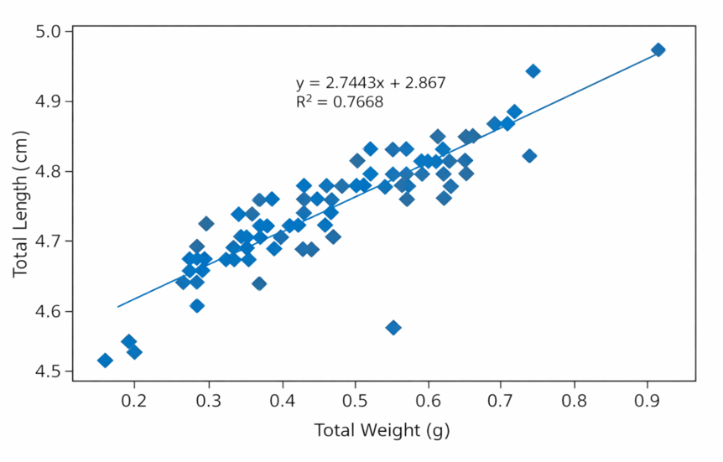
Figure 1: Regression analysis of Total Length vs Total weight of female M. lamarrei
Figure 1 shows the relationship between total weight (TW) and total length (TL) of females, and the scatter plot exhibits a positive linear relationship, with total weight ranging from 0.16 to 0.92 g and total length ranging from 4.51 to 4.97 cm. The majority of the observations are concentrated within the weight interval of 0.30–0.65 gm, corresponding to total lengths of 4.66–4.85 cm, indicating that most specimens belonged to the intermediate size class. The positive regression coefficient (2.7443) indicates that total length increases with increasing body weight. The regression model yielded an R² = 0.7668, indicating that 76.68% of the variation in total length is explained by total body weight, with the remaining 23.32% unexplained.

Table 3: Length–Weight Relationship, Condition Factors of male Macrobrachium lamarrei Based on Grouped Classes

Class Interval (cm) | Mid L (cm) | f | Avg W (g) | log L | log W | logL × logW | (logL)² | Calculated W′ (g) | K | Kn
2.5–2.9 | 2.7 | 3 | 0.120 | 0.431 | −0.921 | −0.397 | 0.186 | 0.070 | 0.610 | 1.714
3.0–3.4 | 3.2 | 9 | 0.198 | 0.505 | −0.703 | −0.355 | 0.255 | 0.116 | 0.605 | 1.707
3.5–3.9 | 3.7 | 10 | 0.326 | 0.568 | −0.487 | −0.277 | 0.323 | 0.179 | 0.644 | 1.821
4.0–4.4 | 4.2 | 31 | 0.480 | 0.623 | −0.319 | −0.199 | 0.389 | 0.258 | 0.648 | 1.860
4.5–4.9 | 4.7 | 9 | 0.676 | 0.672 | −0.170 | −0.114 | 0.452 | 0.361 | 0.651 | 1.873
5.0–5.4 | 5.2 | 2 | 0.905 | 0.716 | −0.043 | −0.031 | 0.513 | 0.489 | 0.644 | 1.851

Length-class distribution of male Macrobrachium lamarrei shows a similar trend, with the highest frequency recorded in the 4.0–4.4 cm class (31 individuals) (Table 1), and mean body weight increased steadily from 0.120 g to 0.905 g, indicating a positive length–weight relationship, which aligned with the calculated weight data.

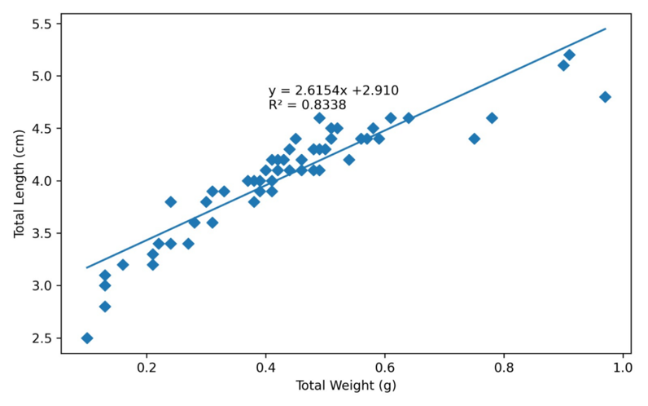
Figure 2: Regression analysis of Total Length vs Total weight of male M. lamarrei in the Sone River
Figure 2 shows the relationship between total weight (TW) and total length (TL) for males, show positive linear association between the two variables. The total weight of male individuals ranged from 0.10 to 0.98 g, while total length varied between 2.50 and 5.20 cm. The regression coefficient was positive, indicating a proportional increase in total length with increasing body weight. The regression model yielded a coefficient of determination (R² = 0.8338), indicating that 83.38% of the total variation in body length was explained by body weight. The model did not explain the remaining 16.62% of the variation, and the observed data points were closely clustered around the fitted regression line, indicating minimal dispersion and a high degree of linearity between the measured variables. The regression model provides a robust statistical description of the morphometric relationship between these two variables within the male population.

Table 4. Length–Weight Relationship, Condition Factors of Pooled data of Macrobrachium lamarrei Based on Grouped Classes
Class Interval (cm) | Mid L (cm) | f | Average Weight (W) (g) | log L | log W | log L × log W | (log L)² | Calculated W′ (g) | K | Kn
2.5–2.9 | 2.7 | 5 | 0.150 | 0.431 | −0.824 | −0.355 | 0.186 | 0.082 | 0.762 | 1.83
3.0–3.4 | 3.2 | 12 | 0.267 | 0.505 | −0.574 | −0.290 | 0.255 | 0.131 | 0.815 | 2.04
3.5–3.9 | 3.7 | 34 | 0.333 | 0.568 | −0.478 | −0.271 | 0.323 | 0.197 | 0.621 | 1.69
4.0–4.4 | 4.2 | 77 | 0.483 | 0.623 | −0.316 | −0.197 | 0.389 | 0.282 | 0.651 | 1.71
4.5–4.9 | 4.7 | 31 | 0.629 | 0.672 | −0.201 | −0.135 | 0.452 | 0.391 | 0.605 | 1.61
5.0–5.4 | 5.2 | 5 | 0.852 | 0.716 | −0.070 | −0.050 | 0.513 | 0.523 | 0.606 | 1.63
In the pooled data for both sexes, the length-class distribution of Macrobrachium lamarrei shows similar trends in frequency and length-weight increase proportion, demonstrating a positive length–weight relationship (Table 4).

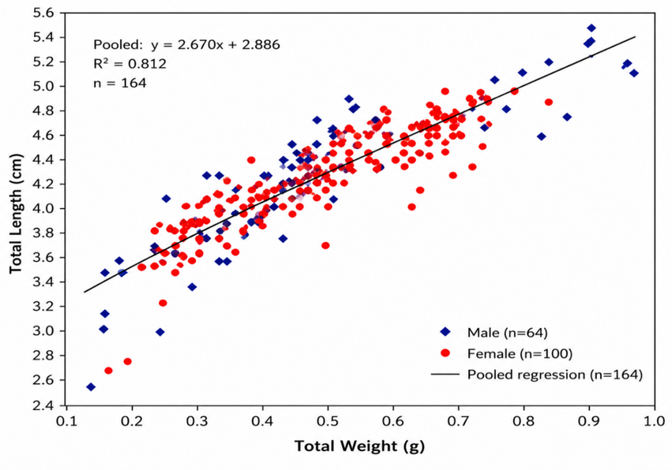
Figure 3: Regression analysis between Total length vs. Body Weight in Pooled data of M. lamarrei in the Son River.
During this study, a total of 164 specimens were examined, including 64 males 9 (blue diamonds) and 100 Females (red circles). Figure 3 shows the pooled data for both sexes, and the scatter plot illustrates the relationship between total weight (gm) and Total length (cm) of Macrobrachium lamarrei. The regression equation (y = 2.670x + 2.886) indicates a strong positive linear relationship between weight and length. Overall, the graph shows that total length increases in proportion to body weight in both sexes, and the value of the positive regression coefficient (2.670) indicates that total length increases linearly with body weight. The regression model yielded an R² = 0.812, indicating that 81.2% of the variation in total length is explained by total body weight, with the remaining 18.8% unexplained.
Condition Factors
The condition factors for female both sexes of Macrobrachium lamarrei across six length classes (2.5–2.9 to 5.0–5.4 cm) have been analyzed and are presented in Figures 4 & Figure 5 . The relative condition factor (Kn) of female individuals remained close to 1.0 across all length classes as shown in Figure 4 below and attained a maximum value 1.11 in the 5.0–5.4 cm class, indicating that the observed body weight was almost equal to, or even slightly greater than, the expected weight. Over all, both indices indicate that female Macrobrachium lamarrei maintained good physiological condition throughout the observed size range. The Fulton Condition Factor (K) value showed a gradual increase from 0.57 (2.5–2.9 cm) to 0.65 (3.0–3.4 cm), a slight fluctuation in the middle two classes (0.62-0.64) and then a decrease to 0.56 in the largest length class (5.0–5.4 cm).
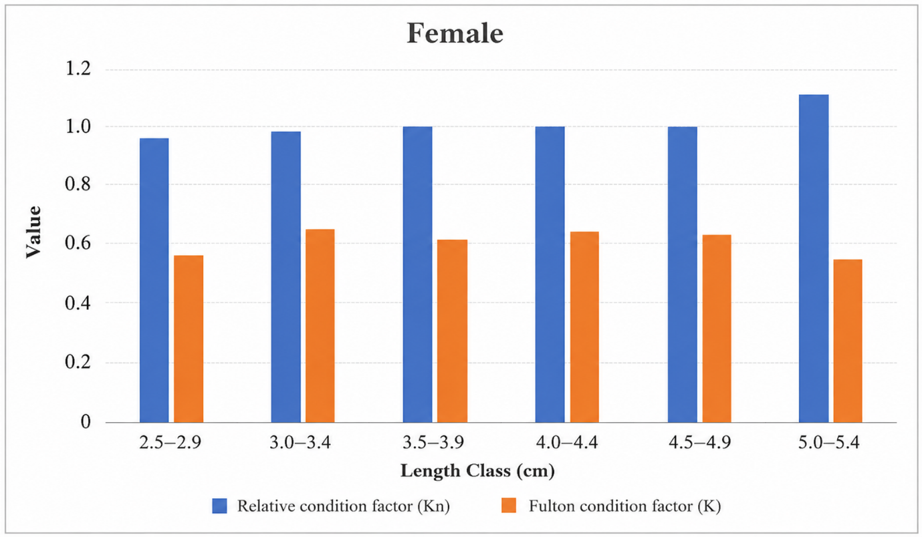
Figure 4: Relative Condition Factor (Kn) and Fulton Condition Factor (K) in Female
Macrobrachium lamarrei

The relative condition factor (Kn) and Fulton's condition factor (K) and of male Macrobrachium lamarrei were analyzed across six length classes (2.5–2.9 to 5.0–5.4 cm), and the results are presented in Figure 5. The relative condition factor (Kn) remained close to unity across all length classes and attained its highest value (1.04) in the 2.5–2.9 cm length class, indicating that the observed body weight was nearly equal to the expected weight. The Fulton's condition factor (K) varied among length classes, reaching a maximum of 0.69 in the 4.5–4.9 cm class and a minimum of 0.57 in the 2.5–2.9 cm class, suggesting generally good physiological condition in male individuals throughout the study period.
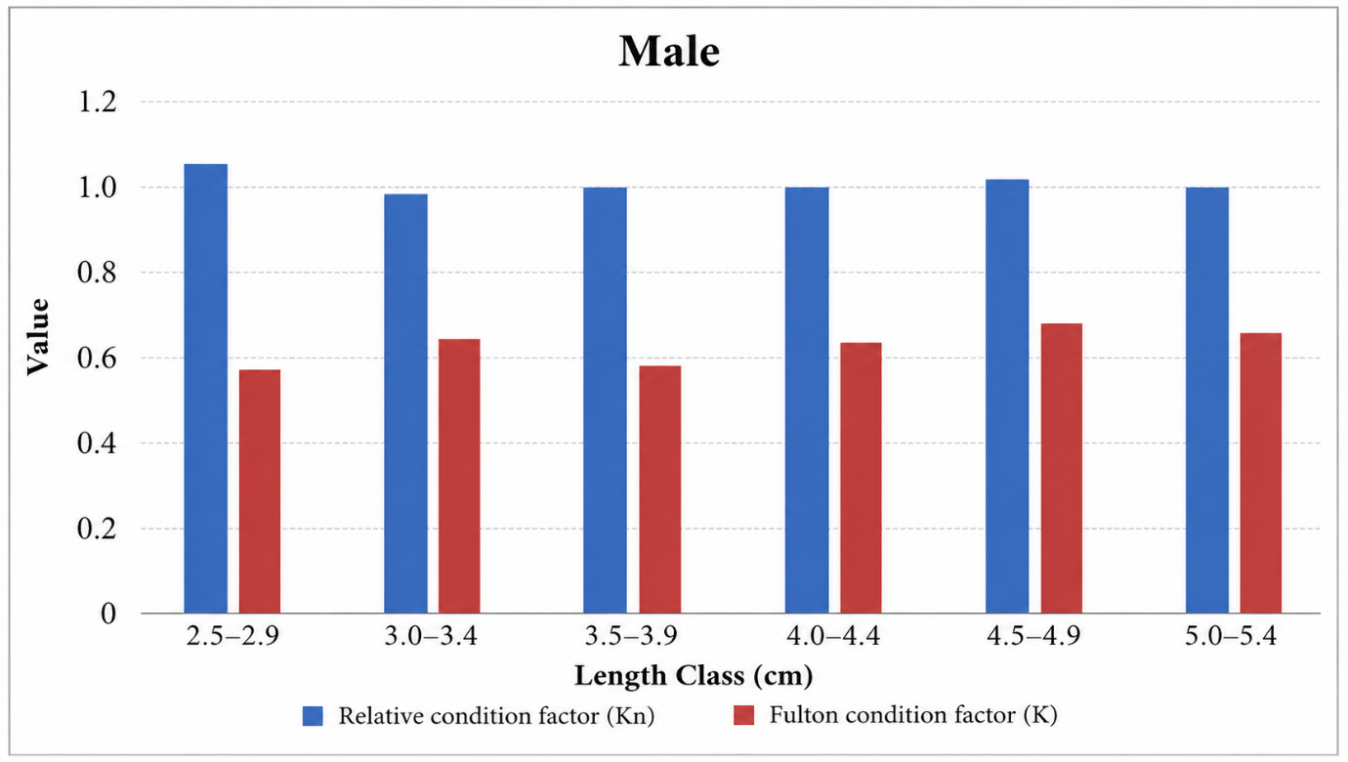
Figure 5: Relative Condition Factor (Kn) and Fulton's Condition Factor (K) in male Macrobrachium lamarrei
Overall, the regression analysis confirms a strong positive association between total weight and total length in female Macrobrachium lamarrei. The relatively high coefficient of determination and the close clustering of observations around the fitted regression line indicate that body weight is a reliable predictor of total length in the studied population. Thus, for both sexes, there was consistency in Kn values and fluctuations in K values, indicating normal physiological conditions and growth under the prevailing environmental conditions of the Sone River.
The present study showed a positive increase in body weight with increasing length of Macrobrachium lamarrei, indicating a significant positive length–weight relationship (LWR), meaning that the body weight of an individual increases consistently with total length. This growth relationship confirms the expected length–weight relationship commonly observed in freshwater prawns. The relatively high coefficients of determination (R² = 0.8338 for males, 0.7668 for females, and 0.812 for both sexes pooled) indicate a strong relationship between total length and body weight, suggesting that body length is a reliable predictor of body weight in the studied population. The comparatively higher R² value observed in males indicates a stronger length–weight relationship than in females. In contrast, the relatively lower R² value in females may be associated with greater variability arising from reproductive development and gonadal maturation.
The estimated growth coefficient (b < 3) indicated that M. lamarrei exhibited a negative allometric growth pattern, in which body length increased at a faster rate than body weight. According to Le Cren (1951), the growth coefficient (b) is an important biological parameter for describing growth patterns: b = 3 indicates isometric growth; b > 3 indicates positive allometric growth; and b < 3 indicates negative allometric growth. The negative allometric growth observed in the present study suggests that body weight increased at a slower rate than body length throughout the sampling period.
Disscussion
The present findings are consistent with those reported by Ara et al. (2015), who documented negative allometric growth in M. lamarrei from Bangladesh. Similar observations were also reported by Lodhi et al. (2024) for populations from northern India, indicating that negative allometric growth is a common characteristic of natural populations of M. lamarrei. These authors suggested that seasonal variation, food availability, reproductive status, and habitat characteristics are among the major factors influencing the growth pattern of freshwater prawns.
Differences in the length–weight relationship among populations are expected because several biological and environmental factors influence growth. Froese (2006) emphasized that LWR parameters are population-specific and may vary with sex, maturity stage, season, habitat quality, food availability, and geographical location. Therefore, slight variations in regression parameters among different studies are considered normal and reflect differences in ecological conditions and population characteristics rather than inconsistencies in growth.
The biology of freshwater prawns can also explain the negative allometric growth observed in the present study. During juvenile stages, a considerable proportion of assimilated energy is allocated to rapid linear growth, whereas mature individuals divert more energy towards gonadal development, reproduction, and maintenance metabolism, resulting in comparatively slower weight gain. Hartnoll (1982) reported that moulting and reproductive cycles are the principal biological processes regulating growth in decapod crustaceans. Similarly, Mariappan and Balasundaram (2004) observed that moulting frequency and reproductive maturity significantly influence growth patterns in freshwater prawns. Chang (1995) further explained that immediately after ecdysis, the exoskeleton expands rapidly, increasing body length, while tissue growth and biomass accumulation occur more gradually, contributing to negative allometric growth.
In the pooled regression analysis of 164 Macrobrachium lamarrei samples (64 male and 100 female), there was an extremely strong positive linear correlation between body weight and body length. The high value of coefficient of determination (R² = 0.812) implies that 81.2% of the variation in body length can be explained by body weight, and therefore, body weight is a dependable predictor of body length in the pooled population. The remaining 18.8% of the variation may be attributable to biological parameters such as gender, age, maturity, and nutritional status, as well as environmental factors. The tight clustering of the data points along the regression line suggests uniform growth rate of individuals in the population.
Overall, the present study demonstrates that Macrobrachium lamarrei from the Sone River exhibits a significant length–weight relationship with negative allometric growth. The observed growth pattern is comparable with previous reports from Bangladesh and northern India, indicating that the species follows a similar growth strategy under natural freshwater conditions. The present findings provide important baseline information on the growth biology of M. lamarrei and will be valuable for future studies on population dynamics, ecological monitoring, fisheries management, and conservation of freshwater prawn resources in the Sone River ecosystem.
Fulton's Condition Factor (K) is widely used as an index of body condition and reflects the balance between body weight and body length of aquatic organisms. In the present study, the observed K values indicated that the population of Macrobrachium lamarrei maintained a stable body condition throughout the study period. Variations in K among different length groups and between sexes were within the expected range for natural populations and are likely associated with differences in growth, moulting, and reproductive status.
The comparatively lower K values observed in smaller individuals may be associated with rapid somatic growth and frequent moulting during the juvenile stage. At this stage, a considerable proportion of assimilated energy is allocated to linear growth rather than biomass accumulation, resulting in relatively lower condition values. As body size increased, K values also increased, suggesting improved tissue development and energy storage with growth. Similar observations have been reported by Mariappan and Balasundaram (2004), who showed that moulting frequency and growth significantly influence the body condition of freshwater prawns.
A slight decline in K in the larger size groups may be associated with sexual maturation and reproductive activity. During gonadal development, a substantial proportion of available energy is diverted towards reproduction rather than somatic tissue growth, leading to a reduction in body condition. Hartnoll (1982) reported that seasonal reproductive cycles and energy allocation are major factors influencing condition in decapod crustaceans. Comparable trends have also been reported by Lodhi et al. (2024), who observed variation in the condition factor of Macrobrachium lamarrei with reproductive development.
The observed variation in K is also consistent with the negative allometric growth pattern recorded in the present study. Because M. lamarrei exhibited b < 3, body length increased faster than body weight, which may contribute to lower condition values in some size groups. Froese (2006) emphasized that Fulton's Condition Factor assumes isometric growth and should therefore be interpreted alongside the length–weight relationship, particularly when growth deviates from isometry.
Overall, the present findings indicate that the population of Macrobrachium lamarrei maintained satisfactory body condition during the study period despite exhibiting negative allometric growth. The observed pattern is consistent with previous studies on freshwater prawns and suggests that normal biological processes such as growth, moulting, and reproduction were the principal factors influencing body condition. These results provide valuable baseline information on the health and growth status of M. lamarrei and contribute to future studies on population dynamics, ecological monitoring, and sustainable management of freshwater prawn resources.
The Relative Condition Factor (Kn) is a widely accepted indicator of the physiological condition of aquatic organisms because it compares the observed body weight with the expected body weight derived from the length–weight relationship (Le Cren, 1951). In the present study, the Kn values of Macrobrachium lamarrei remained close to unity in both males and females, indicating that the sampled population maintained body weights appropriate for their respective lengths and was in satisfactory physiological condition throughout the study period.
Kn in freshwater prawns is affected by age, sex, reproductive stage, molting, nutrition status, and environmental conditions. In general, young prawns have low Kn as considerable amount of energy is used for somatic growth and production of exoskeleton; intermediate-sized prawns have high Kn value, showing good feeding and physiology, while adult prawns have relatively low Kn as more energy is utilized for gonad development, reproduction, and metabolism. Females generally have higher Kn than males, primarily due to greater energy demands during ovarian development. The variation in Kn observed between males and females may be associated with differences in energy allocation for growth and reproduction. If females exhibited relatively higher Kn values, this may be attributed to increased energy reserves associated with ovarian maturation and gonadal development. Similar sex-related variation in condition has been reported in freshwater prawns, where reproductive activity influences body weight relative to body length (Lodhi et al., 2024). However, the magnitude of this variation depends on the reproductive stage and sampling season.
The Relative Condition Factor is directly related to the length–weight relationship because the expected body weight used in its calculation is estimated from the length–weight regression. Le Cren (1951) proposed Kn as a more reliable measure of body condition than Fulton's Condition Factor (K), particularly when growth deviates from isometric conditions. Since the present study demonstrated negative allometric growth (b < 3), using Kn provides a more appropriate assessment of body condition, as it accounts for the species' actual growth pattern rather than assuming isometric growth. Froese (2006) report that condition indices should be interpreted alongside the length–weight relationship to obtain a reliable assessment of the biological condition of aquatic organisms.
Although minor variations in Kn have been reported among different populations, such differences are expected because body condition is influenced by several biological and ecological factors, including reproductive status, food availability, season, size composition, and habitat characteristics (Le Cren, 1951; Froese, 2006). Therefore, slight differences in Kn among studies reflect natural population variability rather than differences in overall population health.
Overall, the Relative Condition Factor recorded in the present study indicates that the population of Macrobrachium lamarrei maintained satisfactory physiological condition and body weights consistent with those expected from the length–weight relationship. The present findings are generally consistent with previous studies on freshwater prawns and provide baseline information on the condition and growth biology of M. lamarrei from the Sone River, Bihar. These results will be valuable for future studies on population dynamics, ecological monitoring, fisheries management, and conservation of freshwater prawn resources.
The significant length–weight relationship (LWR) observed in the present study, together with the favourable values of Fulton's Condition Factor (K) and Relative Condition Factor (Kn), provides a comprehensive assessment of the growth and physiological condition of Macrobrachium lamarrei . Although the species exhibited negative allometric growth (b < 3), the Kn values remained close to unity, indicating that the observed body weights were comparable to those predicted by the length–weight relationship. This suggests that the sampled population maintained satisfactory physiological condition and nutritional status throughout the study period. According to Le Cren (1951), the Relative Condition Factor (Kn) is derived from the length–weight relationship and therefore provides a more reliable assessment of body condition than Fulton's Condition Factor when growth deviates from isometry and similar patterns pg growth and favourable condition indices have been reported for Macrobrachium lamarrei by Ara et al. (2015) and Lodhi et al. (2024), indicating that the present findings are consistent with previous studies on natural populations of the species.
The references used are still dominated by older literature and basic concepts, while recent studies on population dynamics, freshwater shrimp ecology, and condition factor analysis approaches have not been widely utilized. The authors need to expand the use of recent literature to strengthen the interpretation of the results and demonstrate the position of this study compared to previous research.
Conclusion
The result of this study show the lenghe weig exhibit a slineer reegreesion and showed a significant positive relationship between body length and body weight in both males and females, confirming that larger individuals had greater body weight. The calculated all value of b the growth coefficient (b < 3) indicated a negative allometric growth pattern, in which body length increased faster than body weight. Negative allometry is common among freshwater decapod crustaceans that live in natural river ecosystems and may be attributed to factors such as food availability, habitat, reproduction, and seasonality. The high coefficients of determination (R2) for both sexes indicated that the model was appropriate for the relationship between body length and body weight.
Evaluation of the condition factor (K) for Fulton revealed that the collected specimens were in a reasonably healthy physiological state. The slight variations observed in K among the different size classes might be due to differences in energy allocation during the growth and maturity of the organisms, with middle-sized organisms having a higher condition than large specimens because of reproduction. In the same way, the relative condition factor (Kn) was almost equal to one for the two sexes, suggesting that the majority of organisms had body weights similar to their expected weights.
Overall, the higher Kn values (>1.0) across all length classes indicate that the prawns were generally in good physiological condition during the study period. However, condition indices showed a slight decline as body size increased. The Kn values are generally greater than 1, suggesting that the observed fish are, on average, heavier than the weights predicted by the fitted regression equation.

Declaration of AI Use

This manuscript was prepared through the combined contributions of all author(s), including contributions to the study design, data, content development, results, interpretation, and related scholarly work. The author(s) acknowledge the use of Grammarly and ChatGPT to assist with grammar checking, language refinement, reference formatting. These AI-assisted tools were not used as authors and did not replace the intellectual contributions or scholarly judgment of the author(s). All AI-assisted outputs, including content, references, and interpretations, were carefully reviewed, revised, verified, and approved by the author(s). The author(s) accept full responsibility for the accuracy, integrity, and final content of the manuscript.

COMPETING INTERESTS DISCLAIMER:
Authors have declared that they have no known competing financial interests OR non-financial interests OR personal relationships that could have appeared to influence the work reported in this paper.

References
Abohweyere, P. O., & Williams, A. B. (2008). Length-weight relationship and condition factor of Macrobrachium macrobrachion in the Lagos-Lekki Lagoon system, Nigeria. Research Journal of Biological Sciences, 3(11), 1333–1336.
Ara, M. G., Nabi, M. N., Ahmed, Z. F., & Fatema, M. K. (2014). Length-weight relationship and growth pattern inference of a small indigenous freshwater prawn, Macrobrachium lamarrei (H. Milne-Edwards, 1837) in Bangladesh. Research in Agriculture Livestock and Fisheries, 1(1), 137–145.
Chang, E. S. (1995). Physiological and biochemical changes during the molt cycle in decapod crustaceans: An overview. Journal of Experimental Marine Biology and Ecology, 193(1–2), 1–14.
Froese, R. (2006). Cube law, condition factor and weight–length relationships: History, meta-analysis and recommendations. Journal of Applied Ichthyology, 22(4), 241–253.
Fulton, T. W. (1904). The rate of growth of fishes. Twenty-second Annual Report, Part III, Fisheries Board for Scotland, 141–241.
Hartnoll, R. G. (1982). Growth. In L. G. Abele (Ed.), The biology of Crustacea (Vol. 2, pp. 111–196). Academic Press.
Kurup, B. M., & Ranjeet, K. (2002). Management strategies associating batch-graded and size-graded postlarvae can reduce heterogeneous individual growth in Macrobrachium rosenbergii. Aquaculture Research, 33, 1221–1231.
Kurup, B. M., Harikrishnan, M., & Sureshkumar, S. (2011). Length-weight relationship of male morphotypes of Macrobrachium rosenbergii (de Man) as a valid index for differentiating their developmental pathway and growth phases. Indian Journal of Fisheries, 47(4), 283–290.
Kumar, K., Rana, A. R., & Kotnala, C. B. (2014). Length-weight relationship of Macrobrachium assamense peninsulare (Tiwari, 1958), a minor freshwater prawn in Rawasan Stream of Uttarakhand. Journal of Mountain Research, 9, 13–19.
Kumar, K., Rana, A. R., & Kotnala, C. B. (2016). Preliminary study of Fulton's condition factor (CF) and relative condition factor (Kn) of Macrobrachium assamense peninsulare from Rawasan Stream, Uttarakhand, India. International Journal of Current Research, 8(9), 37736–37739.
Lalrinsanga, P. L., Pillai, B. R., Patra, G., Mohanty, S., Naik, N. K., & Sahu, S. (2012). Length–weight relationship and condition factor of giant freshwater prawn Macrobrachium rosenbergii. Turkish Journal of Fisheries and Aquatic Sciences, 12, 917–924.
Le Cren, E. D. (1951). The length-weight relationship and seasonal cycle in gonad weight and condition in the perch (Perca fluviatilis). Journal of Animal Ecology, 20, 201–219.
Lodhi, S., Ahmed, A., Swami, V. P., & Shukla, S. (2024). Morphometric analysis and condition factor of freshwater prawn, Macrobrachium lamarrei from the Gomti River, Uttar Pradesh, India.
Mariappan, P., & Balasundaram, C. (2004). Studies on the morphometry of Macrobrachium nobilii (Decapoda, Palaemonidae). Brazilian Archives of Biology and Technology, 47, 441–449.
Omogoriola, H. O., Williams, A. B., Adegbile, O. M., Olakolu, F. C., Ukaonu, S. U., & Myade, E. F. (2011). Length-weight relationships, condition factor (K) and relative condition factor (Kn) of sparids, Dentex congoensis (Maul, 1954) and Dentex angolensis (Maul & Poll, 1953), in Nigerian coastal waters. International Journal of Biological and Chemical Sciences, 5(2).
Pauly, D. (1984). Fish population dynamics in tropical waters: A manual for use with programmable calculators (Vol. 8). WorldFish.
Rana, A. R., & Kumar, K. (2013). Length-weight relationship and Fulton's condition factor of Macrobrachium assamense peninsulare in the Khoh tributary of the Ramganga River, Garhwal Himalaya, Uttarakhand, India. Environment Conservation Journal, 14(3), 17–22.
Sahu, O., Mogalekar, H. S., Sahil, et al. (2024). Length-weight relationship and exploitation of Macrobrachium species in the Burhi Gandak River, North Bihar, India. Indian Journal of Fisheries, 71(3).
Sarkar, U. K., Khan, G. E., Dabas, A., Pathak, A. K., Mir, J. I., Rebello, S. C., ... & Singh, S. P. (2013). Length-weight relationship and condition factor of selected freshwater fish species found in the Ganga, Gomti and Rapti rivers, India. Journal of Environmental Biology, 34(5), 951–956.
Sethi, S., Ram, N., & Venkatesan, V. (2012). Length-weight relationship of Macrobrachium lar (Fabricius, 1798) from streams and ponds of the Andaman and Nicobar Islands. Indian Journal of Fisheries, 59(4).
Sethi, S. N., Ram, N., & Venkatesan, V. (2013). Morphometric relationships of the monkey river prawn Macrobrachium lar (Fabricius, 1798) (Decapoda, Palaemonidae) from the Andaman Islands. Indian Journal of Fisheries, 60(2), 157–162.
Soomro, A. N., Baloch, W. A., Chandio, T. J., Achakzai, W. M., & Saddozai, S. (2012). Condition factor and length-weight relationship of monsoon river prawn Macrobrachium malcolmsonii malcolmsonii (H. Milne-Edwards, 1844) (Palaemonidae) in the lower Indus River. Pakistan Journal of Zoology, 44(5).
Wootton, R. J. (1992). Fish ecology. Blackie and Son.
Yang, M., Ding, F., & Dai, X. (2016). Length-length, length-weight relationships and condition factor of the giant freshwater prawn Macrobrachium rosenbergii (de Man, 1879) cultured in earthen ponds at high density. Asian Fisheries Science, 29(4), 164–177.

