Case Report
Combination therapy vs monotherapy for management of feline dermatophytosis caused by Microsporum canis and it’s zoonotic importance: report of 4 cases

Abstract
The most prevalent and significant cause of dermatophytosis in cats is Microsporum canis, which also has zoonotic potential. Infected animals often present with circular lesions, scaling, and multifocal alopecia. Notably, M. canis is not part of the normal skin microbiome in cats. This study evaluates three case series demonstrating the successful therapeutic management of dermatophytosis caused by M. canis using a combination of pulse dosing of itraconazole and continuous terbinafine therapy, comparing its effectiveness to continuous monotherapy with terbinafine. Four male Persian cats, aged 20 months, 18 months, 5 months and 2 years, weighing 3.10 kg, 2.5 kg, 1.5 kg and 3.3 kg respectively, were presented at the R.V.P, IVRI, Izatnagar, with complaints of pruritus, alopecia, and scaling on the nose, dorsal of neck and ears. Clinical examination revealed that all vital parameters were within reference range. A ten-year-old boy who owned one of the cats presented with tinea corporis in his groin, highlighting the zoonotic nature of the infection. Diagnosis was confirmed through patient history, clinical signs, direct microscopic examination of hairs, fungal culture, and PCR, all consistent with M. canis. This study indicated that combination therapy of itraconazole and terbinafine was more effective than terbinafine monotherapy to treat feline dermatophytosis caused by Microsporum canis.
Keywords: Alopecia, itraconazole, terbinafine, Zoonotic
1. Introduction
Feline dermatophytosis is caused by a superficial fungal infection of keratinized skin tissues in cats. This skin ailment is significant since it is communicable, infectious, and can spread among individuals (Moriello et al., 2017). Microsporum canis, because of its pathogenicity and considerable zoonotic potential, is the most prevalent and significant cause of dermatophytosis in cats (Miller et al., 2012; Scott et al., 2001). Arthrospore is the infectious form of dermatophytes, which is produced when fungal hyphae break apart into tiny infectious spores. Direct touch with diseased animal hair or scales, contact with the environment, or contact with fomites can all spread the infection (Miller et al., 2012; Moriello et al., 2017). The cuticle of the hair is damaged in ectothrix hair invasion. Dermatophytes that cause ectothrix include M. canis and M. audouinii (Patel et al., 2016). M. canis is not a typical component of the skin microbiome of cats, according to research on the typical fungal flora of healthy companion cats (Meason-Smith et al., 2017; Scott et al., 2013). Condition is usually self- limiting by fourth month following the onset of clinical signs. Still treatment of infected cats is advised to shorten the clinical course of the disease and lower the risk of infection dissemination (Moriello et al., 2017; Scott et al., 2001). The current recommendations for treatment call for the use of combination of two systemic antifungal medicationsto completely eradicate the infection within the hair's intrafollicular area, as well as topical therapy to disinfect the haircoat and environmental cleaning to get rid of mycotic debris.
In cats, Microsporum canis infection is clinically important because infected hairs and environmental arthroconidia facilitate direct and indirect transmission, and feline cases can expose human contacts. Fungal culture remains central to confirmation and monitoring, whereas PCR can provide rapid species-level detection but should be interpreted together with clinical and culture findings (Aneke et al., 2018; Jacobson et al., 2018; Moriello et al., 2017).
Current evidence-based recommendations generally favor one effective systemic agent, such as itraconazole or terbinafine, combined with whole-body topical therapy and environmental decontamination; evidence supporting routine concurrent use of two systemic agents in cats remains limited (DeTar et al., 2025; Moriello et al., 2017; Puls et al., 2018).
Young age, long hair coat, group housing, and environmental exposure can influence the epidemiology of feline dermatophytosis, but these variables should be treated as contextual risk factors rather than deterministic causes (DeTar et al., 2019; Meason-Smith et al., 2017; Scott et al., 2013).
2. Case presentation
Four male Persian cats, aged 20 months, 18 months, 5 months and 2 years, weighing 3.10 kg, 2.5 kg, 1.5 kg and 3.3 kg respectively, were presented at the R.V.P, IVRI, Izatnagar, for presenting pruritis, alopecia and scaling of nose, dorsal of neck and both the ears as seen in (figure 1) in first cat. Second cat has lesions(scales) only on nose (figure 2). Third cat has small focal alopecia on neck area (figure 3) Fourth cat has lesions on neck, both ears, below right ear and above left eye (figure 4)
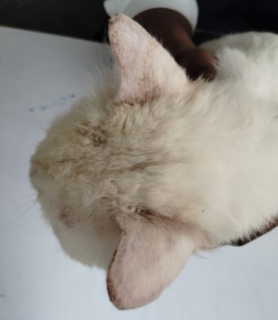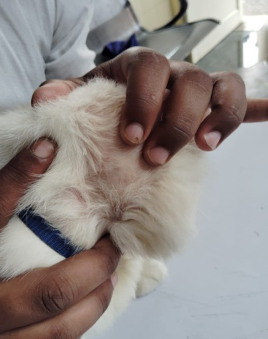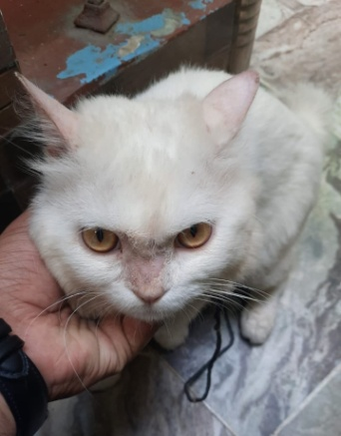
C
B
A
Figure 1 Alopecia on both the ears, neck and nose
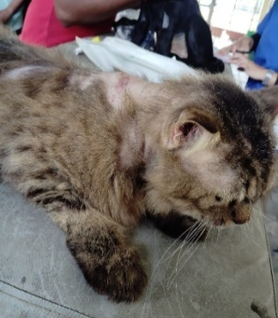
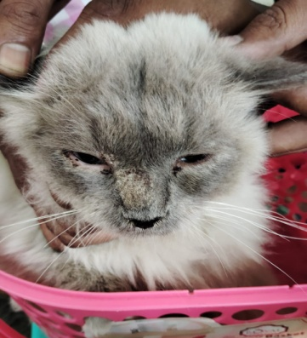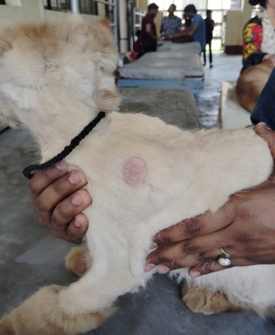
Figure 2 Scaling of nose Figure 3 Alopecia on left shoulder region Figure 4 Lesions on neck and below ear
The skin became red and inflamed where the affected area was scratched.
3. Investigation
For laboratory examination skin scrapings were collected from different skin lesions with the help of bp blade fig. 5.
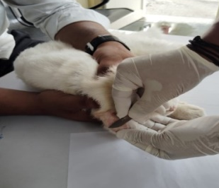
Figure. 5. Sample collection from Microsporum canis infected cat
On direct microscopic examination of scrapped hairs and scales after staining with lactophenol cotton blue stain revealed ectothrix arthroconidia (figure 6)
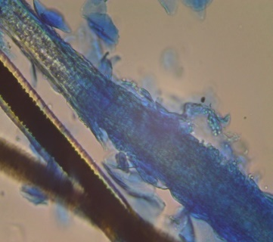
Fig 6 Photomicrograph of skin scraping stained with Lactophenol cotton blue examined microscopically (40X) showing distorted hair shaft with ectothrix hair invasion with arthroconidia.

The definitive diagnosis is provided by fungal culture. Fungus culture is the "gold standard" for diagnosis and the sole method that can identify particular dermatophytes. Culture and isolation was done on Sabouraud’s dextrose agar. The colony was white cottony to woolly (figure 7) and brown or golden-yellow reverse in Sabouraud’s dextrose agar (Carter & Cole, 1990). Molecular confirmation of Microsporum canis done by PCR and the result were found positive for Microsporum canis (176 bp) (figure 8)

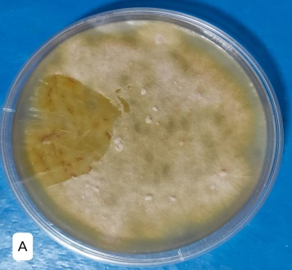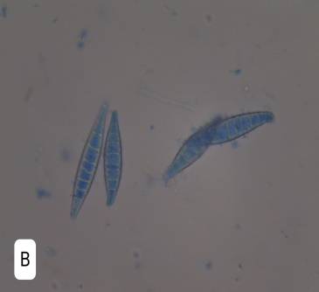

Figure 7 Culture morphology and macroscopic colony (A) and characteristic microscopic morphology in lactophenol cotton blue mount (B) of Microsporum canis
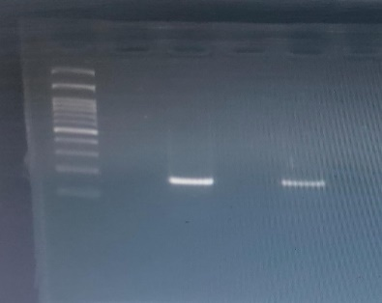
3
2
M
Figure 8 PCR result of Microsporum canis. Lane M- represent ladder, Lane 2- denotes positive control for M. canis. Lane 3- denotes postive for M. canis
The one cat owner of age 10 years also has dermatophytosis (tinea corporis) and itching in crotch area (figure 9)
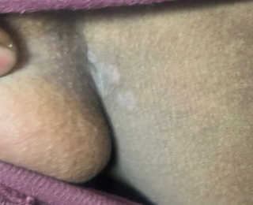
Figure 9 Dermtophytosis (tinea corporis) in owner on groin region
3. Treatment
After investigation both the cats were treated for Microsporum canis.
3.1 Combination Therapy: Two cats treated with Combination of systemic itraconazole @5mg/kg body weight orally once in a day, on the basis of one week on and one week off for 5 weeks (Puls et al., 2018) along with continuous terbinafine @30mg/kg body weight have been used (Moriello et al., 2017).
3.2 Monotherapy: Another two cats treated with oral terbinafine @30 mg/kg body weight once in a day (Kotnik et al., 2001) for a period of 4 month.
Shampoos containing miconazole work best when coupled with chlorhexidine (Aneke et al., 2018). Supportive treatment. Supportive treatment done with omega 3 and omega 6 fatty acids.
4. Outcome and follow up
4.1 Outcome of combination therapy: One cat treated with combined therapy achieved two consecutive negative cultures on day 42 and day 56 so this cat considered cure after 70 days (figure 10) because we mount the sample for culture on 56 days and negative culture is reported after weeks of incubation. Another cat treated with comibined therapy achieved negative culture on day 28 and day 42, So this cat considered cure after 56 days (figure 11)
The 56-70-day cure intervals observed in the two cats receiving itraconazole plus terbinafine fall within the broad time frame reported for protocols incorporating pulse itraconazole and repeated mycological monitoring. However, published feline evidence principally supports itraconazole as a systemic agent used with topical treatment, and the contribution of adding terbinafine cannot be isolated in this uncontrolled two-cat subgroup (DeTar et al., 2025; Moriello et al., 2017; Puls et al., 2018).
Two consecutive negative cultures provide a conservative endpoint, although culture turnaround time may delay the date on which cure is formally documented (Jacobson et al., 2018; Moriello et al., 2017).
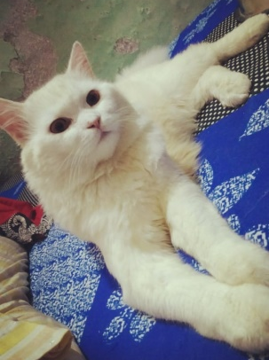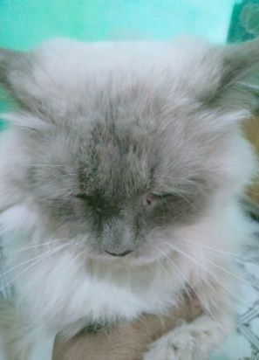
Figure 10 Cat after 70 days post-treatment Figure 11 Cat after 56 days post-treatment
4.2 Monotherapy: Third cat treated with terbinafine alone got negative culture on 98 and 112 days and considered cure after 126 days (figure 12) Fourth cat treated with terbinafine alone considered cure after 112 days post treatment (figure 13)
Terbinafine has documented activity against feline Microsporum canis infection, but treatment duration is variable and mycological cure may lag behind clinical improvement. The longer intervals in these two cats are therefore compatible with reported variability, but they do not establish inferiority because lesion burden, adherence, topical treatment, and isolate susceptibility were not controlled (Aneke et al., 2018; Kotnik et al., 2001; Moriello et al., 2017).
A reported terbinafine-resistant feline Microsporum canis isolate indicates that reduced susceptibility is possible, although a single report does not imply that resistance caused the prolonged treatment courses in the present cats (Hsiao et al., 2018; Khurana et al., 2019).
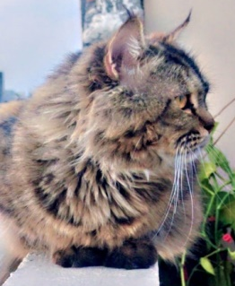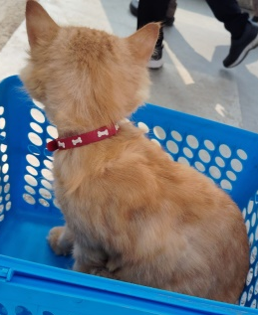
Figure 12 Cat after 126 days post-treatment Figure 13 Cat after 112 days post-treatment
5. Discussion
This study of 4 cases series sought to compare the effectiveness of itraconazole and terbinafine combined therapy with terbinafine monotherapy in managing feline dermatophytosis. Combination therapy had noticeably higher cure rates than terbinafine monotherapy. To the best of our knowledge, this is the first study in vivo to compare the effect of terbinafine compare to combination of itraconazole and terbinafine for treating feline dermatophytosis. The mechanism by which terbinafine and itraconazole target ergosterol in fungal cell membranes at two different stages of its formation pathway can improve clinical outcomes. Additionally, their combination has demonstrated promise synergism in a pharmacokinetic model. Developing resistance to these medications in pathogenic fungi may reduce the relative effectiveness of their monotherapy (Khurana et al., 2019); however, other factors, such as host-fungal interactions and fungal virulence, may also contribute to treatment failures (Sardana et al., 2018). There are few limitations in this study like number of cases included in this study are less and different brands of drugs were uses.
Because all four cats ultimately achieved mycological cure, the principal observed difference was time to documented cure rather than the final cure proportion. With only two cats per regimen and no randomization, blinding, standardized lesion scoring, or susceptibility testing, the findings should be interpreted as a descriptive signal that warrants controlled evaluation rather than proof of superior efficacy.
The biological rationale for combining terbinafine and itraconazole is plausible because the drugs inhibit different steps in ergosterol synthesis; however, dermatophyte combination studies are heterogeneous, and most clinical data derive from human disease or in vitro systems. Consequently, those findings cannot be directly extrapolated to feline Microsporum canis infection (Brescini et al., 2021; Ramzi et al., 2023).
The present observations are compatible with established evidence that pulse itraconazole is effective in cats and that terbinafine can be effective as monotherapy, while response times vary across studies and settings (Kotnik et al., 2001; Moriello et al., 2017; Puls et al., 2018).
Human pharmacokinetic and onychomycosis studies demonstrate persistence of itraconazole and terbinafine in keratinized tissues, but they do not establish feline dose equivalence or comparative efficacy (Cauwenbergh et al., 1988; Goodfield, 1992).
Foundational veterinary texts and diagnostic references describe ectothrix invasion, culture characteristics, and treatment principles, while contemporary feline microbiome and clinical studies provide more specific evidence for cats (Carter & Cole, 1990; Meason-Smith et al., 2017; Miller et al., 2012; Patel et al., 2016; Scott et al., 2001; Scott et al., 2013).
Resistance should be considered only one possible contributor to delayed response; host factors, infection burden, environmental contamination, drug exposure, and adherence may also influence outcome (Aneke et al., 2018; Hsiao et al., 2018; Khurana et al., 2019; Sardana et al., 2018).
Because the literature search was not designed to establish publication priority, the study is best framed as a preliminary case-series comparison rather than a definitive first in-vivo demonstration.
In conclusion, compared to using terbinafine as a monotherapy, the combination of itraconazole with terbinafine had a higher clinical and mycological cure rate.
In this four-cat case series, combination therapy was associated with a shorter observed time to documented mycological cure; controlled studies are required before recommending dual-systemic therapy over established systemic-plus-topical protocols (DeTar et al., 2025; Moriello et al., 2017).

Conclusions
All four cats in this case series achieved documented mycological cure following systemic antifungal treatment. The two cats treated with pulse itraconazole combined with continuous terbinafine reached the reported cure endpoint after 56 and 70 days, while the cats receiving terbinafine alone reached it after 112 and 126 days. The observations therefore indicate a shorter time to documented cure in the combination-treatment cases. However, the study included only two cats per regimen and lacked random allocation, blinding, standardized lesion scoring, baseline matching, and statistical comparison. Differences in age, initial lesion burden, treatment adherence, topical management, environmental contamination, and isolate susceptibility may have influenced the outcomes. Because all animals ultimately recovered, the results do not demonstrate a higher final cure rate for combination therapy. They should instead be interpreted as preliminary clinical observations supporting further investigation. Larger controlled studies with standardized systemic and topical protocols, environmental decontamination, adverse-effect monitoring, and uniform culture schedules are necessary before dual systemic treatment can be recommended over established treatment approaches for feline dermatophytosis.

Limitations
This report included only four cats, with two animals assigned to each treatment regimen, and lacked randomization, blinding, baseline matching, or statistical analysis. Lesion severity, adherence, environmental decontamination, and topical treatment were not standardized. The duration of terbinafine administration in the combination group was unclear, and adverse effects or liver-function monitoring were not reported. Culture procedures, PCR primers, cycling conditions, and negative controls were insufficiently described. The human contact’s lesion was not independently confirmed or linked molecularly to the feline isolate. Owner consent, parental consent for the minor, animal ethics approval, and permission to publish clinical photographs were not documented.

Declaration of AI Use

This manuscript was prepared through the combined contributions of all author(s), including contributions to the study design, data, content development, results, interpretation, and related scholarly work. The author(s) acknowledge the use of Grammarly and ChatGPT to assist with grammar checking, language refinement, reference formatting. These AI-assisted tools were not used as authors and did not replace the intellectual contributions or scholarly judgment of the author(s). All AI-assisted outputs, including content, references, and interpretations, were carefully reviewed, revised, verified, and approved by the author(s). The author(s) accept full responsibility for the accuracy, integrity, and final content of the manuscript.

COMPETING INTERESTS DISCLAIMER:
Authors have declared that they have no known competing financial interests OR non-financial interests OR personal relationships that could have appeared to influence the work reported in this paper.

References
Aneke, C. I., Otranto, D., & Cafarchia, C. (2018). Therapy and antifungal susceptibility profile of Microsporum canis. Journal of Fungi, 4(3), 107. https://doi.org/10.3390/jof4030107
Brescini, L., Fioriti, S., Morroni, G., & Barchiesi, F. (2021). Antifungal combinations in dermatophytes. Journal of Fungi, 7(9), 727. https://doi.org/10.3390/jof7090727
Carter, G. R., & Cole, J. R., Jr. (Eds.). (1990). Diagnostic procedure in veterinary bacteriology and mycology (5th ed.). Academic Press. https://doi.org/10.1016/C2009-0-02725-1
Cauwenbergh, G., Degreef, H., Heykants, J., Woestenborghs, R., Van Rooy, P., & Haeverans, K. (1988). Pharmacokinetic profile of orally administered itraconazole in human skin. Journal of the American Academy of Dermatology, 18(2), 263-268. https://doi.org/10.1016/S0190-9622(88)70037-7
DeTar, L. G., Dubrovsky, V., & Scarlett, J. M. (2019). Descriptive epidemiology and test characteristics of cats diagnosed with Microsporum canis dermatophytosis in a Northwestern US animal shelter. Journal of Feline Medicine and Surgery, 21(12), 1198-1205. https://doi.org/10.1177/1098612X19825519
DeTar, L., Janke, K. J., & Jacobson, L. (2025). Randomized, non-inferiority clinical trial of three topical dermatophytosis treatments in shelter cats. Journal of Feline Medicine and Surgery, 27(9), 1098612X251360611. https://doi.org/10.1177/1098612X251360611
Goodfield, M. J. D. (1992). Short-duration therapy with terbinafine for dermatophyte onychomycosis: A multicentre trial. British Journal of Dermatology, 126(Suppl. 39), 33-35. https://doi.org/10.1111/j.1365-2133.1992.tb00007.x
Jacobson, L. S., McIntyre, L., & Mykusz, J. (2018). Comparison of real-time PCR with fungal culture for the diagnosis of Microsporum canis dermatophytosis in shelter cats: A field study. Journal of Feline Medicine and Surgery, 20(2), 104-108. https://doi.org/10.1177/1098612X17695899
Hsiao, Y.-H., Chen, C., Han, H. S., & Kano, R. (2018). The first report of terbinafine resistance Microsporum canis from a cat. Journal of Veterinary Medical Science, 80(6), 898-900. https://doi.org/10.1292/jvms.17-0680
Khurana, A., Sardana, K., & Chowdhary, A. (2019). Antifungal resistance in dermatophytes: Recent trends and therapeutic implications. Fungal Genetics and Biology, 132, 103255. https://doi.org/10.1016/j.fgb.2019.103255
Kotnik, T., Eržen, N. K., Kužner, J., & Drobnič-Košorok, M. (2001). Terbinafine hydrochloride treatment of Microsporum canis experimentally induced ringworm in cats. Veterinary Microbiology, 83(2), 161-168. https://doi.org/10.1016/S0378-1135(01)00412-6
Meason-Smith, C., Diesel, A., Patterson, A. P., Older, C. E., Johnson, T. J., Mansell, J. M., Suchodolski, J. S., & Rodrigues Hoffmann, A. (2017). Characterization of the cutaneous mycobiota in healthy and allergic cats using next generation sequencing. Veterinary Dermatology, 28(1), 71-e17. https://doi.org/10.1111/vde.12373
Miller, W. H., Griffin, C. E., & Campbell, K. L. (2012). Muller & Kirk's small animal dermatology (7th ed.). Elsevier Saunders. https://books.google.com/books?id=urlFOAYWjxkC
Moriello, K. A., Coyner, K., Paterson, S., & Mignon, B. (2017). Diagnosis and treatment of dermatophytosis in dogs and cats: Clinical consensus guidelines of the World Association for Veterinary Dermatology. Veterinary Dermatology, 28(3), 266-e68. https://doi.org/10.1111/vde.12440
Patel, S., Meixner, J. A., Smith, M. B., & McGinnis, M. R. (2016). Superficial mycoses and dermatophytes. In S. K. Tyring, O. Lupi, & U. R. Hengge (Eds.), Tropical dermatology (2nd ed., pp. 189-201). Elsevier. https://www.sciencedirect.com/book/edited-volume/9780323296342/tropical-dermatology
Puls, C., Johnson, A., Young, K., Hare, J., Rosenkrans, K., Young, L., & Moriello, K. A. (2018). Efficacy of itraconazole oral solution using an alternating-week pulse therapy regimen for treatment of cats with experimental Microsporum canis infection. Journal of Feline Medicine and Surgery, 20(10), 869-874. https://doi.org/10.1177/1098612X17735967
Ramzi, S. H. T., Arif, S. A., Majid, A., Kumar, S., Shumail, H., Qudsia, F., Zainab, Y., Varrassi, G., & Khatri, M. (2023). Efficacy of terbinafine and itraconazole combination therapy versus terbinafine or itraconazole monotherapy in the management of fungal diseases: A systematic review and meta-analysis. Cureus, 15(11), e48819. https://doi.org/10.7759/cureus.48819
Sardana, K., Kaur, R., Arora, P., Goyal, R., & Ghunawat, S. (2018). Is antifungal resistance a cause for treatment failure in dermatophytosis? A study focused on tinea corporis and cruris from a tertiary centre. Indian Dermatology Online Journal, 9(2), 90-95. https://doi.org/10.4103/idoj.IDOJ_137_17
Scott, D. W., Miller, W. H., & Erb, H. N. (2013). Feline dermatology at Cornell University: 1407 cases (1988-2003). Journal of Feline Medicine and Surgery, 15(4), 307-316. https://doi.org/10.1177/1098612X12468922
Scott, D. W., Miller, W. H., & Griffin, C. E. (2001). Muller & Kirk's small animal dermatology (6th ed.). W. B. Saunders. https://www.sciencedirect.com/book/monograph/9780721676180/muller-and-kirks-small-animal-dermatology

