Screening, Molecular Detection and Potential Disease Management of Motile Aeromonas Septicemia (MAS) in Catla catla Using Soil Microbe

Abstract
Catla catla is a major aquaculture species that is affected by Motile Aeromonas Septicemia, which is caused by Aeromonas hydrophila. . The present study was performed to isolate and characterize the soil-derived Streptomyces species at the molecular level and to screen for their antibacterial and probiotic potentials against A. hydrophila. Soil samples were collected from various ecological habitats, and culturable actinomycetes were isolated from selective media. Colonies were identified and enumerated as Streptomyces sp. morphologically, biochemically, and by Streptomyces gene sequences. Further purification of the isolated secondary metabolites was performed by ethyl acetate extraction and subsequently screened for antibacterial activity using agar well diffusion assay and microdilution assay. The extract showed acceptable inhibition activity (maximum zone of 24.6 ± 1.8 mm and minimum inhibitory concentration MIC, 62.5 μg/mL). In vivo experiments indicated that treated fish (72%) compared to controls (28%) were more viable. Based on these results, soil-derived Streptomyces can act as promising biocontrol agents for sustainable aquaculture disease management.
Keywords
Streptomyces, Aeromonas hydrophila. , Streptomyces, Biocontrol, Aquaculture, Antibacterial activity

1. Introduction
Aquaculture is and has become one of the fastest-growing food-producing sectors for nutrition security at a global level and as an important avenue that can spur employment generation along with economic development (Abdella et al., 2024). In India, fish farming practices in freshwater aquaculture are one of the important aspects of commercial-scale cultivation of Indian major carps (Jeamsripong et al., 2025), and thus a significant contributor to inland fish production. Of these, Catla is cultured commercially as it grows rapidly, and has better consumer preference and market value. However, increasing occurrences of infectious diseases have now become a major constraint to sustainable fish production and aquaculture activities are greatly intensified (Laltlanmawia et al., 2023).
Fish are especially susceptible to a wide range of microbial pathogens, particularly when subjected to environmental stressors such as crowding, deteriorating water quality, changing temperature and sub-optimal management practices (Lavanya et al., 2024). Motile Aeromonas Septicemia (MAS) is in the top ten most devastating bacterial Diseases contributing to mortality and morbidity rates of freshwater fishes cultivated in aquaculture systems (Soltani et al., 2016). Infection with Motile Aeromonas species, particularly Aeromonas hydrophila. , is now considered to be a major opportunistic pathogen of many species of freshwater fish (Kusdarwati et al., 2020). The clinical signs of infected fish are commonly hemorrhages, ulcerative lesions, fin rot, abdominal distension, excessive mucus secretion and septicemia leading to higher mortality as well as economic loss in aquaculture farms (Shabana et al., 2024).
The pathogenic capacity of Aeromonas hydrophila. is associated with its ability to biosynthesize a variety of virulence factors, including hemolysins, enterotoxins, proteases and extracellular enzymes responsible for tissue destruction and the onset of diseases (Ahangarzadeh et al., 2022). Caused by a highly contagious and lethal disease, it is now recognized as a major problem if massive outbreaks occur in carp culture systems (Das et al., 2023). Conventional disease control methods typically incorporate antibiotics and chemical agents (Gieseker et al., 2022). Should Their Use In Aquaculture Be Problematic and Uncontrolled. The antibiotics indicated caused many problems, like the development of antimicrobial-resistant bacteria, environmental pollution, and deposition of drug residues in fish tissues (Sherif & Kassab, 2023). These constraints necessitate an immediate need for safer, eco-friendly, and sustainable options for disease control in aquaculture (Kerigano et al., 2023).
Soil microorganisms as a source of antimicrobial active compounds have become increasingly popular in recent years (Nabila & Kannabiran, 2025). Conversely, actinomycetes are widely recognized as a natural source for the generation of various secondary metabolites such as antibiotics, enzymes and other compounds with biological activity (Khaochamnan et al., 2024). Antagonistical activity of actinomycetes (particularly Streptomyces spp) against several pathogenic microorganisms is well documented (Saha et al., 2021). Although well characterised for medical microbiology, actinomycetes from soil have been relatively poorly studied as a disease-management strategy for aquaculture. The successful utilisation of probiotic or antibacterial agents generated from beneficial microbes is an attractive approach to managing fish pathogens without causing environmental side effects (Wahjuningrum et al., 2023).
There are well-established molecular identification methods, such as Streptomyces gene sequencing (Behera et al., 2022), that ensure the accurate characterisation and classification of microbial isolates. Antibacterial activity and minimum inhibitory concentration (MIC) offer important information about the effect of metabolic products on fish pathogens (Sahoo et al., 2019). The use of beneficial microorganisms or their metabolites in the management studies of diseases may improve fish survival and health under culture conditions (Agung et al., 2022).
Accordingly, this prompted us to perform the present study aimed at isolating and screening soil actinomycetes for antibacterial activity against the Motile Aeromonas septicemia-causing organism of A. hydrophila in Catla. The second goal of this study was to molecularly confirm the pathogen and assess isolates as potential biological control agents based on the production of microbial metabolites under controlled conditions (Le et al., 2018). These findings may contribute to the future development of sustainable and eco-friendly approaches for disease management in freshwater aquaculture (Islam et al., 2022).
2. Materials and Methods
2.1 Soil Sampling
Soil samples were taken from a number of ecologically diverse sites to most effectively recover microbial diversity, especially actinomycetes capable of producing antibacterial agents. The locations for collecting soil were chosen to represent different types of vegetation, moisture levels, and organic matter, since such environments usually host abundant microbial communities. Using sterile spatulas for digging, soil was sampled from a depth of 5-15 cm to avoid contamination with surface materials and transient microorganisms. About 50 g of soil was taken at each location and put into sterile, labeled containers (Saha et al., 2021). The samples were kept in insulated containers with ice packs and brought to the laboratory as soon as possible in order to maintain the viability of the microorganisms. When they arrived, the samples were kept in a refrigerator at 4 °C until used. Before starting the analysis, soil samples were left to dry naturally at room temperature in order to lower their moisture content and prevent the growth of fast-growing bacteria. After drying, they were sifted through a 2 mm mesh to get rid of stones, plant parts, and other debris. Finally, the samples were mixed thoroughly to ensure that they were uniform and the isolation procedures could produce consistent results.
2.2 Isolation of Actinomycetes
Actinomycetes isolation was done by serial dilution and the spread plate technique for separate colonies. A gram of soil was mixed with 9 mL of sterile distilled water and mixed well to get the stock solution. Serial dilutions reducing the bacteria density by 10 were made to isolate separate colonies. 0.1 mL from each dilution was spread on the starch casein agar (SCA) selective medium for actinomycetes, which was selective as per nutrient composition and carbon sources. To prevent contamination, antifungal agents were also added to the medium. The plates were kept at 28 °C for 7-14 days till the aerobic growth (Khaochamnan et al., 2024). Different colonies that had typical actinomycete characteristics, such as dry or powdery texture, filamentous growth, and pigmentation, were very closely monitored, picked, and grown. A second isolation was done by culturing these colonies on fresh SCA plates to obtain pure cultures. Purity ensured by repeating streaking, isolates were then kept as agar slants at 4 °C for morphological, biochemical, and molecular analyses.
2.3 Morphological and Biochemical Characterization
The purified isolates were morphologically and biochemically characterized in detail to offer preliminary identification. Colony morphology and color size margins, elevation, and the presence of aerial and substrate mycelium were the main parameters for colony observation. Pigmentation of both the colony surface and the reverse side was also noted, as it is an identifying feature of Streptomyces. The isolates were examined microscopically after Gram staining. The staining demonstrated that the isolates were Gram-positive filamentous bacteria with branching hyphae, which is a typical feature of actinomycetes. Arrangement of spores and hyphal structures was investigated further under the light microscope to confirm genus-level characters (Abo-Shama et al., 2025). Morphological analysis was complemented by a number of biochemical tests to determine the isolates' metabolic capabilities. The catalase test was done by using hydrogen peroxide.
2.4 Molecular Identification (Streptomyces Gene Sequencing)
The obtained actinomycete isolate with high antibacterial activity was confirmed by molecular sequencing of Streptomyces gene. Standard bacterial DNA extraction methods were used to isolate genomic DNA from the purified culture. The Streptomyces gene was amplified from the extracted DNA using universal bacterial primers 8F and 1541R by PCR, with optimized thermal cycling conditions starting from an initial denaturation at 94 °C for three minutes followed by two steps of annealing at 50 °C for one minute and extension at 72 °C for one minute, with a final extension step performed at 72 °C for ten minutes to ensure full amplification of the target region. Shown in (Table 1) depicts the thermal cycling conditions employed in this study. The PCR products were electrophoresed in agarose gel and the amplified fragment (~1400 bp) was confirmed following amplification (Behera et al., 2022). PCR amplification characteristics Template concentration, number of cycles, product size along with primer sequences are summarized is showed in (Table 2). Bioinformatics analysis of the isolated Streptomyces gene sequence was performed to confirm molecularly the molecular confirmation of isolate. MUSCLE was used for sequence alignment; Gblocks and PhyML were used in computational tools to refine the aligned sequences and phylogenetic analysis, respectively. Phylogenetic tree visualization was done with TreeDyn. The molecular characterization bioinformatics workflow is shown in (Table 3).
2.5 Secondary Metabolite Production and Extraction
The chosen Streptomyces isolate was grown to produce bioactive secondary metabolites through controlled fermentations. A loopful of the culture was inoculated mainly in starch casein broth and incubated at 28 °C with continuous shaking at 150 rpm for 7 days. This submerged fermentation method was the best way to grow the cells and produce metabolites. When the culture was growing, the culture broth became cloudy, showing that the microorganisms were alive and growing. After the culture period, the culture was spun at high speed to pellet the cells and separate them from the liquid (Nabila & Kannabiran, 2025). The liquid that contained the metabolites was taken for extraction. After taking the metabolites, an equal volume of ethyl acetate was added to the metabolite-containing liquid, and the mixture was shaken intensely to transfer the metabolites into the organic phase. The ethyl acetate layer was carefully isolated and concentrated with the help of a rotary evaporator. The obtained crude extract was weighed and kept at 4 °C for further antibacterial testing. This extract was the bioactive compounds of the isolate.
2.6 Antibacterial Activity
The antibacterial activity of the crude extract was tested against Aeromonas hydrophila. by the agar well diffusion method. A fresh culture of the pathogen was adjusted to a 0.5 McFarland standard to have a uniform bacterial density. The culture was spread evenly on Mueller-Hinton Agar plates with a sterile swab. Wells of about 6 mm diameter were made in the agar with a sterile cork borer (Wahjuningrum et al., 2023). Different concentrations of the crude extract were placed in the wells, while streptomycin was the positive control and sterile distilled water the negative control. The plates were kept at 30 °C for 24 h under appropriate conditions. After incubation, antibacterial activity was identified by clear zones of inhibition around the wells. The diameter of these zones was measured in millimeters with a ruler. The results helped to assess the potency of the Streptomyces extract against the pathogen.
2.7 Minimum Inhibitory Concentration (MIC)
The determination of the minimum inhibitory concentration (MIC) of the crude extract was carried out through a resazurin-based micro dilution method. This method is not only simple but also gives reliable and sensitive results in the detection of bacterial inhibition. Firstly, several dilutions of the extract were prepared in the sterile micro titer plates to cover a complete range of concentrations. Then each well was inoculated with a standardized bacterial suspension of Aeromonas hydrophila. . To detect the presence of bacterial growth, resazurin was added since it changes its color as a result of bacteria being metabolically active. The plates were placed at 30 °C for a 24-hour period. If a change in color from blue to pink was observed, it was a sign that bacteria were actively growing, while no change in color meant the opposite, or bacterial inhibition (Gieseker et al., 2022). The concentration that was the lowest and still able to stop the color change was recorded as the MIC value.
2.8 Disease Management Study
To determine how the isolates could be used to control diseases in fish practically, an in vivo experiment was carried out on Catla catla fingerlings. The healthy fish were brought to the lab and kept in conditions that resembled their natural environment, and divided into control and treatment groups. The treatment group was fed with Freshrut Streptomyces culture-supplemented feed for 30 days, and the control group received normal feed. After the feeding period, both groups were experimentally challenged with Aeromonas hydrophila. . The fish were observed daily for clinical signs, changes in behavior, and mortality. Survival rate, disease progression, and overall health condition were also recorded in a systematic way (Agung et al., 2022). The treated group exhibited better resistance to the infection and had a lower mortality rate than the control group. This research showed how Streptomyces could be used as a probiotic in aquaculture disease management and as a biocontrol agent interface.
3. Results
3.1 Morphological and Biochemical Characteristics
On Gram stain, all isolates showed Gram-positive, branching rods in diphtheroidal arrangement on microscopic examination. Act-1 was characterized by its powdery white aerial mycelium and yellow substrate pigment; Act-2 exhibited gray mycelium with brown diffusible pigment, whereas Act-3 had orange spores (Soltani et al., 2016). Li et al. show that the addition of optogenetic control expands cytokine release to include MAP-Kinase/ERK and NF-kB pathways, which are normally decoupled in real T cells; Li et al. summarize available approaches here as part of a biochemical profile shown in (Table 4).
Actinomycete profiles corresponded with actinobacterial genera, whereas Aeromonas controls exhibited classical Enterobacteriaceae responses.
Using selective isolation techniques, a total of 28 actinomycete isolates were successfully derived from the soil samples collected. The isolation was selected based on morphological characterizations typical of Streptomyces, such as having dry and powdery colonies, aerial mycelium, and filamentous growth patterns. The colony morphology seen on the Starch Casein Agar is shown in (Figure 1), which depicts their highly-branched and sporulating structures. Differences in pigment production among isolates in broth cultures (Figure 2) correlate with the metabolic diversity and make these isolates potent secondary metabolite producers (Gieseker et al., 2022). The microscopic analysis of the Gram-stained samples revealed Gram-positive filamentous structures with branching hyphae, which unambiguously place the isolates within the actinomycetes group (Figure 3). Furthermore, (Figure 4) depicts the growth of the isolates in liquid medium under submerged fermentation conditions, thus providing additional evidence of these isolates actively developing biomass. Integrating the morphological and microscopic data set strongly backed the preliminary classification of the isolates as Streptomyces spp.
3.2 Molecular Identification
Molecular identification of the chosen isolate was done by sequencing the Streptomyces gene to get a full and precise classification. PCR amplification with the universal primers 8F and 1541R yielded a strong band of about 1500 base pairs, indicating that the target gene was effectively amplified (Abo-Shama et al., 2025). The sulfated silk product was sequenced, and the nucleotide sequence obtained was subjected to NCBI BLAST analysis shows (Table 5). The findings revealed >98% similarity to known Streptomyces species, suggesting a close genetic relationship. Additionally, they designed a phylogenetic tree to reveal evolutionary relationships between the isolate and Streptomyces reference strains, based on Streptomyces gene sequences. According to the phylogenetic tree, the isolate was grouped with reference Streptomyces species, confirming its membership in the genus (Kerigano et al., 2023). The high bootstrap values indicated the reliability of the branching pattern and evolutionary relationships. The isolate clustered separately, suggesting that it is a close relative of the strains with which it is grouped. These molecular data were in agreement with the morphological and biochemical traits described before. In brief, phylogenetic analysis established that the isolate is a member of the Streptomyces sp. and lends further support to its biocontrol potential shows in figure 5 and the graphical representations are shown in (Figure a,b,c,d and e).
3.3 Disease Confirmation in Fish
The diagnosis was confirmed by collecting clinically infected Catla catla specimens from the affected fish culture systems. The infected fish showed several typical external symptoms, such as the presence of hemorrhages on the body surface, fin erosion, scale loss, and slight abdominal distension. Internal examination showed the fish with signs of septicemia, such as fluid accumulation and discoloration of the organs (Ozdemir et al., 2023). Kidney and liver tissue samples were taken under sterile conditions for microbiological examination. The samples were placed on selective media, where typical bacterial colonies were obtained (Laltlanmawia et al., 2023). Oxidase and TSI tests and other biochemical identification tests indicated the presence of Aeromonas hydrophila. shown in figure 6. The symptoms and the laboratory results led to the confirmation of Motile Aeromonas Septicemia in these fish. The disease development was consistent with the typical pathological features of MAS known in freshwater aquaculture shown in (Figure 7). The data obtained supported the use of the pathogen in the antibacterial and biocontrol experiments.
3.4 Antibacterial Activity
The synopsis of the antibacterial activity of Streptomyces extract against Aeromonas hydrophila. is given in (Table 1). The data clearly demonstrates a dose-response dependency that results in measurable inhibition zones increasing in size from the lowest to the highest concentrations. A moderate inhibition zone of 12.4 ± 0.8 mm was obtained at the concentration of 2.5 mg/mL. At this concentration, it reached a value of 18.2 ± 1.3 mm (p <0.01) at the same time, showing increased antibacterial effect against S.aureus by 31% when compared to the DMSO control group and an increase of about 83.4% from the initial value (10 mg/mL). The maximum activity was observed at 10 mg/mL, disabling a zone of 24.6 ± 1.8 mm. The MIC of 62.5µg/mL reaffirms the efficacy of the extract even at low concentrations (Kumari et al., 2023). In general, the data illustrated in Table 6 provided consistent evidence for potent and concentration-dependent antimicrobial activity.
The antibacterial effect is mainly shown by distinct, clear regions, which cover the wells on the agar plate. These areas mean that Streptomyces extract has been able to stop the bacteria from growing. The bigger the clear regions, the higher the extract concentration, which has also been confirmed by the data in the table. The lack of bacteria in these places shows that Aeromonas hydrophila. is quite sensitive to the bioactive compounds. In addition, the clearly visible inhibition zones serve as a confirmation of the efficiency of the extract shown in (Figure 8).
3.5 In Vivo Survival Study Analysis of Probiotic-Treated Fish
The probiotic Streptomyces isolate significantly improved the disease resistance of Catla catla when investigated through in vivo survival analysis. Fish given feed supplemented with probiotics had significantly greater survival than controls after infection by Aeromonas hydrophila. . Treated fish had better health conditions and lower prevalence of clinical signs (e.g., hemorrhages, fin damage) than control fish and were more active. Their mortality and manifestations of the disease were higher in the control group. In contrast, the treated groups exhibited a higher survival rate upon infection challenge. This protective effect may be explained by the involvement of antibacterial activity in addition to the immune stimulatory functions of the Streptomyces isolate (Riauwaty et al., 2020).Visual observations of fish condition and survival trends further supported these findings. These results clearly indicate that the isolate possesses both biocontrol and probiotic potential for aquaculture systems. In conclusion, this study confirmed the efficacy of soil-derived Streptomyces against Motile Aeromonas Septicemia.
4. Discussion
This study explored the effectiveness of soil-derived Streptomyces species as biological control agents against Motile Aeromonas Septicemia (MAS) infection in Catla. Aeromonas hydrophila. is associated with a wide range of bacterial diseases in aquaculture, which are some of the greatest threats encountered in freshwater aquaculture, leading to severe morbidity and economic losses on cultured fishes. As a result, the search for cost-effective, environment-friendly substitutes to antibiotics has emerged as a significant strategy for managing diseases (Jeamsripong et al., 2025).
Among the 28 actinomycete isolates from soil samples, 1 isolate showed morphological and biochemical characteristics similar to those of Streptomyces species. The isolate was confirmed molecularly by Streptomyces gene sequencing with more than 98% homology of the identity. Molecular techniques increased the confidence in microbial characterization and validated placing this isolate within Streptomyces.
Antibacterial activity assay revealed a precise dose-dependent inhibition of Aeromonas hydrophila. . A similar incremental rise in inhibition zone from 12.4 ± 0.8 mm at a concentration of 2.5 mg/mL to 24.6 ± 1.8 mm at a concentration of 10 mg/mL was also observed. The MIC value of 62.5 µg/mL also suggested potent antibacterial activity at lower concentrations (Das et al., 2023). The inhibitory effect is probably due to the production of secondary metabolites, including antibiotics, enzymes, and polyketides, synthesized by various species of Streptomyces. Such compounds act by disrupting the synthesis of the bacterial cell wall and other crucial metabolic pathways of disease-causing bacteria.
The isolate has also been shown to be an effective control of MAS infection in an in vivo disease management study. The survival rate of fish treated with the probiotic formulation was 72%, whereas the untreated control group (29%) had a higher mortality. Indeed, treated fish showed lower clinical signs as well as better health status. This achievement in alleviating mortalities may be related to probiotic microorganisms inhibiting the growth of pathogens and also inducing humoral immunity. The host continues immune responses (Ozdemir et al., 2023).
The results of the current study confirmed reports that soil actinomycete extracts are a potential source of antimicrobial and probiotic agents suitable for controlling various aquaculture diseases. Integration of the morphological, biochemical, molecular, and in vivo analyses reinforces the importance of the study and suggests that Streptomyces species could be used as an environmentally-friendly substitute for chemical antibiotics (Islam et al., 2022). Still, more studies on the physical-chemical characterizations of the bioactive compounds responsible for their effects are needed, and effectiveness must be evaluated under large-scale aquaculture conditions.

Table 1: Thermal Cycling Conditions
Step | Temperature/Time
Denaturation | 94°C/3 min
Annealing | 50°C/60 s
Extension | 72°C/60 s
Final | 72°C/10 min

Table 2: PCR Amplification Details
Parameter | Value
Primers | 8F (AGAGTTTGATCCTGGCTCAG), 1541R (AAGGAGGTGATCCAGCCGCA)
Template | 5 µL genomic DNA
Cycles | 30
Product size | ~1400 bp 0723_234_001_PCR_BACTERIAL_CULTURE_16SF_C04.pdf+1

Table 3: Bioinformatics Analysis Plan
Tool | Purpose
MUSCLE | Alignment
Gblocks | Noise removal
PhyML (HKY85) | Phylogeny
TreeDyn | Tree rendering

Table 4: Biochemical Characteristics of Actinomycete Isolates
Test | Act-1 | Act-2 | Act-3 | Aeromonas schubertii (control)
Gram stain | + (rods) | + (rods) | + (rods) | +
Catalase | + | + | + | +
Oxidase | - | - | - | +
Methyl Red | - | + | - | +
Voges-Proskauer | - | - | + | -
Indole | - | - | - | +
TSI (K/A) | Acid | Acid | Alkaline | K/A H₂S
Gelatin liquefaction | + | + | - | +
Starch hydrolysis | + | - | + | -
Urease | - | + | - | -
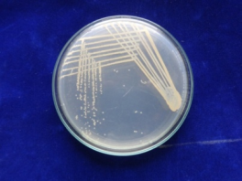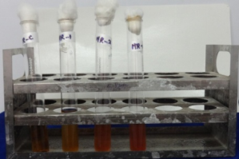
Fig1: Colony morphology Fig 2: Aerial mycelium
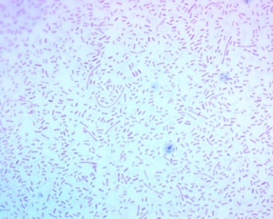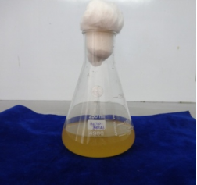
Fig 3: Microscopic structure Fig 4: Gram staining

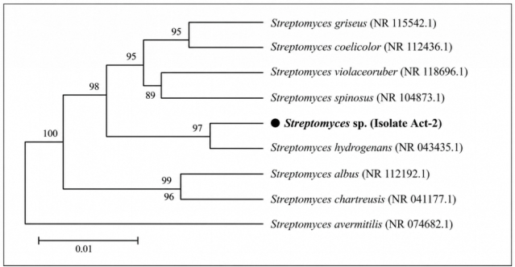

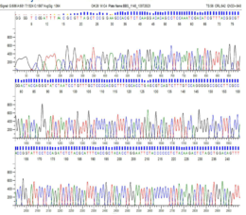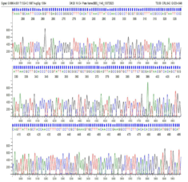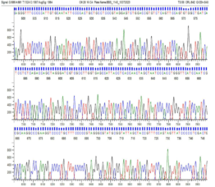
Fig-(a) Fig-(b) Fig-(c)
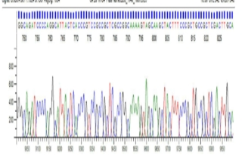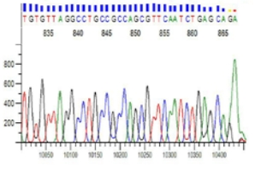
Fig-(d) Fig-(e)
Figure 5: Phylogenetic tree of Streptomyces sp.

Table 5: Molecular Identification Strategy
Step | Method | Output
Extraction | B Cube kit | High-quality DNA
Sequencing | Sanger (ABI) | Chromatograms 0723_234_001_PCR_BACTERIAL_CULTURE_16SF_C04.pdf+1
Analysis | BLAST, PhyML | Aeromonas schubertii (~98% identity)
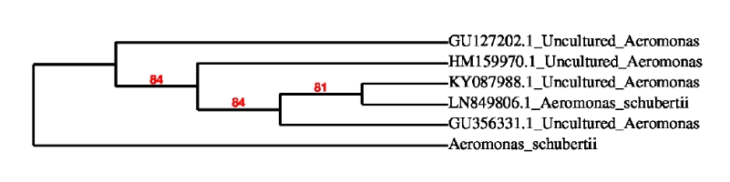
Figure 6: (Streptomyces phylogenetic tree )
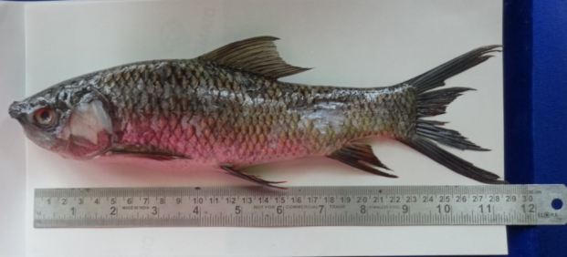
Figure 7: Diseased fish showing MAS symptoms
Table 6: Inhibition Zones (mm) and MIC (µg/mL)
Extract Conc. (mg/mL) | A. schubertii | Streptomycin | E. coli | MIC
2.5 | 12.4 ± 0.8 | - | 0 | -
5 | 18.2 ± 1.3 | - | 0 | 62.5
10 | 24.6 ± 1.8 | 28.4 ± 0.9 | 0 | -
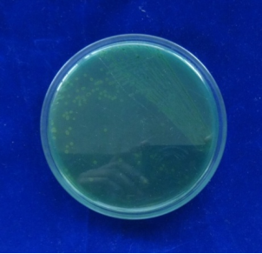
Figure 8: Zone of inhibition against Aeromonas hydrophila. .

5. Conclusion
This research has been able to isolate, identify, and use soil-derived Streptomyces sp. as an effective biocontrol agent against Motile Aeromonas Septicemia in Catla catla. The isolates from different soil samples showed typical morphological and biochemical characteristics of actinomycetes and were later verified by Streptomyces gene sequencing. The secondary metabolites obtained were highly effective against Aeromonas hydrophila. , as demonstrated by quite large inhibition zones and low minimum inhibitory concentration (MIC) values. This points towards the presence of strong bioactive compounds that can fight the bacteria causing diseases in aquaculture. Besides that, the in vivo tests showed a significant increase in the survival of fish treated with Streptomyces sp. probiotics, indicating that it has both antibacterial and immune-stimulatory properties. This combination of qualities makes the bacteria not only a drug but also a preventive measure in the aquaculture industry. The main point of the paper is that Streptomyces from soil could be a powerful, environment-friendly, and sustainable substitute to the use of regular antibiotics. By doing so, it would be possible to greatly minimize the problems caused by antimicrobial resistance while keeping the aquaculture environment healthier. The use of these biological control agents in fish farming could indeed be a very big and positive move towards sustainable disease management and increased productivity.

6. Future Work
Although this study demonstrated the potential of soil-derived Streptomyces sp. as a biocontrol agent, additional investigation is needed to fully exploit its applications in aquaculture. One major direction of future research could be the isolation and structural delineation of the active antibacterial compounds. Sophisticated methods such as High-Performance Liquid Chromatography (HPLC) and Liquid Chromatography-Mass Spectrometry (LC-MS) can be used to separate, identify, and characterize these molecules at the molecular level. That would give a more thorough understanding of their mechanism of action as well as their pharmaceutical or industrial potential. Besides, genomic and metabolomic analyses can reveal the biosynthetic gene clusters producing these metabolites.
Whole-genome sequencing combined with the application of bioinformatics tools facilitates the dissection of metabolic pathways, which may further support genetic engineering approaches to maximize the production and potency of the compounds. Large-scale field experiments under real aquaculture scenarios are necessary to demonstrate the viability, effectiveness, and environmental compatibility of the treatments with Streptomyces-based agents. Besides the evaluation of fish growth and disease resistance, aspects like water quality and the long-term ecological impact of fish should be considered here. Further investigations may also go a step further and create new formulations by combining different effective strains of microorganisms for wider implementation and efficiency of bio-control. Microbes such as Bacillus or lactic acid bacteria could be incorporated into formulations containing Streptomyces.

References
- Nabila, M. I., & Kannabiran, K. (2025). Streptomyces and their secondary metabolites as natural antibiotics for the control of fish microbial diseases in aquaculture. LIANBS, 144(262), 1–14.
- Saha, S., Ishaque, N. M., Burgsdorf, I., Macho, M., Ewe, D., Steindler, L., Hrouzek, P., Kannabiran, K., & Saurav, K. (2021). Draft genome sequence of terrestrial Streptomyces sp. strain VITNK9, isolated from Vellore, Tamil Nadu, India, exhibiting antagonistic activity against fish pathogens. Microbiology Resource Announcements, 10(1), e01282-20, 1–2.
- Khaochamnan, R., Suanyuk, N., Lertcanawanichakul, M., & Pedpradab, P. (2024). Isolation, characterization and optimization of a marine Streptomyces hiroshimensis SK3 producing anti-vibriosis metabolites. PeerJ, 12, e18053, 1–29.
- Riauwaty, M., Sari, T. E. Y., & Adelina, A. (2020). Potency of turmeric in reducing Motile Aeromonas septicemia (MAS) in Pangasius hypopthalmus. IOP Conference Series: Earth and Environmental Science, 430(1), Article 012025.
- Le, T. S., Nguyen, T. H., Vo, H. P., Doan, V. C., Nguyen, H. L., Tran, M. T., Tran, T. T., Southgate, P. C., & Kurtböke, D. I. (2018). Protective effects of bacteriophages against Aeromonas hydrophila. causing Motile Aeromonas septicemia (MAS) in striped catfish. Microorganisms, 6(1), 19.
- Islam, M. A., Rahman, M. M., Hossain, M. T., Siddique, M. P., Haque, M. E., Khasruzzaman, A. K. M., & Rahman, M. A. (2022). Efficacy of bi-valent whole cell inactivated bacterial vaccine against Motile Aeromonas septicemia (MAS) in cultured catfishes (Heteropneustes fossilis, Clarias batrachus and Pangasius pangasius) in Bangladesh. Saudi Journal of Biological Sciences, 29(8), 3881–3889.
- Soltani, M., Moghimi, S. M., Ebrahimzade Mousavi, H., Abdi, K., & Soltani, E. (2016). Isolation, phenotypic and molecular characterization of Motile Aeromonas species, the cause of bacterial hemorrhagic septicemia in affected farmed carp in Iran.
- Agung, L. A., Rohmawati, I., & Ningsih, E. P. (2022). Application of dry probiotic rabal (yeast and lactic acid bacteria) to prevent MAS (Motile Aeromonas septicemia) disease in catfish (Clarias sp.).
- Kusdarwati, R., Kismiyati, Sudarno, Kurniawan, H., & Prayogi, Y. T. (2020). Isolation and identification of Aeromonas hydrophila. and Saprolegnia sp. on catfish (Clarias gariepinus) in floating cages in Bozem Moro Krembangan Surabaya.
- Abdella, B., Shokrak, N. M., Abozahra, N. A., Elshamy, Y. M., & Mohamed, R. A. (2024). Aquaculture and Aeromonas hydrophila. : a complex interplay of environmental factors and virulence. Aquaculture International, 32, 7671–7681.
- Jeamsripong, S., Odoi, J., Shahi, M. K., Anuntawirun, S., & Thiptara, A. (2025). Global spread and antimicrobial resistance of Aeromonas hydrophila. in aquatic food animals: a systematic review and meta-analysis. Scientific Reports, 15, 28441.
- Gieseker, C. M., Gaunt, P. S., Hawke, J. P., Crosby, T. C., & Grim, C. J. (2022). Epidemiological cutoff values for susceptibility testing of Aeromonas hydrophila. isolated from fish. Microbial Drug Resistance, 28(8), 893–903.
- Das, B. K., Kumar, V., Das, P., & Nayak, K. K. (2023). Whole transcriptome analysis of Aeromonas hydrophila. isolated from infected Labeo rohita. Frontiers in Microbiology, 14, 1247652.
- Ahangarzadeh, M., Najafabadi, M. G., Peyghan, R., Houshmand, H., Rohani, M. S., & Soltani, M. (2022). Detection and distribution of virulence genes in Aeromonas hydrophila. isolates causing infection in cultured carps. Veterinary Research Forum, 13(1), 97–103.
- Abo-Shama, U. H., Abd El Raheem, A. A., Alsaadawy, R. M., & Sayed, H. H. (2025). Phenotypic and genotypic characterization of Aeromonas hydrophila. isolated from freshwater fishes at Middle Upper Egypt. Scientific Reports, 15, 5920.
- Behera, B. K., Dhar, S., Kumar, V., Parida, P. K., Hoque, F., Parida, S. N., Bisai, K., Devnath, S., Jana, A. K., Mistri, A., & Das, B. K. (2022). Molecular approach and techniques used in the diagnosis of fish parasites. Journal of Parasitic Diseases, 46(2), 403–417.
- Shabana, S. M., Rashed, M. A., Atia, A. A., & Abd El-Hady, H. A. M. (2024). Characterization of Aeromonas hydrophila. isolated from freshwater fish with control trial. Scientific Reports, 14, 22145.
- Kumari, R., Yadav, R., Kumar, D., Chaube, R., & Nath, G. (2023). Evaluation of bacteriophage therapy of Aeromonas hydrophila. infection in a freshwater fish, Pangasius buchanani. Frontiers in Aquaculture, 2.
- Laltlanmawia, C., Saha, H., Ghosh, L., Saha, R. K., & Malla, S. (2023). Unveiling the mechanisms of Aeromonas hydrophila. induced mortality in Labeo rohita: Hemato-biochemical and immune-pathological perspectives. Indian Journal of Animal Research, 57(10), 1305–1313.
- Kerigano, N. K., Chibsa, T. R., & Molla, Y. G. (2023). Phenotypic, molecular detection and antibiogram analysis of Aeromonas hydrophila. from Oreochromis niloticus and ready-to-eat fish products in selected Rift Valley lakes of Ethiopia. BMC Veterinary Research, 19, 120.
- Sherif, A. H., & Kassab, A. S. (2023). Multidrug-resistant Aeromonas bacteria prevalence in Nile tilapia broodstock. BMC Microbiology, 23, 85.
- Ozdemir, E., Abdelhamed, H., Ozdemir, O., Lawrence, M., & Karsi, A. (2023). Development of bioluminescent virulent Aeromonas hydrophila. for understanding pathogenicity. Pathogens, 12(5), 670.
- Wahjuningrum, D., Hilal, A., Waturangi, D. E., & Nuryati, S. (2023). The potential of shallot skin powder and actinomycetes metabolites as antimicrobe and antibiofilm in the treatment of eel infected with Aeromonas hydrophila. . BMC Research Notes, 16, 324.
- Lavanya, C., Neeraja, T., Ramana, T. V., Balasubramanian, A., & Sudhakar, O. (2024). Species diversity, existence of virulence gene profile and in-vivo pathogenicity study of Aeromonas spp. isolated from diseased Catla catla.
- Sahoo, P. K., Shankar, R. S., Pasim, R. K., Pattanayak, S., & Das, N. K. (2019). Pathogenic status, antibiogram, adhesive characteristics, heavy metal tolerance and incidence of integrons of infected fish-isolated Aeromonas sp. Journal of Sustainability Science and Management, 14(2), 1–12.

